Place Naming Framework
Fishermans Bend
Employment and Innovation Area and Lorimer precincts

Draft July 2025

Acknowledgement of Traditional Owners
The City of Melbourne respectfully acknowledges the Traditional Owners of the land we govern, the Wurundjeri Woi-wurrung and Bunurong Boonwurrung peoples of the Kulin and pays respect to their Elders past and present. We acknowledge and honour the unbroken spiritual, cultural and political connection they have maintained to this unique place for more than 2000 generations.
We accept the invitation in the Uluru Statement from the Heart and are committed to walking together to build a better future.

Contents
Part A: Context 5
Introduction 5
Purpose 5
Objectives 5
Naming Framework structure 5
Fishermans Bend urban renewal area 6
Policy and legislative context 7
Fishermans Bend 9
A snapshot history of Fishermans Bend 9
Significance of place names 12
Why is place naming important? 12
Part B: Naming Themes 13
Connection to Country 14
Significance 14
Policy and community engagement 15
Engaging with Traditional Owners 15
Women who shaped Fishermans Bend 17
Significance 17
Policy and community engagement 17
Influential women in Fishermans Bend 17
Diverse community character 21
Significance 21
Policy and community engagement 21
Diverse communities and events 21
Industry and innovation 25
Significance 26
Policy and community engagement 26
Automotive legacy 26
Aviation and defence legacy 27
Food production legacy 28
Sand, water, scrub and wildlife 32
Significance 32
Policy and community engagement 32
Fishermans Bend’s flora and fauna 33
Naming theme overlap 36
Part C: application of naming framework 34
two-step approach 34
Step 1: Spatial context 34
Step 2: Place type 34
Application examples 36
Overview of Spatial Context Maps 37
Place naming approval process 41
How to engage with Registered Aboriginal Parties 42
Appendices 43
Appendix A 43
Appendix B 45
Appendix C 47
How to contact us 49
Online: 49
In person: 49
Telephone: 49
Fax: 49
In writing: 49
Interpreter services 49
National Relay Service: 49

Issue A
July 2025
Disclaimer
This report is provided for information and it does not purport to be complete. While care has been taken to ensure the content in the report is accurate, we cannot guarantee it is without flaw of any kind. There may be errors and omissions or it may not be wholly appropriate for your particular purposes. In addition, the publication is a snapshot in time based on historic information which is liable to change. The City of Melbourne accepts no responsibility and disclaims all liability for any error, loss or other consequence which may arise from you relying on any information contained in this report.
To find out how you can participate in the decision-making process for City of Melbourne’s current and future initiatives, visit Paricipate Melbourne.

Part A: Context

Introduction
Significant urban renewal is planned for Fishermans Bend in the coming decades, including two precincts within the City of Melbourne: The Employment and Innovation Area (EIA) and Lorimer (Figure 1). This redevelopment will result in many new roads, parks and public places. All these new features will require names.

Purpose
The Fishermans Bend Place Naming Framework (the Naming Framework) applies a localised approach to the selection and determination of new names for new roads and features, such as parks and public places.
The Naming Framework applies to the EIA and Lorimer precincts of the Fishermans Bend urban renewal area in the City of Melbourne municipality (Figure 1).
The Naming Framework can be used by applicants as part of the preparation of naming requests. It also assists the assessment and determination of naming requests by the
City of Melbourne (as the naming authority) and Geographic Names Victoria (the agency responsible for the registration of names across Victoria). The standard process for assessing place name applications is explained in Part C: Application of Naming Framework.

Objectives
The Naming Framework’s objectives are:
- to provide a robust and informed basis to guide decision making around names for new roads and features in the EIA and Lorimer precincts
- to ensure future names are meaningful by reflecting and celebrating Fishermans Bend’s rich and diverse history and character
- to reduce the onus on applicants to research individual naming applications by providing naming themes and additional resources informed by community engagement and research.

Naming Framework structure
The Naming Framework comprises three parts and supporting appendices:
Part A explains the Naming Framework’s purpose, objectives and the policy context in which it sits as well as providing a snapshot of Fishermans Bend’s diverse history.
Part B describes five naming themes, identified through stakeholder engagement and research, that characterise the EIA and Lorimer precincts.
Part C details the processes for applying the Naming Framework, including identifying and approving a suitable place name and engaging with Traditional Owners.
Appendices include descriptions of place types to be named, a summary of factors informing the Naming Framework, and resources to support further place name research.

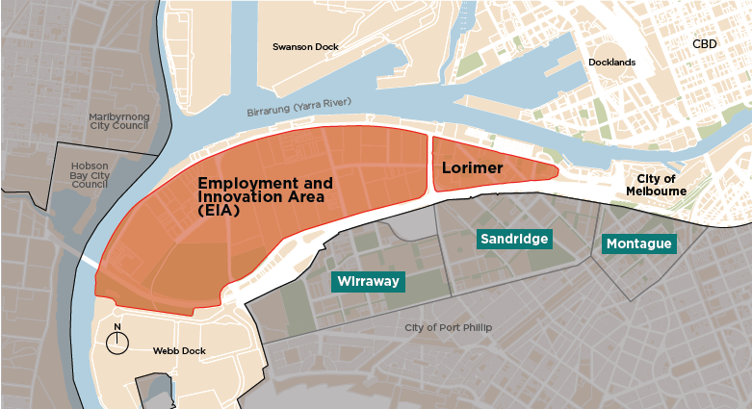
Figure 1: Fishermans Bend EIA and Lorimer precincts

Fishermans Bend urban renewal area
Fishermans Bend is Australia’s largest urban renewal project. Led by the Victorian Government, the project is expected to deliver 80,000 new residents, 40,000 students, and 80,000 jobs to the area by 2050.
The Fishermans Bend urban renewal area is made up of five precincts. The EIA and Lorimer precincts are within the City of Melbourne. The remaining three precincts, Wirraway, Sandridge and Montague, are within City of Port Phillip (Figure 1).
Fishermans Bend’s vision and strategic direction is outlined in the Fishermans Bend Framework (2018) and Advancing Manufacturing – the Fishermans Bend Opportunity (2021). They express the EIA’s future (formerly referred to as the National Employment and Innovation Cluster) as an ‘internationally renowned as a centre of innovation in advanced manufacturing, engineering and design’. Lorimer is to become ‘a vibrant, mixed-use precinct close to the Yarra River and connected to Melbourne’s Central Business District, Docklands and emerging renewal areas.

Policy and legislative context
The Naming Framework is intended to be used as a framework to apply a nuanced and localised approach to the selection and determination of names in Fishermans Bend. As outlined in Figure 2, this is subject to the requirements of the Victorian Government’s Naming Rules for Places in Victoria 2022 – referred to in this framework as the Naming Rules, and City of Melbourne’s overarching Place and Road Naming Policy 2024 – referred to in this framework as our Naming Policy.

Victorian Government
The Victorian Government’s Naming Rules are statutory requirements for naming roads, features and localities, which are based on national standards and policies. They include 13 naming principles and specific statutory requirements, providing a strong basis for standardised and clear naming procedures across Victoria. Naming principles highlight the importance of diversity and inclusion, and linking a place name to the local area.
- Principle A: Ensuring public safety
- Principle B: Recognising the public interest
- Principle C: Linking the name to place
- Principle D: Ensuring names are not duplicated
- Principle E: Recognition and use of Traditional Owner languages
- Principle F: Names must not discriminate or be offensive
- Principle G: Gender equality
- Principle H: Dual names
- Principle I: Using commemorative names
- Principle J: Using commercial and business names
- Principle K: Language
- Principle L: Directional names to be avoided
- Principle M: Assigning extent to a road, feature or locality

City of Melbourne
City of Melbourne’s Naming Policy ensures that naming decisions:
- are made within a transparent framework
- are consistent with Council and community expectations
- comply with the Victorian Government’s Naming Rules
- prioritise recognition and use of Traditional Owner languages
- prioritise gender equity in naming.
The policy identifies a need for ‘precinct naming strategies’ for the Fishermans Bend precincts, leading to development of this Naming Framework. Precinct naming strategies must prioritise the choices of the relevant Registered Aboriginal Party.
Legislative context of this Naming Framework
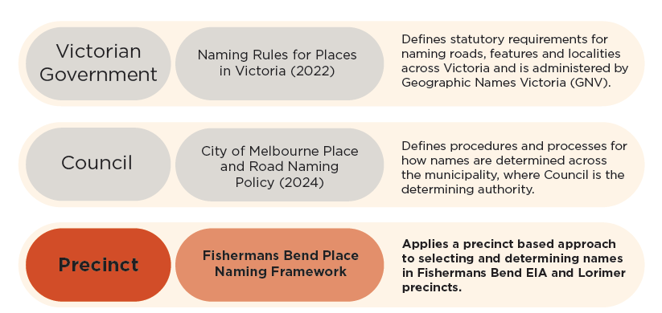
- Figure 2: Legislative context of this Naming Framework

Fishermans Bend

A snapshot history of Fishermans Bend
Fishermans Bend has a rich history, including a deep and ongoing connection to Country for the Bunurong Boonwurrung people and Wurundjeri Woi-wurrung people of the Kulin, and a contemporary history post European settlement.

Bunurong Boonwurrung and Wurundjeri Woi-wurrung Peoples
The Bunurong Boonwurrung and Wurundjeri Woi-wurrung peoples have maintained an ongoing social, cultural, spiritual and economic connection to the area now known as Fishermans Bend for tens of thousands of years. This connection is further detailed in the ‘Connection to Country’ naming theme section.

Post European Settlement
Fishermans Bend’s contemporary history commenced with the establishment of the area now referred to as Melbourne by European settlers in 1835. A snapshot of Fishermans Bend’s post European settlement history focussing on the EIA and Lorimer precincts is outlined in Figure 3.
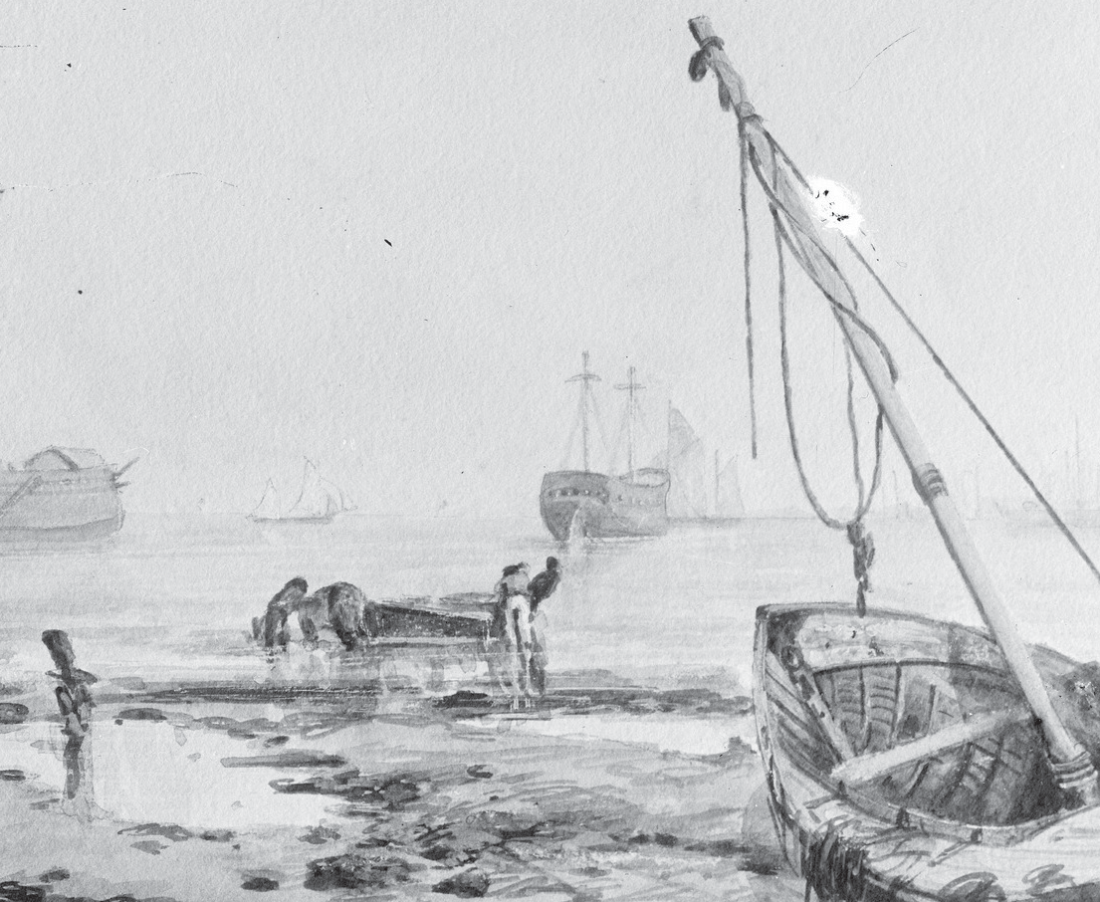
- Image 1: Sketch of Fishermans Bend around 1920, courtesy of the State Library Victoria

- Fishermans Bend’s ongoing industrial legacy
Fishermans Bend has undergone significant change, largely characterised by its industrial activities, as outlined in Figure 3.
From the 1840s, noxious industrial activities, such as soap and candle markers, abattoirs, and chemical works operated locally. These were followed by glass manufacturers which capitalised on the area’s highly accessible sand, a timber yard and asphalt plant in the 1860s and 70s.
During World War II, new industries were established in Fishermans Bend to support Australia’s war effort with aviation, defence and automotive production. Agencies set up from 1936 to 1939 included the Commonwealth Aircraft Corporation and Government Aircraft
Corporation, as well as the Defence, Science and Technology Group, and General Motors Holden.
After the war, Kraft Walker began producing cheddar cheese, Bonox and Vegemite in Fishermans Bend. The distinctive smell of the Vegemite factory has since been recognised for its local heritage value.
Although heavy manufacturing has declined in Fishermans Bend, the thread of science, defence and innovation continued through to the 1990s when the area transitioned to a light industrial use precinct. This involved the establishment of industries such as cement works and distribution centres located near the Port, as well as technology and business parks and automotive dealerships.
Industry and innovation will continue to define the local area into the future, as the Victorian Government’s Fishermans Bend Framework 2018 envisions the EIA (formerly referred to as the National Employment and Innovation Cluster) to be a leading precinct for design, engineering and advanced manufacturing.

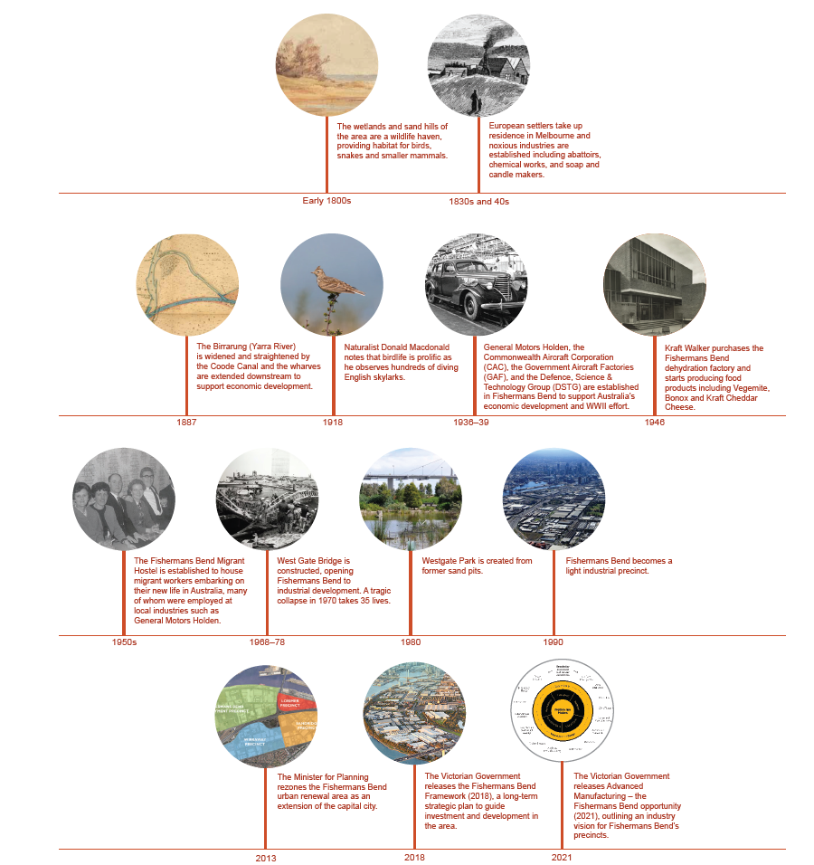
Figure 3: Snapshot of Fishermans Bend’s post-European settlement (refer to Appendix C for image credits)

Significance of place names

Why is place naming important?
Place names are more than a tool for navigating the environment. They contribute to a place’s identity and provide an opportunity to learn about a place’s unique story. Place names
can be used to identify culturally significant locations, commemorate significant people and acknowledge future aspirations.
Many existing place names in Fishermans Bend commemorate men who were involved in Melbourne’s early political movements and the area’s industrial legacy (Figure 4).
Fishermans Bend has a rich, multifaceted history, and the Naming Framework aims to amplify all of these stories.
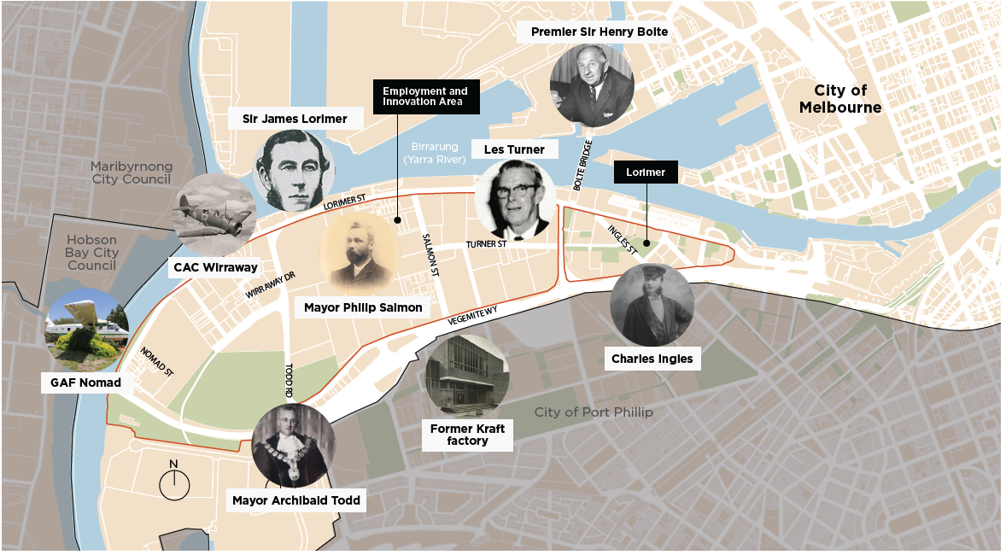
Figure 4: Existing road names in Fishermans Bend (refer to Appendix C for image credits)

Part B: Naming Themes

Five naming themes are identified for the Fishermans Bend precincts within the City of Melbourne. These naming themes are informed by state and local government guidelines, as well as community and stakeholder engagement and supporting research. Appendix B summarises feedback received from the community and stakeholders.
Each naming theme represents an important part of the area’s local culture, history and future aspirations. Naming themes are categorised into priority municipal themes and precinct themes (Figure 5).
The following sections outline:
- significance of each naming theme to Fishermans Bend (EIA and Lorimer precincts)
- legislative and community engagement context
- example stories, imagery, spatial maps of precinct themes, and example names to inspire place naming.
There is a two-tier naming hierarchy. Priority municipal themes are prioritised in state and local government naming policy and can be applied to the entire EIA and Lorimer precincts. These themes are “Connection to Country” and “Women who Shaped Fishermans Bend”.
Precinct themes relate to specific areas or significant sites within the EIA and Lorimer precincts. These themes are “Diverse community character”, “Industry and innovation” and “Sand, water, scrub and wildlife”.
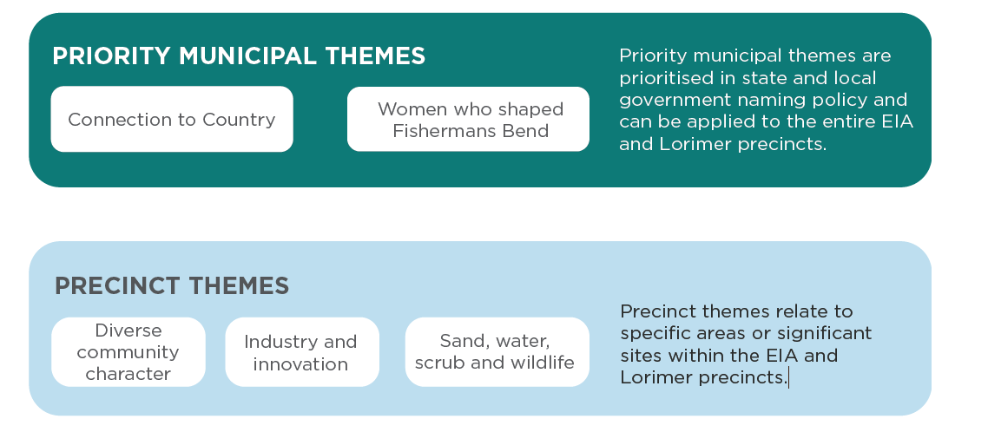
- Figure 5: Priority municipal and precinct naming themes

Connection to Country
Priority Municipal Theme

Significance
The area now known as Fishermans Bend has been the land of the Bunurong Boonwurrung and Wurundjeri Woi-wurrung peoples for tens of thousands of years.

Bunurong Boonwurrung people
The Bunurong peoples have an ongoing social, cultural, spiritual and economic connection to this place where the Birrarung (Yarra River) flows into Naarrm (Port Phillip Bay). The story of the inundation of Naarrm is told through oral tradition. Around 5000 years ago sea levels began to rise, transforming what was once a dry, low-lying area into a vast river plain of wetlands and sand dunes densely covered with melaleuca, tea-tree and coastal banksia, and abundant with wildlife, before forming as the bay as we know today.
Language is sacred and an integral part of Bunurong Country. For this reason, place names connect Bunurong peoples, stories and Country through time, highlighting the importance of places as sites of gathering, culture and identity.
The systematic destruction of Bunurong people and culture by colonial forces over the past two centuries has resulted in significant loss of language. The limited records available today of Boonwurrung language are primarily located in the notes and journals of early colonists. Many of these colonists only spoke English and did not have a good ear for the complex sounds of Boonwurrung language.
The process of determining an appropriate Boonwurrung name is complex, as it is necessary to ensure accuracy, consistency and engagement with community for all words.
The naming of places in Boonwurrung language is an essential part of ongoing truth-telling and education efforts. It is a means by which Bunurong people can proudly express their cultural identity and heritage.
Wurundjeri Woi-wurrung people
Fishermans Bend has long been a site of deep cultural significance to the Wurundjeri people. Spiritual connection to this area has been expressed in Wurundjeri lore, language, and story as the place where the Birrarung (Yarra River) finally rests after its long journey across Wurundjeri Country from its source at Mt Baw Baw.
Wurundjeri creation stories, passed down from Ancestors in the Woi-wurrung language, explain the birth, life and relationship between the river and its surrounds, including as a life source that has sustained the Wurundjeri people for many thousands of years. Influential Wurundjeri ngurungaeta (headman) Billibilleri passed down the story of the origin and evolution of Wurundjeri Country, from ancient volcanic activity to lava-flows and the formation of the Birrarung.
The Birrarung, which translates in Woi-wurrung as the river of mist and shadows, flows out through Fishermans Bend to Hobsons Bay from its source in the Yarra Rangers at the southern side of the Great Dividing Range. The geology of the Birrarung and Fishermans Bend has changed greatly since European settlement. Originally the site was a swamp where Wurundjeri clans would fish for eels.
Wurundjeri Elders and community are still very much engaged in the protection and preservation of the Yarra River and continue to have intimate knowledge of and connection to their waterways. Elders still have a role to play in the management of the river both academically, culturally and spiritually through both the Yarra River Protection Act and the Birrarung Council, advising government ministers on ways of working with the river and it’s surrounds.
This is expressed in many different ways in contemporary naarm (Melbourne), such as the naming of places and the use of the Woi-wurrung language across Country in both Indigenous and non-Indigenous spaces. The use and importance of language keeps the spirit of the Ancestors alive and ensures Wurundjeri people continue to feel connected to Country and Culture.

Policy and community engagement
The Victorian Government’s Naming Rules encourage naming authorities to consider Aboriginal names when assigning names to roads, features, and localities to help the preservation of Aboriginal language across
Victoria. The use of Aboriginal names is subject to agreement from the relevant Traditional Owner group(s).
City of Melbourne’s Naming Policy Section 5.1 gives particular effect to the
Victorian Government’s Naming Rules ‘Principle E: Recognition and use of Traditional Owner languages’ by giving priority to Traditional Owner language names in precinct naming strategies, and by asking Registered Aboriginal Parties (RAPs) to choose those names.
Celebrating Aboriginal culture through place naming in Fishermans Bend was identified as a priority in stakeholder feedback.

Engaging with Traditional Owners
Bunurong Boonwurrung and Wurundjeri Woi-wurrung language names and other
relevant words are to be determined through engagement with the relevant Traditional Owner RAPs: the Bunurong Land Council Aboriginal Corporation and Wurundjeri Woi-Wurrung Cultural Heritage Aboriginal Corporation. This process is outlined in Part C ‘How to engage with Registered Aboriginal Parties’.
Both RAPs have been engaged throughout the development of the Naming Framework. This process involved multiple meetings in-person and online.

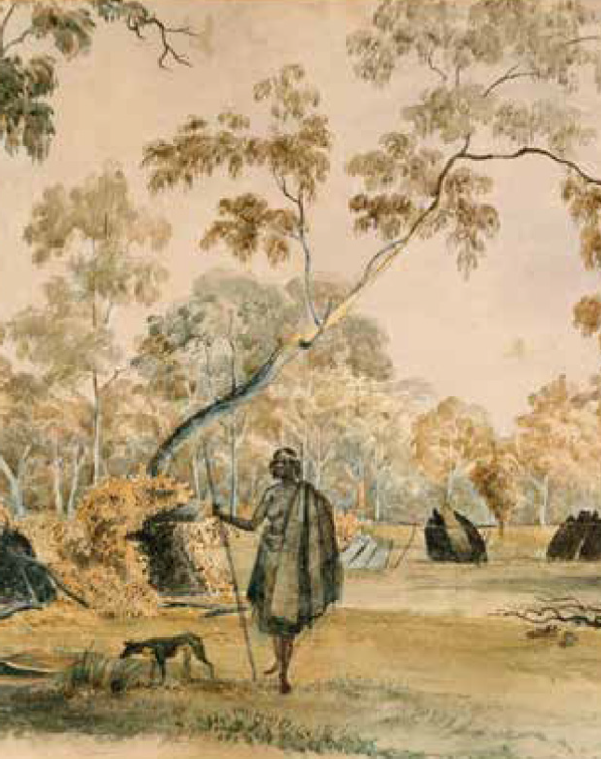
Image 2: Aboriginal camp on the banks of the Birrarung (Yarra River), around 1845, courtesy of Context Pty Ltd
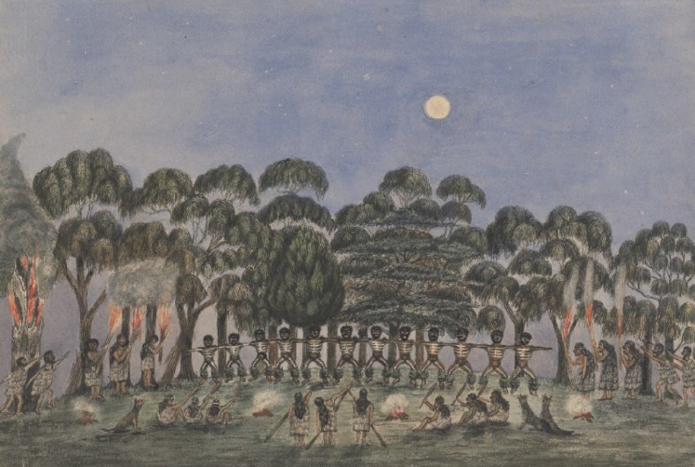
Image 3: A Corroboree on Emerald Hill (Bunorong Boonwurrung Country), around 1840, courtesy of Bunurong Land Council Aboriginal Corporation

Women who shaped Fishermans Bend
Priority municipal theme

Significance
Women and gender diverse people have had a strong presence in Fishermans Bend throughout history, shaping the area’s character and identity. Women have played critical roles in advancing the area’s automotive, aviation, defence,
and science industries. Women living within Fishermans Bend and Port Melbourne have advocated for important community causes, represented Australia in sporting competitions and have been pivotal to the success of community initiatives and groups. And yet, the stories of many influential women and gender diverse people in Fishermans Bend have not been reflected in existing place naming.

Policy and community engagement
The Victorian Government and City of Melbourne support gender equality through place naming policy and initiatives:
- The Victorian Government’s Naming Rules ‘Principle G: Gender equality’ encourages gender equality in the naming of roads, features and localities.
- The Victorian Government’s Gender Equality Strategy and Action Plan 2023–27 includes a target for 70 per cent of new applications for commemorative place naming to be achieved within the lifetime of the strategy.
- The Victorian Government’s Our Equal Places Program supports increasing diversity and equality in commemorative place naming in Victoria.
- The City of Melbourne’s Naming Policy Section 5.2 gives particular effect to the Victorian Naming Rules ‘Principle G: Gender equality’ by annually reporting all places named, and the proportional change of places named for women among all commemorative names. It will ensure that places named for women do not fall short of three-quarters of all commemorative names in any two year period.
- Representing significant people, including women, through place naming in Fishermans Bend was also identified as a priority in stakeholder feedback.

Influential women in Fishermans Bend
Meet some of the women who have contributed to the life and culture of Fishermans Bend.
Many have come to light during community engagement and research for this framework.
Eileen ‘Eliza’ Robertson designed and executed murals in the General Motors Holden (GMH) canteen to celebrate the launch of “Australia’s Own Car” in 1945.
Mai Ho, a Vietnamese immigrant, became the first female quality control inspector at GMH.
Peggy Antonio was a talented spin bowler. She grew up in Port Melbourne and represented Australia in the 1937 Ashes in England.
Cathy Mehmet was the first female leading hand at GMH in 1967 and later became the first GMH forelady in 1976.
Heather Carpenter became the first GMH female shop steward in 1988, working in the Fishermans Bend engine plant.
Jerri Mann was a musician and social advocate for the Fishermans Bend / Port Melbourne local community. In 1988, she formed and led ‘The Jerriantics’, a band of seven mature age performers.
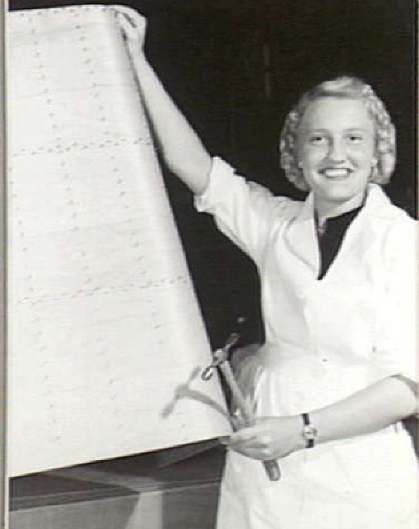
Image 4: Joyce Breedin was employed at GMH during World War II. She became an expert in applying the body to the wing frame of a Wackett trainer aircraft. Photograph courtesy of the Australian War Memorial collection.


Image 5: Dianne Lemaire was the first female engineering graduate from University of Melbourne. Graduating in 1944, she later worked for the Aeronautical Research Group (predecessor department to the CSIRO) in Fishermans Bend. Photograph courtesy of the University of Melbourne.


Image 6: Enid Campbell Plante was the first woman appointed to the Physical Chemistry Section of the CSIR (later renamed CSIRO) Division of Industrial Chemistry in Fishermans Bend. From 1940 to 1946 she contributed to major projects. Photograph courtesy of CSIRO.
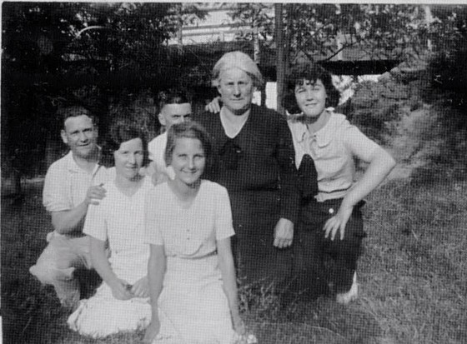
Image 7: Mary McLeavy (centre) led a group of women to Parliament to advocate for the families of Fishermans Bend wharf workers facing imminent unemployment in the 1920s. Photograph courtesy of the Port Melbourne Historical and Preservation Society.

Diverse community character
Precinct Theme

Significance
Fishermans Bend’s rich pre-settlement natural environment, expansive space, proximity to Melbourne’s CBD and rise in industrial jobs and services has attracted diverse communities and events throughout history. Collectively, these communities have shaped the area’s rich, multicultural character and identity.

Policy and community engagement
Recognising Fishermans Bend’s diverse community character through place naming is aligned with the Victorian Government’s Naming Rules ‘Principle C: Linking the name to place’.
The importance of sharing the history, evolution, and identity of the Fishermans Bend community through place names, was reinforced through community and stakeholder feedback.

Diverse communities and events
Communities that have characterised Fishermans Bend include but are not limited to:
- ‘Fisher folk’ or ‘wharfies’ who lived in Fishermans Bend and worked at the wharves.
- The Indian Lascar seamen who docked their ships at Port Melbourne from the 1880s to the 1940s, and bought goats, live chickens and eggs from Fishermans Bend’s fishing community.
- Individuals and families associated with the quarantine hospital, established for the Spanish Flu epidemic of 1918–19.
- Migrants and their families living in the Fishermans Bend migrant hostel on Lorimer Street in the 1950s.
This community added great value to the local area through working at local industries, such as General Motors Holden and the Commonwealth Aircraft Factory, and contributing to civic events and groups. Fishermans Bend also provided sport and recreational opportunities for the local and regional communities. Activities included walking, riding, fishing, horse-racing, golf and car racing. Key historic events included:
- The 1884 Port Melbourne Cup, a horse- racing event held on a grass racecourse in Fishermans Bend.
- The 12-hole Victoria Golf Club from 1903 to 1926, extending south-west from the corner of Lorimer and Ingles streets.
- Use of the former Fishermans Bend Aerodrome for car racing from 1948 to 1966, when construction began on the Lower Yarra Freeway and West Gate Bridge.
- Formation of the Rossy Rovers, a community football and basketball team made up of boys living in Port Melbourne.
The community was engaged and collaborative. They rallied to support each other through tough times, such as the collapse of the West Gate Bridge in 1970.
Significant sites identified through desktop research and community engagement relating to the local area’s diverse community character are identified in Figure 6.
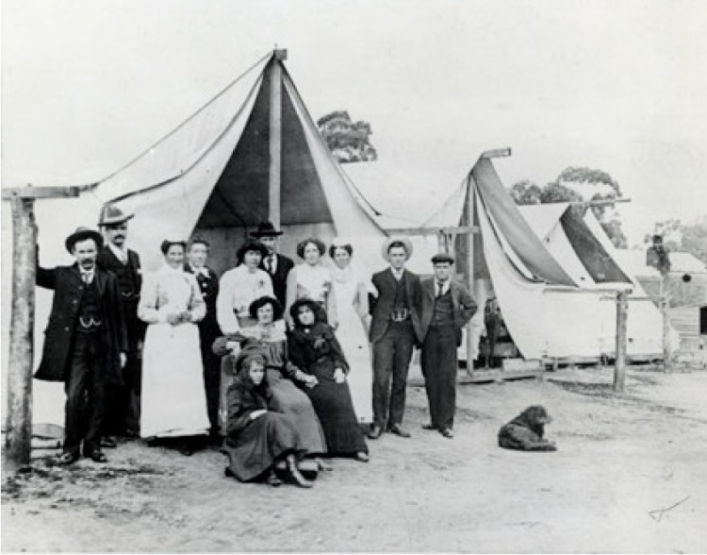
Image 8: Quarantine hospital in Fishermans Bend around 1918–19, courtesy of Context Pty Ltd
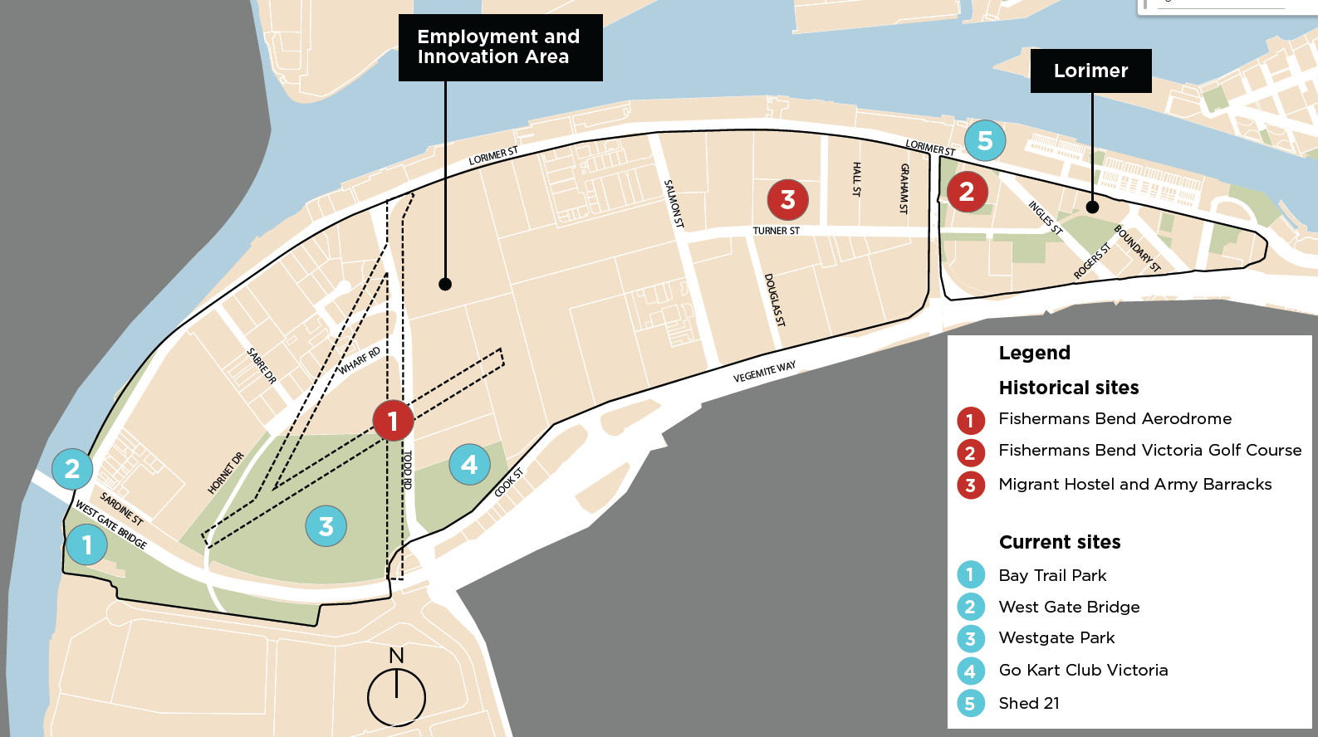
Figure 6: Fishermans Bend’s diverse community significant sites
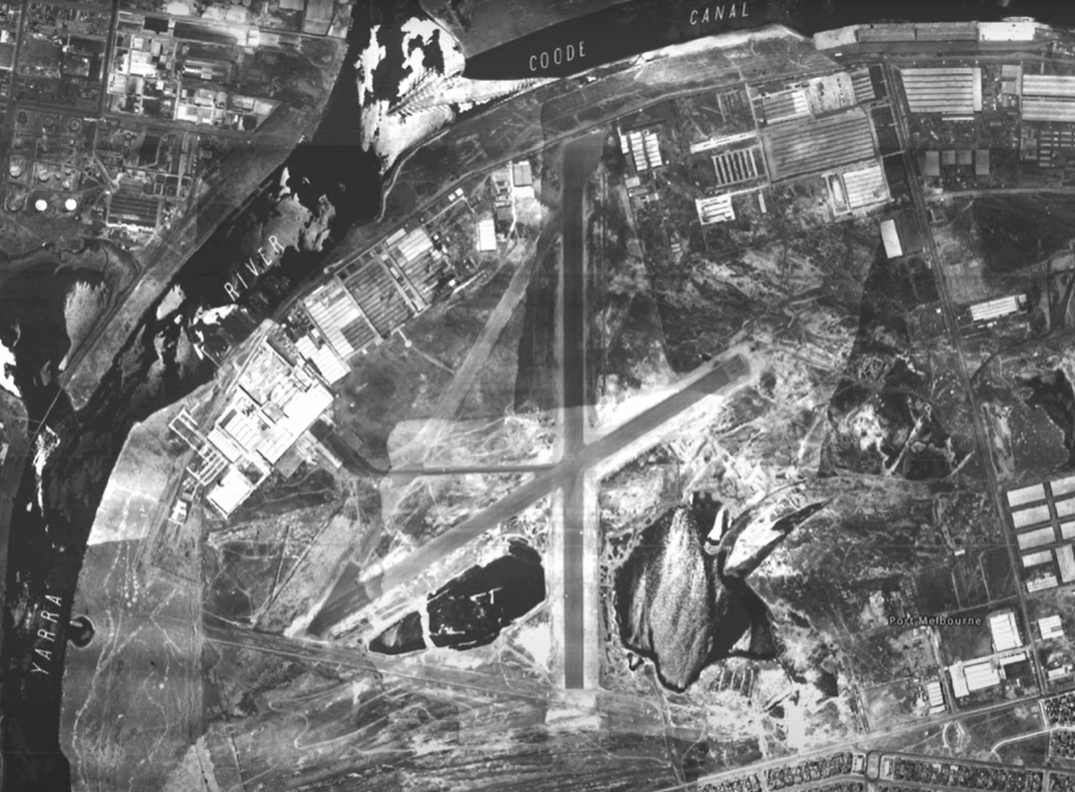
Image 9: Fishermans Bend shack between 1939-1945, courtesy of the State Library Victoria
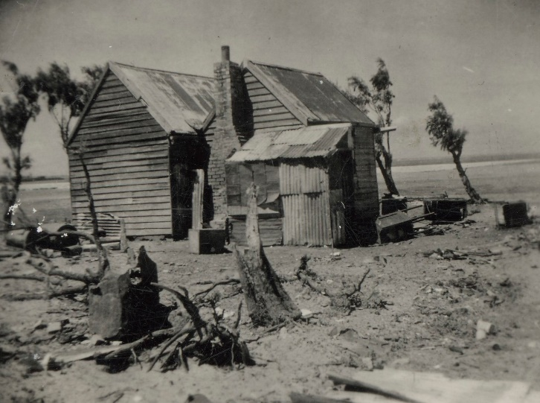
Image 10: Aerial view of Fishermans Bend Aerodrome, around 1945, courtesy of the University of Melbourne Library Collection
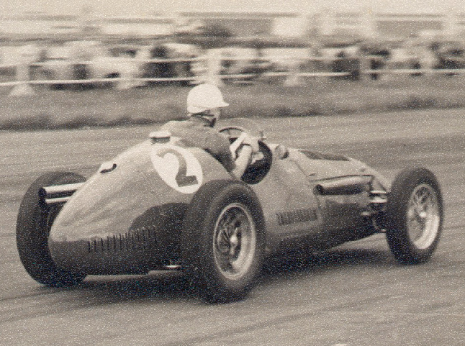
Image 11: Car racing on the Fishermans Bend Aerodrome, around 1945, courtesy of the State Library Victoria
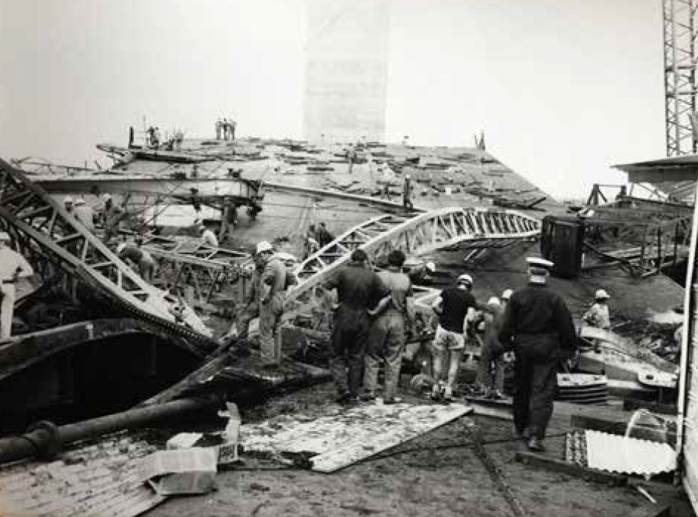
Image 12: Tragic collapse of Westgate Bridge in 1970, courtesy of Context Pty Ltd

Industry and innovation
Precinct Theme

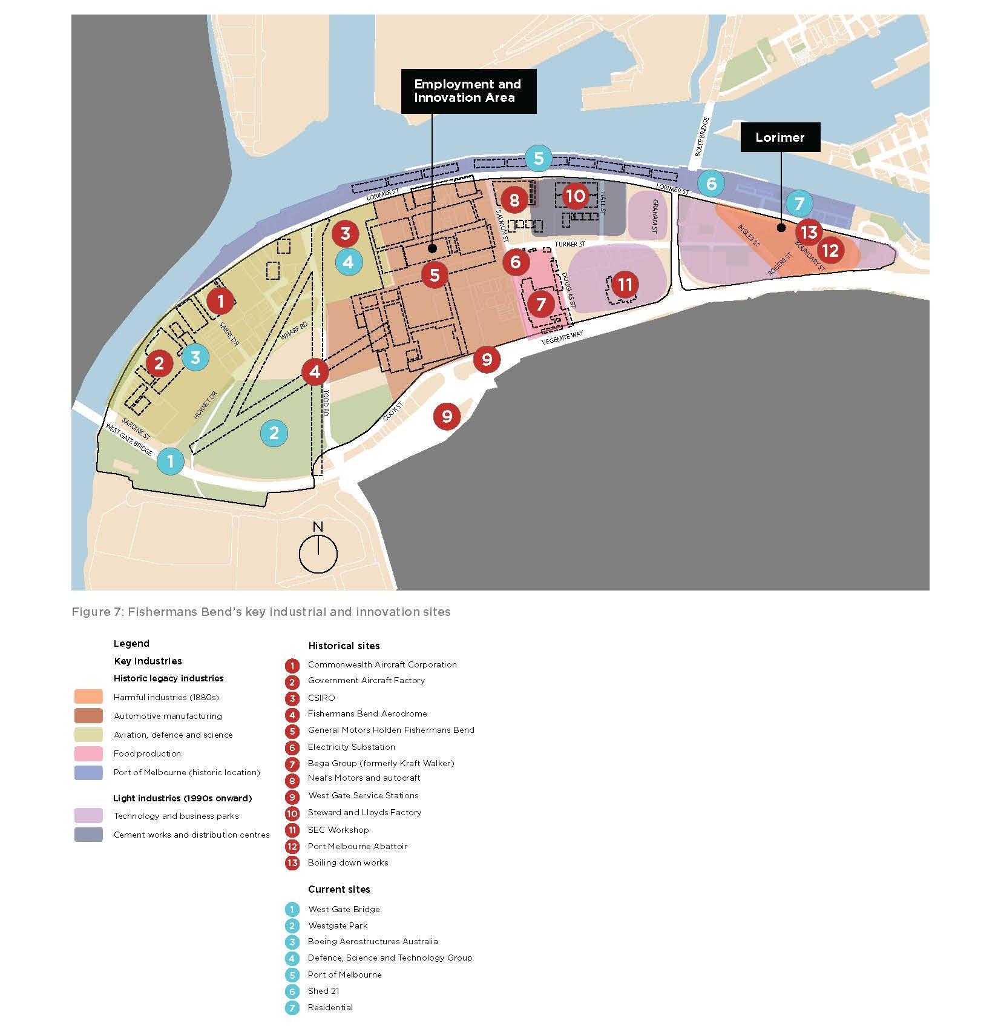
Figure 7: Fishermans Bend’s key industrial and innovation sites

Significance
Fishermans Bend has a strong legacy of industry and innovation. The vast expanse of land attracted agricultural activities such as goat farming from as early as the 1840s.
Harmful industrial activities such as soap and candle-making, abattoirs and chemical works also operated in the area from the 1840s. Glass manufacturers worked a roaring trade from the 1860s and 70s, drawing on the area’s highly accessible sand reserves to produce tens of thousands of glass medicine bottles.
In the 1870s, efforts were made to clean up the Birrarung (Yarra River) and relocate the most harmful industries. This made way for new industries, such as a timber yard and asphalt plant.
Industrial development was enhanced by the construction of the Coode Canal in the 1880s Good access to the port, river, wharves and the central business district also made Fishermans Bend attractive for industrial development.
In the 1930s, select industries benefited from Australian Government stimulus programs in preparation for Australia’s involvement in World War II. Key industries included automotive, aviation, defence, food production, steel and cement works.
Into the future, industry and innovation will continue to evolve in Fishermans Bend through its designated role as the EIA and vision to become ‘Australia’s leading design, engineering, and advanced manufacturing precinct.’ Significant sites relating to Fishermans Bend’s industrial legacy are identified in Figure 7.

Policy and community engagement
Reflecting Fishermans Bend’s industrial legacy is aligned with the Victorian Government’s Naming Rules ‘Principle C: Linking the name to place’. Celebrating Fishermans Bend’s industrial heritage and innovation was also a key naming theme identified in community and stakeholder feedback.

Automotive legacy
Lawrence Hartnett arrived in Australia from England in 1934 to lead the newly merged General Motors Holden (GMH). He promptly set about relocating the business from the area now known as Southbank to Fishermans Bend, where it became the expanded Australian headquarters for GMH. In recognition of the industry’s importance for the national economy, the new headquarters were opened by Australian Prime Minister, Mr JA Lyons, in 1936.
In 2017, GMH closes its doors and the land was purchased by the Victorian Government to be developed as the Fishermans Bend Innovation Precinct (FBIP). FBIP is envisioned to be an internationally renowned centre of innovation in advanced manufacturing, engineering and design, carrying GMH’s legacy into the future.
Example names that represent industry and innovation stories of Fishermans Bend include:
- Disco: The Disco plant produced automotive electrical components and was a key plant for female employees. Originally located on Williamstown Road, it was relocated into GMH’s Salmon Street site in 1977.
- Hurricane: The Hurricane was a two-seat concept car built by Holden in 1969.
- Sawtooth: Sawtooth refers to the built form design of GMH’s factories built in 1935.
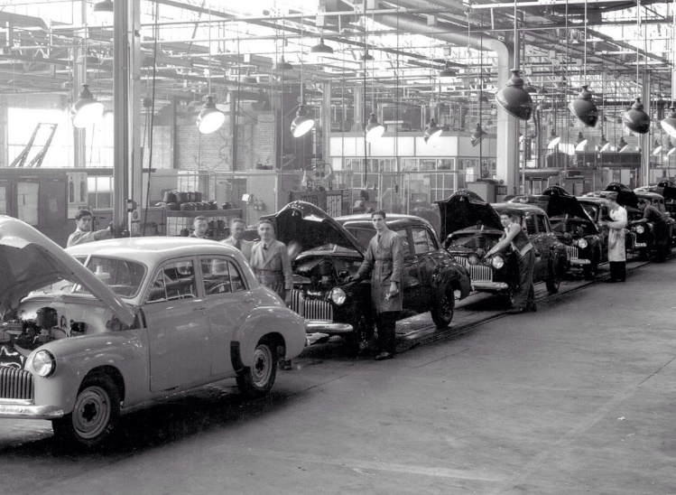
Image 13: The General Motors Holden production line, 1948, courtesy of State Library Victoria

Aviation and defence legacy
The Commonwealth Aircraft Corporation (CAC) was a private entity formed within Fishermans Bend in 1936. It was designed to increase Australia’s capacity to produce military aircraft and influenced the establishment of the Fishermans Bend aerodrome. With similar ambitions, the Defence, Science and Technology Group (DSTG) and the Department of Aircraft Production were both established in 1939. At the end of World War II, the Department of Airport Production became the Government Aircraft Factories (GAF). In the early 2000s, Boeing Australia acquired both the CAC and the GAF. Several street names in Fishermans Bend reflect this legacy, such as Beaufort Place, Canberra Street and Hornet Drive.
Other example place names connected to aviation and defence stories include:
- Black Box: David Warren invented the Black Box flight recorder in the 1950s at the DSTG site in Fishermans Bend.
- Gearbox: Research into helicopter gearbox failure began at DSTG in the early 1980s.
- Wackett: The CAC Wackett Trainer was the first aircraft type designed in-house by the CAC. The name was derived from its designer Lawrence Wackett.
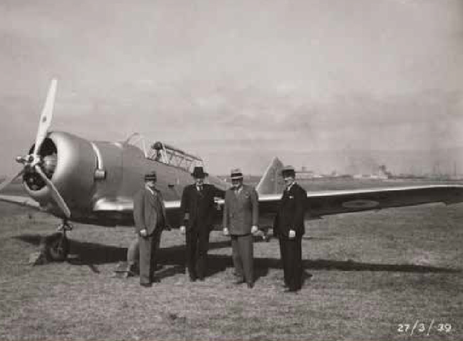
Image 14: Key figures in the establishment of the Commonwealth Aircraft Corporation, including Essington Lewis and LJ Wackett, pictured at Fishermans Bend, 1939, courtesy of Context Pty Ltd

Food production legacy
The Kraft factory was built in Fishermans Bend 1943 as a food dehydration plant, responding to high demand during World War II. It was owned by the Australian Government and operated by Kraft Walker. In 1946, Kraft Walker
purchased the factory from the government and started producing products such as Vegemite, Bonox and Kraft Cheddar Cheese. In 2012, Kraft Walker split into the Kraft Foods Company and Mondelez. Bega Cheese purchased the Vegemite and Kraft brands from Mondelez in 2017.
Example place names connected to food production stories include:
- Walker: Fred Walker started in the food business in 1899. Vegemite was the major innovation at his company, Kraft Walker.
- Callister: Dr Cyril Callister, a food technologist, invented Vegemite in 1923. It was developed at the request of Fred Walker for a spread like Marmite.
- Malt: Malt is a key ingredient of Vegemite.
Key elements of Fishermans Bend’s industrial history identified through desktop research and community engagement are mapped in Figure 7.
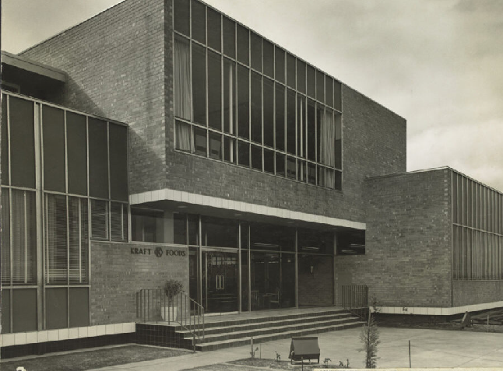
Image 15: Kraft Foods administration building, Fishermans Bend, around 1955–63, courtesy of the State Library Victoria

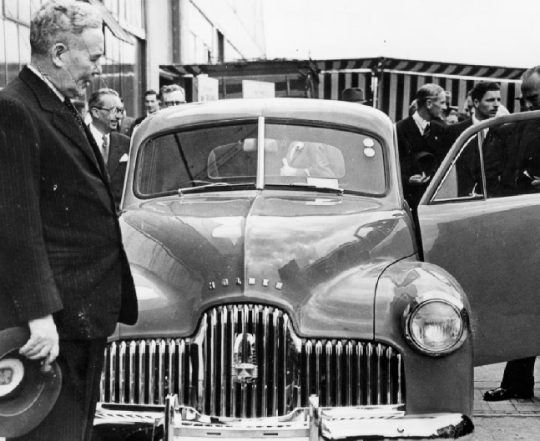
Image 16: Prime Minister Ben Chifley at the 1948 launch of ‘Australia’s own car’, the General Motors Holden ‘Holden FX’ at Fishermans Bend, courtesy of the National Motor Museum
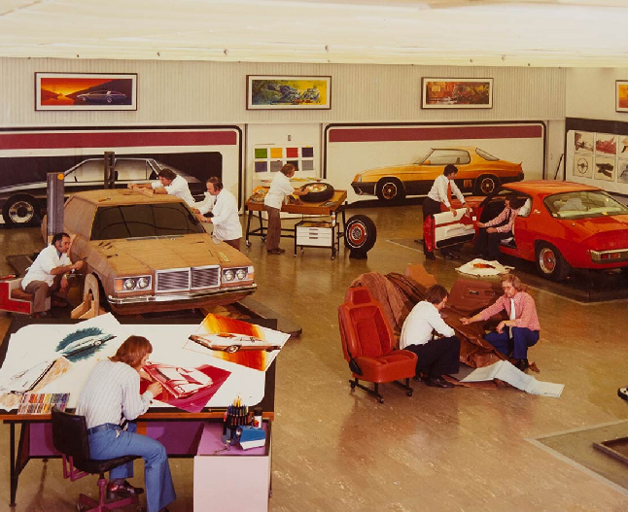
Image 17: The General Motors Holden Technical Centre, an extension to engineering Plant 3, 1960s, courtesy of RMIT Design Archives Collection

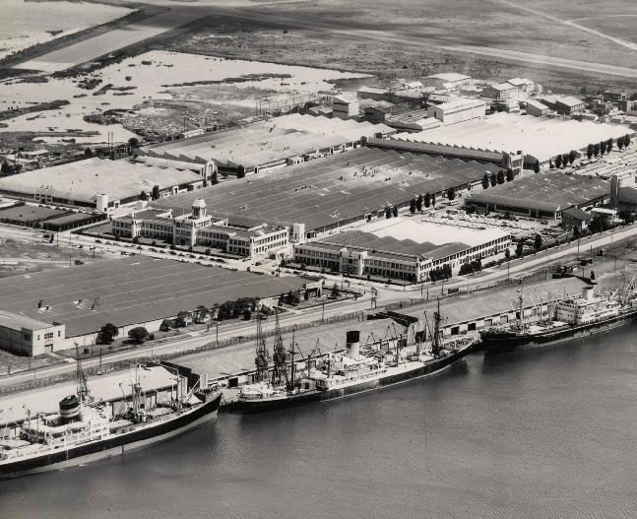
Image 18: Aerial view of Fishermans Bend and Port Melbourne looking south, with ships and General Motors Holden, 1950s, courtesy of the State Library Victoria

Image 19: Canberra Bomber at Government Aircraft Factory, around 1945, courtesy of the State Library Victoria

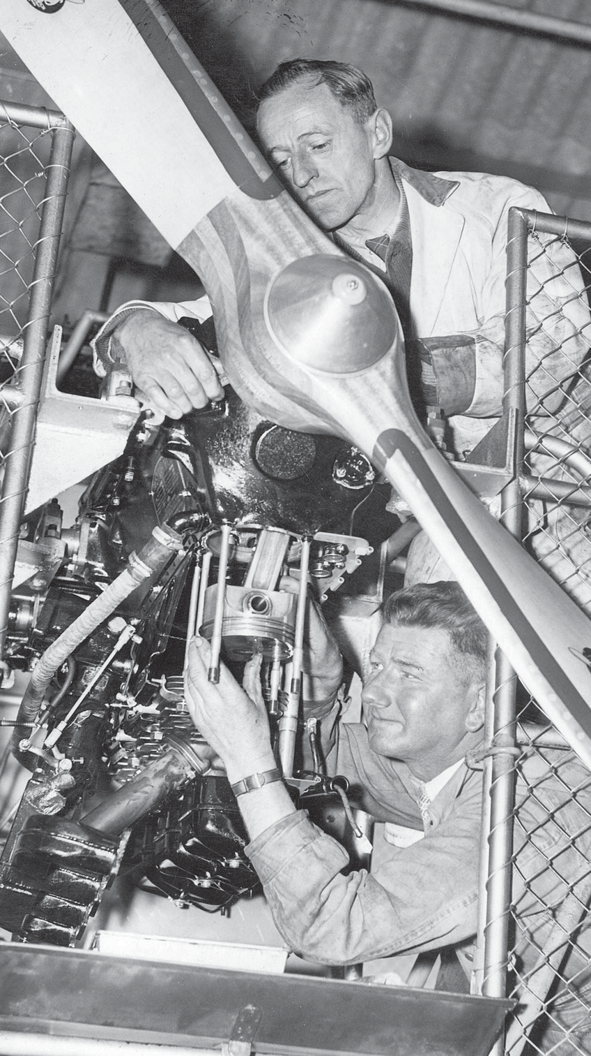
Image 20: First Australian made Gypsy Moth at the test bench at General Motors Holden, Fishermans Bend, around 1940, courtesy of the State Library Victoria

Sand, water, scrub and wildlife

Significance
The early landscape and ecological features, in particular the Birrarung (Yarra River), have significantly shaped Fishermans Bend’s place identity. The wetlands and sand hills of Fishermans Bend have long provided a rich habitat for birds, snakes and small mammals.
In the 1980s, Westgate Park was created on the site of a former sand quarry and remains one of Melbourne’s most biodiverse areas.

Policy and community engagement
Reflecting Fishermans Bend’s early landscape aligns with the Victorian Government’s Naming Rules ‘Principle C: Linking the name to place’. Celebrating Fishermans Bend’s natural
environment and connection to water was a key naming theme identified through community and stakeholder engagement. Native plants, wildlife, historical wetlands, Westgate Park, and future open spaces were especially valued by the community.
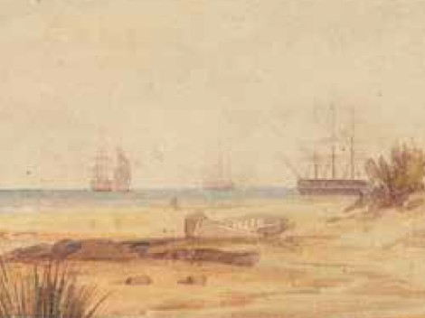
Image 21: Sandy landscape of Fishermans Bend as depicted in an 1853 painting by artist Edmund Thomas, courtesy of Context Pty Ltd.

Fishermans Bend’s flora and fauna
Before European settlement, the low-lying environs were mostly damp sands and herb-rich woodland, brackish wetlands, swamp scrub, reed swamp and coastal saltmarsh (Figure 8).
Westgate Park, once part of the lower Yarra wetlands, has had many uses, including sand extraction, an aerodrome and a car-racing track. In the 1970s, chair of the West Gate Bridge Authority, Oscar Meyer, developed the vision
for a ‘beautiful park straddling the Yarra River to complement his sculptural bridge’. His vision
was fulfilled in 1984, as Westgate Park formed as part of Victoria’s 150th anniversary celebrations. It was officially opened a year later. Westgate Park provides habitat to many bird species, including several species of honeyeaters and parrots, teals, wrens, dotterels, stilts, moorhens, and swans.
Example names connected to Fishermans Bend’s natural environment include:
- Salt grass: salt grass is a vegetation type that was abundant in Fishermans Bend in the 1800s. The plant continues grow in Westgate Park.
- River red gum: river red gums grew in the river flats of Fishermans Bend in the 1800s.
- Tea tree: tea trees were prolific on the edge of the Birrarung riverbanks in Fishermans Bend in the 1800s.
- Wild fowl: Fishermans Bend was a haven for wild fowl in the 1800s.
- Parrot: The orange bellied parrot was first seen in the area known as Westgate Park in 1949.
- Humbug: The term ‘Fishermans Bend’ is thought to derive from the former sharp bend in the Birrarung (Yarra River). It is believed to be the same spot that was historically referred to as humbug reach.
Significant sites identified through desktop research and community engagement relating to Fishermans Bend’s natural environment are identified in Figure 8.

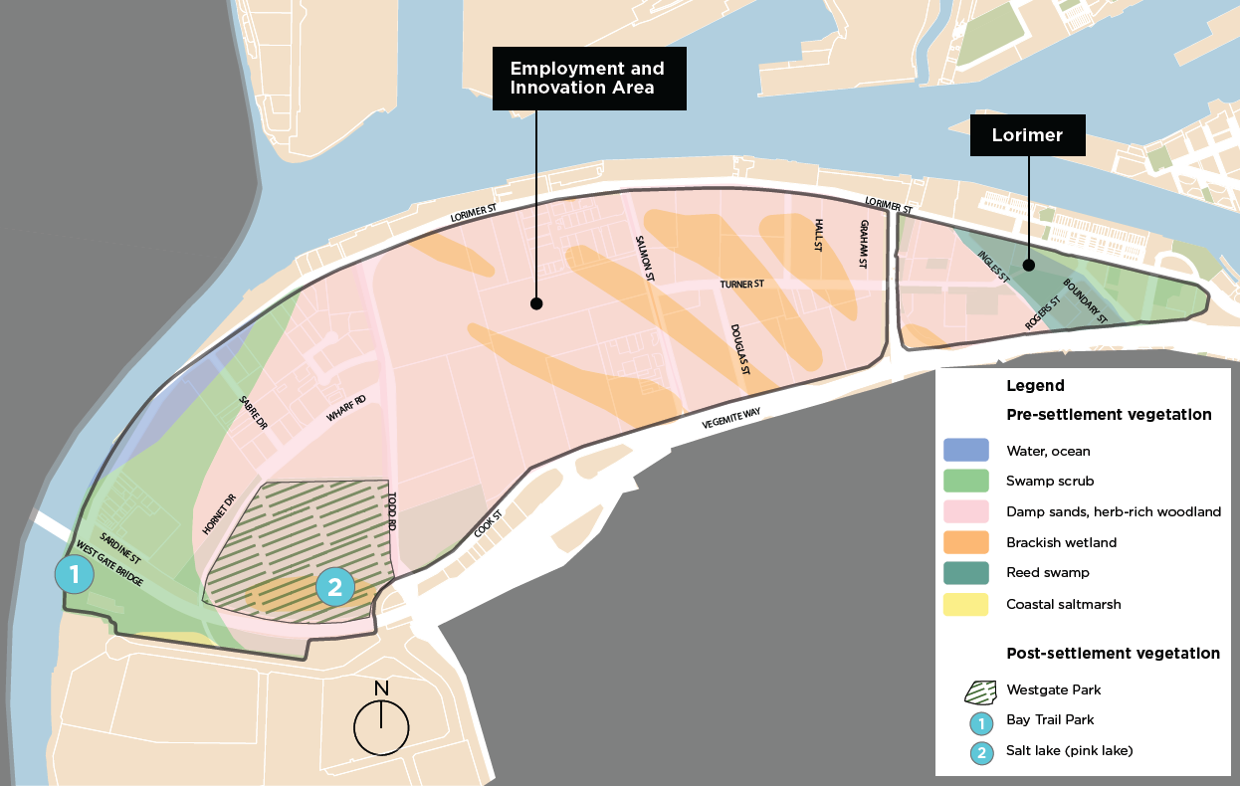
Figure 8: Fishermans Bend’s natural environment sites

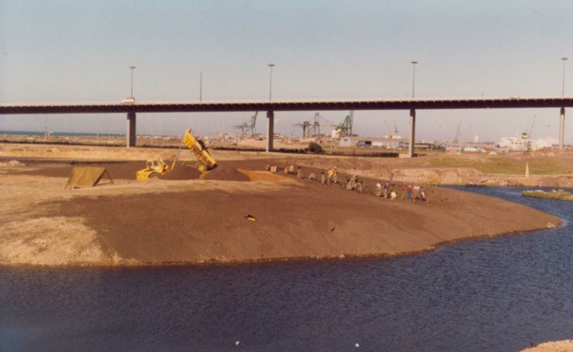
Image 22: Creation of Westgate Park in the 1980s, courtesy of Westgate Biodiversity Bili Nursery & Landscape

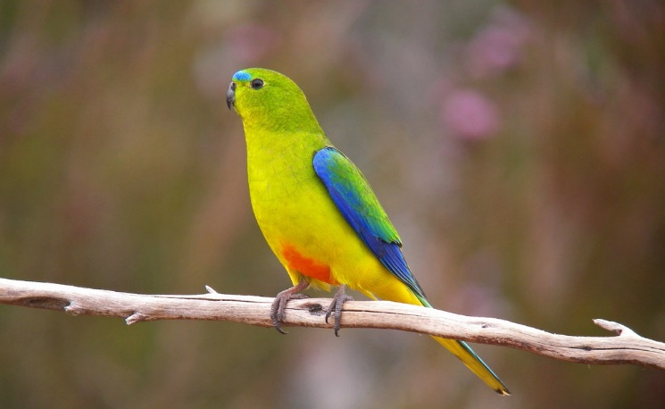
Image 23: Orange bellied parrot, known to be seen in Fishermans Bend, courtesy of Currumbin Sanctuary

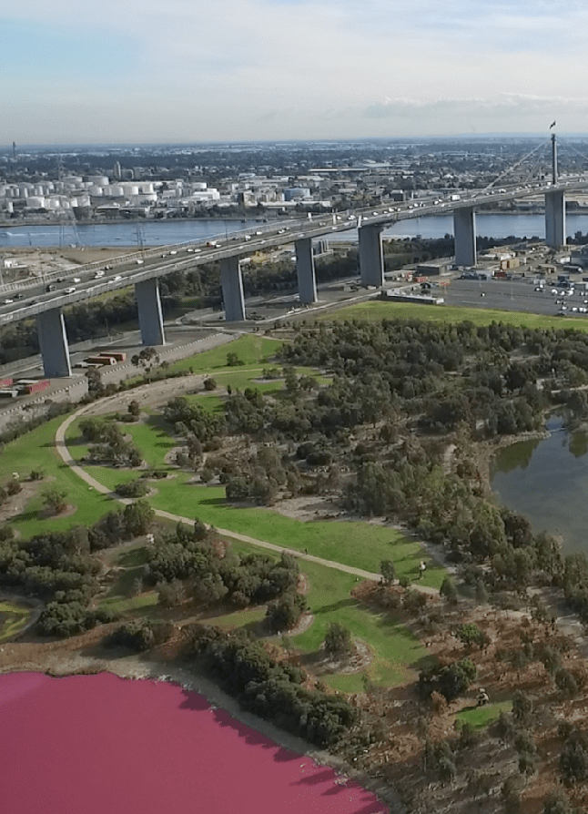
Image 24: West Gate Bridge and Westgate Park with pink algae in bloom, courtesy of Parks Victoria

Naming theme overlap

Many of the naming themes set out for Fishermans Bend will overlap, as the many histories of the area are interwoven. Most likely, future place names will relate to more than one naming theme. This is an opportunity to draw upon more place significant names. Examples of overlapping naming themes include:
- Women who shaped the early science, defence, aviation and automotive industries of Fishermans Bend, particularly during World War II.
- Prominent women from diverse backgrounds who shaped the local community. This could be through involvement in areas such as the Fishermans Bend Migrant Hostel, leadership in advocacy or political groups, sporting talent or the restoration of Westgate Park.
- Engaging Registered Aboriginal Parties to consider overlapping naming themes in their naming process (further detail provided in Part C: Application of Naming Framework: how to engage with Registered Aboriginal Parties).
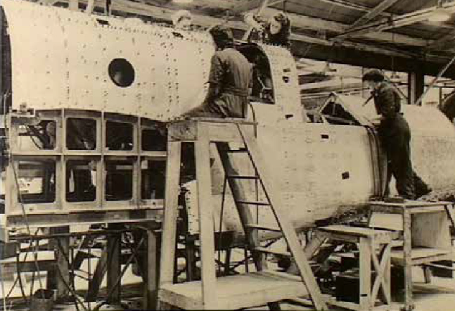
Image 25: Women workers at the Commonwealth Aircraft Factory during World War II, courtesy of Context Pty Ltd

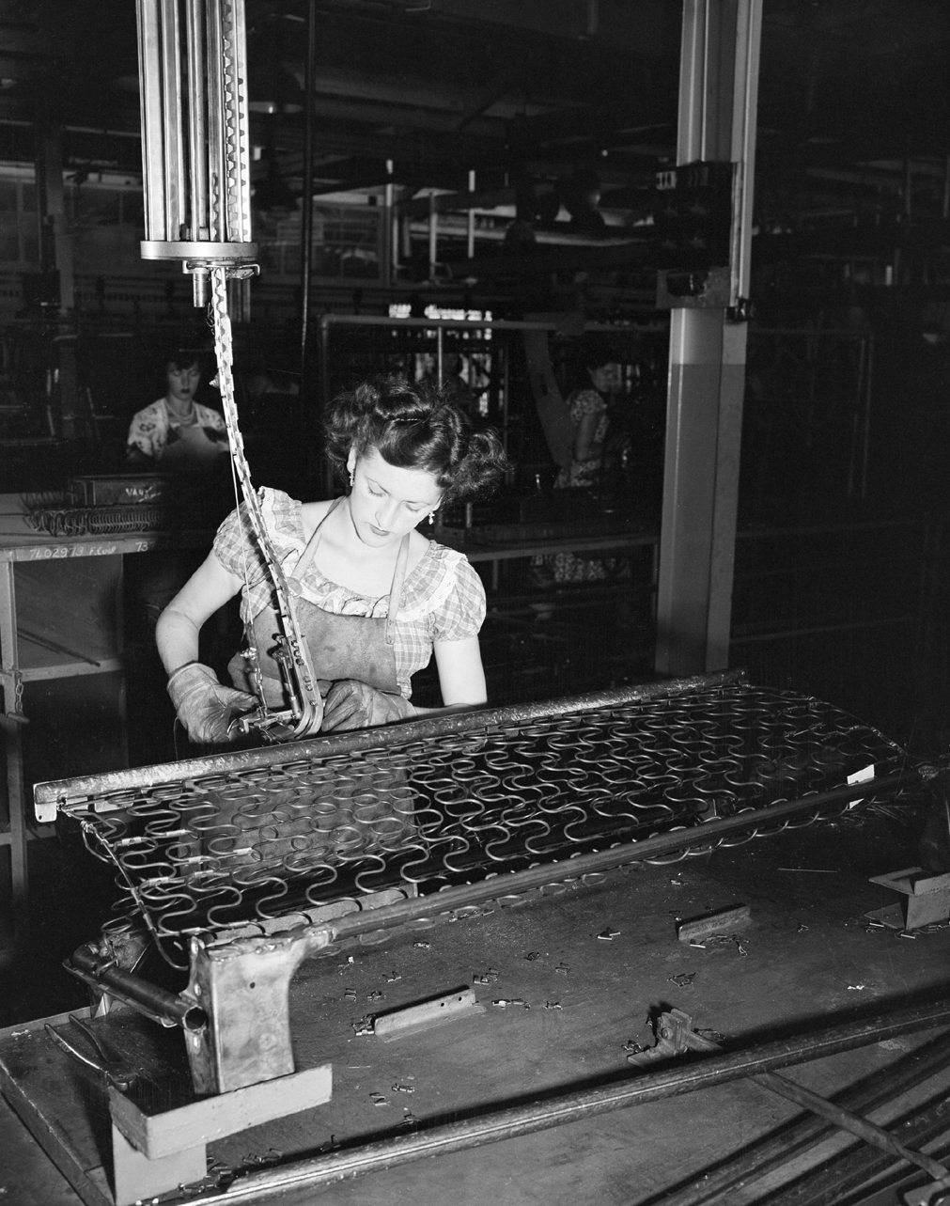
Image 26: Eileen ‘Eliza’ Robertson’s murals in the General Motors Holden Social Centre, painted for the launch of the FX Holden attended by Prime Minister Chifley, 1948, courtesy of the Port Melbourne Historical and Preservation Society.
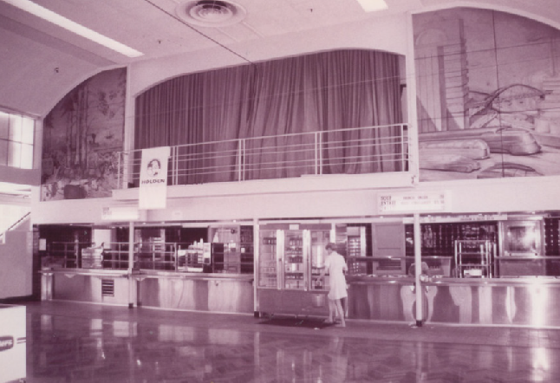
Image 27: Woman working on car seat springs, General Motors Holden Fishermans Bend, 1953, courtesy of the National Archives of Australia


Image 28: Modellers producing a 1/8” scale model of a proposed Holden car at the Fishermans Bend General Motors Holden engineering studio, around 1946, courtesy of the N Darwin Collection

Part C: application of naming framework

Two-step approach
Follow these two steps when identifying a name or multiple names for new roads and features in Fishermans Bend.

Step 1: Spatial context
Step one involves identifying precinct naming themes and significant sites within the EIA and Lorimer precincts (page 35-37).
A new road, park or public building within or near a precinct naming theme or significant site should draw upon this significance in the selection of a place name.

Step 2: Place type
Step two involves prioritising naming themes based on the prominence of a place type (Figure 9).
Place types referenced in this Naming Framework include major roads, minor roads, major parks, minor parks and Council buildings and other public places. Appendix A provides place type descriptions.
The two-step approach ensures:
- names link to relevant spatial context
- the naming of prominent places are aligned with the priority municipal naming themes
- the importance of connection to Country and commemorating influential women in future urban form through the naming of prominent places
- minor roads and features, which will form a sizeable proportion of all future development, will have a larger choice of names through the inclusion of both precinct naming themes and priority municipal naming themes.
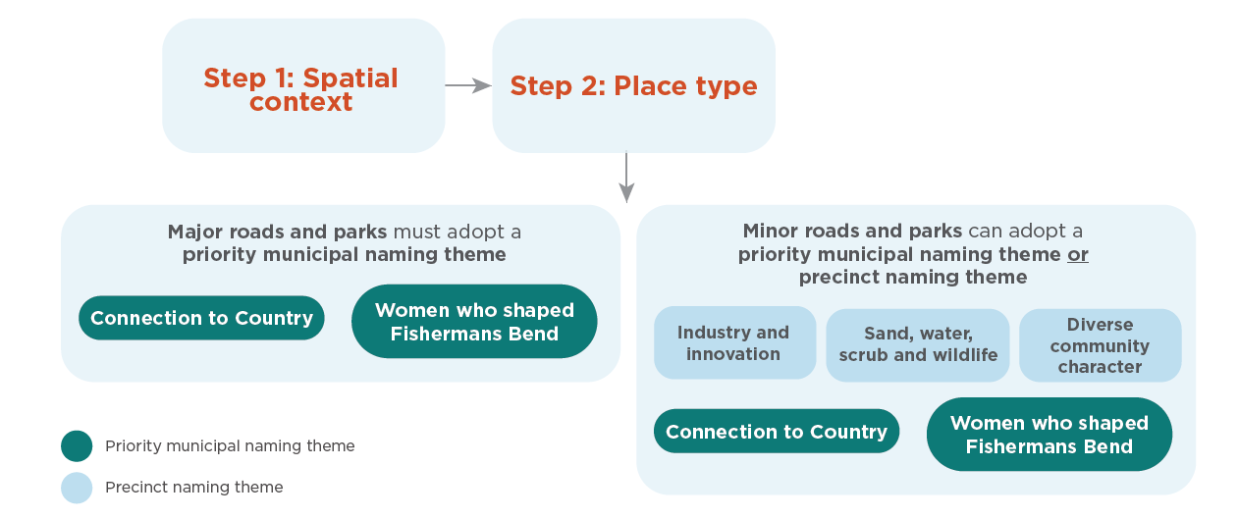Figure 9: Two-step Naming Framework application approach
Application examples
Two examples of how the Naming Framework could be applied are provided in Figure 10 and identified spatially on page 35-37.
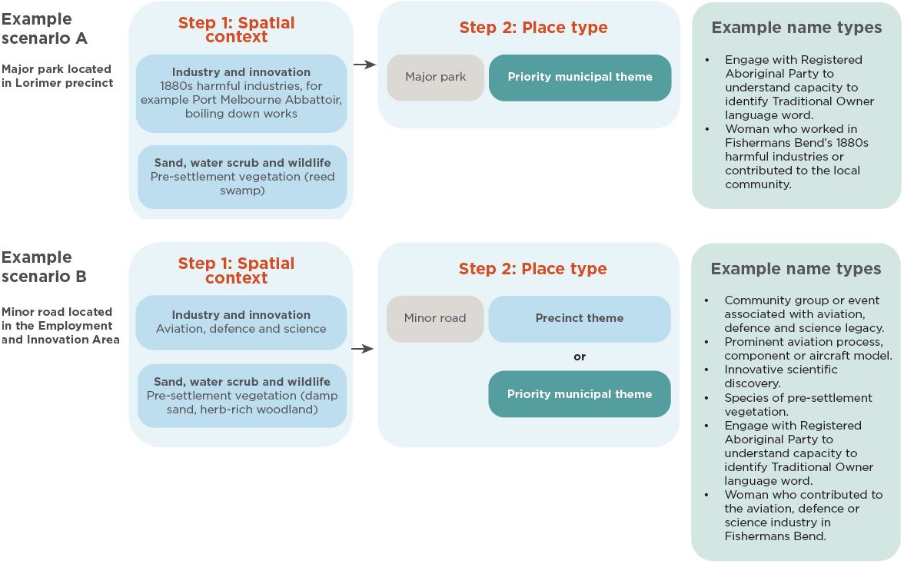Figure 10: Examples outlining how to apply the Naming Framework
Wayfinding and learning opportunities
A wayfinding strategy helps to create a legible environment that supports people to easily find their way through a place.
If a naming request involves multiple new roads or features, it is encouraged that a wayfinding strategy is prepared to show how new names relate through shared meaning or connection to the site.
This will help to enhance place experience as people move through the area. For example, a new development could comprise street names associated with the same historical site. Once place names are endorsed, they should be supported by additional information to educate the community on the name’s meaning, where appropriate. This was flagged as an important aspect of place naming during community and stakeholder engagement.
Opportunities for learning could be provided through sub-text on a street sign, an informative plaque, or public art.

Overview of Spatial Context Maps
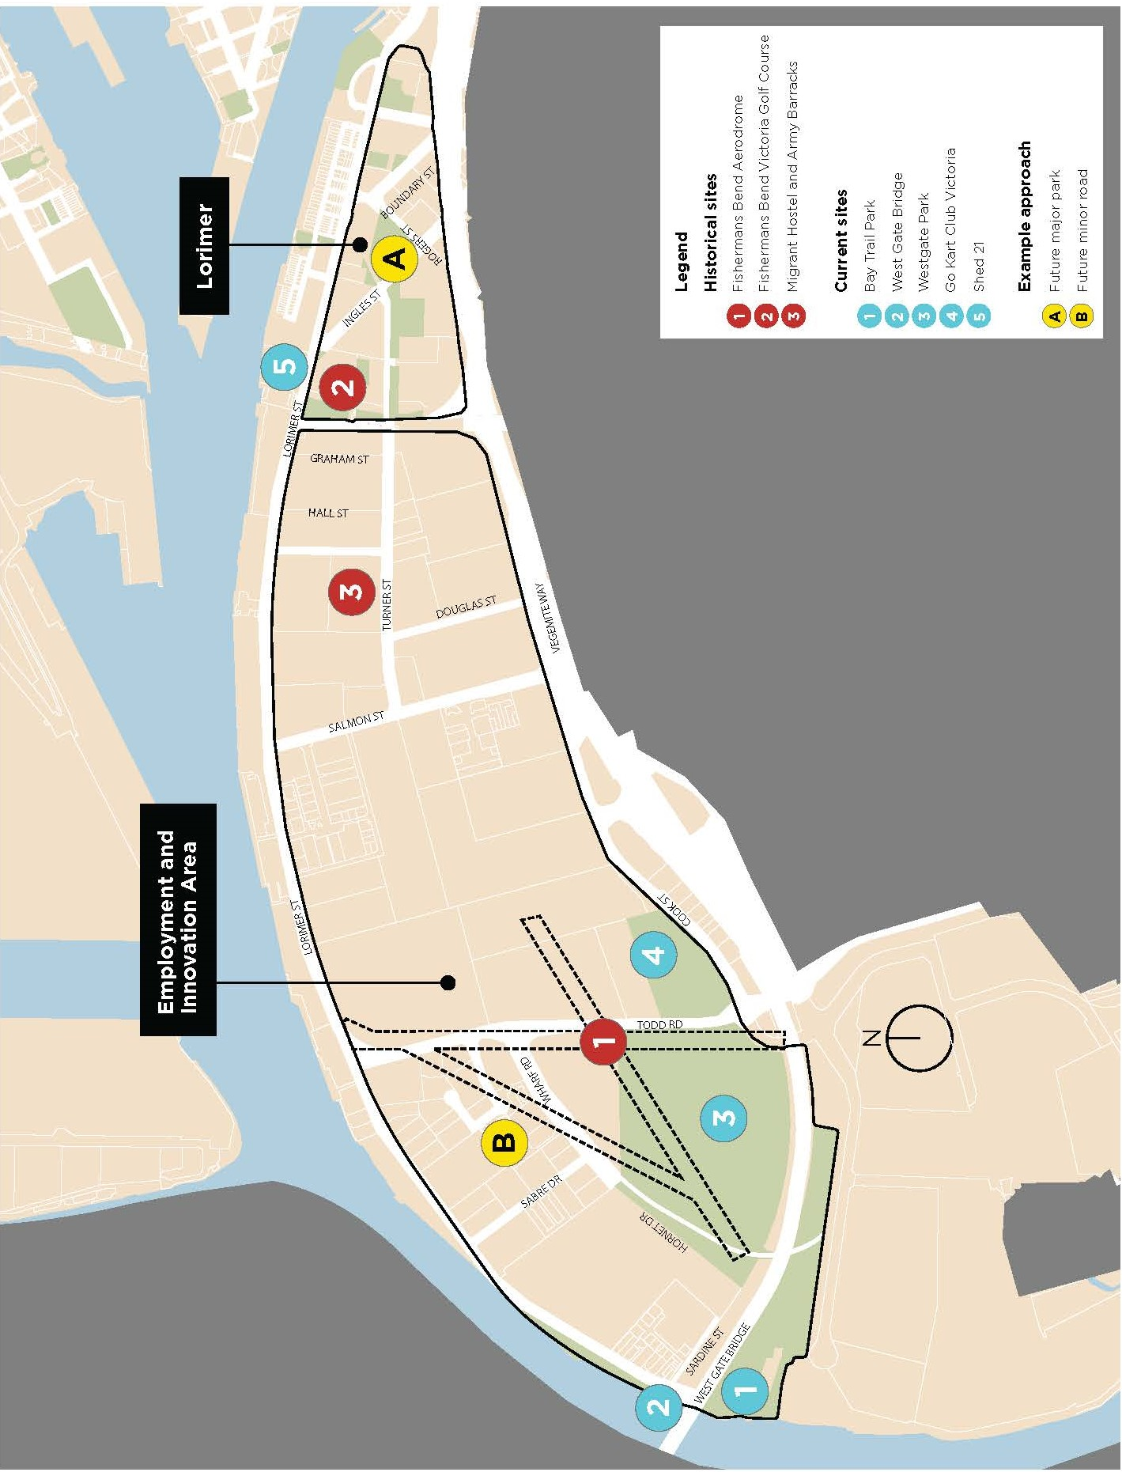
- Figure 11: Diverse community character map

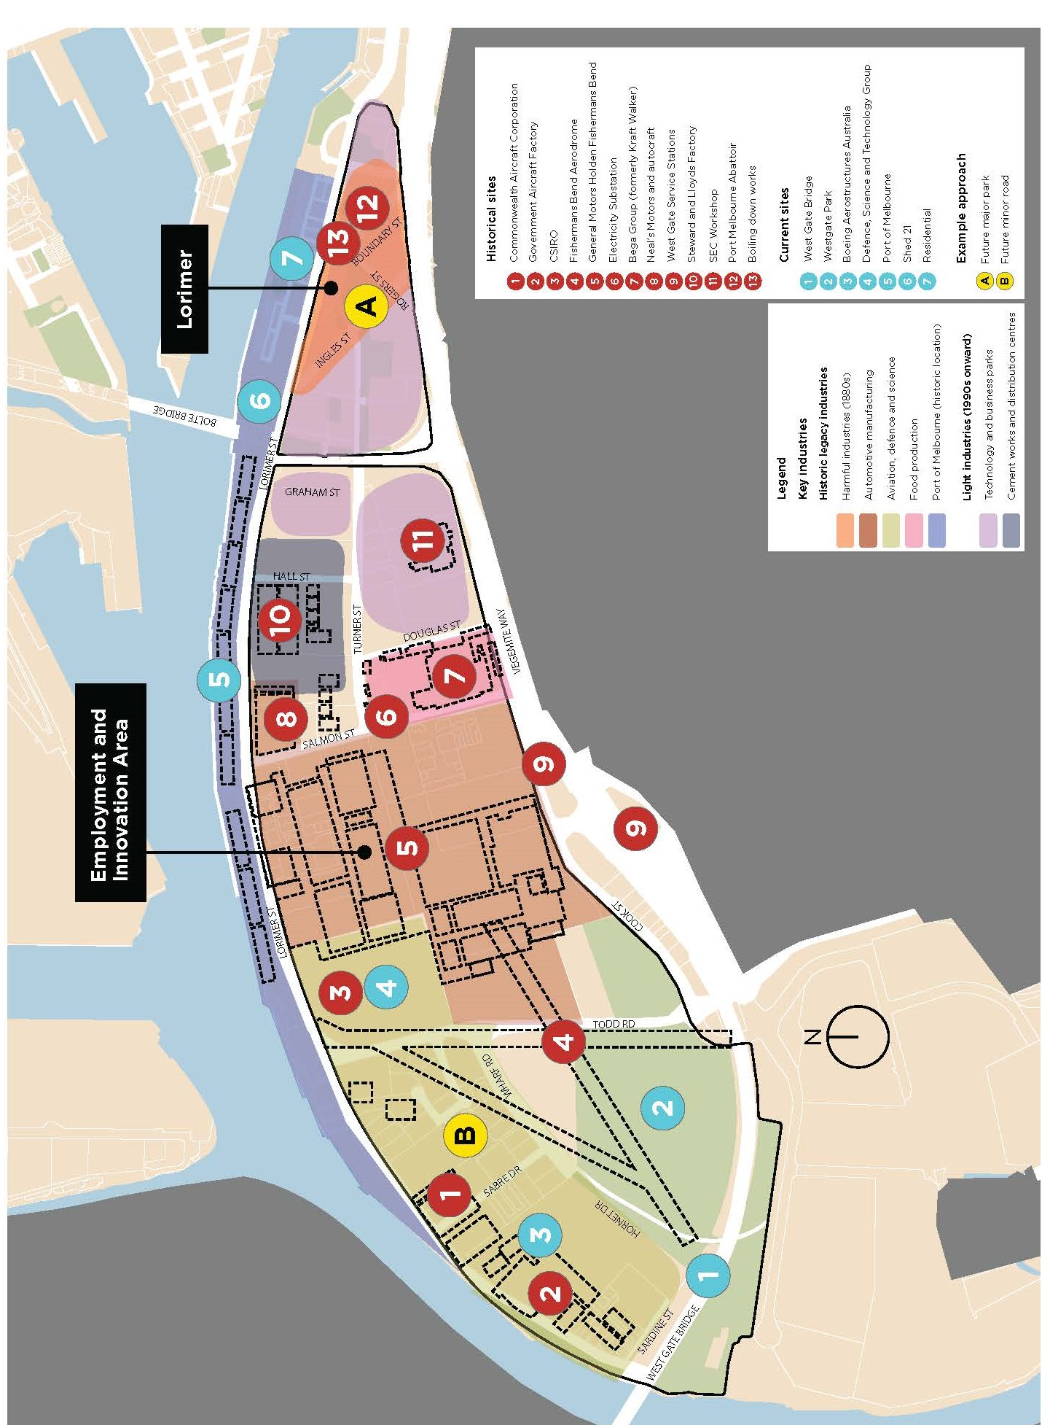
- Figure 12: Industry and innovation map

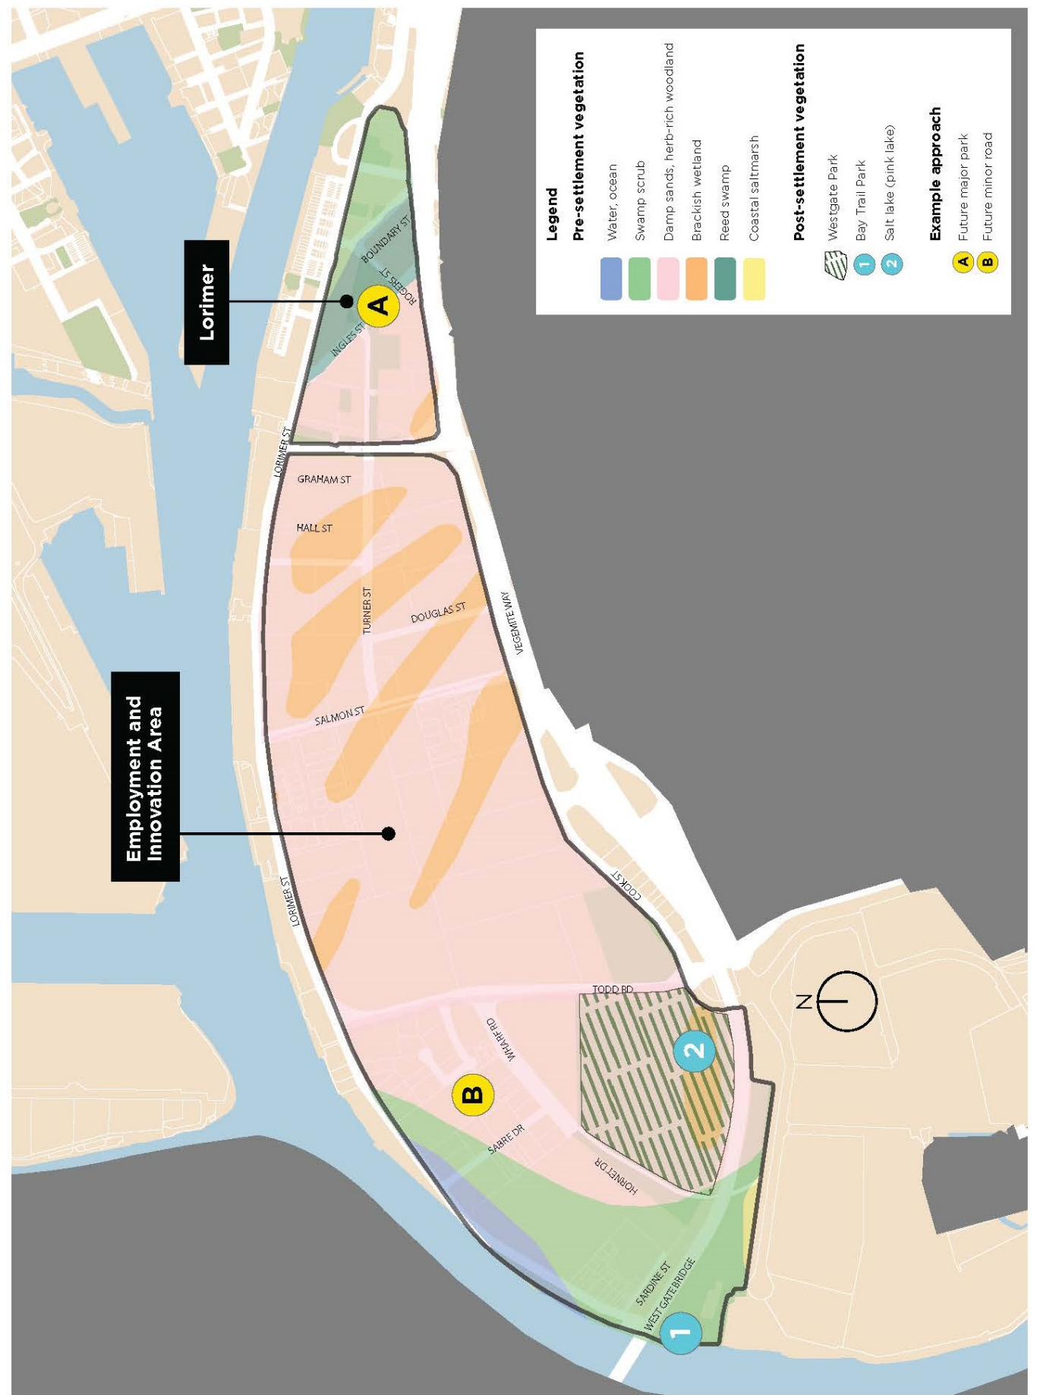
Figure 13: Sand, water, scrub and wildlife map

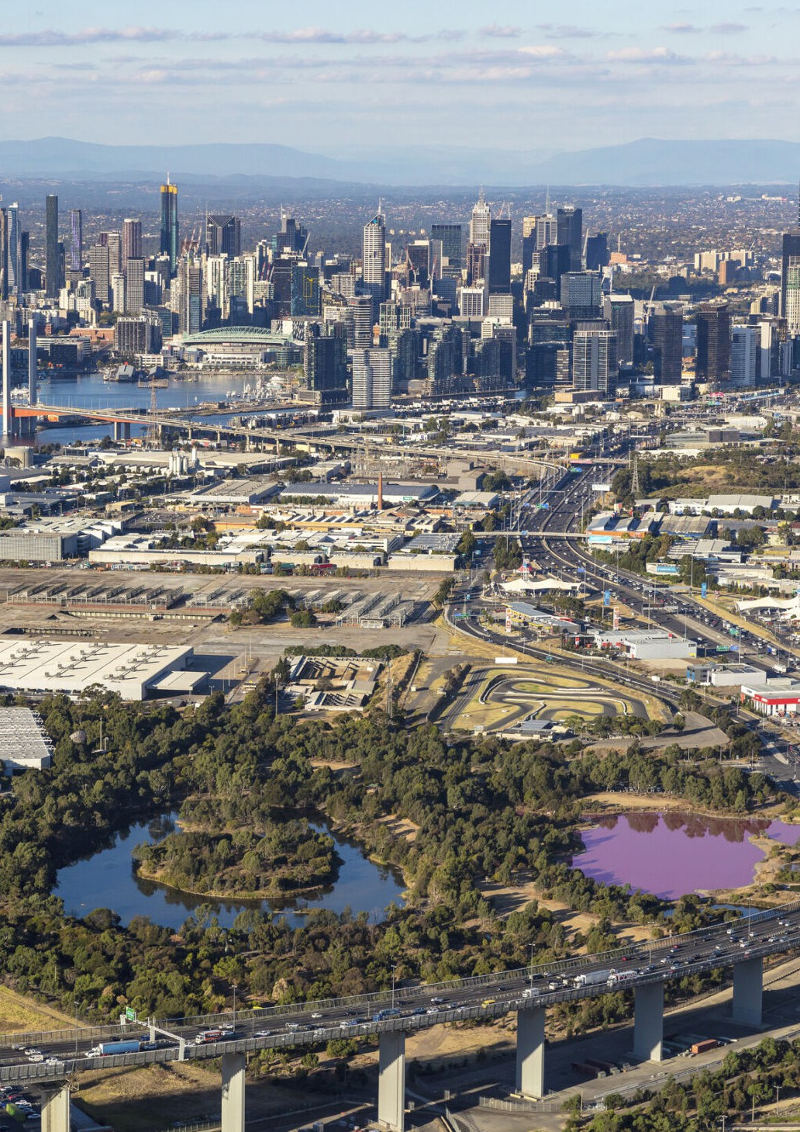
Image 29: Aerial of Fishermans Bend, Courtesy of the Victorian Government

Place naming approval process

Standard approval process
The City of Melbourne is the naming authority for roads and features such as parks, community buildings and public spaces within the municipality. The organisation receives naming requests as part of applications for subdivision or development approval, as well as ad-hoc requests.
Shown in Figure 14, standard naming approval involves a sequential process with input from the applicant, City of Melbourne (the responsible naming authority) and Geographic Names Victoria (the agency responsible for the registration of names across Victoria).
The Naming Framework supports this process by providing naming themes, spatial maps identifying significant sites and additional resources to reduce the onus on applicants to undertake research for individual naming requests.
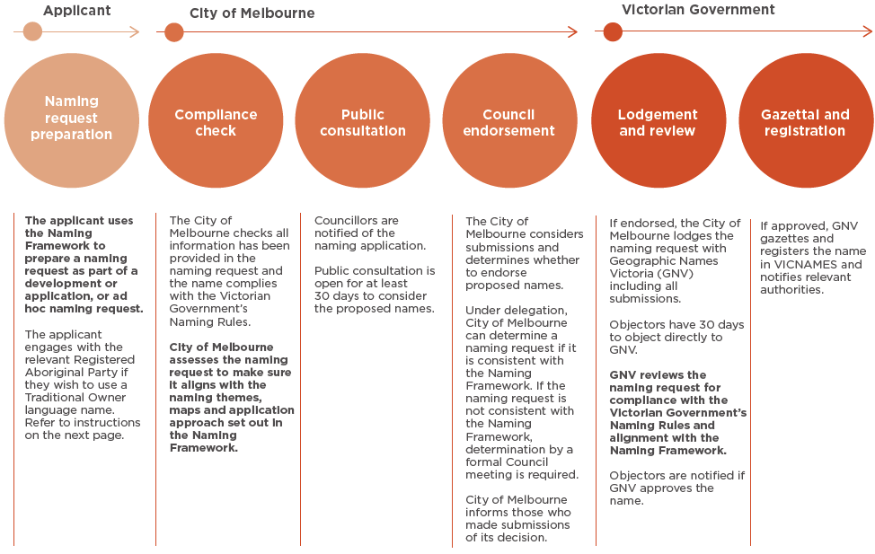
Figure 14: Standard name approval process

How to engage with Registered Aboriginal Parties
Bunurong Land Council Aboriginal Corporation
The use of Boonwurrung language in place naming requires engagement with the Bunurong community. This is done through the Bunurong Land Council Aboriginal Corporation (BLCAC), the Registered Aboriginal Party for Bunurong people.
To begin a language request, contact the BLCAC linguist via email at linguist@bunuronglc.org.au. The process to identify appropriate names generally involves:
- BLCAC to organise a project inception meeting to discuss the specifics of the naming project.
- The BLCAC linguist will engage directly with Bunurong community.
- BLCAC will carry out an extensive research process to determine a Boonwurrung name for a place including finding the word/s in as many archival records of Boonwurrung (and related languages) as possible; analysing the word to reconstruct its pronunciation and meaning, and writing the word in a standardised spelling; getting the word peer reviewed by a team of experts to ensure accuracy; and confirming the word with Bunurong Elders and Knowledge Holders.
This process takes about a month, depending on the scope of the project. More information about language work with BLCAC can be found at Bunurong Land Council, or by emailing linguist@bunuronglc.org.au directly.
Wurundjeri Woi-wurrung Cultural Heritage Aboriginal Corporation
The use of Woi-wurrung language in place naming requires engagement with the Wurundjeri community. This is done through the Wurundjeri Woi-wurrung Cultural Heritage Aboriginal Corporation (WWCHAC), the Registered Aboriginal Party for Wurundjeri Woi- wurrung people.
To begin a naming and language enquiry, email culturalconsultations@wurundjeri.com.au.
More information can be found at wurundjeri.com.au.

Appendices

Appendix A
Place type descriptions
Key place types referenced in this Naming Framework include major roads, minor roads, major parks, minor parks and Council buildings and other public places. Descriptions for these are summarised below.
Categories of roads have been informed by City of Melbourne’s road classifications, which reflect the Vicmap Transport Road Classifications.
Categories of open spaces have been informed by the City of Melbourne’s Open Space Strategy (Light Touch Review 2024).

Major roads
Major roads act as principal avenues for traffic movements and provide ‘through access’ to multiple properties or public land. Examples include arterial roads, sub-arterial roads, and collector roads.

Minor roads
Minor roads service a smaller number of properties or public land. Examples include dead-end roads, laneways, or service roads.



Major open spaces
Major open spaces include capital city open space, state open space, regional open space and municipal open space.

Minor open spaces
Minor open spaces consist of neighbourhood open space, local open space, small open space and small local link open space.

Public places
Public places include prominent structures and facilities such as community, arts, health and sport and recreation hubs.

Appendix B
Informing the Naming Framework

The Naming Framework has been informed by desktop research and community and stakeholder engagement including Traditional Owner engagement.
Research and stakeholder engagement
Place naming themes and principles within the Naming Framework are informed by:
- a review of documents relating to the social, cultural and environmental heritage of Fishermans Bend
- extensive community and stakeholder engagement.
- Phase 1 community and stakeholder engagement was held from August to October 2023 and encouraged the sharing of unique connections and memories of Fishermans Bend. Engagement activities included:
- Focus group conversations with
- 20 stakeholders from groups including the Port Melbourne Historical and Preservation Society, former employees of General Motors Holden and employees of Defence, Science and Technology Group and Boeing Aerostructures Australia.
- Interactive workshops with 20 employees from local businesses, community members and Port Melbourne Secondary College students.
- An interactive pop-up stall in the EIA, attended by 35 community members (Figure 15).
- An online survey (receiving 65 responses) and an interactive map available on Participate Melbourne (receiving
- 16 contributions).
Further details and insights on Phase 1 community and stakeholder engagement can be found at Participate Melbourne.

Phase 2 community and stakeholder engagement will seek feedback on the draft Naming Framework (this document) to inform the final Naming Framework to be endorsed by Council.
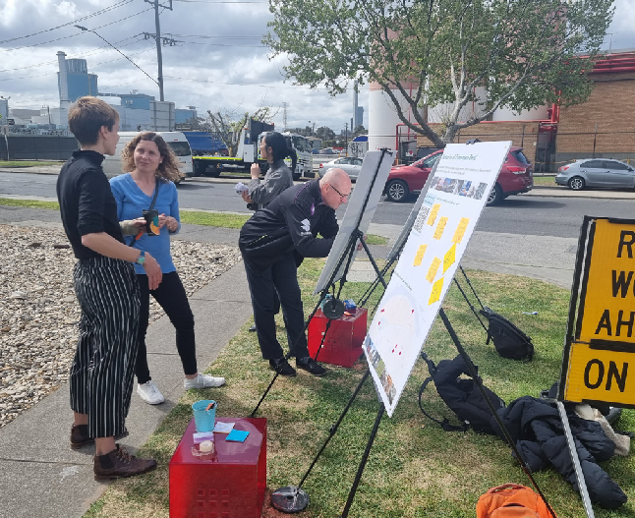
Image 30: Interactive pop-up stall as part of community and stakeholder engagement
Traditional Owner engagement
Fishermans Bend is located on the areas overseen by two Registered Aboriginal Parties: Bunurong Land Council Aboriginal Corporation and the Wurundjeri Woi-Wurrung Cultural Heritage Aboriginal Corporation. Both parties have been engaged throughout the development of the Naming Framework. This process involved multiple meetings in-person and online.

Appendix C
Fishermans Bend and place naming resources
History of Fishermans Bend (web)
- Port Melbourne Historical and Preservation Society
- Port Places Blog
- General Motors Holden Retirees Club Archives
- Fishermans Bend Social History, Victorian Government
- Life on the Bend: A social history of Fishermans Bend, Melbourne, 2017, Context Pty Ltd (9.73MB)
- Southbank and Fishermans Bend Heritage Review, 2017, Biosis (4.76MB)
- Fishermans Bend Heritage Study, 2013, Biosis (8.53MB)
- Fishermans Bend In-Depth Heritage Review and Stakeholder Engagement, 2021, HLCD Pty Ltd (15.6MB)
- History of Fishermans Bend (print)
- Women of Port Melbourne: Guide to the Exhibition, Port Melbourne Historical and Preservation Society 17 October 2005
- Fisher Folk of Fishermans Bend, Allan Meiers, Port Melbourne Historical and Preservation Society, 2006
- The Borough and Its People, Margaret & Graham Bride, Port Melbourne Historical and Preservation Society, 2013
- Making it Here – Four Enterprising Immigrant Engineers and the Evolution of Manufacturing in Port Melbourne, David F Radcliffe, 2024
- The Yarra, A Natural Treasure, Beardsell and Beardsell, 1999
- Strategic and legislative documents
- The Naming rules for places in Victoria, 2022 Victorian Government
- City of Melbourne standard naming process, 2024, City of Melbourne
- The Fishermans Bend Framework, 2018, Victorian Government
- Advancing Manufacturing – the Fishermans Bend opportunity, Victorian Government
- Image credits for Figure 3 (Snapshot of Fishermans Bend’s post-European settlement)
- Early 1880s: early wetlands, image courtesy of Context Pty Ltd
- 1830s and 40s: European settlement illustration, image courtesy of Context Pty Ltd
- 1887: widening of Coode Canal, image courtesy of Context Pty Ltd
- 1918: prolific birdlife including English skylarks, image couresy of National Audubon Society
- 1936 to 1939: establishment of automotive and aviation manufacturing industries, image courtesy of Rohan Russell
- 1946: establishment of Kraft Walker, image courtesy of the State Library Victoria
- 1950s: the Fishermans Bend Migrant Hostel, image courtesy of Facebook photo contributed by P McDade
- 1968–78: the West Gate Bridge, image courtesy of Context Pty Ltd
- 1980: Westgate Park is created, image courtesy of Parks Victoria
- 1990: Fishermans Bend becomes a light industrial precinct, image courtesy of the Victorian Government
- 2013: Fishermans Bend is rezoned as an extension of the capital city, image courtesy of the Victorian Government
- 2018: Fishermans Bend Framework, image courtesy of the Victorian Government
- 2021: Advanced Manufacturing - the Fishermans Bend opportunity, image courtesy of the Victorian Government
- Image credits for Figure 4 (Existing road names in Fishermans Bend)
- GAF Nomad aircraft, image courtesy of Wikipedia
- CAC Wirraway aircraft, image courtesy of the State Library Victoria
- Sir James Lorimer, image courtesy of the Parliament of Victoria
- Mayor Phillip Salmon, image courtesy of the Port Melbourne Historical and Preservation Society
- Les Turner, image courtesy of the Port Melbourne Historical and Preservation Society
- Premier Sir Henry Bolte, image courtesy of The Age Archives
- Charles Ingles, image courtesy of the Port Melbourne Historical and Preservation Society
- Former Kraft factory, image courtesy of the State Library Victoria
- Mayor Archibald Todd, image courtesy of the Port Melbourne Historical and Preservation Society

How to contact us

Online:
melbourne.vic.gov.au

In person:
Melbourne Town Hall – Administration Building
120 Swanston Street, Melbourne
Business hours, Monday to Friday
(Public holidays excluded)

Telephone:
03 9658 9658
Business hours, Monday to Friday
(Public holidays excluded)

Fax:
03 9654 4854

In writing:
City of Melbourne
GPO Box 1503
Melbourne VIC 3001
Australia

Interpreter services
We cater for people of all backgrounds
Please call 03 9280 0726

National Relay Service:
If you are deaf, hearing impaired or speech-impaired, call us via the National Relay Service: Teletypewriter (TTY) user phone 1300 555 727 then ask for 03 9658 9658 9am to 5pm, Monday to Friday (Public holidays excluded)

participate.melbourne.vic.gov.au
participate.melbourne.vic.gov.au/fishermans-bend-place-naming
pmhps.org.au
portplaces.com
hrc.au
https://www.vic.gov.au/social-history
https://www.vic.gov.au/sites/default/files/2024-12/Life-on-the-bend-a-social-history-study-of-Fishermans-Bend%2C-Melbourne.pdf
https://hdp-au-prod-app-com-participate-files.s3.ap-southeast-2.amazonaws.com/1115/0646/9918/Participate_Melbourne_C305_Part_1_-_History_of_Southbank_and_Fishermans_Bend.pdf
https://www.portphillip.vic.gov.au/media/gbpcyiw1/fishermans-bend-heritage-study-apr-2013.pdf
https://hdp-au-prod-app-com-participate-files.s3.ap-southeast-2.amazonaws.com/3516/2209/0924/Fishermans_Bend_In-Depth_Heritage_Review_-_Heritage_Study.pdf
land.vic.gov.au/place-naming/understand-the-naming-process/the-naming-rules
participate.melbourne.vic.gov.au/place-and-road-naming/naming-process
https://www.vic.gov.au/fishermans-bend-framework
https://www.vic.gov.au/advancing-manufacturing-fishermans-bend-opportunity
oldsmobileinaustralia.info

