
Docklands Community Resilience Report
City of Melbourne
October 2023

Contents
Summary 3
2. Context 4
2.1. Major Initiative 52 – Prepare Melbourne 4
2.2. Disasters 4
2.3. Resilience 4
2.4. A focus on community resilience 5
2.5. Docklands 5
3. Community Resilience Assessments 6
3.1 Purpose and objectives 6
3.2 What we presented to the group 6
What we heard in previous resilience workshops 6
Showcasing resource – Heat Safe Collateral and Heat Health Kits 7
3.3 What we heard 7
Resilience 7
Vulnerabilities and strengths 8
Inclusive information and engagement 8
Community connection 9
Community safety and wellbeing 10
3.4 Idea prioritisation 11
3.5 Heat Collateral 11
Heat Safe Brochure 11
Heat Health Kits 11
3.6 Before and After 11
Before 12
After 12
Feedback 12
3.7 Next Steps 13
Appendices 14

Summary
In 2019, City of Melbourne declared a climate and biodiversity emergency,
which recognises the serious risks that climate change poses to human health and our lifestyles. This recognition is reflected in the Council Plan 2021-25 as one of the six strategic objectives and in the Major Initiative 52, which focuses on building community disaster resilience.
The characteristics, geographies and communities of each neighbourhood across the municipality are unique and diverse. This means a localised approach to building resilience is important.
In October 2023, the City of Melbourne City Resilience & Sustainable Futures, Community Development and Wellbeing team undertook a Community Resilience workshop in Docklands.
This workshop sought to understand the experiences of people living in Docklands, and where they see the major vulnerabilities, strengths, and opportunities to build better resilience to future shocks and stresses.
A newly created Heat Safe Brochure and Heat Health Kits were showcased and participants provided feedback for them to better support the community.
Community members then identified actions that could be taken and prioritised to improve disaster resilience and preparedness in their neighbourhoods across four themes:
- Inclusive information and engagement
- Accessible urban environment
- Community connection
- Safety and wellbeing.
Many ideas emerged from the very engaged Docklands workshop participants. High rises constitute great opportunities for coordinated and efficient communication and clear protocols, through emergency services and building managers. Residents highly value the Harbour and its unique characteristics and consider the Marvel stadium as a key potential asset for relief. Local community groups have community cohesion and safety at heart and want to see greater collaboration across council, corporates and community, to support the centralised access to services and information on disasters and wellbeing. These include human, physical and digital resources, made available at a local, council-staffed community hub.

2. Context

2.1. Major Initiative 52 – Prepare Melbourne
The City of Melbourne is delivering Major Initiative 52 under the Safety & Wellbeing objective in Council Plan 2021-2025. The purpose of this initiative is to 'engage and prepare residents and communities, and enhance their resilience to hazards, disasters and the health impacts of climate change'. It seeks to:
- Understand the current context of disaster likelihood, risk and preparedness.
- Build organisational capacity in disaster preparedness and risk management.
- Enable community preparedness and disaster resilience.

2.2. Disasters
"Disasters are expected to become more complex, more unpredictable, and more difficult to manage... with far-reaching consequences." (Royal Commission into National Natural Disaster Arrangements, 2020).
The term 'disaster' is used to describe the range of natural and human-influenced events that put us in potential danger and that require us to respond and do things differently.
'Disasters' encompasses climate disasters such as heatwaves, floods, fires and hurricanes, as well as more human-level events such as pandemics and acts of terror​.
Disaster risk is a function of hazard, exposure, vulnerability and capacity.

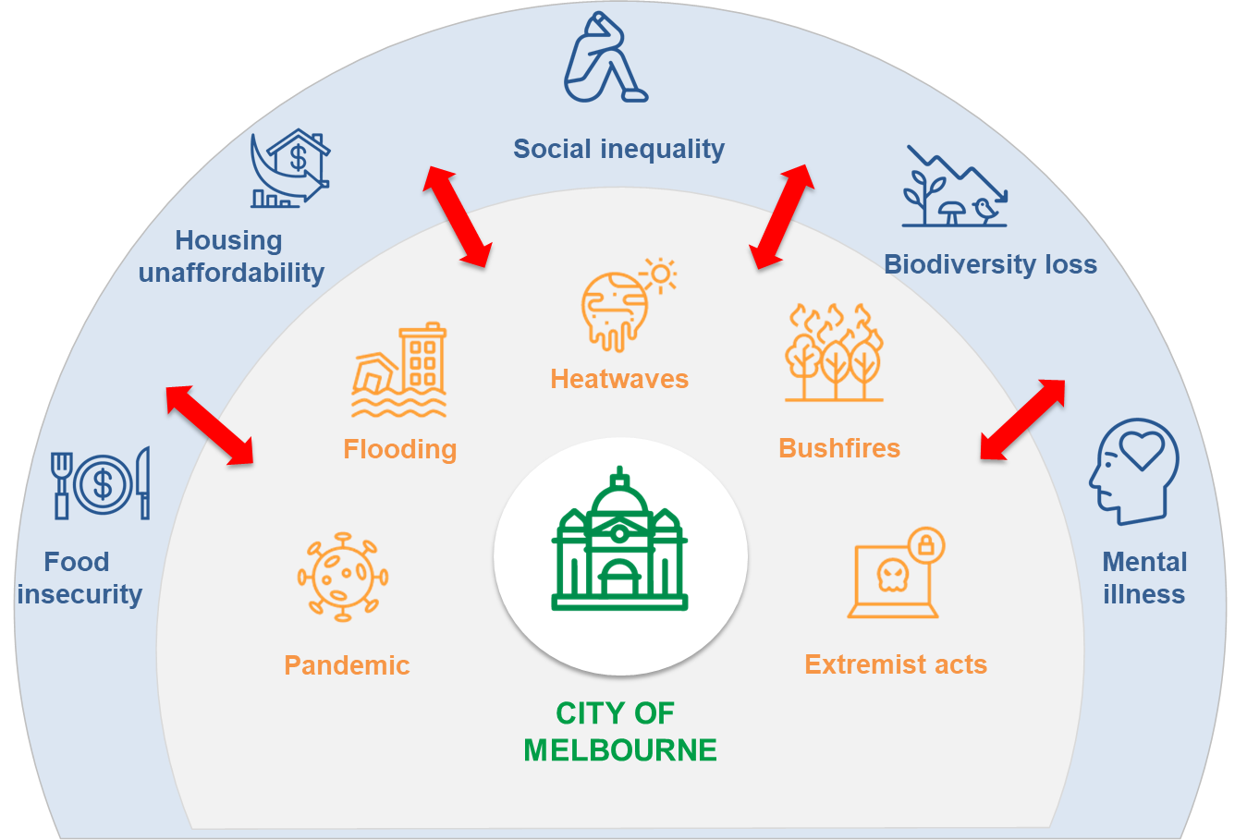

2.3. Resilience
Resilience is the capacity of individuals, communities, institutions, businesses and systems within a city to adapt, survive and thrive, and positively transform as a result.
Disasters are known to have disproportionate impacts on people facing physical, social, economic and environmental barriers. This includes the elderly, people with a disability, people experiencing homelessness, people living public housing and high-rise buildings, people with pre-existing health conditions When we talk about "resilience", we are talking about the capacity to adapt, survive and thrive, and positively transform in response to these sorts of challenges.
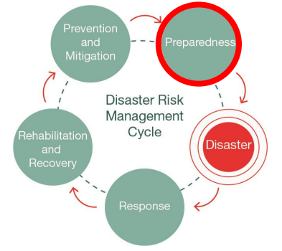
Resilient and prepared communities are more likely to withstand the negative impacts of natural disasters. Likewise, strong social capital correlates to a more effective recovery.

2.4. A focus on community resilience
All the research indicates that communities who are connected are more resilient because people are more likely to look out for the people around them. Our emergency services will not always have the capacity to help everyone during a disaster, and preparing for disasters cannot be the sole domain of government agencies if we are to become truly resilient. The emphasis on building capability within the community to adapt, survive and thrive in response to shocks and stresses, is critical in developing community resilience.
The Community Resilience Assessment approach is about looking at the unique experiences, needs and vulnerabilities of the people living in each of our neighbourhoods so we can determine where and how City of Melbourne and its partners can best support.

2.5. Docklands
Docklands, at the lower delta of the Yarra River Birrarung, was once a wetland rich with natural resources. After European settlement, industry increased and by 1908, Victoria Dock was handling around 90 per cent of Victoria’s imports. By the 1970s the dock and wharves were in decline, then lay derelict until urban renewal began in the 1990s.
When Docklands was absorbed into the City of Melbourne, it doubled the size of Melbourne's central city and returned a significant area of waterfront to the city.
The suburb now stretches out over 200 hectares of land and water. From the first development at New Quay, Docklands has evolved into a sophisticated waterfront precinct. Docklands offers a mix of inner city living, shopping at The District Docklands, commerce, connection to nature, entertainment, dining, sporting and community events, arts and culture.
This work is well aligned with Docklands’ community connection neighbourhood priority. In Docklands, 52 per cent of people have confidence in their neighbourhood pulling together during a disaster or an emergency, but only 35 per cent believe that they could receive help from a neighbour (Neighbourhood Plan survey data, 2022, 228 Docklands respondents).
For more information about Docklands, visit: Neighbourhood overview | Docklands Neighbourhood Portal | Participate Melbourne.

3. Community Resilience Assessments

3.1 Purpose and objectives
Purpose. To understand where and how the City of Melbourne and its partners can best support or enable community disaster resilience in Docklands.
Outcomes. This work seeks to:
- Explore and validate community needs, experiences and challenges around managing disasters for residents in the neighbourhoods
- Seek ideas from the community about how we might solve some existing challenges
- Identify priorities relevant to individuals, the community and service providers.
Workshops. The City Resilience & Sustainable Futures, Community Development and Wellbeing team ran a face to face workshop with the Docklands community on October 05, 2023. The workshop was designed to better understand the physical and social vulnerabilities and strengths to disasters in the neighbourhood, showcase resources under development, and building on these, generate ideas to support community resilience.
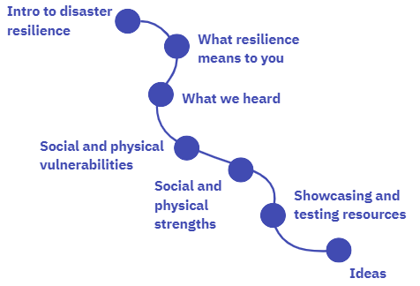
Participants. Sixteen Docklands residents attended the community workshop. Some participants had lived in the neighbourhood for many years, are actively involved in a range of volunteering activities and some were new residents, both owning and renting in the area.
Showcase focus. As part of our efforts to prepare our communities for heat events, newly created heat collateral and heat health kits were showcased and feedback was sought on how we could improve them.

3.2 What we presented to the group

What we heard in previous resilience workshops
We conducted resilience workshops in Southbank, Kensington and Carlton.
To feel prepared for a disaster, the community expressed four fundamental needs:
- I am safe
- I know where to go
- I know what to do
- I know who to connect with.
Community members told us they want to be safe and have information on how to stay safe and be prepared for a disaster. Overwhelmingly, community members seek opportunities to enhance their sense of community connection and wellbeing. Four themes emerged from the rich conversations:
- Inclusive information and engagement
- Accessible urban environment
- Community connection
- Safety and wellbeing.
Community members identified and prioritised actions to improve disaster resilience and preparedness in their neighbourhood. Across neighbourhoods, we heard two key priority ideas:
- Physical: a local, culturally inclusive, community hub
- Digital: a centralised and shared database of information.
For more information, visit: Community consultation | Community Resilience Assessment | Participate Melbourne.

Showcasing resource – Heat Safe Collateral and Heat Health Kits
The City of Melbourne is developing Heat Safe Collateral and Kits as part of our efforts to prepare our most vulnerable communities to hot weather events.
The aim of the Heat Safe Brochures is to provide advice and information to residents on staying safe and well during hot weather events. The brochure will include a map of cool places, information and tips on heat health safety, and a directory of resources to connect with for further information.
The aim of the Heat Health Kits is to provide practical resources to residents who live in homes which are not resilient to extreme heat, or those experiencing chronic homelessness or sleeping rough. The kit provides physical, low-cost cooling equipment, the cost of which is covered by a grant from Emergency Management Victoria.
For more information, visit: Heatwaves - City of Melbourne.

3.3 What we heard

Resilience
We facilitated an icebreaker where workshop attendees bought to mind a time when they felt resilient. These were some of the words used to describe resilience by the workshop participants.
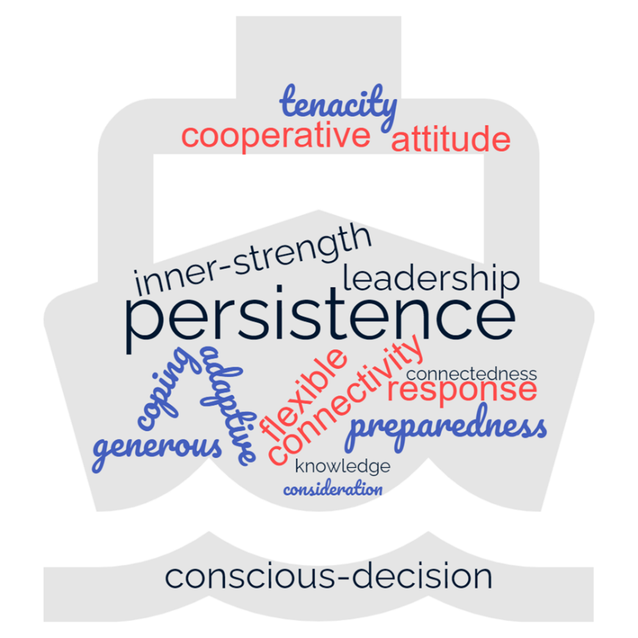

Vulnerabilities and strengths
We asked participants to identify some of the social and physical vulnerabilities in Docklands that may impact on the community’s ability to deal with a disaster. We used the four common themes described in the introduction to structure the outputs from these rich conversations. Building on vulnerabilities and strengths, the same themes were used to generate ideas to build community resilience:
- Inclusive information and engagement
- Accessible urban environment
- Community connection
- Safety and wellbeing.
Complete raw data is available in the Appendices. ​

Inclusive information and engagement
Docklands residents highlighted the need to disseminate information quickly to many people. High rises and their high density create opportunities for coordinated and efficient communication, through emergency services and building managers.
Collaboration between council, owners corporations, building managers and community members is paramount to create centralised systems with information and resources all residents can have access to. These include human, physical and digital resources.
We asked: ​ How might we best share information so that people feel clear about what to do and where to go in the event of a disaster?
Your ideas on how to best share information
- A council application
- A way to contact the council through the emergency app
- An additional function of the Snap + Resolve app
- ‘In case of emergency’ QR codes available in public places to link to website and information (beware of QR code scams though)
- Building induction programs
- A list of contacts and information for each building
- A volunteer for each building that has information, resources and tools
- Kit: Physical resources that can be shared between buildings and precincts (e.g. temporary lighting, batteries, etc.)
- A list of first responders
- Providing training to volunteer first responders.
Accessible urban environment
High rises constitute both a strength and vulnerability to disasters in Docklands, particularly to heatwaves and floods. Participants would like to see high rises included in initiatives and clear coordinated protocols in place.
The harbour area that residents value is prone to flash flooding. Participants identified Marvel Stadium as a key potential asset for relief and encouraged conversations and collaborations between residents and corporates.
Participants raised concerns about transport and traffic management and evacuations issues stemming from events and compounded road works. Participants were also afraid of losing parks to new developments, when there are currently not many green spaces for cooling purposes.
We asked: ​How might we make our built environment more accessible and resilient to disasters?
Your ideas to improve accessibility of the built environment
- Retrofitting (supported by schemes and lobbying to include high rises in schemes) (e.g. glazing etc.)
- Providing clear evacuation routes at different scales depending on the disaster (e.g. neighbourhood scale and city-wide scale), including instructions for visitors and / or clear visitors info points
- Closing the gap between residents and corporates (NAB, Marvel, AFL) and deepen conversation and collaboration with range of stakeholders who are keepers of key spaces (e.g. Marvel Stadium)
- Making flood and heat maps publicly accessible to raise awareness and include details of what to do.

Community connection
Community cohesion is a priority community members are working on, notably through Facebook groups such as the Docklands residents community group.
Local events, activation spaces in commercial areas, the Library at the Dock offer opportunities for connection but Docklands residents encourage more community spaces and ways to connect with one another.
Participants are proud of their rich and diverse community and highlighted that international students living alone, transient residents and renters, younger people might not be as well connected as others and would need supporting.
We asked: ​How might we improve community connection to reduce disaster risk and isolation?
Your ideas to improve community connection
- Social media should be considered as a viable and serious source for providing information
- Incorporate a genuine residents community group for the residents by the residents
- Communication in multiple languages
- Community assistance / networking “Get to know your neighbour” campaign
- Community networking to include ageing population, multi-generational learnings and sharing positive neighbourhood stories
- Need more community spaces / facilities look at zoning the parks
- More green spaces for community connection
- Joining up other residents groups
- Signage in building for people to connect e.g. residents 3000.

Community safety and wellbeing
Docklands community groups are working on making Docklands and the water precinct safer. Perspectives varied across group participants with regard to perceptions and experiences of street safety and lighting.
Residents love the Harbour’s unique characteristics, its highly educated and young population, its stadium and festivals which all constitute assets to the community’s health and wellbeing.
Participants also highlighted the limited access to hospitals and risk of traffic evacuation issues if a disaster was to strike during an event (e.g. Festival, games at Marvel).
We asked: ​How might we support the health and wellbeing of our community so we can be more resilient to disasters? ​
Your ideas to improve community health and wellbeing
- Council-staffed resident or community hub to act as central point for services, information on disasters and wellbeing, operating at extended business hours
- Online service hub and showing people how to use it
- Have a Karma Network like the Kensington one and Heatwave page
- Display messages on the building TVs, lobbies, display boards, at tram stops, pamphlets in letter boxes and with building managers
- Cameras and better lighting for higher safety
- Dog parks should be fenced and lighted to increase safety and wellbeing
- Using abrasive material to avoid slippage on pavements.

3.4 Idea prioritisation
Across all themes, participants voted for their favourite ideas and the top-rated ideas were: ​
- Council-staffed resident or community hub to act as central point for services, information on disasters and wellbeing, operating at extended business hours
- A volunteer for each building that has information, resources and tools
- Incorporate a genuine residents community group for the residents by the residents
- Closing the gap between residents and corporates and deepen conversation and collaboration with key stakeholders (e.g. Marvel Stadium)
- ‘In case of emergency’ QR codes available in public places to link to website and information.

3.5 Heat Collateral
After showcasing the newly created Heat Safe Brochure and Heat Health Kits, we asked participant whether the collateral was supporting their needs and what were the opportunities for improvement. Participants were prompted to provide feedback on what information would be useful to help them stay safe during heat events, how they would access this information, and how it could be formatted so it is easy to understand. Complete raw data is available in the Appendices.
Heat Safe Brochure
Participants noted the need for the use of plain English and multiple translations. Suggestions included highlighting medical facilities, water coolers, disability access and trees/shading on the map. Participants noted a need for child-specific and disability-specific information, as well as tips on staying cool in homes and further nuance on where residents can go to get relief.
Heat Health Kits
Participants noted a hat and sunglasses would be useful items to include in the kits, and suggested using electrolyte tablets rather than liquids. Participants noted the use of plastic in the kits, and this is something we will work with suppliers to address. The target recipients for the kits needed to be clearer, and will be primarily for community members without access to heat safe housing and people experiencing homelessness.

3.6 Before and After
Workshop participants were surveyed at both the beginning and the end of the workshop to determine whether their participation in the session had been beneficial to them in gaining greater understanding and awareness about community disaster resilience in their neighbourhood.
It is worth noting that a brief Prepare Melbourne resource pack with key emergency links was prepared and shared with the workshop participants before the workshop.
Based on the evaluation, both understanding of community resilience and confidence in individual and neighbourhood’s capacity to respond to disasters increased after the Community Resilience workshops. It is worth noting that individual confidence is stronger that community confidence in Docklands.

Before
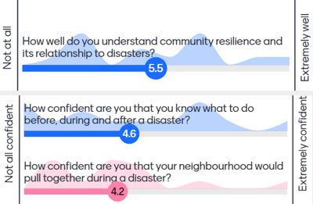

After
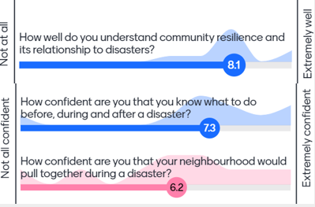

Feedback
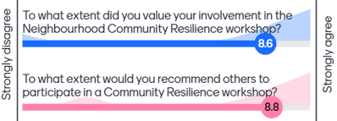

​

3.7 Next Steps
- ​Review findings and feedback
  - Review findings, compare resilience building ideas from each neighbourhood and explore ways to implement priority actions across municipality
  - Incorporate feedback into Heat Brochure and Heat Health Kits
- Portal updates
  - Add resources and findings, from workshops and survey inputs to the project's Participate Melbourne page and Neighbourhood Portal
  - Launch the centralised community resilience digital resource hub accessible through Neighbourhood Portals
- Action focus
  - Include community resilience ideas in Neighbourhood Priorities and identify avenues for implementation
  - Continue conversations with community organisations, local community members and other stakeholders and agencies to collaborate on delivering actions
Thank you to all workshop participants for your input and ideas!

Appendices
Appendix 1. Raw data workshop
What are the social and physical vulnerabilities to disasters in Docklands
Accessible Urban Environment
- High rise issues
  - Lack of clear protocols and procedures – consistent across all high rises “currently like the Wild West”
  - Responsibility gets pushed down to residents and should sit with facilities managers (people who hire their building managers etc.)
  - People with disability in high rise buildings – what do they do in an emergency --> should be part of their business offering
  - High-rise buildings fire emergencies with floor levels inaccessible by fire brigades
  - Lots of high rise buildings that are west facing without double glazing
  - High rises always excluded from initiatives
  - Fire risk at bottom of apartments -- commercial leases
  - People relying on building managers and them not being always available
  - Flammable cladding in building, hot apartment in summer and cold in winter
  - New development and residents
- Not many green spaces for cooling purposes
  - Spaces for dogs, roads are too hot
  - Kids do not have places to play outdoors
  - Losing open air space and green space for sheltering, potential of losing parks to development, only two zoned parks
  - No shelter when it is hot
- Flooding
  - Low-lying, flood prone areas. Flash flooding of particular concern around waterways
  - Potential of flooding on bridge
  - When there is a flood, you cannot be in Docklands, potential for Marvel Stadium for relief
  - Flooding issue already with Harbour Esplanade x2
- Transport issues
  - Trams not accessible for people in wheelchairs
  - Transport issue: grid lock traffic when there is an event
  - Some trams are not accessible
- Traffic issues
  - Traffic management due to development and future development concern
  - Inbound/outbound difficult for residents getting in and out of Docklands + EM services
  - Traffic and evacuation issues stemming from events and compounded road works
  - Docklands needs a distinctive landmark
Inclusive information and engagement
- Need to disseminate information quickly to many people
- Preparedness
  - Response to recovery time, no systems available, residual risk of fear
  - Community cohesion
Community connection
- very diverse community
  - Lots of international students, people who live alone, transient residents and renters who don’t know many people of where to go
- Low resident connectivity
  - Not knowing other people or socializing in neighbourhood
- High percentage of young people who maybe aren’t as connected
- Lack of community groups and support
- Existing Docklands Good Karma network, what FB groups are there? – Should include other nationalities
- Missing middle: new suburb, grid lines, no common spaces, community space, NGOs
Community safety and wellbeing
- People experiencing homelessness
  - More during winter because it’s cooler
- Safety concerns with minimally lit spaces + safe spaces for residents
- Wind tunnels coming straight in, concerns during storms
- No hospitals close. Access limited if a disaster was to happen during events
  - Festival road closure
  - Traffic jams
  - Games at Marvel
- A lot of visitors to Docklands with electric scooters pose risk to residents
- Commercial parking near Docklands primary school pose risk to kids walking
- Basket Ball court, games after hours, very loud music, abused when asked to move/leave
- Fence barrier around Victoria Harbour
- “We don’t have emergency power and water”

Activity 2: What are the social and physical strengths to disasters in Docklands

Accessible Urban Environment
- Ron Barassi Park, studios // assembly areas
  - Marvel Stadium for shelter
- Accessibility to water evacuation
- Southern Cross station is a good exit point
- Free tram
- Transport
- Good walkability, sidewalks are leveled
- Good accessibility to public toilets
- High rise in case of flood
- Green Spaces
- Fantastic dog park and dog walking
- Convenient evacuation

Inclusive information and engagement
- High rises offer good opportunities for communication
  - Emergency services and building managers
- High rises / high density create opportunities for efficient communication as all in one place
- Created community group social page and list that will be centralised, with important information and contacts that all residents will have access to

Community connection
- Activation spaces in commercial areas
- Community connection through Facebook groups
- Facebook group ‘Docklands residents community group’
- Community cohesiveness / building connection is a priority community members are working on
- Diverse community
- Diverse cultural background = diverse experience
- Some buildings have community meet-ups
- Recreation activities / social gathering
- Events
- Feels residential / a place to live
- Connection to rest of VIC

Community safety and wellbeing
- People who live in Docklands love it, love the natural elements, the harbour, swans = shared appreciation
- Major institutions our door step doing lots of research we can draw on
- Highly educated population
- Untapped resource = developers -> retrofitting and sustainability opportunities
- Big companies
- Community garden
- Library at the Dock
- Marvel stadium
- Unique characteristics / landscape
- Young age demographic
- Cleanliness
- Community groups working on
  - Safer Docklands
  - Safe water precinct
- Street lighting – Docklands is well lit and safe

*ideas which emerged during this activity
- CoM should have list of buildings and use adequate channels to share it> List should be completed and centralised with CoM to made accessible throughout the neighbourhood
- Docklands community app
- Mines rescue team : in the mines they have volunteer safety groups – young people physically trained for emergencies

Activity 3: Heat Collateral

What information would be useful to know to help you stay safe during heat events?
- Multiple languages
- How to stay cool inside apartments
- Nuanced information for people with disability
- Stay home advice
- What can you actually do at the cool place (drink fountain? Shade? Air conditioning? Seating? How long can they stay?)
- Knowing where to go when it got hot!
- Where to take dogs in heatwave
- Water coolers, drinking water
- Misting parks, misters
- Disability access shown on the cool routes
- Child-specific information
- Where to go to get relief
- Is the library open late hours during heat event
- Where to get information on first and for heatwave

How would you access this information? Online or brochure?
- Having online version to reach more people, through portal and social channels
- Have QR code
- Depends on your age and demographic
- Ideally both
- Printed signs e.g. “cool route this way”
- Front + centre
- Much bigger and bolder emergency numbers
- Reduce complex words for translation purposes
- Website
- Digital boards in building
- Emails via OC companies
- Foyer signs

How can the information be formatted so it is easy to understand?
- Multiple languages
- Short animations
- Depends on intended use situation e.g. awareness (need detail) or emergency (need summary / quick info)
- Show trees and shading on the map
- Show more of signs of heat stress
- Mention cool places that are under cover
- Show medical facilities on the map
- QR codes are excellent
- Easy to read brochure

Ideas about the Heat Kits:
- Hat for Heat Kit
- Paper resources could fold into a hat!
- Change liquid hydralite to tablet
- Less plastic
- Sunglasses
- Who are these handed out to? How are they distributed? E.g. events? --> Opportunity to hand out at events already hot such as Aus Open or visitor info sessions.
- Not something people would need at home, also not as valuable in extreme heat situation, however should be ready for distribution in locations where people get caught out without necessary supplies
- Could have known distribution centres
- Resources are great to set up people and be ready for a heatwave event

Other ideas
- What is the 4D cinema?
- Add the District in Docklands, Docklands Park
- Map misses a lot of cool spots in Docklands and Port Melbourne
- Real time information?

Activity 4: Ideas and actions to build resilience

- Idea / number of votes
​
Urban environment
How might we make our built environment more accessible and resilient to disasters?
- Retrofitting (supported by schemes and lobbying to include high rises in schemes) – glazing etc. /1
- Clear evacuation routes at different scales depending on the disaster (e.g. neighbourhood scale and city-wide scale), including instructions for visitors and / or clear visitors info points / 2
- Closing the gap between residents and corporates (NAB, Marvel, AFL) who are keepers of a lot of spaces (e.g Marvel stadium). Corporates should be part of the conversation --> greater overall collaboration with different stakeholders / 4
- Making flood and heat maps publicly accessible to raise awareness and include details of what to do

Community safety and wellbeing
How might we support the health and wellbeing of our community so we can be more resilient to disasters?
- Using abrasive material to avoid slippage on pavements / 1
- Council-staffed resident or community hub to act as central point for services, information, info on disasters, wellbeing. Catering to individuals. Open 24/7. --> Pamphlets, display boards + tram stops + letter boxes + building managers / 11 Correction provided by participant post workshop: Operating at extended business hours, not open 24/7.
- Online service hub as well – show people how to use that
- Display messages on the building TVs / lobbies / 2
- Cameras and better lighting for higher safety
- Dog parks should be fenced and lighted to increase safety and wellbeing
- Karma Network like the Kensington one, Heatwave page

Information
How might we best share information so that people feel clear about what to do and where to go in the event of a disaster?
- Council application
- A way to contact the council through the emergency app
- An additional function of the Snap + Resolve app / 2
- QR codes in public places – in case of emergency -> link to website and information (beware of QR code scams though) / 4
- Building induction programs
- A list of contacts and information for each building / 2
- A volunteer for each building that has information, resources and tools / 5
- Kit: Physical resources that can be shared between buildings and precincts (e.g. temporary lighting, batteries, etc.) / 2
- List of first responders / 1
- Providing training to volunteer first responders

Community connection
How might we improve community connection to reduce disaster risk and isolation?
- Social media should be considered as a viable and serious source for providing information
- Incorporate a genuine residents community group for the residents by the residents / 4
- Communication in multiple languages
- Community assistance / networking “get to know your neighbour” campaign / 3
- Community networking to include ageing population, multi-generational learnings and sharing positive neighbourhood stories
- Need more community spaces / facilities --> look at zoning the parks / 1
- More green spaces for community connection
- Joining up other residents groups /1
- Signage in building for people to connect e.g. residents 3000 / 1

