

Queen Victoria Market Precinct Renewal

City of Melbourne

Phase 3 Community Engagement Report, April 2015

Privacy
Unless otherwise stated, all feedback documented by Capire Consulting Group and any person(s) acting on our behalf was written and/or recorded during the engagement activities.
Capire staff and associates take great care while transcribing participant feedback but unfortunately cannot guarantee the accuracy of all notes. We are however confident that the full range of ideas, concerns and views presented have been acknowledged in this report.
Unless otherwise noted, the views expressed in our work represent those of the participants and not necessarily those of our consultants or our clients.
If you would like to speak to someone about how we manage personal information, please call the Project Manager or Capire’s office on (03) 9285 9000.
© Capire Consulting Group Pty Ltd.
This document belongs to and will remain the property of Capire Consulting Group Pty Ltd.
All content is subject to copyright and may not be reproduced in any form without express written consent of Capire Consulting Group Pty Ltd.
Authorisation can be obtained via email to info@capire.com.au or in writing to:
Capire Consulting Group 96 Pelham Street Carlton VIC Australia 3053.

Contents
Preface 7
Executive summary 8
Introduction 11
Purpose of this report 11
Project background 11
Key project milestones 12
Community engagement overview 13
Phase three engagement approach 17
Engagement activities 17
Limitations 17
Communications 18
Participate Melbourne 19
Engagement Hub 19
Intercept surveys 20
Trader discussion groups 20
Stakeholder discussion groups 21
Submissions 21
Key findings 23
Engagement findings 25
Who did we speak with? 25
Trader profile 30
Open space 31
Trader feedback 31
Public feedback 32
Car parking and access 34
Trader feedback 34
Public transport 35
Public feedback 36
Public transport 37
Celebrating the market’s history 38
Trader feedback 38
Public feedback 39
Introducing the Market Cross 40
Trader Feedback 41
Public feedback 42
Q1 – Quarter One 44
Quarter 2 48
Quarter Three 53
Opening hours 57
Trader feedback 58
Public feedback 59
Participation in previous phases of engagement 60
Trader feedback 60
Public feedback 61
Previous engagement 61
Further comments on the draft master plan 62
Trader feedback 63
Public feedback 63
Submissions 64
Next steps 67

Preface
The City of Melbourne is committed to engaging communities in the decisions they are interested in and impact upon them. Creating opportunities for people to be informed and involved is integral to the way we work together.
This commitment is reflected through the Council Plan goals and actions, which identify our priorities and outcomes for the current council term. This includes the biggest investment in the City of Melbourne’s history, the renewal of the Queen Victoria Market (QVM) precinct. Community engagement and the creation of a shared vision and plan for the renewal are key to the success of this project.

Executive summary

Background to the project
In October 2013, City of Melbourne announced Council’s commitment to undertaking the largest investment in its history to renew Queen Victoria Market (QVM) and create one of the world’s great market precincts.
The key aim of the renewal process is to preserve the market’s heritage and authentic atmosphere, while allowing the market precinct to evolve and meet the contemporary needs of visitors, traders and our growing city.
A Strategic Brief prepared by market management (QVM Pty Ltd) underpins the Draft Master Plan. It draws on interviews with traders, stakeholder feedback and expert advice.
In response, City of Melbourne (in partnership with QVM Pty Ltd) has prepared the Queen Victoria Market Precinct Renewal Draft Master Plan (the Draft Master Plan) to set out the broad plans for renewal and enable further detailed consultation with the community, market visitors and traders.
Two phases of stakeholder and community engagement has helped shape the Draft Master Plan.
Phase One occurred in November 2013 and sought to:
- introduce the concept of renewal;
- discover the elements of the market that people most valued
- identify the aspects of QVM that needed to be improved and protected in the future.
Phase Two occurred from April to May 2014 and introduced renewal concepts that were grouped into six key themes
- heritage;
- open space;
- car parking;
- access;
- attractions and activities; and
- retail, hospitality and services.
The Draft Master Plan has also been shaped by two key milestones – City of Melbourne’s strategic purchase of properties on a large site within the market precinct known as the Munro site and the signing of a formal agreement with the Victorian government to undertake improvements at Queen Victoria Market, and the surrounding precinct and to realign Franklin Street.

Phase three of the engagement process
Phase Three occurred in March 2015. It introduced and sought feedback on the Draft Master Plan.
During this phase, targeted and informal activities were undertaken with a broad range of people including market traders, local residents, local workers, customers, visitors and stakeholders with an interest in the project.
From 2 to 29 March 2015 approximately 4,381 people participated in the engagement and more than 1,120 surveys were completed. This number includes:
- the total participation numbers from Participate Melbourne website ‘informed’ users: 3,468
- engagement hub visitors: 606
- intercept surveys undertaken within the market: 60
- stakeholder and trader discussion groups: 229
- submitters: 18
The Draft Master Plan outlined a variety of proposals to revitalise the market precinct with a strong focus placed on improving the trader, customer and community experience. The Draft Master Plan divided QVM into four distinct quarters, each linked by a market cross of public spaces within the heart of the precinct.

Engagement Hub
Building on the success of the engagement hub operated in phase two, a larger engagement hub was established at 452 Queen Street to provide a dedicated space for people to find out more about the Draft Master Plan and to provide their feedback. The new engagement hub featured presentation facilities, enabling it to host up to 60 people for group workshops. During the phase three engagement period, the hub was regularly visited by key project team members, and staffed by up to three community engagement staff seven days per week. The engagement hub was open daily for open communication and provided a highly visible focal point for the process.

Trader and stakeholder discussion sessions
All QVM traders were invited to attend trader discussion groups focused on their specific trading category. Stakeholder discussion groups were held with members of the Wurundjeri and heritage representatives. A total of 204 traders and 25 stakeholders attended these sessions. Each facilitated session went for two hours and included a presentation by the Project Manager for the Queen Victoria Market Precinct Renewal Project and question and answer discussion about the Draft Master Plan. A total of nine trader discussion groups were held in the following categories:
- Dairy Hall
- General Merchandise (three sessions)
- Night Market
- Meat and Fish Hall
- Box Hire Company
- Fruit and Vegetable
- Food and Hospitality.
Trader comments were documented and agreed by the group within the session, with the summary of these discussions then made available to the broader trader community.

Survey
From 2 to 29 March 2015 more than 1,120 surveys were completed online and in hard copy. There were two surveys available, one for QVM traders (155 completed) and one for the public (965 completed). Surveys were completed during the trader discussion groups, online, while visiting or passing the engagement hub. The trader survey had an additional section on the proposed upgraded trader facilities. These questions asked traders to indicate, on a scale of one to five, how important upgrades are to them in Quarters One to Three.
The surveys invited comment on:
- the uses for the open space proposed for Q3 – Quarter Three and Market Cross
- improving access to the market
- how to celebrate the market’s history
- support for extending the opening hours and market offering; and prioritising upgrades to trader facilities.

Key findings
The engagement process elicited a range of feedback on the Draft Master Plan, a summary of the key findings is the purpose of this report. Below is an overview of the key findings.
- Opening Hours: The majority of both the traders and the public participants are supportive of the concept to enhance the market as a destination that provides a changeable range of offers.
- Use of open space: Both the traders and the public showed a preference for programmed markets and events in the new open space proposed for Q3 – Quarter Three.
- Access: While traders said that improved car parking would improve access to the market, public participants said that improved pedestrian amenity and safety would make it easier for them to access the market.
- Heritage: Both the traders and the public participants said that they preferred artwork, signage or landscape features as ways to celebrate the market’s history.
- Market Cross: The most common suggestion by traders and public participants for Market Cross was public seating.

Introduction

Purpose of this report
The purpose of this report is to provide a summary of the activities and findings of the third phase of community engagement for the proposed renewal of QVM. The third phase focuses on the Draft Master Plan. It details each engagement activity and outlines the key feedback from each theme.
The report presents the broad range of values, ideas and aspirations expressed by participants. In some cases, comments are paraphrased and quotes are used to illustrate the community sentiment.
Further information on the previous phases of community engagement for this project can be found on Participate Melbourne:
- Phase One Community Consultation Report, February 2014, Capire Consulting Group
- Phase Two Community Consultation Report, June 2014, Capire Consulting Group

Project background
In October 2013, City of Melbourne announced that it would make the largest investment in its history to preserve and renew QVM, creating an expanded market precinct. As part of the renewal process, City of Melbourne will seek UNESCO World Heritage listing for QVM following a comprehensive renewal program. From 2013 to mid-2015 City of Melbourne in partnership with market management has been preparing a plan to guide the renewal process, informed by community and stakeholder engagement. A Strategic Brief was prepared by market management (QVM Pty Ltd) to set out the recommended changes that will enable the delivery of the aims of the renewal project, drawing on trader interviews, stakeholder feedback and expert advice.
The seven hectare QVM site is located on the north western corner of Melbourne’s Hoddle grid where West Melbourne, North Melbourne and the CBD converge. The market is located between the major roads of Victoria, Peel and Elizabeth streets. QVM comprises of two distinct sections separated by Queen Street. The southern boundaries of each market section are Franklin Street and Therry Street.
Figure 1: Aerial image of the QVM precinct
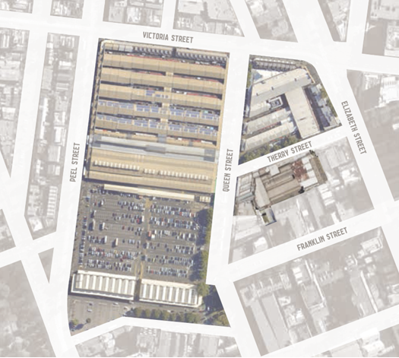
In October 2014, City of Melbourne announced the purchase of properties of a site bounded by Therry, Queen and Franklin streets, commonly known as the Munro site. This purchase opens up new possibilities for the QVM renewal process. As outlined in the Draft Master Plan this may include a different configuration of car parking, new community uses and ways to optimise Therry Street retail.

Key project milestones
The key project milestones in developing a master plan to guide renewal of the market are expected to occur between October 2013 and July 2015.
Milestones
October 2013 – City of Melbourne announces the largest investment in its history to preserve and renew the Queen Victoria Market and surrounding precinct.
November 2013 – First phase of community engagement begins, with the community invited to learn about the history of the market, the renewal and identify areas to be improved and protected in the future.
February 2014 – CE1 report of consultation findings.
April to May 2014 – Second phase of engagement takes place with the community invited to share their ideas about renewal proposals.
June 2014 – CE2 report of consultation findings.
September 2014 – A formal land transfer agreement between the state government and City of Melbourne is signed, enabling future improvements and developments on Franklin Street. Historic ‘Munro’ site within market precinct goes up for sale. City of Melbourne release Development Control Guidelines to support a best practice approach for the development of the site.
October 2014 – City of Melbourne announces the purchase of the large block of land within the market precinct paying $76 million for the historic Munro site.
We Are Here
March 2015 – Third phase of community engagement takes place with people invited to give feedback on Queen Victoria Market Precinct Draft Master Plan.
Next Steps
April to May 2015 – Report on third phase of community engagement released. Review of existing development controls.
May 2015 – Final Queen Victoria Market Precinct Draft Master Plan released for final community feedback.
June 2015 – Queen Victoria Market Precinct Master Plan presented to Council for adoption.
From July 2015 – Master plan implementation: detailed scoping and preparation of concepts and options for each quarter, including targeted consultation with key stakeholders.
July 2015 – Munro site settlement.
December 2015 – Master plan implementation strategy prepared.
Renewal Works to Commence
2016 Renewal works to commence.
Key milestone dates outlined in agreement between City of Melbourne and state government
By August 2019 – New Franklin Street and a new street built, roundabouts removed. Existing car parking spaces replaced elsewhere within the precinct. Construction of Queens Corner building.
By August 2022 – New open space on site of existing car park.
By August 2026 – New mixed used development site. Public realm improvements.

Community engagement overview
City of Melbourne and QVM Pty Ltd initiated broad community engagement to inform future planning for the market. Capire Consulting Group were appointed to help design and deliver a community engagement strategy that would enable a broad range of people to contribute to a discussion about preserving QVM’s heritage and authentic atmosphere, while allowing it to evolve to meet contemporary needs of traders, shoppers and the growing city. Stakeholders included QVM traders and employees, customers, tourists, local residents, businesses and interested groups. Four phases of stakeholder and community engagement have been planned for the QVM Precinct Renewal Master Plan, details about each phase are below.

Phase One (1 to 30 November 2013)
Phase One sought to introduce the concept of renewal, discover the elements of the market that people most valued and identify the aspects of QVM that needed to be improved and protected in future. The engagement was conducted over four weeks from 1 to 30 November 2013. There was no draft plan developed at this stage and conversations drew on people’s familiarity and experience with the market. This phase sought to deliver an engagement process which provided opportunities for the community and traders to:
- learn about the history of the QVM and the QVM Precinct Renewal
- identify QVM’s sense of place including its identity, uniqueness and key experiences
- learn about the new precinct and its various elements
- identify aspects of QVM to be protected
- identify aspects of QVM to be improved.

Phase Two (22 April to 16 May 2014)
Phase Two introduced five draft renewal concepts. The concepts were grouped into six key themes – heritage, open space, car parking, access, attractions and activities, retail, hospitality and services. Feedback was sought in response to these themes. The four week engagement ran from 22 April to 16 May 2014. This phase sought to deliver an engagement process which provided opportunities for the community and traders to:
- learn about the rationale for the future layout of the QVM precinct
- provide a forum to identify issues, opportunities and share ideas associated with the future market and its precinct
- provide opportunities for groups with expert knowledge to participate in ideas generation about the future market
- learn and provide feedback about the proposed business continuity principles that will guide the implementation of the QVM Precinct Renewal Master Plan
- provide feedback on impacts to trade and mitigation responses to ensure a continuous and vibrant market.

Phase Three (2 to 29 March 2015)
Phase Three introduced the QVM Precinct Renewal Draft Master Plan (Draft Master Plan), with the Strategic Brief as background. The Draft Master Plan was informed by the findings of phase one and the responses to the draft concepts provided in phase two. The engagement took place from 2 to 29 March 2015 and sought feedback on the Draft Master Plan. Engagement findings will inform the final QVM Precinct Renewal Master Plan. The objectives of this phase of engagement were to:
- seek broad feedback on the Draft Master Plan
- build on previous phases of community and trader engagement
- validate QVM Pty Ltd’s Strategic Directions contained within the Strategic Brief
- educate people about the need for change
- generate community and trader support for the change
- educate traders about business continuity
- consult the community and traders about key negotiable elements of the draft master plan
- deliver a genuine and robust engagement process
- build trust amongst all stakeholders.
Phase Three of the engagement was centred on the Draft Master Plan which focused on making QVM a ‘market of markets’, with a distinctive offer and experience in each of the main trading quarters. The Draft Master Plan outlined a wide variety of proposals to revitalise the market precinct with a strong focus placed on improving the trader, customer and community experience. The Draft Master Plan included:
- Q1 (Quarter One) – shop front trading in market halls and street oriented terraces
- Q2 (Quarter Two) – fixed trading stalls in open sheds, sheltered in a structured perimeter to surrounding streets
- Q3 (Quarter Three) – changing daily, weekly, seasonally markets and events in open-air sheds and a plaza
- Q4 (Quarter Four) – mixed-use development, fine grained retail, hospitality and community facilities complementary to QVM
- Market Cross – one of Melbourne’s great public and local places
- City Grid – the best of Melbourne’s city streets.
Figure 3: Summary of Key Draft Master Plan proposals
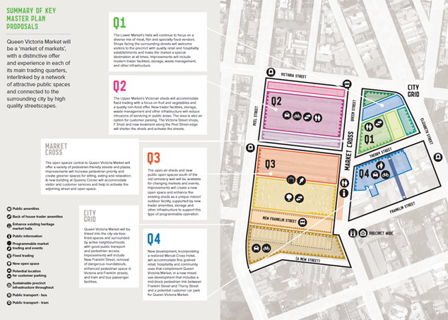
Queen Victoria Market will be a ‘market of markets’, with a distinctive offer and experience in each of its main trading quarters, interlinked by a network of attractive public spaces and connected to the surrounding city by high quality streetscapes.

Q1
The Lower Market’s halls will continue to focus on a diverse mix of meat, fish and specialty food vendors. Shops facing the surrounding streets will welcome visitors to the precinct with quality retail and hospitality establishments and make the market a special destination at all times. Improvements will include modern trader facilities, storage, waste management, and other infrastructure.

Q2
The Upper Market’s Victorian sheds will accommodate fixed trading with a focus on fruit and vegetables and a quality non-food offer. New trader facilities, storage, waste management and other infrastructure will reduce intrusions of servicing in public areas. The area is also an option for customer parking. The Victoria Street shops, F Shed and new treatment along the Peel Street edge will shelter the sheds and activate the streets.

Q3
The open-air sheds and new public open spaces south of the old cemetery wall will be available for changing markets and events. Improvements will create a new open space and enhance the existing sheds as a unique indoor/ outdoor facility, supported by new trader amenities, storage and other infrastructure to support this type of programmable operation.

Q4
New development, incorporating a restored Mercat Cross Hotel, will accommodate fine grained retail, hospitality and community uses that complement Queen Victoria Market, in a new mixed use development that includes a mid-block pedestrian link between Franklin Street and Therry Street and a potential customer car park for Queen Victoria Market.

Market Cross
The open spaces central to Queen Victoria Market will offer a variety of pedestrian-friendly streets and plazas. Improvements will increase pedestrian priority and create greener spaces for sitting, eating and relaxation. A new building at Queens Corner will accommodate visitor and customer services and help to activate the adjoining street and open space.

City Grid
Queen Victoria Market will be linked into the city via tree-lined spaces and surrounded by active neighbourhoods with good public transport and pedestrian access. Improvements will include New Franklin Street, removal of dangerous roundabouts, enhanced pedestrian space in Victoria and Franklin streets, and tram and bus passenger facilities.

Phase Four
Phase Four is planned to take place in June 2015, this phase will present the QVM Precinct Renewal Final Draft Master Plan (Final Draft Master Plan) to the community for information prior to adoption. Details of this phase will be made available shortly.

Phase three engagement approach
During the third phase of engagement, activities were undertaken with a broad range of people including market traders, local residents, local workers, customers, visitors and stakeholders with an interest in the project. The engagement sought feedback on the QVM Precinct Renewal Draft Master Plan, captured predominately via a survey. There were two surveys available, one for QVM traders and one for the public. The surveys invited specific comment on the following:
- Open space proposed for Q3 – Quarter Three - what are your preferred uses for the proposed open space?
- Car parking and access - what would make it easier for you to access the market?
- Celebrating the market’s history - what are your preferred ways to celebrate the market’s history?
- Introducing the Market Cross - what features and activities would you like to see in the new public spaces proposed for the Market Cross?
- Opening hours: how supportive are you of the concept to enhance the market as a destination that provides a changeable range of offers seven days a week, from morning to night?
The trader survey had an additional section on the proposed upgraded trader facilities. These questions asked traders to indicate on a scale of one to five how important upgrades are to them in Quarters One to Quarter Three.

Engagement activities
A number of engagement activities were undertaken as part of Phase Three. Details about the engagement activities carried out are detailed in the following sections.
From 2 to 29 March 2015 approximately 4,381 people participated in the engagement with approximately 1,120 surveys completed.

Limitations
There are some limitations associated with the consultation that should be acknowledged.
The information included in this report is based on qualitative data collected from willing, non-incentivised participants. Survey results therefore should not be regarded as a representation of the views of a statistically validated sample of the community.
Stakeholders were invited to attend Access and Inclusion discussion groups. The scheduled sessions were cancelled due to non-attendance.
In some instances participants used the opportunity to provide feedback that was not related to the QVM Precinct Renewal. This feedback has not been included in this report however it has been given to QVM Pty Ltd and City of Melbourne for their review and consideration.
A number of survey questions allowed multiple answers and not all participants answered all questions.
In some instances, survey participants did not answer all questions, this meant that some questions received fewer responses than others.
Open field questions and the option to expand on an ‘other’ option in multiple choice questions allowed participants to provide unique responses or comment on issues outside the scope of this project.

Communications
The following promotional techniques and activities were used to inform the community including QVM traders about the third phase of the project.

Media releases
The City of Melbourne announced the third phase of the project with a media release on 26 February titled “An exciting vision for Melbourne’s favourite market”. This resulted in a number of news items as described below.

Print and broadcast media
A total of 80 individual items of news ran during the engagement period. This included 54 radio items, seven print items and five TV items. A list of these can be found in Appendix C.

Advertisements
Print advertisements promoting the engagement activities were included in City of Melbourne’s regular corporate advertisements in The Weekly Review – Melbourne Times Weekly, The Weekly Review – City, The Weekly Review – Moonee Valley, and Melbourne Leader.

Posters and postcards
Posters were displayed at QVM and City of Melbourne’s key community information points. Two postcards were prepared - one for the public which gave an overview of the project and ways to get involved and one for traders which listed the trader discussion groups. Throughout the engagement period postcards were handed out at the engagement hub. Postcards detailing times and dates of trader discussion groups were hand delivered to traders throughout the engagement period.

Social media
City of Melbourne social media channels were used to promote the engagement as follows:
- City of Melbourne Facebook 340,000 reach, 5,058 likes, comments and shares
- City of Melbourne Twitter 23 re-tweets and 10 Favourites
- City of Melbourne LinkedIn 34 likes.

Websites
City of Melbourne and QVM websites were used to promote the project, provide information and a link to Participate Melbourne. During the engagement period 1 to 29 March 2015:
- the QVM Precinct Renewal project page on the City of Melbourne website received 1,390 unique page views
- QVM Pty Ltd website received 330,459 unique page views and the QVM Pty Ltd Precinct Renewal page received 462 unique page views
Victraders is a website operated by QVM traders for QVM traders. A number of articles are published each week with the aim of informing traders, stimulating discussion on trader issues and encouraging feedback and debate. In the lead up to and during the engagement period 15 articles were published.

Letters and emails
Approximately 1,330 letters were sent to commercial businesses and 2,500 letters were sent to residents in the area surrounding the market precinct announcing the project and encouraging their participation. Approximately 750 emails were sent to key stakeholders announcing the project and encouraging their participation

Participate Melbourne
Participate Melbourne is a City of Melbourne managed and administrated online community engagement hub that provides an additional way for members of the community to understand and contribute to the decisions that shape Melbourne’s future. Participate Melbourne has played a key part in each phase of engagement, and provides updates on project milestones to interested community members on an ongoing basis. During phase three of the engagement process, Participate Melbourne provided information about the QVM Precinct Renewal project including the Draft Master Plan, background documents, FAQs and the surveys. There was a total of 6,699 unique page visits. Of these 3,468 represented an informed visit where they have visited a specific piece of information such as viewing a document, clicking a link, visiting key dates. A total of 648 people are considered to be engaged and have completed a survey.

Engagement Hub
Building on the success of the engagement hub operated in phase two, a larger engagement hub was established at 452 Queen Street to provide a dedicated space for people to find out more about the Draft Master Plan and to provide their feedback. The new engagement hub featured presentation facilities, enabling it to host groups of up to 60 people for group workshops. During the phase three engagement period, the hub was open from 9am to 3pm on Thursday to Sunday, 8am to 2pm on Tuesday and 4.30pm to 7.30pm on Wednesday. It was regularly visited by key project team members senior City of Melbourne representatives, senior QVM Pty Ltd representatives and staffed by at least three community engagement staff.
The engagement hub was open daily for open communication and provided a highly visible focal point for the process, providing the venue for trader and stakeholder discussion group sessions. The visitors to the hub, along with some participant information was recorded as follows below.

Visitor overview
Approximately 600 individuals visited the engagement hub throughout the engagement period. Of these visitors six per cent work at the market, seven per cent work near the market, 26 per cent live near the market, 42 per cent shop at the market and 19 per cent have an interest in the project.

Work at the market
Of those who work at the market 78 per cent were business owners and 22 per cent were employees including both market trader employees and QVM management employees. We asked those who worked at the market what trading group they belong to; 16 per cent belong to the Fruit and Vegetable trading group, 49 per cent to General Merchandise, 13 per cent to Dairy Hall, three per cent to Meat And Fish Hall and 19 per cent belong to the Food and Hospitality trading group.
Traders were asked to identify which section of the market they work in, 40 per cent work in Q1 – Quarter One, 25 per cent in Q2 – Quarter Two and 35 per cent in Q3 – Quarter Three.

Length of stay
The approximate length of stay of visitors to the hub was recorded. Roughly 53 per cent stayed for longer than five minutes, 20 per cent for between three to five minutes, 20 per cent for less than two minutes and seven per cent just passed through briefly without talking to staff.

Survey and project collateral
Of the total number of visitors to the hub 43 per cent completed a survey at the hub and 33 per cent took a survey away to complete. Approximately 64 per cent of visitors to the hub collected project collateral such as a postcard or copy of the Draft Master Plan.

Intercept surveys
On the busier market days, Wednesday night, Friday, Saturday and Sunday, staff at the hub undertook intercept surveys with people at the market. This ensured feedback was collected from those people who have not self-selected to participate by visiting the hub or completing a survey online. Approximately 60 intercept surveys were completed using the community survey.

Trader discussion groups
QVM has over 700 traders currently in operation. All were invited to attend trader discussion groups. The trader discussion groups provided traders with the opportunity to learn more about the Draft Master Plan for QVM. There was a total of nine trader discussion groups held, with each session dedicated to a trading group, this allowed discussion to focus on relevant quarters. A total of 204 traders participated by attending a discussion group. The trader discussion group schedule can be found in Table 1.
Table 1 - Trader discussion group schedule
Number | Date | Time | Group | No. of attendees
1 | 4 March 2015 | 10am to 12pm | Dairy Hall | 36
2 | 5 March 2015 | 2.30 to 4.30pm | General Merchandise | 21
3 | 10 March 2015 | 2 to 4pm | Night Market | 42
4 | 11 March 2015 | 10am to 12pm | Meat and Fish Hall | 33
5 | 16 March 2015 | 2 to 4pm | General Merchandise | 10
6 | 17 March 2015 | 10am to 12pm | Box Hire Company | 6
7 | 17 March 2015 | 3.30 to 5.30pm | General Merchandise | 27
8 | 18 March 2015 | 10am to 12pm | Fruit and Vegetable | 17
9 | 18 March 2015 | 2 to 4pm | Food and Hospitality | 12

At each session there were attendees from QVM Pty Ltd, City of Melbourne and Capire, including senior management and the City of Melbourne Project Manager for the QVM Precinct Renewal Project. The sessions included a presentation from QVM Pty Ltd on the project and a presentation from City of Melbourne that gave an overview of the Draft Master Plan. After the presentation, time was allocated for questions and answers followed by a general discussion about the Draft Master Plan. Traders were asked to discuss two key questions:
- Please describe what you see as positives [in the Draft Master Plan] – What should be improved?
- Which proposal(s) [in your quarter] do you consider is the highest priority? – Why?
A summary of each session was prepared and copies of the notes were delivered or emailed to all participants along with a copy of the trader survey. The notes were also published on the Victraders website.

Stakeholder discussion groups
Stakeholder discussion groups were held with heritage stakeholders and members of the Wurundjeri Tribe. Senior representatives from QVM Pty Ltd, City of Melbourne and Capire attended each of these sessions. The sessions included a presentation from QVM Pty Ltd management on the project and a presentation from City of Melbourne outlining the Draft Master Plan. Following the presentation there was time for questions and answers and a general discussion on the proposals outlined in the draft master plan. A summary of the key messages and themes discussed at each session was prepared and emailed to the attendees.
Table 2 - Stakeholder discussion group schedule
Number | Date | Time | Group | No. of attendees
1 | 10 March 2015 | 5.30 to 8pm | Heritage | 19
2 | 20 March 2015 | 10am to 12pm | Wurundjeri Tribe | 6

Submissions
Although submissions were not formally called for as part of the phase three engagement process, 18 submissions were received and have been incorporated in this report. The submitters and their organisation (where applicable) are listed below. A summary of the key themes from each submission has been provided in Section 4.10 of this report.
Table 3 – Submissions received
Submission no. | Submitter
1 | Dean Steinberg, Adviser, Government and External Relations, Bicycle Network
2 | Dominic Esposito Solicitors on behalf of Mr Carl Greco, Bratwurst Shop and Co. and Pizza By Nature
3 | Elizabeth Vines, President, Australia, International Council on Monuments and Sites
4 | Katy Dean, Director, Advocacy, Green Building Council Australia
5 | Chris Hardman, Regional Director, Melbourne, Parks Victoria
6 | Angela Williams (individual)
7 | Shirley Pimmell (individual)
8 | QVM Dairy Hall Traders
9 | Jenny Hickinbotham (individual)
10 | Yolande Leonardi (individual)
11 | Ingrid Galitis (individual)
12 | QVM General Merchandise Trader Representative
13 | Mark Benson (individual)
14 | Olive Hamilton (individual)
15 | Peter Langtry (individual)
16 | Tim Smith, Executive Director, Heritage Victoria, Department of Environment, Land, Water and Planning
17 | Jon Shinkfield, President, Victorian Chapter, Australian Institute of Landscape Architects
18 | Gabrielle Fitzgerald, RMIT University

Key findings
The third phase of stakeholder and community engagement for QVM has revealed a number of clear messages that should be considered when preparing the Draft Final Master Plan for QVM.

Participation rates and profile of respondents
- Of the 135 traders who responded 40 per cent, work in General Merchandise businesses.
- Good representation from traders from across different parts of the market.
- 1,120 surveys were received, this includes 155 trader surveys and 965 general public surveys.
- A total of 204 traders and 25 stakeholders attended the discussion groups.
The key findings have been listed by theme below and where applicable have been grouped by trader and public feedback:

An overview of the key findings
- Opening Hours: The majority of both the traders and the public participants are supportive of the concept to enhance the market as a destination that provides a changeable range of offers.
- Use of open space: Both the traders and the public showed a preference for programmed markets and events in the new open space proposed for Q3 – Quarter Three.
- Access: While traders said that improved car parking would improve access to the market, public participants said that improved pedestrian amenity and safety would make it easier for them to access the market.
- Heritage: Both the traders and the public participants said that they preferred artwork, signage or landscape features as ways to celebrate the market’s history.
- Market Cross: The most common suggestion by traders and public participants for Market Cross was public seating.

Preferred uses for the new open space proposed for Q3 – Quarter Three
Both traders and the public have a preference for programmed markets and events (37 per cent of the traders and 30 per cent of the public) in the new open space proposed for Q3 – Quarter Three. The public also showed a preference for health and wellbeing spaces (25 per cent). Informal spaces were of lesser preference to both groups.

Car parking and access
When asked about what would improve access to the market precinct traders showed a clear preference for improved car parking (57 per cent).
While the public also showed a preference for improved car parking (23 per cent), the highest number of responses (25 per cent) supported improved pedestrian amenity with improved public transport (20 per cent) also important to many.

Celebrating the market’s history
The top three preferred ways to celebrate the market’s history for both traders and the public was:
- artwork (27 per cent traders and 25 per cent public)
- signage (26 per cent traders and 25 per cent public)
- landscape features (26 per cent traders and 28 per cent public).

Features and activities for the Market Cross
The most common suggestion from both traders and the public for the Market Cross was seating (20 per cent traders and 22 per cent public). A high number of traders (16 per cent) also suggested additional market stalls along with a proportion of public who suggested pop up stalls and a greater variety of stalls (11 per cent). The public also commonly suggested green/open spaces, picnic areas and meeting places (11 per cent).

Opening hours
A total of 63 per cent of the public were supportive of the concept to enhance the market as a destination that provides a changeable range of offers seven days a week from morning to night. A total of 20 per cent were not supportive of the concept.
A total of 50 per cent of the traders were supportive of the concept. A total of 38 per cent were not supportive.

Trader facility upgrades
The trader upgrades have been grouped into feedback received from traders responding to their quarter and traders responding to all quarters.

Q1 – Quarter One trader facility upgrades (traders only)
- Almost half of the traders from Q1 – Quarter One and traders from other areas of the market considered developing precinct wide infrastructure for power, water, waste management and recycling to be important and very important upgrades (72 per cent Q1 – Quarter One traders and 66 per cent other traders).
- Almost half of the traders from Q1 – Quarter One and traders from other areas of the market considered improving waste management and recycling facilities for meat and fish offal, organics and packaging to be important and very important upgrades (72 per cent Q1 – Quarter One traders and 63 per cent other traders).
- A high number of traders from both Q1 – Quarter One and traders from other areas of the market considered improving trader amenities with the inclusion of showers, toilets, breakout spaces and storage to be important and very important upgrades (57 per cent Q1 – Quarter One traders and 56 per cent other traders).
- A high number of traders from both Q1 – Quarter One and traders from other areas of the market considered improving access for delivery and waste removal by including a new loading dock, off-street loading areas, wash-down services and storage facilities to be important and very important upgrades (68 per cent Q1 – Quarter One traders and 55 per cent other traders).
- A high number of traders from both Q1 – Quarter One and traders from other areas of the market considered reducing the conflicts between service vehicles and public access to be important and very important upgrade (55 per cent Q1 – Quarter One traders and 56 per cent other traders).

Q2 – Quarter Two trader facility upgrades (traders only)
- A high number of the traders including both Q2 – Quarter Two and other areas of the market considered developing precinct wide infrastructure for power, water, waste management and recycling to be important and very important upgrades (81 per cent Q2 – Quarter Two traders and 59 per cent other traders).
- A high number of traders from both Q2 – Quarter Two and other areas of the market considered reducing conflicts between forklifts and other service vehicles and public access to be important and very important upgrades (76 per cent Q2 – Quarter Two traders and 60 per cent other traders).
- A high number of traders from both Q2 – Quarter Two and traders from other areas of the market considered improving access for delivery including off-street loading and breakdown areas, wash down services and storage facilities to be important and very important upgrades (84 per cent Q2 – Quarter Two traders and 54 per cent other traders).
- A high number of traders from both Q2 – Quarter Two and other areas of the market considered improving waste management facilities with a focus on organic waste to be important and very important upgrades (78 per cent Q2 – Quarter Two traders 54 per cent other traders).
- A high number of traders from both Q2 – Quarter Two and other areas of the market considered improving trader facilities with the inclusion of showers, toilets, breakout spaces and storage to be important and very important upgrades (54 per cent Q2 – Quarter Two traders and 59 per cent other traders).

Q3 – Quarter Three trader facility upgrades (traders only)
- A high number of traders from both Q3 – Quarter Three and other areas of the market considered developing precinct wide infrastructure for power, water, waste management and recycling to be important and very important (55 per cent Q3 – Quarter Three traders and 56 per cent other traders).
- A high number of traders from Q3 – Quarter Three considered upgrading the infrastructure to support events including alternative market operations and arrangements to be of neutral importance (37 per cent) while traders from other areas of the market considered this upgrade to be very important (36 per cent).
- A high number of traders from Q3 – Quarter Three considered upgrading waste management facilities to be of neutral importance (32 per cent) while traders from other areas of the market considered this upgrade to be very important (36 per cent).
- A high number of traders from Q3 – Quarter Three considered developing specialist back of house amenities to be of neutral importance (30 per cent) while traders from other areas of the market considered this upgrade to be very important (36 per cent).

Engagement findings
The engagement sought feedback on the QVM Precinct Renewal Draft Master Plan primarily via a survey. There were two surveys available, one for QVM traders and one for members of the general public. The sections below present the key findings from the surveys. Where appropriate each section has been split into two to provide specific trader and public feedback. Where applicable the discussion from the trader and stakeholder discussion groups has also been included in the findings.

Who did we speak with?
Throughout the engagement period 1,120 surveys were received, this includes 155 trader surveys and 965 general public surveys. Surveys could be completed online or in person at the engagement hub. Hard copy surveys could be collected from the hub and returned by mail.
A total of 204 traders and 25 stakeholders attended the discussion groups.
Figure 4: Trader and public surveys received
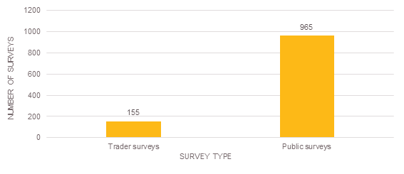
Number of Surveys | Total: 1120
Trader Surveys | 155
Public Surveys | 965

Relationship to the market
Participants were asked about their relationship with the market, this question helps the project team to understand participants in the engagement process. This question received 1,120 responses.
Just under half of the public participants (46 per cent) shop at the market

Figure 5: What is your relationship to the market?
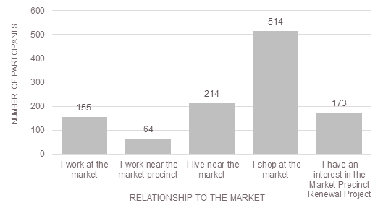
Relationship to the market | Number of Participants
I work at the market | 155
I work near the market precinct | 64
I live near the market | 214
I shop at the market | 514
I have an interest in the Market Precinct Renewal Project | 173

Participation within the City of Melbourne
To understand people’s relationships with the surrounding area, participants were asked to select the most applicable answer to the question ‘How do you participate in the city of Melbourne?’ This question received a total of 1,164 responses.
A high proportion of participants (28 per cent) work within the boundaries of the city of Melbourne

Figure 6: How do you participate in the city of Melbourne
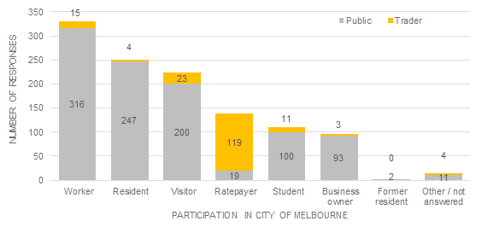
Participation in the City of Melbourne | Number of Responses - Public | Number of Responses - Traders
Worker | 316 | 15
Resident | 247 | 4
Visitor | 200 | 23
Ratepayer | 19 | 119
Student | 100 | 11
Business Owner | 93 | 3
Former Resident | 2 | 0
Other/not answered | 11 | 4

Age
A total of 1,074 participants responded to this question. Figure five shows the total number of participants by age group.
Most participants (63 per cent) were aged between 26 and 55 years

Figure 7: What is your age group?
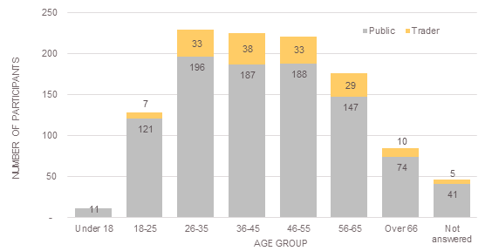
Age Group | Number of Participants - Public | Number of Participants - Trader
Under 18 | 11 | 0
18-25 | 121 | 7
26-35 | 196 | 33
36-45 | 187 | 38
46-55 | 188 | 33
56-65 | 147 | 29
Over 66 | 74 | 10
Not answered | 41 | 5

Gender
A total of 1,064 participants responded to this question. Figure 8 shows the number of trader and public participants by gender.
Figure 8: What is your gender?
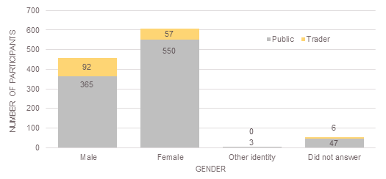
Gender | Number of Participants - Public | Number of Participants - Trader
Male | 365 | 92
Female | 550 | 57
Other identity | 3 | 0
Did not answer | 47 | 6

Postcode
Participants were asked to provide their postcode of residence to help us understand where market visitors were travelling from. In total, 1,084 responded to this question. Table 4 lists the suburbs in which 15 or more participants reside. This combines both trader and public responses.
The majority of participants reside in Melbourne CBD (14.5 per cent) or the inner northern suburbs (28 per cent)

Table 4: What postcode area do you live in?
Postcode and suburb | Number of survey responses | Percentage total survey responses
3000 – Melbourne | 157 | 14.5
3051 – North Melbourne | 63 | 5.8
3003 – West Melbourne | 38 | 3.5
3053 – Carlton | 32 | 3.0
3056 – Brunswick | 25 | 2.3
3031 – Flemington, Kensington | 23 | 2.1
3070 – Northcote | 23 | 2.1
3068 – Clifton Hill, Fitzroy North | 20 | 1.8
3052 – Parkville | 19 | 1.8
3032 – Ascot Vale, Highpoint, Maribyrnong, Travancore | 16 | 1.5
3044 – Pascoe Vale, Pascoe Vale South | 16 | 1.5
3058 – Coburg, Coburg North, Moreland | 15 | 1.4
3141 – Essendon North, Strathmore, Strathmore Heights | 15 | 1.4

Trader profile
Market traders were asked to provide some information regarding the type and location of their business within the market. This helps us to understand the mix of traders who participated in this consultation and in which part of the market they currently operate.
Of the 135 traders who responded to this question40 per cent work in General Merchandise businesses.
The greatest proportion of traders (40 per cent) belong to the General Merchandise trading group

Figure 9: Which trading group do you belong to?
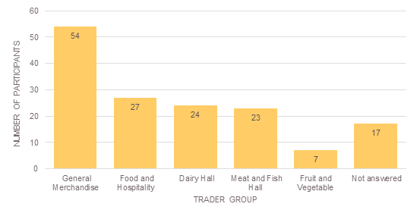
Trader Group | Number of Participants
General Merchandise | 54
Food and Hospitality | 27
Dairy Hall | 24
Meat and Fish Hall | 23
Fruit and Vegetable | 7
Not answered | 17

We asked traders to identify which part of the market they currently work in. Of the 118 traders who responded to this question, most work in either Q3 – Quarter Three (38 per cent) and Q1 – Quarter One (36 per cent) of the market.
Figure 10: Which area of the market do you work in?
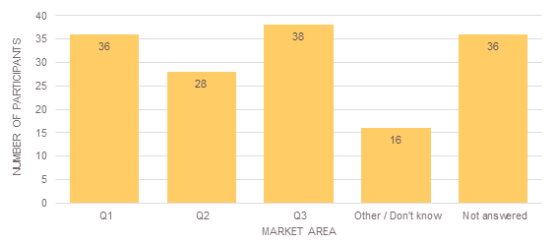
Market Area | Number of Participants
Q1 | 36
Q2 | 28
Q3 | 38
Other/Don’t know | 16
Not answered | 36

Open space
The Draft Master Plan includes a new large scale open space in Q3 – Quarter Three, in place of the current car park accessed from Franklin and Queen streets. The open space will provide multiple uses by supporting market trading and new recreational and event opportunities which will complement Flagstaff Gardens.
Selecting from a shortlist of options, which were informed by traders, residents and visitors feedback during the previous two phases of community engagement, participants were asked to choose up to three preferred uses for the new open space. The options presented to participants were:
- informal spaces for example, picnics, a place to sit and relax
- programmed market and events for example, pop-up market stalls, night markets, festivals, music al concerts, performances, school holiday programs
- health and wellbeing spaces for example, children’s play, yoga, tai chi
- informal outdoor recreation for example, half-court basketball, table tennis, bocce
- other.
Participants were also invited to offer other suggestions outside of these options.
This question received a total of 1,231 responses, comprising 1,059 from public participants and 172 traders. Feedback has been analysed separately for trader and public survey participants to identify the different role of the stakeholders and to also reduce the skew of the data given the significant differences in sample size.

Trader feedback
In total 172 suggestions were received from 155 trader participants. Feedback incorporated a broad array of ideas which have then grouped by common themes. Overall traders showed a preference for programmed markets and events in the new open space informed Q Q3 – Quarter Three. Health and wellbeing spaces, and informal outdoor recreation were also popular uses.
Overall traders showed a preference for programmed markets and events (37 per cent) in the new open space in Q3 – Quarter Three

Figure 11: Traders’ preferred uses for the new open space in Q3 – Quarter Three
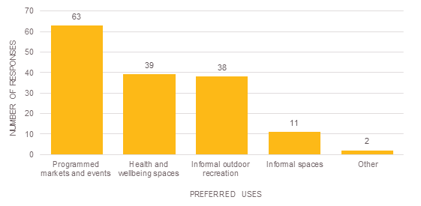
Preferred Uses | Number of Responses
Programmed markets and events | 63
Health and wellbeing spaces | 39
Informal outdoor recreation | 38
Informal spaces | 11
Other | 2

Traders also provided a number of additional suggestions for the use of the new space, these responses have been grouped together under common themes and are listed below:
- Retain the current car parking or provide free or cheaper parking (10 participants)
- Parks, garden or green spaces (4)
Feedback received at trader discussion groups on the new open space was generally positive. Traders recognised that improved open spaces will strengthen the market as a major community meeting place and will increase the utilisation of the precinct on non-market days (Mondays and Wednesdays). Traders also suggested that more creative spaces such as galleries and studies should be a priority for the Final Draft Master Plan.

Public feedback
For this question 1,059 responses were received from 965 participants. Feedback incorporated a broad array of ideas which were then grouped by common themes.
Feedback from public participants on the possible use of the new space in Q3 – Quarter Three reflected feedback with a strong preference for programed markets and events. However public participants showed a stronger preference for health and wellbeing spaces over informal outdoor recreation for this space.
Figure 12: The public’s preferred uses for the new open space in Q3 – Quarter Three
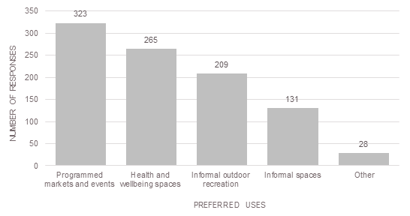
Preferred Uses | Number of Responses
Programmed markets and events | 323
Health and wellbeing spaces | 265
Informal outdoor recreation | 209
Informal spaces | 131
Other | 28

Many participants provided details of other uses they would like to see in the proposed new open space. These responses have been grouped together under common themes below:
- retain the current car parking or provide free or cheaper parking (24)
- parks, gardens or green spaces (31)
- other facilities such as toilets or bike racks (8)
- interpretative signage, such as information and stories related to the market’s history (8)
In total, 32 public survey participants preferred none of the options presented or were unsure which options they preferred.
Feedback from the stakeholder discussion groups showed a preference for the proposed new open space to reflect the history of the market.

Car parking and access
City of Melbourne and QVM Pty Ltd are committed to replacing the current car park at Franklin and Queen streets and improving access to the market precinct. Participants were asked to identify what would make it easier for them to access the market from the list of provided options.
Participants were invited to select multiple answers from the following options:
- Improved car parking
- Improved public transport
  - Trams
  - Trains
- Buses
- Improved cycling paths ad storage facilities
- Improved pedestrian amenity and safety
- Improved disability and aged care access and facilities
- Other.
Participants were also invited to offer other suggestions outside of these options.
This question received a total of 1,708 responses, comprising 1,474 responses from public participants and 234 from traders. Feedback has been analysed separately for trader and public survey participants.

Trader feedback
In total 234 responses were received from 150 traders. Feedback incorporated a broad array of ideas which have then grouped by common themes.
Traders showed a clear preference towards improved car parking as it would make it easier to access the market. This was followed by improved public transport (all modes).
Traders showed a clear preference (57 per cent) for improved car parking at the market

Figure 13: What would make it easier for traders to access the market?
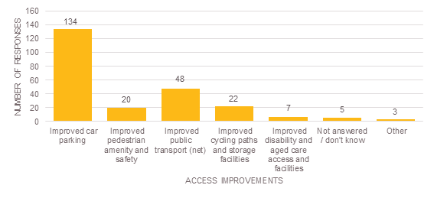

Access Improvements | Number of Responses
Improved car parking | 134
Improved pedestrian amenity and safety | 20
Improved public transport (net) | 48
Improved cycling paths and storage facilities | 22
Improved disability and aged care access and facilities | 7
Not answered/don’t know | 5
Other | 3

A total of seven participants requested free or cheaper parking for market customers. This was reiterated through a series of discussion groups, in which traders suggested that parking affordability and clarity around the quantity and location of relocated parking should be a priority of the Final Draft Master Plan. Improved pedestrian amenity across Queen Street, and the removal of public vehicle access through Victoria Street and Therry Street was identified by traders as key strengths of the Draft Master Plan. Traders also felt that the removal of roundabouts on Franklin Street would make it easier to cross the road in these areas.

Public transport
Participants who said that improved public transport would improve their access to the market were asked to identify a mode. Participants were able to select multiple transport modes. Overall, traders favoured public transport improvements for trams, however train and bus improvements were also supported.
Figure 14: What public transport improvements would make it easier for traders to access the market?
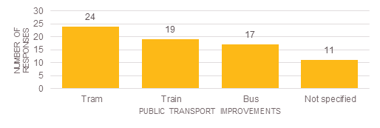
Public Transport Improvements | Number of Responses
Tram | 24
Train | 19
Bus | 17
Not specified | 11

Through discussion forums traders also raised the opportunity for an improved bus hub to service the market. A number of Trader Groups suggested that bus parking should be located closer to the main market and visitor centre. Traders suggested that adequate public transport such as extended bus timetables we required to support longer opening hours and night time activities at the market. Traders also identified the potential for shuttle bus services to the market from other major transport hubs. There was concern that the existing tram stop on Elizabeth Street was difficult to access for market visitors with trolleys.

Public feedback
In total 1,581 suggestions were received from 933 public participants. Feedback incorporated a broad array of ideas which were then grouped by common themes.
Public participants placed priority on improved pedestrian amenity and safety as a way to improve their access to the market. Improved car parking was also a popular response, closely followed by improved public transport.
Public participants favoured improved pedestrian amenity and safety (25 per cent) as a way to improve their access to the market

Figure 15: What would make it easier for the public to access the market?
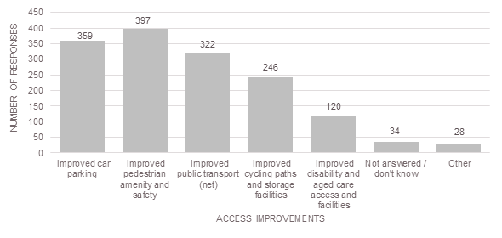
Access Improvements | Number of Responses
Improved car parking | 359
Improved pedestrian amenity and safety | 397
Improved public transport (net) | 322
Improved cycling paths and storage facilities | 246
Improved disability and aged care access and facilities | 120
Not answered/don’t know | 34
Other | 28

Participants were invited to provide additional feedback regarding car parking and access. These comments further supported the preference for improved car parking with 18 participants requesting free or cheaper parking for market users. Participants were invited to provide further comments on other opportunities to improve public access to the market. These responses were grouped under common themes, and are listed below:
- Free or cheaper parking (18)
- Better traffic flow / less traffic on Franklin and Queen Streets (12)
- Retain the current parking (11)
Feedback from conversations held during a series of stakeholder forums identified a desire for better access and more facilities for mothers and babies, as well as other people and groups with specific needs. Wayfinding signage and touchscreens were identified as a priority for the Final Draft Master Plan. The need for high quality and convenient customer car parking was a strong theme of stakeholder forums with a suggestion to provide free car parking at key times.

Public transport
Survey participants who identified improved public transport as a way to improve their access to the market were asked to identify a mode. Participants were able to select multiple public transport modes. Participants showed a clear preference for tram improvements, however train improvements were also a popular choice.
Of those public participants who said that improved public transport, over half (61 per cent) said improvement to trams

Figure 16: What public transport improvements would make it easier for the public to access the market?
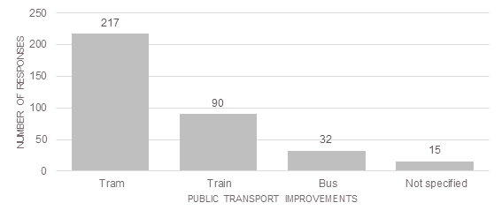
Public Transport Improvements | Number of Responses
Tram | 217
Train | 90
Bus | 32
Not specified | 15

Feedback received through stakeholder forums suggests that access and parking for buses should be a priority of the Final Master Plan.

Celebrating the market’s history
The Draft Master Plan recognises the historical significance of QVM. It is an important Aboriginal cultural place, the site of Melbourne’s first cemetery and it began as the city’s main wholesale food market. From a short list of options, which were informed by what traders, residents and visitors said during the previous two phases of community engagement, participants were asked to choose up to three preferred ways to celebrate the market’s history. Participants were invited to select multiple answers from the following options:
  - Artwork for example, light installations, sculptures, photography
  - Landscape features for example, commemorative or reflective spaces, formal plantings, public seating
  - Signage for example information and stories related to QVM’s history, wayfinding
  - Activities for example walking tours, performances, cultural events, art and craft
  - Other.
Participants were also invited to offer other suggestions outside of these options.
This question received a total of 2,398 responses. Feedback has been analysed separately for trader and public survey participants.

Trader feedback
In total 327 suggestions were received from 155 trader participants. Feedback incorporated a broad array of ideas which were then grouped by common themes.
Traders preferred artwork, signage or landscape features as ways to celebrate the market’s history. Traders showed less preference for activities.
Traders preferred artwork (27 per cent), signage (26 per cent) or landscape features (26 per cent) as ways to celebrate the Market’s history

Figure 17: Preferred ways for traders to celebrate the market’s history.

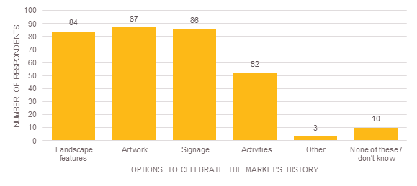
Options to Celebrate the Market’s History | Number of Respondents
Landscape features | 84
Artwork | 87
Signage | 86
Activities | 52
Other | 3
None of these/don’t know | 10

When invited to provide other ideas of ways to celebrate the market’s history five traders suggested a use that includes acknowledgement of Aboriginal heritage or culture.
Feedback received through a series of trader forums showed a strong preference to retain the character of the market and key heritage elements such as the historic Dairy Hall. Traders emphasised the importance of retaining the quality of produce and range of offers, and ensuring that the market does not become a supermarket. Some traders suggested that the heritage façade of the Munro site should be retained while others suggest a new vertical green wall. The character of Therry Street was seen as important along with new businesses that could help to link the site to the existing market area. Traders also suggested that public art and the market’s heritage elements could be used to create strong entry points and landmarks to attract visitors to the market.

Public feedback
In total 2,071 suggestions were received from 965 public participants. Feedback incorporated a broad array of ideas which were then grouped by common themes.
Public participants reflected trader feedback with a preference for landscape features followed by artwork and signage as ways to celebrate the market’s history over activities.
Public participants preferred landscape features (28 per cent), artwork (25 per cent) or signage (25 per cent) as ways to celebrate the market’s history

Figure 18: Preferred ways for the public to celebrate the market’s history.
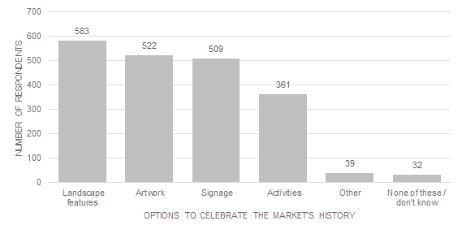
Options to Celebrate the Market’s History | Number of Respondents
Landscape features | 583
Artwork | 522
Signage | 509
Activities | 361
Other | 39
None of these/don’t know | 32

When invited to provide other ideas, 20 public participants suggested a use that acknowledges Aboriginal heritage or culture. A further five participants suggested that works should not be built over the cemetery under the existing car park, this was also a strong theme from feedback received during the stakeholder discussion groups.
At the stakeholder discussion groups the historic Meat and Dairy Hall was identified as a key strength of the Draft Master Plan with respect to the market’s heritage. Additionally, discussion group attendees expressed a preference for the Final Master Plan to incorporate strong links to heritage aspects of the precinct, specifically with regard to the cemetery underneath the current car park in Q3 – Quarter Three. The opportunity to use interpretive signage to reflect the precinct’s history was raised, with a focus on the shared history of various cultural groups including the Chinese and Wurundjeri communities. Stakeholders suggested that defining the ‘authentic experience’, and creating intensity and vibrancy should be priorities in the Final Master Plan to support a strong heritage theme.

Introducing the Market Cross
The Draft Master Plan includes a series of new public spaces called the Market Cross within the heart of the market precinct. This responds to feedback provided in earlier stages which identified the need to improve road safety and prioritising pedestrian and bicycle access. The proposed Market Cross proposes this by reducing kerb side parking and private vehicle access from Queen Street between Victoria and Therry streets.
Participants were asked what features and activities they would like to see in the new public spaces proposed for Market Cross. This question invited open field responses which allowed participants to make their own suggestions without pre-assigned categories.
This question received a total of 2,305 responses. Feedback has been analysed separately for trader and public survey participants.

Trader Feedback
In total 279 suggestions were received from 129 trader participants. Feedback incorporated a broad array of ideas which were then grouped by common themes.
The most common suggestion was for seating to be provided in Market Cross. Traders indicated a preference for increased public activity in Market Cross, with pop-up stalls, buskers or music, and events, entertainment or activities being popular ideas.
The most common suggestion by traders for Market Cross was seating (20 per cent), closely followed by additional market stalls (16 per cent)

Figure 19: What features and activities would traders like to see in the new public spaces proposed for Market Cross?
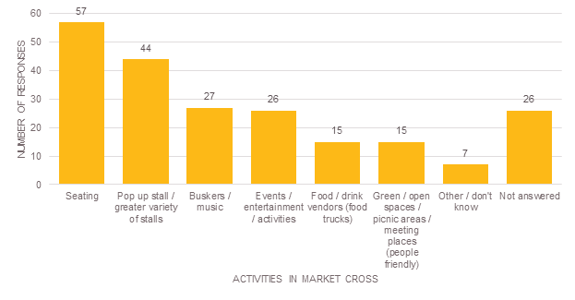
Activities in Market Cross | Number of Responses
Seating | 57
Pop-up stall/greater variety of stalls | 44
Buskers/music | 27
Events/entertainment/activities | 26
Food/drink vendors (food trucks) | 15
Green/open spaces/picnic areas/meeting places (people-friendly) | 15
Other/don’t know | 7
Not answered | 26

Other suggestions made by trader participants for uses within the new area at Market Cross included:
  - Public art (11)
  - No reduction, or increased supply of parking and disabled parking (11)
  - Shaded or sheltered areas (7)
  - Other cultural events (6)
  - More or improved toilets and drinking fountains (4)
  - Family friendly areas such as play grounds (4)
During the discussion groups, traders identified the Market Cross as a strength of the Draft Master Plan.

Public feedback
In total 1,906 suggestions were received from 845 public participants. Feedback incorporated a broad array of ideas which were then grouped by common themes.
The most common suggestion for the new public space in Market Cross was seating. Feedback from public survey participants also indicates a preference for increased public activity in Market Cross, with pop-up stalls, buskers or music, and events, entertainment or activities being popular ideas. Additionally, public participants also indicated a preference for informal uses such as green and open spaces, picnic areas, meeting places, pop-up stalls and more diverse stalls in this area.
The most common suggestion by the public for Market Cross was seating (22 per cent)

Figure 20: What features and activities would the public like to see in the new public spaces proposed for Market Cross?
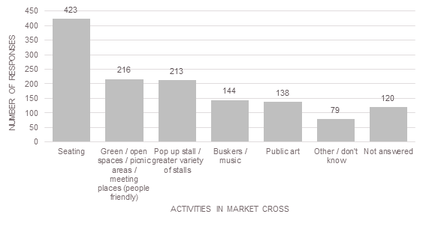
Activities in Market Cross | Number of Responses
Seating | 423
Green/open spaces/picnic areas/meeting places (people-friendly) | 216
Pop-up stall/greater variety of stalls | 213
Buskers/music | 144
Public Art | 138
Other/don’t know | 79
Not answered | 120

Public participants had many varied suggestions regarding the use of the new space in Market Cross. The remaining themes have been listed in order of preference below:
  - Events, entertainment or activities (117)
  - Food and drink vendors including food trucks (105)
  - Pedestrian friendly areas, improved universal access and areas free of car and obstacles to access free areas (91)
  - Shaded areas/shelter (80)
  - Family friendly areas such as play grounds (56)
  - Other cultural events (36)
  - Historical / culturally sensitive areas and information (35)
  - Bike Facilities such as bike parking and cycle paths (35)
  - No reduction, or increased supply of parking and disabled parking (22)
  - Educational events, classes or information (30)
  - More or improved toilets and drinking fountains (22)
  - No change (18)
  - Better signage such as way finding signage or an information centre (11)
  - Environmental sustainable facilities (10)
  - ATM and money exchange facilities (6).
  - Upgraded trader facilities
The market is in need of upgraded facilities and improved infrastructure. The Draft Master Plan proposes to create dedicated back of house areas for each of the market’s major trading areas. The improvements aim to increase efficiency, cleanliness and displays and to make it a better place to work.
Traders were asked to provide a rating between one to five (one being not important and five being very important) for a range of upgrade scenarios across three quarters of the market precinct. This feedback will assist the project team to validate that issues were relevant and understand which of the potential upgrades are of higher priority for existing traders in the existing trading areas.
Traders were invited to respond to questions regardless of where their stall was located within the market. This means that a trader could answer questions on Q1 – Quarter One upgrades even if their business was located in Q3 – Quarter Three. We have provided separate analysis for traders who have completed questions relating to the quarter within which they operate, and traders who have completed questions relating to all quarters of QVM.

Q1 – Quarter One
Traders were asked to indicate the level of importance of the Q1 – Quarter One upgrades proposed in the Draft Master Plan. The upgrades seek to improve the back of house trader amenities, delivery, and storage and waste management facilities.

Reduce the conflicts between service vehicles and public access
A total of 116 traders, comprising 36 traders from Q1 – Quarter One, and 80 traders from other areas of the market responded to this question. Participants from both groups rated this question similarly, with 36 per cent rating improvements to reduce conflicts between service vehicles and public access as very important.
The highest proportion of Q1 – Quarter One traders (36 per cent) said that reducing conflicts between service vehicles and public access was very important

Figure 21: How important is it to reduce the conflicts between service vehicles and public access in Q1 – Quarter One?
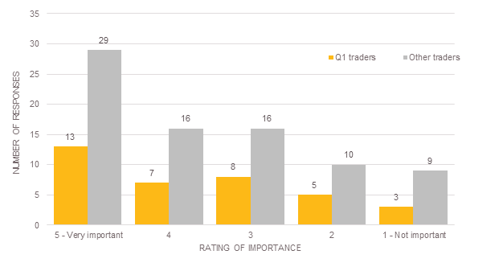

Rating of Importance | Number of Participants – Q1 traders | Number of Participants – other traders
5 – Very Important | 13 | 29
4 | 7 | 16
3 | 8 | 16
2 | 5 | 10
1 – Not Important | 3 | 9

Improve access for delivery and waste removal by including a new loading dock, off-street loading areas, wash-down services and storage facilities
A total of 114 traders, comprising 34 traders from Q1 – Quarter One and 80 traders from other areas of the market responded to this question. Traders from Q1 – Quarter One generally rated these improvements as more important with 68 per cent giving a rating of four or five compared with 55 per cent of other traders.
The largest proportion of Q1 – Quarter One traders (47 per cent) said that improving access for delivery and waste removal in Q1 was very important

Figure 22: Quarter 1 – How important is it to improve access for delivery and waste removal in Q1 – Quarter One?
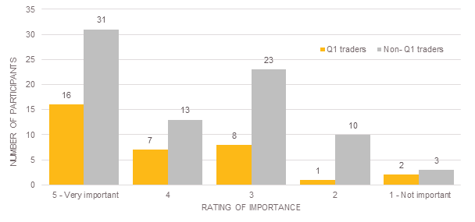
Rating of importance | Number of Participants – Q1 traders | Number of Participants – other traders
5 - Very important | 16 | 31
4 | 7 | 13
3 | 8 | 23
2 | 1 | 10
1 - Not important | 2 | 3

Improve trader amenities with the inclusion of showers, toilets, breakout spaces and storage
A total of 115 traders, comprising 35 traders from Q1 – Quarter One, and 79 traders from other areas of the market responded to this question. The largest proportion of traders from Q1 – Quarter One and other areas of the market both rated this improvement as very important (49 per cent and 41 per cent respectively).
Figure 23: Quarter 1 – How important is it to improve trader amenities in Q1 – Quarter One?
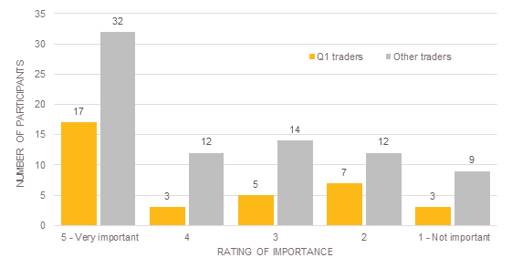
Rating of importance | Number of Participants – Q1 traders | Number of Participants – other traders
5 - Very important | 17 | 32
4 | 3 | 12
3 | 5 | 14
2 | 7 | 12
1 - Not important | 3 | 9

Improve waste management and recycling facilities for meat and fish offal, organics and packaging
A total of 115 traders, comprising 36 traders from Q1 – Quarter One, and 79 traders from other areas of the market responded to this question. The largest proportion of traders from both Q1 – Quarter One and other areas of the market rated this improvement as very important (50 per cent and 41 per cent respectively). However, traders from Q1 – Quarter One generally rated this improvement more important overall.
The largest proportion of traders from both Q1 – Quarter One (50 per cent) and from other areas of the market (41 per cent) said improving waste management and recycling facilities in Q1 – Quarter One was very important

Figure 24: Quarter 1 – How important is it to improve waste management and recycling facilities in Q1 – Quarter One?
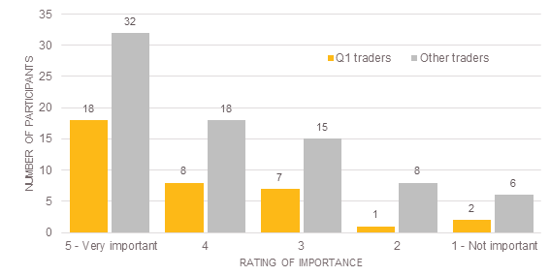
Rating of importance | Number of Participants – Q1 traders | Number of Participants – other traders
5 - Very important | 18 | 32
4 | 8 | 18
3 | 7 | 15
2 | 1 | 8
1 - Not important | 2 | 6

Develop sustainable precinct-wide infrastructure for power, water, waste management and recycling
A total of 115 traders, comprising 36 traders from Q1 – Quarter One, and 79 traders from other areas of the market responded to this question. Over half of the traders from Q1 – Quarter One (53 per cent) and the largest proportion of traders from other areas (46 per cent) rated this improvement as very important. Overall, traders from areas other than Q1 – Quarter One more commonly rated this improvement as neutral or not important.
Feedback received through trader discussion groups highlighted a desire for improved heating and cooling in the Deli Hall.
Over half of the traders from Q1 – Quarter One (53 per cent) and the largest proportion of traders from other areas (46 per cent) said developing sustainable precinct-wide infrastructure was very important

Figure 25: Quarter 1 – How important is it to develop precinct wide infrastructure in Q1 – Quarter One?
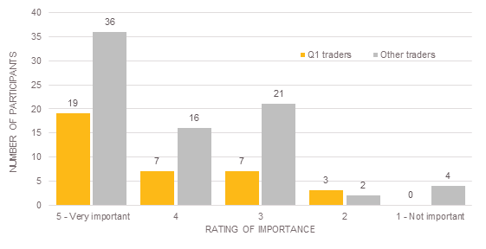
Rating of importance | Number of Participants – Q1 traders | Number of Participants – other traders
5 - Very important | 19 | 36
4 | 7 | 16
3 | 7 | 21
2 | 3 | 2
1 - Not important | 0 | 4

Quarter 2
Traders were asked to indicate the level of importance of the Q2 – Quarter Two upgrades proposed in the Draft Master Plan. The upgrades seek to improve the back of house trader amenities, delivery, and waste management facilities.

Reduce the conflicts between forklift and other service vehicles and public access
A total of 108 traders, comprising 25 traders from Q2 – Quarter Two, and 83 traders from other areas of the market answered this question. Over half of traders operating within Q2 – Quarter Two rated this improvement as very important (52 per cent). A further 24 per cent rated this improvement a rating of four. Traders from other areas of the market, generally considered this improvement important with a combined total of 60 per cent of traders giving a rating of four or five.
The majority of Q2 – Quarter Two traders (52 per cent) said that reducing conflicts between forklifts and other service vehicles and public access in Q2 – Quarter Two was very important

Figure 26: Quarter 2 – How important is it to reduce conflicts between forklifts and other service vehicles and public access in Q2 - Quarter Two?
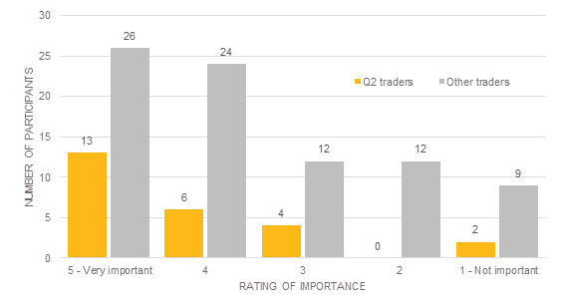
Rating of importance | Number of Participants – Q2 traders | Number of Participants – other traders
5 - Very important | 13 | 26
4 | 6 | 24
3 | 4 | 12
2 | 0 | 12
1 - Not important | 2 | 9

Improve access for delivery including off-street loading and break-down areas, wash-down services and storage facilities
A total of 108 traders, comprising 25 traders from Q2 – Quarter Two, and 83 traders from other areas of the market responded to this question. Almost half of traders operating in Q2 – Quarter Two rated this improvement as very important (48 per cent), compared with 34 per cent of traders from other areas of the market. A further 36 per cent of traders from Q2 – Quarter Two gave this improvement a rating of four. Traders from other areas of the market, were more likely to rate this improvement as neutral or not important.
The majority of Q2 – Quarter Two traders (48 per cent) said that improving access for delivery in Q2 – Quarter Two was very important

Figure 27: Quarter 2 – How important is it to improve access for delivery in Q2 - Quarter Two?
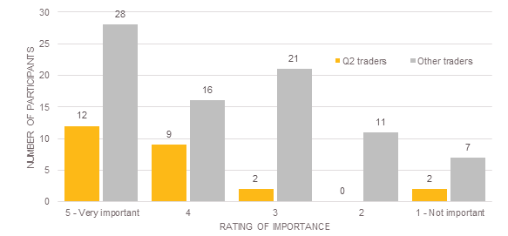
Rating of importance | Number of Participants – Q2 traders | Number of Participants – other traders
5 - Very important | 12 | 28
4 | 9 | 16
3 | 2 | 21
2 | 0 | 11
1 - Not important | 2 | 7

Improve trader facilities with the inclusion of showers, toilets, breakout spaces and storage
A total of 112 traders, comprising 28 traders from Q2 – Quarter Two, and 84 traders from other areas of the market responded to this question. The largest proportion of traders from both Q2 – Quarter Two and other areas of the market rated this improvement as very important (36 per cent and 32 per cent respectively). However a combined total of 28 per cent of traders from Q2 – Quarter Two gave this improvement a rating of either one or two, indicating that they did not consider these improvements important.
The highest proportion of Q2 – Quarter Two traders (36 per cent) said that improving trader facilities in Q2 – Quarter Two was very important

Figure 28: Quarter 2 – How important is it to improve trader facilities in Q2 - Quarter Two?
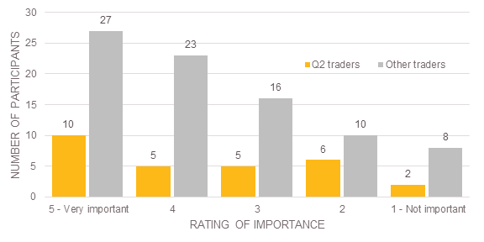
Rating of importance | Number of Participants – Q2 traders | Number of Participants – other traders
5 - Very important | 10 | 27
4 | 5 | 23
3 | 5 | 16
2 | 6 | 10
1 - Not important | 2 | 8

Improve waste management facilities with a focus on organic waste
A total of 111 traders, comprising 27 traders from Q2 – Quarter Two, and 84 traders from other areas of the market responded to this question. Almost half of traders from Q2 – Quarter Two rated this improvement as very important (48 per cent), with a further 30 per cent giving this improvement a rating of four. This indicates that this improvement is very important or important to traders within Q2 – Quarter Two.
Traders from other areas of the market generally considered this improvement important with a combined total of 54 per cent giving a rating of four or five. However 29 per cent of traders from other areas rated the importance of this improvement as a three, suggesting that it was neutral.
The greatest proportion of Q2 – Quarter Two traders (48 per cent) said that improving waste management facilities in Q2 – Quarter Two was very important

Figure 29: Quarter 2 – How important is it to improve waste management facilities in Q2 - Quarter Two?
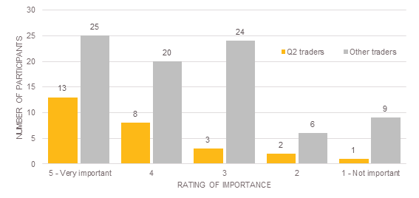
Rating of importance | Number of Participants – Q2 traders | Number of Participants – other traders
5 - Very important | 13 | 25
4 | 8 | 20
3 | 3 | 24
2 | 2 | 6
1 - Not important | 1 | 9

Develop sustainable precinct-wide infrastructure
A total of 106 traders, comprising 26 traders from Q2 – Quarter Two, and 80 traders from other areas of the market answered this question. Half of traders from Q2 – Quarter Two rated this improvement as very important (50 per cent), with a further 31 per cent giving this improvement a rating of four. This indicates that this improvement is important or very important to traders within Q2 – Quarter Two.
Traders from other areas of the market generally considered this improvement important with a combined total of 59 per cent giving it a rating of four or five. However 26 per cent of traders from other areas rated the importance of this improvement as a three, suggesting that it was neutral.
Feedback received through trader discussion groups highlighted the need for improved heating and cooling in sheds such as ceiling fans.
Half of the Q2 – Quarter Two traders (50 per cent) said that developing sustainable precinct-wide infrastructure was very important

Figure 30: Quarter 2 – How important is it to develop sustainable precinct wide infrastructure in Q2 - Quarter Two?
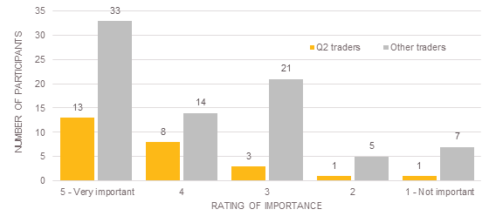
Rating of importance | Number of Participants – Q2 traders | Number of Participants – other traders
5 - Very important | 13 | 33
4 | 8 | 14
3 | 3 | 21
2 | 1 | 5
1 - Not important | 1 | 7

Quarter Three
Traders were asked to indicate the level of importance of the Q3 – Quarter Three upgrades proposed in the Draft Master Plan. The upgrades seek to improve the back of house trader amenities, delivery, and waste management facilities.

Develop specialist back of house amenities
A total of 111 traders, comprising 37 traders from Q3 – Quarter Three, and 74 traders from other areas of the market responded to this question. The largest proportion of traders from Q3 – Quarter Three three gave these improvements a rating of three, suggesting that they were of neutral importance. The remaining responses were evenly spread with 38 per cent considering these improvements as important (ratings of four or five), and 32 per cent indicated that these improvements were relatively not important (rating of one and two). Traders from other areas of the market generally considered these improvements to be more important with 36 per cent giving a rating of five.
Traders from other areas of the market considered these improvements to be more important with 36 per cent saying that developing specialist back of house amenities in Q3 – Quarter Three was very important

Figure 31: Quarter 3 – How important is it to develop specialist back of house amenities in Q3 - Quarter Three?
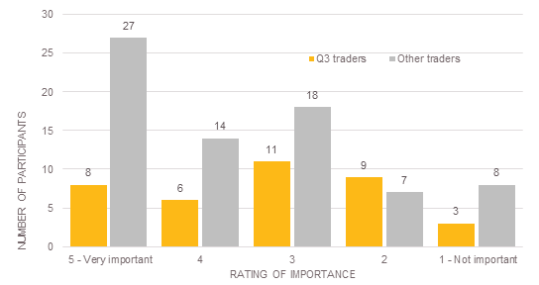
Rating of importance | Number of Participants – Q3 traders | Number of Participants – other traders
5 - Very important | 8 | 27
4 | 6 | 14
3 | 11 | 18
2 | 9 | 7
1 - Not important | 3 | 8

Upgrade the infrastructure to support events including alternative market operations and arrangements
A total of 113 traders, comprising 38 traders from Q3 – Quarter Three, and 75 traders from other areas of the market answered this question. Half of traders from Q3 – Quarter Three rated these improvements as a four or five suggesting that these improvements were generally important. A further 37 per cent gave these improvements a rating of three, suggesting that they were of neutral importance.
Traders from other areas of the market generally considered these improvements to be more important with a combined total of 55 per cent giving a rating of five or four.
The highest proportion of traders from Q3 – Quarter Three considered these improvements to be of neutral importance with 36 per cent rating upgrading infrastructure to support large events in Q3 – Quarter Three a rating of three

Figure 32: Quarter 3 – How important is it to upgrade infrastructure to support events in Q3 - Quarter Three?
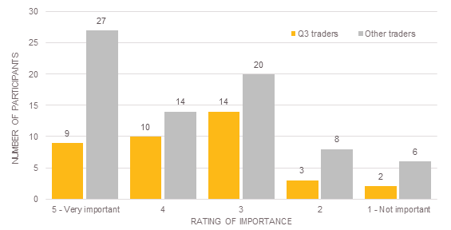
Rating of importance | Number of Participants – Q3 traders | Number of Participants – other traders
5 - Very important | 9 | 27
4 | 10 | 14
3 | 14 | 20
2 | 3 | 8
1 - Not important | 2 | 6

Upgrade waste management facilities
A total of 112 traders, comprising 38 traders from Q3 – Quarter Three, and 74 traders from other areas of the market responded to this question. Half of the traders from Q3 – Quarter Three rated these improvements as a four or five, suggesting that these improvements were generally important. A further 32 per cent gave these improvements a rating of three, suggesting that they were of neutral importance. Traders from other areas of the market generally considered these improvements to be more important with a combined total of 62 per cent giving a rating of five or four.
Half of the traders from Q3 – Quarter Three (50 per cent) rated upgrading waste management facilities for Q3 – Quarter Three as a four or five, suggesting that these improvements were generally important

Figure 33: Quarter 3 – How important is it to upgrade waste management facilities in Q3 - Quarter Three?

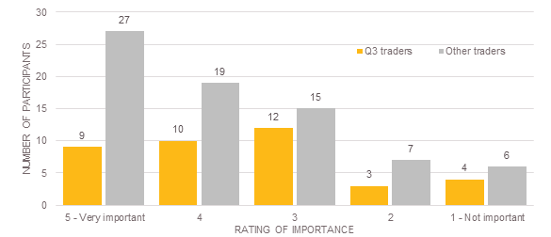
Rating of importance | Number of Participants – Q3 traders | Number of Participants – other traders
5 - Very important | 9 | 27
4 | 10 | 19
3 | 12 | 15
2 | 3 | 7
1 - Not important | 4 | 6

Develop sustainable precinct-wide infrastructure
A total of 113 traders, comprising 38 traders from Q3 – Quarter Three, and 75 traders from other areas of the market responded to this question. Participants from both Q3 – Quarter Three and other areas of the market rated this question similarly. There is a clear indication from both Q3 – Quarter Three traders and traders from other areas that these improvements are important.
The highest proportion of Q3 – Quarter Three traders (42 per cent) and traders from other areas of the market (43 per cent) said that developing sustainable precinct-wide infrastructure is very important

Figure 34: Quarter 3 – How important is it to develop sustainable precinct-wide infrastructure in Q3 - Quarter Three?
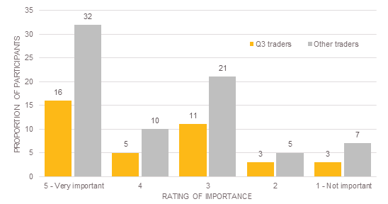

Rating of importance | Number of Participants – Q3 traders | Number of Participants – other traders
5 - Very important | 16 | 32
4 | 5 | 10
3 | 11 | 21
2 | 3 | 5
1 - Not important | 3 | 7

Opening hours
In the future, there is an opportunity to enhance the market as a destination that provides a changeable range of offers seven days a week, from morning to night, such as fresh food, general merchandise, specialty markets and events and festivals. Participants were asked to rate their level of support for this statement from one, not supportive, to five, very supportive. Feedback helps the project team to understand how participants feel about the concept of new and diversified trading hours for the market precinct. Participants were also invited to provide further comments to expand on why they do or do not support this statement. These have been grouped into themes and listed below.
This question received a total of 1,091 responses. Feedback has been analysed separately for trader and public survey participants. Responses have been shown proportionally. Participants responding to this statement with a rating of four or five are considered to be in support of the statement, those providing a rating of one and two are considered to be unsupportive, and a rating of three is considered to be neutral. The proportions have been calculated based on the total number of participants answering this question.
A total of 50 per cent of traders are supportive of the concept to enhance the market as a destination that provides a changeable range of offers

Trader feedback
A total of 151 trader participants ranked their support for this statement. This is shown in Figure 35 below. A total of 50 per cent of traders are supportive of the statement and 38 per cent were unsupportive. The largest portion of traders were very supportive of the statement (34 per cent).

Figure 35: Trader feedback – How supportive are traders of the concept to enhance the market as a destination that provides a changeable range of offers?
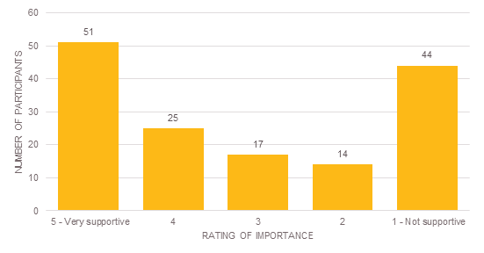
Rating of support | Number of participants
5 - Very supportive | 51
4 | 25
3 | 17
2 | 14
1 - Not supportive | 44

When invited to expand further on their rating, trader participants provided a range of reasons for their support of the concept to enhance the market as a destination that provides a changeable range of offers. These have been grouped into themes and are listed below:
  - Extend the opening hours or more open days would be more convenient (32)
  - The market is a tourist attraction (12)
  - Extended hours would be good for traders (7)
  - Extended hours can accommodate more events to attract customers (7)
  - The current opening hours and days are confusing (6)
  - Extended hours create opportunities for a changeable or enhanced range of offers to attract customers (4).
Many trader groups saw the proposed new opening hours, greater utilisation of space on non-market days and new activities as a strength of the Draft Master Plan as it would attract new customers to the market. Additionally the feedback received during the trader discussion groups also supported increased diversity of uses, events and activities to attract new customers.
Traders who were unsupportive of the concept provided additional comments; these have been grouped into themes and are listed below:
  - Extended hours would be too long for traders, the market doesn’t need to be open 24/7 (39)
  - Extended opening hours would change the nature of the market and it would lose its charm (14)
  - The current opening hours and days are fine (7).
Feedback received at the trader discussion groups raised concerns stating that increased trading hours would require additional security and management of noise and pollution.

Public feedback
A total of 940 public participants answered this question. Overall, 63 per cent of the public are supportive of the concept to enhance the market as a destination that provides a changeable range of offers, and a total of 20 per cent unsupportive. While the largest proportion of participants (44 per cent) were very supportive of the concept, a total of 14 per cent were very unsupportive. This suggests that public participants felt strongly about the proposed concept in both a positive and negative sense.
A total of 63 per cent of the public are supportive of the concept to enhance the market as a destination that provides a changeable range of offers

Figure 36: Trader feedback – How supportive are the public of the concept to enhance the market as a destination that provides a changeable range of offers?
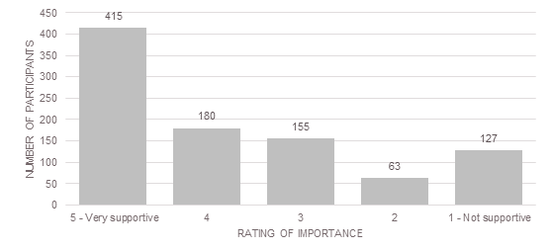

Rating of support | Number of participants
5 - Very supportive | 415
4 | 180
3 | 155
2 | 63
1 - Not supportive | 127

When invited to expand further on their rating, public participants provided a broad range of reasons for their support of the concept to enhance the market as a destination that provides a changeable range of offers. These have been grouped into themes and are listed below:
  - Extended opening hours or more open days would be more convenient (323)
  - Extended hours would better utilise the space and facilities at QVM (112)
  - Tourist attraction (64)
  - Extended hours create opportunities for a changeable or enhanced range of offers to attract customers (69)
  - More events to attract customers (50)
  - More accessible to all (42)
  - Current opening hours and days are confusing (29)
  - Good for traders (22).

Public participants who were unsupportive of the concept provided additional comments; these have been grouped into themes and are listed below:
  - Extended hours would be too long for traders, the market doesn’t need to be open 24/7 (188)
  - Extended hours would change the nature of the market/lose its charm (111)
  - The current opening hours and days are fine (70)
  - Extended hours would be disruptive for residents especially with noise and traffic issues (30)
  - The quality of goods would decline (13).

Participation in previous phases of engagement
Participants were asked to indicate whether they had been involved in previous phases of engagement for the QVM Precinct Renewal. This question received a total of 1,089 responses. Feedback has been analysed separately for trader and public survey participants.

Trader feedback
A total of 155 traders answered this question. Almost half (45 per cent) of traders who responded to this question indicated that they had been involved in previous phases of engagement.

Figure 37: Trader feedback - Trader participants in previous phases of engagement
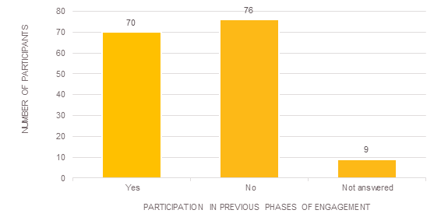
This table chart highlights that 70 traders participated in previous phases of engagement, 76 had not participated in previous phases of engagement and 9 traders did not answer this question.
In trader discussion groups, many traders emphasised the importance of ongoing engagement through subsequent stages of the project. Specifically, many trader groups expressed a desire for more clarity of potential disruptions and projected timeframes during construction activities.

Public feedback
A total of 965 public participants answered this question. In contrast, most public participants (84 per cent) had not been involved in previous phases of engagement.

Figure 38: Public feedback - Public participants in previous phases of engagement
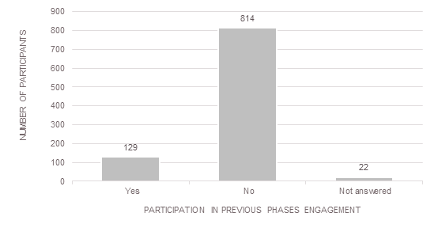
This table chart highlights that 129 members of the public participated in previous phases of engagement, 814 had not participated in previous phases of engagement and 22 did not answer this question.

Previous engagement
Participants who had been involved in previous phases were then asked to rate out of five how successfully the Draft Master Plan reflects the feedback they provided in the previous phases of engagement with one being not successful, and five being very successful. This helps us to assess and continually improve our engagement process and review our final outcome.
Participants responding to this statement with a rating of four or five are considered to feel that the Draft Master Plan has been very successful in reflecting feedback provided in previous phases and those providing a rating of one and two are considered to feel that it has been unsuccessful. A rating of three is considered to be neutral. To allow meaningful comparison between the trader and public participants, responses to this question have been converted to proportions.
The highest proportion of both trader and public participants was neutral (a rating of three). A slightly higher proportion of traders believe that the Draft Master Plan does not successfully reflect the feedback they provided in previous phases with 30 per cent of participants giving a rating of one or two. A total of 25 per cent of traders do feel that the Draft Master Plan has successfully reflected their feedback.
A slightly higher proportion (36 per cent) of public participants believe that the Draft Master Plan does successfully reflect their feedback from previous phases of engagement, with 31 per cent feeling like the Draft Master Plan does successfully reflect their feedback.

Figure 39: Previous engagement – how successfully does the Draft Master Plan reflect what you told us during previous phases of engagement?
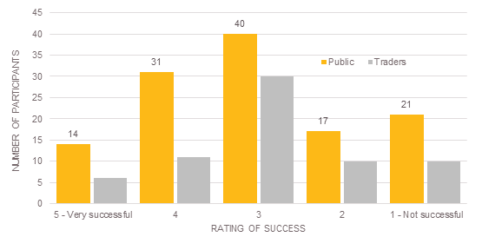
Rating of success | Number of participants – public | Number of participants - traders
5 - very successful | 14
4 | 31
3 | 40
2 | 17
1 – not successful | 21

Further comments on the draft master plan
Participants were invited to offer any further comments on the Draft Master Plan. This question invited open field responses, which allowed participants to make their own suggestions without pre-assigned categories. For reporting, each separate idea is counted as a single response and ideas have been grouped into common themes. In total, 1,275 responses to this question were received including 1,120 from public participants and 155 from traders.

Trader feedback
A total of 155 responses were received from 72 traders. Feedback themes are broad and relate to specific areas or proposals within the Draft Master Plan, aspects of the planning and consultation process and the overall vision and direction for QVM. Table 5 lists the five most common themes from traders.
Feedback about the process and the vision of the plan was also common with twelve responses suggesting improved project consultation, eleven expressing support for the Draft Master Plan, and a further six responses indicating reservations or requesting more information about the project.

Table 5 – Do you have any further comments on the draft master plan?
Statement | Responses
Increase / better parking | 21
Better community consultation about the renewal | 12
It is a good plan / I look forward to it | 11
The market should be left as is / make only minimal changes | 11
Would like cheap parking | 8
I have reservations / I would like to know more about it | 6
Better quality stalls / implement restrictions on types of stalls | 6
Greater variety of stalls | 6

Public feedback
A total of 1,120 responses were received from 544 public participants. Feedback themes are broad and relate to specific areas or proposals within the Draft Master Plan, aspects of the planning and consultation process and the overall vision and direction for the market. The most common feedback received from public participants was that the market should be left as it is or with only minimal changes (103). However support for the Draft Master Plan was also a common theme with a total of 93 comments. Table 6 lists the five most common themes from the public participants.

Table 6 - Do you have any further comments on the Draft Master Plan?
Statement | Responses
The market should be left as is or with only minimal changes | 103
It is a good plan / I look forward to it | 93
Historical / cultural concerns | 81
Better quality stalls / implement restrictions on types of stalls | 61
Increased or improved parking | 56

Submissions
The following provides a summary of submissions made by individuals and organisations to the Draft Master Plan. Although not formally requested, submissions were accepted throughout the engagement period. In total, 18 submissions were received. Table 7 details a summary of the submissions received.
Table 7 - Summary of submissions to the Draft Master Plan
Number | Submitter | Submission summary
1 | Dean Steinberg, Adviser, Government and External Relations, Bicycle Network | Extended trading hours will generate additional vehicle trips and congestion. Transport efficiency, safety, and the public realm improvements proposed in the Draft Master Plan will be enhanced by supporting active transport through the provision of end of trip infrastructure such as on-street bike parking, a bicycle arrival station and the removal of roundabouts at the intersections of Dudley, Peel, and William streets, and Queen and Franklin streets.
2 | Dominic Esposito Solicitors on behalf of Mr Carl Greco, Bratwurst Shop and Co. and Pizza By Nature | It is acknowledged that the ownership and tenure arrangements within the Market precinct are complex, but that occupiers expect occupational rights will be renewed and that a collaborative relationship with QVM management, CoM and the State Government will be maintained throughout the renewal process. The submitter requests further information regarding governance arrangements for newly acquired and refurbished sites and assurances that existing businesses will not be adversely impacted by new competition or vested interests, specifically with regard to the Munro site. The submitter suggests the appointment of an independent supervisory and advisory body to oversee the renewal project, that all references listed on page 157 of the Strategic Brief be made publically available, that all interests and partnerships are disclosed, and a commitment is made to existing traders that the changes will not generate detrimental outcomes against the status quo.
3 | Elizabeth Vines, President, Australia, International Council on Monuments and Sites (ICOMOS) | ICOMOS supports the work CoM are doing to preserve the heritage of the Market. However they are concerned that World Heritage listing is an unrealistic expectation. They would prefer the expectations of the public were not raised to expect that this renewal will lead to QVM being listed on the World Heritage Register.
4 | Katy Dean, Director, Advocacy, Green Building Council Australia (GBCA) | The GBCA supports the QVM Precinct Renewal Draft Master Plan. In particular the Council commends CoM’s commitment to achieving the Green Star – Communities Certification. The Council is looking forward to working with CoM to achieve this certification.
5 | Chris Hardman, Regional Director, Melbourne, Parks Victoria | Parks Victoria supports the renewal plans for QVM. While the renewal has no direct impact on any parks, Parks Victoria believe the additional tourism potential will have positive ‘spin offs’ for parks in Melbourne. Parks Victoria would like to continue to be kept updated on the project.
6 | Angela Williams | Angela Williams supports reviewing trading hours at the market but no at adverse cost to small family businesses. She is concerned that built form changes on Peel Street, Victoria Street and edges of sheds will overshadow the market and block the historic views into the open sheds. She also does not support any activity that encourages franchises in the market including fixed trading, iconic tenants and increasing the footprint of the Victoria Street shops. She supports the increased pedestrian space and bicycle racks but does not feel that the Draft Master Plan fully resolves the traffic flow issues within the market.
7 | Shirley Pimmell | Shirley Pimmell supports aspects of the Draft Master Plan including recognising heritage and improving customer amenities, however she is concerned the plan lacks overarching ‘why’ drivers. She is particularly concerned with the increased trading hours (she does not see them as viable for small traders), encouraging new traders at the cost of existing ones, continuing the markets function during construction, the activation of Therry Street and the market edges. She would like to see the provision of more disabled parking in the Master Plan.
8 | QVM Dairy Hall Traders | The Dairy Hall Traders are concerned are that the market will be too sanitised and lose its ‘real human feel.’ They would like to see the market remain car friendly and have affordable and sufficient parking for market customers. The support keeping the synergy of H and I sheds as a one stop shop but are concerned about the prospect of seven day trading. It is important to them that not too much focus is put on attracting tourists and the market remains for and by locals. They support the purchasing of the Munro site, improving the perimeter of the market, having a Visitors Centre, shed upgrades, have a green belt in Market Cross, having multiple users of the upper market and improving public transport access. They want to see continued engagement with traders throughout the renewal process and improved relations between management and traders. The traders also highlight the additional stress of a possible rent increases within the renewal time frame. They support beginning some of the changes now to test them out including; enforcing rules around rubbish management, trailing a longer trading day, free or cheap parking for the first two hours and closing off Therry Street to traffic.
9 | Jenny Hickinbotham | Jenny Hickinbotham is concerned that if artwork is used to celebrate the markets history it will be wasted after the event. She would like to see artists paid for any contributions they make and that stall holders are consulted about what impacts the artwork or event will have on them.
10 | Yolande Leonardi | Yolande Leonardi strongly supports the plans to invest in the market and keep it in its current location. She also supports the ongoing community engagement that has taken place. Yolande supports many of the key elements of the Draft Master Plan including providing better facilities for the traders, keeping a focus on fresh goods and activating the market for events. She would like to see a wall of photos in the market to celebrate its history.
11 | Ingrid Galitis | Ingrid Galitis is concerned that additional buskers in and around QVM will override the ambient noises of the market and detract from the shopping experience.
12 | QVM General Merchandise Trader Representative | The General Merchandise Traders support the vision for the renewal and the opportunity to evaluate the market’s performance and future. They feel the weakness of the Draft Master Plan is a lack of detail about the transfer of the space between market and events. They are concerned that small businesses will be adversely affected by ‘ad-hoc transfer of trader activity to accommodate events’ and that the events would not complement the market activity. The General Merchandise Traders would like CoM to make the provision of more details about the construction phases of the renewal a priority. The would also like to see the continuation of promotion and marketing outside of the renewal such as the successful cruise ship buses, cash giveaways and visits from conference delegations.
13 | Mark Benson | Mark Benson supports the renewal of the QVM and highlights the Mercado da Ribeira as a great example of a of a market renewal.
14 | Olive Hamilton | Olive Hamilton supports giving the market some attention but does not want to see it lose its current nature. She states that seven day trading is provided in many centres nearby such as the Emporium, the market provides a different experience.
15 | Peter Langtry | Peter Langtry, a trader at QVM in the Deli Hall strongly supports the decision by CoM to purchase the Munro site and invest in the market to ensure it is a ‘jewel in place for future generations’. Peter suggests that to maximise the benefits from the purchase and the $130,000,000 from the State Government the car park should be relocated to one site within the Munro site. He suggests acquiring the Drummond Golf Building (perhaps under the Major Roads Facilitation Act 2009), which he believes will allow the construction of a large 800-1000 space car park with ramp access points onto Franklin Street.
16 | Tim Smith, Executive Director, Heritage Victoria, Department of Environment, Land, Water and Planning | Heritage Victoria supports the efforts CoM is taking to preserve the former cemetery and increase general public awareness of the site. Heritage Victoria have some concerns over the planned re-development of the H and I sheds, upgrades to open air sheds and Fish and Dairy Hall, new pavilions on Queens Street and improving the market edges. Their concern regards the ambiguity of the current descriptions and how they will work with the buildings that have heritage registration. Heritage Victoria reinforced their belief that the Conservation Management Plan needs to be updated.
17 | Jon Shinkfield, President, Victorian Chapter, Australian Institute of Landscape Architects (AILA) | AILA notes that new and improved open space and amenity is required to meet the needs of the growing population and increasing residential density around the market. CoM should consider the public space and street network within the larger market precinct, beyond the current scope of the Draft Master Plan. Specifically, the new open space provided through the removal of the car park in Q3 – Quarter Three should be designed as an important public place with a particular purpose and character. The values of Queen Street as open space should not be overlooked. The Draft Master Plan is generally supported, however relocated parking should be provided in a way that improves the overall precinct environment, on-street parking should be significantly reduced, and there should be a long term strategy to reduce customers’ reliance on cars overall.
18 | Gabrielle Fitzgerald, Deputy Director Corporate and Client Services, RMIT University | RMIT expressed concern about the proposed amendment to traffic conditions. In particular, the proposal to relocate 700 car parking spaces to Therry Street (Munro site) and remove traffic egress into Elizabeth Street in favour of diverting all traffic along the continuation of Therry Street to Victoria Road which may potentially impact RMIT Campus. Amendments to Franklin Street and inclusion of buses will increase traffic volumes including at the intersection of Swanston Street which is a major student thoroughfare.

Next steps
The feedback included in this report will assist City of Melbourne to refine the Draft Master Plan. A fourth phase of stakeholder and community engagement is expected to occur in June 2015, this phase will present the Final Draft Master Plan to the community for information prior to adoption. Details of this phase will be made available shortly.
For further information about the QVM Precinct Renewal and for updates please visit the project website.

An informed user of Participate Melbourne is a participant who has visited a specific piece of information such as viewing a document, clicking a link, visiting key dates.
http://participate.melbourne.vic.gov.au/projects/queenvictoriamarket/
This number has been calculated using the total participation numbers from Participate Melbourne informed users (3,468), Engagement Hub visitors (606), intercept surveys (60), stakeholder and trader discussion groups (229) and submitters (18).
The QVM engagement campaign was successful in gaining high click through rate of 2.98 per cent by gaining over 16,272 clicks to the ads. Twenty per cent of these clicks resulted in clicks to the ‘Participate Melbourne’ website which means the campaign was successful in gaining the desired conversation and interest from the targeted audience. The marketplace ads were responsible for 89 per cent of the total website clicks from this campaign and were served over 290,000 times.
The total number of visitors to the engagement hub does not include discussion group participants.
http://participate.melbourne.vic.gov.au/projects/queenvictoriamarket

