SCHEDULE 6 TO clause 37.01 SPECIAL USE ZONE
--/--/----
Proposed C309
Shown on the planning scheme map as SUZ6.
WEST MELBOURNE
Purpose
To implement the West Melbourne Structure Plan 2018 and support the development of West Melbourne as a vibrant, mixed use inner city neighbourhood with a genuine mix of retail, commercial and residential uses and affordable housing.
To retain and increase local employment and facilitate an increase in jobs in West Melbourne.
To support a less car dependent transport system by ensuring that opportunities to adapt and repurpose car parks are protected, and to facilitate the adoption of sustainable transport alternatives.
To encourage provision of new public open spaces throughout West Melbourne to meet the different needs of the growing community.
To develop the Spencer Street Village as a local activity centre with a mix of commercial, retail, residential and community uses to complement its activity centre function.
1.0 Table of uses
--/--/----
Proposed C309
Section 1 - Permit not required
Use | Condition
Animal Keeping (other than animal boarding) | Must be no more than 2 animals
Bed and Breakfast | No more than 10 persons may be accommodated away from their normal place of residence
Dependent person’s unit | Must be the only dependent person’s unit on the lot
Dwelling (other than Bed and breakfast) | The total number of dwellings must not exceed 9  Must not have a ground floor frontage to Spencer Street between Hawke Street and Dudley Street (this does not include a shared residential entry providing access to a dwelling)
Food and drink premises | Except for properties fronting Spencer Street between Hawke Street and Dudley Street, the leasable floor area must not exceed 150 square metres
Home based business
Informal outdoor recreation
Medical centre | The gross floor area must not exceed 250 square metres
Office (other than Medical centre) | Except for properties fronting Spencer Street between Hawke Street and Dudley Street, the leasable floor area must not exceed 250 square metres
Place of worship | The gross floor area must not exceed 250 square metres
Railway

Residential aged care facility | For properties fronting Spencer Street, between Hawke Street and Dudley Street must not be located at the ground floor
Shop (other than Adult sex bookshop) | Except for properties fronting Spencer Street between Hawke Street and Dudley Street, the leasable floor area must not exceed 150 square metres
Tramway
Any use listed in Clause 62.01 | Must meet the requirements of Clause 62.01
Section 2 - Permit required
Use | Condition
Accommodation (other than Dependent person's unit and Residential aged care facility) | Must not have a ground floor frontage to Spencer Street between Hawke Street and Dudley Street (this does not include a shared residential entry)
Agriculture (other than Animal keeping and Apiculture)
Animal boarding
Animal keeping (other than Animal boarding) – if the Section 1 condition is not met | Must be no more than 5 animals.
Car Park | Must be located on land occupied by a residential or commercial (other than Car Park) land use (i.e. the land must not be solely used for a Car Park)
Industry (other than Materials recycling and Transfer station) | Must not be a purpose listed in the table to Clause 53.10.
Leisure and recreation (other than Informal outdoor recreation)
Place of assembly (other than Carnival, Circus and Place of worship)
Retail premises (other than Food and drink premises and Shop)
Utility installation (other than Minor utility installation and Telecommunications facility)
Warehouse | Must not be a purpose listed in the table to Clause 53.10.
Any other use not in Section 1 or 3

Section 3 - Prohibited
Use
Adult sex bookshop
Brothel
Materials recycling
Transfer station
Stone extraction
2.0 Use of land
--/--/----
Proposed C309

Use for Dwellings – Affordable Housing
For land located in the Flagstaff, Spencer and Station Precincts, as shown on Figure 1, where a permit is required to use land for Dwellings, one in sixteen dwellings within the development (at least 6%) should be an affordable housing dwelling unless otherwise agreed to by the Responsible Authority.
This should be provided to a Housing Provider at no cost or to be held in an affordable housing Trust and managed for the sole purpose of affordable housing, unless otherwise agreed to by the Responsible Authority.
If in calculating the affordable housing requirement the result is not a whole number, the affordable housing requirement is to be rounded up to the nearest whole number.

Use for Accommodation – Minimum Floor Area Requirement for Use Other than Accommodation
A permit cannot be granted to use land for Accommodation unless:

For land located in the Spencer Precinct as shown on Figure 1:

- A minimum of 25 per cent of the gross floor area of a development is allocated to a use other than Accommodation (excluding carparking, bicycle and loading and unloading facilities, and any bonus floor area under an applicable Design and Development Overlay).

For land located in the Flagstaff and Adderley Precincts as shown on Figure 1:

- A minimum of 16.6 per cent of the gross floor area of a development is allocated to a use other than Accommodation (excluding carparking, bicycle and loading and unloading facilities, and any bonus floor area under an applicable Design and Development Overlay).

For land located in the Station Precinct as shown on Figure 1:

- A minimum of 20 per cent of the gross floor area of a development is allocated to a use other than Accommodation (excluding carparking, bicycle and loading and unloading facilities, and any bonus floor area under an applicable Design and Development Overlay).

The above requirement does not apply to:

- An application that seeks to increase the gross floor area of an existing development that is to be allocated to a use other than Accommodation, which does not increase the gross floor area of any existing Accommodation land use (excluding carparking, bicycle and loading and unloading facilities).

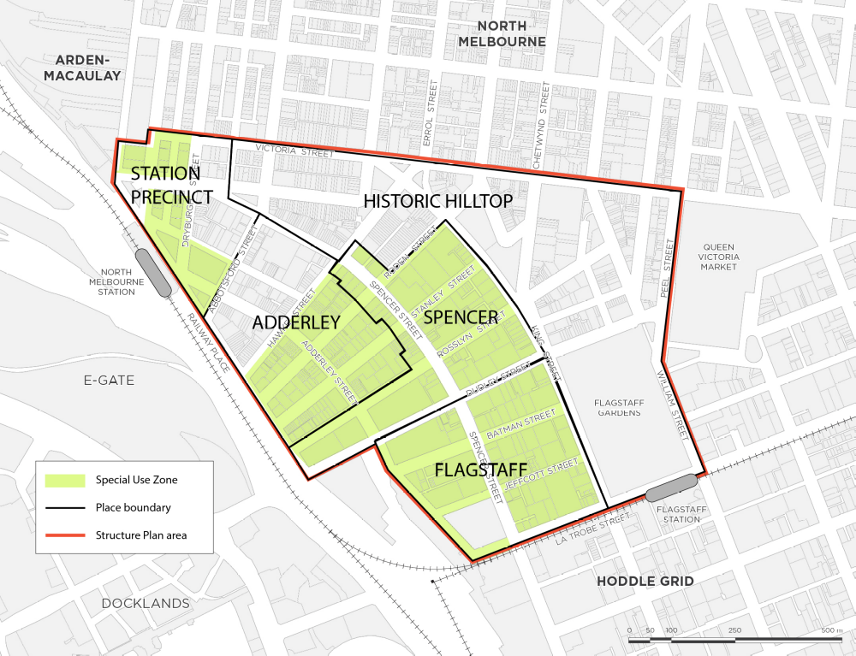
Figure 1 - Special Use Zone Schedule 6 and West Melbourne Structure Plan 2018 Precincts

Use for industry, service station and warehouse - Amenity of the neighbourhood
The use of land for an industry, services station or warehouse must not adversely affect the amenity of the
neighbourhood, including through:
- The transport of materials or goods to or from the land.
- The appearance of any stored materials or goods.
- Traffic generated by the use.
- Emissions from the land.
Application Requirements
The following application requirements apply to an application for a permit under Clause 37.01, in addition to those specified in Clause 37.01 and elsewhere in the scheme and must accompany an application, as appropriate, to the satisfaction of the responsible authority:
Use for Dwellings
- An application to use land for Dwellings must be accompanied by a report which addresses how the proposal contributes to the goal of delivering 6% of housing as affordable housing in West Melbourne.
- An application to use land for a Dwelling that does not achieve at least 6% affordable housing, must be accompanied by a detailed report prepared by a Quantity Surveyor or other suitably qualified professional to the satisfaction of the Responsible Authority. The report must set out indicative profit margins for the project, and substantiated findings demonstrating why the proposed number of affordable housing dwellings within the development, to satisfy the applicable requirement, cannot be delivered without rendering the project economically non-viable. The Responsible Authority may require this report to be analysed by a suitably qualified independent third party at the applicant’s cost.
Use for industry, service station or warehouse
- An application to use land for an industry, service station or warehouse must be accompanied by the following information:
- The purpose of the use and the types of activities to be carried out.
- The type and quantity of materials and goods to be stored, processed or produced.
- Whether a Works Approval or Waste Discharge Licence is required from the Environment Protection Authority.
- Whether a notification under the Occupational Health and Safety (Major Hazard Facilities) Regulations 2000 is required, a licence under the Dangerous Goods Act 1985 is required, or a fire protection quantity under the Dangerous Goods (Storage and Handling) Regulations 2000 is exceeded.
- How land not required for immediate use is to be maintained.
- The likely effects, if any, on the neighbourhood, including noise levels, traffic, air-borne emissions, emissions to land and water, light spill, glare, solar access and hours of operation (including the hours of delivery and dispatch of materials and goods).
Decision Guidelines
The following decision guidelines apply to an application for a permit under Clause 37.01, in addition to those specified in Clause 37.01 and elsewhere in the scheme which must be considered, as appropriate, by the responsible authority:

Use for Dwellings
- The extent to which the proposal provides floor space for uses other than dwellings.
- Whether the proposal delivers an activated ground floor along Spencer Street between Hawke Street and Dudley Street.
- The extent to which the proposal contributes to the provision of at least 6% affordable housing in West Melbourne.
- The views of the relevant housing provider.

Use for industry, service station or warehouse
- The effect that existing uses on adjoining or nearby land may have on the proposed use.
- The design of buildings, including provision for solar access.
- The availability and provision of utility services.
- The effect of traffic to be generated by the use.
- The interim use of those parts of the land not required for the proposed use.
- Whether the use is compatible with adjoining and nearby land uses.
- For non-residential uses, the proposed hours of operation, noise and any other likely off-site amenity impacts.
3.0 Subdivision
--/--/----
Proposed C309
An application to subdivide land, whether or not in accordance with an approved development, must ensure that all car parking spaces are retained as common property. This requirement does not apply to an enclosed garage forming part of a townhouse.
An application to subdivide land, other than an application to subdivide land into lots each containing an existing dwelling or car parking space, must meet the requirements of Clause 56 and:
- Must meet all of the objectives included in the clauses specified in the following table.
- Should meet all of the standards included in the clauses specified in the following table.
Class of subdivision | Objectives and standards to be met
60 or more lots | All except Clause 56.03-5.
16 – 59 lots | All except Clauses 56.03-1 to 56.03-3, 56.03-5, 56.06-1 and 56.06-3.
3 – 15 lots | All except Clauses 56.02-1, 56.03-1 to 56.03-4, 56.05-2, 56.06-1, 56.06-3 and 56.06-6.
2 lots | Clauses 56.03-5, 56.04-2, 56.04-3, 56.04-5, 56.06-8 to 56.09-2
Application Requirements
The following application requirements apply to an application for a permit under Clause 37.01, in addition to those specified in Clause 37.01 and elsewhere in the scheme and must accompany an application, as appropriate, to the satisfaction of the responsible authority:
- A report which addresses whether the subdivision provides for the transition of car parks and car spaces on common property to alternative uses over time.
Exemption from notice and review
An application for subdivision of the land is exempt from the notice requirements of Section 52(1)(a), (b) and (d), the decision requirements of Section 64(1), (2) and (3) and the review rights of Section 82(1) of the Act.
Decision Guidelines
The following decision guidelines apply to an application for a permit under Clause 37.01, in addition to those specified in Clause 37.01 and elsewhere in the scheme which must be considered, as appropriate, by the responsible authority:
- The pattern of subdivision and its effect on the spacing of buildings.
- For subdivision of land for residential development, the objectives and standards of Clause 56.
- The contribution the proposed subdivision makes to a fine grain precinct, and pedestrian and bicycle permeability
- Whether the proposed car parking area is designed for future adaptation or repurposing as an alternative use.
4.0 Buildings and works
--/--/----
Proposed C309

Construction and extension of one dwelling on a lot
No permit is required to construct or carry out works for the following:
- Construct or extend one dwelling on a lot of greater than 300 square metres.
- Construct or carry out works normal to a dwelling.
- Construct or extend an out-building (other than a garage or carport) on a lot provided the gross floor area of the out-building does not exceed 10 square metres and the maximum building height is not more than 3 metres above ground level.
- Make structural changes to a dwelling provided the size of the dwelling is not increased or the number of dwellings is not increased.
The following requirements apply to the construction and extension of one dwelling on a lot:
- A development must meet the requirements of Clause 54.
Construction and extension of two or more dwellings on a lot, dwellings on common property and residential buildings

No permit is required to construct or carry out works for the following:
- To construct one dependent person’s unit on a lot.
The following requirements apply to the construction and extension of two or more dwellings on a lot, dwellings on common property and residential buildings:
- A development must meet the requirements of Clause 55. This does not apply to a development of five or more storeys, excluding a basement.
- An apartment development of five or more storeys, excluding a basement, must meet the requirements of Clause 58.
Motorcycle parking
The following requirements apply to construct a building or construct or carry out works:
- All buildings that provide on-site car parking must provide motorcycle parking for the use of occupants and visitors, at a minium rate of one motor cycle parking space for every 100 car parking spaces, unless the responsible authority is satisfied that a lesser number is sufficient.
Buildings on lots that abut another residential zone
The following requirements apply to construct a building or construct or carry out works on a lot that abuts another residential zone:
- Any buildings or works constructed on a lot that abuts land which is in a General Residential Zone, Residential Growth Zone, Neighbourhood Residential Zone or Township Zone must meet the requirements of Clauses 55.04-1, 55.04-2, 55.04-3, 55.04-5 and 55.04- 6 along that boundary.
Application Requirements
The following application requirements apply to an application for a permit under Clause 37.01, in addition to those specified in Clause 37.01 and elsewhere in the scheme and must accompany an application, as appropriate, to the satisfaction of the responsible authority:
- .A site analysis and descriptive statement explaining how the proposal responds to the site and its context.
- Plans drawn to scale and dimensioned which show:
- The layout of proposed buildings and works.
- An elevation of the building design and height.
- Setbacks to property boundaries.
- All proposed access and pedestrian areas.
- All proposed driveway, car parking and loading areas.
- Existing vegetation and proposed landscape areas.
- The location of easements and services.
Decision Guidelines
The following decision guidelines apply to an application for a permit under Clause 37.01, in addition to those specified in Clause 37.01 and elsewhere in the scheme which must be considered, as appropriate, by the responsible authority:
Construction and extension of one dwelling on a lot
- The objectives, standards and decision guidelines of Clause 54.

Construction and extension of two or more dwellings on a lot, dwellings on common property and residential buildings
- For two or more dwellings on a lot, dwellings on common property and residential buildings, the objectives, standards and decision guidelines of Clause 55. This does not apply to an apartment development of five or more storeys, excluding a basement.
- For an apartment development of five or more storeys, excluding a basement, the objectives, standards and decisions guidelines of Clause 58.
5.0 Signs
--/--/----
Proposed C309
Sign requirements are at Clause 52.05. All land located within SUZ6 is in Category 3.

