Proposed open space for Errol Street, North Melbourne 
Two options are being presented for open space expansion at Errol Street North Melbourne.
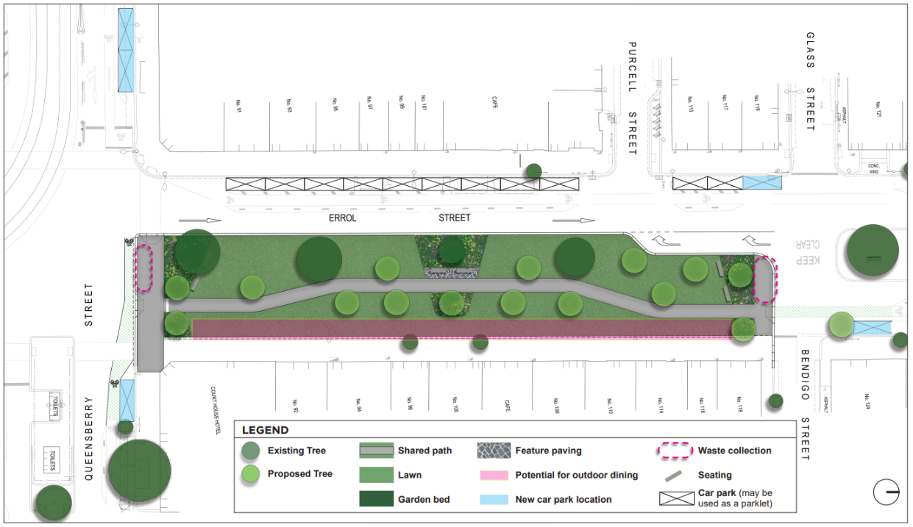
Option One - Partial closure
This plan presents a concept for the partial closure of Errol Street from Queensberry Street to Bendigo Street, maintaining the northbound traffic lane on Errol Street.
This concept plan indicates that this option provides:
- 770 square metres of green space

- 16 additional trees

- Partial expansion

- Reduction of 10 car parking spaces (this includes one car space that is occupied by a street dining parklet)

A number of view points are shown for Option One - Partial closure
View Point One:
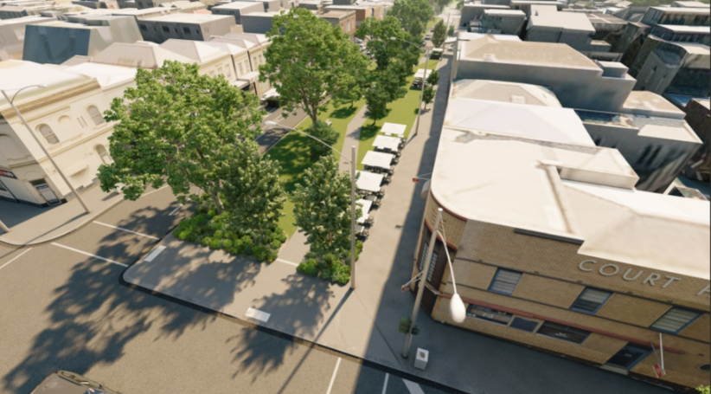
Artist impression from Queensberry Street facing north down Errol Street, with potential future outdoor street dining shown to the east.
The existing median has been extended to the east to meet the footpath with additional lawn, garden beds, seating and tree planting throughout. A central path meanders through the landscape.

View Point Two:

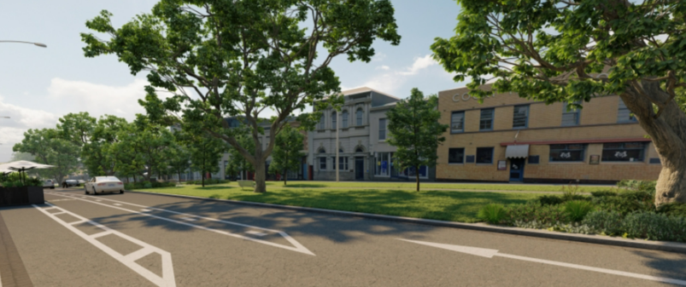

Artist impression north west on Errol Street showing additional lawn, seating, garden beds and trees.

View Point Three:
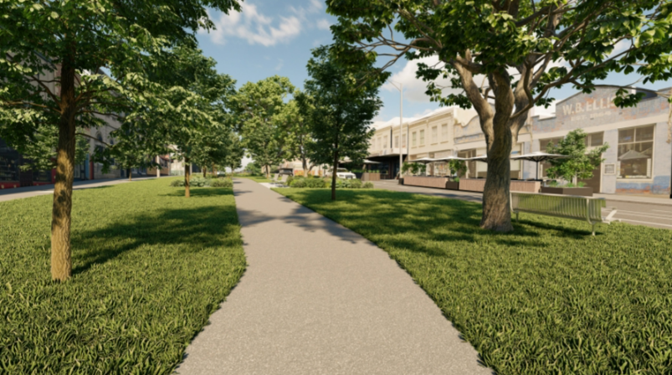
Artist impression of Errol Street facing south towards Queensberry Street showing a central path with additional lawn, garden beds, seating and trees.

The existing on street dining is shown in the background.

View Point Four:

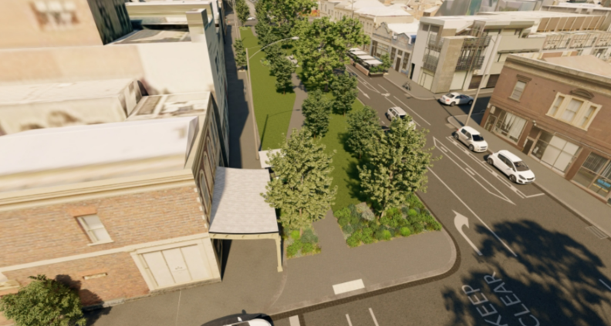
Artist impression from Bendigo Street south towards Queensberry Street with the existing green median extended to the east to create additional green open space with garden beds, trees, seating and a central path.

Option Two – Full width expansion from Queensberry to Purcell Street
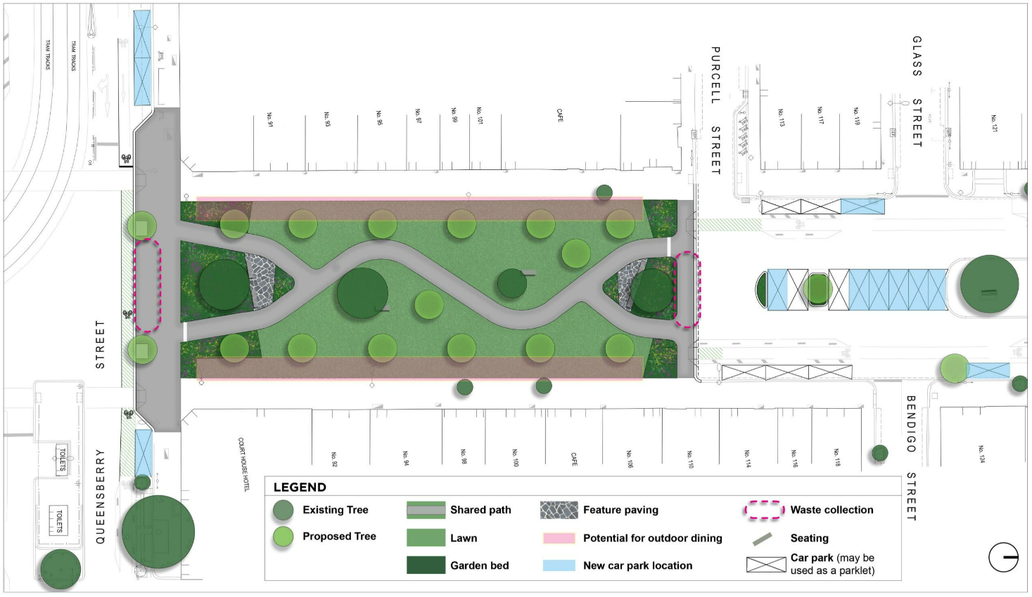
This plan presents a concept for a full width expansion from Queensberry to Purcell Street. North and south bound traffic on Errol Street from Purcell Street to Queensberry would not be permitted.
This concept plan indicates that this option provides:
- 1120 square metres of green space

- 18 additional trees

- Reduction of eight car parking spaces (this includes four car spaces that are occupied by street dining parklets)

A number of view points are shown for Option Two - Full width expansion from Queensberry to Purcell Street
View Point 1:

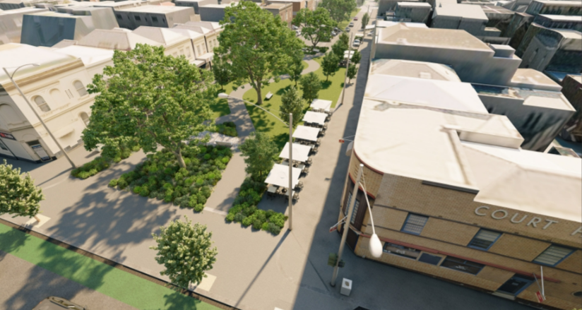
Artist impression from Queensberry Street facing north down Errol Street, with potential future outdoor dining shown to the east and the incorporation of existing street dining to the west.

The existing median has been extended to both the east and west to meet the existing footpath with additional garden beds, lawn, seating and tree planting throughout. A central path meanders through the landscape.

View Point 2:

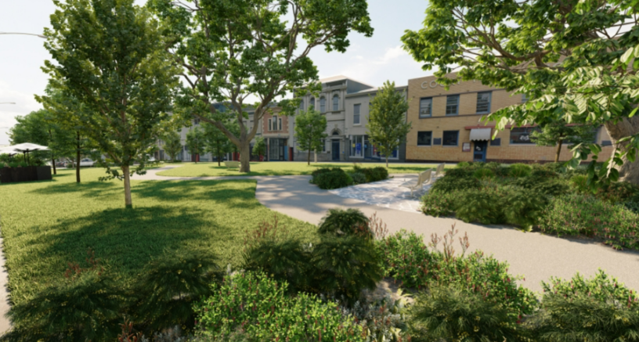

Artist impression looking north east on Errol Street across garden beds, central path, feature paving and seating, with additional trees through an extended lawn.

View Point 3:

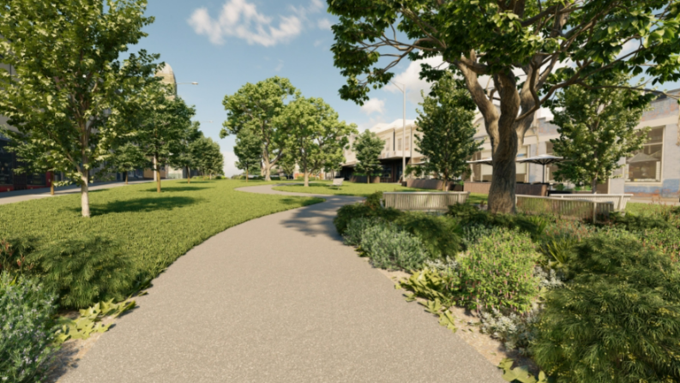

Artist impression of Errol Street facing south towards Queensberry Street showing a central path with additional lawn, garden beds, seating and trees.

View Point 4:
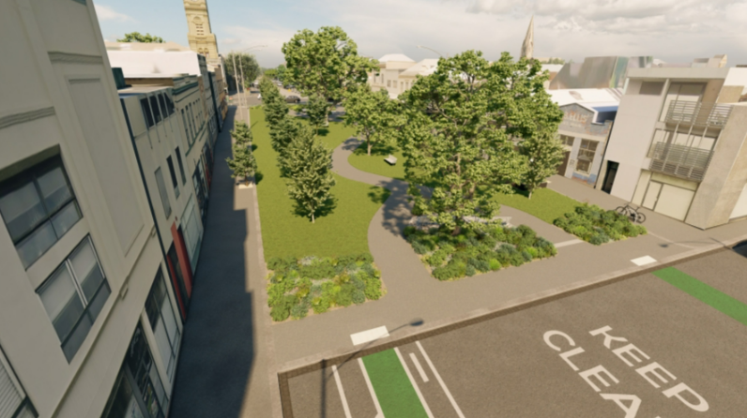
Artist impression facing south opposite Purcell Street towards Queensberry Street. The existing green median has been extended both to the east and west footpaths to create additional green open space with garden beds, trees, seating and a meandering central path.

