
Draft Place and Road Naming Policy and Guidelines
Community Engagement Report
January 2024

Acknowledgement of Traditional Owners
The City of Melbourne respectfully acknowledges the Traditional Owners of the land we govern, the Wurundjeri Woi-wurrung and Bunurong / Boon Wurrung peoples of the Kulin and pays respect to their Elders past and present. We acknowledge and honour the unbroken spiritual, cultural
and political connection they have maintained to this unique place for more than 2000 generations.
We accept the invitation in the Uluru Statement from the Heart and are committed to walking together to build a better future.

Executive Summary

This report
This community engagement report outlines the extent of community consultation undertaken, seeking feedback of the proposed Place and Road Naming Policy and Place and Road Naming Guidelines, to gain a better understanding of how the priorities of the Policy align with the goals and aspirations of our diverse community when naming new places and roads. This proposed Policy does not seek to rename any existing places and roads, but will be considered where an existing place or road is proposed to be renamed.

The consultation
The primary objective of the consultation was to ensure that the communities broad range of perspectives were captured, promoting a transparent policy process through a tailored community feedback process that focuses on a community lead approach to naming proposals.
The extent of the community consultation involved multifaceted outreach using various channels, including: a notice in The Age; a dedicated page on Participate Melbourne; advertisements on X (formerly known as Twitter), Facebook and Instagram; posters at City of Melbourne buildings; Consultation with the Registered Aboriginal Parties, internal Branches, Geographical Naming Victoria, and local resident associations and heritage societies.
A total of 205 responses were received with nearly half of all participants (97 people or 47.78%) participating in a City of Melbourne consultation for the first time.

Consultation results
The survey asked participants to indicate whether they support the prioritisation of Aboriginal lanague and women in history in order to help address the current imbalances in our place and road names:
- 61.31% do not support the proposed priorities
- 33.17% support
- 5.53% were unsure.

The five most common themes identified in comments describing why participants do not support the proposed priorities (in order of prominence) are as follows:
- no particular gender, culture, demographic, group etc. should be prioritised
- strength of connection to local area, contribution to the local community or other positive historical impact should be the main criteria for prioritising potential names
- Council should prioritise the representation of our multicultural history and diverse community
- existing road and place names should not be renamed based on the proposed priorities
- concerns that some Aboriginal language names may be difficult to pronounce, spell or remember.

The five most common themes in comments from participants who do support the priorities are:
            - the proposed priorities are an appropriate way to balance/address the historical depriorisation of Aboriginal language and women in history
            - naming is an appropriate way to acknowledge Traditional Owners and Aboriginal culture
            - naming is an appropriate way to preserve and educate about Aboriginal language and heritage
            - naming is an appropriate way to highlight and honour the success of women
            - the proposed naming priorities should not result in the exclusion of names outside these categories where appropriate.

In terms of information to support community understanding of the policy and community participation in the naming process, 70.34% of participants would like more information about how the community can suggest new names and 66.10% would like to know more about how the community can make a submission on proposed names.
The survey also collected data about specific preferred information and support types. For instance, 73.33% of participants indicated that clear information about why a particular name has been proposed was important to support their participation in considering and making a submission in response to a proposed name.
Regarding mechanisms to supporting building a list of potential names suggested by the community, 70.41% of participants indicated a mechanism (e.g. website) the community can use to suggest names at any time is important. 70.53% would like to suggest names via Council’s community engagement platform, Participate Melbourne (54.74% would like the option to suggest names via email).
Finally, indicating strong community support for polling on name options, 74.00% of participants would participate in a poll for a proposed name anywhere within City of Melbourne.

Impact and next steps
The findings of this engagement will inform the final Place and Road Naming Policy and Guidelines.
This community consultation report will be presented to Future Melbourne Committee (FMC) on the 6 February 2024. The final Place and Road Naming Policy will be presented to FMC for approval in mid-2024.

Expected outcomes of the Policy
The expected outcomes of introducing a Place and Road Naming Policy include a clear Policy position for Council, with informed decision-making, enhanced community consultation, and engaged residents. The implementation of a new Place and Road Naming Policy seeks to ensure that the priorities for naming proposals are effectively used and result in naming of Places and Roads with the City of Melbourne that are consistent with the Policy and represent community expectations.
Ultimately, this Policy aims to create a community led approach to place and road naming with clear guidance for proposals submitted to Council which achieve compliance with this Policy and the Naming Rules for Victoria.

Contents
Acknowledgement of Traditional Owners 2
Executive Summary 3
This report 3
The consultation 3
Consultation results 3
Impact and next steps 4
Expected outcomes of the Policy 4
Introduction 7
Report purpose 7
Project background and context 7
Purpose of the engagement 7
Engagement methodology 8
Engagement approach 8
Inform 8
Consultation 9
Survey participants 10
Gender 10
Age 11
Other identities 12
Connection to this City of Melbourne project 13
Previous participation in City of Melbourne consultations 16
Motivations to participate in this consultation 16
How we analysed the feedback 17
Engagement findings 18
Council’s naming priorities 18
Gendered analysis: support for the proposed naming priorities 19
Why participants support the prioritization of Aboriginal language and women in history 20
Why participants do not support the prioritization of Aboriginal language and women in history 21
Comparative summary: What we heard from participants who do or do not support the proposed priorities 23
Information in the Draft Policy 24
Enabling a community-led approach to naming 25
Community consultation on proposed names 25
Building a list of potential names identified by the community – information and support provided 26
Building a list of potential names identified by the community – mechanism to suggest names 26
Community polling on compliant name options 27
Other comments and feedback 28
Appendix 1 Example of paid social media advertisement 30
X (Twitter) advertisement 30
Meta (Facebook/Instagram) advertisement 30
Appendix 2 Printed poster distributed to Council Libraries and community hubs 31
Appendix 3 Online survey questions 32
Council’s naming priorities 32
Information in the Draft Policy 32
Enabling a community-led approach to naming 32
Other suggestions and feedback 33
About you 33

Introduction

Report purpose
The purpose of this report is to outline:
- the engagement approach undertaken to gather community feedback on Council’s Draft Place and Road Naming Policy and Guidelines, with particular focus on the online survey which consitutes the principal engagement method
- demographic information of who particiated in the online survey
- engagement survey findings.
The report also provides a summary of how the engagement findings will inform revision of the Draft Policy and Guidelines and next steps.

Project background and context
City of Melbourne is responsible for creating or changing the names of places and roads in our municipality.
Any proposed name must comply with the naming rules for places in Victoria (set by the State Government). The naming rules uphold the guidelines in the Geographic Place Names Act 1988.
In addition to adhering to the naming rules, Council encourages and supports names that recongnise and Indigenous history and connections, our diverse multicultural community, and other local history, culture and citizens, with an emphasis on Aboriginal naming and women in history.
The purpose of introducing the proposed Place and Road Naming Policy and Guidelines is to:
- enable community-led (rather than developer-led) naming by
- clearly affirming Council’s preference for Aboriginal language and the names of women in history.

Purpose of the engagement
The purpose of this enagement is to collect community feedback on the Draft Place and Road Naming Policy and Guidelines to inform:
- the final Policy and Guidelines, including the prioritised naming themes of the Policy and the focus of Council’s naming approach
- how Council enables community consultation in the naming process.

Engagement methodology

Engagement approach
The engagement approach consisted of inform activities to build awareness, and consultation activities to gather feedback. This consultation ran from the 15 of November to the 20 December 2023 (35 days in total).

Inform
Communication and promotion activities to create awareness of the consultation included:
- Participate Melbourne webpage that hosted the online survey, as well as full copies of the Draft Policy and Guidelines, along with Frequently Asked Questions and link to another Participate Melbourne webpage that provides further details of Council’s current naming approach (see Table 1 for performance metrics)
- paid social media advertising on Twitter/X and Meta (Facebook and Instagram) (see Appendix 1 for example advertisement and Table 2 for performance metrics)
- email to Participate Melbourne members who indicated relevant categories of interest
- inclusion in the monthly (November) Participate Melbourne enewsletter to all subscribing members
- inclusion on Participate Melbourne’s Neighborhood Portals
- direct email to local Historical Societies
- direct email to Resident Associations and similar community groups
- printed posters in Council Libraries and community hubs (see Appendix 2).
Table 1 – Engagement metrics
Metric | Amount
Participate Melbourne page views | 2833
Survey participants | 205
Downloads of the full Draft Place and Road Naming Policy document* | 135
Downloads of the full Draft Place and Road Naming Guidelines document* | 73
Participate Melbourne page followers | 20
Survey participants who provided their email to receive updates about this engagement | 76
*Key information from the Draft Policy and Guidelines was also provided in the survey to support informed participation (see Appendix 3 survey questions)
Table 2 – Paid social media advertising performance metrics
Social media channel | Impressions* | Reach** | Clicks
Twitter/X | 341721 | 91095 | 610
Meta (Instagram/Facebook) | 85402 | 42671 | 1355
*Impressions: Number of times the advertisement was seen, including multiple views from individual users
**Reach: Number of users that saw the advertisement

Consultation
Community feedback on the Draft Place and Road Naming Policy and Guidelines was sought via an online survey on Council’s community engagement website, Participate Melbourne.
The survey consisted of a mix of multiple choice questions (quantitative data) and open ended questions (qualitative data) grouped according to the following subsections:
- Council’s naming priorities
- information in the Draft Policy
- enabling a community-led approach to naming
- other suggestions and feedback
- demographic questions (standard across all City of Melbourne engagement surveys).
Open ended questions allowed community members to provide feedback in their own words. Additionally, most multiple choice questions enabled participants to select ‘Other’ and add additional feedback.
Appendix 3 provides the full survey questions (18 total).
Council, through Aboriginal Melbourne, is also engaging with the Wurundjeri Woi Wurrung Cultural Heritage Aboriginal Corporate and the Bunurong Land Council Aboriginal Corporation on the Draft Policy and Guidelines.

Survey participants
A total of 205 community members completed the survey. All demographic questions are optional. The percentages reported here are calculated using the total number of participants who responded to each question.

Gender
201 participants responded to this question.
Most survey participants were male (44.28%), followed by females (35.32%). 14.43% responded ‘prefer not to say’ to the gender survey question. Nine participants are non-binary/gender diverse (4.48%) and 3 prefer to use another term (1.49%)
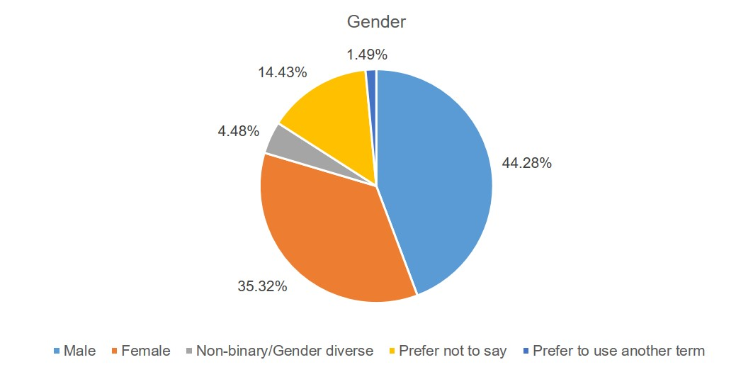
Table 3 – Survey participant gender
Gender response option | Percentage
Male | 44.28%
Female | 35.32%
Prefer not to say | 14.43%
Non-binary/gender diverse | 4.48%
Prefer to use another term | 1.49%

Age
196 participants responded to this question.
Most participants responded ‘prefer not to say’ (11.22%). Of the participants who did indicate their age, the most common age groups were 65-29 years, 50-54 years and 55-59 years (9.18% each).
Overall, the age distribution of survey participants generally reflects a bell curve, with most participants between the ages of 25 and 59 years, and lower participation from community members under 24 years and over 80 years.
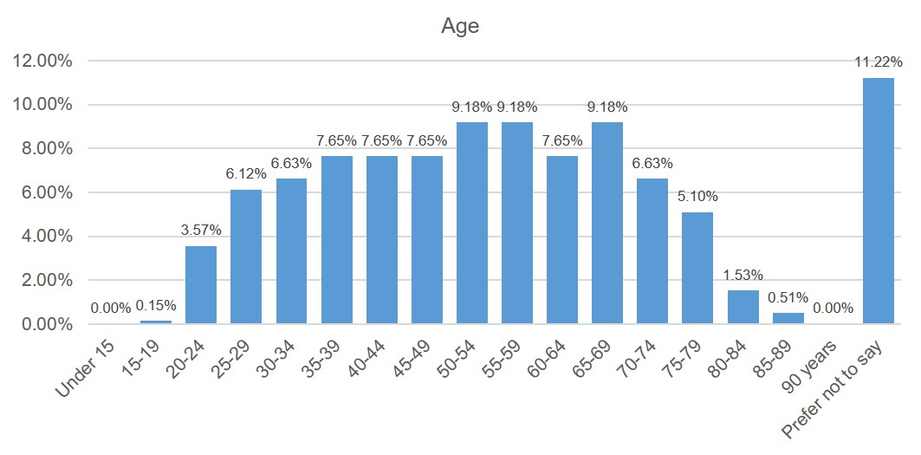
Table 4 – Survey participant ages
Age group | Percentage
Under 15 | 00.00%
15-19 | 0.15%
20-24 | 3.57%
25-29 | 6.12%
30-34 | 6.63%
35-39 | 7.65%
40-44 | 7.65%
45-49 | 7.65%
50-54 | 9.18%
55-59 | 9.18%
60-64 | 7.65%
65-69 | 9.18%
70-74 | 6.63%
75-79 | 5.10%
80-84 | 1.53%
85-89 | 0.51%
90 years | 0.00%
Prefer not to say | 11.22%

Other identities
197 participants responded to this question. Overall, most (79 or 40.10%) participants responded ‘none of these’ when asked if they identify with any of the following groups. 37 participants (18.78%) identify as LGBTIQ, 34 (17.26%) were born overseas and 32 (16.24%) speak language other than English at home. 23 participants (11.68%) participants identified as Aboriginal or Torres Strait Islander.
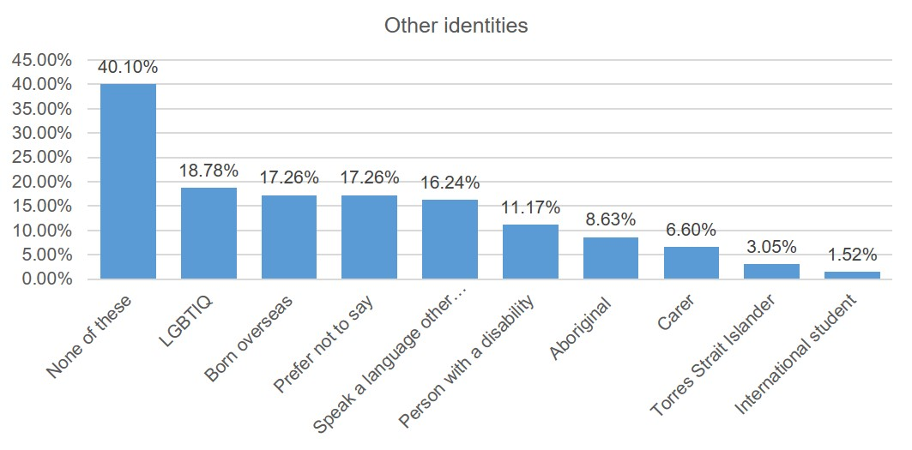
Table 5 – Other identities
Other identities | Percentage
None of these | 40.10%
LGBTIQ | 18.78%
Born overseas | 17.26%
Prefer not to say | 17.26%
Speak a language other than English at home | 16.24%
Person with a disability | 11.17%
Aboriginal | 8.63%
Carer | 6.60%
Torres Strait Islander | 3.05%
International student | 1.52%

Connection to this City of Melbourne project
201 participants responded to the question ‘Which of the following best describes your connection to the City of Melbourne project?’
Most participants (44.78% or 88) are residents, followed by workers (21.89% or 44).
Most of the 18 (8.96%) participants who responded ‘other’ to this question commented that they live in near by municpalities and feel a particular connection to the City of Melbourne (e.g. grew up in Melbourne, own a property in the municipality).
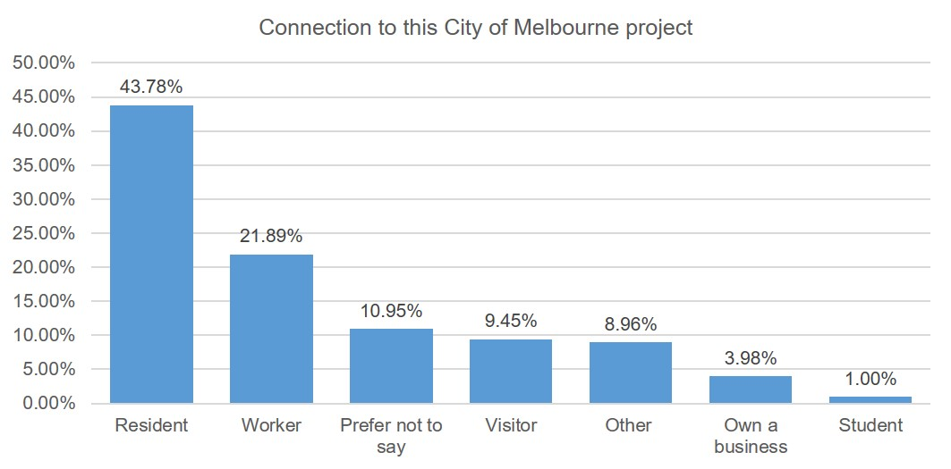
Table 6 – Connection to this project
Connection to this project | Percentage
Resident | 43.78%
Worker | 21.89%
Prefer not to say | 10.95%
Visitor | 9.45%
Other | 8.69%
Own a business | 3.98%
Student | 1.00%

197 participants responded to the question asking which neighbourhood they live, work, vist, own a business or study in. Most participants are connected to the CBD (29.44% or 58 participants), followed by Docklands (9.14% or 18) and North Melbourne (8.63% or 17).
Most of the 27 participants who selected ‘other’ responded inner and outer Melbourne suburbs, and one participant was from regional Victoria (Bendgio).
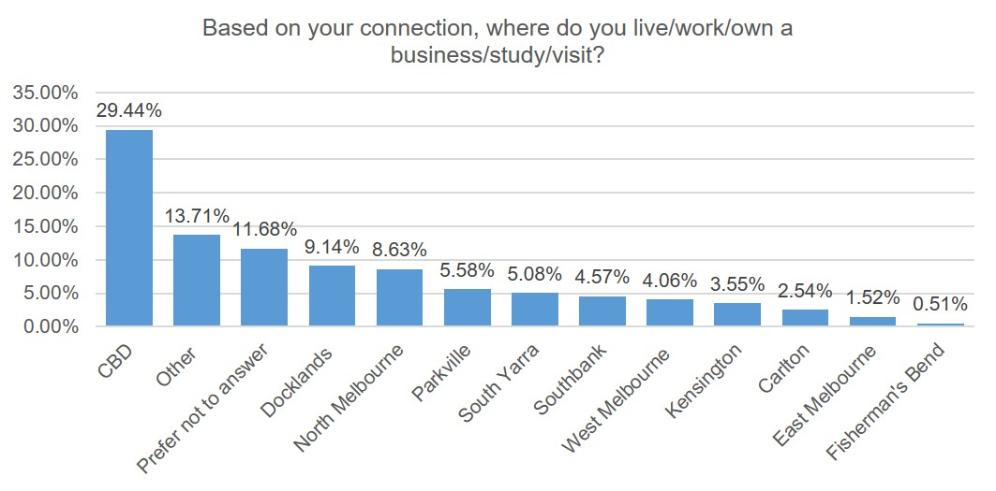
Table 7 – Location of survey participant connection to this project
Location of connection to this project | Percentage
CBD | 29.44%
Other | 13.71%
Prefer not to answer | 11.68%
Docklands | 9.14%
North Melbourne | 8.63%
Parkville | 5.58%
South Yarra | 5.08%
Southbank | 4.57%
West Melbourne | 4.06%
Kensington | 3.55%
Carlton | 2.54%
East Melbourne | 1.52%
Fisherman’s Bend | 0.51%

Of the 58 participants connected to the CBD, most were workers (22 or 37.93%), followed by residents (18 or 31.03%). visitors (6 or 10.34%) and business owners (3 or 5.17%).
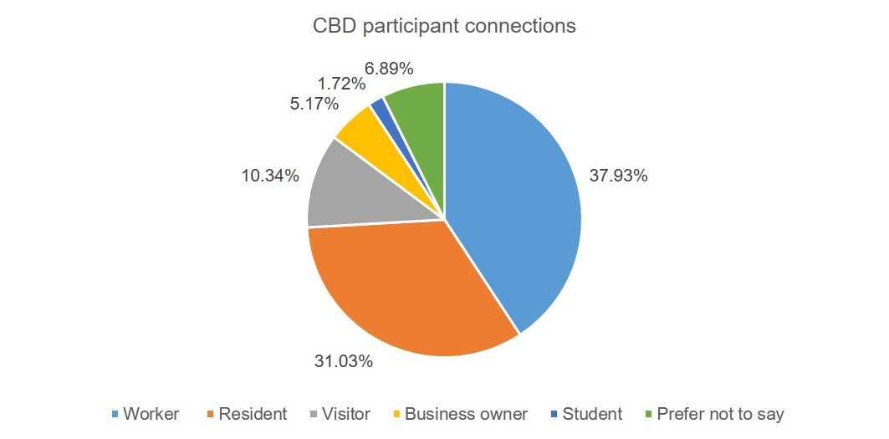
Table 8 – CBD survey participant connections to this project
CBD participant connections to this project | Percentage
Worker | 37.93%
Resident | 31.03%
Visitor | 10.34%
Prefer not to say | 6.89%
Business owner | 5.17%
Student | 1.72%

Previous participation in City of Melbourne consultations
203 participants responded to this question.
Nearly half participants (47.78% or 97) had not participated in a City of Melbourne consultation before this engagement.
50 (or 24.63%) have participated once or twice before, and 34 (16.75%) participate regularly.
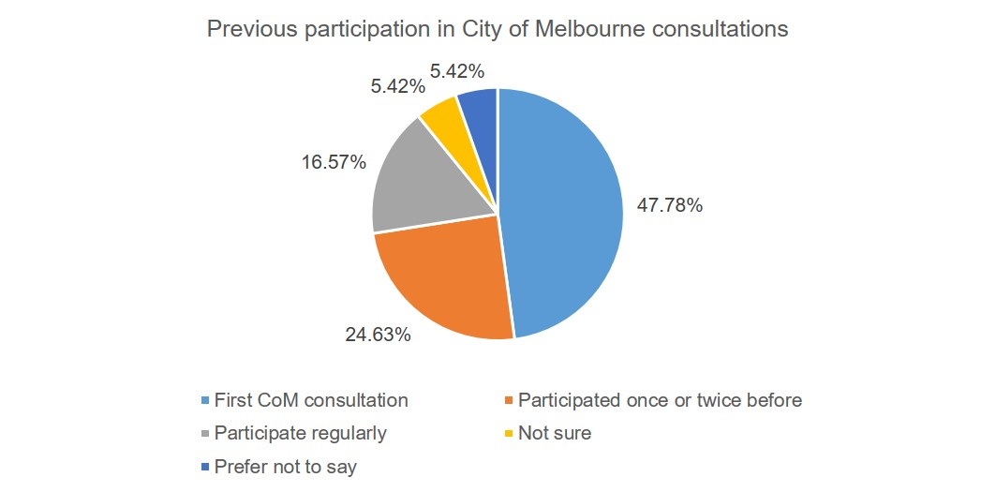
Table 9 – Survey participant previous participation in City of Melbourne consultations
Previous participation in City of Melbourne consultations | Percentage
First City of Melbourne consultation | 47.78 %
Participated once or twice before | 24.63%
Participate regularly | 16.57%
Not sure | 5.42%
Prefer not to say | 5.42%

Motivations to participate in this consultation
202 participants responded to this question.
Half survey participants (102 or 50.50%) think it is important to have your say and contribute to the future of the city.
In terms of communication methods to create awareness, most participants (76 or 37.62%) saw the project on social media, followed by 35 participants (17.33%) who received a letter/email from City of Melbourne. These findings indicate the effectiveness of paid social media advertising, as well as emails sent directly from Participate Melbourne to subscribers and emails sent from City of Melbourne staff to community networks such as heritage groups and resident associations. The ‘Engagement approach’ section of this report provides a full overview of the communication methods employed in this consultation.
Most participants who responded ‘Other’ noted a desire to provide feedback on the Draft Policy and Guidelines.
Table 10 – Survey participant motivations to participate in this consultation
Motivations to participate in this consultation | Percentage
I think it’s important to have your say and contribute to the future of the city | 50.50%
I saw the project on social media | 37.62%
I received a letter/email directly from City of Melbourne | 17.33%
The project directly impacts me | 16.83%
Other | 10.40%
Word of mouth | 8.91%
I saw the project on media (TV, radio, newspaper etc.) | 3.96%
Prefer not to say | 3.47%
I was passing by/approached by City of Melbourne | 1.98%

How we analysed the feedback
Feedback gathered through multiple choice survey questions (i.e. quantitative data), inlcuding demographic data, was analysed using basic statistics (e.g. percentage calculations).
All written feedback (i.e. qualitative data gathered through open text survey responses) was categorised or coded manually into themes by issue or idea. For example, one survey comment may have five or more separate points which were categorised individually. This process of manual coding enables the identification or common themes in qualitative survey data. Atleast two survey comments are provided verbaitm in the report to illustrate each theme within the findings.

Engagement findings

Council’s naming priorities
The Draft Policy seeks to clearly afffirm Council’s preference for Aboriginal langauge names and women in history in the naming of our places and roads to address the underrepresentation of women and Aboriginal culture in Melbourne’s streetscape. For instance, in the last 20 years, 50 new roads were named after men; 23 named after women and only six were named using Aboriginal langague.
Under the Draft Policy, names outside these priorities can still be considered if approved at a Council Meeting, unless consistent with a precinct specific naming framework.
The survey asked participants to indicate whether they support the prioritisation of Aboriginal lanague and women in history in order to help address the current imbalances in our place and road names.
199 participants responded to this question. Perecentages exclude non-responses.
- 61.31% do not support
- 33.17% support
- 5.53% were unsure.

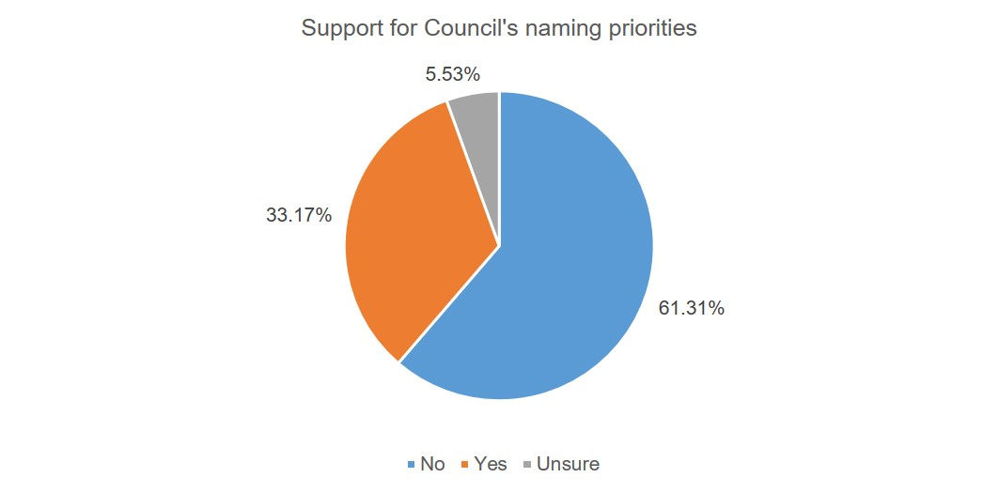
Table 11 – Survey participant support for Council’s proposed naming priorities
Support for Council’s proposed naming priorities | Percentage
No do not support | 61.31%
Yes support | 33.17%
Unsure | 5.53%

Gendered analysis: support for the proposed naming priorities
The following graph compares responses from gender groups.
Gendered analysis of support for the proposed naming priorities is based on the 201 participants who provided a response to the gender question (i.e. non-responses to the gender question are excluded from these calculations).
Key insights from the gendered analysis include:
- More than twice as a many male participants responded ‘no’ (I do not support) the proposed priorities (57 ‘no’ compared to 24 ‘yes’). About the same number of female participants responded ‘yes’ (support) and ‘no’ (I do not support) (34 and 32 respectively). Therefore, male participants are more likely than female participants to not support the proposed priorities.
- About the same number of males and females were unsure whether they supported the proposed priorities or not (5 male and 4 female participants).
- Participants who responded ‘prefer not to say’ in response to the gender survey question were more likely to not support the proposed priorities (22 ‘’no’ I don’t support the priorities and 4 ‘yes’ I do support the priorities).
- The three participants who responded ‘I use a different term’ to the gender survey question responded ‘no’ they do not support the proposed naming priorities.
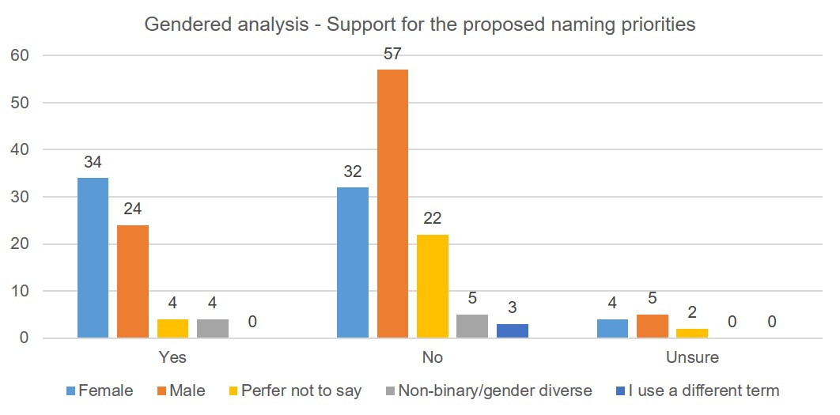
Table 12 - Gendered analysis – Support for the proposed naming priorities

Yes
Gender | Total
Female | 34
Male | 24
Prefer not to say | 4
Non-binary/gender diverse | 4
I use a different term | 0

No
Gender | Total
Female | 32
Make | 57
Prefer not to say | 22
Non-binary/gender diverse | 5
I use a different term | 03

Unsure
Gender | Total
Female | 4
Male | 5
Prefer not to say | 2
Non-binary/gender diverse | 0
I use a different term | 0

Why participants support the prioritization of Aboriginal language and women in history
The 66 participants who support the proposed priorities were given the opportunity to comment or describe why they support the priorities. 60 provided a comment.
We heard that:
The proposed priorities are an appropriate way to balance/address the historical deprioritisation of Aboriginal language and women in history (32 comments)
- ‘The Aboriginal community and women play an important role in our city and should be celebrated along side significant men who have contributed’
- ‘Both are markedly under-represented in names, but have made significant contributions’
Naming is an appropriate way to acknowledge Traditional Owners and Aboriginal culture (15 comments)
- ‘It’s really important to acknowledge the traditional custodians and one of the best ways to do this is with language.’
- ‘From institutions to parks, it's time we highlight our traditional owners and others who have shaped places like Melbourne into what it is today.’
Naming is an appropriate way to preserve and educate about Aboriginal language and heritage (8 comments)
- ‘And anything we can do to preserve anything of Aboriginal language and the heritage of this place I welcome’
- ‘Aboriginal language and history is fundamental to who are and we non Aboriginal people need to do much more to learn about it – so what better way that learning through place naming’
Naming is an appropriate way to highlight and honor the success of women (8 comments)
- ‘Because we, as women, are underrepresented in too many aspects of society. You cannot be what you cannot see. I want my daughter and my future grandchildren to be proud of the contributions that women have made to the history of the city of Melbourne.’
- ‘Women have played an enormous part in the development of Melbourne across multiple sectors.’
Additionally, five participants who support the proposed priorities also commented that the proposed priorities should not result in the exclusion of names outside these categories where appropriate.
- ‘I believe that there should be better representation of both groups but this should not exclude other names where appropriate and should not result in existing names being changed.’
- ‘I support it and think that the best place name should be chosen based on a wide range of factors and ‘with community consultation. It's important that we recognise our Aboriginal history and women in history along with others who have made contributions to the community and the city.’

Why participants do not support the prioritization of Aboriginal language and women in history
The survey required the 122 participants who do not support the proposed priorities to provide a comment or description of why they do not support the priorities. The most prominent theme within responses was that no particular gender, culture, demographic, group etc. should be prioritised (41 comments).
- ‘No ‘group’ should have priority over anyone.’
- ‘I believe everyone is equal and by supporting in this case two particular groups you are cancelling all others’
We also heard that strength of the connection to the local area, contribution to the local community or other positive historical impact should be the main criteria for prioritising potential names (22 comments). These comments encompassed support for either or both place-based names (i.e. strong connections to the local area) and merit-based names (i.e. contribution to community or positive impact on history).
- ‘‘Street names should be sensitive to the context of the site and area they are within, and give the location a sense of place and meaning. While aboriginal language and women of history do have special meaning in the correct context, they do not necessarily fit in all scenarios. Each individual case should be assessed on its merits without a “prioritisation” of specific outcomes’
- ‘Priority should not be based on political factors like gender and race. Rather, priority should be given to persons and events who have made significant contributions to society and culture’
Other common themes within these responses include:
Council should prioritise the representation of our multicultural history and diverse community (14 comments)
- ‘We need to support all cultures – to support our multicultural community. Prioritising one is exclusionary to all the other many diverse cultures in Melbourne’
- ‘Names of migrants to this country, who have contributed to the making of it, should be considered more, be they men or women or whatever.’

Concerns that some Aboriginal language names may be difficult to pronounce, spell or remember (9 comments)
- ‘Many Aboriginal names are hard to pronounce and spell, especially for those from overseas or with dyslexia.’
- ‘depends on the name. if it is confusing and hard to spell then no, if its a suitable name then yes. This applies to all names whether they are named after men, women, English words or words from an indigenous language’

Council should be open to names that do not relate directly to either gender or culture (6 comments)
- ‘Why do street names have to reflect the names of people at all? There are plenty of other sources of street names’
- ‘Nomenclature of things, rather than people, such as native Australian fauna and flora or descriptive names such as “riverside” should be given strong consideration also.’
Additionally, 14 participants who do not support the proposed priorities explicitly noted that they do not support the renaming of existing roads and place names based on the proposed priorities.
- There's really no need to rename anything as it will erase already important names in Melbourne's history.
- ‘Names of migrants to this country, who have contributed to the making of it, should be considered more, be they men or women or whatever.’

A further 8 participants noted that they do not necessarily oppose the use of Aboriginal language or the names of women in history, but they do not support the prioritisation of these groups over other potential names.
- ‘My objection is to the use of the word "prioritise" (put first) when it would be better to use the word "emphasize" (make important). To prioritize (as a means of correcting an imbalance as described above) while well meaning, will likely have unintended consequences. We are a successful multicultural society - do we not welcome and include immigrants? The solution seems obvious to me - apply a measure of BALANCE and include and recognize the accomplishments of ALL Australians and their cultures.’
- ‘I'm not against the inclusion of both and support it. However, many other gaps exist in our nomenclature. Artists, journalists, writers and poets are poorly represented, including those of different ethnicities, compared to other nations. I think the prioritisation net should be wider than you suggest.’

Comparative summary: What we heard from participants who do or do not support the proposed priorities
Table 13 below identifies themes within responses from participants who do and do not support the proposed prioriisation of Aboriginal lanuage and women in history in the naming of places and roads in the City of Melbourne. Themes are listed here in order of prominence.
Table 13 – Comparative summary of themes
Theme | Participants who support the proposed prioritisation of Aboriginal language and women in history | Participants who do not support the proposed prioritisation of language and women in history
1 | The proposed priorities are an appropriate way to balance/address the historical deprioritisation of Aboriginal language and women in history (32 comments) | No particular gender, culture, demographic, group etc. should be prioritised (41 comments)
2 | Naming is an appropriate way to acknowledge Traditional Owners and Aboriginal culture (15 comments) | Strength of the connection to the local area, contribution to the local community or other positive historical impact should be the main criteria for prioritising potential names (22 comments)
3 | Naming is an appropriate way to preserve and educate about Aboriginal language and heritage (8 comments) | Council should prioritise the representation of our multicultural history and diverse community (14 comments)
4 | Naming is an appropriate way to highlight and honor the success of women (8 comments) | Existing road and place names should not be renamed based on the proposed priorities (14 comments)
5 | The proposed priorities should not result in the exclusion of names outside these categories where appropriate (5 comments) | Concerns that some Aboriginal language names may be difficult to pronounce, spell or remember (9 comments)
6 | NA | I don’t necessarily oppose the use of Aboriginal language or the names of women in history, but these groups should not be prioritised over other potential names (8 comments)
7 | NA | Council should be open to names that do not relate directly to either gender or culture (6 comments)

Information in the Draft Policy
193 participants responded to the question whether the Draft Policy should provide any additional information.
62.18% responded yes, and 37.82% respoded no.
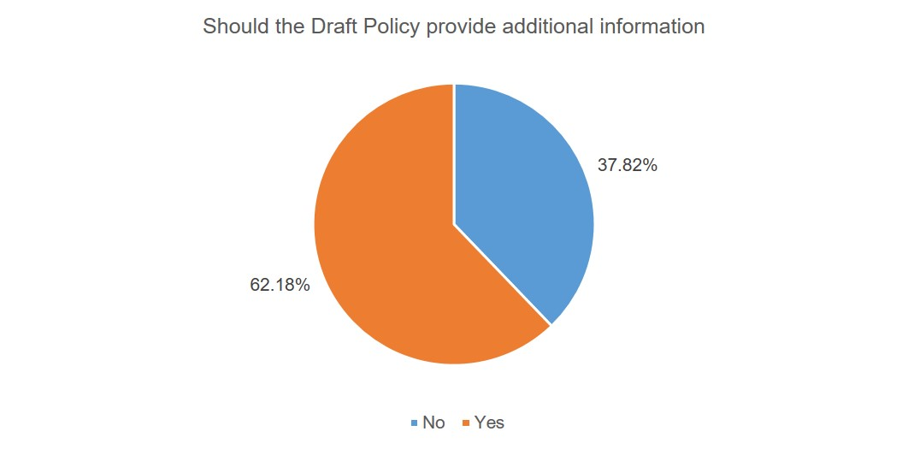
Table 14 – Should the Policy contain additional information
Should the Policy contain additional information | Percentage
Yes | 62.18%
No | 37.82%

The survey also asked 120 participants who responded ‘Yes’, what additional information should be included. Participants could choose multiple response options.
How the community can suggest new names and how the community can make a submission on proposed names were selected most often (70.34% and 66.10% respectively).
Table 15 – Additional information in Policy responses
Area/topic of information | Percentage
How the community can suggested new names | 70.34%
How the community can make a submission on proposed names | 66.10%
The approximate time each stage of the naming process takes | 48.31%
More about the role of Traditional Owners in the naming process | 38.14%
Other (please specify) | 29.66%

Areas and topics highlighted by those participants who selected ‘Other’ in response to this survey question include:
- a clear explanation of the motivations behind introducing the Policy
- the process for community objecting proposed names
- who assesses proposed names
- what is considered a ‘historically significant’ name
- how community feedback is considered
- if this policy relates to changing existing names and if so how.

Enabling a community-led approach to naming
The survey asked a series of questions realted to components in the Policy designed ot enable a community-led appraoch to naming:
- community consultation on proposed names
- building a list of potential names identified by the community
- community polling on compliant name options.

Community consultation on proposed names
The Draft Policy states that Council will take “a proactive Council approach to naming that increases community engagement, especially for significant proposals.”
The survey asked participants what information or support would help them participate in considering and potentially making a submission in response to proposed names open for community feedback.
195 participants responded to this question.
Clear information about why a particular name has been proposed (73.33%) was the most commonly identified information or support type to enable community participation in considering proposed names
59.49% of participants identified promoting proposed names on various Council news channels such as Melbourne news and social media as an important way to support community participation.
Table 16 – Information/support for community consultation in proposed names
Information/support type | Percentage
Clear information about why a particular name has been proposed | 73.33%
Promote proposed names on various Council news channels such as Melbourne News, social media etc. | 59.49%
Promote proposed names on Council’s community engagement website (Participate Melbourne) | 56.41%
Clear information about what is required to make a submission | 56.41%
Advertise proposed names in The Age newspaper (standard current practice) | 36.41%
Other (please specify) | 24.10%

In terms of advertisement and promotional methods, participants who selected ‘other’ shared suggestions such as:
- advertise in newspapers and mainstream media other than The Age that don’t require a subscription
- utilise networks of community organisations, historical societies, local libraries etc. to help create broad awareness
- provide information and promotional materials in different languages
- direct mail
- social media (general).

Suggestions for other information to support community participation in the naming process include:
- if and how the community and Traditional Owners have been consulted prior to the formal consultation process commencing
- what other alternative names were suggested or considered for a particular location.

Building a list of potential names identified by the community – information and support provided
The Draft Policy states that “Council will provide a mechanism for establishing a compliant list of suitable names for a precinct, including renewal areas.”
The survey asked participants what information or support would make suggesting new names for consideration easier. 196 participants answered this question. A mechanism (e.g. website) available to suggest names at any time (70.41%) was the most commonly identified information or support type. Over half participants also selected the other two suggested information/support types: clear direction on the Principles that new names must meet (61.22%) and creating awareness of unnamed places and roads amongst the community (59.18%).
Table 17 – Information/support for community building a list of names identified by the community
Information/support type | Percentage
A mechanism (e.g. website) I can use to suggest names at any time | 70.41%
Clear direction on the Principles that new names must meet | 61.22%
Create awareness of unnamed places and roads amongst the community | 59.18%
Other (please specify) | 14.80%

Other suggested information and support included examples of people who have made a contribution that is considered sufficient for a place or road to be named after them, including an explanation as to why their contribution would be considered sufficient.

Building a list of potential names identified by the community – mechanism to suggest names
The survey also asked participants how they would like to be able to suggest names for future use in a particular neighbourhood.
190 participants responded to this question and participants could choose multiple options
Most (70.53%) would like to propose names via Participate Melbourne, and just over half (54.74%) would like to propose names via email.
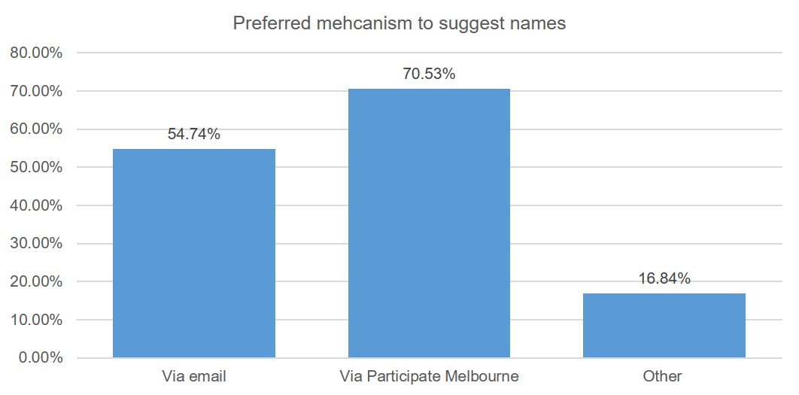
Table 18 – Preferred mechanism to suggest names
Mechanism to suggest names | Percentage
Via email | 54.74%
Via Participate Melbourne | 70.53%
Other | 16.48%

16.84% of participants would like to propose names via other mechanisms. Suggestions included:
- via social media
- via multiple media
- at community events and other face to face discussions
- in conjunction with rates notices
- mail out to surrounding residents when need to gather pool of name options for a particular place or road
- via a webpage that shows all names previously suggested by the community
- provide information in multiple languages
- ensure people with disability are able to access and contribute.

Community polling on compliant name options
The Draft Policy states that Council may hold a community poll if “more than one complaint name has been found for a place or road.”
200 participants responded to the survey question about community polling.
74.00% of participants would participate in a poll for proposed name anywhere within City of Melbourne, and 56.00% would participate on a poll if the proposed name was in their local neighbourhood.
11.50% are not likely to participate in a poll of proposed names.
These findings indicate a strong interest from the community in polling.
10.00% participants selected ‘Other’ in response to this question. Feedback from these participants included:
- the outcomes of the poll should be shown as live data as votes come in (not only when the poll has closed)
- concerns about the ease with which people could sway a poll by encouraging others to vote in a particular way.
Other comments also highlighted:
- the importance of ensuring widespread awareness that a poll is taking place
- the importance of communicating how Traditional Owners have been consulted on the proposed name options prior to the polling stage.

Other comments and feedback
The final survey question invited participants to share any other comments or feedback we should consider as we finalise Council’s Place and Road Naming Policy and Gudelines. 97 particiapnts provided additional comments and feedback.
We primarily heard:
- reinforcement of themes identified in responses to earlier survey questions (e.g. diverse representation, not changing existing names, place-based and merit-based naming criteria and the practicality of names that are easy to spell and pronounce)
- additional suggestions for involving the community in the naming process and other aspects of the Draft Policy.
The seven most common themes are identified below in order of prominence:
The importance of diverse representation of all cultures, genders, demographic groups etc. (14 comments)
- ‘It should be ‘fair opportunity’ for everyone, no matter what your background or gender.’
- ‘Embrace naming. across all of history and communities : Italian, Greek, Nepali, Chinese, etc’
Existing road and place names should not be changed (11 comments)
- ‘Do not change names in place.. they are part of our history’
- ‘The name of our streets are simple and fine.’
Suggestions for effectively involving the community in the naming process (11 comments)
- ‘I would like to see younger people - late school age and beyond engaged in this process. These young people are amazingly inventive and their input could set the tone for the future. They ( and younger) are the group who have to live with the results the longest.
- ‘it is unfair that you only advertise in The Age, information for citizens should not be hidden behind a paywall.’
Suggestions for or references to Policy aspects other than community involvement per se (11 comments)
- ‘Just make it clear & transparent by setting out they way the process will operate beforehand.’
- ‘The naming process needs to be transparent, provide a range of options.’
Names should have connections to the local area or commnity (i.e. place-based names) (7 comments)
- ‘Name chosen should reflect Australian ideals, history and community.’
- ‘People who are considered should have life long contributed to the community, mainly in key areas as the sciences, medicine, technology, arts, and not just be a recent C celebrity.’
Names should be easy to spell and pronounce to enable navigation, wayfinding, providing direction, writing mailing addresses etc. (7 comments)
- ‘simple road names make navigation easier and in general use of the street. If it's too hard to say people describe landmarks or nearest street instead’
- ‘I’m not against any names, just prefer efficient names for navigation and ensure mails arrive safely.’
Names should be based on contribution and merit (i.e merit-based names) (6 comments)
- ‘Please consider all Australians, pioneers, those that contributed to this city, migrants etc. Carlton for example has a very rich migrant history. Let’s celebrate the many Italians who contributed to that.’
- ‘[....] focus on practicality and recognizing those people most deserving, not on the basis of sex or race.’
Impact
The engagement findings will be used to inform Council’s decision on the priorities to be used for proposed Place and Road Naming Policy, the way Coucil engages with the community on naming proposals and provide greater clarity about the use of non-priority themes – specifically where there is a clear link to place or significant contribution made.
Next steps
The feedback and survey results received through the community engagement will be further considered and incorporated, as appropriate, in the updated Policy.
We anticipate the Place and Road Naming Policy with incorporated changes from Community Consultation will be reported back to Future Melbourne Committee mid-2024.
Table 19 – Project timeline
Project milestone | Time period or date
Council meeting to approve consultation on the Draft Policy | 31 October
Community consultation on the Draft Policy and Guidelines | 15 November to 20 December 2023
Consideration of community feedback | 21 December 2023 to January 2024
Community consultation report presented to Future Melbourne Committee | 6 February
Final Place and Road Naming Policy presented to Future Melbourne Committee for approval | Mid-2024
Appendices

Appendix 1 Example of paid social media advertisement

X (Twitter) advertisement
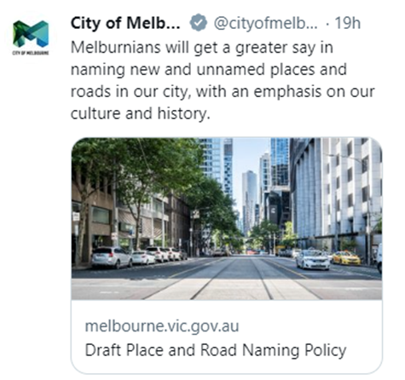

Meta (Facebook/Instagram) advertisement
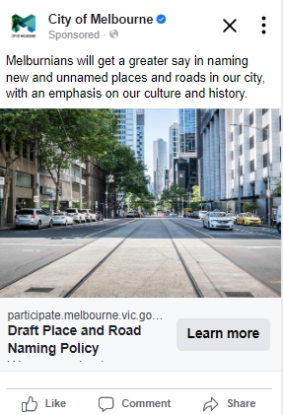

Appendix 2 Printed poster distributed to Council Libraries and community hubs
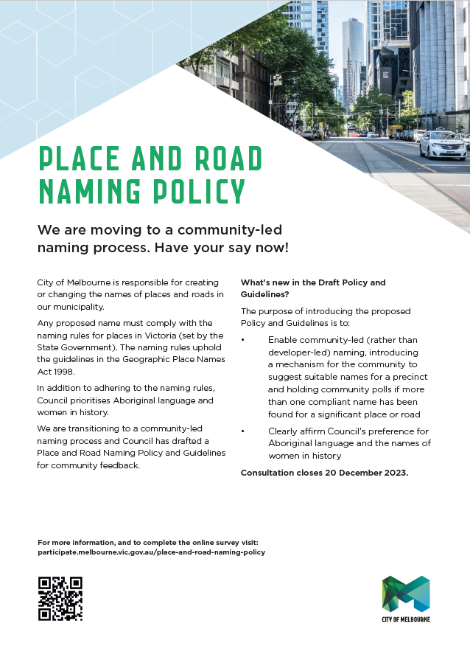

Appendix 3 Online survey questions

Council’s naming priorities
Council is seeking to clearly affirm our preference for Aboriginal language names and women in history in the naming of our places and roads to address the underrepresentation of women and Aboriginal culture in Melbourne’s streetscape.
For instance, in the last 20 years, there have been 50 new roads after men; 23 named after women and only just six were named using Aboriginal language.
Names outside these priorities can still be considered if approved at a Council Meeting unless consistent with a precinct specific naming framework.
Do you support the prioritisation of Aboriginal language and women in history in order to help address the current imbalances in our place and road names?
- Yes
- No
- Unsure

If respond yes: Please describe why you support the prioritisation of Aboriginal language and women in history
Open text response field

If respond no: Please describe why you do not support the prioritisation of Aboriginal language and women in history
Open text response field

Information in the Draft Policy
Should the Draft Place and Road Naming Policy provide any additional information?
- Yes
- No

If respond yes: What additional information should the Draft Place and Road Naming Policy provide?
- How the community can make a submission on proposed names
- How the community can suggest new names
- More about the role of Traditional Owners in the naming process
- The approximate time each stage of the naming process takes
- Other (please specify open text response field)

Enabling a community-led approach to naming
              - Community consultation in proposed names
The Draft Policy states that Council will take “a proactive Council approach to naming that increases community engagement, especially for significant proposals.”
What information or support would help you participate in considering and potentially making a submission in response to proposed names open for community feedback?
- Advertise proposed names in The Age newspaper (standard current practice)
- Promote proposed names on Council’s community engagement website (Participate Melbourne)
- Promote proposed names on various Council news channels such as Melbourne News, social media etc.
- Clear information about why a particular name has been proposed
- Clear information about what is required to make a submission
- Other (please specify open text response field

              - Building a list of potential names identified by the community
The Draft Policy states that “Council will provide a mechanism for establishing a compliant name list of suitable names for a precinct, including renewal areas.”
What information or support would make suggesting new names for consideration easier?
- Clear direction of the Principles that new names must meet
- A mechanism (e.g. website) I can use to suggest names at any time
- Create awareness of unnamed places and roads amongst the community
- Other (please specify open text response field)

How would you like to be able to propose place or road names for future use in a particular neighbourhood?
- Via email
- Via Participate Melbourne
- Other (please specify open text response field)

              - Community polling on complaint name options
The Draft Policy states that “Council may hold a community poll if “more than one complaint name has been found for a place or road.”
- Yes, I would participate in a poll for proposed names anywhere within City of Melbourne
- Yes, I would participate in a poll for proposed names in my local neighbourhood
- No, it is not likely I would participate in a poll of proposed names
- Other (please specify open text response field)

Other suggestions and feedback
Do you have any other comments of feedback that we should consider as we finalise our Place and Road Naming Policy and Guidelines?
Open text response field

About you
The following questions are about you. By telling us a bit about you, we can make sure that we’re hearing from different voices.
You answers will be de-identified for analysis, and we won’t share your data with any other party.
You may choose the option for ‘Prefer not to say’ for questions you do not wish to answer.
How do you describe your gender?
- Female
- Male
- Non-binary/gender diverse
- Prefer not to say
- Other

What is your age?
- Under 15 years
- 15-19 years
- 20-24 years
- 25-29 years
- 30-34 years
- 35-39 years
- 40-44 years
- 45-49 years
- 50-54 years
- 55-59 years
- 60-64 years
- 65-69 years
- 70-74 years
- 75-79 years
- 80-84 years
- 85-89 years
- 90 years
- Prefer not to say

Do you identify with any of the following?
- Aboriginal
- Torres Strait Islander
- Person with a disability
- Carer
- LGBTIQ
- Speak a language other than English at home
- Born overseas
- International student
- Prefer not to say
- None of these

Which of the following best describes your connection to this City of Melbourne project?
- I am a resident
- I am a worker
- I own a business
- I am a student
- I am a visitor
- Prefer not to say
- Other (please specify open text response field)

Based on your connection to this project, where do you live/work/own a business/study/visit?
- Carlton (3053)
- CBD (3000)
- Docklands (3008)
- East Melbourne (3002)
- Kensington (3031)
- North Melbourne (3051)
- Parkville (3052)
- Southbank (2006)
- South Yarra (3141)
- West Melbourne 3003)
- Fisherman’s Bend
- Prefer not to answer
- Other (please specify open text response field)

Have you participated in a consultation with City of Melbourne before?
- No this is my first City of Melbourne consultation
- Yes, I have participated in a City of Melbourne consultation one or twice before today
- Yes, and I participate in City of Melbourne regularly
- Not sure
- Prefer not to say

What motivated you to participate in this consultation today?
- I was passing by/approached by City of Melbourne
- This project directly impacts me
- I think it’s important to have your say and contribute to the future of the city
- I received a letter/email from City of Melbourne
- I saw the project on social media
- I saw the project on media (TV, radio, newspaper etc.)
- Word of mouth
- Prefer not to say
- Other (please specify open text response field)

Please provide your email if you would like to receive updates about this project:
Open text response field

1 https://participate.melbourne.vic.gov.au/place-and-road-naming-policy 2 https://participate.melbourne.vic.gov.au/place-and-road-naming

