
Self–Guided Walk
Parkville Heritage Review
South Parkville Precinct
Tour distance: 1.8 km
Tour time: Approximately 1.5 hours
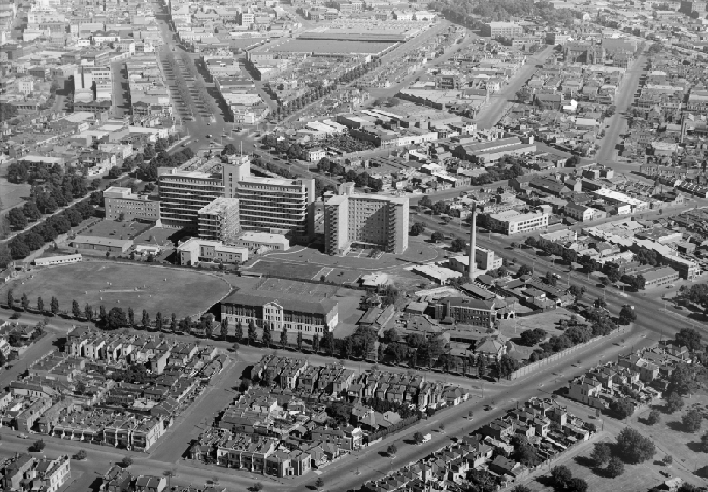
Contents
Acknowledgement of Traditional Owners 4
This Review 5
Front cover 5
Start 6
Ievers Reserve, 42 Flemington Road 6
Notes 7
Places 7
Local Protection 7
Local and Part State Protection 7
Local Context 7
Acronyms 7
Stop 1 8
Local Protection 8
Ievers Reserve, 42 Flemington Road 8
Stop 2 11
Local Protection 11
Stable, 34–36 Gatehouse Street (Rear) 11
Stop 3 13
Local Protection 13
Northern Market and Lecture Hall, Story Street 13
Stop 4 16
Local Protection 16
University High oval, 77 (part) Story Street 16
Stop 5 19
Local Protection 19
Former Shop, 26–30 Morrah Street 19
Stop 6 21
Local Protection 21
Dwelling, 44 Morrah Street 21
Stop 7 23
Local Protection 23
Former shops, 48 Morrah Street and 52 Morrah Street 23
Stop 8 25
Local Protection 25
The Vintage Sports Car Club of Victoria Inc., 110a Gatehouse Street 25
Stop 9 27
Local Protection 27
Saunders House, 90–92 Gatehouse Street 27
Stop 10 29
Local Protection 29
Dwellings, 178–180 Gatehouse Street 29
Stop 11 31
Local Protection 31
Church, 188–198 Gatehouse Street 31
Stop 12 33
Local Context 33
Walmsley House, 161 Gatehouse Street 33
Stop 13 35
Local Protection 35
St Carthages Church, 121–125 Royal Parade 35
Stop 14 37
Local Protection 37
Los Angeles, 113–115 Royal Parade 37
Stop 15 39
Local Protection 39
Elbion, 77–79 Royal Parade 39
Stop 16 41
Local Context 41
Naughton’s Hotel, 43–49 Royal Parade 41
End Notes 43
Back Cover 44

Acknowledgement of Traditional Owners
City of Melbourne respectfully acknowledges the Traditional Owners of the land we govern, the Wurundjeri Woi–wurrung and Bunurong / Boon Wurrung peoples of the Kulin and pays respect to their Elders past and present. We acknowledge and honour the unbroken spiritual, cultural and political connection they have maintained to this unique place for more than 2000 generations.
We accept the invitation in the Uluru Statement from the Heart and are committed to walking together to build a better future.

This Review
The Parkville Heritage Review is the most comprehensive review of heritage places in the local area since 1979. Reviewing an expansive area centred on Royal Park, City of Melbourne’s independent consultant has identified places of local and state significance.
This walking tour takes you to some of the places identified in the Review. Included are houses, a former market, and even a stables with a famous former occupant.
The recommendations in the Review are being implemented through Planning Scheme Amendment C444, which has been prepared by City of Melbourne.
Find out more and have your say at participate.melbourne.vic.gov.au/parkville-heritage-review.
Unless otherwise stated, text based on the Parkville Heritage Review by GML Heritage, and images by GML or City of Melbourne. Other images used with permission.

Front cover
Aerial photo showing Parkville and surrounds, 1948. By Charles Pratt Source: Picture Collection, State Library of Victoria, Accession No. H91.160/470

Start

Ievers Reserve, 42 Flemington Road
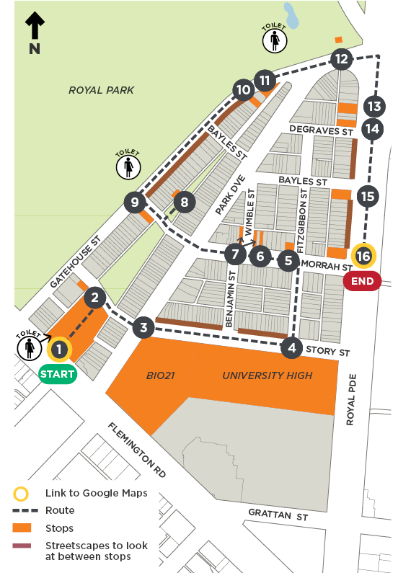

Notes

Places
Each stop nominates the type of protection that is being proposed through the Parkville Heritage Review, as follows:

Local Protection
This place is proposed for local protection through the Melbourne Planning Scheme.

Local and Part State Protection
This place is proposed for local protection through the Melbourne Planning Scheme, and state protection through the Victorian Heritage Register.

Local Context
This place is not proposed to change through the Parkville Heritage Review, but is included due to its importance to Parkville’s local context.

Acronyms
AM Member of the Order of Australia
HO Heritage Overlay
VHR Victorian Heritage Register
WWII World War Two (1939–45)

Stop 1

Local Protection

Ievers Reserve, 42 Flemington Road
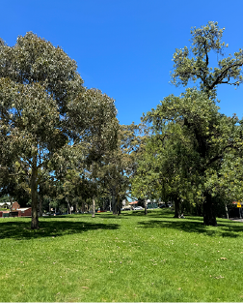
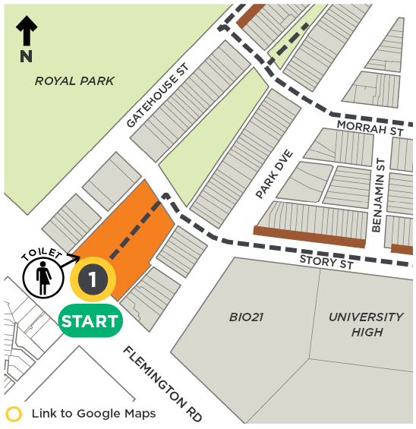

Architect(s): N/A
Constructed: c1870s
Current heritage: In HO4 Parkville Precinct
Proposed heritage: Significant to HO4 South Parkville Precinct
The Wurundjeri Woi–wurrung are the traditional owners of the land that is now called Parkville. For tens of thousands of years, Wurundjeri Woi–wurrung walked this Country. People have been born onto Country and laid to rest on Country. The Wurundjeri Woi–wurrung people continue to be the custodians of the land and its living culture and heritage.
At the time of European colonisation Royal Park was thinly timbered with gum, wattle and she–oak. This was a well–watered and resource rich area, making it an ideal place for living and meeting. Parkville lies only a few kilometres to the north of the Birrarung (Yarra River). Small streams once flowed from the higher ground in Royal Park into the Moonee Ponds Creek, which was defined by a series of lagoons.
The location you are standing on has been heavily modified from the time of European contact. The triangular shaped open space named Ievers Reserve was once the location of a creek, one of a number of creeks that ran through what is now Royal Park. This creek was relocated to an underground drain sometime between the 1860s and 1890s, in order to optimise the area of land available for use, and to reduce its susceptibility to flooding.
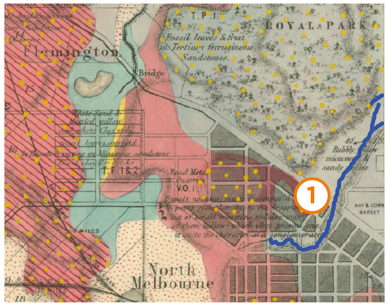
An historic geological map showing the creek that once existed at Stop 1, Ievers Reserve. Melbourne Surveyed, by Department of Public Lands, Victoria, Geological Survey of Victoria, 1860. Source: Maps Collection, State Library of Victoria, Record No. 9918747963607636
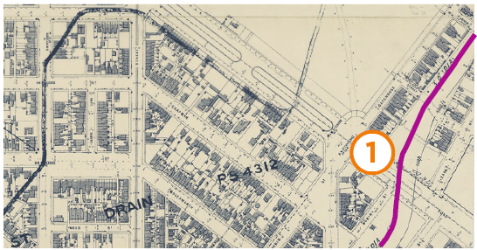
Melbourne and Metropolitan Board of Works Plan No. 31, Melbourne and North Melbourne, 1895. Source: Maps Collection, State Library of Victoria, Record No. 9915969693607636

Stop 2

Local Protection

Stable, 34–36 Gatehouse Street (Rear)
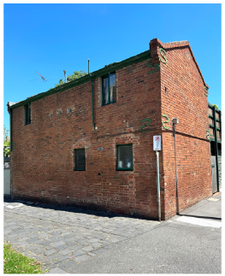

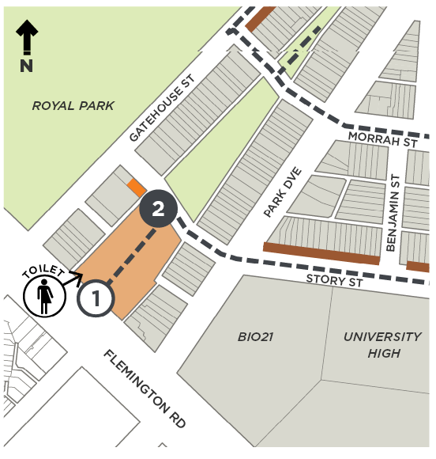

Architect(s): Unknown
Constructed: 1878
Current heritage: Contributory to HO4 Parkville Precinct
Proposed heritage: Significant to HO4 South Parkville Precinct (stable building at rear); no change (34–36 Gatehouse Street)
The former stables at the rear of the property on Redpath Rise, were once occupied by renowned Australian artist Sir Sidney Nolan as his studio. Here he painted View from the Artist’s Studio, Parkville in 1944, and Parkville in c1944 and 45.
Nolan also painted the first of his Ned Kelly series at his Gatehouse Street studio. It is speculated that the way Nolan represented Ned Kelly’s eyes through his helmet was inspired by Nolan himself peering through the letterbox on the door to look out for and avoid compulsory conscription during WWII.
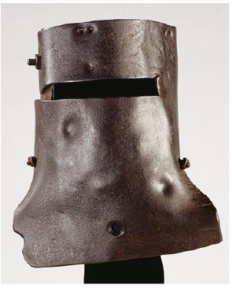
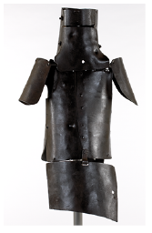
Suit of armour worn by Ned Kelly in 1880. Source: Pictures Collection, State Library of Victoria, Accession No. H20171

Stop 3

Local Protection

Northern Market and Lecture Hall, Story Street
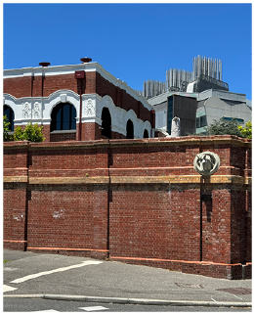
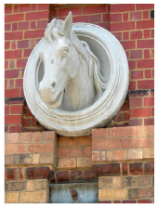
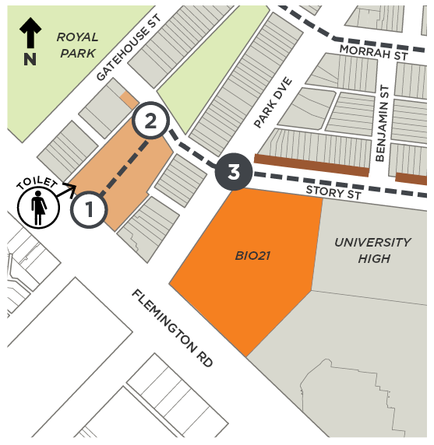
Architect(s): Various
Constructed: Various
Current heritage: Northern Market wall on the VHR
Proposed heritage: Lecture Hall 1908 (Bio21 site) Significant to HO4 South Parkville Precinct
Following a series of subdivisions between 1868 and 79, the street layout of South Parkville was established and included a market area bounded by Sydney Road (now Royal Parade), Story Street, Park Drive, Flemington Road and Grattan Street. From around the 1870s, the Northern Market was operating here as a horse, cow and pig market. It continued until the early twentieth century when the site was progressively redeveloped for a veterinary college (Bio 21 site, Flemington Road), University High (Stop 4) and hospitals (Flemington Road and Royal Parade).
The Northern Market served Melbourne’s early meat industry at a time when the local economy was largely driven by the pastoral industry. In the early 1900s, the occupations of a number of residents of South Parkville, including carters and stablemen, suggest there was a close association with the market.
The market was enclosed with a tall brick wall in 1888, which is still partially present. Constructed to a design by City of Melbourne architect William Salway, the structure features a horse’s bust fixed to the wall in Story Street near the corner of Park Drive.
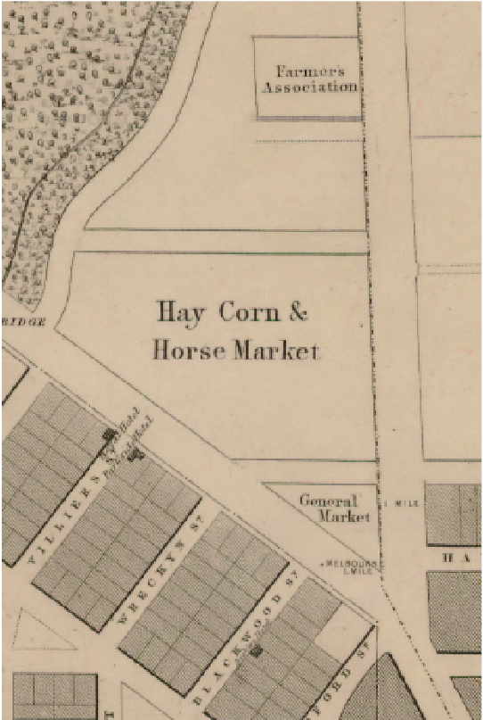
Melbourne and its suburbs compiled by James Kearney, 1855, showing the extent of the Northern Market. Source: Maps Collection, State Library of Victoria, Record No. 997869963607636

Stop 4

Local Protection

University High oval, 77 (part) Story Street
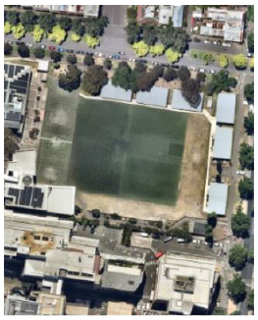
(Nearmap)
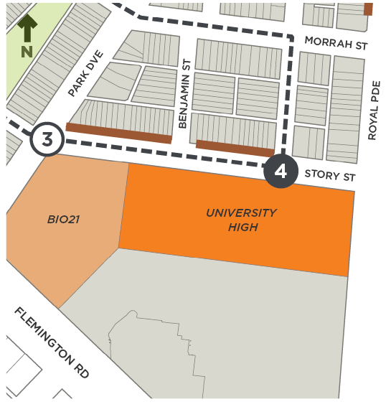

Architect(s): N/A
Constructed: 1860s
Current heritage: University High Northern Building (VHR H2183); oval nil
Proposed heritage: Significant to HO4 South Parkville Precinct
University High School was developed from 1929 on the eastern end of Northern Market, on what was the Victorian–era horse market.
The school oval was formed with the creation of University High in 1929 and was formalised by 1931. It has remained in almost continual recreational use since that time, except during World War II when the United States Army occupied the school oval with barracks for soldiers.
The remainder of the school site comprises a complex of buildings from various periods of development. The Northern Building at 77 Story Street was the initial school building established in 1929 and remains the most publicly visible building on site. This building is heritage protected through the Victorian Heritage Register.
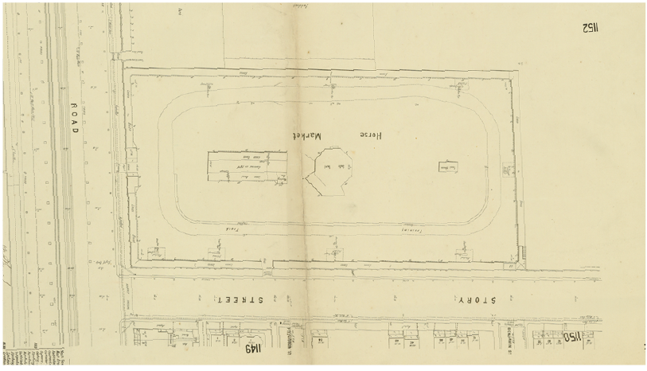
1896 map showing the Horse Market, oriented south to match the aerial photo below. Source: Maps Collection, State Library of Victoria, Record No 9911638363607636
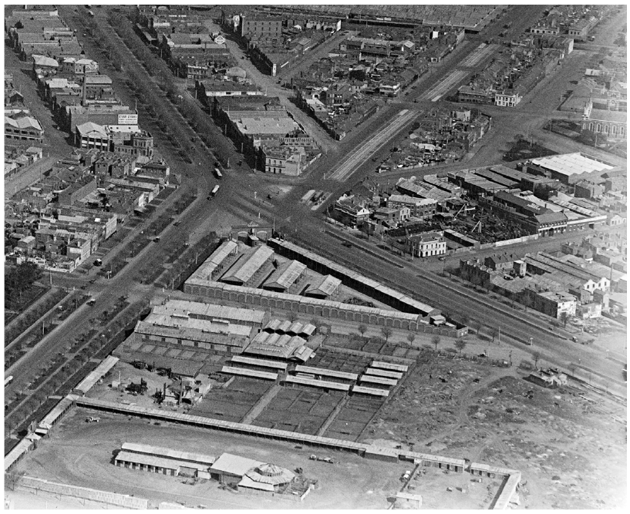
Looking over the city in the c1920s, with the horse market in the foreground. Photo by Charles Pratt. Source: Pictures Collection, State Library of Victoria, Accession No. H91.160/519
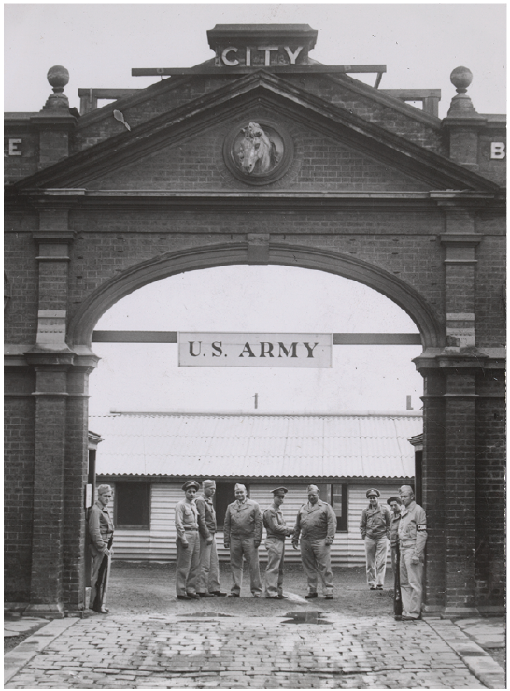
American soldiers standing at the entrance to the United States Army Camp at the old Horse Market (now University High), view from Story Street, c1944. Note the horse bust just under the ‘City’ sign, similar to the bust you saw at Stop 3. It may even be the same bust, which has been moved. Source: Pictures Collection, State Library of Victoria, Accession No. H2000.200/1245

Stop 5

Local Protection

Former Shop, 26–30 Morrah Street
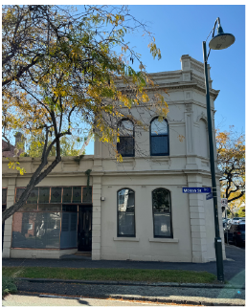
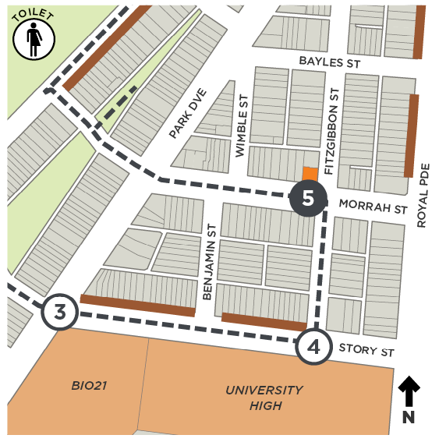

Architect(s): Unknown
Constructed: 1889
Current heritage: Contributory to HO4 Parkville Precinct
Proposed heritage: Significant to HO4 South Parkville Precinct
26–30 Morrah Street comprises a group of three shops built in 1889. On the corner of Morrah and Fitzgibbon streets, the two–storey corner shop originally housed a baker. The two adjacent single–storey shops were a bootmaker and chemist.
Designed in the Victorian Italianate style, the shops are highly intact and retain their classical detailing that is typical of the style, including a panelled parapet topped with urns.
Together, the shops are representative of the small number of stores built in the area to cater to local residents. Such shops were a feature typical to neighbourhoods until the late 20th century when retail operating hours became more relaxed and car ownership enabled people to access their daily needs at all times of the day and further afield.

Stop 6

Local Protection

Dwelling, 44 Morrah Street
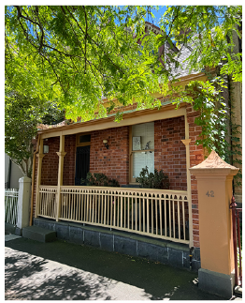
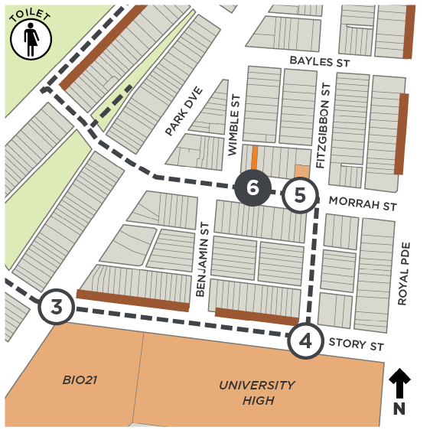

Architect(s): Unknown
Constructed: 1873
Current heritage: Significant to HO4 Parkville Precinct
Proposed heritage: Significant to HO4 South Parkville Precinct
44 Morrah Street is a single storey, single fronted brick terrace dwelling that is one of the first houses built in the precinct, after land was excised from Royal Park in 1872. What is unusual about this workers’ terrace is its particularly steep gable roof form and dormer window with scalloped barge board. Its design simplicity is reminiscent of cottages built in Tasmania that bear links to earlier Georgian architecture. Highly intact, this house is a fine example of early cottage design before Melbourne’s boom years of the 1880s.

Stop 7

Local Protection

Former shops, 48 Morrah Street and 52 Morrah Street
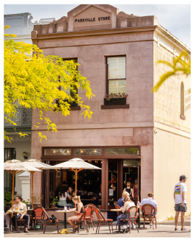
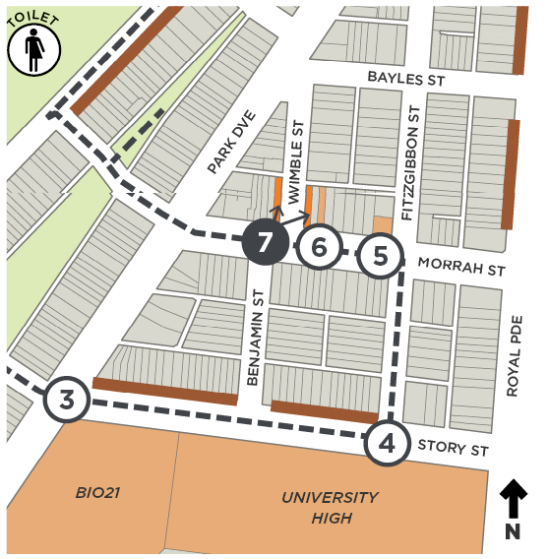

Architect(s): No. 48 – Unknown; No. 52 – Walter Gunn
Constructed: No. 48 – 1890; No. 52 – 1884
Current heritage: No. 48 – Significant to HO4 Parkville Precinct; No. 52 – Contributory to HO4 Parkville Precinct
Proposed heritage: Both Significant to HO4 South Parkville Precinct
48 Morrah Street is a highly intact corner building demonstrating a restrained use of the Victorian Italianate style. The building features what appears to be an original or early shopfront with rounded corners. A second entrance off Wimble Street retains its original door.
52 Morrah Street, Parkville Store, is a Victorian Italianate shop residence, also restrained in design. It was built a little earlier to a design by architect Walter Gunn. Originally occupied by a grocer, the shop features a large ‘ghost sign’ advertising John Bull Oats on its upper wall facing Wimble Street. The date of this sign is unknown. Local shops are often found on corners where they were easy to find and made the most of passing trade from two streets rather than one. Aside from a corner location, former shops can often be identified by remnant advertising, and verandahs (or verandah post holes in the bluestone kerb) that were built to protect window stock from the sun, present advertising and provide weather protection for shoppers.
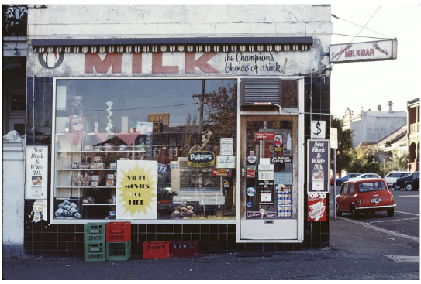
Exterior view of a milkbar in Parkville, c1983–84, as seen from Morrah Street; photo by Christopher van der Craats. Source: Pictures Collection, State Library of Victoria, Accession No. H2019.250/60

Stop 8

Local Protection

The Vintage Sports Car Club of Victoria Inc., 110a Gatehouse Street
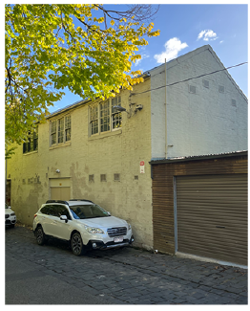
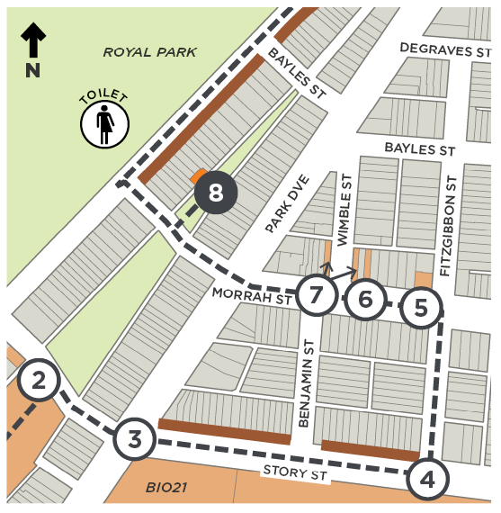

Architect(s): Unknown
Constructed: c1880s
Current heritage: In HO4 Parkville Precinct
Proposed heritage: Significant to HO4 South Parkville Precinct
110A Gatehouse Street is a two–storey brick workshop built at the rear of 110–114 Gatehouse Street. It is thought that the workshop pre–dates the terrace house that was constructed in c1896.
The workshop is significant as the club house of the Vintage Sports Car Club of Victoria (VSCC), which was formed after WWII. The VSCC caters for quality cars manufactured prior to 1940.
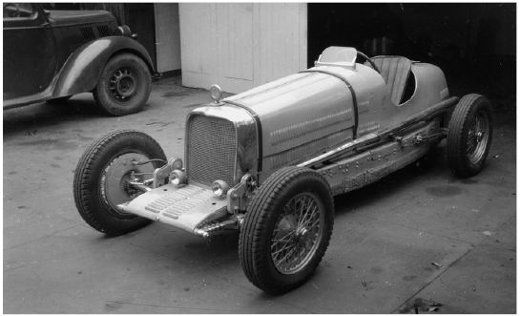
An example of a car that members of the still–active VSCC Inc. may collect. ‘Day special’, 1945–50, photographed by George Thomas. Source: Pictures Collection, State Library of Victoria, Accession No. H2014.115/127

Stop 9

Local Protection

Saunders House, 90–92 Gatehouse Street
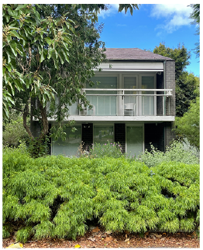
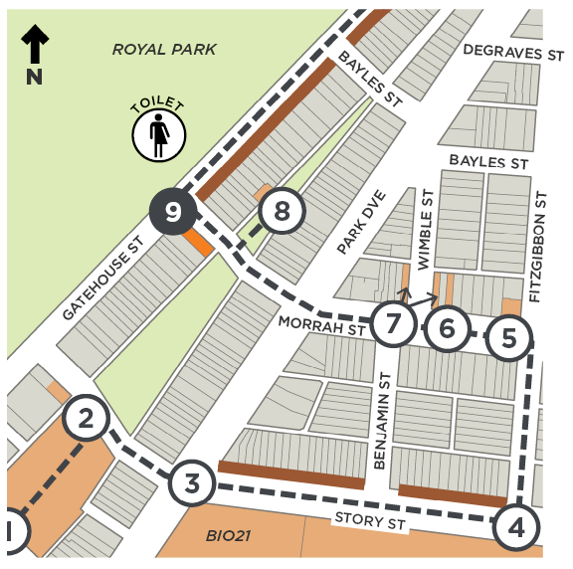

Architect(s): David and Doreen Saunders
Constructed: 1961–62
Current heritage: In HO4 Parkville Precinct
Proposed heritage: Individually Significant Place
The only residential design by David and Doreen Saunders, 90–92 Gatehouse Street was designed as their family home. The house demonstrates careful consideration and manipulation of the terrace typology in built form and setbacks. The skillion roof and stepped–back levels create a sloping frontage that reflects the established Victorian–era terrace house typology in Parkville, in order to conform with the strict planning regulations of the compact urban block at the time. The roof is split in the middle to allow for additional windows, so that natural light flows into the tightly planned interiors.
David Saunders was a well–regarded architectural historian and professor, particularly in the study of nineteenth–century Australian architecture, and was an early advocate of heritage conservation. Saunders House is notably modern but blends into historic Parkville. Its design combines David’s interest in contemporary architecture with the couple’s appreciation of historic buildings.
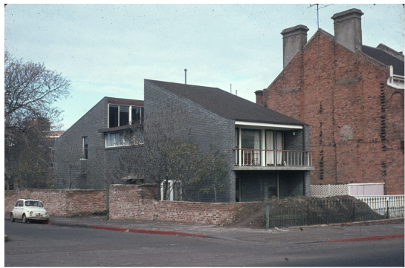
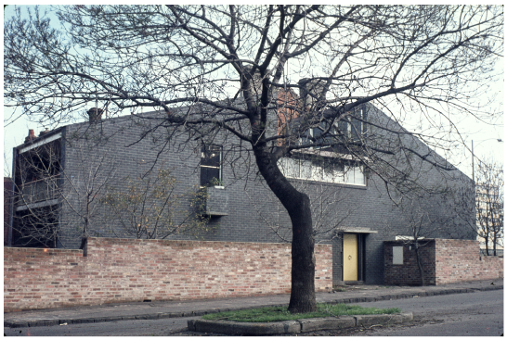
Saunders House, at the corner of Gatehouse and Morrah streets, built in 1962. Photographs by Peter Wille. Source: Pictures Collection, State Library of Victoria, Record No. 9939664460207636

Stop 10

Local Protection

Dwellings, 178–180 Gatehouse Street
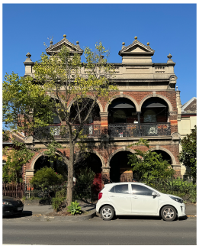
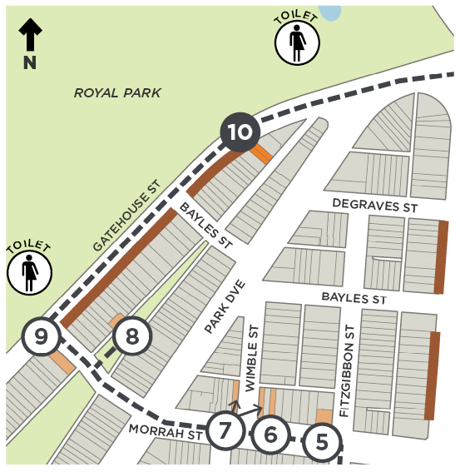

Architect(s): Unknown
Constructed: 1904
Current heritage: Both Significant to HO4 Parkville Precinct
Proposed heritage: Both Significant to HO4 South Parkville Precinct
This pair of two–storey terrace houses, designed in the Victorian–era Italianate style, are unusual for their colonnaded verandah instead of the more typical cast iron. The pair is also uncommonly ornate for its date of construction just after the depression of the 1890s, when building projects stalled or were completed according to a more austere design.
The Depression, which saw real Gross Domestic Profit (GDP) fall 17 per cent in 1892 and 1893, and the accompanying financial crisis that reached a peak in 1893, were the most severe in Australia’s history. The over–extension of the 1880s property boom and its unravelling led to an abrupt collapse of private investment in the pastoral industry and urban development, and a sharp decline in public infrastructure projects.

Stop 11

Local Protection

Church, 188–198 Gatehouse Street
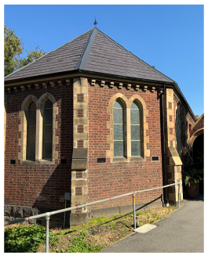
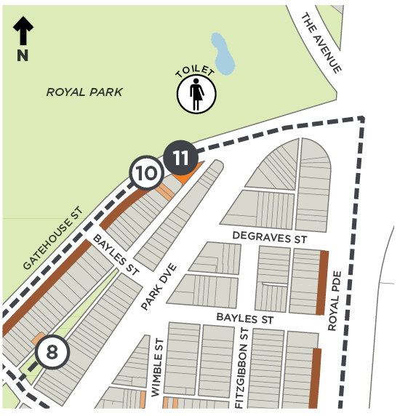

Architect(s): Unknown
Constructed: 1887
Current heritage: Significant to HO4 Parkville Precinct; VHR listing
Proposed heritage: Significant to HO4 South Parkville Precinct; VHR listing amended
College Church Hall was built after Presbyterian families in Parkville felt the need for a local Sunday school as it was too far for their children to walk to Carlton, North Melbourne or Brunswick. The small single roomed hall is built on a wedged shaped site and features walls of Hawthorn bricks with trim details to its buttresses, and paired gothic arched lancet windows in sandstone.
Land uses like churches and Sunday schools can help us understand the extent of historic neighbourhoods because they are a good indicator of past local walkability, when people tended to walk to meet their daily to weekly needs.
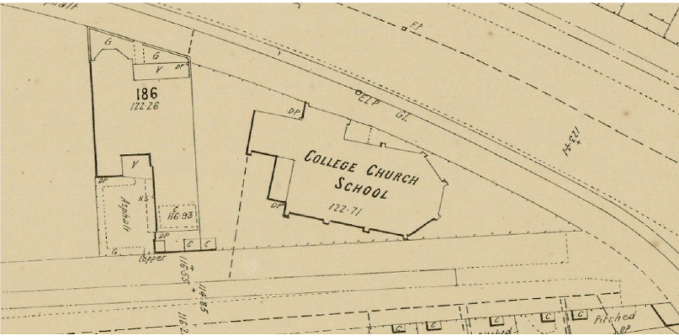Metropolitan Board of Works, Plan No. 1150, 1897 showing the Sunday school. Source: Maps Collection, State Library of Victoria, Record No. 9911638303607636

Stop 12

Local Context

Walmsley House, 161 Gatehouse Street
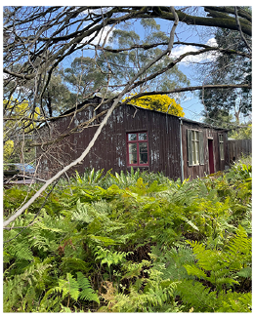
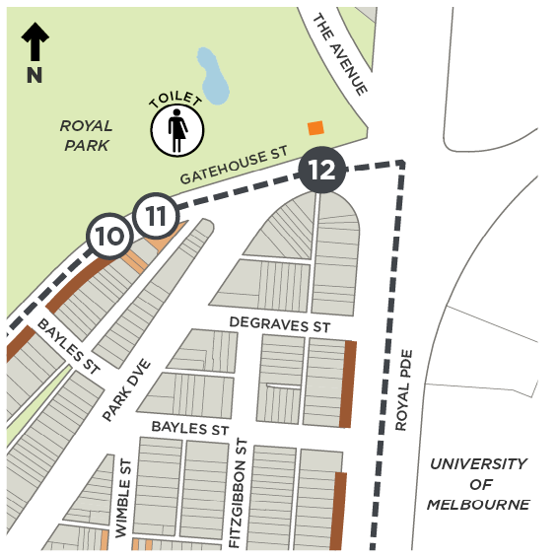

Architect(s): Walmsley of London (manufacturer)
Constructed: 1850s
Current heritage: VHR H1946, HO895
Proposed heritage: No change
Walmsley House is a prefabricated iron house of the mid–nineteenth century. It was manufactured by Walmsley of London, a wholesale ironmonger at 127 London Road, Southwark, London, who supplied prefabricated iron buildings to Australia. It is thought Walmsley may have been subcontracted by John Walker who exported a number of similar houses to Victoria.
Walmsley House was brought to the colony in 1853 or 1854 for use as a public building (such as a military depot or lock–up). In 1862, the building was moved to Royal Park to be used as the first official residence of the park ranger and bailiff, Mr Francis Meaker. In 1905, Frances was succeeded by his son Charles. The Meaker family lived here for 79 years. It would have been an incredibly uncomfortable house, with such buildings referred to as ‘camp ovens’ because they were so hot in summer. Walmsley House is now managed by City of Melbourne and used for local community meetings.
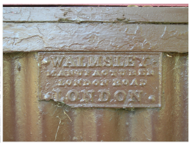
The manufacturer’s plaque. Source: Inset Royal Park Protection Group, retrieved 27/11/23
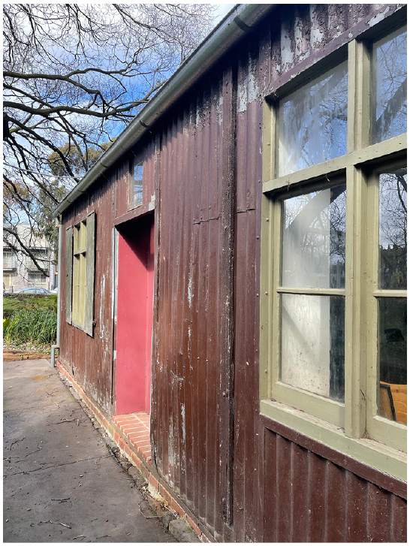
Walmsley House North elevation, looking towards Gatehouse Street

Stop 13

Local Protection

St Carthages Church, 121–125 Royal Parade
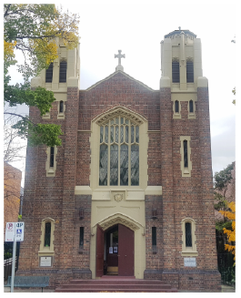
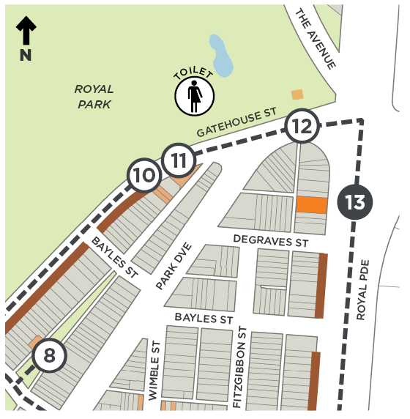

Architect(s): P J O’Connor
Constructed: 1934–35
Current heritage: Contributory to HO4 Parkville Precinct
Proposed heritage: Individually Significant Place
St Carthages is a Catholic ‘chapel of ease’ built in 1934–35 to serve the needs of the growing population of the Catholic Parish of St Mary’s, West Melbourne. This was due in part to the increasing number of Catholic students enrolled at the University of Melbourne, and the establishment of Catholic residential colleges.
The building is a striking example of the Interwar style, with a strong verticality in its design, and its use of typical Gothic motifs. It is highly intact externally and retains key Interwar Gothic Revival elements, such as the use of face brickwork with areas of decorative basketweave bond, Gothic arches to the window and door surrounds, lancet windows and towers, the use of cement render to imitate stone detailing, traditional label moulding, and stained–glass windows.
St Carthages continues to serve the local Catholic community, including current and former University students and staff, and provides religious services and social activities for the parish.
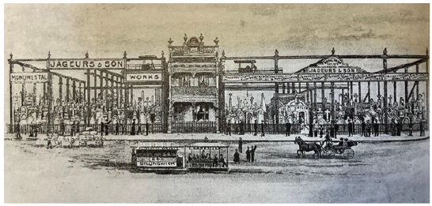
The premises of Jageurs & Sons, monumental masons on Royal Parade, c1890s. St Carthages Church is located on the southern end of the former Jageurs & Sons site. Source: Lewis, 1996:44 in GML’s Parkville Heritage Review
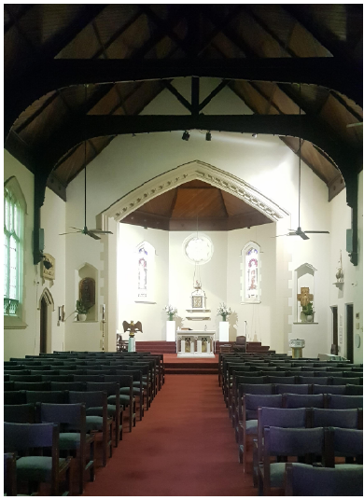
Interior view

Stop 14

Local Protection

Los Angeles, 113–115 Royal Parade
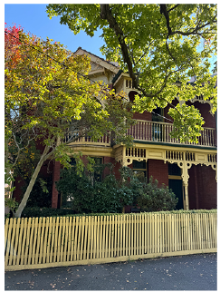
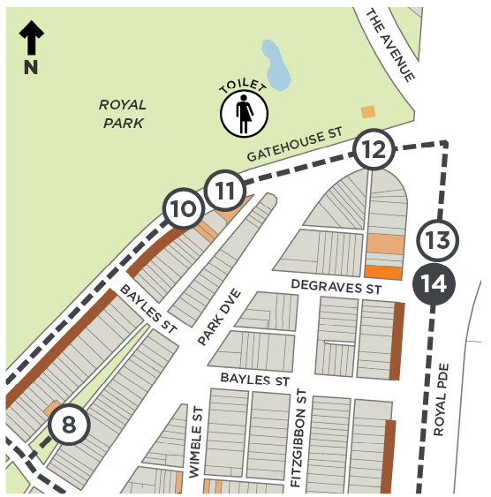

Architect(s): Unknown
Constructed: 1901
Current heritage: Contributory to HO4 Parkville Precinct
Proposed heritage: Significant to HO4 South Parkville Precinct
113–115 Royal Parade is a free standing two storey red brick house. Located on the corner of Degraves Street, the house displays typical characteristics of the Queen Anne style, including a steeply pitched hip and gable terracotta roof with ridge capping, bands of roughcast render under the eaves and at first floor level, projecting gable ends with half–timbering, and a strong corner emphasis with the central room set at an angle. The house is distinguished by its use of pointed arch windows and turned timber rondels and sinuous corner brackets to the fretwork.
A relatively late house to South Parkville, the property was still unbuilt in the mid 1890s, perhaps delayed by the 1890s Depression.

Stop 15

Local Protection

Elbion, 77–79 Royal Parade
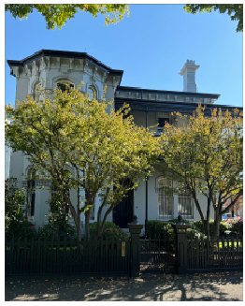
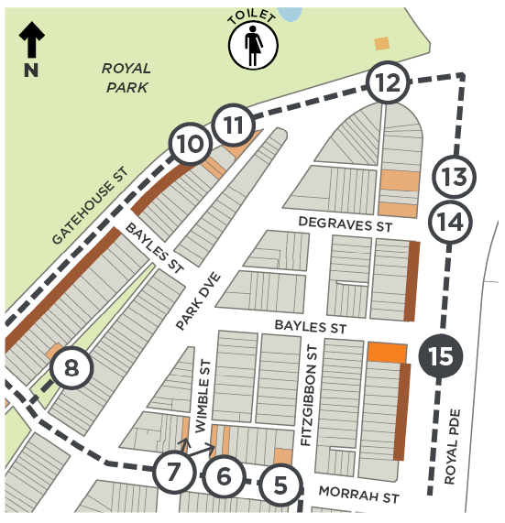

Architect(s): Unknown
Constructed: 1886
Current heritage: Contributory to HO4 Parkville Precinct
Proposed heritage: Significant to HO4 South Parkville Precinct
‘Elbion’ is a two–storey double–fronted asymmetrical house that demonstrates finely resolved detailing typical of the Victorian Italianate style. This includes a hip slate roof, bracketed eaves with decorative panels and rosettes, an acanthus leaf stringer course, window moulds, decorative keystones, and a return verandah with decorative cast–iron work. The house is highly intact and retains an early two–storey outbuilding on the rear lane. Parkville Ladies’ College operated from this address during the 1880s and 1890s.
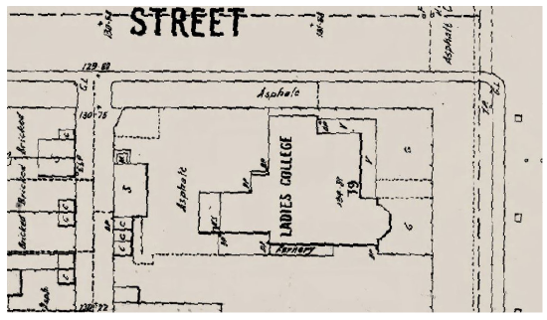
Metropolitan Board of Works, Plan No. 1150, 1897, showing the Ladies College. Source: Maps Collection, State Library of Victoria, Record No. 9911638303607636

Stop 16

Local Context

Naughton’s Hotel, 43–49 Royal Parade
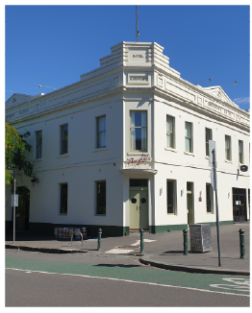
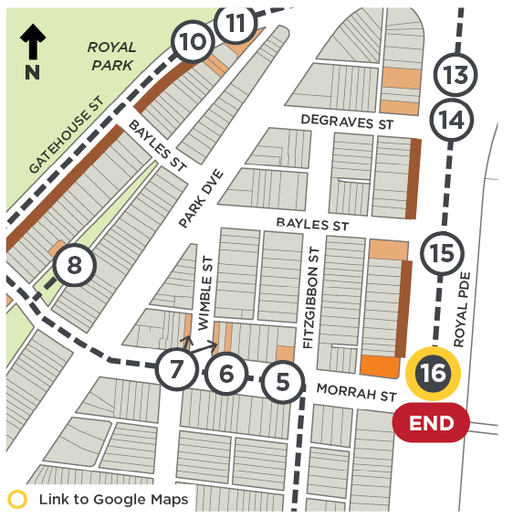

Architect(s): Robert McIntyre (remodelling)
Constructed: 1873 and remodelled 1923, incorporating two shops at 47 and 49 Royal Parade
Current heritage: Contributory to HO4 Parkville Precinct
Proposed heritage: Significant to HO4 South Parkville Precinct
Originally established as the Port Phillip Agricultural Hotel with a corner bar, stables and small vegetable garden, it was later renamed Parkville Hotel. The hotel is now known as Naughton’s Hotel, named after John Naughton, who purchased the hotel in 1916, a week after his marriage to Mary Hickey, who was herself born in a hotel, the Edinburgh Castle, in North Melbourne.
The hotel was altered in the Interwar years using a restrained interpretation of Interwar Stripped Classicism, by architectural practice Joy and McIntyre, who worked on a range of hotel commissions.
Hotels hold strong social significance to local communities, providing a central place to meet and socialise together within walking distance from home. In the case of Naughton’s, its close proximity to the University of Melbourne and its Colleges means that it is also a “watering hole” for the weary student or lecturer. It is also the “unofficial social club” of the Carlton Football Club. It is here Stephen Kernahan (Carlton leading goal kicker) famously belted out ‘Stand By Your Man’ on the Monday after Carlton won the 1987 Grand Final.
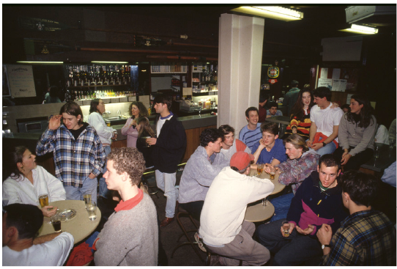
Student haunt Naughton’s Hotel, c1990s. By Rennie Ellis. Source: Pictures Collection, State Library of Victoria, Accession No. H2011.150/2164
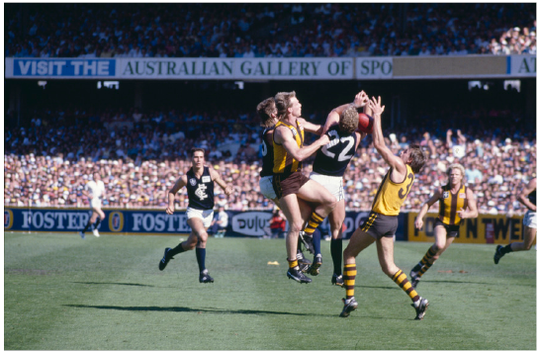
Australian football at Melbourne Cricket Ground. Hawthorn v. Carlton at the 1987 Grand Final. By Rennie Ellis. Source: Pictures Collection, State Library of Victoria, Accession No. H2011.150/2164

End Notes
  - aboriginal-map.melbourne.vic.gov.au/, accessed January 2024.
  - City of Melbourne, unpublished research.
  - Parkville resident, October 2023.
  - City of Melbourne, unpublished research, 2013–14.
  - City of Melbourne, unpublished research.
  - Brine, J, 2012, ‘David Arthur Lewis Saunders’, Australian Dictionary of Biography website, accessed on 4 January 2024, adb.anu.edu.au/biography/saunders-david-arthur-lewis-15756.
  - rba.gov.au/publications/, accessed 28/11/23.
  - City of Melbourne, unpublished research, 2013–14.
  - Royal Park Protection Group, website, accessed 27 November 2023, https://royalparkprotect.com.au/archives/general/walmsley-house/
  - Royal Park Protection Group, website, accessed 27 November 2023, https://royalparkprotect.com.au/archives/general/walmsley-house/
  - State Library of Victoria, Record No. 9911638303607636.
  - innercitynews.com.au/parkvilles-naughtons-hotel-celebrates-150-years-as-a-community-institution/, accessed 5/1/24.
  - carltonfc.com.au/news/111409/naughtons-returns-as-true-blue-venue; https://en.wikipedia.org/wiki/1987_VFL_grand_final, accessed 5/1/24.
  - slv.vic.gov.au, accessed 28/11/23.
  - en.wikipedia.org/wiki/Stephen_Kernahan, accessed 5/1/24.
  - carltonfc.com.au/news/111409/naughtons-returns-as-true-blue-venue; en.wikipedia.org/wiki/1987_VFL_grand_final, both accessed 5/1/24.

Back Cover
We hope you enjoyed the South Parkville self–guided walk, which was prepared as part of the Parkville Heritage Review.
The Parkville Heritage Review recommends heritage protection for a range of places, some of which you have visited today.
Visit participate.melbourne.vic.gov.au/parkville-heritage-review by 31st October, 2025 to find out more and have your say.

