
Chelmsford Street Open Space

Engagement Summary Report

City of Melbourne, 31/01/2024

Privacy
Capire Consulting Group and any person(s) acting on our behalf is committed to protecting privacy and personally identifiable information by meeting our responsibilities under the Victorian Privacy Act 1988 and the Australian Privacy Principles 2014 as well as relevant industry codes of ethics and conduct.
For the purpose of program delivery, and on behalf of our clients, we collect personal information from individuals, such as e-mail addresses, contact details, demographic data and program feedback to enable us to facilitate participation in consultation activities. We follow a strict procedure for the collection, use, disclosure, storage and destruction of personal information. Any information we collect is stored securely on our server for the duration of the program and only disclosed to our client or the program team. Written notes from consultation activities are manually transferred to our server and disposed of securely.
Comments recorded during any consultation activities are faithfully transcribed however not attributed to individuals. Diligence is taken to ensure that any comments or sensitive information does not become personally identifiable in our reporting, or at any stage of the program.
Capire operates an in-office server with security measures that include, but are not limited to, password protected access, restrictions to sensitive data and the encrypted transfer of data.
For more information about the way we collect information, how we use, store and disclose information as well as our complaints procedure, please see www.capire.com.au or telephone (03) 9285 9000.
Consultation
Unless otherwise stated, all feedback documented by Capire Consulting Group and any person(s) acting on our behalf is written and/or recorded during our program/consultation activities.
Capire staff and associates take great care while transcribing participant feedback but unfortunately cannot guarantee the accuracy of all notes. We are however confident that we capture the full range of ideas, concerns and views expressed during our consultation activities.
Unless otherwise noted, the views expressed in our work represent those of the participants and not necessarily those of our consultants or our clients.
Definitions
- Community - An individual or a group of people united by at least one common characteristic such as geography, shared interests, values, experiences, or tradition.
- Community engagement - A planned process with the specific purpose of working with individuals and groups to encourage active involvement in decisions that affect them or are of interest to them.
- Stakeholder - An individual or group that has an interest in any Council decision or activity, including Traditional Custodians and Aboriginal communities, other tiers of government and government agencies, businesses, educational institutes, not-for-profits and philanthropic organisations, visitors, residents, advocacy groups, children, ratepayers and renters, emergency services, culturally and linguistically diverse people and many more.

Version 6. Author: Charlotte Yu. Authorised by Denise Francisco. Date 29/02/2024

Table of Contents
1. Introduction 5
1.1. Project background 5
1.1.1. Chelmsford Street Open Space 5
1.1.2. Preparation of the draft Chelmsford Street Open Space concept plan 6
2. Engagement approach 8
2.1. Engagement objectives 8
2.2. Methodology 9
2.2.1. Promotion 9
2.2.2. Engagement activities 10
2.3. Limitations 12
3. Summary of participants 12
3.1. Gender 13
3.2. Age 13
3.3. Demographics 14
3.4. Connection to the project 15
3.5. Motivation to participate in the engagement 15
3.6. Participation in previous City of Melbourne engagement 16
4. Engagement findings 17
4.1. Level of support for the project vision 17
4.2. Level of support for the project opportunities 18
4.3. Activities and amenities 20
4.4. Making the space feel safe and welcoming 23
4.5. Accessibility of the space 24
4.6. Elements to retain 25
4.7. Expanding the Chelmsford Street Open Space 27
4.8. Additional comments 28
5. Next steps 29
Appendix A: Survey questions 30
Appendix B: Activity booklet 34
Appendix C: Pop-up interactive boards 36

Introduction
This report summarises the key findings from the first phase of community engagement on the Chelmsford Street Open Space project.

Project background

Chelmsford Street Open Space
In 2021, the City of Melbourne (Council) purchased 70-90 Chelmsford Street in Kensington (the future Chelmsford Street Open Space) for the purpose of public open space. The Chelmsford Street Open Space project aims to increase the quantity and quality of public open space in the Kensington catchment area and contribute to the wider open space network within Macaulay.
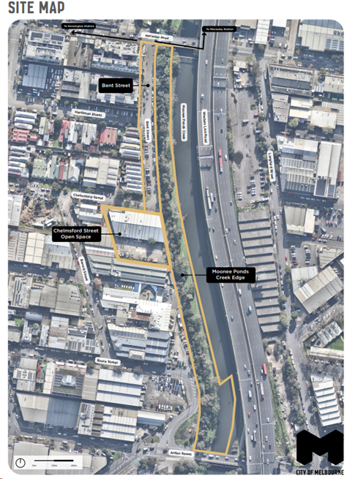
Figure 1: Chelmsford Street Open Space site map
The project is comprised of the following land areas (Figure 1):
- 70-90 Chelmsford Street (the future Chelmsford Street Open Space)
- Bent Street (including the vegetated verge up to the levee wall)
- Railway land owned by VicTrack (the Moonee Ponds Creek interface, from the creek edge to the levee wall/property boundary).
At this stage, Council has funding for the design and implementation of the new Chelmsford Street Open Space. The design for the Chelmsford Street Open Space will incorporate Bent Street and the Moonee Ponds Creek edge to ensure a seamless integration of place, ecology and community in the future. This approach will also allow for more cohesive stormwater management and flood mitigation in the area.
The project has been guided by previous engagement with the local community and existing Council strategies and policies, including:
- Macaulay Structure Plan, 2021 (MSP)
- City of Melbourne Open Space Strategy, 2012.

Preparation of the draft Chelmsford Street Open Space concept plan
To inform the development of the draft concept plan, this phase of engagement focused on seeking diverse community feedback on the draft project vision and key opportunities, potential activities and amenities, and opportunities to expand the future Chelmsford Street Open Space area by repurposing car spaces in Chelmsford Street.
The draft vision statements for Chelmsford Street Open Space were:
- Acknowledging Traditional Owners: Reflect Traditional Owner voices, culture and connection to Country.
- Storytelling and history: Acknowledge the evolving story of the creek, past and present and establish a new direction for the future by revealing and unpacking layers of time, landscape and community.
- Activities for everyone: Offer diverse experiences, providing opportunities for play, exploration, gathering and reflection.
- A place for people and animals: Provide refuge and respite for human and non-human communities and become a robust ecosystem that enables social and environmental resilience for the future.
- A place for the community: Become a new heart for the Kensington community.
- Connecting with nature: Create a place of belonging, learning and local custodianship to shift our relationship with the landscape to become one of care and connection to nature.
The draft project opportunities for the site were:
- Unify: Unify disconnected spaces to create a cohesive place for people and ecology.
- Reveal: Reveal and celebrate the site’s historical, ecological, cultural and community layers.
- Gather: Create a new heart for the local community.
- Connect: Enhance the site’s connection to the local community and surrounding ecological networks.
- Respond: Respond to changing environmental conditions and the growing local community.
The list of potential experiences and activities at the site are outlined in the following text.
Experiences and amenities
- Connecting with and learning about nature
- Walking and wheeling
- Relaxation and contemplation
- Gathering and socialising
- Play
- On-leash dog walking
- Informal sport and exercise
Amenities
- Informal sporting amenities
- Lawn areas
- Picnic areas
- State elements
- Seating for individuals
- Play elements
- BBQs
- Seating for groups
- Outdoor exercise equipment
To create additional street greening and pedestrian amenity, seven car parks near the intersection Chelmsford and Bent streets were identified for potential repurposing, as shown in Figure 2.
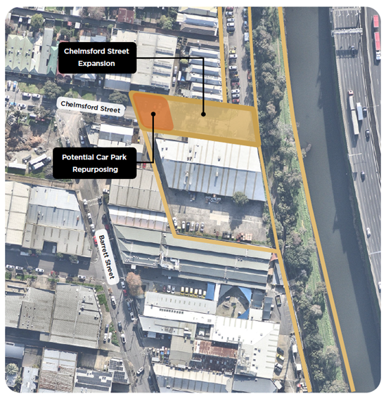
Figure 2: Expansion of Chelmsford Street Open Space and proposed car park repurposing

Engagement approach
This section provides a comprehensive overview of the objectives, methodologies, participation in the engagement process, and limitations of the engagement activities. The engagement activities occurred over eight weeks, commencing on 9 November 2023 and ending on 8 January 2024.

Engagement objectives
The engagement was underpinned by a set of objectives, which guided the planning and design of the engagement activities and allowed for effective monitoring and evaluation. The engagement objectives for the Chelmsford Street Open Space project were to:
- Acknowledge community input from previous engagement and demonstrate how the scope of the project responds to community feedback.
- Create excitement and awareness about the project and ongoing engagement.
- Ensure community and stakeholders understand the strategic and site context for the project and feel supported to participate in ongoing engagement. This includes topics such as ecological benefits, stormwater and flood management, greening, and passive and active open space.
- Consult with internal stakeholders and Wurundjeri Woi-Wurrung Elders at an early stage and seek their feedback on the draft vision and opportunities.
- Seek diverse community feedback on draft project vision, key opportunities, and understand community aspirations for future activities and amenities at the site to inform the draft concept plan.
- Explore opportunities to potentially expand the Chelmsford Street Open Space through repurposing car parking.

Methodology
Throughout the engagement period, the project team sought to inform as many people as possible. This was to ensure residents, visitors, businesses, service providers, and others interested in the Chelmsford Street Open Space project had a chance to share their ideas and feedback to inform the draft concept plan. Various tools and channels were used to provide information about the project and to promote the engagement opportunities.

Promotion
The following text outlines the tools to promote and inform community members about the project.

Participate Melbourne page
A webpage for the Chelmsford Street Open Space was established on Participate Melbourne. This webpage serves as a comprehensive resource, providing project information, frequently asked questions, the draft vision, project opportunities and potential activities for the site, as well as a project timeline and updates. Additionally, the webpage hosted a survey for the project and provided a booking link for engagement sessions.
The Chelmsford Street Open Space Participate Melbourne page received 4,280 views, 3,587 visits, and 2,771 unique visitors. A total of 21 visitors have subscribed to receive future updates about the project.

Email promotion
Emails were directly sent to a wide range of local community groups and organisations in Kensington and surrounding areas to promote the consultation, which comprised of more than 80 different email recipients. Multiple emails were sent at the beginning, middle and end of the consultation period as a final reminder.
The Community Engagement Working Group of the City of Melbourne emailed information about the engagement opportunities to residents, groups, and networks who have existing relationships with the City of Melbourne. This included promotion through the Participate Melbourne online portal and monthly EDMs.

Social media promotion
Council promoted Chelmsford Street Open Space engagement through social media channels such as Facebook, LinkedIn, Twitter, YouTube, and Instagram. Promotional posts were published on Facebook, Instagram, LinkedIn, and Twitter.
In addition to City of Melbourne channels, the project was shared on some local media pages including the Kensington Neighbourhood House Facebook page and, in the Kensington Good Karma Network Facebook group.

Traditional media
The commencement of the engagement period was promoted through Participate Melbourne on 9 November 2023, with regular news updates promoting in-person consultation sessions. The consultation was also shared and promoted on the Kensington Neighbourhood Portal and North Melbourne Neighbourhood Portal.
A media release was also sent to news outlets, and an article was written in the North West City News: New open space proposed for Kensington | North West City News

On-site promotion
Five corflute signs were installed at key locations near the site including two on Chelmsford Street opposite the site, one adjacent to Moonee Ponds Creek to the east of the site, one at the corner of Macaulay Road and Bent Street, and one at the corner of Eastwood and Chelmsford Streets.
Three corflute signs were installed at other sites in Kensington, including one at Robertson Street Reserve, one at Bellair Street Reserve, and one adjacent to the Kensington Train Station.

Postcard
Postcards detailed the core engagement messages and encouraged community members to participate in the community engagement process. This was communicated through providing website links, Council contact details, and a QR code which linked to the Chelmsford Street Open Space Participate Melbourne page.
A total of 840 graphically designed postcards were printed and distributed at engagement events. The postcards were strategically distributed to key community sites and locations around the neighbourhood.

Engagement activities
The following text provides details about the engagement activities undertaken.

Online survey
The online survey was the principal method of gathering community feedback, accessible via the Chelmsford Street Open Space Participate Melbourne webpage.
The objective of the survey was to provide a wide-reaching opportunity for community members to review the draft vision and project opportunities, share ideas for activities and amenities, and provide feedback on opportunities to expand the Chelmsford Street Open Space.
The survey asked nine questions and received 158 responses.
The full list of questions asked in the survey can be found in Appendix A.

Focus groups (online and in-person)
Four focus groups were held to have in-depth discussions about the project with community members and harder-to-reach groups. Discussion questions during focus groups were designed to align with survey questions but varied depending on the interests of the group. An activity booklet was prepared to capture input by children and young people (Appendix B).
All community members were able to register to attend an online focus group session via the project webpage. One online focus group was held. A second online focus group was cancelled due to low registrations. One-on-one phone conversations were made available for registrants as a replacement, however no registrants expressed interest in this opportunity.
Three in-person focus groups were held in collaboration with local organisations and service providers to reach a diverse audience representing different ages, cultural and linguistic backgrounds, as well as socio-economic backgrounds in Kensington. The focus groups were scheduled to coincide with existing programs and events. Children and young people aged between four to 16, and parents were represented in the focus groups.
Details of the focus groups are as follows:
Community focus group (Online)
Thursday 7 December 2023, 6.00-7.00pm
Participants: Six
Homework Club at Kensington Neighbourhood House
4 December 2023, 5.00-6.30pm
Participants: Nine children (primary school aged) and three parents
Kensington Community Children Co-op
Monday 11 December 2023, 10.30am-12.00pm
Participants: 16 children (pre-schoolers)
Christmas Party at The Venny
Thursday 21 December 2023, 3.00-5.00pm
Participants: 35 children and young people (various ages) and approximately 10 parents

Pop-up events
Two community in-person pop-ups were held on-site during the engagement period at different times and days of the week to capture a diverse audience.
The pop-up events shared information about the project, created awareness of the survey, and initiated conversations with participants to gather feedback and ideas on the Chelmsford Street Open Space. Interactive boards were displayed to show project information and record feedback (Appendix C). Coffee vouchers or free coffees were given away to encourage participation.
Approximately 53 conversations were recorded across the pop-ups.
The details of the pop-up events were:
Pop-up 1
Thursday 23 November 2023, 5.00-7.00pm
Pop-up 2
Saturday 25 November 2023, 10.00am-12.00pm

Intercept surveys
Three intercept surveys were held at different times and locations to reach community members who are not typically engaged with or who may not already know about the project. Project information was introduced to community members to help them complete the online survey. Coffee vouchers were offered to passers-by to encourage participation.
Approximately 23 surveys were completed across three intercept survey activities. The project team also raised awareness and distributed information about the project, including approximately 80 postcards.
Intercept survey 1
Saturday, 2 Dec 2023, 10.00am-12.00pm
Kensington Community Fresh Food Market at Skinny Park and Kensington Christmas Fair on Bellair Street
Intercept survey 2
Wednesday, 6 Dec 2023, 9.00-11.00am
Macaulay station and surrounds
Intercept survey 3
Friday, 15 Dec 2023, 3.00-5.00pm
Kensington Station and surrounds

Business and services doorknocking
One doorknocking activity was held on Wednesday 15 November 2023 from 1.30-3.30pm to engage local businesses and service providers. Casual conversations were held to capture their feedback about the project. Postcards with links to the online survey were also handed out to businesses and service providers, and some received extra postcards to share with the broader community. A total of 10 conversations were recorded.

Limitations
While robust, the engagement activities had several limitations that should be acknowledged when reading this report. These are outlined below:
- Capire has reported on information documented by participants and interpreted the information to represent the views of participants as closely as possible.
- The engagement program included multiple opportunities for participants to contribute. Some people may have taken part in multiple engagement activities, for example, they may have completed the survey and participated in a focus group. As such, their views may have been captured more than once.
- In some instances, participants did not respond to all survey questions, and this meant that some questions received fewer responses than others.
- People who participated in the engagement volunteered to take part. As such, whilst every effort has been made to gather a wide range of community and stakeholder feedback, the information in this report only reflects the views of those who took part in the engagement.
- Demographic data was captured through the survey, but not other engagement activities.
- One demographic question regarding respondents’ representation was included a few days after the launch of the online survey, hence the result in the report does not reflect the representation of all survey respondents.
- Qualitative feedback received through the engagement has been summarised in this report. Data was analysed to identify and capture frequently raised or similar participant feedback, which informed key emerging ‘themes’. As such, it does not provide a quantitative analysis of all feedback provided by participants.
- Quantitative survey findings have been supported by qualitative findings from other engagement activities where relevant. Some focus groups also provided quantitative data. Due to smaller numbers of responses in comparison to the survey, these have not been included in the graphs.
- To ensure constructive discussion with participants, not all questions were asked across engagement activities. Feedback from children and young people was gathered and reported on separately.
- There were many more registrations received for online focus groups than the actual number of participants.
- Translated materials or translators were not readily available during the engagement program for community members, potentially impacting participation of individuals with limited English proficiency or those who did not speak English.

Summary of participants
A total of 280 participants provided feedback throughout the engagement period, and these participants were diverse in age, gender, and cultural background.

Gender
Figure 3 shows that there was a slightly higher proportion of females who participated in the survey than males. Over half of the survey respondents were female (54 per cent), with males representing just over a third of participants (39 per cent). Two per cent of participants identified as non-binary or gender diverse. Five per cent of participants preferred not to indicate their gender.
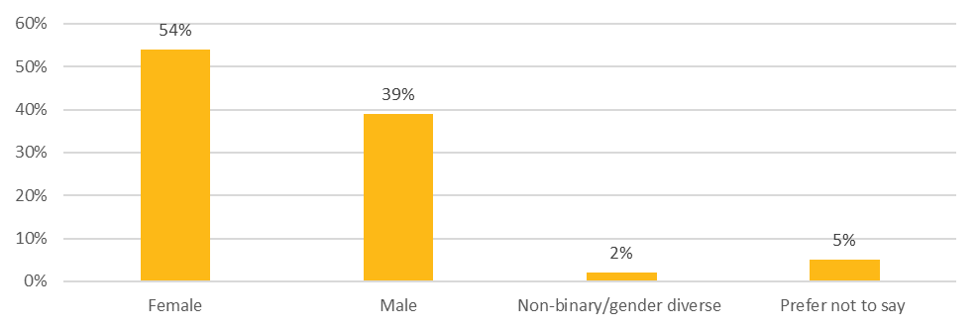
How do you describe your gender? | Percentage
Female | 54%
Male | 39%
Non-binary/gender diverse | 2%
Prefer not to say | 5%
Figure 3: Gender of survey participants (n = 156)

Age
As shown in Figure 4, a spread of ages was represented in the survey. Approximately half of survey respondents were between the ages of 30-44 years. The top four age groups represented were 40-44 years (18 per cent), 35-39 years (18 per cent), 30-34 years (16 per cent) and 25-29 years (eight per cent). The least represented groups were 15-19 years (one per cent) and 75-79 years (one per cent). None of the survey respondents were above the age of 80 or below 15 years. Four per cent of respondents chose not to say.
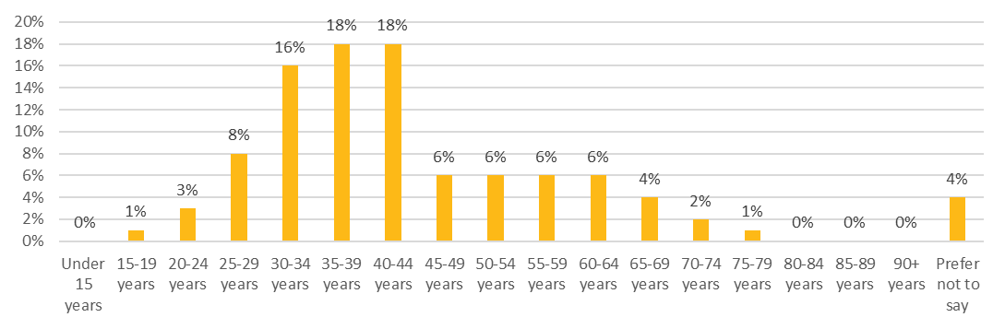
What is your age? | Percentage
Under 15 years | 0%
15-19 years | 1%
20-24 years | 3%
25-29 years | 8%
30-34 years | 16%
35-39 years | 18%
40-44 years | 18%
45-49 years | 6%
50-54 years | 6%
55-59 years | 6%
60-64 years | 6%
65-69 years | 4%
70-74 years | 2%
75-79 years | 1%
80-84 years | 0%
85-89 years | 0%
90+ years | 0%
Prefer not to say | 4%
Figure 4: Age group (n = 154)

Demographics
Survey respondents were asked to select all representation measures that applied to them. As shown in Figure 5, over half of respondents (59 per cent) stated that none of the categories applied to them. The most represented groups across these representation measures were members of the LGBTQI+ community (16 per cent) and people born overseas (13 per cent). Note it was not a requirement that all survey participants answer this question, 56 participants did not respond.
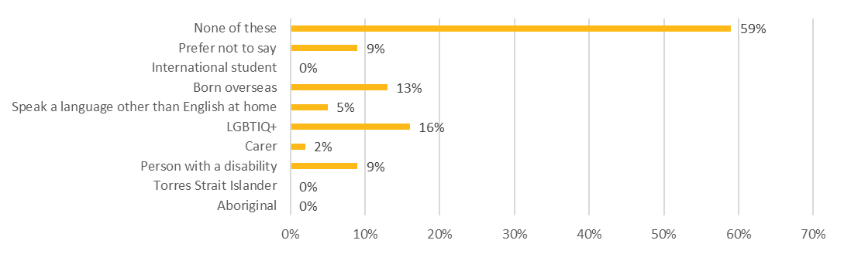
Do you identify with any of the following? | Percentage
None of these | 59%
Prefer not to say | 9%
International student | 0%
Born overseas | 13%
Speak a language other than English at home | 5%
LGBTIQ+ | 16%
Carer | 2%
Person with a disability | 9%
Torres Strait Islander | 0%
Aboriginal | 0%
Figure 5: Demographics (n = 114)

Connection to the project
Respondents were asked to indicate their connection to the project. As shown in Figure 6, most respondents were connected to the project as a resident (89 per cent) followed by worker (5 per cent). Of those who selected resident most lived in Kensington (91 per cent). The least common responses were owning a business (1 per cent), student (1 per cent) and prefer not to say (1 per cent).
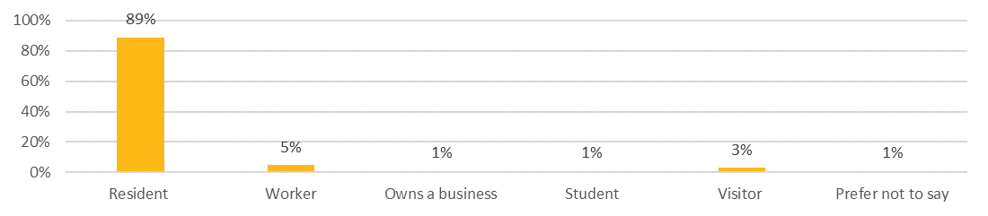
Which of the following best describes your connection to this City of Melbourne project? | Percentage
Resident | 89%
Worker | 5%
Owns a business | 1%
Student | 1%
Visitor | 3%
Prefer not to say | 1%
Figure 6: Connection to the project (n=154)
Respondents were then asked to indicate the suburbs of their connection to the project. Most respondents were connected to the project and were from Kensington (83 per cent). The second most common suburb of connection was North Melbourne (5 per cent) followed by other (3 per cent). Of those who chose other, the suburbs included Essendon, Fitzroy, Moonee Ponds and Flemington.

Motivation to participate in the engagement
Figure 7 outlines the main reasons people were motivated to participate in the survey. Note that respondents could select more than one option that applied to them. The top reasons were that the project had direct impacts to the respondent (54 per cent) or that the respondent valued having a say in the future of the city (41 per cent). The least common responses were seeing the project on media (three per cent), other (three per cent) and prefer not to say (one per cent). Of those who selected other reasons, these included receiving a postcard, seeing a sign, via direct email, website link or friends and neighbours.
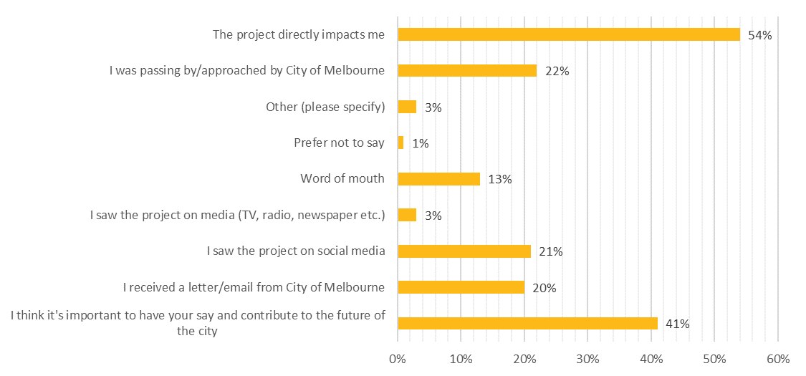
What motivated you to participate in this consultation today? | Percentage
The project directly impacts me | 54%
I was passing by orapproached by City of Melbourne | 22%
Other (please specify) | 3%
Prefer not to say | 1%
Word of mouth | 13%
I saw the project on media (TV, radio, newspaper, etc.) | 3%
I saw the project on social media | 21%
I received a letter/email from City of Melbourne | 20%
I think it’s important to have your say and contribute to the future of the city | 41%
Figure 7: Motivation to participate (n=278)

Participation in previous City of Melbourne engagement
Over half of the participants surveyed (Figure 8) had previously participated in City of Melbourne consultation (62 per cent, once or twice and regularly). For almost a third of participants (32 per cent) this project was their first City of Melbourne engagement. Five per cent of participants were unsure if they had previously engaged in consultation, and one per cent preferred not to say.
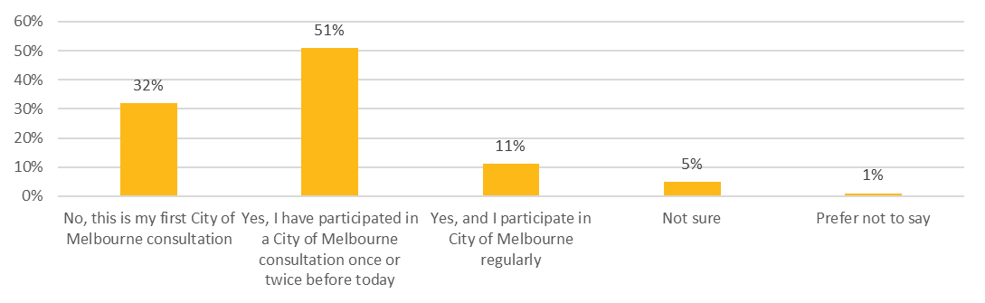
Have you participated in a consultation with City of Melbourne before? | Percentage
No, this is my first City of Melbourne consultation | 32%
Yes, I have participated in a City of Melbourne consultation once or twice before today | 51%
Yes, and I participate in City of Melbourne regularly | 11%
Not sure | 5%
Prefer not to say | 1%
Figure 8: Previous City of Melbourne consultation (n = 107)

Engagement findings
The following findings summarise the feedback and ideas collected through the engagement process.

Level of support for the project vision
Figure 9 shows participants’ level of support for the draft project vision (see Section 1.1.2). Most participants were supportive of the draft vision (90 per cent, supportive or highly supportive). Only three percent of participants stated that they oppose it (three per cent, opposed or strongly opposed).
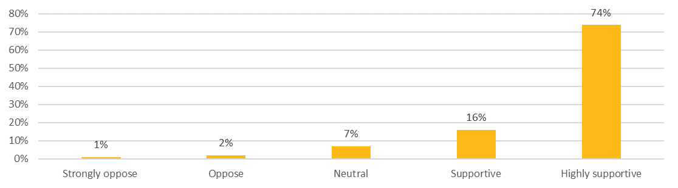
What is your level of support for our proposed project vision? | Percentage
Strongly oppose | 1%
Oppose | 2%
Neutral | 7%
Supportive | 16%
Highly supportive | 74%
Figure 9: Level of support for the vision (n = 176)
Participants who were supportive of the draft vision commonly expressed comments regarding:
- The importance of ‘a place for the community’: Participants highlighted the need for more open spaces for Kensington’s growing population and new apartment blocks going up.
- Opportunity to connect with nature: Participants emphasised the importance of green space for physical and mental health, safety, maintenance alongside increased awareness of Aboriginal cultural heritage.
“More open space is vital to our well-being as the population (both working and residential) increases in this precinct of Kensington.” – Survey respondent
“Community spaces are positive, good for the apartments” – Survey respondent
“I support the idea of creating open green space for community to gather or to take time out.” – Survey respondent
“More of open space and parks in our neighbourhoods & increasing awareness of country & culture” – Survey respondent
“Love the references to nature, Traditional Owners, connectedness – It’s quite shut off at the moment” – Survey respondent
The main concerns raised by participants regarding the draft vision were:
- Draft vision is too ambitious: Some participants stated it would not be realistic to position Chelmsford Street open space to be a ‘heart’ for Kensington given its location.
- Level of detail: A few participants stated that the draft vision was too high level and lacked detail.
- Project delivery: Several participants expressed that they were supportive of the draft vision in theory but were sceptical of the execution and delivery timeline.
“It’s never going to become a new heart for Kensington not quite the right word. It’s on the periphery of Kensington.” – Survey respondent
“New "heart" is a bit too ambitious as it is not centrally located near shops, services, community facilities and transport” – Pop-up participant
“Not one 'heart to Kensington, one of many” – Pop-up participant
“Broadly support community use of the space, but I have no idea what your vision actually means” – Survey respondent

Level of support for the project opportunities
Figure 10 outlines survey and popup participants’ level of support for the draft project opportunities (see Section 1.1.2). Overall, most participants were supportive of the identified opportunities (89 per cent, supportive or highly supportive). There were no participants who selected strongly oppose, with three per cent of participants who opposed the project opportunities. Overall, participants expressed general excitement on the provision of a new open space for the growing community in Kensington.
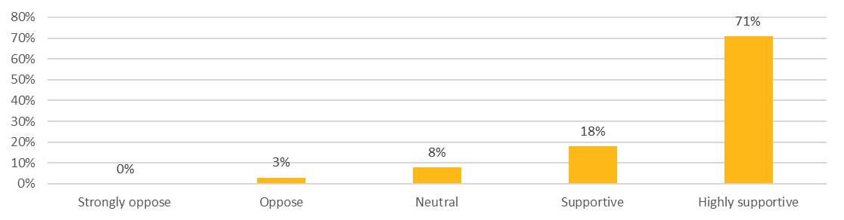
What is your level of support for the proposed project opportunities? | Percentage
Strongly oppose | 0%
Oppose | 3%
Neutral | 8%
Supportive | 18%
Highly supportive | 71%
Figure 10: Level of support for draft project opportunities (n = 170)
Of those who were supportive, the most frequently celebrated opportunities were:
- Emphasis on ‘unify and ‘connect’: Participants highlighted the importance of improving connection between Kensington and North Melbourne, connection to Bent Street and along the Moonee Ponds Creek. There was a significant emphasis on improving pathways to provide visibility, usability, and maintenance of the creek. Comments regarding opportunities to ‘connect’ included providing:
  - a place for people to gather, exercise and relax
  - a place local residents can integrate into their daily routine
  - a place for events such as local music or for school groups.
- Learning opportunities: Participants also highlighted the importance for learning opportunities regarding native plants and Aboriginal cultural heritage, with suggestions to include information boards in the final design.
- Other project opportunities identified by participants included:
  - integrating flood mitigation and management
  - planting native vegetation to create habitat for local birds and wildlife in the area.
“The project opportunity should incorporate the construction of Bent Street and Moonee Ponds Creek Edge. To design these areas only and omit from construction is a wasted opportunity. The long term neglect of these areas is a source of community shame and this is your big chance to address it. Thousands of new residents will move into Kensington within the next 2 years. You must act now.” – Survey respondent
“Need to ensure it connects to the creek and demonstrates the potential for a future upgrade of the creekfront” – Pop-up participant
“Great to unify and connect.” – Survey respondent
“A great opportunity to really beautify and green-up this area along the river” – Survey respondent
“There is a real opportunity for this park to act as a connection point between Kensington and North Melbourne and create a much needed gathering place for residents and workers in this growing area of Kensington” – Survey respondent
“I agree with them. Particularly the “Connect” element. I don’t feel that North Melbourne and Kensington are well connected in that area, and I think this project will support that happening.” Survey respondent
“It’s already a lovely place along the creek but few people know it. Good to expand the connection to the creek and to nature, even though it’s not altogether peaceful because of the freeway” – Survey respondent

Activities and amenities
Respondents were asked to indicate the top three experiences and amenities they would most like the project to support.
As shown in Figure 11, there was a spread of activities participants would like the project to support. The top voted activities voted by participants were gathering and socialising (96 votes), followed by relaxation and contemplation (91 votes), and connecting with and learning about nature (83 votes). Participants commonly expressed desires for a calm open space that is a refuge for urban wildlife where nearby residents and workers can enjoy and unwind. Some further elaborated that they would like the site as an opportunity for children to learn about the life cycles of the local flora and fauna.
The least voted activities were informal sport and exercise (45 votes) and on-leash dog walking (39 votes). Some participants shared that they would like more opportunities for low-impact exercise or exercising space for children and young people, while others indicated that sport and exercise were less preferred given other sports facilities are already available in the surrounding area.
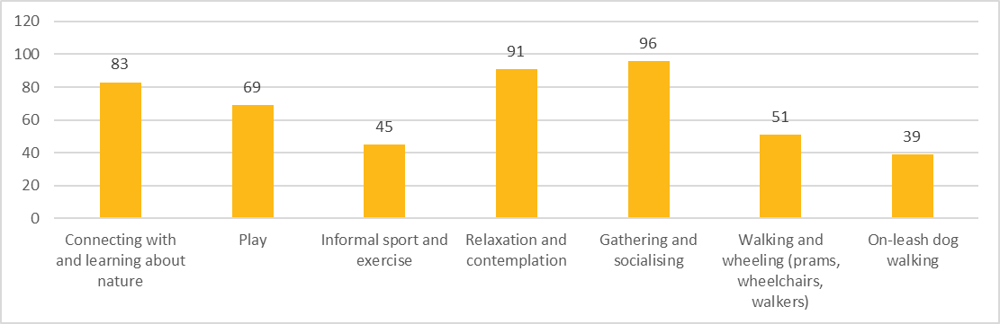
Which of the following experiences and activities would you most like the project to support? | Number of votes
Connecting with and learning about nature | 83
Play | 69
Informal sport and exercise | 45
Relaxation and contemplation | 91
Gathering and socialising | 96
Walking and wheeling (prams, wheelchairs, walkers) | 51
On-leash dog walking | 39
Figure 11: Top activities participants would most like the project to support (n=178)
Some participants further suggested other activities for the site, including:
- learning about Aboriginal cultural heritage
- participating in community events and activities such as community working bees and farmers markets
- engaging in art installations and music performances
- off-leash dog walking.
“There needs to be more consideration of bringing back native animals to the area. Would like to have this place to be more of a quiet, less play area.” – Survey respondent
“Given the situation with the tidal flows and flooding, encouraging passive enjoyment and increased shared usage is best.” – Survey respondent
As shown in Figure 12, the top voted amenities were picnic areas (85 votes), followed by seating for groups (78 votes) and lawn areas (78 votes). The least voted amenities were outdoor exercise equipment (22 votes) and skate elements (8 votes). This result is reflective of participants’ preference for the site as an open space to gather and relax.
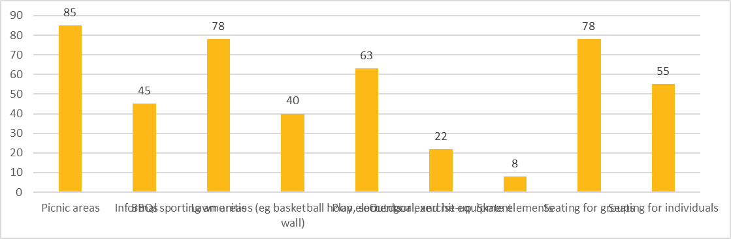
Which of the following amenities would you most like to see included in the project? | Number of votes
Picnic areas | 85
BBQs | 45
Lawn areas | 78
Informal sporting amenities (eg basketball hoop, soccer goal, and hit-up wall) | 40
Play elements | 63
Outdoor exercise equipment | 22
Skate elements | 8
Seating for groups | 78
Seating for individuals | 55
Figure 12: Top amenities participants would most like the project to support (n=178)
Some participants made further suggestions on other amenities they would like to see, including:
- seating areas such as picnic platforms that are flexible for a range of activities for groups and individuals
- play equipment to cater for a variety of ages with nature-themed designs and water play elements
- information or story boards to learn about nature and Aboriginal cultural heritage
- sporting amenities such as outdoor gym equipment, netball ring, pickleball court, and bouldering wall
- water taps
- public toilets and rubbish bins
- disposal bags and dog waste bins
- area or stage for art and music performances
- area for coffee cart and food trucks.
“Play activities are ideally mixed for younger and older children and are constructed using natural elements where possible.” – Survey respondent
“I would love to see a sustainable native garden and small areas to picnic or gather as a community.” – Survey respondent
“Would like to see educational information on plants and Traditional knowledge” – Pop-up participant
Children and young people at focus groups were asked to share their favourite activities to do in the park and draw things they would like to see at the site. Many shared that they enjoy spending time with family and friends, playing, relaxing, and exercising in the park. A range of amenities were suggested for the site, including:
- nature or animal themed playgrounds
- water play opportunities
- play elements such as monkey bars, swings, slides, a trampoline
- sporting amenities such as basketball court and skate elements
- BBQs and picnic areas
- vegetable gardens
- places to observe insects, birds, and other animals
- talking tree.
Figure 13 below provides a snapshot of drawings by children and young people depicting the experiences and amenities they would like to see at the site.
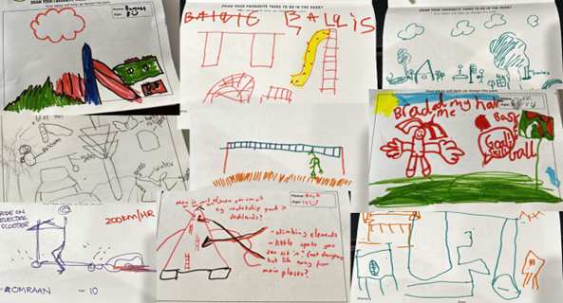
Figure 13: Collage of drawings by children and young people on experiences and amenities they would like to see supported by the project

Making the space feel safe and welcoming
Figure 14 shows that most participants (74 per cent) identified that there were specific things that would make them feel safe and welcome in the space. Approximately 25 per cent of participants could not identify anything that would improve feelings of safety.
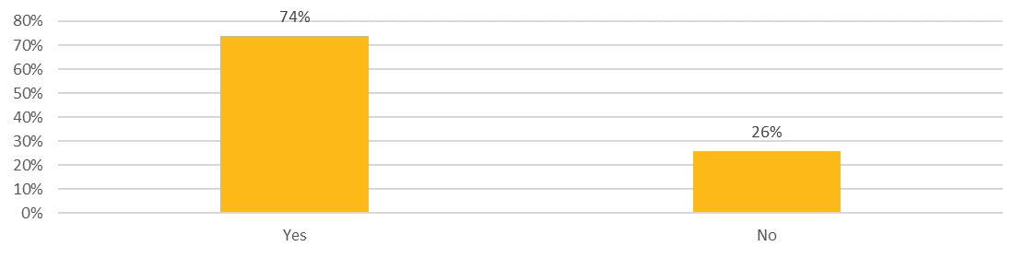
Is there anything specific that would make you feel safe and welcome in this space? (This could be during the day and/or night) | Percentage
Yes | 74%
No | 26%
Figure 14. Is there anything specific that would make you feel safe and welcome in this space during the day and/or night? (n = 144)
For participants who answered yes, common ideas shared were:
- Appropriate lighting types: Lighting was the most common element that would make the Chelmsford Street Open Space feel safer. Participants expressed that a considered approach towards lighting would ensure that the space felt welcoming and allowed for native wildlife. Specific design ideas shared were:
  - layered lighting
  - interactive lighting
  - environmentally friendly lighting
  - artistic lighting.
- Visibility of the site: Participants suggested closed-circuit television, passive surveillance, and clear sightlines would help reduce vandalism and antisocial behaviour. Some of the specific suggestions included:
  - wide paths and exits
  - trees setback from paths, seating and amenities
  - a nearby café
  - an emergency phone.
- Other suggestions: Participants also noted other considerations that would make them feel safer and welcome such as:
  - regular maintenance of the open space
  - a fenced dog area
  - accessibility considerations for example, disabled parking, ramps, wide footpaths
  - shade and seating
  - physical separation from the creek banks such as short grass to prevent snakes
  - designs to ensure safety of play areas such as soft surfaces and separation from the creek.
“Responsive lighting or interactive lighting (there are some good Scandinavian examples) so it’s good for animals too. Solar powered lighting. Good lines of sight. Make the toilet block round rather than square. Play areas make it feel safe (JJ Hollands wooden elements)” – Survey respondent
“Lighting and good lines of sight through the whole space” – Survey respondent
“Good lighting but it needs to be tempered at night for birdlife. I would be concerned if afterhours activity is encouraged - could lead to dangerous and unsafe space especially for women in the streets surrounding the park either accessing the nearby streets or after getting off public transport” – Survey respondent
“Clear, open access without dark corners or need to pass through narrow alleyways. No spaces for nighttime gatherings of people that could appear to reduce safety” – Survey respondent
“I would feel safe if there was a way to stop snakes coming up from the creek (not sure if that is actually a likelihood?). Good lighting at night would make me feel safer too.” – Survey respondent

Accessibility of the space
As shown in Figure 15, most participants did not have specific requirements that would impact their ability to access the space (78 per cent). A total of 22 per cent of participants stated that they had requirements for access.
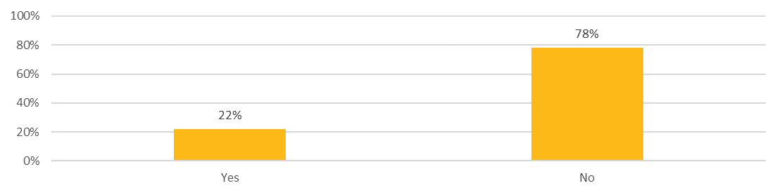
Do you have any specific requirements that would impact your ability to access and use the space? | Percentage
Yes | 22%
No | 78%
Figure 15: Requirements that impact access to the space (n = 134)
Some participants further shared ideas to ensure accessibility of the space:
- Obstacle free access to the site: The main accessibility considerations shared by participants were accessible parking, ramps, wide footpaths and smooth surfaces. Participants noted that ramps would improve access for a broad range of people, from people with accessibility needs, to the elderly, young families and people with prams.
- Considerations for visually impaired people: Several participants also noted the site's proximity to Vision Australia and Seeing Eye Dogs Australia. Participants emphasised that design considerations for visually impaired people were of particular importance.
- Other access considerations discussed were:
  - shade
  - water fountains
  - gender inclusive toilets
  - dogs on leash and disposal bags
  - bike riding amenities
  - planting for asthma
  - wayfinding and signage.
“I cannot handle steps or steep slopes, I would like my father to be able to go there with his rollator (walker)” – Survey respondent
“Pram and family members with limited mobility (scooter and walker)” – Survey respondent

Elements to retain
As shown in Figure 16, there was a relatively even spread of people who identified elements they would like to see retained (46 per cent) and those who could not (54 per cent).
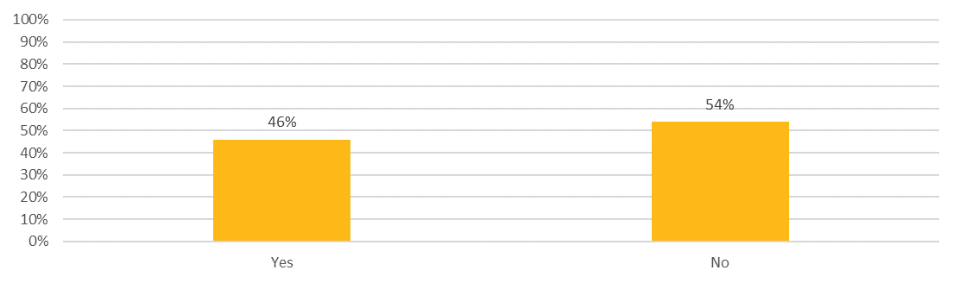
Is there anything you love about the area that you would like to see retained? | Percentage
Yes | 46%
No | 54%
Figure 16: Elements that participants would like to see retained (n = 128)
The most common elements participants noted were:
- Connection to the Moonee Ponds Creek: Participants highlighted that connection to the Moonee Ponds Creek is not only about access but also visibility, maintenance, cleanliness, and retention of greenery and trees.
- ‘Nature’ look and feel: Several Participants shared their desires to retain wild natural elements, mature vegetation with specific references to peppercorn and gum trees. Participants highlighted the importance of providing a space for wildlife noting specific bird species that frequent the area such as ducks, herons and eastern rosellas. Participants suggested habitat could be achieved by planting bird-attracting trees and bushes, and bird baths in the park.
- History of Kensington: Another common element participants wanted to see retained was the history of Kensington, noting the ‘industrial feel’. Several comments pointed to the factory-style buildings in the area, grunge elements and the history of food manufacturing and service delivery.
- Other comments: a few participants identified the importance of retaining parking and the community feel.
“This side of Kensington is known for its industrial era factory-style buildings. Retaining an element of the industrial heritage and working to design new spaces that flow with the existing buildings and surroundings would be aesthetically pleasing and let Kensington's history shine.” – Survey participant
“The creek as close to native habitat as possible with access for cultural and learning use.” – Survey participant
“Maintain at least some of the industrial design of the factory be it the brick walls the steel girders; most recent park additions have become too generic which in turn makes them a less desirable spot” – Survey participant.
“Enhanced access to the creek, considerable bird life uses this corridor” – Survey participant.
“That there is so much native wildlife (blue wrens) in the area. To exist, these birds need dense, bushy shrubs. Please do your research and plant the landscaping for what the wildlife needs.” – Survey participant
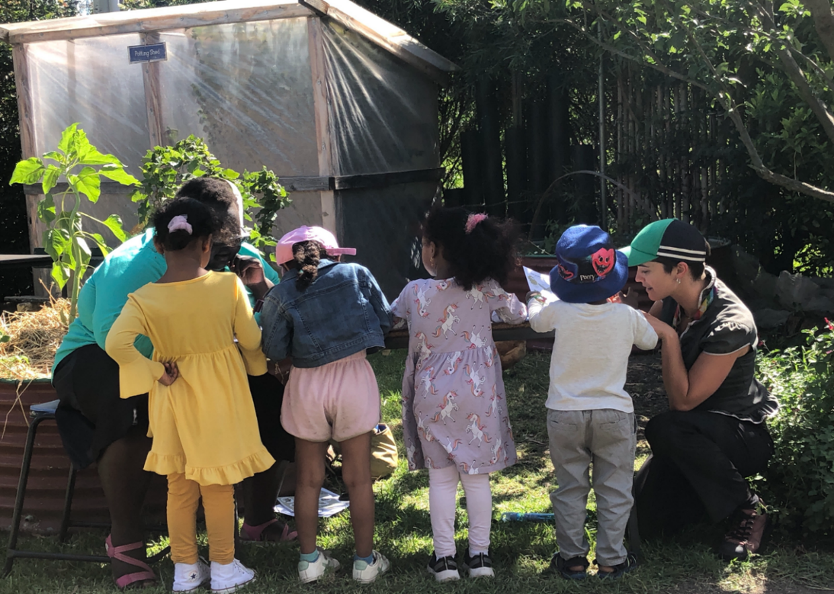
Figure 17: Focus group at The Venny

Expanding the Chelmsford Street Open Space
Participants were asked to indicate their level of support for repurposing seven car parks near the intersection of Chelmsford and Bent Streets to create additional greening and pedestrian safety.
As shown in Figure 18, participants were generally supportive of expanding the Chelmsford Street Open Space, with 67 percent indicating highly supportive or supportive. 20 percent of participants remained neutral, and less than 15 per cent indicated oppose or strongly oppose.
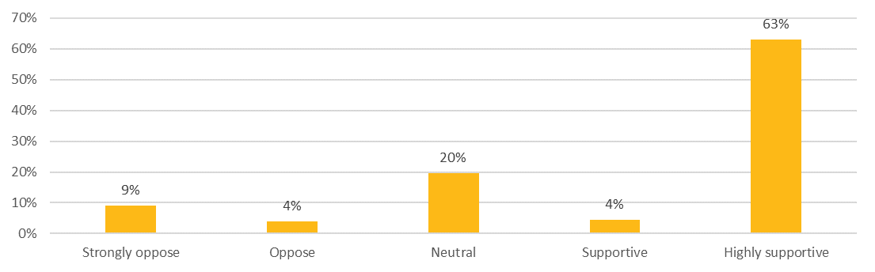
What is your level of support for repurposing seven car parks near the intersection Chelmsford and Bent streets to create additional street greening and pedestrian amenity? | Percentage
Strongly oppose | 9%
Oppose | 4%
Neutral | 20%
Supportive | 4%
Highly supportive | 63%
Figure 18: Participants' level of support to expand the Chelmsford Street Open Space (n=178)
Participants who supported this opportunity commonly shared comments about:
- Preference for additional open space over retaining existing parking spaces: Some stated that there is a rising demand for new open spaces with increasing population and developments in the local area, expanding the Chelmsford Street Open Space would help enhance its design to integrate with its surroundings.
- Limited impact on access by visitors: Several participants mentioned that removing the car parks would not impact their access to the new open space, as local residents prefer to walk or cycle to the area. This is an opportunity to further encourage use of public transport and help slow down traffic, creating a safer and more relaxed environment at the new open space.
- Parking spaces surrounding the site: It was also emphasised however, that some car parks surrounding the site should be remained to ensure accessibility, especially by young families, elderly, and people with disability.
Participants who opposed the repurposing of car parks shared concerns regarding:
- Limited parking spaces in the local area: Participants highlighted that there were already limited parking spaces available. They were worried that removal of car parks would exacerbate this issue with increasing demand from nearby residents, businesses, and workers.
- Accessibility for visitors: Some participants shared that the proposed parking spaces were important for visitors to access the site and surrounding key services, especially to Vision Australia and Seeing Eye Dogs Australia for visually impaired people.
- Parking restrictions: There were suggestions to impose new parking restrictions to ensure adequate access for nearby residents and visitors, such as making the parking spaces available for residential parking permits, and imposing parking space time limits to encourage a smoother flow of visitors.
“I support this as I won't be using car parks. I will either walk or bike to the park.” – Survey respondent
“Parking is not a problem in that area and there are bus stops and a train station nearby. Benefits of more green space outweigh the loss of a handful of parking spaces.” – Survey respondent
“It all depends on how to repurpose the car parks given the already limited car parks in the area, I would suggest changing to short-term parking in order to allow the aging, young families and people with disability to visit the green space. Accessibility is very important for some disadvantaged communities.” – Survey respondent
“Great to have more greening, but parking is already limited in the area with more and more higher density housing being constructed that all have been given parking allocation reductions by Council.” – Survey respondent

Additional comments
A summary of additional comments shared by participants related to the project included:
- Impact of Citylink to the Chelmsford Street Open Space: Some participants expressed concerns about potential noise and air pollution from the highway to the environment and the user experience at the open space.
- Connection to water: Several participants shared desires for the Chelmsford Street Open Space to foster closer connection to the Moonee Ponds Creek in the future, emphasising the need to clean up and improve water quality of the Creek. Two participants would like to see a jetty or platform for visitors to enter and swim in the Creek.
- Flooding mitigation and management: Multiple participants raised the need for integrated flood mitigation at the Chelmsford Street Open Space and surrounds through water sensitive urban design solutions to ensure access and usage of the new open space.
- Traffic management: Multiple participants raised questions about traffic surrounding the site to ensure safety to park users. Specific concerns were highlighted regarding high speed of traffic along Chelmsford Street and vehicles entering the one-way road turning from Bent Street.
- Extending pedestrian and cycling paths: A few participants made suggestions to improve pedestrian and cyclist’s connections to the site, including an additional bridge close to the Chelmsford Street Open Space across the creek instead of using the existing busy Macaulay Road, and extending a shared path to connect with the Capital City Trail to encourage visitors to the site.
- Safety and maintenance: Some participants were curious to learn more about how the site will be maintained and managed after the construction.
- Surrounding services: A few participants would like to learn more about whether the existing dog-run area next to the site managed by Vision Australia will be included in the design.
- Electric Vehicle charging station: One participant would like to see electric vehicle charging stations at the site to support the increasing demand in the Kensington neighbourhood.
“As this is near the highway is there a way to obscure the noise and air pollution?” – Survey respondent
“It needs to be able to flood and hold water in the landscape wherever possible” – Survey respondent
“As a local cyclist, it would be excellent to include a small bridge across the creek so there is better access to Kensington rather using the very busy Macaulay Road” – Survey respondent

Next steps
The feedback collected from this phase of engagement will be used to inform the Chelmsford Street Open Space draft concept plan. The City of Melbourne will present the draft concept plan to the community in early to mid-2024. An indicative timeline is outlined below.
Dec 2023 – Jan 2024 | Early 2024 | Early to mid 2024 | Mid 2024 | Late 2025
First phase of community engagement | Draft concept design development | Second phase of community engagement | Final concept plan endorsed by Council | Chelmsford Steet Open Space construction commencement
Figure 19: Indicative project timeline

Appendix A: Survey questions
Draft vision and project opportunities
1. What is your level of support for our proposed project vision?
(Rate from strongly oppose to highly supportive)
Tell us the reasons behind your rating.
2. What is your level of support for the proposed project opportunities?
(Rate from strongly oppose to highly supportive)
Tell us the reasons behind your rating.
Activities and amenities
3. Which of the following experiences and activities would you most like the project to support?
(select up to three)
- Connecting with and learning about nature
- Play
- Informal sport and exercise
- Relaxation and contemplation
- Gathering and socialising
- Walking and wheeling (prams, wheelchairs, walkers)
- On-leash dog walking
Are there other experiences or activities you would like to see included as part of the project?
4. Which of the following amenities would you most like to see included in the project.
- Picnic areas
- BBQs
- Lawn areas
- Informal sporting amenities (e.g. basketball hoop, soccer goal, and hit-up wall)
- Play elements
- Outdoor exercise equipment
- Skate elements
- Seating for groups
- Seating for individuals
Are there other amenities you would like to see included in the project?
5. Is there anything specific that would make you feel safe and welcome in this space? (This could be during the day and/or night)
- Yes
- No
6. Do you have any specific requirements that would impact your ability to access and use the space?
- Yes
- No
7. Is there anything you love about the area that you would like to see retained?
- Yes
- No
Expanding the Chelmsford Street open space
8. What is your level of support for repurposing seven car parks near the intersection Chelmsford and Bent streets to create additional street greening and pedestrian amenity?
(Rate from strongly oppose to highly supportive)
Tell us the reasons behind your rating.
Additional comments
9. Is there anything else you would like us to consider in the design?
- Yes
- No
About you
The following questions are about you. By telling us a bit about you, we can make sure that we're hearing from different voices. Your answers will be de-identified for analysis, and we won’t share your data with any other party. You may choose the option for 'Prefer not to say' for questions you do not wish to answer.
10. What motivated you to participate in this consultation today?
- I was passing by/approached by City of Melbourne
- The project directly impacts me
- I think it's important to have your say and contribute to the future of the city
- I received a letter/email from City of Melbourne
- I saw the project on social media
- I saw the project on media (TV, radio, newspaper etc.)
- Word of mouth
- Prefer not to say
- Other (please specify)
11. Have you participated in a consultation with City of Melbourne before?
- No, this is my first City of Melbourne consultation
- Yes, I have participated in a City of Melbourne consultation once or twice before today
- Yes, and I participate in City of Melbourne regularly
- Not sure
- Prefer not to say
12. Which of the following best describes your connection to this City of Melbourne project?
- I am a resident
- I am a worker
- I own a business
- I am a student
- I am a visitor
- Prefer not to say
- Other (please specify)
13. Based on your connection to this project, where do you live/work/own a business/study/visit?
- Carlton (3053)
- CBD (3000)
- Docklands (3008)
- East Melbourne (3002)
- Kensington (3031)
- North Melbourne (3051)
- Parkville (3052)
- Southbank (3006)
- South Yarra (3141)
- West Melbourne (3003)
- Fisherman's Bend
- Prefer not to answer
- Other/outside the City of Melbourne
14. How do you describe your gender?
- Female
- Male
- Nonbinary/gender diverse
- Prefer not to say
- use a different term (please specify)
15. What is your age?
- Under 15 years
- 15-19 years
- 20-24 years
- 25-29 years
- 30-34 years
- 35-39 years
- 40-44 years
- 45-49 years
- 50-54 years
- 55-59 years
- 60-64 years
- 65-69 years
- 70-74 years
- 75-79 years
- 80-84 years
- 85-89 years
- 90+ years
- Prefer not to say
16. Do you identify with any of the following?
- Aboriginal
- Torres Strait Islander
- Person with a disability
- Carer
- LGBTIQ+
- Speak a language other than English at home
- Born overseas
- International student
- Prefer not to say
- None of these

Appendix B: Activity booklet
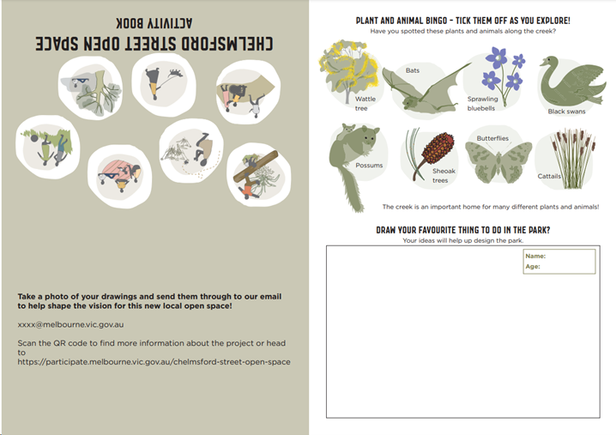

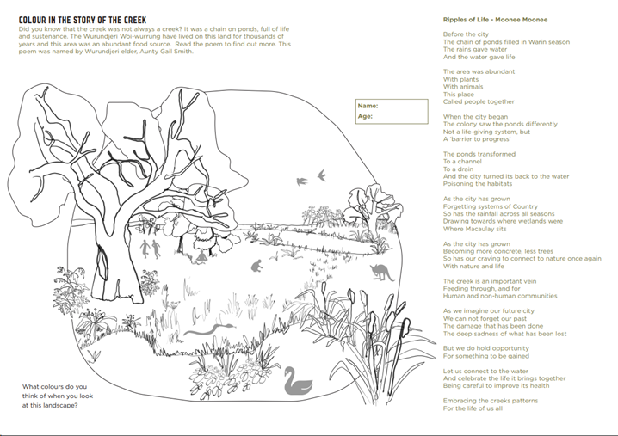

Appendix C: Pop-up interactive boards
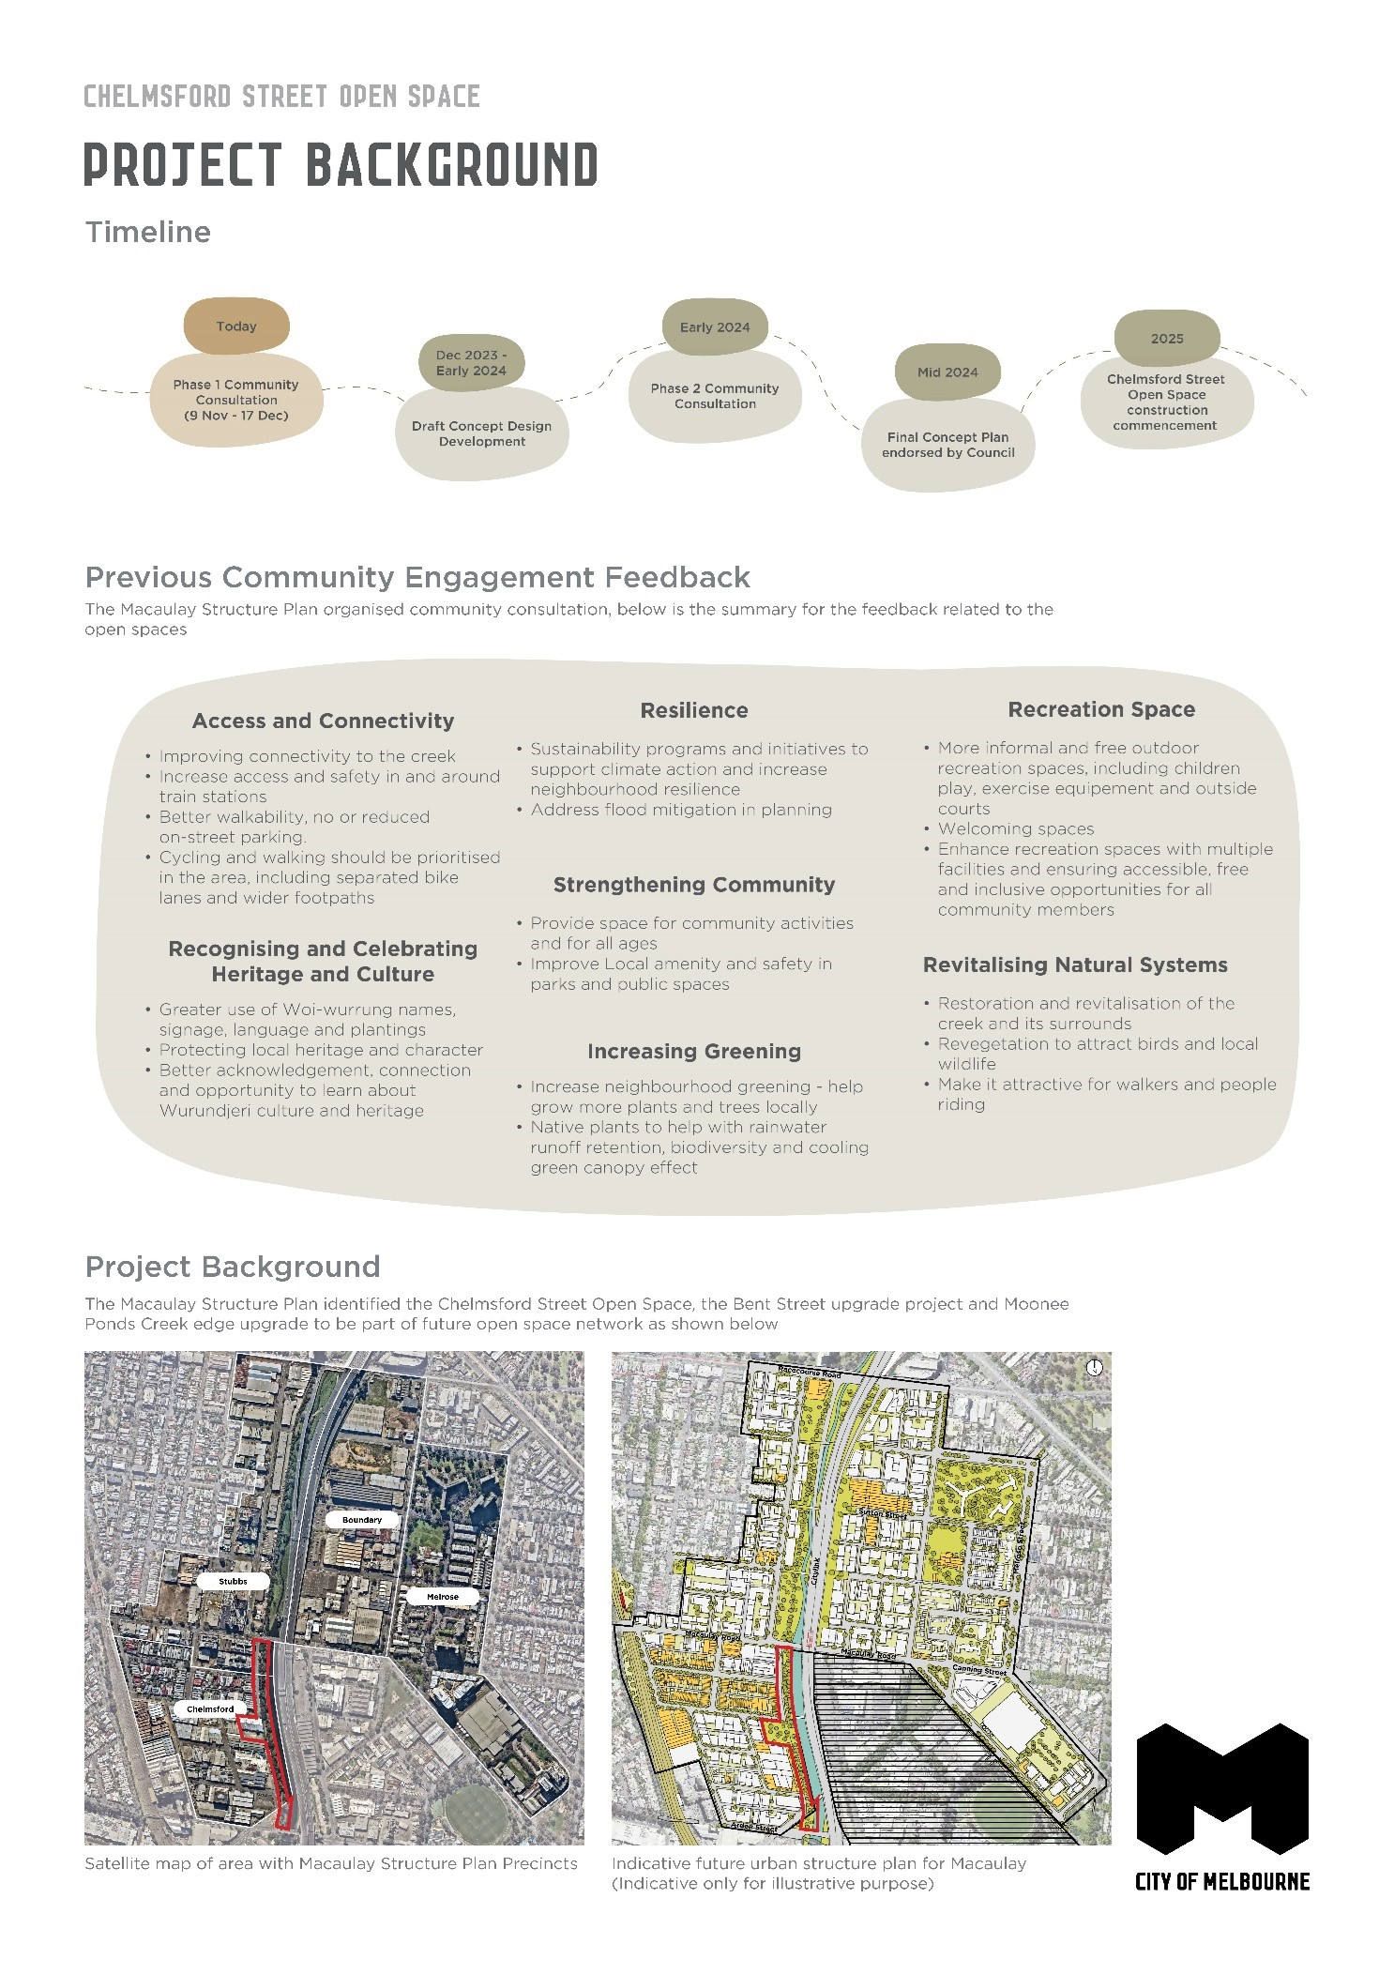
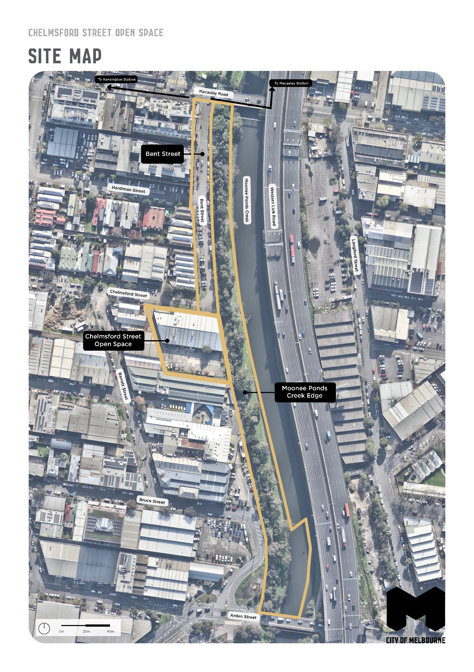

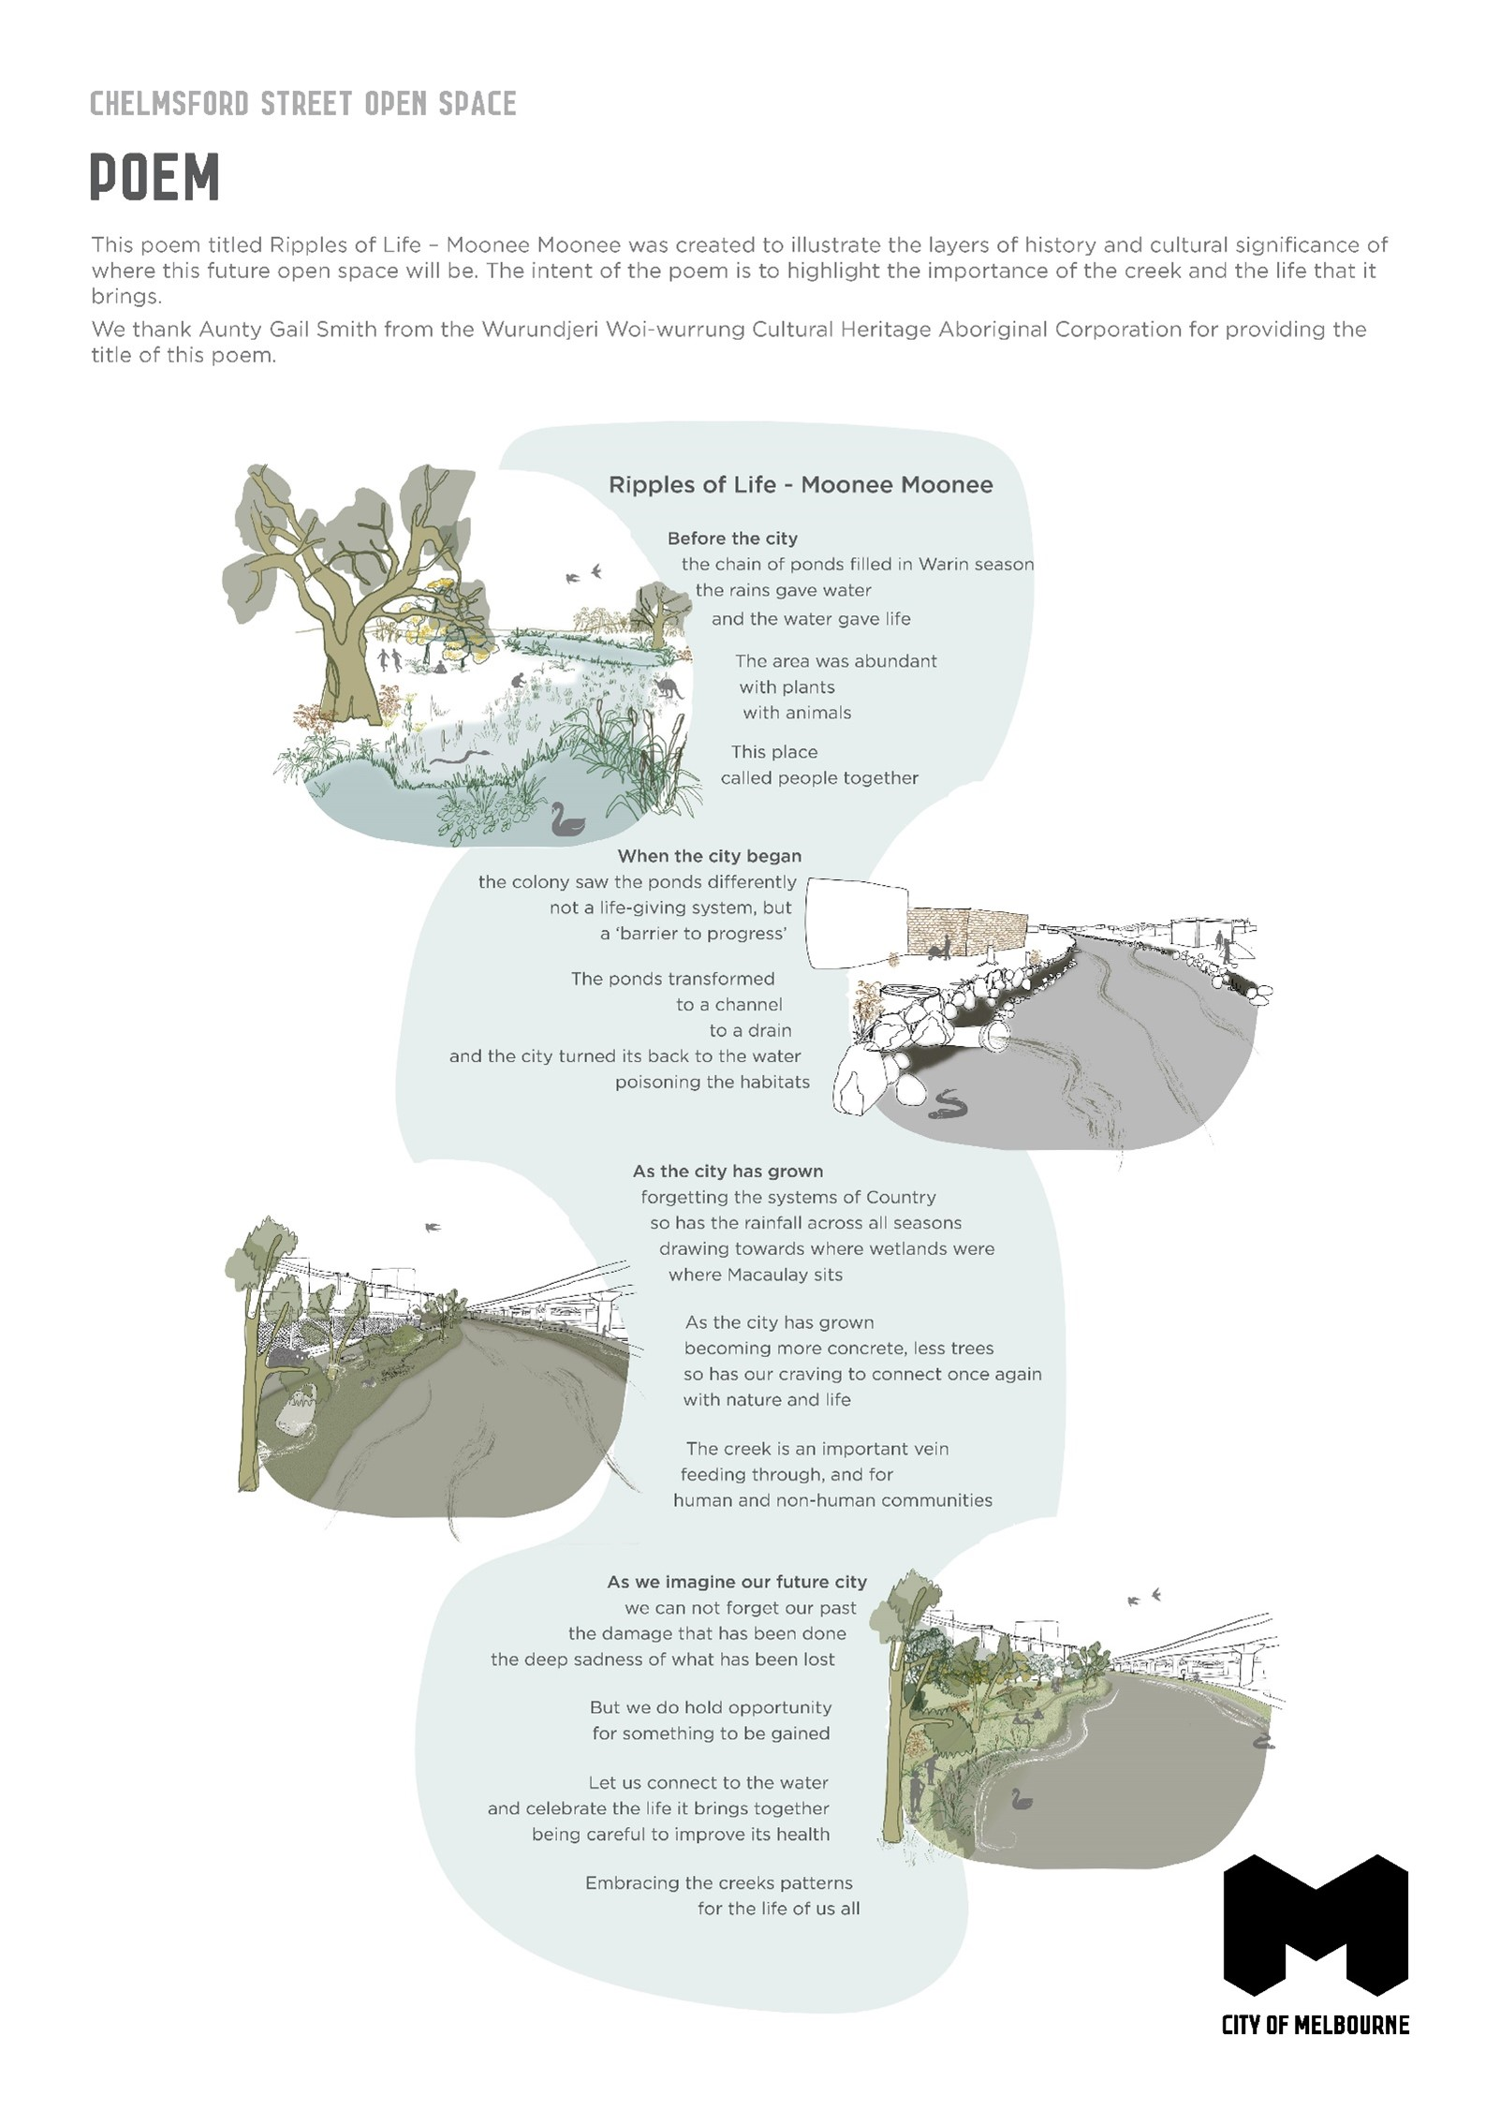

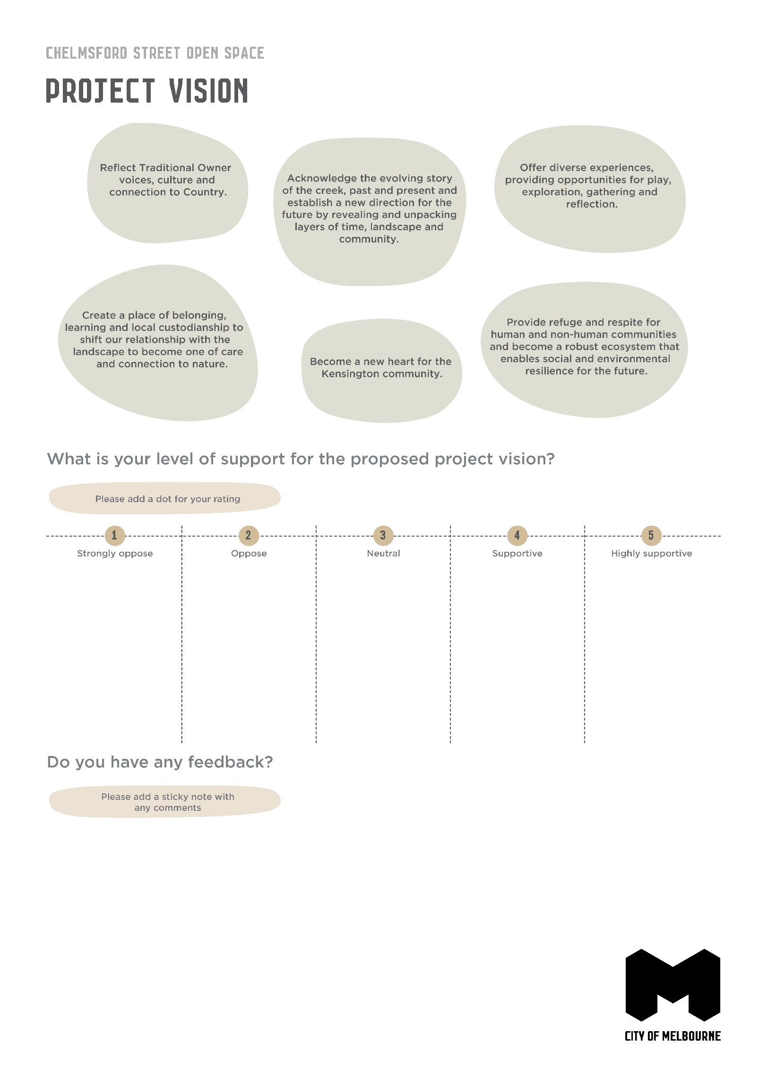

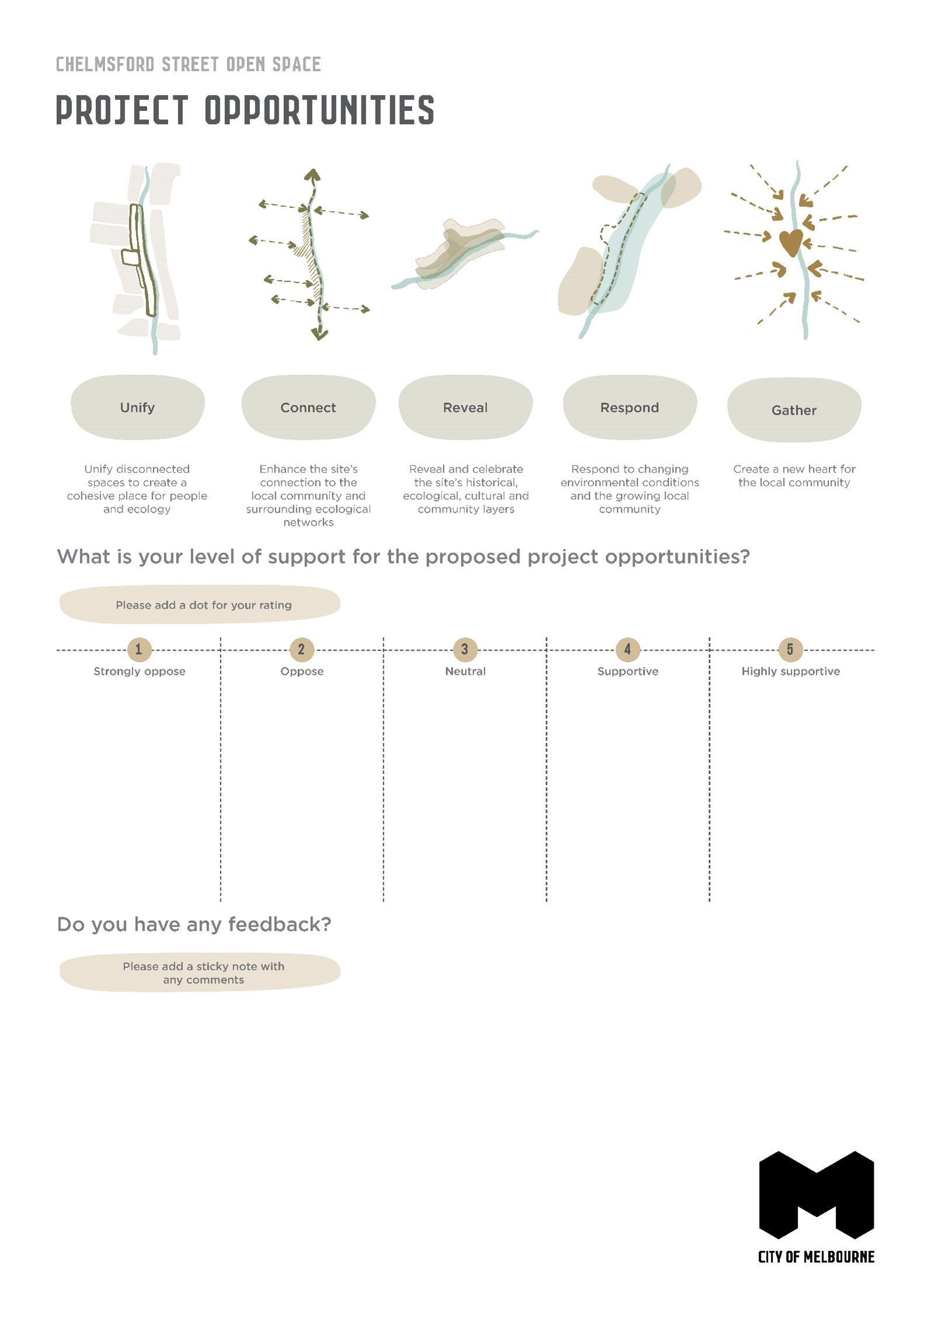

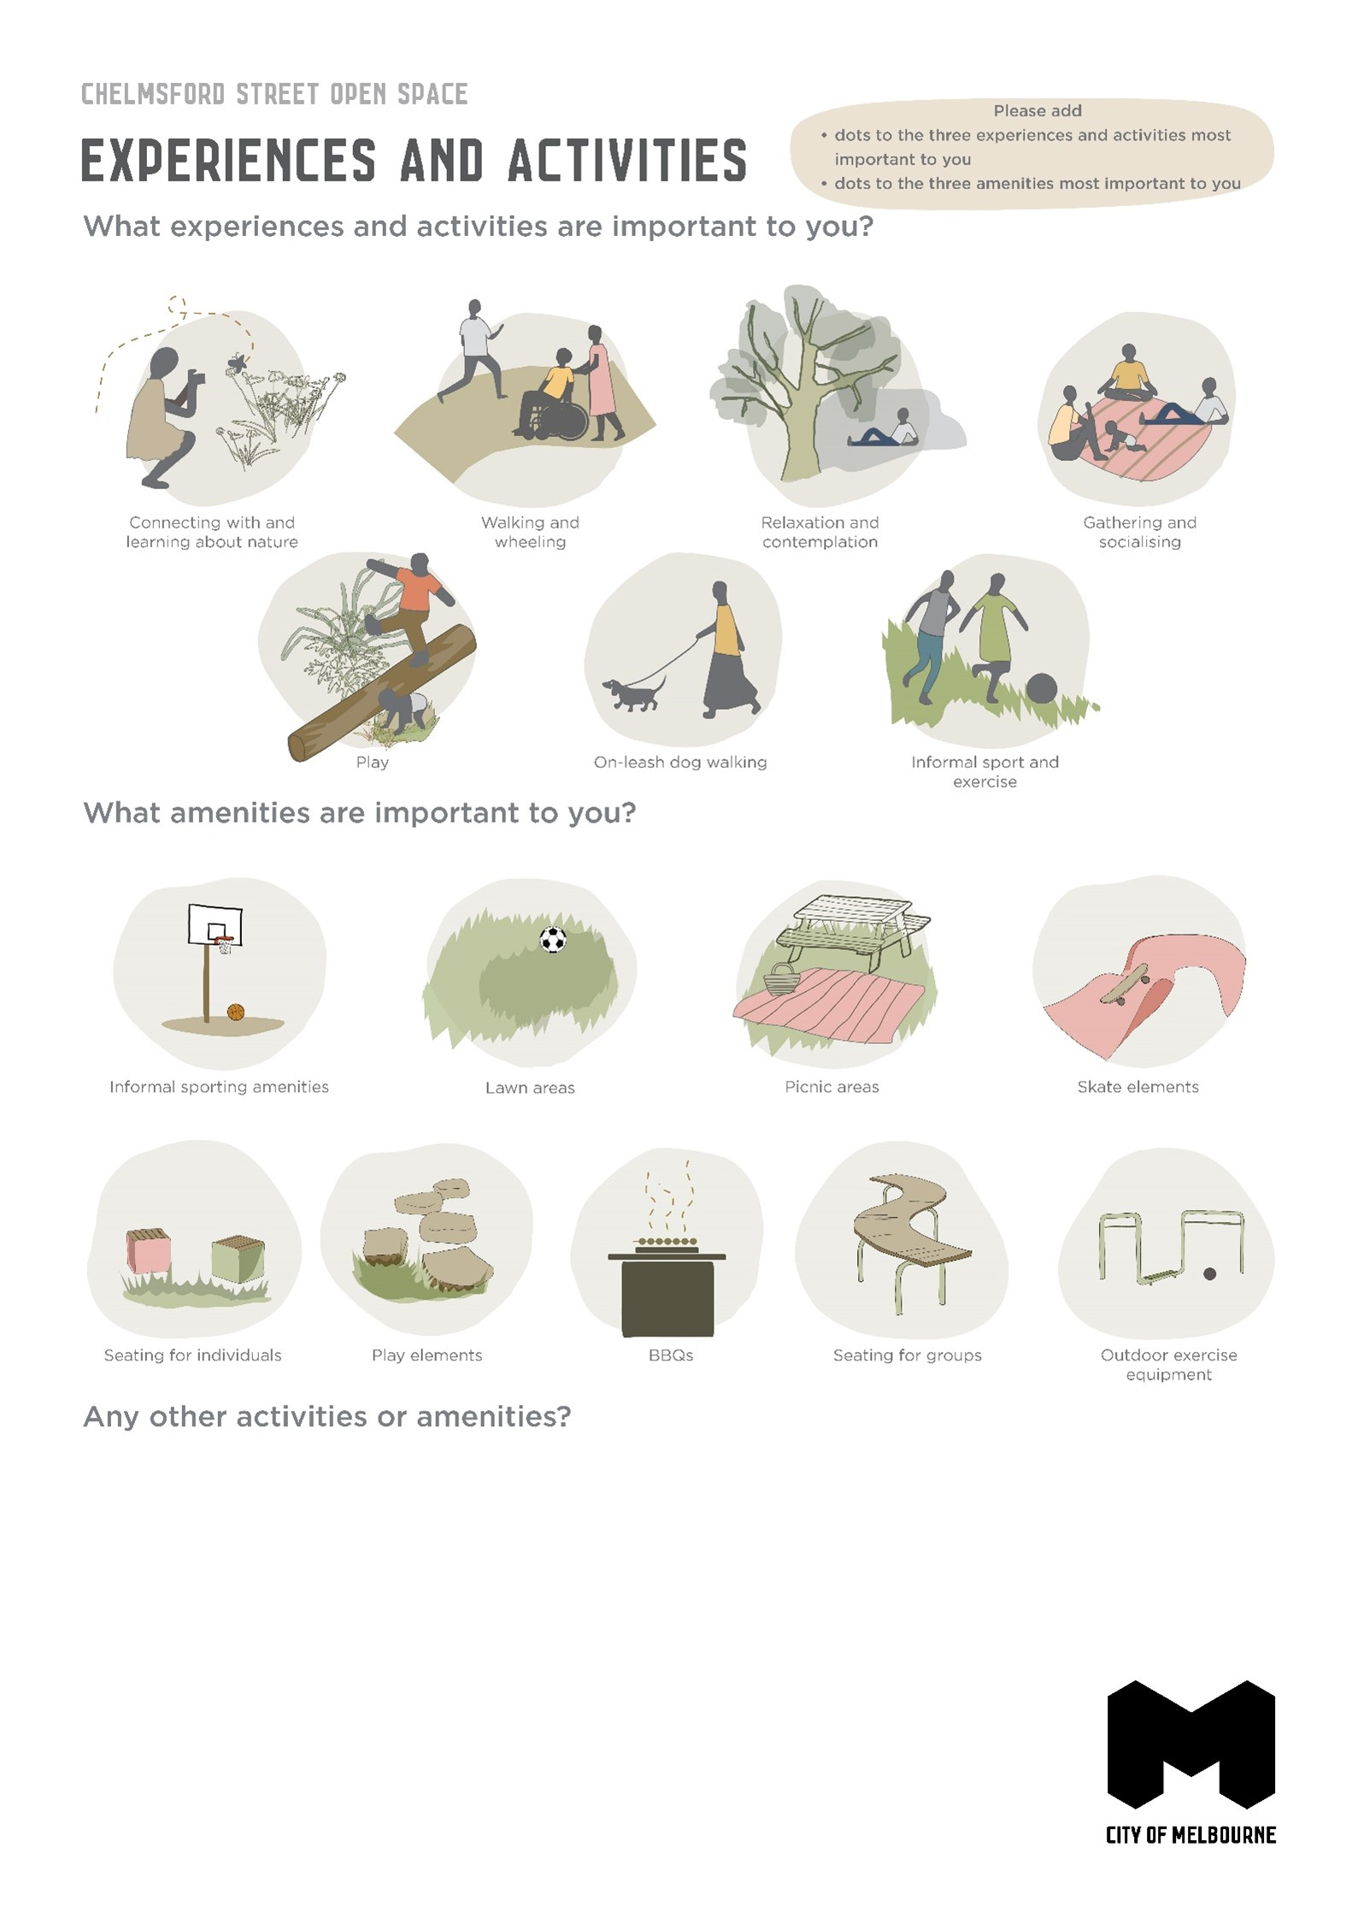

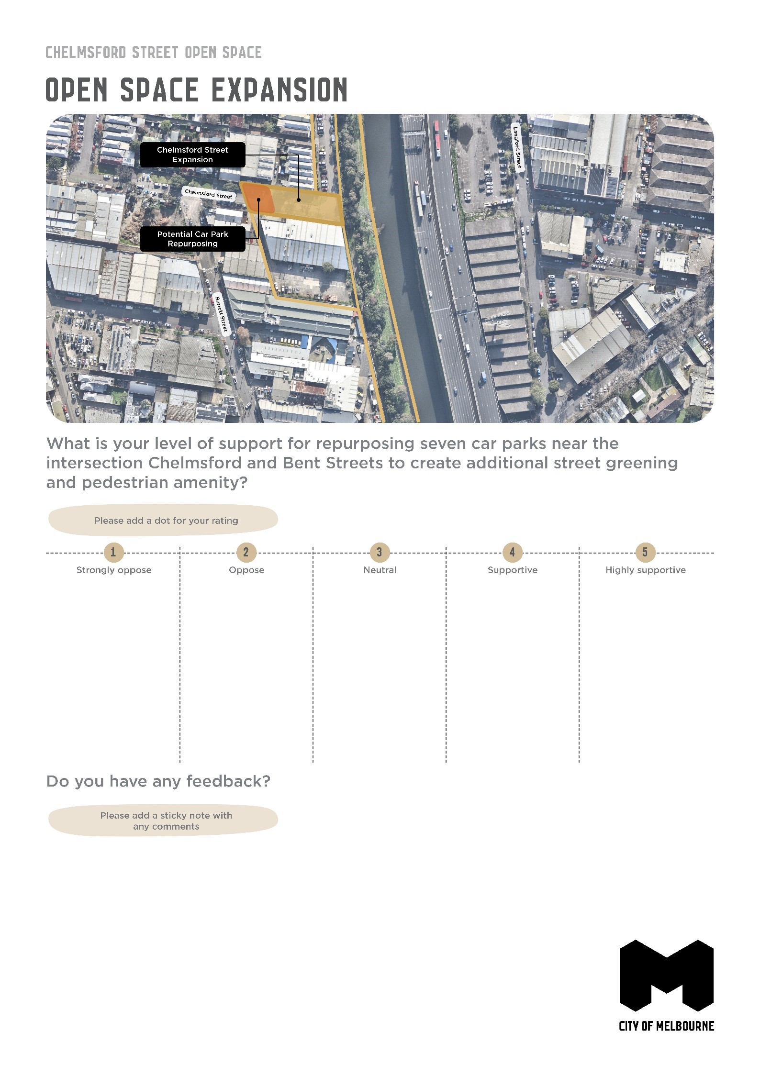

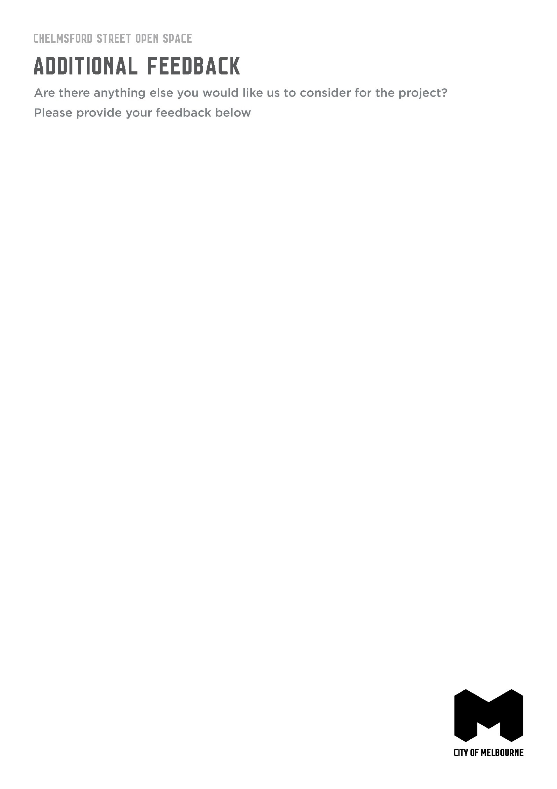

https://participate.melbourne.vic.gov.au/macaulay-refresh
https://www.melbourne.vic.gov.au/community/parks-open-spaces/policies-plans/Pages/open-space-strategy.aspx
https://participate.melbourne.vic.gov.au/chelmsford-street-open-space
https://www.northwestcitynews.com.au/new-open-space-proposed-for-kensington/

