
Draft Affordable Housing Strategy 2030
For public consultation



A city planning for growth
Melbourne will be a leader in planning for growth and technological advancement. We will guide and influence the future development of the city for the benefit of all city users and in a way that values and celebrates its historical and cultural identity.

Acknowledgement of Traditional Owners
The City of Melbourne respectfully acknowledges the Traditional Owners of the land, the Boon Wurrung and Woiwurrung (Wurundjeri) people of the Kulin Nation and pays respect to their Elders, past and present.
Contents

Foreword 8
Executive summary 9
Introduction 12
Context 13
The cost of inaction 21
Understanding affordable housing 23
Role and responsibilities 26
Existing policy, projects and tools in City of Melbourne 32
STRATEGIC APPROACH 38
City of Melbourne’s approach 39
The scale of the opportunity 41
1.ADVOCATE FOR MANDATORY INCLUSIONARY ZONING 42
2. DEVELOP AFFORDABLE RENTAL HOUSING ON CITY OF MELBOURNE LAND 49
3. STRENGTHEN OUR INTERNAL AFFORDABLE HOUSING PROCESSES 53
4. ADVOCATE AND PARTNER FOR AFFORDABLE HOUSING 59
APPENDIX I – REFERENCES 67
APPENDIX II - GLOSSARY OF TERMS 70

Foreword
To be completed following endorsement.

Executive summary
Melbourne is one of the world’s most liveable cities. People who live in our municipality enjoy excellent access to public transport, jobs, education and services. However, housing is becoming less affordable and is out of reach for many people. This makes our community less inclusive, diverse and prosperous.
A wide spectrum of professionals including nurses, administration officers, child care workers, artists, hospitality and service industry staff contribute directly to our local community and economy, but many cannot afford to live here.

“Affordable housing is housing, including social housing, that is appropriate for the housing needs of very low, low, and moderate-income households”. It helps to ensure that a diversity of people can live in our community.

We have an alarming shortage of affordable housing.
The City of Melbourne is in the midst of an affordable housing crisis. There are 1,725 people experiencing homelessness including women and children escaping family violence, people with disabilities and pensioners. There is currently a shortfall of 5,500 safe and affordable rental homes and emergency accommodation for people on moderate, low and very low incomes, including those experiencing homelessness.
This shortfall is a result of a range of factors including a rapidly growing population, rents increasing faster than wages and insufficient investment in social and affordable housing over many years.

Affordable housing is essential infrastructure.
Housing is a basic human need and a vital component of what makes our city and society work. Our city needs a sustained investment in the supply of safe, high-quality affordable rental housing offering secure tenure to meet the needs of our diverse community.

Infrastructure Victoria identified investment in affordable housing as one of its top three priorities for the state in its 30 Year Strategy (2017). Economic analysis shows that for every $1 invested in affordable housing, the economic benefit to the community is $3.4 Research shows our economy benefits through reduced costs associated with crime, family violence and health, as well as enhanced human capital, educational benefits and key worker retention.

There was a time when the State and federal government prioritised investment in housing for those who needed it. However, public housing has seen no growth this century, decreasing slightly from 65,310 dwellings in 2001; to 64,241 dwellings in 2016, according to a series of Property Commission reports (Davies 2017).
The problem won’t get better on its own.

The private market is not delivering enough affordable housing and as a society we have failed to invest in affordable housing for too long. Our current approach isn’t working. We need to change the way we value and invest in affordable housing in order to address this growing crisis.

Addressing the housing affordability crisis is complex and requires a cross government and cross sector approach.

Housing policy in Australia is complex and there is no single solution to the affordability problem.
To address the shortfall in affordable housing action is required from a range of government, not-for-profit and market actors. To inform the development of our approach we’ve spoken to senior representatives from the development industry, finance and investment sector, peak bodies, the community housing sector, as well as state and federal government.
The City of Melbourne commits to being a leader, to influencing change - and where we can - directly contributing to the solutions.
The Affordable Housing Strategy 2030 establishes the City of Melbourne’s policy and actions for the next 10 years.

Our focus is on affordable rental housing.
The focus of this Strategy is on increasing the supply of affordable rental housing in the City of Melbourne which can be developed and managed through registered community housing organisations. Rental housing is more accessible than ownership for those in need, it serves them for the length of time they need it, and can be retained to help others in the long term. The Strategy also outlines how we will best focus our advocacy efforts to enable change more broadly across the social housing and private rental market.
The City of Melbourne is committed to being a city for people. We are inclusive, we care for our most vulnerable and we know that the availability of safe, affordable, quality homes with secure tenure supports the health and wellbeing of our community.

As set out in the table below, we have identified four priorities to address the crisis, with ten corresponding actions and two policies.

Healthy, productive and fulfilling lives start with a home.
Affordable housing is essential infrastructure for liveable and prosperous cities.
Many people in our community are struggling with the cost of housing.
Our goal is to increase the supply of appropriate and accessible affordable rental housing within City of Melbourne.

Priority | Actions and policies
 | 1.1 Advocate to the Victorian Government for State-wide mandatory inclusionary zoning.
  1. Advocate for mandatory inclusionary zoning
2. Develop affordable  rental housing on City of  Melbourne land | Actions:  2.1 Commit a City of Melbourne owned site to deliver an affordable housing project in the next five years.  2.2 Continue to work with other local Councils to establish opportunities for affordable housing development, and consider ways to share resources to enable affordable housing projects  Policies:  I. On all future residential development on City of Melbourne owned land, we aim to deliver up to 25 per cent of residential development as affordable housing. Consideration will be given to accommodating greater than 25 per cent affordable housing in urban renewal areas.  II. Consideration will be given to delivering affordable housing on commercial developments and community facilities on City of Melbourne land.
3. Strengthen our internal affordable housing processes | 3.1 Develop an Affordable Housing planning policy for inclusion in the Melbourne Planning Scheme. This planning tool should clearly outline when an affordable housing contribution should be made, how the rate of affordable housing should be calculated and what should be included in an affordable housing agreement.  3.2 Establish a special purpose entity to manage affordable housing contributions, with potential to operate across local government boundaries.  3.3 Commit staff and budgetary resourcing to the ongoing delivery of affordable housing outcomes.  3.4 Develop a centralised internal process for recording and assessing affordable housing outcomes.
4. Advocate and partner for affordable housing | 4.1 Advocate across all levels of government, the private sector and the broader community to improve affordable housing outcomes.  4.2 Advocate to the Victorian and Australian Governments for the increased investment and provision of social housing, with an emphasis on public housing.  4.3 Partner with the State and Federal Governments to identify surplus land for the delivery of affordable housing in the City of Melbourne. This may include land that is owned by government departments and entities such as Melbourne Water and Victrack.  4.4 Use City of Melbourne events, public forums and media platforms to promote greater awareness and understanding of affordable housing issues and alternative housing models.

Introduction
Affordable housing is essential infrastructure required to support Melbourne’s ambitions for a liveable, inclusive and prosperous city.
We have a current shortfall of 5,500 affordable homes in the City of Melbourne. By 2036 we will need 23,200 additional affordable homes to meet our future need.
A sustained increase in supply of new affordable rental housing is now critical.
“Now I’m very happy to live here, I feel safe. I have freedom, I can do whatever I like. I don’t need to worry about where I have to live, because this is my house.” -Quote from Panmile,(pictured) Hospital food attendant and affordable housing tenant


Context
Melbourne is experiencing an affordable housing crisis
Over the last three decades, our municipality has changed significantly. Melbourne’s commercial heart has transformed into a vibrant, 24-hour city with a diverse residential community. Our established neighbourhoods and evolving urban renewal areas are high-amenity places with excellent access to public transport, jobs, education, and services.
We are a liveable city, but unfortunately, living in the City of Melbourne is out of reach for many households.
Research shows that only five per cent of available housing in the City of Melbourne is affordable to the lowest 25 per cent of earners. Of this, only one per cent of affordable housing stock was available in the private market.
This means when people on moderate, low or very low incomes choose to live in the municipality, they typically need to spend more than 30 per cent of their gross household income on housing - putting them in housing stress.
Between 2011 and 2016, median rent increased by 12.5 per cent, while household incomes only grew by 0.15 per cent over the same period.
The City of Melbourne is Victoria’s fastest growing municipality. During the next 10 years, our residential population is expected to grow by approximately 100,000 - that is more than 42,000 additional households8. Greater Melbourne’s population is forecast to grow from 5 million people today to 8.5 million in 2051.9
A growing population, rising housing costs, low wage growth and insufficient investment in social and affordable housing is compounding the issue of housing affordability.

Rental prices in the City of Melbourne:
Carlton
1 bed apartment = $410/week
2 bed apartment = $590/week
3 bed house = $800/week

Kensington
1 bed apartment = $375/week
2 bed apartment = $450/week
3 bed house = $650/week

North Melbourne
1 bed apartment = $410/week
2 bed apartment = $530/week
3 bed house = $710/week

Docklands
1 bed apartment = $470/week
2 bed apartment = $645/week
3 bed apartment = $970/week

Central City
1 bed apartment = $450/week
2 bed apartment = $610/week
3 bed apartment = $923/week
Southbank
1 bed apartment = $470/week
2 bed apartment = $600/week
3 bed apartment = $900/week
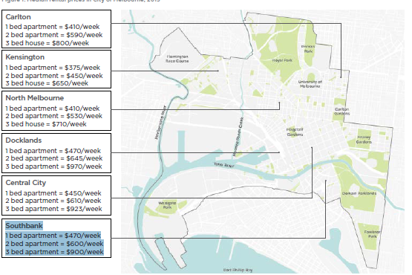

Melbourne has a growing shortage of affordable homes
Melbourne’s affordable housing crisis is expected to get significantly worse by 2036.
The City of Melbourne commissioned research by SGS Economics to determine the current shortfall of social and affordable rental housing in the municipality, and what it is estimated to be in 20 years.
The research estimates that in 2016, 9,400 households were in need of affordable rental homes and emergency housing in the City of Melbourne. This is significantly higher than the 3,900 social and affordable homes that existed within the municipality at that time. This supply of affordable housing represents just 6 per cent of all housing in the municipality.
By 2036 demand for social and affordable housing is expected to almost triple to approximately 27,100 people in need of social and affordable housing, and 1,400 people are estimated to be in need of emergency housing.
The research demonstrated that under a ‘business as usual’ scenario, approximately 5.8 per cent of all new privately constructed dwellings in the municipality would be affordable and an additional 250 new affordable dwellings would be built by Victorian and Australian government programs. This equates to a supply of about 5,200 new dwellings.
With demand expected to grow to 27,100 by 2036, this will result in a shortfall in supply of around 18,000 homes.
If nothing is done now, the additional housing needed could cost as much as $10 billion to deliver.
Approximately 1 in 5 new dwellings will need to be social and affordable rental housing to address the shortfall.
This crisis will require all actors within the housing market - Victorian, Australian and local governments, the not-for-profit sector, the development industry and the finance and investment industry - to participate and collaborate to deliver a solution.
City of Melbourne - Current and projected housing need and affordable housing supply
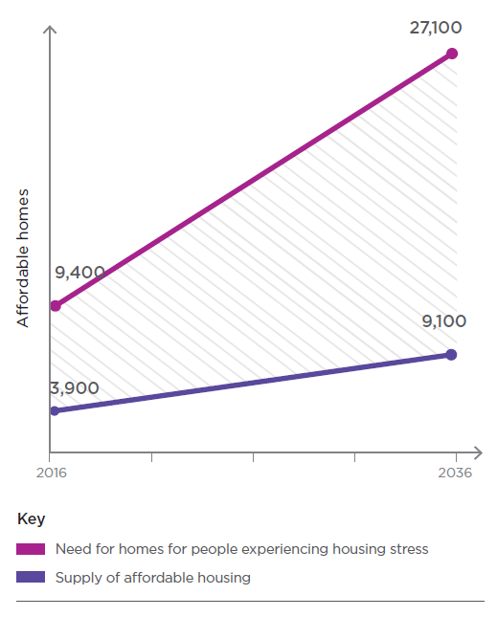
5,500 unit shortfall in 2016
In 2016, there was a shortfall of approximately 5,500 homes needed by people in housing stress.
27,100 units needed by 2036
By 2036, 23,200 new affordable homes need to be delivered to meet the needs of the future community.
1 in 5 dwellings constructed need to be affordable
Approximately 1 in 5 of all new dwellings will need to be social and affordable rental housing to address the shortfall.

Affordable housing is essential infrastructure
Housing is essential infrastructure for our city and is vital to the functioning of our society and economy. Infrastructure Victoria’s 30-Year Strategy (2017) identifies investment in affordable housing for vulnerable Victorians as one of its top three priorities.
Ensuring people on very-low, low and moderate incomes have access to a place to live which is safe, secure and appropriate for their needs is a basic human need and allows people to participate fully in their community. Numerous studies have proven that a safe home improves physical and mental health, personal relationships and quality of family life, education and employment outcomes.
Investing in affordable housing makes economic sense. Our research shows that for every $1 invested in affordable housing, the community benefits by $3 due to worker retention, educational benefits, enhanced human capital, health cost savings, reduced family violence and reduced crime.

Housing affordability is impacting city diversity and inclusivity
A broad spectrum of professionals, students, artists, service and hospitality industry professionals make a significant contribution to our city. They are critical to Melbourne’s liveability and economic prosperity.
Research has shown that workforce diversity supports economic productivity.15 Cities which lack sufficient affordable housing often see the displacement of low-income workers to outer suburb locations and the loss of industry which relocates to be closer to their workforce. Cities experiencing housing pressure have difficulty attracting quality key workers for their schools, hospitals and other services due to the inability for workers to live close to their employment.
As the affordable housing crisis worsens, some current and future residents - including families - will continue to be excluded from our community.
Every $1 spent on affordable housing provides $3 of community benefit.
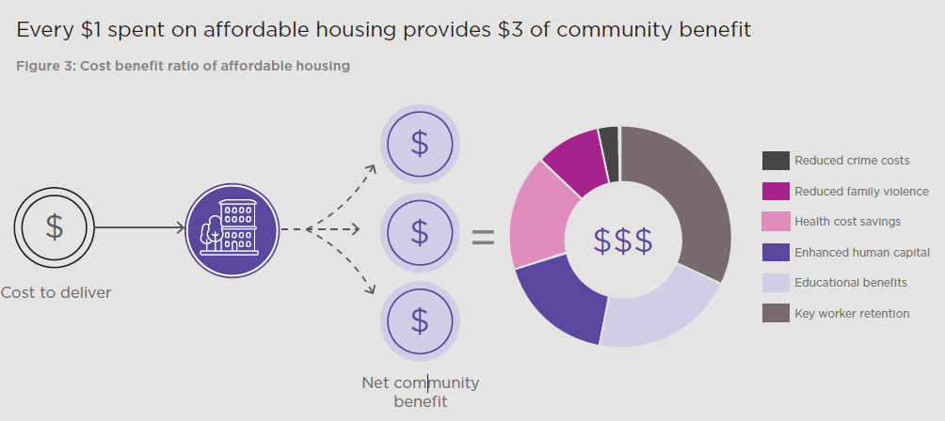

How much does it cost to rent in the City of Melbourne?

Lenny, nurse and single-parent
Weekly income after tax: $1000 (low income family)
Weekly rent for an average two bedroom apartment in Kensington would cost Lenny $450 leaving $550 a week for all other living expenses.

Hui, musician (supplements income with bar work)
Weekly income after tax: $850 (moderate income single)
Weekly rent for an average one bedroom apartment in North Melbourne would cost Hui $410 leaving $440 a week for all other living expenses.

Louise, barista
Weekly income (after tax): $750 (moderate income single)
Weekly rent for an room in a share-house in Carlton would cost Louise about $265 leaving $485 a week for all other living expenses.

Luke, office cleaner
Weekly income (after tax): $811 (moderate income single)
Weekly rent for an average one bedroom apartment in Southbank would cost Luke $470 leaving $341 a week for all other living expenses.

Ana, pensioner
Weekly income (pension): $420 (very low income single) Weekly rent for an average one bedroom apartment in Kensington would cost Ana $475 leaving $55 a week for all other living expenses.

Mae, PhD student
Weekly income: $540 (low income single)
Weekly rent for a bedroom in a shared apartment in the Central City would cost Mae $280 leaving $260 a week for all other living expenses
HOUSEHOLD | Very low income range (annual) | Low income range (annual) | Moderate income range (annual)
Single adult | Up to $25,970 | $25,971 to $41,550 | $41,551 to $62,310
Couple, no dependent | Up to $38,950 | $38,951 to $62,320 | $62,321 to $93,470
Family (with one or two parents) and dependent children | Up to $54,520 | $54,521 to $87,250 | $87,251 to $130,870
The Planning and Environment Act 1987 defines affordable housing as “housing which is appropriate for very low, low and moderate income households”. The table above provides definitions of the income ranges for very low, low and moderate income households. Typical incomes by profession have been obtained from a variety of job advertisement sources.

Underinvestment in social housing
There was a time when the State and federal government prioritised investment in housing for those who needed it.
In the 1930s, state and federal governments made a concerted effort to provide housing to those who needed it, which was ramped up after World War 2. By 1956, the Housing Commission of Victoria owned and managed 30,170 dwellings.
However, public housing has seen no growth this century, decreasing slightly from 65,310 dwellings in 2001; to 64,241 dwellings in 2016, according to a series of Property Commission reports (Davies 2017)
Reduced investment in social housing over the past three decades has seen supply fall well behind population growth. In Australia, the proportion of social housing has reduced from 8 per cent of all homes in 1966 to just 4.3 per cent in 2016. As housing across Greater Melbourne has become less affordable, there is increasing demand for public and community housing.
As a result, people with the highest-needs are prioritised for the limited available social and affordable housing. This leaves a large and growing number of people who meet the eligibility criteria for affordable housing but are unable to access it - exposing them to the risk of homelessness. The wait list for public housing in Victoria is 51,500 people.
The limited stock of public and community housing is in demand from people living in private market homes who are struggling to meet the cost of their housing, and from people who are experiencing homelessness and need assistance transitioning to permanent housing.
Ideally, we would have enough social housing in metropolitan Melbourne to meet the needs of our community. If there was an adequate supply, we would be able to prevent people from having to make trade-offs between housing and other life necessities. Social housing once served a broader cross-section of our community. In places like Vienna, known for its social housing policy, 1 in 4 citizens live in municpal social housing.
In the City of Melbourne, there is a risk of lower income workers moving away from the municipality, making our community less diverse and more inequitable. There is also a higher chance that people who become homeless will seek emergency housing in inner Melbourne.

Aboriginal housing
The City of Melbourne acknowledges that Aboriginal and Torres Strait Islander peoples were the First Peoples of this land and have strived to retain their culture and identity through the period of European settlement. We also recognise that European settlement forced the displacement of many Aboriginal people from their traditional lands, including those of the Kulin Nation. The echoes of this displacement are still experienced today.
Aboriginal people disproportionately experience homelessness and housing insecurity in Australia. The City of Melbourne is committed to reconciliation and working towards greater housing security for Aboriginal people in our municipality.

Climate change has a compounding effect on housing
Climate change is compounding the housing crisis. The increasing severity and frequency of extreme weather events such as storms, fires, and flooding are destroying people’s homes and leaving them without a place to live. The recent bushfires of the 2020 summer are just one example. These events are expected to continue and worsen.
The City of Melbourne has declared a Climate Emergency. We must prepare to house people displaced by climate change locally, nationally and internationally.
During the 2009 Black Saturday bushfires, more than 2,000 homes were destroyed and an estimated 7,000 people left homeless. During such emergency events, many people who have lost homes are forced to temporarily relocate to capital cities placing pressure on the housing system. Without sufficient and liquid housing stock these people are have difficulty finding a place to live.
Further climate change worsens the conditions for people experiencing homelessness and people experiencing housing stress. Heat waves and cold spells are often more acute for those living in housing stress as people are unable to pay for the electricity to run their air conditioning and heating and so become more exposed to these conditions. These weather events heighten physical and mental health conditions and often result in heat stress related deaths and rises in mental health episodes and domestic violence.

The cost of inaction
Housing affordability is a problem in capital cities across the world. Without intervention it gets worse.
Over recent decades, Melbourne has built a highly prosperous economy, which continues to grow on the back of investment attraction and Melbourne’s status as a liveable city. Like other global cities, this success has seen growing housing demand from households on higher incomes, rising housing costs and reduced affordability for those on lower incomes.
Some of the most liveable cities in the world – including London, Vancouver and San Francisco - are becoming less diverse, squeezing out people on lower incomes. In London, 263,000 households are on the social housing waitlist.
The housing crisis has not reached this scale in Melbourne. However with Greater Melbourne forecast to have a population of 8.5 million - almost the size of London today - by 2051, the cost of not acting now could be significant.
Providing emergency shelter, health services and law enforcement to homeless people often costs more than the provision of housing. Studies from Canada show that cost savings were made by providing permanent housing for homeless people who had the highest cost to society. Despite the upfront costs associated with providing the housing, the net benefit to society was greater.
Action is needed to address the growing affordable housing crisis in Melbourne and to prevent our city facing a problem of the scale seen in other cities. This action will require an increased investment in affordable housing by all – such as increased government spending and reduced profit margins in private developments. However, the cost of doing nothing is greater.

How much does it cost to keep someone homeless?
Studies of the Housing First model in Canada calculate an average annual cost to society of CA$55,000 (AU$61,500) for each homeless person with complex health needs. To provide housing instead costs approximately CA$37,000 (AU$41,400) for each person
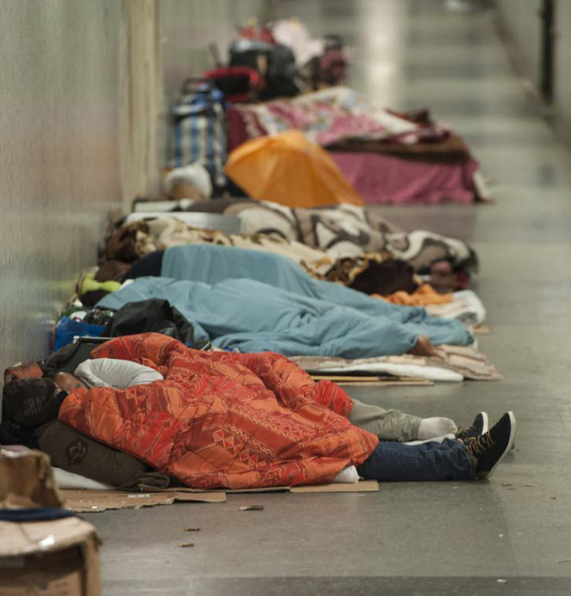

San Francisco’s housing affordability crisis
In San Francisco, housing affordability has declined significantly since the 1990s. Today it is one of the most expensive cities in the USA to live in, with average monthly rent for a two-bedroom apartment costing US$4,690 (AU$7,000). Many professionals - including teachers, police and emergency workers – cannot afford to live in the city they serve and a growing number of families with children are living in housing stress, moving away or experiencing homeless.
This housing affordability crisis is a result of a booming population and the creation of hundreds of thousands of jobs driven by the growing tech industry economy, coupled with a lack of diverse housing supply, including affordable housing.
There are more than 8,000 people homeless in San Francisco. The number of people living in vehicles has jumped by 45 per cent in two years. On an average night there are 1,000 people on the waiting list to access one of the typically 30-40 unoccupied shelter beds available. These figures continue to rise despite growing annual costs by the city government to address homelessness - US$360 million in 2019 - and the growing costs borne by charities and not-for-profits to provide for people’s basic needs. The cost to build one unit of supportive/crisis housing in San Francisco is US$700,000 (AU$1.05 million) and that unit costs US$25,000 (AU$37,300) annually to operate.

Understanding affordable housing

What is affordable housing?
Affordable housing, as defined by Victoria’s Planning and Environment Act 1987, is “housing, including social housing, that is appropriate for the housing needs of very low, low, and moderate-income households”.
Affordable housing (see figure 5) includes:
- Public housing (provided by the Victorian Government)
- Community housing (managed by Community Housing Organisations)
- Private market housing which is affordable for very low to moderate income households (affordability varies depending on price, property type, location and size).
The Act specifies the income range classification for very low to moderate income households. The income ranges are set annually by Order of the Governor in Council (see page 13).
The widely accepted definition of rental stress is when 30 per cent or more of a household’s income is spent on rent.27 When households on very low to moderate incomes are in rental stress, they are forced to sacrifice necessities of daily life such as food, healthcare or education.
Affordable housing is not ‘cheap’ or of a poorer standard. It is quality, fit-for purpose housing, priced at a level which is affordable relative to the income of its occupants.

What is the difference between affordable housing and social housing?
Social housing is long-term rental housing intentionally for very low to moderate income households; it includes both public housing and community housing.
Affordable housing is an umbrella term that includes social housing, but is not limited to social housing. Affordable housing may also include housing in the private market, if it is affordable for very low to moderate income households.

Who is affordable housing for?
Anyone can be in need of affordable rental housing during their life. Affordable housing is for anyone in our community who meets the household income thresholds. This can include families, older people, artists, hospitality workers, cleaners and people with low to moderate paying jobs.
Some people will need affordable rental housing for the duration of their life, whilst others will only need it for a short time - for example when their children are young or when an illness prevents them from working full time.

The Housing Spectrum
Where affordable housing fits in the housing spectrum
Note: Emergency housing and homelessness needs in the City of Melbourne are addressed by separate policies and services
EMERGENCY HOUSING: Emergency accommodation for people experiencing homelessness.  - CRISIS ACCOMODATION (stay for days to weeks)  - TRANSITIONAL HOUSING (stay for weeks to months)  - ROOMING HOUSES (insecure tenure) | SOCIAL HOUSING: Rental housing specifically for very low to moderate income households.  - PUBLIC HOUSING - Victorian Government (long-term rental)  - COMMUNITY HOUSING - Community Housing Organisations (long-term rental) | PRIVATE HOUSING: Prices are dictated by market settings (affordability varies).  - PRIVATE RENTAL HOUSING  - PROPERTY OWNERSHIP

Our focus: affordable rental housing
This Strategy focuses on the importance of increasing affordable rental housing. Affordable housing which can be rented offers prospective tenants with greater certainty over the ongoing affordability of housing and ensures housing can be accessed by people who need it most.
Affordable rental housing is essential infrastructure needed to support the prosperity, diversity and inclusion of the City of Melbourne. It is provided by the Victorian Government (public housing), the Community Housing sector and may be provided by the private market, depending on the location and type of housing.
Affordable housing which is rented allows people to transition into and out of a home at different stages of their life. For example, a tenant can move out of an affordable housing unit after beginning a new, higher paying job - allowing someone in need to take their place.
Permanent affordable rental housing also protects the retention of affordable housing within the municipality. This is possible with affordable purchase, but becomes more complicated as the affordable housing unit grows in value over time and owner may choose to sell or rent the property. Without ongoing controls the affordability of the unit can be lost. Protecting the ongoing affordability of purchased affordable housing is possible, but is also complicated and involved.
Many of the levers for impacting the private housing market are largely outside of local government control. This includes property and investment taxes, interest rates, wages and major infrastructure. We can play a role through advocacy, but our impact on people’s ability to purchase homes is likely to be small.
As we review and strengthen our role in the affordable housing space, we recognise the value of contributing the existing capacity of the community housing sector: who operate within a regulated sector and offer ongoing affordable rents for those most in need.

Housing and homelessness
Housing affordability is inextricably linked to homelessness. Without enough affordable housing, we increase our community’s vulnerability to homelessness.
Affordable housing and emergency housing serves to transition people out of homelessness and prevents people from becoming homeless in the first place. However, affordable housing is not exclusively for people experiencing homelessness.
City of Melbourne is working to end homelessness through a separate but integrated approach to emergency housing and outreach support.
For more information on how we are working to help people experiencing homelessness and at risk of homelessness, please see the homelessness page at melbourne.vic.gov.au.

Role and responsibilities

The roles of government in housing
The supply of affordable housing is impacted by policies across the three tiers of government as well as by the private and not-for-profit housing sectors. To address the housing crisis, a coordinated and sustained approach across all levels of government is needed to ensure that policy, funding, incentives and governance is effective.
The Australian Government collects approximately 80 per cent of all government taxes and is responsible for allocating the majority of funding into the social housing sector and to other governments. They also influence housing through taxation and regulatory levers to incentivise the delivery of affordable housing, to disincentivise undesirable outcomes and provide financial support for not-for-profit organisations.
The Victorian Government builds, owns and manages public housing. They provide funding to community housing agencies and set the rules on how community housing is managed and by who. The Victorian Government also controls the planning scheme and the majority of property taxes - constituting approximately 15 per cent of tax revenue30 - which significantly affects the housing market.
Local governments collect approximately 3 per cent of all government taxes through rates.31 Increases to rates are capped by the Victorian government, limiting local government’s financial capacity. Councils use the planning tools available to them in the planning scheme to negotiate development outcomes through the planning permit process. Local Government can also use rates concessions to support improved affordable housing outcomes. Many homelessness services are funded or directly provided by Local Governments. In addition community infrastructure, such as libraries, often provides support to those experiencing housing stress.
An integrated approach is needed across all levels of government to ensure that housing policy, funding, incentives and governance is effective.
Government roles in housing
Australian Government | Victorian Government | Local government
Housing demand  - Tax incentives (negative gearing capital gains tax reduction)  - Migration policy  Home ownership  - Capital gains tax reduction  - First home buyer super save scheme  - Home value exclusion from the Age Pension eligibility  Social Housing investment  - National Housing and Homelessness Agreement. (NHHA)  - National Housing Finance and Investment Corporation (NHFIC)  Welfare Support  - Commonwealth rent assistance  Major infrastructure funding  - City Deals  - • National Housing Infrastructure Facility(NHIF) | Taxes and duties  - Stamp duty  - Land tax  Public and community housing  - Funding public housing  - Transfer to Community Housing Organisations  Home ownership  - First Home Owner Grants  - Stamp duty exemptions  - Other exemptions  Land release  - Release of public non-residential land  Major Infrastructure funding  - Transport  - Healthcare  - Education | Minor infrastructure  - Roads and minor infrastructure  - Libraries and community spaces  Planning laws  - Land use zoning  - Inclusionary zoning  - Planning permits and restrictions

What is the City of Melbourne’s role in affordable housing?
As a local government, the City of Melbourne has limited ability to directly and significantly the address affordable housing crisis. We do not have a formal role in setting state and federal government policy which impacts housing affordability such as property and investment taxes, interest rates and wages.
As a capital city council, we have a leadership role. We can use this position to advocate and partner with other Councils and the Victorian and Australian Governments.
We also make decisions about how we use our own land and can utilise existing planning tools to improve affordable housing outcomes.

City of Melbourne housing policy
Meeting the diverse housing needs of Melbourne’s community is a priority identified in both the Future Melbourne 2026 Plan and Council Plan 2017-2021.
The City of Melbourne is committed to being a City for People. Future Melbourne 2026 identifies ‘affordable for all to live’ and ‘support the homeless’ as two priorities under the City for People goal. Future Melbourne 2026 commits to enabling a mix of housing and facilities in our municipality to support a diverse and inclusive community and creating effective pathways out of homelessness.
The provision of affordable housing in our municipality also delivers on other goals: A Creative City, A Prosperous City and A Knowledge City.
The City of Melbourne’s current housing policy Homes for People: Housing Strategy 2014-18 established three key goals: increasing supply of affordable housing, improving the design quality and environmental performance of apartments and fostering awareness of good housing outcomes.

Victorian Government housing policy
The Victorian Government plays a significant role in the provision of affordable housing and housing policy.
Plan Melbourne 2017-2050 identifies the need to increase the supply of affordable housing for Melbourne to remain liveable. Reforms include new planning provisions and tools to deliver social and affordable housing.
Victoria’s 30-year Infrastructure Strategy 2017 was released by the government’s independent adviser, Infrastructure Victoria. It identified ‘investing in social housing and other forms of affordable housing for vulnerable Victorians to significantly increase supply’ as one of the top three priorities for the government’s infrastructure agenda.
Homes for Victorians 2017 establishes the government’s response to the housing affordability crisis. It seeks to deliver 6,000 new social housing homes, renew 2,500 public housing residences and help 19,000 people who are homeless or at risk of homelessness. These initiatives were accompanied by a template draft voluntary agreement (Section 173 Agreement) for affordable housing planning applications and a pilot of inclusionary zoning on surplus government land including on one site in the City of Melbourne - Manningham Street, Parkville.
Legislative amendments were introduced to the Planning and Environment Act 1987 in 2018 to extend the objectives to ‘facilitate affordable housing supply’ and introduce a definition of affordable housing. This change provides strong rationale for the role of local government in facilitating affordable housing outcomes and the use of planning mechanisms to achieve this.
The Residential Tenancies Act 1997 impacts the private rental housing affordability indirectly through the rights of landlords and tenants which impacts rental prices and security of tenure.

Australian Government housing policy
A national housing strategy or policy does not currently exist. The Australian Government’s main role is in the provision of funding to support affordable housing supply and rent assistance to support eligible Australians on low incomes, as well as establishing the tax and market settings that govern the housing market.
The Australian Government recently established the National Housing and Homelessness Agreement with the states which sets which sets housing supply targets and distributes funding for housing to the states.
The government has also established the National Housing Finance and Investment Corporation to operate an affordable housing bond aggregator to provide long-term, low cost finance for affordable housing providers. Funding from the Australian Government is also directed through the National Housing Infrastructure Facility to fund critical supporting infrastructure which enables the delivery of new housing.
The National Construction Code outlines building standards including energy efficiency which impacts on the operating cost of housing.

Engagement
The City of Melbourne engaged PWC Australia as an independent advisor to conduct targeted stakeholder engagement on a range of potential mechanisms we could adopt to address the affordable housing crisis.
As part of this, PWC spoke to senior representatives from the development industry, finance and investment sector, peak bodies, the community housing sector, as well as state and federal government.
The findings from this engagement have directly informed and been integrated throughout this Draft Affordable Housing Strategy.

The role of community housing organisations
Community housing organisations (CHOs) are not-for-profit entities which include registered housing associations and providers. Importantly, they are registered and regulated by the State Government. Their not-for-profit and charitable status attracts a range of funding opportunities and tax concessions.
CHOs are able to build and manage affordable rental properties. Across Australia they are responsible for a portfolio of more than 100,000 affordable rental properties worth more than $30 billion.
CHOs are able to choose their tenants and provide different housing types to meet the different housing needs and preferences of their clients. Some CHOs specialise in helping specific groups such as people with a disability, women, singles or older people.
Rent is charged at approximately 30 per cent of the combined gross household income and tenancies continue until the tenant decides to leave. Community housing tenants have the same rights as public housing and private tenants.
The funding gap describes the shortfall between what CHOs earn from rental income and what they spend operating and maintaining the housing. This is partially, but not fully, filled by government subsidies.
Unlike public housing agencies, CHOs are encouraged to leverage their asset base and cash flows as security to obtain private finance. This can be used to develop their own projects or to purchase new properties that are produced by the private sector and provided to the CHOs at discounted rates. However, because the funding gap means they often operate at a financial loss, they are often unable to secure financing for future projects.
Beyond meaning that CHOs are financially constrained and dependent on subsidies, the funding gap means that they have limited ability to leverage their properties and scale their role in the sector.

The role of the private sector
The provision of affordable housing in private sector development is currently voluntary in Victoria. As part of the planning permit process, a developer may negotiate the delivery of affordable housing in exchange for other incentives such as additional development rights.
Developers in the property market typically aim to achieve a fixed profit margin through the construction and sale of housing. Where incentives and bonuses provided offset the cost of delivering affordable housing to the community housing industry then affordable housing outcomes will be feasible within their operating model.
Similarly, if the requirements for affordable housing are determined well in advance, developers are able to anticipate the cost and accordingly pay less for land, which enables them to deliver the required housing contribution.
Alternatively, some developers take different approaches to the funding, development, ownership and sale of property which can reduce the cost of housing. Popular examples in Melbourne include the Nightingale model - which uses innovative design to reduce the cost of the apartment - and the Assemble model - which offers long-term leasing of apartments with an opportunity to purchase at the end of the lease. Whilst these don’t necessarily constitute affordable housing as defined in the Planning and Environment Act, they offer below market rents that relieve pressure on the housing system and create housing mobility opportunities.

What about build-to-rent?

What is build-to-rent?
Build-to-rent is housing that is purpose built, retained and managed as long-term rental stock, usually by a single owner. Institutional investors (such as superannuation funds) are often attracted to the model because it can generate a long-term and stable income.
Build-to-rent is commonplace in both the UK and United States (where it is known as multi-family residential housing).

Is build-to-rent affordable?
Build-to-rent is not an affordable housing product in itself, although it can be made affordable if the dwellings are offered at a discount to market rent. To make this possible, the gap between market rent and affordable rent would require subsidising.

Can’t the private sector build more housing to reduce the price for everyone?
The housing market is complex, and supplying more housing is an important part of addressing overall housing affordability. However, increased supply of housing by the private market will not improve housing affordability alone.
Housing affordability has worsened despite growth in housing supply.
In Melbourne the construction of new dwellings has kept pace with population growth34. Despite the building ‘boom’ in Melbourne, housing costs have continued to increase; and a larger proportion of the population are renting. This indicates that despite strong supply, affordability has worsened.
A lot of new housing is absorbed by investors, rather than owner occupiers. In Australia, home ownership is one of the primary ways to build wealth. As a result in small per cent of properties sold are purchased by first home owners, highlighting that much of the new housing supply is absorbed by existing property owners building wealth.
Whilst investment housing could be used to provide additional rental supply and reduce the rental cost of housing, this has not been the case. Rather than providing homes for people, housing stock in Australia is often treated as a financial asset for generating income. As a result, investment property owners will charge high rents to ensure the property generates a return, or if it is generating strong capital gains it may be left vacant.
Affordable housing requires a cross-government approach.
Supply alone has not addressed the crisis and action needs to be taken to protect the affordability of housing. Additional mechanisms are required to ensure that housing supply is efficient, meaning it is used as homes for people rather than for investment, and that housing is available for people of all incomes.
Governments of all levels must directly enable greater levels of supply of affordable housing and the ongoing protection of that affordability through the planning scheme and other mechanisms.

Existing policy, projects and tools in City of Melbourne

Summary
There are a number of different affordable housing mechanisms currently in place in the City of Melbourne. These include uplift mechanisms, building on government land and voluntary agreements and aspirational targets. Collectively, however, these mechanisms are not delivering the scale of new homes required to meet our need. The ad hoc nature of the mechanisms, coupled with the absence of any mandatory planning tools has resulted in few new affordable homes being delivered.
The map at right captures the range of affordable housing projects and mechanisms, including uplift incentives, aspirational targets and building on some government owned land.

Uplift incentives
What is an uplift incentive?
An uplift incentive is created by offering additional development rights where affordable housing - or other community benefit - is provided. The Melbourne Planning Scheme encourages the provision of affordable housing in exchange for uplift incentives.

Where does it apply?
Central City - Melbourne Planning Scheme Amendment C270 introduced a floor area ratio of 18:1 to provide a guide for what a reasonable development yield should be within the central city. Development density which exceeds this threshold (floor area uplift), triggers a value sharing contribution towards a public benefit. The public benefit provided must be commensurate with the uplift sought and could include strategically justified uses such as office space, publicly accessible areas or affordable housing.
West Melbourne Waterfront - a preferred building height of 10 storeys is given in this precinct. A building height of up to 14 storeys may be permitted by Council if, amongst other things, 15 per cent of this additional floor area is set aside for affordable housing. This arrangement was agreed to through a site-specific planning scheme amendment.
Fishermans Bend (Lorimer precinct) - in 2018, the Fishermans Bend Framework introduced an affordable housing target of 6 per and a social housing uplift incentive. The uplift incentive offers an increase of eight dwellings above the ‘as-of-right’ density for each social housing dwelling provided, at the discretion of the responsible authority. At current, the social housing uplift incentive has not been applied to any developments in the Lorimer precinct.
Macaulay (DDO63) - New built form controls were introduced to Macaulay through Design and Development Overlay 63 (DDO63). An uplift incentive was included in the controls allowing developers to exceed the preferred building heights if they can prove their development provides ‘a demonstrable benefit to the broader community’.
However, affordable housing was not explicitly defined as a community benefit. There was also no measurable criteria for assessing how much uplift a community benefit was worth. That is, if affordable housing is offered as a community benefit there is no defined measure to calculate how many affordable housing units and increase in ‘X’ height is worth. This creates uncertainty and confusion for both the developer and the responsible authority.

What are the challenges?
Despite inclusion in the planning scheme, these uplift incentives have not yet delivered any affordable housing units in the City of Melbourne: failing to provide sufficient incentive for developers to exceed the floor area ratio or dwelling densities offered in these policies.
The correlation between the uplift incentive provided and the cost of providing affordable housing is not always clear, and adds risk and cost to developments. Similarly incentives provided are often insufficient to offset the cost of the affordable housing requirements.

What have we learned?
- Current uplift incentives are inconsistent and are not delivering affordable housing.
- Opportunities to deliver affordable housing on publicly owned land has been ad hoc and produced limited stock.
- We have missed value capture opportunities for affordable housing when rezoning land in the past. We need to commit to affordable housing requirements early and providing certainty around these requirements.
- Changes to the Planning and Environment Act related to voluntary agreements have had limited impact on the delivery of affordable housing.
- Affordable housing targets for new developments are not being met due to voluntary nature of affordable housing agreements.
- A mandatory affordable housing tool would allow for greater certainty over the delivery of affordable housing.

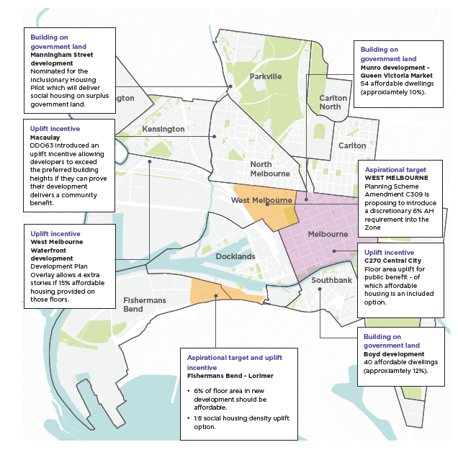

Building on government land
Our 2014 Housing Strategy committed that when Council develop on land that we own, we would consider up to 15 percent of dwellings constructed being made available for affordable housing. This has been a relatively successful policy in two instances. The Council owned Munro site as part of the Queen Victoria Market Precinct Renewal is one of these projects, which has been approved to provide 48 affordable apartments.
Affordable dwellings have also been proposed as part of the City owned Boyd redevelopment in South Bank, which is expected to result in 56 affordable dwellings.
There is an example in the City of Melbourne of the Victorian Government using its own land to build new affordable housing. The Inclusionary Housing Pilot at Manningham Street will deliver social housing on surplus government land.

Value Capture
Value capture is a means of ‘capturing’ a portion of increased land value which occurs through the planning process, such as when land is rezoned to higher value uses. The value created and then captured can be contributed towards a community benefit such as affordable housing. This can be done by stating a requirement for the development of affordable housing at the time of rezoning, ensuring that increased land values that result from the rezoning include the cost of delivery of affordable housing.
Although rezoning of land can occur on a site specific basis, urban renewal areas generally provide the greatest opportunity for value capture. Arden, Macaulay and Dynon and E-Gate are planned future urban renewal sites within the City of Melbourne that represent opportunities for value capture.

What are the challenges?
Due to the speculative nature of Melbourne’s housing market, attempts to value capture are often undermined by rises land values occurring prior to rezoning due to speculation. This occurred recently in Arden where a proposed land sale showed land prices that reflected a speculative residential land use.
Speculation is inherently risky and therefore the implementation of value capture mechanisms should be independent of speculative land prices. Land valuation that does not accurately speculate the inclusion of affordable housing requirements should simply be regarded as a cost of the risk of speculating and not effect government policy.
This risk can be mitigated by committing to affordable housing requirements early and providing certainty around these requirements. Mandatory inclusionary zoning would enable this level of confidence.

Voluntary agreements

What are voluntary agreements for affordable housing?
The Planning and Environment Act, 1987 (the Act) was amended in June 2018, adding an objective to “facilitate the provision of affordable housing in Victoria”. It clarifies that Responsible Authorities - such as the City of Melbourne - can enter into a voluntary agreement with a land owner under section 173 of the Act for the provision of affordable housing.

What are the challenges?
Since June 2018, no voluntary agreements have been entered into with landowners for the delivery of affordable housing in the City of Melbourne.
The success of securing affordable housing through section 173 agreements is dependent on Council being able to negotiate with developers at the planning permit stage. To date, these negotiations have been relatively unsuccessful. The main reason is that the agreements are voluntary in nature and therefore difficult to deliver. Outcomes are also limited by the lack of clarity that the Council has provided on the preferred outcomes or which is provided too late in the process.
The requirement to enter a section 173 agreement may be required by Council as a condition of a planning permit but if the developer does not agree, the condition is likely to be challenged at the Victorian Civil and Administrative Tribunal (VCAT).
In the absence of mandatory controls, the Fishermans Bend Framework and Amendment C309 West Melbourne Structure Plan introduced affordable housing requirements for their respective areas. New developments are expected to include a percentage of affordable housing, unless it can be proven that this renders the development infeasible. Ultimately, these agreements are still voluntary.
In Lorimer (Fishermans Bend) and West Melbourne, it falls to the proponent to prove why they cannot provide the expected amount of affordable housing. A likely and undesired outcome of this approach is that proponents may consider it financially preferable to argue against provision at VCAT - a time and resource intensive process for all parties which may not result in the desired affordable housing outcomes.

Affordable housing development targets

What are affordable housing development targets?
In the absence of mandatory controls, the Fishermans Bend Framework and the West Melbourne Structure Plan introduced affordable housing requirements for their respective areas. New developments are expected to include a percentage of affordable housing, unless the proponent can prove that this renders the development infeasible.

What are the challenges?
Ultimately, these agreements rely on section 173 agreements and to an extent are still voluntary. A likely and undesired outcome of this approach is that proponents may consider it financially preferable to argue against provision at VCAT - a time and resource intensive process for all parties which may not result in the desired affordable housing outcomes. A mandatory tool, such as inclusionary zoning, would resolve this problem.

City of Melbourne housing trust
The City of Melbourne created the Inner City Social Housing Trust in the late 1990’s and contributed $1 million as an initial start up contribution.
The trust existed for some years and created approximately 300 affordable housing units in City of Melbourne which still exist, these include Ebsworth House, Guilford Lane, Lion Garden, La Trobe Close, Drill Hall, Common Ground, Boyd High School Site.
The trust underwent a number of management and organisational changes as it developed and expanded through partnerships and mergers with other similar groups such as Ecumenical Housing to fund development of affordable housing in Melbourne.
The Trust became Melbourne Affordable Housing around 2003 and merged with Housing Choices Australia around 2010, a large not-for-profit national affordable housing organisation.

What are the challenges?
Other municipalities also developed Housing Trusts in the past including Port Philip and Greater Geelong. The outcomes of these organisations demonstrate that it is possible to utilise these models to create affordable housing in particular local areas. However it is challenging to scale these organisation up significantly in terms of financial and organisational capacity to expand beyond a certain size.
There are also some significant issues for Local government being involved in these organisations due to the National Competition policy. Councils need to ensure that there are management, operating and fiduciary guidelines in place to ensure sufficient separation of powers such that the organisation is not operating in any way that prevents competition.
This is a particular problem when the ideal option for sufficiently developing a robust affordable housing organisation is to partner in various ways with the private housing sector, other investment businesses and also with financial and or funding organisations such as banks, superannuation funds, investors, charitable funds, state and federal government.
Finally, trusts can sometimes be strict legal entities that may restrict the flexibility of the Council to respond to the housing crisis or adapt to future needs.

STRATEGIC APPROACH
The City of Melbourne is committed to working in partnership with government, development industry and the community housing sector to address the shortfall of affordable housing. We will do this by delivering on four strategic priorities outlined in this section
“To not have to worry about searching for housing is a massive relief” – Quote from James (pictured) PhD student and affordable housing tenant


City of Melbourne’s approach
Priority | Actions and policies
 | 1.1 Advocate to the Victorian Government for State-wide mandatory inclusionary zoning.
  1. Advocate for mandatory inclusionary zoning
2. Develop affordable  rental housing on City of  Melbourne land | Actions:  2.1 Commit a City of Melbourne owned site to deliver an affordable housing project in the next five years.  2.2 Continue to work with other local Councils to establish opportunities for affordable housing development, and consider ways to share resources to enable affordable housing projects  Policies:  I. On all future residential development on City of Melbourne owned land, we aim to deliver up to 25 per cent of residential development as affordable housing. Consideration will be given to accommodating greater than 25 per cent affordable housing in urban renewal areas.  II. Consideration will be given to delivering affordable housing on commercial developments and community facilities on City of Melbourne land.
3. Strengthen our internal affordable housing processes | 3.1 Develop an Affordable Housing planning policy for inclusion in the Melbourne Planning Scheme. This planning tool should clearly outline when an affordable housing contribution should be made, how the rate of affordable housing should be calculated and what should be included in an affordable housing agreement.  3.2 Establish a special purpose entity to manage affordable housing contributions, with potential to operate across local government boundaries.  3.3 Commit staff and budgetary resourcing to the ongoing delivery of affordable housing outcomes.  3.4 Develop a centralised internal process for recording and assessing affordable housing outcomes.
4. Advocate and partner for affordable housing | 4.1 Advocate across all levels of government, the private sector and the broader community to improve affordable housing outcomes.  4.2 Advocate to the Victorian and Australian Governments for the increased investment and provision of social housing, with an emphasis on public housing.  4.3 Partner with the State and Federal Governments to identify surplus land for the delivery of affordable housing in the City of Melbourne. This may include land that is owned by government departments and entities such as Melbourne Water and Victrack.  4.4 Use City of Melbourne events, public forums and media platforms to promote greater awareness and understanding of affordable housing issues and alternative housing models.

The scale of the opportunity
Our goal is to increase the supply of appropriate and accessible affordable rental housing within City of Melbourne.
If implemented effectively and at scale, the proposed priorities outlined in this strategy could deliver up to 5,530 new affordable homes by 203637. This would leave a remaining shortfall of approximately 17,670 homes.
We recognise a shortfall of 17,670 affordable homes may seem overwhelming. However, the problem is not insurmountable. We will advocate and partner across the sector and with other tiers of government to find solutions that address this remaining shortfall.
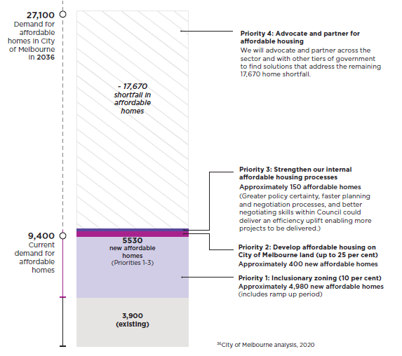

1.ADVOCATE FOR MANDATORY INCLUSIONARY ZONING

What are we proposing?
We support the introduction of state wide mandatory inclusionary zoning (IZ) for affordable housing.
Mandatory IZ is a planning control which requires a percentage of affordable dwellings to be provided within new development. This approach embeds the cost of providing affordable housing in the cost of the land and provides policy certainty to developers.
Mandatory IZ is not currently available within the Victorian Planning Provisions. Its adoption can only be enabled by the Victorian Government. The City of Melbourne can advocate for this change but is not able to implement mandatory IZ independent of the Victorian Government.
Our preferred position is that dwellings are transferred directly to a registered community housing organisation (CHO) at minimal cost.
Where it is agreed that a direct contribution is not practical or appropriate, developers should make a financial contribution towards the delivery of affordable housing in lieu of providing dwellings for this purpose in their development.
The design of dwellings is an important part of the city’s character and a cohesive community. Any dwelling transferred to a CHO should be indistinguishable in design to the other private market dwellings in the same development.
The introduction of mandatory IZ should be phased in over a period of time so that the market has adequate time to adjust to the change. The implementation of mandatory IZ will be supported by guidance to make decision-making clear and consistent.
Actions:
1.1 Advocate to the Victorian Government for statewide mandatory inclusionary zoning.

The City of Melbourne’s position on mandatory inclusionary zoning is for it to be:
- A minimum percentage introduced across all of Victoria or only in metropolitan areas. The percentage should be higher in appropriate locations where this is justified.
- Phased in to allow the property market to adjust and incrementally increased over time to at least 10% by 2031.
- Applied to multiple land use types including residential, commercial and industrial land.
- Calculated as an equivalent percentage of net developable floor area.
- Transferred at minimal cost to registered Community Housing Organisation.
- Owned and managed by registered Community Housing Organisation.
- Designed to be indistinguishable from private market housing.
A.Land zoning (by Local and State Governments) effects land prices and development options.  Introducing mandatory inclusionary zoning creates certainty around a_ordable housing contribution requirements and a level playing field for developers. | B. SITE SELECTION is influenced by zoning and planning requirements. Development costs are calculated prior to site purchase, including the cost of any planning requirements.  Mandatory inclusionary zoning ties the cost of affordable housing contributions to land prices. The cost of affordable housing contributions can be calculated into development costs and will influence the price a developer is willing to pay for the land. | C. PLANNING PERMIT: A planning permit application is submitted to the Responsible Authority (State Government or City of Melbourne).  A developer commits to providing the required amount of affordable housing to an agreed housing provider (or, where appropriate, cash in lieu of physical housing) at the planning permit stage.


Mandatory IZ will deliver new affordable housing to the City of Melbourne. IZ is commonly used in capital cities around the world and in Australia.
Mandatory IZ will be the most effective planning mechanism for delivering new affordable homes in our municipality. In particular, it is appropriate to require a higher percentage in our urban renewal areas. Our modelling demonstrates that the introduction of mandatory IZ, ramping up to a 10 per cent requirement by 2031, would enable approximately 4,980 affordable homes to be built in the City of Melbourne by 2036.
Further, the analysis determined that the market within inner-metro Melbourne could feasibly support this 10 per cent requirement without impacting the ability to meet the wider housing needs of our future population.

Mandatory IZ delivers a strong return on investment for the community
As part of the strategy, the City of Melbourne commissioned a cost benefit analysis of the mandatory IZ which balanced costs such as dwelling construction costs, maintenance and operating costs and a reduction in residual land value against the offsetting benefits; including health cost savings, reduced family violence, reduced cost of crime, enhanced human capital, worker retention.
This analysis found that over a 20 year period, a 10 per cent mandatory IZ requirement delivers $3 in community benefit for every $1 spent.

Mandatory IZ offers greater certainty of expectations and consistency of application
The current voluntary framework and planning mechanisms in the Melbourne Planning Scheme are delivering very few affordable homes. In June 2018, legislative changes were introduced to enable voluntary agreements with landowners to provide affordable housing. This change has had no measurable effect on the number of voluntary agreements entered in to within the City of Melbourne.
Mandatory IZ offers greater certainty and clarity to developers on the planning requirements and associated costs tied to a piece of land. This establishes a level playing field for the market and the cost of providing affordable housing can be factored into the total cost of developing a site.
The clarity is also likely to reduce planning delays and the likelihood of VCAT appeals on both the developer and the council’s behalf.
The community housing sector also benefit from the increased certainty: it assists with planning, lobbying and resource allocation.

How does mandatory inclusionary zoning affect development feasibility?
A developer’s decision to purchase land is influenced by the residual land value (RLV). This is the amount that a developer is willing to pay for a piece of land. RLV is equal to the total sale value of property that can be developed, less the developer’s required profit and the costs of construction.
Where affordable housing is required to be delivered, construction costs are increased. Consequently the RLV, that is the amount that a developer is willing to pay for the land, is reduced as their costs increase. Over time, the land absorbs the cost of affordable housing through a reduction in its value. Provided that the value of developing the land remains higher than the value derived from the land’s current use, development will still occur.
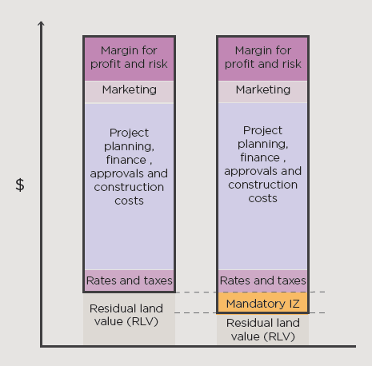

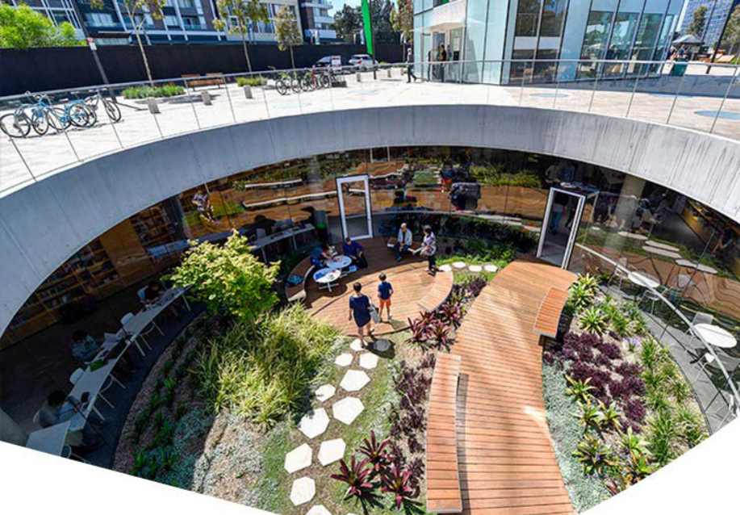

Green Square, Sydney
The City of Sydney has implemented inclusionary zoning to deliver affordable housing dwellings in Pyrmont- Ultimo and an area to the south west of Green Square.
The Green Square Affordable Housing Scheme aims to provide and maintain a stock of approximately 330 units for low to moderate income households in the Green Square urban renewal area.
At the time of rezoning, the New South Wales State Government in partnership with the then South Sydney Council gazetted the South Sydney Local Environment Plan 1998. This piece of legislation allowed the Council to collect affordable housing contributions on developments in Green Square through a inclusionary zoning. When planning permission for redevelopment of any piece of the relevant land is sought, a contribution towards the affordable housing scheme is required.
Affordable housing that is delivered through the program (and through other programs operating in the City of Sydney) are provided to City West Housing. This organisation is a community housing organisation established by the City of Sydney and is identified as their preferred housing provider for the delivery and management of affordable housing.
The Green Square Affordable Housing Scheme has been successful in delivering affordable housing objectives because it is implemented through state legislation. This gives developers and council certainty that planning applications must factor the contribution into their overall development business model.
Clover Moore, the Lord Mayor of City of Sydney, has asked for the scheme to be expanded across the broader council area excluding the CBD. The NSW state government has extended the legislation to apply to five other metropolitan Sydney councils.

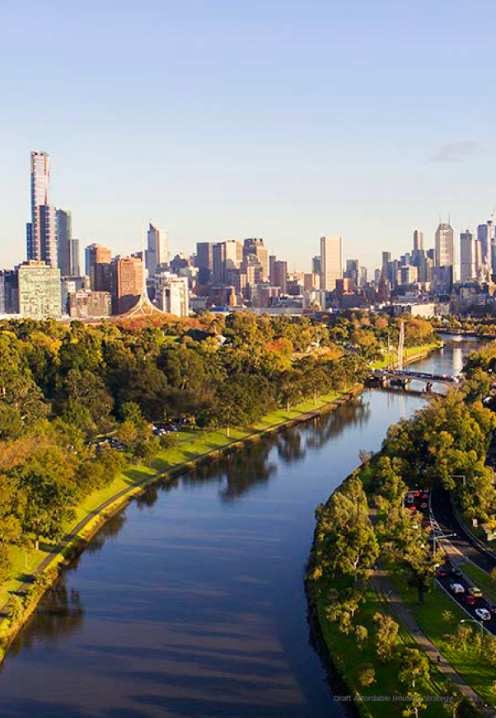

2. DEVELOP AFFORDABLE RENTAL HOUSING ON CITY OF MELBOURNE LAND

What are we proposing?
We will commit to delivering up to 25 per cent affordable rental housing on appropriate City of Melbourne land. The leasing of land will be prioritised over sale to retain public ownership. We will also identify a site to be leased for a demonstration affordable rental housing project, which will seek to deliver the majority of its housing as affordable housing. The feasibility of the percentage of affordable housing will need to be tested for viability.
The City of Melbourne is committed to taking a leadership role in addressing the affordable housing crisis. We’ve heard calls from the community to build affordable housing and obtained expert analysis to determine the substantial scale of the need for affordable housing.
We recognise that there are many competing interests for City of Melbourne owned land and comparatively we don’t own a large amount. However this provides an opportunity to demonstrate the potential for greater use of government land for affordable housing. There are significant Victorian Government land holdings within the City of Melbourne that can be leveraged for affordable housing and we will use this strategy to advocate for the Victorian Government to do so (see Priority 4: Advocate and partner for affordable housing).
This priority also provides an opportunity to draw greater community value from City of Melbourne owned land and trial and showcase alternative and innovative housing models, working in partnership wherever possible.

Actions:
- 2.1 Commit a City of Melbourne owned site to deliver an affordable housing project in the next five years.
- 2.2 Continue to work with other local Councils to establish opportunities for affordable housing development, and consider ways to share resources to enable affordable housing projects.

Policies:
- I. On all future residential development on City of Melbourne owned land, we aim to deliver up to 25 per cent of residential development as affordable housing. Consideration will be given to accommodating greater than 25 per cent affordable housing in urban renewal areas.
- II. Consideration will be given to delivering affordable housing on commercial developments and community facilities on City of Melbourne land.

Kyme Place, Port Melbourne
Kyme Place is a great example of local government contributing land to enable development of affordable housing.
The City of Port Phillip contributed air rights to a Council-owned car park to the Port Phillip Housing Trust. The City of Port Phillip retained ownership of the site and only five car spaces were lost as part of the project.
The Kyme Place project delivered 27 affordable homes, including two fully accessible and 11 adaptable for use by persons with a physical disability.
The project cost $8.75 million project or approximately $324,000 per dwelling.
Kyme Place provides supported community housing developed by the Port Phillip Housing Association under the Trust.
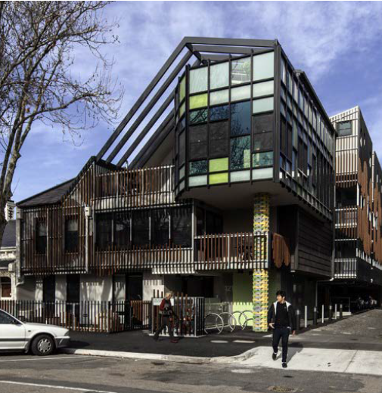

Incorporate up to 25 per cent affordable rental housing in future developments on City of Melbourne land
Council’s previous housing strategy committed up to 15 per cent of housing built on City of Melbourne land to be affordable. This has delivered some affordable housing, but we believe we could be more ambitious. Building on the lessons learned from this experience, we are increasing our commitment to deliver up to 25 per cent affordable housing on our land.
There are other types of development on City of Melbourne land including commercial and community facilities. We commit to considering, as a standard of practice, the extent to which affordable housing can be incorporated in these developments.
Urban renewal areas present unique opportunities to substantially increase the supply of new affordable housing. This is due to the extent of underutilised land available in these areas and the opportunity Council has to shape these precincts as they are regenerated. In urban renewal areas this is an opportunity to be ambitious on Government land to lead the market. On these sites, consideration will be given to accommodating greater than 25 per cent affordable housing.
There are excellent examples from the United Kingdom where affordable housing has been incorporated into the development of community facilities.

Leasing government land
We propose long-term, low cost leases on government land. This is preferred over sale of land. Selling government land adds to the risk of the development being sold to the private market at the end of the life of the development and losing the affordable housing stock. Leasing means that the City of Melbourne retains the benefits of asset ownership and the land is able to continue to deliver community benefit beyond the life of the project.
Secondly, the use of a lease provides the government entity with greater control over development outcomes. In some circumstances, affordable housing projects fail to produce appropriate housing or produce undesirable outcomes. A lease enables contractual enforcement of the use, type and quality of affordable housing.
Leasing arrangements are also desirable to some private industry actors (such as institutional investors) who want to obtain the profits of development and leasing of property without incurring the financial outlay of land acquisition.

Partnering with other Councils
The City of Melbourne has strong and productive relationships with other local governments. In 2019, we established the Inter-Council Affordable Housing Forum, which has a membership of 30 local governments. This has become an effective forum for discussing challenges and sharing learnings in affordable housing policy.
We will build on these relationships by identifying opportunities to establish formal partnerships with other local governments for the development of affordable housing. This may include committing to the pooling of resources to investigate innovate models of delivery, or to pilot and build projects.

Lease a City of Melbourne site for a demonstration affordable housing development
As access to land is one of the most significant barriers to the construction of new affordable housing developments, we will lease a Council owned site for a demonstrative affordable housing project in the next five years.
The demonstration project will be evaluated on its ability to deliver as much affordable rental housing as possible. We support the inclusion of wrap around services and/or community facilities and will prioritise trialling an innovative model with the potential to be scaled for larger impact.
Demonstration projects play an important role in showcasing how policies can be implemented and high quality outcomes achieved. They break down preconceived notions and expand the boundaries of what can be achieved. They provide confidence to the industry, the community and other stakeholders regarding the process and outcome, and help to pave the path forward for future projects.
City of Melbourne delivered a demonstrative project in Council House 2. The 2013 office building was Australia’s first 6 Star Green Star (Design) building constructed by the City of Melbourne. By showcasing how sustainable design, construction methods and operation could work in practice it de-risked future projects taking on these measures and set a new standard for sustainable buildings in Melbourne. The high environmental quality of the building stock in Melbourne today is a legacy of this ground breaking project.
We believe an affordable housing project can do the same for how affordable housing is delivered and managed, and how government land is used.

3. STRENGTHEN OUR INTERNAL AFFORDABLE HOUSING PROCESSES
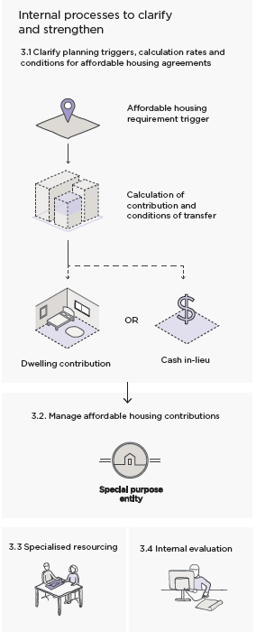

What are we proposing?
We will review and strengthen our existing processes, mechanisms and resources to improve affordable housing outcomes and ensure housing stock is efficiently delivered and managed.
The effectiveness of existing mechanisms to secure affordable housing in the City of Melbourne has been limited by lack of certainty and consistency around how they are implemented.
Our current processes and policies need to be clear and consistent. This sentiment has been provided in feedback from developers, consultants and the community housing sector. To improve the delivery of affordable housing, greater clarity and understanding of expectations are needed to ensure developers can deliver the housing stock, that CHOs are able to receive and manage it and that housing meets our community’s needs.
There are a number of opportunities for us to review and strengthen the existing mechanisms and process to improve affordable housing outcomes. These improvements relate to:
- How we calculate the level of affordable housing contribution and what the conditions of this contribution will be.
- How we manage affordable housing contributions when we receive them.
- The internal resourcing we have to facilitate better affordable housing agreements
- How we monitor and evaluate the performance and outcomes of strategies against the affordable housing need.

Actions:
- 3.1 Develop an Affordable Housing planning policy for inclusion in the Melbourne Planning Scheme. This planning tool should clearly outline when an affordable housing contribution should be made, how the rate of affordable housing should be calculated and what should be included in an affordable housing agreement.
- 3.2 Establish a special purpose entity to manage affordable housing contributions, with potential to operate across local government boundaries.
- 3.3 Commit staff and budgetary resourcing to the ongoing delivery of affordable housing outcomes.
- 3.4 Develop a centralised internal process for recording and assessing affordable housing outcomes.

Clarify planning triggers, calculation rates and conditions for affordable housing agreements
We will work towards greater consistency across affordable housing mechanisms within our municipality. We will offer greater clarity with regards to when they apply, how they are measured and how we expect them to be delivered. This will apply to existing tools, such as uplift mechanisms, and in future may be applied to inclusionary zoning. Through a local policy planning document we will seek to clarify:
- When and where affordable housing policies and requirements will apply and process through which they will be applied.
- The circumstances in which cash-in-lieu of dwelling contributions are acceptable.
- How affordable housing contributions are calculated and translated into direct gifting or a discounted sale of equivalent value. This will have a logical relation to the cost of delivering affordable housing.
- The conditions that will be placed on a dwelling transfer, including how long the dwellings are to be retained as affordable housing.

How do these changes apply to existing mechanisms and processes?
Voluntary Agreements - In the past Section 173 Agreements have been difficult to negotiate due to unclear expectation about what type of housing is needed, for whom and for how long it will be required. The policy will provide a clear starting point for Council’s negotiations and require reasonable justification to deviate from this position.
Uplift incentives - We have heard through our stakeholder engagement that the relationship between additional density provided and the cost of providing affordable housing is not clear. These changes will support a clearer understanding of how uplift is calculated and how it relates to the cost of housing. Combinations of mechanisms may be used to address the additional cost of providing affordable housing.
Value capture - Value capture only works where mechanisms are put in place prior to windfall gains occurring (such as through the rezoning of land to higher value uses). The policy will provide greater confidence to provide earlier announcements about housing expectations of urban renewal areas and clarity about how mechanisms will be applied.
Planning efficiency - Stronger policy direction will help to make the planning process quicker for projects required to deliver affordable housing. This will mean clearer understanding of expectations up front, less time negotiating, smoother processes for delivery and monitoring, and reduced time spent deliberating permit applications.
Interim Affordable Housing Policy
We’ve heard from our industry engagement that a lack of clarity and consistency regarding what the City of Melbourne wants in an affordable housing agreement creates risk and uncertainty and makes reaching an agreement difficult. To address this, we are proposing an Interim Affordable Housing Policy which articulates the basic terms of an agreement. The interim affordable housing policy will guide decision making until a planning policy on affordable housing is adopted by Council and included in the Melbourne Planning Scheme.

Interim Affordable housing Policy
Our interim position on affordable housing agreements is for dwellings to be:
- Transferred at minimal cost to a registered Community Housing Organisation.
- Retained by the Community Housing Organisation for a minimum of 10 years.
- Designed to be indistinguishable from private market housing.

Manage affordable housing contributions
How we manage affordable housing contributions into the future will require further investigation and decisions on:
- Who manages or owns the housing.
- How we ensure that the housing is retained within the City of Melbourne in perpetuity, to ensure the long-term availability of affordability housing in the municipality.
- How funds will be distributed if cash-in-lieu of dwellings is offered as an option; who will be eligible to receive funds and what type of projects or developments can be funded.
These decisions point to the need for a special purpose entity to receive, manage and distribute housing assets and funds. This entity could take the form of a housing trust, a new community housing organisation (as per the City of Sydney model) or an alternative model. The costs, efficiencies and risks of each option will need to be carefully considered before a commitment is made.

Provide additional, specialised resourcing
To successfully deliver more affordable housing in our municipality, we will require new skills and resources within our organisation.
We commit to creating a single point of contact for delivering affordable housing in line with the affordable housing strategy. Key roles of this resource(s) will be to:
- Broker housing agreements between developers and CHOs and offer a direct point of contact for stakeholders.
- Clarify affordable housing triggers, calculation rates and conditions - through both policy and communication channels such as an affordable housing webpage.
- Manage the distribution of housing or cash.
- Providing key input to the lease and development of our own land or assets.
- Provide internal support to statutory planners and other parts of the organisation that are part of the affordable housing process.
- Monitor and evaluate affordable housing mechanisms and outcomes.

A significant amount of time and skill will be required to assist developers and CHOs negotiate housing agreements. In particular, this resource should have a good understanding of the commercial realities facing developers, as well as the social goals, financial constraints and regulatory environment of CHOs and the Council.

Evaluate the outcomes of internal changes
Reviewing the implementation plan against our priority outcomes at set intervals is critical for the ongoing success of this strategy.
We will clearly define the need for affordable housing in the City of Melbourne. We will record the outcomes of affordable housing negotiations, including amount of housing acquired, conditions of the agreement and dwelling size (including number of bedrooms) and evaluate this against the need. This will assist us in assessing the impact of our policy changes, with a view to constantly learning and improving as we move forward.
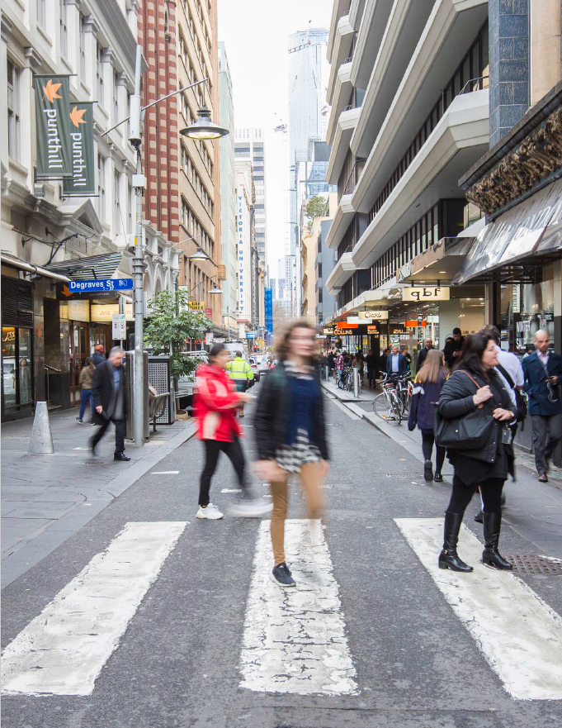

4. ADVOCATE AND PARTNER FOR AFFORDABLE HOUSING

What are we proposing?
We will lead and influence change across government, the community housing sector and development sector. Beyond using our public forums to advocate, we will lead by doing and demonstrate best practice in our own operations.
Other levels of government set policies which impact on the availability of affordable housing in our community. We see that there are many opportunities to enable significant change and increase the supply of affordable housing in our municipality through advocacy and developing constructive partnerships with government.
Actions:
- 4.1 Advocate across all levels of government, the private sector and the broader community to improve affordable housing outcomes.
- 4.2 Advocate to the Victorian and Australian Governments for the increased investment and provision of social housing, with an emphasis on public housing.
- 4.3 Partner with the State and Federal Governments to identify surplus land for the delivery of affordable housing in the City of Melbourne. This may include land that is owned by government departments and entities such as Melbourne Water and Victrack.
- 4.4 Use City of Melbourne events, public forums and media platforms to promote greater awareness and understanding of affordable housing issues and alternative housing models.

Australian Government

A National Housing Strategy
It is important that efforts to provide affordable housing are coordinated and well informed. As major funders and project partners of State government and the housing sector, and legislators of many of the tax and market settings that produce housing, a strategy is required to consider and direct positive housing outcomes that address the nation’s housing needs.
A National Housing Strategy should provide the strategic direction and justification for affordable housing and will inform the basis for allocating Federal funding. The strategy should include a review and reform of housing market design (both the broader housing market and social and affordable housing as it exists within it) and allocation of funding and incentives to stimulate better affordable housing outcomes.

A City Deal
A City Deal is a partnership between all three tiers of government and the local community with the purpose of ensuring productive and liveable cities. It involves the provision, sharing and coordination of investment and planning to secure the prosperity and liveability of our cities.
City of Melbourne will advocate for a City Deal within our municipality, ensuring the deal includes a focus on the provision of affordable housing.

Other funding
Currently the social and affordable housing sector (including State Government and Community Housing Organisations) have limited financial capacity which constrains the ability for new projects to be delivered. Greater levels of funding and financing will need to be made available in order to address the significant gap of social and affordable housing in Victoria and the cost associated with delivering these.
We will advocate for a greater level of funding to be contributed to the sector and greater levels of financing to be made available, such as through the National Housing Finance and Investment Corporation (NHFIC).

Victorian Government

Develop affordable housing on Victorian Government land
The Victorian Government has a responsibility to address the affordable housing crisis and has made significant steps towards this so far. Using its own land for affordable housing projects would be a significant next step to increasing the supply of affordable housing.
We will advocate for the Victorian Government to utilise greater amounts of its land, such as Melbourne Water and Victrack land, for the delivery of new affordable housing. As part of this we will partner with the Victorian Government to identify land that could be utilised for affordable housing in the City of Melbourne and support its use for affordable housing projects. We will investigate opportunities to optimise the value of the land for delivering affordable housing through the planning system.
We support an approach to developing government land consistent with the approach put forward for our own land in Priority 2: Develop affordable housing on City of Melbourne land. This includes developing via a leasing arrangement in order to retain public ownership of land and involving where possible housing organisations to build capacity within the industry.

Establish an affordable housing agency
A dedicated state government agency is needed within the Victorian Government to oversee all aspects of affordable and social housing. This entity could be responsible for:
- Providing a centralised housing strategy that coordinates the different roles and responsibilities of actors within the industry (including the development industry, local government and community housing organisations.
- Registering and monitoring affordable housing dwellings which are either proposed, under construction or delivered to ensure housing targets and needs are met. This should include dwelling size, affordable housing type, tenure, subsidies, etc.
- Ongoing monitoring of demand for affordable housing and providing a framework for local governments to assess demand at fixed intervals.
- Preparing consistent guidelines and provide training on best practice outcomes for the integration of affordable housing within private developments.
- Co-ordinating financial grants for affordable housing offered through government entities to streamline application process for local governments.

Planning mechanisms
See Priority 1 - Advocate for mandatory inclusionary zoning

Using government land
We know there is a lot of Government owned land that is currently not being used efficiently; and is close to transport, services and employment which makes it well suited for affordable housing.
A 2018 study by the University of Melbourne identified almost 195 hectares of under-utilised government land across Greater Melbourne that could be used to deliver more than 30,000 social and affordable homes. It also noted that there were 95 hectares of government land that has already been classified as surplus which could support approximately 2,167 homes.
The availability and suitability of this land offers a practical solution to partly address the current affordable housing crisis.
Land is the most expensive component of delivering housing, especially in the City of Melbourne and the inner metropolitan area. Using government land significantly reduces the upfront cost of building affordable housing; making it one of the most effective and direct contributions government can make to increase the supply of affordable housing in specific areas.
Using its own land also means that Government:
- Has greater control over where affordable housing is delivered.
- Can co-locate housing with other essential infrastructure and facilities, such as childcare centres or sporting facilities.
- Can fast track affordable housing projects compared to private development.
- Is delivering on its mandate to address the affordable housing crisis.

Direct provision of social housing
The Victorian Government spent $530 million on social housing and homelessness services in 2019. This is about half the national average spend per person and significantly lower than the $1.37 billion investment by the NSW Government. The Victorian Government must make more substantial investment in social housing to ensure new stock is increased and older stock is kept fit for purpose. The City of Melbourne will advocate for additional public housing in our municipality, for a strategic role in the renewal of public housing sites in the municipality and for existing public housing tenants and communities to be supported through future renewal projects.

Building awareness and understanding

Public awareness and understanding
The City of Melbourne will champion greater community awareness and understanding of social and affordable housing. The terms social and affordable housing can cause confusion and result in misconceptions and stereotypes, particularly with regards to the tenants living in this type of accommodation.
For some people this may result in perceptions of undesirable activities and anti-social behaviour such as crime, violence and drug dealing. However, these perceptions are unfounded and not representative of the vast majority of social and affordable housing tenants. They do not reflect the significant economic, cultural and social contributions that those on very low to moderate incomes make to the city.
There is a need to promote accurate information and challenge preconceived ideas and prejudice. We can provide a platform to share the stories of people who have experienced and benefited from social and affordable housing and the contribution this has made to their life and to our city.
There are many great examples of innovative housing models both locally and internationally. We will use our media and event platforms to showcase and celebrate new and alternative housing models that increase the supply of affordable housing. We will encourage dialogue and greater public awareness of different approaches to addressing the need for affordable housing.

Industry awareness and understanding
From our engagement with stakeholders there was a consensus for the need to better understand the roles of each sector and how they operate. Lack of understanding leads to misconceptions and inefficiencies that negatively impacts the ability to deliver good housing outcomes, such as lack of understanding of tenant selection processes, development costs, design considerations, planning processes, and industry regulations.
We will promote knowledge sharing across industry to enable better appreciation of the costs and needs of the not-for-profit, development and government sectors.

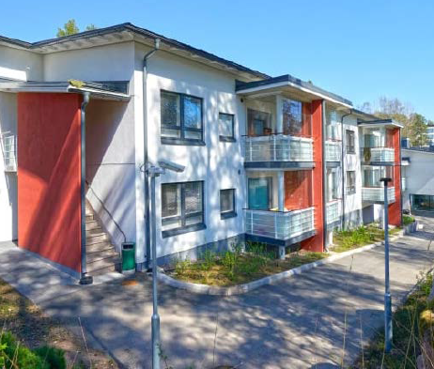

Finland’s Housing First policy
Finland’s government introduced the Housing First policy in 2007 as a new, national approach to dealing with homelessness. Today, Finland is the only European Union country where homelessness is falling.
The Housing First model follows the principle of providing each homeless person with permanent housing upfront, accompanied with health and support tailored to the individual’s needs. This is a reversal of the typical model where a person who is homeless moves from one level of social support to the next - through emergency shelters and transitional housing – with the aim of solving their problems before they access a home with long-term tenure.
All levels of government and NGOs worked together to buy existing apartments, build new apartments and convert shelters into permanent homes. Since its inception, 3,500 homes have been created, the number of long-term homeless has fallen by 35 per cent and rough sleeping has been all but eradicated in Helsinki where only one 50- bed shelter remains.
Finland has spent approximately EU250 million (AU$415 million) creating new homes and hiring support workers under the policy. At the same time, they have made cost savings of approximately EU15,000 per year (AU$25,000) for every homeless person not in supported housing through reduced costs associated with emergency healthcare, social services and the justice system.

 | 2020-22 | 2023-25 | 2026-28 | 2029+
Actions
1.1 Advocate to the Victorian Government for State-wide mandatory inclusionary zoning.
2.1 Commit a City of Melbourne owned site to deliver an affordable housing project in the next five years.
2.2 Continue to work with other local Councils to establish opportunities for affordable housing development, and consider ways to share resources to enable affordable housing projects
3.1 Develop an Affordable Housing planning policy for inclusion in the Melbourne Planning Scheme. This planning tool should clearly outline when an affordable housing contribution should be made, how the rate of affordable housing should be calculated and what should be included in an affordable housing agreement.
3.2 Establish a special purpose entity to manage affordable housing contributions, with potential to operate across local government boundaries.
3.3 Commit staff and budgetary resourcing to the ongoing delivery of affordable housing outcomes.
3.4 Develop a centralised internal process for recording and assessing affordable housing outcomes.
4.1 Advocate across all levels of government, the private sector and the broader community to improve affordable housing outcomes.
4.2 Advocate to the Victorian and Australian Governments for the increased investment and provision of social housing, with an emphasis on public housing.
4.3 Partner with the State and Federal Governments to identify surplus land for the delivery of affordable housing in the City of Melbourne. This may include land that is owned by government departments and entities such as Melbourne Water and Victrack.
4.4 Use City of Melbourne events, public forums and media platforms to promote greater awareness and understanding of affordable housing issues and alternative housing models.
Policies
I. On all future residential development on City of Melbourne owned land, we aim to deliver up to 25 per cent of residential development as affordable housing. Consideration will be given to accommodating greater than 25 per cent affordable housing in urban renewal areas.
II. Consideration will be given to delivering affordable housing on commercial developments and community facilities on City of Melbourne land.

APPENDIX I – REFERENCES

Australian Bureau of Statistics, 2006, 2011 & 2016, Census Quick Stats: Melbourne City (SA3), Commonwealth of Australia, Canberra
Australian Bureau of Statistics, 2018, Taxation Revenue Australia 2017-18, Commonwealth of Australia, Canberra
AHURI, 2019, Understanding the 30:40 indicator of housing affordability stress, Australian Housing and Urban Research Institute, September 2019 [online]. Available at https:// www.ahuri.edu.au/policy/ahuri-briefs/3040-indicator
AHURI, 2020, Glossary, Australian Housing and Urban Research Institute, September 2019 [online]. Available at https://www.ahuri.edu.au/policy/glossary
Australian Productivity Commission, 2019, Report on Government Services 2019 PART G: Housing and homelessness - State and Territory Government real expenditure on social housing, Commonwealth of Australia, Canberra
Berry, M. 2003, Why is it important to boost the supply of social housing in Australia’. Urban Policy and Research 24(1), 413-435
Community Housing Industry Association, 2018 National Plan for Affordable Housing, Community Housing Industry Association, Melbourne.
Country Fire Authority, 2020, ‘About Black Saturday’, February 2020 [online]. Available at https://www.cfa.vic. gov.au/about/black-saturday
City of Melbourne, 2014, Dwelling Stock and Diversity 2006- 2014, City of Melbourne, Melbourne
City of Melbourne, 2015, Homes for People Housing Strategy 2014 - 2018, City of Melbourne, Melbourne
City of Melbourne, 2018, Census of Land Use and Employment, City of Melbourne, Melbourne
City of Melbourne, 2020 - Estimates based on internal data analysis using housing forecasts and development data
City of Sydney, 2019, Green Square affordable housing, City of Sydney, January 2020 [online]. Available at https://www. cityofsydney.nsw.gov.au/development/planning-controls/ affordable-housing-contributions/green-square-affordable-housing
City of Vienna - Wienee Wohnen, 2018, Municipal Housing in Vienna. History, facts & figures, January 2020 [online]. Available at https://www.wienerwohnen.at/wiener-gemeindebau/municipal-housing-in-vienna.html
DELWP, 2019, Victoria in Future 2019: Population Projections 2016 to 2056, State Government of Victoria, Melbourne
DELWP, 2020, Melbourne Planning Scheme, State Government of Victoria, Melbourne
Department of Health and Human Services, 2019, Victorian Housing Register December 2019, State Government of Victoria, Melbourne
Gaetz, S. 2012, The Real Cost of Homelessness: Can we save money by doing the right thing?, Canadian Homelessness Research Network Press, Toronto.
Hanson, S., Richardson, J,. Every, D., Krackowizer, A., Tehan, B., 2016, Climate change, housing and homelessness, Red Cross Victoria, Melbourne
Housing First, 2018, Kyme Place, Port Melbourne, Housing First Ltd, November 2019 [online]. Available at https:// housingfirst.org.au/portfolio/developments/104- completed-projects/144-kyme-place
Housing First Europe Hub, 2020, Finland, Housing First Europe Hub, Finland
Ministry of Housing, Communities & Local Government, 2018, Households on Local Authority Waiting List, Greater London Authority, December 2019 [online]. Available at https://data.london.gov.uk/dataset/households-local-authority-waiting-list-borough
Planning & Environment Act, 1987, Section 3AA: Meaning of Affordable Housing, State Government of Victoria, Melbourne
Raynor, K, Palm, M, O’Neil, M and Whitzman, C. 2018. Investigating the costs and benefits of the Melbourne Apartments Project, Transforming Housing, The University of Melbourne, Melbourne.
Realestate.com.au, 2019, Suburb profile: Median units rent, REA Group Ltd, Jan 2020 [online]. Available at https:// www.realestate.com.au/neighbourhoods
SGS Economics & Planning, 2019, City of Melbourne Housing Needs Analysis, SGS Economics & Planning, Melbourne
Whitzman, C., Palm, M., Raynor, K., 2018, Project 3000: Producing social and affordable housing on government land, University of Melbourne, Melbourne

APPENDIX II - GLOSSARY OF TERMS
Affordable housing: “housing, including social housing, that is appropriate for the housing needs of very low, low, and moderate-income households” (Victorian Planning and Environment Act 1987).
Affordable rental housing: rental housing which is affordable (within 30 per cent of income) for households on a very low to moderate income. It includes public housing, community housing and may include some private rental housing, depending on the cost of said housing.
Inclusionary zoning: a planning control that requires a percentage of affordable dwellings to be provided within new development.
Housing stress: when people on moderate, low or very low incomes spend more than 30 per cent of their gross household income on rent or mortgage repayments.
Community Housing Organisations (CHOs): Not-for-profit entities which include registered housing associations and providers. CHOs manage, and may own and develop, affordable housing.
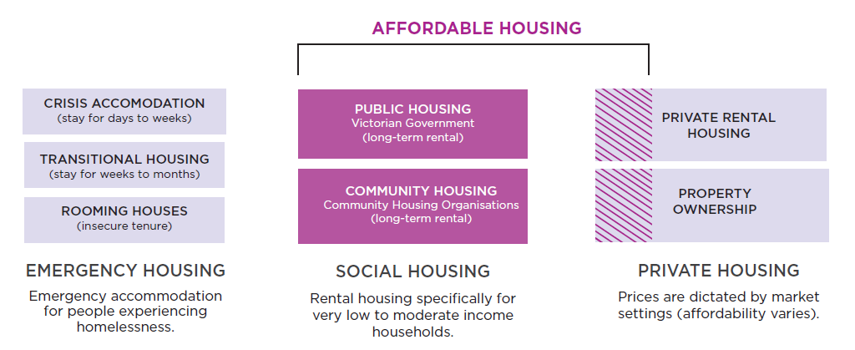

Emergency housing
Rough sleeping: people living on the streets or in parks, sleeping in their car or squatting in derelict buildings for temporary shelter.
Crisis accommodation: short term accommodation, which includes additional support for the resident. It includes women’s refuges, youth refuges and major crisis supported accommodation services. Provided by: State government and Community Housing Providers (CHPs)
Transitional housing: medium-term accommodation, which often includes support services for residents. Provided by: State government and Community Housing Providers (CHPs)
Rooming houses: buildings where one or more rooms is available for occupancy by four or more people (in return for the payment of rent). Rooming houses do not offer secure tenancy and residents can be asked to leave with only 24 hours notice. The quality of housing can vary significantly depending on the provider. Provided by: Private for-profit providers and not-for-profit Community Housing Providers (CHPs).

Social housing
Social housing: an umbrella term that includes both public housing (government owned) and community housing (housing association owned). This is typically long-term accommodation involving some degree of subsidy. It is for people on very low incomes to moderate incomes.
Public Housing: housing owned and managed by the Director of Housing. This is provided to eligible disadvantaged Victorians including those unemployed, on low incomes, with a disability, with a mental illness or at risk of homelessness. Typically households with the highest need for housing assistance are accommodated in public housing. Rents are typically less than 25 per cent of the gross income of very low to low income households. Provided by: State government
Supported housing: long-term accommodation for people with high needs for support / care (e.g. people with disability or elderly). Provided by: State government and Community Housing Organisations (CHOs)
Community Housing: housing owned or managed by community housing agencies for low income people, including those eligible for public housing. They charge up to 75 per cent of market rent for housing and prices are capped at 30 per cent of a households income. Community housing agencies are regulated by the Government. Provided by: Community Housing Organisations (CHOs)

Private market housing
Rental housing: Housing that is available for rent within the private market. It covers a range of housing types.
Property ownership: housing that is privately purchased.
Affordable home ownership: property ownership which is affordable for households on a moderate income or lower. This encompasses alternative models such as housing trusts, shared equity and cooperative housing.
Build-to-rent: housing that is purpose built, retained and managed as long-term rental stock, usually by a single owner. It is not an inherently affordable housing model, but may be designed to offer affordable rents.

How to contact us
Online:
Melbourne.vic.gov.au

In person:
Melbourne Town Hall – Administration Building
120 Swanston Street, Melbourne
Business hours, Monday to Friday
(Public holidays excluded)

Telephone:
03 9658 9658
Business hours, Monday to Friday
(Public holidays excluded)

Fax:
03 9654 4854

In writing:
City of Melbourne
GPO Box 1603
Melbourne VIC 3001
Australia

