

Proposed Amendment of Road Management Plan 2021

Version 6

[Insert date of adoption]

Document Reference DM#18147898 V2

Guideline Governance

Responsible Service / Department:
Adoption authorised: | Council
Date of adoption: | <<date>>
Date of effective from: | <<date>>
Enterprise Content Manager Ref:
Document Set ID:
Endorsed CEO or ELT member or department manager to make and approve
document editorial amendments:
Annual desktop review  date: | <<date>>
Review date: | <<date>>
Completion date: | <<date>>
Version number:
Stakeholder review and engagement:
Relevant Legislation:
Associated Strategic Direction #: | Council Plan and Transport Strategy
Associated instruments:
Supersedes:

Review history 2013 to 2025

Name | Content Manager File Reference | Date | Description of Edits
Version 3 | N/A | July 2015
Version 4 | DM#1106799v1 | July 2017
Version 5 | DM#14920397v2 | September 2021

Contents
Guideline Governance 2
Review history 2013 to 2025 2
Contents 3
Definitions 5
Introduction 7
1.1 What is the purpose of this Plan 7
1.2 Legislation guiding this Plan 7
1.3 What is covered in this Plan? 7
1.4 Updating the Plan 8
1.5 Exceptional Circumstances 8
1.5.1 Suspension of the Plan 8
1.5.2 Reinstatement of the Plan 8
1.5.3 Communication and documentation around Plan suspension 9
1.5.4 Inspections and repairs during suspension of Plan 9
1.6 Responsibility for the Plan 9
Rights and Responsibilities 9
2.1 Public Roads 9
2.2 Key stakeholders 10
2.3 Coordinating & Responsible Road Authority 10
2.4 General Functions of a Road Authority 10
2.5 Rights of the Road User 10
2.6 Obligations of Road Users 10
2.6.1 General Usage 10
2.6.2 Incident Claims 11
2.6.3 Permits for work within a road reserve 11
2.6.4 Obligation of others 12
Road Management Systems 14
3.1 Background and Process 14
3.2 Asset Hierarchies – Municipal Road Network 15
3.3 Our Road Network 15
3.4 Maintenance Management System 15
3.4.1 Maintenance Management 15
3.4.2 Asset Management Plans 16
3.4.3 Maintenance Surveys and inspections 16
3.4.4 Maintenance responsiveness and performance targets 17
3.5 Asset Levels of Service 18
Register of Public Roads 18
4.1 Maintenance Demarcation (Boundary) Agreements 18
4.2 Roads not listed on the Register 19
Technical References 19
City of Melbourne Documents 19
Attachment 1: Inspection Requirements 20
Attachment 2: Inspection Frequencies 21
Attachment 3: Defect Intervention Levels and Repair Timeframes 22
Roads 22
Footpaths, Bike Paths & Shared Zones 23
Decking 23
Tree Plot Pavements 24
Traffic Control Devices 24
Bluestone and Precast Concrete Kerb and Channel 24
Bridges and Culverts 24

Definitions

Arterial Road | Refers to freeways, highways and declared main roads, which are managed by the Victorian Government, through Head of Transport for Victoria (as the co-ordinating road authority).
Co-ordinating road authority | The organisation which has the responsibility to co-ordinate works. Generally, if the road is a freeway or arterial road, this will be Head of Transport for Victoria. Generally, if the road is a municipal road, this will be Council.
Council | Refers to the City of Melbourne
Demarcation agreement | A formal agreement between Council and another organisation that defines areas of responsibility.
Motor vehicle | Refers to a vehicle that is propelled by an in-built motor and is intended to be used on a roadway. This does not include a motorised wheelchair or mobility scooter which is incapable of travelling at a speed greater than 10 km/h and is solely used for the conveyance of an injured or disabled person.
Municipal road(s) | Road for which the municipal council is the co-ordinating road authority. The Road Management Act 2004 imposes specific duties on the municipal council with respect to the inspection, repair and maintenance of these roads and associated road-related infrastructure.
Non-road infrastructure | Refers to infrastructure in, on, under or over a road, which is not road infrastructure. This includes (but is not limited to) such items as gas pipes, water and sewerage pipes, cables, electricity poles and cables, tram wires, rail infrastructure, bus shelters, public telephones, mailboxes, roadside furniture and fences erected by utilities, or providers of public transport.
Other roads | Include roads in state forests and reserves, and roads on private property. Municipal councils are not responsible for the inspection, repair or maintenance of these roads.
Pathway | Refers to a footpath, bicycle path, shared path or other area that is constructed or developed by Council for members of the public (not motor vehicles) to use.  Pathways may be further categorised as:  - Footpaths – pathways designated solely for use by foot traffic (and limited mobility devices such as wheelchair users)  - Bicycle pathways – pathways designated solely for use by cyclists, scooters and the like but excluding foot traffic, and  - Shared pathways – pathways designated for use by riders of bicycles, the riders of electric scooters and pedestrians.
Public Road | As defined by the Road Management Act 2004 and includes a freeway, an arterial road, a municipal road declared under section 14(1) of the Act and a road in respect of which Council has made a decision that it is reasonably required for general public use and is included on the Register of Public Roads.
Plan | Refers to this Road Management Plan.
Road | Has the same meaning as in the Road Management Act 2004, being inclusive of any public highway, any ancillary area and any land declared to be a road under section 11 of that Act or forming part of a public highway or ancillary area.
Road infrastructure | Refers to infrastructure which forms part of a roadway, pathway or shoulder, which includes structures and materials.
Road-related infrastructure | Refers to infrastructure installed or constructed by the relevant road authority to either facilitate the operation or use of the roadway or pathway, or support or protect the roadway or pathway.
Road Reserve | Refers to the area of land that is within the boundaries of a road.
Roadside | Refers to any land that is within the boundaries of the road (other than shoulders) which is not a roadway or pathway. This includes land on which any vehicle crossing or pathway, which connects from a roadway or pathway on a road to other land, has been constructed.  Example: any nature strip, forest, bushland, grassland or landscaped area within the road reserve would be considered roadside.
Roadway | Refers to the area of a public road that is open to, or used by, the public, and has been developed by a road authority for the driving or riding of motor vehicles. This does not include a driveway providing access to a public road, or other road, from adjoining land.
Shoulder | Refers to the cleared area, whether constructed or not, that adjoins a roadway to provide clearance between the roadway and roadside. This does not refer to any area that is not in the road reserve.

Introduction

1.1 What is the purpose of this Plan
Section 50 of the Road Management Act 2004 sets the following objectives for a municipal road management plan:

- To establish a system for our road management functions, which is based on policy, operational objectives and available resources.
- To set a performance standard for our road management functions.

Although it is termed a ‘plan’ in the legislation, it is functionally an operational protocol document – describing the systems and rules we use to make decisions and meet obligations within our available resources. The plan forms part of a larger Asset Management Framework related to maintenance and operations.

For the avoidance of doubt, this Plan is a road management plan for the purposes of s.39 of the Road Management Act 2004.

1.2 Legislation guiding this Plan
In addition to the Road Management Act 2004, the plan also considers the following Acts, regulations and codes of practice:

- Local Government Act 2020
- Ministerial Codes of Practice
- Road Management (General) Regulations 2016
- Road Management (Works and Infrastructure) Regulations 2015
- Road Safety Act 1986
- Wrongs Act 1958.

1.3 What is covered in this Plan?
The Plan is divided into six sections:

- Introduction.
- Rights and Responsibilities – covers legislation and local laws relevant to road management.
- Road Management Systems - how we classify roads, streets and footpaths – known as our asset hierarchy – and the plans and processes we use to maintain roads and road-related infrastructure.
- Register of Public Roads – what’s in it, how to access it and the process for making changes.
- Technical References.
- Attachments:
  - Attachment 1, Inspection Requirements
  - Attachment 2, Inspection Frequencies
  - Attachment 3, Defect Intervention Levels and Repair Timeframes

1.4 Updating the Plan
This Plan must be updated within a set period following a Council election. Outside of this cycle, changes may be required from time to time.

The following process will be used to manage these changes:

- If material changes are made to standards and specifications, a report will be presented to Council, along with a brief explanation as to why such changes are necessary. The review process must follow the steps as set out in the Road Management (General) Regulations 2016 Part 3 – Road Management Plans.
- When changes do not alter these technical aspects of road management, changes will be approved by the Director City Infrastructure.

These changes will be made in accordance with the processes prescribed by the Road Management Act 2004. To assist with version control, these changes will be numbered as follows:

- Versions presented to Council will be renumbered by whole numbers – for example, from Version 1.00 to 2.00.
- Those approved by the Director will be renumbered by decimals – for example, from Version 1.00 to 1.01.

1.5 Exceptional Circumstances
Council will make every effort to meet its commitments under this Plan.
However, there may be situations or circumstances that affect Council's business activities to the extent that it cannot deliver on the service levels of the RMP. These include but are not limited to: natural disasters, such as fires, floods, or storms, or a prolonged labour or resource shortage, due to a need to commit or redeploy Council staff and/or equipment elsewhere or due to the effects of pandemic and or government intervention.

1.5.1 Suspension of the Plan

In the event that the Chief Executive Officer (CEO) of Council has considered the impact of such an event on the limited financial resources of Council and its other conflicting priorities, and determined that the Plan cannot be met, then pursuant to Section 83 of the Wrongs Act 1958, the CEO will write to Council’s Officer in charge of the Plan and inform them that some, or all, of the timeframes and responses in Council’s Plan are to be suspended.

1.5.2 Reinstatement of the Plan

Once the scope of the event/s have been determined, and the resources committed to the event response have been identified, then there will be an ongoing consultation between Council’s CEO and Council’s Officer responsible for the Plan, to determine which parts of Council’s Plan are to be reactivated and when.

1.5.3 Communication and documentation around Plan suspension

Council will provide information/statements to residents about the suspension or reduction of the services under its Plan, including:

- How the work that will be done has been prioritised; and
- The period for which it is likely to be affected.

This information will be provided by the Council on its website where its Plan is located and other channels as appropriate such as press releases or social media.
Where Council has suspended, in part or whole, it’s Plan, associated documents (e.g. communications, meeting minutes, schedules, etc.) will be recorded and stored.

1.5.4 Inspections and repairs during suspension of Plan

The suspension of the Plan will not necessarily mean that all inspections and repairs halt. However, it may mean that only certain categories of inspections and repairs are undertaken. These will be based on a risk assessment and resources available to the Council, taking into account the resources needed to address the impact of the trigger event. For example, some reactive inspections may take place and repair (temporary or permanent) of roads/footpaths which pose a high risk may be undertaken, depending on the resources available to the council and the accessibility of each asset.

1.6 Responsibility for the Plan

Overall responsibility for administering and implementing the Plan rests with the City of Melbourne’s Manager Infrastructure.

Rights and Responsibilities

2.1 Public Roads

Public roads are defined in the Road Management Act 2004 as including:

- a freeway
- an arterial road
- a road declared under section 204(1) of the Local Government Act 1989
- a municipal road declared under section 14(1) of the Road Management Act 2004
- a road in respect of which Council has made a decision that it is reasonably required for general public use and is included on the Register of Public Roads.

2.2 Key stakeholders
The key stakeholders impacted by this Plan include:

- the general community (for recreation, sport, leisure and business)
- residents and businesses adjoining the road network
- pedestrians
- vehicle users with motorised vehicles, such as trucks, buses, commercial vehicles, cars and motorcycles
- users of smaller, lightweight vehicles, such as pedal-powered bicycles, motorised buggies, wheelchairs, prams and so on
- tourists and visitors to the area
- emergency agencies (Victoria Police, Country Fire Authority, Ambulance Victoria, State Emergency Services)
- the military (in times of conflict and emergency)
- traffic and transportation managers
- managers of the road network asset
- construction and maintenance personnel, who build and maintain asset components
- utility agencies using the road reserve for infrastructure (water, sewerage, gas, electricity, telecommunications)
- state and federal governments, who periodically provide funding for roads.

Coordinating & Responsible Road Authority
Section 35 of the Road Management Act 2004 provides that a road authority has power to do all things necessary or convenient to be done for or in connection with the performance of its functions under the Act.

Section 36 of the Road Management Act 2004 outlines which road authority is the coordinating road authority. According to subsection (c), the coordinating road authority:

If the road is a municipal road, the municipal council of the municipal district in which the road or part of the road is situated.

However, there are instances where several authorities are responsible for components of the road within the road reserve. Section 37 of the Road Management Act 2004 identifies who is the responsible road authority in particular circumstances.

2.4 General Functions of a Road Authority
The general functions of a road authority are described within Section 34 of the Road Management Act 2004.

2.5 Rights of the Road User
The rights of public road users, which are legally enforceable, are set out in Sections 8 to 10 of the Road Management Act 2004.

2.6 Obligations of Road Users

2.6.1 General Usage

The common law requires that a road user must take reasonable care for their own safety (see Ghantous v Hawkesbury City Council)

The Road Safety Act 1986 sets out obligations on road users, including section 17A which requires that a person who drives a motor vehicle on, or uses, a highway must drive in a safe manner have regard for all relevant factors, including without limiting their generality, the following:

- physical characteristics of the road
- prevailing weather conditions
- level of visibility
- the condition of any vehicle the person is driving or riding on the highway
- prevailing traffic conditions
- the relevant road laws and advisory signs
- the physical and mental condition of the driver or road user.

Section 17A of the Road Safety Act 1986 also requires that a road user must take reasonable care:

- to avoid any conduct that may endanger the safety or welfare of other road users
- to avoid any conduct that may damage road infrastructure and non-road infrastructure on the road reserve
- to avoid conduct that may harm the environment of the road reserve

2.6.2 Incident Claims

If a person proposes to make a claim in relation to a public road or infrastructure for which Council is the responsible road authority, that person should contact Council and Council will initiate respective investigation and insurance reporting processes.
In accordance with Section 110 of the Road Management Act 2004, Council is not legally liable for property damages where the value of the damage is equal to or less than the threshold amount.
In cases where the claim relates to assets Council does not own or is not responsible for on the road reserve, the person who proposes to make a claim must refer the claim to the other authority or person responsible for those assets.

2.6.3 Permits for work within a road reserve

In cases where an individual or organisation proposes to carry out works within the road reserve that may impede public access, or interfere with road infrastructure, they must apply for a ‘works within road reserve’ permit. There are some exemptions, as noted in the Road Management (Works and Infrastructure) Regulations 2015.
Local laws also require property owners to apply for a vehicle crossing permit if they plan to build a driveway.
In both cases, a fee applies to cover the costs of the administration and inspection of the work.

2.6.4 Obligation of others

There are several assets within the road reserve that Council does not have an obligation to inspect and/or maintain. These include:
- Non-road infrastructure – This includes (but is not limited to) such items as gas pipes, water and sewerage pipes, cables, electricity poles and cables, tram wires, rail infrastructure, bus shelters, public telephones, mail boxes, roadside furniture and fences erected by utilities, or providers of public transport.
- Vehicle driveways – the vehicle crossing (including Cross-over), located between the carriageway and the property boundary, must be maintained by the adjoining property owner. However, Council is responsible for the portion of the driveway where the constructed pathway is reasonably required by the public in accordance with the following diagrams:
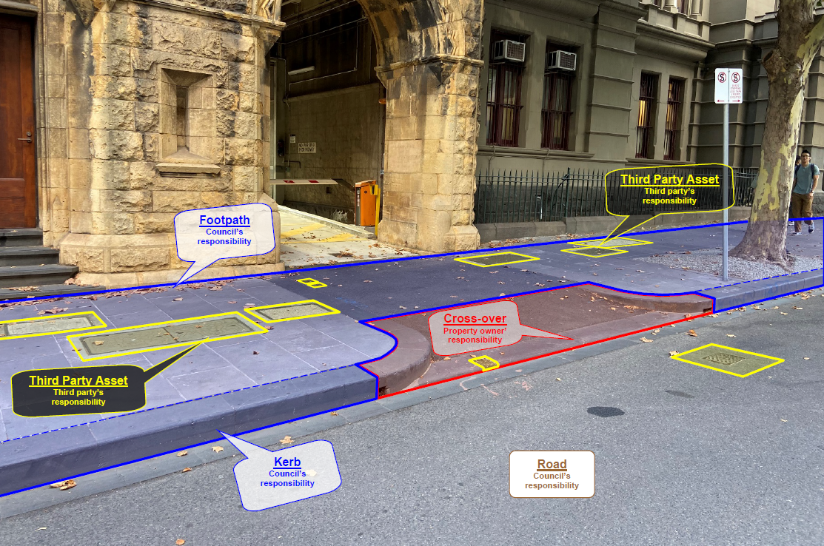
Example of a Central Business District Street within the City of Melbourne

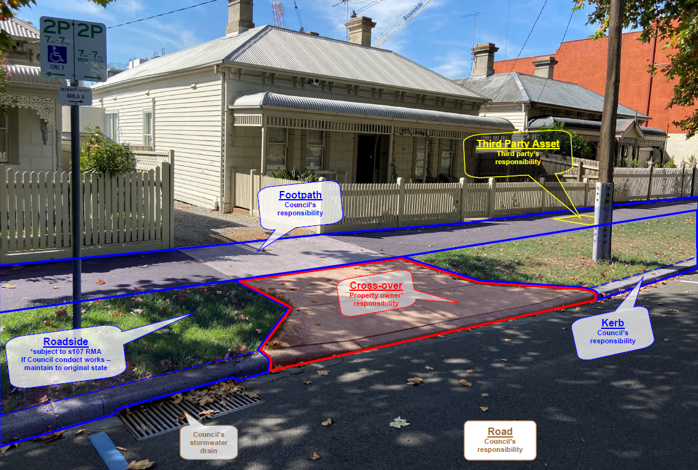
Example of a residential street within the City of Melbourne

- Single property stormwater drains – for drains constructed within the reserve that carry water from a single property to an outlet in the kerb, or other drain.
- Basement Lights – Basement lights wells are common throughout the City of Melbourne. The majority of these basement lights are found within the footpath. They are private assets owned and maintained by the respective property owner. 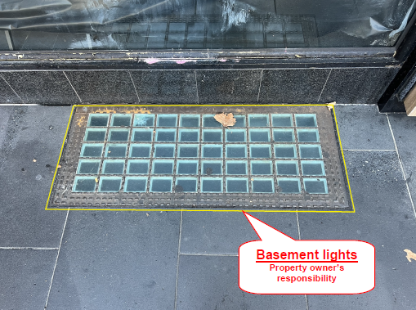
- Utilities – including, but not limited to; telecommunication, power, water, gas and rail authority assets.
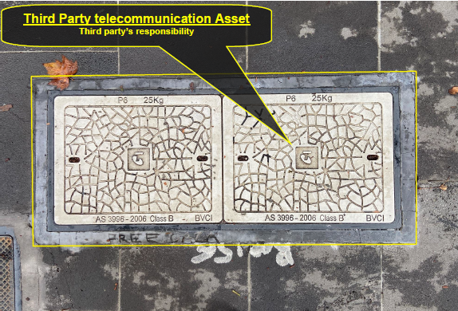
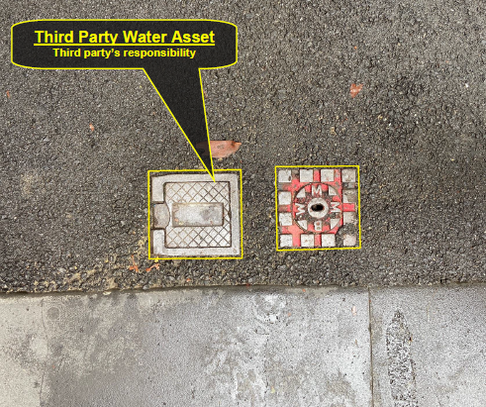
Examples of typical utility assets found within City of Melbourne Road Reserves

- Roadside – as per Section 107 of the Road Management Act, Council has no “statutory duty or a common law duty to perform road management functions in respect of a public highway which is not a public road or to maintain, inspect or repair the roadside”, described as “any land that is within the boundaries of the road (other than shoulders) which is not a roadway or pathway”. This includes landscaped tree plots within the footpath/pathway where the surface of the tree plot is not constructed with the intention of providing a trafficable pedestrian surface.

Where Council becomes aware of a hazard created by the defective condition of assets / infrastructure owned by another party, Council may at its absolute discretion:
- If located within assets / infrastructure for which Council is responsible (e.g. footpaths, road surfaces, etc.), or otherwise presents an immediate and significant risk to members of the public, undertake temporary measures to reduce the risk to members of the public until such time as the respective owner can implement permanent repairs (subject to Council’s available resources).
- Report in writing (e.g. email or letter) the presence of the hazard to the responsible party and request that repairs be implemented within a reasonable timeframe.
- Where repairs are not completed by the responsible party within the respective timeframe, Council may complete necessary repairs and invoice the responsible party for the costs.

However, where another party has a duty in relation to the asset / infrastructure, and Council has a discretionary power to take remedial action in relation to that matter, only that other party with the duty is liable in a subsequent proceeding, in accordance with s.104 of the Road Management Act 2004.

Road Management Systems

3.1 Background and Process

Road asset management involves managing both physical assets, and uses and operation that have the potential to impact their condition. It applies to all road assets, including:

- the road – pavement and surface, as well as footpaths, kerb and channel
- structures – bridges, culverts and traffic management devices
- road infrastructure – traffic signals and on-road electrical assets.

The aim of our road management system is to deliver a safe and efficient road network and meet community needs to the best of our ability, within available resources.

To create a road asset management system that would best meet our needs when inspecting, maintaining and repairing public roads, we used the following nationally-recognised asset management frameworks:

- International Infrastructure Management Manual (IIMM) 2015, IPWEA
- IPWEA National Asset Management Systems (NAMS+)
- Other references, as listed in Technical References.

The system is designed to set the direction for our asset management activities. It is also linked to the annual business planning cycle.

3.2 Asset Hierarchies – Municipal Road Network

All roads and footpaths within the municipal road network are classified according to a hierarchy that takes into account how they are used, who uses them and how often.
The hierarchy classification is used to determine the levels of service required, prioritise works programs and determine defect intervention responses.
The hierarchy is shown in the table below.

Road Category | Road Hierarchy Description | Minimum Inspection Frequency
A | Premium Roads and Public Realm Areas | 2 Monthly
B | Arterials & Major Local | 4 Monthly
C | Minor Local (CBD) | 6 Monthly
D | Laneways, Right of Way and Residential | 12 Monthly

Our Road Network

In order to facilitate the provision of its services to the community, the Council manages an extensive range of community assets. One of the most significant groups of these assets, with regard to the difficulty and expense of managing, are road assets. The Council is responsible for approximately 250 kilometres of local roads, along with associated footpath, kerb & channel and drainage.

3.4 Maintenance Management System

3.4.1 Maintenance Management

Council has responsibilities to all road users and the community to maintain public roads to a reasonably safe and suitable standard, within our available funds and resources. By developing long-term maintenance programs for our assets, we are better able to plan how we do this.

The following maintenance requirements shape our annual program and budget:

Routine maintenance standards
Standards vary across the network depending on the asset type and relevant risk factors, such as traffic volumes and composition, operating speeds, the susceptibility of assets to deterioration and the cost effectiveness of repairs. Competing priorities for funding are also relevant.

Defect intervention levels have been established using the VicRoads Standard Specification Section 750 and adapting it to local conditions.

The standards will be reviewed periodically to make sure they are adequate (see section 1.4).

Repair and maintenance works
Works must be completed within a specified time, depending on the severity and location of the defect. Response times are determined using local knowledge and experience and past performance as a guide.

Response times are monitored and will be periodically reviewed (see section 1.4).

Temporary mitigation measures
These are temporary works designed to reduce the risk of an incident, until such time as repair or maintenance works can be completed.

Response times and safety measures – for example warning signs, flashing lights, and safety barriers – are determined by reference to the risk to safety, road type and traffic volume.

Emergency works
Works that result from emergency incidents and must be undertaken immediately, for the safety of road users and the public.

Emergency works might include traffic incident management, responses to fires, floods, storms and spillages, and any assistance required under the Victorian State Emergency Response Plan and Municipal Emergency Management Plan.

3.4.2 Asset Management Plans

Our asset management plans guide the development of long-term asset renewal programs, helping us to plan and finance asset renewal and replacement.

3.4.3 Maintenance Surveys and inspections

A four-tier regime is used to inspect our road network assets. It covers safety issues, incidents, defects and condition inspections.

- Reactive inspections (Request for Service or RFS)
These inspections are conducted in response to requests from the community. The inspection is carried out by a Council and/or Contractor employee and assessed according to the Hazard intervention levels, contained within Attachment 3.

- Proactive Inspections
Regular timetabled inspections that are scheduled depending on traffic flow, the types of defects likely to impact the asset and the perceived risks of these defects.

- Condition Inspections
These inspections identify structural integrity issues which, if untreated, are likely to adversely affect the network overall. These issues may impact short-term serviceability, as well as the ability of the asset to perform for the duration of its intended life span.

These inspections are carried out in accordance with the Council’s asset management plans. They are undertaken by the City Infrastructure branch on a four yearly schedule.

3.4.4 Maintenance responsiveness and performance targets

The following information is recorded when we receive a Request for Service (RFS) from the community:

- Date the request was received
- Details of the request, including the location and nature of the reported hazard/defect (including any specific measurements if provided), name of the person making the request, copies of any photographs provided, etc.
- The personnel / department to which the request has been assigned for action
- Date by which the request must be actioned (based on the target response times specified in Attachment 3)
- Date when the request was actioned and/or completed (this typically involves someone carrying out an RFS inspection, as described in section 3.4.3, followed by any necessary repair works conducted).

By recording this information, we can monitor compliance against target response times – that is, the time it takes from receiving a request to carrying out an inspection and ultimately completing necessary works.

Customer requests will be reviewed and assessed in accordance with timeframes specified in Attachment 3. Following are some possible outcomes from a reactive inspection:

- If a defect identified exceeds a Description / Intervention level specified in Attachment 3, a work order would be created with a date for completion of works in line with respective specified repair timeframes.
- If repairs are significant – for example, rehabilitation works are required – temporary mitigation measures may be undertaken to reduce the risk posed by the hazard/defect until the proper works can be undertaken (and subject to available resources).
- If the defect is assessed as below the Description / Intervention Level specified in Attachment 3, it would be noted (including why), but no remedial action will be conducted.

In all cases, the action taken would be noted against the original request.

Target response times and intervention times are based on ‘normal’ conditions. The same level of service would not apply in cases where the Plan has been suspended, under Section 1.5.

3.5 Asset Levels of Service

Five elements are taken into account when determining appropriate levels of service for the road network. These are:

- Community expectations;
- Technical standards;
- Organisational capacity;
- Performance measures and targets;
- Safety of road and footpath users.

Register of Public Roads

Council maintains a register of public roads – called the Register of Public Roads – with the details of all public roads and ancillary areas for which we are responsible.

The Register of Public Roads is available on Council’s website.

4.1 Maintenance Demarcation (Boundary) Agreements

Where there are boundary agreements between us and other road authorities or private organisations, the schedule of roads affected, and agreements are listed in the Municipal Road Register.

Presently, the Council has no agreements with neighbouring councils.

The Codes of Practice mentioned in Section 1.2 clarify demarcations of responsibility between councils and relevant state government departments and between councils and utilities. Due to the unique nature of a capital city municipality in the state, the Council has in place an arrangement pursuant to Section 15 of the Act with the relevant state government departments that specifies the Council responsibility for median strips, traffic islands, road trees, irrigation systems, etc. in arterial road reserves. This agreement must be reviewed by the parties every two years and can be terminated by either party with six months prior written notice to the other party. In addition, the relevant state government department has accepted responsibility for management and maintenance of all traffic signals and associated line-marking at all signalised installations in the municipality on both arterial and municipal roads, and also for maintenance of fairway line-marking and separators on arterial and local roads.

4.2 Roads not listed on the Register

The following roads are not listed on our Register of Public Roads:

- Roads which are the full responsibility of the state government, or a private enterprise;
- Unused roads for which we have not accepted responsibility;
- Roads drawn out on a plan of subdivision, until such time that we accept responsibility for these roads;
- Roads which we have not determined are reasonably required for general public use.

Technical References

- AS ISO 31000:2018 – Risk Management – Guidelines
- Integrated Asset Management Guidelines for Road Networks (AP-R202) 2002, Austroads Inc.
- International Infrastructure Management Manual (IIMM) 2015, IPWEA
- VicRoads Risk Management Guidelines
- VicRoads Standard Specification Section 750 – Routine Maintenance

City of Melbourne Documents

- Relevant Council Plan.
- Current Transport Strategy.
- Current Civil Infrastructure Services (CIS) Contract.
- Risk Register.
- Section 15 Arrangement with VicRoads.

Attachment 1: Inspection Requirements

Inspection Type | Purpose | Inspection and Reporting Requirements
Reactive – Request for Service (RFS) | RTS reviews and Reactive inspections are designed to confirm the nature of defects/hazards reported by members of the public or Council employees and identify any that exceed the intervention levels specified in Attachment 3. | Performed by a Council representative with knowledge of Description / Intervention Levels (Attachment 3) and road maintenance techniques who may then call in a higher level of expertise if necessary.  All information provided as part of a RFS is reviewed via a desktop analysis within 2 business days. Council’s representative may determine to undertake a reactive inspection if further information regarding the defect. Council’s system is required to document information relevant to the RFS including time first reported, time inspected and by whom, subsequent action and time defect rectification works were completed.
Proactive Inspection | Inspection undertaken in accordance with a formal programmed inspection schedule to determine if the road asset complies with the levels of service as specified.  A record of each asset is to be completed detailing the name of the inspector, the inspection date, and a description of any defects found that exceed the intervention levels specified in Attachment 3.  In addition, details of the inspection will be electronically recorded against the particular asset inspected. | Performed by a dedicated Surveillance Officer. Proactive Inspections of all asset types are conducted on foot, with defects measured and photographed. Council will maintain processes and procedures relating to Surveillance Officer operations.  Performed by a dedicated Plan inspector.

Attachment 2: Inspection Frequencies

Road Category | Road Hierarchy Description | Reactive Inspection Timeframe  W = Weeks  H = Hours | Proactive Inspection Frequency  M = Months
A | Premium Roads and Public Realm Areas | 4 W | 2 M
B | Arterials & Major Local | 4 W | 4 M
C | Minor Local (CBD) | 4 W | 6 M
D | Laneways, Right of Way and Residential | 4 W | 12 M
Emergency Response – All Asset / Categories  * Reported Incidents / Hazards that present an immediate and significant risk to members of the public.  Temporary measures (e.g. installing barriers, signage, closing the road/footpath, etc.) will be implemented to reduce the risk to users of the road network until such time as appropriate repairs can be completed. |  | 12 H | N/A

* If a Proactive Inspection Frequency elapses on a Weekend or Public Holiday, the actual due date will be the next Working Day.

Attachment 3: Defect Intervention Levels and Repair Timeframes

NOTES:
* If a Repair Timeframe elapses on a Weekend or Public Holiday, the actual due date will be the next Working Day.
** In cases where a defect is not due to be repaired in less than 4 weeks, temporary measures, such as installing warning signage, erecting barriers, or painting the defect with a bright contrasting colour, may be implemented at the time of identification to reduce the risk as much as is reasonably practicable until permanent repairs can be completed in line with the specified Repair Timeframes.

Roads
Defect type | Description / Intervention Level for Asphalt Road Pavements | Description / Intervention Level for Bluestone, Concrete and other Segmental Pavement | Repair timeframes W=Week  WD= Working Day
Pothole | Potholes in sealed pavement >50 mm in depth and >200 mm in diameter |  | 4 W
Edge break | Edge breaks >50 mm laterally over a 5m or greater length from the nominal seal line |  | 4 W
Mounding or Heaving | Mounding or Heaving >100mm in height over a 1.2m straight edge |  | 4 W
Depressions / deformations | Depression / deformations in the traffic lane of a sealed pavement >50 mm in depth under a 3m long straight edge |  | 4 W
Cracking | Cracking in road >30 mm wide |  | 4 W
Vertical Displacement | Intervention not applicable | Vertical Displacement >20 mm in height | 4 W
Loose pavers | Intervention not applicable | Loose and unstable segmented pavers (i.e. bluestone, bricks, etc.) that move underfoot | 4 W
Dislodged / Missing pavers | Intervention not applicable | Dislodged or missing segmental pavers | 4 W
Missing pit lids | Missing Council pit lids |  | 1 WD
Damaged pit lids | Damaged Council pit lids (such that they are potentially structurally unsound). |  | 4 W
Roadside Vegetation – Overhead clearance | Vegetation intruding into the road envelope <4.5m over the trafficable portion of the road |  | 4 W
Roadside Vegetation – Obstructing sightlines | Vegetation that is obstructing sightlines to intersections or regulatory, warning and hazard signs |  | 4 W

Footpaths, Bike Paths & Shared Zones
Excluding Decking and Tree Plot Pavements
Defect type | Description / Intervention Level | Repair timeframes W=Week  WD= Working Day
Mounding or Heaving | Mounding or Heaving >100mm in height over a 1.2m straight edge | 4 W
Depressions / deformations | Depression / deformations >50mm under a 1.2m straight edge | 4 W
Vertical Displacement | Vertical Displacement >20 mm in height | 4 W
Loose segmented pavers | Loose and unstable segmented pavers (i.e. bluestone, bricks, etc.) that move underfoot | 4 W
Cracking | Cracking in footpath >30 mm wide | 4 W
Dislodged / Missing | Dislodged or missing segmental pavers | 4 W
Missing pit lids | Missing Council pit lids | 1 WD
Damaged pit lids | Damaged Council pit lids (such that they are potentially structurally unsound). | 4 W
Roadside Vegetation – encroaching footpath | Vegetation that is overgrown and encroaching a footpath by more than 250mm | 4 W
Roadside Vegetation – encroaching shared path | Vegetation that is overgrown and encroaching a bike path or shared path by more than 500mm | 4 W
* Pram crossings / ramps providing transition between road and footpath levels are treated as part of the footpath for the purposes of the application of description / intervention levels

Decking
Defect type | Description / Intervention Level | Repair timeframes W=Week
Vertical Displacement | Vertical Displacement >30 mm in height | 4 W
Protrusion of fixing screws | Vertical Displacement >20 mm in height | 4W
Loose decking boards | Loose and unstable decking boards that move underfoot | 4 W
Gaps between decking boards | Gaps between decking boards larger than 40mm | 4 W
Missing decking boards | Missing decking boards | 4 W

Tree Plot Pavements
Defect type | Description / Intervention Level | Repair timeframes W=Week
Vertical Displacement | Vertical Displacement >40 mm in height | 4 W
Cracking | Cracking >45 mm wide | 4 W
Mounding or Heaving | Mounding or Heaving >150mm in height over a 1.2m straight edge | 4 W
Depressions / deformations | Depression / deformations >75mm under a 1.2m straight edge | 4 W

Traffic Control Devices
Defect type | Description / Intervention Level | Repair timeframes W=Week
Missing / Damaged Signage | Regulatory, warning & hazard signs - missing, illegible or damaged making them substantially ineffective | 4 W
Damaged Signage | All council owned signs – damaged making them potentially hazardous | 4 W
Missing / Damaged Guard Rail or fencing | Guard rail/fence damaged or missing making them substantially ineffective | 4 W
Missing / Damaged Pavement Markings | Pavement markings which are missing or faded making them substantially ineffective | 4 W

Bluestone and Precast Concrete Kerb and Channel
Defect type | Description / Intervention Level | Repair timeframes W=Week
Vertical Displacement | Vertical displacement – uplift section >50 mm | 4 W
Horizontal Displacement | Horizontal displacement section >50 mm | 4 W
Dislodged / Missing | Dislodged or missing segments of kerb | 4 W

Bridges and Culverts
Defect type | Description / Intervention Level | Repair timeframes  H= Hours
Bridge and Culvert defects | Visible damage likely to pose an immediate and significant risk to members of the public | 12 H

