Notication of works

Franklin Street and Queen Street - Upcoming Works
(WKO101121288 & DM#17597182)
Citywide, on behalf of City of Melbourne, are about to commence construction in your area.The works to remove the roundabout and realign the Franklin Street roadway is Stage 1 of the Transforming Franklin Street project and will also establish the boundary of the new Gurrowa Place development.
Where: Franklin Street between Queen Street and William Street.
When: Starting in the week commencing Monday 6th May 2024. Workhours: 7:00am to 5:00pm. Traffic and parking changes will be implemented up to 24 hours prior to the commencement of the works.
Why: To remove part of the existing roundabout in order to add a northbound lane on Queen Street and construct a new footpath running north-south across the roundabout.
What we are doing: Installing new kerb, footpath, pedestrian crossings and road pavement.

How could this impact you?
While we continue to make every effort to minimise disruption and inconvenience to nearby properties, the following can be expected.
- On-street car parking spaces within the area of works will be reserved for contractor vehicles during the period of works.
- There will be construction noise and dust from machinery and construction vehicles for certain periods during working hours.
- Traffic controllers will be on site to ensure that only local traffic can enter while works are underway.
- Residential vehicle access may need to be coordinated at times. Traffic controllers will assist.
- Parking signs will be changed within 24 hours prior to construction work starting to ensure the area is clear for the necessary works to be undertaken.
- The temporary parking signs will state ‘authorised council contractors excepted’ and the signs will look like this:

- A reserved parking permit is a special permit issued during construction for construction vehicles only. Please note that standard resident or other parking permits cannot be used during the construction period. Any vehicles parked in the area that do not have a reserved parking permit displayed after the parking signs have been changed may be issued an infringement notice.

Site Map: A site map can be found at the back of this letter.
Contact us: For further information regarding these works, please contact:
Pradeep Parvatham - Citywide Works Officer
9267 5119
pradeep.parvatham@citywide.com.au
or
Jonathan Petridis - Citywide Project Engineer
9257 5090
Jonathan.Petridis@citywide.com.au
For afterhours enquiries regarding works, please contact Citywide support on 1300 136 234

Site map
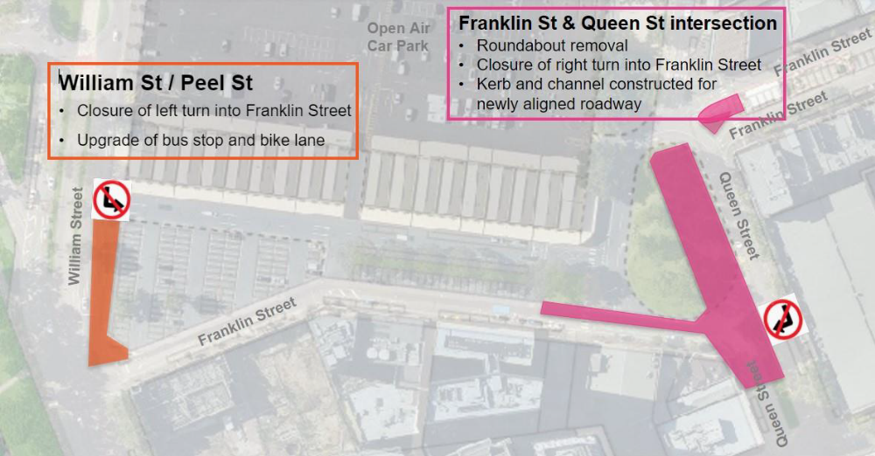

Traffic conditions
- To safely undertake the works, lane closures will be required.
- Road closures will be avoided where possible, however are expected for line marking and kerb works. Any detours will be communicated.
- Increased traffic management around the site may lead to some delays.
- Vehicles will be unable to turn right into Franklin Street from Queen Street.
- The left turn into Franklin Street from William Street will be permanently closed to vehicles in coming weeks.
We apologise for any inconvenience caused and appreciate your cooperation while we carry out these important works.

