Transforming Franklin Street 
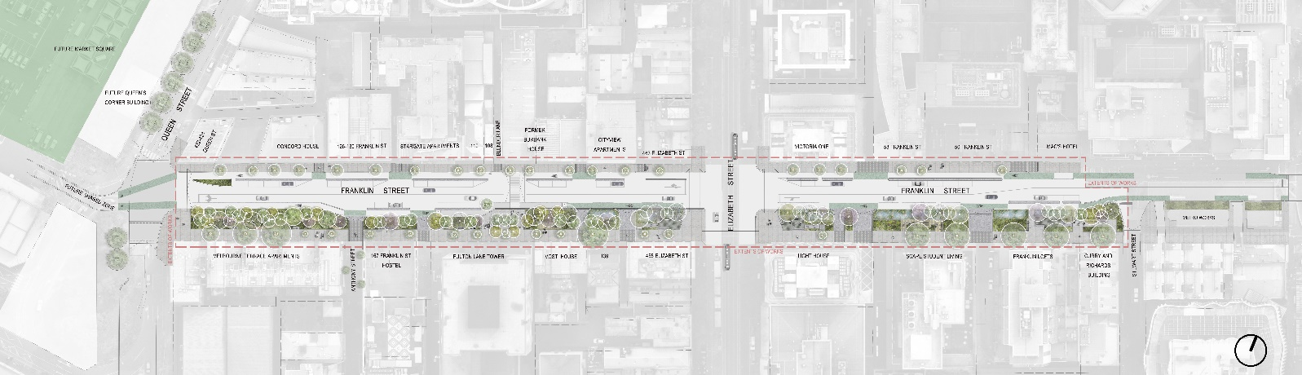

Along with a new Market Square and Queens Corner Building, the transformation of Franklin Street will continue the City of Melbourne’s investment in the Queen Victoria Market precinct.
The main works to remove the Franklin Street and Queen Street roundabout and realign the roadway was completed in May 2024.
The Franklin Street transformation project proposes:

- 1,800m2 of biodiversity-focused planting.
- Turning four lanes of traffic into two, maintaining access for motorists in both directions and reduced car parking.
- Better connections for people moving between the CBD and Queen Victoria Market.
- More trees and plants; targeting for 40 per cent tree canopy cover and helping to create a cooler environment.
- Opportunities for integrated public art in partnership with Traditional Owners throughout the street.
- Improved safety for the community with new pedestrian crossings, lighting and reduced traffic flow.
- Stormwater flooding management with draining upgrades and water-sensitive urban design solutions.

View looking east down Franklin Street
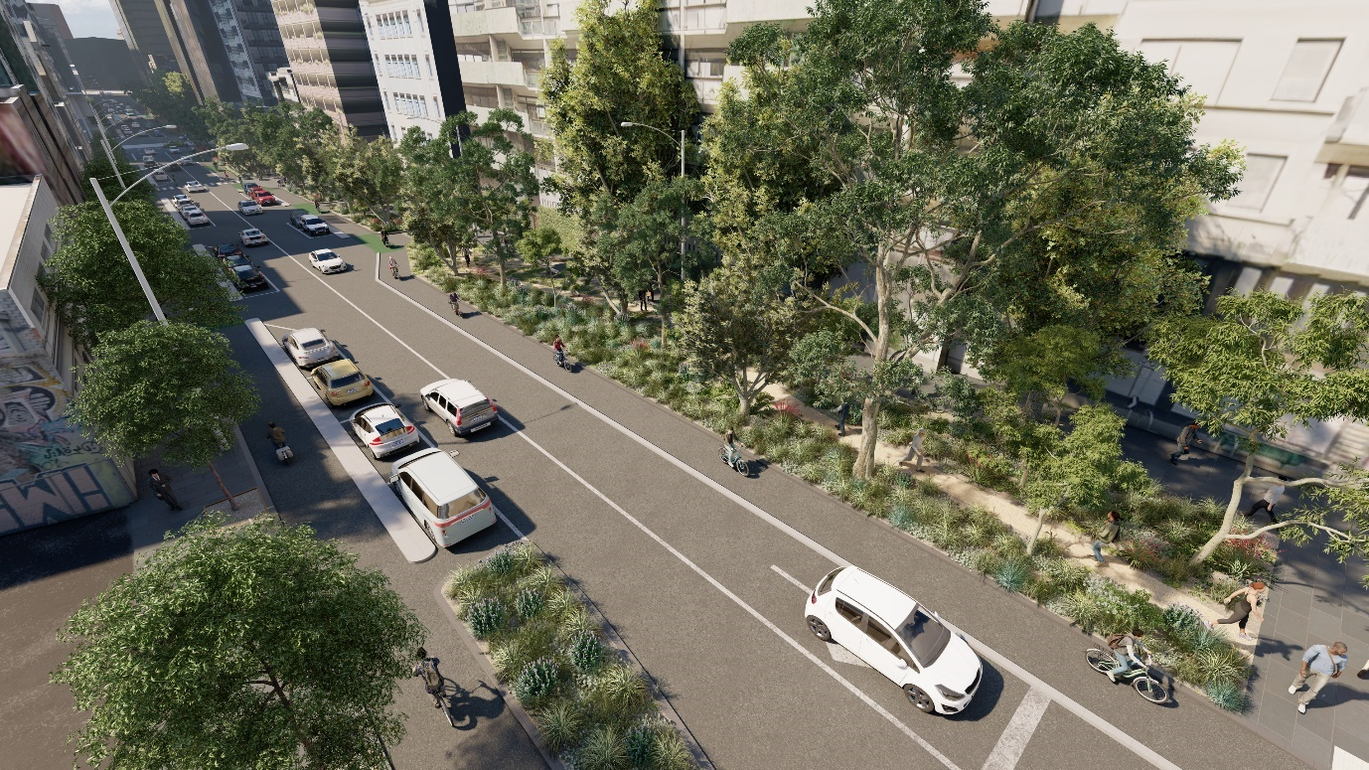
Artist’s impression of Franklin Street looking east towards Swanston Street. It shows the traffic lanes reduced to one lane each way with parking along the north side of the street and reduced parking along the south. Dedicated bike lanes are on either side of the road with separation kerbs for increased safety. There is a significant increase of vegetation to the southern footpath, including large trees and understorey plants. The concept design includes the proposed removal of the existing public toilet at the intersection with Elizabeth Street, noting increased provision of contemporary facilities across the precinct.

View looking west up Franklin Street – existing
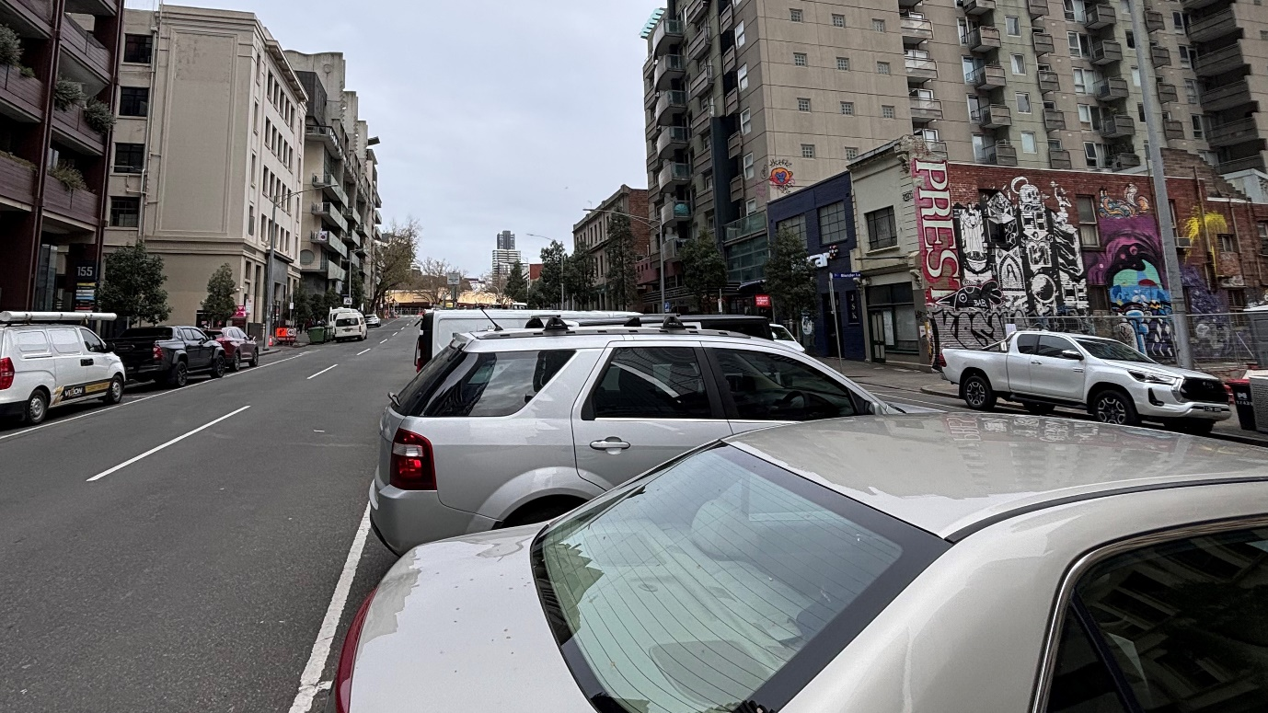
Existing conditions of Franklin Street show parking in the central median and four lanes of traffic, two each direction with parking along both kerbs. The slider then reveals….

View looking west up Franklin Street – proposed
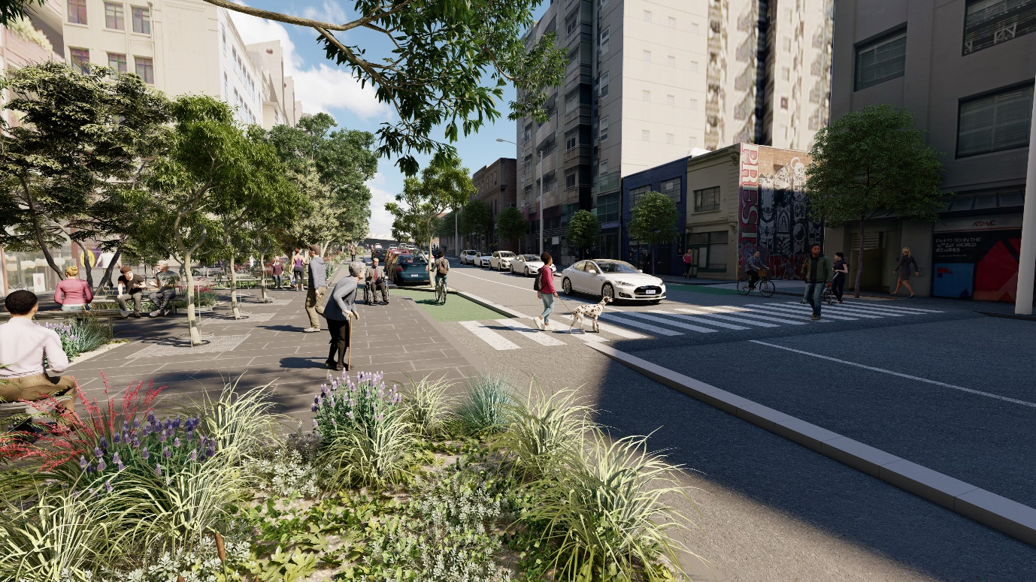
Artist’s impression of Franklin Street looking west towards Queen Street. It shows the southern side of the street with a small social gathering space and an increased area for greening with trees and understorey plants. Raised pedestrian crossings that are level with the footpaths encourage pedestrian safety from bikes and vehicles.

Existing typical section
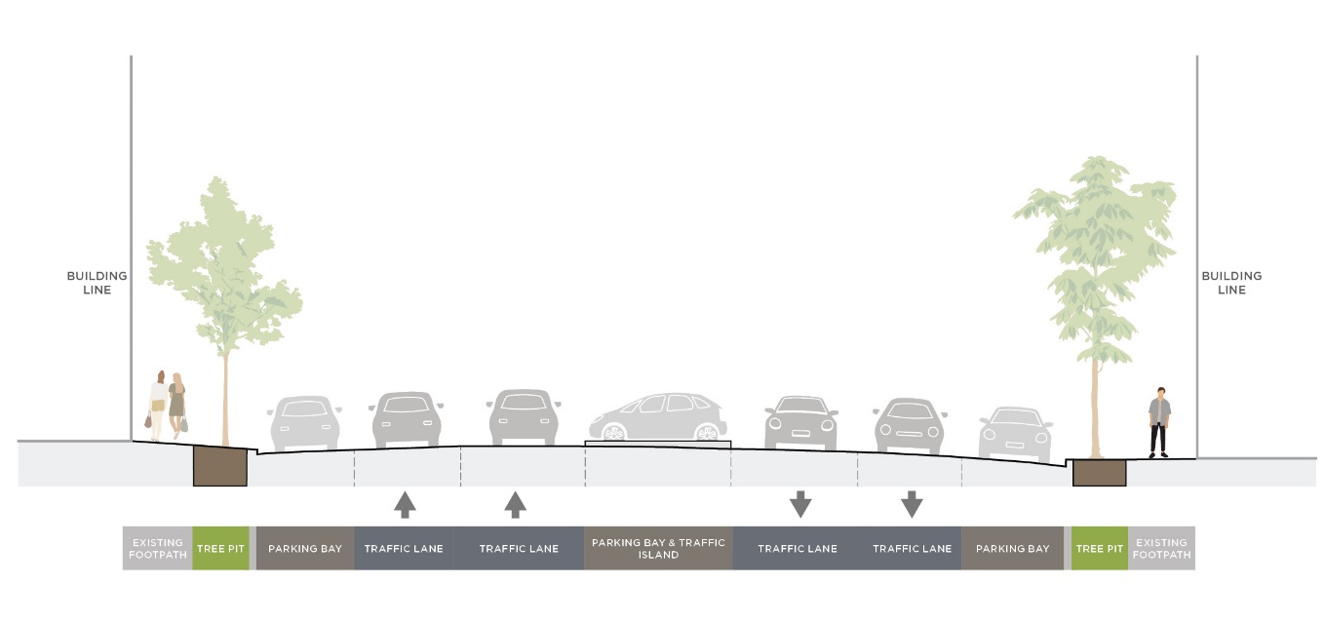
A typical section shows the current configuration of the street layout. A wide four lane road with central parking bays in the centre of the street and parking bays along both the north and south side of the street. Narrow footpaths are planted with minimal trees. When the slider is move to the left it reveals….

Proposed typical section

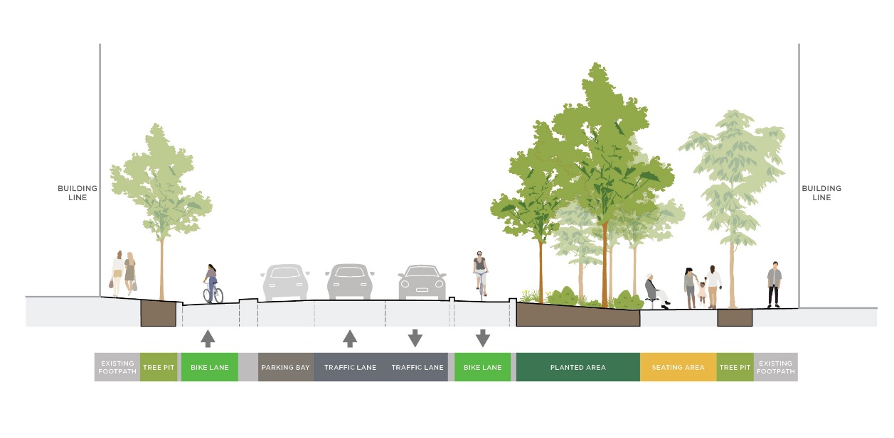
A proposed section that has narrowed the road down from 4 lanes of traffic to two. There are now two dedicated bike lanes on either side of the road with separation kerbs and the existing street trees remain. The southern side of the street has a significantly increased area for planting, widened footpaths, social gathering spaces and increased tree canopy.

