
Draft Melbourne Heritage Strategy 2024
Stories of People and Place
Contents
Heading 1 4
Heading 2 4
Heading 3 4
Bullet styles 5
Numbered list styles 5
Acknowledgement of Traditional Owners 6
Summary 7
Heritage snapshot 9
Aboriginal heritage 9
Parks and gardens 11
Heritage buildings as creative hubs and exhibition and community spaces 11
Heritage fleet 11
Our collections 11
Languages and cultural diversity 11
People and organisations 11
Why heritage? 12
What is heritage? 12
What can heritage do for us? 12
Heritage, wellbeing and sustainable development 13
Our role 14
What is our role in heritage? 14
Who are our partners? 14
Creating the draft strategy 16
What have we achieved? 16
A snapshot of changes to local heritage controls since 2013 17
Why do we need a new strategy? 20
Who has been involved? 20
What we heard from our community 21
Making the link to other plans 23
Mission and approach 25
Draft mission 25
A people-centred approach 26
A whole-of-City-of-Melbourne approach 27
Five ways of working 27
Applying the five ways of working to heritage 27
Our priorities 28
Aboriginal heritage 28
Aboriginal heritage and the future of the city 28
Opportunities and challenges 29
Our priority 30
Powerful experiences 32
How heritage interpretation creates powerful experiences 32
Opportunities and challenges 33
Our priority 33
Distinctive places 35
How heritage can create distinctive places and neighbourhoods 35
Opportunities and challenges 36
Our priority 37
The climate and biodiversity emergency 39
How heritage can help address the climate and biodiversity emergency 39
Opportunities and challenges 40
Our priority 40
Stewardship and biodiversity emergency 41
The value of stewardship 41
Opportunities and challenges 42
Our priority 42
Next steps 44
Finalising the strategy 44
Monitoring and review 44
Glossary 45
Bibliography 47

Acknowledgement of Traditional Owners
The City of Melbourne respectfully acknowledges the Traditional Owners of the land we govern, the Wurundjeri Woi-wurrung and Bunurong / Boon Wurrung peoples of the Kulin and pays respect to their Elders past and present.
We acknowledge and honour the unbroken spiritual, cultural and political connection they maintained to this unique place for more than 2000 generations.
We accept the invitation in the Uluru Statement from the Heart and are committed to walking together to build a better future.

Summary
This is our draft new heritage plan for the City of Melbourne. It sets a new direction, based on a broad, people- centred and city-wide approach to cultural heritage.
We have taken the opportunity to review what we have achieved since the last strategy was published in 2013 and to consider some of the challenges ahead. We are proud of what we have achieved, including a series of comprehensive Heritage Reviews for our neighbourhoods, an updated heritage protection system and the first online map of Aboriginal Melbourne, working with Traditional Owners and other Aboriginal people with connections to the City of Melbourne, to begin to capture the places and landmarks that hold special significance.
However, much has changed since 2013, and we need to reconsider our priorities in light of the major challenges that we face as a city. In this strategy, we outline five priorities for our work on heritage:
- Aboriginal heritage
- Powerful experiences
- Distinctive places
- The climate and biodiversity emergency
- Stewardship.
In line with the Uluru Statement from the Heart, we need to walk together with the Traditional Owners of the land, the Wurundjeri Woi-wurrung, and the Bunurong / Boon Wurrung peoples, as well as other Aboriginal and Torres Strait Island peoples with connections to the City of Melbourne.
One of our headline challenges is the climate and biodiversity emergency. Heritage must be part of the solution and not contribute to the problem. When we consider sustainable development in Melbourne’s future, we need to consider culture – including heritage – alongside environmental and social issues. Our city is growing fast, and we must find new and more creative ways to both care for people’s heritage and address other issues that are important to our community and impact their lives, such as the need for an increased housing supply.
We also need to listen to the views of our partners and stakeholders, from those who question the value of heritage to the passionate enthusiasts, understanding their concerns and priorities. This way of thinking goes beyond the perspective that heritage is about protection alone. It also recognises the many ways people engage with heritage through heritage experiences and activities. It takes a city-wide approach that embeds heritage in other aspects of our work.
We recognise that how we work is just as important as what we do. We are proposing five ways of working that embed a broad, people-centred city-wide approach into everything we do. We will be respectful and informed, collaborative, integrated, inclusive, and long-term and sustainable. We look forward to your feedback and working in partnership to take this draft plan forward.

Figure 1 Plan on a page
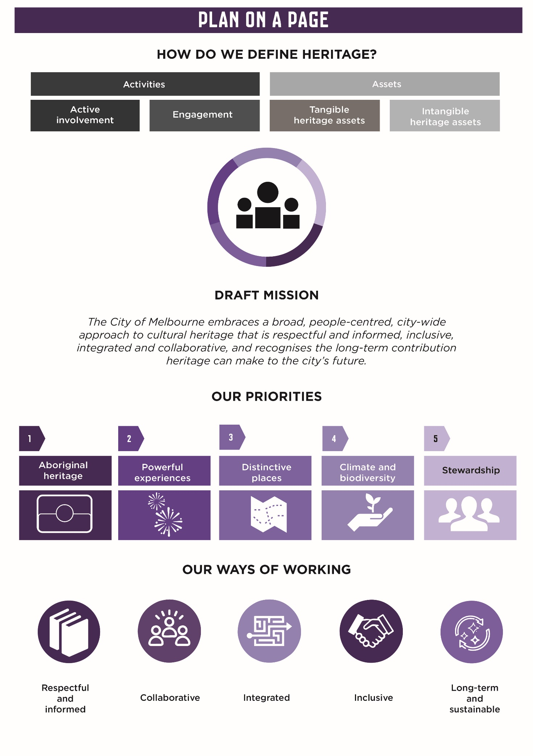

Heritage snapshot
We have compiled an initial overview of the rich diversity of the City of Melbourne’s heritage, including some of the people and organisations involved.

Aboriginal heritage
Vast areas of cultural heritage sensitivity across the municipality have been identified, which may contain Aboriginal heritage. The local Heritage Overlay lists three places as Aboriginal heritage places and many more potential places have been identified through our recent heritage reviews. Mapping Aboriginal Melbourne, an interactive digital map developed with Traditional Owners and Aboriginal communities, maps places of Aboriginal historical and cultural significance within the municipality.
Figure 2 Locations of Aboriginal cultural significance
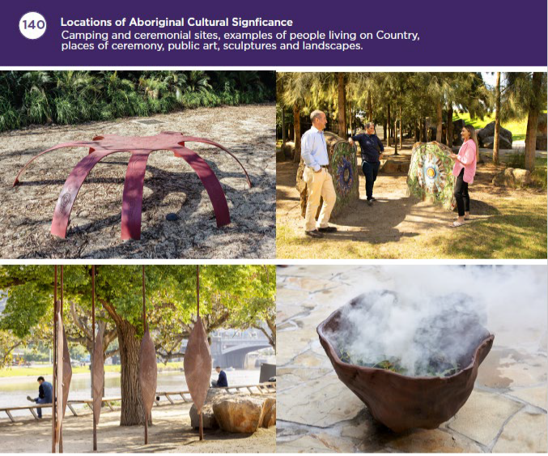
Top Left Eel Trap, 2003, Fiona Clark (Kirrae Whurrong) and Ken McKean, Location: Birrarung Marr
Top Right Futurescape, 2013, Helen Bodycomb (and the children at ArtPlay) Location: Backyard at ArtPlay, Birrarung Marr Bottom Left Birrarung Wilam (Common Ground), 2006, Vicki Couzens (Kirrae Whurrong/Gunditjmara), Lee Darroch (Yorta Yorta, Mutti Mutti and Trawlwoolway) and Treahna Hamm (Yorta Yorta), Location: ArtPlay, Birrarung Marr Bottom Right Smoking ceremony at narrm ngarrgu Library and Family Services, Munro development, 2024
Figure 3 Heritage places in the City of Melbourne
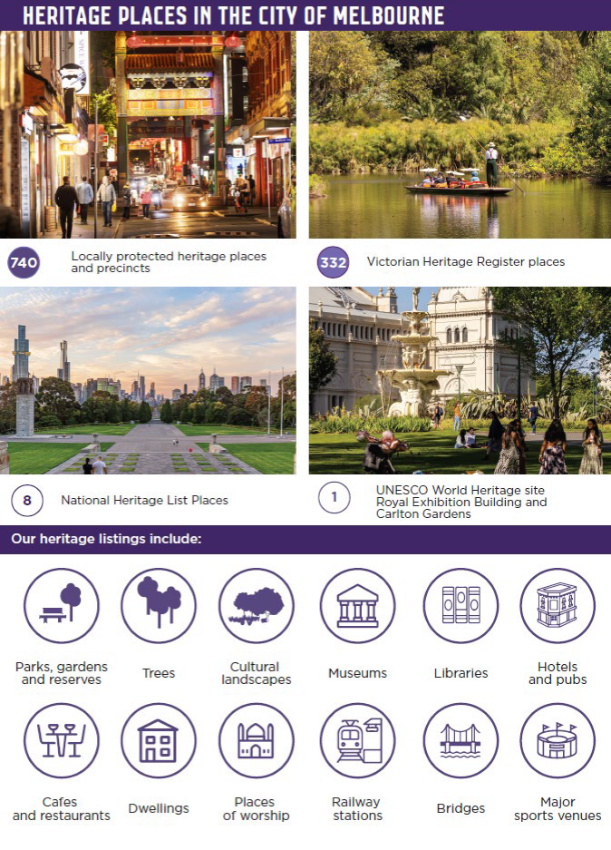

Parks and gardens
The City of Melbourne has nearly 480 hectares of internationally acclaimed parks and gardens. Most of our 14 major parks and gardens have some form of heritage protection or include important cultural assets, such as the World Heritage-listed Carlton Gardens and Royal Exhibition Building. While not all are heritage-listed, smaller local parks and reserves also add definitive character to our neighbourhoods. Many trees on private properties and in public spaces have heritage protection.

Heritage buildings as creative hubs and exhibition and community spaces
City of Melbourne manages galleries, exhibition spaces and studio spaces, some of which are housed in historic buildings. For example, the Meat Market is an iconic heritage-listed building, which provides a hub for creative arts and cultural productions. A former railway signal box houses the Signal creative hub, while other historic buildings such as Kathleen Syme Library, Kensington Town Hall, Boyd Community Hub and Melbourne Town Hall provide public facilities and host exhibitions and events.

Heritage fleet
Melbourne is home to a significant number of historic vessels and replicas of historic ships. The heritage fleet comprises the Alma Doepel, Enterprize, Steam Tug Wattle, Polly Woodside and the Mission to Seafarers building, which opens vessels to the public and provides sailing experiences. The Australian Register of Heritage Vessels includes many other historic vessels with connections to Melbourne.

Our collections
Our City Collection is an eclectic and important range of cultural material, comprising 8000 items from public art and memorials to historical artefacts, photography and more. The City Gallery at Melbourne Town Hall presents frequent exhibitions on city life past and present. Specialist curators collaborate with artists and filmmakers to offer intriguing views of Melbourne life. Our seven public libraries provide physical and digital resources to help visitors explore the history of their house, create a family tree, research history, or simply browse. The libraries also offer interactive self-guided walks and access to various exhibits.

Languages and cultural diversity
Melbourne is home to one of the most multicultural communities in Australia. More than half of residents were born overseas and use a language other than English at home. The city’s residents speak more than 100 languages and come from around 140 different cultures.
Cultural diversity is also celebrated within our streetscapes. Chinatown and Lygon Street boast a rich and long- standing history of migration to the municipality. Chinatown was first protected over 40 years ago and today maintains a vibrant and ever-evolving network of colourful traditional signage, food and cultural events.

People and organisations
Many other people and organisations are involved in heritage in the municipality.
- Owners and occupiers – The majority of protected heritage places are owned or occupied by individual householders. Others are owned or occupied by businesses or not-for-profit organisations. A relatively small percentage of heritage assets are open to the public – the majority are in everyday use as residences, business premises or public services.
- Volunteers – Heritage relies heavily on volunteers. Approximately 14 per cent of people in the municipality volunteer, although we don’t know how many of those volunteer for heritage activities.
- Heritage organisations, museums and galleries – Melbourne hosts a range of museums, galleries and heritage visitor attractions, including the Australian Centre for the Moving Image, Melbourne Immigration Museum, Melbourne Museum, National Gallery of Victoria, Shrine of Remembrance and the Old Treasury Building Museum.
- Community organisations – Many passionate local organisations advocate for community heritage including a wide range of Aboriginal community organisations, six historical societies including the Royal Historical Society of Victoria, 16 resident and community groups and the Genealogical Society of Victoria, which represents 46 member societies. A range of other not-for-profit organisations look after cultural heritage, often opening it up to the public by providing exhibitions and heritage experiences. These include the National Trust (Victoria), which opens places like Old Melbourne Gaol to the public for tours interactive tours. Working Heritage manages 16 sites across Victoria, including several in our municipality. There are many other wonderful museums and heritage attractions across the city.

Why heritage?

What is heritage?
Heritage shapes our neighbourhoods and the places where we work and play. It is beneath our feet and all around us. The often-untold stories of the people of Melbourne are written in buildings, streets and open spaces. Food, cultural traditions, languages, stories and memories are also part of our heritage. Heritage contributes to the distinctiveness that makes Melbourne special and is core to the cultural diversity of our city.
The word heritage can be confusing. Is it just buildings that are formally protected under heritage and planning legislation? Or does it go beyond that?
Our new draft Str starts with a very broad view of heritage, defining it as the things people care about and want to hand on to the future. It is inspired by the Aboriginal philosophy of caring for Country, and the idea that if we care for Country, Country will look after us.
This document uses the terms ‘heritage’ and ‘cultural heritage’ interchangeably. Although Victorian heritage legislation distinguishes Aboriginal cultural heritage from other heritage, this draft Strategy takes an integrated approach to the term.
This broad view includes physical places, landscapes and buildings, collections and other physical things that matter to us, as well as intangible stories and memories. While all of these may be important to people, only some are formally protected.
Heritage is also something that we experience. Festivals and activities such as Open House Melbourne, NAIDOC Week events or Lunar New Year events bring people together to encounter cultural heritage. Museums, libraries, public parks and cultural hubs all provide ways to engage with our past.
Heritage activities can also be the things we do in our own lives when we research, share, protect or advocate for history, tradition or our own heritage. Perhaps you have researched your family history, restored a much-loved object, building or vehicle, or belong to one of Melbourne’s many active historical societies, or community, multicultural and neighbourhood groups, or heritage technology groups?

What can heritage do for us?
So why does heritage matter? Heritage can be seen as a luxury, or, sometimes, an impediment to growth.
Yet comprehending our heritage and history is vital to understanding, inclusion and belonging. All who live and work in the municipality encounter heritage in our daily lives. Heritage experiences can impact people in many different ways, perhaps through encountering new or surprising stories. Heritage can bring people together, but it also has the potential to divide us.
Caring for heritage can also deliver wider public benefits. Older buildings are an important carbon sink and reusing them can contribute to decarbonisation. Heritage activities can foster social connections and new skills; seeing one’s heritage and stories reflected in the city can create a powerful sense of belonging and inclusion. Heritage makes the places people live, work and visit distinctive and special.
Heritage sectors (for example museums and architecture) are a key part of the creative industries which play an important role in Victoria’s economy, contributing $38.5 billion as a whole in the financial year ending 2022.
International research has also shown that creative businesses located in historic places can be more successful than those located elsewhere.
Heritage is a large contributor to Melbourne’s visitor economy. Melbourne is considered Australia’s capital for culture and history, which are major drivers of visitation. Individual heritage sites are core to the visitor experience, such as Old Melbourne Gaol, the Queen Victoria Market, or Federation Square – Melbourne’s premier meeting place, visitor destination and event location. More than one in four international tourists to Melbourne visit historic or heritage buildings.

Heritage, wellbeing and sustainable development
Cultural heritage can also play an important role in wellbeing and sustainable development. There is a move toward placing people’s wellbeing at the heart of our thinking about the economy and how society functions now and in the future. Heritage can contribute to wellbeing through both caring for heritage assets and engaging in heritage activities.
Sustainable development meets the needs of current generations without compromising the ability of future generations to meet their needs. Cities around the world are now promoting culture as part of sustainability, noting that the arts, culture, and heritage can contribute to sustainable development in their own right and by contributing to other goals.
City of Melbourne recognises the importance of sustainability – how we balance ecological, social and economic factors in order to protect the planet, halt climate change and promote social development for present and future generations. We were one of the first cities to sign up to the United Nations Sustainable Development Goals (SDGs) and create a Voluntary Local Review of our progress towards them. The review provides a guiding framework for us to assess how we are tackling global challenges with local action – to end poverty, protect the planet and support peace and prosperity by 2030. Heritage can contribute to our efforts to achieve a number of the SDGs.
Figure 4 Heritage and the United Nations Sustainable Development Goals
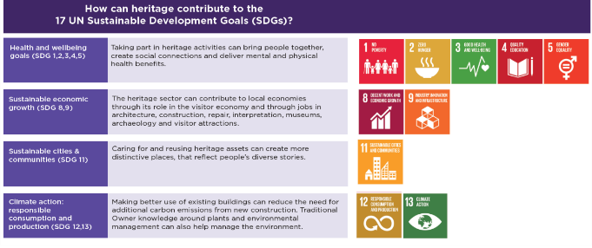

Our role

What is our role in heritage?
As the local council, City of Melbourne provides municipal services that support the community, including planning, community services, recreation and arts and culture.
Heritage is relevant to many aspects of our work including:
- Support for Aboriginal cultural heritage – We are committed to working with Traditional Owners and Aboriginal people to ensure Aboriginal heritage can continue to enrich the city and be considered through planning and development processes.
- Planning services – Heritage is part of the wider role we play in both strategic and statutory planning processes. As the local planning authority, we work in partnership with others to research, identify, protect and manage heritage in the municipality and keep the local Heritage Overlay up to date, reflecting expert knowledge and changing views of what is important. We are also the responsible authority in relation to most planning permits and ensure that heritage is given due weight in decisions about the future of the city to achieve net community benefit.
- Cultural and community services – Heritage activities are part of the work of many of our cultural and community services, including arts and creativity, libraries, public programs and events.
- Property management services – City of Melbourne maintains and manages a wide range of heritage places and items, including parks, buildings, collections and public art. All have a history and many are formally protected. Most are open to the public and help us deliver wider community services.
- Support for heritage owners – We support heritage owners through our Melbourne Heritage Restoration Fund and by providing advice and information, such as the recent Heritage Owner’s Guide.
- Strategic projects – We take an active role in Melbourne’s future when we lead projects such as the Greenline Project, where heritage is core to the creative design approach.

Who are our partners?
As explained in Figure 5 below, City of Melbourne is only one small part of a wider network of people and organisations that do much of the everyday work of caring for the municipality’s heritage. Traditional Owners provide cultural leadership for Aboriginal cultural heritage, while other Aboriginal-led businesses and organisations provide cultural heritage expertise and services. Several not-for-profit trusts and organisations look after cultural heritage, opening to the public through exhibitions and heritage experiences.
Major public authorities manage or advocate for heritage protection, such as the Victorian Aboriginal Heritage Council, the Heritage Council of Victoria and Heritage Victoria – with whom we have an essential working relationship – as well as the Melbourne Museum, the Public Record Office Victoria and the State Library of Victoria.
Our other partners include community groups, businesses, developers and individual owners who play vital roles in heritage, either as owners and occupiers, advocates, or providers of heritage services.

Figure 5 Heritage organisations and their responsibilities
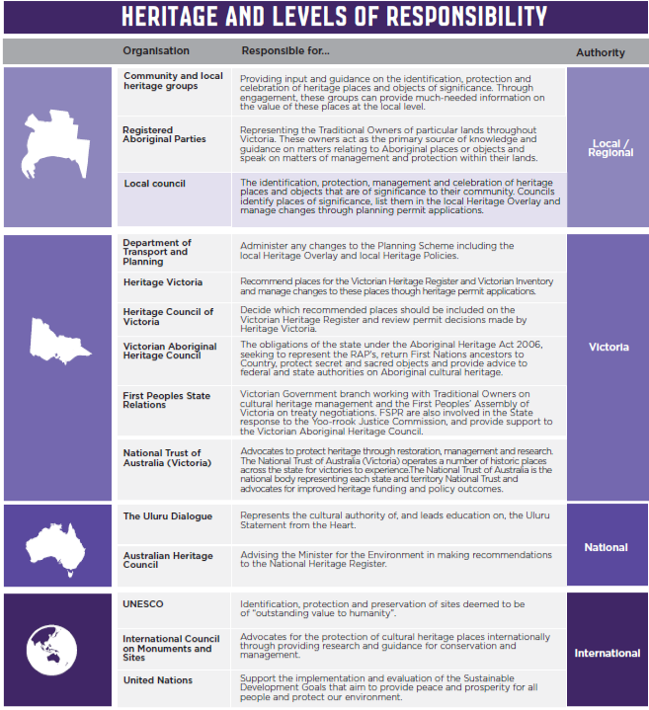

Creating the draft strategy

What have we achieved?
Our last heritage strategy was published in 2013. It focused on heritage protection, including managing our extensive heritage information, creating new ways to protect heritage, looking after our existing heritage and celebrating and communicating heritage in partnership with the community and other stakeholders. The significant amount of work done since 2013 ensures the future growth of the city will be informed by its distinctive heritage.
We are proud that we have achieved much of what we set out to do. We commissioned a series of neighbourhood heritage reviews, which captured what is special and distinctive about each of our local areas. These reviews included investigating previously unloved or under-protected heritage, such as modern movement buildings. Figure 6 shows the status of our heritage reviews. All of the reviews recommend changes to our heritage controls, and some of these changes are still being progressed through Planning Scheme Amendments.
In the last two years alone, our Melbourne Heritage Restoration Fund has helped 36 heritage building owners to repair their buildings in order to help keep them in use. We updated our system of categorising heritage places and introduced a new policy to guide the development of heritage places, which applies to all new heritage planning permit applications. We created a Heritage Design Guide to provide simple advice for developers and key stakeholders. Our Heritage Owner’s Guide helps owners understand how they can maintain, change or develop heritage buildings. We have improved the way we identify, assess and document gaps in the recording of items and places of cultural and natural heritage significance. Our art and heritage collection at the Town Hall is now publicly accessible, helping everyone access, understand and celebrate parts of Melbourne’s history and heritage.
We have also pioneered a new collaborative approach toward heritage studies through the Hoddle Grid Heritage Review co-research model. It sets a methodology for identifying places of significance to Aboriginal people and how these places can be protected, working with Traditional Owners to better understand their connections and stories.
The Aboriginal Heritage Action Plan was published in 2015. It has directed our work with Traditional Owners to create an online map of Aboriginal Melbourne – which establishes a vital starting point for telling stories and planning for the future – as well as many projects that celebrate Melbourne as an Aboriginal place, including narrm ngarrgu Library and Family Services.
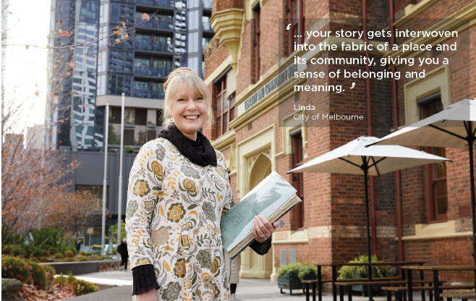
Image 1 Linda, Library Branch and Community Heritage Team Leader, standing at the front of the Boyd Community Hub in Southbank

A snapshot of changes to local heritage controls since 2013
The 2013 Heritage Strategy commissioned a series of heritage reviews. Since 2013, the Council has overseen a rolling program of suburb-by suburb heritage reviews and other policy changes, to ensure that contemporary understandings about where heritage fabric exists are reflected in the Melbourne Planning Scheme. Prior to these reviews, most parts of the municipality were relying on heritage studies completed in the 1980s.

The most significant local heritage related changes to the planning scheme are shown in Table 1 below:
Table 1 City of Melbourne’s heritage review history and completion dates
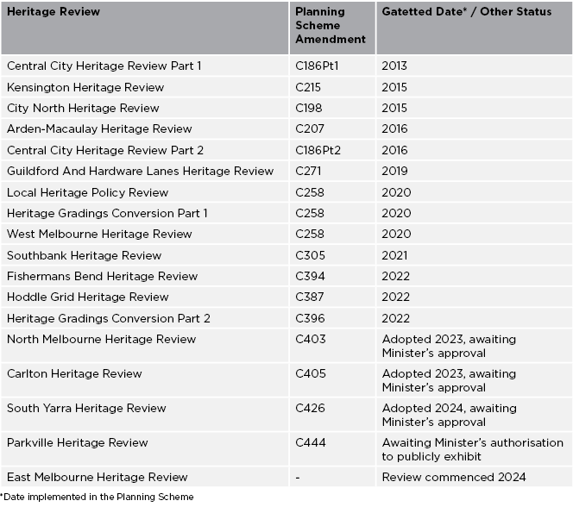
Planning scheme amendments are not retrospective, in that they do not alter planning permissions already granted. As such, it takes some time for any changes to heritage policies and controls to take effect. This is particularly true of the changes to the local heritage policy secured in 2020: these changes resist ‘facadism’ in the central city, and support more solar panels on rooves outside the central city, for example, but will only result in changes to the built environment planning permit by planning permit.
Together, these changes to the Melbourne Planning Scheme constitute more strategic work on heritage than had been undertaken in a generation. We have been getting our house in order, so that the extraordinary pace of infill development and population growth in the inner city is guided by, and not inhibited by, contemporary understandings about where built heritage exists.
For these reasons, the draft Heritage Strategy 2024 does not commission significant new updates to heritage controls in any particular precinct.

Figure 6 City of Melbourne’s heritage review status, June 2024
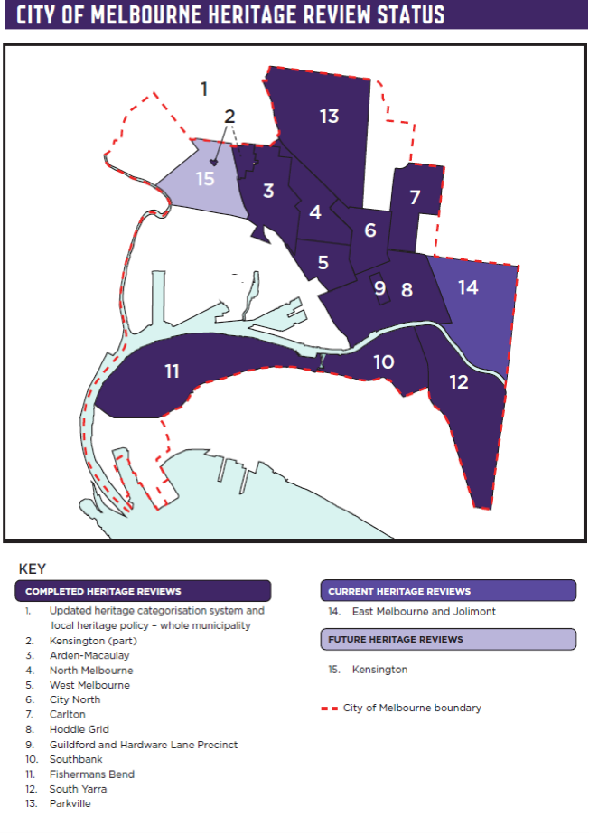

Why do we need a new strategy?
Much has changed since the 2013 strategy was published and new challenges are ahead. We have an opportunity to go beyond heritage protection and think differently, exploring how heritage can contribute to our wider work. We need to do more to understand how different people engage with and experience heritage across the municipality.
We recognise that we must be guided by Aboriginal cultural heritage. Aboriginal stories and connections are central to the story of Melbourne. We need to do more to acknowledge Aboriginal stories in everything we do while respecting the authority of Traditional Owners and learning from Aboriginal thinking and philosophy about caring for Country.
We need to ensure that heritage does not prevent us from addressing our problems. Melbourne has been growing fast, and it faces immense pressure to provide affordable, secure and well-located housing. In this context, heritage can be seen as a barrier to be removed rather than a feature that can contribute character to change.
Heritage has also been understood as a barrier to responding to the climate emergency, but this needs to change. We need to consider how heritage can help achieve a zero-carbon future.
Above all, we need to acknowledge that heritage is not easy. People value their heritage and that of others in different ways. When untold stories finally come to light, they can change our understanding of ourselves and of others. Our ideas of heritage change over time, as each new generation comes to terms with the past. As part of our new plan, we need to continue to reflect on those changing ideas about heritage.

Who has been involved?
We have created this draft Strategy in collaboration with others. To start the conversation, we published the Heritage, People and Place Discussion Paper 2024. We put forward the idea of a people-centred approach to heritage that focussed not just on why heritage matters to people, but ways to empower people to get involved. It explored how this could be achieved through five focus areas – reflecting Aboriginal heritage at the centre of the municipality; heritage interpretation; heritage, urban change and economic growth; heritage and climate change; and innovative heritage planning approaches.
Over four weeks in early 2024, we reached out to residents, businesses, government agencies, industry partners and other relevant stakeholders by conducting workshops, exhibiting promotional tools and releasing an online survey. Our aim was to understand what aspects of heritage are valued by the community and how the community would like to see heritage protected, managed and celebrated.
We met with Traditional Owners to discuss this strategy and a potential approach to heritage interpretation. These conversations will continue as we collaborate on the final Strategy.
The engagement process has helped reveal the connections between our work and that of others. It has helped us understand people’s views and how this work may affect their lives. It has been an opportunity to think about the role of heritage in pressing issues such as the climate and biodiversity emergency.
The feedback has shaped our thinking and influenced this draft. We recognise that people have different views on heritage and have taken the time to reflect deeply on what we have heard. We have reshaped the priorities, weaving the initial focus on innovative heritage planning and processes into each of the other priorities. We added a new priority relating to stewardship and day-to-day care of heritage. Key points from the consultation have been incorporated into the opportunities and challenges section of each priority within this draft Strategy and will inform our potential action areas.
We have heard the call to take a whole-of-city approach, extending heritage’s reach beyond planning to collaborating internally across City of Melbourne. You can find out more about the feedback we received in our Engagement Report.

What we heard from our community
Figure 7 Responses to the Discussion Paper
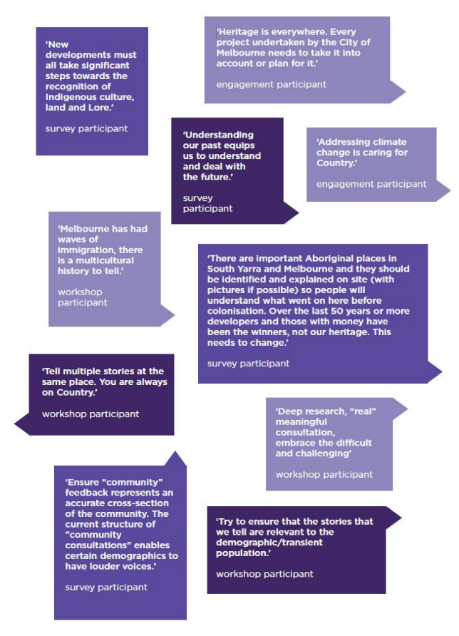
Over the past 10 years, we have also received thousands of community comments on heritage in response to many other projects.
Figure 8 Community feedback on heritage over the last 10 years
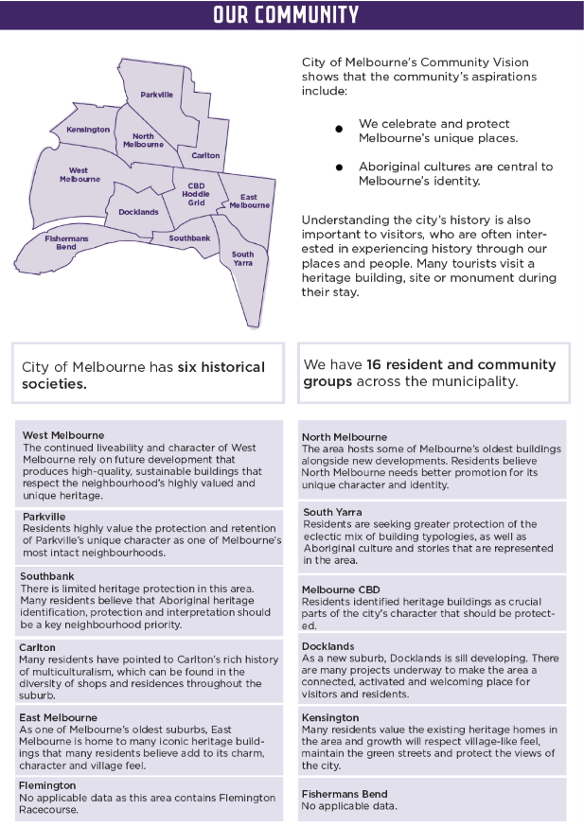

Making the link to other plans
In developing this draft Strategy, we collaborated across teams within City of Melbourne to learn more about how heritage can contribute to other priorities. For example, we understood that heritage sits at the heart of each of the themes in the Council Plan 2021–25:
- Aboriginal cultural heritage is central to our vision to govern with Traditional Owners and the broader Aboriginal community and make the changes needed for the City of Melbourne to be recognised an Aboriginal city.
- As part of the economy of the future, heritage activities make a significant contribution to both the visitor and creative economies and are an important asset to maintain.
- Melbourne’s unique identity and place is underpinned by thousands of years of living on Country and by the historic places and buildings of the past two centuries.
- Extending the life of existing buildings, whether protected or not, can contribute directly to addressing the climate emergency, while trees and places keep the city cool and can contribute to biodiversity.
- Given that so many of us have different needs, heritage experiences must be accessible and affordable.
- Participating in heritage activities can bring us together and contribute to health and wellbeing, while cultural safety is a key consideration in how we share and present what can sometimes be difficult stories of our past.
While heritage can help with almost any aspect of our work, we have identified strong connections to other City of Melbourne documents, shown in Figure 9.
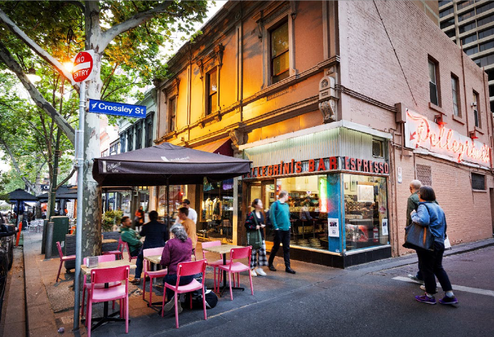
Image 2 People walking past heritage shopfronts at the corner of Bourke and Crossley Streets Melbourne

Figure 9 How the draft Heritage Strategy relates to other City of Melbourne plans, policy and programs
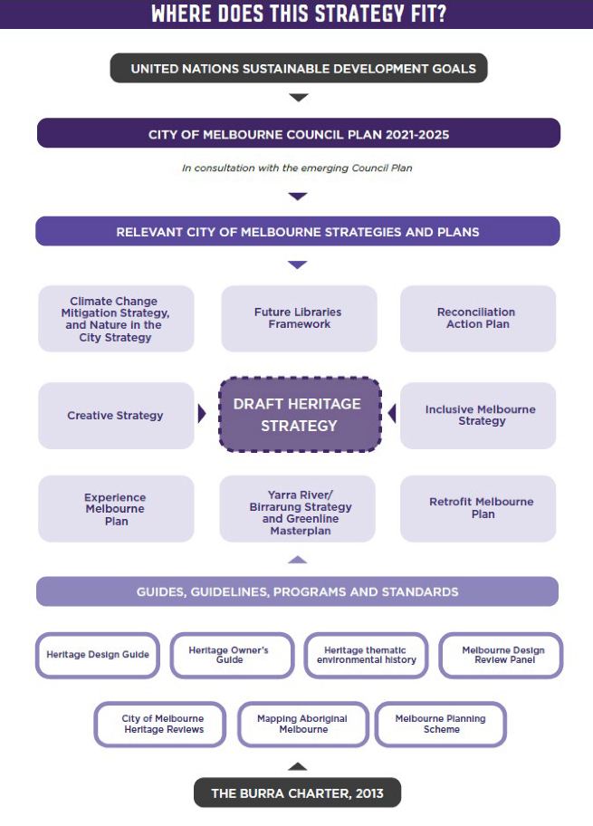

Mission and approach

Draft mission
City of Melbourne embraces a broad, people-centred, city-wide approach to cultural heritage that is respectful and informed, inclusive, integrated and collaborative, and recognises the long-term contribution heritage can make to the city’s future.
This approach involves thinking differently about heritage. It goes beyond protecting heritage to understanding how heritage experiences and activities can help achieve other City of Melbourne ambitions. This draft mission is informed by what we have heard during engagement so far and through our ongoing conversations with stakeholders across the city.
An inclusive view of heritage embraces Aboriginal and non-Aboriginal cultural heritage, recognising and respecting the leadership and authority of Traditional Owners.
It includes places that are formally protected for their cultural and natural significance. It acknowledges the importance of Country and recognises the responsibilities of caring for Country. It extends to other tangible (or physical) heritage that people value and want to pass on to the future, such as collections, public artworks and memorials, historic ships and technology and archives. It also recognises the importance of intangible cultural heritage – the stories, traditions and languages of the diverse communities of Melbourne.
This broad view also recognises that heritage is something we experience in our city every day, as visitors, workers and residents, shaping the places we live, work and play. It reflects the value of heritage activities – the things that we do in our own lives, or collectively when we come together to research, care for, or advocate for our shared heritage.
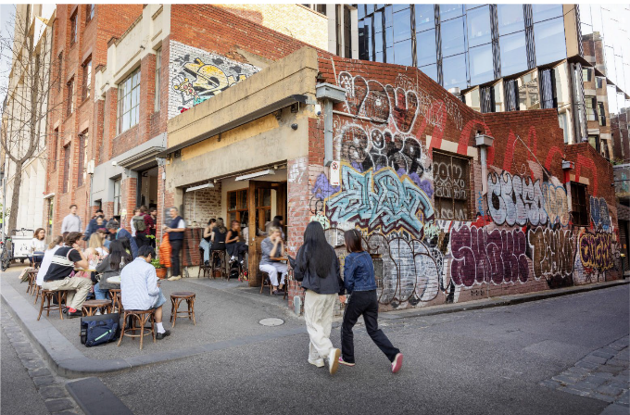
Image 3 People dining on the footpath in a heritage streetscape in Carlton.

A people-centred approach
This draft Strategy takes a people-centred approach, by aiming to find ways to connect and work with our community. Since our last heritage strategy, we have focused on identifying and protecting places that are important to people across the City of Melbourne. We can now focus on finding new ways to work with people to care for and understand heritage, involving diverse members of our community and respecting heritage expertise.
A people-centred approach is central to everything we do at City of Melbourne. Listening to the voices of the community is critical to success. We involve communities in shaping our future through initiatives such as neighbourhood planning. This draft Strategy extends this approach to heritage.
A people-centred approach recognises that heritage is significant because of people’s connection to it and that caring for heritage can create wider public value. It acknowledges that heritage can benefit people and recognising our past is meaningful to our community.
To take this approach, we must involve and empower communities in our heritage work, ensuring that the heritage and stories of all people are acknowledged and celebrated, reflecting current values. This means moving beyond statutory processes. It could result in more underrepresented places being considered for protection and could provide more opportunities for community involvement in heritage reviews, but it does not change the statutory process for applying heritage controls, which must be done in accordance with Victorian Government guidance.
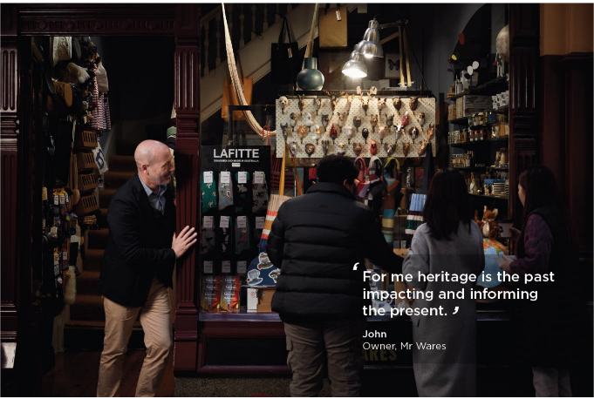
Image 4 John and customers standing in front of a heritage shopfront in the Block Arcade

A whole-of-City-of-Melbourne approach
Cultural heritage does not exist in a silo. It is part of the identity of our city and can be a foundation that helps us achieve other things. This is a strategy for how heritage can contribute to our wider work.

Five ways of working
An inclusive, people-centred, whole-of-city approach to heritage means working differently. We propose five ways of working that will help us do that, recognising that how we work with people to do things is as important as what we do. They are not specific to heritage but are inspired by international thinking on sustainability and wellbeing, which require us all to work differently. They draw on guiding principles set out in other City of Melbourne strategies.
Respectful and informed working means ensuring we understand and respect the values and perspectives of others. It means listening to and learning from others and gathering data and information before making decisions.
Collaborative working involves co-creation and co-production. It recognises that we can achieve more by working together on projects and initiatives to find shared goals.
Integrated working focuses on our integrated approach to policymaking. Integrated means considering the full range of consequences or impacts of action so that activity in one policy area or strategy can complement, rather than undermine, the work of others.
Inclusive working recognises the importance of involving a diverse range of people in helping to shape the decisions that will affect their lives. It goes beyond consultation to finding ways to involve people in the ongoing realisation of actions within the strategy in conjunction with final decision-making.
Long-term and sustainable working ensures we focus on long-term solutions. It includes a shift to how actions can be preventative, acting early to tackle the root of the problem, by considering how decisions will impact the wellbeing of future as well as current generations.

Applying the five ways of working to heritage
Implementing the plan involves more than setting actions and processes. Our new broad, people-centred, whole- of-city approach to heritage does not mean business as usual. We need to change the way we work and think about heritage:
- We will demonstrate respect for people’s knowledge and perceptions of their own heritage and what is important to them. We recognise that people have different views on their own heritage and that of others and will listen to a wide range of views about what is important. We will base decisions on the best available evidence.
- We will collaborate with partners in the public, private and not-for-profit sectors on new initiatives to achieve wider heritage outcomes, including working with Traditional Owners, building owners, community history and heritage groups, developers and property owners.
- We will integrate heritage into other City of Melbourne initiatives, including the visitor and creative economy, planning, asset management and new design to achieve social, economic, environmental and cultural benefits.
- We will adopt a more inclusive approach to interpretation and other heritage initiatives, ensuring that people are involved in our work.
- We will apply long-term thinking to heritage by developing a better understanding of the strategic and cumulative impacts of development on heritage, and the longer-term economic, social and environmental benefits of caring for it. We will promote the maintenance and care of our existing heritage through preventative conservation.
- As we apply each of these ways of working, we will support self-determination of Traditional Owners and the broader Aboriginal community when engaging and collaborating, so that they have the power to determine priorities and be involved in decisions that affect them. We will respect Aboriginal knowledge, history, heritage, and culture and connection to Country, and integrate this into our work. We will be inclusive by supporting the voices and aspirations of Aboriginal people, and plan for the long-term by investing in strong and sustainable partnerships and Aboriginal led approaches.

Our priorities

Aboriginal heritage
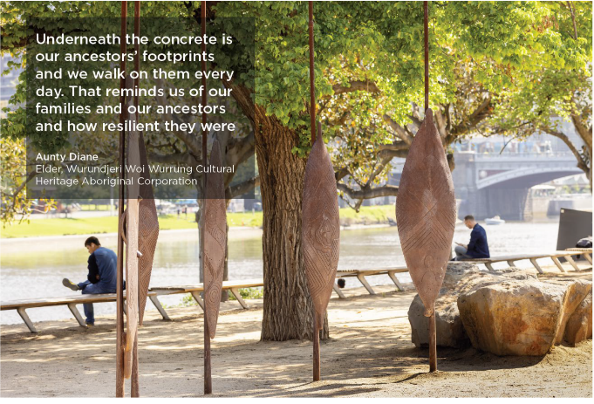
Image 5 Birrarung Wilam (Common Ground) sculpture at Birrarung Marr, Wurundjeri Country

Aboriginal heritage and the future of the city
Melbourne is an Aboriginal city. Aboriginal culture and heritage is important to the stories we tell, the way we care for place and our approach to climate change. Traditional Owners provide leadership on Aboriginal cultural heritage issues. Other Aboriginal and Torres Strait Islander people also continue to have important connections to the municipality.
The Victorian Aboriginal Heritage Council describe Aboriginal cultural heritage as including meaningful places and objects, and going beyond that to include intangible heritage including knowledge and lore. Aboriginal cultural heritage cannot be isolated from other heritage. Past, contemporary and continuing Aboriginal stories are woven into the places, heritage buildings and landscapes of the city. Aboriginal stories, language and traditions are intrinsically linked to the landscape and our heritage experiences today.
The principles of self-determination are vital to cultural heritage management, set out in ‘Dharuwa Ngilan – the vision for Aboriginal and Torres Strait Islander heritage in Australia and the Best Practice Standards in Indigenous cultural heritage management and legislation’.
In addition to mapping Aboriginal Melbourne and the activities in the Aboriginal Heritage Action Plan 2015–18, we have been working with Traditional Owners on a co-creation approach to heritage research as part of the Hoddle Grid Heritage Review. But that is only part of the transformation to embed Aboriginal cultural heritage into our work.
It is also important to acknowledge that Aboriginal heritage in Victoria is protected under the Aboriginal Heritage Act 2006 (the Act) and local Council’s do not influence its application. The Act recognises Registered Aboriginal Parties as the primary guardians, keepers and knowledge holders of Aboriginal Cultural Heritage. Our role is to acknowledge Aboriginal heritage and celebrate continuing Aboriginal culture as vital to our city identity.

Opportunities and challenges
Aboriginal cultural heritage, language and storytelling are already reflected in so many different aspects of our work, from the Council Plan, which notes that Melbourne is an Aboriginal city, to planning and development, creativity, the visitor economy, the Melbourne Arts Precinct and the Greenline. We have much to learn from Aboriginal people about Country and Caring for Country, which is inspiring new urban design thinking.
However, there are also challenges. During our consultation, we heard that truth-telling about our heritage is vital as we strive for reconciliation. The places and stories of the Traditional Owners, the Wurundjeri Woi-wurrung and Bunurong / Boon Wurrung peoples of the Kulin, as well as other Aboriginal and Torres Strait Islander people who have a connection to the city, should be told as part of our living history and identity. Engagement must be meaningful and we should not shy away from learning from uncomfortable stories that are appropriate to be shared.
We heard that non-Aboriginal people want to know more about the Aboriginal culture and stories of Melbourne, but also recognise the need to respect culturally sensitive knowledge.
Traditional Owners and workshop and survey participants told us we need to centralise Aboriginal culture, heritage and knowledge into heritage planning and change standard approaches to provide Traditional Owners with more opportunities to influence future change. Most respondents saw the design of public spaces, community events and onsite interpretation as priorities for acknowledging Aboriginal cultural heritage. People were also interested in Aboriginal place names for different parts of the city.
The Hoddle Grid Heritage Review taught us about the value of a co-creation approach to research, in line with the Australian Institute of Aboriginal and Torres Strait Islander Studies ethical principles. This approach demonstrates the potential to continue taking a layered approach to heritage, recognising that all heritage places in Melbourne are on Country and side-by-side with other heritage values.

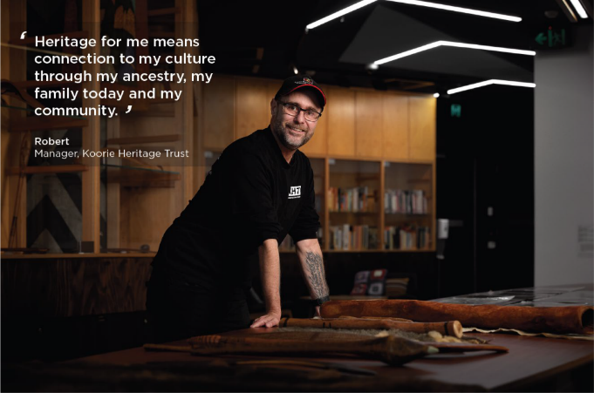
Image 6 Robert standing in the Koorie Heritage Trust on Wurundjeri Country

Our priority
We will respect the knowledge and authority of Traditional Owners regarding the municipality's Aboriginal cultural heritage. We will work together with Traditional Owners and all Aboriginal and Torres Strait Islander people with connections to the City of Melbourne to ensure their culture and stories they want shared are elevated in all our heritage activities, including experiences, placemaking, stewardship and addressing the climate emergency.
We will collaborate with Traditional Owners and other Aboriginal people with connections to the City of Melbourne in exploring the following actions:
  - Empowering Traditional Owners to shape the way Aboriginal cultural heritage is prominently acknowledged, respected, and interpreted across all City of Melbourne heritage activities
  - Exploring an Aboriginal Cultural Heritage Framework to embed Aboriginal cultural heritage leadership and a co-creation model across our wider work, in line with our Reconciliation Action Plan
  - Progressing and updating Aboriginal heritage actions for the City, including those from our recent Heritage Reviews, in collaboration with Traditional Owners and the broader Aboriginal Community
  - Continuing to develop and promote the Aboriginal Mapping project to enhance the information, accessibility, user experience and achieve more widespread use by those who visit the municipality.
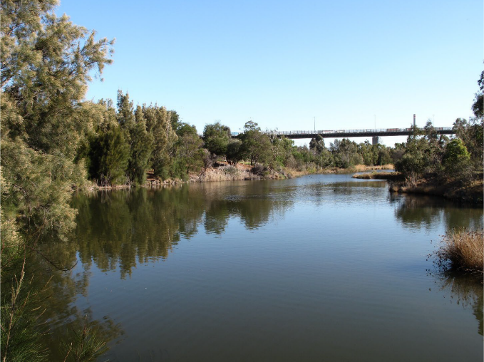
Image 7 Reestablished indigenous plants in West Gate Park on Bunurong Country

Powerful experiences
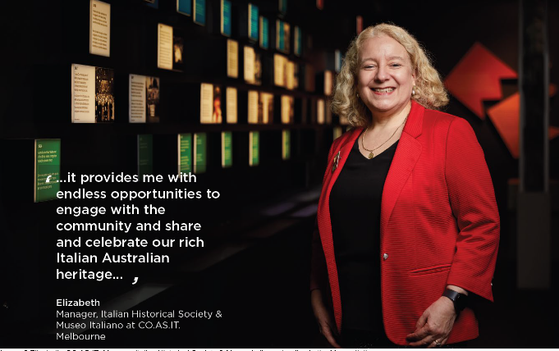
Image 8 Elizabeth, CO.AS.IT. Manager Italian Historical Society & Museo Italiano standing in the Museo Italiano

How heritage interpretation creates powerful experiences
Heritage places need to be understood for them to remain meaningful and supported by the community. Heritage interpretation aims to strengthen the relationship between people and heritage places by sharing the stories and connections a place holds with those who live, work in, or visit the city. It can take many forms, commonly including signage and artwork, but can also include wayfinding, events, digital media, building and public realm design.
Every year the Open House Melbourne event – the largest built-environment festival in Australia – opens hundreds of heritage and modern places to the public, inspiring conversations about the importance of good design in shaping communities. It is one of the many examples of how transformational heritage experiences can encourage us to think differently.
Creative and cultural experiences such as these are one of the top three reasons people visit the City of Melbourne. Heritage is key to how visitors – and indeed our existing residents and workers – experience our city. Heritage protection shapes the setting in which experiences happen by giving the city its distinctive physical form and character, while powerful heritage stories can amaze, delight, or challenge us.
Across the city, artists, curators, designers, historians and community leaders tell stories that connect us with the past. For example, 40 of Melbourne’s historic laneways have been revitalised by artists through the recent Flash Forward visual and acoustic art initiative. At the Old Treasury building, curators work with filmmakers and other artists to showcase the history of Melbourne and Victoria.
The city is an open-air gallery. We encounter culture, heritage and stories in the public realm through signage and tours as we meander through heritage buildings like the Block Arcade or see monuments against the city skyline. Our eclectic city collection of public art, memorials and historic artefacts continues to inspire new stories. We also experience the past through digital media, festivals, exhibitions and performances.
Heritage interpretation should be a key component of our work to reveal and celebrate our city’s different layers of history. Good interpretation requires care; it should capture the attention and connect heritage and people’s own personal experiences to meet the needs of different audiences. Communicating heritage requires compassion: not everyone wants to celebrate the past. Many of Melbourne’s public institutions are multi-layered places that also hold stories of pain and trauma.

Opportunities and challenges
Heritage activities, storytelling and interpretation can contribute directly to many of our city-wide ambitions. Embedding Aboriginal culture, heritage and stories into the public realm helps people understand whose Country they are on and can transform the very essence of the Melbourne experience. Heritage experiences connect visitors with the psyche of place and contribute to our ambitions for creative Melbourne. They ensure that the city leaves visitors with the feeling of having connected with something intangible yet distinctively Melbourne.
The heritage collections held by our libraries foster a sense of belonging to ensure our city and its community thrive through citizen engagement and better access to city data. Seeing your stories reflected in the city – whoever you are – is part of the vision of our Inclusive Melbourne strategy.
But there are also challenges. As people’s ideas about the past change, we must rethink how we tell stories and whose stories are being told and not told. For example, fewer than two percent of the 580 statutes in Melbourne, and only five of the 25 on City of Melbourne land, represent women. We must tell a more diverse story of Melbourne’s past.
Survey and workshop participants told us that a respectful and inclusive approach to interpreting heritage is important, recognising that many places have more than one story. They argued for a layered approach, telling multiple stories of places and involving people in interpretation and storytelling. We also heard more from Traditional Owners about how they interpret the city, and the need to share their stories so we better understand the meaning and history of places. Victorian participation in Aboriginal experiences designed for visitors, such as walks or visits, is below national levels.
Knowledge and information about the past are essential to creating great experiences. However, we also heard that there are gaps in how we manage the huge amount of knowledge and data about the city’s past. It is not widely accessible and can easily be lost as we transition to new technology. We must also consider how people with different abilities can participate.

Our priority
Create many more powerful heritage experiences that connect people to the multi-layered stories of Melbourne, through creative, informed, inclusive and accessible interpretation.
We will collaborate with others to explore the following actions:
  - Working with Traditional Owners and other Aboriginal and Torres Strait Islander peoples with connections to Melbourne to co-create an approach to making Aboriginal culture, stories and language visible across the city, including immersive experiences, events, festivals, public art, signage and more
  - Working with neighbouring municipalities to share stories that carry across boundaries
  - Creating a role for a city historian to raise awareness of the city’s history and embed history and heritage across everything we do
  - Developing a heritage interpretation strategy for the municipality, co-created with Traditional Owners and other Aboriginal and Torres Strait Islander peoples, involving historical societies and local people. This could include:
- gathering stories the community deems important in interpreting the city’s tangible and intangible heritage, such as adding new stories to historic sites to show the layers of our past
- a framework to promote high-quality interpretation as part of new development, to ensure that good storytelling informs design
- direction to ensure our existing and new plaques and memorials reflect people’s diversity and their contemporary values, including under-represented groups and stories
- a heritage hoardings policy, to create temporary structures to tell heritage stories, representing the multiple voices of the community
- an approach to affirm distinct stories and narratives for our diverse neighbourhoods, celebrating their unique sense of place and culture
  - Enhancing the role of heritage in the City of Melbourne’s brand and experiences and its reputation as the cultural capital of Australia
  - Exploring an improved content management system for heritage and historical content across City of Melbourne to help others more easily access heritage information
  - Exploring options for publication and improved public access to the completed heritage reviews.

Distinctive places
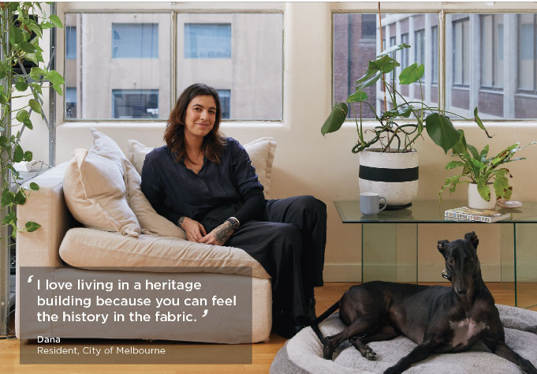
Image 9 Dana sitting in heritage residence with their dog

How heritage can create distinctive places and neighbourhoods
Heritage is what makes Melbourne different. Country, history, place and water have shaped the Melbourne of today. They give our city its special character and the distinctiveness that drives our visitor economy, attracts creative industries and businesses and makes Melbourne a great place to live, work and play.
Melbourne boasts established neighbourhoods with distinct cultural identities, from the Italian enclave of Lygon Street in Carlton to the longest-continuing Chinatown in Australia. Through it all is the ongoing cultural heritage of the Wurundjeri Woi-wurrung and Bunurong / Boon Wurrung peoples, and other Aboriginal and Torres Strait Islander peoples who connect to this place. The city blends well-preserved Victorian architecture with cutting-edge modern landmarks. From the iconic Flinders Steet Station to the world heritage-listed Royal Exhibition Building and the contemporary marvels of heritage-listed Federation Square, the city’s architecture, vibrant streets and iconic laneways mirror its evolving cultural narrative.
Planning for the city’s future is integral to its sustainability, prosperity and distinctiveness. From an early focus on building controls to more strategic planning in the 1980s that highlighted Melbourne’s unique character and the role of parks, boulevards and historic precincts, our role has always been to care for what makes it special.
The full public value of heritage is not well understood. Heritage can play a vital role in shaping the future. Conserving heritage is not about creating monuments frozen in time – instead, it is a way of managing change to celebrate the defining elements of our history. Change includes alteration, development and adaptive reuse; indeed, the best way to conserve a building is to keep it in use.
People’s changing view of heritage and its cultural significance is critical to shaping this process. Heritage is one of the planning goals in Victoria and must be considered alongside other priorities in achieving net public benefit.
Caring for heritage can also contribute to other planning goals, such as economic or environmental benefit.
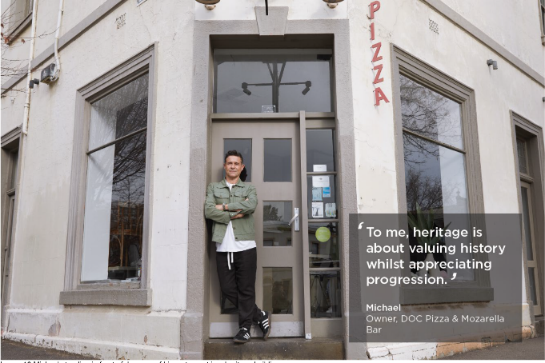
Image 10 Michael standing in front of doorway of his restaurant in a heritage building

Opportunities and challenges
Heritage is an opportunity to shape better places, not to create a barrier to change. We can celebrate heritage as an important feature of our city’s sustainable development and economic growth, and there are many examples of how heritage has facilitated high-quality design. Heritage buildings can be adapted and complemented by modern additions, giving places another life and meaning – ensuring they continue to contribute to our city’s culture and story. Heritage places can also complement more affordable housing and increase in supply by playing a role in shaping high quality design and planning of better quality and denser housing. The relationship between heritage and housing supply and affordability needs to be better understood as we work to tackle the housing crisis.
However, through our engagement on the Discussion Paper, we heard that we need to find ways to protect what is important while allowing our city to grow and prosper. Survey and workshop feedback reminded us that urban living should be accessible and heritage should not be a barrier to a more inclusive city.
‘City identity’ and ‘place’ were the two most important benefits of heritage identified by survey participants. Nevertheless, most survey participants felt that we do not provide the right balance between heritage protection and opportunity for new development. Some said heritage has a negative effect on housing which is a growing issue; others were concerned about the quality of new developments and missed opportunities for placemaking and integration. Some felt that developers were winning out over residents and communities advocating for heritage protection.
We heard that Country can be hard to discern and we need to do more to make Country legible – reflecting the views, waterways, landforms and topography that shaped Melbourne and restoring some of the lost indigenous species and planting that once dominated.
We heard about the need for innovative heritage planning and processes, such as engaging communities more, so that underrepresented stories can be acknowledged. Others said heritage processes and systems are not always easy to understand. People asked how we can protect places that are important for their social function, such as a pub, cafe or a much-loved venue. Some were concerned about preserving individual sites: keeping the facade may not be sufficient because the heritage is inside the building, but, in most cases, interiors are not protected.
There were mixed views on the need for flexibility in managing changes to heritage, with equal numbers of survey participants advocating for more, less or targeted flexibility. Some felt that heritage protection might be driving construction in greenfield developments, while others were concerned at the perception that heritage is anti-
development, rather than part of the evolving story of Melbourne. We need to better understand the contribution that heritage makes to tourism, character, amenity and liveability, and the retention of unique skills and trades.
Our new neighbourhood model provides an opportunity for people-centred heritage. It uses a place-based approach to bring diverse perspectives into neighbourhood planning by understanding the priorities of residents, students, businesses, workers and visitors.

Our priority
We will celebrate and preserve the city’s diverse cultural heritage. We will embed heritage into planning and design at an early stage to ensure that the distinctive and special qualities of the city and its neighbourhoods continue to be legible and inform the way they grow.
We will collaborate with others to explore the following actions:
  - Empowering Traditional Owners and broader Aboriginal community to play a greater role in embedding Aboriginal cultural heritage in future planning and design, potentially through an Aboriginal Cultural Heritage Framework.
  - Identifying view lines of Country and exploring how their importance and meaning can be better understood.
  - Fostering creative methods of engagement that encourage active participation in shaping our city, neighbourhoods and streets, and community input about what makes neighbourhoods special or distinctive
  - Balancing expert heritage advice on planning decisions, and the views of communities where these differ
  - Continuing to review how we protect heritage to reflect people’s changing perceptions, including post-war heritage, previously unloved heritage such as modern movement buildings, the heritage of under-represented groups or periods and Melbourne’s multicultural communities
  - Actively exploring how heritage data can be publicly available and accessible
  - Promoting examples where heritage has enabled sustainable development, good design, and economic activity
  - Exploring the need for improved guidance and mechanisms to assess when economic, social and environmental considerations might override policy objectives to retain heritage fabric.
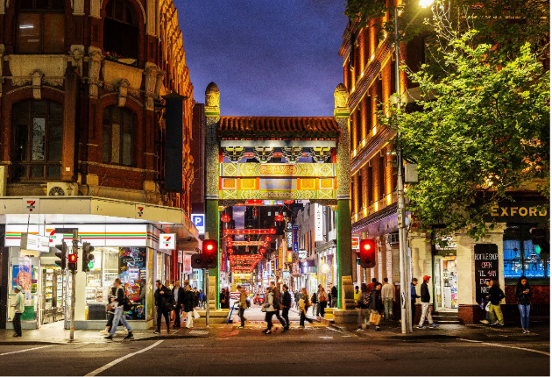
Image 11 People walking through Chinatown, Little Bourke Street

The climate and biodiversity emergency
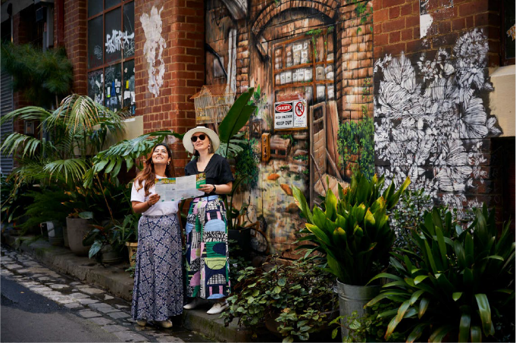
Image 12 Two people standing in Melbourne laneway with planting

The climate‘The greenest building is the one that already exists’
Carl Elefante – former president of the American Institute of Architects

How heritage can help address the climate and biodiversity emergency
Heritage conservation can help address climate change by retaining the energy and carbon embodied in heritage building fabric and by reducing waste.
Existing buildings account for more than two-thirds of energy consumption and emissions in the municipality. However, retrofitting and adapting buildings causes fewer construction emissions than a knockdown rebuild approach. Retrofitting with an innovative design can improve environmental performance and liveability. Reusing existing buildings reduces construction waste and avoids demand for new steel or concrete.
Heritage can also foster nature and ecology in the city. Aboriginal approaches to caring for Country, including knowledge of indigenous plant species, have much to teach us about biodiversity and ecological resilience. Many of our major parks and green spaces are cultural heritage assets. Our system of local heritage protection also involves protecting urban trees, and other important trees are protected through our Exceptional Tree Register. Our canopy contributes to ecological resilience and cooling the city.
On the other hand, climate change-driven fire, flood and extreme weather events pose a risk to heritage. Existing buildings may need to be adapted to respond to more extreme weather. Loss of cultural heritage, including places, stories and treasured items, can have a significant impact on individuals and whole communities.

Opportunities and challenges
In 2019, City of Melbourne declared a climate and biodiversity emergency. We are committed to net zero emissions by 2040. Our Climate Change Mitigation Strategy commits us to four priorities for achieving our emissions reduction targets. Heritage can contribute to two of these: zero emission buildings and precincts, and reducing the impact of waste.
To reach zero emissions, the city’s buildings must be transformed – so we are driving better reuse of existing buildings, including heritage buildings. Our Retrofit Melbourne framework helps facilitate investment to retrofit mid- tier commercial buildings to make them zero-carbon ready. The heritage sector is also learning more about modest retrofit mechanisms that may not always need a permit, such as improving heating and cooling systems, secondary glazing and insulation. However, we learned from workshop feedback that the private sector continues to struggle with meeting heritage requirements as well as building codes designed for modern buildings.
Making better use of existing buildings and infrastructure, including heritage buildings, can reduce waste. Cities consume three-quarters of all natural resources globally, which is why Melbourne has adopted the principles of the circular economy. A circular economy designs out waste, keeps products and materials in use, and preserves and regenerates natural capital.
Industry experts told us that we need to do more to incentivise retrofitting heritage buildings. Challenges include the need for specialist materials and modern standards for thermal comfort. Although installing solar panels on heritage buildings has benefits, there is debate about how best to do so. People also asked for more information about retrofitting and suggested incentives such as targets and rewards for sustainable retrofits.
Going beyond heritage, the bigger and more strategic challenge is to acknowledge the value of embodied energy in existing buildings, whether listed or not, and to encourage their reuse. There is a risk that current energy efficiency ratings can create unintended incentives to demolish existing buildings.
We also have an opportunity to strengthen the link between heritage and nature in the city. Our ambition is for thriving biodiversity and ecosystem resilience. As we protect heritage trees and facilitate the greening of buildings and heritage laneways, we can also increase people’s thermal comfort on the streets.

Our priority
We will contribute to our zero emissions target by encouraging the retrofit and reuse of existing buildings to make use of their embodied carbon, and contribute to nature in the city by protecting heritage trees and encouraging initiatives such as greening historic places.
We will collaborate with others to explore the following actions:
  - Helping achieve zero-emission buildings and precincts by exploring the need for clearer guidance or policy updates to guide how to retrofit heritage and older buildings, including strategies for addressing issues such as glazing, solar panels and particular types of heritage, such as post-war buildings
  - Adopting circular economy principles by making better use of existing buildings and promoting examples of adaptive reuse
  - Exploring ways to address both energy efficiency and cultural significance in heritage buildings
  - Understanding more about the value of embodied carbon in existing buildings, including heritage buildings, in decarbonising construction
  - Protecting heritage trees and encouraging new planting associated with heritage spaces and buildings
  - Increasing indigenous plant species in heritage projects, drawing on Aboriginal knowledge and expertise
  - Advocating for incentives to promote retrofit and adaptive reuse as an alternative to new construction
  - Considering whether planning permits should continue to be required for visible solar panels on local heritage places across the municipality.

Stewardship and biodiversity emergency
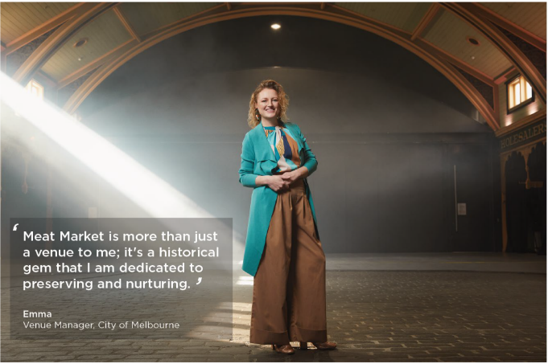
Image 13 Emma standing inside heritage venue Meat Market in North Melbourne

The value of stewardship
Practising heritage in all forms is about stewardship – caring for the things people value and want to pass on to the future, whether physical or intangible.
Stewardship starts with everyday care. It can include maintaining or repairing things to extend their life. Keeping things in use is one of the best ways to sustain our heritage, whether languages, traditions or buildings. Traditional Owners have an ongoing stewardship role in caring for Country and people on Country.
Caring for our shared heritage creates wider public value. There are economic, social, environmental and cultural benefits from caring for heritage. It delivers wider rewards, from the mental health benefits of connecting with stories and seeing one’s history acknowledged, to the economic impact of the heritage sector. Importantly, caring for heritage does not stop change – it is simply a starting point for how we shape the future. Innovative design, writing and creativity often spring from exploring, honouring and reimagining our past.
At City of Melbourne, we are proud heritage stewards. We care for a portfolio of heritage buildings, open spaces and collections. Some are open to the public and others support our core services and functions. We also assist others to care for their heritage, helping them keep heritage buildings in use and providing support for conservation through our Melbourne Heritage Restoration Fund. We work in partnership with a range of community and not-for- profit organisations that care for Melbourne’s heritage.

Opportunities and challenges
We have already highlighted how caring for heritage contributes to wider City of Melbourne goals, from planning and placemaking, addressing climate change and reducing waste, to the visitor and creative economies. There are a range of tools, such as conservation management plans, that can help property owners or managers care for their buildings in a way that also respects their cultural significance.
But stewardship is not always easy. As a property manager, we know how important it is to maintain and manage what we have. Day-to-day maintenance – sometimes known as preventative conservation, or repair works are vital,
but often unglamorous aspects of caring for heritage and can require access to heritage craft skills or Traditional Owner knowledge in caring for Country. Property managers can face technical challenges.
Engagement participants told us that we need to do more to acknowledge the value of heritage, including the wider cultural and social benefits. We heard that we need to do more to recognise unsung heritage heroes – the community groups and individuals who play a vital role in caring for our past. We were reminded of the benefits of adaptive reuse as a way to care for heritage places and deepening their history, allowing existing buildings to be reinvigorated as they are repurposed as spaces for housing and commercial uses such as the recent City of Melbourne Make Room initiative. Participants pointed to examples of arts organisations that reuse heritage buildings, keeping them in community use while protecting urban distinctiveness.

Our priority
We will take a sustainable approach to heritage stewardship, in a way that recognises not just why heritage matters to people, but also the wider social, economic, place-based and cultural impacts and benefits of conserving it.
We will collaborate with others to explore the following actions:
  - Showing leadership through the stewardship of our own properties, collections and open spaces, by maintaining and managing them well and ensuring that they are accessible and inclusive
  - Finding ways to better engage with heritage managers and custodians, including Traditional Owners, community groups, businesses and individual owners, and creating regular opportunities for these groups and individuals to come together and share knowledge and information
  - Seeking to understand the barriers that prevent people and organisations from caring for and investing in heritage and exploring ways to address barriers to adaptive reuse
  - Complementing our program of arts research with heritage research to understand more about how it creates public value for the municipality
  - Exploring ways to celebrate Melbourne’s unsung heritage heroes, including community groups and individuals who are leading the way in caring for, researching or interpreting heritage.

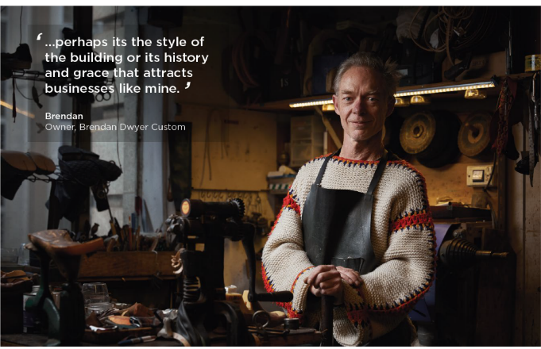
Image 14 Brendan standing in his workshop in the Nicholas Building

Next steps

Finalising the strategy
This draft Strategy is a high-level document prepared in response to engagement and consultation on our Heritage People and Place Discussion Paper. It ensures that the strategy is based on an understanding of what the community wants.
We will conduct further engagement on this draft. The community’s feedback and our collaboration with Traditional Owners and other key stakeholders will inform our final strategy.
Before publishing the final version, we will host a formal public engagement and review the document based on further internal and external feedback. The strategy will also be reviewed against City of Melbourne priorities and include a detailed implementation plan with agreed actions and timeframes.
By grounding this draft in a rich understanding of community needs, we have created a foundation for a broad, people-centred, city-wide approach to heritage.

Monitoring and review
Once the strategy and priorities are finalised, it will set specific short- and long-term actions that can be regularly reviewed against our five overarching priorities. We will also assess how to track progress against those actions and review the plan, identifying specific outcomes linking heritage to achieving wider City of Melbourne outcomes and goals.
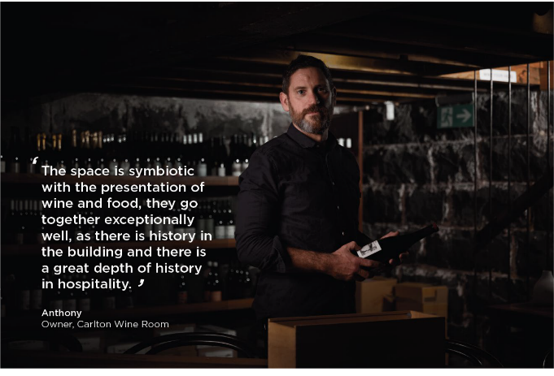
Image 15 Anthony standing in wine cellar of restaurant in heritage building

Glossary
Burra Charter - The basic principles and procedures to be followed in the conservation of Australian heritage places, published by ICOMOS Australia.
Country – a term Aboriginal people use that can be described as the lands with which they have a traditional attachment or relationship. Caring for Country is an approach that embraces the Aboriginal philosophy that if we care for Country, Country will care for us.
Cultural heritage – Victorian heritage legislation refers to Aboriginal cultural heritage and uses the term heritage to refer to non-Aboriginal heritage. However, cultural values are central to both.
Heritage – what people value and want to pass on to the future. It includes Aboriginal cultural heritage and historic heritage, and tangible and intangible heritage. Some but not all of that heritage is formally protected.
Heritage activities – used here to mean the many ways people actively engage with heritage, including their heritage or that of others, including researching family history or restoring vintage vehicles or buildings.
Heritage assets – the things people value and want to pass on to the future including physical things such as buildings, places, landscapes or objects and intangible heritage such as traditions, stories and memories.
Heritage building – formally defined in heritage legislation as a building that is a place, or forms part of a place, that has been given heritage protection under a planning scheme.
Heritage experiences – the different ways that people encounter the past in their lives and as residents, workers and visitors, including public programs and events, exhibitions, walks, signage and digital media.
Heritage Overlay – one of several overlays in the Victorian Planning Provisions. The Heritage Overlay protects sites with heritage value and includes lists of places of local and state significance.
Intangible heritage – things people value that don’t have a physical form, such as knowledge, skills and languages. They are not usually protected in planning but can be protected through intellectual property rights.
Interpretation – the different ways of telling stories that enable people to encounter and understand the past, whether online or in-person, including exhibitions, productions, events, public programs, artworks, talks, plaques and signage.
People-centred approach – a way of working that recognises that heritage is what people value, that it delivers wider benefits, and that it is important to involve people and communities in heritage activities and in caring for heritage assets.
Planning scheme – A statutory document setting out objectives, policies and provisions relating to the use, development, protection and conservation of land in this area to which it now applies.
Protected heritage places – buildings and sites formally protected under local, state or national heritage legislation, including places under World Heritage, the Victorian Heritage Register and the Heritage Overlay.
Statement of Significance – a document that describes what, how and why a place has heritage significance. It is incorporated into the planning scheme and guides planning decisions.
Sustainable development – development that meets the needs of present generations without compromising the ability of future generations to meet their needs. The United Nations 2030 Agenda for Sustainable Development was adopted by member nations in 2015.
Sustainable development goals – 17 goals that provide a roadmap for global efforts to achieve sustainability to 2030 and beyond. City of Melbourne is committed to the goals as a framework for shaping action.
Tangible heritage – heritage that has a physical form such as buildings, places, landscapes, collections and infrastructure. It distinguishes physical heritage assets from intangible heritage assets.
Victorian Heritage Register – lists places deemed to be of cultural significance to the State of Victoria. Places on the list are protected by Heritage Victoria under the Heritage Act 2017.
Wellbeing – wellbeing approaches to policy go beyond macroeconomic statistics to recognise that social progress is about improving the wellbeing of people and households. Local councils have a role in supporting community members to achieve optimal health and wellbeing under the Victorian Public Health and Wellbeing Act 2008.
Australia’s new wellbeing framework measures our progress towards a more healthy, secure, sustainable, cohesive and prosperous Australia

Bibliography
Australian Institute of Aboriginal and Torres Strait Islander Studies, 2020, ‘AIATSIS Code of Ethics for Aboriginal and Torres Strait Islander Research’, AIATSIS website: https://aiatsis.gov.au/sites/default/files/2022-02/aiatsis- code-ethics-jan22.pdf
Australian Institute of Aboriginal and Torres Strait Islander Studies, ‘The benefits associated with caring for country – literature review’, AIATSIS website: https://aiatsis.gov.au/sites/default/files/research_pub/benefits-cfc_0_2.pdf
Commonwealth of Australia, 2023, ‘Measuring what matters – national wellbeing framework’, Treasury website: https://treasury.gov.au/policy-topics/measuring-what-matters
Capire Consulting Group, 2024, ‘Heritage, people and place discussion paper 2024 – engagement report’. City of Melbourne, ‘Mapping Aboriginal Melbourne’: https://aboriginal-map.melbourne.vic.gov.au
City of Melbourne, 2013, ‘Heritage Strategy 2013’
City of Melbourne, 2015, ‘Aboriginal Heritage Action Plan 2015–18’: https://www.melbourne.vic.gov.au/SiteCollectionDocuments/aboriginal-heritage-action-plan-2015-18.pdf
City of Melbourne 2016, ‘Plaques and Memorials Policy’: https://www.melbourne.vic.gov.au/SiteCollectionDocuments/policy-plaques-memorials.pdf
City of Melbourne 2016, ‘Future Melbourne 2026’: https://www.melbourne.vic.gov.au/SiteCollectionDocuments/future-melbourne-2026-plan.pdf
City of Melbourne, 2017, ‘Nature in the City – thriving biodiversity and healthy ecosystems’: https://www.melbourne.vic.gov.au/SiteCollectionDocuments/nature-in-the-city-strategy.pdf
City of Melbourne 2018, ‘Climate Change Mitigation Strategy to 2050: Melbourne together for 1.5 C’: https://www.melbourne.vic.gov.au/about-council/vision-goals/eco-city/Pages/climate-change-mitigation- strategy.aspx
City of Melbourne 2018, ‘Creative Strategy 2018–2028’: https://www.melbourne.vic.gov.au/sitecollectiondocuments/com-creative-strategy.pdf
City of Melbourne 2019, ‘Waste and resource recovery strategy 2030’: https://www.melbourne.vic.gov.au/SiteCollectionDocuments/waste-resource-recovery-strategy.pdf
City of Melbourne 2020, ‘Heritage Owner’s Guide’: https://www.melbourne.vic.gov.au/building-and- development/heritage-planning/heritage-owners-guide/Pages/heritage-owners-guide.aspx
City of Melbourne 2021, ‘City of Melbourne City of Possibility: Council Plan 2021–25’: https://www.melbourne.vic.gov.au/SiteCollectionDocuments/council-plan-2021-25.pdf
City of Melbourne, 2021, ‘(Innovate) Reconciliation Action Plan June 2021–June 2023’. City of Melbourne, 2021, ‘Future Libraries Framework 2021’.
City of Melbourne, 2021, ‘Community Engagement Policy’: https://www.melbourne.vic.gov.au/SiteCollectionDocuments/community-engagement-policy.pdf
City of Melbourne, 2022, ‘Inclusive Melbourne Strategy 2022–32’, https://www.melbourne.vic.gov.au/community/strong-communities/Pages/inclusive-melbourne-strategy.aspx
City of Melbourne, 2022, ‘United Nations Sustainable Development Goals: Voluntary Local Review’: https://hdp-au- prod-app-com-participate-files.s3.ap-southeast-2.amazonaws.com/4816/5595/7875/SDGs- FINAL_21_06_2022_4195_Voluntary_Local_Review_ONLINE-compressed.pdf
City of Melbourne, 2023, ‘Heritage Design Guide’: https://www.melbourne.vic.gov.au/building-and- development/heritage-planning/heritage-design-guide/Pages/heritage-design-guide.aspx
City of Melbourne, 2023, ‘The Greenline Project Master Plan’.
City of Melbourne 2023, ‘Retrofit Melbourne – framework to enable mid-tier commercial buildings to transition to be zero carbon ready’: https://www.melbourne.vic.gov.au/business/sustainable-business/building- retrofits/Pages/retrofit-melbourne.aspx

City of Melbourne, 2024, ‘Heritage, people and place discussion paper 2024’
City of Melbourne, 2024, ‘Experience Melbourne 2028 – a destination management plan for Melbourne’s visitor economy.
City of Melbourne and Capire Consulting Group, 2024, Engagement Report Summary – Heritage, people and place discussion paper 2024.
Colliers International, 2018, ‘Creative industries in historic buildings and environments: Conservation area case studies’: https://historicengland.org.uk/content/docs/research/creative-industries-case-studies/
Context, 2012, ‘Thematic History – a history of the City of Melbourne’s urban environment’:
Creative Victoria, 2024: https://creative.vic.gov.au/resources/data-insights/victorias-creative-economy

Department of Transport and Planning, ‘Melbourne Planning Scheme 43.01 Heritage Overlay’: https://planning- schemes.app.planning.vic.gov.au/Melbourne/ordinance/43.01
Heritage Chairs and Officials of Australia and New Zealand, 2020, ‘Dharuwa Ngilan: A vision for Aboriginal and Torres Strait Islander heritage in Australia and the best practice standards on Indigenous cultural heritage management and legislation’: https://www.dcceew.gov.au/parks-heritage/heritage/publications/dhawura-ngilan- vision-atsi-heritage

ICOMOS, Cultural heritage and sustainable development: https://www.icomos.org/en/focus/un-sustainable- development-goals/76821-cultural-heritage-and-sustainable-development-2
Jones, RL, Waghorne, J and Langton, M 2024, Dhoombak Goobgoowana: A History of Indigenous Australia and the University of Melbourne, Volume 1: Truth, University of Melbourne Press: https://www.unimelb.edu.au/dhoombak-goobgoowana
NSW State Government, 2023, ‘Connecting with Country Framework – good practice guidance on how to respond to Country in the planning, design and delivery of built environment projects in NSW’: https://www.planning.nsw.gov.au/sites/default/files/2023-10/connecting-with-country.pdf
Public Value Consulting and Extent, 2023, ‘Why heritage; a synthesis of evidence for the social, economic and environmental impact of heritage’, Report for the Heritage Council of Victoria: https://heritagecouncil.vic.gov.au/research-projects/valuing-victorias-heritage/
SHP (Sue Hodges Productions) 2024, ‘City of Melbourne Heritage Interpretation Scoping Study’. Tourism Australia, 2022, ‘Future of Global Tourism Demand’:
https://www.tourism.australia.com/content/dam/digital/corporate/documents/future-of-demand/tourism-australia-
global-future-of-tourism-demand-research-public-report.pdf
United Cities and Local Governments, ‘Culture: Fourth Pillar of Sustainable Development’: https://agenda21culture.net/sites/default/files/files/documents/en/zz_culture4pillarsd_eng.pdf
United Cities and Local Governments, ‘Culture in the Sustainable Development Goals – A guide for local action’: https://uclg.org/sites/default/files/culture_in_the_sdgs.pdf
UNESCO, 2013, ‘The Hangzhou Declaration – placing culture at the heart of sustainable development’
UNESCO, 2017, ‘Culture at the heart of sustainable development goals’: https://www.unesco.org/en/articles/culture-heart-sustainable-development-goals
United Nations, 2030 Agenda for Sustainable Development: https://www.un.org/sustainabledevelopment/development-agenda/
Victorian Aboriginal Heritage Council https://www.aboriginalheritagecouncil.vic.gov.au/

Welsh Council of Voluntary Associations, 2020, ‘The Well-being of Future Generations Act – Ways of working factsheet’: https://wcva.cymru/resources/the-well-being-of-future-generations-act-five-ways-of-working/

