Acknowledgement of Traditional Owners
The City of Melbourne respectfully acknowledges the Traditional Owners of the land we govern, the Wurundjeri Woi-wurrung and Bunurong / Boon Wurrung peoples of the Kulin and pays respect to their Elders past and present.
We acknowledge and honour the unbroken spiritual, cultural and political connection they have maintained to this unique place for more than 2000 generations.
We accept the invitation in the Uluru Statement from the Heart and are committed to walking together to build a better future.

Contents

Introduction 4

Background 5

The Master Plan Refresh 7

Themes for discussion 9

Theme 1 Celebrating Aboriginal Culture and knowledge 10

Theme 2 Caring for nature 11

Theme 3 Continuing the legacy of previous Royal Park master plans 13

Theme 4 Landscape characters 15

Theme 5 Recreation and community wellbeing 18

Theme 6 Visitor experience 20

Theme 7 Movement through and within the park 22

Theme 8 Parking, roads and transport 23

30 October 2023

Introduction
We are refreshing the Royal Park Master Plan to ensure our ongoing management reflects Royal Park’s significance, its diverse values and your aspirations for our largest and most diverse park.
We have a lot of information about Royal Park and now need to hear from you so that we can draw a meaningful vision and guiding principles out of what we know and are learning.
We are thankful to the Traditional Owners of Royal Park, the Wurundjeri Woi-wurrung Cultural Heritage Aboriginal Corporation for sharing cultural values and knowledge with us as we develop this plan. Any sharing of the Aboriginal cultural values of Royal Park will be guided by Traditional Owners and does not form part of the Discussion Paper.
We hope that this Discussion Paper will prompt you to consider new information, to reflect on what Royal Park means to you and to engage with us as we seek to learn from you.
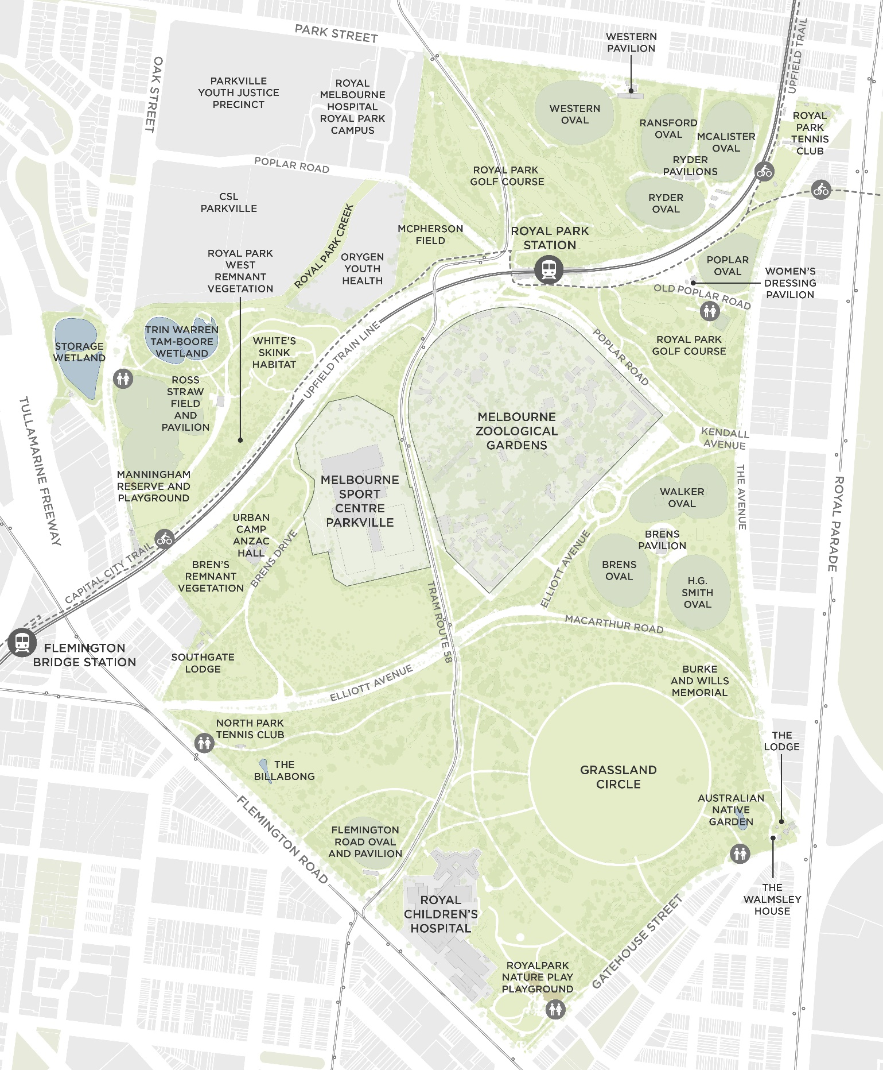
Figure 1. Royal Park

Background
Royal Park is on the land of the Wurundjeri Woi-wurrung people of the Kulin. The Wurundjeri people have cared for this Country for thousands of generations and current archaeological records of the Melbourne area place human occupation at somewhere between 30,000 and 40,000 years ago. The ongoing connection of Aboriginal people to Country, culture and knowledge will be celebrated in the Royal Park Master Plan Refresh.

What is Royal Park?
Royal Park (Figure 1) is 169 hectares of Crown land which is permanently reserved for public recreation. An area even larger than the current boundaries of Royal Park was originally set aside as a park in 1844, and it was reserved as public parkland in 1854 with the name Royal Park. The City of Melbourne was appointed Committee of Management for Royal Park in 1934. We now perform that role under the provisions of the Crown Land (Reserves) Act 1978.
The study area Figure 1 includes the full extent of Royal Park, as well as:
- The creek line south of Poplar Road, west of the Orygen Youth Health facility
- The western pond of the Trin-Warren Tamboore Wetlands, west of Oak Street
- The former railway reserve between The Avenue and Royal Parade that links through to Princes Park
- The small reserves adjacent to Royal Parade at the north and south ends of The Avenue
The study area does not include Melbourne Zoo or the Royal Children’s Hospital, which have different reservations and are managed as separate entities to the park. The Melbourne Sports Centres Parkville (formerly named the State Netball Hockey Centre) is within the Royal Park reservation but is also managed separately. Some recommendations of the master plan will probably relate to the park interfaces with these facilities.
Figure 2 shows the areas of different management and some land status information.

What guides our planning?
The Crown Land (Reserves) Act 1978 establishes the statutory basis for the protection, use and management of Victoria’s system of parks not owned by other statutory bodies. Royal Park is permanently reserved for public recreation. Council is the Committee of Management for Royal Park under the Crown Land (Reserves) Act.
All tangible and intangible Aboriginal heritage is protected under the Aboriginal Heritage Act 2006.
The Heritage Act 2017 provides a modern framework for the protection and conservation of places and objects of cultural heritage significance. Royal Park is listed as a Heritage Place under this legislation.
The Planning and Environment Act 1987 protects native vegetation and the Flora and Fauna Guarantee Act 1988 (Victorian) and Environmental Protection and Biodiversity Conservation Act 1999 (Commonwealth) are legislation that protect threatened species.
We have to analyse opportunities and make recommendations within a framework of existing policy and context that is outside of the scope of the master plan to change. Some of the key ‘non-negotiable’ elements that we will work around or with are:
- Sites of tangible and intangible Aboriginal Cultural Heritage.
- The Victorian Heritage registration for Royal Park and some individual elements. Royal Park is on the Victorian Heritage Register for its historic and aesthetic significance to the state of Victoria, in particular for its:
  - Importance to the course, or pattern, of Victoria's cultural history. It is a largely intact example of the parks set aside by Governor LaTrobe and was a site for scientific advancement; the starting point of Burke and Wills’ expedition to the Gulf of Carpentaria in 1860 and wartime camps. It is historically significant for its long association with sport in Victoria, especially women’s sport.
  - Possession of uncommon, rare or endangered aspects of Victoria's cultural history, including stands (rather than individual specimens) of remnant indigenous vegetation and a dedication to planting native and indigenous vegetation for over 150 years.
  - Importance in exhibiting particular aesthetic characteristics, such as its notable use of native vegetation, the views to the city and the development associated with the 1984 master plan.
- The principle of no net reduction in area of open space in accordance with Council’s Parks Policy.
- Protection and enhancement of remnant vegetation areas of the park.
- Retention and protection of trees in accordance with Council’s Tree Policy.

The Master Plan Refresh

What does a master plan do?
A master plan sets out the long-term vision and guides the future development and management of a park. The principles and recommendations of a master plan act as the roadmap to the vision from the here and now.

Why are we refreshing the master plan?
Royal Park is one of Melbourne’s most precious and highly valued places. Like many open spaces, it is under increasing pressure from population growth and climate change, both of which can impact on the useability and capacity of the park and the health of the landscape if not carefully managed.
The development and management of Royal Park has been significantly guided over nearly 40 years by two master plans. The first, the 1984 Royal Park Master Plan and subsequent Royal Park Landscape Development Plan (herein collectively referred to as the 1984 master plan) was the result of a public design competition and was a very successful plan that effectively established many of the park forms and uses that are so recognisable today. The 1997 Royal Park Master Plan (herein referred to as the 1997 master plan) reinforced much of the direction of the 1984 master plan and updated some actions to respond to the challenges of the time.
The master plan refresh will review and update the 1997 master plan, continuing with the aspects that have proved successful and enduring, updating others and introducing new themes to reflect contemporary practice and values, particularly relating to Aboriginal culture and knowledge, the climate and biodiversity emergency and a health and wellbeing crisis.
This master plan will guide our planning and management of Royal Park for the next 20 years.

What do we know?
We know a lot about Royal Park; we’ve been managing it for a long time. We’ve done a lot of recent work to understand some issues in greater depth, and are very interested to hear from you to validate or challenge our findings and to learn what your priorities are.
We are also very aware that our knowledge and experience of Royal Park cannot compare to the cultural knowledge and connection to Country of Traditional Owners. We are committed to learning more about how ‘Caring for Country’ knowledge and practices can be applied through the master plan.
We know that Royal Park is well-loved and it is serving the community well. It received an extremely high satisfaction rating in our most recent annual parks survey. But we know that some areas are not meeting the needs of the community and other areas are under pressure from inappropriate uses or overuse. The impacts of climate change, in particular of increased heat and reduced rainfall, will reduce the capacity of Royal Park’s living landscape to cope with these pressures.
We know that the population of surrounding areas is increasing and that Royal Park is the nearest and best park option for many people to visit. For many, it’s where they watch or play sport and where children play. The two playgrounds get thousands of uses between them on a warm day and sports fields are being used at their capacity.
We know that walking is the most popular activity in Royal Park and that you can go for a long walk to all corners of the park using the path network, although you will have to cross roads, the train line and tram line to fully explore. We also know that the paths in some areas can be crowded with walkers, riders, dogs and golf carts, and that there are sometimes conflicts between those users.
We have learned that some people don’t feel safe in Royal Park and that the reasons for this are quite varied. Others value the more isolated areas where they can experience a quietness and closeness to nature that is rare in the city.
We know that Royal Park is a hotspot for citizen scientists, bird watchers and nature observers and that there are very active and passionate community groups organised around enhancing and protecting the environmental values of Royal Park. We know that Royal Park is a regular stopping point for threatened species, including the EPBC-listed Grey-headed flying fox and it contains a regionally significant population of White’s Skink.

What’s the process?
There are many opportunities over November and December for you to be involved in providing feedback on the Discussion Paper and to contribute to the development of the draft master plan refresh. Follow our Participate Melbourne page to be notified of all the engagement activities we’ve got planned and select some (or all) to participate in.
Once we’ve wrapped up engagement on this discussion paper, we’ll get to work on the draft master plan refresh. We’ll bring that back to you for further feedback early in 2024 with a view to having the final Royal Park Master Plan Refresh completed around mid-2024.
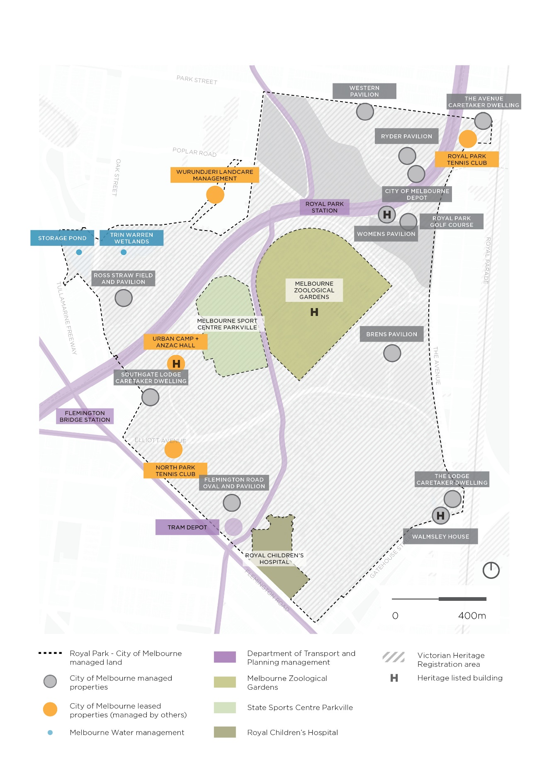
Figure 2. Royal Park management areas

Themes for discussion
We have organised the information we have into eight themes to guide discussion.
The themes are broadly consistent with principles identified in the 1984 and 1997 master plans, with some updating to reflect contemporary practice and values relating to Aboriginal culture and knowledge, the climate and biodiversity emergency and a health and wellbeing crisis.
The themes are:
Theme 1 Celebrating Aboriginal culture and knowledge
Theme 2 Caring for nature
Theme 3 Continuing the legacy of previous Royal Park master plans
Theme 4 Landscape characters
Theme 5 Recreation and community wellbeing
Theme 6 Visitor experience
Theme 7 Movement through and within the park
Theme 8 Parking, roads and transport

How to read this document
Each theme section includes a background and brief exploration of the current issues relating to that theme. Based on what we know and are learning, we’ve identified key areas that we think the master plan refresh will need to explore. The lists are not exhaustive.
Each theme also includes a ‘what if’ statement that asks you to imagine a scenario. The purpose of these statements is to get you thinking about a particular aspect of the theme that we tend not to hear as much about. Consider what it would look like for the statement to be true? Would it change your experience of Royal Park? How? We’d love for you to keep these statements in mind as you provide input on the interactive map, come to a pop-up in the park or participate in a workshop.
Each theme also has at least one related question included in our survey. You can complete the survey online at Participate Melbourne or in hard copy at one of our events.

Theme 1
Celebrating Aboriginal Culture and knowledge

Background
The Wurundjeri Woi-wurrung are the Traditional Owners of Royal Park and its surrounds.
Aboriginal Cultural Heritage refers to the physical and spiritual expression of Aboriginal people's cultural identity. It encompasses intangible elements like mythology, language, and spirituality, as well as tangible forms such as scarred trees, ceremonial sites, camp sites, and meeting places.
The Victorian Aboriginal Heritage Act 2006 recognises Registered Aboriginal Parties (RAP) as the primary guardians, keepers and knowledge holders of Aboriginal Cultural Heritage. Prior to 1 July 2021, there was no RAP for the southern half of Royal Park (from Macarthur Road / Elliott Avenue south to the park boundary) and the Wurundjeri Woi-wurrung Cultural Heritage Aboriginal Corporation was the RAP for the area to the north of Macarthur / Elliott. On 1 July 2021, the RAP boundary of the Wurundjeri Woi-wurrung Cultural Heritage Aboriginal Corporation was extended to include the whole of Royal Park.
We are committed to raising awareness and promoting Melbourne’s Aboriginal Cultural Heritage, including through initiatives of the Council Plan 2021–25 and the Innovate Reconciliation Action Plan 2021–23.

What are the current issues?
Recognising Traditional Owner connection to Country has the potential to enrich everyone’s experience of Royal Park. Previous Royal Park master plans were silent on Aboriginal culture, heritage and knowledge, however we know that the area now known as Royal Park has been occupied and managed by Aboriginal people for thousands of generations, and that it holds important associations for the Aboriginal history of Melbourne.

Master Plan Refresh to consider
- Identifying ways to celebrate Aboriginal culture and knowledge, guided by what we are learning through extensive and ongoing engagement with Traditional Owners to identify Aboriginal Cultural Values in Royal Park. This will only be in accordance with the wishes and under the guidance of the Traditional Owners.
- What the threats to the Aboriginal Cultural Values of Royal Park are and how they can be managed and mitigated.

What if?

Your experience of Royal Park was enriched through an understanding of Aboriginal culture and the connection to Country of the Wurundjeri Woi-wurrung Traditional Owners.

Use your imagination! What would it look like for this statement to be true?

We want your thoughts
How would you like to acknowledge and celebrate Aboriginal Culture and connection to Country at Royal Park?

Theme 2
Caring for nature

Background
Royal Park is home to a diverse range of flora and fauna, with many species found nowhere else in the municipality. Royal Park contains the only remnant stands of indigenous vegetation and is the most ecologically diverse site within the City of Melbourne. This provides opportunities to implement or contribute to biodiversity projects which are not possible in other park locations.
Due to its size and native vegetation character, Royal Park has higher biodiversity value than other parks in the city.

What are the current issues?
Caring for nature in Royal Park requires a holistic and sustainable approach that may involve researching biodiversity, setting ecological goals specific to the opportunities available in Royal Park, preserving existing habitats, reducing pollution and creating public awareness.
Currently the park is comprised of indigenous and novel plant communities coexisting alongside urban infrastructure including roads, rail, tram, and community and sporting infrastructure. We have been fortunate to develop strong relationships with nearby Universities who have used the park to further research in ecological studies and test various concepts, such as using goats to manage vegetation in the White’s Skink habitat and experimenting with native wildflower meadows. These projects have helped to advance our understanding and management of the park.
City of Melbourne residents surveyed for the Connection to Nature survey in 2019 broadly agree with the statement: ‘biodiversity is fundamental to human wellbeing and supports all systems of life on earth’. Royal Park can play an important role in supporting connections between people and areas of high biodiversity, however population growth may result in the demand for access to nature exceeding supply.
Impacts of a more densely populated urban environment, such as increases in artificial light at night, can be critical stressors affecting biodiversity in urban landscapes. Royal Park is the city’s only deliberately dark open space; the scale of this darkness means it can provide benefits to biodiversity that smaller dark spaces cannot provide. As an urban park with busy transport corridors, including commuter paths, and sports fields within it, there may be a tension between the ecological benefits of darkness and the expectations of some park users for well-lit paths and facilities.

Master Plan Refresh to consider
- Defining ambitious but realistic goals for increased biodiversity in the park
- Identifying which ecological values are being threatened, how they are being threatened, and possible responses to the threat/s
- Supporting ongoing research in Royal Park
- Prioritising best practice nighttime lighting for wildlife principles

What if?
You were a citizen scientist and your observations in Royal Park contributed to the collective understanding of Royal Park’s ecological significance.

Use your imagination! What would it look like for this statement to be true?

We want your thoughts
Have you been involved in any environmental or nature projects in the park in the past 5 years?

Theme 3
Continuing the legacy of previous Royal Park master plans

Background
Royal Park is a successful celebration of the Australian landscape. It has been a space for learning and evolving our knowledge of native landscapes in an urban context. Royal Park was the first site of proactive planning to connect with Australian flora and fauna, without the rigours of English design that defines other large parks in the City of Melbourne.
This celebration and evolution have been guided by two master plans that created a simple and compelling framework. The original was produced in 1984 (with subsequent accompanying Landscape Development and Management Plans) as the winning response to a design competition and refreshed in 1997. These plans are well recognised, particularly in the wider landscape architecture profession, for establishing a new design approach for urban landscapes. The approach valued ‘editing’ or ‘clarifying’ the landscape to achieve the landscape strategies, rather than constantly adding new elements.
Works in the park have been based on this approach over many years and have led to the distinctive park we know today. The simple framework has allowed the park to be managed and to evolve into a rich and diverse grassy woodland, with an impressive growth of tree canopy from 24.8 per cent in 2012 to 30.9 per cent in 2022. Royal Park contains 32 per cent of the trees in Melbourne's urban forest, 19 per cent of our public realm canopy cover, yet retains the expansive grassland areas that allow views to the horizon and sky.
In addition to the principles evoking landscape characters and the approach to park development, previous master plans directed that Royal Park is for people and that its primary purpose is to provide for the activities which are of importance to the community. This is reflected in the 30% of Council’s outdoor community recreation facilities and activities occurring in Royal Park.
The master plan principles underpinning the design for Royal Park are recognised as being aesthetically significant at the state level as contributing to the heritage significance of Royal Park. Our draft Conservation Management Plan recommends that the principles of the past master plans be continued and that future principles should also be responsive to Aboriginal cultural values.

What are the current issues?
While many actions from the current master plan have been realised, some have not. Some have been found not to be viable, others are out-dated or don’t reflect best practice. We have reviewed the status of the actions from the current master plan and have made suggestions for the actions that we feel are appropriate to carry through and those that may be discontinued.

Master Plan Refresh to consider
Outstanding actions that are consistent with the themes outlined in this discussion paper and could be carried through to the refreshed master plan include:
- Crossing the railway in one or more additional locations to physically unite the separated areas of the park
- Consolidating car parking areas in the park
- Actions relating to access, circulation and parking, including the consolidation of car parking areas and the realignment of the Brens Pavilion vehicle entry from Macarthur Road to The Avenue.
- Sports facility upgrades, including reviewing the location of the golf club pavilion
Outstanding actions that are unlikely to be achieved or are no longer practical due to changed circumstances or other reasons include the below:
- Advocating for Macarthur Road to be put into a tunnel is not consistent with our broader transport strategies
- Consolidation of the Western Pavilion and the golf clubhouse west of Western Oval is no longer viable due to the recent redevelopment of Western Pavilion.

What if?
We told the story of the park’s significant and enduring design legacy.

Use your imagination! What would it look like for this statement to be true?

We want your thoughts
What do you believe have been the three most successful projects within Royal Park in the past?

Theme 4
Landscape characters

Background
The four landscape images depicted in the 1984 master plan identified the landscape character aspirations for Royal Park. They are sketches of:
- Landform and horizon
- Sky and wind
- Expansive grassland
- Tree form and silhouette
These images successfully captured the essence of Royal Park at the time and provided a distinctive structure to direct the physical intent of future developments in the park. The sketches and a contemporary interpretation of the each are provided as comparison photographs in Figure 3.

What are the current issues?
The significance and strength of the landscape character sketches as a tool for park planning is recognised in the draft Conservation Management Plan (CMP) we commissioned to help inform the master plan. The draft CMP suggests that future design proposals should remain true to the landscape characters initially identified in the 1984 master plan.
Maintaining these distinct landscape characters while experiencing more challenging climatic conditions and high usage requires us to be diligent about educating planners and maintainers of the landscape significance.
Two notable developments in the park since the 1984 master plan that do not conform to the four landscape characters are the development of the Billabong (between Flemington Road and the North Park Tennis Club) and the Trin Warren Tam-boore wetlands either side of Oak Street.
These two popular and successful water-related projects, along with the more recent reintegration of the creek corridor between Orygen Youth Health and the former CSL site into the park, have highlighted that the four landscape characters do not acknowledge or recognise the significance of water in the landscape.

Master Plan Refresh to consider
- How the landscape characters can continue to be used to guide the design of any new park elements and park management.
- How the connections between areas of different landscape character in the park should be treated, how you should feel as you pass from one character to another.

What if?
We added a fifth sketch representing water to the iconic series of sketches that define Royal Park’s landscape character.

Use your imagination! What would it look like for this statement to be true?

We want your thoughts
Which of the four landscape character sketches resonates most with you?
How strongly do you support that waterbodies or waterways will become more distinctive over time as a new landscape character?

Figure 3. Comparison of the 1984 master plan landscape character sketches against Royal Park today

The 1984 landscape sketches | Royal Park today
  Landform and horizon | 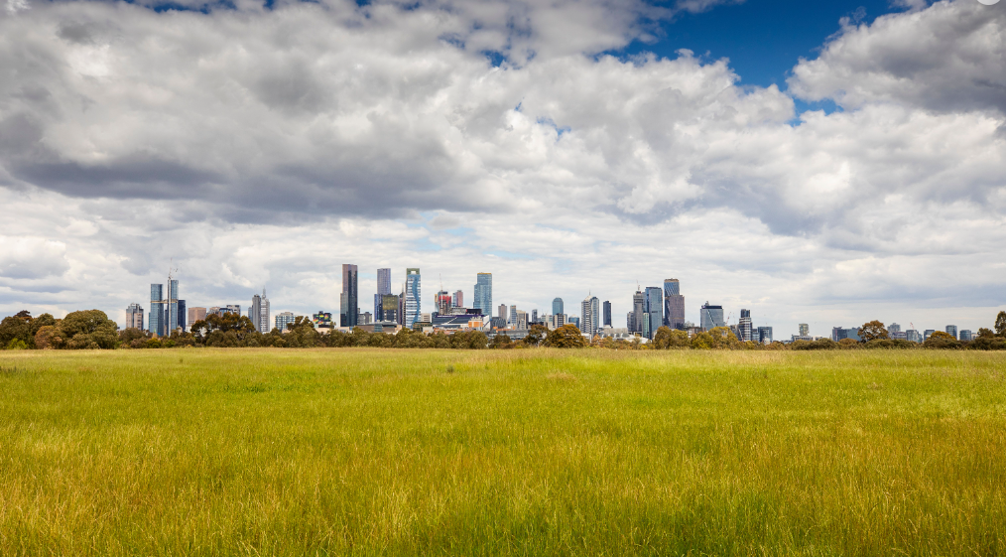  This landscape and view of the city is only possible due to the generosity of size and scale of Royal Park, the absence of buildings and infrastructure, and the careful siting of tree planting.
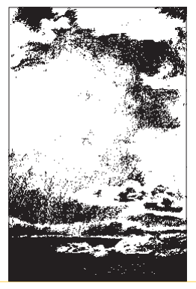  Sky and wind | 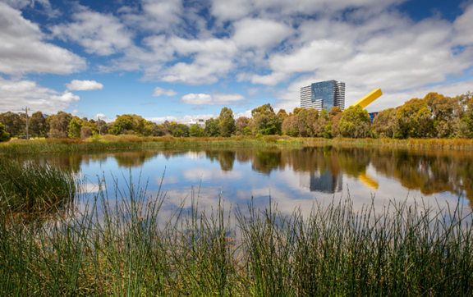  This shows a reflection of sky and wind in the newer landscape character of water.
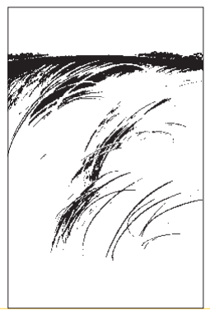  Expansive grassland | 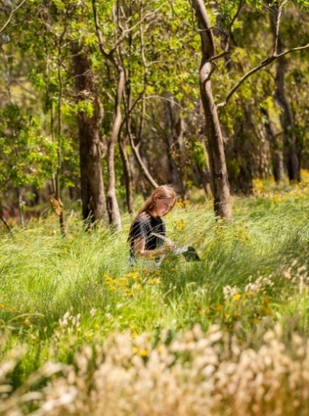  The indigenous wildflower meadow on Gatehouse Street is the modern interpretation of expansive grassland.
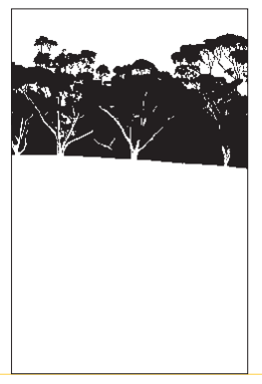  Tree form and silhouette | 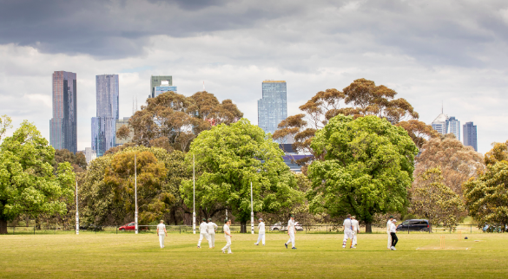  This image shows the frame of tree species around ovals, with taller species behind, creating a recognizable tree form silhouette that is used in signage for Royal Park.

Theme 5
Recreation and community wellbeing

Background
The population of Greater Melbourne is forecast to double to 9 million by 2056. Royal Park’s size, location, existing infrastructure and natural spaces means it can provide many benefits for the people who visit, particularly those engaging in activities that support their health and wellbeing. It also has the capacity to contribute to reducing the health impacts of climate change, particularly extreme heat, by providing areas of relative cool in the hot urban environment.
Royal Park has a long history of being a place for participation in community sport and recreation, both organised and unstructured. It is a place to play organised sport, play casual games, a place to walk or run, or a place to have a picnic or watch birdlife. It supports play, discovery, spontaneity and reflection. It needs to be a place for all ages and abilities.
Informal recreation is the largest use of Royal Park, with non-structured activities including walking, running, sitting, reading, children’s play, keeping fit, dog walking, having picnics, birdwatching, cycling and exploring. As a park of State significance it attracts people from a local, regional and state catchment.
Royal Park has cultural heritage significance to the state of Victoria as a venue for sporting competitions from the 1850s and is particularly associated with women’s sporting history. Royal Park was an important venue for women’s cricket from the early 1900s, girls played netball in the park from the late 1920s and Poplar Oval was the home of women’s amateur athletics from the mid-1930s. Sport has been played in Royal Park from at least the 1850s, with cricket and Australian football having the earliest records. The Royal Park golf course was one of the earliest established on public land in Victoria, in 1903.
Sporting activities at Royal Park tended to be those that required large areas of space that retained an ‘open’ character of the reserve. Tennis courts are the exception to this general rule; the earliest tennis courts were built in Royal Park proper in 1925.
Facilities for community sport and recreation remain a significant part of Royal Park. Some 4500 people are members of sports clubs playing on fields and courts in Royal Park. Royal Park includes 14 outdoor turf playing fields (used for football, soccer, cricket, baseball, rugby, touch rugby and lacrosse), 17 tennis courts, a nine-hole golf course and the Melbourne Sports Centre Parkville (netball and hockey).

What are the current issues?
More than half of City of Melbourne residents (53 per cent) do not engage in the recommended amount of physical activity and around one fifth (22 per cent) spend more than eight hours sitting on an average weekday. These figures highlight how supporting participation in physical activity is a significant health concern for the city.
Social isolation and loneliness is also a rising concern, reinforcing the importance of providing opportunities for community connection. Community connection could be supported through having places and destinations in the park that are welcoming and accessible to all.
Participation in community sport and recreation at Royal Park remains high, however several sports fields have been removed from the park since the mid-1990s and there is significant demand on the remaining facilities. Many are operating very near capacity.

Master Plan Refresh to consider
- Increasing the capacity of existing sports fields so that Royal Park can continue to support participation in community sport and recreation
- Supporting longer stays in the park, especially around play and other gathering spaces, to increase opportunities for social connection
- Identifying cool places in the park that could accommodate people at risk of heat stress on very hot days

What if?
Royal Park is adaptable to different uses as community preferences change over time.

Use your imagination! What would it look like for this statement to be true?

We want your thoughts
What do you currently do in Royal Park to support a healthy lifestyle?
What do you want to be able to do in the future to support a healthy lifestyle in Royal Park?

Theme 6
Visitor experience

Background
Royal Park offers a range of experiences for visitors, from diverse sport fields, to relaxing in nature. Visitation and broad use is supported by the amenities within the park. The term ‘amenities’ describes things like seats, drink fountains, bins, public toilets, lighting, shelters and picnic and barbecue areas. There are many such amenities to support visitation in Royal Park, and most areas of the park have at least one barbecue and picnic area, although the amenities provided at each is not consistent. For example, some picnic areas do not include a drinking fountain and some are quite a distance from the nearest public toilet.
In order to understand more about how women and girls experience Royal Park, we undertook community safety audits in early 2023. This process identified ‘hot spots’ where participants identified amenity and safety concerns, which were then further explored in workshops. The insights and possible solutions that were workshopped have deepened our understanding of how to best support a diverse range of visitor experiences as part of the master plan refresh.

What are the current issues?
In talking about amenity and safety in Royal Park, we often refer to precincts to help clarify the area we’re referring to. These precincts, shown in Figure 4, are mostly defined by the physical barriers in the park. It remains a principle that the whole of Royal Park will be planned and designed according to the landscape characters we talked about in Theme 4, so that the whole park feels like one park, but looking at precincts helps us to understand where there might be gaps in the provision of amenities for those who only use one area of the park.
Royal Park’s size and the physical separations within it mean that some visitors only visit certain precincts and may not be aware of how much there is to do and see in other areas. We understand that visitors tend to stay in the same area of the park and this seems to relate to where they live or where they entered the park. For example, residents of North Melbourne tend to enter from Flemington Road and use the southern area of Royal Park, including the grassland circle, and don’t cross to the north of Macarthur Road / Elliott Avenue as often.
We also understand that some people’s experience of the park is limited by safety concerns; people may avoid some areas at certain times of day or altogether, or only feel comfortable visiting when they’re in a group.

Master Plan Refresh to consider
- What the visitor experience of Royal Park is and how to support the variety of experiences people are seeking
- Reviewing the provision of amenities in each precinct and identifying opportunities to improve provision
- Identifying key areas for safety upgrades

What if?
Royal Park is an attractive destination for visitors with a variety of things to see and do.

Use your imagination! What would it look like for this statement to be true?

We want your thoughts
Which part of the park do you visit or use the most?
Are there are any parts of Royal Park that you don’t like to visit and why?
What additional facilities or amenities would make the park more usable, accessible and enjoyable for you?
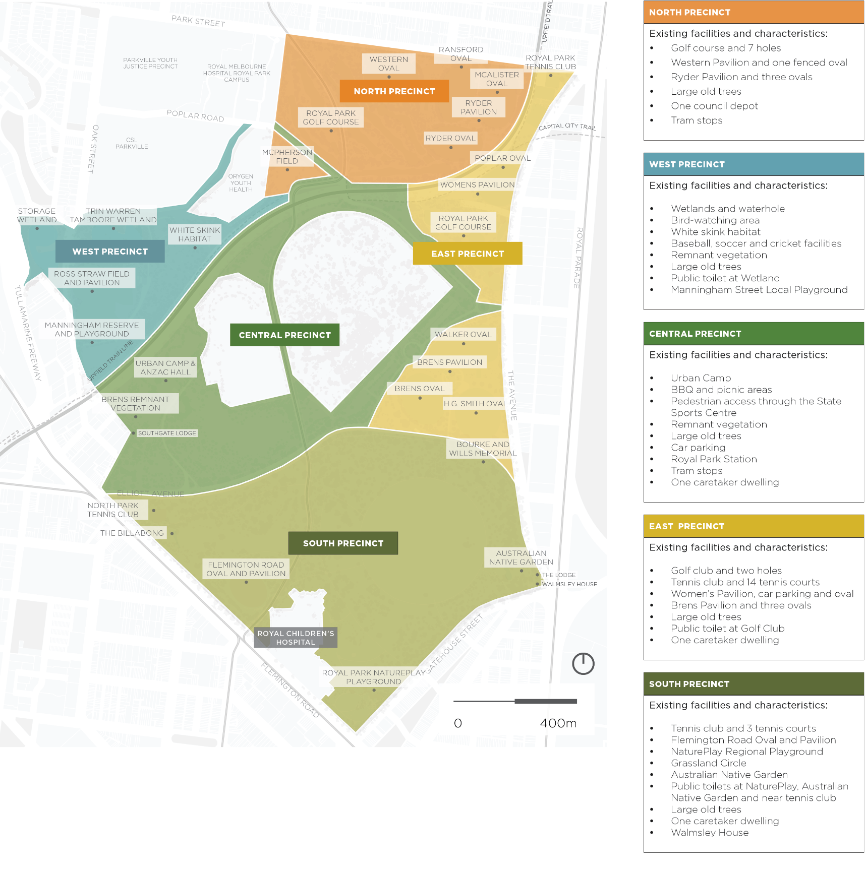
Figure 4. Royal Park precincts and features

Theme 7
Movement through and within the park

Background
Movement corridors provide safe and convenient connections through a large park with a range of regional and local destinations. Royal Park is a great place to walk and many people enjoy cycling through the park for both commuting and recreation. Given the distinctive landform of the park, it provides some of Melbourne’s most scenic commutes into the city. In addition to walking and cycling, thousands of people move through the park each day on trains and trams. Active mobility is a key part of City of Melbourne strategies for healthier lifestyles, as it can be an important contributor to reaching daily physical activity targets.

What are the current issues?
Royal Park plays a critical role in promoting physical activity, environmental sustainability, and social connectivity. However, sub-optimal pedestrian infrastructure and traffic conditions, particularly crossing Macarthur Road / Elliott Avenue, pose challenges to the park's accessibility and safety. By examining the current state of the pedestrian and bike network, analysing the benefits of enhanced walkability, and proposing recommendations, this theme aims to underscore the urgent need for prioritising pedestrian-centric improvements in Royal Park.
In some areas there are barriers to accessing the park via walking and wheeling. A barrier may be a low fence, planting, or lack of path connection from inside the park to the footpath or kerb outside the park. In other areas, the access points are few and far between and don’t allow for easy exploration into the park.
There are disjointed pedestrian and cycle connections through the park. There is no clear hierarchy of paths that makes it clear to people which path is likely to lead to a destination as opposed to a more informal wander. The roads, train line and tram line are major interrupters to most journeys through or within the park.
The safety audits undertaken in the park identified that the lack of lighting reduces accessibility, especially among women, leading to few people using the park during low light periods. People are less likely to travel through the park after nightfall due to safety concerns. This information tells us that the strategic movement corridors through the park as well as the tram stops and train station are probably not performing to their maximum capacity as alternative transport options, especially in winter.

Master Plan Refresh to consider
- Identifying the most important movement corridors and destinations through and within the park for different types of users
- Defining a hierarchy of paths so that through movement doesn’t negatively impact the amenity, safety and permeability of the park
- Identifying key routes or conflict points for safety upgrades

What if?
You felt invited to enter the park and could safely and easily navigate to different areas within.

Use your imagination! What would it look like for this statement to be true?

We want your thoughts
How do you move through or within the park when you visit?

Theme 8
Parking, roads and transport

Background
People travel to Royal Park using a variety of transport modes. These include walking and wheeling, by vehicle and by tram, train or bus. The various transport options influence the physical form of the park, through land allocated to paths, roads, car parking and rail and tram corridors.
It is important that we continue to ensure Royal Park is accessible to all of the community and there is a balance between the different transport options.

What are the current issues?
Royal Park is a destination for people who are local and also for people across the greater Melbourne area. Currently 8 hectares of the park is used for car parking and several road corridors separate areas of the park.
Research has shown much of the 8 hectares of car parking is not regularly used or laid out efficiently, so the area is more than what is required to currently service park users. Repurposing areas currently used for roads and parking is the largest opportunity to increase the size of Royal Park.
Safety audits identified a range of issues and conflicts between people and vehicles in the park. Key issues include but are not limited to car parking encroaching on pedestrian paths, no clear pedestrian crossings from Royal Park Station to the Zoo and limited pedestrian crossings to the park.
The paths, roads and vehicles that provide connectivity for people can also separate habitats, reduce the quality of adjacent habitat, and cause direct injury and mortality of wildlife.

Master Plan Refresh to consider
- Reducing speed limits to increase safety and amenity in and around the park.
- Prioritising walking with clear, safe crossing points through and around the park.
- Improving car parking layouts to make them more efficient.

What if?
Car parking in and around Royal Park was managed in a way that prioritised people visiting the park.

Use your imagination! What would it look like for this statement to be true?

We want your thoughts
What has been your experience of car parking at Royal Park?

