21.16 OTHER LOCAL AREAS
05/10/2018
GC81
The following local area plans provide spatial and built form directions for the remaining neighbourhoods of the municipality.
21.16–1 St Kilda Road and South Yarra
29/01/2015
C225
St Kilda Road remains a premier boulevard containing high density office and residential development. The continued development of the area has necessitated the introduction of a wide range of uses and services to support residents, workers and businesses in the area.
In St Kilda Road and South Yarra, the educational, institutional and research facilities continue to be supported. As South Yarra is an area of stability with minimal potential for new development, residential amenity has been maintained and the area’s historic character and features have been preserved.
Housing
- Support residential development on St Kilda Road within its context as a premier office and residential boulevard.
Economic development
- Support street level convenience retailing and food and drink premises on St Kilda Road to provide for the needs of workers and residents.
- Ensure that the mix of uses does not prejudice the established character of St Kilda Road as a premier office and residential boulevard.
- Ensure Domain Road shopping area maintains its role for convenience shopping, neighbourhood facilities and as a neighbourhood focus.
- Support the ongoing operation and establishment of offices and related commercial developments along St Kilda Road to support its strategic role as a premier office district.
Built Environment and Heritage
- Ensure development in South Yarra is sensitively designed so that it maintains the generally low scale nature of heritage streetscapes and buildings.
- Ensure future development in St Kilda Road respects and maintains the prominence of the landscaped boulevard character which includes generous landscaped front setbacks, the appearance of “buildings in grounds” and established street trees.
- Ensure that building design along St Kilda Road maintains the prominence of views to the Arts Centre Spire and Shrine of Remembrance.
- Ensure that the scale of buildings along St Kilda Road maintain the silhouette of the Shrine of Remembrance.
- Encourage high rise residential and office developments along St Kilda Road.
- Encourage low rise sympathetic infill redevelopment and extensions that complement the architecture, scale and character of the residential areas in South Yarra.
- Protect the Royal Botanic Gardens by limiting the height of developments around the Gardens.
- Ensure that development around Fawkner Park protects the visual amenity of the park and avoids overshadowing.
Infrastructure
- Support medical research and associated medical uses in South Yarra in a cluster near the Alfred Hospital in the Public Use Zone.
- Support the on-going operation of the State significant Alfred Hospital (including direct 24 hour emergency helicopter access) and other institutions on St Kilda Road.
- Support the functioning and growth of education uses in St Kilda Road and South Yarra, consistent with the local amenity at the interface of Residential and Mixed Use zones.
- Preserve and enhance the landscape qualities and recreational role of Fawkner Park.
Figure 16: St Kilda Road and South Yarra
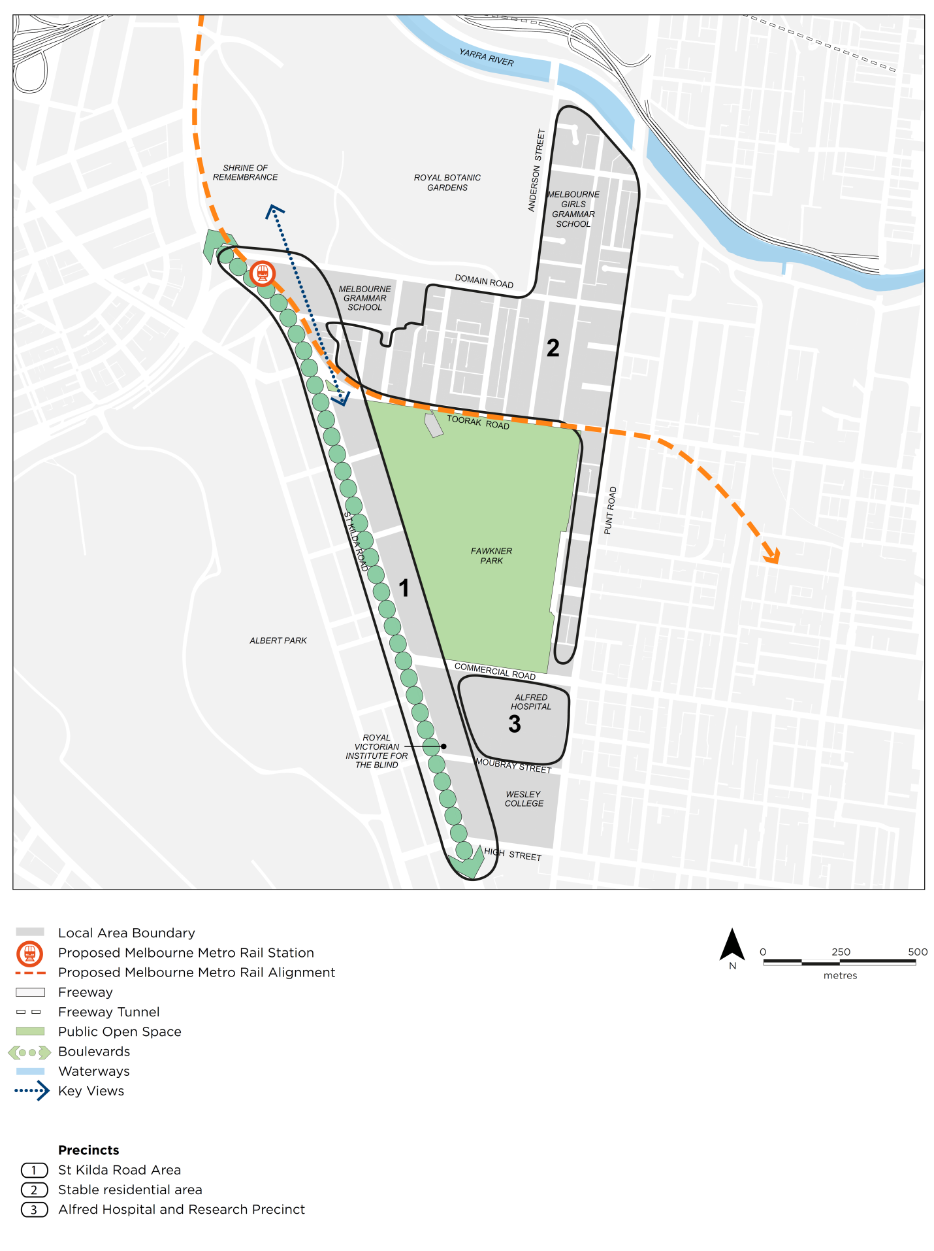
21.16–2 East Melbourne and Jolimont
29/01/2015
C225
The East Melbourne and Jolimont area will continue to accommodate Government facilities, institutions and businesses in the Treasury and Parliament precinct. It has an important role in providing hospital and medical services and supporting Central City edge business uses while maintaining residential amenity through limited development of residential areas.
Housing
- Ensure development in the residential areas of East Melbourne and Jolimont is sensitively designed so that it maintains the generally low scale nature of heritage streetscapes and buildings.
- Support a mix of residential and office development in Commercial Zones in Jolimont.
Economic Development
- Support the continued operation of existing businesses in East Melbourne between Victoria Parade and Albert Street (west of Powlett Street), Wellington Parade and in the Jolimont commercial area.
- Support the government function of the Treasury and Parliament Reserves.
- Discourage medical centres and other commercial uses in the Residential Zones of East Melbourne where they do not serve a local community function or cause adverse impacts on residential amenity.
- Encourage the role of Wellington Parade shopping area for convenience shopping, neighbourhood facilities and a neighbourhood focus.
Built Environment and Heritage
- Ensure any redevelopment of the sites respects the scale of the surrounding residential area, heritage buildings and Fitzroy Gardens.
- Ensure views to the World Heritage Listed Royal Exhibition Building drum, dome, lantern and flagpole from Spring and Nicholson Streets are protected.
- Encourage sympathetic infill redevelopment and extensions that complement the architecture, scale and character of the areas in the low rise areas of East Melbourne and Jolimont.
- Ensure development in the Commercial Zone along Albert Street and Victoria Parade is consistent with the existing scale and character of the area.
- Maintain and enhance the landscape qualities of Victoria Parade boulevard and ensure that buildings along Victoria Parade are designed to enhance its appearance as a major boulevard.
- Ensure that development along Wellington Parade and Albert Street enhances these roads as key entrances to the Hoddle Grid.
- Ensure that development does not adversely affect Fitzroy Gardens, Treasury Gardens or Yarra Park by minimising the visual impact of buildings and overshadowing of the parks.
Infrastructure
- Support hospital, medical and medical research uses in East Melbourne in the Commercial and Public Use Zones.
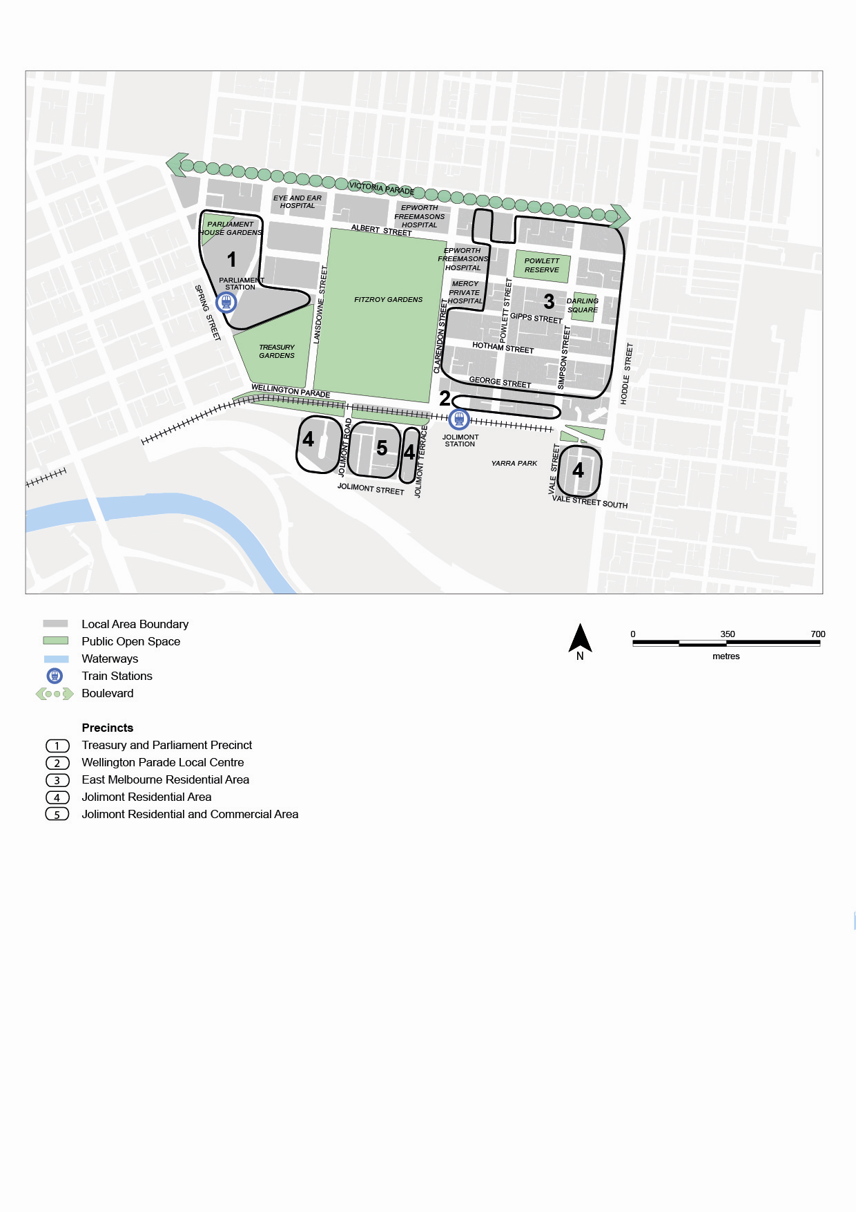Figure 17: East Melbourne and Jolimont
21.06–3 Carlton
29/01/2015
C225
Carlton is a dynamic and diverse local area. It accommodates a range of uses including housing, retailing, entertainment, leisure and cultural activities. Lygon /Elgin Street is an important local shopping centre that also has a regional tourist role based on the popularity of its restaurants. The tourism functions, needs of local residents and the retailing needs of the Commercial Zone in Lygon and Elgin Streets need to be balanced.
Carlton provides for a range of housing needs including a significant amount of public housing and student accommodation.
Carlton will continue to accommodate a mix of retail, commercial, educational, institutional and residential uses of different scales. In the established residential areas it is important that new development maintains the neighbourhood’s amenity and complements the highly valued heritage buildings and streetscapes.
The scale and form of development in Carlton is determined by reference to the cultural heritage significance and preferred built form character of the locality in which the development has established.
Housing
- Support limited residential development which maintains the low scale nature of heritage streetscapes and buildings north of Grattan Street.
- Support further residential development (including student accommodation) along Swanston Street (between Elgin and Victoria Streets). This area will continue to accommodate a mix of land uses including education, commercial, medical and research and development uses. It will develop a new built form character over time.
- Support the on-going use of College Square on Swanston Street and Lygon Street as high density student housing accommodation.
- Support shop-top housing in the Lygon Street shopping strip, ensuring that such uses do not affect the viability of commercial activities operating in the shopping centre.
- Ensure existing levels of social housing are retained in the redeveloped Rathdowne and Nicholson Street Public Housing Estates.
- Support redevelopment of the Queen Elizabeth Hospital site for medium density housing (including a component of social housing).
Economic development
- Support the ongoing tourism, cultural and entertainment role of Lygon Street (south of Grattan Street), Melbourne Museum and the Royal Exhibition Building.
- Support the ongoing regional role of Lygon Street (south of Grattan Street) as a retail, restaurant and entertainment precinct.
- Ensure Lygon Street (north of Grattan Street continues to provide for the convenience retail needs of the local residents and working community while discouraging the encroachment of restaurants and entertainment uses.
- Encourage a mix of retail, tourist and commercial uses around Argyle Square, compatible with the amenity of existing residences.
- Support the ongoing operation and establishment of small scale office and commercial uses (including start-up businesses, consultancies, creative enterprises) in South Carlton, consistent with the local amenity.
- Support the continued operation of service business activity in the Commercial and Mixed Use Zones.
- Encourage small scale office and commercial activities locate along Elgin Street in the existing Commercial Zone.
- Encourage home offices and small scale ground floor office and commercial activities along the Pelham Street axis to promote active street frontages.
Built Environment and Heritage
- Ensure development north of Grattan Street is sensitively designed so that it maintains the generally low scale nature of heritage streetscapes and buildings.
- Support infill residential development in south of Grattan Street where it maintains the predominant low scale nature of these areas and respects the area’s heritage context.
- Maintain a strong contrast in scale between the built form and character of the Hoddle Grid and Carlton at the Victoria Street interface.
- Ensure the scale of development in Victoria Street, west of Carlton Gardens reinforces the distinct contrast between medium rise development in North Melbourne and Carlton, and higher rise development in the Hoddle Grid.
- Ensure that development in the block bounded by Victoria Parade, Drummond Street, Queensberry Street and Lygon Street respects the heritage values of Trades Hall and other significant streetscapes in the area.
- Maintain the predominantly low scale and ensure sympathetic infill redevelopment and extensions that complement the architecture, scale and character of the areas around Carlton Gardens, Lygon Street and residential areas included in the heritage overlay area.
- Ensure any redevelopment of the College Square on Swanston Street creates an environment of high pedestrian amenity along Swanston Street, and respects the scale and form of heritage buildings on Faraday and Cardigan Streets.
- Ensure that the height and mass of new development in proximity to Carlton Gardens and the World Heritage Listed Royal Exhibition Building maintains views of this World Heritage Listed site and does not adversely impact on this significance.
- Ensure development fronting Swanston Street (corner of Victoria Street) positively contribute to the built form character.
- Ensure that development is sympathetic to the heritage values of adjacent heritage areas and places.
Infrastructure
Open Space
- Ensure the retention of all parkland and protect Carlton Gardens, and the Carlton squares (Macarthur, Murchison and Argyle) from uses that would reduce their landscape character and recreational role.
- Ensure any buildings or structures in parks and gardens in Carlton are sensitively designed and located to minimise impacts on the landscape character and recreational role.
Figure 18: Carlton
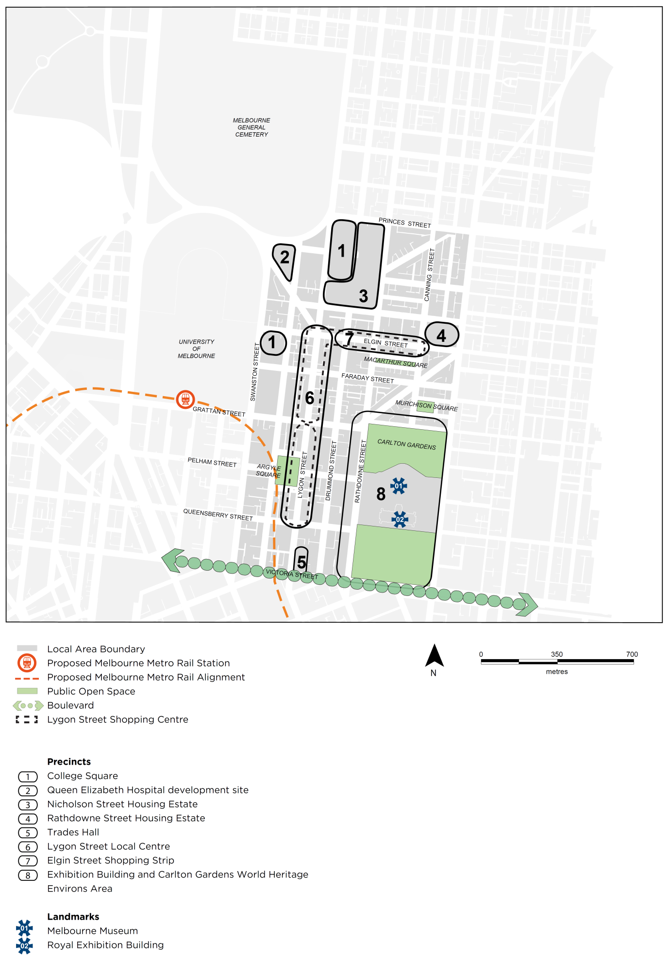
21.16–4 Parkville
29/01/2015
C225
The extensive parklands of Royal Park and Princes Park dominate the land use of this area and provide both local and regional open space.
Parkville has small established residential neighbourhoods, defined by their park context and the high integrity of the heritage buildings.
These will remain residential areas where preservation of heritage and parkland values and maintenance of residential amenity are key priorities. Residential development will be been mainly confined to infill development. More intensive residential development will continue in the Parkville Gardens Estate.
Housing
- Support new residential development in Parkville Gardens, West Parkville.
- Support residential buildings associated with the institutions in the Commercial Zone land along Royal Parade.
- Discourage medical centres and other commercial uses in the residential zones, the stable residential areas of Parkville, except where they serve a local community function and do not cause adverse impacts on residential amenity.
Built Environment and Heritage
- Ensure that the Residential zoned areas of South Parkville, West Parkville and North Parkville maintain their residential character, predominantly low scale nature and heritage context
- Ensure that Royal Park remains the defining feature of Parkville by protecting the landscape character of the Park, preserving the recreational role of the Park and maintaining the open skyline from inside the Park.
- Reinforce Royal Parade and Flemington Road as major tree-lined boulevards.
- Ensure future development along Royal Parade and Flemington Road respects and maintains the prominence of the landscaped boulevard character which includes heritage buildings, landscaped front setbacks and established street trees.
- Ensure the scale of development respects the heritage and parkland values of the area and does not dominate or visually intrude upon parkland, streetscapes or lane-scapes.
- Ensure that new development in North Parkville maintains the existing built form character of buildings in a landscaped setting with generous setbacks from the street and between buildings. At the same time, promote quality building design and a consistent building scale.
- Ensure that development around the perimeter of the Royal Park does not significantly intrude into close range views from Royal Park.
Infrastructure
- Support State significant hospitals (including direct 24 hour emergency helicopter access) and research uses in the public use zoned land along Flemington Road from Elizabeth Street to the Royal Childrens’ Hospital consistent with the local amenity of residential and mixed use zones.
- Support industrial research and development at the Commonwealth Serum Laboratory Limited site to the north of Royal Park, consistent with the local amenity at the interface of residential and mixed use zones.
- Support research and education uses in the Commercial zoned land along Royal Parade in North Parkville, consistent with the local amenity in the Residential and Mixed use Zones.
- Discourage the encroachment of institutional uses into parkland and residential areas.
- Ensure the retention of all parkland and protect Royal Park and Princes Park from uses that would reduce its landscape character and recreational role.
- Ensure that buildings and other structures (e.g. communications infrastructure) in Royal Park and Princes Park are sensitively designed and located to minimise its impacts on the Park’s landscape character.
- Support the on-going operation of the Royal Melbourne Zoological Gardens, while ensuring that the landscape character of Royal Park is maintained.
- Encourage the retention and re-growth of predominantly indigenous vegetation in Royal Park.
Figure 19: Parkville
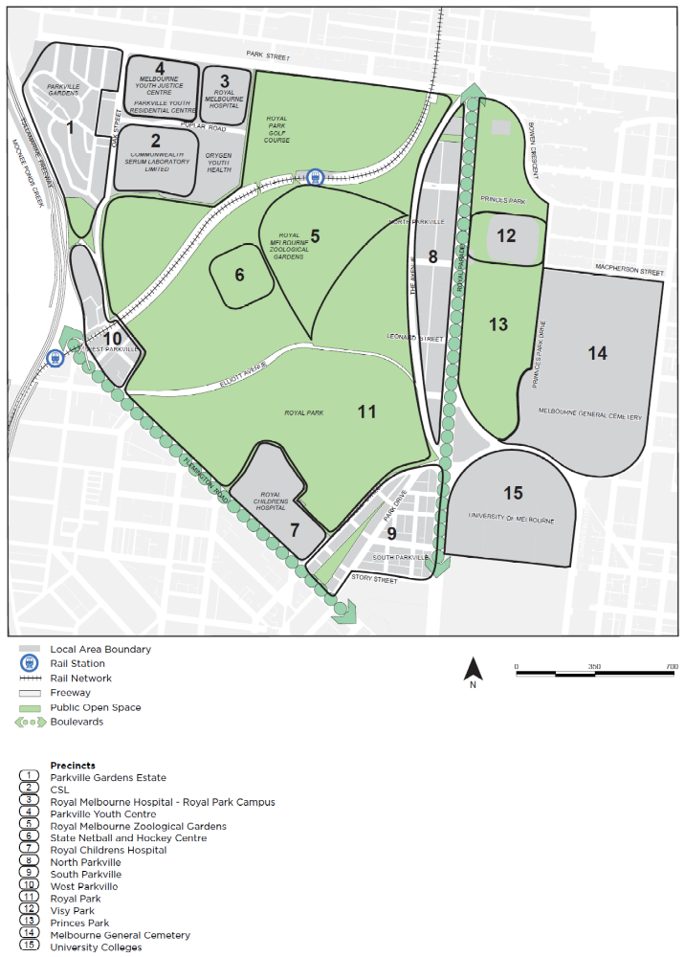
21.16–5 North Melbourne
29/01/2015

Proposed C309
North Melbourne has a strong residential base as well as commercial and industrial uses. Many of the area’s streetscapes and buildings have been recognised for their heritage significance. Flemington Road is a key tree-lined boulevard entry into the City.
North Melbourne should provide a balance of residential and commercial uses that maintains an emphasis on local community and liveability. There should be a clear distinction in scale from the Central City with higher scales of development expected along Flemington Road. In all other areas, a lower scale of development should be maintained.
The role and character of the Errol Street and Victoria Street shopping area should be strengthened, as local community centres.
Housing
- Support residential development in the Hoddle Grid fringe. In this area, increased residential densities should be balanced with the strategic role of this area in providing for small to medium enterprises that support the Hoddle Grid and Docklands.
- Promote the retention and refurbishment of existing public housing estates.
- Support limited residential development that maintains the low scale nature of heritage buildings and streetscapes in the Residential Zone (stable residential areas).
Economic Development
- Support a mix of uses with retail and small scale business uses and some light industrial uses in the Mixed Use Zone in North Melbourne.

- Support commercial development in the Hoddle Grid fringe.
- Strengthen the role of the Errol and Victoria Streets shopping area for convenience shopping, neighbourhood facilities and as a neighbourhood focus.
- Support the ongoing operation and establishment of small to medium enterprises and businesses that provide professional and business support services to the Capital City Zone in the Mixed Use Zone of North Melbourne adjacent to the Hoddle Grid.
- Support home business, small to medium offices and other commercial developments in the Mixed Use Zone of North a Melbourne.
- Support light and service industry in the Mixed Use Zone in North Melbourne.
Built Environment and Heritage

- Maintain the predominantly low scale of residential areas and the Mixed Use Zone in North Melbourne.
- Maintain lower scale streetscapes in other parts of North Melbourne. Ensure that development is sympathetic to the architecture, scale and heritage character of the lower scale areas.

- Encourage the re-use of existing warehouse and industrial buildings with efficient recycling potential where these contribute to the traditional mixed use character of the area.
- Ensure infill redevelopment and extensions complement the architecture, scale and heritage values of the residential area, especially where it is in a Heritage Overlay.

- Maintain the existing two storey scale in the Errol and Victoria Street shopping precinct consistent with the area’s heritage buildings.
- Reinforce Flemington Road as a key tree lined boulevard entry to the Central City.
Transport

- Strengthen public open space and pedestrian and cycle connections in North Melbourne, across the Moonee Ponds Creek and with the Capital City trails.
- Strengthen pedestrian, cycle and visual connections to Royal Park.
- Encourage better links between existing transport modes in North Melbourne and between key precincts, e.g. Errol Street shopping precinct.
Infrastructure
- Support the role of the North Melbourne Town Hall arts precinct, including the Metropolitan Meat Market.
- Support the provision of open space and recreational facilities for the local resident and working community.
- Facilitate opportunities for the creation of new open space in North Melbourne.
Figure 20: North and West Melbourne
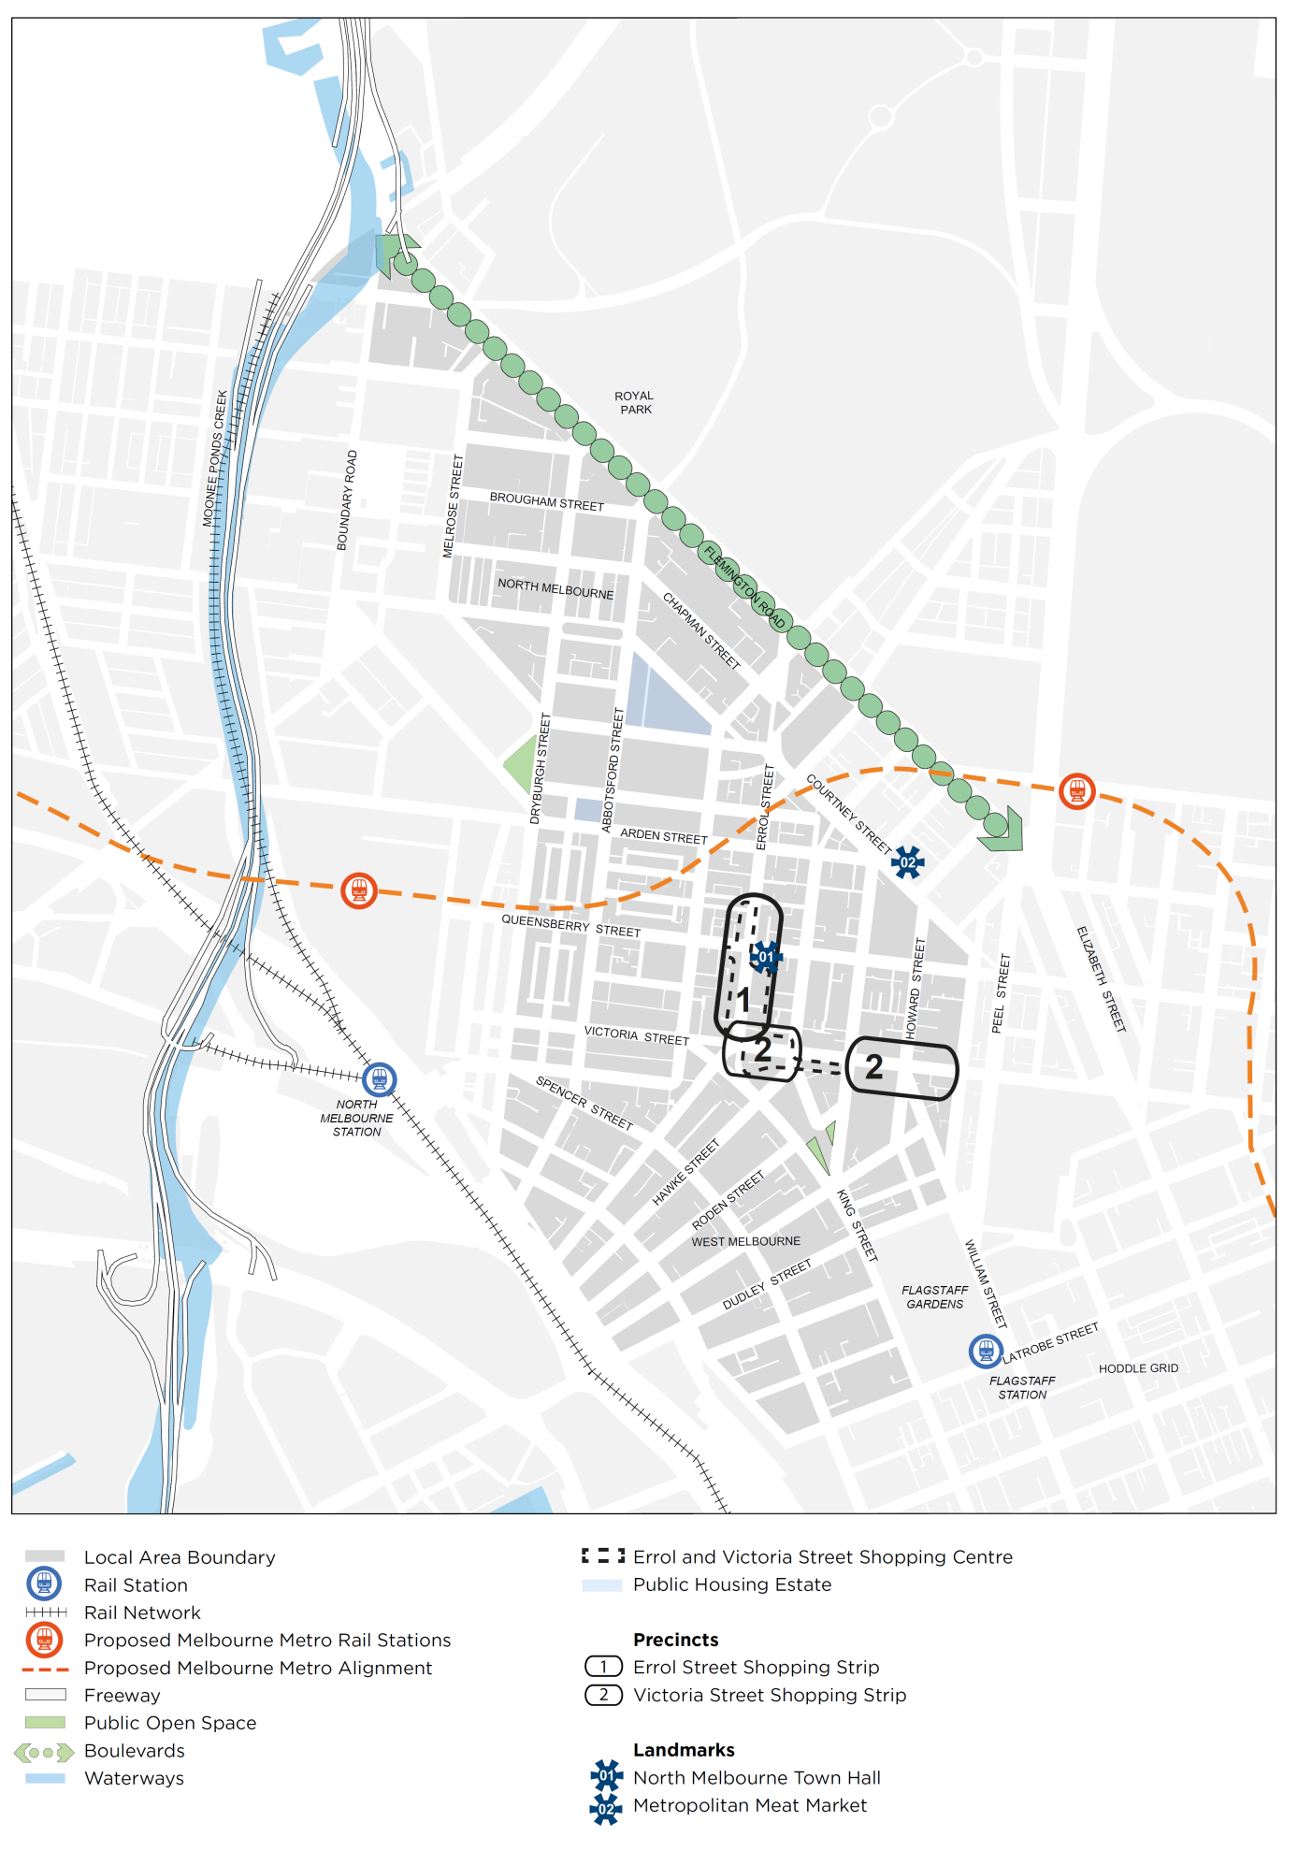
21.16–6 West Melbourne
--/--/----
Proposed C309

West Melbourne accommodates a mix of residential, commercial and industrial uses, along with the major regional open space of Flagstaff Gardens and North Melbourne (future West Melbourne) Station - a major interchange station connecting six train lines to the north-west of Melbourne.
The area now known as West Melbourne has been the country of the Wurundjeri (Woiwurrung) and Boon wurrung (Bunurong) people of the Kulin nation for tens of thousands of years. The hill now occupied by Flagstaff Gardens was a meeting place for local clans. with expansive views across the salt lakes, flats and lagoons to the You Yangs in the west. The hills of West Melbourne were once covered in grasslands and eucalypt woodland leading down to salt marshes, billabongs and floodplains to the west
West Melbourne’s distinctive variety of uses and rich cultural and architectural heritage has long been shaped by its adjacency to the central city, nearby industrial areas, proximity to the port and good road and rail connections. Many of the area’s streetscapes and buildings have been recognised for their heritage significance.
The projected population of West Melbourne is between 8000-9000 residents by 2037. It is predicted that there will be the need for between around 4500 to 7000 new jobs in West Melbourne by 2036, requiring approximately 100,000m² to 200,000m² of employment floor space.
West Melbourne will retain its unique identity, varied areas of character and mix of uses as it evolves into one of Melbourne’s distinct inner urban neighbourhoods and a counterpoint to the central city. Its heritage and other characterful buildings will provide opportunity for a diverse range of uses. New mixed use development of the highest design quality will bring high amenity for residents, workers and visitors. Its wide green streets will provide excellent connections and a network of local spaces to rest and play. The establishment of Spencer Street as a vibrant local high street will create an economic centre for West Melbourne.
West Melbourne is made up of five distinct places (see Figure 21), each with its own character and qualities and each with its own vision, as set out in the West Melbourne Structure Plan 2018.
Housing
- Encourage the provision of affordable housing in the Flagstaff, Spencer, and Station precincts.
- Provide for residential development in appropriate locations in order to support West Melbourne as a mixed use area, through the application of the Special Use Zone.
- Deliver approximately 5500 additional dwellings to meet the projected population growth.
Economic Development
- Retain and provide opportunities for the creation of employment through the application of the Special Use Zone.
- Support the development of Spencer Street into an economically thriving local activity centre through the application of the Special Use Zone and Design and Development Overlay.
- Support mixed use development to facilitate a range of business and employment opportunities throughout West Melbourne.
- Support the delivery of the projected 10,000 jobs.
- Enhance North Melbourne (future West Melbourne) Railway Station with active uses to reinforce this area as key gateway into West Melbourne.
Built Environment and Heritage
- Ensure that built form positively responds to a site, its context and the public realm, through the application of Design and Development Overlays for each precinct.
- Ensure all new development responds sympathetically to, and enhances the valued heritage character of West Melbourne.
- Support the development of West Melbourne as a mid-rise, human scaled neighbourhood with a diverse range of building types and some higher built form in specified locations.
- Ensure that new development is of the highest design quality, and is responsive to the local context, varied subdivision patterns and site sizes West Melbourne.
- Provide for a highly walkable neighbourhood with increased permeability and laneways through blocks.
- Ensure new development enables sunlight and daylight to reach into the parks, streets and lower levels of buildings.
- Encourage the retention and adaptive re-use of existing buildings
- Support equitable development by ensuring primary outlook is secured to the street or within development sites.
- Provide for fine grain adaptable tenancies within the lower levels of buildings.
- Deliver a lower scale of development along the laneways and the activation of the laneway interface.
- In the Spencer Precinct, encourage:
- a vibrant, inner-city area with a mix of retail, commercial, residential, community and creative uses.
- this neighbourhood to be distinct from the central city and North Melbourne
- a mix of converted warehouses, contemporary developments, heritage corner pubs and Victorian shop fronts.
- the incorporation of older buildings into new developments, Tree planting throughout to be well established and consistent, and to include large canopy trees in all streets.
- the retention and enhancement of views towards Eades Park and St Mary’s Cathedral.
- In the Flagstaff Precinct encourage:
- a diverse area of mostly residential and commercial buildings that is well connected to the Flagstaff Gardens.
- the area to be distinct from the central city, characterized by large historic brick buildings, contemporary developments and warehouse restorations
- local streets to be home to small parks, recreation spaces and broad canopy trees
- a variety of shops and services on Spencer, King and La Trobe Streets.
- streets to be sheltered and green at pedestrian level due to the avenues of canopy trees.
- In the Adderley Precinct, encourage:
- an eclectic mix of uses, tucked away from busy thoroughfares of West Melbourne but with great views of the city and Docklands
- the retention of a mix of heritage cottages and terraces, contemporary buildings and restored warehouses and factories
- the retention an renovation of buildings from all eras, including workers’ cottages and Victorian terraces, together with more recent apartment buildings
- the existing leafy streets to connect to the Hawke Street green spine
- a new pedestrian and cycle route over to Docklands and excellent walking and cycling access to surrounding areas
- In the Historic Hilltop Precinct, retain and enhance:
- the valued heritage character, clustered around the shopping strips on Errol, Victoria and Peel Streets.
- the fine grained residential area with intact rows of workers’ cottages, two storey terraces and Federation homes, and the retrofitted warehouses and larger institutional buildings
- the wide green streets and open spaces
- the Hawke and King intersection, Hawke Street linear park and regular avenues of street trees that reinforce the visual links to Flagstaff Gardens.
- views to the central city and access to Flagstaff Gardens and Queen Victoria Market
- In the Station Precinct, encourage:
- a thriving area of converted warehouse apartments and new mid-rise residential buildings
- North Melbourne Station (future West Melbourne) to be become the focal point of the precinct by green avenues that extend to the north and east of the Station and new pedestrian and cycling bridges to link the south and west to E-Gate and Docklands.
- A mix of retail, commercial and residential buildings to encourage people to linger in the precinct rather than just pass through.
Transport
- Expand and upgrade the cycling network in West Melbourne.
- Upgrade the area around North Melbourne (future West Melbourne) Railway Station including Railway Place.
- Support a less car dependent transport system through the application of the Parking Overlay.
- Develop high quality and feasible options to connect West Melbourne with Docklands via pedestrian and cycling bridges.
- Strengthen public open space and pedestrian and cycle connections in the North and West Melbourne area, across the Moonee Ponds Creek and with the Capital City trails.
- Strengthen pedestrian, cycle and visual connections to Royal Park.
Infrastructure
- Ensure good access to community and creative infrastructure within and around West Melbourne.
- Support the provision of recreational facilities for the local resident and working community.
Open Space
- Support the creation of linear open spaces through West Melbourne to enhance pedestrian connectivity with surrounding areas.
- Improve the function, usability, safety and access of existing open spaces.
- Deliver new open spaces in Flagstaff, Spencer and Adderley to meet the needs of the growing community.
- Create high quality green streets.
Sustainability
- Incorporate Integrated Water Management (IWM) into West Melbourne to support a resilient and liveable neighbourhood.
Figure 21: West Melbourne Structure Plan area and precincts
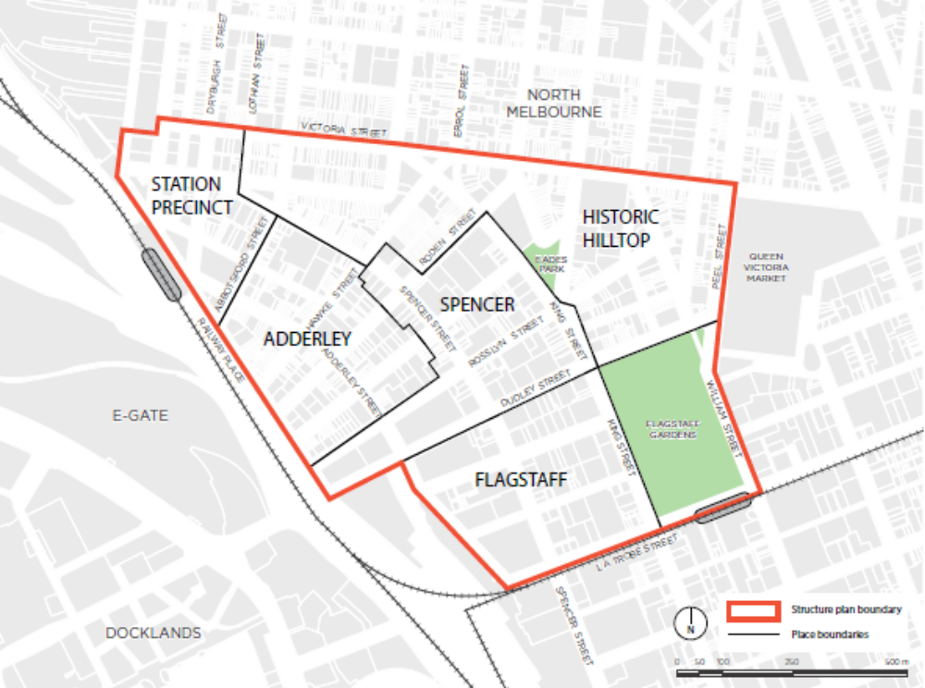

21.16–7 Fishermans Bend Employment Precinct
05/10/2018

Proposed C309
The Fishermans Bend Employment Precinct is one of Victoria’s National Employment and Innovation Clusters (NEIC). It is located west of the city adjacent to the Port of Melbourne. The Port of Melbourne is covered by a separate planning scheme administered by the Minister for Planning. While not the responsible authority for the Port, the City of Melbourne must ensure an appropriate interface and access to the Port as Australia’s largest container and general cargo port.
The continued protection of industry and the Port from encroachment by residential and other sensitive uses will be important.
Economic Development
- Support the development of limited convenience retail and professional services in the area to support the area’s growing workforce.
- Support advanced manufacturing and associated research and development organisations especially within the aerospace and automotive sectors to locate inthe area, to provide mutual benefit through proximity to existing businesses and activities.
- Support development of the area as a National Employment and Innovation Cluser to attract new manufacturing business and corporate headquarters, focused on research and technology.
- Support the development of the precinct as a transitional area separating the larger manufacturing industries to the west from more intensive industrial businesses to the north east and encourage a variety of business and industrial uses and business incubators.
- Discourage small scale industrial and commercial development and subdivision in the precinct that is not related to advanced manufacturing and research and development uses.
- Manage the interface between the future residents of nearby areas by encouraging emission free or office based manufacturing uses and development.
- Encourage larger manufacturing businesses to locate in the western portion of precinct to minimise conflict with future residents of nearby areas.
- Discourage the location of sensitive activities in the precinct that are not compatible with the operations of the Port of Melbourne or other industrial activities.
Built Environment and Heritage
- Strengthen pedestrian and cycle connections and support provision of open space and links through the area between the Port Melbourne foreshore, the Hoddle Grid and Westgate Park.
- Ensure that development in the precinct visible from Docklands does not detract from the appearance or visual amenity of the Docklands area.
- Support improvements to the physical infrastructure, urban design and amenity of the precinct to make the area a high quality urban environment and more attractive for business.
- Encourage a high standard of visual amenity along Lorimer Street to reinforce the image of Fishermans Bend and to strengthen main vistas and views.
- Encourage large front landscaped setbacks on larger industrial sites in the precinct.
- Discourage the location of car parking along Lorimer Street where it is visible from the street.
- Discourage high wire mesh fencing at street frontages particularly along Lorimer Street.
- Enhance the environmental and open space values of Westgate Park.
- Enhance open space in the precinct to provide for the needs of the working population.
Transport
- Support the extension of bus, fixed and light rail services to the precinct.
- Support the development of transport infrastructure required for the Port of Melbourne in the precinct including planning for future rail links to Webb Dock to the south, heavy vehicles and freight and protecting shipping lanes.
- Support the extension of heavy rail to Webb Dock.
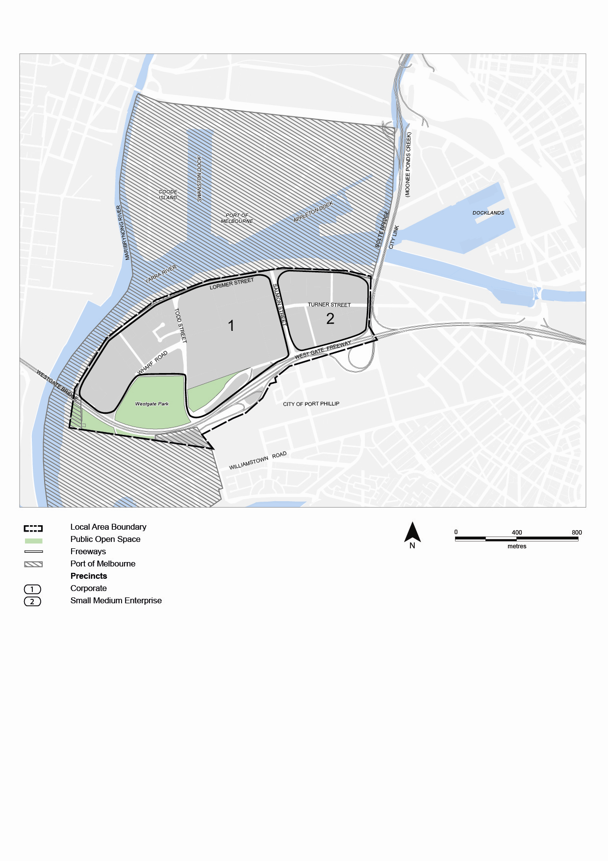Figure 21: Fishermans Bend Employment Precinct

