
Domestic Animal Management Plan 2026-2029 Community Engagement Summary Report
Phase One
June 2025
Contents

Executive Summary: Overview and Key Findings 3
Background and Methodology 3
Who we heard from 5
6
What we heard from the community 8
Engagement Findings 16
Outcome and Next Steps 18

Executive Summary: Overview and Key Findings
A total of 973 contributions were received via the online survey. We also received 15 written submissions via email. Of the 973 people who participated in the survey, 89 per cent of people lived within the City of Melbourne, 65 per cent were dog owners, 28 per cent were cat owners and 58 per cent of all contributors used local parks, reserves and playgrounds.
Respondents were asked about trends they had observed in public spaces relating to domestic animals, their knowledge of municipal pet ownership laws, what services are effective/important and general qualitative feedback about existing animal management services.
Through the feedback, the community has identified a number of important topics that they would like to be addressed in the DAMP. The community reaffirmed their support of cat curfews and mandatory desexing but also called for greater supports to comply with the new orders, as well as a program for the management of semi-owned and unowned cats. The community feedback indicated that the management of dogs in public places was still challenging. There was a large amount of feedback around the need for more areas to exercise dogs off leash, with an emphasis on infrastructure such as fencing, lighting and dog waste bag dispenser bins. There was also a large amount of feedback indicating that compliance with municipal leashing requirements was an issue, and that enforcement of the rules should be more visible and more frequent.

Background and Methodology

Background
The Domestic Animals Act 1994 (the Act) requires domestic animal management plans to be prepared by every council in Victoria at four yearly intervals. The plan is required to outline the services, programs and policies the council have established to address the administration of the Act and the management of dogs and cats in their community.
The DAMP focuses solely on cats and dogs and will set priorities, actions and programs around things like:
- promotion and encouragement of responsible ownership of cats and dogs.
- ensuring that people comply with this Act, the regulations and any related legislation.
- minimising the risk of attacks by dogs on people and animals.
- addressing any over-population and high euthanasia rates for dogs and cats.
- encouraging the registration and identification of dogs and cats.
- minimising the potential for dogs and cats to create a nuisance.
- effectively identifying all dangerous dogs, menacing dogs and restricted breed dogs in that district and ensuring that those dogs are kept in compliance with this Act and the regulations.

Methodology
From 3 April 2025 to 29 April 2025, the City of Melbourne undertook the first phase of community engagement in relation to the Domestic Animal Management Plan 2026–2029 (DAMP). This involved an online survey on the Participate Melbourne website which included the publishing of a discussion paper to help inform feedback.
We used several tools to promote participation in the survey including social media posts, direct engagement with key stakeholders, an email campaign and promotional signage in local parks and animal businesses.
Key internal and external stakeholders contacted directly and encouraged to contribute to the development of the draft DAMP.

Who we heard from
Throughout the engagement, participants had the opportunity to engage online through the Participate Melbourne page and through written submissions via email. This is a snapshot of who we heard from:
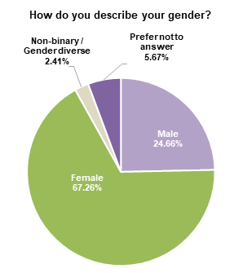
Fig. 1 – Gender

Pie chart showing the gender distribution from the survey. The majority of respondents identified as female (67.26%), followed by male (24.66%). A smaller percentage preferred not to answer (5.67%), while 2.41% identified as non-binary or gender diverse. This distribution highlights a strong female representation among the survey participants.
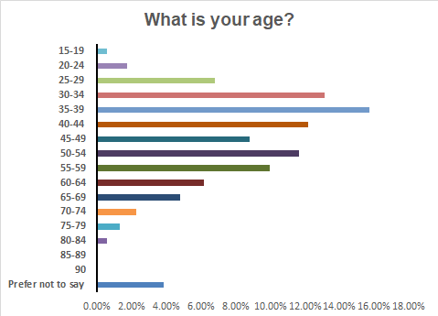
Fig. 2 – Age

This data shows the age distribution of survey respondents. The largest group falls between 35–39 years old, representing nearly 20% of total respondents. Participation varies across age groups, with a noticeable decline in representation among those over 60 years old. Very few respondents were under 20 or over 85. A small percentage chose not to disclose their age. This indicates that the survey reached a diverse age range but had stronger engagement from middle-aged adults.
Fig. 3– Connection to this City of Melbourne project
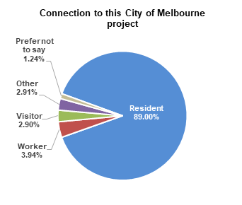

Pie chart showing the connection of respondents to this City of Melbourne project. The majority identified as residents (89.00%), followed by workers (3.94%). Smaller percentages were visitors (2.90%), identified as other (2.91%), or preferred not to say (1.24%). This distribution highlights that the project primarily engaged local residents.
Fig. 4- Identity
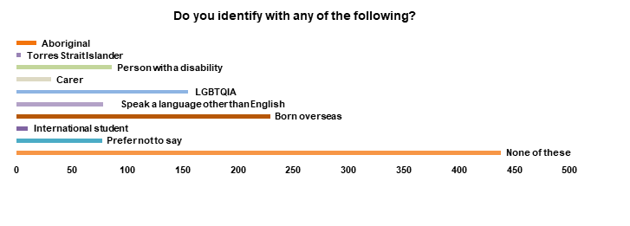

This data outlines the diverse identities of survey respondents. A significant portion (38.90%) indicated that none of the listed categories applied to them. Notably, 13.77% of respondents identified as LGBTQIA, and 20.34% were born overseas, highlighting strong representation from these groups. People with disabilities (7.64%) and those speaking a language other than English at home (6.93%) also had notable participation. Smaller groups included carers (2.75%), Aboriginal (1.60%), Torres Strait Islander (0.36%), and international students (0.89%). Additionally, (6.84%) of respondents preferred not to disclose this information.

Fig. 5- Identity
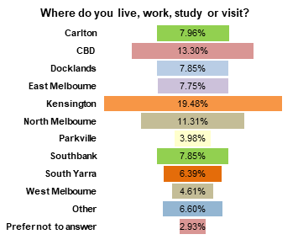

This data shows the distribution of survey respondents by location. The majority of responses came from Kensington (19.48%) and CBD (13.30%), with North Melbourne (11.31%) and Carlton (7.96%) also contributing significant portions. Notably, 2.93% of respondents chose not to disclose their location. Areas like Docklands (7.85%) and Parkville (3.98%) had lower participation rates. This suggests that engagement was higher in central and well-populated areas, while some outer neighbourhoods had less representation.

What we heard from the community

Respondents were asked a series of questions to help identify how they relate to the topic, things they had observed around pet ownership in the municipality and what strategies they believe to be effective to manage the impacts of domestic animals. They were also asked to outline what matters they believe should be the priorities for City of Melbourne for this plan.

Connection to the topic
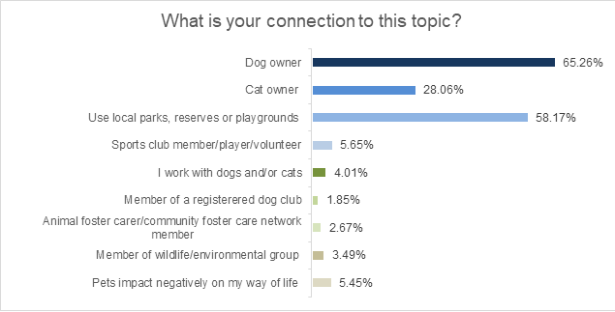
Caption here: full page image layout
Fig. 1 – Bar chart depicting respondents’ connection to survey topic
Most respondents said they were connected to the DAMP because they owned a dog (65.26%) of respondents or used our local parks, reserves or playgrounds (58.17%). This data demonstrates the importance of ensuring our public spaces can be shared by different user groups, and the importance of regulations like municipal leashing laws. Cat owners made up (28.06%) of survey respondents; the survey also provided an opportunity to cat owners to provide feedback on what we can include in the DAMP to better manage cats outside of cat curfews and mandatory desexing rules that will be introduced in October 2025.
Only small percentages of respondents identified as foster carers (2.67%), professionals that work with animals (4.01%), or as members of advocacy or conservation groups (3.49%). Additionally, 5.45% of respondents said that pets negatively impacted their way of life, indicating that we may need to review and improve the services we provide around nuisance issues including barking dogs, roaming cats and dogs off leash in places they shouldn’t be.

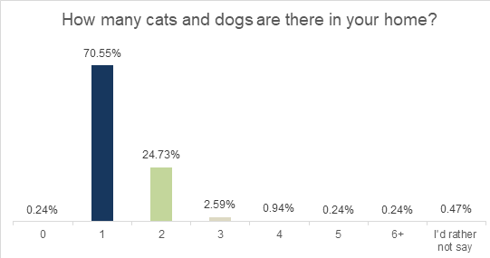

Fig. 2 – Column chart depicting how many cats or dogs respondents have in their home
The majority of respondents (70.55%) said that they only had one pet at home, indicating that single-pet households are the norm. Households with two pets only made up (24.73%) of respondents. Households with three or more pets is far less common, with only (2.59%) reporting that they have three pets.

Community observations around pet ownership
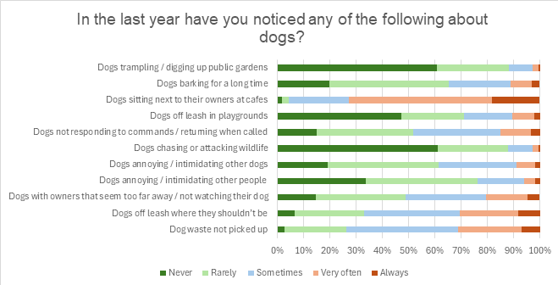

Fig. 3 – Bar chart expressing community sentiment on behaviour of dogs and their owners over the past year
Respondents indicated that most frequently observed issues concerning dogs in public spaces relate to dogs being off leash in places they shouldn’t be and dog waste. More respondents indicated they very often or always observed dog waste not being picked up (31.14%) and dogs off leash where they shouldn’t be (40.08%) than not. Contrastingly, respondents said they rarely or never observed dog waste left behind or dogs off leash where they shouldn’t be 26.31% and 31.35% of the time respectively. A significant number of respondents indicated they sometimes observed these issues (42.55% for dog waste and 32.48% for dogs off leash). This data indicates that the more work needs to be address the nuisance and safety issues posed by off leash dogs and uncollected dog waste. The remainder of the feedback received indicates that the other issues concerning dogs in public spaces are less common; respondents said that they rarely or never see dogs attacking wildlife (87.77%) or damaging garden beds (88.28%).

Community sentiment on the management of cats in the municipality
Over four weeks in July and August 2024, City of Melbourne consulted the community on the introduction of mandatory cat desexing and some form of cat containment to their owners’ property.
The consultation revealed that the majority of the community was supportive of cat containment measures such as night-time curfews (85%) and prohibitions in environmentally sensitive areas (81%). 84% of respondents expressed their support for the introduction of mandatory desexing of cats.
At the Future Melbourne committee meeting on 1 April 2025, Council resolved to make municipal orders to require all cats to be:
contained to their property between the hours of 6pm and 8am
desexed
prohibited from waterways, riverine environments and certain major parks and gardens, unless under effective control by means of a purpose-built carrier, or harness and leash, and in the presence of their owner at all times.
These orders will come into effect on 1 October 2025 and be reviewed in mid-2026
Given that we consulted with the community recently concerning the new cat management controls, we wanted to use the DAMP survey to capture new feedback that highlighted other way we can improve services for cat owners and to manage the impacts of cats on our community.
We highlighted this in the survey, and asked the community:
“Is there anything else you think could be done differently or better to manage cats in the City of Melbourne?”
Cat curfews
The majority of the feedback we received still related to cat curfews and mandatory desexing. Most respondents reiterated their support for cat curfews as a means to protect wildlife, improve welfare outcomes for cats and reduce nuisance issues such as trespassing onto neighbouring properties.
“Cat curfews are a necessary measure to protect native wildlife. I strongly support them.”
Some respondents oppose curfews, citing concerns for the welfare of their cats who will need to be kept inside instead of being allowed to roam. Some people advised that the changes would significantly impact their lifestyle their lifestyle because of the changes that would have to make in how they manage their cat. A number of respondents also questioned council’s ability to enforce cat curfews.
“I think cat curfews don’t work. How do you get a cat to come back at a certain time if they are outside?”
The community also indicated that they wanted additional education and support to ensure the curfews are successful and can be complied with. Respondents advised that supports around building cat enclosures or modifying properties to contain cats would be helpful, as well as education on providing enrichment to cats that spend more time indoors.
“To improve cat management in the City of Melbourne, it would be beneficial to enhance public education initiatives about responsible pet ownership, including the importance of desexing, containment, and providing enrichment for indoor cats”

Mandatory desexing
Respondents broadly supported mandatory desexing of cats. Respondents said that desexed cats have a reduced tendency to hunt, and that making desexing mandatory will a positive impact on stray cat numbers. Respondents indicated that this is an important step towards protecting local wildlife from predation.
“Mandatory desexing is great, as is a cat curfew. I foster kittens and there has been a ridiculous amount of feral kittens brought to the shelter”
A number of respondents also raised concerns around the introduction of the mandatory desexing of cats. Respondents cited the cost of desexing as a barrier to compliance, ability to enforce the requirements and the importance of owner autonomy to make decisions about their pet. Respondents indicated that they would prefer a program targeted at managing the semi-owned and unowned cat population, advising that this will achieve greater welfare outcomes for both cats and wildlife.
“Address stray cat issues and implement free desexing for people wanting to take them on”

Education
Many respondents said there was a need for greater community education on range of topics relating to cat ownership, including the benefits of desexing, impacts of roaming cats on wildlife and methods of containing your cat on your property such as catios and cat runs.
“Education around keeping cats entertained indoors, many people still believe it to be cruel to keep cats indoors, but with the right education, we can keep them happy being safe inside”

Feedback on local laws and compliance 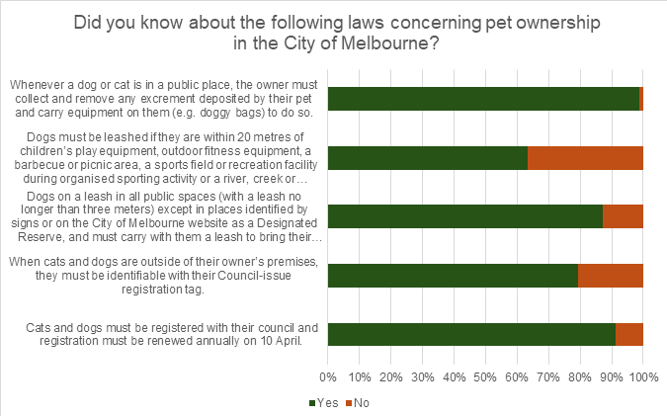

Fig. 4 – Bar chart depicting respondent’s knowledge of municipal pet ownership rules
Data from the survey indicates that the majority of respondents have a good knowledge of local laws concerning pet ownership. The two laws that people were least aware of were:
- 36.59% of respondents did not know that dogs must be leashed if they are within 20 metres of children’s play equipment, outdoor fitness equipment, a barbecue or picnic area, a sports field or recreation facility during organised sporting activity or a river, creek or water body.
- 20.66% of respondents did not know that when cats and dogs are outside of their owner’s premises, they must be identifiable with their Council-issue registration tag.
Notably, 12.95% of respondents indicated they weren’t aware that dogs must be on a leash in all public spaces (with a leash no longer than three meters) except in places identified by signs or on the City of Melbourne website as a Designated Reserve, and that they must carry at all times carry with them a leash to bring their dog under effective control. This is large percentage given that the majority of respondents identified as dog owners who use our parks and gardens.
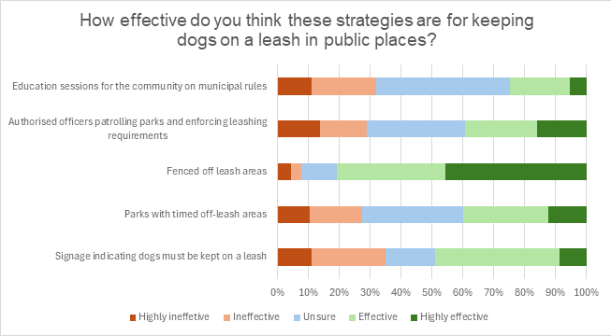
Fig. 5 – Community feedback on what strategies are effective for managing dogs in public places
The vast majority of respondents indicated that they believe that fenced off leash areas are a desirable strategy for managing dogs in public spaces, with 80.68% of people rating them as effective or highly effective. The majority of respondents rated all of the strategies listed as effective as opposed to ineffective, with the exception of education sessions. 43.17% of respondents indicated they were unsure if education sessions would be an effective tool to ensure dogs are keep on a leash in public places; 31.97% think that education sessions will be ineffective all together.

Feedback on priorities for the Domestic Animal Management Plan 2026-2029
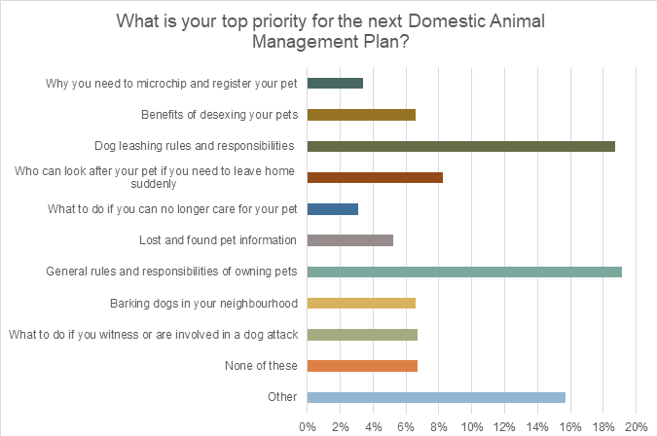
Fig. 5 – Community feedback on what strategies are effective for managing dogs in public places
The majority of respondents indicated that their top priorities for the DAMP are:
- General rules and responsibilities around pet ownership (19.12%)
- Dog leashing rules and responsibilities (18.71%)
- Who can look after your pet if you need to leave home suddenly (8.22%)
The remaining other selections available were a priority for between 3% and 8% of respondents. Notably, 15.72% of respondents indicated that their top priority for the DAMP wasn’t listed. This indicates that the needs of the community are diverse and that more work may be required to identify and deliver services needed by the community.

Feedback on equipment and infrastructure in parks and reserves for pets
One of City of Melbourne’s key roles in managing animals in the municipality is the provision of spaces in our parks, gardens and reserves for pets such as designated off leash areas. Additionally, City of Melbourne provides and maintains infrastructure to ensure spaces are accessible and for pet owners and can also be shared with other members of the public. As part of the survey, we asked:
“Do you have any suggestions for new equipment or infrastructure needed at local parks and reserves to better accommodate pets?”

Designated off leash areas
The majority of the feedback we received related to the provision of designated off leash areas. Respondents indicated that they would generally like to have more areas designated to exercise their dogs of leash, but also stated that a range of areas dedicated to different animals such as small, large or older dogs would be helpful. There was also a substantial number of responses indicating the want for existing or new designated areas to be fenced. Respondents said that by fencing areas they think our park spaces will be better shared, rules around leashing will be clearer and safety would be improved for other park users such as cyclists and children.
“Definitely need a lot more off-leash areas! Having those areas fenced is also helpful”

Infrastructure
Respondents indicated that infrastructure was important to ensure our parks and public spaces are more pet-friendly, with an emphasis on improved signage, dog waste bag dispensing bins and water bowls for dogs. Respondents also provided feedback about the need for infrastructure that supported access to parks after dark and during inclement weather. Some respondents indicated that they can only walk their dog after dark and advised that lighting would improve park accessibility and safety. Respondents also said they would be interested in having agility equipment included in some designated off leash areas.
“Poo bags need to be more available. Signage with basic rules. Definitely more water stations for dogs to have a drink”

General feedback on animal management services provided by City of Melbourne
As part of the survey, we asked:
“Do you have any feedback as to how the City of Melbourne can improve its animal management service or any general feedback on animals in the city?”
There was a large amount of feedback from pet owners concerning community access with their pets; respondents would like to be able to better incorporate their pets into their day to day lives and would like to be able to take their pets on public transport and to more restaurants, bars and cafes.
“Work with cafes/bars, similar to Europe where animals are allowed inside premises”
Respondents said that they wanted to more education on a range of pet ownership topics, with a range of delivery methods to ensure accessibility and inclusion. Respondents provided a range of suggestions about what services they would like to see, including free dog training events, online educational resources and videos, social media campaigns, stories in local newspapers and print materials in multi-lingual formats. Respondents suggested a broader educational approach would be highly beneficial, clarifying what responsible pet ownership means, what steps people can take to ensure prioritise the welfare of their pets and what laws and regulations people need to comply with.
“Educate kids about approaching and petting dogs”
“Expanding assistance programs, outreach initiatives, and accessible education campaigns would ensure that all residents, regardless of financial circumstances, are supported in providing responsible care for their pets. A compassionate, proactive approach will deliver better animal welfare outcomes and build stronger, more inclusive communities”
Respondents indicated that the issues caused by dogs being off leash outside of designated areas persist, and that they would like to see more visible enforcement of the rules during peak times to boost compliance. Many respondents feel that various factors contribute to compliance issues, such as designated off leash areas being too large, poorly signed and in need of more monitoring, leading to frequent incidents involving off leash dogs. Respondents report that there some dog owners lack awareness of some of the issues posed by dogs being allowed to roam in areas they shouldn’t, including spaces being made unusable for people trying to exercise reactive dogs on a lead of for people who feel unsafe around dogs.
Feedback overall suggests that people desire a balance between having ample space to exercise their dogs and having greater compliance with the relevant laws. Feedback provided acknowledges the community value of dogs in public spaces, but also the importance of greater education and enforcement to ensure our public spaces remain accessible and safe for all users.
“My main concern is the constant disregard for leashing dogs and people's ignorance about what happens when a leashed dog is bailed up by an off-leash dog. Lots of people don't seem to understand the power imbalance here and how it can lead to fights”
“Routine but random patrols need to happen in suburbs to ensure dog owners have their dog on leash. Fines need to be issued”

Engagement Findings

What we heard from key stakeholders
Australian Pet Welfare Foundation
Australian Pet Welfare Foundation is (APWF) a charity whose mission is to improve the health and wellbeing of pets, people and their environments. APWF advocates for changes to policy and practice that improve the health and wellbeing of pets and people. APWF was founded by Jacquie Rand, Professor Emeritus of Companion Animal Health, who authored the submission to council concerning the draft DAMP.
APWF provided the following feedback as part of their submission:
- APWF recommended that City of Melbourne continue to expand efforts to identify unregistered animals through targeted, community-centered initiatives. APWF suggested that outreach programs and provision of multi-lingual educational materials on the importance of microchipping and registration would be beneficial. APWF advised that expanding access to low-cost or subsidized registration programs for individual experiencing financial hardship or homelessness would help reduce barriers to compliance and increase the chances of pets being reunited with their owners.
- APWF’s position is that introducing mandatory desexing is not an effective cat management strategy, and instead suggested implementing a community cat program that empowers semi-owners to take full responsibility for cats in their care is the best way forward. APWF advised that a community cat program would need to be “high intensity”, and its focus should be on delivering targeted subsidized or free desexing programs in areas where the most cat related complaints occur.
- APWF’s position is that City of Melbourne should not pursue mandatory cat containment, arguing that such mandates are unenforceable and place burdens on cat owners that eventually lead to more animal impoundments, complaints and higher euthanasia rates. APWF instead recommended the promotion of voluntary strategies such as feeding night-time feeding routines and affordable cat enclosure support schemes.
- APWF suggest that timed off leash areas can create more confusion and conflict when trying to share public spaces, and stated that equitable use of park spaces is better supported through permanent, clearly designated off leash areas with appropriate fencing and signage. APWF’s position is that clear, consistent and accessible communication around pet-related rules would help all pet owners better what is required of them. This may include updated signage, use of QR codes to make pertinent information more accessible and having information available in multi-lingual formats.
- APWF’s submission had a strong focus on providing free or low-cost services to the community, including those relating to registration, microchipping, desexing, animal training and education programs. APWF highlighted that providing subsidised services to vulnerable community members, such as those experiencing financial hardship and homelessness. APWF suggests that providing more comprehensive and accessible services would be effective in addressing issues ranging from barking dogs through to reduction in dog attack incidents.
- APWF contend that the way education is delivered needs be diversified, and should include regular mobile pop-ups and sessions run in partnership with local schools, community centers, and housing providers. APWF states that by increasing the volume of and accessibility to education in the community, the prevalence of animal related complaints will reduce.

The Lost Dogs’ Home

The Lost Dogs’ Home (LDH) is City of Melbourne’s contracted pound services provider and is the largest animal shelter services provider in Victoria.

LDH provided the following feedback as part of their submission:
- LDH’s view is that as part of the DAMP, City of Melbourne should offer incentives for cat owners and low-income households to maintain ownership of semi-owned and unowned cats that they are caring for. LDH state that as part of this program, free desexing, microchipping and registration should be provided to people who agree to take ownership of a cat. LDH state that this program should initially focus on suburbs with high levels of social and economic disadvantage but could be extended to all suburbs in the municipality.
- LDH takes the view that cat containment has benefits such as reduced predation of wildlife and less instances of cats becoming lost but goes on to say that cat containment can also have negative consequences. LDH states that cats contained indoors for long periods without stimulation, enrichment or human contacts can be negative for a cat’s welfare. LDH recommends that City of Melbourne’s new cat curfew should be accompanied by an education campaign around cat enrichment and welfare, and that council should offer subsidised cat enclosures to cat owners on low incomes, older people or people with a disability.
- LDH recommends that a priority of the DAMP should be delivery of education programs for pet owners, provision of responsible pet ownership education materials to culturally and linguistically diverse communities and supports to aimed at assisting pet owners with the cost-of-living crisis. The recommended supports include discounted vet care to low-income households to help them manage the cost of vet bills.

Friends of Royal Park

The Friends of Royal Park are a community group who come together to protect and enhance biodiversity, habitat and indigenous flora and fauna in Royal Park.
The Friends of Royal Park provided the following feedback as part of their submission:
- The Friends of Royal Park expressed concerns that the current laws and enforcement efforts do not properly protect these important biodiversity and habitat areas within Royal Park, despite being designation as ‘Dogs Prohibited’ areas. They state that greater protections are needed to protect habitats within Royal Park.
- The Friends of Royal Park state that the existing ‘Dogs Prohibited’ areas in the park need to be changed to ‘Dogs & Cats Prohibited’. They advise that cats should also be excluded from these areas due to their predatory impacts on wildlife. The Friends of Royal Park advise that this needs to be reflected in the cat management orders due to be introduced in October 2025.
- The Friends of Royal Park recommend that several other areas with Royal Park be designated as ‘Dog and Cats Prohibited’ areas, including the second remnant vegetation site at Brens Remnant Native Vegetation Site, an area of remnant native vegetation in the triangle bounded by Manningham Street and Oak Street, Parkville and the Royal Park creek corridor.
- The Friends of Royal Park believe that council should reconsider the cat curfew due to be introduced in October 2025; they contend that cats should be contained to their owners’ property full-time, reasoning that cats roam and kill during daytime hours and not only at night.
- The Friends of Royal Park would like to see increased enforcement of the rules in the ‘Dogs Prohibited’ areas within Royal Park, especially after hours and on weekends when non-compliance occurs.

Outcome and Next Steps
Council would like to thank everyone who took the time to provide their feedback to support us in drafting the DAMP.
The feedback we received from the community indicated that we are on the right track with cat curfews and mandatory desexing of cats, but work needs to be done to manage the impacts of unowned and semi-owned cats. The feedback told us there is a need for a review of how dogs are managed in public spaces, and consideration needs to be given to how infrastructure such as fencing and lighting can play a role in making our parks more accessible.
The Domestic Animal Management Plan 2026-2029 will be drafted with the feedback of the community in mind. The draft DAMP will be presented to the Future Melbourne Committee on 1 July 2025 for endorsement.
A second round of community consultation is due to commence in July 2025, during which time we’ll seek your input on the draft DAMP.

