Acknowledgement of Traditional Owners
The City of Melbourne respectfully acknowledges the Traditional Owners of the land we govern, the Wurundjeri Woi-wurrung
and Bunurong Boon Wurrung peoples of the Eastern Kulin
and pays respect to their Elders past, present and emerging.
We acknowledge and honour the unbroken spiritual, cultural
and political connection the Wurundjeri, Bunurong, Dja Dja Wurrung, Taungurung and Wadawurrung peoples of the Eastern Kulin have to this unique place for more than 2000 generations.
We are committed to our reconciliation journey, because
at its heart, reconciliation is about strengthening relationships between Aboriginal and non-Aboriginal peoples, for the benefit
of all Victorians.

Contents

HeatSens Pilot 4

Project purpose 4

HeatSens 5

Approach 5

Outcomes 6

Lessons learnt 6

Recommendations 6

Next steps 6

12 December 2024

HeatSens Pilot

Project purpose
Due to climate change, our city is experiencing more hot days than ever before. Heatwaves are becoming more frequent and intense, causing disruption to city infrastructure and services, and impacts on health and wellbeing.
City of Melbourne is committed to reducing the threat of extreme urban heat for all, particularly vulnerable people. Our goal is to ensure residents, workers and visitors are informed, safe and well during extreme heat events.
We are trialing new technology and data platforms to explore how they might be able to help us better plan, prepare and respond in an extreme heat event and create a more resilient city.
Last summer we trialed HeatSens - a digital tool that combines data to help us understand more about our municipality and reveal opportunities to deliver appropriate and time-critical support in a heat event.
The pilot was part of a strategic project called Heat Lab to pilot and test new heat safety solutions. This project was supported with funds from Emergency Management Victoria. Pilot initiatives were developed through combining council, business, public health and community leader expertise. Data and technology were an important part of developing and delivering the interventions piloted through Heat Lab.
The HeatSens pilot aimed to:
- test the integration of City of Melbourne spatial datasets into the HeatSens platform
- equip City of Melbourne operations with real-time heat risk insights
- facilitate an informed, strategic response to extreme heat events for summer 2023-24
- capture insights so City of Melbourne can improve our approach to using data in heat response
- test a new digital data platform to understand if City of Melbourne should adopt the tool in the future
- co-design and make improvements in shaping the development of HeatSens, ensuring that it meets the city's needs as it faces the challenges of extreme heat.

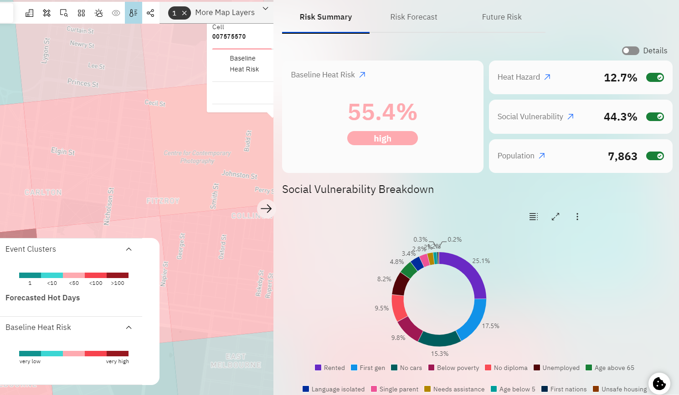
Figure 1: Screenshot of the HeatSens platform, showing social vulnerability factors

HeatSens
HeatSens is a digital tool, created by ClimaSens, providing:
- heat social vulnerability index at 1 kilometre resolution analysing at risk populations to heat stress
- 30 metre resolution analysis of Land Surface Temperature to understand which areas have the most extreme heat absorption
- realtime and forecasted heatwave risk to assess when and where heatwaves would take place across the city
• projected heat risk using the latest CMIP6 downscaled climate projections to understand how many days over 35 Celsius we will have in the future.

Approach

How did we use HeatSens?
The pilot team had access to the following tools through desktop applications:
- Localised Heat Risk Ratings - users identified at risk population groups in different neighbourhoods within a 1 km² radius. The risk tool also enabled users to interrogate why locations are at risk and understand the different factors such as population and social vulnerability that contribute to the risk rating.
- Extreme Heat Forecasting - users looked at upcoming temperature forecasts in the municipality, neighbourhoods and 1 km² cells to see if heat events were likely to occur in the seven days ahead. The temperature outlook showed if the temperature would exceed the local extreme heat threshold and seven-day mean temperature.
- Linked data - users explored the correlation between urban forest, land use and surface types and heat risk.
- Places - users marked up places of interest to them, so they could identify heat risk for that specific location and understand the factors that contributed to the rating.
- Watcher - users created 'Watcher' events, a self-service to categorise a hot day or heat event so that signals are sent on that basis from the watcher.
In addition, email reports provided a summary of heat alerts for each neighbourhood seven days in advance, generated by the HeatSens platform. This notified staff if hot days (temperatures over the local extreme heat threshold) or heatwave conditions were forecasted across City of Melbourne’s neighbourhoods.
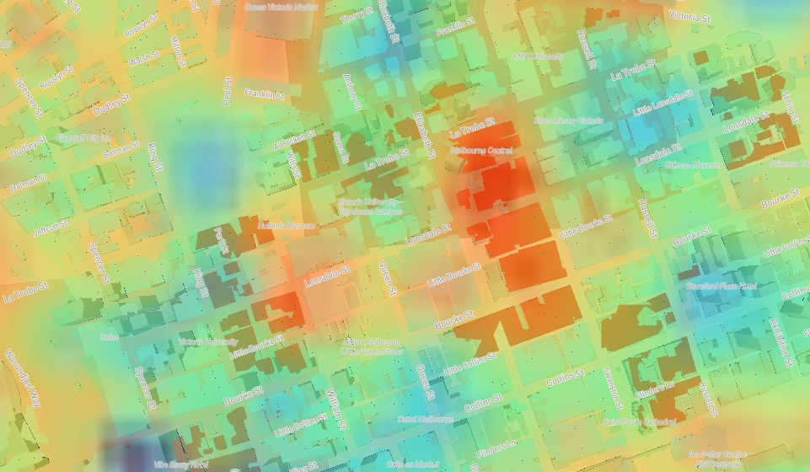
Figure 2. Screenshot of the HeatSens platform showing Land Surface Temperature

Outcomes
Lifting capability through data and technology was central to developing and delivering the interventions piloted through Heat Lab. The HeatSens pilot contributed to the broader strategic approach of initiatives including:
Identification of neighbourhoods with the highest heat risk which enabled:
- prioritisation of locations for Cool Places
- geotargeted communications to the neighbourhoods with the highest heat risk.

Real-time email alerts which provided warnings about upcoming heat events for each neighbourhood seven days in advance. This allowed City of Melbourne to promptly activate:
- opening of Community Cool Places and extended hours at libraries
- heat health communications
- outreach activities.

Lessons learnt
The following lessons were learnt throughout the pilot:
- the tool has allowed City of Melbourne to explore extreme heat trigger points for when operations need to be notified and heat action plans activated
- the tool stimulated understanding of localised heat risk across the municipality
- the tool stimulated collaboration and operational coordination for preparing and responding to heat events
- the tool provides multiple services, including early warning, spatial risk analysis and prediction of future risk
- the tool helped us understand an extreme heat definition in more detail and different methods to measure heat risk
- risk data and information is valued, but users can struggle to turn it into insights and then action. When investing in the development and use of technology tools, it is important to also invest in people, the users of the tool, to ensure they can draw insights from the data. Increased knowledge is a direct result of sustained engagement and communication about the data.

Recommendations
Based on the pilot findings, the following recommendations were identified:
- Continue collaboration across the organisation to stimulate operational coordinating for heat events and other hazards.
- Continue with technology trials to shape tools that are fit-for-purpose and provide benefits for both councils and product developers.
- Enable tools like this to be tested across a range of phases and time scales, for example, not just in response but also in strategic planning.
• Granular multi-hazard data is critical for local government in many ways including preparing, planning, response and mitigation for extreme weather events.

Next steps
Based on the success of this pilot, City of Melbourne is exploring the ongoing use of the tool to inform our approach to extreme heat and reduce the impacts of heat events for our community, particularly those more vulnerable. HeatSens will be used as a tool to inform planning and response to extreme heat over Summer 2024-25.



Figure 3: Cool spaces in our city



