
North and West Melbourne Community Resilience Report
City of Melbourne
October 2023

Contents
Summary 4
2. Context 5
2.1. Major Initiative 52 – Prepare Melbourne 5
2.2. Disasters 5
2.3. Resilience 5
2.4. A focus on community resilience 6
2.5. Neighbourhoods 6
North Melbourne 6
West Melbourne 7
3. Community Resilience Assessments 7
3.1 Purpose and objectives 7
3.2 What we presented to the group 8
What we heard in previous resilience workshops 8
Showcasing resources 9
Wellbeing and Connection Map 9
3.3 What we heard 10
Resilience 10
Vulnerabilities and strengths 10
Inclusive information and engagement 10
Community connection 12
Community safety and wellbeing 12
3.4 Idea prioritisation 13
3.5 Wellbeing and Connection Map 13
3.6 Before and After 13
Before 14
After 14
Feedback 14
3.7 Next Steps 15
Appendices 16

Summary
In 2019, City of Melbourne declared a climate and biodiversity emergency,
which recognises the serious risks that climate change poses to human health and our lifestyles. This recognition is reflected in the Council Plan 2021-25 as one of the six strategic objectives and in the Major Initiative 52, which focuses on building community disaster resilience.
The characteristics, geographies and communities of each neighbourhood across the municipality are unique and diverse. This means a localised approach to building resilience is important.
In September 2023, the City of Melbourne City Resilience & Sustainable Futures, Community Development and Wellbeing team undertook a Community Resilience workshop in North and West Melbourne.
This workshop sought to understand the experiences of people living in North and West Melbourne, and where they see the major vulnerabilities, strengths, and opportunities to build better resilience to future shocks and stresses.
The newly created Wellbeing and Connection map was showcased and participants provided feedback for it to better support the community.
Community members then identified actions that could be taken and prioritised to improve disaster resilience and preparedness in their neighbourhoods across four themes:
- Inclusive information and engagement
- Accessible urban environment
- Community connection
- Safety and wellbeing.
Many ideas emerged from the very engaged North and West Melbourne workshop participants. Ways to make the streets of North and West Melbourne safer, more accessible and more resilient to disasters, such as heatwaves and floods, were strongly encouraged. Access to a range of services including local community food services, green spaces and shading, community hubs and information was considered paramount to community resilience.
Participants identified transient and new residents as particularly vulnerable to disasters and proposed to have a community volunteer connector system and information to provide new comers, which in turn would enhance the sense of community connection and belonging.

2. Context

2.1. Major Initiative 52 – Prepare Melbourne
The City of Melbourne is delivering Major Initiative 52 under the Safety & Wellbeing objective in Council Plan 2021-2025. The purpose of this initiative is to 'engage and prepare residents and communities, and enhance their resilience to hazards, disasters and the health impacts of climate change'. It seeks to:
- Understand the current context of disaster likelihood, risk and preparedness.
- Build organisational capacity in disaster preparedness and risk management.
- Enable community preparedness and disaster resilience.

2.2. Disasters
"Disasters are expected to become more complex, more unpredictable, and more difficult to manage... with far-reaching consequences." (Royal Commission into National Natural Disaster Arrangements, 2020).
The term 'disaster' is used to describe the range of natural and human-influenced events that put us in potential danger and that require us to respond and do things differently.
'Disasters' encompasses climate disasters such as heatwaves, floods, fires and hurricanes, as well as more human-level events such as pandemics and acts of terror​.
Disaster risk is a function of hazard, exposure, vulnerability and capacity.

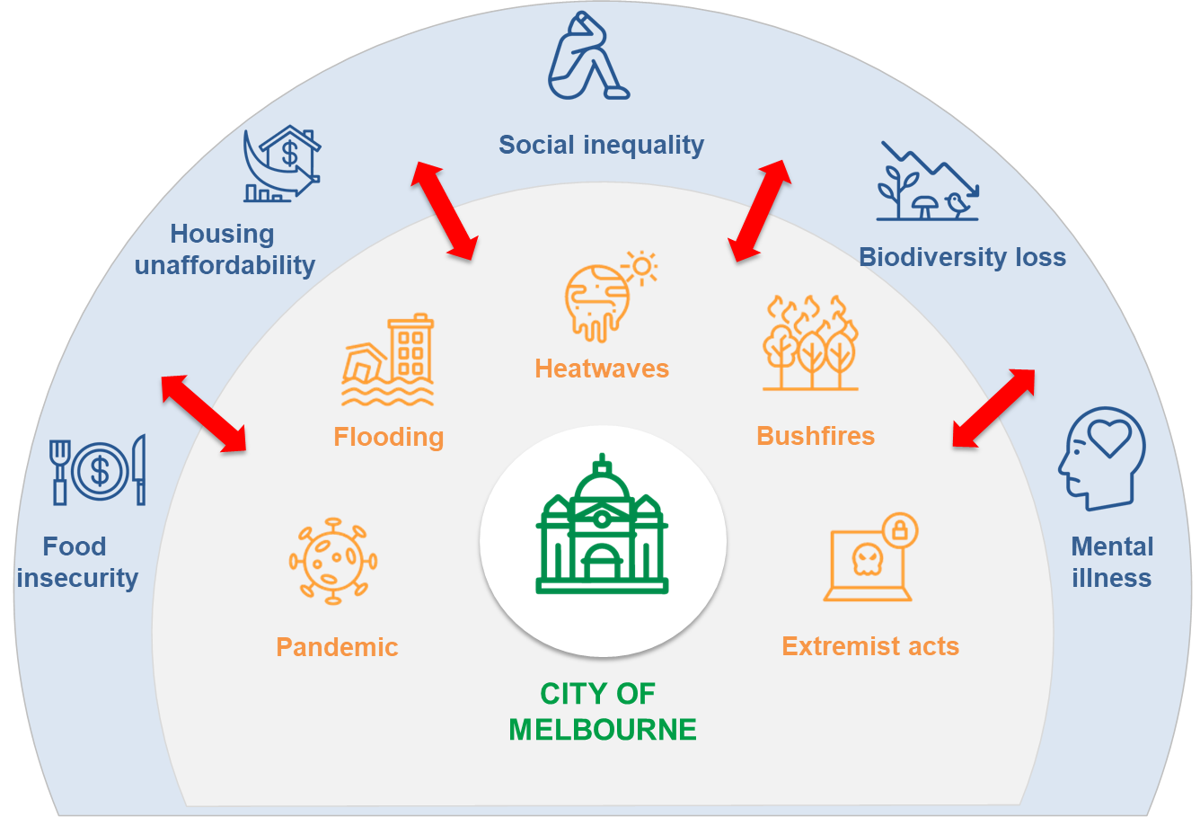

2.3. Resilience
Resilience is the capacity of individuals, communities, institutions, businesses and systems within a city to adapt, survive and thrive, and positively transform as a result.
Disasters are known to have disproportionate impacts on people facing physical, social, economic and environmental barriers. This includes the elderly, people with a disability, people experiencing homelessness, people living public housing and high-rise buildings, people with pre-existing health conditions When we talk about "resilience", we are talking about the capacity to adapt, survive and thrive, and positively transform in response to these sorts of challenges.
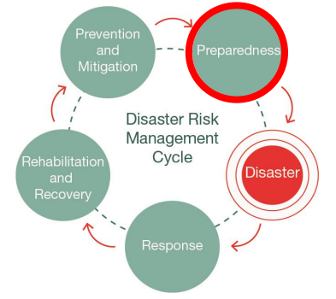
Resilient and prepared communities are more likely to withstand the negative impacts of natural disasters. Likewise, strong social capital correlates to a more effective recovery.

2.4. A focus on community resilience
All the research indicates that communities who are connected are more resilient because people are more likely to look out for the people around them. Our emergency services will not always have the capacity to help everyone during a disaster, and preparing for disasters cannot be the sole domain of government agencies if we are to become truly resilient. The emphasis on building capability within the community to adapt, survive and thrive in response to shocks and stresses, is critical in developing community resilience.
The Community Resilience Assessment approach is about looking at the unique experiences, needs and vulnerabilities of the people living in each of our neighbourhoods so we can determine where and how City of Melbourne and its partners can best support.

2.5. Neighbourhoods

North Melbourne

North Melbourne is renowned for its charming village vibe, complete with Victorian-era shopfronts and Robert Hoddle’s distinctive wide streetscapes. North Melbourne is a lively, cosmopolitan neighbourhood boasting an eclectic mix of boutique retail, arts, dining and community experiences. It has come a long way from its days as an industrial employment hub for the local livestock precinct, though its landmarks still pay homage to these origins. North Melbourne is also home to Arts House, in the former North Melbourne Town Hall and the North Melbourne Library which has been an important community gathering place for many local residents over the years. North Melbourne’s streets tell a story of its evolution, featuring both heritage and urban-industrial architecture seamlessly. The area is home to almost 18,000 residents – half of whom were born overseas, with the majority aged between 20 and 34 years. More than 70 per cent of North Melburnians live in apartments – whether in public housing towers around Boundary Road, in private medium-density complexes, or contemporary warehouse conversions.
In North Melbourne, although 64 per cent have confidence in their neighbourhood "pulling together" during a disaster, only 23 per cent believe they could receive help from a neighbour (Neighbourhood Plan survey data, 2022, 297 North Melbourne respondents). This work is well aligned with North Melbourne’s 'caring for each other in an emergency' neighbourhood priority.
For more information about North Melbourne, visit: Neighbourhood overview | North Melbourne Neighbourhood Portal | Participate Melbourne.

West Melbourne
West Melbourne is shaped by three waterways; the Maribyrnong River, the Birrarung (Yarra), and Moonee Ponds Creek. Residents enjoy the environment, easily reached by walking, and its proximity to the city centre. Most of the suburb’s 7,619 residents live close to Flagstaff Gardens, a defining feature of the area.
West Melbourne is popular among students, young professional couples and downsizers with more than 80% of local residents living in apartments. They are drawn to the city life represented by venues such as Festival Hall, synonymous with live music in the city for decades.
The neighbourhood is also known for the Islamic Council of Victoria on Jeffcott Street, the peak body representing an estimated 200,000 Victorian Muslims. The historic and industrial character of West Melbourne is highly valued by the community and has the potential for much creative re-use. Currently, the western section of this area features railway lines, container yards, shipping docks and industrial warehouses.
East of Railway Place has become a dynamic mixed-use residential area, with a strong sense of community, a diverse mix of businesses and a rich cultural and architectural heritage.
Only 33 per cent of people in West Melbourne have confidence that their neighbourhood would "pull together" during a disaster or emergency and 41 per cent believed that they could get help from a neighbour (Neighbourhood Plan survey data, 2022, 189 West Melbourne respondents). This work is aligned with West Melbourne’s 'future proofing' neighbourhood priority.
For more information about West Melbourne, visit: Neighbourhood overview | West Melbourne Neighbourhood Portal | Participate Melbourne.

3. Community Resilience Assessments

3.1 Purpose and objectives
Purpose. To understand where and how the City of Melbourne and its partners can best support or enable community disaster resilience in North and West Melbourne.
Outcomes. This work seeks to:
- Explore and validate community needs, experiences and challenges around managing disasters for residents in the neighbourhoods
- Seek ideas from the community about how we might solve some existing challenges
- Identify priorities relevant to individuals, the community and service providers.
Workshops. The City Resilience & Sustainable Futures, Community Development and Wellbeing team ran a face to face workshop with the North and West Melbourne community on September 26, 2023. The workshop was designed to better understand the physical and social vulnerabilities and strengths to disasters in the neighbourhoods, showcase resources under development, and building on these, generate ideas to support community resilience.
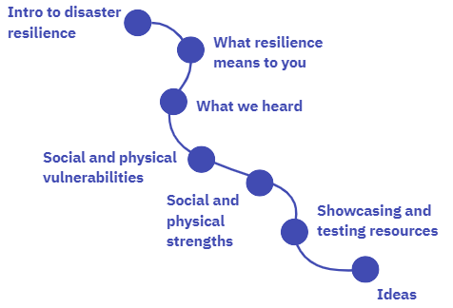
Participants. Twenty three North and West Melbourne residents attended the community workshop, eight from West Melbourne and fifteen from North Melbourne. Some participants have lived in the North-West neighbourhoods for many decades, are actively involved in a range of volunteering activities and some were new residents, both owning and renting in the area.
Showcase focus. As part of our efforts to address and prevent forms of loneliness and social isolation linked to poor mental health and wellbeing, the newly created Wellbeing and Connection Map was showcased and feedback was sought on how we could improve it.

3.2 What we presented to the group

What we heard in previous resilience workshops
We conducted resilience workshops in Southbank, Kensington and Carlton.
To feel prepared for a disaster, the community expressed four fundamental needs:
- I am safe
- I know where to go
- I know what to do
- I know who to connect with.
Community members told us they want to be safe and have information on how to stay safe and be prepared for a disaster. Overwhelmingly, community members seek opportunities to enhance their sense of community connection and wellbeing. Four themes emerged from the rich conversations:
- Inclusive information and engagement
- Accessible urban environment
- Community connection
- Safety and wellbeing.
Community members identified and prioritised actions to improve disaster resilience and preparedness in their neighbourhood. Across neighbourhoods, we heard two key priority ideas:
- Physical: a local, culturally inclusive, community hub
- Digital: a centralised and shared database of information.
For more information, visit: Community consultation | Community Resilience Assessment | Participate Melbourne.

Showcasing resources
The City of Melbourne is planning a new community centre in North Melbourne. This new multi-purpose community centre will be located at 91-115 Melrose Street, the current site of Jean McKendry Neighbourhood Centre (JMNC) and Hotham Hub. It will be 3,000 square metres in size. For comparison, the existing NMCC is approximately 1,500 square metres. The new centre will include:
- Youth, family and ageing services
- Additional services to be decided on following engagement with the community so we best meet the needs of the neighbourhood.
Find out more and follow the project to receive updates https://participate.melbourne.vic.gov.au/community-centre. Although Consultation Phase 1 has closed, City of Melbourne is continuing to include community insights into the design of the new centre. Please send suggestions or questions to Project Lead, D'Arcy Butler darcy.butler@melbourne.vic.gov.au.

Wellbeing and Connection Map
Our wellbeing is largely shaped by the connection we have to our local community and our ability to access quality support close to where we live. In addition to having access to strong mental health supports and clinical services, it is important that we feel included and engaged within our community to reduce feelings of loneliness and isolation.
The City of Melbourne has designed the Wellbeing and Connection Map as part of our efforts to address and prevent forms of loneliness and social isolation linked to poor mental health and wellbeing. We hope this map will make it easy to navigate the many fantastic community initiatives and programs we have in and around our municipality.
Categories include health, wellbeing and fitness, arts and culture, education and lifelong learning, food, gardening, social groups and much more. This interactive map provides information about existing community initiatives and programs within the City of Melbourne and surrounding suburbs.
For more information, visit: Wellbeing and connection map webpage.

3.3 What we heard

Resilience
We facilitated an icebreaker where workshop attendees bought to mind a time when they felt resilient. These were some of the words used to describe resilience by the workshop participants.
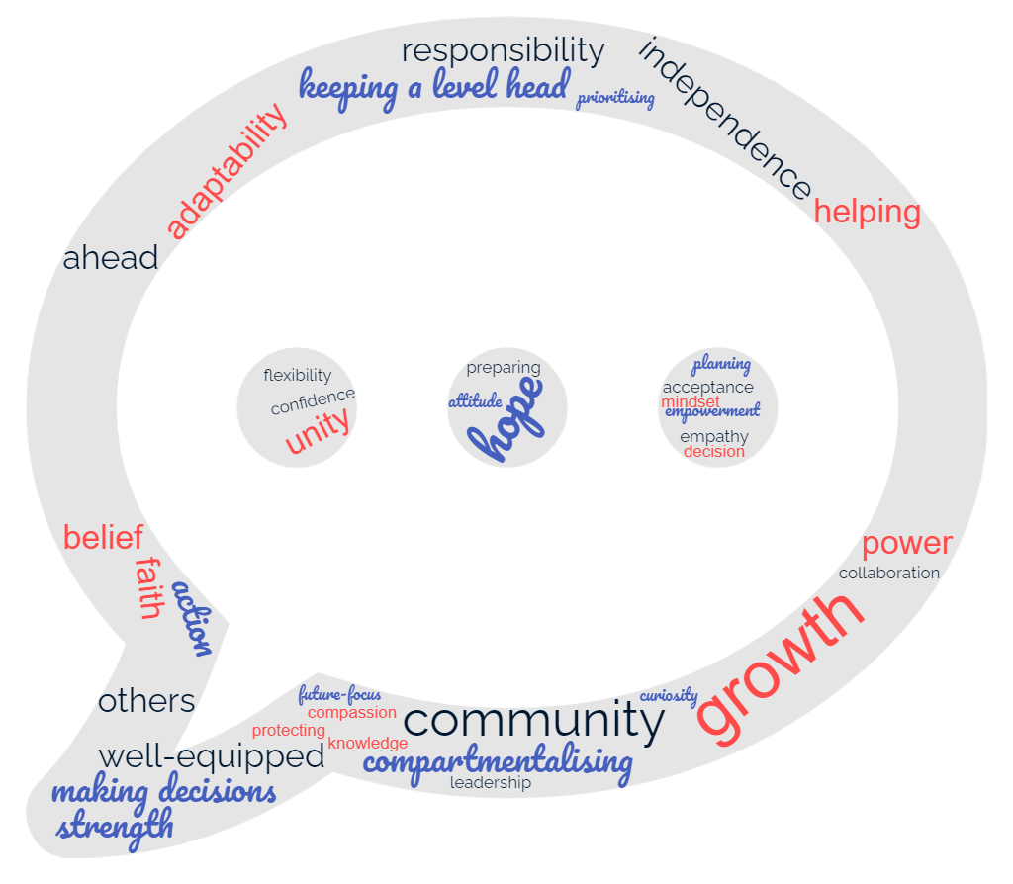

Vulnerabilities and strengths
We asked participants to identify some of the social and physical vulnerabilities in North and West Melbourne that may impact on the community’s ability to deal with a disaster. We used the four common themes described in the introduction to structure the outputs from these rich conversations. Building on vulnerabilities and strengths, the same themes were used to generate ideas to build community resilience:
- Inclusive information and engagement
- Accessible urban environment
- Community connection
- Safety and wellbeing.
Complete raw data is available in the Appendices. ​

Inclusive information and engagement
Residents highlighted the need for an education campaign on what to do in the event of a disaster, tailoring support for those with diverse needs and leveraging local newspaper and existing social networks.
The campaign should be inclusive, incorporate languages other than English, and build confidence in the community that information regarding where to gather will be made public in the event of an emergency.
The campaign should include both centralised digital information and physical copies at strategic locations.
We asked: ​ How might we best share information so that people feel clear about what to do and where to go in the event of a disaster?
Your ideas on how to best share information
- Build confidence in the community that they can access safety planning information in the event of a disaster
- Provide quality and reliable information in a centralised location, that can be filtered into communication channels in a reliable, efficient and swift manner
- Expand and promote information on existing Neighbourhood Portals
- Allocate physical copies of disaster management plans at community facilities / busy locations
- Script for call centre / customer service officers to ensure they know how to best respond to community enquiring about a disaster.
Accessible urban environment
Participants believe certain streets in North and West Melbourne are vulnerable to disasters, particularly to heatwaves and floods.
Residents highly value access to a range of services and to public transport, noting the 57 tram was not accessible for people with disabilities or people with prams. Participants raised concerns about services and new developments being in the middle of a flood zone and that high traffic means that streets can be challenging to navigate on foot too.
Due to poor quality high density living, limited green space and shading, creating severe heat stress in West Melbourne, participants recommended more tree canopy coverage.
We asked: ​How might we make our built environment more accessible and resilient to disasters?
Your ideas to improve accessibility of the built environment
- Find opportunities to close rat-run streets and activate them, bringing streetscapes to life through community grants
- Increase accessibility of footpaths and bike paths and improve drainage
- Proactively manage increasing traffic
- Clean up Moonee Ponds Creek and return it to a more natural state and provide resources to nurture biodiversity
- Promote tree planting and shade, and other nature-based solutions (e.g., perforating footpaths), as well as increase places for play in shade
- Build a centralised and well signed community centre where people can go in an emergency and where people can gather
- Extend library hours
- Create awareness of where to go in an emergency
- Provide a map of defibrillators and how to get one for my building
- Resilient power network (e.g., neighbourhood batteries).

Community connection
North Melbourne has a small-town vibe with restaurants, local businesses, many cultural events and sports clubs, all promoting community connection.
In West Melbourne, living close to others and a growing population has made it easier to feel a social connection and sense of place. There is a strong feeling that community members could turn to one another in a crisis. The lack of community hub in West Melbourne means that residents tend to turn to North Melbourne.
Participants believe that the good karma network has morphed into a community support network and that transient populations need supporting.
We asked: ​How might we improve community connection to reduce disaster risk and isolation?
Your ideas to improve community connection
- West Melbourne needs a council-run Community Centre, this could include a Community volunteer connector system (like the Red Coats) where the council could give authority and training
- Give new residents a ‘Welcome Cheat Sheet’, which would link to wellbeing and connection map, local library, partner with real estate agents, OCs, Universities
- Community Gardens on streets and verges
- Physical / visual notice boards (exterior of buildings, tram stops, languages, multiple places)
- Hospitality – Free drinks and food to bring people together
- More regular, smaller events
- Interest-led meet-ups, intergenerational and cross-cultural social activities
- Information made available through trusted sources via community centre staff and library.

Community safety and wellbeing
North Melbournians praised their privileged access to health services and their cultural diverse community bringing a range of skills, experiences and knowledge. Participants highlighted the benefits of mid-century buildings where the feeling of safety was stronger and where informal spaces allowed neighbourhoods to get to know each other.
West Melbourne residents noted that there were financial barriers to accessing affordable housing that meets people’s basic health and safety needs; meaning many people were left behind. Participants reported feeling unsafe in certain streets, with people sleeping rough and the presence of drug usage.
We asked: ​How might we support the health and wellbeing of our community so we can be more resilient to disasters? ​
Your ideas to improve community health and wellbeing
- Programs to increase self-resilience
- Subsidised exercise programs
- Better connected hubs
- Increasing accessibility of services i.e., flat trams
- Increased food growing on streets
- Funded community food services
- Increased street lighting.

3.4 Idea prioritisation
Across all themes, participants voted for their favourite ideas and the top-rated ideas were: ​
- Tree planting and shade, and other nature-based solutions (e.g. perforating footpaths)
- Increased food growing on streets
- Community volunteer connector system (like the Red Coats)
- Give new residents a ‘Welcome Cheat Sheet’.

3.5 Wellbeing and Connection Map
After showcasing the newly created Wellbeing and Connection map, we asked participants whether the map was supporting their needs and what were the opportunities for improvement. Participants were prompted to provide feedback on how the map could best reach community, what were the barriers to using the map, ​and if there was any missing information. Complete raw data is available in the Appendices.
Community members in North and West Melbourne emphasised the map's potential to enhance social connections and expressed support for filtering options based on age, interests, and identity. Feedback identified accessibility challenges, especially for individuals with visual impairments, non-English speakers, or limited technological access. Additionally, the online map's performance on mobile devices was suboptimal, with slow loading times negatively impacting its usability. Suggestions were made to make the map accessible through a CoM App and promote the map through posters, QR codes at council/community facilities, and instructional videos. Respondents highlighted an opportunity to expand the map's coverage to include faith-based groups, sports clubs, online community forums, and volunteer opportunities, ensuring a more comprehensive representation of social and community groups within the municipality.

3.6 Before and After
Workshop participants were surveyed at both the beginning and the end of the workshop to determine whether their participation in the session had been beneficial to them in gaining greater understanding and awareness about community disaster resilience in their neighbourhood.
It is worth noting that a brief Prepare Melbourne resource pack with key emergency links was prepared and shared with the workshop participants before the workshop.
Based on the evaluation, both understanding of community resilience and confidence in individual and neighbourhood’s capacity to respond to disasters increased after the Community Resilience workshops.

Before
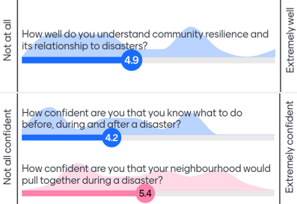

After
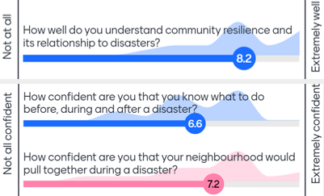

Feedback
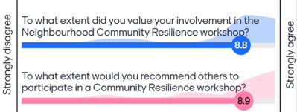

​

3.7 Next Steps
- ​Review findings and feedback
  - Review findings, compare resilience building ideas from each neighbourhood and explore ways to implement priority actions across municipality
  - Incorporate feedback into Wellbeing and Connection Map
- Portal updates
  - Add resources and findings, from workshops and survey inputs to the project's Participate Melbourne page and Neighbourhood Portals
  - Launch the centralised community resilience digital resource hub accessible through Neighbourhood Portals
- Action focus
  - Include community resilience ideas in Neighbourhood Priorities and identify avenues for implementation
  - Continue conversations with community organisations, local community members and other stakeholders and agencies to collaborate on delivering actions
Thank you to all workshop participants for your input and ideas!

Appendices
Appendix 1. Raw data workshop
What are the social and physical vulnerabilities to disasters in North and West Melbourne

North Melbourne
Accessible Urban Environment
- Haines Street flooding awareness
- Lack of tree cover in Abbotsford Street x 2 and Flemington Road – gets very hot
- Lack of water storage
- Heatwaves making other issues worse
- Water reserving for the natural world, especially birds
- Social housing not built for purpose
- Exposure on the streets due to extreme weather
- Services located in flood prone are
- Lack of public transport spaces and covered stops
- 57 tram line frequent but hard to get on and off
- More developments but not more car parks

Inclusive information and engagement
- Lack of public awareness of where to go in a disaster
- Lack of risk information for the public

Community connection
- Lack of community spaces in a heatwave
- Lack of community spaces for organising
- New communities in high rise development may not know the areas as well as neighbours
  - Shiel Street, North Melbourne primary school
- Student housing, transient, maybe fewer connections, family, friends
- Languages other than English
- Good karma network has morphed into a community support network – risk of vulnerability if you do not have Facebook

Community safety and wellbeing
- Older people less mobile
- Huge influx of people with metro, Queen Vic Market redevelopment creating more demand on services, more traffic, i.e pool too busy in summer
- Feeling unsafe in industrial areas, Royal Park at night, Victoria Street, near the pharmacy on Haines Streets; with the methadone clinic bringing drug users.
- People sleeping rough (Errol St, Peel St, Elizabeth St.)
- Curzon Street and North West end of Flemington road hard to cross
- Diverse community with access issues and existing vulnerabilities, and low social networks
West Melbourne
Accessible Urban Environment
- Biodiversity loss
- Green space very limited and very busy
- So much concrete, limited green – need more trees!
- Think about tree species and impacts with people with allergies
- Royal Park could have more green shading – a lot of areas you cannot use in heatwave
- Traffic
- High density living / poor quality
- Some houses and apartments without aircon, where to go in heatwave? Library not suitable for large crowds
- Housing infrastructure is old
- Not built for humans / accessibility
- Cargo access disruption
- Flood risk
- Drainage issues on footpaths if needed to walk
- Rodent movement
- Heat stress everywhere
- Car pollution
- Chemical disaster
- Oil spills / environmental mishaps
- 57 tram not accessible
- Flood over tram line would inhibit access
- Lots of new development in flood zone
- Woolworths in middle of flood zone
- New station in flood zone
Inclusive information and engagement
- Need for broader education campaign
- High rise dwellings in West Melbourne
  - Community education on what to do in the event of a natural disaster (e.g. the recent earthquake)
  - Tailored planning and support for those with diverse needs
- No obvious place to go in the event of emergency
Community connection
- No community hub
- Lack of clear community centre where people can meet and hang out x 2
- Lack of community and belonging – which would support community members to respond to a crisis (e.g. to know where to gather in a crisis)
Community safety and wellbeing
- Working population in industrial areas and their disconnection in the event of a natural disaster. Is this areas accessible for those with mobility issues?
- Limited access to amenities and resources (post office, groceries) – this was a challenge during COVID-19 where suburbs were locked down.
- Barriers to accessing affordable housing that meets people’s basic health and safety needs – many expensive options but many people left behind
- Safety planning (anti-social, large homeless population)
- Road safety among major construction works
- Split by major transit roads – unsafe
- Quiet Streets at night
- Antisocial behavior e.g. drug use dealing
- King Street – bad end of city
- Crime
- Safety
- Reliance on internet and electricity could create vulnerability in event of blackout

Activity 2: What are the social and physical strengths to disasters in North and West Melbourne

North Melbourne
Accessible Urban Environment
- Lots of public transport
- Well serviced and resourced for the current population
- North Melbourne station is well connected, constant and consistent
- Access and Connectivity
- Dog walking easy to connect with
- Access to Royal Park
- Access to health care – hospital
- Bike access, walkability and public transport good
- Community gardens – increasing greening and access to fresh food
- Pedestrian access is good in most parts
- People sit in the nature strips in nice weather
- Great location, close to CBD, Royal Park etc.

Inclusive information and engagement
- Thriving local newspaper
- Existing social networks

Community connection
- Activities at the community centre --> getting to know people
- Schools and community
- Access to green spaces to enable community connection
- Some student connection
- Putting funding into existing community spaces
- Existing clubs and other network e.g. good karma network build up social connections
- Existing cultural events promote opportunities for people to connect
- Small town vibe – people watch out for each other
- Football clubs – social connectedness and big green space
- Small business owners + strip shopping creates vibrancy and activity
- Lots of local businesses

Community safety and wellbeing
- Close to the hospital
- Lots of health services in the area
- Access to food (fresh and affordable)
- New City of Melbourne Wholefoods
- North Melbourne safer compared with other neighbourhoods
- Mid-century buildings feel safer and you get to know neighbours easier because there are spaces to bump into each other
- Cultural diversity (feeling accepted, many ethnic organisations)
- Diverse community with different skills and knowledge
- Multiple buildings exist in the area already that could be used as emergency gathering points

West Melbourne

Accessible Urban Environment / Geography
- Wide Streets
- Access to PT often free
- Proximity to CBD
- Close to QVM and Theatre
- Availability / Accessibility of emergency and education services and facilities (police, fire brigade, schools) close to home

Community Connection
- Elderly Union W. A.
- West Melbourne Baptist Community Church
- During hard lockdown: immediate volunteering: community, unity, compassion
- Living close to other people, growing population, in West Melbourne, has made it easier to feel a social connection
- Social cohesion – strong feeling that community members can turn to one another in a crisis
- There is a row of restaurants promoting community connection
- Growth in population leading to business confidence, which in turn fosters the sense of place
- Close to QVM and Theatre – supports social connection and access to basic amenities
- Small concentrated residential pocket can support connection and social cohesion – this could be positive in the event of a crisis

Places to gather
- ICV Mosque
- Haileybury, St Simmons
- Flagstaff gardens
- Bowlers Club
- QVM
- North Melb station
- Cafes
- Festival Hall
- ALDI and Woolworths
Potential:
- Maribyrnong River
- Spencer St
- Connection to Country and Aboriginal wisdom

Activity 3: Wellbeing and Connection Map

Positive Feedback
- Like the ability to filter
- Mobile friendly

Barriers
- Slow load time
- Awareness – without having to pay lots of money
- Update more often than a few months, should not be stagnant
- Could be more like social media – opportunity to chat, post questions
- Visual impairment and accessibility
- Pins wouldn’t open descriptions on phone
- Can you add a calendar filter?
- Anywhere to search for volunteer opportunities?
- Not mobile friendly – APP would work better! X 2
  - Better if is a CoM app
- Phone use not intuitive
- Inclusivity:
  - Other languages than English x2
  - Access to laptop
  - Tech-savvy x2
- Audio version?
- How do we capture more granular groups – social network mapping --> through submission form
- Needs to integrate with existing networks
- Affordability

Best ways to reach
- Promoting via North and West Melbourne Precinct (combined)
- Advocating for local businesses already in database
- Advertise at woolies, dog park, train station, good karma network
- Connecting in and cross-promotion with libraries x 2
- Facebook advertising
- Community notice board
- Posters with QR codes x 2
- Physically advertising: tram / public posters, maps at public spaces
- Not relying on social media and include variety of advertising
- Signing up for updates
- Videos of the services – access
- 25-65 age group?

Missing info
- Institute for post-colonial studies organise a lot of cool events!
- Churches
- Hotham History group
- ICV
- Old St James
- St Mary's Catholic church
- WMBCC
- Hillsong at Fest Hall
- Disability sport at Flagstaff
- Bowlers Club
- Elderly Ch. Welf. Assoc.
- Community pantries
- Faith-based groups

Activity 4: Ideas and actions to build resilience
​
Urban environment
How might we make our built environment more accessible and resilient to disasters?
- Find opportunities to close rat-run streets and activate them
- Passable footpaths and bike paths / 3
- Better drainage
- Clean up Moone Ponds Creek (currently toxic) and return it to a more natural state / 2
- Tree planting and shade, and other nature-based solutions (e.g. perforating footpaths) / 11
- Resources for our fauna (eg. birds) for biodiversity / 1
- Increase places for play in shade
- Build a centralised and well signed community centre where people can go in an emergency and somewhere people can gather at low cost with low entry requirements / 1
- Extend library hours (into evening etc.) / 1
- Map of defibrillators and info on how to get one for my building
- Proactively manage increasing traffic
- Create awareness of where to go in an emergency
- Resilient power network (eg. neighbourhood batteries)
- Brig streetscapes to life eg. community grants and business support

Community safety and wellbeing
How might we support the health and wellbeing of our community so we can be more resilient to disasters?
- Programs to increase self-resilience / 2
- Subsidised exercise programs / 1
- Better connected hubs
- Increasing accessibility of services i.e. flat trams / 2
- Increased food growing on streets / 10
- Funded community food services / 1
- Increased street lighting

Information
How might we best share information so that people feel clear about what to do and where to go in the event of a disaster?
- ‘You don’t need the information until you need it’
- Build confidence in the community that they can access safety planning information in the event of a disaster / 1
- Provide quality and reliable information in a centralised location, that can be filtered into communication channels in a reliable, efficient and swift manner / 3
- Activate the new portals expenditure on promotion of portal information / 3
- Allocate physical copies of disaster management, plans at community facilities / busy locations
- Script for call centre / customer service officers to ensure they know how to best respond to community enquiring about a disaster / 1

Community connection
How might we improve community connection to reduce disaster risk and isolation?
- Trusted sources of information, community centre staff and library
- West Melbourne needs a Council Community Centre / 3
- Community volunteer connector system (like the Red Coats) / 10
- CoM could give authority + training
- Give new residents a ‘Welcome Cheat Sheet’ / 8
- Link to wellbeing and connection map, local library, partner with real estate agents, OCs, Universities
- Community Gardens on streets and verges / 3
- Physical / visual notice boards (exterior of buildings, tram stop, languages, multiple places
- Hospitality – Free drinks and food to bring people together / 1
- More regular, smaller events
- Interest-led meet-ups, intergenerational and cross-cultural social activities / 1

