
  - City of Melbourne

Draft M2050 Vision
  - August 2025
Contents
Acknowledgement of Traditional Owners 3
About this document 3
How to share your feedback and help create the final vision 3
Draft Melbourne 2050 Vision 3
Draft principles supporting the M2050 Vision 4
Project overview 4
How we got here 4
Preparing our vision in a changing world 5
Building on our strengths 5
Why a 2050 vision now? 5
Building the collective story 5
What we heard 6
Connecting engagement themes and draft vision principles 6
Next steps 7

Acknowledgement of Traditional Owners
The City of Melbourne respectfully acknowledges the Traditional Owners of the land we govern, the Wurundjeri Woi-wurrung and Bunurong / Boon Wurrung peoples of the Kulin and pay respect to their Elders past and present.
We acknowledge and honour the unbroken spiritual, cultural and political connection they have maintained to this unique place for more than 2000 generations.
We accept the invitation in the Uluru Statement from the Heart and are committed to walking together to build a better future.

About this document
This document contains a summary of information to support the draft Melbourne 2050 Vision. It focuses on how voices from across Melbourne have shaped the draft, as well as the principles that underpin it.
All councils are required to prepare a 10-year Community Vision. Knowing that the world around us is changing rapidly, we’ve gone further and looked to the next 25 years. We’re calling this our ‘M2050 Vision'. It will inform our short, medium and long-term planning and actions in the years ahead.
Now, we’re asking for your feedback on what resonates.

How to share your feedback and help create the final vision
- Read the section entitled Draft Melbourne 2050 Vision, and review the section entitled Draft principles supporting the M2050 Vision.
- Read the table entitled Connecting engagement themes and draft M2050 Vision principles.
- Tell us what you think of the draft vision and the principles at Participate Melbourne.

Draft Melbourne 2050 Vision
The draft aspiration that links the long-term M2050 Vision to the Council Plan 2025-29 is:
"The best and fairest city."
The draft M2050 Vision is:
“We share opportunity, back ambition, and create prosperity with purpose.”
In a changing world, we grow together, sharing ideas and creating opportunity for the next generations. We back ambition and champion innovation. We invest in inclusive growth that delivers for everyone. Our city is people-first, diverse, creative and grounded in First Nations knowledge and culture. It is green, and alive with experiences, driven by regeneration and bold leadership.
We’re asking for your feedback on the draft community vision, and the principles that support it (set out later in this document).
We want to know what resonates most.

Draft principles supporting the M2050 Vision
These draft principles have been identified from across all engagement activities and further explain the intent and considerations of the draft M2050 Vision.
- People-first, diverse, creative: Our city is for people, its character comes through design and intercultural connection, celebrating diversity and creative spirit.
- Changing world, growing together: We are connected, ready for our future and empowered to move forward together.
- Sharing ideas and creating opportunity for the next generations: We explore what is possible with curiosity and are committed to a city that provides chances for everyone.
- Back ambition and champion innovation: Bold ideas flourish here. We celebrate entrepreneurship, innovative design and creativity across our city.
- Inclusive growth that delivers for everyone: We design for dignity and connection, where every neighbourhood supports wellbeing, opportunity and belonging.
- Grounded in First Nations knowledge and culture: Our future city honours and empowers First Peoples self-determination, guided by their knowledge, culture, and enduring connection to Country, working together to care for and shape Melbourne for generations to come.
- Green and alive with experiences: Our green spaces are connected across every neighbourhood, street and building. We create vibrant places and experiences, celebrating culture and design.
- Driven by regeneration: Our systems are circular. We restore, renew and replenish our natural environment and biodiversity.
- Bold leadership: We govern with transparency, fairness and optimism.

Project overview

How we got here
The City of Melbourne is working with our community and stakeholders to create a 25-year vision, a vision to 2050.
The community-led vision, which we’re calling the M2050 Vision, is a long-term, co-created story of the city’s future. It’s a long-term aspirational and values-driven statement of the hopes, values and priorities for Melbourne.
Our vision is the call to action: it explains why we do what we do. We’re setting a 25-year vision because we know that Melbourne means something to millions of people. We want to celebrate what makes this city great, and prepare for what lies ahead, empowered and ready.
We are also preparing the next Council Plan, with a four-year horizon. Together, these documents tell a story about the kind of city and community we want to be in the future, and the steps we plan to take over the next four years to get there.
Project timeline
March to May 2025: First phase of community engagement on future aspirations and priorities
June to July 2025: Draft the Melbourne 2050 Vision and prepare Council’s strategic plans
August to September 2025: Second phase of community engagement to test and refine draft the vision and strategic plans
October 2025: Adopt final M2050 Vision and strategic plans, including the Council Plan 2025-29.

Preparing our vision in a changing world

Building on our strengths
Melbourne is a city where you are welcome to be you. We’re known for our coffee, laneways, sports, arts and culture. Everything you need is a short walk or ride away. The fabric and vibrancy of our city the Melbourne vibe and our unique character is created by our diverse community, shared cultures and creativity.
The delight of Melbourne is that it slowly unfolds before you: you peel back the layers, you search down laneways and in neighbourhood shops for your favourite coffee, bar, local park.
Ours is a global city with a local way of living. A city with a big heart and plenty of ambition. On any given day, we estimate there are up to 1 million people in central Melbourne: living, working, studying, running a business and visiting for one of the many vibrant events and experiences happening in our city, day and night. We’re problem-solvers, inventors and collaborators. An enterprising economic powerhouse, a university town, a hub of culture and unique experiences.

Why a 2050 vision now?
We’re watching what’s changing in the world around us. We know that we must adapt to a changing climate, be ready for rapid digital transformation, keep pushing towards net zero, and improve our economic and social resilience in the years ahead.
When it comes to quality of life today, Melbourne sits in the top five global cities. We feel the world changing around us. We want to make sure that our community and all who have a connection to or an interest in Melbourne can share in the opportunities before us, grow their ideas, work together and be a part of a great future in Melbourne.
A long-term vision helps us make the most of Melbourne s creative and inventive spirit. It shows us how to take advantage of the opportunities ahead of us. It also prepares us for other changes that may come our way.
Setting a vision for 2050 makes room for a conversation about how we will create opportunity, be led by hope, nurture great ideas and share prosperity across our city in the future.

Building the collective story
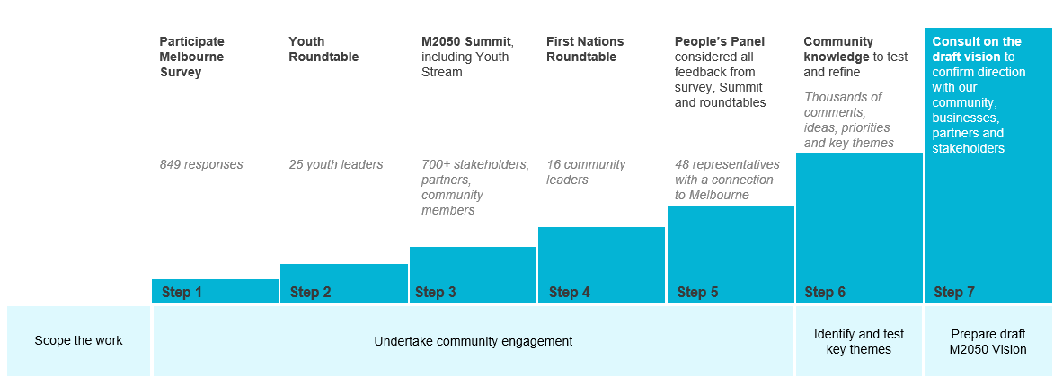

What we heard
Across all forms of engagement, some common threads emerged about the kind of city Melburnians want in 2050. These themes inform the principles of the draft M2050 Vision, alongside analysis of global trends affecting cities and local opportunities in Melbourne.
- Accessibility: Affordable housing, services, food systems, transport and education
- People-first design: Great transport and walkability
- Connected and intercultural community
- Country-centred: connected to First Nations culture, knowledge and systems
- Exciting and engaging: Rich in arts, entertainment and creativity
- Opportunity and choice: Fostering business, innovation, creativity and collaboration
- Future-focused: Prioritising regeneration and sustainability
- Green: Strong connections between parks, open spaces and greenery integrated into buildings and streets
- Prioritising community health and wellbeing
- Safe and welcoming: Grounded in fair leadership, governance and democracy

Connecting engagement themes and draft vision principles
The draft vision for 2050 is:
“We share opportunity, back ambition, and create prosperity with purpose.”
In a changing world, we grow together, sharing ideas and creating opportunity for the next generations. We back ambition and champion innovation. We invest in inclusive growth that delivers for everyone. Our city is people-first, diverse, creative and grounded in First Nations knowledge and culture. It is green, and alive with experiences, driven by regeneration and bold leadership.
Table 1: Connecting engagement themes and draft M2050 Vision principles
Engagement themes | Principles currently captured in the draft M2050 Vision
Accessibility: affordable housing, services, food systems, transport and education | - Sharing ideas and creating opportunity for the next generations  - Inclusive growth that delivers for everyone  - Green and alive with experiences
People-first design: great transport and walkability | - People-first, diverse and creative  - Vibrant and accessible by design  - Inclusive growth that delivers for everyone
Connected and intercultural community | - Inclusive growth that delivers for everyone  - People-first, diverse and creative  - Grounded in First Nations knowledge and culture
Country-centred: connected to First Nations culture, knowledge and systems | - Sharing ideas and creating opportunity for the next generations  - Grounded in First Nations knowledge and culture  - Driven by regeneration
Exciting and engaging: rich in arts, entertainment and creativity | - Sharing ideas and creating opportunity for the next generations  - Back ambition and champion innovation  - People-first, diverse and creative
Opportunity and choice: fostering business, innovation, creativity and collaboration | - Changing world, growing together  - Sharing ideas and creating opportunity for the next generations  - We back ambition, champion innovation
Future-focused: prioritising regeneration and sustainability | - Changing world, growing together  - Sharing ideas and creating opportunity for the next generations  - We back ambition, champion innovation  - Driven by regeneration
Green: strong connections between parks, open spaces, and greenery integrated into buildings and streets | - Green and alive with experiences  - Grounded in First Nations knowledge and culture  - Driven by regeneration
Prioritising community health and wellbeing | - Changing world, growing together  - Inclusive growth that delivers for everyone  - Bold leadership
Safe and welcoming: grounded in fair leadership, governance and democracy | - Sharing ideas and creating opportunity for the next generations  - Grounded in First Nations knowledge and culture  - Bold leadership

Next steps
The draft aspiration that links the long-term M2050 Vision to the Council Plan 2025-29 is:
"The best and fairest city."
We’ve outlined a draft M2050 Vision and supporting principles based on what we heard. The draft M2050 Vision is:
“We share opportunity, back ambition, and create prosperity with purpose.”
Now, we’re asking for your feedback on what resonates.
Tell us what you think of the draft vision and the principles, at Participate Melbourne.
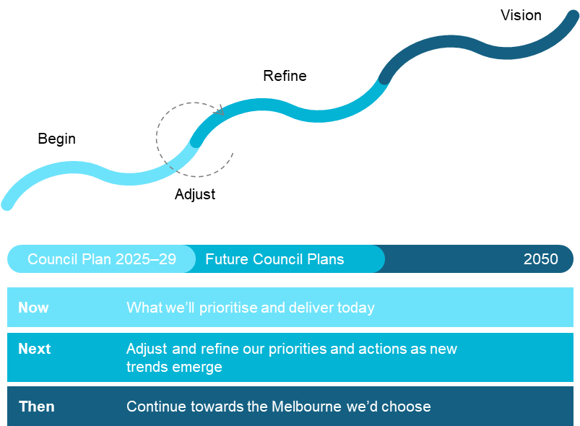

https://participate.melbourne.vic.gov.au/m2050-vision
https://participate.melbourne.vic.gov.au/m2050-vision

