STATEMENT OF SIGNIFICANCE
Heritage Place: Little Lonsdale Street Precinct | PS ref no: HO984  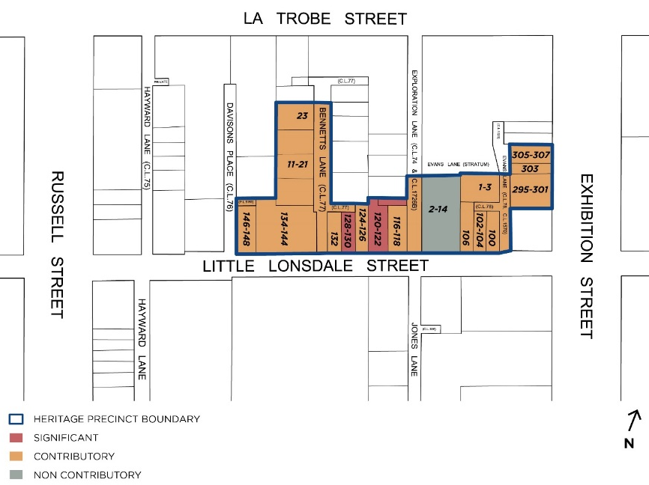
What is significant?
The Little Lonsdale Precinct including 100-148 Little Lonsdale Street, 11-23 Bennetts Lane, 1-3 Evans Lane, 295-301 Exhibition Street, the rear of 303-307 Exhibition Street, 2-14 Exploration Lane, Bennetts Lane, Exploration Lane and Evans Lane, Melbourne is significant.
Elements that contribute to the significance of the precinct include (but are not limited to):
- The commercial and warehouse buildings constructed from c1840s to c1936, as shown on the precinct map.
- The overall consistency of building form (two- to three-story scale).
- The pattern of development in the precinct which comprises mixed streetscapes of Victorian, Federation and interwar residential, commercial and industrial buildings, and the key features and original detailing characteristic of their respective styles and typologies.
- The industrial streetscapes throughout the fine grain network of laneways comprising Bennetts, Evans and Exploration lanes and Davisons Place.
The buildings at 11-21 and 23 Bennetts Lane, 1-3 Evans Lane, 295-301 Exhibition Street, and 100, 102-104, 106, 116-118, 124-126, 132, 134-144 and 146-148 Little Lonsdale Street are contributory. The Evans Lane frontages of 303 and 305-307 Exhibition Street are also contributory.
The buildings at 120-122 and 128-130 Little Lonsdale Street are significant.
Non-original alterations and additions to the contributory buildings are not significant.
The building at 2-14 Exploration Lane is non-contributory to the precinct.
How it is significant?
The Little Lonsdale Street Precinct is of local historic, representative, aesthetic and associative significance to the City of Melbourne.
Why it is significant?
The Little Lonsdale precinct is historically significant for its demonstration of less salubrious 'fringe' areas in the central city, and as a working-class residential precinct for mostly Irish immigrants who had settled by the late 1840s and early 1850s in an area referred to as 'Little Lon’ (Little Lonsdale Street bounded by Spring Street, Exhibition Street, La Trobe Street and Lonsdale Street). The Little Lonsdale Street Precinct is historically significant for its association with phases of migration, firstly by the Irish, and later by the Chinese, Germans, Jews, Lebanese and Italians who were part of a later wave of migration after the 1890s depression, often working as hawkers, small traders, or in the case of the Chinese, cabinetmakers and laundrymen. (Criterion A)
The Little Lonsdale Street Precinct demonstrates changing functions in the central city from residential to manufacturing and commercial use, workshops, small factories and shops. Following the razing of the area east of Exhibition Street the Little Lonsdale Street Precinct is significant as a remnant of the vibrant and complex community that evolved in the area from the 1840s. (Criterion A)
The Little Lonsdale Street Precinct is significant for its evidence of at least three phases of development from the 1870s to the 1940s.The Victorian era is represented by buildings at 102, 116, 120 and 146-148 Little Lonsdale Street and includes the Leitrim Hotel at 128 Little Lonsdale Street designed by Henry E Tolhurst. Edwardian factories and small warehouses are at 11-21 and 23 Bennetts Lane, 1 Evans Lane, 132 and 134 Little Lonsdale Street and the rear of no.146-148 Little Lonsdale Street. The interwar period is represented by commercial buildings at 100, 106, 124 Little Lonsdale Street. (Criterion D)
The Little Lonsdale Street Precinct is aesthetically significant for the combination of low-scale two to three storey buildings on both Little Lonsdale Street and within its laneway network. The buildings of the precinct generally complement each other through the use of predominantly red brick and stucco materials. The Little Lonsdale Street Precinct demonstrates a high level of integrity, particularly in the core group of buildings between 116 and 132 Little Lonsdale, and these are supported by the others of similar scale and materials. Evans Lane is aesthetically significant for the highly intact substation at 1 Evans Lane and the rear of the properties between 295 and 307 Exhibition Street that border it. Bennetts Lane frames views to the south of the Wesley church spire. The highly decorative Leitrim Hotel with intact stucco façade is of individual aesthetic significance. (Criterion E)
Part of the precinct is associated with King O’Malley (1858-1953), a North American politician who rose through the Australian Labor Party ranks to become minister for home affairs, a prominent advocate against conscription and supporter of women’s rights. (Criterion H)
Primary source
Hoddle Grid Heritage Review (Context & GJM Heritage, 2020)

