
Draft Arden and Macaulay Place Naming Framework
August 2026

Acknowledgement of Traditional Owners
The City of Melbourne respectfully acknowledges the Traditional Owners of the land we govern, the Wurundjeri Woi-wurrung and Bunurong / Boon Wurrung peoples of the Kulin and pays respect to their Elders past and present.
We acknowledge and honour the unbroken spiritual, cultural and political connection they have maintained to this unique place for more than 2000 generations. We accept the invitation in the Uluru Statement from the Heart and are committed to walking together to build a better future.
Contents
1. Introduction 5
1.1 Objectives 5
1.2 How to use this document 5
2. Arden and Macaulay urban renewal areas 5
2.1 A snapshot history of Arden and Macaulay 6
3. Statutory and legislative context 6
3.1 Victorian Government 6
3.2 City of Melbourne 7
4. Significance of place names 7
4.1 Why is place naming important? 7
4.2 Existing place names in Arden and Macaulay 7
Existing street names in Arden and Macaulay that reflect local character and history: 7
PART B 8
5. Naming themes overview 8
6. Connection to Country 9
6.1 Significance 9
6.2 The land as known by the Wurundjeri Woi-wurrung peoples 9
6.3 Policy 9
6.4 Engaging with Traditional Owners 9
6.5 Theme application 9
7. Women who shaped Arden and Macaulay 10
7.1 Significance 10
7.2 Historical women in Arden and Macaulay 10
7.3 Policy 10
7.4 Theme application 11
8. Waterways and wetlands 11
8.1 Significance 11
8.2 The dynamic pre-colonial landscape 11
8.3 Water as an enabler and a constraint 12
8.4 Policy 12
8.5 Theme application 12
9. Industry 12
9.1 Significance 12
9.2 From dispersed workshops to industrial clusters 13
9.3 Policy 14
9.4 Theme application 15
10. Sport and recreation 15
10.1 Significance 15
10.2 Sessions and shinboners 15
10.3 Betting on women’s cricket 15
10.4 Other recreational activities 16
10.5 Theme application 16
11. Activism 17
11.1 Significance 17
11.2 Activism over the years 17
11.3 Policy 18
11.4 Theme application 18
12. Multiculturalism 18
12.1 Significance 18
12.2 Diverse communities 18
12.3 Policy 18
12.4 Theme application 19
13. Naming theme overlap 19
PART C: Application of the draft Naming Framework 19
14. Two-step approach for name selection 19
15. Wayfinding and education 20
15.1 Wayfinding 20
15.2 Education on name meaning 20
16. Naming approval process 20
16.1 Representation of naming themes 21
17. How to engage with Registered Aboriginal Parties 21
17.1 Wurundjeri Woi-wurrung Cultural Heritage Aboriginal Corporation 21
18. Appendix A 21
18.1 Place type descriptions 21
19. Appendix B 21
19.1 Informing the draft Naming Framework 21
20. Appendix C 22
20.1 References and resources 22
History and place naming resources 22
20.2 Images 24

Part A: Context

1. Introduction
The draft Arden and Macaulay Place Naming Framework (the draft Naming Framework) guides the selection of names for new places and roads in the Arden and Macaulay urban renewal precincts (Arden and Macaulay).
Located north-west of central Melbourne, Arden is within the suburb of North Melbourne, and Macaulay includes parts of the suburbs of Kensington and North Melbourne. Recognised as areas for urban renewal, Arden and Macaulay are expected to transform over the coming decades in line with the Arden Structure Plan (2022) and Macaulay Structure Plan (2021).
Arden and Macaulay are separate urban renewal precincts. They are being considered together in this draft Naming Framework due to their proximity, related histories and similar timelines for urban renewal.
Arden and Macaulay’s history is deep and multi-faceted. The draft Naming Framework will help commemorate this through meaningful and inclusive place and road names.

1.1 Objectives
The draft Naming Framework has 3 main objectives:
- Support the selection of place and road names that endure and preserve cultural identity through strong links to place.
- Define an easy-to-apply process for proponents to follow when preparing a new place or road name application.
- Respond to the Victorian Government’s Naming Rules for Places in Victoria 2022 and City of Melbourne’s Place and Road Naming Policy 2024.

1.2 How to use this document
The draft Naming Framework comprises 3 parts and supporting appendices:
Part A provides:
- the draft Naming Framework’s purpose and objectives
- a summary of Arden and Macaulay’s key characteristics
- a summary of the statutory and policy settings that apply to the draft Naming Framework.
Part B describes the naming themes identified through research. The naming themes are embedded in the naming application process.
Part C details the processes for applying the draft Naming Framework, identifying and submitting place names and Traditional Owner engagement.
Appendices include a description of place and road types, a summary of the evidence base used to inform the draft Naming Framework and resources to support further research.
The draft Naming Framework can be read from start to finish, or readers can skip to sections that are most interesting or relevant to them. If short on time, start with Part C to learn how to apply the framework and then go to the theme sections in Part B.

2. Arden and Macaulay urban renewal areas
Arden and Macaulay are major urban renewal areas in the City of Melbourne. Historically industrial areas, they are transitioning into to sustainable, mixed-use locations that increase local living and provide work opportunities.
Figure 1: Arden and Macaulay urban renewal areas
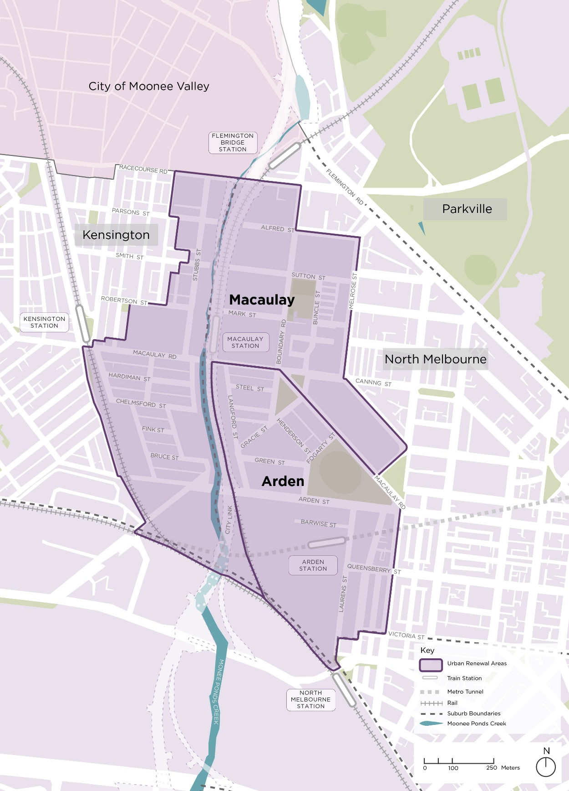
Arden and Macaulay each have a structure plan to guide their urban renewal.
Arden Structure Plan
The Arden Structure Plan (2022) establishes a vision for Arden to become an employment and innovation precinct. It will be a thriving new neighbourhood accommodating 34,000 jobs and 15,000 residents by 2052.
Controls have been introduced into the Melbourne Planning Scheme to facilitate the vision and the objectives of the Arden Structure Plan as the 44.6-hectare Arden precinct develops.
Macaulay Structure Plan
The Macaulay Structure Plan 2021 establishes the vision for Macaulay to become a thriving mix-use, mid-rise precinct with diverse housing and employment options to support local living. The Macaulay Structure Plan sets targets of 10,000 residents and 9,500 jobs in the precinct by 2051.
Development in Macaulay’s 90-hectares will be guided by planning controls to realise the vision and objectives of the Macaulay Structure Plan 2021. These were introduced into the Melbourne Planning Scheme via Amendment C497.

2.1 A snapshot history of Arden and Macaulay
Arden and Macaulay have a rich history, including a deep and ongoing connection to Country for the Wurundjeri Woi-wurrung people of the Kulin and a more recent history post European colonisation.
The Wurundjeri Woi-wurrung peoples have maintained an ongoing social, cultural, spiritual and economic connection to the precincts now known as Arden and Macaulay for tens of thousands of years. This connection is further detailed in the ‘Connection to Country’ naming theme section.
Post early colonisation, waves of migration to Arden and Macaulay have seen these areas become established multicultural communities.

A snapshot of Arden and Macaulay’s settlement history is outlined in Figure 2.
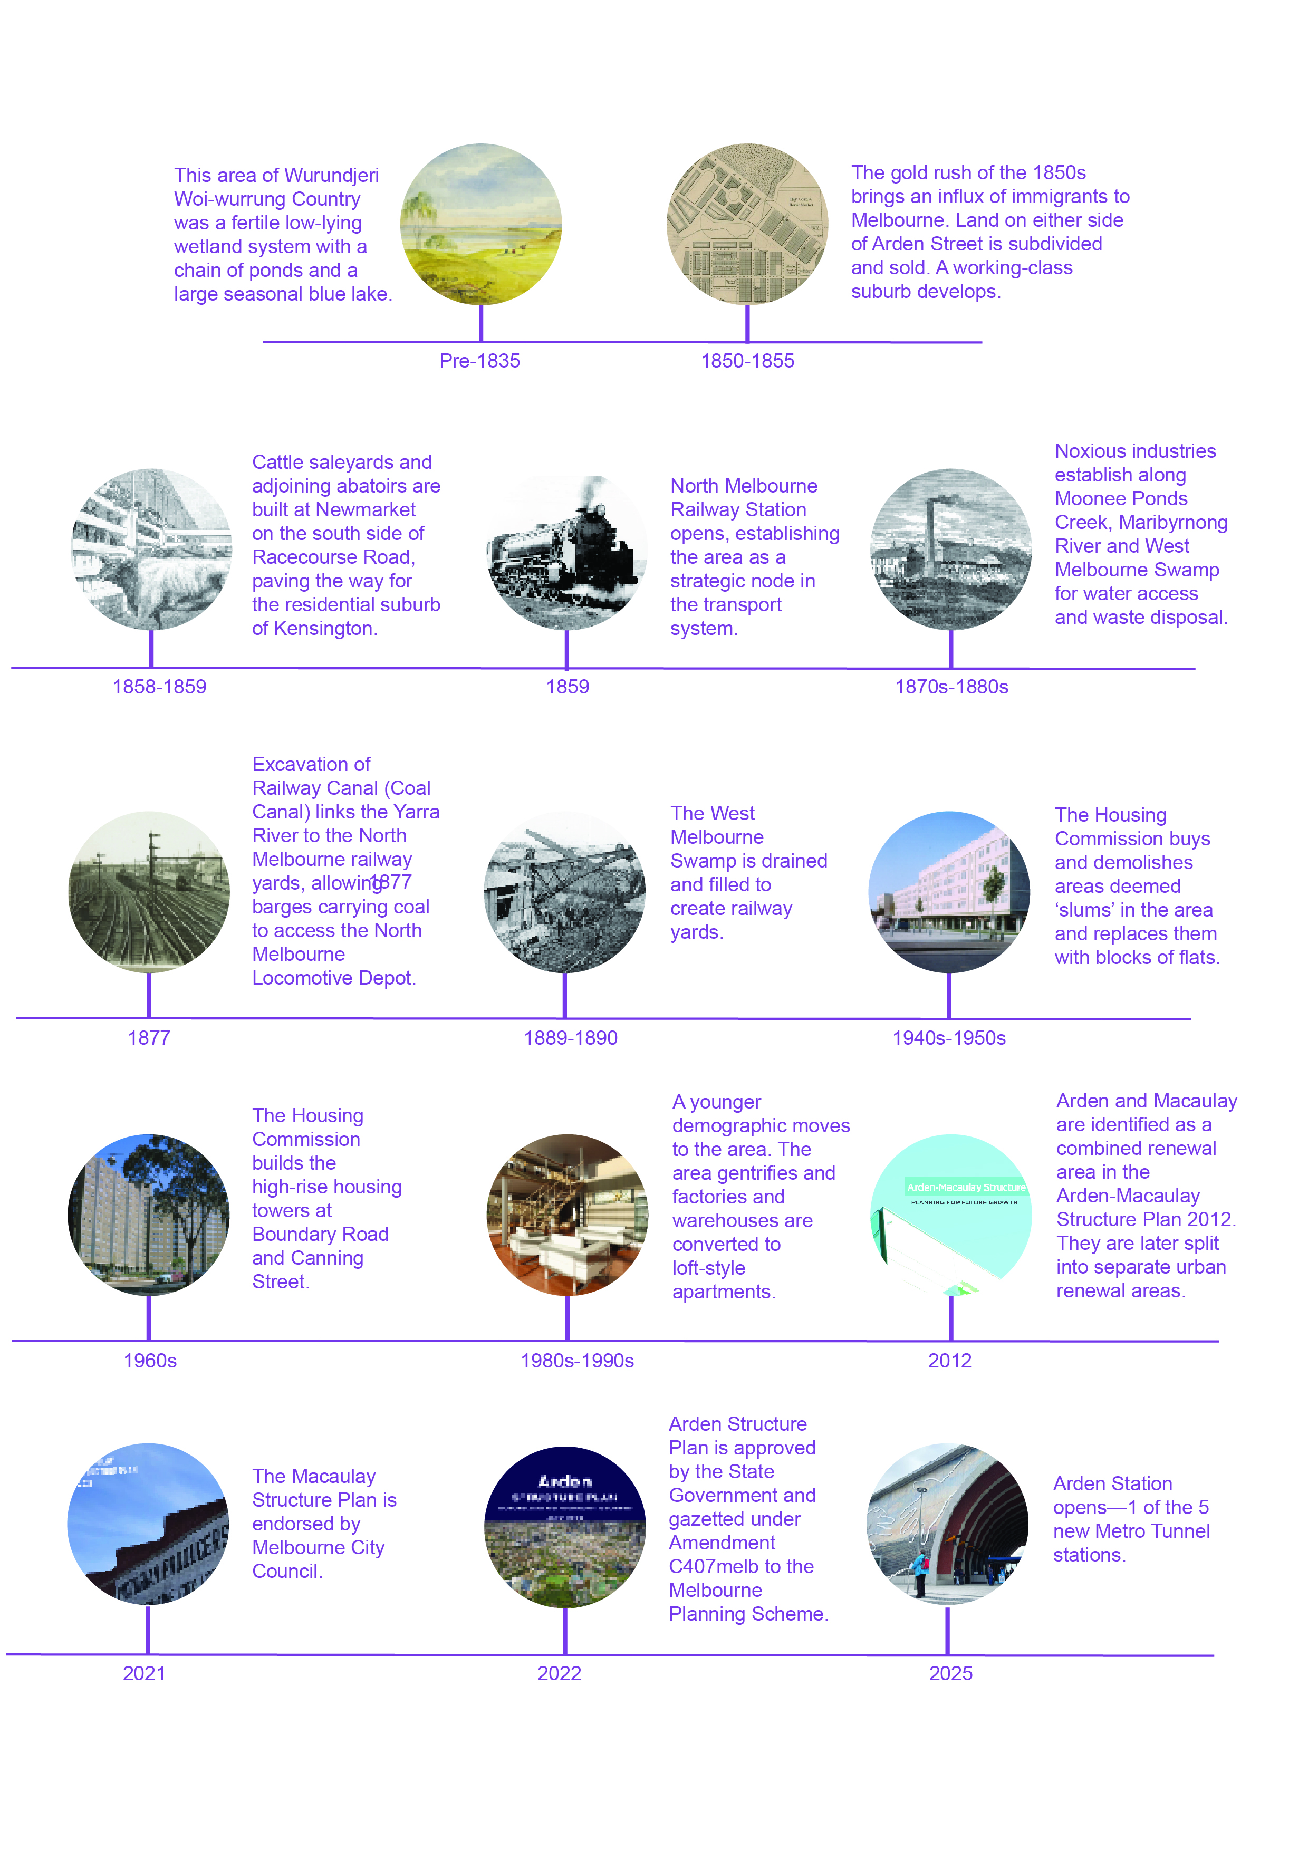
The timeline reads as follows:
- Pre 1835: This area of Wurundjeri Woi-wurrung Country was a fertile low-lying wetland system with a chain of ponds and a large seasonal blue lake.
- 1850-1855: The gold rush of the 1850s brought an influx of immigrants to Melbourne. Land on either side of Arden Street was subdivided and sold. A working-class suburb develops.
- 1858-59: Cattle saleyards and adjoining abattoirs were built at Newmarket on the south side of Racecourse Road, paving the way for the residential suburb of Kensington.
- 1859: North Melbourne Railway Station opened, establishing the area as a strategic node in the transport system.
- 1870-1880s: Noxious industries established along Moonee Ponds Creek, Maribyrnong River and West Melbourne Swamp for water access and waste disposal.
- 1877: Excavation of the Railway Canal (Coal Canal) linked the Yarra River to North Melbourne railway yards, allowing barges carrying coal to access the North Melbourne Locomotive Depot.
- 1889-1890: The West Melbourne Swamp was drained and filled to create railway yards.
- 1940-1950: The Housing Commission bought and demolished areas deemed "slums" in the area and replaced them with blocks of flats.
- 1960: The Housing Commission built high-rise housing towers at Boundary Road and Canning Street.
- 1980s-1990s: A younger demographic moved to the area. Garages and factories and warehouses were converted from industrial uses to loft-style apartments.
- 2012: Arden and Macaulay were combined and named as a renewal area in the Arden-Macaulay Structure Plan 2012. They are later split into separate urban renewal areas.
- 2021: The Macaulay Structure Plan was endorsed by Melbourne City Council.
- 2022: The Arden Structure Plan was approved by the Victorian Government and gazetted under Amendment C407 to the Melbourne Planning Scheme.
- 2025: Arden Station opened as one of the five new Metro Tunnel stations.3. Statutory and legislative context

3. Statutory and legislative context
The draft Naming Framework is subject to Victorian Government and local naming requirements.

3.1 Victorian Government
The Victorian Government’s Naming Rules for Places in Victoria 2022 (Victorian Naming Rules) are statutory requirements for naming roads, features and localities based on national standards and policies. They include naming principles and statutory requirements for standardised and clear naming procedures in Victoria.
The naming principles within the Victorian Naming Rules emphasise the concepts of diversity, inclusion, and place identity. There are 13 naming principals:
Principle A: Ensuring public safety
Principle B: Recognising the public interest
Principle C: Linking the name to place
Principle D: Ensuring names are not duplicated
Principle E: Recognition and use of Traditional Owner languages
Principle F: Names must not discriminate or be offensive
Principle G: Gender equality
Principle H: Dual names
Principle I: Using commemorative names
Principle J: Using commercial and business names
Principle K: Language
Principle L: Directional names to be avoided
Principle M: Assigning extent to a road, feature or locality

3.2 City of Melbourne
City of Melbourne’s overarching Place and Road Naming Policy 2024 (Naming Policy) is designed to make place and road naming decisions transparent and aligned with the Victorian Naming Rules and community expectations. The Naming Policy prioritises recognition and use of Traditional Owner languages and gender equity in naming.
Development of a ‘precinct naming strategy’ for Arden and Macaulay is required by the Naming Policy.
Figure 3: Legislative context of the draft Naming Framework.
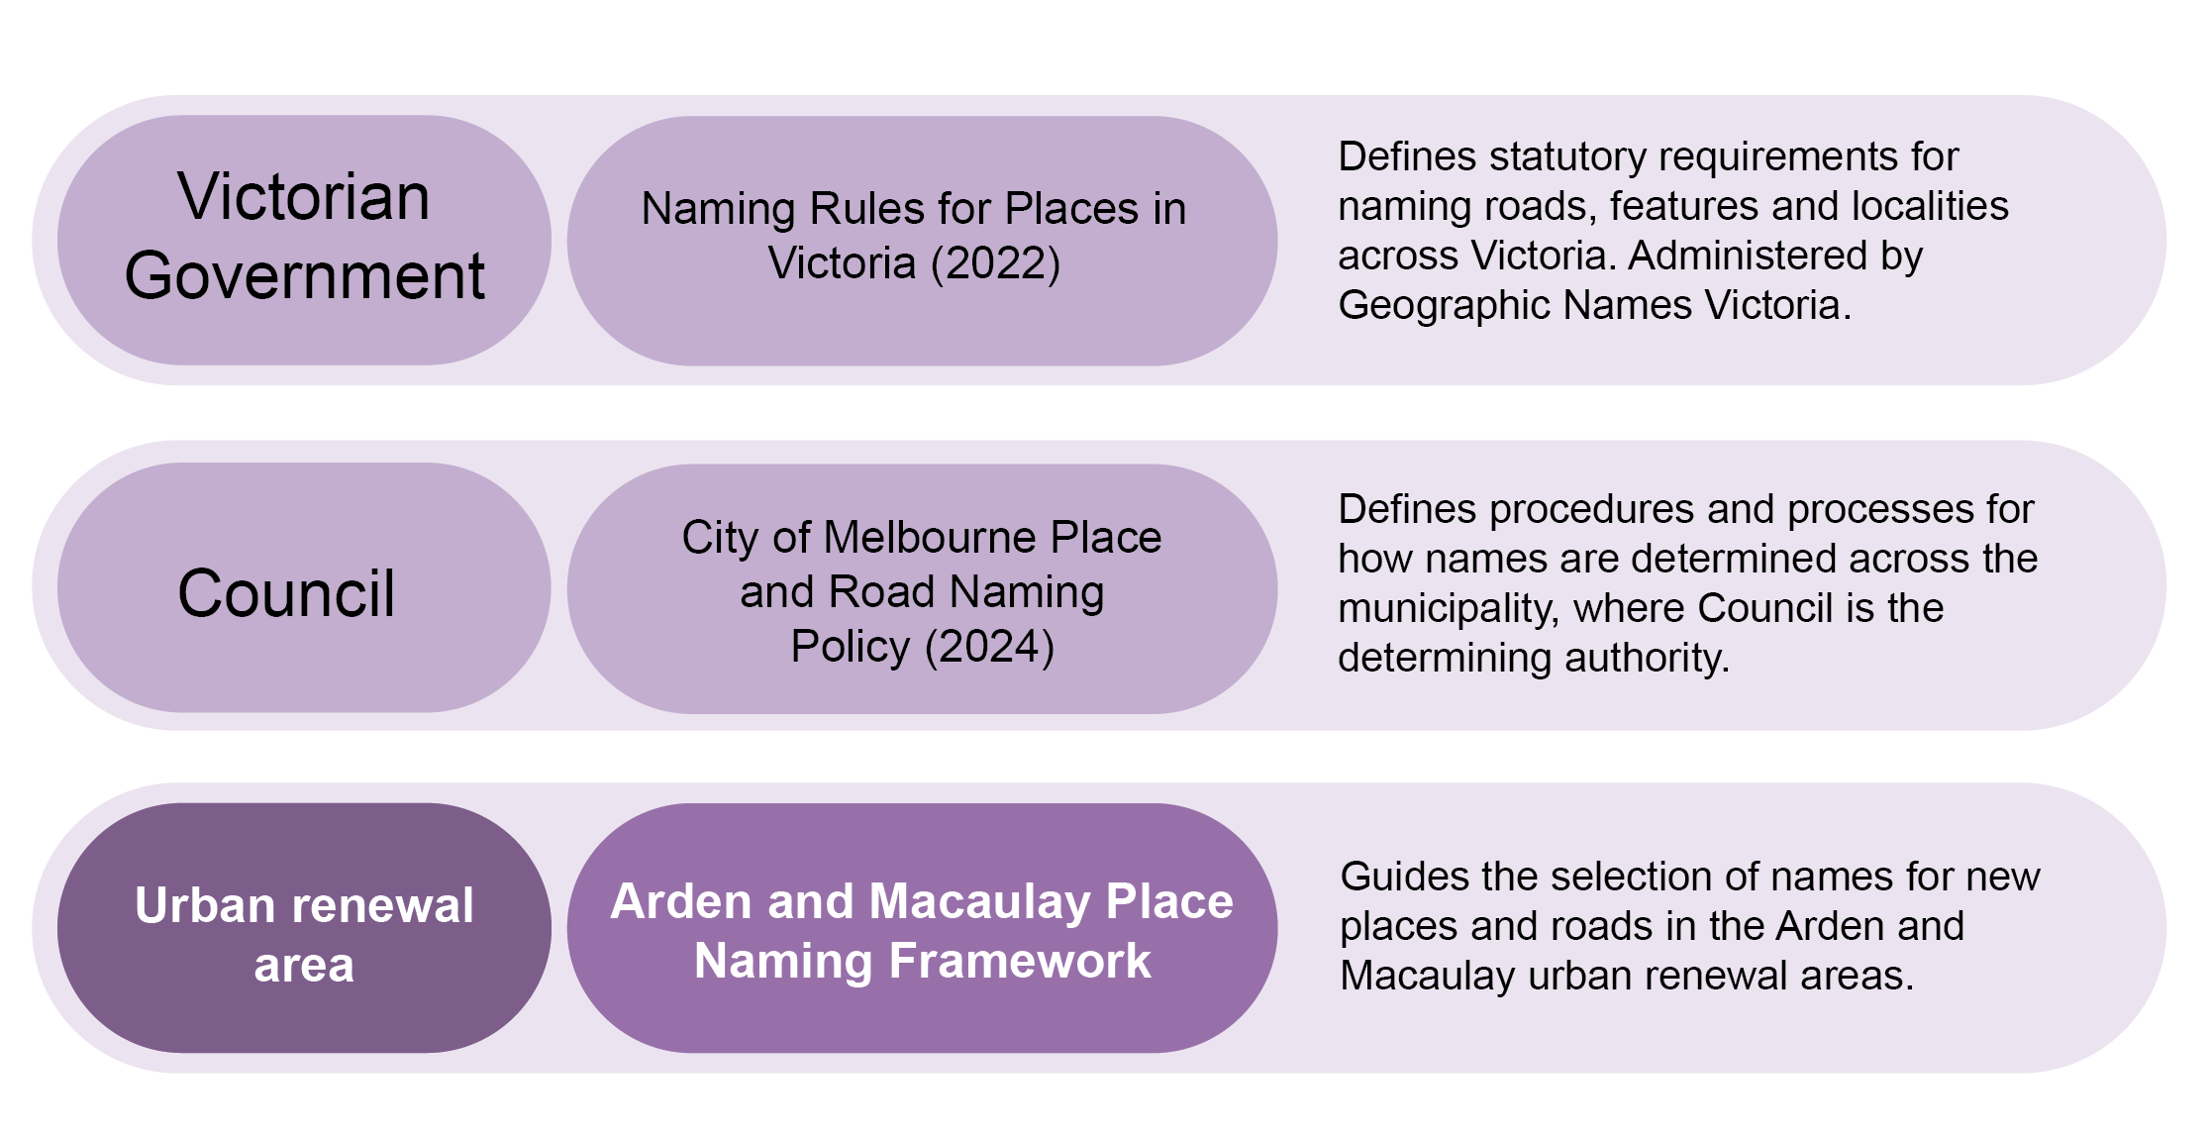Victorian Government
Naming Rules for Places in Victoria (2022)
Defines statutory requirements for naming roads, features and localities across Victoria. Administered by Geographic Names Victoria (GNV).
Council
City of Melbourne Place and Road Naming Policy (2024)
Defines procedures and processes for how names are determined across the municipality, where Council is the determining authority.
Precinct
Arden and Macaulay Place Naming Framework
Guides the selection of names for new places and roads in the Arden and Macaulay urban renewal areas

4. Significance of place names

4.1 Why is place naming important?
Place naming is more than a navigational tool. It can:
- support the creation of inclusive, vibrant neighbourhoods by celebrating an area’s diverse history and future aspirations
- educate the community by recognising local culturally significant sites, pivotal people and communities, and landmark innovations
- bolster opportunities for public realm initiatives that tell the story of place, such as public art and interpretive wayfinding.

4.2 Existing place names in Arden and Macaulay
Many existing place names in Arden and Macaulay commemorate men who were involved in the area’s establishment and industrial legacy. The draft Naming Framework aims to expand upon these existing names and amplify a wider variety of stories.

Existing street names in Arden and Macaulay that reflect local character and history:
Arden Street: George Arden was the co-founder of Melbourne’s first newspaper, the Port Phillip Gazette.
Barwise Street: John Barwise served on Hotham Council for 20 years and was Mayor 6 times. He was known as the father of North Melbourne.
Buncle Street: John Buncle was engineer, designer and politician and served 2 terms as Mayor of Hotham (North Melbourne). The factory of John Buncle & Sons produced iron work for several large bridges in Melbourne.
Crow Street: Ruth Crow was an activist, teacher and writer who advocated for improved town planning, community services and environmental justice. She and her husband Maurie were partners in activism and received multiple awards for their work.
De Feu Street: James De Feu worked in metalwork and spouting and established a business on Franklin Street.
Fogarty Street: Thomas Fogarty was a grocer, wholesaler and landlord who served 4 terms as Mayor of Hotham. He commissioned a free library with reading rooms and initiated a Mechanics Institute, where local workers could learn practical skills.
Gracie Street: Hugh Gracie was a contractor and timber yard owner who served 2 terms as Mayor of Hotham. He was remembered for holding an annual ball for ratepayers.
Hardiman Street: The Hardiman family were the operators of a nearby hotel.
Hayden Lane: Eric Haydon ran a wrought iron manufacturing business and forge at the corner of Thompson and Robertson Streets from 1928.
Langford: Robert Langford was a councillor and one-time Mayor of Hotham known for the large, beautiful house he built in the area.
Laurens Street: John Laurens served as a councillor, Mayor of Hotham and member of the Legislative Council. He advocated for the establishment of what is now North Melbourne Library.
Lightwood Walk: Acacia implexa is a native species of wattle tree commonly found along the banks of Moonee Ponds Creek. The common name for this species is Lightwood.
Mark Street: James Mark was a hotel owner, councillor and one-time Mayor of Hotham, known for his role in the annexation of Flemington Bank and allocation of funds for a town hall.
Smyth Street: Brettena Smyth owned a drapery and druggist shop on Errol Street and was a campaigner for women’s health reform and women’s suffrage.
Straker Street: Charles Straker was a local butcher, hotel owner and caterer.
Swift Walk: Swift Manufacturing Co. was a local manufacturer known for its pioneering one-piece tennis ball.
Thompson Street: Thompson was a stock and station agent that was prominent in the area.
Willow Ware Close: Willow Ware, founded in 1887, was a local manufacturer of tin canisters and kitchenware.
Wilson Mews: The Wilson brothers were the founders of Willow Ware.

Figure 4: Existing place names in Arden and Macaulay that reflect local character and history
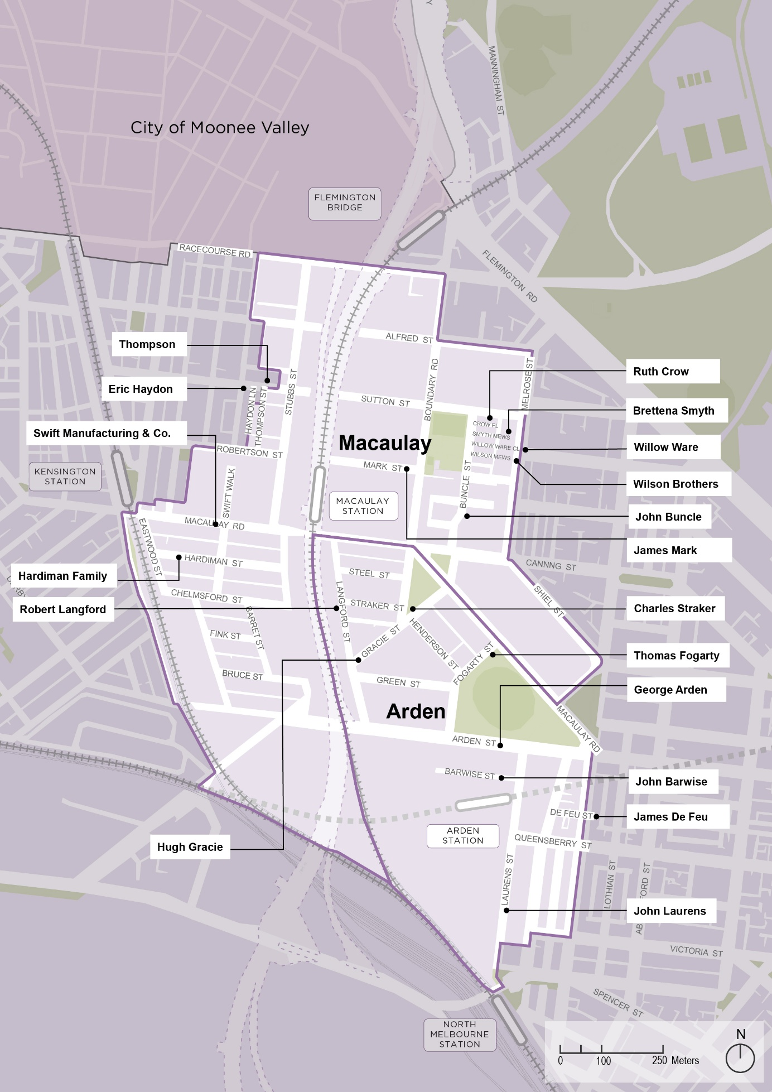

PART B: Naming Themes

5. Naming themes overview
Seven naming themes are identified for Arden and Macaulay. They are informed by state and local government policy, historical research and community feedback received from engagement on previous planning processes.
Naming themes are categorised into priority themes and precinct themes (Figure 5). Priority themes are prioritised in state and local place naming policy. Local area naming themes have strong links to the local area’s character.
Figure 5: Priority themes and precinct themes
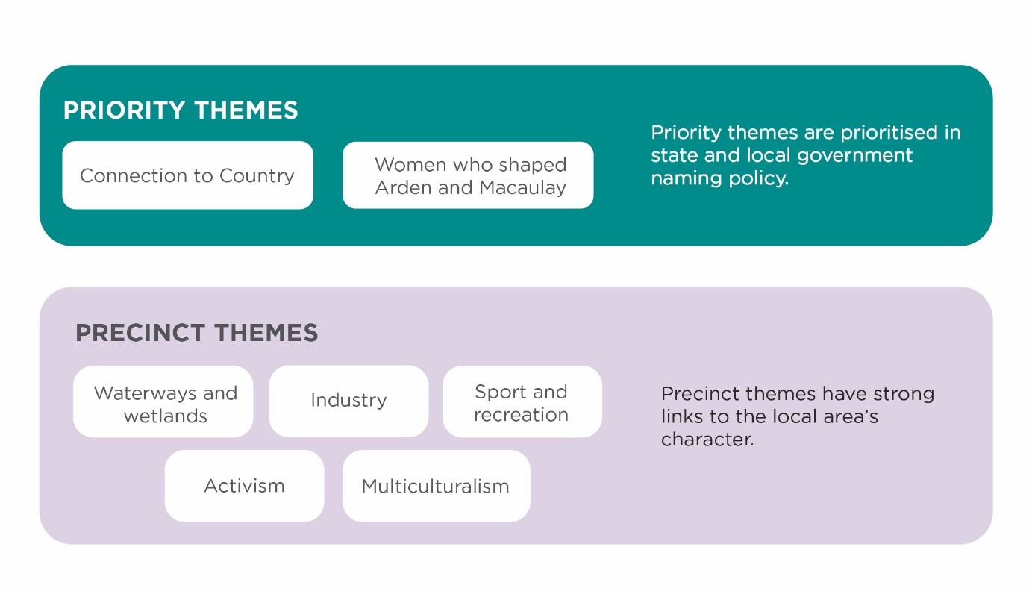
Priority Municipal Themes
Connection to Country
Women who shaped Arden and Macaulay
Priority municipal themes are prioritised in state and local government naming policy.
Precinct Themes
Waterways and Wetlands
Industry
Sports and Recreation
Activism
Multiculturalism6. Connection to Country
Precinct themes have strong links ot the local area’s character

6.1 Significance
The Wurundjeri Woi-wurrung peoples are the Traditional Owners of the areas now known as Arden and Macaulay, occupying the land as far back as 26,000 years.

6.2 The land as known by the Wurundjeri Woi-wurrung peoples
The land of the Wurundjeri Woi-wurrung was gently undulating and rich in wildlife and natural resources. Water sources were plentiful. A variety of reeds, grasses and food sources grew on the land, supporting a diversity of birds, snakes, mammals and aquatic life.
The chain of ponds in the area, now Moonee Ponds Creek, was used as a travel route and source of water, food and medicine. Along this route, Traditional Owners collected tuber yam daisy and bull-rush roots and caught eels in stone weirs and long fibre nets.
The chain of ponds blended into an area of swampland culminating in a clear blue saltwater lagoon, which was host to a diversity of bird species.
Figure 6: View from Flagstaff Hill in 1841, West Melbourne, with Batman's Swamp in the foreground, by engraver Julian Ashton
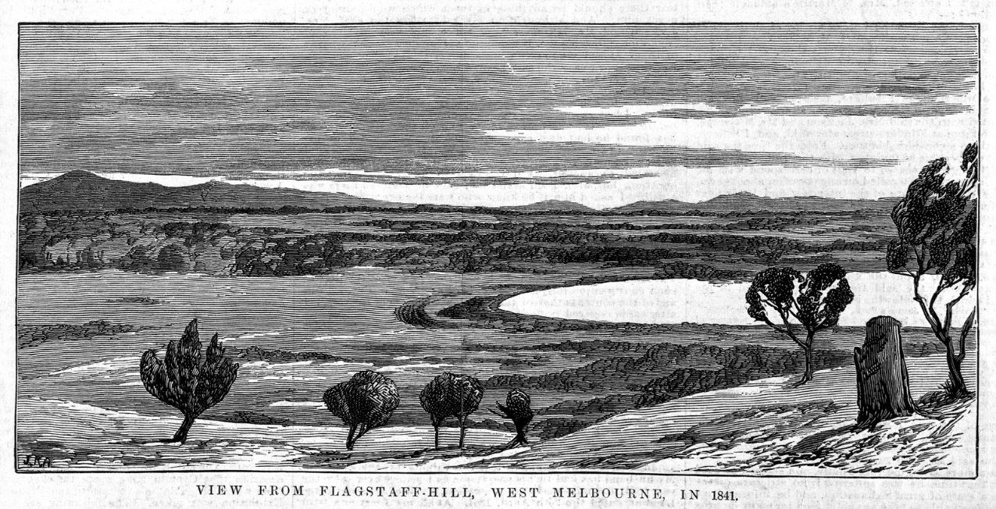

6.3 Policy
The Victorian Naming Rules encourage naming authorities to consider Aboriginal names when assigning names to roads, features and localities to help preserve Aboriginal language across Victoria. The use of Aboriginal names is subject to agreement from the relevant Traditional Owner group(s).
City of Melbourne’s Naming Policy Section 5.1 gives effect to the Victorian Naming Rules ‘Principle E: Recognition and use of Traditional Owner languages’ by giving priority to Traditional Owner language names in precinct naming strategies and by asking Registered Aboriginal Parties to choose those names.

6.4 Engaging with Traditional Owners
Wurundjeri Woi-wurrung language names and other relevant words are determined through engagement with the relevant Traditional Owner Registered Aboriginal Party: the Wurundjeri Woi-Wurrung Cultural Heritage Aboriginal Corporation. This process is outlined in Part C ‘How to engage with Registered Aboriginal Parties’ of this Naming Framework.
The Wurundjeri Woi-Wurrung Cultural Heritage Aboriginal Corporation has been engaged throughout the development of the draft Naming Framework. This process involved multiple meetings in-person and online.

6.5 Theme application
Connection to Country is a priority theme that can be used for naming assets across the Arden and Macaulay precincts. To respect the Traditional Owners of the precincts, it is important that the locations of Traditional Owner language names do not intersect names that commemorate colonisers. Colonisers are defined in this draft Naming Framework as people, groups, or authorities that invaded and settled Aboriginal lands without consent, asserting control over Country, people, and resources and establishing systems that dispossessed First Peoples and continue to cause harm.
Priority themes should be used for major assets and can be used for minor assets. Refer to Part C and Appendix A for more information.

7. Women who shaped Arden and Macaulay

7.1 Significance
Women have shaped Arden and Macaulay through their work in industry, commerce, hospitality, education, activism and community building. Some of the most prominent women of the area have run businesses, fought for women’s right to vote, organised art exchanges and developed community programs.
Only a few existing places in Arden and Macaulay honour women. The growth of Arden and Macaulay will provide more opportunities to elevate the stories of significant women—particularly those that lived or worked locally.

7.2 Historical women in Arden and Macaulay
Meet some of the historical women of the area:
Brettena Smyth was a store owner and activist who campaigned for women’s rights and health reform in the 1880s. Described as a free thinker, she lectured on women’s health and sold early forms of birth control. She was also a leading advocate for women’s suffrage and founded the Australian Women’s Suffrage Society in 1888. Smyth Mews in North Melbourne is named after her.
Marie ‘Ma’ Dalley was a hardworking businesswoman who ran multiple business ventures including a scrap metal yard that became one of the leading scrap dealers in Australia in the 1920s and a freezing works that pioneered a system of cooling fruit for local growers and canneries. She served as special magistrate of the North Melbourne Court from 1935 and became Mayor of Kew in 1954.
Ailsa O’Connor was an artist and political activist who taught at various schools including Flemington High School in the 1950s and 1960s. She is known for organising the Asian Australian Child Art Exchange from 1953-1956 to counter anti-Asian sentiment.
Florence ‘Florrie’ Lord was publican of a number of hotels including Kensington Hotel in North Melbourne. When a hotel owner tried to charge her for transferring her liquor license and stake in the business to another female publican, she sued him, arguing that he she should not need to pay a fee for his consent.
Alice Munche was the first President of North Melbourne Creche, which had progressive operating hours including 7am-1pm on Saturdays. A beloved leader, she was described in the 1908 creche annual report as having a ‘clear intellect and strong sense of justice, combined with a gentle dignity’.
Mrs Quinlan was a well-regarded teacher in North Melbourne in the 1850s. In 1857 she started teaching 86 pupils out of a former butcher’s shop in North Melbourne.
Alice Emily Nolan ‘Alice Brick’ was a widow written about by public servant Arthur Caldwell, who commended her endurance in caring for 3 children while working as a cleaner for a bank.
Figure 7: Brettena Smyth, one of Melbourne’s most prominent activists for women’s suffrage and women’s health reform
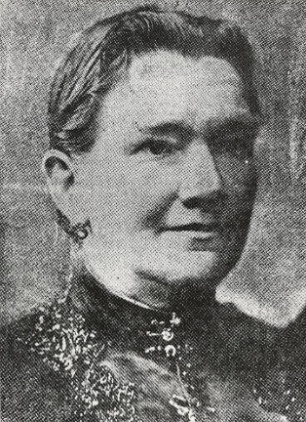
Figure 8: Advertisement in the Essendon and Flemington Chronicle (17 March 1893) for a lecture given by Brettena Smyth
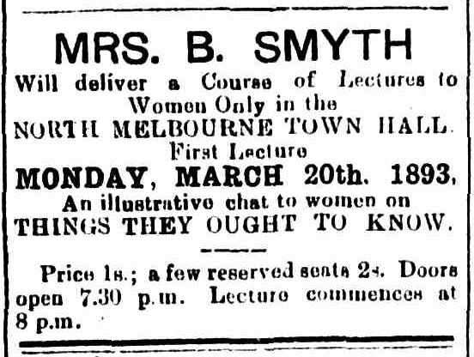
Figure 9: Marie Ma Dalley at her scrap metal yard from The Herald (27 Sept 1950)
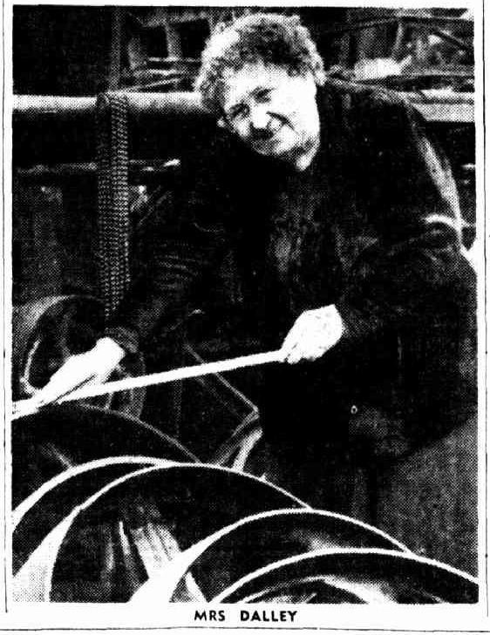

7.3 Policy
Place naming can play an important role in promoting gender equality.
- The Victorian Government and City of Melbourne support gender equality through the following policy and initiatives:
- The Victorian Naming Rules ‘Principle G: Gender equality’ encourages gender equality in the naming of roads, features and localities.
- The Victorian Government’s Gender Equality Strategy and Action Plan 2023–27 includes a target for 70% of new applications for commemorative place naming to commemorate women by 2027.
- The Victorian Government’s Our Equal Places Program 2024 supports increasing diversity and equality in commemorative place naming in Victoria. This is led by Geographic Names Victoria.
- The City of Melbourne’s Naming Policy Section 5.2 prioritises the Victorian Naming Rules ‘Principle G: Gender equality’ by annually reporting all places named and the proportional change of places named for women among all commemorative names. Council will ensure that places named for women do not fall short of 75% of all commemorative names in any two-year period.

7.4 Theme application
Women who shaped Arden and Macaulay is a priority theme that can be used for naming assets across the Arden and Macaulay precincts. Priority themes should be used for major assets and can be used for minor assets. Refer to Part C and Appendix A for more information.

8. Waterways and wetlands

8.1 Significance
Water has been a dynamic presence in the Arden and Macaulay areas since pre-colonial times, shaping settlement patterns, industry and infrastructure. Today water continues to influence development, as authorities and developers manage flood risk.

8.2 The dynamic pre-colonial landscape
The low-lying, flood-prone land we know today was once covered by wetlands. Water was a resource and wetlands were valuable ecological and cultural systems, supporting a diversity of plant and animal life. Flooding was a normal part of the shifting landscape.
What is now Moonee Ponds Creek was a chain of ponds. This chain of ponds served as a travel route and source of water, food and medicine for Aboriginal people. Plants that grew in the area included a variety of river reeds and grasses, which were used to make baskets, nets and fish traps. The area was also a source of yam daisy, a staple food. During times of high rainfall, the ponds would merge and become a floodplain.
The ponds adjoined a large area of wetlands to the west, referred to as the West Melbourne Swamp or Batman’s Swamp by early colonists. This area was home to a diverse array of bird species including swans, pelicans, geese, ducks, cormorants, curlews, cranes, sand-pipers, dotterels, quail and stone plover.
Southwest of the wetlands lay a large salt lagoon, known by early colonists as the ‘Blue Lake’ or ‘Saltwater Lake’. As described at by George Gorden McCrae in 1841, this was:
a real lake, intensely blue, nearly oval, and full of the clearest salt water…fringed gaily all round by… pig face… in full bloom, it seemed in the broad sunshine as though girdled about with a belt of magenta fire…the whole air heavy with the…odours of the golden Myrniong flowers.
Sources suggest that the Blue Lake was a seasonal lake and at certain times during the year it would become part of the swamp.

8.3 Water as an enabler and a constraint
For early colonists, water was not only a resource, but something to be managed. Creeks were buried to make way for early residential development. Drainage issues and flooding became persistent.
The swamp was used as a dumping ground for industrial and household waste, harming its ecological function and creating a major amenity issue. Colonists began calling for its drainage as early as 1849. The swamp was eventually drained, starting in 1877, to make way for expanded port facilities and rail infrastructure.
Water was also an enabler. Factories established along the edges of the swamp and Moonee Ponds Creek, using it as a water source and for disposal of industrial waste. In the broader area, Coode Canal was excavated to improve cargo ship access and Railway Canal excavated so that ships carrying coal could access the North Melbourne Locomotive Depot.
While these changes supported industry, they did so at the expense of valuable ecosystems and the health of Country.

Figure 10: Runner along Moonee Ponds Creek near Chelmsford Street, 2024
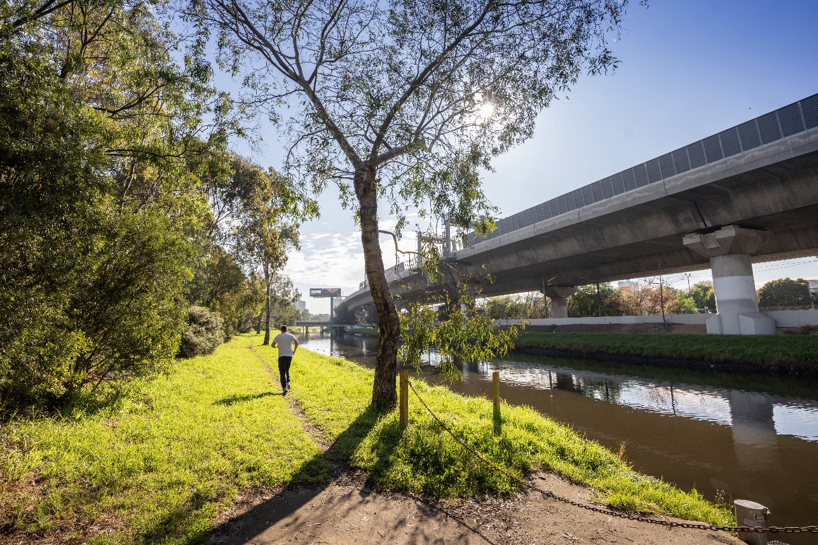
Figure 11: Aerial view looking south of Moonee Ponds Creek and CityLink elevated freeway, 2024
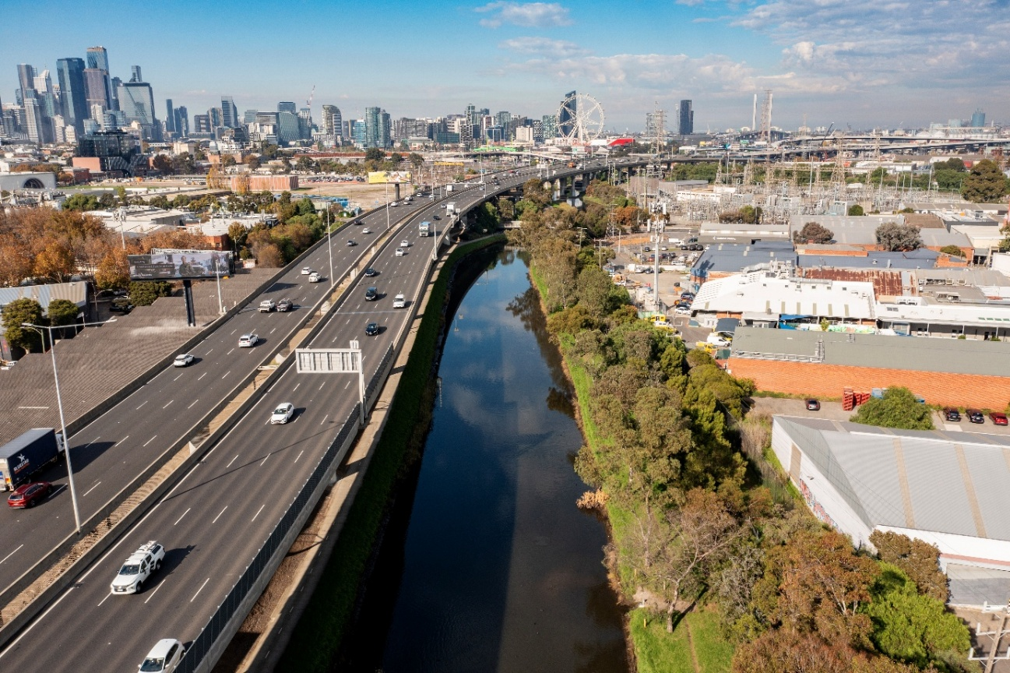
Example names that represent the history of water in the area include:
- Blue Lake or Saltwater Lake
- Lagoon: The Blue Lake was also known as a lagoon.
- Swan, pelican, cormorant, curlew, crane, sand-piper, dotterel, quail, stone plover: Bird species associated with the swamp and lake in early writings.
- River reed, rock correa, bottlebrush, bindweed: Native plants of the Moonee Ponds Creek area.

8.4 Policy
Names referencing the role of water in the area align with the Victorian Naming Rules ‘Principle C: Linking the name to place’.

8.5 Theme application
Waterways and Wetlands is a precinct theme. Precinct themes can be used for minor assets in specified areas (Figure 12). Refer to Part C and Appendix A for more information.

Figure 12: Waterways and Wetlands Theme Map
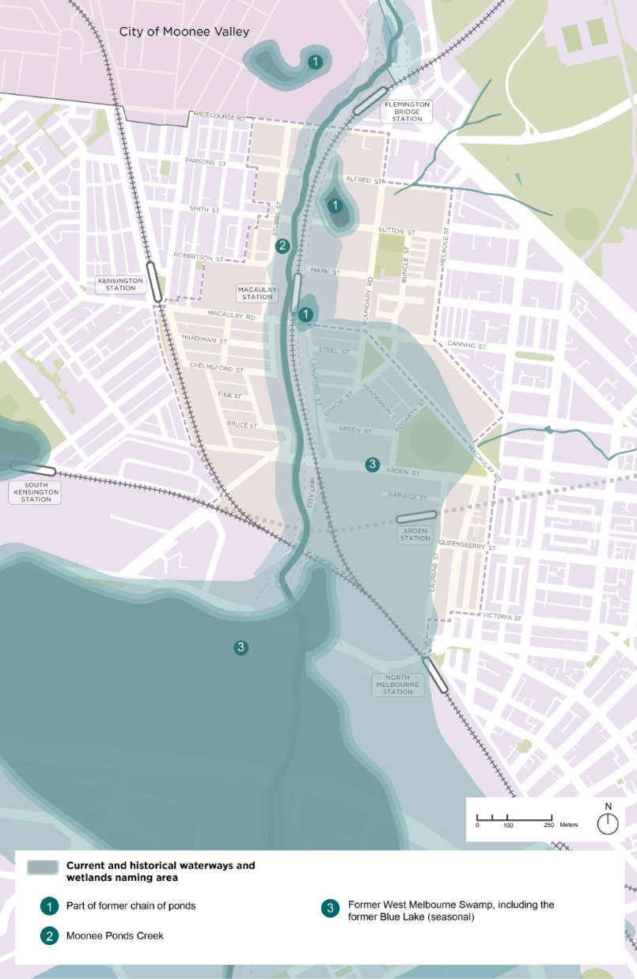

9. Industry

9.1 Significance
Located between the City of Melbourne and the goldfields, Arden and Macaulay were prime areas for industry. Early enterprise supported travel, trade and the development of new residential areas. This laid the foundation for larger scale industry to develop along waterways and rail lines.
The legacy of industry can be seen today in the layout of transport routes and remaining industrial buildings. While some industries continue to operate, many industrial buildings will be repurposed and reimagined as part of new development.

9.2 From dispersed workshops to industrial clusters
Early economic activity in the area supported a growing residential community. Small-scale factories and businesses established throughout residential neighbourhoods, operating out of houses, yards or attached workshops. This included pottery, carpentry, metal working, bakeries, butchers, retail shops, sign-making, stables and clothing-related trades.
By the 1860s and 1870s, clusters appeared. Tanneries established on the eastern side of Moonee Ponds Creek, using the waterway as a dump for industrial waste. After rail expanded into the area, flour milling and biscuit production established adjacent to rail lines in the 1880s. Wool storage and trading facilities established near railways in the 1900s, taking over many of the former tannery sites.
Industry within Arden and Macaulay remained strong throughout the 1900s, with periods of expansion during the world wars to supply the war effort.
From the mid-1960s, however, manufacturing in inner suburbs began to decline. While some industry remained in Arden and Macaulay, many industries moved to the outer suburbs, which could accommodate new methods of production.
Table 1: Industries in Arden and Macaulay from the 1850s to 1900s
Industry | Characteristics | Established | Location | Notable businesses
Construction and home goods (e.g. timber, pottery) | Small-scale production and retail | 1850s-1890s | Residential areas and edges | North Melbourne Pottery at 103–131 Laurens Street, North Melbourne  Holmes and Son Foundry at Robertson Street and Thompson Street
Tanning | Noxious, larger-scale, industrial | 1860s-1870s | Between Boundary Road and Moonee Ponds Creek | Glenmore Tannery
Soap and candleworks | Noxious, larger-scale, industrial | 1860s-1870s | Along Moonee Ponds Creek
Omnibus horse carriages | Extension of Melbourne network | 1873 | Hotham Stables at 36-58 Macaulay Road | Melbourne Omnibus Company
Rail operations | Large-scale | 1850s-1860s | North Melbourne Station and Kensington Station areas | Melbourne and Essendon Railway Company, Victorian Railways
Biscuit production | Industrial scale | 1870s-1890s | Laurens Street | Smith & Sons Steam Biscuit Bakery  A.J. Brockhoff & Co. Biscuit Factory  T.B. Guest and Co. Steam Biscuit Factory
Flour milling | Industrial scale | 1880s-1900s | Laurens Street, Elizabeth Street | Gillespie’s Kensington Roller Flour Mill  Kimpton’s Eclipse Hungarian Roller Flour Mills (now Allied Pinnacle Mill)  Minifie & Co’s Victoria Roller Flour Mill  Thomas Brunton & Co. Flour Mill (now Weston Milling)
Natural gas distribution | Large scale | 1887 | North Melbourne Gasworks outstation at 90 Macaulay Road | Metropolitan Gas Company
Wool storage and trade | Medium-to-large scale | 1900s | Between Boundary Road and Moonee Ponds Creek north of Macaulay Road; between Chelmsford Street and Arden Street west of Moonee Ponds Creek | Younghusband & Co wool store and complex  Victorian Producers Co-operative Company Ltd. No. 5 Wool Store

Some example names that represent the history of this industry in Arden and Macaulay include:
- Roller / Roller Mill: Thomas Brunton developed the process of roller milling in Australia after visiting American, English and European flour milling centres. Roller milling was more efficient than stone milling and produced consistent, light flour with a mild flavour.
- Crispette, trellis and nutrola: Names of biscuits produced by Brockhoff.
- Paragon: Paragon rusk was one of the biscuits produced by Smith & Sons.
- Skirting: The process of removing lower-quality edges of fleece.
- Lanolin: Natural wool oil.

9.3 Policy
Reflecting Arden and Macaulay’s industrial history aligns with the Victorian Naming Rules ‘Principle C: Linking the name to place’.
Figure 13: Advertisement from Brockhoff's crispettes biscuits circa 1934

Figure 14: T.B. Guest & Co. steam biscuit factory poster from around 1870
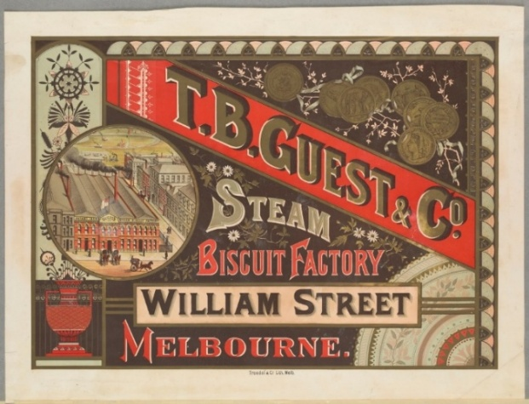
Figure 15: Younghusband wool tags
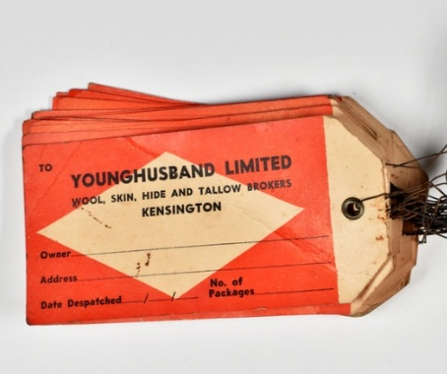
Figure 16: Buyers examining fleece in Victorian Producers Co-operative Wool Warehouse North Melbourne, showing buyers examining fleece
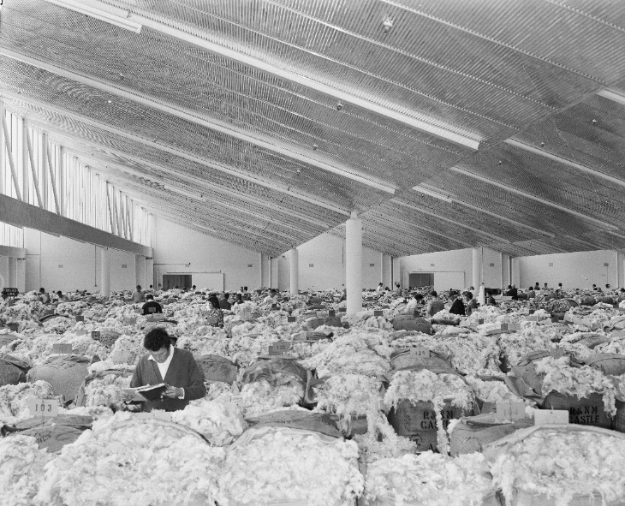

Figure 17: Images from the Brunton & Co. flour mill
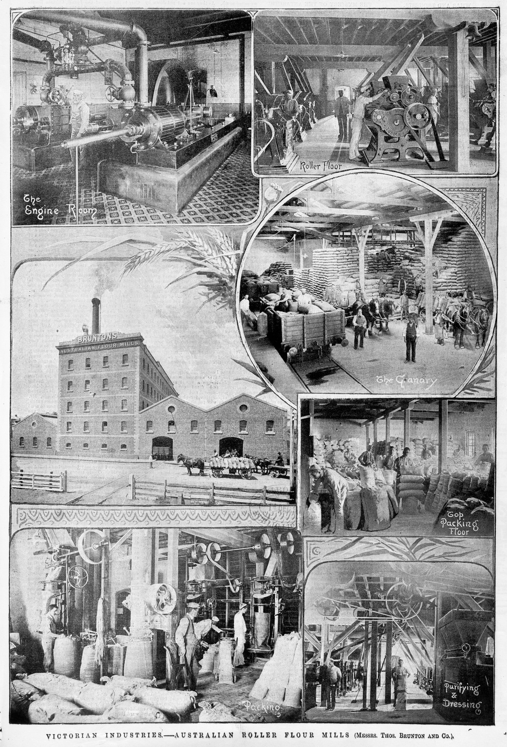

9.4 Theme application
Industry is a precinct theme. Precinct themes can be used for minor assets in specified areas (Figure 18). Refer to Part C and Appendix A for more information.
Naming of assets near Moonee Ponds Creek should consider healing of Country and avoid names associated with causing harm to waterways, including as names associated with industry.
Figure 18: Industry Theme Map
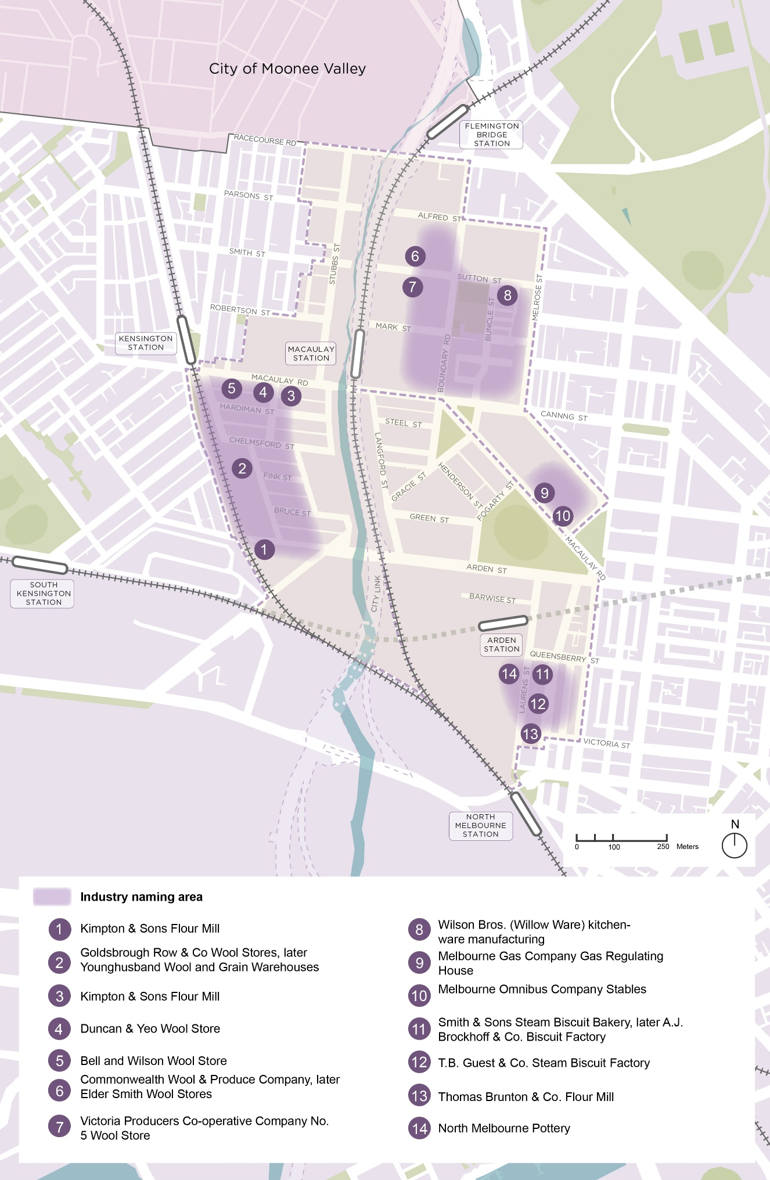

10. Sport and recreation

10.1 Significance
The Arden Street Oval and adjoining recreation centre are prominent features of Arden and Macaulay today. They serve as a testament to the long history of sport and recreation in the area.

10.2 Sessions and shinboners
Cricket was the first organised sport to be played by residents of Arden and Macaulay. Without a home cricket ground, the North Melbourne Cricket Club played its first season in Royal Park in 1868-69. After the season was over, the members decided to form a football club. James Gardiner was one of the founding members, and Gardiner Reserve now bears his name. Although the names and composition of these clubs have changed over the years, both still exist today.
The cricket club secured land between Arden Street and Macaulay Road to form their own ground in 1873-74. The low-lying land needed to be improved before it could become a functional sports ground, and the club spent a considerable amount of money improving it. By 1882, the cricket and football clubs were set up at Hotham Cricket Ground — now Arden Street Oval.
The footballers and cricketeers were nicknamed the ‘shinboners’. There are a few stories behind the name. One goes that the butcher would decorate his shop with shinbones after a notable victory. Another attributes this to fierce players that worked at the abattoirs and played with bloodied shinbones. A third story goes that the members also played the brutal Irish game of hurling, involving hits to the opponents’ shins. All suggested tough, indestructible players.
Figure 19: North Melbourne football team in front of Arden Street Oval grandstand, circa 1934
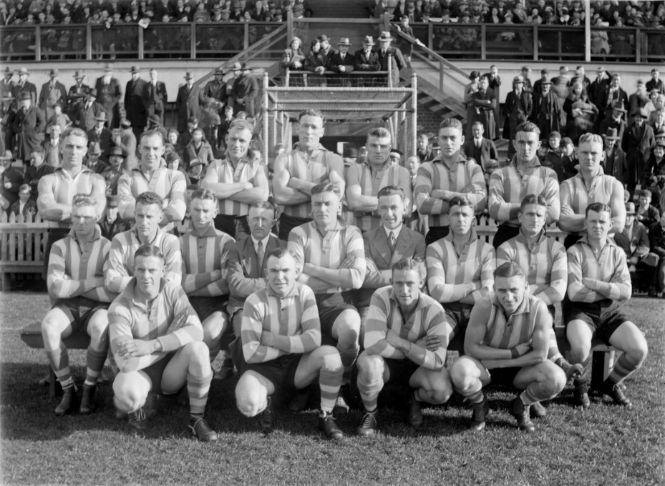
Senior player Alf Egan was the team’s first known Aboriginal player. After beginning his football career with Carlton, he played 15 games for North Melbourne between 1934 and 1935. Egan was a skilled player noted for his high marking and long punt kicks. He was named one of North Melbourne’s best due to his strong attack.

10.3 Betting on women’s cricket
Women faced significant barriers to participating in sport in the 1900s due to gender stereotypes and a lack of institutional support. Early football matches between women were viewed as a spectacle and described in patronising ways in the press. It wasn’t until the 1980s that a formal league was established, and women’s teams continued to face challenges of funding and poor facilities.
Cricket leagues were available to women earlier due to the sport being perceived as more graceful and modest. The Kensington and Flemington Ladies Cricket Club was established in 1905, shortly after the Victorian Ladies Cricket Association that same year.
In the 1930s, a women’s cricket team called the ‘Youldens’ was formed, funded by bookmaker Harry Youlden. Youlden Street in Kensington commemorates this team. Youlden’s player Lorna Kettles’ became a pioneering player, earning a spot on Australia’s first women’s Test team.

10.4 Other recreational activities
While cricket and football were prominent, there were plenty of other clubs and activities for locals. These included:
- The North Melbourne Choral Society – founded in 1857
- The Volunteer Rifle Corps – established in 1859
- At various locations in the 1880s:
  - Invitation-only dances, performances and clubs for well-known local residents
  - Performances by local musical and dramatic groups for working class residents, including fundraising concerts for churches, schools, sports clubs, and lodges and associations
  - Masons and friendly societies
  - Working men’s clubs, including the Victorian Signalman’s Association
  - Church-led social gatherings
- Skating at indoor rinks – the Kensington Skating Rink opened in 1888 and could accommodate 800 skaters. This venue also held events including tug-of-war competitions between workplace teams and the Victorian Poultry and Dog Show.
- Speedwell Cycling Club – established 1895
- North Melbourne Baths – opened 1929

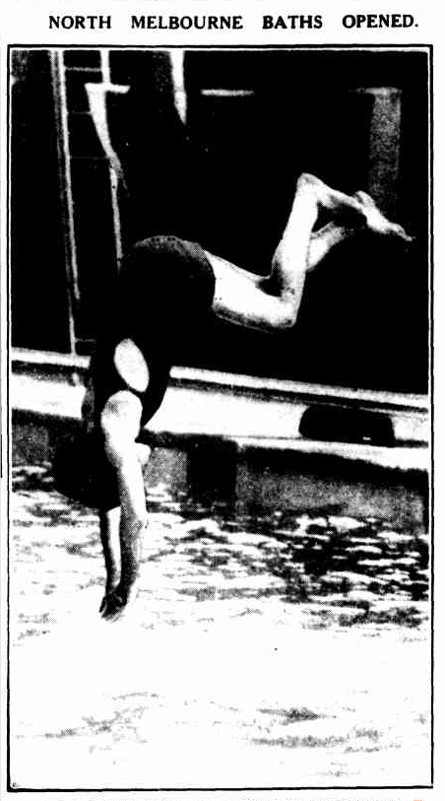
Figure 20: Photo in The Argus from the opening of the North Melbourne Baths, 1929
Figure 21: Cycling club, most likely the Speedwell Cycling Club, formed in 1895 in North Melbourne
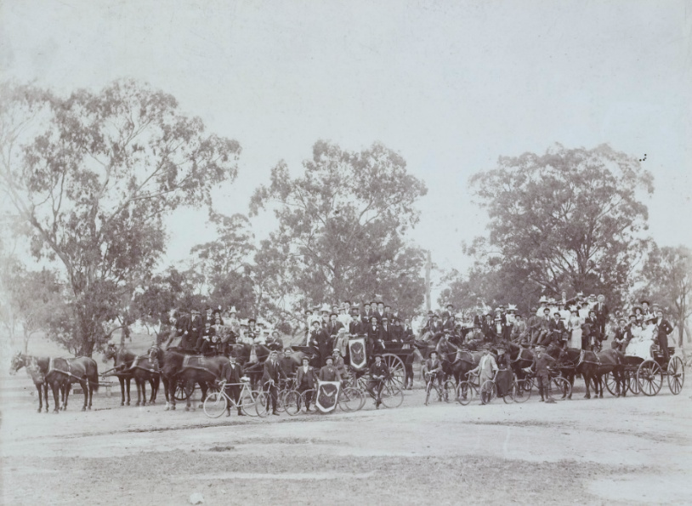
Some examples of names that reference the history of sport and recreation in Arden and Macaulay include:
- Shinboner: The nickname of the cricket and football teams.
- Alf or Alf Egan: After the first known Aboriginal shinboner Alf Egan. (Note: The name Egan has already been used within 5km of the precinct, in reference to a different person).
- Kettels: After pioneering female cricket player Lorna Kettels.
Kettels and Alf could also be used as a priority theme names, as they overlap with the Women who shaped Arden and Macaulay and Connection to Country themes.

10.5 Theme application
Sport and Recreation is a precinct theme. Precinct themes can be used for minor assets in specified areas (Figure 22). Refer to Part C and Appendix A for more information.
Figure 22: Sport and Recreation Theme Map
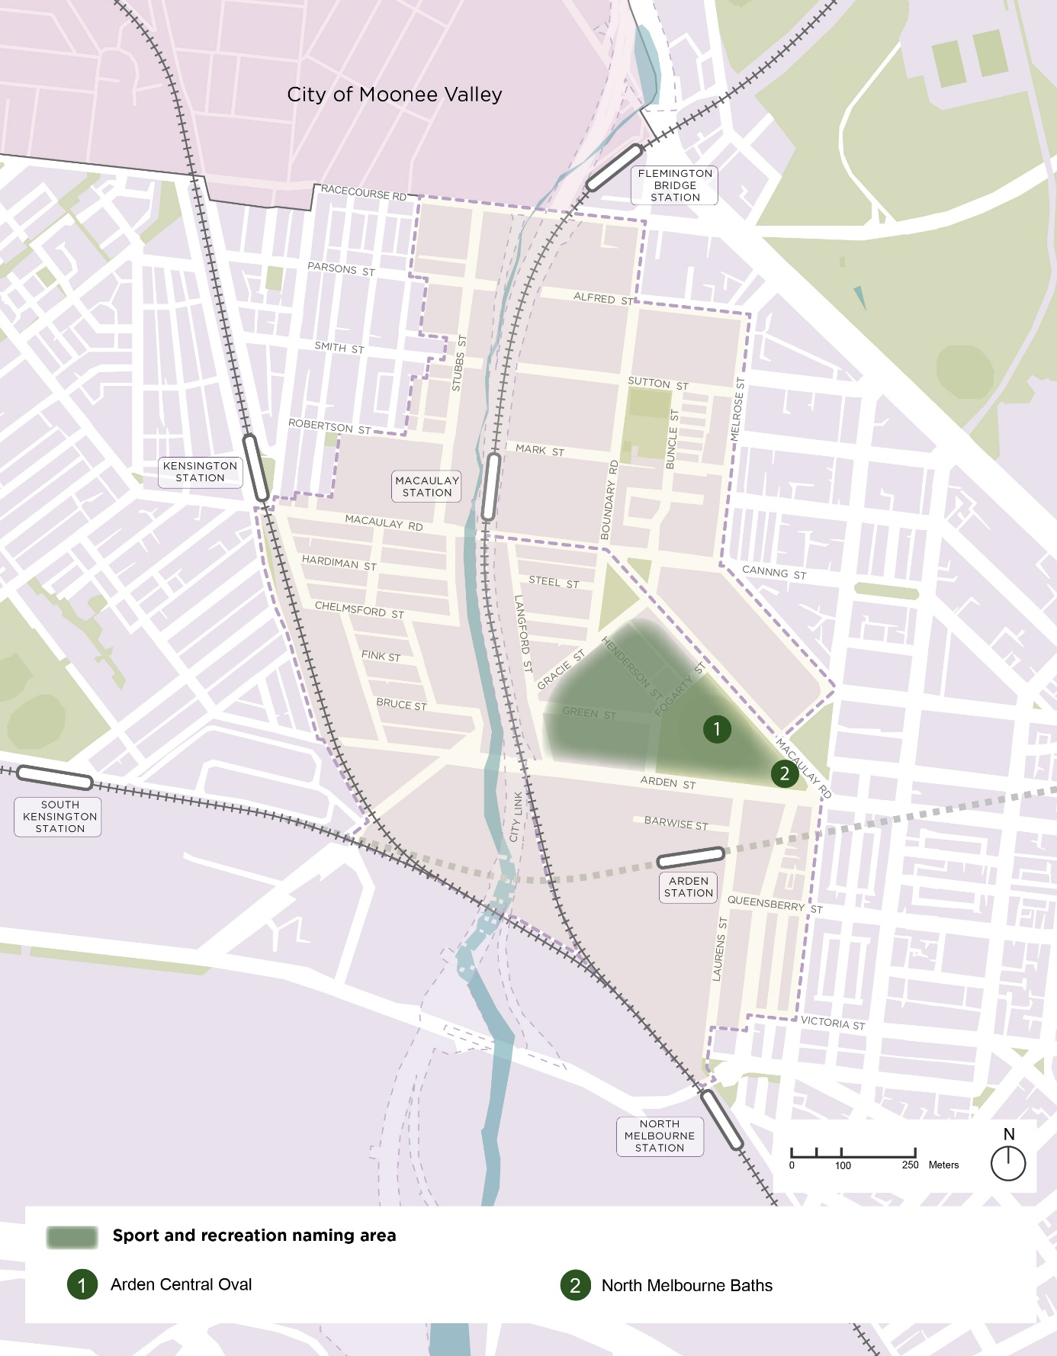

11. Activism

11.1 Significance
Arden and Macaulay have a legacy of activism. In the earliest days, residents advocated for improved infrastructure and amenity. Over the years, activism has remained strong through the women’s suffrage movement, slum clearance and engagement on major projects.

11.2 Activism over the years
Activism in the Arden and Macaulay areas included:
- 1850s – Advocacy for improved amenity: North Melbourne residents petitioned the government for removal of the manure depot and cattle yards and funding to form proper roads.
- 1870s – The eight-hour workday: Hotham Council supported the movement for the eight-hour workday by making this the standard for all Council employees in 1870.
- 1880s – Fight for women’s suffrage: North Melbourne women campaigned for the right to vote, forming the Women’s Suffrage Society in 1888 and signing the ‘Monster Petition’ that would go before parliament.
- 1910 – Improving the welfare of stray dogs: A group of men and women set out to raise funds to establish a shelter for lost and stray dogs in Melbourne. The Lost Dogs’ Home was opened in 1913 and continues to operate on Gracie Street.
- 1940s – Kensington community development: Kensington churches and community centres provided services and became hubs of social and political activity amidst post-war migration.
- 1975 – Kensington women start a foundational community support program: A group of women start the Kensington Neighbourhood House, a ‘drop-in’ house where women of all backgrounds could bring their children and meet.
- 1969–present – Kensington residents organise to make their voice heard: Kensington residents formed the Kensington Social Action Group (which became the Kensington Association in 1977) representing the community on numerous planning and infrastructure proposals and community shaping initiatives.
Some example names related to activism in the Arden and Macaulay areas and surrounds include:
- Maloney: Jane Maloney was the mother of politician William Maloney, who was involved with the Women’s Suffrage Society and introduced several women’s suffrage bills into the Victorian parliament. She was reportedly socially rebellious and the inspiration for William Maloney’s values.
- Flashman: Dr Ann Flashman was appointment veterinary officer of the Lost Dog’s Home. Believed to be the first women in Australia to hold such a position, she’d also been the first woman to enter the faculty of Veterinary Science in Sydney.
- Moffat: Hedley Moffat was a councillor for Debney Ward in the 1990s who fought for City Link concessions including sound barriers and landscaping.
These names may also be used as priority theme names since they overlap with the Women who shaped Arden and Macaulay theme.

11.3 Policy
Reflecting Arden and Macaulay’s history of activism aligns with the Victorian Naming Rules ‘Principle C: Linking the name to place’.

Figure 23: The Founders of Kensington Neighbourhood House, circa 1977
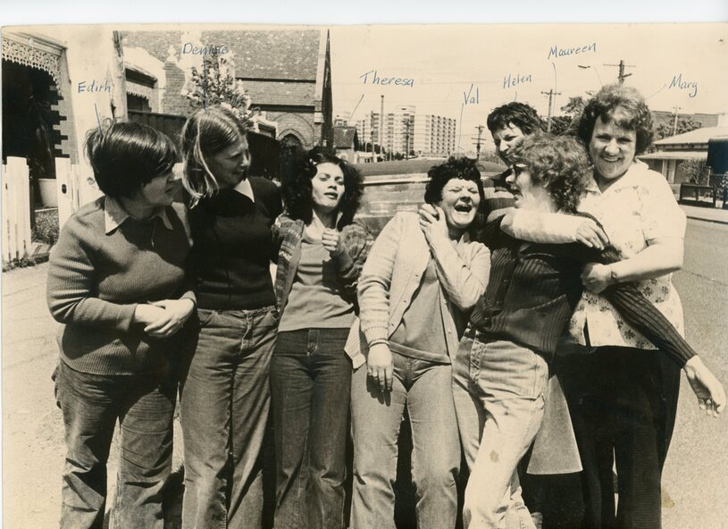
Figure 24: Photograph of a group outside the Kensington Neighbourhood House with Victorian Premier Joan Kirner when she visited to during the formal opening of the second-storey extension, 1992
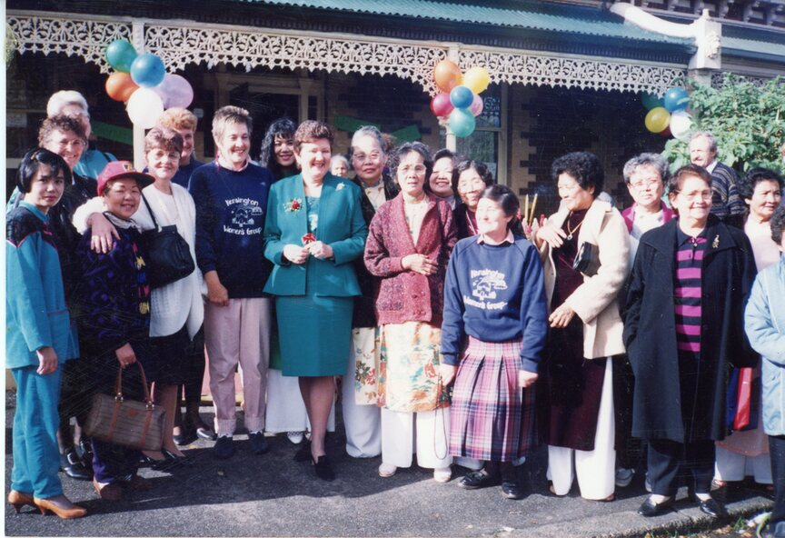

11.4 Theme application
Activism is a precinct theme that can be applied to any part of Arden and Macaulay. Refer to Part C and Appendix A for more information.

12. Multiculturalism

12.1 Significance
Arden and Macaulay’s location relative to the goldfields, central Melbourne and industry have attracted diverse communities through multiple waves of migration. From early influxes of goldrush migrants to later waves of post-war migration, these areas have welcomed immigrants and become established multicultural communities.

12.2 Diverse communities
Communities that have characterised Arden and Macaulay since early colonisation include but are not limited to:
- English, Irish, Scottish and Chinese immigrants that came to North Melbourne as part of the goldrush.
- English, Irish and Scottish immigrants that established churches and schools for the new community of North Melbourne.
- Italian, Maltese, Yugoslavian and Baltic immigrants that arrived in the wake of World War II. The suburbs’ industrial and housing mix made a practical landing place, as immigrants could work in factories without needing to speak English.
- Immigrants housed in the Kensington and North Melbourne housing towers, constructed in the mid-to-late 1960s. The towers have been home to:
  - Turkish, Timorese and Vietnamese immigrants and refugees from the 1970s
  - Balkan refugees and post-Soviet migrants from the 1990s
  - Horn of Africa refugees from the late 1990s, specifically from Somalia and Eritrea
  - Smaller numbers of Oromo, Amhara and Tigray community members

12.3 Policy
Reflecting Arden and Macaulay’s history of multiculturalism aligns with the Victorian Naming Rules ‘Principle C: Linking the name to place’.
Figure 25: Boundary Road State school with Housing Commission towers in the background
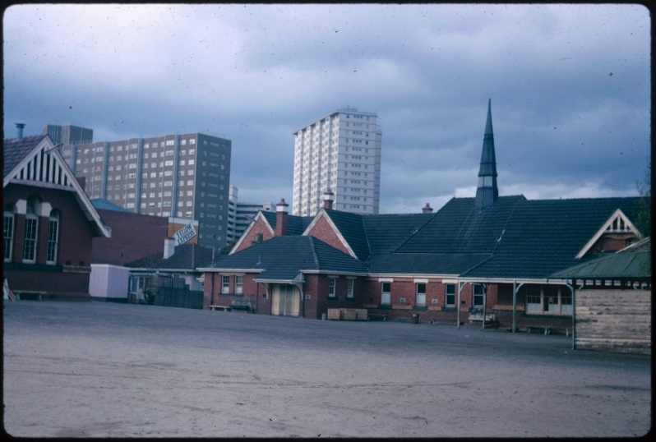
Figure 26: Onlookers in front of Buddhist candles and flowers used during the opening ceremony for the second story extension to the Kensington Neighbourhood House, Nov 1992
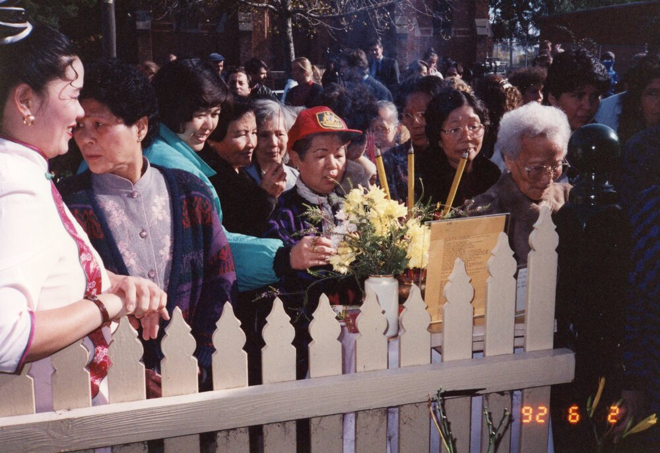

12.4 Theme application
Multiculturalism is a precinct theme that can be applied to any part of Arden and Macaulay. Refer to Part C and Appendix A for more information.

13. Naming theme overlap
Many of the naming themes set out for Arden and Macaulay will overlap, just as the histories of the area interweave. Many future place names will relate to more than one naming theme. This is encouraged.
Examples of overlapping naming themes include:
- Women who were involved in activism in North Melbourne or Kensington.
- Prominent Wurundjeri Woi-wurrung women.
- Names of plants or wildlife prevalent along waterways when the Wurundjeri Woi-wurrung peoples inhabited the land.
- Names reflecting activism related to industrial activities.
- Factory workers who participated in company cricket teams.
Figure 27: Wild Cries Wings of Wetland and Swamp (2010) by artist John Wolseley


PART C: Application of the draft Naming Framework
This section outlines how to apply the Naming Framework to identify names that celebrate Arden and Macaulay’s local character. It outlines steps to improve wayfinding and educate the community on the meaning and pronunciation of names. This section also explains the Naming Framework’s role in the name approval process and identifies the best way to engage with Registered Aboriginal Parties on naming opportunities.

14. Two-step approach for name selection
Follow these steps when identifying a name or names for new places and roads in Arden and Macaulay.
Step 1: Where is the place or road located?
A new road, park or public building within or near a themed area or significant site should draw upon this significance in the selection of a place name. To identify if a place or road is within or near a themed area or significant site, refer to the theme maps in Part B.
Step 2: Is the road or place type major or minor?
The type of place to be named will influence the naming theme referenced for the name selection. Major roads, open spaces and public places should reference the priority themes of ‘Connection to Country’ or ‘Women of significance’. Other place types can reference any of the naming themes. A description of place types is provided in Appendix A.
This approach is illustrated in Figure 28.

Figure 28: How to apply the draft Naming Framework
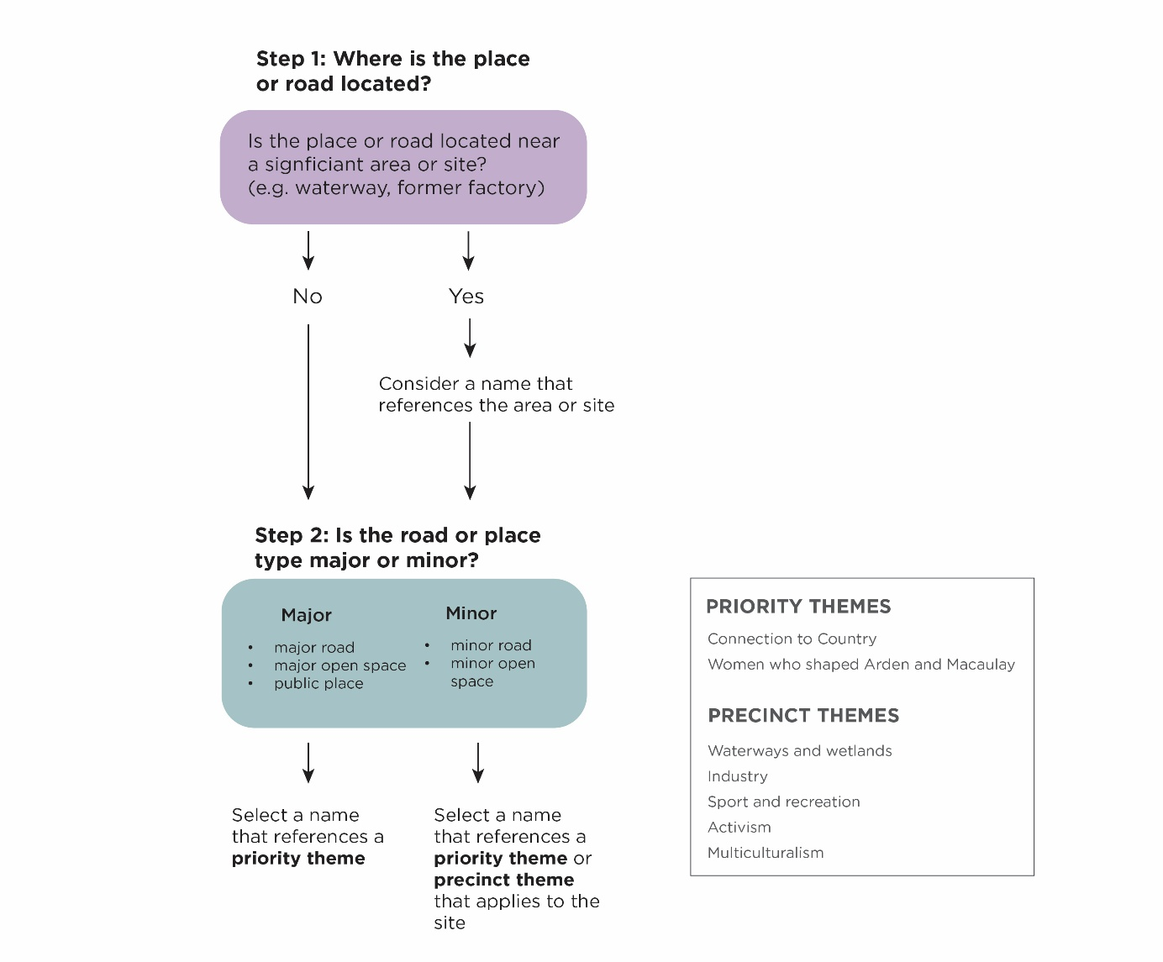
Figure 29: Example scenarios
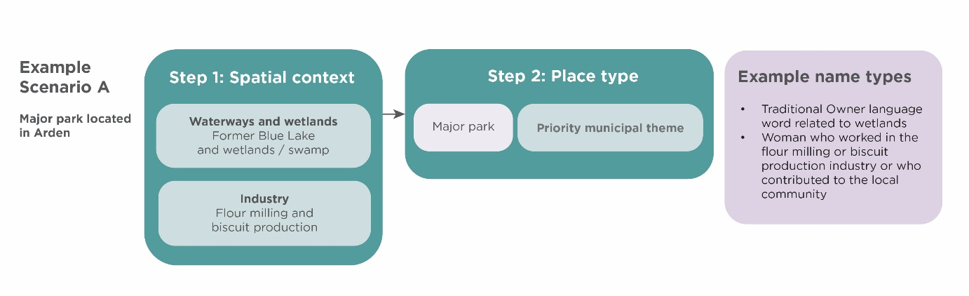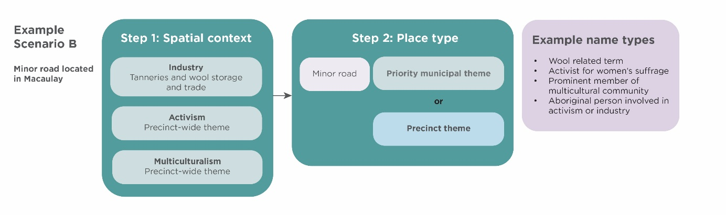
Naming considerations
To respect the Traditional Owners of the precincts, it is important that the locations of future Traditional Owner language do not intersect names that commemorate colonisers. Colonisers are defined in this draft Naming Framework as people, groups, or authorities that invaded and settled Aboriginal lands without consent, asserting control over Country, people, and resources and establishing systems that dispossessed First Peoples and continue to cause harm.
Consideration of naming near Moonee Ponds Creek should also avoid names associated with causing harm to waterways, including as names associated with industry, and should take into account healing of Country.

15. Wayfinding and education
Follow these additional steps to enhance the community and visitor experience of Arden and Macaulay and help tell the areas’ diverse local stories through place naming.

15.1 Wayfinding
A wayfinding strategy helps to create an environment that supports people to easily find their way through a place.
If a naming request involves multiple new roads or features, preparation of a wayfinding strategy is encouraged to show how names relate through shared meaning or connection to the site. This will help deliver meaningful and cohesive neighbourhoods. For example, a new development could comprise names associated with a historical site formerly in its location.

15.2 Education on name meaning
Endorsed place names must be supported by additional information to educate the community on the name’s meaning and correct pronunciation where appropriate.
Education opportunities include additional text on signage as a minimum, and additional public realm initiatives for example public art and interpretive walking trails.
The relevant Registered Aboriginal Party must be engaged to inform what information supports Traditional Owner informed language names.
Refer to preferred process in Part C ‘How to engage with Registered Aboriginal Parties’.

16. Naming approval process
The City of Melbourne is the naming authority for roads and features such as parks, community buildings and public spaces in the municipality. The organisation receives naming requests as part of applications for subdivision or development approval, as well as ad-hoc requests.
The standard naming approval involves a sequential process with input from the applicant, City of Melbourne (the responsible naming authority) and Geographic Names Victoria (the agency responsible for the registration of names across Victoria). This is shown in Figure 27.
The draft Naming Framework supports this process by providing naming themes, spatial maps identifying significant sites, and additional resources to reduce the onus on applicants to undertake research for individual naming requests.
Figure 30: Standard name approval process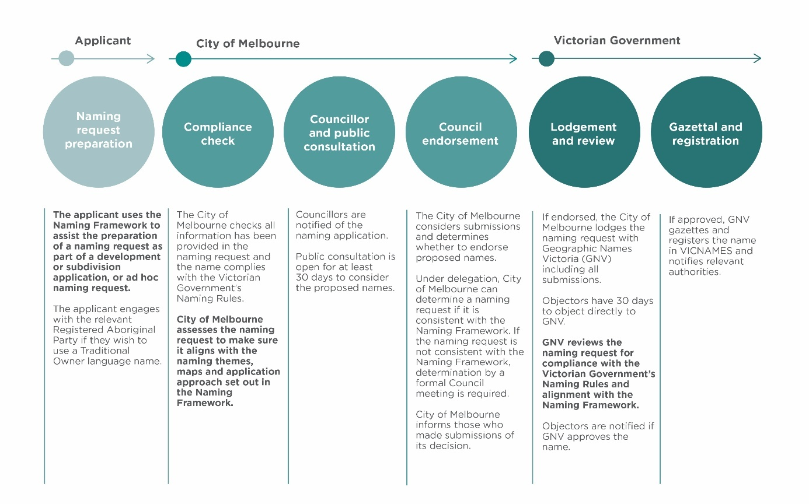
Applicant:
Naming request preparation
The applicant uses the Naming Framework to assist the preparation of a naming request as part of a development or subdivision application, or ad hoc naming request.
The applicant engages with the relevant Registered Aboriginal Party if they wish to use a Traditional Owner language name. Refer to instructions on page 33.
City of Melbourne:
Compliance check
The City of Melbourne checks all information has been provided in the naming request and the name complies with the Victorian Government’s Naming Rules.
City of Melbourne assesses the naming request to make sure it aligns with the naming themes, maps and application approach set out in the Naming Framework.
Councillor and public consultation
Councillors are notified of the naming application.
Public consultation is open for at least 30 days to consider the proposed names.
Council endorsement
The City of Melbourne considers submissions and determines whether to endorse proposed names.
Under delegation, City of Melbourne can determine a naming request if it is consistent with the Naming Framework. If the naming request is not consistent with the Naming Framework, determination by a formal Council meeting is required.
City of Melbourne informs those who made submissions of its decision.
Victorian Government:
Lodgement and review
If endorsed, the City of Melbourne lodges the naming request with Geographic Names Victoria (GNV) including all submissions.
Objectors have 30 days to object directly to GNV.
GNV reviews the naming request for compliance with the Victorian Government’s Naming Rules and alignment with the Naming Framework.
Objectors are notified if GNV approves the name.
Gazettal and registration
If approved, GNV gazettes and registers the name in VICNAMES and notifies relevant authorities.

Representation of naming themes
The City of Melbourne will review names as they are approved and gazetted in Arden and Macaulay. This will help ensure the Naming Framework achieves representation across the five naming themes.

16.1 Representation of naming themes
The City of Melbourne will review names as they are approved and gazetted in Arden and Macaulay. This will help ensure the Naming Framework achieves representation across the seven naming themes.

17. How to engage with Registered Aboriginal Parties

17.1 Wurundjeri Woi-wurrung Cultural Heritage Aboriginal Corporation
Traditional Owners have managed the land and waters of Australia for tens of thousands of years. Incorporating their views into planning processes is integral in enabling them to care for Country and fully exercise their cultural and spiritual rights.
Registered Aboriginal Parties are the current avenue for engaging Traditional Owners on planning and development matters.
For place naming within Arden and Macaulay, the use of Woi-wurrung language requires engagement with the Wurundjeri community. This is done through the Wurundjeri Woi-wurrung Cultural Heritage Aboriginal Corporation (WWCHAC), the Registered Aboriginal Party for Wurundjeri Woi-wurrung people.
To begin a naming and language enquiry, email culturalconsultations@wurundjeri.com.au.
More information can be found at wurundjeri.com.au.

18. Appendix A

18.1 Place type descriptions
Key place types referenced in this draft Naming Framework include major roads, minor roads, major parks, minor parks and Council buildings and other public places. Descriptions for these are set out below.
Categories of roads have been informed by City of Melbourne’s road classifications, which reflect the Vicmap Transport Road Classifications.
Categories of open spaces have been informed by the City of Melbourne’s Open Space Strategy (Light Touch Review 2024).
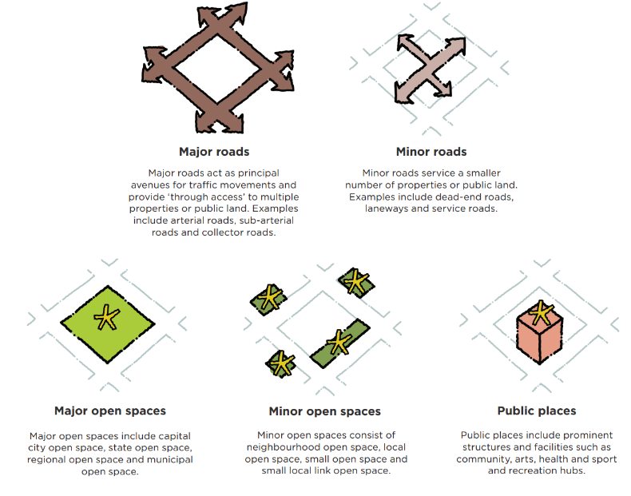

19. Appendix B

19.1 Informing the draft Naming Framework
The draft Naming Framework has been informed by historical research and engagement with the Registered Aboriginal Party.
Engagement with Registered Aboriginal Parties
The area now known as Arden and Macaulay is overseen by the Wurundjeri Woi-Wurrung Cultural Heritage Aboriginal Corporation Registered Aboriginal Party. The Wurundjeri Woi-Wurrung Cultural Heritage Aboriginal Corporation was engaged throughout the preparation of the draft Naming Framework. This involved meetings in-person and online, and a walk on Country.
Historical research
The draft Naming Framework’s content has been informed by an in-depth review of web and print resources relating to the social, cultural and environmental heritage of Arden and Macaulay. Appendix C outlines key resources used.
Community and stakeholder engagement
An eight-week period of community and stakeholder engagement on the draft Naming Framework will be used to further inform and shape the final Naming Framework. This complies with the requirement in the Naming Policy.

20. Appendix C

20.1 References and resources

History and place naming resources
General resources / resources relating to multiple themes
- North Melbourne Heritage Review participate.melbourne.vic.gov.au/amendment-c403/amendment-overview
- Arden Macaulay and Kensington Heritage Review – Thematic Environmental History 2012 melbourne.vic.gov.au/neighbourhood-histories
- Kensington Heritage Review – Thematic Environmental History 2013 melbourne.vic.gov.au/neighbourhood-histories
- Hotham History Project hothamhistory.org.au
- Arden Station Hoardings Project https://www.hothamhistory.org.au/arden-station-hoardings/
- Gatt, Fiona. The lived experience of urbanisation in Hotham/North Melbourne, 1852-1905 [Doctoral dissertation, Deakin University]. Deakin Research Online. hdl.handle.net/10779/DRO/DU:24761034.
Connection to Country
- North Melbourne Heritage Review: Thematic Environmental History melbourne.vic.gov.au/neighbourhood-histories
- Wurundjeri Woi-wurrung Cultural Heritage Aboriginal Corporation wurundjeri.com.au/
Women of significance
- Brettena Smyth oldtreasurybuilding.org.au/past-exhibitions/wayward-women/brettena-smyth
- Marie (Ma) Dalley adb.anu.edu.au/biography/dalley-marie-ma-9893
- Ailsa O’Connor hothamhistory.org.au/ailsa-oconnor
- O'Connor, Ailsa. Unfinished Work: Articles and Notes on Women and the Politics of Art. Greenhouse Publications, 1982. Available through City of Melbourne Libraries.
- Florence ‘Florrie’ Lord blogs.slv.vic.gov.au/family-matters/finding-florrie/
Industry and manufacturing
- Melbourne C207 Heritage Overlay – Industrial places melbourne.vic.gov.au/media-files/2024-07/statement-gary-vines.pdf
- Kensington industry victorianplaces.com.au/kensington
- Biscuit making blogs.slv.vic.gov.au/our-stories/collection-care/reconstructing-brockhoff-biscuits-part-1/
Water
- Arden and Macaulay Framed Through Water watersensitivecities.org.au/wp-content/uploads/2017/09/Arden-Macaulay-Framed-Through-Water.pdf
- Lost and Found Wetlands of Melbourne academia.edu/26422124/Lost_and_Found_Wetlands_of_Melbourne
- Victorian Harbour Heritage Trail Stop 14 Moonee Moonee / Moonee Ponds Creek: mmhn.org.au/heritage-trails/victoria-harbour/stop14/
- The erasure of Melbourne’s wetlands blogs.slv.vic.gov.au/such-was-life/the-erasure-of-melbournes-wetlands/

Activism
- The Australian Women’s Suffrage Society womenaustralia.info/entries/the-australian-womens-suffrage-society/
- 1891 Women’s Suffrage Petition prov.vic.gov.au/about-us/our-blog/1891-womens-suffrage-petition
- The Lost Dogs’ Home history.dogshome.com/
- Kensington Association northwestcitynews.com.au/a-brief-history-of-the-kensington-association/; kensingtonassociation.org.au/
- Kensington Neighbourhood House kensingtonneighbourhoodhouse.com/history
Multiculturalism
- Trost, Alex, Cultural diversity in North & West Melbourne, North Melbourne, Vic.: North & West Melbourne Neighbourhood Centre, 1997. Available through City of Melbourne Libraries.
- Chinese during the goldrush prov.vic.gov.au/about-us/our-blog/vegetable-veterans
- The rich and resilient communities inside the housing towers theguardian.com/australia-news/2020/jul/09/a-completely-different-world-the-rich-and-resilient-communities-inside-melbournes-towers
Sport and recreation
- North Melbourne Football Club hothamhistory.org.au/the-north-melbourne-football-club-the-shinboners/
- Kensington Skating Rink timetravellers.pbworks.com/w/page/140500491/Kensington%20Skating%20Rink
- North Melbourne Baths hothamhistory.org.au/in-the-swim-history-of-the-north-melbourne-pool/

Naming rules
- Naming rules for places in Victoria land.vic.gov.au/place-naming/first-time-here/about-geographic-names-victoria
- City of Melbourne Place and Road Naming Policy melbourne.vic.gov.au/place-and-road-naming
- Fishermans Bend Place Naming Framework melbourne.vic.gov.au/fishermans-bend-place-naming-framework

20.2 Images
Document images
- Figure 6: View from Flagstaff Hill, West Melbourne, in 1841, engraving, by Julian Ashton, sourced from State Library Victoria, used under public domain.
- Figure 7: Brettena Smyth, by unknown, sourced from Wikipedia, used under public domain.
- Figure 8: Advertisement in the Essendon and Flemington Chronicle (17 March 1893) for a lecture given by Brettena Smyth, photo from The Essendon and Flemington Chronicle, 17 March 1893, sourced from TROVE, used under public domain.
- Figure 9: Marie Ma Dalley at her scrap metal yard from The Herald (27 Sept 1950), photo from The Herald, 27 Sept 1950, sourced from TROVE, used under public domain.
- Figure 13: The Perfect Supper Cracker...Crispettes Another of Brockhoff’s oven-crisp Biscuits Established Victoria 1880, advertisement, by R. M. Warner, sourced from State Library Victoria, used under public domain.
- Figure 14: T.B. Guest & Co. Steam Biscuit Factory William Street Melbourne, lithograph, by Troedel & Co. lithographers, sourced from State Library Victoria, used under public domain.
- Figure 15: Ephemera wool tags Younghusband Limited, photograph, by unknown, sourced from Victorian Collections, used under CC BY-NC-ND 4.0.
- Figure 16: Victorian Producers Co-operative Wool Warehouse North Melbourne showing buyers examining fleece and exterior views, photograph, by Adrian Crothers, sourced from State Library Victoria, used with permission of State Library Victoria.
- Figure 17: Victorian Industries - Australian Roller Flour Mills Messrs Thos Brunton and Co, picture, by David Syme and Co., sourced from State Library Victoria, used under public domain.
- Figure 19: North Melbourne VFL football team in front of a grandstand Arden Street, photograph, by Charles Edward Boyles, sourced from State Library Victoria, used under public domain.
- Figure 20: North Melbourne Baths Opened, photo from The Argus, 14 Dec 1929, sourced from TROVE, used under public domain.
- Figure 21: Group of men and women with cycling club probably the Speedwell Cycling Club, photograph, by unknown, sourced from State Library Victoria, used under public domain.
- Figure 23: Photograph of KNH founders circa 1977, by unknown, sourced from Victorian Collections, used under public domain.
- Figure 24: Opening of KNH Upstairs Extension 1992 Group outside 89 McCracken Street, photograph, by unknown, sourced from Victorian Collections, used under public domain.
- Figure 25: Boundary Road State School, North Melbourne, photograph, by Laurie Burchell, sourced from State Library Victoria, used with permission of State Library Victoria.
- Figure 26: Colour photograph of onlookers in front of Buddhist candles and flowers used during the opening ceremony for 2nd story extension to 89 McCracken Street, Nov 1992, by unknown, sourced from Victorian Collections, used under public domain.
- Figure 27: Wild Cries Wild Wings of Wetland and Swamp, by John Wolseley, sourced from City of Melbourne City Collection, used with permission of City of Melbourne.

Timeline images
- View from Batman’s Hill February 5 1844 looking North West, picture, by Robert Russell, sourced from State Library Victoria, used under public domain.
- Melbourne and suburbs, cartographic material, compiled by James Kearney, draughtsman, engraved by David Tulloch and James D. Brown, sourced from State Library Victoria, used under public domain.
- The Cattle Yards, Newmarket, picture, by David Syme and Co., sourced from State Library Victoria, used under public domain.
- S Class Steam Locomotive No.301 Perspective View Circa 1928 Location North Melbourne Loco photograph, by unknown, sourced from Public Record Office Victoria, used under public domain.
- Brearley Brothers' Tannery, Geelong picture, by Samuel Calvert, sourced from State Library Victoria, used under public domain.
- Sydney Express at North Melbourne, photograph, by Victorian Railways, sourced from State Library Victoria, used under public domain.
- Construction of Coode Canal Excavation, black and white photograph, by unknown, sourced from Public Record Office Victoria, used under public domain.
- Housing commission flats North Melbourne, photograph, by Housing Commission Victoria, sourced from State Library Victoria, used under CC BY 4.0.
- Housing Commission, photograph, by Peter Wille, sourced from State Library Victoria, used under permission from State Library Victoria.
- Modern Luxury Loft Apartment Architecture Interior, by Foto Miki Digital, sourced from Openverse, used under public domain.
- Arden-Macaulay Structure Plan 2021, by City of Melbourne, sourced from TROVE, used under public domain.
- Macaulay Structure Plan 2021, by City of Melbourne, sourced from City of Melbourne website, used under public domain.
- Arden Structure Plan, 2022, by Victoria Planning Authority, sourced from Victoria Planning Authority website, used under public domain.
- Arden Station, by hde.photo, used with permission from hde.photo.

