
Cat Management Community Engagement Summary Report
Phase One
April 2025
Contents
Executive Summary: Overview and Key Findings 3
Findings 3
Next Steps 3
Project Background 3
Background 3
Methodology 3
Who we heard from 4
What we heard from the Community 8
Engagement Findings 16
What we heard from the community in support of mandatory desexing 16
What the community told us was concerning about mandatory desexing of cats 17
What we heard from the community in support of cat containment 17
What the community told us was concerning about cat containment 18
What we heard from key stakeholders 19
The Lost’ Dogs Home 19
Australian Pet Welfare Foundation 19
Outcome and next steps 19

Executive Summary: Overview and Key Findings
A total of 1758 contributions were received via the online survey. We also received 6 written submissions via email.
This document summarises the feedback received, providing validation and clear direction regarding next steps to inform the draft proposal for Cat Management in the City of Melbourne.

Findings
The response from the local community was overwhelmingly supportive of cat desexing and some form of cat containment.
Further detail on the feedback is available in this report.

Next Steps
The outcome of this community engagement is to proceed with the development of a draft proposal to explore mandatory cat desexing and cat containment.

Project Background
Over four weeks in July and August 2024, Council invited community to provide feedback on the possibility of introducing Cat Management, this included mandatory cat desexing and some form of cat containment to their owner’s property.
The project asked for feedback in relation to:
- Mandatory cat desexing: all cats and kittens would need to be desexed before they can be registered with the City of Melbourne.
- Mandatory cat containment
  - Nighttime cat curfew: cats must be securely confined to their owner’s property during certain hours. E.g. sunset to sunrise
  - Full-time cat curfew: cats must be securely confined to their owner’s property at all times.
Feedback was received via Participate Melbourne’s though a short survey and through the option to provide a written submissions emailed directly to the Animal Management team.

Background
The City of Melbourne’s Domestic Animal Management Plan 2022-25 concludes that CoM will “investigate Council making an order requiring the mandatory desexing of cats”. In March 2024 the Future Melbourne Committee approved the integration of cat containment into the investigation, including community consultation.

Methodology
Responses were encouraged through the Participate Melbourne website, while information was also gathered through written submissions emailed directly to the Animal Management team for consideration.
The invitation to participate in the community engagement was promoted by the City of Melbourne through a range of mediums including:
- Participate Melbourne website
- Online survey with questions asking the community how they feel about issues surrounding cats in the City of Melbourne and if they support mandatory cat desexing and various forms of cat containment.
- Information page and frequently asked questions
- Social media campaign
- Email campaign to key stakeholders including City of Melbourne’s contracted pound The Lost Dogs’ Home and vets operating in the municipality.
- Text message campaign to registered pet owners in the 2024/25 registration period.

Who we heard from
Through the engagement participants had the opportunity to engage online through the Participate Melbourne page and through written submissions via email. This is a snapshot of who we heard from:
Fig 1. Connection to CoM
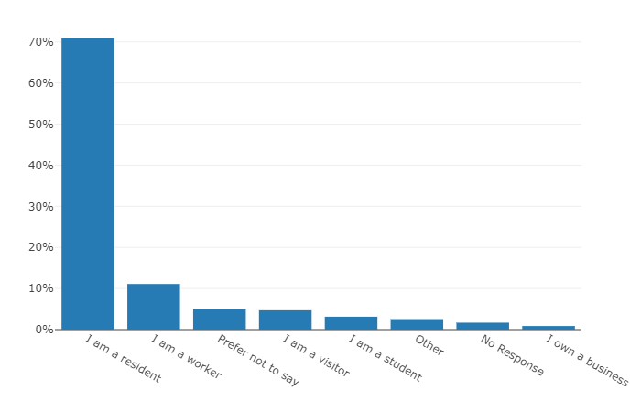
Data from the bar chart shows the distribution of respondents based on their relationship to a particular area:
- Approximately 70% of respondents are residents.
- Approximately 10% are workers.
- Approximately 5% prefer not to say.
- Approximately 5% are visitors.
- Approximately 3% are students.
- Approximately 2% fall into the "Other" category.
- Approximately 2% did not respond.
- Less than 1% own a business.
This indicates that the majority of respondents are residents, with smaller proportions being workers, visitors, students, and others.
Fig. 2 – Connection to CoM suburbs
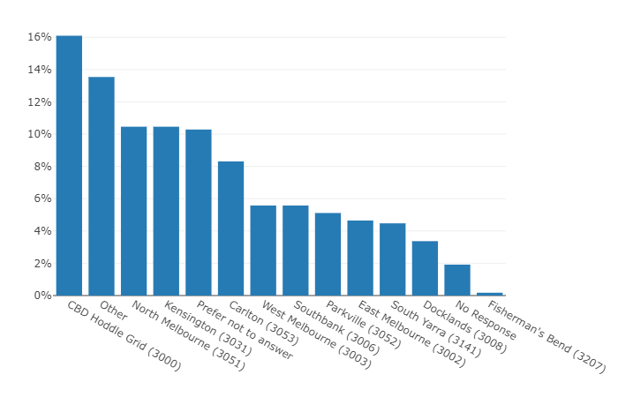This data shows the distribution of survey respondents by location. The majority of responses came from the CBD (16.31%) and "Other" locations (14.28%), with Carlton (8.36%) and Kensington (10.68%) also contributing significant portions. Notably, 10.5% of respondents chose not to disclose their location. Areas like Docklands and Fisherman’s Bend had much lower participation rates, at 3.37% and 0.17%, respectively. This suggests that engagement was higher in central and well-populated areas, while some outer neighbourhoods had less representation.
Fig 3. - Gender
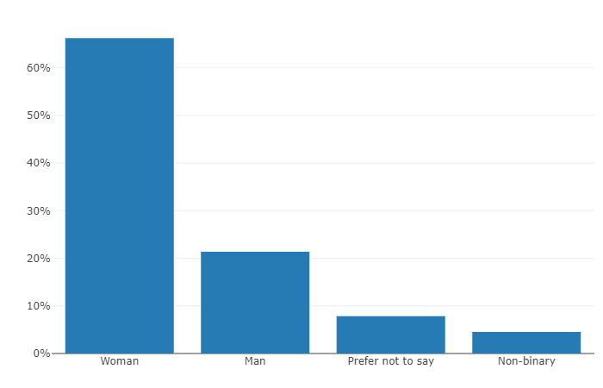Column chart showing the gender distribution from the survey. The majority of respondents identified as women (67.2%), followed by men (21.7%). A smaller percentage identified as non-binary (4.6%), while 5.8% preferred not to answer, and 0.6% identified as "Other." This distribution highlights a strong female participation in the survey.
Fig. 4 - Age
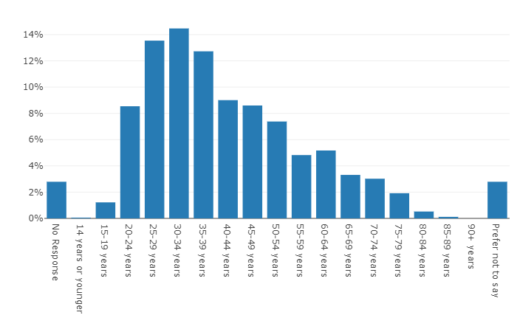This data shows the age distribution of survey respondents. The largest group falls between 25-34 years old, representing nearly 29% of total respondents. Participation decreases steadily with age, with fewer responses from those over 60. Very few respondents were under 15 or over 85. Notably, 2.87% chose not to disclose their age. This indicates that the survey reached a diverse age range but had stronger engagement from younger adults.
Fig. 5 – Identity
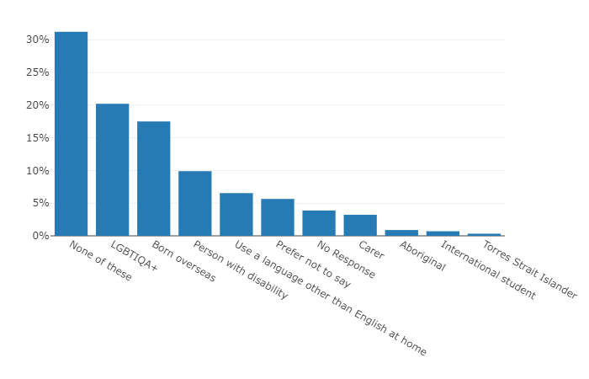This data outlines the diverse identities of survey respondents. A significant portion (40.97%) indicated that none of the listed categories applied to them. Notably, 26.5% of respondents identified as LGBTQIA, and 22.97% were born overseas, highlighting strong representation from these groups. People with disabilities (13.04%) and those speaking a language other than English at home (8.49%) also had notable participation. Smaller groups included carers (4.25%), Aboriginal (1.14%), Torres Strait Islander (0.42%), and international students (0.90%). Additionally, 7.24% of respondents preferred not to disclose this information.

What we heard from the Community
During the engagement we asked a variety of questions, hearing how the community are currently affected by roaming cats and whether they support cat desexing and forms of cat containment.
There were 1758 survey responses and 6 written submissions. Below are the results, expressed as a percentage out of the 1758 survey responses.
Graph 1 - Pie chart showing ownership statistics of respondents
The data illustrates the distribution of respondents based on their cat ownership status. The majority of respondents, (66%), indicated that they currently own a cat. (15.27%) of respondents have previously owned a cat, while (14.87%) do not own a cat at all. A smaller portion, (3.19%), are considering owning a cat in the future. Lastly, (0.63%) of respondents do not own a cat but feed cats that visit their property.
Graph 2 – Bar chart showing peoples opinion on roaming cats in City of Melbourne
The graph illustrates respondents' opinions on whether roaming cats are an issue in the City of Melbourne. A slight majority, (51.01%), believe that roaming cats are indeed an issue. (30.50%) of respondents do not think roaming cats are a problem, while (18.42%) are unsure about the matter.
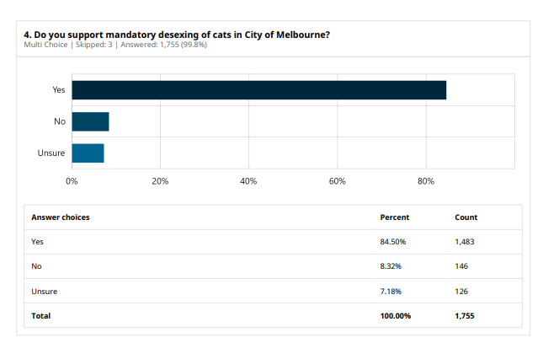
Graph 3 - Bar graph outlining respondents’ opinion on mandatory desexing of cats in City of Melbourne
The graph illustrates respondents' support for mandatory desexing of cats in the City of Melbourne. Out of a total of 1,755 responses, a significant majority, 84.50% (1,483 responses), support mandatory desexing. 8.32% (146 responses) are against it, while 7.18% (126 responses) are unsure.
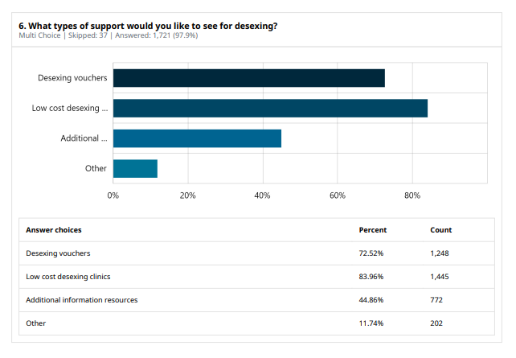Graph 4 – What supports the community would like to see for desexing of cats
The data illustrates the types of support respondents would like to see for desexing. Out of a total of 1,721 responses, 83.96% (1,445 responses) prefer low-cost desexing clinics. 72.52% (1,248 responses) prefer desexing vouchers. Additionally, 44.86% (772 responses) prefer additional information resources, while 11.74% (202 responses) prefer other types of support.
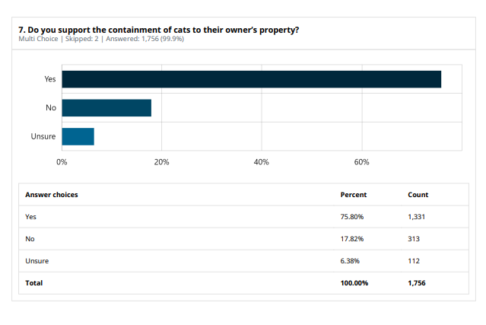 Graph 5 - Bar graph outlining the support for containment of cats to their owner’s property
The data illustrates respondents' support for the containment of cats to their owners' property. Out of a total of 1,756 responses, 75.80% (1,331 responses) support the containment of cats. 17.82% (313 responses) are against it, while 6.38% (112 responses) are unsure.
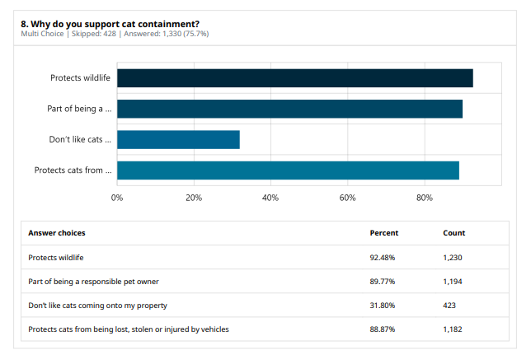Graph 6 – Respondents’ reasons for supporting cat containment
The data from the survey indicates the reasons why respondents support cat containment:
- 92.48% of respondents (1,230 people) support containment to protect wildlife.
- 89.77% of respondents (1,193 people) believe it is part of being a responsible pet owner.
- 88.87% of respondents (1,183 people) support containment to protect cats from being lost, stolen, or injured by vehicles.
- 31.80% of respondents (423 people) do not like cats coming onto their property.
This suggests that the primary motivations for supporting cat containment are to protect wildlife and to ensure the safety of cats. Around one third of respondents indicated that they support cat containment because they do not like cats trespassing on their property.
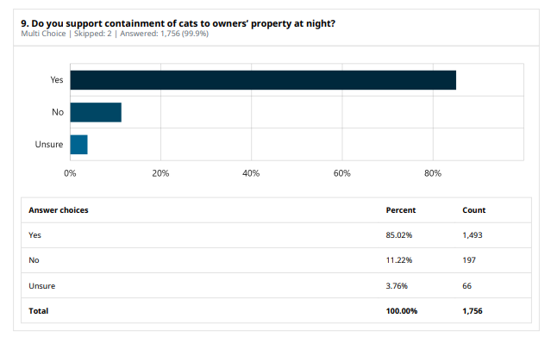Graph 7 – Community sentiment on cat curfew
The data indicates the community's stance on containing cats to their owners' property at night (cat curfews):
- 85.02% of respondents (1,493 people) support cat curfews.
- 11.22% of respondents (197 people) do not support it.
- 3.76% of respondents (66 people) are unsure.
This suggests that a significant majority of the community supports the idea of keeping cats contained to their owners' property at night.
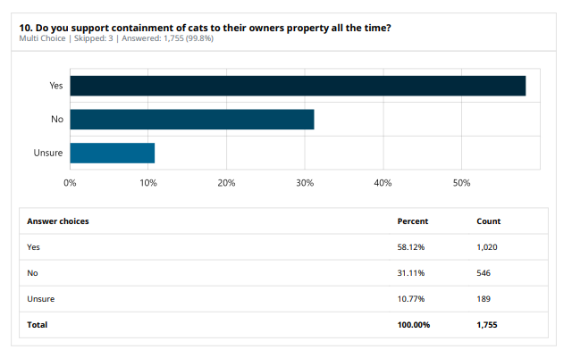Graph 8 – Community sentiment on cat containment
The data from the survey indicates the community's stance on containing cats to their owners' property at all times:
- 58.12% of respondents (1,020 people) support the containment.
- 31.11% of respondents (546 people) do not support it.
- 10.77% of respondents (189 people) are unsure.
This suggests that the majority of the community favours the idea of keeping cats contained to their owners' property, improving welfare outcomes for cats and reducing their impact the environment.
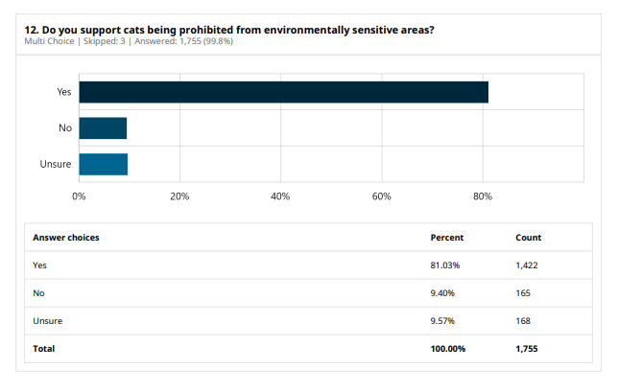Graph 9 – respondents’ opinion on prohibiting cats from environmentally sensitive areas in City of Melbourne
The data indicates strong support for prohibiting cats from environmentally sensitive areas:
- 81.03% of respondents (1,422 people) support the prohibition.
- 9.40% of respondents (165 people) do not support it.
- 9.57% of respondents (168 people) are unsure.
This suggests that a significant majority of the community is in favour of measures to protect environmentally sensitive areas from the impact of roaming cats.

Engagement Findings

What we heard from the community in support of mandatory desexing
Population control
The community expressed their support of mandatory desexing being introduced as a measure to reduce the numbers of stray, unowned and feral cats within the municipality. A number of respondents told us that they believe trap and neuter programs are especially important in managing the stray cat population.
“Cat desexing is the most important, effective, and humane thing to protect them and prevent strays suffering and causing trouble. If you love your cat, do it”.

Conservation of wildlife
Residents told us that they think the mandatory desexing of cats will assist with the conservation of native wildlife. By reducing the stray cat population, we can protect wildlife from predation. Entire cats are more likely to hunt, impacting our native wildlife which is already impacted by urbanisation.
“I value native wildlife above uncontained domestic cats and feel that cat owners need to be educated on both containment and desexing. Having rules in place is a terrific additional step”.
Reducing pressure on animal pounds, shelters and rescue groups
The community has told us that they believe introducing mandatory desexing for cats will ease the strain that stray and unowned cats place on animal pounds, shelters and rescue groups.
“Mandatory desexing will help lessen the number of animals coming into the care of rescues and shelters, and also stops backyard breeders from popping up”.

What the community told us was concerning about mandatory desexing of cats
Financial barriers and accessibility
The community expressed concerns around the affordability of desexing being a barrier to compliance for some cat owners. Some respondents said that if people can’t afford to have their cat desexed to comply with the new policy, it may lead to less animals being registered with council and broader regulatory problems.
“Mandatory desexing may discourage registration due to costs involved for both, as well as requirement to desex before registration”.
Efficacy of policy and barriers to enforcement
Respondents questioned how effective a mandatory desexing policy for cats would be and questioned the practicality of enforcing its requirements. The community expressed concern that people might resort to abandoning or surrendering their cats rather than complying with the legislation, which would in turn worsen the strain on pounds, shelters and rescues. People also questioned why it was necessary to make it mandatory to have your pet cat neutered with such a high percentage of registered cats were already desexed.
“Population control should be important, but I can see why it would be unattainable to enforce. Desexing is expensive, who pays for it?”
Owner autonomy
Some people expressed their belief that the decision to desex a pet should be left to the owner and not mandated by law. Some owners questioned what a mandatory desexing policy would mean for recreational breeders or pet owners who may want their cats to have a litter and can cater for this in a responsible way.
“This may discriminate against legitimate cat breeders and would just discourage registration”

What we heard from the community in support of cat containment
Protecting wildlife
There was strong support for having cat containment introduced as a measure to protect native wildlife. Many residents raised concerns around the harm that free-roaming cats can cause to native wildlife populations and stated that they believed cat containment is an essential harm reduction measure.
“I think it is very important that we do everything we can to support native wildlife in the area. Cat containment is essential to preventing the killing of wildlife”
Welfare and safety of cats
Many respondents agreed that better welfare outcomes are achieved for cats when owners contain them on their property. Residents expressed their belief that containing cats ensures they are protected from hazards such as vehicle traffic, predators and disease.
“I think it is very important that we do everything we can to support native wildlife in the area. Cat containment is essential to preventing the killing of wildlife”
Identification and management of unowned and stray cat population
Residents have told us that they believe introducing cat containment will assist with identifying and managing stray and unowned cats within the municipality. Residents expressed concern that allowing un-desexed cats to roam can lead to unwanted breeding and an increase in stray and unowned cats in the community.
“Cat containment and compulsory desexing are essential for population control. I work with a rescue shelter and the number of unwanted kittens, trauma to cats, strays and dumped pets is only increasing”.

What the community told us was concerning about cat containment
Challenges with compliance and enforcement
The community told us about the difficulties they may have with complying with an order mandating that cats are contained to the owner’s property. Respondents told us that containing cats, especially those not used to being kept indoors, can be challenging. Residents told us they were worried that the introduction of a cat containment policy may lead to an increase in animals being surrendered or abandoned, and a decline in compliance with registration requirements. The community also questioned the viability of council enforcing a cat containment order.
“Most cat owners I know ignore cat curfews and the Council do not have the staff to enforce it”
Impact on cat wellbeing
Residents expressed that keeping cats confined to the owner’s property at all times may negatively impact the animal’s physical and mental health. Community members suggested that they did not see any reason for containing cats during daylight hours and expressed their belief that cats benefitted from being able to roam.
“It's very difficult to keep cats from roaming especially during the summer. They don't want to be contained. We try to keep ours indoors but when it's hot they run so they won't be put indoors”.
Cost and practicality
Residents who were unsupportive of cat containment cited the issues of cost and practicality as a barrier to compliance. Respondents advised that building cat enclosures or modifying properties to contain cats can be expensive, especially for those in rental properties. Cat owners expressed that it could be impractical to expect people to try and contain older cats that are accustomed to roaming.
“I’m not sure about the practicalities of that for house owners. It’s easy to contain cats in apartments, but in properties on ground level it might be hard and stressful for both humans and cats”.

What we heard from key stakeholders

The Lost’ Dogs Home
The Lost Dogs' Home (LDH) suggests that mandatory desexing and cat containment policies should be paired with other initiatives to change attitudes towards cat ownership and reduce the number of cats in shelters. They recommend the City of Melbourne (CoM) to:
- Offer free desexing, microchipping, and registration to cat owners from low-income households and those needing financial support.
- Offer free desexing, microchipping and registration to semi owners of cats it they agree to take full ownership.
- Include an education program in any cat containment policy to emphasize cat welfare, including enrichment toys and human contact.
- Provide free or discounted cat enclosures to low-income households, older residents, and people with disabilities.
- Implement programs offering free desexing, microchipping
“The Lost Dogs’ Home believes that the focus on mandatory desexing and cat containment in the consultation, should be considered in partnership with other policies and programs that help to change attitudes to cat ownership and reduce the number of cats and kittens coming to the shelters and pounds each year.”

Australian Pet Welfare Foundation
The Australian Pet Welfare Foundation (APWF) opposes mandatory cat containment, stating that it will lead to increased cat-related complaints, impoundments, euthanasia, higher council costs, and enforcement difficulties for local governments. They argue that containment policies discourage semi-owners from taking full ownership of cats.
The APWF stated that the solution to reducing the problem of wandering cats and associated issues is high intensity free desexing programs targeting at areas of high impoundments and cat related complaints. The APWF expressed their full support for place-based cat desexing programs.
“The expansion of local cat confinement laws will not solve the issue of semi-owned and stray domestic cats”.

Outcome and next steps

Outcome
Council would like to thank everyone who took the time to provide their feedback on Cat Management. Overall, the majority of responses indicated strong support for cat desexing and cat containment.
We heard a positive response from cat owners who encourage responsible pet ownership and have happy healthy desexed cats already contained to their properties. We also heard some objections, suggestions and valid concerns around cat desexing and cat containment.
All consultation feedback has been reviewed and taking into consideration, with particular attention given to concerns raised amongst the community.
The outcome of this first phase of community engagement is to proceed with the development of a draft proposal for cat containment and cat desexing.
As part of the proposal, Council will explore programs that respond to the concerns raised around the cost of desexing and cat enclosures, impacts of cat containment on owners and increases in cat impoundments.
The draft proposal will be presented back to the community for further consultation at Future Melbourne Committee 1 April 2025.
If you have any feedback, please write to the Animal Management Team at animal.management@melbourne.vic.gov.au

Next Steps and Key Dates
The next steps and key dates include:
1 April 2025
Report back to Future Melbourne Committee with an update and advice on the role of cat containment in Council’s next Domestic Animal Management Plan, due in December 2025.

