Community Consultation Report

Racecourse Road Strategic Improvements Discussion Paper

July 2024
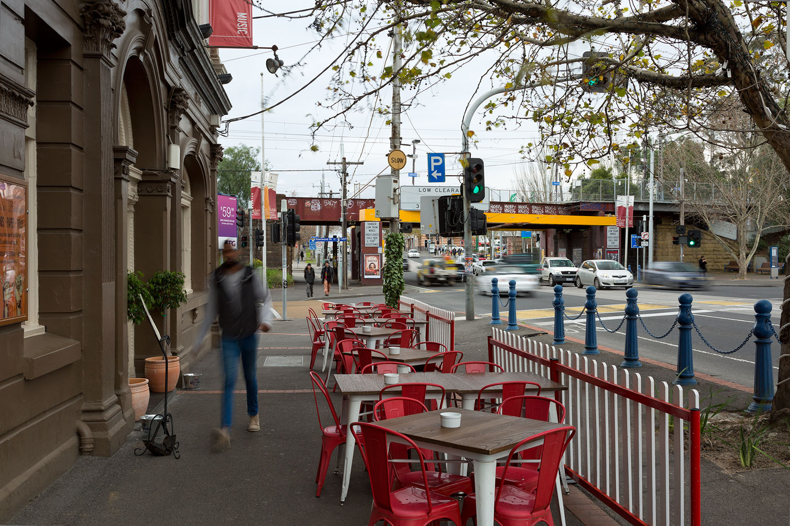
1 Summary 3
2 Methodology 5
2.1 Theming Framework 5
2.2 Key decisions and questions for engagement 6
2.3 Participation 7
2.4 Communication 8
2.5 Survey respondent demographics 10
3 Findings 15
3.1 Ranking of streetscape principles 15
3.2 Missing streetscape principles 18
3.3 Streetscape opportunities 19
3.4 Further information 22
3.5 Flemington Traders Association Meeting 23
4 Conclusion 24
5 Appendices 25
5.1 Your Say page (Moonee Valley City Council) 25
5.2 Participate Melbourne Page (City of Melbourne) 26
5.3 Survey tool 27
5.4 Social media posts 28
5.5 Email received 30
5.6 Respondent Suburbs 31
5.7 Respondent language spoken at home 32
5.8 Ranked Streetscape Principles – Gender breakdown 33
5.9 Open text comments – what is your connection to the project? 34

Summary
Racecourse Road is situated in the North of Melbourne and serves as a border marker for the suburbs of Flemington and Kensington, as well as the Councils of City of Melbourne and Moonee Valley. It is important both as a place and as a transport corridor for various modes of transport. As well as being on the Victorian Government’s Strategic Cycling Corridor network, it serves as a tram corridor for the 57 tram, with connections to the Craigieburn and Upfield train lines. It is identified as a major activity centre in Victorian planning policy, which means it has an important role in providing a diverse range of jobs, activities and housing. Racecourse Road serves as the high street for the Flemington Kensington community, supporting the livelihoods of a diverse mix of traders and providing a focus for public activity and connection.
There is significant pressure for change in the local area, given the anticipated growth including the Flemington Estate and the Macaulay and Arden urban renewal areas. It is important to plan for the needs of new and existing residents to ensure both Councils and the Victorian Government can coordinate their strategies and reflect community expectations.
Moonee Valley City Council (MVCC) and City of Melbourne (CoM) have partnered to develop a shared, long-term vision for Racecourse Road. As Flemington and Kensington grow, both Council’s want Racecourse Road to be as safe, welcoming and accessible as possible.
From 12 June to 10 July 2024, the Councils undertook a consultation process to seek community feedback on a Strategic Improvements Discussion Paper for this key arterial.
The Discussion Paper outlines several proposed design principles and potential design opportunities to improve Racecourse Road as a place, destination, as well as a route for people travelling by foot, wheelchair, bicycle, scooter, public transport and motor vehicle.
Feedback received during this consultation will inform a Strategic Improvements Plan (SIP) that will be used to advocate for coordinated improvements to Racecourse Road. This engagement report shares the findings of the consultation process.
Individuals could contribute to the consultation in a variety of ways such as; an online survey available through both MVCC’s Your Say and CoM’s Participate Melbourne websites, via email, phone or by completing a hard copy survey at one of the face-to-face pop-ups that were held. A specific consultation meeting was also held with the Flemington Traders Association.
The consultation was promoted via MVCC’s and CoM’s websites, social media, and posters in community facilities and along Racecourse Road. A postcard with consultation information was also delivered to letterboxes of traders along Racecourse Road, and residents within a 850m radius of Racecourse Road.
A total of 727 people responded to the survey online, with additional people taking the time to stop and chat at information sessions held by Council Officers. One additional response was received via email.
The top three streetscape principles identified by survey respondents were:
- Prioritise people
- Green the street
- Create a vibrant streetscape identity
All streetscape opportunities received over 70% support, with the exception of ‘improve traffic flow and safety by limiting some turning movements’, which received 63% support.
Overall, respondents were supportive of the discussion paper. The majority of consultation respondents have a vested interest in the area’s future as residents and business owners. Their passion for the area and the possibilities of growth and improvement are evident in the large number of respondents, and their enthusiasm for the principles proposed in the Discussion Paper.
Key feedback around transport included improving access to tram stops, improving safety for bicycles and improving access to the road on large scale event days. Key themes around community included opportunities for improving greening and developing a place-based approach to art and culture in the area.

Methodology

Theming Framework
Respondents were provided with opportunities to respond using open text to prompts in the survey. A sample of 110 of these open text responses were used to develop a theming framework with themes determined as follows:
Cycling: There is a strong emphasis on the desire for fully separated bike lanes. Cyclists feel unsafe due to inconsistent bike lanes
Pedestrian accessibility: Pedestrians face challenges with traffic, especially near tram stops. Need safer pedestrian pathways. The state of the footpaths is a concern, with calls for improvements to make them more accessible and pleasant to walk on. Uneven surfaces and hazardous conditions are frequently mentioned.
Prioritisation of Public Transport: Many comments suggest prioritising trams and public transport over cars. There is support for dedicated tram lanes and more accessible public transport options to reduce traffic congestion and delays.
Community, vibrancy and character: There is a desire to create a more vibrant and community-focused environment. Comments suggest enhancing the area's appeal with more outdoor seating, greenery, and spaces for social interaction, making it a destination rather than just a thoroughfare. Comments express a desire to enhance the street's identity and character, making it a more attractive and enjoyable place. This includes preserving heritage buildings while improving the overall aesthetic and functionality of the street.
Traffic and Congestion: Traffic congestion, particularly during peak hours, is a significant concern. Some comments suggest that reducing car dominance and prioritising alternative transport modes could alleviate traffic issues.
Increased greening: Many comments call for more green spaces, trees, and environmental considerations to make the area more pleasant and sustainable. Greenery and a tree canopy are seen as vital for improving the street's ambiance.
Balancing Transport and Community Needs: There is an acknowledgment of the challenge in balancing the road's function as a transport corridor with its potential as a community hub. Finding a middle ground that accommodates both needs is seen as crucial.
Retail and Local Businesses: Encouraging local shopping and supporting businesses by making the street more attractive and accessible is a recurring theme. Empty storefronts and a lack of vibrancy are noted issues.
Parking: People who want more/less of it, suggestions around how it could be managed/prioritised
Safety and Comfort: General personal safety and road safety concerns, including the risk of collisions and the uncomfortable, car-centric environment, are highlighted. There is a call for measures to improve safety and comfort for all users.
Unknown: This theme applied if the comment did not fit into any of the other themes.

Key decisions and questions for engagement
The survey asked respondents the following key questions:
- Please rank the following streetscape principles in order of your priority. 1= most important, 7= least important.
  - Prioritise people
  - Green the street
  - Create a vibrant street identity
  - Support active transport
  - Encourage public transport
  - Increase street activation
  - Minimise unnecessary impacts to driving and parking
- Why have you chosen your top 3 priorities?
- Have we missed anything?
- Please tell us to what extent you oppose or support the following potential streetscape opportunities?
  - Make more space for walking and trading activities
  - Make it easier for people to cross Racecourse Road
  - Make side streets safer and more accessible
  - Provide safe and separate bike lanes for people of all ages and abilities
  - Create a comfortable place for people to spend time through increased tree canopy, understorey and raingardens
  - Ensure safe and accessible access to future tram stops
  - Improve traffic flow and safety by limiting some turning movements
- Is there anything else you would like to tell us that would help inform the plan?

Participation
The table below provides information about consultation participation.
Consultation | Engagement Type | Participation
MVCC Your Say page | Page visits | 1,646
MVCC Your Say page | Unique visitors | 1,256
MVCC Your Say page | Project followers | 22
CoM Participate Melbourne page | Page visits | 1,495
CoM Participate Melbourne page | Unique visitors | 1,182
CoM Participate Melbourne page | Project followers | 4
Survey responses | Online Survey | 727
Emails (appendix 5.5) | Response received via email | 5
Information sessions | Flemington Traders Association meeting 19 June 2024 | 8 attendees
Information sessions | Flemington Library pop-up 24 June 2024 | 18 attendees
Information sessions | Newmarket Station pop-up 26 June 2024 | Information post-cards handed out to commuters

Communication
Both Councils promoted the consultation widely across a series of communication channels.
Collateral distribution:
Poster and postcard distributed to local Moonee Valley City Council and City of Melbourne facilities including:
- Djerring Flemington Hub
- Moonee Valley City Council Civic Centre and library facilities
- Clocktower Centre
- Incinerator Gallery
- Kensington Town Hall
- Kensington Neighbourhood Centre
- Kensington Neighbourhood House
- The Venny Adventure Playground
- Unison Housing/Public Housing estate office
Targeted postcard letterbox delivery to approximately 12,680 premises north and south of Racecourse Road (approx. 850m radius).
Collateral distributed to local businesses along Racecourse Road.
Collateral distributed during consultation pop-up events.
Social media promotion:
Organic social media posts across Moonee Valley City Council and City of Melbourne channels including Instagram, Facebook and LinkedIn
Geo-targeted paid social media advertising across Moonee Valley City Council channels over a 3-week period to properties within 4-5km of Racecourse Road, capturing all genders and ages.
Other communications activities:
Consultation promoted through several Moonee Valley City Council and City of Melbourne e-newsletters including:
- Valley View e-news
- Melbourne e-news
- Business in Melbourne
- Moonee Valley City Council Business Connect
Consultation information shared to a number of community groups and organisations in Kensington.
Consultation information shared on City of Melbourne’s Kensington neighbourhood portal.

Survey respondent demographics

Connection to the project
Respondents were asked what their connection to the Racecourse Road project is, with the ability to select multiple of the following options:
- I am a resident
- I am a worker
- I prefer not to say
- I own a business
- I am a student
- I am a visitor
- Other - Write In
The overwhelming majority of respondents (n=607) selected that they are residents.
Figure 1. Which of the following best describes your connection to this project?

Respondents who chose to respond to the write in prompt (n=39) for a reason other than those listed, mostly wrote about transiting through the area or visiting businesses. A full list of these responses are included in Appendix 5.8.

Suburb of residence
Respondents were asked to identify the suburb they live in. 696 respondents chose to answer this question, with the majority of respondents being from Flemington (n=252) and Kensington (n=214). The highest respondent suburbs are represented in a graph below. All respondent suburbs can be found in Appendix 5.5.
Figure 2. Suburb you live in - majority respondents

Gender Identity
Respondents were asked their gender identity. Of those who chose to respond (n=708) there was a fairly even split between those who identified as a man (n=328) and those who identified as a woman (n=325).
Figure 3. Gender Identity

Respondents who used another term included male, female, trans man and non-gender identifying people.

Age
Respondents were asked to identify their age. Of the 708 respondents who chose to identify their age the majority (n=229) were aged between 30-39.
Figure 4. Respondent age group.

Identity
Respondents were asked if they identify with a series of demographic indicators including:
- Aboriginal
- Torres Strait Islander
- Person with a disability
- Carer
- LGBTIQA+
- Speak a language other than English
- Born Overseas
- International Student
- Prefer not to say, or,
- None of these

Most respondents (n=367) did not identify with any of these identities. Of respondents who chose to identify with one or more of these identities, the majority nominated that they were born overseas (n=109).

Figure 5. Identity

Language
Respondents were asked if they usually speak a language other than English at home. Of those who chose to respond (n=703), the majority only spoke English at home (n=642).
Respondents who identified that they usually speak a language other than English at home were asked what language they spoke. Of those who chose to respond (n=58), several selected English (n=9), making 49 valid responses to this question. The highest language other than English came from those who speak Greek (n=7). All responses can be seen in Appendix 5.7.

Findings

Ranking of streetscape principles
Moonee Valley City Council and City of Melbourne identified seven streetscape principles for Racecourse Road. Survey respondents were asked to rank the streetscape principles in order of their priority. The overall ranked list was:
- Prioritise people
- Green the street
- Create a vibrant streetscape identity
- Encourage public transport
- Support active transport
- Increase street activation
- Minimise unnecessary impacts to driving and parking
There was no difference in the ranked list when compared between respondents who were from Flemington versus Kensington.
There were no significant differences in the ranked lists based on gender. However, when broken down to those who identified as man and those who identified as woman, there were slight differences to the ranked list with men ranking ‘encourage public transport’ as third, and women ranking ‘create a vibrant street identity’ as third. A breakdown of the ranked lists based on gender can be seen in Appendix 5.5.
Survey respondents were asked why they had chosen their top 3. For the top 3 ranked streetscape principles, comments from those who ranked each of those principles as ‘1’ have been analysed, with overarching comment themes below.
Prioritise people
Overall sentiment is that cars and traffic is prioritised and the impact this has on how the local community, primarily those who live there, interact with Racecourse Road. This doesn’t only refer to how they get around as pedestrians or on bikes/Public transport. It speaks more to the impact traffic has on community wellbeing, safety and everyday life. Additional commentary about the quality and efficiency for the 57 tram came through in the feedback. Most of the feedback that reflected prioritising pedestrians, cyclists and public transport did so with specific reference to de-prioritising cars. Road safety and behaviour of motorists was also frequently referenced.
Green the street
Support for this priority was motivated primarily by participants desire for a better experience on Racecourse Road both visually and as a contribution to the unique identity of the street. Whilst environmental sustainability came through, the overwhelming motivation was to ‘clean up’ the street for the benefit of the community who expressed a desire to engage with the traders, hospitality venues and public spaces. Pin Oak Crescent was used as a good example of a community ‘high street’ in a number of submissions in addition to Lygon Street, High Street and Smith Street.
Create a vibrant street identity
Feedback for this priority reflected community sentiment for cleaning up Racecourse Road. Currently the shopping strip, hospitality options and general look needs attention. Community wellbeing is impacted by the lack of identity of the road and there is interest from locals to have a ‘high street’ like Smith Street, Lygon Street etc as an anchor for the area. Safety is also a concern and impacted by lack of attention to the general character and aesthetics of the road.

General theming of all comments
All comments were themed against the theming framework outlined in Methodology section 2.1. The most popular comment theme related to ‘community, vibrancy and character’ (n=286), followed by ‘safety and comfort’ (n=187) and ‘pedestrian accessibility’ (n=179).
Figure 6. Reasons for choosing top 3 principles - themed comments

Sample comments relating to the top 6 themes have been copied below.
Community, Vibrancy and Character
I believe there is incredible potential for racecourse to be such a great place for people. To be able to walk down through all the amazing shops and restaurants without the constant blare of traffic 2 feet away would truly unlock something special in the area.
This is a neighbourhood centre surrounded by dense housing and well served by public transport and adjacent cycling links. If we can make it a nicer, safer place to spend time we improve many people's quality of life
Safety and Comfort
Racecourse road is an important place for the Kensington and Flemington community. But it currently feels like people are not prioritised in how it plans. Crossing roads and getting off the tram feels really scary. I have seen lots of near misses with cars almost running people over at the tram stop. I feel scared crossing roads there with my kids.
It is an incredibly busy road and very unsafe particularly for people who ride and choose to use public transport. The tram stops are in the middle of this very busy arterial and it is dangerous to access these. Especially the tram stop nearest to Newmarket Station feels extremely unsafe to get to and also when waiting for a tram. Often when bus services stop at night the Tram becomes the alternative and waiting here late at night is very unpleasant. Many crashes have occurred here.
Pedestrian Accessibility
I currently walk down racecourse road each morning on my way to work and it isn't a pleasant experience. More trees, better footpaths, better crossing opportunities would improve it...
Creating more amenable space for pedestrians (including those with disabilities, via proper universal access and design) and cyclists is the highest priority we should have for any street.
Cycling
Currently it is very dangerous to cycle on the non-continuous cycle lanes, even for me as a very confident bicycle commuter…
Cycling and public transport infrastructure should be prioritised to support a growing and sustainable community. Specifically racecourse road is a key east-west connection for cycling and currently does not adequately link bike lanes from the road to capital city trail/monee ponds creek trail.
Increased Greening
We need more trees, it cools the street and surrounding buildings as well as create a friendly vibe...
It is an ugly concrete mess today. We need green spaces. Some places to stop, take a seat like the area surrounding racecourse road. People & some atmosphere a good vibe rather than somewhere you dont want to be
Prioritisation of Public Transport
Due to its location on a tram corridor its important that trams are prioritised in terms of efficient running and new tram stops.
Racecourse Road is there to serve the people - of all ages and all abilities - as they grow and their needs change. It is not there to serve interest groups. Grening is important for the quality of the air we breathe, the shade it provides, and the calming impact it has on its surroundings. By its very name - public transport - says it all: it's there for all to use.

Missing streetscape principles
Survey respondents were provided a free text box and asked if there was anything that had been missed in the streetscape principles. All comments were themed against the theming framework outlined in Methodology section 2.1. The majority of comments (n=145) noted that nothing had been missed.
The most popular themes identified from the comments related to ‘community, vibrancy and character’ (n=97), followed by ‘safety and comfort’ (n=95).
Figure 7. Missing streetscape principles - themed comments

Sample comments relating to the top 3 themes have been copied below.
Community, Vibrancy and Character
Racecourse Road already has a strong identity in the suburb, i am very happy with the shops we have, and it would be cool to have more events etc but I like the community feel it already has without that. I like the mix of shops and eateries that we have.
It has evolved into its own unique precinct and to see that change would be a huge loss to the diversity of Melbourne. Improve what is there don't change it drastically.
Safety and Comfort
Probably safety of users, lighting and delineated pedestrian routes. accessibility options for disabled members of the community. Activated pocket parks and activity pods.
Accessibility for people with mobility issues should also be included.
Traffic and Congestion
In terms of driving infrastructure, where the car and tram lanes come together needs improvement. There are points where the car lane unexpectedly merges with the tram lane, dangerously feeding the car into the tram's path. Particularly travelling east, in front of Macdonalds/Rankins Rd, where the road curves. While I'm suggesting improvements for road infrastructure, what I wouldn't like to see is over-enginered traffic management solutions.
Traffic flow is already high along racecourse road and Mt Alexander road, care should be taken to allow efficient flow of traffic (private and commercial traffic) if the street is refreshed to prioritise people.

Streetscape opportunities
Survey respondents were asked to what extent they opposed or supported the following streetscape opportunities:
- Improve traffic flow and safety by limiting some turning movements
- Ensure safe and accessible access to future tram stops
- Create a comfortable place to spend time through increased tree canopy, understorey and raingardens
- Provide safe and separate bike lanes for people of all ages and abilities
- Make side streets safer and more accessible
- Make it easier for people to cross Racecourse Road
- Make more space for walking and trading activities
All streetscape opportunities received over 70% support, with the exception of ‘improve traffic flow and safety by limiting some turning movements’, which received 63% support. Figure 8 below shows the streetscape opportunities in order of overall level of support.
There was no significant difference in level of support from respondents from Flemington versus Kensington.
There were no significant differences in level of support when broken down to respondents who identified as man or woman, with the exception of ‘improve traffic flow and safety by limiting some turning movements’, which was supported by 70% of men and 60% of women respectively.
Figure 8. Level of support for streetscape opportunities

Further information
Survey respondents were provided a free text box and asked if there was anything else they would like to tell us that would help inform the plan. All comments were themed against the theming framework outlined in Methodology section 2.1. The majority of comments related to ‘traffic and congestion’ (n=109), followed by ‘balancing transport and community needs’ (n=87).
Figure 9. Further information - themed comments

Sample comments relating to the top 5 themes have been copied below.
Traffic and Congestion
Racecourse road is likely only to become more busy given Macauley road apartments. Consider impact on traffic flow when redesigning
Racecourse Road is an extremely important and very busy link to Citylink, North Melbourne and on to the Eastern Freeway, for potentially thousands of commuters every day. whilst I would support all of the initiatives mentioned, without considering the vehicle flow all that will cause is slow moving traffic, increase atmospheric pollution and the potential for road rage and injuries to pedestrians.
Balancing Transport and Community Needs
Preserving car park spaces should be a consideration, but this should not impact the planning of more people-centered changes to Racecourse Rd. Wider footpaths, bike lanes, improving the tram stops and more tree planting should be prioritized over the preservation of car parks.
Don't stuff up the traffic for locals It's hard enough Don't make it so we can not get easily to neighbouring suburbs
Safety and Comfort
Safer tram stops for commuters - currently it's very unsafe for commuters getting off trams along racecourse Rd. Even with the 40 speed limit it is not enough to protect passengers.
Noise reduction and adequate safe lighting at night
Community, Vibrancy and Character
I would like to see elements of the street/suburbs cultural history included in new designs. Including but not limited to Italian and Indigenous Australian heritage.
While art may seem superfluous, as we don't need it to live, it is infact one of the things we live for. So please include lots of it! Everything can be art. The toilet windows could be stained. Shading meshes & grates could have patterns. Anything can be painted/stained/patterned!
Cycling
The city needs to build more proper alternate routes for bikes - it is unsafe for cyclists to be on the roads. Painted bike lanes do not offer cyclists enough space and as a driver I feel the wind force of my car while passing them is unsafe. Do not take Flemington Road as an example of what to copy - to drive to one lf my workshops i must cross my car over a bike lane. Sometimes I must come to a crawl so I can safely undertake a cyclist. I hate this. It artificially slows traffic, and I always worry that someone might become impatient then try to get around me and hit the cyclist in the process.
I ride a bike every day but do not want to see traffic limited to one lane each way. If a bike lane can be done without this limitation i am in favour

Flemington Traders Association Meeting
A meeting was held with Flemington Traders on 19 June 2024 from 2:30pm – 3:30pm. This meeting was held at the Doutta Galla Hotel in Flemington.
Offers from Moonee Valley City Council and City of Melbourne provided an overview of the project including: general background; streetscape principles; streetscape opportunities; and future of the project. Traders also received information about the engagement process.
Traders present raised safety concerns about the existing tram stops, the speed limit along racecourse road and general safety of the area. In addition, traders also noted concerns about the potential impacts that construction may have when aspects of this project are being implemented. Traders agreed that increased wayfinding and street art should be installed to add to a sense of place on Racecourse Road.

Conclusion
Racecourse Road is a well-loved, mixed-use, inner-city corridor that serves as a major arterial transport road and a community high street. The majority of consultation respondents have a vested interest in the area’s future as residents and business owners. Their passion for the area and the possibilities of growth and improvement are evident in the large number of respondents, and their enthusiasm for the principles proposed in the Discussion Paper.
Key feedback around transport included improving access to tram stops, improving safety for bicycles and improving access to the road on large scale event days. Key themes around community included opportunities for improving greening and developing a place-based approach to art and culture in the area.

Appendices

Your Say page (Moonee Valley City Council)
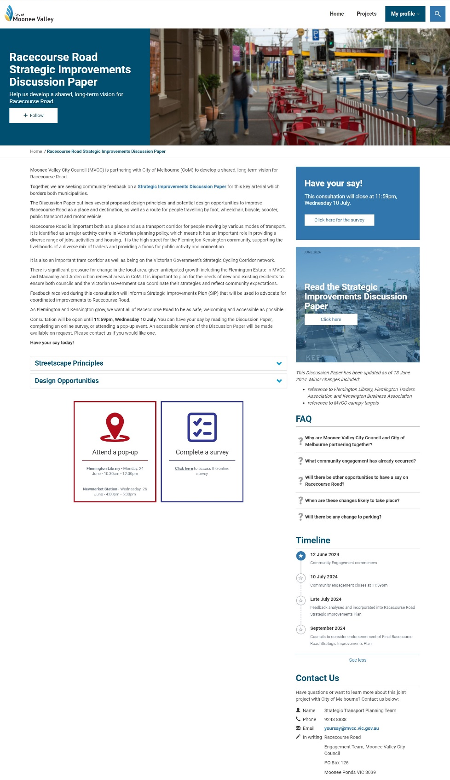

Participate Melbourne Page (City of Melbourne)
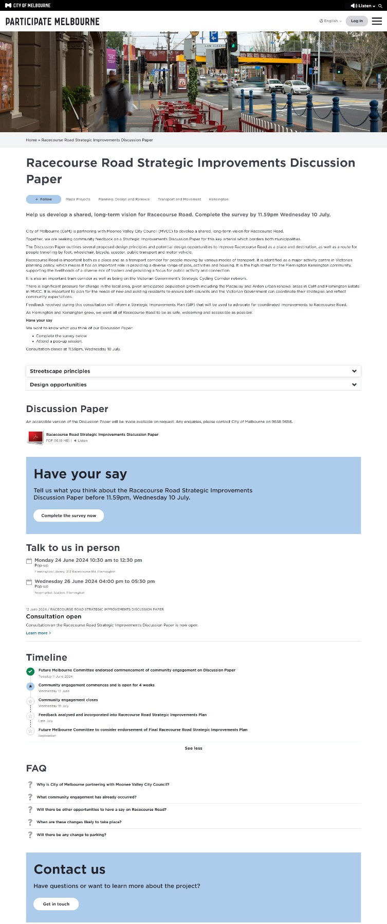

Survey tool
Moonee Valley City Council and City of Melbourne have identified seven streetscape principles for Racecourse Road. These principles are based on feedback from community members as well strategic policy directions from both Councils.
Please rank the following streetscape principles in order of your priority. 1= most important, 7= least important.
- Prioritise people
- Green the street
- Create a vibrant street identity
- Support active transport
- Encourage public transport
- Increase street activation
- Minimise unnecessary impacts to driving and parking
Why have you chosen your top 3 priorities?
Have we missed anything?
Please tell us to what extent you oppose or support the following potential streetscape opportunities?
- Make more space for walking and trading activities
- Make it easier for people to cross Racecourse Road
- Make side streets safer and more accessible
- Provide safe and separate bike lanes for people of all ages and abilities
- Create a comfortable place for people to spend time through increased tree canopy, understorey and raingardens
- Ensure safe and accessible access to future tram stops
- Improve traffic flow and safety by limiting some turning movements
Is there anything else you would like to tell us that would help inform the plan?
What is your suburb of residence?
How do you describe your gender?
What is your age?
Do you identify with any of the following?
- Aboriginal
- Torres Strait Islander
- Person with a disability
- Carer
- LGBTIQA+
- Speak a language other than English
- Born Overseas
- International Student
- Prefer not to say
- None of these
Do you usually speak a language other than English at home?
Which of the following best describes your connection to this project?
- I am a resident
- I am a worker
- I prefer not to say
- I own a business
- I am a student
- I am a visitor
- Other - Write In:

Social media posts
Post: 13 June 2024
graphic | Facebook |  | Instagram
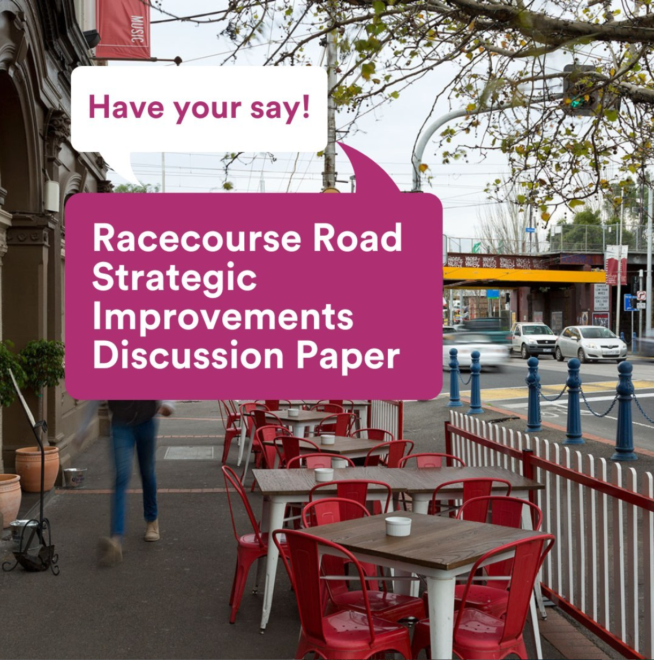 | Clicks | 712 | Impressions | 773
 | Comments | 14 | Likes | 7
 | Impressions | 22,474 | Reach | 740
 | Link Clicks | 203
 | Reach | 10,917
 | Reactions | 31
 | Shares | 4

Post: 26 June 2024
graphic | Facebook |  | Instagram
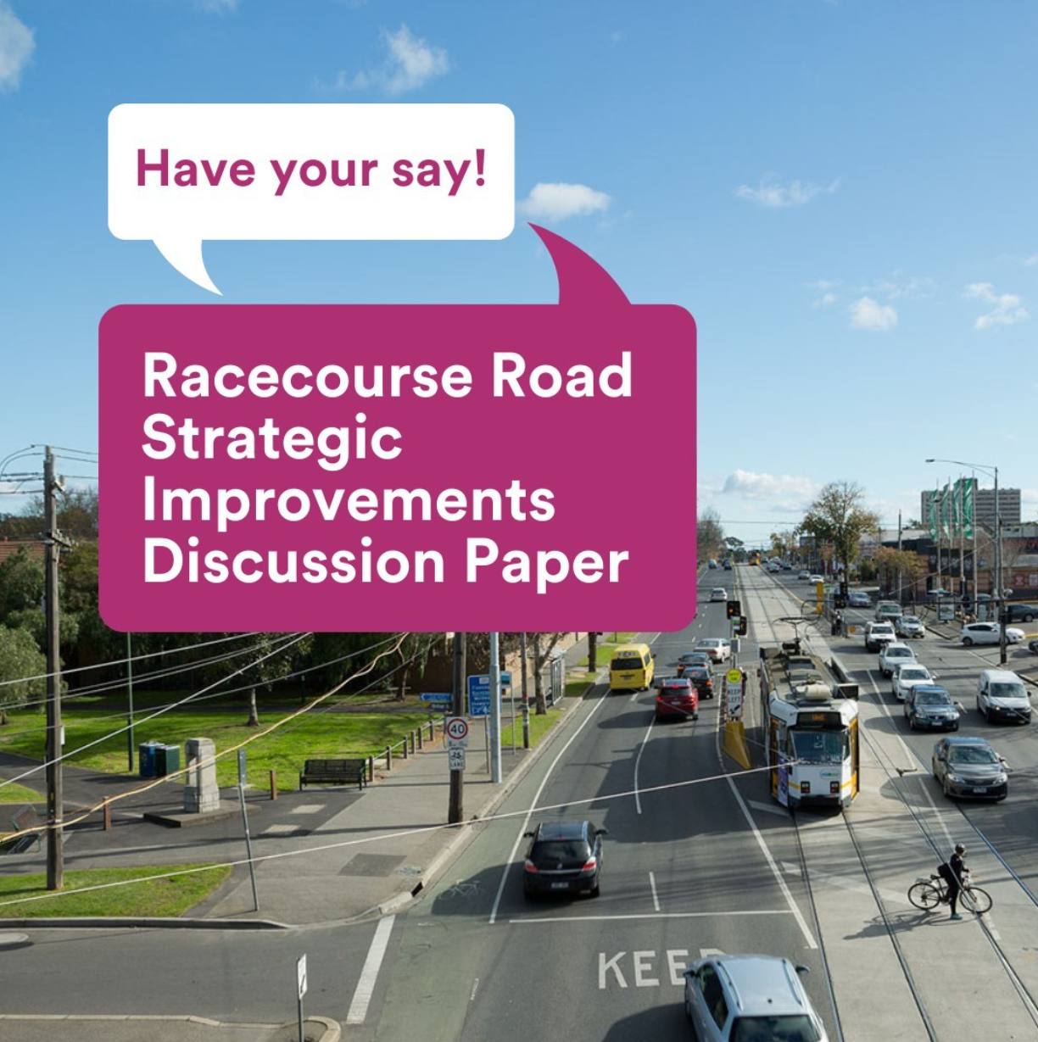 | Clicks | 356 | Impressions | 544
 | Comments | 2 | Likes | 8
 | Impressions | 8,125 | Reach | 529
 | Link Clicks | 58
 | Reach | 4,694
 | Reactions | 13
 | Shares | 0

Post: 7 July 2024
graphic | Facebook |  | Instagram
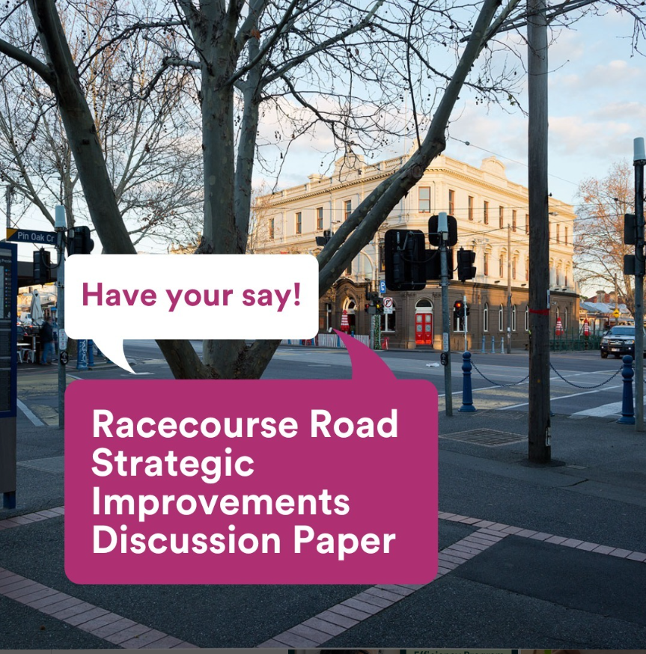 | Clicks | 9 | Impressions | 543
 | Comments | 0 | Likes | 7
 | Impressions | 1,150 | Reach | 531
 | Link Clicks | 5
 | Reach | 1,103
 | Reactions | 7
 | Shares | 0

Email received
Dear Mayor Pierce Tyson,
This is a written response in regards to the Moonee Valley City Council Racecourse Road Strategic Improvements Discussion Paper.
The deadline for this section of community feedback is tonight, Wednesday 10 July, 2024 at 11:59pm.
At the City of Melbourne Future Melbourne Committee meeting of Tuesday 11th June, 2024, Racecourse Road - Strategic Improvements Plan was the focus of discussion of Agenda Item 6.4.
Here is a link to a page that has a video of that meeting.
https://www.melbourne.vic.gov.au/about-council/committees-meetings/meeting-archive/Pages/Future-Melbourne-Committee-11-June-2024.aspx
I am including in this message a draft of the written response of [NAME REDACTED] concerning Agenda Item 6.4 Racecourse Road - Strategic Improvements Plan .
I support the shared vision plan of the Moonee Valley City Council and City of Melbourne in regards to the Racecourse Road Strategic Improvements Discussion Paper.
However, I would like to highlight the fact that this is a tremendous opportunity to create a heightened awareness of the magnificence of this precinct by renaming Racecourse Road and changing the name of the road to Phar Lap Drive.
2030 will be the 100th Anniversary of Phar Lap winning the 1930 Melbourne Cup. What better way to celebrate Australia's greatest racehorse, a true Australian sporting icon, than to change the name of Racecourse Road to Phar Lap Drive
The most popular exhibit to this day at Melbourne Museum is the Phar Lap Exhibition. Calling the road Phar Lap Drive would be embraced by the general public.
2030 will also be the 100th Anniversary of Greenline winning the 1930 Newmarket Handicap. Greenline's jockey was Jim Pike, Phar Lap's jockey. The Greenline Project of the City of Melbourne will be well advanced in 2030.
There would be a beautiful symmetry to Melbourne, having the Greenline project on the North Bank of the Yarra River, and having Phar Lap Drive heading towards Flemington Racecourse.

Thank you to both the City of Melbourne and the City of Moonee Valley for giving citizens the opportunity to provide feedback concerning this part of Melbourne and Moonee Valley
https://participate.melbourne.vic.gov.au/racecourse-road-strategic-improvements-discussion-paper
https://yoursay.mvcc.vic.gov.au/racecourse-road
Looking forward to City of Melbourne and Moonee Valley City Council working together to provide a much improved road and community.
[REDACTED]

Respondent Suburbs
Suburb | Number of Respondents
My suburb is not listed | 3
Abbotsford | 1
Aberfeldie | 3
Altona | 1
Ardeer | 1
Ascot Vale | 78
Aspendale | 1
Avondale Heights | 5
Blackburn North | 1
Brooklyn | 1
Brunswick | 8
Brunswick East | 1
Brunswick West | 3
Carlton | 1
Chelsea | 1
Clifton Hill | 1
Coburg | 2
Dingley Village | 1
Docklands | 1
Eltham | 1
Essendon | 8
Essendon North | 1
Fitzroy North | 1
Flemington | 252
Footscray | 9
Gladysdale | 1
Glen Huntly | 1
Hawksburn | 1
Heidelberg West | 1
Keilor East | 1
Kensington | 214
Kingsville | 1
Maidstone | 3
Maribyrnong | 5
Melbourne (CBD) | 3
Moonee Ponds | 21
North Melbourne | 18
Panton Hill | 1
Parkville | 7
Pascoe Vale | 1
Port Melbourne | 1
Richmond | 1
South Yarra | 1
Southbank | 1
St Kilda | 1
Sunshine | 2
Taylors Hill | 1
Thornbury | 1
Travancore | 14
West Footscray | 3
West Melbourne | 4
Williamstown North | 1

Respondent language spoken at home
Language other than English spoken | Number of speakers
Aboriginal English, so described | 2
Acholi | 1
African Languages, nec | 2
Afrikaans | 2
Arabic | 2
Cantonese | 5
Chinese, nec | 1
Croatian | 1
Dutch | 1
Filipino | 1
French | 4
German | 1
Greek | 7
Hindi | 1
Hungarian | 1
Italian | 2
Japanese | 1
Korean | 1
Norwegian | 1
Portuguese | 2
Punjabi | 1
Serbian | 1
Spanish | 4
Tigre | 1
Urdu | 1
Vietnamese | 2

Ranked Streetscape Principles – Gender breakdown
Man | Woman | Prefer not to answer
- Prioritise people  - Green the street  - Encourage public transport  - Support active transport  - Create a vibrant street identity  - Increase street activation  - Minimise unnecessary impacts to driving and parking | - Prioritise people  - Green the street  - Create a vibrant street identity  - Encourage public transport  - Support active transport  - Increase street activation  - Minimise unnecessary impacts to driving and parking | - Prioritise people  - Green the street  - Create a vibrant street identity  - Encourage public transport  - Minimise unnecessary impacts to driving and parking  - Increase street activation  - Support active transport
Non-binary | I use another term (please specify)
- Prioritise people  - Encourage public transport  - Green the street  - Support active transport  - Create a vibrant street identity  - Increase street activation  - Minimise unnecessary impacts to driving and parking | - Encourage public transport  - Prioritise people  - Green the street  - Create a vibrant street identity  - Increase street activation  - Minimise unnecessary impacts to driving and parking  - Support active transport

Open text comments – what is your connection to the project?
What is your connection to the project? Other – write in
Transit through the area frequently
I'm a former resident, that now owns an investment property. Still strongly support local business in Kensington and Flemington.
Pensioner
property owner
Parent of child at local daycare
Frequent visitor
[Redacted – not related to question]
Use the bike route to connect north and west
I cycle along Pin Oak Crescent four times per week. Sometimes visit to eat and visit shops.
Strong ties to area. Neighbourhood House shopping library etc
I am a traveler and a customer/client to businesses in the area
Former Flemington resident
I am a Seeing Eye Dog puppy carer volunteer.
Volunteer
i cycle through the area 3 days per week
Family lives nearby as well so I'm often there
as a frequent visitor to the area
rate payer
[Blank]
self-employed with home office
commuter through this area
Previous resident of 6 years
Previous resident until recently, likely future resident again soon.
I commute through here daily.
I am a senior urban design and planning academic
I commute through here daily.
Property owner
Ki commute through this suburb by bicycle
Representative of Gregory Lodge Aged care
retired
I use the area
Racecourse Road is part of my community, and a regular transit corridor
I ride to shops and train station
I used to live in the area
I use the road as a thoroughfare
resident of nearby suburb - often visit & use
Teenage child works on RCR
former resident of Travancore
I use Racecourse Rd Daily for work and on the weekends.
Daily commuter of Racecourse Road

