
Transport Strategy Discussion Paper
Parking

This discussion paper is to inform a new City of Melbourne Transport Strategy to 2050. A draft strategy will be released for consultation in 2018. We are seeking your views on these issues and ideas.
To protect Melbourne’s liveability for future generations, we need greener, people friendly streets. The management of parking has a profound impact on our transport system and city streets. The City of Melbourne manages on-street parking across the municipality and some off-street parking. Most off-street parking spaces are built and managed by the private sector. The Melbourne Planning Scheme controls the amount of car parking in new developments.
The City of Melbourne has introduced progressive policies and innovative changes to on and off street parking since the 1970s. Despite this, there is an oversupply of off-street parking and low occupancy of on-street in some locations.
The availability of cheap or free parking strongly influences people’s decision to drive. Reforms to pricing and supply are among the most influential changes the new Transport Strategy can make. If parking charges reflected the true cost of providing the infrastructure, substantial changes to behaviour could be expected.
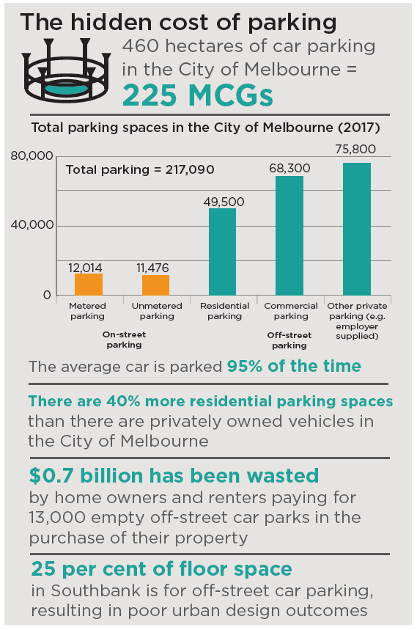

What are the current issues?

Hidden costs of on-street parking
The convenience of storing a private vehicle on a central city street will soon cost $7 per hour - a third of the rate charged by many commercial garages off the street. Cheap on-street parking incentivises people to drive and adds to congestion when drivers search for a space. Cars parked on the street result in public space used only by a small number of people and prevent improvements to the public realm, such as more trees, wider footpaths and new bike paths.

Parking and retail performance
Only 14 per cent of people shopping in the municipality park on the street, while 73 per cent arrive by non-car modes (VISTA 2016). There is a perception that retail is dependent on parking, however this is disputed by evidence in the central city. A study in Carlton found that space converted to bike parking returned five times as much retail spend as on-street car parking (Lee & March 2010).

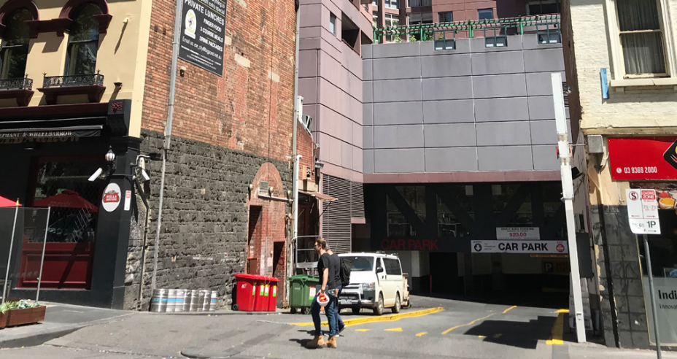
Off street car parks on Russell Street contribute poorly to the street

Oversupply of off-street parking
New apartments typically include a parking space. Residential parking spaces outnumber vehicles owned by 40 per cent. Surveys in Southbank and West Melbourne have revealed that between 26 and 41 per cent of private parking spaces are empty. Many people are paying for a space that they do not want or need. This adds to the high cost of housing and undermines the quality of the street.

New technologies, decline in parking revenue
New technologies such as ride share, Mobility as a Service (MaaS) and driverless cars will generate structural change to mobility and the need for car parking will decline. The City of Melbourne currently receives significant revenue from on-street parking fees. Since 2011, there has been a 22 per cent reduction in parking spaces in the central city due to street improvements such as tree planting, wider footpaths, bike lanes and new tram stops. This trend will continue and accelerate. New revenue streams will need to be found to deliver essential city services.

Access for all people
To ensure that everyone has equal access to the city, access for people with a disability needs to improve. As the population grows, we need better access and more space for people who cannot access the city without a private vehicle. On-street parking conversions need to maintain and improve the accessible parking that is provided.

What are other cities doing?
Cities around the world are facing similar challenges. These global best practice ideas can help to inform the right approach for Melbourne.

Capping of parking supply
Zurich (Switzerland), Hamburg (Germany), Oslo (Norway) and New York (USA) have capped the total parking supply.
In Zurich the cap was part of a plan to reduce car use to improve the performance of its extensive tram network as well as address urban pollution. If there is new off-street parking, the equivalent amount of on-street space is converted to another use.
Capping parking supply could reduce car use and improve walking, cycling and public transport in Melbourne.
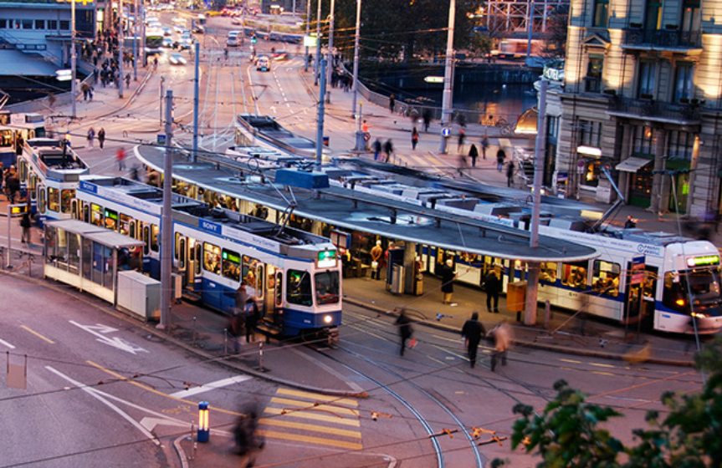
Capping the parking supply contributed to a more efficient tram network (City of Zurich).

San Francisco dynamic parking pricing (SFpark)
Traditionally, on-street parking is priced at the same hourly rate every day regardless of demand varying across the day and week.
- Under the SFpark program, prices vary according to demand with lower prices when more space is available.
- Prices are adjusted constantly and increase so that one space is available on each block all the time or decreased when parking spaces are plentiful.
- Prices are adjusted without increasing overall revenue. Prices for some car spaces have fallen, reflecting lower demand at certain times and locations.
Following the introduction of dynamic pricing, there was a 50 per cent reduction in drivers circulating streets searching for parking.

What should be done to address these issues?

On-street conversions
If we want to be the most liveable city and meet our Urban Forest target of 40% canopy cover by 2040, we need to make space for more trees in the city. Underused parking spaces should continue to be converted to other uses, but at a faster rate. Higher value uses of street space include more trees, wider footpaths, improved tram stops and on-street dining areas. The large amount of space dedicated to on-street parking provides a significant opportunity to increase tree canopy cover and mitigate climate change impacts.

Pricing reform
On-street parking pricing should reflect real-time market demand for the space, the real cost of providing the infrastructure and factor in other potential uses. Dynamic, market-based pricing may cause prices to increase in the most valuable parts of the city and allow prices to fall in areas with high vacancy. This can support more reliable availability. By using street space more efficiently, congestion can be reduced and opportunities created to repurpose street parking for higher-value uses.

Cap parking supply, set reductions targets
A cap on parking could help even out the oversupply of off-street parking spaces and improve occupancy in some areas on the street. This could result in existing spaces being used more efficiently and reduce the number of people paying for off-street parking they do not use or need. More new buildings should be built without car parks and existing rules which limit parking provided in new buildings should be expanded across the municipality.

Dynamic digital signage
New technologies provide an opportunity to reimagine on-street parking as ‘flexible kerb space’ with multiple uses. Sensible digital signage and innovative design could enable loading bays and disabled parking spaces to be provided on demand and at other times these spaces can be used for other purposes. Street space could be used for commercial purposes like cafe tables when parking demand is low.

Enhance open data
The City of Melbourne provides rich car parking data to the public through an open data platform. Parking data collection could be extended, including through partnerships with off-street parking providers, to further support outcomes which optimise efficient use of parking in the city. This must be aligned with policies to consistently reduce on-street parking over time.

What if?
- Large numbers of on-street parking spaces across Melbourne were converted to open space, trees, bike lanes and footpaths.
- New residential buildings near public transport were provided with car share instead of car storage, supporting sustainable travel.
- The price of on-street space was adjusted according to demand to ensure some spaces are always available on each block.
- All parking structures were publicly accessible to use parking more efficiently and enable widespread sharing of vehicles and car parks.
- People without cars could buy cheaper apartments because all car parks were sold separately.

We want your thoughts!
participate.melbourne.vic.gov.au/transportstrategy
9658 9658
transport@melbourne.vic.gov.au

