

Plan for Melbourne
Directions Paper
For stakeholder and community consultation
October 2026
City of Melbourne
Accessible version

Acknowledgement of Traditional Owners
City of Melbourne respectfully acknowledges the Traditional Owners of the land we govern, the Wurundjeri Woi-wurrung and Bunurong / Boon Wurrung peoples of the Kulin and pays respect to their Elders past and present. We acknowledge and honour the unbroken spiritual, cultural and political connection they have maintained to this unique place for more than 2000 generations. We accept the invitation in the Uluru Statement from the Heart and are committed to walking together to build a better future.
Contents
Acknowledgement of Traditional Owners 1
Executive summary 3
Your input matters 4
Chapter 1. Introduction 4
What this Directions Paper does 5
Why do we need a Plan for Melbourne? 5
Melbourne’s many roles 5
Melbourne’s story 6
Our shared ambition 6
Chapter 2. Draft directions for the future 9
A framework for action 10
Theme 1: Living well as Melbourne grows 11
Theme 2: Strengthening Melbourne’s identity 21
Theme 3: Supporting jobs and a changing economy 28
Theme 4: Moving safely and conveniently through Melbourne 34
Theme 5: Building a greener, cooler and more climate-liveable city 39
Chapter 3. Next steps 48
Finalising the plan 49
How will we use the Plan for Melbourne? 49
Appendix A. What we’ve heard 51
Neighbourhoods that support everyday living 52
Our places, growing stronger 52
An easy city to get around 52
Leading in green 52
Resilient economy 53

Executive summary
Melbourne is growing and changing. More people are choosing to live, work, study, visit, create and invest here. This brings energy and opportunity, but also puts pressure on housing, transport, parks, community facilities, services, waterways and the places people use every day.
Plan for Melbourne will guide how the municipality grows over the next 25 years, so Melbourne remains liveable, inclusive, resilient and unique. It is about planning for people: providing homes people can afford and neighbourhoods that work well. It also means making it easier and safer to get around, creating greener and cooler places, supporting local businesses, jobs and providing public spaces where everyone feels welcome.
This Directions Paper tests draft directions, ideas and options for Melbourne’s future growth and development. It does not change the Melbourne Planning Scheme, approve development, commit funding or alter land use controls. Instead, it seeks feedback on ideas that could inform future planning and decisions.
This is an interim step, not the final plan. It brings together community feedback, technical evidence and draft directions to explore the choices ahead. These include where growth should occur, what should be protected, what may need to change and where investment is needed most.
The scale of change is significant. The Victorian Government’s housing targets require the municipality to plan for 119,500 additional homes by 2051. Meeting this target is about more than providing housing. New and existing communities will also need access to transport, open space, schools, services, jobs and community infrastructure.
Melbourne has many roles to balance. It is a city of neighbourhoods, communities and daily life. It is also Victoria’s capital, a national centre for jobs, culture, education and innovation, and a global gateway. The plan must support residents, workers, students, visitors, businesses and institutions. It must also strengthen Melbourne’s unique identity and keep local liveability at its centre.
Growth must support Country and strengthen climate resilience. Future development needs to work with waterways, parks, biodiversity and natural systems. It must also respond to heat, flooding and climate change, drawing on Caring for Country, Traditional Owner knowledge and water-sensitive design.
Community feedback provides a clear direction. People want more housing choice and affordability, safer streets, reliable services, welcoming public spaces, stronger local centres and greener, cooler neighbourhoods. They also want growth to strengthen Melbourne’s identity, not dilute it.
Together, these challenges have shaped five themes for Melbourne’s future. Each theme includes draft directions and a bold move to test how Melbourne can build on its strengths and respond to future opportunities:
- Living well as Melbourne grows
- Strengthening Melbourne’s identity
- Supporting jobs and a changing economy
- Moving safely and conveniently through Melbourne
- Building a greener, cooler and more climate-liveable city.

Your input matters
The draft directions and bold moves aim to spark discussion about Melbourne’s future. Community feedback will inform the Plan for Melbourne, being presented to Council in early 2027. Future action will require further analysis, approvals and partnerships with government and landowners. Once endorsed, the final plan will guide the decisions and investment needed to shape a liveable, resilient and distinctive Melbourne for generations to come.

Chapter 1. Introduction
Setting the scene to create a plan for Melbourne

What this Directions Paper does
This Directions Paper is an early opportunity for the community to help shape how Melbourne grows and changes and will inform the Plan for Melbourne. Getting involved early is important. Decisions about where new homes and jobs should go, how land can be used and what new development should provide are made before proposals for individual sites are considered. These early decisions guide what can happen later at the local level.
The paper shares draft directions and ideas for feedback. It does not make final decisions or change planning rules. Community feedback will help refine the directions and shape the final Plan for Melbourne.

Why do we need a Plan for Melbourne?
Plan for Melbourne is a framework to ensure the city continues to work well for the people who live, work, study and spend time here as it grows and changes over the next 25 years.
More people will call Melbourne home in the coming decades. Many more will come here each day to work, study, visit and access services. Under Victorian Government housing targets, the municipality must plan for the capacity to accommodate 119,500 additional homes by 2051. However, growth is about more than numbers. Council must also respond to Government policy, community expectation and changing needs, while guiding growth in a way that reflects local challenges and aspirations.
The Melbourne 2050 vision describes the future Melburnians want. Plan for Melbourne will translate this vision into a spatial framework for land use, development and infrastructure decisions. It will help ensure people can find a suitable home, move around safely, access jobs and everyday services, enjoy parks and public spaces, and feel connected to their neighbourhood and city, as it changes.
This Directions Paper tests draft directions, ideas and options for Melbourne’s future growth and development. It does not change the Melbourne Planning Scheme, approve development, commit funding or alter land use controls. Instead, it seeks feedback on ideas that could inform future planning and decisions.
Feedback on this Paper will inform the final Plan for Melbourne. The Plan will balance the needs of residents, workers, students, visitors, businesses and institutions. It will provide a strategic foundation for reviewing the Melbourne Planning Scheme under the Planning and Environment Act 1987. It will also guide future planning controls, infrastructure investment and advocacy.

Melbourne’s many roles
Melbourne plays many roles at once. Plan for Melbourne must balance local neighbourhood needs with the city’s wider metropolitan, state, national and global responsibilities.
Much of Melbourne’s distinctive culture and character is created at street level. It is experienced through its footpaths, parks, shops, libraries and neighbourhood centres. Each of the city’s 11 neighbourhoods has its own history and community. Each will experience growth and change differently.
Melbourne also sits at the centre of networks that extend well beyond the municipality. Housing, infrastructure, climate resilience and economic activity are shared challenges that require coordinated planning across the wider region. As Victoria’s capital, Melbourne serves people from across the state. It must accommodate significant population growth while continuing to support institutions, destinations, events and public spaces that benefit all Victorians.
Melbourne is also one of Australia’s most important economic centres. It supports more than 679,000 jobs and attracts investment and ideas from around the world. As a global gateway, it connects Victoria to international trade, education, tourism and markets.

Melbourne’s story
Melbourne is on the traditional lands of the Wurundjeri Woi-wurrung and Bunurong / Boon Wurrung peoples of the Kulin. Before colonisation, this area was part of a wider cultural landscape shaped by trade routes, meeting places, knowledge and systems of governance.
European settlement from the 1830s brought major changes. Waterways were altered, wetlands were drained and vegetation was cleared. New streets, buildings and infrastructure were established, creating the central city structure that still shapes Melbourne today.
The Gold Rush of the 1850s brought rapid growth and investment. Melbourne expanded quickly, with many public buildings, parks, streets, institutions and commercial areas established during this time. These places remain an important part of the city’s character, public life and visitor economy.
Migration has also played a major role in Melbourne’s growth. People from around the world have shaped the city’s communities, economy, culture, education, food, shops and international connections.
Melbourne’s story continues to shape the city today. Its layers of Country, heritage, civic development, neighbourhood character and diverse industries help us decide what can change, what should be protected and where new investment is needed.

Our shared ambition
This Directions Paper builds on what the community has already told us, as outlined in Appendix A. In 2025, thousands of people helped create the Melbourne 2050 vision. The vision and community aspirations describe the future people want for Melbourne.
How the city is planned and built affects how people live, work and spend time here. Plan for Melbourne will turn the vision into clear choices about land use, development and infrastructure. Staying true to this shared ambition will give the community, government and other partners greater certainty about how Melbourne will grow and change over time.
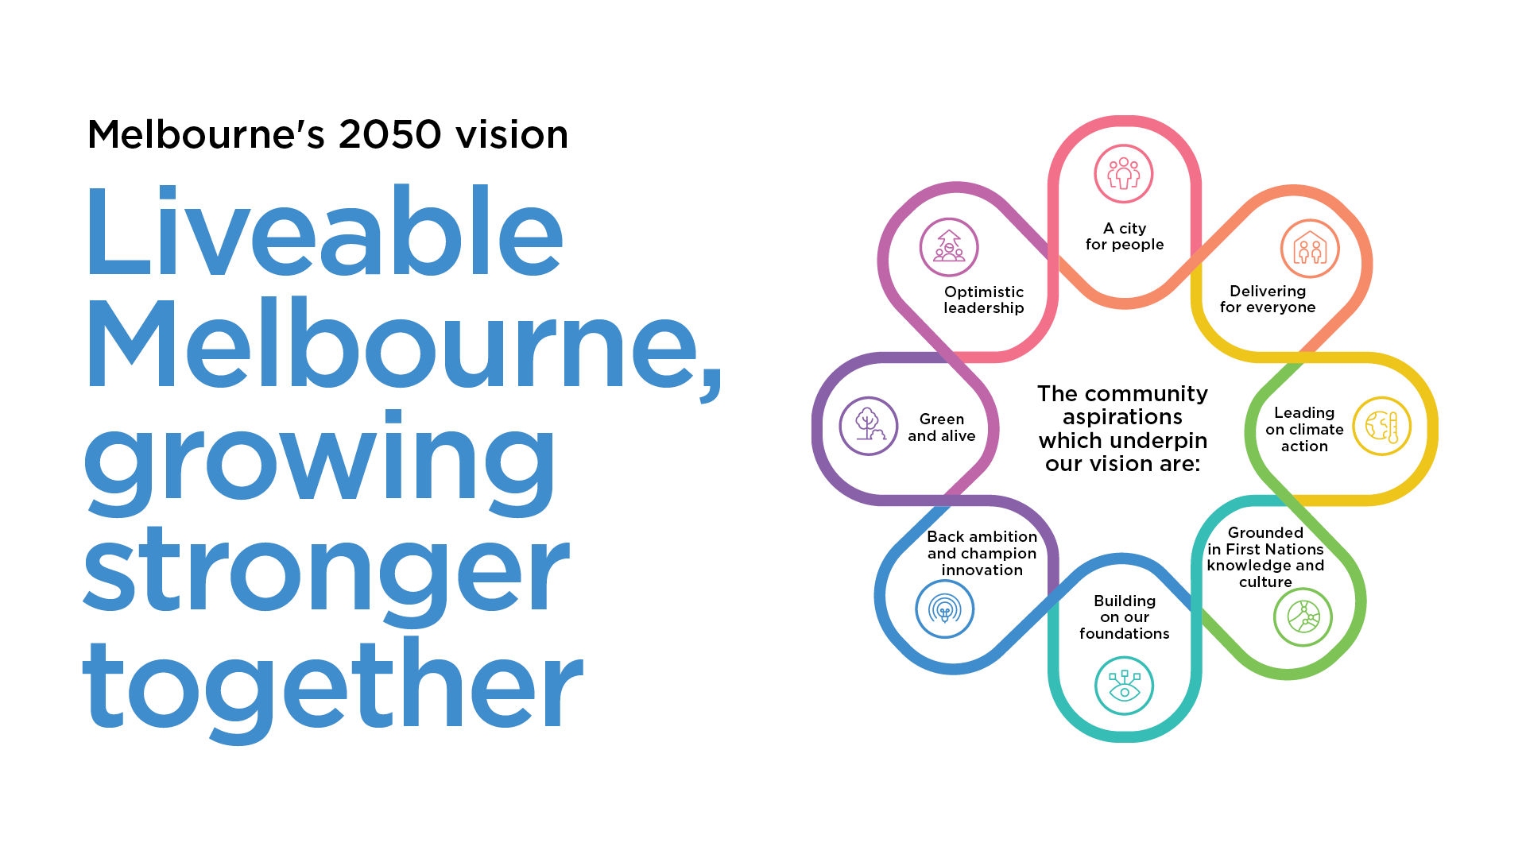
Melbourne’s 2050 vision: Liveable Melbourne, growing stronger together.
The community aspirations which underpin our vision are:
- A city for people
- Delivering for everyone
- Leading on climate action
- Grounded in First Nations knowledge and culture
- Building on our foundations
- Back ambition and champion innovation
- Green and alive
- Optimistic leadership.

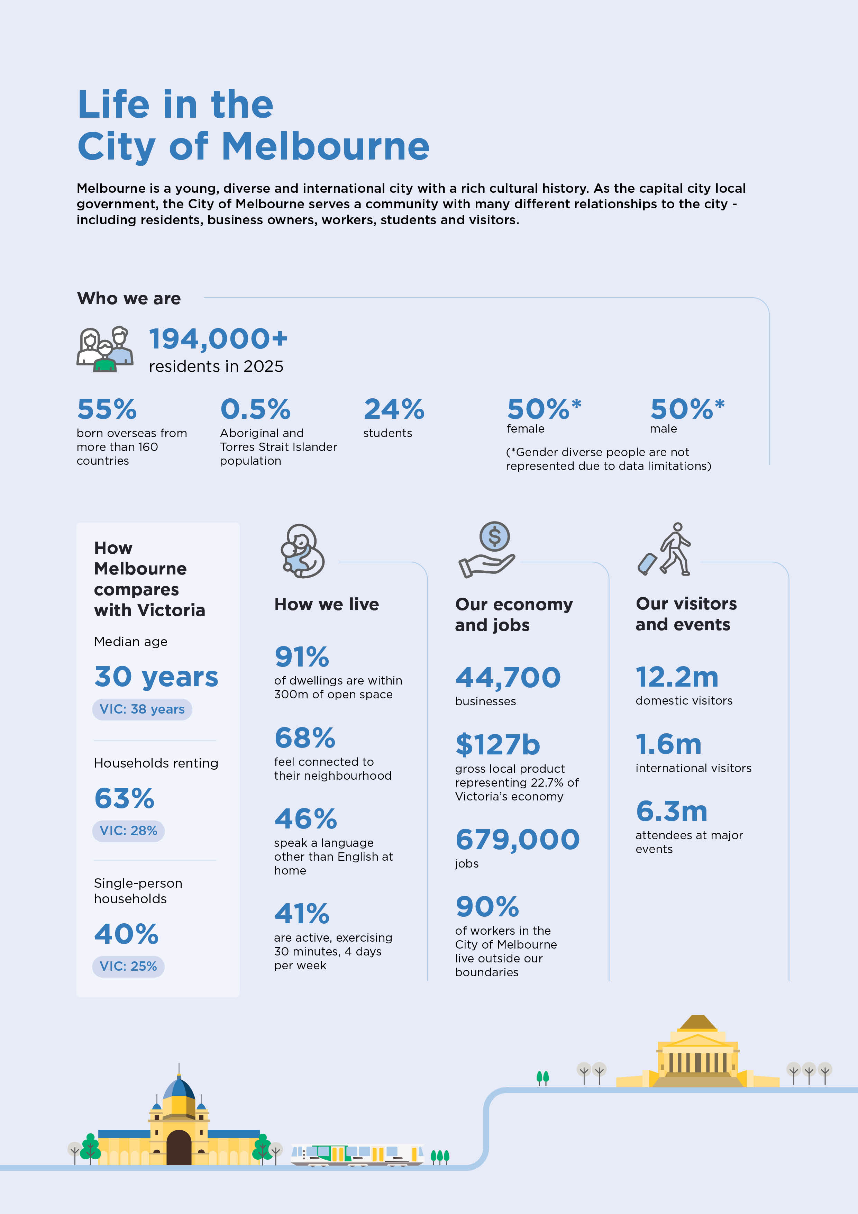

Life in the City of Melbourne
Melbourne is a young, diverse and international city with a rich cultural history. As the capital city local government, the City of Melbourne serves a community with many different relationships to the city - including residents, business owners, workers, students and visitors.

Who we are
- 194,000+ residents in 2025.
- 55% born overseas from more than 160 countries.
- 0.5% Aboriginal and Torres Strait Islander population.
- 24% students.
- 50% female and 50% male. Gender diverse people are not represented due to data limitations.

How Melbourne compares with Victoria
- The median age for the City of Melbourne is 30 years, while Victoria’s median age is 38 years.
- The proportion of households renting in the City of Melbourne is 63%, while the proportion of households renting across Victoria is 28%.
- The proportion of single-person households in the City of Melbourne is 40%, while the proportion of single-person households in Victoria is 25%.

How we live
- 91% of dwellings are within 300 metres of open space.
- 68% feel connected to their neighbourhood.
- 46% speak a language other than English at home.
- 41% are active, exercising 30 minutes, 4 days per week.

Our economy and jobs
- 44,700 businesses.
- $127 billion gross local product, representing 22.7% of Victoria’s economy.
- 679,000 jobs.
- 90% of workers in the City of Melbourne live outside our boundaries.

Our visitors and events
- 12.2 million domestic visitors.
- 1.6 million international visitors.
- 6.3 million attendees at major events.

Chapter 2. Draft directions for the future
How do we plan for a city that is liveable, memorable, innovative, connected and cooler?

A framework for action
Built on community feedback and technical evidence, this Directions Paper sets out draft directions across five themes. These directions will guide local planning, future updates to the Melbourne Planning Scheme and other work that shapes how Melbourne grows and changes. Each theme includes a bold move to spark discussion about Melbourne’s future. These ideas are not final decisions. They explore how Melbourne could build on its strengths and respond to future opportunities and challenges.

Theme 1: Living well as Melbourne grows
- Direction 1: More homes in the right locations
- Direction 2: Infrastructure keeps pace with growth
- Direction 3: Housing meets different needs
- Direction 4: Daily services are close to home
- Bold move: Climate-first urban renewal.

Theme 2: Strengthening Melbourne’s identity
- Direction 5: Growth and good design go hand in hand
- Direction 6: Heritage, culture and identity are celebrated
- Direction 7: Public spaces are where social connection happens
- Direction 8: Our landmarks are destinations for everyone
- Bold move: Australia’s garden city.

Theme 3: Supporting jobs and a changing economy
- Direction 9: Melbourne’s employment clusters are strategically located
- Direction 10: Our economy is adaptable
- Direction 11: Land use supports diverse economies
- Direction 12: Melbourne’s freight and logistics advantage is maintained
- Bold move: A city of connected experiences.

Theme 4: Moving safely and conveniently through Melbourne
- Direction 13: People move safely and efficiently
- Direction 14: Streets work better for everyone
- Direction 15: Major infrastructure investment delivers community benefit
- Bold move: Australia’s most walkable city.

Theme 5: Building a greener, cooler and more climate-liveable city
- Direction 16: Communities are climate-ready
- Direction 17: We design with natural systems
- Direction 18: Our urban forests, biodiversity and water supplies are connected
- Bold move: Melbourne’s living river.
As you review this Directions Paper, consider: What do you support? What concerns you? What is missing? What actions should be prioritised? What could those ideas mean for your neighbourhood, business, or experience of Melbourne?

Theme 1: Living well as Melbourne grows
Melbourne will continue to grow over the coming decades. The Victorian Government requires the municipality to plan for the capacity to accommodate around 119,500 additional homes by 2051. But growth must be about creating neighbourhoods, not just building homes.
People need access to jobs, shops, health services, playgrounds, libraries and other facilities. As more people live in and use the city, growth should improve neighbourhoods, provide more housing choice and make daily needs easier to access.

Direction 1: More homes in the right locations
- The municipality's population is forecast to grow from 194,000 residents in 2025 to more than 292,000 by 2043, representing growth of around 51%.
- More than 60,000 homes have been built or are under construction across Melbourne over the past decade, reflecting the city's significant contribution to housing supply.
- Around two-thirds of recent housing growth has been concentrated in the central city, including Docklands and Southbank, highlighting the importance of urban renewal areas in accommodating future growth.
Melbourne is home to many people and is also a centre for jobs, education, arts and entertainment. New homes need to be built in places that can support growth and become successful neighbourhoods. The question is not whether Melbourne will grow, but how and where that growth happens.
The draft Residential Change Areas Framework is an early proposal for where different levels of housing growth may be suitable. It will be tested through this consultation phase and is not a final approach.
Community feedback and further technical work will help refine the framework. The framework considers how much development is practical, what infrastructure is needed and when, flooding and climate risks, heritage, and impacts on employment land.
The framework is shown in the Draft Residential Change Areas map, with the different areas explained in Table 1 and Figure 1. The proposed levels of growth consider access to jobs, public transport, services, open space and infrastructure. It also considers flooding, climate risks and heritage.
Some decisions about housing growth are made by the Victorian Government, including Melbourne’s housing capacity target. Council’s role is to guide where and how this growth occurs so that it reflects community priorities and creates liveable neighbourhoods.
Table 1. Proposed residential change area categories
Residential change area | Proposed definition
Substantial change: central city | Central city areas suited to the highest-density housing and mixed-use development. These areas also support major employment and services used across metropolitan Melbourne.
Substantial change: urban intensification | Areas suitable for substantial growth or renewal. This includes established areas changing over time and new mixed-use neighbourhoods that will provide homes, jobs and services.
Incremental change | Areas suitable for gradual change due to lot sizes, heritage, sensitive uses, environmental conditions or other factors.
Figure 1. Proposed development scale by residential change area
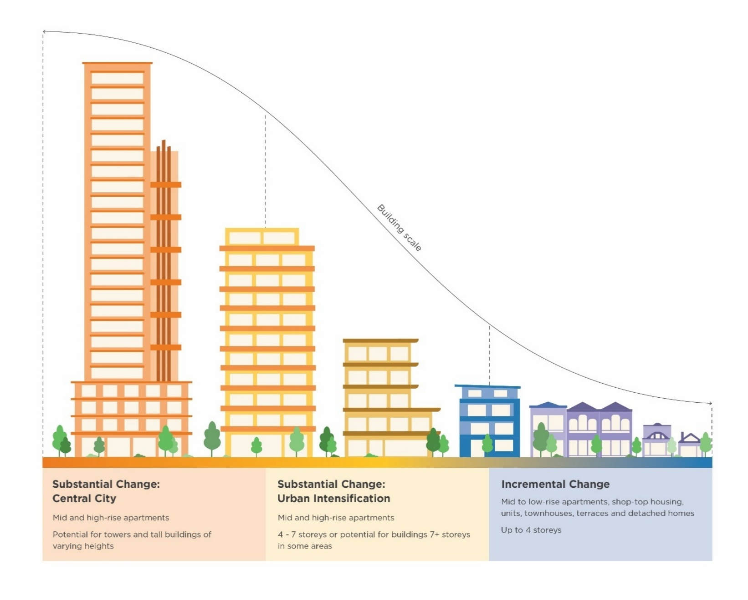
Substantial Change: Central City.
- Mid and high-rise apartments.
- Potential for towers and tall buildings of varying heights.
Substantial Change: Urban Intensification.
- Mid and high-rise apartments.
- 4-7 storeys or potential for buildings 7+ storeys in some areas.
Incremental Change.
- Mid to low-rise apartments, shop-top housing, units, townhouses, terraces and detached homes.
- Up to 4 storeys.

Direction 2: Infrastructure keeps pace with growth
- Melbourne has more than 500 community spaces and 573 hectares of open space, providing a strong foundation of community infrastructure.
- Ninety-one per cent of dwellings are within 300 metres of open space. However, demand for parks, recreation facilities and community spaces continues to grow.
- In 2024, one in three residents reported they could not access the Council services and support they needed, indicating increasing pressure on community infrastructure and services.
As Melbourne grows, finding land for community facilities and open space will become harder and more expensive. Our Community Infrastructure Plan identifies growing demand for kindergartens, recreation centres, open spaces and community meeting rooms.
We need new ways to provide these facilities sooner and make better use of the space available. Where possible, community spaces should support different activities and be available to as many people as possible.
Each neighbourhood will have different needs. Areas with more young families may need additional maternal and child health services. Areas near student housing may need more places to meet and study.
Libraries show how one space can meet many needs. On any day, a library may be used by students, families, older people and residents seeking drinking water or relief from extreme weather. Parks also support many activities. Children can explore nature, people can walk their dogs, friends can meet and sporting teams can train and play. Spaces that serve many people in different ways provide greater value to the community.
We must also plan for the infrastructure that keeps Melbourne moving and functioning. This includes public transport, footpaths, roads and drains. Responsibility for this infrastructure is shared by government agencies, developers and service providers. Strong partnerships will be needed to fund and deliver it as the city grows.

Direction 3: Housing meets different needs
- In the municipality 63% of residents rent their homes, compared with 28% across Victoria.
- Apartments make up 86% of the municipality’s housing, with limited options for families. Couples with children account for 12.6% of households, compared with 43.3% across Greater Melbourne.
- Melbourne has around 4,500 affordable homes. However, an estimated 27,100 households will need affordable housing by 2036.
- Almost half of Melbourne’s 142,000 key worker households are on low to moderate incomes. Around one in five key workers lives over 30 kilometres from the city.
Building more homes has not automatically delivered greater choice or affordability. Most apartments are studios or have one or two bedrooms. This limits options for families, larger households and people whose needs change over time.
High housing costs and the large number of renters also make it harder for key workers and lower-income households to live near their jobs, families and community networks.
Melburnians want the city to remain a place where people of different backgrounds, incomes and life stages can live and thrive. This means providing more social and affordable housing, including culturally safe, Aboriginal-led housing. It also means encouraging a greater mix of housing sizes and types.
Delivering affordable housing requires action from all levels of government, community housing providers and the development sector. The Australian and Victorian governments have the main responsibility for funding and delivering social and affordable housing. Council can contribute through its planning role, use of Council land, partnerships and advocacy. Community housing providers and Aboriginal housing organisations also play an important role in developing and managing homes.
Council is exploring how planning can support more diverse and affordable housing. We also want the Victorian Government to take stronger action to require affordable homes in new developments. Emerging housing options, such as co-living and build-to-rent, must also be planned for carefully.

Direction 4: Daily services are close to home
- Jobs that support Melbourne’s growing population are expected to increase by more than 80,000 by 2043. This may require up to an additional 2.2 million square metres of employment space.
- In the six months to November 2025, 13.5% of vacant shopfronts across the municipality and central city were brought back into use.
- Local activity centres support jobs and services. However, trends in employment spaces in Mixed Use and Commercial 1 Zones has remained largely unchanged since 2003.
Successful neighbourhoods need more than homes. They also need lively local centres where people can easily reach shops, services, jobs and community facilities. Macaulay Road in Kensington and Lygon Street in Carlton are examples. These centres make daily life more convenient. They also create local character, support businesses, attract visitors and strengthen the local economy.
However, many local centres are under pressure. New housing can compete with shops, workplaces and other commercial uses. The design of streets, footpaths and public spaces can also limit opportunities for businesses and community activities.
Without a clear approach to supporting these centres, Melbourne could lose some of the local activity that makes neighbourhoods convenient and welcoming. The draft directions aim to strengthen local centres as places where residents, workers and visitors can meet their daily needs.

How the draft directions could be implemented

Direction 1: More homes in the right locations
- Encourage more homes in locations best suited for growth, while supporting Melbourne’s capital city role and diverse mix of activities.
- Establish a residential development framework that identifies areas for incremental and substantial housing change.

Direction 2: Infrastructure keeps pace with growth
- Establish clear and consistent infrastructure contribution requirements so new development helps fund the facilities, open spaces and services needed as the city grows
- Require and advocate major urban renewal areas to have funded infrastructure plans that align housing delivery with transport, drainage, parks, schools and community facilities.
- Secure land and funding for essential infrastructure early, and support partnerships that enable its delivery before rising land costs limit options.
- Explore new funding, partnership and shared-use models to address infrastructure gaps and deliver facilities sooner in high-growth neighbourhoods.

Direction 3: Housing meets different needs
- Encourage developments to provide a mix of housing types and sizes so people at different life stages can find homes that meet their needs.
- Support and advocate for social and affordable housing, including culturally safe, Aboriginal-led housing.
- Facilitate new housing models, including build-to-rent, co-living, student housing and multigenerational housing, that respond to changing needs and different ways of living.
- Encourage housing models that improve affordability, security and choice for renters, families, students, key workers and older people.

Direction 4: Daily services are close to home
- Recognise activity centres as important social and economic hubs that support daily life, local business, community connection and neighbourhood identity.
- Enhance and strengthen a network of local centres so people can access shops, services, jobs, hospitality and community activity close to where they live, work, study and visit.
- Support local shopping areas, small centres and neighbourhood precincts as mixed-use places for living, working, shopping, services and community life, including through local events and activities.

Bold move: Climate-first urban renewal
Imagine Melbourne's urban renewal precincts as global leaders in climate liveability: places where housing, jobs, innovation, transport and community infrastructure are designed around the realities of a changing climate. Where climate liveability is the foundation of every decision, ensuring these precincts are resilient, beautiful and comfortable places for generations to come.
This means planning with water first. Rather than treating water, flooding and drainage as constraints to manage, renewal precincts can be shaped around waterways, wetlands, parks and green infrastructure that cool neighbourhoods, reduce flood risk, improve biodiversity and create attractive public spaces. It means embedding climate-resilient infrastructure and buildings, and adaptable public spaces from the outset so communities are prepared for future climate shocks and stresses while benefiting from healthier, more liveable environments every day.
Precincts such as Arden, Fishermans Bend, E-Gate and Dynon can show how neighbourhoods can be designed for Melbourne's future climate. Where planning rules and funding from development delivers the drainage, green spaces, buildings and other infrastructure these areas need to remain safe and liveable.
We could:
- Design renewal precincts around water and landscape systems that manage flood risk, cool the city, support biodiversity and create memorable places.
- Make Melbourne's renewal areas global exemplars of climate liveability and disaster resilience.
- Use planning tools and development contributions to fund and deliver climate-resilient infrastructure from the outset.
- Ensure growth delivers enduring public benefits, including affordable housing, jobs, community infrastructure, open space and climate resilience.
Should City of Melbourne explore opportunities for more waterfront living in Fishermans Bend?
Map 1. Draft Residential Change Areas
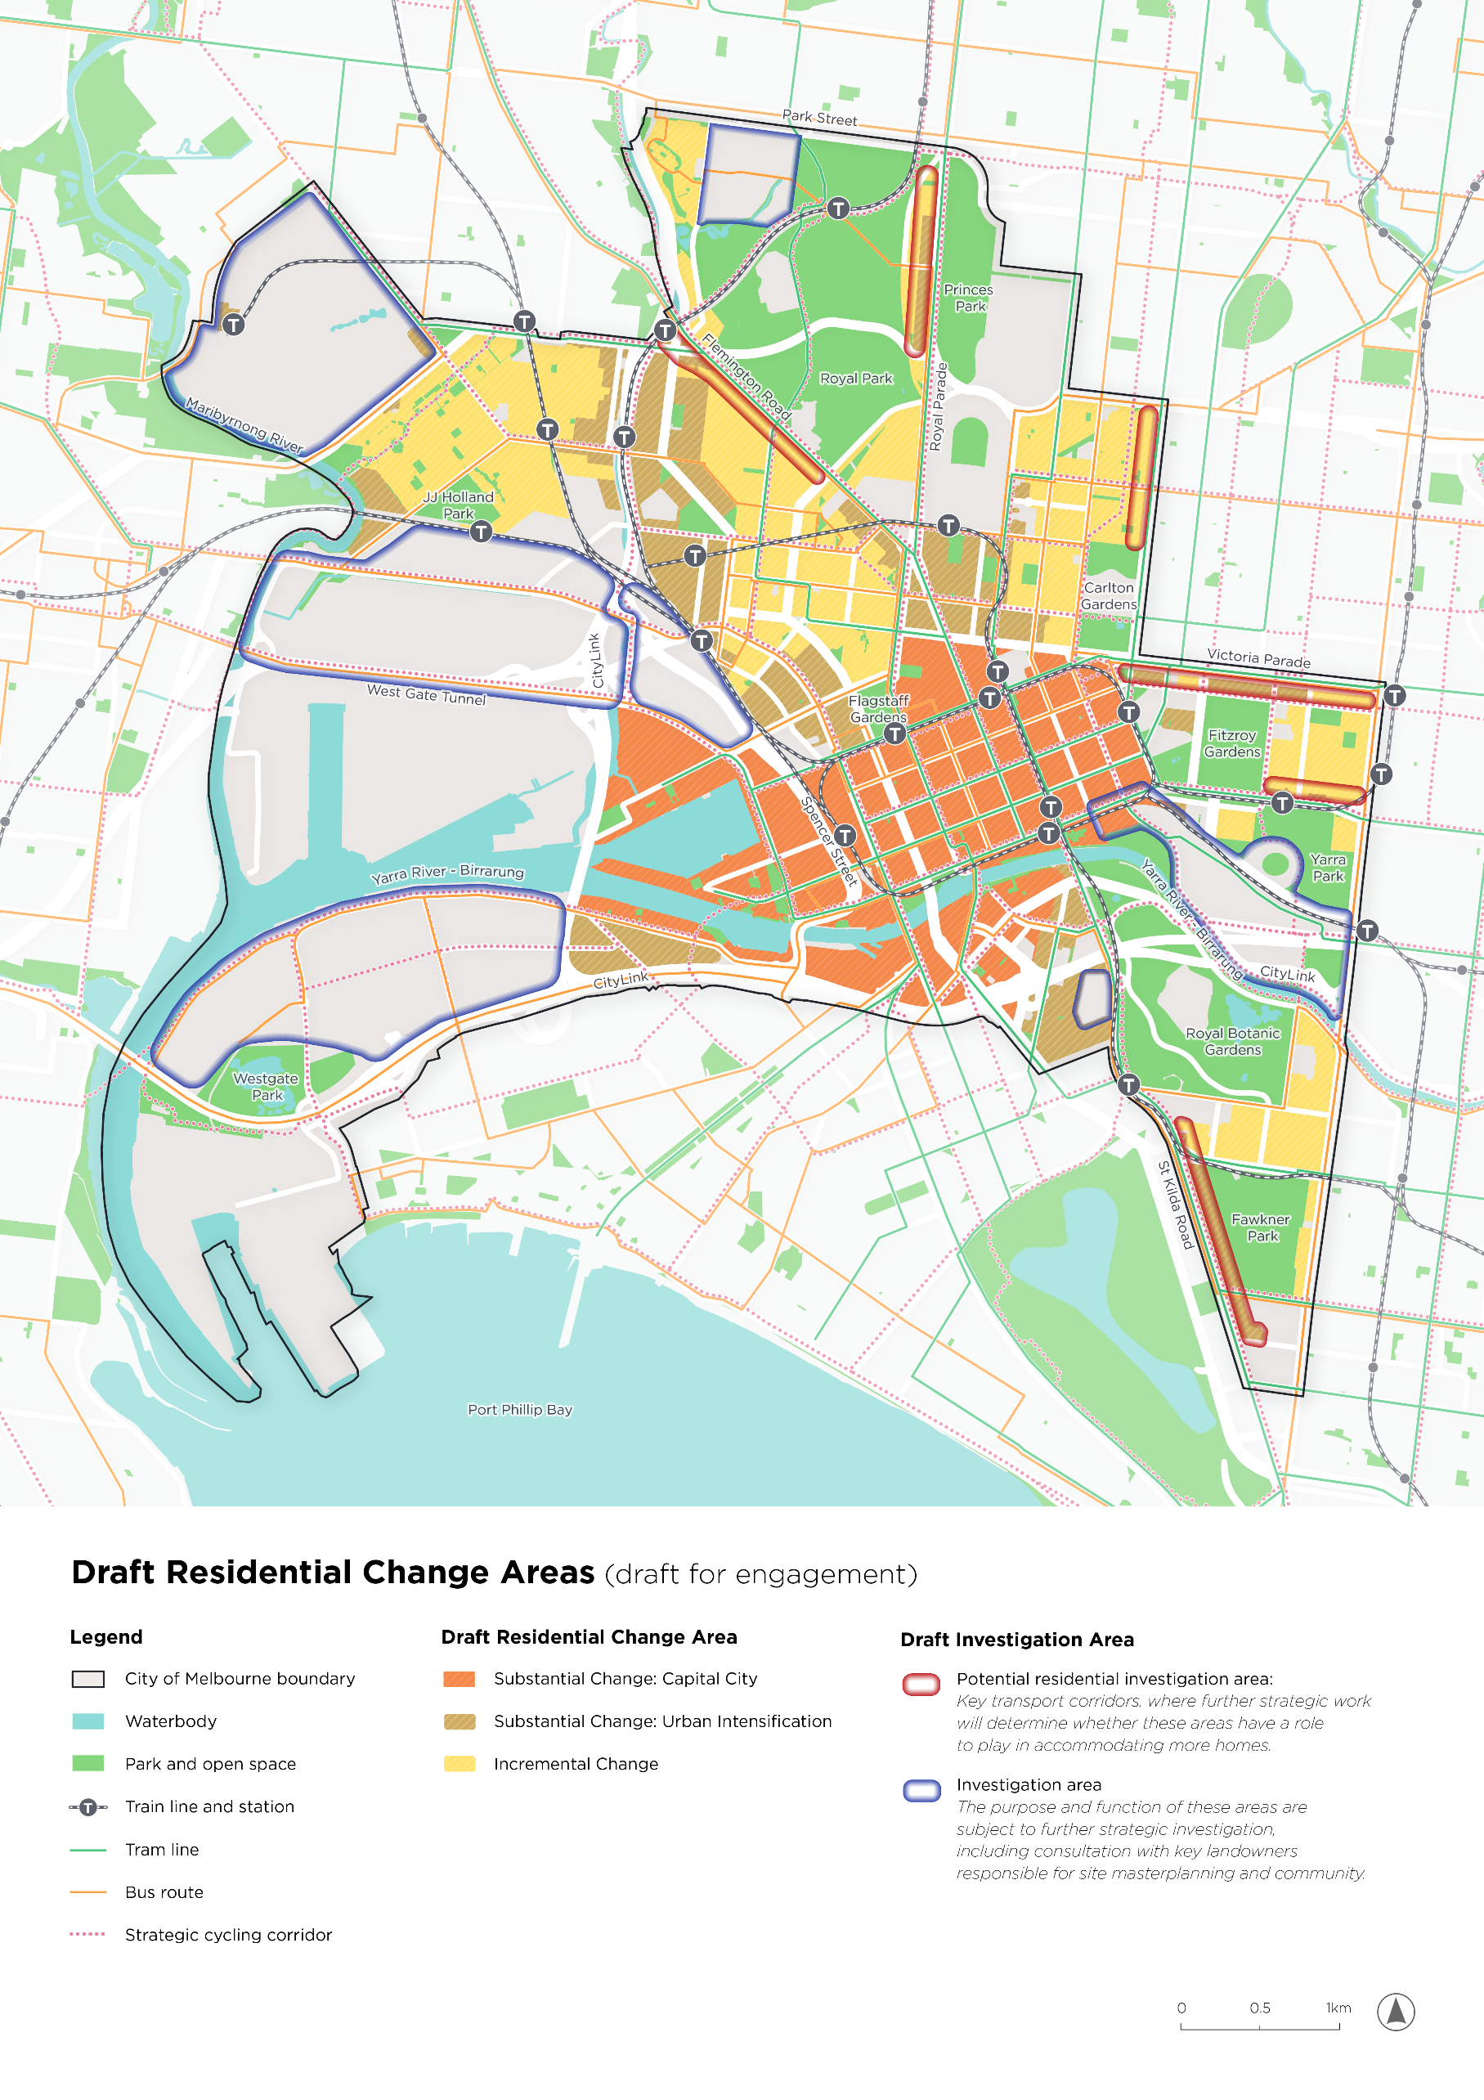
Draft Residential Change Areas (draft for engagement)
The map groups residential areas by proposed levels of housing change and marks areas requiring further investigation.
The map shows the City of Melbourne boundary, waterbodies, parks and open space.
Transport features include train lines and stations, tram lines, bus routes and strategic cycling corridors.
Residential change categories
- Substantial Change: Capital City is shown in orange diagonal hatching, concentrated in the central city, Docklands and Southbank.
- Substantial Change: Urban Intensification is shown in ochre diagonal hatching, including parts of Arden and Macaulay, North and West Melbourne, City North and Southbank.
- Incremental Change is shown in yellow diagonal hatching, covering existing residential areas of Kensington, North Melbourne, Parkville, Carlton, East Melbourne and South Yarra.
Areas for further investigation
- Potential residential investigation areas are outlined in red. These areas are identified along key transport corridors where further strategic work will determine whether these areas have a role to play in accommodating more homes. The potential residential investigation areas include Royal Parade, Flemington Road, Nicholson Street, Victoria Parade, Wellington Parade and St Kilda Road.
- Investigation areas are outlined in dark blue. The purpose and function of these areas are subject to further strategic investigation, including consultation with key landowners responsible for site masterplanning and community. The investigation areas include the Flemington Racecourse and Melbourne Showgrounds area, a site north of Royal Park, western rail and renewal land, Fishermans Bend, and Melbourne’s sporting and arts precincts.
Map 2. Liveability
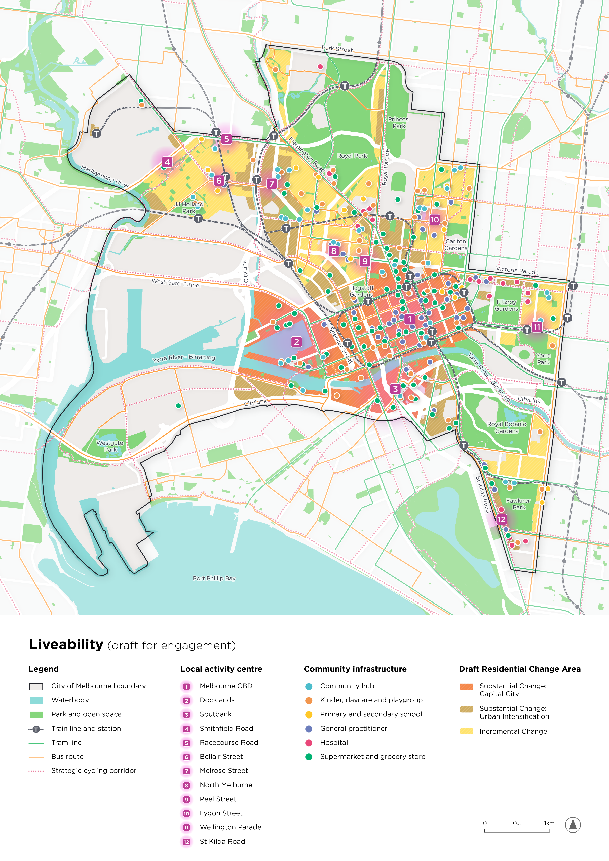
Liveability (draft for engagement)
The map overlays proposed residential change areas with twelve local activity centres and locations of community infrastructure.
The map shows the City of Melbourne boundary, waterbodies, parks and open space.
Transport features include train lines and stations, tram lines, bus routes and strategic cycling corridors.
The residential background uses orange for Substantial Change: Capital City, ochre for Substantial Change: Urban Intensification and yellow for Incremental Change.
Community infrastructure key
- Turquoise circle: community hubs.
- Orange circle: kindergarten, daycare and playgroup.
- Yellow circle: primary and secondary school.
- Blue-purple circle: general practitioner.
- Pink circle: hospital.
- Green circle: supermarkets and grocery store.
Geographic pattern
- Many facilities are concentrated in the central city, City North, Carlton and Parkville, with additional clusters in Kensington, North Melbourne, Docklands, Southbank and along St Kilda Road.
- Fewer facility symbols appear across western port and industrial land. The map shows facility locations without naming individual services.
Local activity centres
- Melbourne CBD
- Docklands
- Southbank
- Smithfield Road
- Racecourse Road
- Bellair Street
- Melrose Street
- North Melbourne
- Peel Street
- Lygon Street
- Wellington Parade
- St Kilda Road

Theme 2: Strengthening Melbourne’s identity
Identity and culture are built from the ground up. The design of Melbourne is one of the key things that sets it apart from other Australian cities - rich in connection to Country, contrast and scale. From heritage bluestone and contemporary architecture to intimate laneways and bold public spaces. Melbourne is a city that’s intentionally designed for exploration and everyday connection.
It’s hard to imagine Melbourne without Federation Square and the Arts Centre spire. Both were bold additions to the city when they were built, but today they’re unmistakably Melbourne. As the city grows, we need to keep making room for that kind of ambition. New buildings and public spaces should add to Melbourne’s originality, not simply blend into what’s already here.
Good design shapes how we experience Melbourne. It’s in the buildings we call home, the laneways we walk down and the parks and public spaces where we come together. These places tell Melbourne’s story. It also helps attract residents, workers, students, visitors, businesses and investment. Getting design right means creating places that are welcoming and active throughout the day and all year round.

Direction 5: Growth and good design go hand in hand
- Around 80% of development investment in the municipality is delivered by the private sector, making planning and design controls critical.
- As of April 2026, there were more than 30,000 dwellings (including student housing units) approved but not built in the municipality.
- Almost half of existing dwellings in the municipality were built in the last 10 years.
Excellent design isn’t just about how a building looks. It creates homes, workplaces and public spaces that are welcoming, inclusive and enjoyable to use. Good design can improve health and wellbeing while creating buildings that are more durable, efficient and adaptable.
Melburnians want new development to strengthen its identity rather than diminish it. With around 80% of development investment delivered by the private sector, a clear vision and strong design standards are essential. They ensure individual developments add up to a city that works well as a whole. They can also reduce long-term operating costs and the need for expensive renovations or retrofits down the track, while giving businesses and developers confidence to invest.
Recent Victorian Government planning reforms have focused on accelerating development approvals, increasing the importance of maintaining design quality as development proceeds more quickly. Good design should not be seen as a barrier to growth. Building quickly shouldn’t lower the quality of what gets built.

Direction 6: Heritage, culture and identity are celebrated
- Melbourne contains 740 locally protected heritage places and precincts, 332 Victorian Heritage Register places, 10 National Heritage places and one World Heritage-listed site.
- Melbourne residents come from more than 160 countries each contributing to the city’s cultural identity.
Melbourne's identity has been shaped by the enduring connection to Country of the Wurundjeri Woi-wurrung and Bunurong / Boon Wurrung peoples, and by generations of people from around the world.
These histories are reflected in Aboriginal places of significance, Victorian-era streetscapes, world-famous venues and iconic laneways. But heritage is about more than buildings. It includes communities, stories and traditions connected to them.
The Italian community shaped Lygon Street, while generations of Chinese Melburnians made our Chinatown the oldest continuous Chinatown in the Western world. Camp Sovereignty is a significant site for ceremony and truth-telling.
Places like these can provide pockets of home, where people see their own heritage reflected in the city and feel that they belong. Melburnians want these qualities to be protected, celebrated and passed on to future generations. That means recognising and embracing Traditional Owner language and knowledge in our places, celebrating diverse cultural stories, and adapting heritage places so they continue to contribute to the city.
Heritage reviews have an important role to play in identifying sites for heritage retention, while our Heritage Design Guide supports development that protects the city’s heritage fabric to evolve. The City of Melbourne’s Heritage Strategy 2026 will guide, celebrate and share our heritage, while Mapping Aboriginal Melbourne continues to build our understanding of Aboriginal history and stories. Adaptive reuse, public storytelling and climate action can also make these histories more visible in everyday city life.

Direction 7: Public spaces are where social connection happens
- Melbourne has 573 hectares of public open space.
- Walking is the most common way people move around central Melbourne.
Before the Hoddle Grid, the laneways and the skyline, people came together along the Yarra River - Birrarung to share knowledge, culture, resources and stories. The instinct to bring people and ideas together did not begin with the modern city - it is one of Melbourne’s oldest and most enduring characteristics.
Today, Melbourne’s streets, laneways, parks and public squares are vital shared spaces. They are where culture spills into the street, local businesses find customers and the city comes to life. Public spaces need to feel safe and welcoming throughout the day and night. Good design makes public spaces easy to navigate and move through. Clear paths and entrances, good lighting and fewer hidden spaces can all help people feel safe and comfortable. Access to free and informal spaces is essential to an inclusive city. The quality of public spaces influences where people choose to walk, linger and spend time, shaping social life, local business and public participation. Signs can help people find their way, promote local businesses and add character, Too much signage, or signage in the wrong place, can create clutter and confusion.
As Melbourne grows, competition for space will increase. Development must strengthen connections between streets, parks and squares so they continue to support social life, local business and Melbourne’s distinctive character.

Direction 8: Our landmarks are destinations for everyone
- Melbourne attracts 12.2 million domestic visitors and 1.6 million international visitors annually.
- Moomba Festival is Australia’s largest free community event and attracts around 1.3 million visitors.
Melbourne is Australia's cultural capital and home to some of the nation's most significant cultural, sporting and entertainment destinations. Major events, including the AFL season and the Australian Open, attract millions of visitors and generate substantial economic activity, while contributing to the city's identity and global reputation. But Melbourne is more than its headline events. Our neighbourhoods, laneways, public spaces and cultural institutions give people reasons to explore the city, whether there’s a major event on or not. The city's major arts and sporting precincts, including the MCG and Yarra Park, Melbourne Park, AAMI Park and Marvel Stadium, are destinations. But what happens around them matters too. How you get there, the streets and public spaces and what there is to see and do nearby all shape the experience. Whether you live here or have travelled across the world to visit, these precincts are for everyone, year-round. They should be part of everyday city life, not destinations that come alive only during major events. Strengthening connections between venues, surrounding neighbourhoods and public spaces will support year-round activity and build on the experiences that make Melbourne world-famous. That includes showcasing the arts and cultural institutions spread across the city, including within local neighbourhoods.

How the draft directions could be implemented

Direction 5: Growth and good design go hand in hand
- Encourage new buildings and development to be adaptable and well-designed so they strengthen Melbourne’s identity, support long-term value and reinforce its reputation as a city of excellent design.
- Support improvements to the quality, comfort and safety of all homes, from heritage terraces to high-rise apartments.
- Embed good design in public and civic spaces to improve social connection and everyday life in the city, and to create opportunities for future place-making and activation.
- Promote design review, clear standards and design leadership to improve the quality of development and public realm outcomes.

Direction 6: Heritage, culture and identity are celebrated
- Promote the living patterns of Country, layered histories and local stories, making them visible in the design of buildings, streets and public spaces.
- Respect the voices, rights and cultural practices of Wurundjeri Woi-wurrung and Bunurong / Boon Wurrung Traditional Owners in the design, naming and planning of places.
- Celebrate historic buildings and places through thoughtful adaptation, reuse and ongoing public life.

Direction 7: Public spaces are where social connection happens
- Strengthen and expand a connected network of streets, parks and squares that supports social connection, daily life and public enjoyment.
- Design and encourage streets and public spaces as shared places for activity, local business, events, programming and everyday community life.
- Plan, design and encourage public spaces to be inclusive, safe, welcoming and comfortable for people of all ages, genders and abilities.

Direction 8: Our landmarks are destinations for everyone
- Improve visual and physical connections between civic and cultural precincts to surrounding streets, public spaces and neighbourhoods so they support everyday public life as well as major events.
- Improve visual and physical connections between Melbourne’s landmarks, destinations and central city places.
- Celebrate and support the experiences people come to Melbourne for through great places, precincts and connections.

Bold move: Australia’s garden city
Imagine Melbourne as a true garden city: greener, cooler, healthier and more alive with nature in every neighbourhood. Streets, parks, rooftops, walls, rail corridors, underused land and new development sites all play a role in cooling the city, supporting biodiversity, managing stormwater and making everyday places more comfortable. As Melbourne becomes denser and hotter, greening will need to be treated as essential city infrastructure, not an added extra. This idea asks how every available space can help create a city where residents, workers, students and visitors are closer to shade, trees, gardens, habitat and clean air.
We could:
- Partner and advocate for E-Gate to be transformed into a major new park and wetland that manages flood risk and provides generous green space in the north-west.
- Support a greener economy by accelerating renewable energy, low-carbon development and jobs that help Melbourne adapt to climate change.
- Treat greening as essential city infrastructure by requiring new development, streets and public spaces to deliver shade, trees, biodiversity and cooling.
- Strengthen a connected garden city network by transforming underused spaces, including rail corridors, undercrofts, rooftops, walls, vacant land and low-traffic streets, into green spaces, habitat corridors and places for people.
Should City of Melbourne explore how E-Gate could be transformed into the inner west’s largest new park?
Map 3. Places and spaces
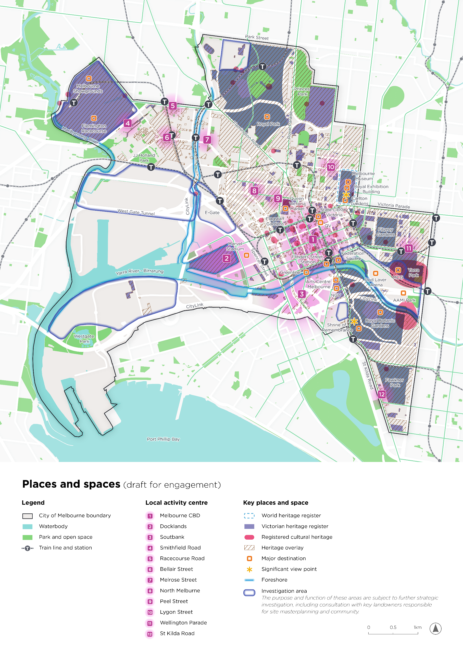
Places and spaces (draft for engagement)
The map brings together heritage places, cultural destinations, public spaces, local activity centres and waterfront connections.
The map shows the City of Melbourne boundary, waterbodies, parks and open space.
Train lines and stations are also shown.
Map key
- A dashed light-blue outline marks the World Heritage Register area at the Royal Exhibition Building and Carlton Gardens.
- Purple areas mark Victorian Heritage Register places; pink marks registered cultural heritage; brown diagonal hatching marks Heritage Overlay areas.
- Orange outlined squares identify major destinations. Yellow stars mark significant viewpoints at the Royal Exhibition Building and the Shrine of Remembrance.
- A light blue line highlights foreshore connections along the Maribyrnong River, Moonee Ponds Creek and Yarra River - Birrarung.
- Dark blue outlined investigation areas are also shown. The purpose and function of these areas are subject to further strategic investigation, including consultation with key landowners responsible for site masterplanning and community.
Named places and geographic pattern
- Northern and north-western destinations include Melbourne Showgrounds, Flemington Racecourse, Royal Park, Melbourne Museum and the Royal Exhibition Building.
- Central city destinations include Queen Victoria Market, State Library Victoria, QV, Flinders Street Station, Greenline and Federation Square. Marvel Stadium is shown in Docklands, with E-Gate labelled to its north.
- Southbank and eastern destinations include Arts Centre Melbourne, the National Gallery of Victoria (NGV), the Melbourne Cricket Ground (MCG), Rod Laver Arena, AAMI Park, the Shrine of Remembrance and Royal Botanic Gardens.
- Heritage layers extend across established northern and eastern neighbourhoods, the central city and major parks. Major destinations form a connected sequence from Docklands through the central city to Southbank and the sports precinct.
Numbered local activity centres
- Melbourne CBD
- Docklands
- Southbank
- Smithfield Road
- Racecourse Road
- Bellair Street
- Melrose Street
- North Melbourne
- Peel Street
- Lygon Street
- Wellington Parade
- St Kilda Road

Theme 3: Supporting jobs and a changing economy
Melbourne is the engine room of Victoria’s economy, generating 22.7% of the state’s economic output. With around 3.5 jobs for every resident, our city is as much a place people come to work in as a place people call home.
And much of that work needs a physical home too. Our offices, universities, hospitals and innovation precincts create opportunities for people and businesses across metropolitan Melbourne and support the city’s role as a national employment hub and global gateway.
Growing our knowledge economy means creating the spaces where global businesses want to invest and where start-ups, researchers and creatives want to work. As the economy changes, we also need adaptable workspaces and room for local businesses, visitors, freight and the everyday services that support a strong and diverse economy.

Direction 9: Melbourne’s employment clusters are strategically located
- Knowledge-based industries account for 150,000 jobs, that is 22% of 679,000 total jobs.
- Melbourne supports more than 679,000 jobs, around 18% of all Victorian jobs.
- Around 90% of workers commute to their jobs from outside the municipality.
- There are approximately 3.5 jobs for every resident in the municipality.
Knowledge-based industries, including professional services, finance, technology, health, education and public administration, are a major driver of Melbourne’s economy and competitiveness.
Different parts of the city support different industries and functions. The CBD is the state’s premier business district. Parkville is a major centre for health and education, while the Port, Dynon and Fishermans Bend precincts support freight, industrial and innovation activities. Universities and specialist schools create clusters of related jobs and institutions that define iconically local industries. Examples include Victorian College of the Arts and Australian Ballet School within the Arts Precinct, and the hospitals, biomedical organisations and university research centres in the Parkville Employment and Innovation Area and CBD.
People value being able to work close to home, particularly young people, international students and those seeking flexible employment opportunities. Nobody wants to spend hours each day sitting in traffic or on a train. An easier commute gives people more time in their day and can help make them more likely to work from the office, supporting the city businesses that rely on workers. Supporting local jobs can reduce travel, create stronger neighbourhoods where people can live, work and access everyday services close by.
Clear planning for these precincts can help attract investment, make it easier for related businesses and organisations to work together and create room for new industries to grow.

Direction 10: Our economy is adaptable
- Vacant office floorspace increased by more than one million square metres between 2019 and 2024, reaching approximately 1.64 million square metres.
- Employment floorspace demand is forecast to increase by 4.6 million square metres by 2043.
- Data centres are enabling infrastructure for the digital economy and need careful planning to manage land, energy, infrastructure, amenity and local benefit.
Technology, hybrid work and emerging industries are changing demand for workplaces. Demand is shifting towards high-quality, well-located and adaptable spaces, while older offices face weaker demand. Affordable workspaces are also important for retaining small businesses, creative organisations and community services in the city.
Growth in health, education, entertainment and accommodation is increasing competition for land and infrastructure. These uses support jobs and innovation, but they need to go in the right places and be planned alongside the infrastructure and communities around them.
Data centres are part of this picture. The Victorian Government's Sustainable Data Centre Action Plan gives industry and communities greater certainty about where data centres can locate and what they must deliver for energy, water and local benefit. Council's role is to make sure this framework works for our local context. That means retaining the housing and strategic employment land the city needs to grow, while applying the State requirements through planning decisions and advice, and managing impacts on amenity and infrastructure. It also means looking beyond individual projects to the combined demand that several facilities place on energy, water and networks, and ensuring the community benefits. As enabling infrastructure for Melbourne's knowledge economy, data centres support investment, innovation, technological advancement and productivity, which is why planning for them well matters.
Urban renewal areas will play a major role in Melbourne’s future economy. The Victorian Government leads precinct planning for Arden and Fishermans Bend, with visions for these precincts to attract significant employment and foster innovation. Meanwhile the future roles of Dynon and E-Gate need to be clarified, including the future role of Victorian Government- and privately-owned land in these precincts.
The community wants more affordable and flexible workplaces, including co-working spaces, studios, workshops and small business premises. Shared workspaces mean remote workers and satellite teams can still be part of a working community in Melbourne, even if their employer is based elsewhere. Clear planning can provide investment certainty while allowing these precincts to adapt to new industries, technologies and ways of working.

Direction 11: Land use supports diverse economies
- Melbourne's night-time economy supports around 78,200 workers (about 15% of the municipal workforce).
- Entertainment and accommodation are forecast to make up 45% of future employment floorspace growth.
- The municipality has Australia's fastest-growing night-time economy.
The city experience supports economic success, day and night. Cafes, restaurants, retail, cultural venues, events, parks and public spaces attract workers, businesses, students and visitors and support Melbourne’s global reputation. Inner Melbourne has the largest number of night-time businesses and workers across healthcare, retail, cultural events, hospitality and logistics of any Australian city, making it a vibrant place to be, day or night.
For our city to succeed, the culture and creativity of our communities needs to be valued and the places that support that creativity and culture need to be protected. High rents and operating costs are placing increasing pressure on independent businesses across the CBD and neighbourhood shopping streets. People want planning and investment to support small businesses, encourage diverse local services and maintain the unique character and experiences that distinguish Melbourne from other cities.

Direction 12: Melbourne’s freight and logistics advantage is maintained
- Freight and logistics contribute more than $36 billion annually to Victoria's economy.
- The Port of Melbourne supports approximately 19,600 jobs and contributes around $6 billion annually to Victoria's economy.
Victoria’s economy depends on goods moving efficiently. Important freight and logistics assets in the municipality include the Port of Melbourne, Dynon and surrounding freight precincts. These assets support trade, businesses and supply chains across the state. Freight demand is expected to grow as the population increases and e-commerce expands.
As homes and freight routes move closer together, we also need to manage the impacts of trucks and delivery vehicles on safety, noise and air quality.
The draft directions identify ways the City of Melbourne can protect and modernise its freight and logistics advantage while making room for new neighbourhoods and keeping goods moving efficiently.

How the draft directions could be implemented

Direction 9: Melbourne’s employment clusters are strategically located
- Coordinate planning, development and investment in streets and public spaces so employment areas attract businesses and connect people with jobs.
- Strengthen and enable innovation areas by helping businesses, universities and start-ups work together.
- Define and advocate for clear economic and land use roles for employment and urban renewal precincts to guide investment, infrastructure delivery and long-term growth.
- Support a diverse pipeline of well-located employment land and floorspace so businesses have room to operate and people can access a wide range of jobs.

Direction 10: Our economy is adaptable
- Promote Melbourne as a place for future jobs, where we can grow emerging industries and expand economic opportunity.
- Anticipate and plan proactively for emerging technologies and industries to capture economic benefits while managing impacts on communities, infrastructure and the environment.
- Encourage adaptable buildings and development in employment precincts so they can respond to evolving industries, technologies and ways of working.

Direction 11: Land use supports diverse economies
- Strengthen and grow affordable, diverse workspaces for creative industries, start-ups, social enterprises and community organisations that contribute to Melbourne’s reputation as a cultural capital.
- Support cultural activity, hospitality, retail, events and programming so Melbourne’s day and night-time economy remains vibrant and prosperous.

Direction 12: Melbourne’s freight and logistics advantage is maintained
- Support efficient and sustainable freight movement that strengthens economic activity while protecting liveable neighbourhoods.
- Plan freight, deliveries and servicing so businesses can operate efficiently while reducing noise, air pollution and safety impacts in nearby neighbourhoods.

Bold move: A city of connected experiences
Imagine Melbourne as Australia’s sporting and cultural capital every day of the year. A city where major venues, cultural precincts, laneways, restaurants, galleries, theatres, parks and public spaces feel connected as one larger experience. A city that embraces its identity as somewhere you can be both a spectator and participant in major cultural events.
The city not only comes alive for major events. The journey is part of the experience too: with interesting streets and public spaces that give people reasons to explore, stop and spend time between destinations. These land uses create jobs and attract visitors from across the globe. The city invites people to stay longer and take part in public life before and after a match, show, exhibition or festival. Visitors should feel welcome, while locals continue to discover and enjoy their city.
This bold move asks how Melbourne can better connect destinations such as the Arts Precinct, Birrarung Marr, Melbourne Park, the MCG, Federation Square, Docklands, neighbourhood cultural precincts and the central city. It also recognises the need to support creativity, sport and innovation as these networks evolve.
We could:
- Support and encourage a connected cultural and sporting spine linking Docklands, Marvel Stadium, the central city, Federation Square, Birrarung Marr, the Arts Precinct, Melbourne Park and the MCG, with clear and accessible routes for people of all ages and abilities.
- Activate public spaces between major destinations through culture, community and welcoming design.
- Connect laneways and our river edges as clear walking routes that help people move confidently between precincts and neighbourhoods.
- Plan surrounding streets and ground floors to support cafés, retail, galleries, creative uses, community activity and family-friendly experiences that connect major destinations with everyday city life.
What if moving between our destinations was part of the experience?
Map 4. Economy and employment
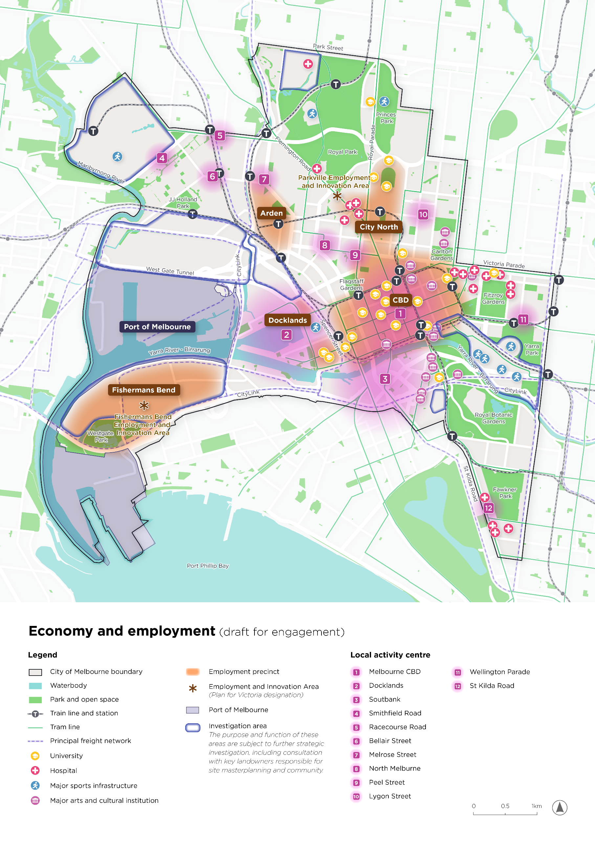
Economy and employment (draft for engagement)
The map shows employment precincts and the institutions, transport connections and local centres that support Melbourne’s economy.
The map shows the City of Melbourne boundary, waterbodies, parks and open space.
Train lines and stations and tram lines provide transport context.
Employment areas
- Orange shading identifies employment precincts labelled Arden, City North, CBD, Docklands and Fishermans Bend.
- Star symbols identify the Parkville Employment and Innovation Area and Fishermans Bend Employment and Innovation Area, designated in Plan for Victoria.
- Purple shading identifies Port of Melbourne land on the western waterfront. Purple dashed lines show the principal freight network connecting the port and wider transport network.
- Dark blue outlines identify investigation areas. The purpose and function of these areas are subject to further strategic investigation, including consultation with key landowners responsible for site masterplanning and community.
Institutions and geographic pattern
- Yellow graduation-cap symbols mark universities, pink crosses mark hospitals, blue sporting symbols mark major sports infrastructure, and purple building symbols mark major arts and cultural institutions.
- Universities and hospitals cluster in Parkville, City North, the central city and East Melbourne. Arts and cultural institutions concentrate in Carlton, the central city and Southbank.
- Major sports infrastructure is shown in the racecourse area, Royal Park, Princes Park, Docklands and the eastern sports precinct.
Numbered local activity centres
- Melbourne CBD
- Docklands
- Southbank
- Smithfield Road
- Racecourse Road
- Bellair Street
- Melrose Street
- North Melbourne
- Peel Street
- Lygon Street
- Wellington Parade
- St Kilda Road

Theme 4: Moving safely and conveniently through Melbourne
Melbourne’s success depends on how easily people can reach the places, services and opportunities that matter. Residents, workers, students, visitors, freight and essential services all rely on the city’s streets and transport networks. As the municipality grows and becomes busier, movement and access need to make better use of limited space, support local life and keep Melbourne connected to the wider metropolitan and state transport system.
Moving safely and conveniently is about more than getting from one place to another. It is also about the quality of the journey, including safer walking and cycling, reliable public transport, efficient freight movement, accessible pathways, cooler streets, clearer wayfinding and better connections between neighbourhoods, destinations and transport hubs. The aim of a great movement network is to improve the experience of the city for people, whether your destination is the central city, a neighbourhood or you’re simply passing through.

Direction 13: People move safely and efficiently
- 89% of trips within the CBD are made by people walking, yet only 26% of street space is allocated to walking.
- Melbourne has delivered approximately 30 kilometres of protected bike lanes.
- Around 47 pedestrians are killed or seriously injured each year in Melbourne.
Walking and wheeling are central to how people move around Melbourne, especially in the Hoddle Grid and within neighbourhoods. However, many busy streets have limited footpath space, which can make walking uncomfortable or difficult at peak times. Narrow footpaths and high pedestrian volumes on streets such as Flinders Lane, Little Collins Street and Little Bourke Street can create challenges for older people, children and people with disability.
Vehicle access also remains important for deliveries, servicing, emergency response and for people who choose or need to travel by car. Streets should support these essential movements while, where possible, limiting unnecessary vehicle trips and directing traffic to appropriate routes to reduce congestion, improve safety and protect neighbourhood amenity.
The cycling network is expanding but remains incomplete with missing links and unsafe intersections continuing to discourage cycling. Many people said they would walk or cycle more if it felt safer and more comfortable. Disconnected paths, busy intersections and limited separation from traffic discourage people from choosing active transport. Better footpaths, safer crossings and protected cycling routes are seen as important investments for creating healthier and connected neighbourhoods.

Direction 14: Streets work better for everyone
- Public transport, walking and riding are already the dominant modes of travel to and within the central city making up 59% of trips.
- Melbourne has approximately 23,000 kerbside spaces, of which 17,000 are allocated to car parking. There are almost 200,000 off-street car parking spaces.
- Space at the kerbside (including space for parking) makes up only 4% of the total space on our streets.
- In 2024, approximately 41% of vehicles travelling within the Hoddle Grid had no local destination.
Many communities are concerned about increasing through-traffic, congestion and parking pressure in residential neighbourhoods. There is support for measures that slow traffic and discourage unnecessary shortcutting, helping create quieter streets that are safer for walking, cycling and everyday community life while maintaining access for residents and emergency services.
New transport technology will change what streets and parking areas need to provide. As more people use electric vehicles, charging points will need to be planned carefully so they are convenient and make good use of limited street and kerbside space. Driverless vehicles may also change traffic and how people use streets. Planning should prepare for these changes without making congestion worse or reducing the safety and quality of streets and public spaces.
Melburnians support giving greater priority to walking, cycling and public transport where this improves safety and helps move more people. Streets still need to provide access for residents, businesses, deliveries, emergency services and people who need to drive. Future changes should balance movement, local access and welcoming public spaces, with each street designed clearly for the role it needs to play.

Direction 15: Major infrastructure investment delivers community benefit
- More than 900,000 people move through the central city each day, forecast to grow to 1.4 million by 2036.
- Five new Metro Tunnel stations opened in 2025–26.
- Pedestrian activity around Town Hall Station reached approximately 3,000 people per hour, 1.8 times higher than immediately after the station opened.
Melbourne is the centre of Victoria's transport network, with metropolitan and regional rail, tram and bus services connecting people to jobs, services and opportunities across the state. The opening of the Metro Tunnel stations and West Gate Tunnel has created new opportunities to reshape how people move through and experience the city. These investments can do more than improve transport connections. They can unlock new homes and jobs, support urban renewal and create vibrant places around stations and transport corridors. The community wants transport infrastructure and services to be delivered early, particularly in urban renewal areas and neighbourhoods experiencing significant growth, so people have real travel choices from the outset.

How the draft directions could be implemented

Direction 13: People move safely and efficiently
- Enable people of all ages and abilities to move safely, comfortably and independently throughout the city.
- Allocate and advocate for street space to move more people efficiently and support a lower-carbon city through walking, cycling and public transport.
- Create and advocate for a network of social streets that makes walking an attractive and convenient choice for local trips, including getting to school or going to the shops.

Direction 14: Streets work better for everyone
- Manage the transport network and work with others to reduce unnecessary through-traffic and direct vehicles to the most appropriate routes, reducing the impact of cars on local and city streets.
- Design streets according to their role so they balance movement, access and place outcomes.
- Maintain access for freight, delivery, service and emergency vehicles while adapting the street network for changing technologies and travel needs, including electric vehicle charging and automated vehicle infrastructure.

Direction 15: Major infrastructure investment delivers community benefit
- Work with others and encourage major infrastructure investments that create great places as well as better transport connections.
- Advocate for and encourage public transport investment that aligns with growth so communities are connected to homes, jobs, services and opportunities as the city changes.

Bold move: Australia’s most walkable city
Imagine Melbourne as Australia’s most walkable city, a place where green corridors and parks link everyday destinations and major precincts. Walking, or moving with prams, wheelchairs or mobility aids, wouldn’t just be transport. It would shape how people experience the city, support local businesses and connect with neighbourhoods. Routes would be step‑free, simple to navigate and designed with safe crossings, places to rest, shade and lighting. Clear visual, tactile and audible wayfinding would help people with different mobility, sensory and cognitive needs move safely, comfortably and independently.
A walkable Melbourne would be easier and safer to move through, healthier, more enjoyable and more sustainable for generations to come. The foundations are already in place: the world’s largest tram network, distinct neighbourhoods and local centres, and an extensive network of streets and laneways.
This idea asks how Melbourne can make walking the preferred way to experience city life, connecting people to jobs, entertainment, services and each other.
We could:
- Connect key destinations and neighbourhoods by advocating for and delivering new green links.
- Build on and advocate for open-space improvements to create an integrated blue-green network connecting major open spaces.
- Prioritise walking in street design and activity centre planning.
- Create pedestrian or shared zones in the CBD’s ‘little streets’ to improve pedestrian movement and support shopping and cultural activity.
What if the city was connected by world-class walking routes which made it easy to walk, cycle, drive and use public transport?
Map 5. Movement and transport
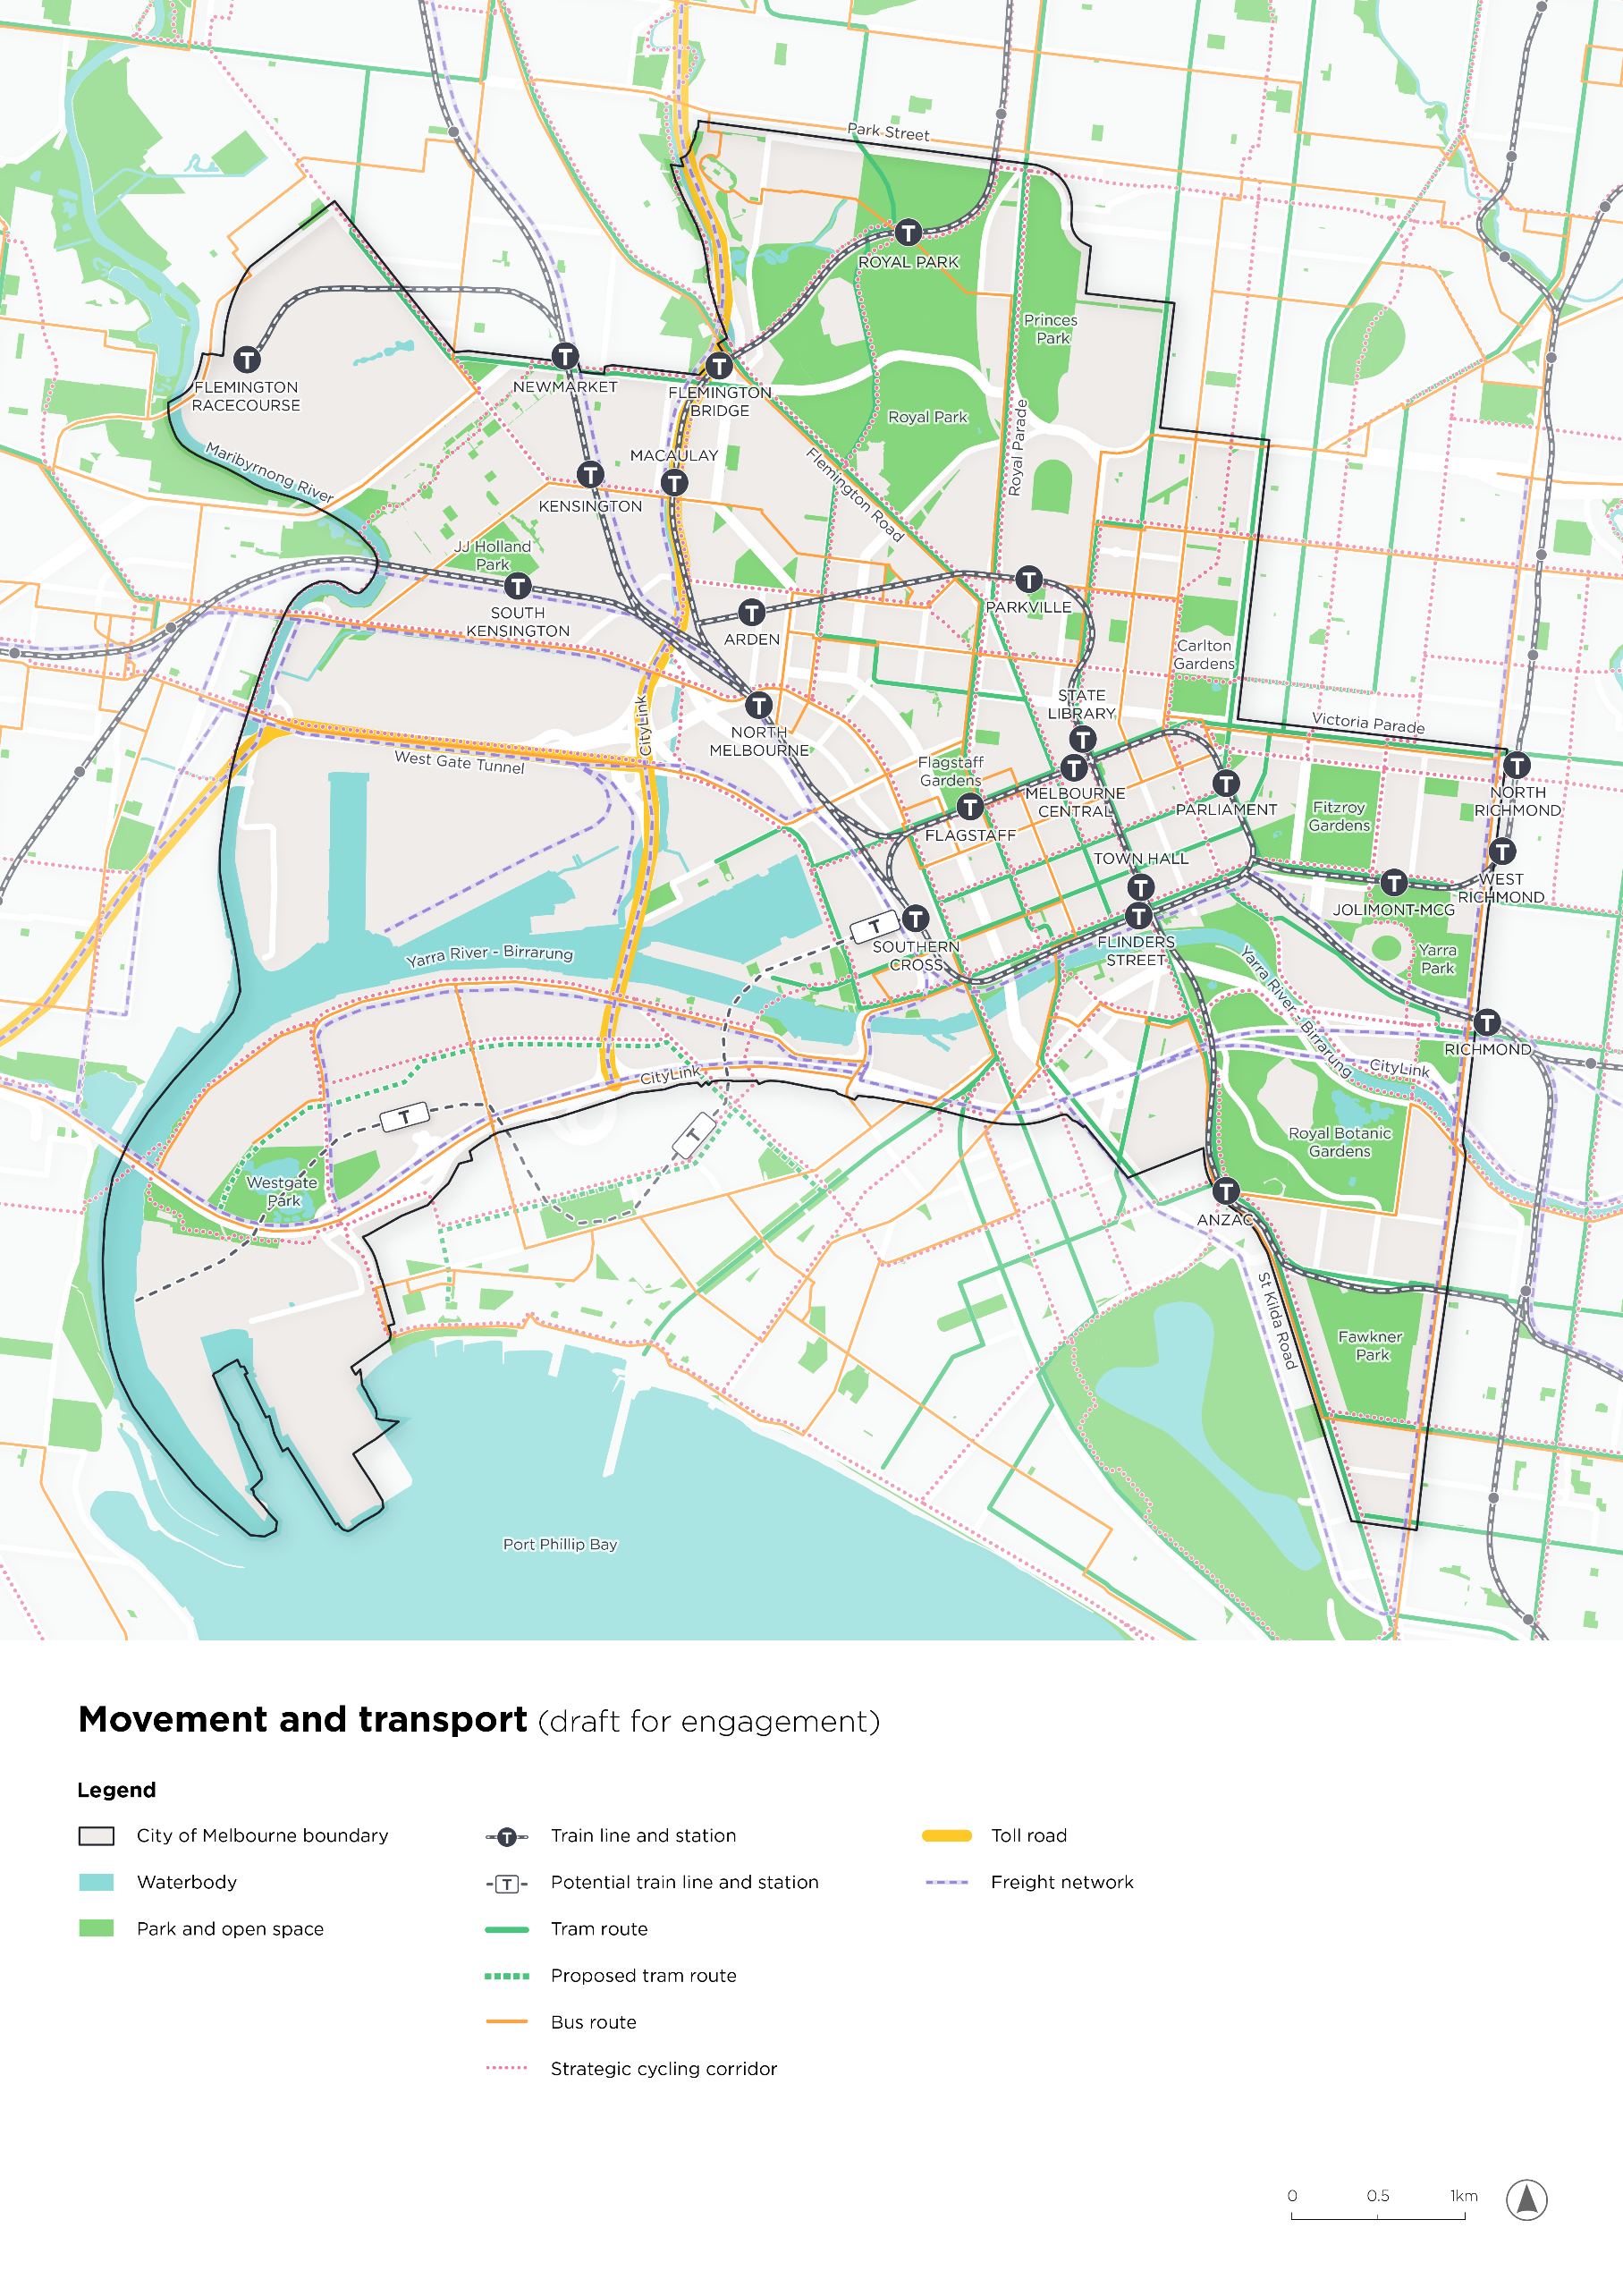
Movement and transport (draft for engagement)
The map shows how rail, tram, bus, cycling, road and freight networks connect Melbourne and its surrounding areas.
The map shows the City of Melbourne boundary, waterbodies, parks and open space.
Transport key
- Dark rail lines with circular station symbols show existing train lines and stations. Grey dashed lines and outlined square station symbols show potential train lines and stations.
- Solid green lines show tram routes; dashed green lines show proposed tram routes.
- Orange lines show bus routes; dotted pink lines show strategic cycling corridors.
- Yellow lines show toll roads, including CityLink and the West Gate Tunnel. Dashed purple lines show the freight network.
Stations named on the map
- North and west: Flemington Racecourse, Newmarket, Kensington, South Kensington, Royal Park, Flemington Bridge, Macaulay, Arden, North Melbourne and Parkville.
- Central city: Southern Cross, Flagstaff, Melbourne Central, State Library, Parliament, Town Hall and Flinders Street.
- South and east: Anzac, Jolimont-MCG, Richmond, West Richmond and North Richmond.
Network pattern
- Rail routes converge on the central city from the north, west and east. The Metro Tunnel route connects Arden, Parkville, State Library, Town Hall and Anzac.
- Potential rail and stations extend south-west from Southern Cross through Fishermans Bend. Proposed tram routes also extend through western renewal areas. These are distinguished from existing services.
- Tram and bus routes run through the central city and along major corridors. Strategic cycling corridors form links across neighbourhoods and along waterways. Freight routes connect western industrial and port land to the wider network.

Theme 5: Building a greener, cooler and more climate-liveable city
Melbourne is a part of a living natural system. Its parks, trees, waterways and open spaces are central to the city's character, health and liveability. They help cool neighbourhoods, support biodiversity, manage water, improve environmental resilience and provide places for people to connect with nature. As Melbourne grows, these natural assets will play an increasingly important role in shaping the city's future.
The municipality is defined by the Yarra River - Birrarung, Maribyrnong River, Moonee Ponds Creek and Port Phillip Bay, as well as a network of parks, gardens and green spaces. These environments support the health of the city and contribute to the unique identity of Melbourne's neighbourhoods. This means planning buildings, streets, parks, drainage, waterways and infrastructure to reduce risk, improve environmental outcomes and support healthier neighbourhoods. These choices will affect whether homes, businesses and community facilities remain safe and comfortable as heat, flooding and other climate risks increase. A climate-ready Melbourne needs coordinated action across private development and public investment.

Direction 16: Communities are climate-ready
- Infrastructure Victoria estimates that $22.3 billion of Victorian Government-owned or regulated infrastructure is already at risk of flooding.
- Melbourne currently averages 11 days greater than 35°C, increasing to 16 days a year by 2050.
- Office and residential uses account for around 60% of Melbourne's energy consumption. High energy costs have led to 43% of residents intentionally reducing energy consumption to inadequate levels.
Melbourne faces multiple climate risks. Heat is a growing health and equity issue. Hard surfaces and buildings absorb and retain heat, while neighbourhoods with less tree canopy and poorer-quality housing can face greater exposure to heat and fewer opportunities to adapt. Flooding and storms can damage roads, drains, buildings, parks and community facilities, with significant costs for governments, businesses and communities. Some urban renewal areas, including Arden (led by the Victorian Government), Macaulay and Southbank, are more exposed to flooding and in the future will need drainage and flood mitigation infrastructure to safely support more homes and activity.
People consistently identified more trees, vegetation and shade as a priority. Greener neighbourhoods are essential for reducing urban heat, improving biodiversity and creating healthier, more comfortable places. The community also wants new buildings and infrastructure to be designed for a changing climate. There is strong support for higher environmental standards that improve energy efficiency, reduce emissions and help neighbourhoods adapt to more frequent heatwaves, flooding, drought and storms.
The City of Melbourne is working towards net zero emissions by 2040. Buildings and construction produce a large share of city emissions. As Melbourne grows, the way buildings are designed, built and powered will affect energy use, costs and progress towards this target. More efficient buildings, renewable energy and lower-emission materials can reduce future emissions and costs.

Direction 17: We design with natural systems
- Many growth areas including Arden (led by the Victorian Government), Macaulay and Southbank are flood prone.
- By 2050, sea levels are predicted to rise by 24 cm compared with 1990s levels.
- City of Melbourne manages 6 stormwater harvesting systems, including at Fitzroy Gardens.
Waterways shape the city, but flood risk is increasing and water quality remains a concern. The Yarra River - Birrarung, Maribyrnong River, Moonee Ponds Creek and Port Phillip Bay all flow within the municipality. Stormwater, urban runoff and legacy contamination continue to affect the health of Melbourne’s waterways and the long-term aspiration for a swimmable Birrarung. Many urban renewal areas are located on low-lying land, where more intense rainfall, river flooding and sea-level rise could affect homes, jobs and infrastructure. Flooding, drainage and stormwater management are significant concerns in many parts of Melbourne. People support rain gardens, permeable surfaces and greener streets that capture, slow and reuse rainwater, helping to create cooler, healthier and more resilient neighbourhoods.

Direction 18: Our urban forests, biodiversity and water supplies are connected
- Melbourne currently has around 80,000 public trees and 20,000 trees on private land.
- Tree canopy cover is approximately 25%, with a target of 40% by 2040.
- Only 23% of open space irrigation currently uses alternative water sources, with a target of 50% by 2030.
- City of Melbourne has a goal to plant 3,000 trees in Melbourne every year to increase the resilience of the urban forest and contribute to a cooler city.
Parks, waterways, streets and private development all have a role in creating connected habitat and ecological corridors across the municipality. Increasing the proportion of open space that is irrigated by alternative water sources is important for protecting trees and parks during future droughts.
The community values stronger connections between parks, waterways, streets and open spaces to support biodiversity and create greener neighbourhoods. Connected green corridors are seen as particularly important in highly urbanised areas where access to nature is more limited. Traditional Owner and First Nations engagement highlighted the importance of Caring for Country as a foundation for Melbourne's future. This includes restoring waterways, strengthening biodiversity, increasing native planting and embedding Traditional Owner knowledge and cultural values into environmental planning and climate adaptation.

How the draft directions could be implemented

Direction 16: Communities are climate-ready
- Require and encourage new development to improve environmental outcomes by delivering greener, more sustainable and resource-efficient buildings, streets and open spaces.
- Plan and partner to deliver climate-liveable neighbourhoods that are more resilient to heat, flooding and other climate change impacts.
- Prioritise greening, shade, water-sensitive design and climate adaptation in streets, buildings, parks and renewal areas.
- Support a fair and inclusive low-carbon transition that shares the benefits of climate action across the community.

Direction 17: We design with natural systems
- Integrate water into the design of streets and open spaces to strengthen our connection with waterways and support a healthier urban environment.
- Plan with water to reduce flood risk, improve water quality and create safer homes, businesses, streets and community facilities.

Direction 18: Our urban forests, biodiversity and water supplies are connected
- Create a connected network of nature, parklands and open spaces that restores habitat, supports biodiversity and gives more people access to shade, cleaner air and nature close to where they live and work.
- Embed caring for Country and Traditional Owner knowledge in how we plan, design and care for Melbourne's environment.

Bold move: Melbourne’s living river
Imagine the Yarra River - Birrarung as a living river: visible, reachable, healthy and woven into everyday city life. Where the city turns towards the river, with clearer views, easier connections and more welcoming places to walk, ride, gather, rest and spend time by the water. River edges become greener, cooler and more generous, supporting biodiversity, public life, tourism, events and a stronger connection to Country. This idea puts the Yarra River - Birrarung first, while recognising the Maribyrnong River, Moonee Ponds Creek and connected waterways as part of a wider living network that can help shape growth, manage flood risk, improve water quality and support long-term stewardship with Traditional Owners.
We could:
- Design and partner with others to open the city towards the river by improving paths, crossings, ramps, wayfinding, shade, seating, lighting and links from nearby streets, stations, parks and neighbourhoods.
- Strengthen connections across the wider waterway network between the Yarra River - Birrarung, the Maribyrnong River, Moonee Ponds Creek, parks, wetlands, streets and renewal precincts.
- Partner with others to improve river health by reducing stormwater pollution, increasing water-sensitive design and working towards the long-term aspiration for a swimmable Birrarung.
- Plan with Traditional Owners so waterways are managed as living systems connected to Country, culture, biodiversity and long-term stewardship.
- Investigate ways to uncover hidden waterways, starting with opportunities to daylight the Elizabeth Street creek line.
What if a healthy Yarra River - Birrarung became the heart of our city?
Map 6. Green and blue network
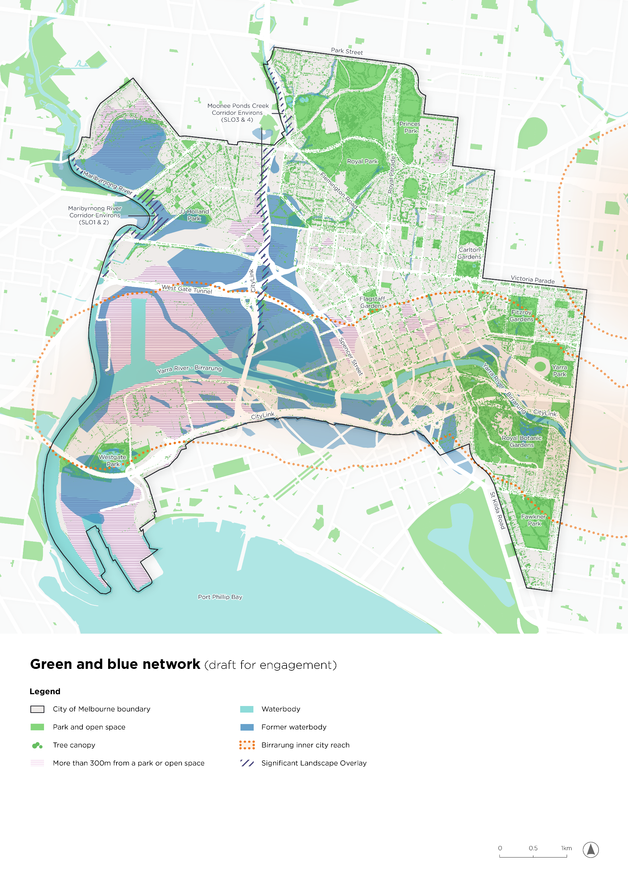
Green and blue network (draft for engagement)
The map shows the relationship between Melbourne’s parks, tree canopy, waterways, former waterbodies and areas more than 300 metres from a park or open space.
The map shows the City of Melbourne boundary, waterbodies, parks and open space.
Map key
- Green dots represent tree canopy. Pink horizontal hatching marks areas more than 300 metres from a park or open space.
- Turquoise represents current waterbodies and darker blue represents former waterbodies.
- An orange dotted boundary identifies the Birrarung inner city reach. Purple diagonal hatching identifies Significant Landscape Overlays.
- The labelled overlays are Maribyrnong River Corridor Environs (SLO1 and SLO2) and Moonee Ponds Creek Corridor Environs (SLO3 and SLO4).
Geographic pattern
- Large park and canopy areas include Royal Park, Princes Park, Carlton Gardens, Fitzroy Gardens, Yarra Park, Royal Botanic Gardens and Fawkner Park, with JJ Holland Park and Westgate Park to the west.
- Former waterbodies extend across low-lying western land around the rivers, Docklands, Fishermans Bend and parts of Southbank.
- Areas more than 300 metres from a park or open space occur prominently in western port, industrial and renewal land, with additional pockets in the central city and established neighbourhoods.
- The river and creek corridors connect these landscapes from the north and west through the central city to Port Phillip Bay.
Map 7. Stormwater and flooding
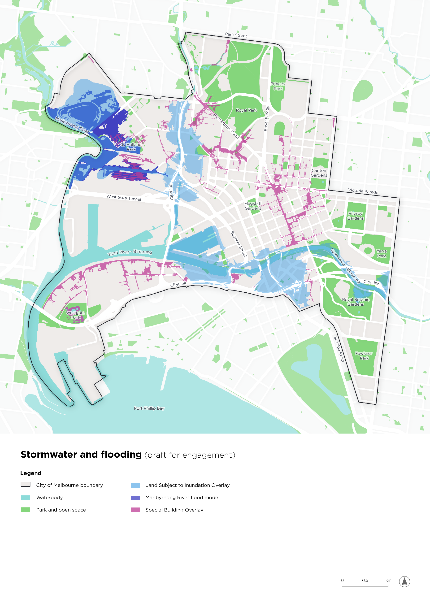
Stormwater and flooding (draft for engagement)
The map combines three flooding and drainage layers across the municipality.
The map shows the City of Melbourne boundary, waterbodies, parks and open space.
Flooding and drainage key
- Light blue: Land Subject to Inundation Overlay.
- Dark blue-purple: Maribyrnong River flood model.
- Pink: Special Building Overlay.
Geographic pattern
- The Maribyrnong River flood model covers river-adjacent areas around Flemington Racecourse, Kensington and land near JJ Holland Park and the western rail precinct.
- The Land Subject to Inundation Overlay follows parts of the Maribyrnong River, Moonee Ponds Creek and Yarra River - Birrarung, including areas in Arden and Macaulay, Docklands and Southbank.
- The Special Building Overlay follows local drainage paths through parts of the northern neighbourhoods, Carlton and the central city, and across parts of Fishermans Bend.
- The three layers overlap in some locations and describe different mapped flood and drainage extents.
Map 8. Heat hazard
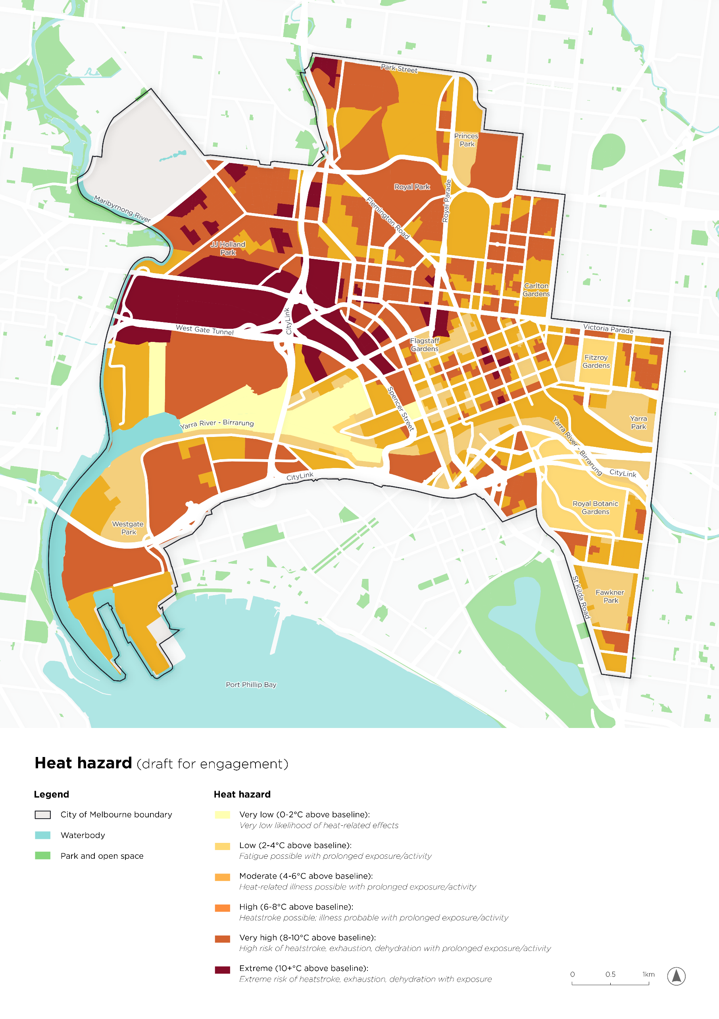
Heat hazard (draft for engagement)
The map classifies heat hazard into six categories using degrees Celsius above a baseline. The legend does not identify the baseline temperature or observation date.
The map shows the City of Melbourne boundary, waterbodies, parks and open space.
Heat hazard
The degree of heat hazard is outlined below, and represented on the map as a gradient of light yellow for very low to deep orange for extreme.
- Very low – 0-2°C above baseline: Very low likelihood of heat-related effects.
- Low – 2-4°C above baseline: Fatigue possible with prolonged exposure/activity.
- Moderate – 4-6°C above baseline: Heat-related illness possible with prolonged exposure/activity.
- High – 6-8°C above baseline: Heatstroke possible; illness probable with prolonged exposure/activity.
- Very high – 8-10°C above baseline: High risk of heatstroke, exhaustion, dehydration with prolonged exposure/activity.
- Extreme – 10+°C above baseline: Extreme risk of heatstroke, exhaustion, dehydration with exposure.
Geographic pattern
- The darkest extreme-category areas are concentrated in western rail and industrial land and parts of the northern neighbourhoods, with smaller pockets in the central city.
- Much of the developed north and west is shown in higher heat categories. Central, eastern and southern areas show a mixture of categories.
- Several major parks and areas near Docklands are shown in lower categories than nearby developed land. The racecourse area is unshaded; the legend does not assign a heat category to that unshaded area.

Chapter 3. Next steps
What happens next?

Finalising the plan
This Directions Paper brings together the findings of background research, technical analysis and community feedback gathered through the M2050 Vision, Council Plan 2025–29 and other recent engagement.
We are now seeking community feedback on the draft directions and bold moves. We want to know what people support, what concerns them, what is missing and which actions should be prioritised. Feedback can also explain what these ideas would mean for different neighbourhoods and for people who live, work, study, visit or run a business in Melbourne.
After consultation closes, we will review the feedback and use it to refine the directions and bold moves. The final Plan for Melbourne will be presented to Council for consideration in early 2027. If endorsed, the plan and an explanation of how community feedback shaped it will be published.

How will we use the Plan for Melbourne?
Once endorsed, Plan for Melbourne will provide the spatial framework for how Melbourne grows and changes over the next 25 years. It will guide future updates to the Melbourne Planning Scheme and other planning tools and inform future City of Melbourne strategies (Figure 2). The Plan will be the basis for local area planning across the municipality’s 11 neighbourhoods.
Plan for Melbourne will be reviewed every four years alongside Council's planning and Melbourne Planning Scheme review cycle. Reviews will provide opportunities to monitor progress, evaluate outcomes and respond to changing needs, including through community feedback.
Figure 2. Plan for Melbourne in relation to City of Melbourne’s integrated planning framework
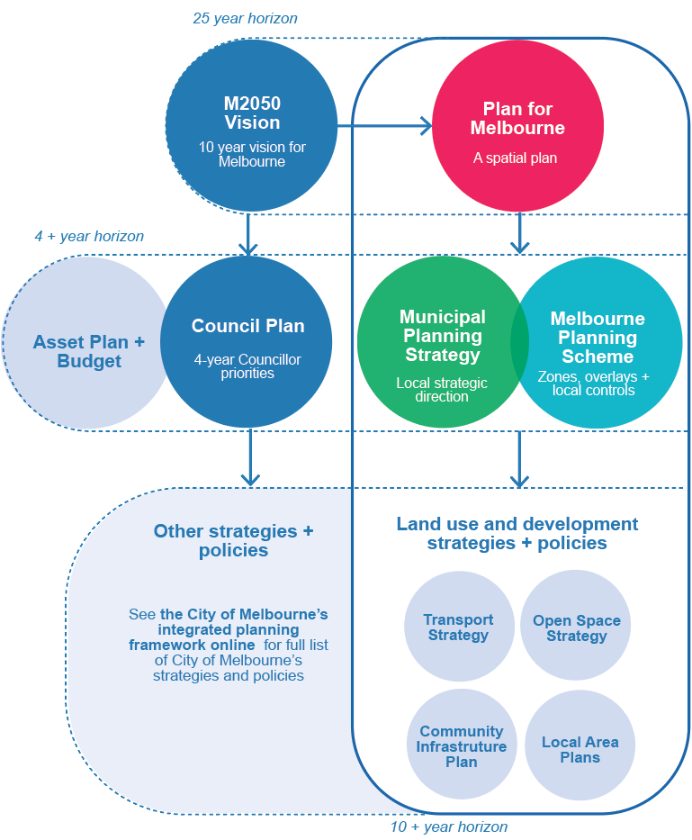
Plan for Melbourne in relation to City of Melbourne’s integrated planning framework
Figure 2 shows how the Plan for Melbourne fits within the City of Melbourne’s integrated planning framework. The framework links the long-term M2050 Vision to the Council Plan (and Asset Plan and Budget), which in turn informs council strategies and policies. The M2050 Vision informs the Plan for Melbourne (the city’s spatial plan), which itself informs the Municipal Planning Strategy (which informs local strategic direction) and Planning Scheme Review (including a review of our zones, overlays and controls). These documents drive our land use and development strategies and policies, including our Transport Strategy, Open Space Strategy, Community Infrastructure Plan and Local Area Plans.

The Plan for Melbourne and M2050 Vision have 25 year horizons, whereas the Council Plan, Municipal Planning Strategy and Planning Scheme review have a 4+ year horizon. Each of the strategies and policies these documents inform have a 10+ year horizon.

See the City of Melbourne’s integrated planning framework online for full list of City of Melbourne’s strategies and policies.

Appendix A. What we’ve heard
This Directions Paper is built on what the community has told us. The following describes consistent themes that emerged across thousands of comments from engagement on the M2050 Vision, Council Plan 2025–29 and a range of projects since 2023.

Neighbourhoods that support everyday living
Our communities want neighbourhoods that are easy to live in day to day. This includes more affordable and diverse housing, reliable access to local services, safer streets and public spaces, and community infrastructure that keeps pace with growth. As the city becomes denser, our communities want confidence that new development will support liveable neighbourhoods and not place more pressure on already stretched services and spaces. This reflects Melbourne’s local role as a city of neighbourhoods, where growth needs to improve everyday life as well as accommodate more people.
Everyday living in Melbourne also extends beyond residents. Workers, students and visitors rely on the same streets, services, shops, transport, public spaces, seating, shade, toilets and places to spend time. This reflects Melbourne’s wider role as a place where people work, study, visit, shop, attend events and connect with the city. Planning needs to consider these daily users as part of how neighbourhoods and city places function, while keeping the residential experience at the centre of local liveability.
This feedback also points to the need for growth to support complete places, where housing, daily services, community infrastructure, transport, open space and local activity are planned together.

Our places, growing stronger
Our communities value the places, buildings and public spaces that give Melbourne its character. Feedback has highlighted the importance of protecting heritage, improving amenity, supporting access to light and ensuring new development contributes positively to streets, neighbourhoods and the public realm. Melbourne’s originality comes from the way these layers come together: Country and waterways, Victorian streetscapes, laneways, arcades, civic buildings, markets, gardens, cultural precincts, creative industries and everyday street life. It is not one single feature, but the mix of history, design, activity and public life that makes Melbourne recognisable and memorable.
This feedback highlights the importance of planning for places that build on Melbourne’s own strengths and add to the city’s identity rather than replacing it.

An easy city to get around
Our communities want it to be easier and safer to move around Melbourne. Feedback points to strong support for better public transport, safer walking and cycling connections, and streets that balance movement, access and local life. Melbourne also has a metropolitan and statewide role as a transport hub, with workers, students, visitors, freight and services moving through the municipality every day. This means planning for a transport network that supports public transport, walking and cycling, while still maintaining vehicle access where it is needed for the city to function, including freight, deliveries, services, emergency access and people for whom public transport is not a practical option or preferred choice. Our communities want streets and transport networks that support these different movements while still making local streets safer, more convenient and comfortable for everyday use.
These issues present the opportunity to make better use of major transport investment and to design streets that do more than move people through the city.

Leading in green
Our communities want Melbourne to be greener, cooler and better prepared for climate change. Shade, trees, biodiversity, clean air and nearby open space are seen as essential parts of a liveable city. Feedback has also highlighted the need for new development, streets and public spaces to respond to heat, flooding and other climate risks. This reflects Melbourne’s role as a growing city that must protect its natural systems, manage water more carefully and make neighbourhoods resilient for residents, workers, students and visitors.
This feedback suggests that greening, water, heat and biodiversity should be treated as part of how the city functions, not as separate issues.

Resilient economy
Our communities value Melbourne’s local businesses, shopping streets, employment precincts, creative economy and visitor economy. Melbourne’s tourism, culture, events, hospitality, retail and night-time economy are central to the city’s identity and economic strength. Feedback has raised concerns about declining foot traffic, safety, accessibility, high operating costs and the need for more flexible ways of working.
Feedback points to a need to better connect major destinations and protect creative and cultural spaces so that businesses, workers, visitors and communities can share in the benefits of Melbourne’s growth.

