Fast Tracking Neighbourhood Batteries


Stage 2 Engagement Findings

Prepared by Capire Consulting Group Pty Ltd on behalf of City Of Melbourne, City of Yarra, and City of Port Phillip

20 October 2023
Giving every person a voice.
Capire Consulting Group  The Commons,  Wurundjeri Country  36-38 Gipps Street,  Collingwood VIC 3066  (03) 9285 9000  info@capire.com.au  capire.com.au  Capire acknowledges  and deeply respects the Wurundjeri people and  the Traditional Owners  of the Victorian land. | 


Privacy  Capire Consulting Group and any person(s) acting on our behalf is committed to protecting privacy and personally identifiable information by meeting our responsibilities under the Victorian Privacy Act 1988 and the Australian Privacy Principles 2014 as well as relevant industry codes of ethics and conduct.  For the purpose of program delivery, and on behalf of our clients, we collect personal information from individuals, such as e-mail addresses, contact details, demographic data and program feedback to enable us to facilitate participation in consultation activities. We follow a strict procedure for the collection, use, disclosure, storage and destruction of personal information. Any information we collect is stored securely on our server for the duration of the program and only disclosed to our client or the program team. Written notes from consultation activities are manually transferred to our server and disposed of securely.  Comments recorded during any consultation activities are faithfully transcribed however not attributed to individuals. Diligence is taken to ensure that any comments or sensitive information does not become personally identifiable in our reporting, or at any stage of the program.  Capire operates an in-office server with security measures that include, but are not limited to, password protected access, restrictions to sensitive data and the encrypted transfer of data.  For more information about the way we collect information, how we use, store and disclose information as well as our complaints procedure, please see www.capire.com.au or telephone (03) 9285 9000. |  | Consultation  Unless otherwise stated, all feedback documented by Capire Consulting Group and any person(s) acting on our behalf is written and/or recorded during our program/consultation activities.  Capire staff and associates take great care while transcribing participant feedback but unfortunately cannot guarantee the accuracy of all notes. We are however confident that we capture the full range of ideas, concerns and views expressed during our consultation activities.  Unless otherwise noted, the views expressed in our work represent those of the participants and not necessarily those of our consultants or our clients.  Definitions  The following definitions are used in this document.  Engagement: A genuine process to inform decisions, share knowledge and strengthen relationships.  Community: A group of people, the members of which reside in the same geographical area or have a shared background, interest, affiliation, or membership

VERSION | AUTHOR | AUTHORISED | DATE
1 | Capire Consulting Group | CoM, CoY, CoPP | 21/09/2023
2 | Capire Consulting Group | CoM, CoY, CoPP | 20/10/2023

Contents
1. Introduction 1
1.1. Report purpose 1
1.2. Project background 1
1.3. Stage two engagement overview 2
2. Engagement approach 4
3. Who participated 6
4. Findings 9
East Melbourne 10
Kensington 11
North Melbourne 12
South Yarra 13
Carlton and Fitzroy 14
Abbotsford 15
Clifton Hill 16
Richmond 17
Fitzroy North 18
Balaclava, Elwood and Ripponlea 19
Port Melbourne 20
St Kilda West 21
South Melbourne 22
Community Champion conversation findings 23
5. Key Insights and observations 25
5.1. City of Melbourne 25
5.2. City of Yarra 25
5.3. City of Port Phillip 26
Appendix A: Pop-up schedule 27

Introduction

Report purpose
This report summarises the methodology and engagement findings of the Fast-tracking Neighbourhood Batteries Project stage two engagement. Capire Consulting Group (Capire) delivered this work in partnership with City of Melbourne, City of Yarra and City of Port Phillip. The stage two engagement ran from 10 July to 8 August 2023.

Project background
City of Melbourne, City of Port Phillip and City of Yarra have teamed up to deliver the Fast-tracking Neighbourhood Batteries Project (the Project), intending to tackle the lack of access to renewable energy. While solar power may be abundant, many communities, families and organisations at a local level can’t collect, store or share it. This Project will identify the local potential and feasibility of neighbourhood batteries in the inner metropolitan Melbourne area. It will proactively engage and empower local communities to participate in neighbourhood battery projects.
The Victorian Government has funded the three councils through the Metropolitan Partnerships Development Fund Program. The funding enables the councils to undertake community engagement, an assessment of the electrical network, and design work to fast-track the rollout of neighbourhood batteries across these three municipalities. Funding for the installation of batteries will be sought once feasible locations are determined.
Each Council recognises its community’s desire for urgent and ambitious action to mitigate and adapt to climate change. The three councils are working together to undertake community engagement to build the community’s knowledge around the purpose and benefits of neighbourhood batteries and how communities can participate meaningfully. This includes exploring what the community think about potentially having neighbourhood batteries in their local area, including what might motivate their support or concern them.
The engagement process aims to facilitate the establishment of active communities that feel informed about the nature, purpose and benefits of neighbourhood batteries. A key outcome of the engagement is to build social licence for - and community capacity to engage with - neighbourhood battery projects by developing the community’s understanding of the options available and their capability to identify preferred sites and project delivery models.
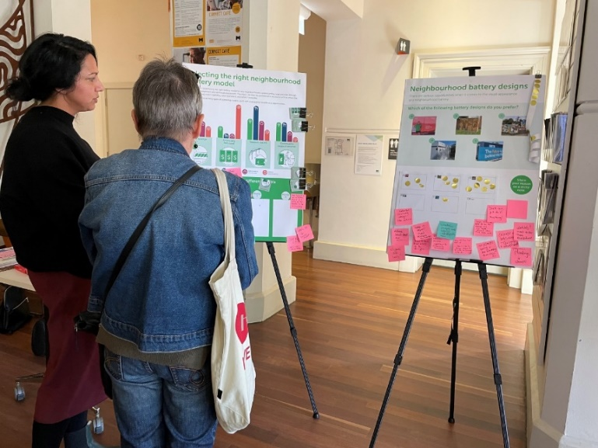

Stage two engagement overview
Over four weeks, between July and August, the project team sought to hear from selected communities about how they felt about having a neighbourhood battery in their local area, the benefits they wanted to see, ideas for specific locations and visual design preferences. To help with the conversation, the project team developed resources describing various options, including operating model and visual design options. The following section describes these engagement resources in more detail.
potential operating models
To help with the conversation, the project team developed four high-level neighbourhood battery models that the community could use to explore the different potential benefits, opportunities and challenges of different operating models. The following points summarise each of the models. Figure 1 illustrates the potential of each operating model to prioritise different opportunities.
- Solar sponge: Prioritises solar uptake and emissions reduction by absorbing excess solar produced during the day and releasing the stored energy into the network at scheduled times. This helps support the uptake and sharing of local renewable energy.
- Financially focused: Operated to release energy to the grid when it is most profitable, with the financial value returned to the community via retail energy plans, dividends, community funds, or similar. This can help reduce energy costs for the community and deliver benefits to the wider energy system.
- Services-based: Prioritises providing resilience to the network, residents and businesses. They help avoid the need for costly network upgrades, reducing network charges for all energy users.
- Community support services: This may include a diversity of services, depending on the objective, such as enhanced energy security, electric vehicle charging, and community resilience.
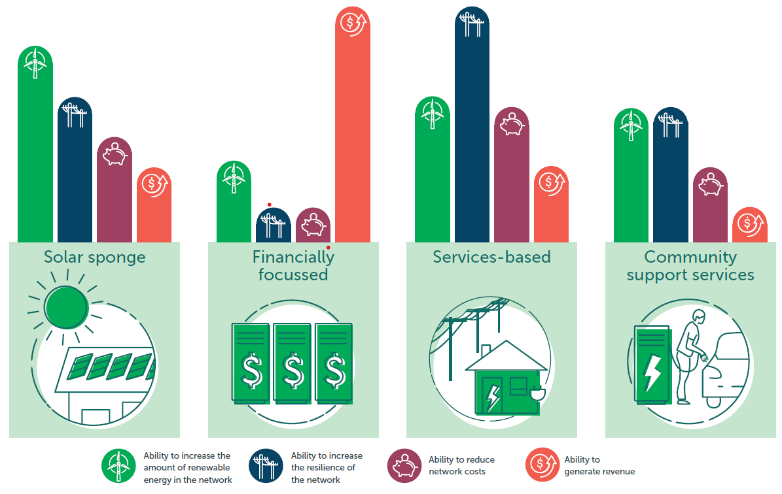
Figure 1. Overview of the operating models and their ability to prioritise different benefit opportunities.

Visual design ideas
The project team collated examples of what neighbourhood batteries could look like to understand the community’s visual design preferences. These are not actual designs that will be used for a future battery. Participants were also able to identify other ideas beyond the options shared.
Figure 2 illustrates the ideas shared as part of the engagement that participants could indicate a preference for.
a) Similar colours to the background (red sand)  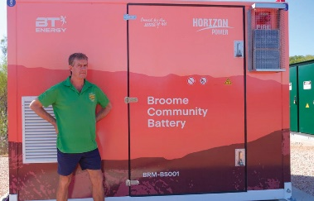 | b) Similar colours to the background (bricks)  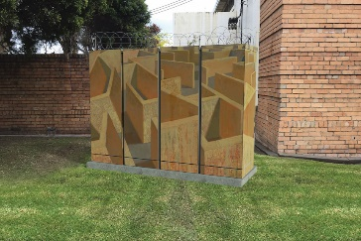 | c) Decorate artwork  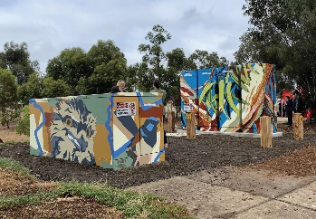
d) Enclosed behind  fencing  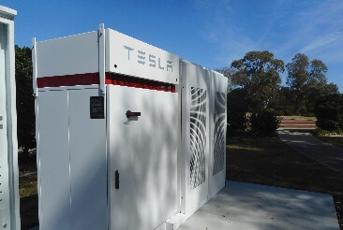 | e) Fence with informative signage  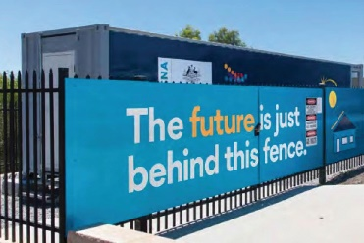 | f) Other
Figure 2. Neighbourhood batter visual design ideas

Engagement approach
This section summarises the activities undertaken to promote and inform people and to gather community insights.

Activities to promote and inform
Councils promoted the Project and engagement opportunities through a range of tools and channels. Below is a summary of the methods used.

  Project webpage  Each Council had a dedicated engagement webpage |   Project factsheet  Providing detailed information about the four operating models in a shareable format |   Emails/letters  To existing databases of interested community members
  Social media  Various posts across existing social media channels |   Posters/postcards  Distributed across community facilities, key places of interest, and in some areas, directly to local residents and businesses. |   EDM/e-Newsletter  Distributed via existing databases and networks

Activities to seek insights
Table 1 summarises the engagement activities the project team delivered, including the number of participants per activity.
Table 1. Activities used to seek community insights
Activity | Description
Survey | Feedback was gathered via each Council’s ‘Have Your Say’ page through a survey. 193 contributions were received (86 from City of Yarra, 26 from City of Port Phillip, and 81 from City of Melbourne).
Pop-ups | Approximately 280 conversations were held over the 14 pop-up events delivered across the three Council areas. See Appendix A for further detail on these events.
Community Champion Program | A total of 25 community champions were recruited from across the three Council areas:  - 12 from the City of Melbourne  - 9 from the City of Yarra  - 4 from the City of Port Phillip  Champions helped promote the Project, hosted their own conversations with their communities and participated in a series of deep-dive conversations. Our champions hosted seven conversations in which 48 people participated.

Limitations
The engagement methodology, while robust, also had several limitations that should be acknowledged when reading this report. The following points outline the limitations.
- There were minor differences in how the Councils designed the online survey. This did not impact the overall analysis of the findings.
- Some participants may have participated in more than one engagement activity, e.g. completed an online survey and attended a pop-up; therefore, some views may have been captured more than once.
- Not all participants who attended the pop-up events completed each of the activity boards, which asked similar questions to the online survey. Therefore, each of the engagement questions has various response rates.
- Demographic information was not captured at the pop-up events; therefore, the reported demographic information was derived from the information provided by survey participants only.
- Participants were self-selected to participate in the engagement. While efforts were made to communicate the Project to a broad mix of the community, the views presented in this report should not be considered representative of the whole community.

Who participated
Approximately 546 people participated in the engagement across all three councils. This section outlines the demographic and household characteristic information gathered through the surveys.

Suburb
The survey collected participants’ suburbs where they live. As illustrated in Figure 3, the suburbs that had the highest rates of participation were Fitzroy North, Richmond and North Melbourne.

Figure 3. Participants’ suburb

Gender
Figure 4 illustrates the gender of survey participants in the three municipalities.

Figure 4. Survey participants’ gender

Age
Figure 5 shows the different age groups of survey participation within each municipality. City of Yarra and City of Melbourne had high representation from those aged 35 to 40. City of Port Phillp had many participants aged 60 and over.

Figure 5. Survey participants’ age group

Connection to each potential neighbourhood battery project AREA
The survey asked participants to identify which potential neighbourhood battery project they would like to comment on and identify their connection to the project area. Figure 6 illustrates that most participants live in the area connected to the potential neighbourhood battery project.

Figure 6. Survey participants’ connection to the potential neighbourhood battery project area

Current understanding of neighbourhood batteries
The survey asked participants to indicate their level of understanding of neighbourhood batteries. Figure 7 shows that participants were predominantly a mix of people who are quite knowledgeable and those who learned what they knew from the stage 1 engagement. An analysis of the data did not indicate significant trends between understanding and support for neighbourhood batteries.

Figure 7. Survey participants’ current understanding of neighbourhood batteries

Solar power and solar battery ownership
The survey asked participants to indicate their solar power and solar battery ownership. As Figure 8 and Figure 9 show, most respondents in Yarra and Port Phillip have solar panels but not solar batteries. A high proportion of these participants are interested in getting a solar battery. Many participants in City of Melbourne indicated they can’t have solar panels and therefore, can’t have a solar battery.
An analysis of the data indicated no significant trend between solar power or battery ownership with support for neighbourhood batteries.

Figure 8. Number of participants with solar power

Figure 9. Number of participants with solar batteries

Findings
Across the three councils, the project team identified 16 areas for further assessment (Table 2). These areas were selected because of their potential to generate high levels of solar energy as well as use the energy the battery would store when it is most needed (in the evening).
This section provides a summary of the engagement findings by area. The following suburbs have been combined as the areas identified for a potential future neighbourhood battery in these suburbs are alongside each other:
- Carlton and Fitzroy (which also had a joint pop-up event)
- Elwood, Balaclava and Ripponlea.
The findings summarised in this section are combined from the survey and pop-ups. Findings from the community champion-led conversations have been reported separately.
For each potential project, the engagement activities asked participants:
- to indicate their level of support for a neighbourhood battery in the area
- how they would prioritise the different operating models and their benefits
- how they would prioritise the different benefits neighbourhood batteries could provide irrespective of the operating model
- to indicate the preferred visual appearance of any future neighbourhood battery in the area
- ideas for specific locations within the project area.
The online survey asked participants to consider their preference for Councils to fast-track neighbourhood battery projects or to take the time to explore models that allow for greater community involvement. The findings from this question have been reported on at a municipal level in section 5.
Table 2. List of proposed projects by council area
Council area | Suburb
City of Melbourne | East Melbourne
City of Melbourne | Kensington
City of Melbourne | North Melbourne
City of Melbourne | South Yarra
City of Melbourne | Carlton
City of Yarra | Fitzroy
City of Yarra | Abbotsford
City of Yarra | Clifton Hill
City of Yarra | Richmond
City of Yarra | Fitzroy North
City of Port Phillip | Balaclava
City of Port Phillip | Elwood
City of Port Phillip | Ripponlea
City of Port Phillip | Port Melbourne
City of Port Phillip | St Kilda West
City of Port Phillip | South Melbourne

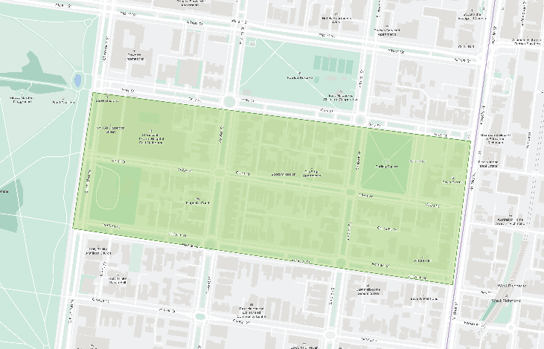
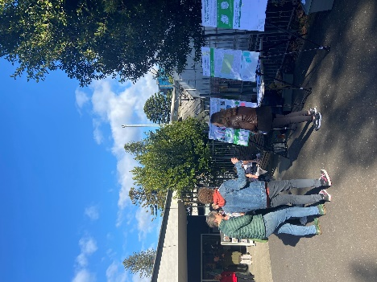
East Melbourne
60% support for a neighbourhood battery project in the East Melbourne area

Participants discussed their support in relation to the importance of transitioning to renewables and moving to carbon neutrality.
“Batteries are extremely important to transition to renewables. We should all welcome them in our communities.” – Survey participant
70% identified the solar sponge model as a first priority.
Participants commented positively about this model providing the opportunity to share resources, reduce emissions, benefit the community, and reduce pressure on the grid.
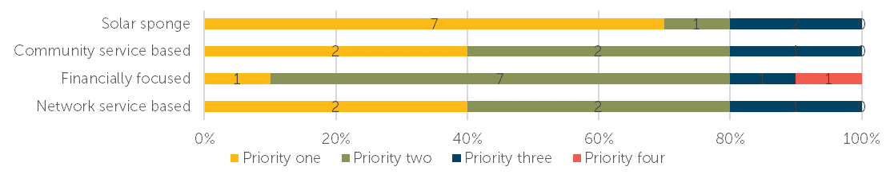
Support for other benefits neighbourhood batteries could provide
Of the other benefits a neighbourhood battery could provide, the top supported benefits were:
- Publicly accessible electric vehicle charging points (top-voted priority one)
- A dedicated renewable electricity plan linked to revenues from the neighbourhood battery, which anyone can sign up to.
Some concerns raised
Participants expressed some concerns. Concerns include the potential impact on the streetscape and that a battery could be best located on existing community facilities. Other comments included a desire to see a quantitative difference in electricity security and concern that the financially focused model would remove a sense of community connection.
The top voted-for visual design options | 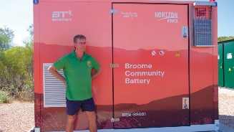  33% support | 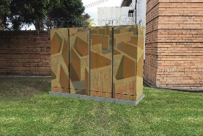  33% support
Location ideas
Participants did not identify specific locations. General responses indicated preferences for locations with a low visual impact, such as along the railway line or hidden behind existing structures.
Six survey participants commented on this project area, and 22 people attended the pop-up.

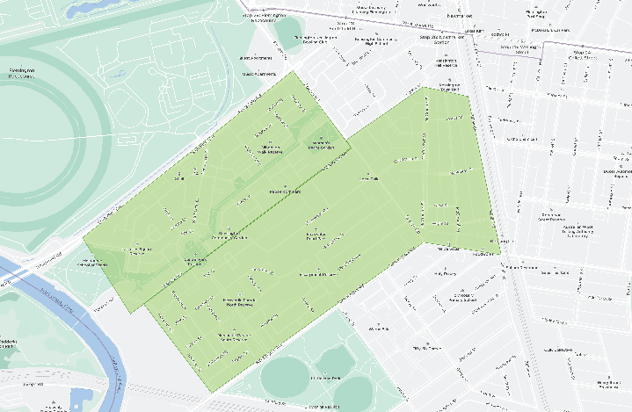
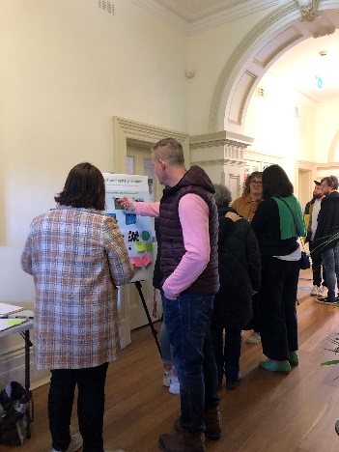
Kensington
100% support for a neighbourhood battery project in the Kensington area
Participants expressed that transitioning to renewable energy is a high priority. Despite the prevalence of solar panels in the area, cost and available space limit people having personal batteries. This is an opportunity for Kensington to host communal infrastructure and increase access to solar energy and storage options.
Over 75% identified the solar sponge model as a first priority.
Participants like that it prioritises emissions reduction, encourages more people to use solar energy simply and practically and encourages solar uptake.
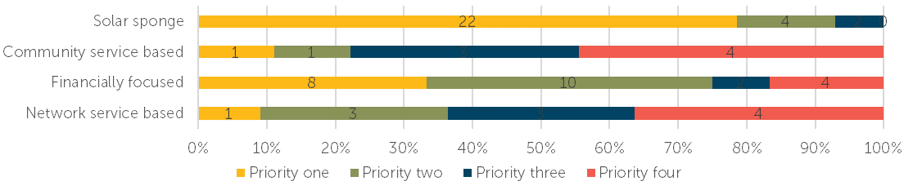
Support for other benefits neighbourhood batteries could provide
Of the other benefits a neighbourhood battery could provide, the top supported benefits were:
- A dedicated renewable electricity plan, which solar panel owners can sign up to
- Publicly accessible electric vehicle charging points
- The opportunity to own or invest.
Some concerns raised
Some participants expressed concerns relating to the safety of locating neighbourhood batteries near homes. Participants don’t want network providers to primarily benefit from the batteries. The local community should feel the benefits through lower bills and or emissions reductions.
“I think people want emissions reductions as their main priority but also energy bills are getting so expensive so anything to reduce bills for people is important.” – Survey participant
The top voted-for visual design options | 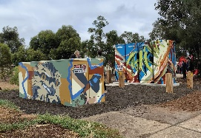  48% support | 30% support
Location ideas
JJ Holland Reserve was the most cited location, with participants noting the opportunity to include it as part of the Kensington Community Recreation Centre redevelopment.
13 survey participants commented on this project area, and 44 people attended the pop-up.

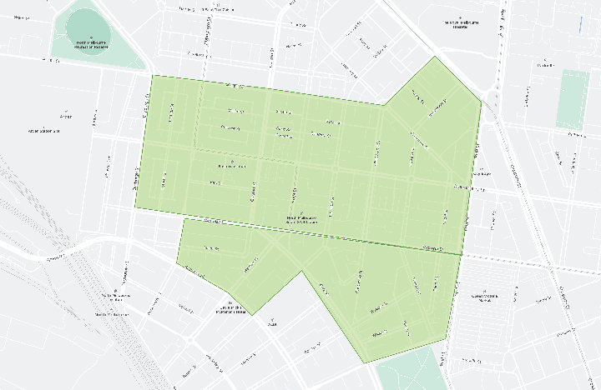
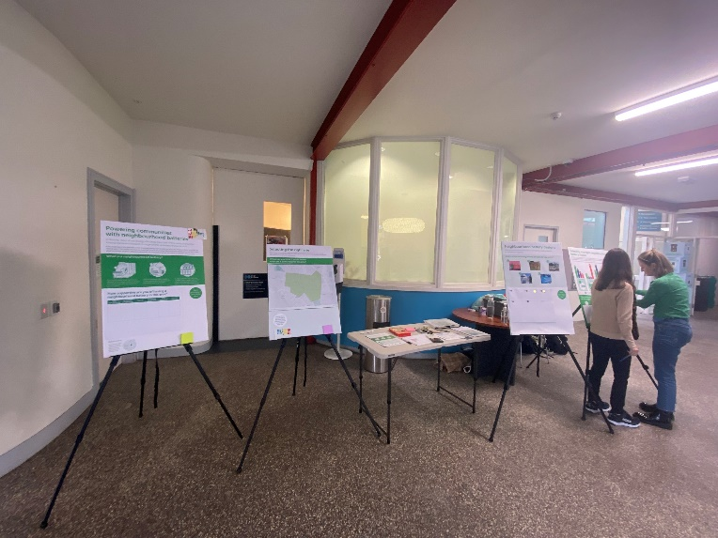
North Melbourne
96% support for a neighbourhood battery project in the North Melbourne area
Participants expressed support for neighbourhood batteries to increase access to solar power and storage for those unable to have their own (either through cost, space or building design, e.g. apartments). Others noted the importance of increasing greener energy in the grid and reducing emissions.
55% identified the solar sponge model as a first priority.
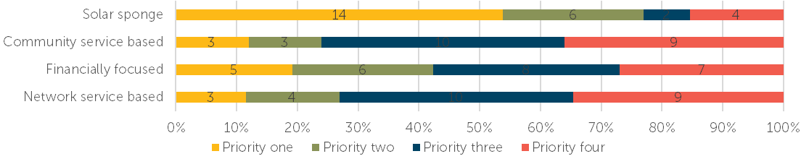
Participants like that it prioritises using stored solar energy and emissions reduction.
Support for other benefits neighbourhood batteries could provide
Of the other benefits a neighbourhood battery could provide, the top supported benefits were:
- A dedicated renewable electricity plan that is linked to revenues from the neighbourhood battery, which anyone can sign up to
- Publicly accessible electric vehicle charging points
- A community benefit fund linked to revenues from the battery.
Some concerns raised
Some participants raised concerns relating to the financially focused model. Concerns included the model not aligning with the need to reduce emissions and whether or not the local community would feel the financial benefits. Participants want to ensure local communities benefit directly.
“We need change in our energy production, it is overdue. And I love that it can directly benefit the community not the power companies.” – Survey participant
The top voted-for visual design options | 40% support | 28% support
Location ideas
Participants identified the opportunity to explore how land could be found as part of the various redevelopments happening in the area. Others identified train stations or underutilised car parks, including near a local sub-station.
32 survey participants commented on this project area, and two people attended the pop-up.

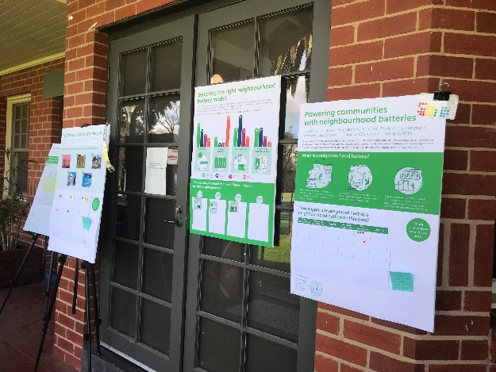
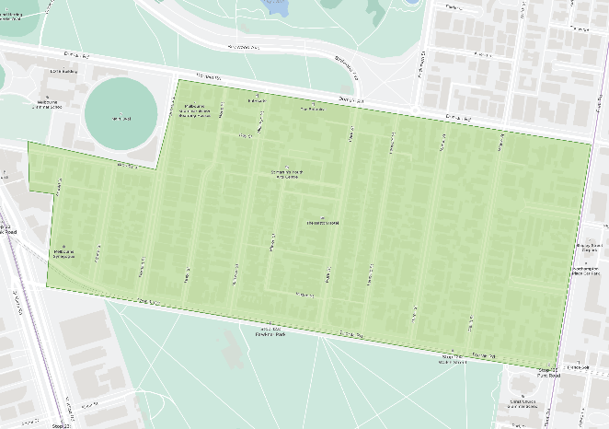
South Yarra
90% support for a neighbourhood battery project in the South Yarra area
Participants expressed support for neighbourhood batteries as they aligned with their support for renewable energy.
All operating models received relatively even levels of support.
“The power grid has to change and this feels like a good first step in that direction.” – Survey participant
Financial viability was identified as important along with being future-focused, including options to purchase more neighbourhood batteries from any revenues and making solar more accessible.
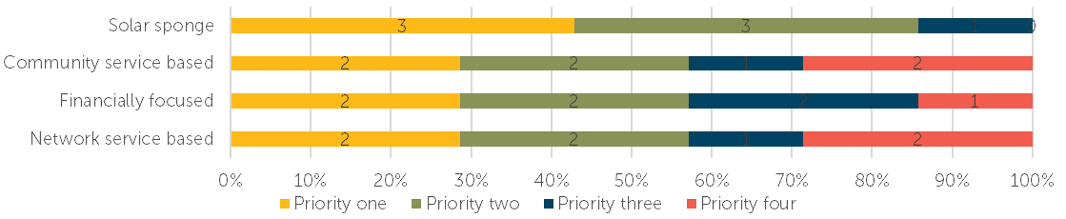
Support for other benefits neighbourhood batteries could provide
Of the other benefits a neighbourhood battery could provide, the top supported benefits were:
- A dedicated renewable electricity plan that solar panel owners can sign up to
- The opportunity to own or invest
- Publicly accessible electric vehicle charging points.
Some concerns raised
Participants raised very few concerns about neighbourhood batteries. One participant commented on the complexity of the models, another asked about the social procurement practices in place to deliver the projects and another questioned how they are funded.
The top voted-for visual design options | 50% support | 25% support
Location ideas
Participants identified Fawkner Park as a potential location.
Seven survey participants commented on this project area, and five people attended the pop-up.

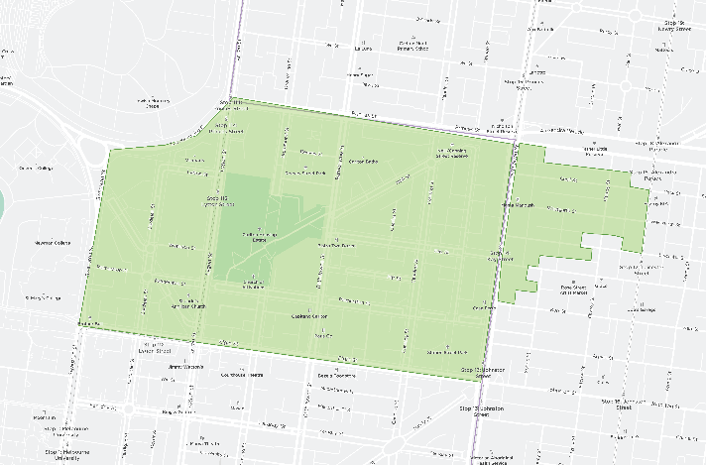
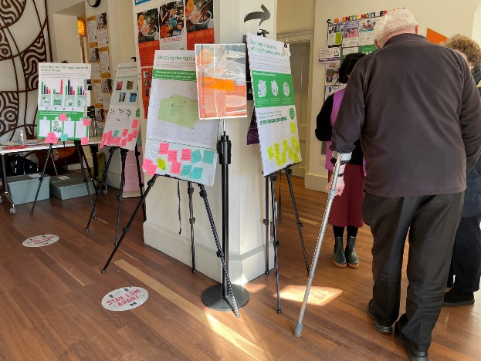
Carlton and Fitzroy
95% support for a neighbourhood battery project in the Carlton and Fitzroy areas
Participants’ support for neighbourhood batteries included reducing emissions and reliance on fossil fuel generation and increasing access to renewable energy for those in need and those who can’t produce their own. Others see it as a tangible benefit for an environmentally conscious community.
Close to 60% identified the solar sponge model as a first priority.
Participants like this model because it focuses on increasing the amount of renewable energy available and reducing emissions.
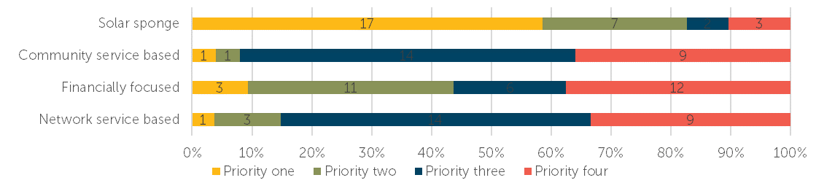
Support for other benefits neighbourhood batteries could provide
Of the other benefits a neighbourhood battery could provide, the top supported benefits were:
- Publicly accessible electric vehicle charging points
- A dedicated renewable electricity plan that is linked to revenues from the neighbourhood battery, which anyone can sign up to
- A community benefit fund linked to revenues from the battery.
Other benefits identified included support for vulnerable communities and education opportunities.
Some concerns raised
Participants’ concerns were few and varied. Concerns included the need to locate batteries in lower socio-economic areas, neighbourhood batteries are not a long-term solution for our power supply, the availability of ongoing funding for maintenance and financial benefits only being felt by energy companies.
“We need to move to a renewable and sustainable economy and community batteries share the opportunity to have access to solar to power our homes.” – Survey participant
The top voted-for visual design option | 53% support
Location ideas
Participants suggested numerous community facilities including Carlton Neighbourhood Learning Centre, libraries, Fitzroy Town Hall, Fitzroy Pool and Melbourne Museum. Participants also noted under-utilised commercial carparks and median strips.
32 survey participants commented on this project area, and 24 people attended the pop-up.

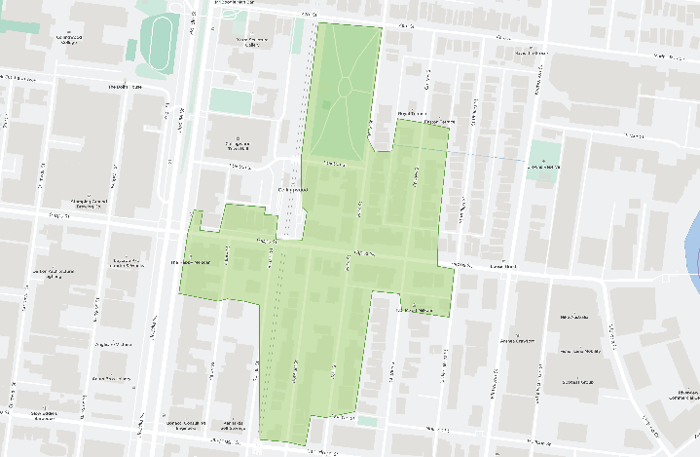
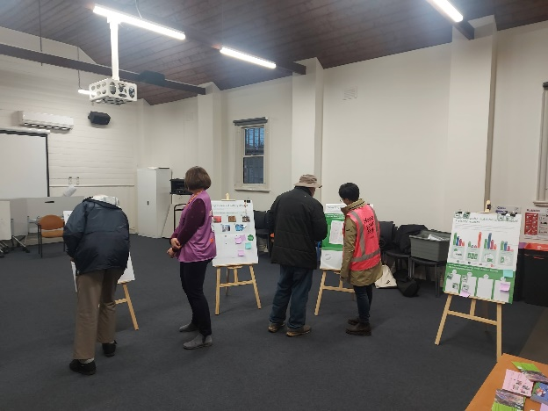
Abbotsford
90% support for a neighbourhood battery project in the Abbotsford area
Participants supported neighbourhood batteries to increase renewable energy, use wasted solar energy, and respond to climate change.
55% identified the solar sponge model as a first priority.
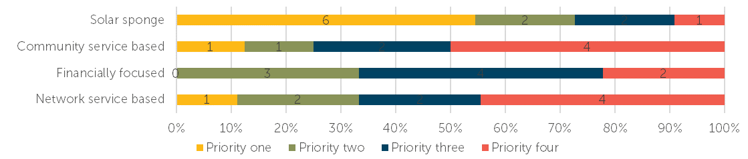
Participants like that it prioritises increasing the available solar and reducing solar energy wastage.
Support for other benefits neighbourhood batteries could provide
Of the other benefits a neighbourhood battery could provide, the top supported benefits were:
- A dedicated renewable electricity plan that solar panel owners can sign up to
- A dedicated renewable electricity plan that is linked to revenues from the neighbourhood battery, which anyone can sign up to.
Other ideas participants identified included providing subsidies to vulnerable community members, public art and education.
Some concerns raised
Concerns raised by participants included safety, funding arrangements and any impact on ratepayers, power companies benefiting over local communities, whether the environmental impacts of producing the batteries outweigh the potential emission reductions, and the ability to reduce the cost of electricity.
“Community batteries are the first step in using solar that is being wasted, I’m supportive of these everywhere to demonstrate and set an example of other council.” – Survey participant
The top voted-for visual design options | 53% support | 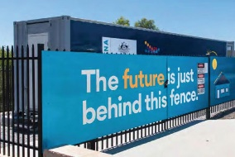  26% support
Location ideas
Participants did not identify specific locations. Participants shared general ideas about locating a battery at community facilities or the Abbotsford train station.
16 survey participants commented on this project area, and nine people attended the pop-up.

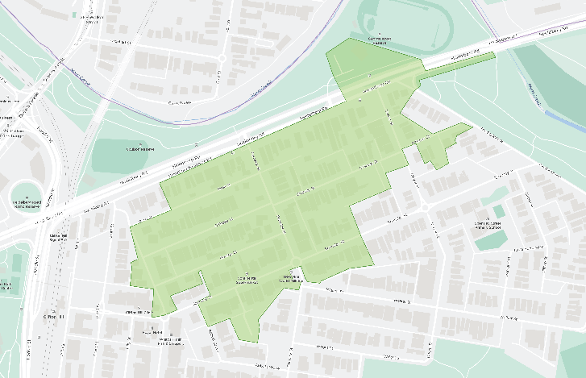
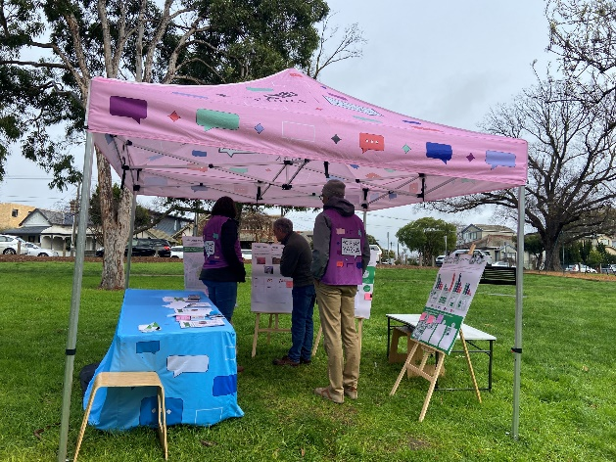
Clifton Hill
96% support for a neighbourhood battery project in the Clifton Hill area
Participants expressed support for neighbourhood batteries as a shared solution to increase utilisation and access to solar energy and as a way to reduce emissions.
65% identified the solar sponge model as a first priority.
Participants like that it prioritises using locally generated solar energy to benefit all and will help alleviate existing pressures on the grid.
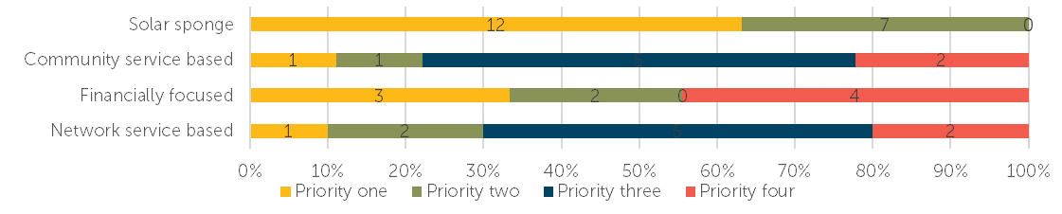
Support for other benefits neighbourhood batteries could provide
Of the other benefits a neighbourhood battery could provide, the top supported benefits were:
- Publicly accessible electric vehicle charging points (top-voted priority one)
- A dedicated renewable electricity plan that is linked to revenues from the neighbourhood battery, which anyone can sign up to.
Other potential benefits participants identified were supporting vulnerable community members through subsidised electricity, increasing solar exports for surrounding properties, powering public infrastructure and reducing electricity bills.
Some concerns raised
“It benefits the community and reduces green house emissions. At a very practical level, most residents don't have off-street parking so EV vehicles are not possible. However, community charging stations, powered by community batteries, could change this.” – Survey participant
Some participants expressed concerns relating to health and safety, where the batteries would be located and wanting to understand more about potential health and safety consequences.
The top voted-for visual design options | 53% support | 32% support
Location ideas
Participants identified Clifton Hill train station, schools, underutilised commercial space, Council depot and George Knott Reserve carpark as potential locations.
29 survey participants commented on this project area, and 27 people attended the pop-up.

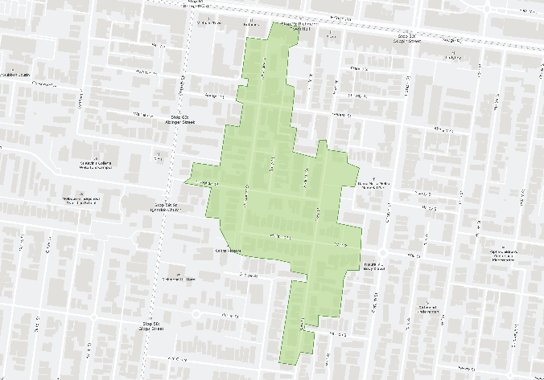
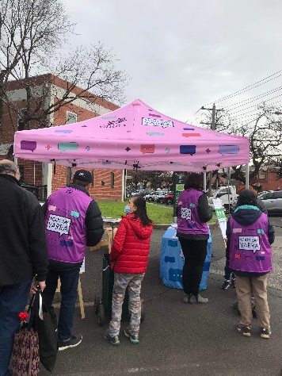
Richmond
90% support for a neighbourhood battery project in the Richmond area
Participants supported neighbourhood batteries to limit fossil fuel use, increase renewable energy and reduce solar energy wastage.
Close to 70% identified the solar sponge model as a first priority.
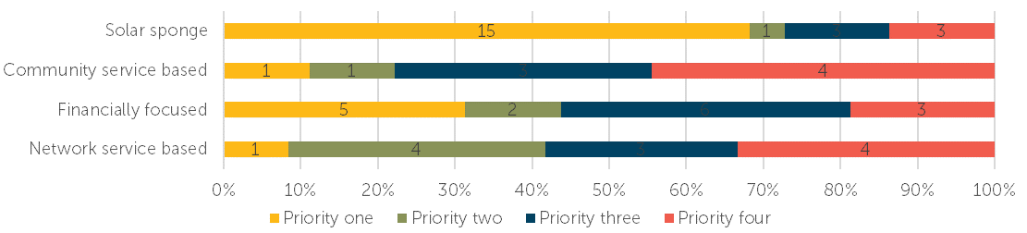
Participants like that it prioritises maximising available solar energy and reducing the use of non-renewable energy sources.
Support for other benefits neighbourhood batteries could provide
Of the other benefits a neighbourhood battery could provide, the top supported benefits were:
- Publicly accessible electric vehicle charging points (top-voted priority one)
- A dedicated renewable electricity plan that is linked to revenues from the neighbourhood battery, which anyone can sign up to.
Other benefits participants identified were raising community awareness and the potential to influence a future increase in solar export limits to make the most of all available solar.
Some concerns raised
Participants raised several concerns relating to the overall financial viability of the batteries and the impact on Council if it subsidises the batteries. Other concerns included safety risks, impact on existing solar credit arrangements and premature investment in emerging infrastructure.
“I support using renewable energy but have reservations about the Yarra council being able to deliver a cost effective solution.” – Survey participant
The top voted-for visual design option | 62% support
Location ideas
Participants identified the carparks and edges of various public spaces as potential locations, including Burnley Park, Kevin Bartlett Reserve, Dame Nellie Melba Park and the rowing sheds. Participants also suggested utilising community facilities such as council buildings, Finbar Neighbourhood House and Richmond Community Learning Centre.
20 survey participants commented on this project area, and 55 people attended the pop-up.

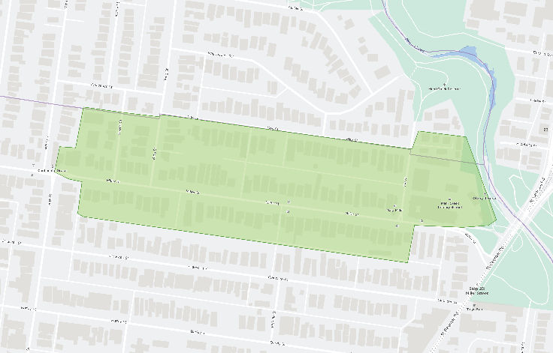
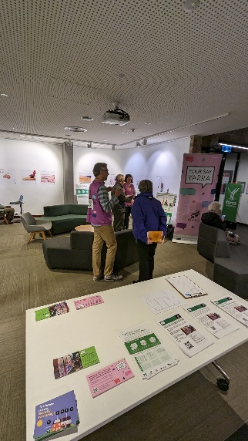
Fitzroy North
97% support for a neighbourhood battery project in the North Fitzroy area
Participants expressed support for neighbourhood batteries as an important part of the energy transition by increasing the use of renewable energy and increasing access for those who can’t have solar panels or batteries.
“I generate excess solar power and would like this to be stored to be used by others in my community.” – Survey participant
Close to 55% identified the solar sponge model as a first priority.
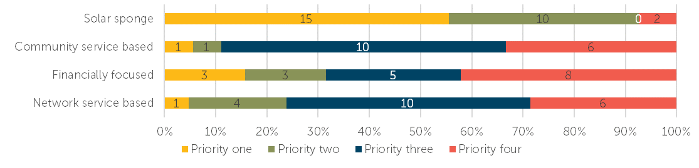
Participants like that it prioritises maximising available solar energy, emissions reduction and supporting those who can’t have a battery to store their solar energy.
Support for other benefits neighbourhood batteries could provide
Of the other benefits a neighbourhood battery could provide, the top supported benefits were:
- A dedicated renewable electricity plan that is linked to revenues from the neighbourhood battery, which anyone can sign up to
- Publicly accessible electric vehicle charging points.
Other benefits participants identified were providing opportunities for public art, support for lower economic groups and driving demand for green technology, which will drive down prices.
Some concerns raised
Participants identified very few concerns about neighbourhood batteries. Comments included the need to learn more to understand financial modelling and graffiti management concerns.
“Art in public places! The Fitzroy North battery is outstanding, turned a dark corner into a colorful artwork that brings attention to the project in a beautiful way.” – Survey participant
The top voted-for visual design option | 80% support
Location ideas
Participants’ ideas included near public facilities and spaces such as Holden Street Neighbourhood House, Rushall Park and local schools. Park Street and the train station carpark were also noted.
27 survey participants commented on this project area, and 18 people attended the pop-up.

Balaclava, Elwood and Ripponlea
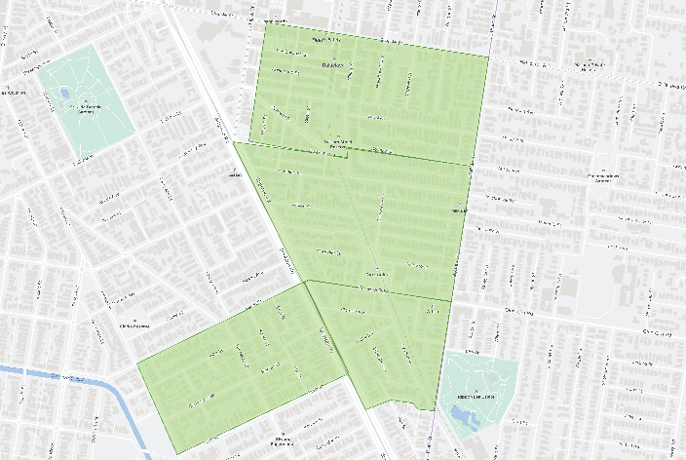
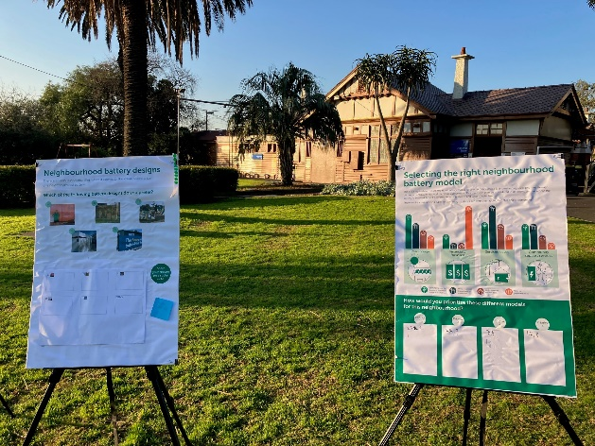
96% support for a neighbourhood battery project in the Balaclava, Elwood and Ripponlea areas
Participants expressed support for neighbourhood batteries as they may lead to increased use of renewable energy in the local community and support those who can’t access solar.
45% identified the solar sponge model as a first priority.
“Emissions reductions is my first priority with batteries. Financial incentives come with emissions reductions.” – Survey participant
Participants like that it prioritises emissions reduction and increasing the amount of renewable energy available.
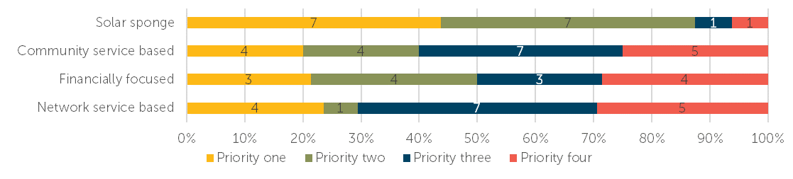
Support for other benefits neighbourhood batteries could provide
Of the other benefits a neighbourhood battery could provide, the top supported benefits were:
- Publicly accessible electric vehicle charging points (top-voted priority one)
- A dedicated renewable electricity plan that solar panel owners can sign up to.
Other benefits that participants identified were consideration for models that support apartment buildings through smaller-scale residential batteries and public art.
Some concerns raised
A participant discussed concerns about how potential benefits will be used or prioritised.
The top voted-for visual design options | 52% support | 38% support
Location ideas
Participants identified VicTrack land and underutilised car parks as potential sites.
Seven survey participants commented on this project area, and 37 people attended the pop-up events.

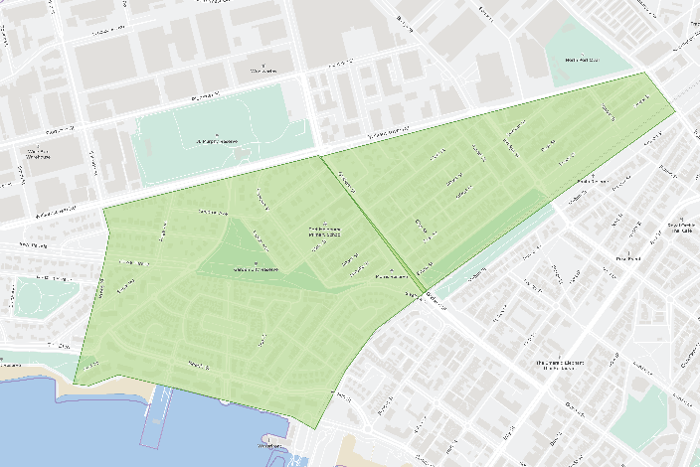
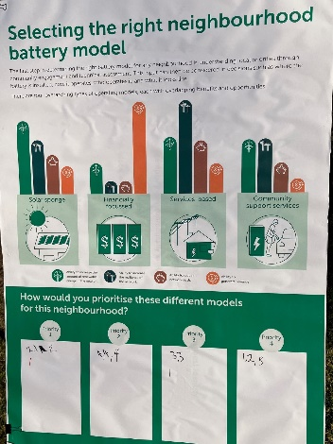
Port Melbourne
74% support for a neighbourhood battery project in the Port Melbourne area
Participants expressed support for neighbourhood batteries as an important way of transitioning to cleaner energy and sharing their collected solar energy with neighbours to reduce emissions.
“Just do it. The world is moving on from legacy power sources and methods of distribution... We're just ready to do it.”– Survey participant
Close to 45% identified the solar sponge model as a first priority.
Participants like that it focuses on pooling resources to allow greater solar energy storage and the environmental benefits.
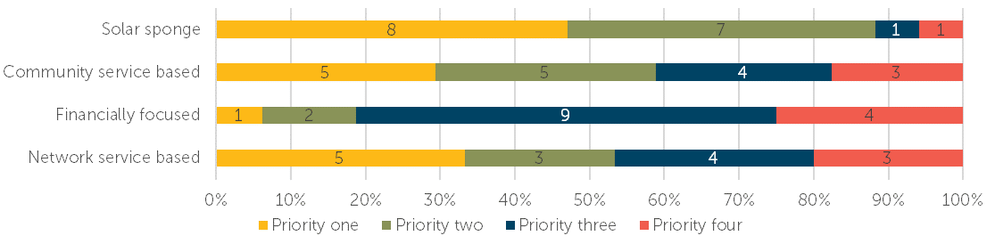
Support for other benefits neighbourhood batteries could provide
Of the other benefits a neighbourhood battery could provide, the top supported benefits were:
- A dedicated renewable electricity plan that is linked to revenues from the neighbourhood battery, which anyone can sign up to
- Publicly accessible electric vehicle charging points.
Other benefits participants identified were reducing red tape for residents to install solar panels and options more focused on apartment buildings.
Some concerns raised
Participants raised concerns about the need for a reasonable business model to demonstrate how the community would benefit over electricity companies, fire risks and the need for a safety plan, the model's flexibility to adapt as the community’s needs change and available funding for ongoing maintenance.
“I am not convinced that the battery will benefit the local community because there is no reasonable business model proposed to ensure that the community, and not the electricity companies, will benefit”– Survey participant
The top voted-for visual design options | 40% support | 32% support
Location ideas
Participants identified the Telstra network building, the old cinema on Bay Street, the outskirts of public spaces and nearby schools as potential locations.
19 survey participants commented on this project area, and 11 people attended the pop-up.

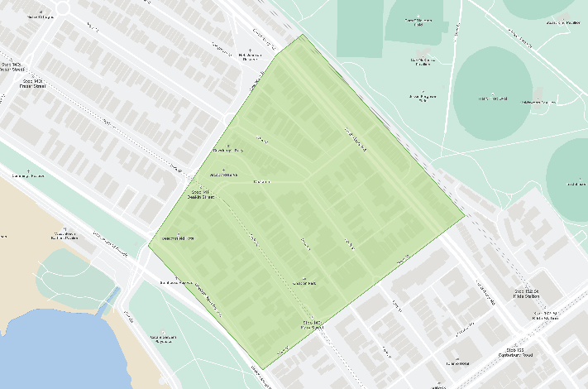
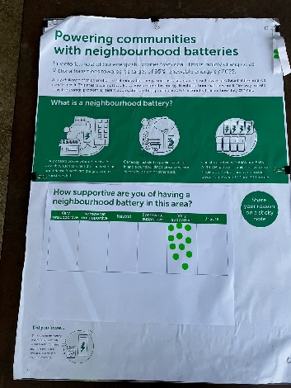
St Kilda West
93% support for a neighbourhood battery project in the St Kilda West area
Participants expressed support for neighbourhood batteries as an important way to help those who can’t access solar energy.
35% identified the solar sponge model as a first priority.
“Because I believe in a society that shares its values and resources equally.”– Survey participant
Participants like that it focuses on emissions reduction and prioritising environmental and community outcomes over financial ones.
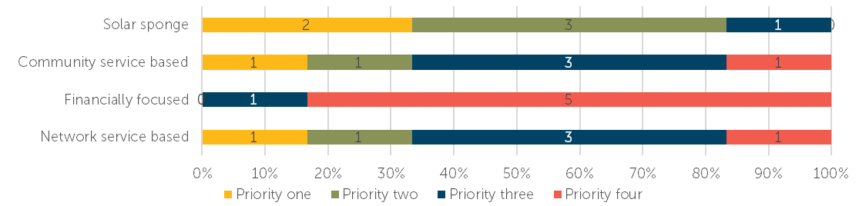
Support for other benefits neighbourhood batteries could provide
Of the other benefits a neighbourhood battery could provide, the top supported benefits were:
- A dedicated renewable electricity plan that is linked to revenues from the neighbourhood battery, which anyone can sign up to
- Publicly accessible electric vehicle charging points.
Some concerns raised
Only a couple of concerns were captured from participants. They were around the focus on financial outcomes needing to come second to reducing emissions.
The top voted-for visual design option | 42% support
Location ideas
Participants identified the median strip of Beaconsfield Parade and public spaces such as Church Square, Acland Street and Cleve Gardens.

4 survey participants commented on this project area, and 12 people attended the pop-up.

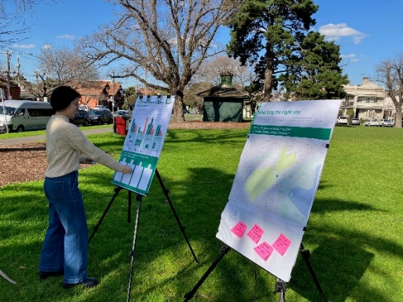
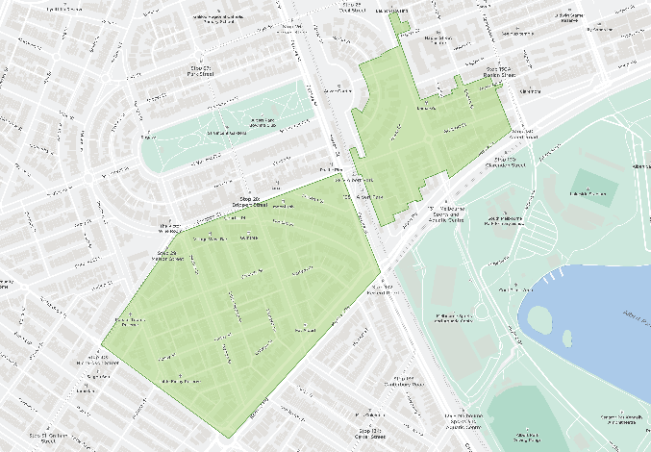
South Melbourne
81% support for a neighbourhood battery project in the South Melbourne area
Participants expressed support for neighbourhood batteries as a way of maximising the use of available solar energy, enabling solar energy sharing, and building resilience locally.
55% identified the solar sponge model as a first priority.
Participants like that it allows great use of the available solar to share with others.
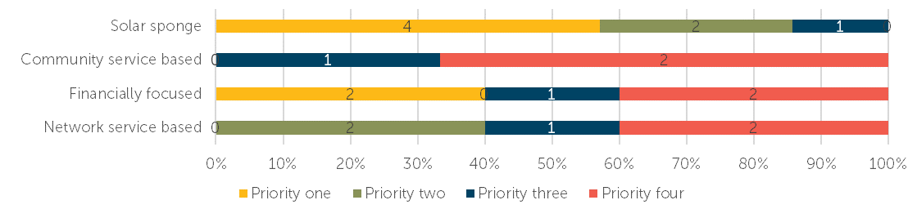
Support for other benefits neighbourhood batteries could provide
Of the other benefits a neighbourhood battery could provide, all options received even levels of support:
- Publicly accessible electric vehicle charging points
- A dedicated renewable electricity plan that is linked to revenues from the neighbourhood battery, which anyone can sign up to
- A dedicated renewable electricity plan that solar panel owners can sign up to
- A community benefit fund linked to revenues from the battery
- The opportunity to own or invest.
Other benefits participants identified were additional capacity during outages and community education.
Some concerns raised
Participants raised safety concerns, how to create real opportunities for community involvement and the visual design of the battery.
“I believe local batteries make more use of local solar and reduce limitations of sharing that the grid imposes. Small and local is very identifiable.”– Survey participant
The top voted-for visual design option | 50% support
Location ideas
Participants identified a mix of locations, including in public spaces, alongside transport corridors and at the South Melbourne Market.
7 survey participants commented on this project area, and 14 people attended the pop-up.

Community Champion conversation findings
The neighbourhood battery community champions were encouraged to host conversations with their neighbours, networks or friends. They used a conversation toolkit to help guide their conversations. The conversation toolkit included background information and key questions from the survey to guide a conversation about neighbourhood battery projects in general.
The following section summarises the findings from these conversations.
General support for neighbourhood batteries
There was general support for neighbourhood batteries from the perspective that neighbourhood batteries are an important part of the energy transition, they limit solar wastage, reduce energy inequity and increase affordability.
While support was overall positive, discussions highlighted critical barriers to gaining support at the project level. These included:
- the complexity of the operating models and potential benefits
“’Trickle down’ economics has largely been disproven. -Companies generally just increase their profits if their costs go down and do not pass on savings to their customers unless they have to because of regulations or clear competition.” – Conversation participant
- lack of a clear path to saving households money
- the regulatory landscape favours the energy company over the community, and it is difficult to see how neighbourhood batteries could change that
- export limits will still result in solar wastage
- lack of clarity around the environmental impacts of producing and disposing of the batteries.
There is a sense of frustration from those who have talked about neighbourhood batteries for a long time. They want to see action.
Demonstrating the user experience will help increase support
Conversations highlighted the challenge of seeing any tangible benefits for individuals and households. Being able to demonstrate the user experience for each of the models would help the community to determine priorities. While the objective of reducing emissions is important, community acceptance will come with being able to see what these projects specifically mean for them. It was noted that energy companies are already installing batteries without the communities in mind. There were questions about how a neighbourhood battery differs from these.
Some of the individual benefits participants could see were the potential for neighbourhood batteries to be a more efficient, cost-effective alternative than the low return on investment for residential batteries. Ultimately, people want to see the cost of living reduced. Residential solar panel support and uptake was noted as an example of when people who see financial benefits they are more likely to support the initiative.
Concern that some groups will be left behind in the energy transition
Conversations highlighted the need for options that specifically target groups currently being left behind in the energy transition. These groups were noted as apartment dwellers, renters and lower socio-economic groups. These groups have limited control or capacity to adopt current initiatives.
Suggestions were made around the role of Council in facilitating conversations and actions that address the gap between the various groups.

It is important to involve the community, but the priority needs to be taking action
While there is support for involving the community, the priority needs to be fast-tracking the delivery of batteries. Conversations suggested focusing initially on projects with low community involvement but that demonstrate benefits to smaller specific groups. Ideas included:
- Combining batteries and rooftop solar on Council assets to reduce council operating costs and create a source of income – e.g. South Melbourne Market
- Working with schools by aligning neighbourhood batteries with educational outcomes and the Greener Government School Buildings Program
- Neighbourhood batteries within social housing developments to reduce tenants’ electricity costs
- Neighbourhood batteries within apartment buildings (particularly smaller ones) to reduce tenant and renter electricity costs.
Neighbourhood batteries are just part of the solution
“’Batteries are not a complete solution to our climate emergency and they should only be part of a multi-pronged approach.” – Conversation participant
Discussions highlighted the range of potential initiatives that would help communities transition to renewable energy and interest in understanding more about the role of neighbourhood batteries compared to larger-scale initiatives. Efforts should be focused on the initiatives that can achieve the most impact quickly at a low cost.
Discussions also highlighted interest in how neighbourhood batteries could increase the take-up of EVs. Encouraging people to transition to EVs is a must, and neighbourhood batteries could increase access to charging stations while generating an income for the battery. Selecting sites that would best suit public EV charging stations should be preferenced.

Key Insights and observations
The following section summarises the key insights and observations at a municipal level for each Council area.

City of Melbourne

Strong community support
City of Melbourne participants expressed high levels of community support (95%) for the proposed neighbourhood battery projects. The key reasons for this level of support included transitioning to renewable energy, reducing emissions and providing equitable access to renewable energy.
Solar sponge Is the preferred model
Over 60% of participants noted the solar sponge model as the preferred model. Participants prefer how this model prioritises reducing emissions and increases the amount of renewable energy available.
Strong Support for EV vehICle charging points
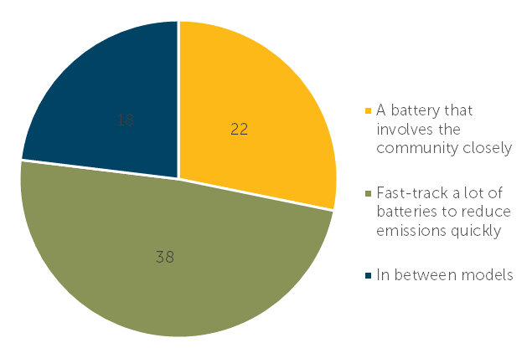
Participants support having publicly accessible EV charging points at neighbourhood batteries. This was followed by support for a dedicated renewable electricity plan linked to revenues from the neighbourhood battery, which anyone can sign up for.
Fast-track batteries over community involvement
Almost half the participants (49%) support fast-tracking many batteries to reduce emissions quickly. While 28% prefer having a battery that involves the community closely, and 23% sit somewhere between these two options.
CONCERNS ABOUT WHO REALLY BENEFITS
A key concern was who financially benefits from a neighbourhood battery project. Participants want the focus to be on creating direct financial benefits to local communities, particularly lower socio-economic community members, over energy companies.

City of Yarra
Strong community support
City of Yarra participants expressed high levels of community support (91%) for the proposed neighbourhood battery projects. The key reasons for this support included the focus on reducing emissions and reliance on fossil fuel generation and increasing access to solar energy for those who can’t access or store solar energy.
Solar sponge Is the preferred model
60% of participants noted the solar sponge model as the preferred model. Participants prefer how this model focuses on increasing the amount of renewable energy available in the grid, reducing solar energy wastage and emissions.

Strong support for EV charging and supporting vulnerable community members to access renewable energy
Over 40% of participants support having publicly accessible electric vehicle charging points as part of future neighbourhood battery projects, followed by a dedicated renewable energy electricity plan linked to neighbourhood battery revenues, which anyone can sign up for. Other benefits participants identified included supporting vulnerable community members to access affordable renewable energy and community education opportunities.
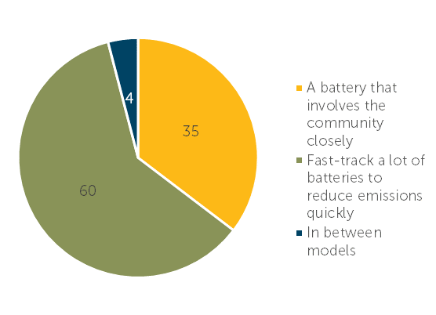
Fast-track batteries over community involvement
Most participants (60%) support fast-tracking many batteries to reduce emissions quickly. In contrast, 35% prefer having a battery that involves the community closely.
Concerns about the financial aspects
Participants are concerned about the financial aspects of any future projects, including how the ongoing maintenance is funded, cost to ratepayers and questions around who really financially benefits from these projects. Participants don’t want power companies to benefit over communities. Participants also raised health and safety concerns and the environmental impacts of producing and disposing of the batteries.

City of Port Phillip
Strong community support
City of Port Phillip participants expressed high levels of community support (72%) for the proposed neighbourhood battery projects. The key reasons for this support included enabling solar energy sharing, particularly with those who can’t access solar energy. Reducing emissions was also a common reason for support.
Solar sponge Is the preferred model
45% of participants noted the solar sponge model as the preferred model. Participants like how it prioritises emissions reduction, increases the amount of renewable energy available by pooling resources and focuses on environmental and community benefits over financial ones.
Strong support for EV charging and models that support apartments
50% of participants support publicly accessible electric vehicle charging points as part of future neighbourhood battery projects. Participants also want options or models that create solutions for apartment buildings and for Council to make it easier for residents to install solar panels.
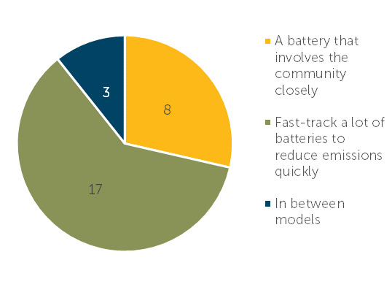
Fast-track batteries over community involvement
Most participants (61%) support fast-tracking many batteries to reduce emissions quickly. In contrast, 29% prefer having a battery that involves the community closely.
Concerns about the business model and who benefits
Participants are concerned about the lack of detail regarding the business model and the potential benefits. The concern is that electricity companies will benefit over the community. Safety is also a concern, as well as the adaptability of the models as the community’s needs change.
- Pop-up schedule

The following pop-ups were held during the phase two engagement period.

City of Melbourne

- Kensington
10:30am to 12:30pm
Sunday 16 July
Kensington Art and Craft Market
- North Melbourne
3:30pm to 5:30pm
Wednesday 19 July
North Melbourne Community Centre
- South Yarra
10:30am to 12:30pm
Saturday 22 July
Fawkner Park Senior Centre/Tennis Club
- Carlton/ Fitzroy (shared with City of Yarra)
11am to 2pm
Friday 28 July
Kathleen Syme Library
- East Melbourne
10am to 12pm
Saturday 29 July
Visitor centre outside Kere Kere Café, Fitzroy Gardens

City of Yarra

- Richmond
9:30am to 11:30am
Saturday 15 July
Gleadell St Market
- Abbotsford
4pm to 6pm
Thursday 20 July
Collingwood Library Meeting Room
- Clifton Hill
10:30am to 12:30pm
Sunday 23 July
Halls Reserve (north) playground
- North Fitzroy
5:30pm to 7:30pm
Wednesday 26 July
North Fitzroy Library
- Carlton/ Fitzroy (shared with City of Melbourne)
11am to 2pm
Friday 28 July
Kathleen Syme Library

City of Port Phillip

- Elwood
8:30am to 1pm
Saturday 22 July
Elwood Primary School Market
- South Melbourne
10am to 12pm
Wednesday 2 August
Howe Crescent Reserve
- St Kilda West
3:30pm to 5:30pm
Thursday 3 August
Jacoby Reserve
- Port Melbourne
2pm to 4pm
Saturday 5 August
Turner Reserve
- Ripponlea
2.30pm to 5.30pm
Tuesday 8 August
Burnett Grey Gardens

Capire Consulting Group
The Commons,
Wurundjeri Country
36-38 Gipps Street,
Collingwood VIC 3066
(03) 9285 9000
info@capire.com.au
capire.com.au

Capire acknowledges
and deeply respects the Wurundjeri people and
the Traditional Owners
of the Victorian land.

