
Clayton Reserve Dog Park Upgrade
Community Consultation Summary Report
Consultation period: June 2 to June 30 2025.
Report produced 11 July 2025
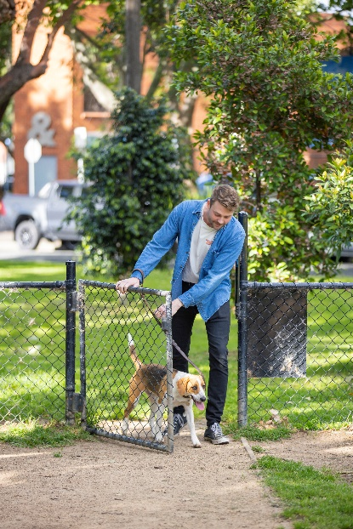

The project 3
Strategic context 3
Engagement methods 3
Who we heard from 4
Dog ownership and park usage 5
Engagement findings: Key insights from what we heard 5
Support for the concept plan 5
Preference for designated areas for quiet and confident dogs 6
Support for park furniture upgraded or added in Clayton Reserve 6
Suggestions for how we could improve the picnic area outside the the dog park for surrounding residents, workers and visitors 6
Example direct quotes from the feedback received 7
Photos from consultation 8
Appendix 1 – Survey Questions 9

The project
The City of Melbourne is upgrading the Clayton Reserve Dog Park to better meet the needs of local dog owners and improve safety, amenity, and environmental sustainability.

The upgrade is guided by extensive community feedback and aims to enhance the experience for both dogs and their owners while balancing the needs of other park users.

Key features of the proposed upgrade include:
- Separation of areas for large and small dogs
- Improved fencing and entry points
- New seating, shade, and water facilities
- Turf and landscape improvements
- Environmentally sensitive drainage solutions

The design responds to ongoing concerns about overcrowding, maintenance, and dog behaviour management.

The aim of this upgrade is to create a safer, more inclusive and enjoyable open space for people and pets.

4 weeks of community engagement on the concept plan (2 June to 30 June 2025) will inform detailed design, subject to available budget. This report outlines what we heard from community through this engagement.

Construction is scheduled to begin in early 2026, with the project due for completion by October 2026.

Strategic context
Clayton Reserve is a 6531sqm neighbourhood park in North Melbourne. It is the city’s oldest fenced off leash area, historically used by the Lost Dogs home until it was formally gazetted as a fenced off leash area in 2010.
City of Melbourne has had an increase from 3618 dog registrations in 2020 to 4280 in 2024, with many of these registered to apartment owners with no backyards.
Clayton Reserve will be one of the largest open spaces for the new Arden Macaulay Growth area. By 2040, Arden's local population will increase more than tenfold, from 441 (recorded in 2020) to 5,061, while worker numbers will similarly surge, from 1,761 to 9,896. In Macaulay, resident numbers will rise from 2,725 to 9,311, while local workers will swell from 2,821 to 7,517. Combined, Arden and Macaulay will accommodate 14,372 residents and 17,413 workers by 2040.

Engagement methods
We collected feedback through:
- two in-person sessions in the park during known high visitation time periods (Friday 6 June and Saturday 21 June) to ensure inclusivity for those without internet access, and to talk directly to dog owners who use the park regularly.
- an online survey on Participate Melbourne (paper copies were also available during pop up sessions and later entered into Participate Melbourne).

Who we heard from
We received a total of 166 survey responses (including 45 surveys received across the two 2 pop up events).
Staff interacted with approximately 55 community members across the pop up events (answering questions about the proposed upgrades, encouraging completion of the survey online or on paper etc.).
Note demographic questions were not mandatory and participants can also select ‘prefer not to say’ as a response to all demographic questions.
High-level survey participant demographics
- 84% of participants (139) identify with this project as a resident. Of the 139 participants who identify with the project as a resident:
- 62 live in North Melbourne
- 49 live in Kensington
- 9 live in West Melbourne
- 6 live in the CBD
- 10% (17) identify with this project as a visitor
- Three participants identify with the project as a worker and 1 as a business owner
- 6% (10) identify as a person with a disability
- 16% (26) identify as LGBTQIA
- 8% (12) speak a language other than English at home
- 18% (29) were born overseas
- 36% (59) male, 57% (94) female and 2% (3) non-binary
- In terms of age, highest participation from
- 18% (29) 30-34 years
- 12% (19) 40-44 years
- 11% (18) 35-39 years
- 10% (17) 25-29 years
- 10% (17) 50-54 years
- 10% (17) 55-59 years
- 51% (84) have participated in a CoM consultation once or twice before This was the first time 28% (46) of participants engaged with a CoM consultation and 16% (26) participate in CoM consultations regularly.
- Most participants (82% or 134) participated in this survey because the project directly impacts them. 14% (22) participated because they think it is important to have your say and contribute to the future of our city.
- 30% (49) of participants heard about this project in person, followed by those who heard about the project via a poster or flyer (21% or 34) and via a CoM direct email (21% or 34).

Dog ownership and park usage
- 92% (153) of survey participants own a dog (8% or 13 do not)
- 86% (147) currently use Clayton Reserve (12% or 19 do not)
- Of those who currently use Clayton Reserve, 41% (60) use this space daily, followed by 38% (54) weekly, 12% (17) rarely and 11% (16) monthly.

Engagement findings: Key insights from what we heard

Support for the concept plan
48% (79) like the plan and 23% (38) love it (i.e. total of 71% or 117 like it or love it).
- 34 participants who love the plan, and 69 participants who like the plan, expanded on their reasons in a free text question.
- Common reasons participants loved or liked the proposed plan included:
- Support for the separate fenced areas (55 comments) ranging from behaviour of large dogs who currently use the park and the need to allow diverse dogs to be able to use the park.
- Support for increased and improved lighting (17 comments), especially to support walking dogs in winter and to improve women's safety in the park.
- Support for improved fencing, including air lock gates (17 comments)
- Support for improved landscaping, however wanting to see more grass areas and limited trees (13 comments)
- Improved furniture including shelters, bins, seats and water fountains (9 comments)
- Participants who loved or liked the proposed plan noted additional considerations including ensuring improved maintenance, appreciating Council undertaking the upgrade, a walking circuit, more dog enrichment and concerns about the shutdown period.
16% (26) are neutral about the plan.
- 25 participants who are neutral expanded on their reasons in a free text question.
- Common reasons participants were neutral included:
- More grass less trees/less granitic gravel (6 comments)
- Loss of space for big dogs to run (5 comments)
- Concerns about the definition and enforcement of the separate areas (3 comments)
- Additional considerations noted by these participants included removing the fruit trees from the centre of the park (as they can cause health issues for dogs), a desire for more dog enrichment as part of the upgrade, lighting should be brighter and not just retained, noted concern that fencing wouldn't be high enough for big dogs, concerns the upgrade isn't needed, concerns about accessibility through the new gates with a wheelchair and concerns about not enough safe pedestrian crossing points to the park along Macaulay Road.

10% (16) don’t like the plan and 4% (7) really don’t like it (i.e. total of 14% or 23 either don’t like it or really don’t like it)
- 16 participants who don't like the plan, and 6 who really don't like the plan, expanded on their reasons.
- Common reasons participants do not like the plan included:
- Less gravel and more grass (7 comments)
- More open space for dogs to run, less trees (7 comments)
- Smaller dog area should be somewhere else (6 comments)
- More lighting needed (5 comments)
- No upgraded needed (5 comments)
- More design thought needed (3 comments)
Additional comments included the consideration of more evergreen natives and more maintenance.

Preference for designated areas for quiet and confident dogs
- Most participants (69% or 113) prefer designated areas for quiet and confident dogs:
- 17% (or 29) participants do not prefer these designated areas
- 14% (24) had no opinion

Support for park furniture upgraded or added in Clayton Reserve
Participants were asked what park furniture they would like to see upgraded or added in Clayton Reserve.
Options in order of greatest support:
- Shelter 62% (103 participants)
- Dog water fountains 52% (86)
- Park bench seats 34% (57)
- Low benches 31% (52)
- Picnic tables 7% (11)

Suggestions for how we could improve the picnic area outside the the dog park for surrounding residents, workers and visitors
Common themes within suggestions for improving the picnic area outside the dog park include:
- More seating and tables (31 comments)
- More landscaping (25 comments)
- Shelter over the existing picnic table (17 comments)
- Lighting (9 comments)
- Signs to encourage people not to bring food into the fenced off leash area (6 comments)
- A bin with cigarette disposal (6 comments)
- Dog wash/dog shower (3 comments)
Additional considerations noted from one or two participants included suggestions to expand the dog park into this area, add a playground, add bike parking, add a coffee cart, move the picnic area across the road, and improve the path network outside the fence line.
A key piece of information we found out was a homeless food service arrives at the park at 7pm each day, many people sit in this area with their food.

Example direct quotes from the feedback received
- “Better lighting will be great and more sensory objects. Would be great to have a light coloured foot path that goes around the whole park so you can walk around it watching your pooch that is dryer than grass and with better visibility if you may step in dog poo!”
- “Good to have a quiet space, additional security gates, trees, lighting”
- “Great to have 2 areas for small and large dogs. Just don’t want to lose too much of the grass area. Needs more seating around edges please”
- “I have a very small dog that is currently terrified to go to the dog park if it is busy with big dogs. This plan allows us to enter directly into a "Safe Space" and there is seating for me.”
- “I love the new quiet and confident dog areas as our dog is a bit timid. The improved irrigation is great as there are often large and messy puddles. And the seating and landscaping sounds like a large improvement.”
- “I only use the park when I am dog sitting friend's dogs, but I have felt the park could do with a revamp. In my view, the most important thing that needs to be addressed is the current lighting situation. The lights are so dim they cast no light, and as a result I have avoided using the park at night because it feels unsafe. It’s an industrial area and as a woman I don't feel safe here when its dark. Lighting must be updated to encourage more people to feel safer using the park after dark. The lights actually need to cast light on the park so you can see who is there and who is approaching. To me this is more important than any other upgrade you could make.”
- “I’ve been daily visitor to Clayton reserve for the past 2 years, and have visited all times of day. Some good and bad in this proposal: - Existing lighting needs to be significantly brighter, not just retained. - Park is barely big enough to have split zones - Adding more obstacles in the reduced active dog area (trees, logs, gravel paths) is not the right call, active dogs need space to zoom, more obstacles are an added safety hazard. Quiet zone should be for sniffing, active for running/fetch. The reason I go to Clayton reserve over nearby Eades park is that it is better for active dogs and has more space to run. - Seats are underutilised, no need for more - too much gravel, not enough grass in active dog zone, suggest 1-2 paths max - consider a sandpit in the middle of the active zone (the bench/tree area) to reduce number of dangerous potholes in running spaces. Many of the active regulars are diggers. - water fountains need to tip rather than drain, current drains get blocked.”

Photos from consultation
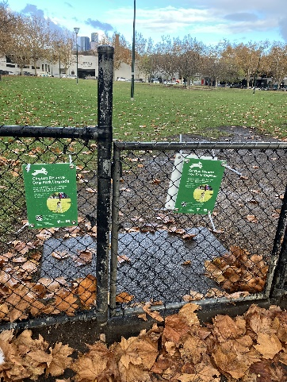 | 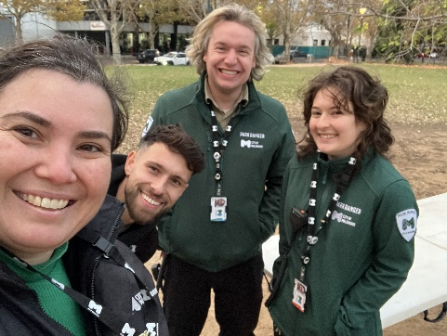 | 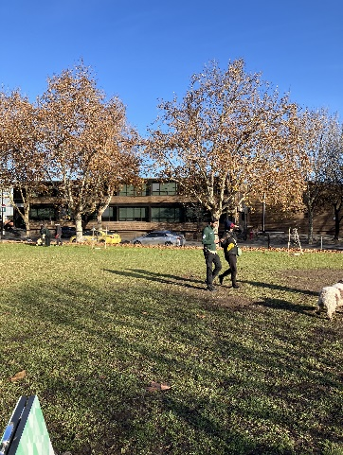
Signs placed at all entrances advising of project on 1 June 2025 | Project team onsite for pop up 1 on 6 June 2025 | Active discussions with project team onsite on 21 June 2025
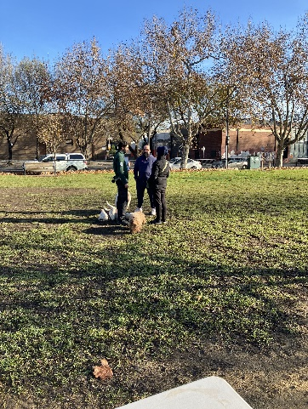 | 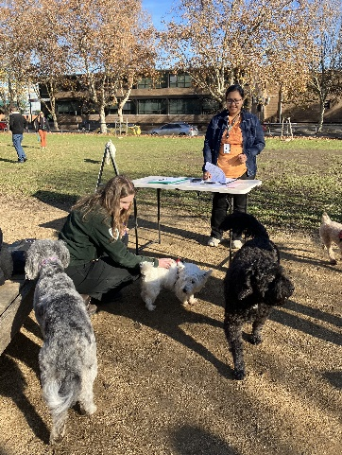 | 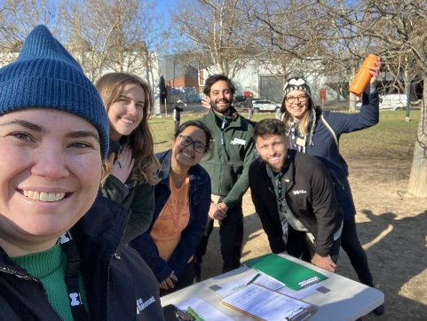
Active discussions with project team onsite on 21 June 2025 | Project team giving lots of pats to local dogs on 21 June 2025 | Project team, including 2 volunteers after consultation on 21 June 2025

Appendix 1 – Survey Questions
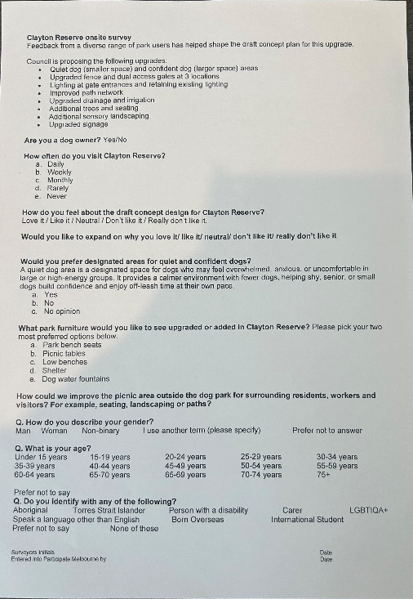 | 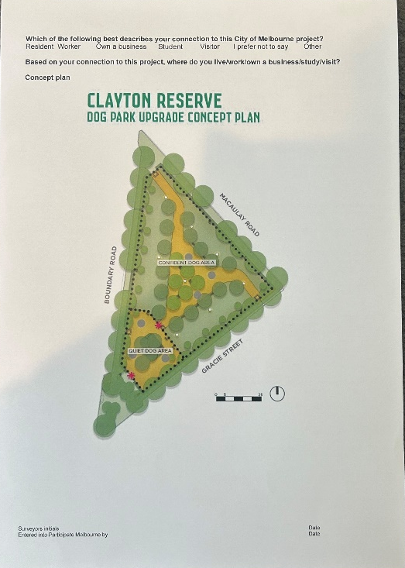
Page 1 – In person survey | Page 2 – In person survey

