
Greening MacKenzie Street Engagement Summary Report
April 2024
This report prepared by Global Research.
Disclaimer
This report is provided for information and it does not purport to be complete. While care has been taken to ensure the content in the report is accurate, we cannot guarantee it is without flaw of any kind. There may be errors and omissions or it may not be wholly appropriate for your particular purposes. In addition, the publication is a snapshot in time based on historic information which is liable to change. The City of Melbourne accepts no responsibility and disclaims all liability for any error, loss or other consequence which may arise from you relying on any information contained in this report.
To find out how you can participate in the decision-making process for City of Melbourne’s current and future initiatives, visit melbourne.vic.gov.au/participate

Acknowledgement of Traditional Owners
The City of Melbourne respectfully acknowledges the Traditional Owners of the land we govern, the Wurundjeri Woi-wurrung and Bunurong / Boon Wurrung peoples of the Kulin Nation and pays respect to their Elders past and present. We acknowledge and honour the unbroken spiritual, cultural and political connection they have maintained to this unique place for more than 2000 generations.

We accept the invitation in the Uluru Statement from the Heart and are committed to walking together to build a better future.

Contents
Acknowledgement of Traditional Owners 2
The Greening MacKenzie Street Proposal 4
How we engaged 6
Who we engaged 7
Key topics and ideas 9
Overall level of support for the Proposal 10
Reasons for your level of support for the Proposal 11
How this feedback will be used 12

The Greening MacKenzie Street Proposal
The City of Melbourne undertook community engagement on the Greening MacKenzie Street Proposal from 12 February 2024 to 11 March 2024. The Greening MacKenzie Street Proposal (pictured on page 4) responds to the growing and changing residential and worker population in central Melbourne and the impacts of climate change.
Features of the Proposal include:
- a new 400-square-metre park that includes seating, lighting, bike parking, lawn, feature trees and biodiverse garden beds
- improved streetscape amenity and pedestrian experience for MacKenzie Street through canopy cover and garden bed plantings
- reduced pedestrian crossing widths for improved safety at intersections
- the introduction of 19 additional tree and understory species that will strengthen urban forest resilience and plant community biodiversity, offering long term benefit to the community
- increased permeable ground surfaces to enable both water infiltration and reduce storm water run-off
- shorter and safer pedestrian crossing points
This has been achieved through the reconfiguration of the roadway to create new public open space, the Proposal requires reconfiguration of some existing car parks. The Greening MacKenzie Street Proposal will result in a net loss of two car parks.
This report summarises who we reached and what we heard during the community consultation period on the Proposal.
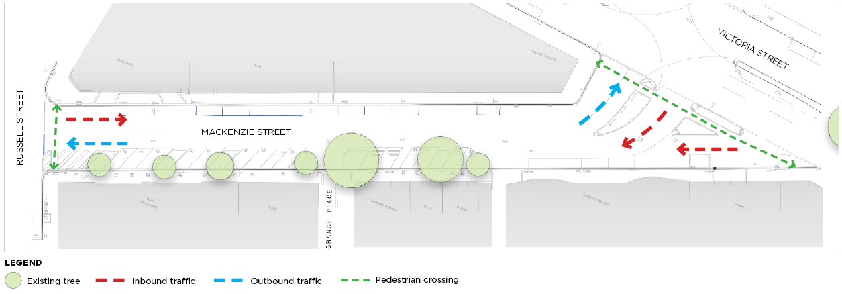

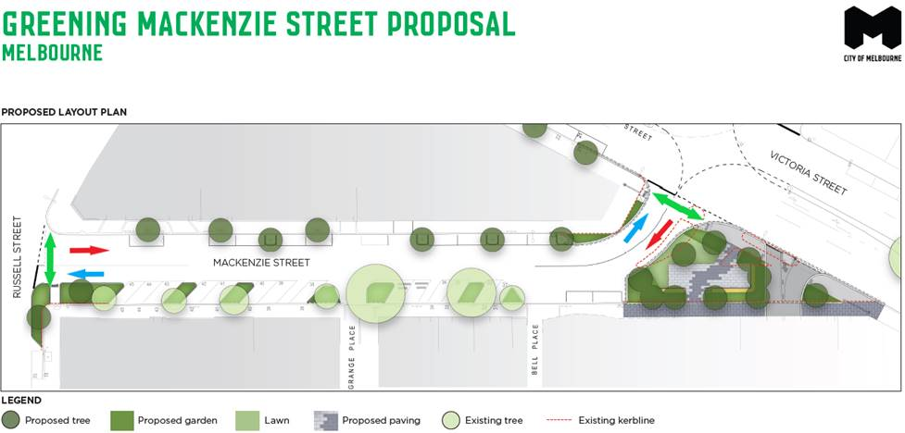

How we engaged
In total, we reached more than 107,000 people via on site signage, social media posts, e-newsletters, a community newspaper article, and letters to directly affected owners, occupiers, and businesses.
372 online surveys were completed by community members providing feedback on our Greening MacKenzie Street Proposal.
- 101,634 Unique social media views
- 2,776 letters sent
- 3,369 e-newsletter recipients
- 372 Surveys completed
- 5,669 Unique website visitors
- 165 Proposal visits via e-newsletters

Who we engaged
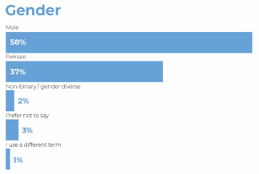

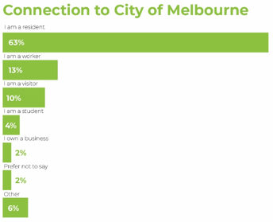
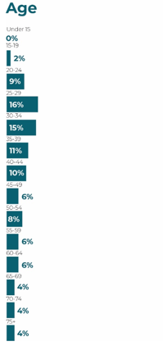
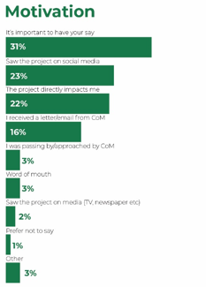

Key topics and ideas
Level of support for Greening MacKenzie Street

There was significantly more support than opposition from survey participants for the Proposal to include a
small park and increase greening on MacKenzie Street, with 91 per cent of participants showing either strong
(87 per cent) or partial (four per cent) support.

The main reasons given for supporting the Proposal were the range of anticipated benefits from the
Proposal. These included better shade and reduced heat, making the street more beautiful and pleasant to be
in, walkability and increased safety for active transport users, and improved mental wellbeing. More generally,
Participants also welcomed the upgrade of an area broadly perceived of as lacking utility and charm.

Significantly fewer comments were made in opposition to the proposed greening of MacKenzie Street, with five per cent of participants strongly opposing and two per cent partly opposing the Proposal. The main reasons given for opposing the proposed upgrade include concerns over vehicle access and parking, perceived misuse of Council funds, or functionality of the design.

Difference in themes by gender

There was little gender difference in overall support for the Proposal. However, further analysis showed thematic differences between participants who identified as male and female (the only gender groups large enough to compare responses). Key differences included males being more likely than females to voice support for how the Proposal would impact parking, mental wellbeing, wildlife, and safety.

Minor design changes
Some participants suggested minor design changes to the Proposal. Common suggestions included additional seating, signage, pet specific facilities, reduction of the paving within the proposed park, and adjustments to the proposed road layout and function.

Overall level of support for the Proposal
Participants were asked: Do you support the Proposal to introduce a small park to MacKenzie Street?
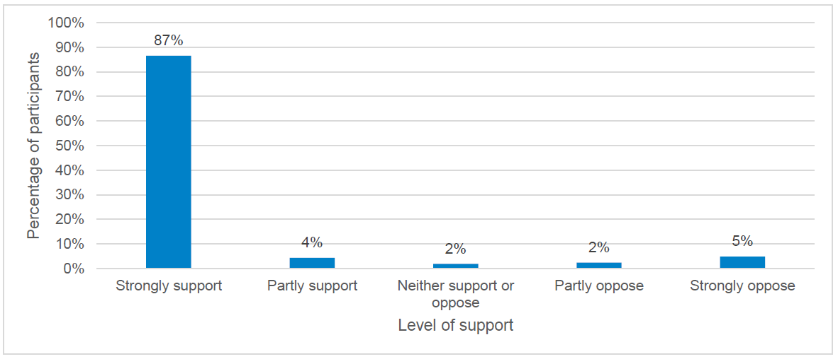
A strong majority (91 per cent) supported the Proposal.
Only seven per cent of participants were unsupportive overall.

Reasons for your level of support for the Proposal
Participants were asked: Why do you feel this way about the Proposal?
You said
“More green spaces improve mental health, keep temperatures lower, and help combat global warming. I'd prefer even more green space and less concrete on even this proposal personally.”
“The area looks really ugly as it is and bringing in the greenery would turn it into a much more lovely area.”
“It turns a little use road for cars into a more useful space for pedestrians, workers, visitors and residents and increases trees and green space to improve urban amenity and the environment”
We heard
- The main reasons participants gave for supporting the Proposal were the range of anticipated benefits. Participants argued that the upgrades would help reduce the urban heat island effect of the street, make the street more beautiful, safe and pleasant, support active transport options, and generally be a welcome upgrade to the area.

- There were several supportive comments that provided suggestions for how the MacKenzie Street greening design could be further enhanced. Suggestions centred around additional facilities and lighting, increased greening over hard stand areas within the proposed park, as well as plant and tree species selection.

You said
“It's a waste of money and resources that can be better spent managing the city's homeless and substance abuse issues.”
A reduction in parking spots will greatly inconvenience visitors to the city and discourage patronage of businesses...”
We heard
- Significantly fewer comments were made in opposition to the proposed greening of MacKenzie Street. The main reasons given for opposing the proposed upgrade included concerns about potential impact on traffic flows and parking, whether it is an appropriate use of council funds, and whether green space is surplus to requirements

How this feedback will be used
The values, priorities, ideas, and concerns of community engagement participants relating to the Greening MacKenzie Street Proposal have been clearly articulated to City of Melbourne.
Community feedback has been collated and analysed by independent social researchers and what we heard presented back in the form of a detailed report, in addition to this synthesised summary report.
The Greening MacKenzie Street team, including infrastructure planning, traffic engineering, park services and landscape design, will review and consider your feedback to help develop a final concept plan.
Thank you to all participants in this planning journey. Your local knowledge and experience of the area is crucial. We look forward to talking to you in the coming months and working towards some outstanding outcomes for central Melbourne residents, businesses, and visitors.

