City of Melbourne | 
20.10.23

The Greenline Project Master Plan
Round Two Engagement Summary Report

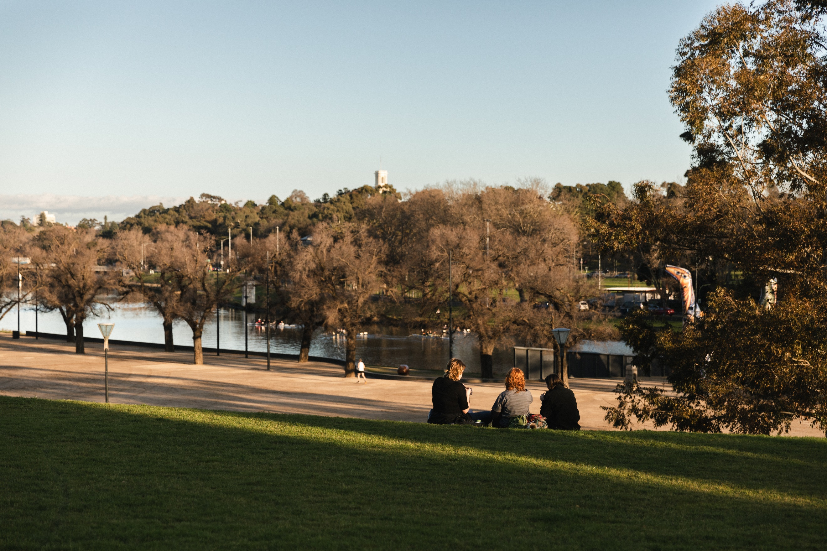
Giving every person a voice.
Capire Consulting Group  The Commons,  Wurundjeri Country  36-38 Gipps Street,  Collingwood VIC 3066  (03) 9285 9000  info@capire.com.au  capire.com.au  Capire acknowledges  and deeply respects the Wurundjeri people and  the Traditional Owners  of the Victorian land. | 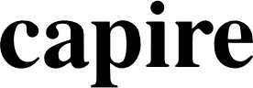
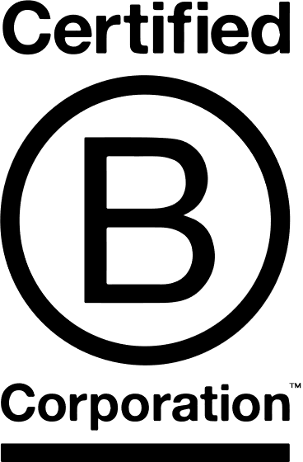

Privacy  Capire Consulting Group and any person(s) acting on our behalf is committed to protecting privacy and personally identifiable information by meeting our responsibilities under the Victorian Privacy Act 1988 and the Australian Privacy Principles 2014 as well as relevant industry codes of ethics and conduct.  For the purpose of program delivery, and on behalf of our clients, we collect personal information from individuals, such as e-mail addresses, contact details, demographic data and program feedback to enable us to facilitate participation in consultation activities. We follow a strict procedure for the collection, use, disclosure, storage and destruction of personal information. Any information we collect is stored securely on our server for the duration of the program and only disclosed to our client or the program team. Written notes from consultation activities are manually transferred to our server and disposed of securely.  Comments recorded during any consultation activities are faithfully transcribed however not attributed to individuals. Diligence is taken to ensure that any comments or sensitive information does not become personally identifiable in our reporting, or at any stage of the program.  Capire operates an in-office server with security measures that include, but are not limited to, password protected access, restrictions to sensitive data and the encrypted transfer of data.  For more information about the way we collect information, how we use, store and disclose information as well as our complaints procedure, please see www.capire.com.au or telephone (03) 9285 9000. |  | Consultation  Unless otherwise stated, all feedback documented by Capire Consulting Group and any person(s) acting on our behalf is written and/or recorded during our program/consultation activities.  Capire staff and associates take great care while transcribing participant feedback but unfortunately cannot guarantee the accuracy of all notes. We are however confident that we capture the full range of ideas, concerns and views expressed during our consultation activities.  Unless otherwise noted, the views expressed in our work represent those of the participants and not necessarily those of our consultants or our clients.  Definitions  The following lists the key definitions for common terms used in the design and delivery of community engagement as stated in the City of Melbourne’s Community Engagement Policy, 2021.  Community  An individual or a group of people united by at least one common characteristic such as geography, shared interests, values, experiences, or tradition.  Community engagement  A planned process with the specific purpose of working with individuals and groups to encourage active involvement in decisions that affect them or are of interest to them.  Stakeholder  An individual or group that has an interest in any Council decision or activity, including Traditional Custodians and Aboriginal communities, other tiers of government and government agencies, businesses, educational institutes, not-for-profits and philanthropic organisations, visitors, residents, advocacy groups, children, ratepayers and renters, emergency services, culturally and linguistically diverse people and many more.

Executive Summary

Project overview
The Greenline Project is an initiative by the City of Melbourne (Council) to transform the north bank of the Yarra River – Birrarung. It will create four-kilometres of interconnected promenades, parks, open spaces, native plantings, cultural activations and environmental renewal between Birrarung Marr and the Bolte Bridge. The Greenline Project is intended to deliver significant value for Melbourne contributing to the city’s economy, environment, tourism, health, wellbeing, and overall resilience.
Informed by the last round of community engagement in April and May 2023, The Greenline Project Draft Master Plan (the draft Master Plan) was prepared to seek community feedback on the Greenline Project as a series of interconnected spaces.In this round of engagement, the draft Master Plan was presented to the community and stakeholders to seek their opinions on how effectively the draft Master Plan addresses the key findings from the previous round of engagement and to identify any existing gaps or additional areas that require further consideration for the finalisation of the Master Plan.

Engagement approach
The public consultation spanned four weeks, running from 16 August 2023 to 13 September 2023. The engagement team sought to connect with a wide range of individuals and groups to ensure community members and stakeholders who were interested or may be impacted by the Greenline Project had a chance to review and provide feedback on the draft Master Plan before final approval by Council. The engagement activities included:
- an online survey to gather community feedback, accessible via the Greenline Project Participate Melbourne page.
- a stakeholder workshop
- a focus group
- two community briefing sessions.

Engagement outcomes
A total of 314 completed surveys and 3 written submissions were received from a diverse group of participants, including people of all genders, individuals with children, various age groups, and participants with disabilities.
Participants expressed overall support for the Greenline Project. Consistent feedback and messages were received in this round, many of which have been further reinforced as participants review the draft Master Plan. The following is a summary of the feedback from this round of consultation against each of the key Greenline Project themes:
Project themes | Description
Culture | - Reflect and share the multi-layered cultures and histories of the north bank.  - Demonstrate stories of the north bank through art and create whole-of-journey experiences for future users.  - Consider opportunities to engage a diverse range of artists and allocate spaces to showcase both permanent and temporary installations.  Reinforced themes from previous engagement:  - Integrate First Nations culture and history, maritime history, environment, and sustainability into the design considerations.
Environment | - Consider more urban greening opportunities to provide more natural shading, attract native birds and insects, and soften landscapes.  - Preference for greening with plant species that are indigenous, change with the season, and are climate resilient.  - Ensure flood-resilient designs throughout and consider how this project will contribute to the improvement of river health.  - Consider opportunities to implement circular economy concepts in innovative ways.  - Limit the use of diesel fumes and motorboat fumes on the river.  Reinforced themes from previous engagement:  - Increased greenery  - Strong support for creating habitat
Place | - Provide a diverse range of experiences supported by amenities that suit different user needs.  - Activate the project area through retail and dining opportunities in a sensitive way.  - Explore temporary activation concepts to include seasonal farmers’ market, food market, designers’ market, pop-up drink stalls etc.  - Consider addition of small permanent traders along the water (e.g., cafes, bookstores)  - Ensure a safe and comfortable experience for all users at different times of the day.  - Consider and address how facilities and amenities will be managed and maintained.  Reinforced themes from previous engagement:  - Ensure effective lighting at night.  - Consider how to address rough sleepers.  - Consider how to manage anti-social behaviour.
Connection | - Consider installing separate bike lanes to address potential safety risks and conflicts of space among cyclists, scooter users, and pedestrians.  - Ensure connection of pedestrian and cycling paths from the north bank to surrounding areas and locations of interest.  - Consider introducing water transport options to connect sites along the north bank.  Reinforced themes from previous engagement:  - Improve wayfinding and connectivity of the north bank to and from the city.  - Ensure accessibility for people of all abilities is incorporated into the design, both in the access to and along the north bank.

Additional feedback from participants highlighted how they would like the Greenline Project to continue to involve communities and stakeholders as the project progresses. Many expressed the need for the Greenline Project to consult diverse community members and stakeholders in future precinct planning, and interest in learning more about future engagement timelines and scope. There were suggestions to use easy-to-understand communication materials to reach a wider range of community members. Participants emphasised that the Greenline Project team should keep in touch with stakeholders, including relevant government bodies, businesses, and developers to identify partnering opportunities and address potential issues effectively to ensure the north bank is revitalised into a desired place that integrates well with its surroundings.

Next steps
The feedback collected from this round of engagement will be used to refine and finalise the Greenline Project Master Plan. This feedback will also inform future Precinct Plans and concept designs following Council approval of the Master Plan. The City of Melbourne will continue to conduct individual and collective discussions with community and stakeholder groups as the Greenline Project progresses.

Contents
Executive Summary 3
Contents 5
1. Introduction 6
1.1. Project background 6
1.2. Scope of engagement 7
2. Engagement approach 9
2.1. Engagement objectives 9
2.2. Methodology 9
2.3. Limitations 12
3. Summary of participants 13
3.1. Community members 13
3.2. Stakeholders 16
4. Engagement findings 17
4.1. Community feedback 17
4.2. Stakeholder feedback 19
5. Next steps 22

Introduction
This report summarises the approach and findings from the Greenline Project Draft Master Plan public consultation (round two) to inform the Greenline Project Master Plan and future Precinct planning.

Project background
The Greenline Project is an initiative by the City of Melbourne (Council) to transform the north bank of the Yarra River – Birrarung into an inspiring public waterfront in the heart of Melbourne. A 4-kilometre promenade which connects diverse, vibrant riverside destinations. The project intends to deliver significant value for Melbourne by contributing to the city’s economy, environment, tourism, health, wellbeing, and overall resilience.
Aboriginal and contemporary cultures will be celebrated, as will the area’s historic values. The river and its surrounding environment will be re-established as an ecological corridor.
The Greenline Project site stretches between Birrarung Marr and Victoria Harbour, adjacent to Melbourne’s central business district for much of its length. The Greenline Implementation Plan identifies five precincts along the north bank (each with distinct characteristics, varied riverbank conditions and multiple landowners and managing authorities). The vision for the Greenline Project is outlined in Figure 1
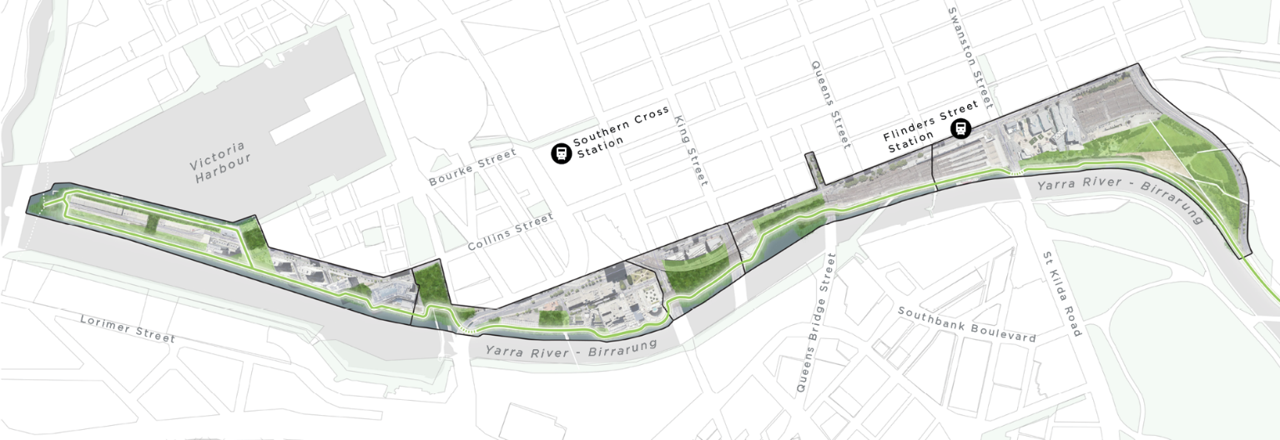
Figure 1: The Greenline Project Vision

The Greenline Project Master Plan
The Greenline Project Master Plan (the Master Plan) is prepared to develop the Greenline Project as a series of interconnected spaces. The Master Plan seeks to address the four key themes that were identified in previous stages of the project:
- Environment: river as a living entity – creating a living, healthy ecosystem
- Culture: authentic stories and experiences – a cultural landscape
- Place: Melbourne’s unique character and place – inclusive, safe and accessible
- Connection: a connected and vibrant waterfront – a continuous journey.
The purpose of the Master Plan is to:
- provide an overarching design framework for the Greenline Project to support a coordinated approached to the staged delivery of projects
- guide design consistency and quality across the delivery of all projects
- outline key design moves and spatial layouts that lay the foundations for the design development of each precinct through future stages
- illustrate the vision, themes and actions that support design and implementation.
The draft Master Plan includes the following chapters:
- Introduction
- Health and Wellbeing of Country
- Master Plan Overview
- Woven Line Threads
- Master Plan Implementation.
Full version of the Greenline Project Draft Master Plan is available on the Participate Melbourne website.
Precinct plans and concept designs for future projects will be developed following the approval of the Master Plan. These designs for each precinct will be integrated and coordinated to achieve a seamless outcome for the Greenline Project, connecting the riverfront with the water itself, and the surrounding city.

Previous engagement
To support the development of the Greenline Project Draft Master Plan, an extensive six-week stakeholder and community engagement was held during April – May 2023. The engagement program included a range of activities and received input from 756 participants related to design ideas and opportunities to inform the continued development of the draft Master Plan. The feedback from this engagement phase was analysed against the four project themes; environment, culture, place, and connection. This feedback has been incorporated into the draft Master Plan.
Prior to consultation on the draft Master Plan, a series of consultation processes were undertaken between 2019 and 2022 to inform the strategic documents guiding the Greenline Project Master Plan. The documents include:
- Yarra River – Birrarung Strategy 2019: a guiding document for the planning of the inner city reach of the river. The document outlines strategic directions and opportunities to improve the way the city uses the river and its edges.
- Greenline Implementation Plan 2021: a document outlining the scope, projects, key actions and milestones for the Greenline Project. The document is based on the strategic directions of the Yarra River – Birrarung Strategy. Community and stakeholder engagement included a Resilience Value Realisation (RVR) methodology, asking where we are now, where do we want to be in the future, and how do we get there, resulting in a collaborative opportunity statement.
- The Draft Concept Plan for Site One of the Birrarung Marr Precinct: the key findings from this round of engagement will be used to refine the concept designs for Birrarung Marr Precinct Site One. The views and values expressed through the engagement process will also continue to inform the overall Greenline Project, including preparation of the future Master Plan and Precinct Plans.

Scope of engagement
In this stage of engagement, the draft Master Plan was shared with the community and stakeholders to understand what they thought about the Master Plan. The engagement scope included broader community engagement and targeted stakeholder engagement.
The engagement sought community and stakeholder feedback on how well they think the draft Master Plan communicates the vision for the revitalisation of the north bank of the Yarra River – Birrarung, and how well the following are addressed:
- health and wellbeing of Country
- river ecology and environment
- safety, accessibility and inclusion
- pedestrians and active transport.
The feedback gathered through this engagement process will be used to refine the Greenline Project Master Plan and inform Precinct Plan development.

Engagement approach
This section provides a comprehensive overview of the objectives, methodologies, participation in the engagement process, and limitations of the engagement activities. The engagement activities spanned four weeks, starting on 16 August 2023 and concluding on 13 September 2023.

Engagement objectives
The engagement was underpinned by a set of objectives. The engagement objectives guided the planning and design of the engagement program and allowed for effective monitoring and evaluation. The engagement objectives for the Greenline Project are:
- To acknowledge community input from previous engagement and present the draft Master Plan to the community and demonstrate how insights from the previous round of engagement have been integrated into the draft Master Plan
- To seek diverse community and stakeholder feedback to ensure community vision and aspirations are adequately reflected and addressed in the draft Master Plan.
- To identify any additional community and stakeholder feedback to be considered to help refine the draft Master Plan before its final approval by Council.
- To maintain and strengthen ongoing genuine relationships with key stakeholders with the intention to form partnerships.
- To continue to promote community ownership and participation in the project. This will help to promote project sustainability and ongoing engagement.
- To continue to deliver targeted ongoing engagement with Wurundjeri Woi-wurrung as central to the Greenline Project.

Methodology
Throughout the engagement period, the engagement team sought to reach as many people as possible. This was to ensure residents, visitors, businesses, government agencies, industry partners, relevant stakeholders, and others interested in the Greenline Project had a chance to review and provide feedback on the draft Master Plan before final approval by Council. Various tools and channels were used to provide information about the project and to promote engagement opportunities (Table 1).

Promotion
Table 1: Promotion
Tool | Description
Participate Melbourne page | A webpage for the Greenline Project was established on Participate Melbourne (https://participate.melbourne.vic.gov.au/greenline-project/draft-master-plan. This webpage hosts a survey for the Greenline Project Master Plan and a document library comprising the draft Master Plan, its appendices and the accessible version of these documents.  This webpage also serves as a comprehensive resource, providing project information, a summary of community feedback from previous engagements, frequently asked questions, the overall site plan for the Greenline Project, as well as its timeline and updates.  Overall, the Greenline Project page on Participate Melbourne received 21,096 views, 17,615 visits, and 15,237 unique visitors. The draft Master Plan page attracted 92.26 per cent visitation with 16,246 page visits.
Email invitations with pre-engagement letter | A pre-engagement letter to 135 key stakeholders was sent via email on 16 August 2023. These stakeholders comprised people from community groups, developers, local businesses and commercial stakeholders, resident groups and other interest groups, and government stakeholders.  The letter thanked stakeholders for their contribution in the previous round of consultation, provided an update on the project progress, invited them to review the draft Master Plan and encouraged participation in the engagement through the online survey.
Email promotion | Emails were directly sent to stakeholders to promote and extend personal invitations to engage in various opportunities. A total of 164 emails were sent, encompassing stakeholders and contacts who represent a diverse range of interests, including businesses, commercial enterprises, cultural organisations, social groups, and the creative arts community.  The Community Engagement Working Group of the City of Melbourne emailed information about the engagement opportunities to residents, groups, and networks who have existing relationships with the City of Melbourne. This included promotion through the Participate Melbourne online portal.
Social media promotion | City of Melbourne promoted the Greenline Project Draft Master Plan engagement through social media channels, including paid promotional posts on Facebook and Twitter with a direct link to the Participate Melbourne page. Assets including renders and key messages were also provided to key stakeholders and Councillors to promote via their own social media channels.
Traditional media | Channel 9, Channel 7, 3AW and Herald Sun all ran stories to promote the engagement period for the master plan. Other outlets including Hyperlocal and industry media also covered the draft master plan release.
On-site promotion | Corflute signage was installed at key locations along the north bank (including Birrarung Marr, Flinders Walk, Sandridge Bridge, Enterprize Park, Batman Park and Seafarers Bridge).  Signage was also provided to other City of Melbourne sites or partnering facilities including the Town Hall Visitor Hubs, Libraries, Town Hall, Community Centres, The Couch International Student Centre, Signal Creative Studio for young people, ArtPlay Creative Space for children, the University of Melbourne. Hard copies of the draft Master Plan were available for browsing at Library@the Dock, City Library and North Melbourne Library.
Council eDM | eDM to business in City of Melbourne reached 3,825 people, with an open rate of 58.52 per cent.
Business newsletter | The engagement period was promoted in the City of Melbourne’s Business newsletter. The first edition went out on 24 August and reached 10,597 people. The second edition went out on 7 September and reached 10,595 people.
Digital engagement pilot tool – Get to know The Greenline Project online webapp | The Greenline Project served as a test case for a pilot webapp developed by the City of Melbourne's in-house Technology Innovation & Data team. The web-based app is designed to help audiences understand, interact, and share the future vision of the Greenline Project. It is for use both on-site along the north bank project area and remotely at other locations via access from QR codes.  Link to the website: https://greenline.melbourne.vic.gov.au/

Engagement activities
Table 2 provides details about the engagement activities undertaken to seek feedback that informed the preparation of the Master Plan.
Table 2: Engagement Activities
Activities | Description
Online survey | The online survey was the principal method of gathering community feedback, accessible via the Greenline Project Participate Melbourne page and paper copies.  The objective of the survey was to provide a wide-reaching opportunity for community members to review the draft Master Plan and share their feedback and ideas for the Master Plan and Precinct plans.  The survey asked two questions and received 314 responses.  The full list of questions asked in the survey can be found in Appendix A.
Stakeholder workshop | One workshop was held to have in-depth conversations with targeted stakeholders and seek feedback and comments on the draft Master Plan.  Insights were presented from the previous engagement with these stakeholders and demonstrate how these have been integrated into the draft Master Plan. The participants were also presented an overview of the process moving forward and encouraged to envisage implementation and how it would impact them.  Workshop tables were split into themes: social, environment, economic and culture, and participants were invited to sit at the table that best represented their interests. Two questions were asked after delivery of a presentation:  - Question 1: As we’re finalising The Master Plan, what else do we need to consider? [particularly in reference to the table theme and the relevant woven line threads]  - Question 2: We have shared the intended forward process from here, what would a good process look like to you? How would you like to continue to be involved as this project progresses? [prompt for any relevant upcoming projects / work in the participant’s space that might connect]  Participants were asked to provide three words they suggest best associate with the Greenline Project via Mentimeter (Figure 11).  Targeted Stakeholder Workshop  Participants: interest groups and precinct partners, State Government departments and agencies, peak bodies for arts, tourism, parks, business, key precinct businesses and developers.  Date and time: Tuesday 5 September 2023, 9.30-11.30am  Location: Swanston Hall, Melbourne Town Hall, Ground Level, Swanston Street, Melbourne  Participants: 42  Stakeholders were invited to attend the workshops via email.
Digital engagement tool pilot – focus group | One face-to-face focus group was conducted with international students for them to help test the use the digital tool to understand the project.  International student engagement session  Date and time: Thursday 7 September, 6.00-8.00pm  Location: The Couch
Community briefing sessions | The Greenline Project team was approached by community / business groups to present at their members meetings for a project update.  The briefing sessions were:  Southbank Residents Association AGM  Date and time: Tuesday 29 August, 6.00-7.30pm  Participants: 12  Yarra River Business Association – Greenline Business Luncheon  Date and time: Thursday 7 September, 12.30-2.00pm  Participants: 39

Limitations
The engagement methodology while robust, also had several limitations that should be acknowledged when reading this report. These are outlined below.
- Capire has independently reported on information documented by participants and interpreted the information to represent the views of participants as closely as possible.
- People who participated in the engagement process voluntarily chose to be involved. Consequently, despite diligent efforts to collect input from stakeholders and the community, this report does not represent the perspectives of a statistically representative sample.
- Despite extensive efforts to promote engagement opportunities, it should be acknowledged that those who participated in the previous round of engagement may not have participated in the current phase. Therefore, it is important to note that this report may not fully represent the perspectives all participants from the previous round. Consistent or differing findings observed between the two rounds of engagement are highlighted in this report where possible.
- Demographic data was captured through the survey, but not the other engagement activities.
- In some instances, participants did not respond to all survey questions, this meant that some questions received fewer responses than others.
- All feedback received through the engagement phase and included in this report has been summarised to reflect key themes. Data was analysed and has been presented in this report under key themes reflecting issues that were frequently raised. It does not provide a quantitative analysis of all feedback provided by participants.
- Quantitative survey findings have been supported by qualitative findings from other engagement activities where relevant. Some workshops provided quantitative data. Due to smaller numbers of responses in comparison to the survey, these have not been included in the graphs.

Summary of participants
Feedback was received from 314 participants, regardless of gender, age and cultural background, across all engagement activities. Participants’ demographic data was collected from survey respondents. The results of this data are reflected below.

Community members

Gender
In this round of engagement, there was a less balanced representation of the participants in terms of gender as compared to the previous round. As expressed in Figure 2, males were more represented than other genders. More than half of the respondents identified themselves as male (60 per cent). Only 30 per cent of respondents identified as female. Four per cent of respondents identified as non-binary or gender diverse, while another four per cent preferred not to indicate their gender in the survey. One per cent of respondents used a different term to describe their gender.

Figure 2: Gender of participants (n=311)

Age group
There was a similar representation of age groups in this round of engagement and the previous round. As expressed in Figure 3, there was a spread of age groups across the survey respondents. The top four age groups represented in the survey was 30-34 years (14 per cent), 35-39 years (11 per cent), and 55-59 years (10 per cent). The least represented age group was those 80-84 years (0.3 per cent) and 85-89 years (0.3 per cent). No respondents aged under 15 years or over 90 years were represented in the survey.
Figure 3: Age group (n=308)

Demographics
Questions were asked to understand who was participating in the engagement process. Across the different representation measures, people who were born overseas (23 per cent) and members of the LGBTIQ+ (21 per cent) were the most represented.
Compared to the previous round, the representation from Aboriginal people has increased from around one per cent to three per cent. Previously, there was no representation from the Torres Strait Islanders, this was increased from zero per cent to two per cent in this phase. Additionally, 11 per cent of participants identified as people with disabilities, 12 per cent spoke a language other than English at home, and two per cent of respondents were international students.

Connection to the Greenline Project
Respondents were asked the suburb that reflected their relationship to the Greenline Project and if they had participated in a consultation with City of Melbourne before. This information helped to understand participants’ connection to the City of Melbourne.

Relationship with the City of Melbourne
As shown in in Figure 4, almost half of survey respondents’ primary relationship with the City of Melbourne is resident (47 per cent). This was followed by 25 per cent of respondents who work in the City of Melbourne, and 15 per cent of respondents who are visitors. Those who own a business were the least represented (1 per cent). Respondents may have had other connections with the City of Melbourne other than the indicated primary relationship. Compared to the last round of engagement, there was an increase of workers and visitors, but a drop in the number of residents who participated in the survey.

Figure 4: Relationship with the City of Melbourne (n=314)

Suburb
As displayed in Figure 5, the most represented suburbs by survey respondents were the Central Business District (31 per cent) of those whose connections were within the City of Melbourne. The least represented suburbs were West Melbourne (0.6 per cent), Fishermans Bend (1 per cent), and Kensington (1 per cent).
More respondents who resided outside of City of Melbourne were represented in this round of engagement. There were 29 per cent of respondents who resided in areas outside of the City of Melbourne. This included other Metropolitan suburbs such as Brunswick, Richmond, St Kilda. There were a few respondents who resided in regional cities such as Geelong and Ballarat or outside of Victoria such as Tasmania.

Figure 5: Suburbs of survey respondents (n=312)

Participation in previous consultations
There was an increase of respondents who participated in a City of Melbourne consultation for the first time compared to the last round. As shown in Figure 6Figure 5, many respondents had never participated in City of Melbourne consultation (61 per cent), whilst 26 per cent of respondents had participated in one or two consultations prior. Six per cent of respondents had participated in City of Melbourne consultations regularly.

Figure 6: Participation in previous consultations (n=314)

Reasons to participate
As shown in Figure 7, more than half of respondents stated the reason they participated in the consultation was because they thought it was important to have a say and contribute to the future of the city (55 per cent). This was followed by 48 per cent of respondents who saw the project on social media, a significant increase from 29 per cent last round.
Seven per cent of respondents offered other reasons, those respondents were interested in the project, heard about the project through community or interest groups such as Bicycle Network Victoria and Southbank Residents’ Association, or had seen signage around the city directing to the survey on the website. Participants were able to select multiple answers in response to this question.

Figure 7 Reasons to participate (n=310)

Stakeholders
Stakeholders represented in engagement are listed below:
Arbory Afloat  Barrett consultant  Bicycle Network  Creative Victoria  Department of Energy, Environment and Climate Action (DEECA)  Department of Jobs, Skills, Industry and Regions (DJSIR)  Department of Transport and Planning (DTP)  Development Victoria  Australian Healthy Ageing Organisation  Heritage Victoria  Immigration Museum  Invest Victoria (DJSIR)  Lendlease  Melbourne Arts Precinct Corporation (MAP Co)  Melbourne Chamber of Commerce / VCCI  Melbourne Convention and Exhibition Centre (MCEC)  Melbourne Water | Northbank Precinct Group  Parks Victoria  Property Council  Riverlee  Regen Melbourne  Rowing Victoria  Salter Brothers  Southbank Safety and Security Committee  Southbank Residents Association  Victoria Tourism Industry Council  Vic Track  Victoria Walks  World Trade Centre Wharf  Yarra River Business Association (YRBA)  Yarra Trams  Zinc at Federation Square

Engagement findings
The following findings summarise the feedback and comments collected through the engagement process.

Community feedback

Vision
Survey respondents were asked to indicate how well they thought the Greenline Project Draft Master Plan communicated a vision for the revitalisation of the north bank of Yarra River – Birrarung, rating from 0 (very poorly) to 5 (very well). Respondents generally thought that the draft Master Plan communicated a vision well, with the average score of 3.8. As shown in Figure 8, the majority of respondents (70 per cent) rated 4 and above, 19 per cent of respondents rated 3, and less than 12 per cent of respondents rated 2 and below.

Figure 8: Survey responses to question 'How well do you think the Greenline Project Draft Master Plan communicates a vision for the revitalisation of the north bank of Yarra River - Birrarung?' (n=286)

Key themes
Survey respondents were asked to indicate how well they thought the Greenline Project Master Plan had responded to feedback on the following themes:
- health and wellbeing of Country
- river ecology and environment
- safety, accessibility and inclusion, and
- pedestrians and active transport.
As displayed in Figure 9, many respondents answered ‘well’ or ‘very well’ across all themes. A total of 67 per cent of respondents felt that the theme health and wellbeing of Country and river ecology and environment were reflected ‘well’ or ‘very well’; followed by 61 per cent for safety, accessibility and inclusion, and 54 per cent for pedestrians and active transport.

Figure 9: Survey responses to question 'How well do think we've responded to feedback on these key themes?' (n=312)
In addition to answering this question, respondents were also able to provide open comment and feedback on what they thought should be considered to refine and finalise the Greenline Project Master Plan. All feedback has been analysed under the key themes of culture, environment, place, and connection to reflect ideas and feedback raised by respondents. A summary of the comments is outlined below.

Culture – Demonstrating Greenline’s culture and history through art
Respondents commonly acknowledged that the Greenline Project area is a site that underlies complex layers of cultures and histories and implies various meanings and values for different communities. There was a high level of support for the Master Plan to reflect and share the history of the site, including the cultures and histories of First Nations People, changes and transformation of the Yarra River, as well as the immigration and maritime history of Melbourne. This feedback is in tune with messages heard in the last round of engagement.
Respondents thought that art would play an important role in demonstrating the stories of the north bank to future users and visitors. Respondents expressed the desire to see a more detailed methodology in the Master Plan to integrate public art thoughtfully and extensively for the Greenline Project to ensure authentic storytelling and a holistic reimagination of its identity. Specific suggestions raised by respondents included to consult and seek recommendations from First Nation groups throughout all stages of the Project, allocate more spaces across the Greenline Project for art installations, and commission a spectrum of artists to present a range of artwork such as murals and temporary installations that change regularly at different seasons.
“With an eye on the public art component for the Greenline, there seems to be scant detail or methodologies presented on how spaces will be determined, who and how artists might be engaged.”
“Would love to see art in situ that responds to the history of the area, both indigenous and our immigration history.”

environment – environmentally sustainable design
Respondents were highly supportive of the vision and designs to promote environmental sustainability outlined in the draft Master Plan, which aligns with feedback heard in the previous round of engagement. Some respondents suggested that the Master Plan should further increase urban greening opportunities by including more unpaved areas to allow for more plantings. This will provide more natural shading, attract native birds and insects, and soften landscapes along the north bank. Respondents expressed preferences for plant species that are indigenous, change with the season and climate resilient.
Several respondents shared comments regarding the need to ensure future designs are flood resilient by conducting careful studies and working closely with other organisations such as Melbourne Water. There were also suggestions to include more designs and initiatives in the Master Plan that implement circular economy concepts in innovative ways such as the use of recycled construction materials, and collaboration with key stakeholders to introduce programs that will create a closed-loop system along the north bank with minimised waste and maximised resources.
“The green area must be as large as possible. Native shrubs & plants should be planted to attract & feed native birds & insects.”
“Consider rise in sea level and how this will impact all activity and built infrastructure along the river and beyond. Is there more that can be done in this wonderful plan to mitigate inundation due to future rise in sea level?”

Place – diverse experiences in safe and inclusive spaces
Respondents shared consistent feedback with the last round of engagement, expressing desires for a range of experiences and amenities they would like to see included in the Master Plan. Multiple respondents expressed support for activating the Greenline Project through retail and dining opportunities. Questions were raised about how the Master Plan would ensure these activities would integrate with the built fabric of the north bank in a sensitive way, including the types of commercial activities that will be introduced and location selection for these activities. There were also suggestions to provide diverse user experiences through the Master Plan by introducing facilities such as event and performance spaces, benches, fitness equipment, and children water play opportunities.
There was a high level of support for the Master Plan to create safe and inclusive spaces across the project area. Amenities commonly mentioned by respondents that would help achieve this opportunity in the Master Plan included sufficient lighting to enhance perception of safety at night, pathways that account for different access requirements, public toilets that are well maintained and rubbish bins at various locations to help ensure cleanliness. A few respondents raised concern to be addressed by the Master Plan regarding noise from nearby rail services approximate to Batman Park in the River Park Precinct that may impact user experiences at the site. Respondents were also interested in learning more about how the project would address and prevent antisocial behaviour and issues of homelessness across the site.
“Good lighting at night along the pathway for safety.”
“It would be great to understand what type of commercial retail you are targeting in new and revamped areas. Market style food and bookshops would be a great addition.”
“Play space with inclusive sensory aspects for children and young people with disabilities and wheelchair users.”

Connection – Active transport planning and connectivity
Similar to findings from the last round of engagement, many respondents further reinforced their support for more active transport along the north bank, and they would like to see more detail about the active transport planning in the draft Master Plan. Respondents shared that the north bank is an important commuting corridor for both pedestrians and cyclists. To minimise safety risks and potential conflicts of space between cyclists, scooter users, and pedestrians, respondents expressed their desire for separate bike lanes along the Greenline Project, instead of the proposed pedestrian-focused shared path. There were suggestions to include bike lanes with consistent design and clear markings to separate cyclists and pedestrians. Some respondents would also like to see more extended pedestrian and cycling connections from the north bank integrated to surrounding key areas and locations, such as Docklands and Flinders Street Railway Station.
Other feedback shared by respondents included suggestions to use non-slip ground surface materials to ensure safety for all users during wet seasons and to introduce water transport options such as ferries and water taxis to connect sites along the north bank.
“Include directional marking on path to show where bicycles and scooters should stick to.”
“If the Greenline is to be a success it is essential that an alternative separated bicycle facility is provided along the length of Flinders Street with the inclusion of "protected intersections". If not, active transport in the form of cycling will continue to be discouraged and there will be a high level of unsafe interaction between pedestrians and bike riders along the Greenline.”
“Given Melbourne's very temperamental weather, please ensure the walkways have good non-slip properties when it gets wet.”

Stakeholder feedback
This section provides a summary of feedback from stakeholders gathered during the Stakeholder Workshop and email submissions sent to the project team. A list of stakeholders represented in the engagement can be found in Section 3.2 of this report.
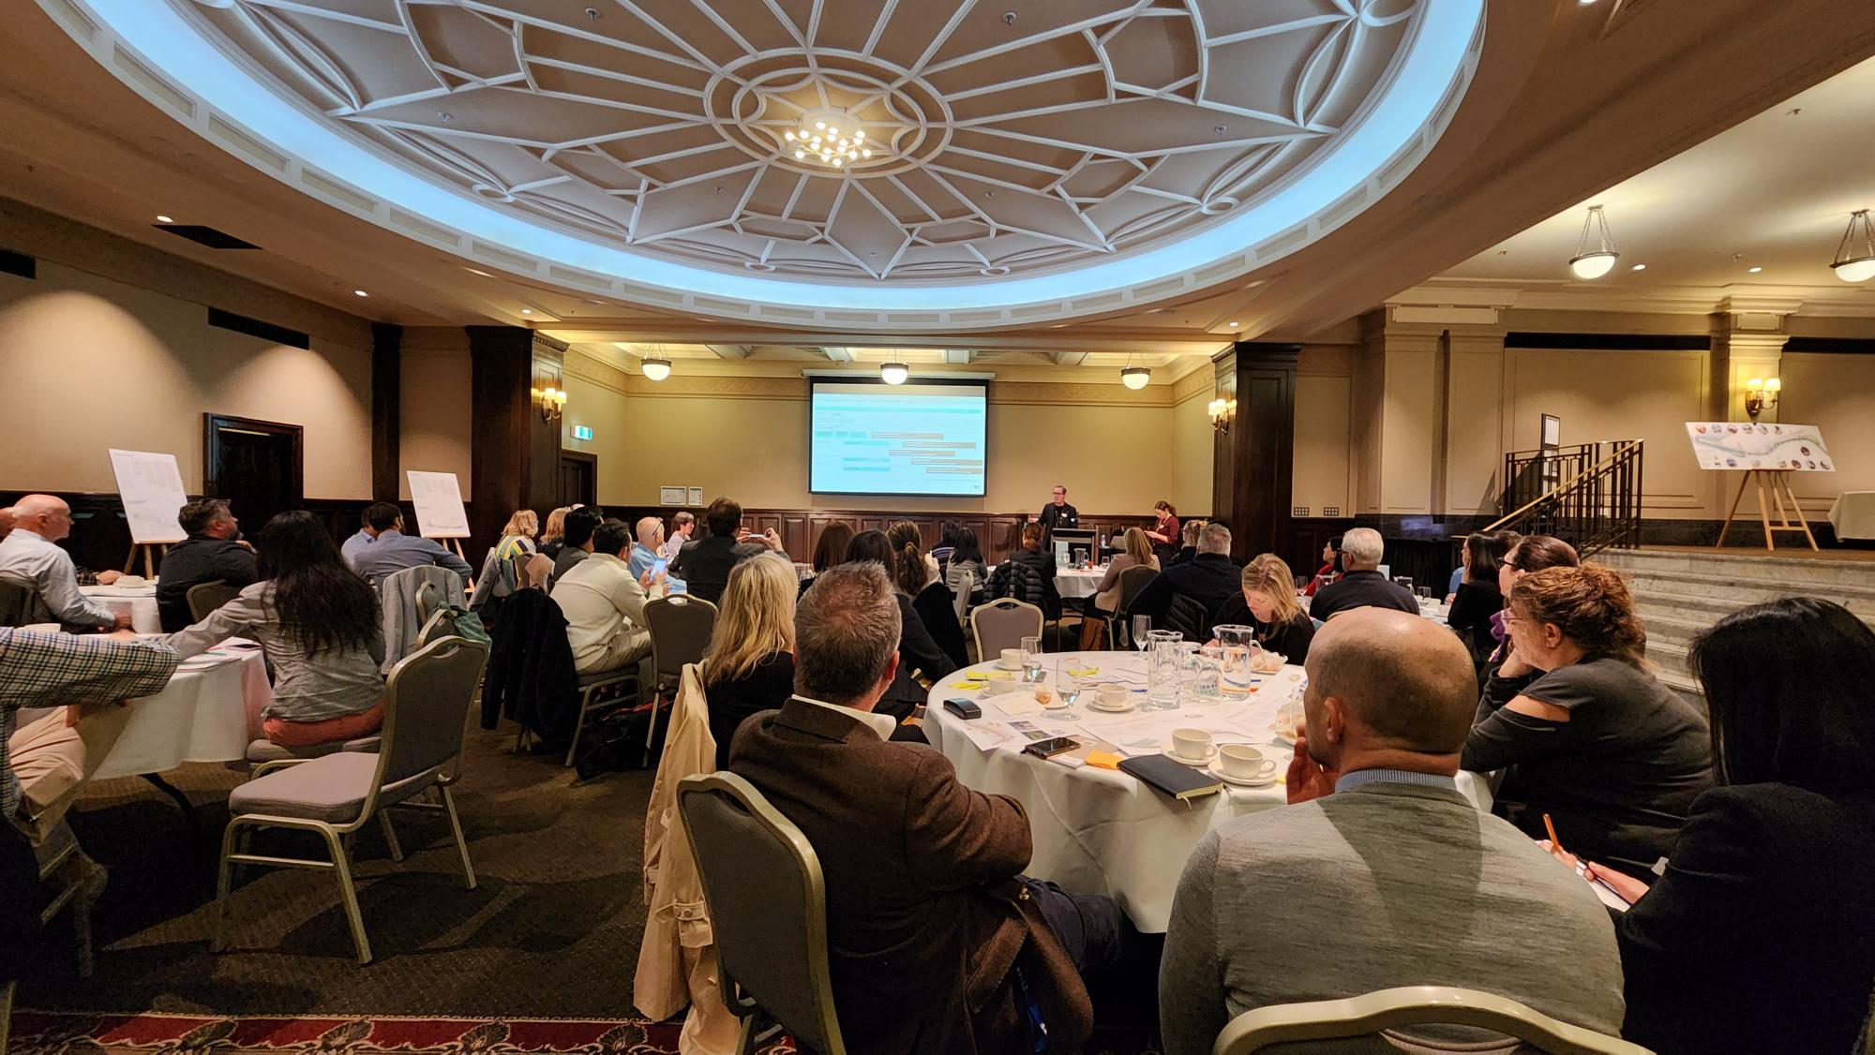
Figure 10: Stakeholder workshop

Further considerations
Overall, stakeholders expressed excitement for the Greenline Project and support for the draft Master Plan. Participants were asked to provide feedback on areas and details that needed to be further considered as the Master Plan is being finalised. A range of feedback was received with common themes, including:
- Engaging experience through storytelling – participants shared that the Master Plan should demonstrate histories and cultures of the project area through a whole-of-journey approach. Participants suggested that storytelling should also present the intangible heritage of the north bank to create an interesting and engaging experience.
- Environmental sustainability and circular economy – participants commented that the Master Plan should consider opportunities to support circular economy which contributes to environmental sustainability through resource recovery and waste reduction. Some participants emphasised the importance of ensuring river health and waterway quality through effective water management and design considered in the Master Plan.
- Active transport and movement – participants expressed support for active transport and pedestrian walkability proposed in the Master Plan. There were comments that the Master Plan needs to consider the Greenline Project area as both a destination and pathway in the city, to explore measures that will ensure the safety and comfort of pedestrians and cyclists. Specific suggestions included separating cycling and pedestrian paths and addressing wind corridors along the north bank.
- Connection to surrounding sites of interest – participants shared feedback for the Greenline Project to integrate with surrounding sites and key infrastructure, such as connection to Flinders Street Station and the Hoddle Grid from Enterprize Park area.

Future involvement in the Greenline Project
Participants shared insights into how the Greenline Project should continue to involve communities and stakeholders as the project progresses, ideas included to:
- continue to involve diverse community members and stakeholder groups in Precinct Planning, such as resident groups and rowing clubs
- use easy-to-understand communication materials to engage with a wider range of community members with varied levels of English literacy
- keep in touch with businesses and developers to identify partnering opportunities, specifically regarding other construction and developments surrounding the Greenline Project such as Central Pier Revitalisation and the opening of Metro Tunnel
- communicate clear engagement timelines and scope in future stages of the Greenline Project.

Moving forward
Participants shared reflections on the Greenline Project and the Master Plan. Figure 11 displays the top three words that participants associated with the Greenline Project. Words most mentioned were ‘transformative’, ‘ambitious’, and ‘connection’, which resonated with comments gathered from stakeholders through this stage of engagement. Some participants raised topics they would like to learn more about as the Project progresses, including:
- project funding, delivery program and timeline
- precinct design and planning
- land tenancy and land management considerations.
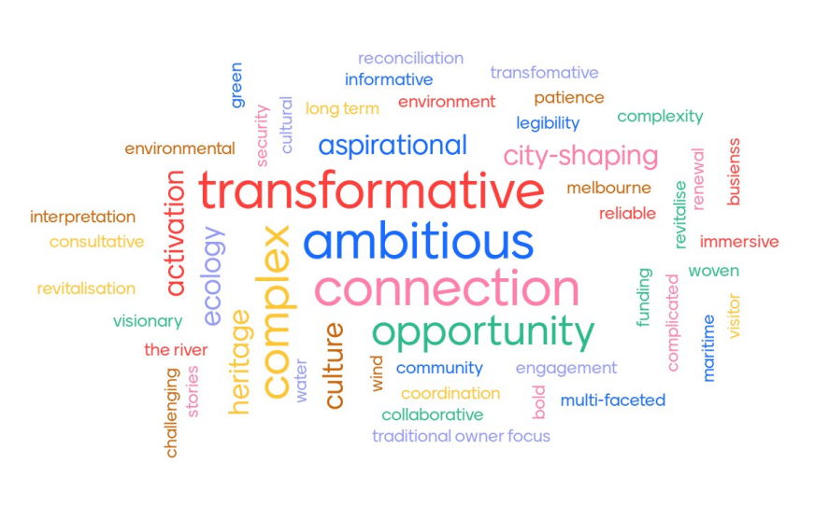
Figure 11: Top words associated with the Greenline Project shared by workshop participants

Next steps
The feedback collected from this phase of engagement will be used to finalise the Master Plan. As shown in Figure 12, Precinct Plans and concept designs will be developed following the approval of the Master plan. The City of Melbourne will continue to conduct individual and collective discussions with community and stakeholder groups as the Greenline Project progresses.
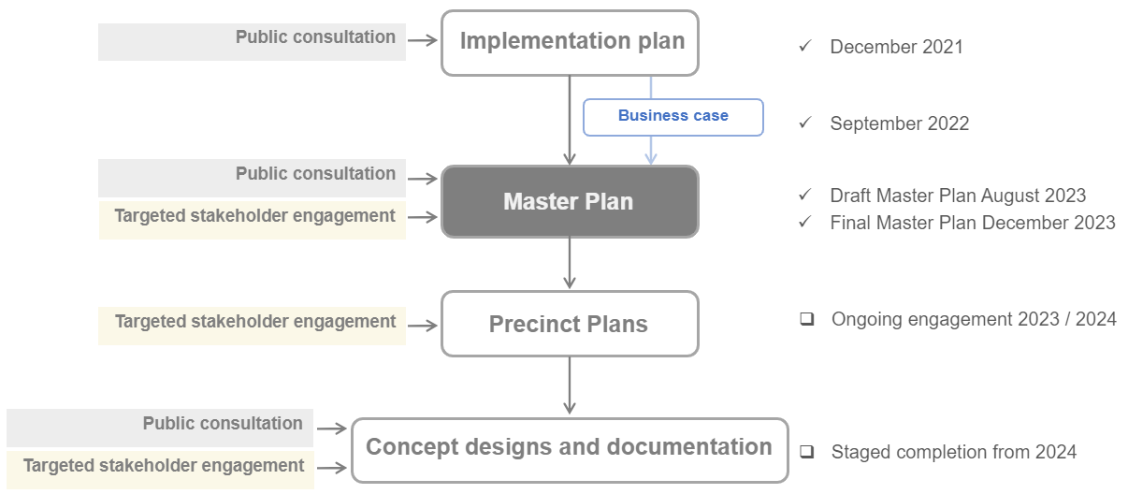

Figure 12: Indicative project timeline

- Survey questions

QUESTION 1: How well do you think the Greenline Project Draft Master Plan communicates a vision for the revitalisation of the north bank of Yarra River - Birrarung?
QUESTION 2: How well do think we've responded to feedback on these key themes –
- Health & Wellbeing of Country
- River ecology & environment
- Safety, accessibility and inclusion
- Pedestrians and active transport
QUESTION 3: Do you have any other comments or feedback that we should consider as we finalise the Greenline Project Master Plan?

Capire Consulting Group
The Commons,
Wurundjeri Country
36-38 Gipps Street,
Collingwood VIC 3066
(03) 9285 9000
info@capire.com.au
capire.com.au

Capire acknowledges
and deeply respects the Wurundjeri people and
the Traditional Owners
of the Victorian land.

