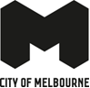

New community hub in North Melbourne
Phase 1 Community Engagement Report

Prepared by
Community Development
Community and City Services
City of Melbourne
23 October 2023

The City of Melbourne respectfully acknowledges the Traditional Owners of the land we govern, the Wurundjeri Woi-wurrung and Bunurong / Boon Wurrung peoples of the Kulin and pays respect to their Elders past and present. We acknowledge and honour the unbroken spiritual, cultural and political connection they have maintained to this unique place for more than 2000 generations.
We accept the invitation in the Uluru Statement from the Heart and are committed to walking together to build a better future.

Table of contents

- Executive summary 4
- The conversation 8
- Engagement approach and activities 9
- Who we heard from 10
  - Survey participants 10
    - Gender 10
    - Age 10
    - Other key demographic groups 11
    - Connection to this City of Melbourne project 12
    - Previous participation in City of Melbourne consultations 13
    - Motivations to participate in this consultation 13
    - Community workshops 14
  - Community pop ups 14
- What we heard 16
  - Additional insights into neighbourhood priorities for North Melbourne 16
  - Features that community would like to see at the new community centre 18
    - Prioritising features 18
    - What the new centre’s features could look and feel like 19
    - What makes priority features important 20
    - Additional services and facilities that important to the community 23
  - How the new community centre should look and feel 25
    - Look 25
    - Feel 25
  - Insights from current use and experiences of the existing North Melbourne Community Centre and the Jean McKendry neighbourhood Centre 27
    - North Melbourne Community Centre 27
    - Jean McKendry Neighbourhood Centre 28
    - Insights into why community members haven’t used services and facilities at these centres that they are interested in 28
- Impact 30
- Next steps 31
- Appendices 32

Executive summary
The conversation
The City of Melbourne is building a new multi-purpose community hub in North Melbourne to meet existing and future demand. The new hub will be located at 91-115 Melrose Street, the current site of the Jean McKendry Neighbourhood Centre (JMNC) and Hotham Hub. It will be 3,000 square meters in size. For comparison, the existing North Melbourne Community Centre (NMCC) is 1,500 square meters.
The new hub will include:
- Youth, family and ageing services; and
- Additional services to be decided on following engagement with the community so we best meet the neighbourhood’s needs.
Phase 1 of community engagement (August – October, 2023) gathered community input on:
- Preferred services and spaces; and
- What the centre should look and feel like.
Phase 1 engagement approach and who we heard from
Consultation was open on Participate Melbourne from 16 August to 5 October 2023. During this time, we received 2,504 Participate Melbourne webpage views and 327 surveys (a mix of paper and online).
We also held 3 community workshops and we interacted with 826 community members at 30 pop ups across the neighbourhood. Workshops enabled deeper conversations, while pop ups helped to raise awareness and encourage survey participation, particularly amongst community members who many not otherwise heard about the engagement through online channels or established connections to existing centres or community groups.
Additional insights into neighbourhood priorities for North Melbourne
Through consideration of previous community engagement including the 17 neighbourhood priorities for North Melbourne, seven priority issues relevant to design and construction of the new community hub were identified. We asked survey participants how important each priority issue was to them. The priority issues that scored highest, with more than 80% of survey participants listing as ‘Very important’, were:
- Parks, outdoor open and green space
- Building design that responds to community needs, sustainability and cultural safety
- Community hubs with multiple services that bring the community together
City of Melbourne will use what we learned about the importance of these priority issues to help ensure the design and services at new community hub contributes to broader neighbourhood priorities.

Features of the new community centre
We asked participants to rank their top three of eight community centre features in order of importance. A ranking of 1 indicated the highest preference, so the lower the score the more highly rated it was. Although close average rank scores reinforce a strong preference for all features, survey participant ranked these features in the following order:
- Spaces for people to spend time casually (Average rank 1.79)
- Culturally safe spaces (e.g. breakout rooms for prayer) (Average rank 1.86)
- Design that includes flexible space for group activities (Average rank 2.00)
- Spaces that encourage learning (Average rank 2.04)
- Design that includes open space (Average rank (2.05)
- Creative and fun spaces AND/EQUAL RANK Meeting spaces for the community (Average rank 2.06)
- Design and mix of spaces that bring the community together (Average rank 2.11)
Participants in the general community workshop found it difficult to prioritise just three features, highlighting that the features are not necessarily mutually exclusive (e.g. spaces that encourage learning can be part of design and mix of spaces that brings the community together).
Through survey comments, workshop discussions and pop-up activities we also heard what these features could look and feel like. For instance, for community members, a space to spend time casually includes somewhere to meet up with friends on the spur of the moment without needing to book, a relaxed and calm atmosphere, ample space to mingle in and a variety of seating options such as benches, tables and chairs. On the other hand, culturally safe spaces feel like a generally welcoming and inclusive atmosphere where people come together to learn grow and connect, as well as specific features such as a dedicated prayer room and wash facilities with appropriate doors, windows and blinds.
When we asked participants what makes their preferred features important, the two most common themes across all responses were:
- Addressing a lack of a certain resource and opportunities within the North Melbourne neighbourhood.
  - For instance, participants highlighted that the high proportion of apartment living in North Melbourne means community members often have limited space in their homes for spending time with causally with others (e.g. “somewhere just hang out with friends”), space for groups of people to gather and open green space.
- Creating opportunities to bring diverse people together to encourage social interaction and build social connections.
  - For instance, one survey participant commented “It should be FOR the community to gather, meet and share ideas and bring people together from all backgrounds. There should be work towards social cohesion and inclusion. Not to focus on one small group but ways a building design can bring people together build sense of community.
What we heard about the importance of these features, and what these features could look and feel like, will inform the design of the new hub. Learning why these features are important also helps City of Melbourne understand how the new community hub can help to support the underlying needs of the community.
Additional services and facilities
Participants also suggested additional services and facilities not explicitly identified in the eight features discussed. Commonly identified services and facilities include:
- Recreation (e.g. light recreation for mature-aged people, soccer space, basketball, gym, Pilates and yoga)
- A swimming pool (heated indoor especially)
- A women empowerment services/design focus
- Office space for charities and community groups to hire
- A café or cafeteria
- Commercial and community kitchen facilities
- Children focused facilities and spaces (e.g. secure play area, on-site childcare and school holiday activity program)
- Low-cost services and low facility hire rates
- Community garden
- BBQ for community use
- Toy library
Communication materials provided to support this engagement informed participants of three services areas to be included in the centre (youth, family and ageing) and the potential for further services to be added. The findings of this engagement will be used to guide Council decisions on the possible inclusion of Children’s Services or Library Services.
City of Melbourne will consider these suggestions in the design of the new hub, both as distinct additions and potential considerations as part of other features (e.g. how open space can be optimised for recreation, how creative and fun spaces can be designed with women and children in mind).
Overall look and feel of the new hub
We asked participants what a good community centre or hub looks and feels like. In terms of appearance, participants highlighted elements of the materials and layout such as natural light, a clear entrance and welcoming street scape and better car parking. Participants also highlighted the design should be accessible for all abilities, safe for neurodivergent people and makes you want to venture further inside as soon as you walk in. We heard maintenance of the centre is paramount, as is more effective communication about events and activities happening at the centre.
We heard that a welcoming, supportive and safe atmosphere where no one group dominates, and friendly staff with strong local connections who greet you with a smile upon entry are central to what a good community centre feels like. Up to date programming, including weekend and evening activities, as well as flexible programs that allow people to join for just one class or at last minute, and visible celebrations of the local community (e.g. artworks of neighbourhood champions) also contribute to the feel of a good community centre.
This feedback will shape how City of Melbourne’s City Design team brings the features and technical elements of the new hub’s design together in an integrated and coordinated way that aligns with community needs and interests.
Current and desired use of the existing centres and barriers
We asked participants about their use and experiences of the existing North Melbourne Community Centre and the Jean McKendry Neighbourhood Centre. These insights can inform the design and operation of the new community hub. We heard the North Melbourne community have particularly wanted to use community halls, kitchens and meeting rooms at both centres, but haven’t been able to for a number of reasons. Common barriers identified include:
- Booking system difficult to use
- Facilities/spaces not available when I wanted to use them
- Opening hours limited (e.g. not open on weekends)
- Facilities/spaces not suitable to needs (e.g. no lockable storage space, space not large enough)
- Expensive to hire
- Lack of parking
We also gathered feedback on experiences of each centre as a whole, with participants sharing that
- The Jean McKendry Neighbourhood Centre can feel closed, exclusive and not welcoming to people who do not belong to established groups with a long-standing booking
- The North Melbourne Community Centre building and facilities is outdated and poorly maintained and can be unwelcoming (particularly if you have not visited the centre before)
This knowledge will help City of Melbourne to prioritise spaces in the design of the new hub begin planning for future management and operating principles (e.g. booking systems, usage terms, opening hours, communication methods).
Impact and next steps
City of Melbourne is utilising feedback from Phase 1 of the new community hub in North Melbourne community engagement to prepare a draft concept design for the new hub.
After the draft concept design is presented for review by Council, Phase 2 of the community engagement will invite the community to provide feedback on draft designs. We anticipate engagement Phase 2 will begin early-mid 2024, with detailed design started by late 2024.

The conversation
City of Melbourne is committed to providing a new community hub in North Melbourne to replace existing facilities, which are approaching the end of their lifespan and won't meet future community needs.

The new hub will be located at 91-115 Melrose Street, the current site of the Jean McKendry Neighbourhood Centre (JMNC) and Hotham Hub. It will be 3,000 square meters in size. For comparison, the existing North Melbourne Community Centre (NMCC) is 1,500 square meters.
The Melrose precinct in North Melbourne is one of the most rapidly growing parts of the municipality and the existing City of Melbourne community facilities are already fully utilised. In several different rounds of engagement with the community, we’ve heard consistent requests for more services to be provided and for existing facilities to be replaced with a new community centre or hub.

The new hub will include:
- Youth, family and ageing services; and
- Additional services to be decided on following engagement with the community so we best meet the neighbourhood’s needs.
By engaging with community and service providers to gather insights on what the community needs and by using the best design principles we can create a centre that supports the needs of local residents and builds stronger community connections for a more resilient North Melbourne community.

Phase 1 of community engagement gathered community input on:
- Preferred services and spaces; and
- What the hub should look and feel like.
This engagement was open from 16 August to 5 October 2023 (seven weeks). This period includes an extension to the original close date (22 September), to allow further engagement with key stakeholder groups.

Engagement approach and activities
The primary objective of this engagement was to understand what mix of community services, spaces and features the community would like to see at the new community centre in North Melbourne.
The engagement approach combined:
- Activities targeting specific community segments (e.g. existing users of the Jean McKendry Neighbourhood Centre, the North Melbourne Community Centre, North Melbourne Language and Learning Centre, public housing tower residents and sporting groups); and
- Activities targeting the broader North Melbourne community who may not already be connected with community centres, sporting groups, community centres etc. through a physical presence of City of Melbourne staff in visible and high traffic public places such as shopping centres, Errol Street, dog parks and cafes.
We also adopted a particular focus on people under the age of 30, people who were born overseas and people who speak a language other than English at home to help engage these “hard to reach” groups and thus ensure an inclusive engagement approach. For instance, City of Melbourne made paper surveys available in English, Arabic, Vietnamese and Simplified Chinese via staff at the Jean McKendry Neighbourhood Centre and community pop ups. Promotional posters were also printed in Arabic, Somali, Simplified Chinese and Vietnamese (see Appendix 2 for examples). In terms of reaching young people, City of Melbourne utilised specifically geo-targeted paid social media advertisements to create awareness amongst the 18-35 year old demographic in North Melbourne.
Other communication channels employed included the Participate Melbourne newsletter, other appropriate newsletters (e.g. ‘Melbourne: A Great Place to Age’), Melbourne Magazine, hyperlocal news outlets and other mainstream media opportunities such as newspaper features. Print communication materials included postcards (see Appendix 3) distributed to local businesses, public housing towers, sporting clubs, and other public venues, as well as corflute posters positioned around the neighbourhood.
During the seven weeks of consultation, we received 2,504 views the Participate Melbourne webpage and 327 surveys (both online and paper, see survey questions Appendix 1).
We also conducted 3 workshops with community members and held 30 community pop ups which enabled us to interact with 826 community members. Workshops created a forum for deeper conversations, while pop ups helped to raise awareness and encourage survey participation, particularly amongst community members who many not otherwise heard about the engagement through online channels or established connections to existing centres or community groups. The following section provides further detail on each engagement activity.
City of Melbourne staff analysed qualitative data (survey comments, workshop notes etc.) through a process of manually coding data to identified key themes. City of Melbourne staff applied basic statistical analysis to quantitative survey data. This report synthesises analysis of both qualitative and quantitative data gathered through the survey, workshops and pop ups.

Who we heard from

Survey participants

Gender
Most survey participants were female (64.17%). This higher proportion of females is not uncommon for community engagement surveys.
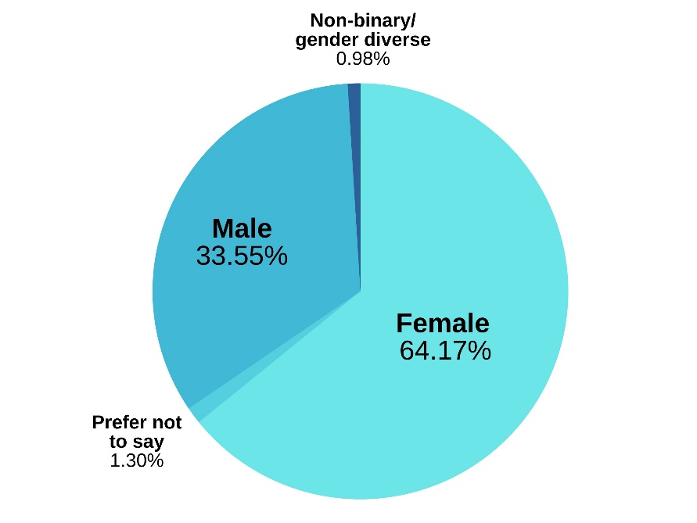

Age
Most survey participants were between the ages of 30 and 34 years (13.64%), followed by 35-39 years (11.69%) and 25-29 years (10.71%). This result aligns with the demographic make-up of North Melbourne. The majority of North Melbourne community members are aged between 20 and 32 years old, with a median age of 31 years (ABS Census, 2021).

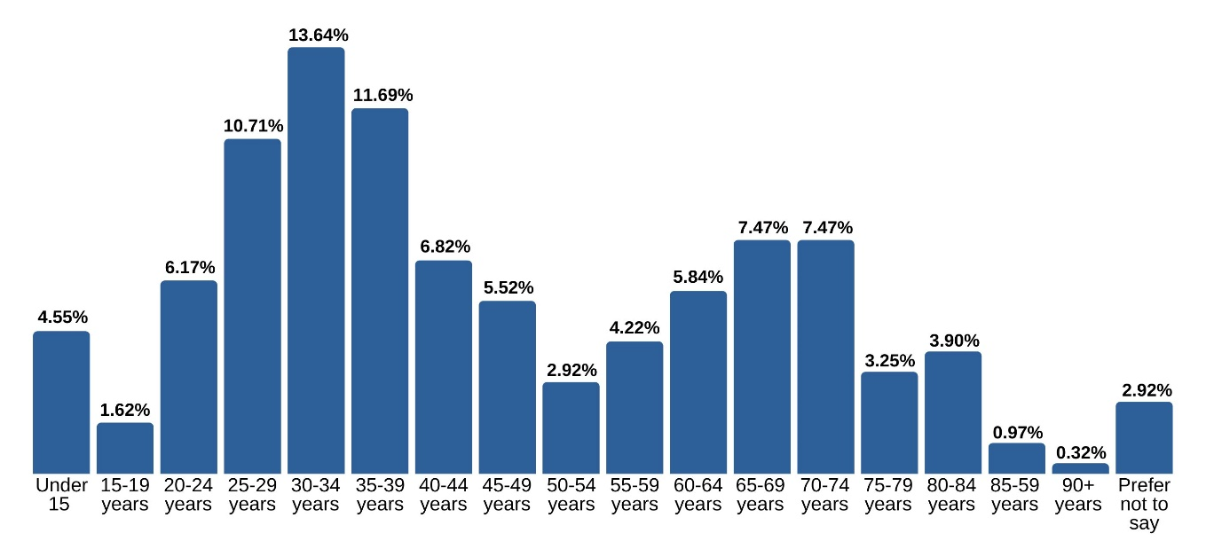

Other key demographic groups
44.48% of survey participants speak a language other than English and 34.45% were born overseas. According to the ABS Census 2021, 38% of North Melbournians speak a language other than English and 42% were born overseas. Survey participants thus slightly exceed the neighbourhood population quotas for speaking a language other than English, whereas slightly less survey participants were born overseas compared to the neighbourhood population quota.
Languages other than English spoken by survey participants at home include: Chinese, Cantonese, Arabic, Serbian, Mandarin, Oromo and Somali.
Representation from other key demographic groups such as LGBTIQ, people with disability, carers and Aboriginal people in survey data was comparatively lower. This result suggests future phases of community engagement for the new community centre in North Melbourne should employ engagement activities targeted to these groups.

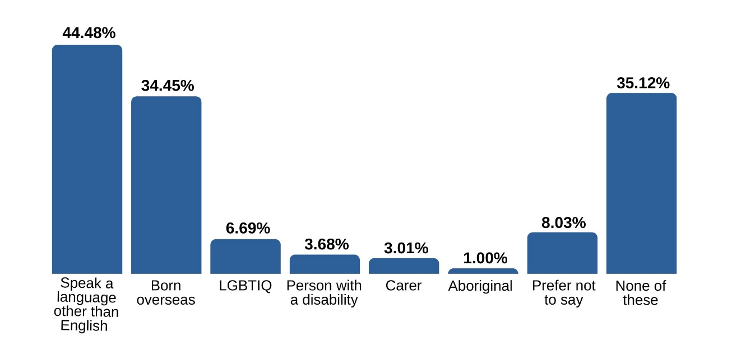
Note: To access more information on the demographics of North Melbourne, visit the North Melbourne community profile on profile.id or the North Melbourne Neighbourhood Portal.

Connection to this City of Melbourne project
The majority of participants (76.11%) of participants live, work, own a business, study or visit North Melbourne. Kensington, West Melbourne, Parkville and CBD were the neighbourhoods with the next highest survey participation.
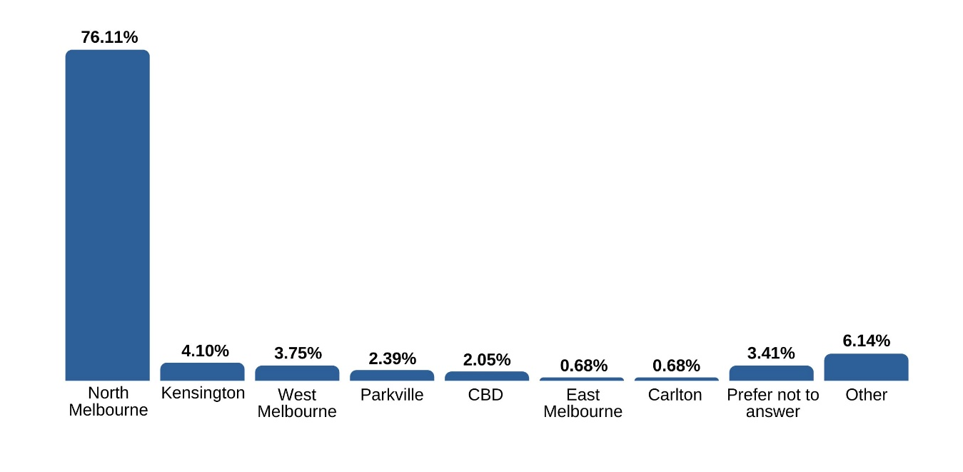
Of the participants with a connection to North Melbourne, most (72.20%) live in the neighbourhood, followed by local workers (10.31%) and visitors (7.62%).
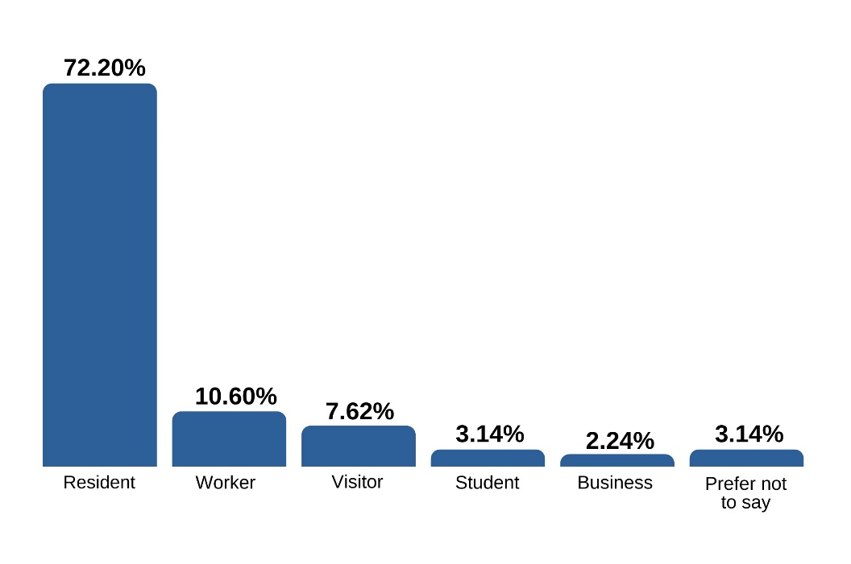

Previous participation in City of Melbourne consultations
Over half (59.79%) of survey participant had not participated in a City of Melbourne consultation before this survey. This result suggest that the engagement and communications approaches were effective at helping to ensure City of Melbourne hears a diverse range of voices through this engagement.
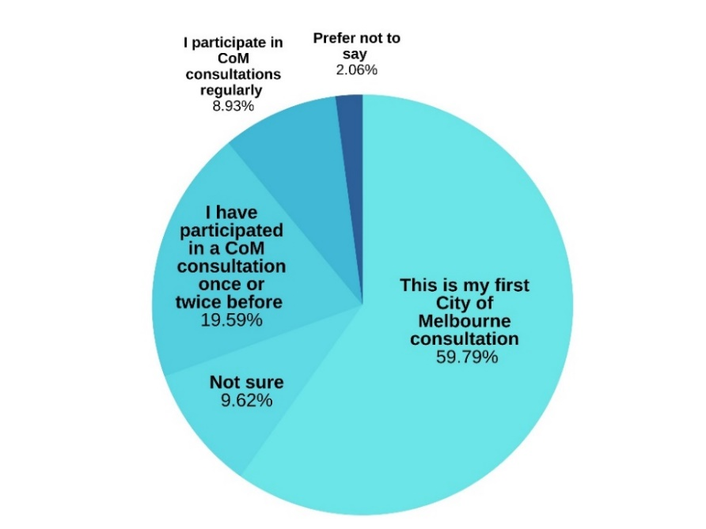

Motivations to participate in this consultation
Over 40% of survey participants were passing by or approached by a City of Melbourne staff member at a community pop up for this community engagement. Additionally, the finding that nearly half (46.88%) of survey participants identified that this project directly impacts them reinforces the effectiveness of the engagement and communications approach at creating awareness amongst community members who are impacted by the future development of a new community centre or hub in North Melbourne.
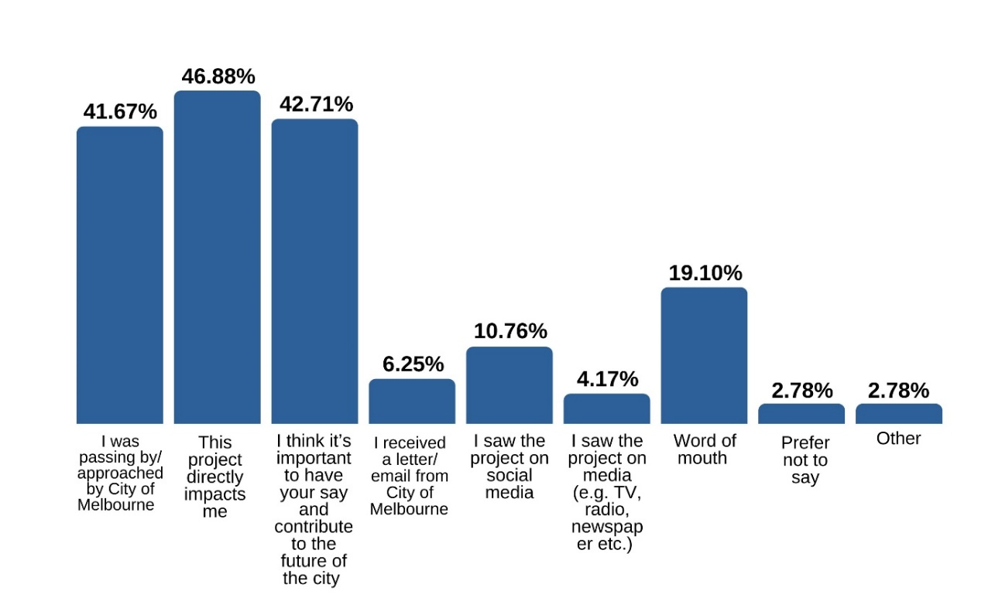

Community workshops
- Workshop with young females in collaboration with The Huddle
  - 12 female participants between the ages of 10-16 years
  - Date: Thursday 14 September 2023
- General community workshop advertised on Participate Melbourne
  - 6 participants of varied demographics
  - Date: Tuesday 19 September 2023
- Workshop with young males who play soccer at the existing NMCC
  - 6 male participants between the ages of 20 and 30 years
  - Date: 14 September 2023

Community pop ups
A total of 30 community pop ups were held across North Melbourne at a variety of times (see table summary below). Pop ups focused on:
- Creating awareness of the engagement and online survey;
- Distributing postcards with a QR code to the Participate Melbourne page (and online survey), and;
- Encouraging community members to complete a survey ‘on the spot’ with City of Melbourne staff.
City of Melbourne staff also facilitated interactive activities (an ideas board and voting exercises) at two of the pop-up locations (Arden Gardens Shopping Centre and North Melbourne Library). The table below shows the total number of community members staff interacted with at each pop up, combining to make a total of 825 interactions.
Time | Location | Total interactions
Wednesday 16 August (10am-11am) | North Melbourne Community Centre | 35
Wednesday 16 August (11.15am-12.15pm) | Jean McKendry Neighbourhood Centre | 15
Thursday 17 August (11am-12pm) | Jean McKendry Neighbourhood Centre | 60
Thursday 17 August (12.15pm-1.15pm) | North Melbourne Community Centre | 5
Friday 18 August (10am-11am) | Melrose Street Shops | 20
Saturday 19 August (10.30am-11.30am) | North Melbourne Community Centre | 23
Monday 21 August (1pm-2.30pm) | North Melbourne Recreation Centre | 17
Monday 21 August (10am-12pm) | Jean McKendry Neighbourhood Centre | 50
Wednesday 23 August (3.30pm-5pm) | North Melbourne Language and Learning | 30
Thursday 24 August (5pm-6.30pm) | North Melbourne Community Centre | 23
Friday 25 August (11am-12pm) | North Melbourne Library/Errol Street | 39
Saturday 26 August (11.30am-1pm) | Arden Gardens Shopping Village | 41
Monday 28 August (12.30pm-1.30pm) | Jean McKendry Neighbourhood Centre | 15
Monday 28 August (1.3opm-2.30pm) | North Melbourne Community Centre | 15
Tuesday 29 August (10.30am-11.30am) | Melrose Street Shops | 35
Wednesday 30 August (1pm-2.30pm) | Melrose Street Shops | 25
Saturday 2 September (10.30am-11.30am) | Elephant Café, Flemington | 12
Saturday 2 September (11am-12.30pm) | Clayton Reserve Dog Park | 12
Sunday 3 September (12.30pm-1.30pm) | North Melbourne Library/Errol Street | 23
Tuesday 5 September (10.30am-11.30am) | North Melbourne Language and Learning | 25
Wednesday 6 September (8.00am-9.30am) | North Melbourne Recreation Centre | 75
Thursday 7 September (4.30pm-6.00pm) | Arden Gardens Shopping Village | 20
Friday 8 September (10am-11.30am) | Jean McKendry Neighbourhood Centre | 70
Saturday 9 September (11am-12pm) | Hotham Hub (Toy Library) | 10
Monday 11 September (10.30am-12pm) | North Melbourne Library | 20
Tuesday 12 September (10.30am-11.30am) | Flemington Hub | 35
Tuesday 12 September (3pm-5pm) | North Melbourne Community Centre | 23
Thursday 14 September (2.30pm-3.30pm) | Flemington Hub | 18
Friday 15 September (1pm-2.30pm) | Australian Muslim Social Services Agency | 35

What we heard

Additional insights into neighbourhood priorities for North Melbourne
Through consideration of previous community engagement including the seventeen neighbourhood priorities for North Melbourne, seven priority issues relevant to design and construction of the new community centre were identified. We asked survey participants to identify how important these seven priorities are to them.
City of Melbourne will use this information to help ensure the design and services at the new community centre contributes to broader neighbourhood priorities.
As the graph below shows the top three priority issues that survey participants (80% or more) identified as ‘Very important’ were:
- Parks, outdoor open and green space
- Building design that responds to community needs, sustainability and cultural safety
- Community hubs with multiple services that bring the community together
Over 70% of survey participants identified a further three priorities as ‘Very important’:
- Community meeting spaces, including spaces for informal socialising
- People living on lower incomes continuing to call North Melbourne home
- Community facilities with adaptable design
60% of survey participants identified the remaining priority as ‘Very important’:
- Recreation and sports facilities for the community
The relatively high proportion of ‘Very important’ ratings across all priorities reinforces the salience of all seven priorities to North Melbournians.
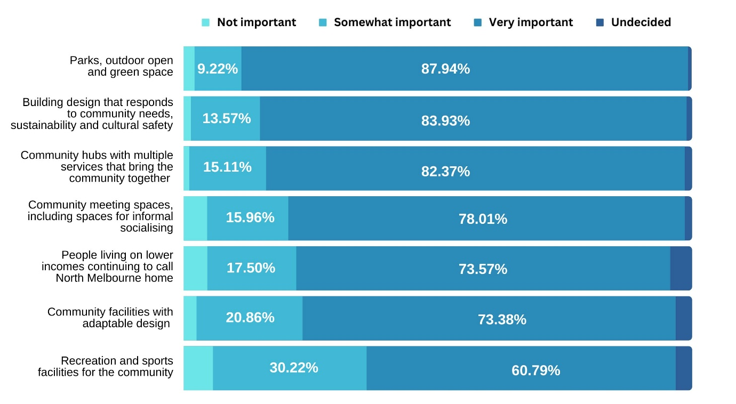
The table below provides the same survey data in a table format.
 | Not important | Somewhat important | Very important | Undecided
Parks, outdoor open and green space | 2.13% | 9.22% | 87.94% | 0.71%
Building design that responds to community needs, sustainability and cultural safety | 1.43% | 13.57% | 83.93% | 1.07%
Community hubs with multiple services that bring the community together | 1.08% | 15.11% | 82.37% | 1.44%
Community meeting spaces with, including spaces for informal socialising | 4.61% | 15.96% | 78.01% | 1.42%
People living on lower incomes continuing to call North Melbourne home | 4.64% | 17.50% | 73.57% | 4.29%
Community facilities with adaptable design | 2.52% | 20.86% | 73.38% | 3.24%
Recreation and sports facilities for the community | 5.76% | 30/22% | 60.79% | 3.24%

Features the community would like to see at the new community hub

Prioritising features
When we speak with community members in North Melbourne about what makes a great community centre, these are some of the features we have heard:
- Meeting spaces for the community
- Culturally safe spaces (e.g. breakout rooms for prayer)
- Design and mix of services that brings the community together
- Design that includes open space
- Design that includes flexible space for group activities
- Spaces to spend time casually
- Creative and fun spaces
- Spaces that encourage learning
Survey participants were asked to rank their top three features in order of importance. The features in order of preference are as follows:
Feature | Average rank
Spaces for people to spend time casually | 1.79
Culturally safe spaces (e.g. breakout rooms for prayer) | 1.86
Design that includes flexible space for group activities | 2.00
Spaces that encourage learning | 2.04
Design that includes open space | 2.05
Creative and fun spaces  AND/EQUAL RANK  Meeting spaces for the community | 2.06
Design and mix of spaces that brings the community together | 2.11

Average rank reported in the table above indicates highest overall preference for spaces for people to spend time casually, and culturally safe spaces. However, the remaining six features received very similar average ranks and thus represent a tight second preference tier of close importance to survey participants (with only .11 average ranks between them).
Participants in the general community workshop found it difficult to prioritise just three features, highlighting that the features are not necessarily mutually exclusive (e.g. spaces that encourage learning can be part of design and mix of spaces that brings the community together).

What the new centre’s features could look and feel like
Participants described what the new centre’s features could look and feel like in survey comments, workshop discussions and pop-up activities.
Feature | What feature could look and feel like
Spaces for people to spend time casually | - Space to casually hangout with friends, mingle, make new friends, “drop in for a cup of tea”, relax and unwind  - Space dedicated for youth to hang out  - A coffee area for casual meet ups  - A space we can meet up with friends and neighbours on the spur of the moment without having to book  - A variety of seating options including benches, tables and chairs  - Plenty of space for people to move around and interact with each other  - A relaxed, calm and inviting atmosphere
Culturally safe spaces (e.g. breakout rooms for prayer) | - A place where anybody is welcome, regardless of their ethnicity, social background or any other characteristic  - An inclusive and welcoming atmosphere where people come together to learn, grow and connect with each other  - Separate dedicated prayer rooms and wash facilities with appropriate doors, windows and blinds (e.g. sound insulation, making prayer mats available)
Design that includes flexible space for group activities | - Spaces that can be used for various activities that target different groups such as meetings, workshops, fitness classes, performances and meeting and conference rooms (rather than specific rooms for specific purposes)  - Storage space for community groups who only operate from the centre during certain times
Spaces that encourage learning | - Library services and space (including spaces for quiet study and reading)  - Language classes  - Cooking classes  - Educational services for young people (e.g. tutoring, homework club)
Design that includes open space | - Indoors blends naturally with green open space outdoors to encourage a feeling of openness, relaxation and wellness  - Outdoor areas that can be used for a variety of purposes such as relaxation, leisure, cultural gatherings and festivals particularly given many North Melbourne residents live in apartments with little or no greenery/open space
Creative and fun spaces | - Music, choir or karaoke rooms and classes  - Movie theatre and room with a large television to watch sports together  - Craft rooms and/or classes  - Visual art (e.g. painting) rooms, classes and exhibitions  - Games room with a pool table, table tennis etc.  - Podcast studio
Meeting spaces for the community | - Spaces that community members can easily book to come together as groups to interact, collaborate, exchange ideas and plan activities  - Welcoming and accessible spaces that act as hubs for social interaction and therefore encourage community organising and civic participation  - Spaces suitable for groups of 15 or more with lectern, AV and microphone or area for presentation for businesses or organisations and talks by special guests
Design and mix of spaces that brings the community together | - A multi-purpose space with a focus on community connection  - Diverse programs and activities that bring people from diverse backgrounds who don’t know each other together and encourage informal interactions  - Space to host events that celebrate diversity and bring the community together  - Facilities and services designed for people who do not play sport  - Up to date programming at all times of day (including evening)

What makes priority features important
The survey asked participants what makes their preferred features important. The two most common themes across all comments related to the importance of particular features were:
- Addressing a lack of a certain resource and opportunities within the North Melbourne neighbourhood. For instance, participants highlighted the high proportion of apartment living in North Melbourne means that community members often have limited spaces in their homes for spending time with causally with others (e.g. “somewhere just hang out with friends”), space for groups of people to gather and open green space.
- Creating opportunities to bring diverse people together to encourage social interaction and build social connections. For instance, one survey participant commented “It should be FOR the community to gather, meet and share ideas and bring people together from all backgrounds. There should be work towards social cohesion and inclusion. Not to focus on one small group but ways a building design can bring people together build sense of community.”
Consistent with this feedback, we know from ABS Census 2021 data that more than 70% of North Melbournians live in apartments, whether that be public housing towers around Boundary Road, in private medium-density complexes, or contemporary warehouse conversations.
Community input gathered through this survey helps City of Melbourne understand how the new community hub can support the underlying needs of the community.
We also synthesised comments providing insight into the importance of particular features.
Feature | Why this feature is important | Example comments
Spaces for people to spend time casually | - Informal and casual use spaces make people feel relaxed and welcome  - These spaces create opportunities to meet new people organically  - People who live in high rises in North Melbourne currently have limited access to spaces to spend time casually with other people  - Interacting casually is important for all age groups, from children and youth to mature aged | “[North Melbourne is currently] lacking spaces to relax or meet friends and to feel safe and welcome”
Culturally safe spaces (e.g. breakout rooms for prayer) | - The North Melbourne community is culturally diverse and it is important that everyone feels safe  - Providing spaces such as prayer rooms in the centre means that people can stay at the centre for longer (e.g. without having to return home to pray) | “The North Melbourne community has many different cultural backgrounds. The need for affordable meeting rooms and places to learn are of vital importance. It’s also important that these people have places to pray and feel safe.”
Design that includes flexible space for group activities | - Flexible spaces can help to ensure the centre can be used by all people, not just a specific groups | “The existing centre could do more but its often booked and there is not flexibility in how to use it”
Spaces that encourage learning | - Learning and education is fundamental to self-development  - Gaining new skills helps individuals supports community development | “Learning opportunities would help me feel part of this community.”
Design that includes open space | - Access to open green space and nature is fundamental to human wellbeing  - People who live in high rises in North Melbourne currently have limited access to open green space  - Open space also provides opportunities for social interaction and communal gathering (both informal/casual and formal/organised) | “Open green space and gardens is important because north Melb is a built up area and we need every precious garden and green space we can get. They are very well used.”
Creative and fun spaces | - It is important to have fun!  - These spaces also provide opportunities for social interaction  - These spaces will help to attract children (and their families, siblings etc.)  - There is currently a lack of creative, fun and safe spaces and programs for youth in North Melbourne | “Provide more chances to meet other people”
Meeting spaces for the community | - People who live in high rises in North Melbourne currently have limited access to spaces to gather as medium-to-large groups  - Groups within North Melbourne need more access to space to run activities for the community  - Meeting spaces allow for open discussion, teamwork, idea sharing and collaborative decision making  - These spaces can be used for an array of purposes (e.g. birthday parties, guest speakers) | “My friends and I need spaces for events we're planning for community”
Design and mix of spaces that brings the community together | - Interacting with diverse members of the community creates opportunities to meet new people and can encourage a sense of belonging  - North Melbourne is culturally diverse, but we need initiatives to bring us together and provide opportunities for cross-cultural connections | “To increase community connectedness.”

What we heard about the importance of certain centre features, and what these features could look and feel like, will inform the design of the new hub.

Additional services and facilities that are important to the community
Participants also identified a number of services and facilities not directly covered in the eight features previously identified:
- Recreation – including
  - Light recreation activities for mature-aged people (e.g. hydrotherapy, dance hall, line dancing, chair yoga and tai chi)
  - Soccer space and activities (e.g. after school coaching clinic)
  - Basketball space and activities
  - Gym (some participants emphasised a low cost, safe, hygienic and welcoming gym)
  - Pilates and yoga classes
- Swimming pool, especially a heated indoor pool
- Women empowerment services/design/focus such as women-only spaces, support services for women affected by violence and female only recreational facilities/programs such as female only gym space and female defence classes
- Office space for hire by charities and community groups
- Café providing light meals and tea/coffee or cafeteria providing larger meals
- Commercial and community kitchen facilities to enable social interaction and cultural exchange through food
- Children focused facilities and spaces such as a secure playground or play area, on-site childcare and programmed activities for school aged children (e.g. sport coaching, art classes) especially during school holidays
- Low cost services, low facility hire rates etc. so that all members of the community can afford to use the programs, services and facilities
- Community garden to stimulate informal learning and casual interaction
- BBQ for community use
- Toy library
Communication materials provided to support this engagement informed participants of three services areas to be included in the centre (youth, family and ageing) and the potential for further services to be added. The findings of this engagement will be used to guide Council decisions on the possible inclusion of Children’s Services or Library Services.
City of Melbourne will consider the additional services and facilities identified by the community in the design of the new hub, both as distinct additions and potential considerations as part of other features (e.g. how open space can be optimised for recreation, how creative and fun spaces can be designed with women and children in mind).

Gendered analysis of additional services and facilities suggested
The table below provide a gendered comparison of the most commonly suggested additional services and facilities for the new community hub, listed in order of prominence within the data. This comparison brings together survey data from the survey, the workshop with young females, and the workshop with young males.
Both females and males suggested many of the same additions. The main differences in order can be observed in the prominence of the following themes in what we heard from female survey participants:
- Women empowerment services/design focus
- Community garden
- Celebrating the local community (e.g. artwork in the centre featuring people from the neighbourhood)
- Cultural and/or gender inclusion focus
- Accessible for all abilities
Female | Male
- Recreation  - Swimming pool  - Women empowerment services/design focus  - Kitchens  - Café/cafeteria space  - Children focused services, facilities, spaces  - Office space for hire by charities, community groups etc.  - Welcoming, supportive and safe atmosphere  - Toy library  - Low cost services, low facility hire rates etc.  - Community Garden  - Friendly and welcoming staff with local knowledge  - Celebrate the local community (e.g. artworks featuring people from the neighbourhood)  - Cultural and/or gender inclusion focus  - Accessible for people of all abilities  - Space dedicated for youth to hang out | - Recreation  - Office space for hire by charities, community groups etc.  - Kitchens  - Swimming pool  - Café/cafeteria  - Toy library  - Low cost services, low facility hire rates etc.  - Child focused services, facilities and spaces  - Friendly and welcoming staff with local knowledge  - Welcoming, safe and supportive atmosphere  - Space dedicated for youth to hang out
The higher number of themes identified in responses from females in part reflects the higher proportion of female survey respondents (66.17%) compared to males (33.55%). In other words, we were able to collect and analyse more data/survey comments from female participants. Please also note that further comparison of response themes by gender is not possible because only three people who identify as non-binary or gender diverse completed the survey.

How the new community hub should look and feel
The main themes identified through synthesising insights into how the new hub should look and feel as a whole are listed below.

Look
- Materials, design and layout
  - Lots of natural light
  - Not too much concrete
  - Clear entrance and welcoming street scape
  - Safe for neurodivergent people
  - Welcoming, pleasant/aesthetically pleasing design (e.g. designed so that as soon as you walk in, you want to explore more)
  - Communal furniture in open areas so people can just sit and relax casually
  - Better car parking and public transport options, especially given demand for carparks and general activity around the Melrose Street site will increase when the new centre is built
  - Accessible for all abilities
  - Sustainable building design and operating principles
- Maintenance
  - Clean, pleasant and well-maintained
- Communications approach and methods
  - More effective communication about activities and services at the new centre, including consideration of:
    - Proactive use of social media, particularly Facebook (e.g. a dedicated Facebook page and leverage off existing membership of the Good Karma Network)
    - Digital notice boards inside the centre showing current activities and updates in multiple languages
    - A large community notice board for community groups and individuals to advertise initiatives, services, events etc.

Feel
- Intangible atmosphere and staff
  - Welcoming, supportive and safe atmosphere for everyone, especially children, and ensure no one group dominates
  - Friendly staff (e.g. a welcome smile upon entry) who live locally or have background knowledge of the area. Some participants also highlighted the potential value of community-led management approaches and other initiates to ensure the centre remains committed to addressing local needs
- Programming approach and opening hours
  - Up to date programming all the time, including evenings during the week and weekends with security provided
  - Keep it flexible, with a loose structure and programming (e.g. can join a class at last minute, don’t need to pay for a whole term in advance)
  - Design and management approaches that celebrate the local community and encourage the community to have a sense of ownership over the centre (e.g. artwork or display of people from the neighbourhood)
  - Cultural and gender inclusion focus to design elements and programming
City of Melbourne will use these insights to shape how the more features and technical elements of the new hub’s design are brought together in an integrated and coordinated way that aligns with community needs and interests.

Insights from current use and experiences of the existing North Melbourne Community Centre and the Jean McKendry neighbourhood Centre

We asked participants about their use and experiences of existing centres in North Melbourne so these insights can inform the design and operation of the new community hub.
Services and facilities that the community desires greater future use across both centres include
- Community halls;
- Kitchens; and
- Meeting rooms.
These insights will help City of Melbourne to prioritise spaces in the design of the new centre.

North Melbourne Community Centre
The survey asked participants to identify which facilities and services at the existing North Melbourne Community Centre (NMCC) they have used in the last 12 months, as well as which of these facilities and services they would like to use, but haven’t.
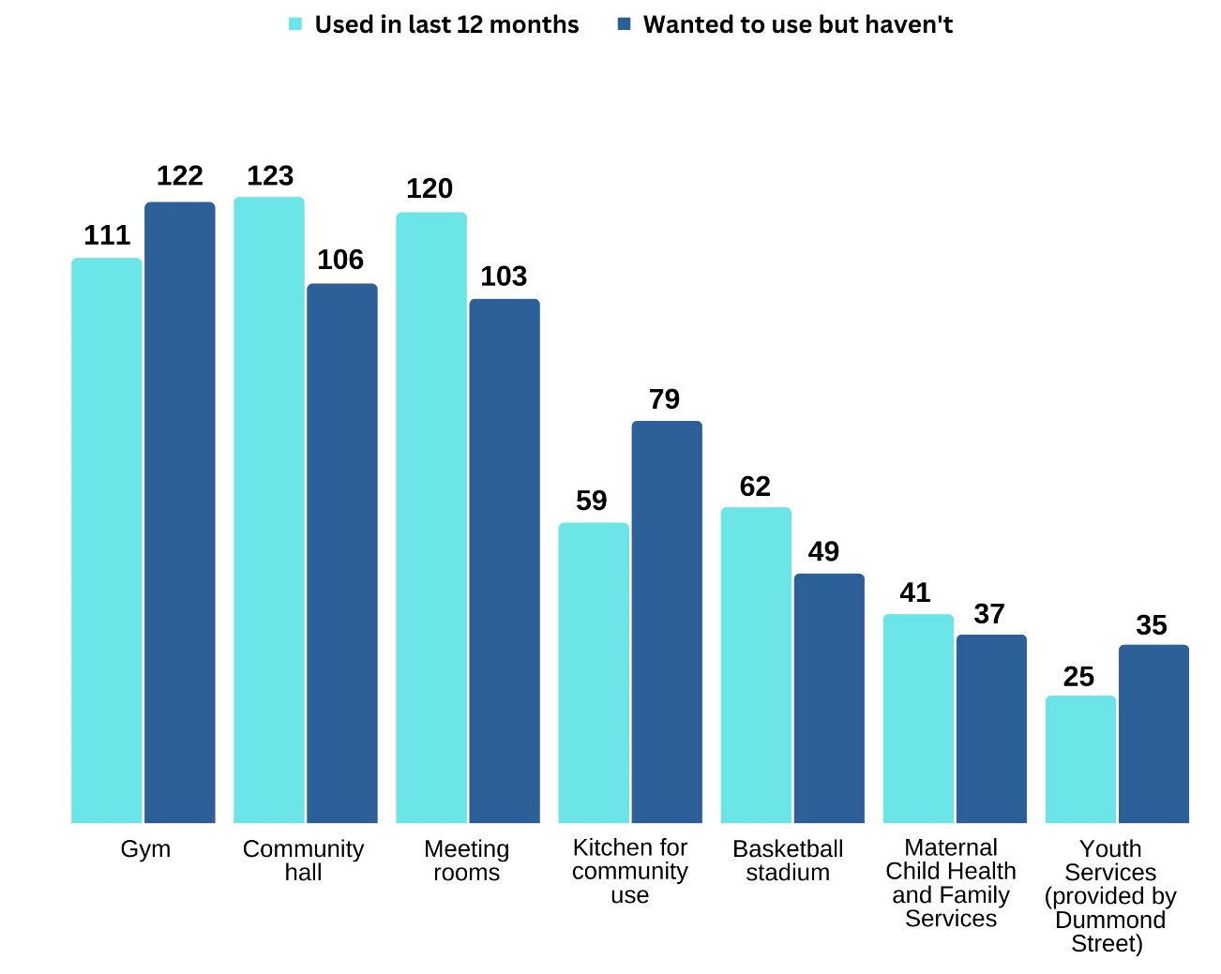
The graph above highlights a particularly strong current and desired use of the Gym, Community hall and Meeting rooms amongst survey participants. This data also highlights a strong interest in further use of the kitchen at the existing NMCC.

Jean McKendry Neighbourhood Centre
The survey asked participants to identify which facilities and services at the Jean McKendry Neighbourhood Centre (JMNC) they have used in the last 12 months, as well as which of these facilities and services they would like to use, but haven’t.
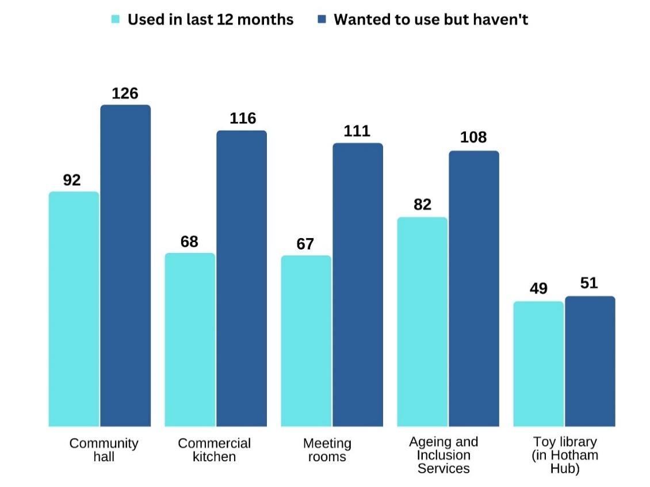
Compared to results for the NMCC, the graph above illustrates higher overall desire to use the services and facilities at the JMNC amongst survey participants (although current and desired use of the Toy library is approximately equal).

Insights into why community members haven’t used services and facilities at these centres that they are interested in
When we asked survey and workshop participants why they have not been able to use facilities and services at JMNC or the existing NMCC that they are interested in we heard that:
- Some community members were not previously aware that the JMNC or particular facilities and services existed prior to completing the survey
- Some community members have not had time to explore the facilities and services they are interested in
- The JMNC feels closed, exclusive and not welcoming to people who do not belong to established groups with a long-standing booking
- The NMCC building and facilities is outdated and poorly maintained and not welcoming (particularly if you have not visited the centre before)
Participants also identified specific barriers to using facilities and services at JMNC and NMCC including:
- Booking system difficult to use
- Facilities/spaces not available when I wanted to use them
- Opening hours limited (e.g. not open on weekends)
- Facilities/spaces not suitable to needs (e.g. no lockable storage space, space not large enough)
- Expensive to hire
- Lack of parking
This feedback was common to both JMNC and NMCC unless otherwise stated above.
Understanding these barriers will inform City of Melbourne design of the new hub and planning for future management and operating principles (e.g. booking systems, usage terms, opening hours, communication methods).

Impact
The findings of this community engagement will inform Council’s decisions on the services to be included in the new community hub and shape development of a draft concept design in a number of ways.
NEIGHBOURHOOD PRIORITIES
City of Melbourne will use what we learned about the response to the North Melbourne neighbourhood priorities featured in the survey to help ensure the design and services at new community hub contribute to broader priorities for the neighbourhood.
CENTRE FEATURES
Participants were asked to rank eight features of a good community centre that were identified through previous community consultation in order of importance.
What we heard about the importance of these features, and what these features could look and feel like, will inform the design of the new hub.
Through survey, workshop and pop-up data we also gained a better understanding of why these features are important. This knowledge helps City of Melbourne understand how the new community centre can help to support the underlying needs of the community.
ADDITIONAL SERVICES AND FACILITIES
Communication materials provided to support this engagement informed participants of three services areas to be included in the hub (youth, family and ageing) and the potential for further services to be added. The findings of this engagement will be used to guide Council decisions on the possible inclusion of Children’s Services or Library Services.
Participants identified a number of additional services and facilities that they would like to see at the new hub. City of Melbourne will consider these suggestions in the design of the new hub, both as distinct additions and potential considerations as part of other features (e.g. how open space can be optimised for recreation, how creative and fun spaces can be designed with women and children in mind).
OVERALL LOOK AND FEEL OF THE NEW HUB
Community feedback on what a good community hub looks and feels like to North Melbournians will shape how City of Melbourne’s City Design team brings the features and technical elements of the new hub’s design together in an integrated and coordinated way that aligns with community needs and interests.
CURRENT AND DESIRED USE OF THE EXISTING CENTRES AND BARRIERS
The knowledge of what services and facilities at the existing North Melbourne Community Centre and the Jean McKendry Neighbourhood Centre participants currently use, and would like to use but haven’t will also help Council to prioritise spaces in the design of the new hub.
And finally, understanding current barriers to the North Melbourne community using services and facilities at the existing centres will inform Council design of the new hub and early planning for future management and operating principles (e.g. booking systems, usage terms, opening hours, communication methods).

Next steps
City of Melbourne is utilising feedback from Phase 1 of the new community centre in North Melbourne community engagement to complete a comprehensive list of services and facilities to be incorporated in the new hub and to prepare a draft concept design.
After the draft concept design has been reviewed by Council, Phase 2 of the community engagement will invite the community to provide feedback on draft designs. We anticipate engagement Phase 2 will begin late 2024, with the outcomes of that process used to begin the detailed design process by December 2024.

Appendices
Appendix 1. Survey questions

START OF THE SURVEY
City of Melbourne is committed to providing a new community centre in the North Melbourne and Macauly area to replace existing facilities, which are ageing and won’t meet future community needs.

Community and service providers have consistently expressed the desire for larger and improved facilities to enhance the services that make a positive difference to life in North Melbourne.

The new multi-use in North Melbourne will include youth, family and ageing services, as well as additional services to be decided on following engagement with the community so we best service the needs of the neighbourhood.

This centre will be located at 91-115 Melrose Street (the site of Jean McKendry Neighbourhood Centre and the Hotham Hub) and will be 3,000m² in size – twice the size of the current North Melbourne Community Centre.

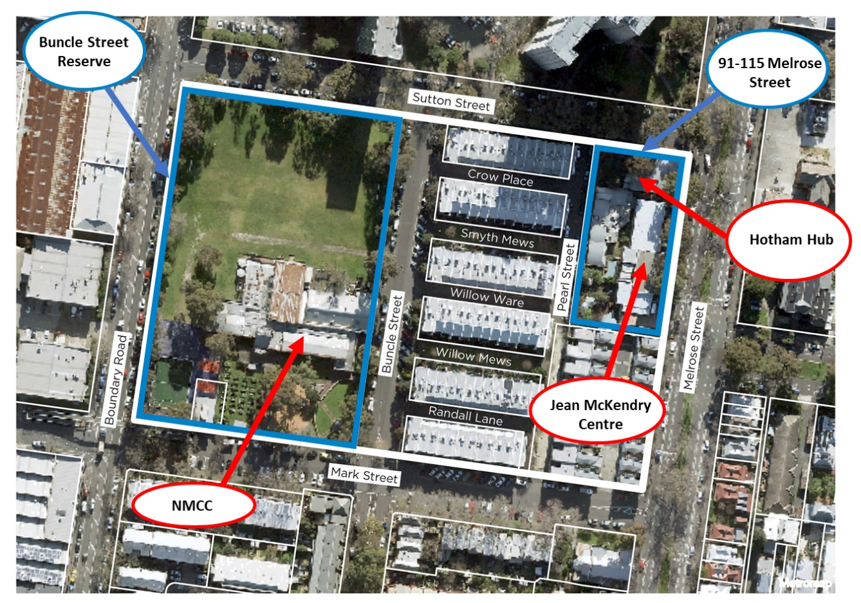

Q1. Through previous community engagement the following neighbourhood priorities have been defined as important for North Melbourne. How important are they to you?

Please tick the relevant space to indicate your responses.
Neighbourhood priorities | Not important | Somewhat important | Very important | Undecided
Parks, outdoor open and green space

Community meeting spaces, including spaces for informal socialising

Recreation and sports facilities for the community

Building design that responds to community needs, sustainability and cultural safety

People living on lower incomes continuing to call North Melbourne home

Community facilities with adaptable design

Community hubs with multiple services that bring the community together

Q2. Have you used any of the existing services and facilities at the Jean McKendry Neighbourhood Centre or the North Melbourne Community Centre in the last 12 months?

Please tick the relevant space to indicate your responses.
Existing services and facilities | Yes | No
Jean Mckendry - Ageing and Inclusion Services

Jean McKendry - Community hall

Jean McKendry - Meeting rooms

Jean McKendry - Commercial kitchen

Toy library (in the Hotham Hub)

NMCC - Maternal Child Health and Family Services

NMCC - Youth Services (funded by City of Melbourne and provided by Drummond Street)
NMCC - Community hall

NMCC - Meeting rooms

NMCC - Gym

NMCC - Basketball stadium

NMCC - Kitchen for community use

Q3 – Which of the existing facilities or services have you or your family wanted to use but haven’t?

Please tick the relevant space to indicate your responses.
Existing facilities or services | Want to use
Jean Mckendry - Ageing and Inclusion Services

Jean McKendry - Community hall

Jean McKendry - Meeting rooms

Jean McKendry - Commercial kitchen

Toy library (in the Hotham Hub)

NMCC - Maternal Child Health and Family Services

NMCC - Youth Services (funded by City of Melbourne and provided by Drummond Street)
NMCC - Community hall

NMCC - Meeting rooms

NMCC - Gym

NMCC - Basketball stadium

NMCC - Kitchen for community use

Q4. If you answered yes to any of the above, why haven’t you been able to use these services or facilities? (open text)

Q5. What additional facilities or services would you like to see at the new centre? (open text)

Q6. When we speak with community members in North Melbourne about what makes a great community centre, these are some of the features we’ve heard:
- Meeting spaces for the community
- Culturally safe spaces (e.g. breakout rooms for prayer)
- Design and mix of services that brings the community together
- Design that includes open space
- Design that includes passive recreation spaces
- Spaces for people to spend time casually
- Creative and fun spaces
- Spaces that encourage learning
Please rank your top 3 features in order of importance by writing 1, 2 or 3 in the space next to your preferred feature below:
Please rank your top 3 only.

Features | Record rank  (1, 2 or 3)
Meeting spaces for the community

Culturally safe spaces (e.g. breakout rooms for prayer)

Design and mix of services that brings the community together

Design that includes open space

Design that includes flexible space for group activities

Spaces for people to spend time casually

Creative and fun spaces

Spaces that encourage learning

Q7. What makes your top 3 features most important to you? (open text)

Q8. Do you have other suggestions for what makes a great community centre? (open text)

The following questions are about you. By telling us a bit about you, we can make sure that we're hearing from different voices. Your answers will be de-identified for analysis, and we won’t share your data with any other party.

You may choose the option for 'Prefer not to say' for question you do not wish to answer.

Q9. How do you describe your gender?
- Female
- Male
- Non-binary/gender diverse
- Prefer not to say
- I use a different term, please specify:

Q10. What is your age?
- Under 15 years
- 15-19 years
- 20-24 years
- 25-29 years
- 30-34 years
- 35-39 years
- 40-44 years
- 45-49 years
- 50-54 years
- 55-59 years
- 60-64 years
- 65-69 years
- 70-74 years
- 75-79 years
- 80-84 years
- 85-89 years
- 90+ years
- Prefer not to say

Q11. Do you identify with any of the following?
- Aboriginal
- Torres Strait Islander
- Person with disability
- Carer
- LGBTIQ+
- Speak a language other than English at home
- Born overseas
- International student
- Prefer not to say
- None of these

Q12. If you speak a language other than English at home, what language do you speak?

Q13. Which of the following best describes your connection to this City of Melbourne project?
- I am a resident
- I am a worker
- I own a business
- I am a student
- I am a visitor
- Prefer not to say
- Other, please specify:

Q14. Based on your connection this project, where do you live/work/own a business/study/visit?
- Carlton (3053)
- CBD (3000)
- Docklands (3008)
- East Melbourne (3002)
- Kensington (3031)
- North Melbourne (3051)
- Parkville (3052)
- Southbank (3006)
- South Yarra (3141)
- West Melbourne (3003)
- Fisherman's Bend
- Prefer not to answer
- Other/outside the City of Melbourne

Q15. Have you participated in a consultation with City of Melbourne before?
- No, this is my first City of Melbourne consultation
- Yes, I have participated in a City of Melbourne consultation once or twice before today
- Yes, and I participate in City of Melbourne consultations regularly
- Not sure
- Prefer not to say

Q16. What motivated you to participate in this consultation today?
Please select all that apply.
- I was passing by/approached by City of Melbourne
- The project directly impacts me
- I think it’s important to have your say and contribute to the future of our city
- I received a letter/email from City of Melbourne
- I saw the project on social media
- I saw the project in the media (TV, radio, newspaper etc.)
- Word of mouth
- Prefer not to say
- Other, please specify:

Q17. Please provide your email if you would like to receive updates about this project:

Appendix 2. Promotional poster
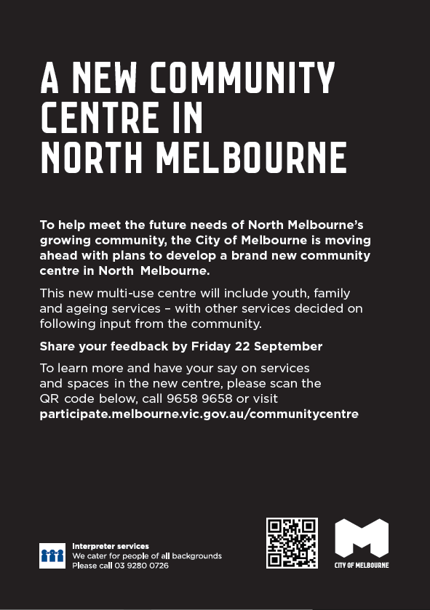

Simplified Chinese Translation

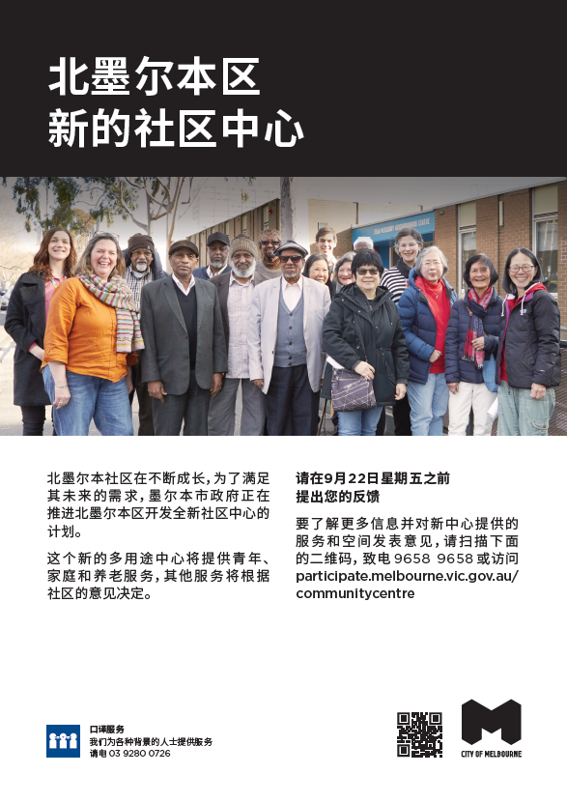

Arabic Translation

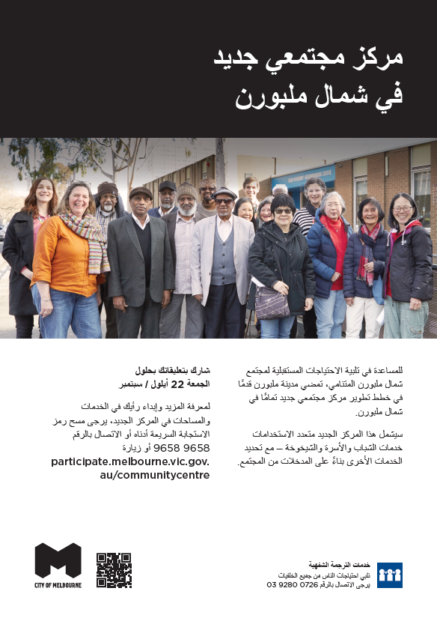

Somali Translation
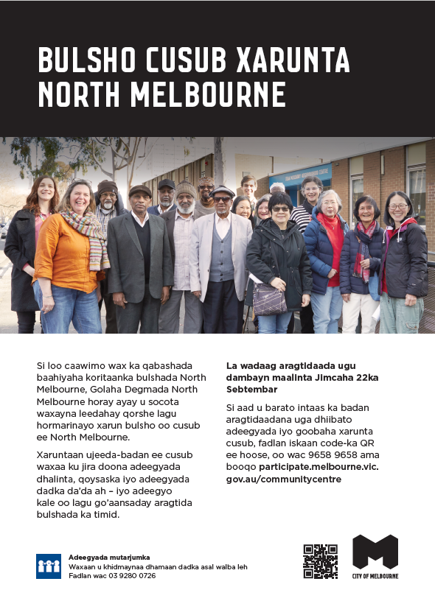

Vietnamese Translation

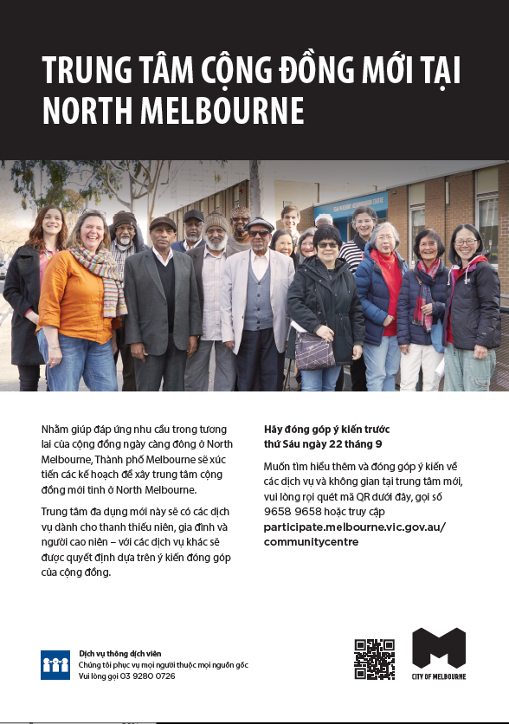

Appendix 3. Promotional postcard
