21.04 SETTLEMENT
05/10/2018
GC81
21.04–1 Growth Area Framework
23/10/2017
C190(Part 1)
As the municipality continues to grow and develop, the culture and functioning of the City in twenty years time will be very different from today. However, through these changes the characteristics of the city we value today must be retained.
This can be achieved by: targeting urban growth and development into specific areas of the City; enabling ongoing but incremental growth and development in those parts of the City needing constant renewal of their vitality, and by maintaining the existing character in valued established areas.
The focus of this MSS is on promoting areas of growth and protecting areas of stability. Areas of ongoing and incremental growth will continue to be regulated under the current planning scheme controls. The MSS identifies five types of areas:
- The original city centre (the Hoddle Grid)
- Urban renewal areas
- Proposed urban renewal areas
- Potential urban renewal areas
- Stable residential areas
The Growth Area Framework Plan at Figure 1 identifies these areas.
Figure 1 Growth Area Framework Plan
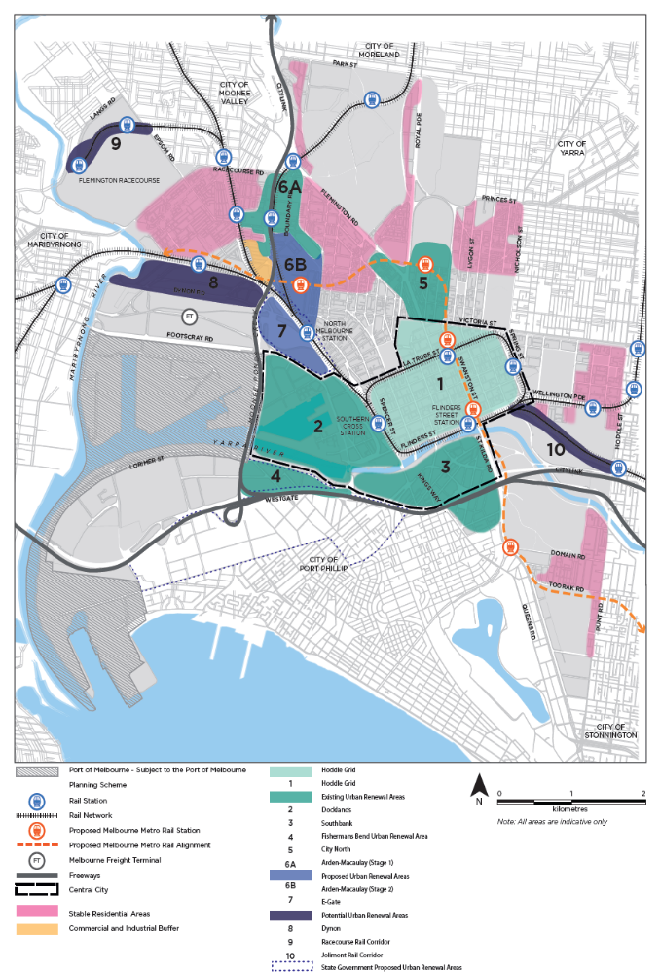
21.04–1.1 The original city centre – the Hoddle Grid
29/01/2015
C225

Central City functions will be located in the Hoddle Grid. This area will be managed to facilitate continued growth where appropriate and limit change or the scale of development in identified locations to preserve valued characteristics. A strong emphasis will be placed on a quality public realm and good pedestrian amenity and connectivity.
21.04–1.2 Urban renewal areas
Proposed Amendment C323
The urban renewal areas are Southbank, Docklands and the Fishermans Bend Urban Renewal Area. These areas have been planned and designed to provide for the expansion of the Central City in optimal living and working environments with a new mix of uses, higher density of development and excellent provision for walking, cycling and pubic transport services. Here change is guided by well-developed structure plans and master plans adopted by State Government and Council.
The design of the buildings, streets, public open spaces should be integrated over whole precincts with provision of utilities services to minimise the precinct’s greenhouse gas emissions, optimise water management, mitigate the effects of extreme storm events, reduce the urban heat island and take precautions against sea level rise.
Southbank
Starting in the early 1980s as an "Engaging with the Yarra River Initiative", Southbank has been under urban renewal for close to 30 years. It has now brought the Yarra River into the heart of the city’s life and provided a dynamic extension of the Central City with good commercial and residential high-density development opportunities.
Southbank is home to the State’s major arts facilities as part of its the internationally recognised Arts Precinct and other major activity areas including the Southbank Promenade, Melbourne Convention and Exhibition Centre and the South Wharf complex.
The Southbank Structure Plan 2010 was prepared to update the 1999 and 2007 plans. It provides a vision and strategy for the next 30 years for the area’s continued development as an extension of the central city with a high-density mix of commercial and residential uses, with a focus of arts, cultural and creative industry uses within the Arts Precinct, a built form of a human scale and fine grain detail, greater permeability, activity and pedestrian priority at street level.
Docklands
Once one of Victoria’s main ports, by the 1990s it was an industrial wasteland. Around 2000 Docklands urban renewal began its transformation into a new residential, commercial and visitor destination providing housing, office, industry, research, institutional, business, education, entertainment/leisure, marina and sporting uses and public spaces. Docklands is an extension of the Central City and it is intended that leisure-related retailing complementary to retailing in the Retail Core is also be provided.
Together, Places Victoria, the City of Melbourne and the Docklands community have been assessing the first decade of development and planning for the second. Where the first decade focussed on creating buildings and attracting investment, the second decade is now being planned to be a place where people want to work, live and visit with a diversity of businesses, activities, residents, public spaces and community infrastructure.
Fishermans Bend Urban Renewal Area
The area measuring over 480 hectares includes four mixed use precincts which form part of the expanded Central City. The four mixed use precincts have been declared as a project of State significance and rezoned as part of an expansion to the Capital City Zone. One of these mixed-use precincts is the Lorimer precinct, and is within the City of Melbourne.
This rezoning expands the Capital City Zone by more than 50 per cent and is expected to accommodate jobs and residents within the four mixed use precincts.
The urban renewal area is also within the City of Port Phillip municipality. The area adjoins the Docklands and Southbank existing urban renewal areas.
City North
City North is identified for proposed renewal given its existing role as a specialised activity centre, the proposed Parkville Station as part of the Melbourne Metro project and its proximity as an extension of the Central City. The City North Structure Plan 2012 has been adopted by the City of Melbourne and has been implemented into the planning scheme via a planning scheme amendment.
Arden-Macaulay
Arden-Macaulay is an area in transition. Since the 1880’s, Arden-Macaulay has been primarily an industrial area supporting the city’s economy through manufacturing and production. The profile of business activity in the area has been changing with some degree of land under utililisation given its potential in relation to its proximity to the central City.
The Melbourne Metro station project to be located between Citylink and Laurens Street will lead to major change east of the Moonee Ponds Creek.
The Arden-Macaulay Structure Plan 2012 has been prepared and adopted by the City of Melbourne and will be implemented into the planning scheme via a planning scheme amendment. The directions of this plan for this local area are still to be inserted into the planning scheme.
Planning controls address the interface between on-going industrial and residential areas, and the interface between new development and existing residential areas and large manufacturing industry will be protected from sensitive uses by a land use buffer of non-residential development and/ or non-sensitive land uses (depicted within Figure 11 as “Commercial and Industrial Buffer”). The planning controls are being introduced in two stages (Stage 1 shown as Area 6A and Stage 2 shown as Area 6B on the Growth Framework Plan).
21.04–1.3 Proposed Urban Renewal Areas
23/10/2017
C190(Part 1)
The Proposed Urban Renewal Areas have been broadly identified as the locations for the next generation of the city’s urban renewal. Once the structure plans for each of these areas are incorporated into the planning scheme the plan for the relevant local area will be updated with new objectives and strategies and the Growth Area Framework Plan will be updated to show the areas as ‘Existing Urban Renewal Areas’.
Until the objectives and strategies of approved structure plans are approved and implemented via a planning scheme amendment the existing local area policies for the area will apply.
E-Gate
This land is mostly railway reserve in State Government ownership and it adjoins the Docklands and Arden Macaulay urban renewal areas. State Government is developing plans for its urban renewal area and these plans being implemented into the planning scheme via a planning scheme amendment. The directions of this plan for this local area are still to be inserted into the planning scheme.
21.04–1.4 Potential Urban Renewal Areas
29/01/2015
C225

The Potential Urban Renewal Areas have been identified as long term options for future urban renewal that are dependant on the resolution of other related infrastructure planning before they can be considered in detail for urban renewal.
Dynon
This area accommodates mainly freight and some industrial activities. In the longer term, these activities will be reconfigured and rationalised within the area. This will be done in conjunction with the planning and development of the Port of Melbourne and the Melbourne Intermodal Freight Terminal serving the port south of Dynon Road.
The rationalisation and modernisation of the freight functions in the precinct will open up the potential for the renewal of the northern section of this area. Any urban renewal of this area should not constrain the operations of the port freight terminal to the south. The State Government in conjunction with the City will undertake the planning for this area.
Racecourse Rail Corridor
The Racecourse Rail Corridor between the Flemington Racecourse and the Showgrounds has potential similar to the Jolimont Rail Corridor. The area’s potential for urban renewal will depend on future options of a rail service to the area.
Jolimont Rail Corridor
The Jolimont rail corridor runs through the middle of the Sports and Entertainment precinct. The Federation Square development was the first step in the urban renewal of this corridor. As inner and central city locations have become more highly valued, development over transport corridors will become increasingly attractive not only for the development space they can yield but also for the opportunity to connect adjacent parts of the city that have been separated.
21.04–1.5 Stable Residential Areas
29/01/2015
C225

These residential areas are valued for their existing character and the important contribution this makes to the city. In these areas limited change such as in-fill development and alterations and additions, will continue to occur so that new land use or development fits in with the existing valued character.
21.04–2 Growth
23/10/2017
C190(Part 1)
Objective 1 To provide for the anticipated growth in the municipality over the next 20 years.
Strategy 1.1 Retain the Hoddle Grid area as the core of the Central City and plan for its ongoing change and growth.
Strategy 1.2 Direct new urban growth into the Docklands and Southbank Urban Renewal Areas.
Strategy 1.3 Plan and design Urban Renewal areas to provide optimal living and working environments, to be energy, water and waste efficient and adapted to predicted climate change.
Strategy 1.4 Plan identified Urban Renewal Areas, and define their exact extent, through structure planning for the local area.
Strategy 1.5 Ensure new development in Urban Renewal Areas does not compromise the preferred future renewal of the area.
Strategy 1.6 In the longer term, consider sites of Potential Urban Renewal at Dynon Road, the Jolimont Rail Corridor, the Racecourse Rail Corridor. Urban renewal of these areas will be dependant on the resolution of other related infrastructure planning.
Objective 2 To direct growth to identified areas.
Strategy 2.1 Support the ongoing development of the Hoddle Grid.
Strategy 2.2 Support ongoing urban renewal and Central City expansion in:
- Southbank
- Docklands
- Fishermans Bend Urban Renewal Area
- City North
- Arden-Macaulay
Strategy 2.3 Plan for urban renewal in:
- E-Gate
Strategy 2.4 Consider potential for urban renewal in:
- Dynon,
- Jolimont Rail Corridor
- Racecourse Rail Corridor
Strategy 2.5 Develop Structure Plans to guide the local detail of urban renewal.
21.04–3 Implementation
29/01/2015
C225

Update structure plans for the existing urban renewal areas and implement structure plans into the planning scheme for proposed urban renewal areas.

