
Domestic Animal Management Plan 2026-2029 Community Engagement Summary Report

Phase 2
September 2025
Contents
Executive Summary: Overview and Key Findings 3
Background and Methodology 3
Background 3
Methodology 3
Who we heard from 4
What we heard from the community 7
Community satisfaction of the draft plan 8
Further feedback from the community 11
What we heard from key stakeholders 12
Outcome and next steps 15

Executive Summary: Overview and key findings
A total of 227 people contributed to the online survey and we received a further 16 written submissions via email. The survey sought to understand community sentiment regarding the draft plan, identify areas for improvement, and to ensure the final version reflects the needs and expectations of the community.
Of the 227 respondents who participated in the survey, 94 % were residents of City of Melbourne, 59 % were dog owners, 40 % were cat owners and 57 % of total respondents were users of local parks, reserves and playgrounds.
Respondents were asked a range of multiple choice and open-ended questions covering their satisfaction with the draft plan, their connection to the topic, demographic information and suggestions for improvement on the plan.
The feedback identified key themes of community sentiment on the draft plan. The community expressed strong concerns about management of dogs in public places including dogs being off-leash in public spaces not designated for off-leash use. There was also feedback indicating a desire for more designated off-leash areas with effective signage in the municipality. Additionally, issues in relation to dog waste was frequently mentioned with a strong desire for better infrastructure including more bins and bag dispensers to support responsible pet ownership. Feedback was supportive of cat curfews, however there was a portion of respondents that were seeking greater support around the new orders and had concerns of how the curfews would be enforced and how this would impact certain community members. The feedback indicated there was strong support for education programs to be implemented aimed at responsible pet ownership and improving pet owner behaviours. Respondents expressed a desire for more pet-friendly spaces in high-density areas. Suggestions included allowing pets on public transport and permitting them in cafes and restaurants, to better accommodate pet owners in a city environment. We also received feedback with concerns for vulnerable people who own pets in the municipality and what support could be offered to ensure equitable access to pet ownership.

Background and Methodology

Background
The Domestic Animals Act 1994 (the Act) requires domestic animal management plans to be prepared by every
council in Victoria at four yearly intervals. The plan is required to outline the services, programs and policies the
council have established to address the administration of the Act and the management of dogs and cats in their
community.

The DAMP focuses solely on cats and dogs and will set priorities, actions and programs around things like:

- promotion and encouragement of responsible ownership of cats and dogs.
- ensuring that people comply with this Act, the regulations and any related legislation.
- minimising the risk of attacks by dogs on people and animals.
- addressing any over-population and high euthanasia rates for dogs and cats.
- encouraging the registration and identification of dogs and cats.
- minimising the potential for dogs and cats to create a nuisance.
- effectively identifying all dangerous dogs, menacing dogs and restricted breed dogs in that district and ensuring
- that those dogs are kept in compliance with this Act and the regulations.

Methodology
On 1 July 2025 at the Future Melbourne Committee, the draft Domestic Animal Management Plan 2026-2029 was endorsed for the purpose of community engagement.
From 7 July 2025 to 4 August 2025, the City of Melbourne conducted the second phase of community engagement in relation to the draft Domestic Animal Management Plan 2026-2029 (DAMP). This phase of engagement involved an online survey on the Participate Melbourne website which included the draft plan and an infographic outlining the key issues addressed in the plan.
Several tools were used to promote survey participation which included targeted social media posts, an email campaign to all registered animal owners, stakeholders directly engaged in phase one and all previous respondents in phase one, a text campaign to registered animal owners and promotional signage in local parks and animal businesses.

Who we heard from
This engagement provided participants the opportunity to provide feedback online through the Participate Melbourne page and written submissions via email. Here is an overview of who contributed to the second phase of engagement:
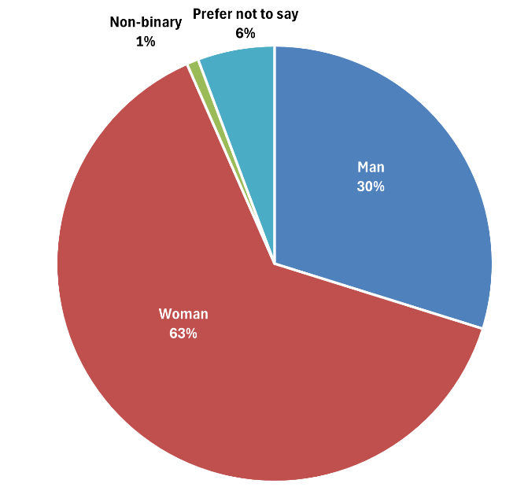
Fig. 1- Gender

Pie chart showing the gender distribution from the survey. The majority of respondents identified as female (63%), followed by male (30%). A smaller %age preferred not to answer (6%), while 1% identified as non-binary or gender diverse. This distribution highlights a strong female representation among the survey participants.
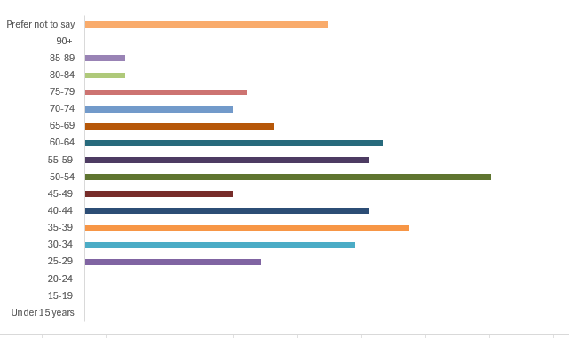
Fig. 2- Age

This data shows the age distribution of survey respondents. The largest group falls between 50–54 years old, representing the highest %age of total respondents. Participation varies across age groups, with a gradual decline in representation among those over 60 years old. Very few respondents were under 20 or over 85, and a small %age chose not to disclose their age. This indicates that the survey reached a diverse age range but had stronger engagement from adults in their early 50s.

Fig. 3- Connection to this City of Melbourne project
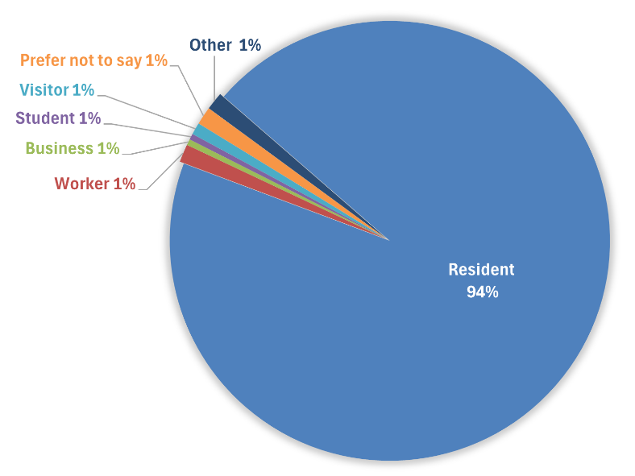

Pie chart showing the connection of respondents to this City of Melbourne project. The majority identified as residents (94%). While all other categories including worker, business owner, student, visitor, prefer not to say, and other each accounted for 1% of responses. This distribution highlights that the project primarily engaged residents.

Fig.4- Identity
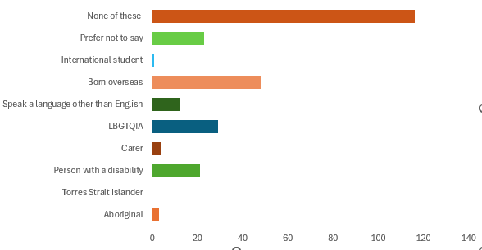

This data outlines the diverse identities of survey respondents. A significant portion (51.56%) indicated that the listed categories did not apply to them. Notably, 21.33% of respondents were born overseas and 12.89% identified as LGBTQIA, highlighting strong representation from these groups. There was also notable participation from people with disabilities (9.33%) and those who speak a language other than English at home (5.33%). Smaller groups included representation from carers (1.78%), Aboriginal (1.33%) and international students (0.44%). Additionally, 10.22% of respondents preferred not to disclose this information. This distribution reflects a broad range of identities, with particularly strong engagement from multicultural and LGBTQIA communities.

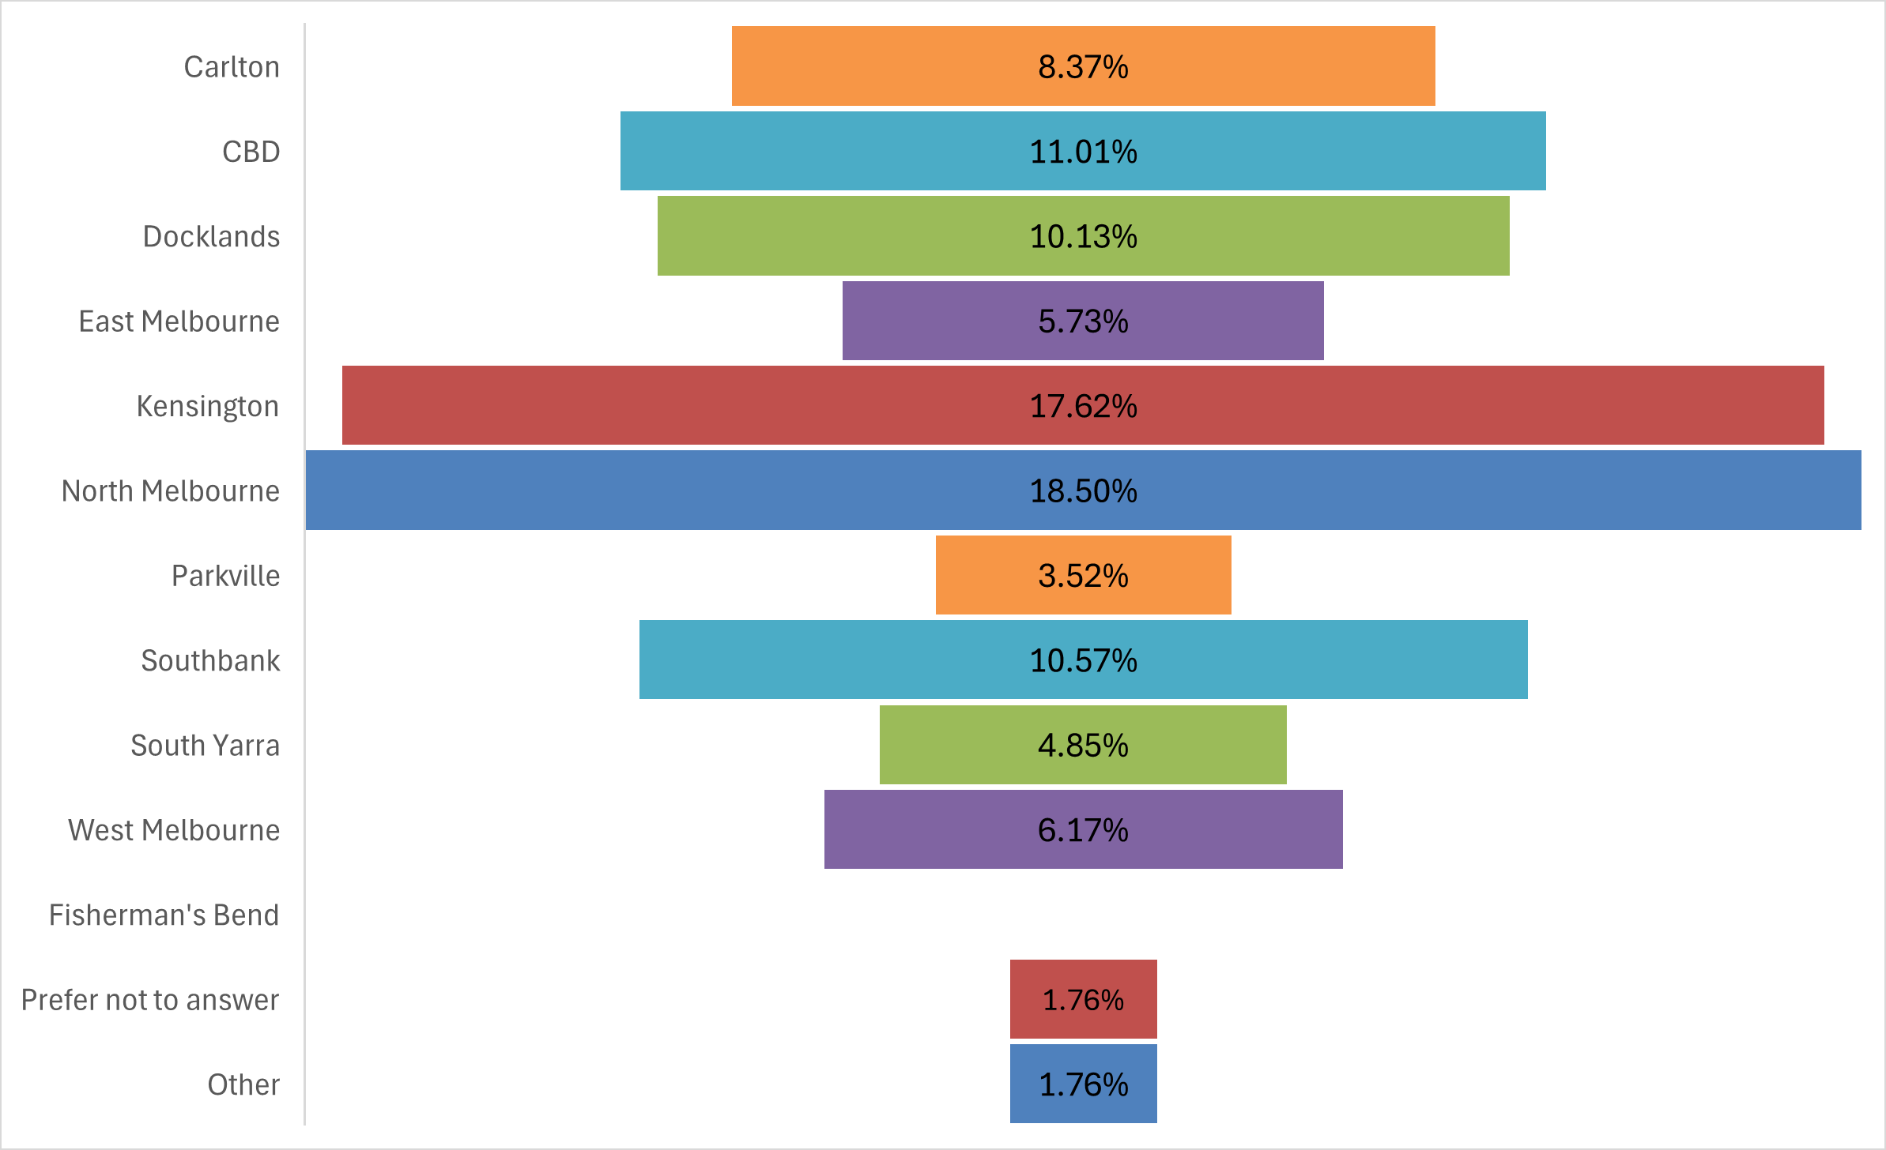
Fig. 5- Identity

This data shows the distribution of survey respondents by location. The majority of responses came from North Melbourne (18.50%) and Kensington (17.62%), with CBD (11.01%), Southbank (10.57%), and Docklands (10.13%) also contributing significant portions. Areas like Carlton (8.37%), West Melbourne (6.17%), and Parkville (3.52%) had lower participation rates. This distribution highlights strong engagement from residents in North Melbourne and Kensington.

What we heard from the community
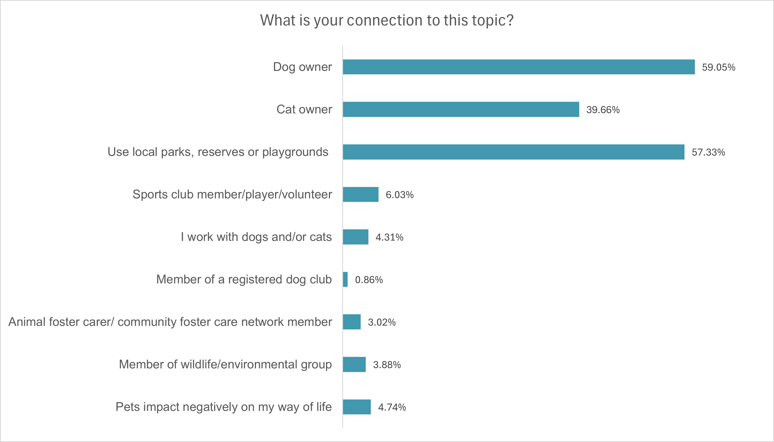
Participants were asked a series of questions in the survey in relation to their connection with the topic, how satisfied they were with the draft plan and were asked for contributions on what may be missing from the plan and areas of suggested improvement for the final plan. The survey aimed to establish whether the draft plan sufficiently addressed community sentiment on what the animal management service should look like for the period of 2026-2029.
Fig. 1- Bar chart depicting respondent’s connection to the survey topic
The majority of respondents indicated their connection to the DAMP because they were dog owners (59.05%) and similarly high portion were users of local parks, reserves, or playgrounds (57.33%). Cat ownership was also common among respondents, with 39.66% identifying as cat owners.
A smaller proportion of participants reported more specific or professional connections to the topic. These included 6.03% who are members, players, or volunteers at sports clubs, and 4.31% who work with dogs and/or cats in a professional capacity.
A small number of respondents (4.74%) indicated that pets negatively impact their way of life.
This data suggest that the consultation successfully engaged various groups within the community, with particularly strong representation from pet owners and users of shared public spaces. The diversity in perspectives including pet owners, non pet owners and those who experience challenges with pets in the community adds valuable depth to the feedback.
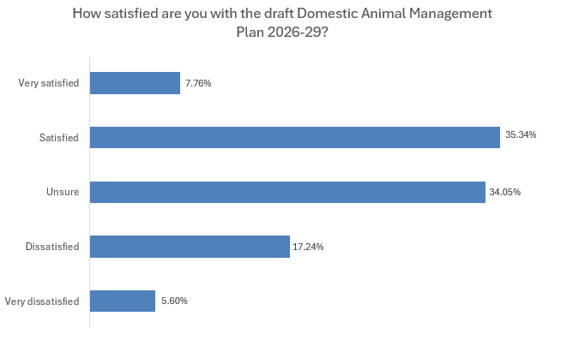

Fig. 2- Bar chart depicting respondent’s satisfaction of the draft Domestic Animal Management Plan 2026-29
A significant proportion of respondents expressed a positive view of the draft plan, with (35.34%) indicating they were satisfied and a further (7.76%) reporting they were very satisfied. Combined, these figures suggest that over 43% of respondents responded favourably to the draft, reflecting a strong level of community support.
Additionally, (34.05%) of respondents reported being unsure about their level of satisfaction.
At the other end of the spectrum, (17.24%) of respondents stated that they were dissatisfied, while (5.60%) reported being very dissatisfied with the draft plan.
Overall, the results suggest that the draft plan has been generally well received, with a clear majority of respondents either satisfied or undecided.

Community satisfaction of the draft plan
As part of the survey, respondents were asked to expand on their response to the satisfaction score of the draft plan with free text feedback.
We asked:
“Can you tell us why you are very satisfied with the DAMP?”
Respondents shared their confidence in the draft plan and with some stating it was a responsible and considered plan overall. Some respondents were supportive of the cat curfew and mandatory desexing orders stating the positive benefits to cats and on local wildlife. Respondents also expressed their support for community education on responsible pet ownership imbedded in the plan.

“It balances a range of interests without being overly punitive and there is support to comply.”
“Very supportive of the proposal to develop and implement education program targeted at apartment dwellers.”

We asked:
“Can you tell us why you are satisfied with the DAMP?”
Community feedback indicates strong overall support for the draft plan, with many respondents describing the plan as balanced, comprehensive, and grounded in common sense. Key areas of support included improved dog safety measures in public spaces, responsible pet ownership, and enhanced education for pet owners. There was widespread endorsement of cat containment and curfews, and the positive impact this has on protecting native wildlife. Respondents also valued the plan’s attention to public safety, particularly in relation to off-leash dogs in shared spaces and enforcement of regulations. Infrastructure improvements, such as more off-leash parks and better waste management, were well received. Most of the feedback reflected confidence in the plan’s ability to address community needs and promote responsible pet ownership and animal welfare.

“It strikes a balance between supporting all animals (and their owners), preserving wildlife, and considering those who may not want pets/animals near them or may not be familiar with animals.”
“Seems to be a balanced approach to management of cats and dogs I think it addresses important issues whilst recognising the importance of animal welfare and diversity within the community”
“I strongly support the introduction of a night cat curfew, well done.”

We asked:
“Can you tell us why you are unsure about the DAMP?”
Feedback from respondents on the draft plan demonstrates broad support for the actions and objectives, particularly its focus on responsible pet ownership, animal welfare, and public safety. Respondents endorsed cat management measures such as mandatory desexing and cat containment including curfews. However, we received feedback expressing concerns about the practicality and clarity of implementation of the cat containment and desexing orders, specifically the enforcement of the regulations.
Issues relating to dog ownership such as off-leash behaviour, barking, and waste management were frequently raised, with calls for stronger compliance, clearer signage, and improved infrastructure like fenced parks and waste bag dispensers. The feedback also highlighted the need for more inclusive and pet friendly planning for high-density urban areas such as the CBD to better support owners and their furry friends to live cohesively.
Community educate was acknowledged as important throughout the feedback and however many felt it should be complemented with enforceable actions to address key nuisance issues.
Overall, the community supports the plan’s direction however through feedback it was highlighted that there is a desire for more specific and enforceable actions to be reflected in the plan in response to the experiences of pet owners in the municipality and more broadly to promote responsible pet ownership.

“I like the emphasis being placed on pet ownership education, but I don’t know if enough emphasis is being placed on improving the facilities for existing responsible pet owners.”
“The DAMP does not provide management of irresponsible dog owners who don’t pick their dog’s poo. There must be more concrete measures to ensure littering is reduced to a minimum.”
“It covers all the key issues that are impacted by pets and pet owners, however some of the actions planned are vague and unclear on how they will reduce particular nuisances such as enforcing dogs on leash, and patrolling persons who do not clean up dog waste.”
“I feel that more could be done to improve the liveability of Melbourne for pets and pet owners”

We asked:
“Can you tell us why you are dissatisfied with the DAMP?”
Community feedback on the draft plan reflects broad support for its overarching goals, particularly around desexing and containment of cats, responsible pet ownership, and more broadly the protection of wildlife. However, respondents have raised concerns about the plan’s practical application, especially regarding the enforceability and fairness of proposed measures such as the cat curfew, which has been received as overly restrictive and potentially difficult to enforce.
A recurring theme was the lack of off-leash dog areas in high-density areas like the CBD and Docklands, with suggestions for new fenced spaces and better infrastructure to support safe and responsible pet ownership.
Feedback was also provided about the disproportionate impact of pet ownership on vulnerable residents, and the need for a more inclusive approach. Respondents called for clearer communication in the plan and stronger enforcement strategies to address issues impacting pet owners and domestic animals in the City.
“It’s very surface level. Underlying issue linked to off leash dogs, nuisance call outs is based on the lack of pet friendly infrastructure and support.”
“The plan does not address important issues of facilities for pet owners in the CBD.”
“For the protection of wildlife, cats need to be kept indoors unless they are being walked on a lead”

We asked:
“Can you tell us why you are very dissatisfied with the DAMP?”
Community feedback on the draft plan highlights concern about the plan’s practicality, equity and responsiveness to the needs of pet owners in the municipality.
A recurring theme was concerns with the mandated cat curfew, which was received as excessive and difficult to comply with. Feedback was provided by community members that identified as long-time cat owners and renters that were unsure or concerned about how these orders will impact themselves and their cats livelihoods.
Respondents also expressed frustration over the lack of fenced off-leash dog areas in the CBD and Docklands.
Respondents felt that the plan prioritised enforcement and penalties over improvements to infrastructure and inclusive planning of the needs of pet owners in the City.
“As a dog owner in Docklands, there are clearly many people with dogs who also bring a lot of positivity to the community. The council needs to work alongside the residents rather than work against them.”
“A successful plan should not rely solely on compliance mechanisms but should foster a sense of inclusion and fairness across all members of the community, including those with dogs.”
“I don’t agree with the cat curfew”

Further feedback from the community
As part of the survey, respondents were asked for further commentary on their thoughts on the draft plan with free text feedback.

We asked:
“What, if anything, is missing from the Draft Domestic Animal Management Plan?
Community feedback emphasized key concerns of the effectiveness of the cat containment and mandatory de-sexing orders, in particular there was sentiment on the humane and welfare concerns of the orders on semi-owned and unowned cat colonies. Feedback also highlighted the need for community support and education on implementation of the orders and the enforcement of the regulations.
Feedback on the management of dogs in a public place focused on increasing and improving off-leash areas, clearer enforcement of leash requirements and better infrastructure such as bins, signage, and fencing.
There was support for increased enforcement for non-compliance of key nuisance issues including off-leash dogs in a public place and noise complaints associated with barking dogs. Strong
Respondents also highlighted the importance of supporting vulnerable people, including homeless pet owners to promote equitable and responsible pet ownership
Additional suggestions included more accessible and pet-friendly infrastructure in high density areas including the CBD and on public transport.
Overall, the feedback was constructive and passionate with the community seeking a transparent and enforceable plan that addresses the key issues impacting pets and owners in the city and promotes responsible pet ownership supported by improved amenities and infrastructure.

“"The draft DAMP is fantastic. I'm not currently a pet owner but I'm a resident that has pets as neighbours! The document seems genuinely keen to reflect the needs of the community in a balanced way - well done!”
“Commitment to enforcement patrols outside of 9am-5pm and on weekends.”
“More work needs to be done with owners not picking up their dog waste.”
“It may be small, but a third bin would serve the park greatly. If one needs a bin or a bag in one of the thirds of the park, there's a long way to travel in order to get to a bin. I've noticed a lot of older dog owners at the park that might benefit from this.”

We asked:
“Please share any additional comments about the Draft Domestic Animal Management Plan?
Community feedback highlights the need for a practical, inclusive, and well-enforced approach to the management of domestic animals. Key themes that arose from respondents included the appropriate management of off-leash dog activity, and suggestions to consider increasing access to fenced off-leash areas with better signage, and increased availability of dog waste bins.
Opinions on the cat curfew order were ranged from strong support for cat containment to protect wildlife to respondents who raised concerns about enforcement and animal welfare.
There is strong support for responsible pet ownership through inclusive education in conjunction, respondents expressed their concerns for animal cruelty and welfare issues and called for more action and enforcement.
Residents also seek more pet-friendly infrastructure in high-density areas, including access to hospitality venues.
Finally, equity and inclusion were emphasized by respondents, with suggestions for more access to support services for low-income pet owners and better outreach to diverse communities.
“Need more off leash areas, more bins and poo bags available.”
“Also cat curfew - great idea!"”
“I am not a dog owner or lover but hate to see any animal cruelty. Too many dogs are locked up in high density dwellings all day in my area.”
“Education of pet owners is so important.”

What we heard from key stakeholders
We received a total of 16 written submissions via email from the community as part of this phase of consultation. Included in these submissions was feedback from key stakeholders on the draft DAMP including the following.
Animal Care Australia
Animal Care Australia (ACA) is a national incorporated association whom lobby for animal welfare by those who keep, breed and care for animals. ACA is currently recognised by Animal Welfare Victoria as a key stakeholder in the review of Victoria’s Animal Welfare Act and it’s associated regulations. ACA continue to advocate and encourage the development of animal welfare standards and Codes of Practice for the keeping of pets as well as animal husbandry, breeding, training and sale.
ACA provided the following feedback on the draft plan as part of their submission:
In response to the statement:
“Work with RSPCA Victoria to upskill our staff to manage cruelty related matters to provide a collaborative, timely and effective response to reports of cruelty within the City of Melbourne”
ACA does not support the methods, or the overall ethos of the RSPCA and these concerns are now being voiced more loudly within the broader community. We trust City of Melbourne’s collaboration with RSPCA does not diminish Council’s Animal Management Officers’ ability to recognise individual circumstances, financial hardships, etc before jumping into ‘prosecution is the only solution’ mindsets.

In response to the statement:
“Introduce a program that uses data obtained from microchip registries relating to animals within our municipality to identify animals not recorded City of Melbourne’s pet registration database, and to follow up on any unregistered animals.”
It is ACA’s contention that while this reads well in black and white, the actual implementation and subsequent appearance of Council knocking on residents’ doors, is more likely to lead to people seeking out and sourcing non-microchipped pets, or they will not supply correct details for microchips – to avoid getting door-knocked by authorities. Council must consider not condemning residents for not registering or microchipping and continue to incentivize registration and microchipping that does not include the use of penalty – other than for repeat offenders.
In response to semi-owned and unowned cats:
ACA finds these sections slightly lacking in information relating to the processes of how Council will deal with these cats. Will Council be looking to follow the Cat Management Strategy recently introduced? How will Council ensure a semi-owned or simply wandering cat is not treated as a feral cat? This is particularly important as nearly all cats’ behaviour will be indicative of a feral for several days when first trapped or taken into custody.
Further feedback:
ACA were supportive of utilising Council’s website as a promotion and education. ACA also suggested direct community engagement to promote responsible pet ownership and compliance of relevant laws through visits to schools, TAFE and other community-based groups.

Friends of Royal Park
The Friends of Royal Park are a community group who come together to protect and enhance biodiversity, habitat and indigenous flora and fauna in Royal Park.
The Friends of Royal Park provided the following feedback on the draft plan as part of their submission:
In response to the objective:
“Minimise the impact caused by cats and dogs on the environment and community”
The Friends of Royal Park provided feedback stating that it is logical and responsible that cats now be included in the specified areas of high biodiversity and habitat value – the designated ‘Dogs Prohibited Areas’.
Further feedback:
The Friends of Royal Park believe that greater protection is needed for the important biodiversity and habitat areas in Royal Park and have called for enhancing enforcement by Animal Management authorised officers in their duties by increasing proactive patrols of parks and open spaces after ours including weekends.

The Lost Dogs’ Home
The Lost Dogs’ Home (LDH) is City of Melbourne’s contracted pound services provider and is the largest animal shelter in Victoria. The LDH’s vision is to give animals the best chance of a happy and healthy life by providing the highest standard of care for animals.
The LDH provided the following feedback on the draft plan as part of their submission:
In response to the activity:
“Define what ‘responsible pet ownership’ means in the City of Melbourne and deliver a communications campaign promoting ideal behaviours”
- Develop a definition of responsible pet ownership that is based on the human animal bond, and the Five Domains and One Welfare Models.
- Apply this definition to all areas of the new DAMP.
- Develop a communications campaign that includes key aspects of the definition including the benefits of pet ownership for the health and wellbeing of pets and their owners.
In response to the activity:
“Investigate and implement programs to manage unowned and semi-owned cats in the municipality to improve ownership of them or reduce numbers of unowned cat colonies.”
The LDH welcomes the inclusion of this activity in the draft DAMP and have provided further feedback on how this activity could be achieved:
- Provide free desexing, microchipping and registration to semi-owners of cats, if they agree to take full ownership of the cat.
- Highlight the importance of welfare for contained cats, including providing an appropriate environment, enrichment and human contact, in the communications and education campaign, outlined in the draft DAMP.
- Provide free or discounted cat enclosures to low-income households, older residents and people with disability.
In response to the section:
“2.8 Other Matters, Community Support Services”
The LDH have provided feedback stating the draft DAMP further highlights the importance of the need to support women escaping family violence. Further feedback for this section in the plan by the LDH included:
- Support the LDH’s Home Together Program, to help owners experiencing hardship to stay united with their pets.
- Provide funding for the development of the LDH’s Mobile Low-Cost Vet Clinic which intends to provide discounted vet care to pet owners from low-income households.

Outcome and next steps
Council would like to thank everyone who participated and took the time to provide feedback on the draft Domestic Animal Management Plan 2026-2029.
This phase of consultation aimed to capture community sentiment on the draft plan, identify opportunities for improvement, and ensure the final plan aligns with the needs and expectations of the community in relation to the management of domestic animals.
The feedback and submissions we received have been reviewed and relevant amendments have been made to the final Domestic Animal Management Plan 2026-2029.
The final Domestic Animal Management Plan 2026-2029 will be presented to the Future Melbourne Committee on 16 September 2025 for endorsement.
The final step will be submission of the final DAMP to State Government before December 2025.

