che
Royal Exhibition Building
& Carlton Gardens
Carlton Gardens Master Plan
Part 4 of 5 of the World Heritage Management Plan
Prepared for the World Heritage Steering Committee for the Royal Exhibition Building and Carlton Gardens.

The World Heritage Management Plan (WHMP) for the Royal Exhibition Building and Carlton Gardens consists of five parts; this Carlton Gardens Master Plan is Part 4.
The five parts are as follow:
- Royal Exhibition Building and Carlton Gardens Overview Site Management Plan; Part 1 of the WHMP
- Traditional Owner and First Peoples’ Cultural Values for the Royal Exhibition Building and Carlton Gardens; Part 2 of the WHMP
- Royal Exhibition Building and Carlton Gardens Heritage Management Plan; Part 3 of the WHMP
- Carlton Gardens Master Plan; Part 4 of the WHMP
- Exhibition Reserve Master Plan; Part 5 of the WHMP
All five parts should be considered together as the complete WHMP. The Overview Site Management Plan provides overarching guidance. Users should refer first to the Overview Site Management Plan to understand the framework for the WHMP and the overarching policies and principles for managing the site. Individual parts respond to different management requirements and proposed outcomes across the Royal Exhibition Building and Carlton Gardens. For this reason, the parts may be used individually when being practically applied by the responsible management bodies.
Users should refer to the World Heritage Environs Area Strategy Plan in conjunction with the WHMP for strategic guidance for planning and management in the World Heritage Environs Area.



Carlton Gardens Master Plan 2022

Acknowledgement of Traditional Owners
The City of Melbourne respectfully acknowledges the Traditional Owners of the land we govern, the Wurundjeri Woi-wurrung and Bunurong Boon Wurrung peoples of the Eastern Kulin and pays respect to their Elders past, present and emerging.
We acknowledge and honour the unbroken spiritual, cultural and political connection the Wurundjeri, Bunurong, Dja Dja Wurrung, Taungurung and Wadawurrung peoples of the Eastern Kulin have to this unique place for more than 2000 generations.
We are committed to our reconciliation journey, because at its heart, reconciliation is about strengthening relationships between Aboriginal and non-Aboriginal peoples, for the benefit of all Victorians.

Council Plan 2021-25
The Council Plan 2021-25 sets out our strategic direction and commitment to the community for the next four years. Based on six strategic objectives for our city, this is our detailed plan for our city’s revitalisation and considers the needs of all people who access and experience the City of Melbourne municipality. For more information visit melbourne.vic.gov.au/council-plan
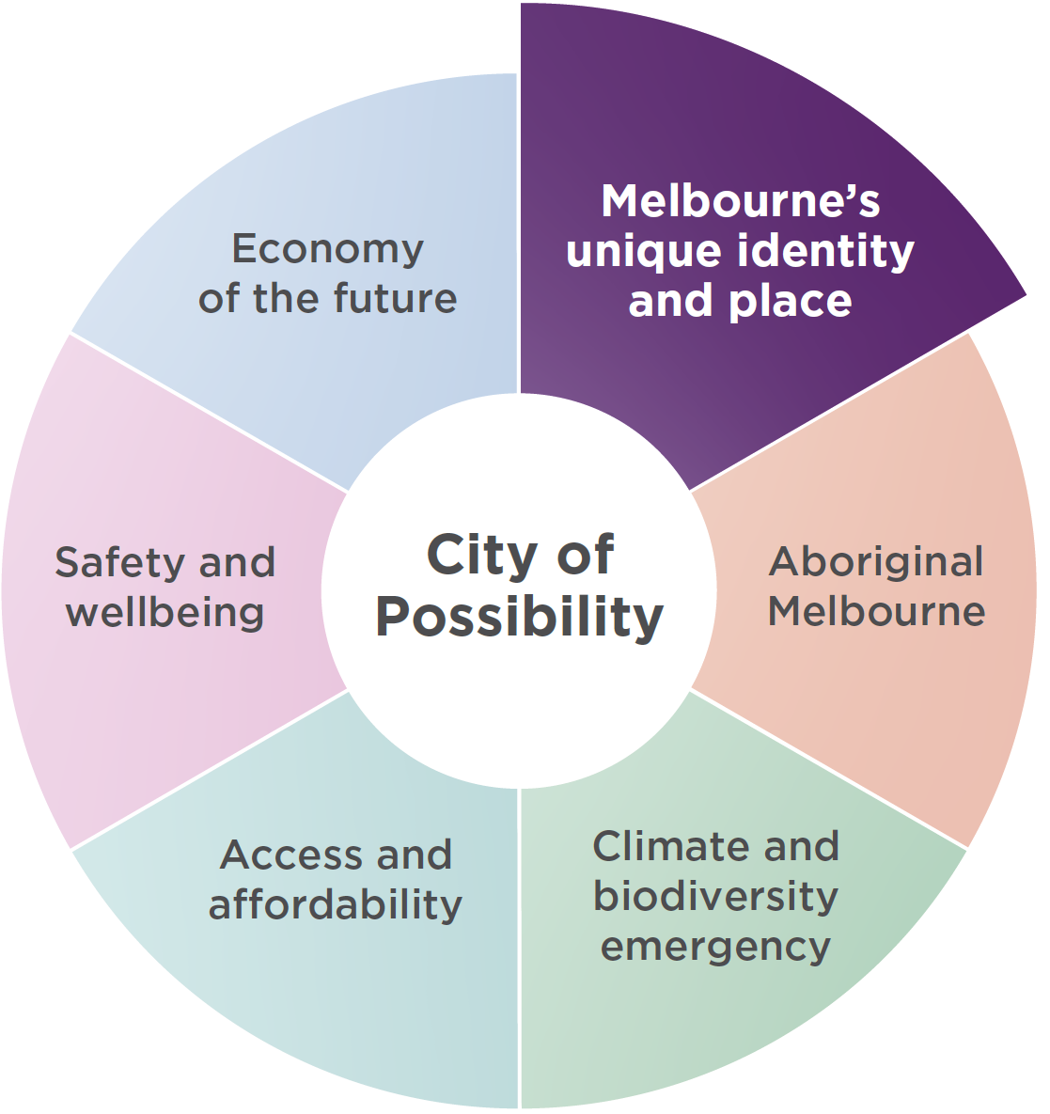

Melbourne’s unique identity and place
Melbourne is a city defined by its places, people and cultures, assets we want to celebrate and protect. Driven by our creative, entertainment and education sectors we will ensure Melbourne remains a unique, vibrant and creative city with world-leading liveability.

Contents
Carlton Gardens Master Plan 2022 3
Acknowledgement of Traditional Owners 4
Council Plan 2021-25 5
Melbourne’s unique identity and place 5
Disclaimer 8
Foreword from the Lord Mayor of Melbourne and Councillor 9
1. Introduction 10
1.1. Preparing this Master Plan 11
2. The place 13
2.1. The current gardens 13
2.2. Heritage significance – world, national, state and local 14
World heritage 14
National heritage 14
State heritage 15
Local heritage 15
2.3. Planning and management responsibility 15
International obligations 15
Commonwealth legislation 15
State legislation 16
3. Master Plan vision and guiding principles 17
3.1. Master Plan vision 17
4. Recommendations 18
4.1. Heritage and conservation 18
Recommendations: Heritage, culture and conservation 18
4.2. Fabric and features 20
Garden beds 20
Garden bed iron fencing 20
Lawns 22
Water features: lakes and fountains 22
Pathways 22
Exhibition Gardens Meeting Place 23
Garden entrances 24
4.3. Facilities 24
General garden furniture 25
4.4. Tree management and replacement 26
Tree replacement in a changing climate 26
Community perception of tree management in Carlton Gardens 27
4.5. Uses and activities 32
Recreational uses in Carlton Gardens 32
Community perception of recreational uses in Carlton Gardens 32
What people liked about Carlton Gardens: 33
4.6. Events 36
Events in Carlton Gardens 36
Community perception of events in Carlton Gardens 37
Monitoring and assessment of heritage impacts 39
4.7. Connections and linkages 40
Safe access to Carlton Gardens 40
4.8. Climate resilience 42
The impacts of a changing climate on Carlton Gardens 43
4.9. Interpretation 44
Community perception of interpretative practices 44
5. Carlton Gardens Master Plan projects – summary 47
6. Management and cooperation 49
7. Implementation of the Master Plan 50
8. Review of the Master Plan 50
9. Appendices 51
9.1. Appendix A – Carlton Gardens selected plans. 51
9.2. Appendix B – Master Plan implementation 2005 to 2021 55
Key 56
9.3. Appendix C – Summary of recommendations Carlton Gardens Master Plan 2022 57
4.1 Heritage and conservation 57
4.2 Fabric and features: Garden beds 57
4.2 Fabric and features: Garden bed iron fencing 58
4.2 Fabric and features: Lawns 58
4.2 Fabric and features: Water features 58
4.2 Fabric and features: Pathways 59
4.2 Fabric and features: Exhibition Gardens Meeting Place 59
4.2 Fabric and features: Garden entrances 59
4.3 Facilities 60
4.3 Facilities: General garden furniture 60
4.4 Tree management and replacement 60
4.4 Tree management and replacement 63
4.5 Uses and activities 63
4.5 Uses and activities 65
4.6 Events 66
4.7 Connections and linkages 68
4.8 Climate resilience 70
4.9 Interpretation 70
6. Management and cooperation 72
10. ADDITIONAL REFERENCE 73

June 2023
Cover Image: Carlton Gardens South. Photo Credit: David Hannah.

Disclaimer
This report is provided for information and it does not purport to be complete. While care has been taken to ensure the content in the report is accurate, we cannot guarantee it is without flaw of any kind. There may be errors and omissions or it may not be wholly appropriate for your particular purposes. In addition, the publication is a snapshot in time based on historic information which is liable to change. The City of Melbourne accepts no responsibility and disclaims all liability for any error, loss or other consequence which may arise from you relying on any information contained in this report.
To find out how you can participate in the decision-making process for City of Melbourne’s current and future initiatives, visit melbourne.vic.gov.au/participate

Foreword from the Lord Mayor of Melbourne and Councillor

The Carlton Gardens are one of Australia’s most significant heritage gardens. Surrounding the Royal Exhibition Building and Melbourne Museum, the gardens are a key component of Melbourne’s unique identity and place. To this day, the gardens remain an important gathering and connection place for the Victorian Aboriginal community.
The Carlton Gardens Master Plan has been developed to guide our future management of the gardens, by considering contemporary requirements of public open space, and builds on the direction of the previous Master Plan in 2005.
The Royal Exhibition Building and Carlton Gardens are globally recognised, listed as UNESCO World Heritage Site in 2004. Together, they preserve the cultural and social stories of the late 19th century, revealing a unique period of Melbourne’s history. The City of Melbourne continues to work in close cooperation with our World Heritage site partners to protect Carlton Gardens’ cultural values and heritage assets while ensuring the gardens continue to be available for recreational use.
Green spaces, parks and gardens are vital to a city’s liveability and to the wellbeing of residents, workers and visitors. Climate change and extreme weather events present significant challenges, demanding a well-informed approach to ongoing management of the gardens. The master plan responds effectively to the most recent climate change forecasts and the need to mitigate or adapt landscapes in response to these challenges.
With close to three million visitors each year, Carlton Gardens is one of Melbourne’s most popular green spaces. We thank everyone in the community who has been involved in the development of this master plan.
We know that Melburnians have a strong attachment to Carlton Gardens. We are confident this master plan will help us retain the historic qualities of this iconic garden, while preserving its integrity for the future.


Sally Capp
Lord Mayor
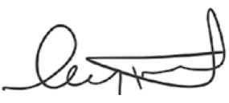
Councillor Rohan Leppert
Environment Portfolio Lead

Introduction
The Carlton Gardens form the essential and unique setting for the majestic Royal Exhibition Building, which together make up Australia’s first built environment inclusion on the World Heritage List in 2004. It is one of only two World Heritage Listed sites in Victoria, the other being the Budj Bim Cultural Landscape, included in 2019.
With its stunning tree avenues, formal garden beds, central fountain, ponds, pathways and sweeping lawns the site is linked to the historic International Exhibition movement of the late 19th and early 20th centuries. Established in the 1850s on the traditional Country of the Eastern Kulin, the early Carlton Gardens were redesigned for the 1880 Melbourne International Exhibition and the 1888 Centennial International Exhibition. They are one of Australia’s most significant heritage gardens. The site played a key part in the story of Australian federation, with the opening of the first national Parliament held at the Royal Exhibition Building in 1901. The site is also on the National Heritage List.
Now comprised of two distinct garden areas, with the Melbourne Museum and the Royal Exhibition Building situated at its centre, Carlton Gardens South and Carlton Gardens North are much loved by Melburnians and form a key component of Melbourne’s capital city and inner-urban regional open space network. The Gardens provide a valuable recreational space for Melbourne residents, workers and visitors.
A Carlton Gardens Master Plan was first adopted by the City of Melbourne in 2005. In 2013, a comprehensive World Heritage Management Plan was developed for both the World Heritage Listed site and the surrounding buffer zone by the Royal Exhibition Building and Carlton Gardens World Heritage Steering Committee (Steering Committee). The 2005 Carlton Gardens Master Plan was included as one of a suite of five documents that together made up the Royal Exhibition Building and Carlton Gardens World Heritage Management Plan (2013) (original World Heritage Management Plan).
In 2020 the Steering Committee, with support from Heritage Victoria, commenced a review and update of the original World Heritage Management Plan thereby enabling a simultaneous review of the Carlton Gardens Master Plan.

Preparing this Master Plan
The City of Melbourne’s Council Plan 2021-25 has ‘identity and place’ as a key strategic objective. It states:
“Melbourne’s unique identity and place: celebrate and protect the places, people and cultures that make Melbourne a unique, vibrant and creative city with world-leading liveability.”
Master plans are prepared for all major parks and gardens for which the City of Melbourne is responsible. The purpose of a master plan is to guide Council decision-making and overall management of a park or garden and recommend funding priorities in line with community needs and expectations.
This Carlton Gardens Master Plan 2022 covers Carlton Gardens South and Carlton Gardens North, both managed by the City of Melbourne. The central area called Exhibition Reserve – which is where the Royal Exhibition Building and Melbourne Museum is located – is addressed in a separate, yet complementary master plan developed by Museums Victoria. (Refer Figure 1).
A key consideration for the Carlton Gardens Master Plan is to manage the Gardens in accordance with their recognised cultural and heritage significance. Underpinning this revised Carlton Gardens Master Plan are two key cultural heritage reports: the Royal Exhibition Building and Carlton Gardens Traditional Owners and First Peoples Cultural Values Report (Traditional Owners and First Peoples Cultural Values Report) and the Royal Exhibition Building and Carlton Gardens Heritage Management Plan (Heritage Management Plan).
The Traditional Owners and First Peoples Cultural Values Report outlines the cultural heritage significance of the combined site and surrounding area from the perspective of its Traditional Owners and the broader Aboriginal and Torres Strait Islander community. This report was prepared by GML Heritage in 2020-21 and is a contributory document to the World Heritage Management Plan.
The Heritage Management Plan outlines the overall heritage significance of the Royal Exhibition Building and Carlton Gardens and provides guidance and policies to inform the ongoing management of the Outstanding Universal Values of the place. Recommendations in this Master Plan are informed by the Heritage Management Plan revised by Lovell Chen in 2022. This document updates and replaces the previous Conservation Management Plan for the site and is a contributory document to the World Heritage Management Plan.
This Carlton Gardens Master Plan also takes into account new community issues and needs identified following the adoption of the previous Master Plan in 2005.1 It includes new recommendations to accommodate increased general public use of the Gardens and to respond effectively to the most recent climate change forecasts and the need to mitigate or adapt landscapes in response to these challenges. Within the overarching planning framework of the World Heritage Listed site, the Master Plan includes a set of guiding principles, recommended actions and key works to enable the City of Melbourne to appropriately manage the Carlton Gardens while responding to current and future community needs.
Other key inputs to this Master Plan include:
- relevant recommendations from the World Heritage Management Plan (2013)
- the World and National Heritage Values of the Royal Exhibition Building and Carlton Gardens
- responses and submissions received by City of Melbourne in November 2021 from community engagement on the draft Carlton Gardens Master Plan
- responses and submissions received by the Steering Committee in mid–2020 from community engagement undertaken to inform the revision and of the original World Heritage Management Plan
- garden user surveys undertaken by the City of Melbourne in 2017 and ABS demographic information
- Climate Change Vulnerability and Risk for Australia’s World Heritage Properties (2021), CSIRO for Commonwealth of Australia.
- recommendations for open space provision and management set out in the City of Melbourne Open Space Strategy (2012)
- Arboricultural Assessment and Report (2021), Tree Logic for City of Melbourne
- City of Melbourne park asset condition assessments and quality assurance audits using Institute of Public Works Engineering Australasia (IPWEA) condition assessment methodology.
Figure 1: Area covered by the Carlton Gardens Master Plan and surrounding context
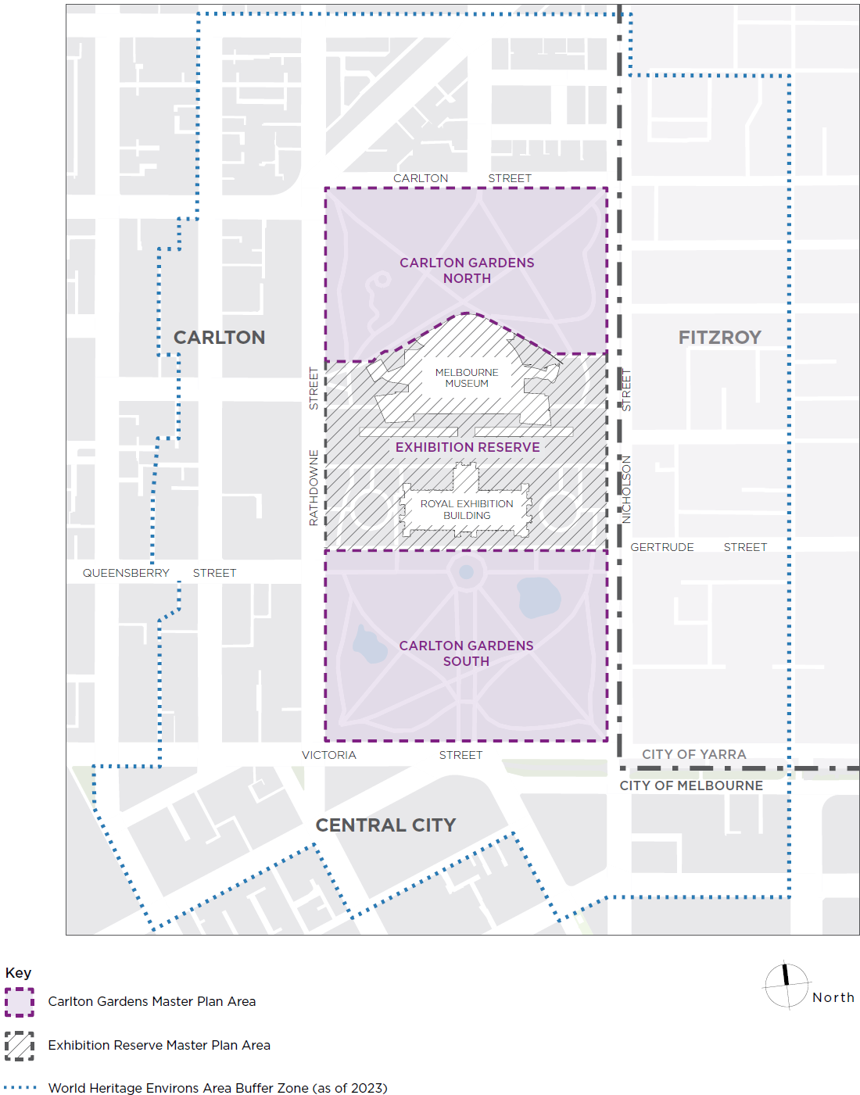

The place
The Wurundjeri Woi-wurrung people of the Eastern Kulin have an enduring and continuing connection to the land now called central Melbourne, having lived in and used the area for thousands of years. Carlton Gardens is situated on land that gently slopes towards the central city, which was originally part of a plains grassy woodlands before European settlement. The foundation of Melbourne in 1835 led to a complete reorganisation of the land and the dislocation of Aboriginal people connected to the place. The original vegetation was substantially removed and the landscape form extensively modified.
The present Carlton Gardens were set aside for public purposes and recreation by the Victorian colonial administration of Superintendent Charles J. La Trobe when the Carlton area was released for land sale in the 1850s, and permanently reserved for public gardens in 1873. A plan for Carlton Gardens was developed in the mid-1850s and partially implemented. In 1878, the land was re-acquired for use as the site of the Melbourne International Exhibitions which were held in 1880 and 1888. As part of this arrangement, Carlton Gardens South was further redesigned to form the setting for the Royal Exhibition Building – a layout that remains substantially intact today.
The main Exhibition Hall was built in the centre of the Gardens (now renamed Exhibition Reserve) with Carlton Gardens North largely used for temporary annexes during both the 1880 International Exhibition and again during the 1888 Centennial Exhibition. After both Exhibitions, the temporary annexes were demolished and the North Gardens reinstated in a revised layout. The North Gardens retain much of the original layout from this circa 1892 reinstatement but also include subsequent 20th century developments such as the tennis courts and playgrounds. Between Carlton Gardens South and North lies Exhibition Reserve, where the Royal Exhibition Building and Melbourne Museum are located. (Refer to Historic Plans in Appendix A – Carlton Gardens selected plans.).

The current gardens
The Carlton Gardens are bound by Rathdowne Street to the west, Carlton Street to the north, Nicholson Street to the east, and Victoria Street to the south. While Carlton Gardens and Exhibition Reserve read as one contiguous site, for master planning purposes, the site is divided into three distinct land parcels:
- the southern section – Carlton Gardens South
- the central section, where Melbourne Museum and the Royal Exhibition Building are located – Exhibition Reserve, and
- the northern section – Carlton Gardens North.
The City of Melbourne, as both joint Trustee and Committee of Management, is responsible for the Land Reserve Rs 9990 (Carlton Gardens) – that is the northern and southern sections of the site.
Carlton Gardens continue to be a place of connection and gathering for Aboriginal people.
The Gardens are formal in design and execution, providing tree-lined pathways, fountains and lakes as an integral part of the overall site design and setting for the Royal Exhibition Building. The original gardens were developed as a public garden for passive recreation, with later, more classical garden modifications, including ‘Gardenesque’ elements, made in 1879 to form an appropriate setting for Royal Exhibition Building.
The main garden elements in Carlton Gardens South include:
- the main north-south, tree-lined avenue (the Grand Allée)
- the central Hochgurtel Fountain and surrounding garden beds
- the radial pattern of tree-lined linear pathways converging at the fountain and the serpentine path around the interior edge
- formal garden beds (parterres) and several informal garden beds
- the ornamental lakes
- the planting of trees in groups or clumps (bosquets) on lawns, and in a denser pattern on the perimeter edge
- the incorporation of axial views and vistas between Carlton Gardens South and the Royal Exhibition Building.
Carlton Gardens North features diagonal, tree-lined paths and mature specimen trees, primarily circa 1890 when these Gardens were reinstated following the removal of various structures erected for the 1888 Centennial Exhibition. Recreational facilities, such tennis courts (circa 1924) and various playgrounds (circa 1910), are longstanding features of Carlton Gardens North.
Throughout both Carlton Gardens North and South, 19th and 20th century plantings include pines, cedar, araucaria, cypress, gums, figs, pepper trees, elms, plane trees, oaks, poplars, Canary Island date palms and Washington palms. Most of these plantings are mature and many are of a significant size.
Carlton Gardens and its specimen trees are maintained by specialist contractors, with clear oversight by the City of Melbourne. Contracts stipulate the highest possible maintenance standards and frequent assessments are carried out by City of Melbourne staff to ensure these standards are met. Exhibition Reserve is maintained by contractors on behalf of Museums Victoria.

Heritage significance – world, national, state and local
The heritage significance of the Royal Exhibition Building and Carlton Gardens is best understood as a hierarchy, ranging from World Heritage significance, followed by national, state and local levels. Each level of significance is assessed against different, yet complementary sets of criteria.
The Heritage Management Plan outlines each of these levels of significance in detail in Section 2 of that document. The formal levels of significance are summarised below.

World heritage
The Royal Exhibition Building and Carlton Gardens were inscribed on 1 July 2004 on the World Heritage List by the World Heritage Committee under criteria (ii) of the World Heritage Convention adopted by UNESCO in 1972. The description of Criterion (ii) is exhibit an important interchange of human values, over a span of time or within a cultural area of the world, on developments in architecture or technology, monumental arts, town-planning or landscape design. The designation for the Royal Exhibition Building and Carlton Gardens reads:
“The Royal Exhibition Building and the surrounding Carlton Gardens, as the main extant survivors of a Palace of Industry and its setting, together reflect the global influence of the international exhibition movement of the 19th and early 20th centuries. The movement showcased technological innovation and change, which helped promote a rapid increase in industrialisation and international trade through the exchange of knowledge and ideas.”

National heritage
The Royal Exhibition Building and Carlton Gardens were listed on the National Heritage List in 2004 as a place of National Heritage significance (Place ID 105708, and Place File 2 / 11 / 033 / 0235). This listing is based on the role the Royal Exhibition Building and Carlton Gardens played in the exhibition movement and the Federation of Australia. It is the place where the first national Parliament was held in 1901 and where the first Australian flag was flown. It was also the location of the Victorian Parliament while the national Parliament sat in Parliament House, Spring Street prior to (Old) Parliament House in Canberra being constructed.

State heritage
The Royal Exhibition Building and Carlton Gardens are included on the Victorian Heritage Register (no. H1501). While referencing the complete World Heritage values, the Victorian Heritage Register Statement of Significance concludes the Carlton Gardens are of historical, architectural, aesthetic, social and scientific (botanical) significance to the State of Victoria in their own right:
The Carlton Gardens, the setting for the Royal Exhibition Building, are aesthetically significant for their 19th century ‘Gardenesque’ style, featuring specimen trees and parterre garden beds in a symmetrical design with the use of axial views and foci. The Hochgurtel Fountain and the ‘Grand Allée’ lined with Plane trees are integral to the setting of the Royal Exhibition Building.
The Exhibition Gardens Meeting Place, within Carlton Gardens, is included on the Victorian Aboriginal Heritage Register as an Aboriginal historical place. Its cultural significance is as an important gathering and connection place for the Victorian Aboriginal community since at least World War One and meeting place since the 1930s.
Two large Moreton Bay fig trees (Ficus macrophylla) at the edge of Carlton Gardens, near the junction of Nicholson and Gertrude streets, mark the significance of this Meeting Place.

Local heritage
Carlton Gardens is included under heritage overlay (HO69) in the City of Melbourne planning scheme.

Planning and management responsibility
Planning and management responsibilities are specified under Commonwealth and State legislation as follows.

International obligations
The Australian Government has signed and ratified the UNESCO Convention concerning the Protection of the World Cultural and Natural Heritage (the World Heritage Convention). Under the World Heritage Convention all countries that have ratified the convention are expected to protect the World Heritage values of the properties inscribed and are encouraged to report periodically on their condition.

Commonwealth legislation
The Australian Government protects and manages the World Heritage values of World Heritage Listed sites through the Environment Protection and Biodiversity Conservation Act 1999 (Cth) (EPBC Act). The EPBC Act requires that no actions are taken that would have a significant impact on the world or national heritage values of the site, and requires the development of comprehensive planning and management arrangements for the site. In 2004 the Victorian Heritage Act 2017 was amended to require the preparation of a World Heritage Management Plan for the site and a Strategy Plan for the precinct surrounding the site to assist in meeting the obligations under the EPBC Act for a planning and management framework.
The original Royal Exhibition Building and Carlton Gardens World Heritage Management Plan was approved in 2013, and updated in 2023.

State legislation
As a place included on the Victorian Heritage Register, the Heritage Act requires the approval of the Executive Director, Heritage Victoria, for any works or activities in Carlton Gardens unless there is a permit exemption. Permit applications are made through the existing statutory heritage permit approvals process and may include pre-application discussions with Heritage Victoria and public advertising of permit applications for proposed works. At the request of the applicant, the Heritage Council of Victoria is able to review a decision not to grant a heritage permit.
The Crown Land (Reserves) Act 1978 provides the underpinning reservation of the Carlton Gardens as permanently reserved for Public Gardens and enables the Melbourne City Council to manage Carlton Gardens as both Joint Trustee and Committee of Management. This means Melbourne City Council is responsible for the care and management of Carlton Gardens.
The Victorian Aboriginal Heritage Act 2006 recognises Registered Aboriginal Parties (RAP) as the primary guardians, keepers and knowledge holders of Aboriginal Cultural Heritage. The RAP for the land where Carlton Gardens is located is the Wurundjeri Woi-wurrung Cultural Heritage Aboriginal Corporation. The Act includes provision to protect registered places from harm and statutory approvals are required for works within the area registered as the Exhibition Gardens Meeting Place.
The Local Government Act 2020 governs the operations of all Councils in Victoria. The Act includes a requirement that in performing its role, the Council must adopt and maintain a Community Engagement policy. The City of Melbourne’s Community Engagement Policy 2021 outlines the Council’s approach to community engagement practice, and the principles that guide shared problem-solving, open dialogue and meaningful participation in consultation processes, such as master plans.

Master Plan vision and guiding principles

Master Plan vision
Carlton Gardens is a living setting for the world-renowned Royal Exhibition Building and reflects the historical, cultural and social fabric of late 19th century ‘Marvellous Melbourne’. The Gardens will continue to be a treasured recreational space, contributing significantly to Melbourne’s public open space network.
Four overarching guiding principles underpin the vision for the Carlton Gardens Master Plan. These principles will help guide decisions on all aspects of the Gardens and have been used to shape the detailed recommendations in the Master Plan.
The four guiding principles are:
- Culture and heritage: The recognised heritage and cultural values of Carlton Gardens are understood and reflected in the presentation, management approach and promotion of the Gardens.
- Use: Carlton Gardens is managed primarily as a passive recreation space, with uses, activities and supporting facilities provided to meet contemporary public open space needs.
- Resilience: The impact of climate change is actively planned for in renewal works at Carlton Gardens so that it remains a healthy, accessible and resilient landscape in the future.
- Partnership: The City of Melbourne continues to work in close cooperation with World Heritage site partners to protect and promote the values of the site and provide a positive visitor experience.

Recommendations
When formulating the recommendations contained in this revised Master Plan, the overarching consideration was to protect Carlton Gardens’ cultural values and heritage assets while ensuring the site remains available for continuing community use. Recommendations also take into account responses received during the community engagement process for the draft Master Plan, and relevant contemporary issues and requirements such as community safety, equitable access for all abilities, recreational opportunities and environmental management.
For ease of reference, where applicable the relevant Heritage Management Plan (HMP) section number or reference to the Traditional Owner and First Peoples Cultural Values Report (TO and FPCV) is included in brackets underneath each recommendation heading.

Heritage and conservation
Recommendations relating to cultural and heritage values, and the features and fabric of Carlton Gardens, are based on the policies of the Heritage Management Plan, the findings of the Traditional Owner and First Peoples’ Cultural Values Report and the World and National Heritage List determinations. In the World Heritage Listing, the key period of historic significance for the overall site is defined as 1880 to 1901. While all cultural and heritage values are important, physical elements of Carlton Gardens relating to this period are of particular importance.

Recommendations: Heritage, culture and conservation
- To conserve the landscape and structures remaining from the 19th century period of key heritage significance to form and character through preservation of existing elements or restoration, where practicable.
- To conserve areas of importance to Traditional Owner and First Peoples as identified in the Traditional Owner and First Peoples Cultural Values Report.
- To investigate the feasibility of reintroducing horticultural features of the key historic period of significance, where this assists the understanding or interpretation of the site.
- To maintain and enhance identified historic significant views and vistas both to the Royal Exhibition Building and within the Carlton Gardens South.
- To ensure that no new permanent structures (including monuments or memorials) are permitted in Carlton Gardens unless contemplated in this Master Plan or are replacements of existing structures.

Figure 2: Historic views and vistas in Carlton Gardens South
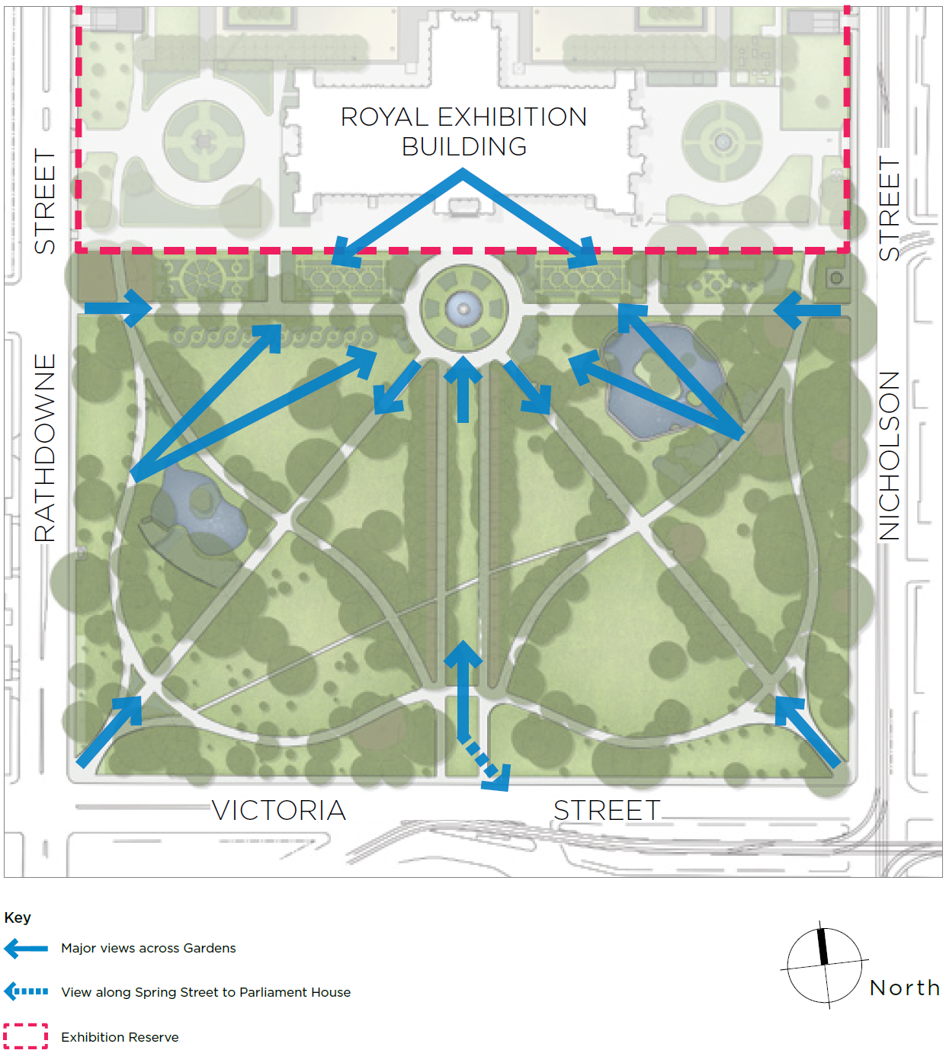

Fabric and features
The essential components of historic gardens are living and growing plants, which require a different management approach to historic buildings. While buildings can be preserved, restored and managed without significant change, gardens continually change and need ongoing management and renewal. Key historic fabric and features of Carlton Gardens that need to be managed and maintained are garden beds and garden bed iron fencing, lawns, water features, pathways, garden entrances, the Exhibition Gardens Meeting Place and the curator’s cottage. Other parts of the Carlton Gardens fabric contribute to the overall presentation of the Gardens and are also included in these recommendations.

Garden beds
(HMP 3.7.5 and 3.7.6)
Garden beds were used prolifically in 19th century planting schemes and are particularly evident in Carlton Gardens South. The beds varied in presentation but generally contained plantings at various heights. Some contained a mix of shrubs and lower-level plantings and others contained trees, shrubs and lower-level plantings. (Refer to Figure 3). The number of beds and the layout and planting stock of garden beds has changed continually over time, including the removal of some beds all together. Removal was most likely due to changes in maintenance costs and regimes, an increase in the overall tree canopy in the Gardens, changes in growing conditions, or as a result of public safety considerations. However, detailed investigations show that some of the earlier 19th century garden bed layer could be reinstated in either a full or modified form.
Opportunities exist to increase the number of garden beds and lower-level plantings, particularly in Carlton Gardens South. These opportunities could occur at the same time as other horticultural renewal works such as tree avenue renewal.

Recommendations: Garden beds
- Investigate the creation of new garden beds where current conditions allow and where a reintroduction of a garden bed is supported by historic evidence. Key areas of interest include the ornamental lakes surrounds and the internal pathway intersections in Carlton Gardens South (refer to Figure 4 for priority investigation areas).
- Continue to conserve and renovate the surviving and reconstructed elements of the historical 19th century garden bed planting schemes, maintaining overall form, character, edge and structure for beds consistent with historic evidence.
- Prepare maintenance and renewal plans for all garden beds including an assessment of their importance in the interpretation of the overall site. The plan should include a planting schedule, future plant selection options which will serve the form and character of the bed, preferred maintenance techniques and the requirements for a high standard of horticultural excellence.

Garden bed iron fencing
(HMP 3.6.5)
Iron hurdle fencing, used since the 19th century as movable fencing to control access to garden sections, is still present in Carlton Gardens North around a garden bed and as the fence for the curator’s cottage. Similar fencing was removed and repaired when the Carlton Gardens North depot was demolished in 2007 and is currently held in storage.

Recommendations: Garden bed iron fencing
- Retain and conserve all existing portions of fence around garden beds and the curator’s cottage.
- Reuse stored fencing, as required, in other areas of Carlton Gardens and in other City of Melbourne historic gardens which used the same style of fencing. It can be used for repairs, reconstruction of fencing sections or where it assists in the interpretation of the place.

Figure 3: 19th century historic garden bed typology
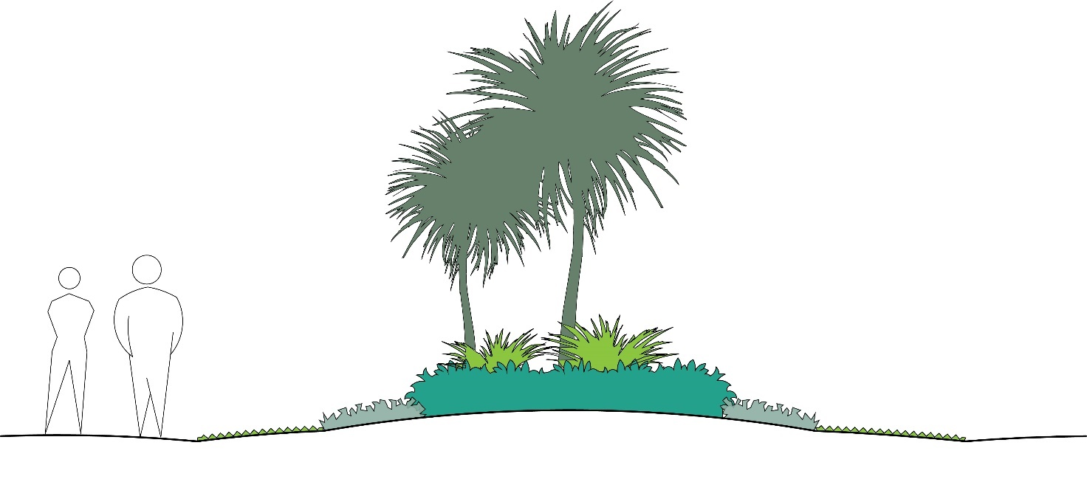
Example of typology of a Garden bed - used for re-construction of the south-west corner entrance bed

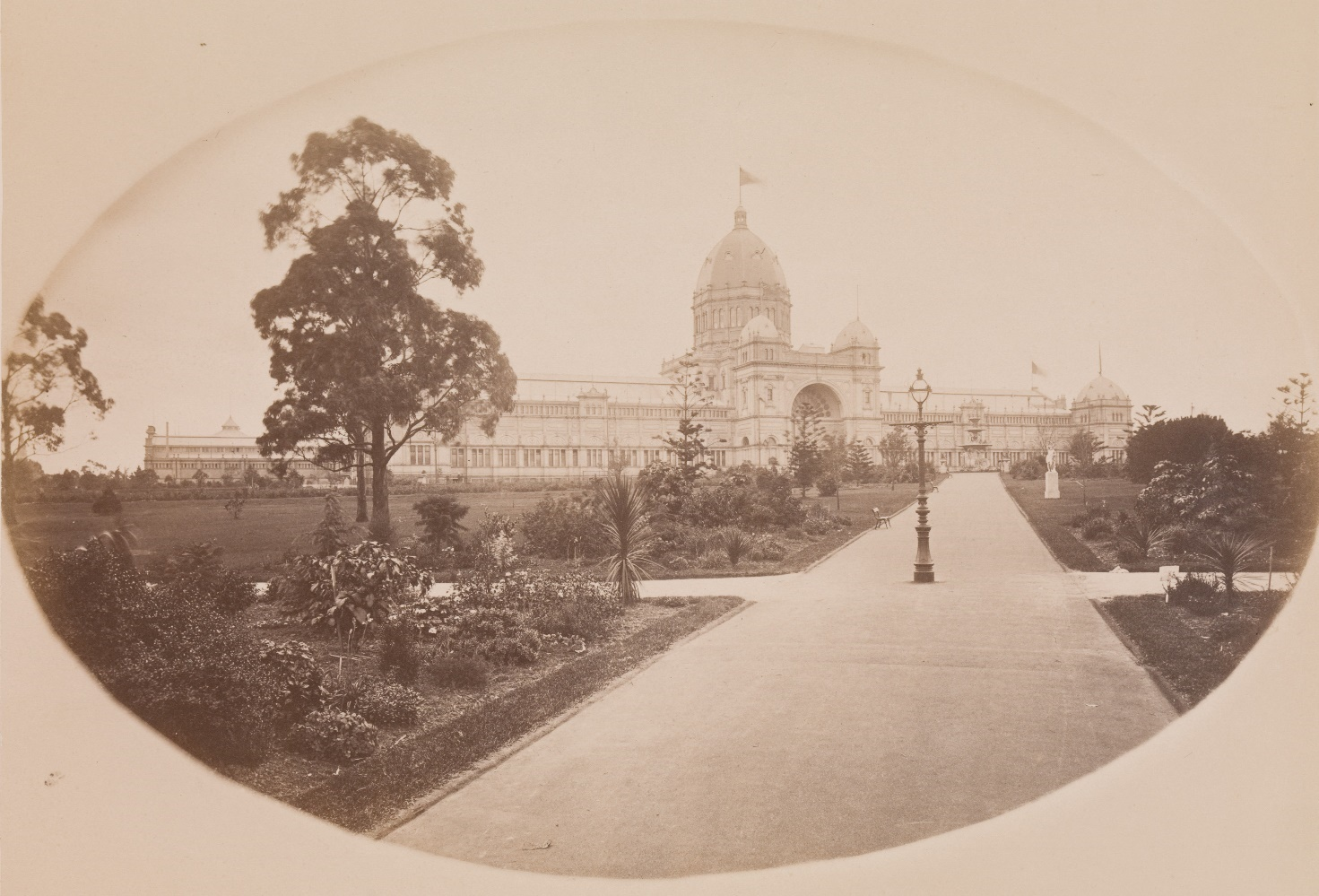
VIew of the Exhibition Building looking north-east, 1880-1881. Photographer:Ludovico Hart Source: Museums Victoria (MM107801)

Lawns
(HMP 3.7.7)
Lawn areas are an important landscape feature in both Carlton Gardens North and South and are associated with the 19th century character of the site. The current internal open lawns are a significant visual element of the Gardens and provide for multiple passive recreational uses. Lawns also provide key areas of ground permeability in an urban setting and assist with urban cooling.

Recommendations: Lawns
- Open lawns should be kept to a high standard of visual presentation and be irrigated where required. Locations of specimen tree plantings should allow the open lawns to present as a feature in their own right, in keeping with the historic Gardenesque style.

Water features: lakes and fountains
(HMP 2.4, 3.6.2 and 3.6.4 and TO and FPCV)
The two ornamental lakes and the Hochgurtel Fountain at the northern end of the Grand Allée are key features of Carlton Gardens South. A number of historic trees planted around the lakes have died or failed over the last decade presenting the opportunity to replant around the immediate surrounds of both lakes and repair the existing infrastructure. The use of trees and lower-level shrub plantings around the lakes is evident in 19th century presentations and this character should be continued in any new plans.

Recommendations: Water features
- Maintain both the fountain and lakes in good order, retaining the current landscape envelopes for these features. In a circumstance where the extent of the current eastern lake needed to change, consultation with key heritage and cultural heritage stakeholders is recommended. Heritage Management Plan guidance on options to restore the original alignment of the eastern lake and the values of the adjacent registered Aboriginal historic place (identified in the TO and FPCV) should be used to inform any future alignment changes.
- Continue to maintain natural clay lake bases to support both local birds, insects and amphibians, and current water permeability function.
- Implement new planting and landscape plans for both of the lake surrounds including planting of replacement trees and introducing a variety of low planting.
- For the western pond, progress replanting of the entire pond edge with lower-level planting and garden beds.
- For the eastern pond investigate additional riparian and aquatic native species at the pond margins.
- Undertake repairs and refurbishment, based on conservation advice, to the historic fabric of the fountain, lake walls and islands, as required.

Pathways
(HMP 3.6.3)
Much of the 19th century pathway layout, dating from the Exhibition period, remains intact today, meaning all surviving elements of this layout should be conserved.

Recommendations: Pathways
- Preserve the surviving 19th century layout of the path system and restore or reconstruct missing parts of the 19th century path system if needed.
- Retain asphalt surfacing and the simple edge treatment of the historic pathways as this treatment is associated with the Exhibition period.
- Minor access pathways to, or for particular features in the Carlton Gardens, can be created as required for community access but should be modest in presentation and width and be constructed of granitic gravel.

Exhibition Gardens Meeting Place
(HMP 2.4)
The connection to, and importance of, the Meeting Place in Carlton Gardens South for Aboriginal people was re-stated during the process of developing the Traditional Owners and First People’s Cultural Values Report in 2021. The Meeting Place is centred around two fig trees on the south-east side of the Gardens between the eastern lake and the intersection of Gertrude and Nicholson streets, and includes the land around the trees. A plaque acknowledging the significance of the Meeting Place is positioned in the surround of the tree closest to Gertrude Street and is part of a City of Yarra self-guided cultural heritage walk. This tree is in need of additional interventions to keep it in good health. The existing stone surround and associated paving are restricting the tree’s growth and deteriorating under root pressure.

A plan has been developed to create a larger growing area for the tree and to provide an opportunity for greater connection and acknowledgment of the site in consultation with Registered Aboriginal Parties and other Aboriginal stakeholders with a strong connection to the site. The project has received both cultural and heritage permits to proceed. While recent pandemic restrictions have delayed the implementation phase of the project, Council is committed to completing the works. The City of Melbourne will continue to progress these plans in consultation with Registered Aboriginal Parties and other stakeholders with a clear connection to this place.

Recommendation: Exhibition Gardens Meeting Place
- Progress work on improving fig tree health and longevity and recognising and interpreting the significance of the Exhibition Gardens Meeting Place.

Garden entrances
(HMP 3.6.1 and 3.9)
The remnant bluestone plinth on the perimeter of Carlton Gardens shows the location of the former iron fence used to control entry into the International Exhibitions. Current Garden entrance points are associated with this former fence and gates. The majority of the current Carlton Gardens entrances reflect this arrangement; with the notable exception being the entrance to the Grand Allée from the south. The original entrance here was smaller and oriented to the alignment of Spring Street. At a later date it was modified to allow vehicular access to the site, still required today.

Recommendations: Garden entrances
- Maintain all current entrance locations.
- Undertake any works at entrances as required for disability access.
- Keep the area around the former south entrance to the Grand Allée clear of planting to allow interpretation or reconstruction of this entry at a future date.
- Reintroduce triangular planted beds in South Carlton Gardens at the south-east entrance to match the reconstructed beds at the south-west entrance.

Facilities
(HMP 3.5.8, 3.5.9, 3.5.10, 3.6.6, 3.6.7, 4.15.3)
Facilities to support public open space use and enjoyment of gardens are important to their successful management. Community facilities in Carlton Gardens North include a tennis club pavilion and courts, a playground, a casual ball court, picnic area and general garden furniture. Valued and well-used, the tennis pavilion and courts are leased to the Carlton Gardens Tennis Club, a community-based club with a large, active membership. Public toilet facilities are situated in both Carlton Gardens North and South. Garden maintenance facilities are based at the curator’s cottage located at the north-west corner of the Gardens. These facilities have been established at different times, ranging from the historic curator’s cottage in the late 19th century, the tennis courts in the 1920s and the maintenance facility in 2009. All facilities are in daily use, and all community facilities have experienced an increase in use in recent years, in line with increased visitation to the Gardens.
Each of these facilities will continue to be required for the foreseeable future. The upkeep and maintenance of community facilities is managed by the City of Melbourne. A 2017 garden user survey shows the playground and tennis court rated well as facilities whereas the current toilet facilities were identified as in need of improvement. The current public toilets are necessary facilities that present in an older style but were installed in the 1990s. While visually discreet, they do not meet current user needs or accessibility standards and are assessed as below standard in asset condition assessments and quality assurance audits.
Public consultation on the draft Master Plan in 2021 strongly supported the recommendation to replace the existing toilets with safer, secure and more accessible facilities. The City of Melbourne Public Toilet Strategy guides the replacement and management of all public toilet facilities in the municipality and should be used as the basis for planning the replacement facilities in Carlton Gardens.

Recommendations: Facilities
- Replace the existing public toilet facilities with new facilities. Key considerations for replacement are that the public toilets are safe to use, secure, accessible to contemporary standards and are unobtrusive in design and siting. The current street frontage location of the existing facilities is consistent with the City of Melbourne’s policy for public toilet provision and it is recommended these same general locations are used for the new facilities. A new design should respond to the policy guidance at 3.5.10 in the Heritage Management Plan.
- Retain all other existing community facilities in Carlton Gardens and ensure these assets are well maintained to acceptable asset condition ratings and renew if required.
- For the curator’s cottage, conduct a program of regular inspection and undertake maintenance and heritage preservation works as required, particularly for its exterior historic fabric, front garden and fencing.

General garden furniture
Carlton Gardens contains a range of public furniture such as seats, picnic tables, rubbish bins, lighting, bollards, drinking fountains and signage. The current suite of furniture is part of the City of Melbourne’s standard parks and gardens furniture set and is not part of the historic fabric of the Gardens. The standard furniture set designs meet standards for disability access, durability and maintenance requirements. Both general public consultation and consultation with children on the draft Master Plan in 2021 invited feedback on the existing garden furniture. Participants were able to nominate what additional public furniture would be beneficial to garden users and suggest appropriate locations.
Children were keen to see clean public toilets and benches, more rubbish bins and drinking fountains. In the general public consultation the most popular request was for additional park seating, which was suggested in over half of the responses. Seats in the shade and / or near existing garden features and community facilities were the most popular responses. Seating suitable for disabled use and new seating near garden beds in the north-west corner of the Gardens and near the lakes in Carlton Gardens South were specifically requested.
The second most requested furniture item was additional picnic tables, situated in shady locations and close to the playground precinct. Also nominated in the general public survey were additional rubbish bins and drinking fountains, including for dogs, and new dog bag dispensers and barbecues.

Recommendation: General garden furniture
- Use community engagement input to guide installation of new garden furniture or to replace existing furniture.
- New or replacement furniture should be in keeping with the overall Gardens presentation and be pre-approved by the City of Melbourne if not part of the current furniture suite.
- Audit existing signage and replace or update to current standards where required.
- Further investigate installation of barbecues and, if supported, install in the picnic area in North Carlton Gardens.

Tree management and replacement
(HMP 3.7.1, 3.7.2, 3.7.3, 3.7.4. TO and FPCV)
Trees are a major landscape feature in Carlton Gardens, providing character, visual appeal, amenity, environmental and ecological benefits and a sense of history for visitors. As living things, trees must be individually and collectively cared for, and a clear framework must be used to guide management, replacement and renewal decisions.
The tree layer in Carlton Gardens is formally recognised as being of heritage significance at the world, national and state level. Tree removal and replacement is of high interest to many stakeholders and proposed activities may require consideration of EPBC Act requirements and permit approval from Heritage Victoria.
The 2005 Carlton Gardens Master Plan provided broad recommendations to guide tree replacement and identified locations where significant replacement would be required in the foreseeable future. A summary of renewal and replacement actions completed since 2005 is included in Appendix B. Avenue renewal and tree replacement will continue to be an ongoing activity in the Gardens.
The City of Melbourne has longstanding policies for tree management which guide the protection, management and replacement of all trees managed by the municipality. There is a high degree of consistency between City of Melbourne policy and practices and Heritage Management Plan policy guidance. A Tree Conservation Strategy was prepared for Carlton Gardens in 2006 and further guidance on replacement of tree avenues was provided in the World Heritage Management Plan in 2013.
Section 3.7 of the Heritage Management Plan (2022) sets out an updated set of guidance policies around the landscape character and management of trees, building on earlier tree management strategies and guidance. It recommends preparation of a new Tree Management and Replacement Plan, as a successor document to the 2006 Tree Conservation Strategy and seeking relevant expertise in landscape heritage and arboriculture to assist in its preparation.

Tree replacement in a changing climate
A key driver of the City of Melbourne’s Urban Forest Strategy (2012) and Tree Policy (2021) is to ensure all new trees planted can respond to a changing climate.
Given that many trees planted today will still be there in decades to come, it is important to incorporate anticipated climate change impacts when making tree species replacement decisions. This consideration is required for all open space in the City of Melbourne, including heritage-listed places such as Carlton Gardens.
All current tree species planted in the City of Melbourne have been assessed for vulnerability against predicted mean temperature increases expected to occur over the next 25 years. (The City of Melbourne’s Future Urban Forest, 2016). This research shows that some tree species will perform better than others.
Across Melbourne 35 per cent of all trees were assessed as either moderately or extremely vulnerable to changing climatic conditions. This includes some of the current tree population in Carlton Gardens, which contains a number of ‘category one’ tree species from colder climates, such as northern Europe and north-eastern United States, a group which is particularly vulnerable to climate change.
While this group of trees make important contributions to the City of Melbourne’s cultural identity, liveability and biodiversity, they may become less reliable. This means that over time, there will likely be a need for increased tree removal, pruning and re-planting in response to accelerated tree decline and mortality.
Within this broad category of vulnerability, replanting of existing ‘like for like’ species may still be suitable in some places where there are reliable supporting management actions, such as guaranteed irrigation and improved soil conditions. However, even with this support, some tree species present in the gardens will not thrive. Replanting decisions will need to be assessed on a location by location basis, with the best course of action resolved based on specific species and site information. Where the replacement of climate vulnerable trees is being considered, climate resilient species alternatives should be prioritised over a like for like approach.
When considering substitute species for Carlton Gardens, a priority will be to use alternative tree choices with similar characteristics of the tree(s) to be replaced.

During preparation of the draft Master Plan, an independent audit of all trees in Carlton Gardens was completed for standard indicators of tree health, useful life expectancy and overall condition. The audit found that of the 643 trees in the Carlton Gardens, while 30 per cent were assessed as being ‘over mature,’ approximately 90 per cent of trees were healthy and had a useful life expectancy greater than 10 years.
However, approximately 10 per cent of the total existing tree population is likely to need replacing within the next 10 years. These trees include:
- 20 trees located in Carlton Gardens North
- 23 trees located in Carlton Gardens South.
Within this group of 43 trees, 19 are from two older avenues and one more recently planted row of Populus alba (White Poplar). This tree species has been assessed as being climate vulnerable in both moderate and extreme future climate change scenarios. An alternative replacement tree should be considered in these locations when being replanted.
There are also a number of locations were 19th century trees have either died or been removed in recent years. Replanting plans are required for these areas. (Refer figure 4)

Community perception of tree management in Carlton Gardens
As part of the engagement undertaken in 2020 for the World Heritage Management Plan, survey participants were invited to comment on the following statement:
“The gardens need to adapt for changing climate conditions, whilst retaining their historic layout and features.”
Seventy-seven per cent of survey participants agreed or strongly agreed that the management of Carlton Gardens needed to adapt to changing climate conditions.
Further, as part of the community engagement survey on the draft Carlton Gardens Master Plan in 2021, participants were asked to nominate how well they understood considerations about tree replacement. Seventy per cent of participants advised they had a full understanding of the issue, with a further 20 per cent nominating partial understanding. Details of what would be replanted, when it would occur and the details of the replacement process were key areas of further interest.

Recommendations: Tree management and replacement
- Strategic recommendations
  - Continue to monitor and nurture the existing historic trees and maintain the garden character of a densely treed edge, axial avenues, mixed layer plantings in garden beds and internal open lawn areas supporting specimen trees.
  - Continue to plant a range of tree species in the Gardens, with selection being consistent in character with the trees planted in the 1880-1901 period of significance.
  - Develop a Tree Management and Replacement Plan specific to Carlton Gardens. This plan will be based on the policies of the Heritage Management Plan (2022), the City of Melbourne’s Urban Forest Strategy and Tree Policy and the tree audit completed in 2021. A particular focus for the Plan will be to prepare detailed replacement strategies for trees audited as most likely to need replacing over the next 10 years, and to develop planting plans for key areas that currently require tree planting. (Listed in the recommendations below).
The revised Tree Management and Replacement Plan should:
- Include a short list of options for ‘climate resilient’ species, which can be used where assessed as being required, and allow for the advanced growing of these new replacement trees to proceed if necessary.
- For major tree avenue replanting, investigate the feasibility of reinstating shrub beds as part of the revised planting, if this was part of the earlier 19th century historic presentation. (see 4.2 Garden beds)
- Use historic planting presentations where evidence supports this action (examples include irregular / regular avenue set outs, bosquets groups of specimen trees, denser planting on perimeter garden edges).
- Consider relevant recommendations in the
- Traditional Owner and First People’s Cultural Values Report on tree management species selection and cultural values.
- Provide new tree plantings, particularly in key activity areas in Carlton Gardens North, in response to community requests to increase shade in these areas.
- Prior to finalisation of the revised plan invite comment from Heritage Victoria and the Heritage Branch of the federal Department of Climate Change, Energy, the Environment and Water, the World Heritage Management Plan Steering Committee and the public.

  - If tree replacement is required prior to this revised plan being completed, continue to use the Heritage Management Plan policies and Urban Forest Strategy to guide decision making.
  - Continue to monitor the health of identified individual rare tree species in Carlton Gardens. If replacement is required, prioritise propagation of replacement specimens for replanting.
- Recommendations for tree renewal – Carlton Gardens South

Avenues
  - White Poplar Avenue replacement – This avenue is not part of the original 19th century plantings and is senescent. The opportunity to select a new species and design a replacement avenue that includes former shrub beds should be explored.
  - Investigate enhancement planting to reinstate the form of the west axial Elm Avenue.
  - Continue the replanting program to renew individual trees in the formal Oak Avenue on the curved pathway extent, as growing conditions allow

General tree planting
  - Eastern pond surrounds – Develop a design to replant around the lake edge and replace trees that have died or been removed in the last decade, or are senescent. Recreate a lower-level planting layer beneath the trees, in line with the 19th century presentation (also refer to section 4.2 Water features)
  - Western pond and west garden perimeter edge – Replant a new tree layer to replace trees that have died or been removed. Recreate the informal, dense pattern on the western edge of the gardens typical of the 19th century character.
  - Undertake works to improve the growing conditions of the Moreton Bay Fig closest to Gertrude Street, in line with recognising the importance of the Exhibition Gardens Meeting Place.
  - Replace individual specimen trees, as required, informed by the revised Tree Management and Replacement Plan and Heritage Management Plan policies.
- Recommendations for tree renewal - Carlton Gardens North

Avenue replacement
  - White Poplar Avenue replacement, including both the senescent 19th century avenue section and the failed 2005 replacement planting section. The opportunity to select a new climate resilient species should be investigated, informed by the revised Tree Management and Replacement Plan and Heritage Management Plan policies.

General tree planting
  - Undertake new tree planting in the playground (the former lake) and picnic area lawns to provide additional shade, improve user amenity and comfort and respond to current user needs.
  - Replace individual specimen trees as required, informed by the revised Tree Management and Replacement Plan or Heritage Management Plan.

Figure 4: Summary of all replanting priorities for Carlton Gardens
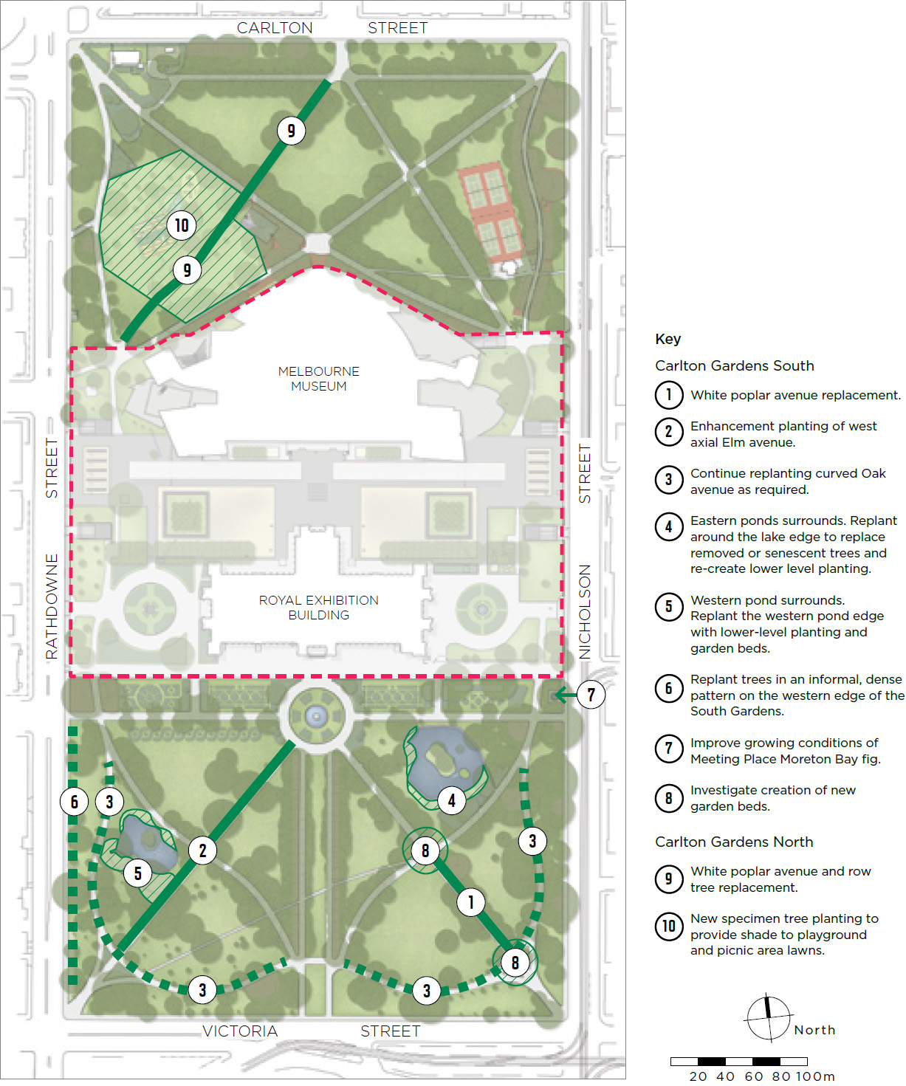

Key
Carlton Gardens South
- White poplar avenue replacement.
- Enhancement planting of west axial Elm avenue.
- Continue replanting curved Oak avenue as required.
- Eastern ponds surrounds. Replant around the lake edge to replace removed or senescent trees and re-create lower level planting.
- Western pond surrounds. Replant the western pond edge with lower-level planting and garden beds.
- Replant trees in an informal, dense pattern on the western edge of the South Gardens.
- Improve growing conditions of Meeting Place Moreton Bay fig.
- Investigate creation of new garden beds.
Carlton Gardens North
- White poplar avenue and row tree replacement.
- New specimen tree planting to provide shade to playground and picnic area lawns.

Uses and activities
(HMP 3.4.2)

Recreational uses in Carlton Gardens
Carlton Gardens is well known as an ideal place for informal recreation and is used by people who live in the nearby area as well as those who visit from further away. There are many reasons why people visit Carlton Gardens, ranging from taking a daily walk or run to attending a specific event or activity. With close to three million visitors per annum, Carlton Gardens is one of Melbourne’s most popular green spaces.
The City of Melbourne’s Open Space Strategy 2012 provides policy guidance on managing uses in public spaces such as Carlton Gardens including direction on appropriate facilities and activity types for each open space type in the municipality. Under this strategy, Carlton Gardens South and Carlton Gardens North have differing roles and emphasis:
Carlton Gardens South is classified a ‘capital city open space’ defined as “Iconic open space that is primarily established and managed to stage activities and events of international, national, state and metropolitan importance, catering to a broader public need. These spaces are synonymous with the character of the City of Melbourne and provide facilities that are known by and primarily for international and interstate visitors to Victoria and the City of Melbourne”.
Carlton Gardens North is classified as a ‘regional open space’ which should “cater to a broader Melbourne-wide catchment of visitors, as well the local community. Generally regional open spaces are easily accessible to people from adjoining municipalities and may be of regional recreational importance and use and / or regional environmental value”.
Carlton Gardens Master Plan addresses the specific roles each section of the Gardens (North and South) plays as part of meeting the open space and recreational needs of people who live, study and work in the City of Melbourne. In addition to residential and commercial uses, the nearby presence of University of Melbourne and RMIT campuses has led to Carlton accommodating a large student population, with people aged between 20 and 24 the largest age group in the suburb.
In general, recommendations about uses and activities in Carlton Gardens must be consistent with the requirements contained in relevant legislation and local laws. These include the Joint Trustee Regulations under the Crown Land (Reserves) Act, the Activities Local Law 2019 and the Domestic Animals Act 1994.

Community perception of recreational uses in Carlton Gardens
A 2017 survey found most people who visited Carlton Gardens (64 per cent) were regular users, with total annual visitation estimated to be 2.8 million visits per year.
This same survey found the most popular activities in Carlton Gardens were walking (commuting or exercise) jogging, socialising, playground use, reading / relaxing, social games, picnicking, sightseeing and school excursions. Key improvements people wanted to see were:
- more and improved toilets including baby change facilities
- more lighting on pathways and around the basketball court
- more play equipment and / or a second playground
- more general park furniture such as drinking fountains and water bottle fillers, seats, tables, a coffee point, barbecues and dog waste bag dispensers.
The 2020 survey undertaken during the World Heritage Management Plan community engagement found there is a strong attachment to Carlton Gardens, with 90 per cent of respondents ‘agreeing’ or ‘strongly agreeing’ the site is well-maintained and accessible to the public while 80 per cent ‘agreed’ or ‘strongly agreed’ the site allowed for an appropriate balance of passive and active activities.
The 2020 survey found 63 per cent of respondents visited Carlton Gardens to undertake leisure activities (such as reading, relaxing, social gathering, basketball, playground use). This was confirmed in the frequency of visits to Carlton Gardens (daily, weekly, fortnightly) which indicated most visits (63 per cent) were for recreational purposes from local users who could walk to the site.
A significant number of comments were also lodged about the value of the tennis courts and the Carlton Tennis Club program. Lighting in Carlton Gardens North was identified as needing attention around the basketball court and the path north of the tennis courts.

What people liked about Carlton Gardens:
- mature avenues of trees for shade and visual appeal
- the varied wildlife and biodiversity found around the lakes and gardens
- the beautiful green space so close to the Melbourne CBD
- feeling connected to the Melbourne community when using the space for recreation, walking and relaxing
The following individual responses reflect common responses to the question: ‘What is your favourite thing about the Royal Exhibition Building and Carlton Gardens?’
“Everything! I love the gardens, the museum, the fountain, the trees, the slope of the hills, seeing people sitting in the gardens.”
“The ponds and different paths. And the ducks!”
“It is a stunning garden space in the middle of the city. I love going through it for my dose of beauty and green on the way to work.”
“The basketball court and the community that gathers there.”

Community engagement on the draft Carlton Gardens Master Plan in 2021 invited primary school age children to share their thoughts about the Gardens and explain how they used it.
Most children visit the Gardens during the day but predominantly between 1-5pm accompanied by direct family members, friends or classmates. The two common responses from children when asked what the Gardens mean to them can be summarised as nature: including trees, flowers, ponds and ducks, and play and exercise: both at the playground and throughout the wider Gardens. Common areas for improvement suggested by children were clean public toilets, rubbish bins, clean benches and more drinking fountains.
Wider community engagement on specific proposals to promote recreational use were also tested, with the following proposals widely supported:
- replacing the existing public toilet facilities with a safer, secure and more accessible offer
- installing new lighting along the north-eastern pathway in Carlton Gardens North and increasing the light levels in activity areas in Carlton Gardens North to allow for longer use times in these areas
- increasing shade levels in key activity areas.

Recommendations: Uses and activities
- Whole of Carlton Gardens
  - Continue to manage Carlton Gardens primarily as a passive recreation space with Carlton Gardens North also available for local informal active recreation activities. The tennis courts are recognised as providing a different activity, and can continue to be used for that purpose.
  - Continue to promote Carlton Gardens as an environment where a range of passive recreation activities can be provided. These include relaxation, quiet contemplation, informal play, personal exercise and socialising and connecting.
  - Formal, organised active recreation activities or sports, outside the existing tennis courts, are not supported.
- Carlton Gardens South
  - Continue to manage Carlton Gardens South as a passive recreation space, with primary use by city workers, students, day visitors and residents.

  - Enable capital city activities such as appropriate tourism visits and tours, interpretation, education and events, in keeping with the capital city designation and the clear relationship of Carlton Gardens South to the Royal Exhibition Building.
  - Continue a high level of maintenance and presentation in horticulture, water features, trees and lawns to ensure the aesthetic experience and historical presentation of Carlton Gardens South is maintained.
  - Maintain amenity assets to a good standard and provide new toilets, seats, drinking fountains, signage and public lighting as required. (also refer to section 4.3 Facilities for detailed recommendations).
- Carlton Gardens North
  - Continue to manage Carlton Gardens North for both passive recreation and informal recreation activities in line with the current arrangements and facilities.
  - Prioritise regional and local general recreation uses in Carlton Gardens North for residents, workers and day visitors. This includes visitors to Melbourne Museum, including school and other education-based groups.
  - As ongoing use is clearly demonstrated, maintain the current range of community facilities and renew, as required, taking into account the current demographic profile of the local community in any asset renewal works.
  - Improve facility amenity by following Council’s asset maintenance standards and providing renewed assets such as playground equipment, toilets, seats, picnic tables and drinking fountains when required.
  - To further meet current community requests, investigate the addition of:
- Barbecue facilities in the picnic area
- A modest adult informal exercise area to allow for this kind of activity to occur in a suitable location.
  - To ameliorate potential increases in urban heat and the consequent negative impact on recreational uses, provide more shade in key public gathering areas, such as the playground and picnic area, by planting additional specimen trees. (also refer to section 4.4 Tree Management and Replacement).
  - Undertake a lighting audit of Carlton Gardens North to assess current lighting levels and inform the planned improvement in lighting levels.
  - Specific lighting improvement actions include:
- Installing new park lights along the north-east path from the tennis club to the corner of Carlton and Nicholson streets
- Providing additional general lawn lighting to improve recreational amenity in the playground, ball court and picnic area precincts, so that these areas can be used for longer periods, particularly in winter months.
  - Maintain amenity assets to a good standard and provide new toilets, seats, drinking fountains, signage and public lighting as required. (also refer to section 4.3 Facilities for detailed recommendations)
  - Minor upgrades, additions or adjustments to the current recreational and open space facilities may be considered if community need or demand is demonstrated and the changes do not impact on the heritage values or presentation of Carlton Gardens.

Events

Events in Carlton Gardens
(HMP 4.7, 4.10.1)
Melbourne is Victoria’s capital city and the business, administrative, cultural and recreational hub of the state. Carlton Gardens, Melbourne Museum and the Royal Exhibition Building all contribute to the cultural and recreational experience of Melbourne.
In conjunction with the Royal Exhibition Building, Carlton Gardens has a long history of hosting large-scale exhibitions and events including the two International Exhibitions in 1880 and 1888.
Contemporary approvals and permit arrangements are linked to the land management arrangements for each portion of the site, meaning the City of Melbourne as Committee of Management holds specific responsibilities for licencing, permitting and managing events in Carlton Gardens. Key considerations for large events from a Council perspective are potential heritage impacts and the impact on other general uses of the site.
In addition to these large events, Carlton Gardens is also popular for wedding ceremonies, film and television shoots, photography and smaller-scale community events, which are also managed via event permits. It is envisaged these small event bookings will continue in line with standard City of Melbourne management and booking procedures.
Larger events involving Carlton Gardens require additional consideration and guidance, given the potential for negative heritage impacts on the Gardens site and the impact on general public access to the Gardens while the event is taking place.
While many events are held in the Royal Exhibition Building each year, contemporary major events involving both the Building and the Gardens are the Melbourne International Flower and Garden Show and in more recent years, the White Night Festival or the Rising Festival.
A designated state major event, the five-day Melbourne International Flower and Garden Show has taken place in the Royal Exhibition Building and Carlton Gardens South since the late 1990s. A major highlight of Melbourne’s events program, it is a gated, ticketed event that attracts up to 270 exhibitors and vendors and 100,000 visitors. Given the nature of the displays, the event requires an exclusive two-week installation phase, followed by post show restoration works, primarily turf replacement, after which the Gardens are re-opened for public use. It takes around six weeks for Carlton Gardens South to revert to its usual presentation levels. The City of Melbourne issues a licence under the Crown Land (Reserves) Act and an annual event permit for this event.
As part of these procedures, an exhibitors’ handbook, setting out installation and operational requirements for the Melbourne International Flower and Garden Show, has been used for many years and is continually updated. Regular soil testing is undertaken to measure soil compaction and an onsite monitor is present during the installation and removal of all show exhibits.
A heritage permit for the event and a pre- and post-occupancy event report are also required by Heritage Victoria. Although an event of the size of the Melbourne International Flower and Garden Show has the potential to have a high impact on Carlton Gardens South, a review of test results and reports since 2005 shows that clear guidance, strict management and consistent onsite monitoring has served the site and exhibitors well, with no apparent cumulative impact on the heritage values of Carlton Gardens. Other factors contributing to this positive outcome are:
- the time of year the event is held (autumn, where soils are not as likely to be impacted)
- returning exhibitors from the landscape management profession who understand the event well and are briefed annually on permit requirements and expectations.
The White Night Festival was a shorter duration event with limited infrastructure. The key focus was the projection of images on external walls of the Royal Exhibition Building, with some ancillary art installations throughout Carlton Gardens South. While visitor numbers were large, very little post-event restoration was required as the event required only modest additional infrastructure. The City of Melbourne issued an event permit for the White Night Festival. It is likely similar applications to use the Gardens will be made in the future.
The distinguishing features of these events has been the continued use of the ‘exhibition’ concept (through horticulture and art) for which the Royal Exhibition Building and Carlton Gardens South were first established, which continue to attract visitors from across Melbourne, Victoria and interstate.

Community perception of events in Carlton Gardens
As part of the engagement undertaken in 2020 for the World Heritage Management Plan, survey participants were invited to comment on the following statement:
“The events and exhibitions held on the Royal Exhibition Building and Carlton Gardens site are appropriate to the setting and the community.”
In total, around 72 per cent of respondents ‘agreed’ or ‘strongly agreed’ with this statement. For this reason, it can be argued the public are generally comfortable with the current program of events at Carlton Gardens, with the strict management processes and clear limits on the use of the site likely to be key contributors to this perception.
During the community engagement phase of the draft Carlton Gardens Master Plan, public support was tested via survey for introducing a cap of 13 weeks for major event use in Carlton Gardens South. 64 per cent ‘supported’ or ‘strongly supported’ this idea, with the balance of responses either indicating they were unsure or not in support of this idea. Three direct public submissions argued against the principle of permitting major event use in the Gardens, two were generally in support and two did not express a specific view.
Acknowledging there are a variety of community views on this matter, it is also noted that the HMP recognises the principle of using Carlton Gardens South for appropriate larger events.
For the City of Melbourne, the key considerations for approving large events are to understand and manage the potential for negative heritage impacts on the Gardens and to balance the impact of large events against other uses. The following recommendations have been formed to provide guidance for Council when making decisions on this matter.

Recommendations: Events
- All events
Events are part of a range of activities that occur in Carlton Gardens, however the number, size and impact of these events needs to be balanced against both the impact on the cultural and historic values of the site and general public access to the Gardens.
- Major events
Major events in Carlton Gardens South will be supported if they are provided for under the Crown Land (Reserves) Act 1978 and / or any Victorian Government Regulations. Major events must meet the following criteria:

Heritage considerations
  - The event must use the Royal Exhibition Building (or its historic forecourts) and Carlton Gardens South in an integrated way (i.e. no major events in the Gardens only).
  - The nature and purpose of the event should relate to the cultural values of the place, such as exhibition or civic / ceremonial events.
  - The event recognises the First Peoples’ cultural association with the site, which should be included in event programming.
  - The event is conducted in accordance with strict management processes to avoid impact on the heritage and cultural values of the place and be consistent with heritage permits.
  - The event must have an approved Heritage Victoria permit and a heritage impact assessment (note: if there is any inconsistency between a City of Melbourne policy or procedure and a heritage permit, the heritage permit requirement takes precedence).
  - A program of onsite monitoring before, during and after the major event and a reinstatement plan are required.

Access / use considerations
  - The combined Carlton Gardens South and North site is not available at one time for major events for public access reasons.
  - If an event is held annually, the conduct and layout of the event must adjust to any permanent changes in the layout of Carlton Gardens that have taken place between events.
  - The total period of time allowed for major events per year is capped at 13 weeks or 25 per cent of the calendar year. This includes event set-up and delivery and any required post-event reinstatement works. Any variation to this provision must be specifically considered and approved by Council.
  - When considering applications for major events in the Carlton Gardens, Council should consider relevant seasonally specific conditions, for example, if there is a reduced risk of soil compaction and the irrigation requirements of historic trees at different times of year.

- General event bookings
  - Continue to allow small event bookings in both Carlton Gardens South and Carlton Gardens North. As Carlton Gardens North plays a significant open space role on a regional level and contains a range of recreational facilities that must be available at all times (i.e. playground, tennis courts and the half basketball courts), events bookings should not impact on these regular uses.
  - For both Carlton Gardens South and North, develop agreed standard heritage permit exemptions for small events and request inclusion in the Victorian Heritage Register site registration.
  - As recommended in the Heritage Management Plan, work cooperatively with Museums Victoria and the Steering Committee on a Temporary Events Management Plan for the entire Carlton Gardens site.

Monitoring and assessment of heritage impacts
The Melbourne International Flower and Garden Show is held annually in both the Royal Exhibition Building and Carlton Gardens South. The City of Melbourne must issue a licence for the event, and Heritage Victoria must issue a permit. As at 2022, a range of monitoring and reporting requirements are undertaken as part of these approvals. Some of these are outlined below.

Soil compaction testing
Regular soil compaction testing has been undertaken at Carlton Gardens as part of the Melbourne International Flower and Garden Show since 2003, with tests taken both before and after the show since 2007. Over that time there has been no overall detectable change in the bulk density of the soils in Carlton Gardens. A key reason for this is that the soil exhibits an increased strength at drier times of the year, which is when the event is held.

Tree protection plan
A tree protection plan is prepared as part of the planning process for the Melbourne International Flower and Garden Show. This plan identifies tree protection zones and is used to inform the location and layout of exhibitor spaces and other activities. Limited activity occurs within these zones. To date there has been no major impacts on trees as a result of the show, indicating early planning is effective.

Monitoring exhibitor set up and removal
All exhibitors receive an Exhibitor Manual and attend an information session where installation requirements are explained. An onsite monitor attends during the show set-up and removal to ensure exhibitor compliance with garden and tree protection requirements.
The onsite monitor is able to direct adjustments on site to ensure compliance and provides a report at the conclusion of the event on any incidents which have occurred as well as any recommendations for future shows. A review of these reports from 2005 and 2019 shows that a small number of minor incidents (under five per show) is typical.
Since 2003 the Exhibitor Manual has been updated regularly in response to monitor reports, which have included recommendations such as the use of pro-floor in stands to reduce turf impact and the use of the Western Forecourt for vehicle entry, rather than Nicholson Street.

City of Melbourne annual works
Trees are inspected annually prior to the Melbourne International Flower and Garden Show to ensure they are within tree maintenance guidelines. Lawn reinstatement after the show is now undertaken with pre-grown turf, reducing the time required for lawns to return to a suitable level of presentation. This approach is in contrast to earlier years where a mix of turf and direct seeding was used for lawn reinstatement.

Connections and linkages
(HMP 3.6.3, 4.8)
How people access Carlton Gardens, and how they move through the Gardens, is as important today as it was in the 2005 Master Plan. The Gardens, Royal Exhibition Building and Melbourne Museum are popular visitor destinations and must be well supported by clear information, appropriate wayfinding signage and safe, direct links to nearby public transport. This includes providing a high standard of adjacent footpaths and roads.
As most people think of Carlton Gardens as one place, it is important to enhance the perception of a single site and maintain clear connections between Carlton Gardens
South and North, the Royal Exhibition Building and Melbourne Museum.
As a location adjacent to the central city, Carlton Gardens also serves a secondary role as a movement corridor, particularly for pedestrians. The 2005 Master Plan recommended the entire site be managed as a pedestrian precinct, with pedestrians having priority and vehicle movements kept to a minimum.
It was also recommended that bicycle routes around the Gardens, rather than through the Gardens, be upgraded to provide for cyclists who commute to the city. This has largely occurred, with the installation of a dedicated bicycle lane on Rathdowne Street in 2010. In 2021 this route was upgraded to a protected bike lane, further establishing Rathdowne Street as a key cycling route into the central city.
A new cycling route on Barkly Street, from Canning to Rathdowne streets, was also developed as recommended by the 2005 Master Plan. The current east-west cycling link, from Gertrude to Queensberry streets, runs through Exhibition Reserve. Changes or amendments to this link will be addressed in the Exhibition Reserve Master Plan.

Safe access to Carlton Gardens
Despite these access improvements, pedestrian access to Carlton Gardens is still a key challenge.
While all crossing points and garden entrances are important, the most commonly used entry points for Carlton Gardens and Melbourne Museum are at Nicholson Street and Victoria Street for Carlton Gardens South and Rathdowne Street and Carlton Street for Carlton Gardens North.
Identified in the 2005 Master Plan as a key issue is the connection to Carlton Gardens via Victoria Street, a primary linkage that still needs improvement. In order to access the Gardens and the Museum from the CBD, Parliament Station and adjacent tram stops, pedestrians need to cross Victoria Street. As a VicRoads managed road, any improvements to the Victoria Street crossing can only occur by advocating for safety improvements to these pedestrian crossings.
As part of the community engagement phase for the draft Carlton Gardens Master Plan, over 90 per cent of those surveyed agreed that Council should continue to advocate for safer pedestrian crossing points across Victoria Parade.
Vehicle crossovers and footpaths abutting Carlton Gardens and Melbourne Museum, particularly on Rathdowne Street and the shared path on Nicholson Street, vary in condition from adequate to below standard. These footpaths cannot be widened which means improvements must focus on asset maintenance, small interventions and general management.

Recommendations: Connections and linkages
- External to the site
  - In conjunction with Museums Victoria, improve access to Exhibition Reserve and Carlton Gardens from footpaths on Rathdowne Street and Nicholson Street. A key focus should be on providing a contemporary standard of disability access, repairing and modifying bluestone crossovers, asphalt maintenance and minimising installation of unnecessary street furniture on these paths.
  - Improve pedestrian access, develop and install wayfinding signage from key transport hubs such as Parliament Station, and adjacent tram stops, to Carlton Gardens and Melbourne Museum.
  - Continue to advocate to VicRoads for improved, safer pedestrian crossing points on Victoria Street.
- Within the site
  - Continue to manage Carlton Gardens as a pedestrian precinct, with pedestrians having priority use and other vehicle movements kept to a minimum.
  - In conjunction with Museums Victoria, maintain visual connection and public access between Carlton Gardens South and North, particularly along the eastern and western ends of Exhibition Reserve.
  - In conjunction with Museums Victoria, maintain a suitable presentation along the south face of the Royal Exhibition Building to provide a positive visual connection between the Building and the Carlton Gardens South setting.
  - Maintain major pathways to a satisfactory standard, consistent with the historic layout.
  - The addition of new pathways to this historic network would not be supported without a high level of justification.
  - Minor access pathways as required (such as around the lake) are supported to access facilities or features and / or provide for DDA access. Minor paths should present in a different material to the main network such as granitic sand.

Climate resilience
In developing this revised Master Plan it is important to consider new and emerging factors that may impact Carlton Gardens and consider how to reduce the impact of climate change, manage disruptions should they occur, and allow the Gardens to continue to contribute positively to the social and economic life of Melbourne.
Commissioned by the Australian Government in 2020–21, the CSIRO report entitled Climate Change Vulnerability and Risk for Australia’s World Heritage Properties, points to some of these key considerations. New actions to build resilience are considered within the context of a valuable heritage landscape.
Carlton Gardens is an ageing garden and continued stress on its vegetation could lead to an accelerated decline in some species. The renewal of the living layer of the Gardens needs to occur in an environment that is predicted to change due to a drier climate, higher average temperatures and increased evaporation.
In addition, the residential population around Carlton Gardens has increased since 2005, with the residential population of neighbouring Carlton increasing from 14,000 people in 2011 to 19,000 people in 2016, an increase of around 25 per cent over that period. Flats and apartments are now the most common dwelling type and the area has a younger age profile, reflective of its large student population.
Over the same period the number of daily visitors to the City of Melbourne has also increased. While there was a decrease in city workers, students and visitors during the COVID-19 pandemic period, it is still estimated that overall worker, visitor and resident numbers will continue to rise in the City of Melbourne for the foreseeable future. Between 2005 and 2017, the number of visitors to Carlton Gardens rose by a third, creating more demand on local open space, both in terms of facilities use and maintenance requirements.
Based on current climate change projections, actions will be required to ensure Carlton Gardens retains a good level of amenity and comfort for visitors, particularly on hotter days. The 2005 Master Plan canvassed a range of opportunities for continuing to maintain an irrigated garden, while decreasing overall potable water use, through more efficient irrigation methods and increased access to non-potable water sources.
Museums Victoria installed an underground rainwater tank under the Western Forecourt in 2014 and Melbourne Museum and the City of Melbourne share this resource. The efficiency of the City of Melbourne’s overall open space irrigation system is continually improving through a combination of better management and upgraded irrigation systems.

Recommendations: Climate resilience
- Continuing to monitor and investigate opportunities to increase the amount of non-potable water use in Carlton Gardens.
- Continue to improve the efficiency of irrigation systems and complete the upgrade of the Carlton Gardens North irrigation system.
- Increase the amount of natural shade through additional tree planting in key activity areas in Carlton Gardens North to improve user comfort (refer also to section 4.5 Recreational uses in Carlton Gardens).
- Monitor heat and shade levels across Carlton Gardens and identify areas where improvement may be required.

The impacts of a changing climate on Carlton Gardens
In 2020 / 21 the Australian Government commissioned the CSIRO to undertake a report entitled Climate Change Vulnerability and Risk for Australia’s World Heritage Properties. This report builds on a 2009 report – Implications of Climate Change for Australia’s World Heritage properties.
While not a site listed for natural values, the Report showed the Royal Exhibition Building and Carlton Gardens is not immune to the vulnerabilities and risks associated with climate change.
Potential climate change risks* for Carlton Gardens include:
- temperature rise and more extreme temperatures
- drought
- more extreme rainfall
- potential impacts on the property
- reduced water available for irrigation of Carlton Gardens and damage to vegetation
- high temperatures can affect presentation of Outstanding Universal Value and visitation
- flooding and extreme storm events prevent access and hosting of large events.

Impacts on Outstanding Universal Value
One of the most important threats to the Outstanding Universal Value of the Royal Exhibition Building and Carlton Gardens is the impact higher temperatures and more extreme daily rainfall may have on the iconic trees and plants of Carlton Gardens.
Replacement of existing plants with more heat- and dry-tolerant species may be necessary, which will change the iconic look and authenticity of the current horticultural fabric of Carlton Gardens. However, tree species that can survive in future climate conditions and can provide shade and green space will allow for recreational uses to continue for most of the year.
If trees with similar characteristics to those currently in Carlton Gardens are used, the recognised garden layout and look and feel of the Gardens could be maintained. The Moreton Bay Fig trees, which are of historic importance to the Aboriginal community, if lost, would be irreplaceable.
More extreme rainfall, flooding, winds and storms will damage plants and building structures. A redesign of the landscape and an upgrade to the Royal Exhibition Building’s roof may be necessary to prevent water ingress during storms. However, these changes would need to occur in a sustainable way to protect the authenticity of the property.
Alterations to stormwater infrastructure may help redirect water flows away from the building and gardens. A large underground water tank has been installed in the Western Forecourt to help capture water for irrigation of Exhibition Reserve and Carlton Gardens.
*Key climate change risks in the report have been edited to list impacts to Carlton Gardens only

Interpretation
(HMP 3.11 and TO and FPCV)

Interpretation of the World Heritage Site
Raising community awareness and developing interpretation programs for the Royal Exhibition Building and Carlton Gardens is an ongoing consideration for any place on the World Heritage List. Interpretation should be planned cohesively for the entire site and include both tangible and intangible values.
Interpretation can be delivered by all parties with a responsibility for the site, including the Australian Government, Heritage Victoria, the Steering Committee, Museums Victoria and the City of Melbourne, with each organisation having different roles to play and audiences to communicate with. The Heritage Management Plan and Traditional Owners and First Peoples Cultural Values Report are resources from which key elements can be drawn for interpretation purposes.
Currently Museums Victoria and the City of Melbourne have a number of joint interpretation actions and products including:
- use of a consistent style of onsite World Heritage and interpretive signage
- a self-guided walk which includes Exhibition Reserve, Carlton Gardens and the immediate urban area surrounding the Gardens
- a dedicated Royal Exhibition Building webpage, which includes information about Carlton Gardens, developed and curated by Museums Victoria. This content was developed on behalf of all organisations as part of the World Heritage Management Plan 2013 recommendations
- promotion of Carlton Gardens on City of Melbourne websites and social media channels.

Community perception of interpretative practices
As part of the engagement undertaken in 2020 for the World Heritage Management Plan, survey participants were invited to comment on the following statement:
“The information available about the history, significance and features of the Royal Exhibition Building and Carlton Gardens site is sufficient.”
In response to this statement, only 50 per cent of those surveyed rated current interpretative practices as delivering well or very well. While signs on site, exhibitions, displays and walking tours are still the preferred delivery methods nominated by those surveyed, new digital platforms and methods should be considered.
During community engagement on the draft Carlton Gardens Master Plan in 2021, there was strong support for a broader range of stories and cultural values to be interpreted and celebrated. For example, children nominated the tennis courts, fountain and lakes as the places they would most likely show a visitor.
The scheduled opening of the Royal Exhibition Building dome promenade walk by Museums Victoria in 2022 provides an opportunity to revise and refresh the current interpretative offer.
In addition to information-based tools and resources, place interpretation is also supported by people’s experiences of that place. Careful management of Carlton Gardens, particularly the protection of key views and aesthetic elements in Carlton Gardens South, is an important factor in this form of interpretation.
For example, the dome promenade at the Royal Exhibition Building will give visitors a similar experience to the 19th century viewing platform around the dome. Therefore, to be a successful experience, Carlton Gardens South must present from the dome as an appropriate visual spectacle and enable key historic elements of the 1880 layer to be identified appropriately. (Refer Figure 5)
Similarly, protecting an uninterrupted view line to the historic building entrance from both the southern and northern end of Grand Allée is an important management device that will aid historic interpretation.

Figure 5: Historic photographs of Carlton Gardens South from the Royal Exhibition Building Dome, circa 1880-88
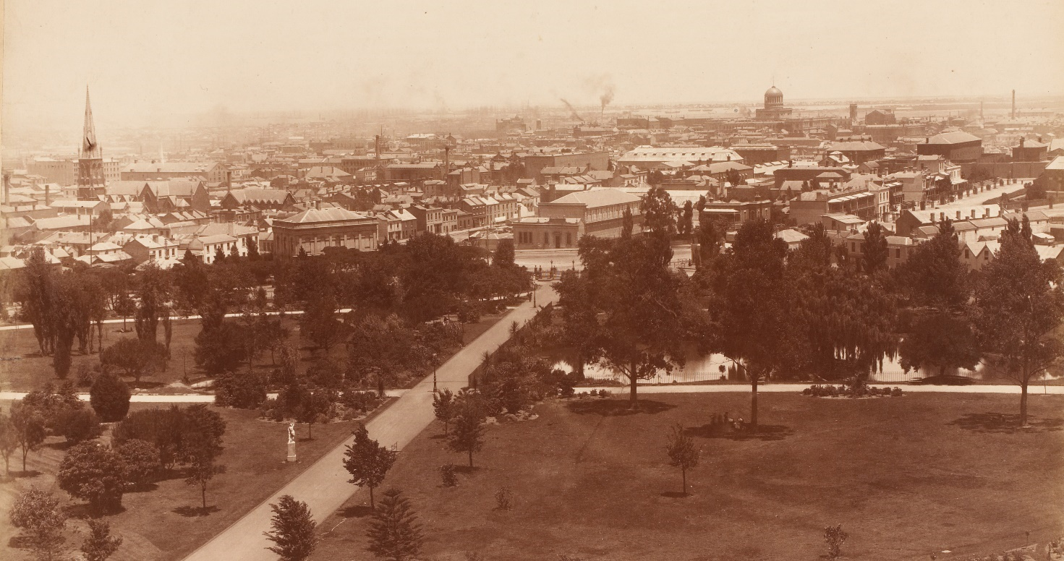
View of Melbourne (west) from the terrace of the Exhibition Building, Carlton Gardens, 1883. Charles Nettleton photographer. H848 State Library of Victoria
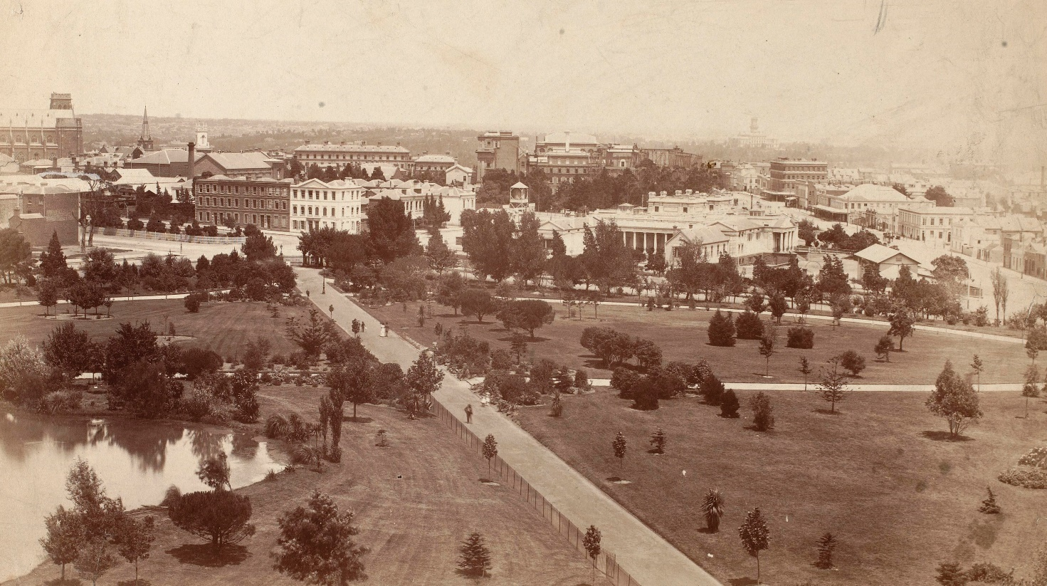
Melbourne from the Carlton Gardens, ca 1880 / 1890. Charles Nettleton photographer. H 4512.State Library of Victoria

Recommendations: Interpretation
- Revise and refresh the current interpretive offer, in conjunction with other key agencies, in particular Museums Victoria.
- Develop and expand the range of stories about the site, including interpretation that is inclusive of what children value about the site.
- Ensure presentation of the whole site is consistent with agreed interpretive messages and consistent with information in both the Heritage Management Plan and Traditional Owners and First Peoples Cultural Values Report.
- Continue to cooperate and work with both the Steering Committee and Museums Victoria on interpretation projects of mutual interest.
- Develop a plan in conjunction with Museums Victoria for interpretative actions and products. Priority actions are to:
- update the current self-guided walk (with Museums Victoria) – including making it available on digital formats and platforms used by the City of Melbourne to promote visitor experiences in Melbourne
- investigate the extension of the visitor experience of the dome promenade by enhancing onsite interpretation, with a focus on the Melia Avenue precinct in Carlton Gardens South. Actions could include new, discreet identification signage for selected historic trees and shrubs and a convenient starting point for the self-guided walk.
- Enhance recognition of the Aboriginal cultural values of the site, including:
- completing the agreed installation at the Exhibition Gardens Meeting Place as part of the fig tree protection works
- investigating opportunities for the use of Aboriginal language in signage and place naming
- Monitor visitor demand and tourist profile, and explore the introduction of additional interpretative activities if opportunities arise.
- New permanent monuments, artworks, memorials or plaques in Carlton Gardens will generally not be contemplated unless there is a specific connection to the site and the proposed topic is of a significance appropriate to its heritage values. The assessment of any request should be consistent with the World Heritage Management Plan, the Heritage Management Plan policies and the City of Melbourne’s Plaques and Memorials Policy.

Carlton Gardens Master Plan projects – summary
Figure 6: Carlton Gardens Master Plan projects – summary
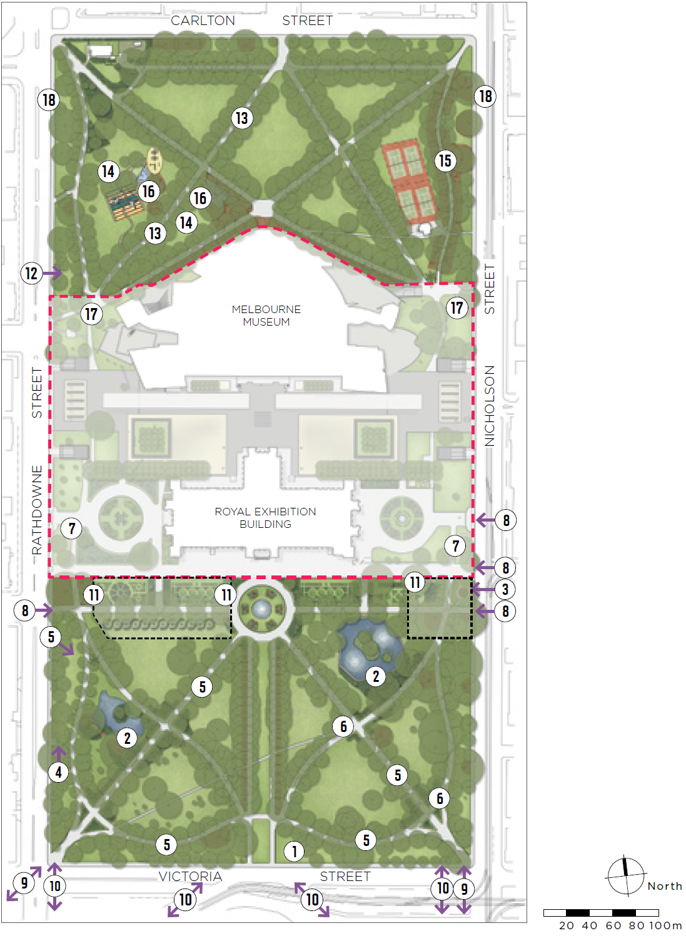

Key
Carlton Gardens South
- Views and vistas – Maintain clear view at the southern entry from Spring Street to the Grand Allée.
- Lake surrounds – New planting and landscape plans for both lake surrounds. Retain important view lines to the Royal Exhibition Building.
- Meeting Place – Progress works to protect the health of the Moreton Bay fig tree at Exhibition Gardens Meeting Place. Work with Traditional Owners and the wider Aboriginal community on recognition and interpretive elements in the place.
- Toilet facilities – Replace existing toilet with new facility in same location.
- Trees and avenues – Renew avenues and renew general tree planting.
- Historic shrub beds – Investigate potential to reinstate shrub beds, consistent with the 1880 design, at key pathway intersections.
- North-south connection – Work with Museums Victoria to maintain and enhance connection between the North and South Gardens through Exhibition Reserve.
- Pedestrian access – Repair crossovers and footpath on Rathdowne Street and crossovers and shared path on Nicholson Street.
- Wayfinding – Develop and install new pedestrian wayfinding signage from the central city to the Gardens.
- Pedestrian crossings – Advocate for safer pedestrian crossing points to the Gardens from Victoria Street.
- Interpretation zone – Investigate additional on-site interpretation to complement the Dome Promenade walk.
Carlton Gardens North
- Toilet facilities – Replace existing toilet with new facility in same location.
- Trees and avenues – Replace White poplar avenue and row.
- Shade trees – New tree planting for shade in playground and picnic areas.
- Pathway lighting – New lighting along eastern pathway from tennis courts to corner of Carlton and Nicholson streets.
- Activity lighting – New activity lighting in playground, picnic area and basketball areas.
- North-south connection – Work with Museums Victoria to maintain and enhance connection between the North and South Gardens through Exhibition Reserve.
- Pedestrian access – Ongoing maintenance of footpath on Rathdowne Street and shared path on Nicholson Street.

Management and cooperation
Although Carlton Gardens is managed by the City of Melbourne and Exhibition Reserve is managed by Museums Victoria, a coordinated approach to managing the whole site is essential to ensure the shared objectives of the Carlton Gardens Master Plan and the World Heritage Management Plan are realised.
A high standard of maintenance of Carlton Gardens and Royal Exhibition Building forecourts is required to meet the community expectations of a World Heritage Listed site.

Recommendations: Management
- Museums Victoria and the City of Melbourne continue to work cooperatively on projects of mutual interest at the site and share relevant information, plans and interpretation approaches particularly in relation to the World and National Heritage values. This can occur both directly and through the World Heritage Management Plan Steering Committee structure. Key priorities include refreshing the current interpretation offer and self-guided walk and development of a Temporary Events Management Plan.
- Museums Victoria and the City of Melbourne continue to share the use of recycled water from a storage tank underneath Exhibition Reserve, with the current agreement due to be renewed in 2024.
- Using City of Melbourne contract specifications, ensure the highest standards of work by all open space, tree management and other maintenance contractors to achieve good presentation of the site at all times. Encourage the development of similar, consistent service standards across the entire site.
- All contractors responsible for the care and management of Carlton Gardens must be familiar with the heritage significance of the site and its component elements.
- The City of Melbourne continues to be actively involved as a member of the World Heritage Management Plan Steering Committee for the site and the surrounding World Heritage Environs Area.

Implementation of the Master Plan
An implementation plan for future capital and renewal works over next five years will be developed once the revised Carlton Gardens Master Plan is approved by Melbourne City Council. The directions of the Master Plan remain in place until the next review. If new issues or needs arise, which are not contemplated in the Master Plan, the vision and guiding principles set out in the Master Plan should be used to inform assessment and decision-making.

Review of the Master Plan
Currently the Heritage Act requires that the World Heritage Management Plan be reviewed every seven years. The next review of the Carlton Gardens Master Plan should occur as part of the wider review of the current World Heritage Management Plan.

Appendices

Appendix A – Carlton Gardens selected plans.
Figure 7: Historic Plans of the Exhibition Buildings and Carlton Gardens from 1879 and 1888
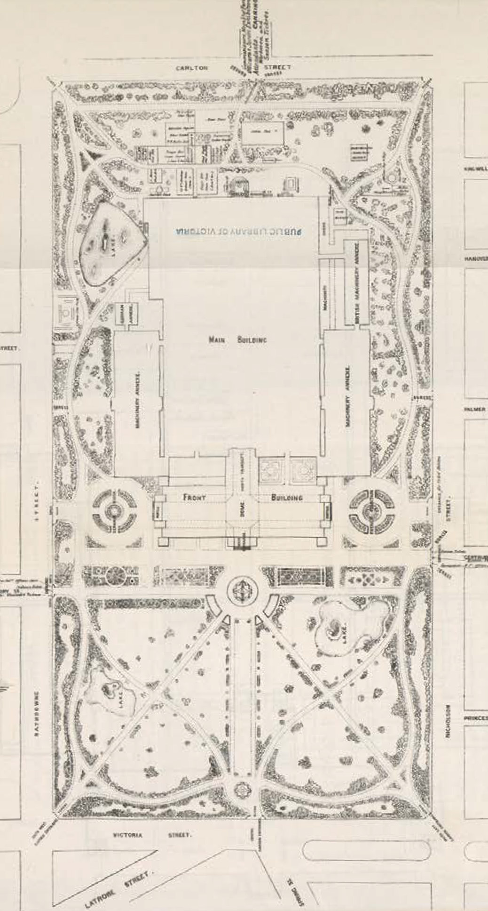
Reed and Barnes 1879 garden design completed for the first Melbourne International Exhibition of 1880-1881. Source: Melbourne International Exhibition 1880-1881 Official Record.

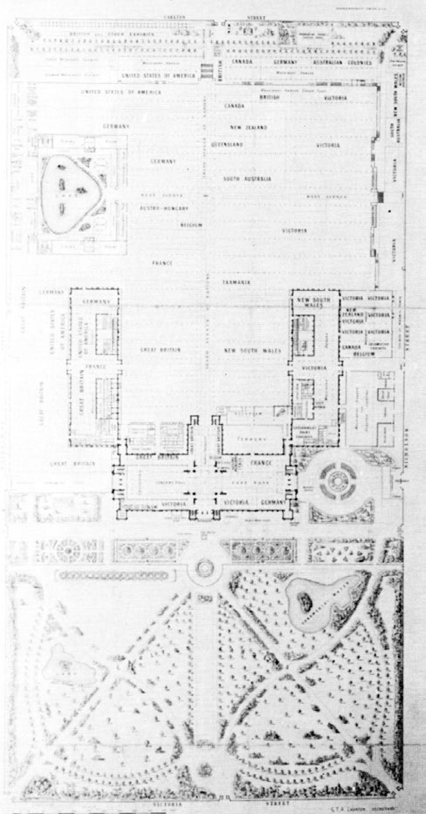
Plan for the Centennial International Exhibition 1888.

Figure 8: Historic Plans of Carlton Gardens and Exhibition Reserve from 1941 and c1990s
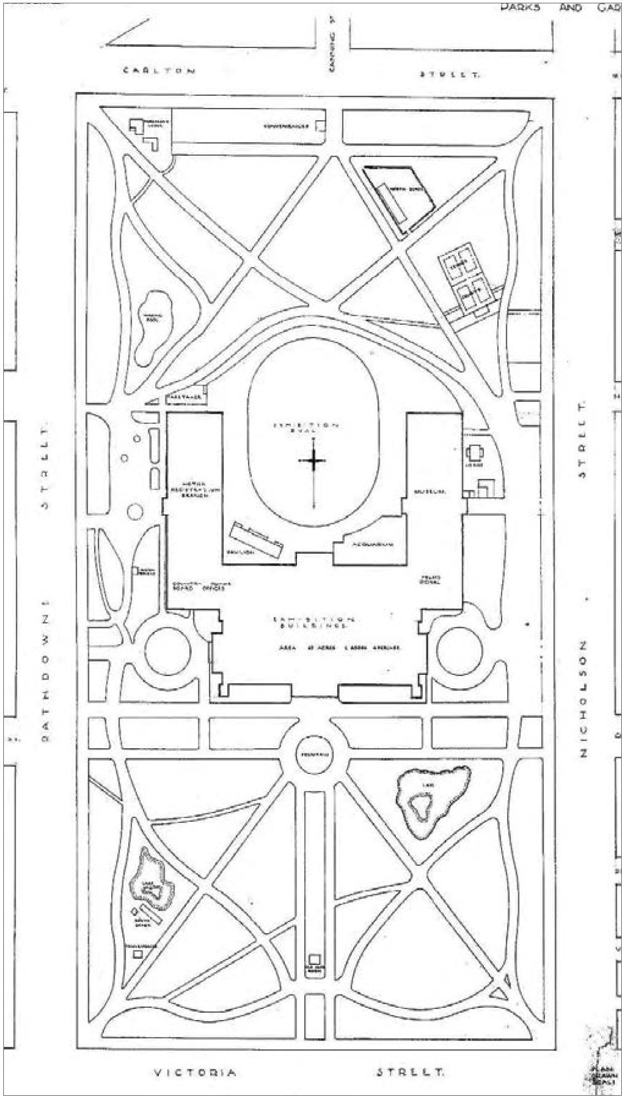
Plan of Carlton Gardens, January 1941. Source: City of Melbourne, Park and Gardens Department.
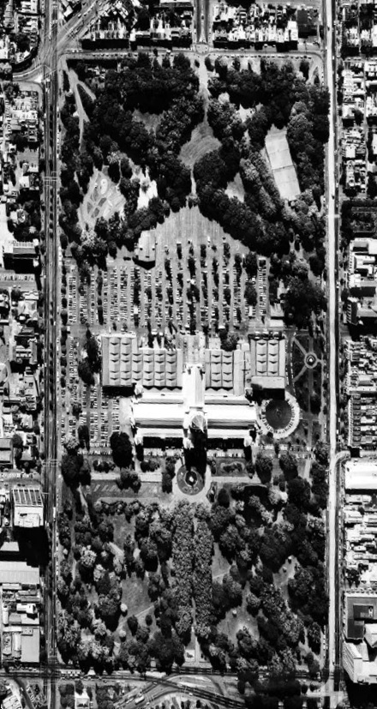
Aerial view of the Exhibition Building and Carlton Gardens c.1990s.

Appendix B – Master Plan implementation 2005 to 2021
Figure 9: Master Plan implementation, 2005 to 2021
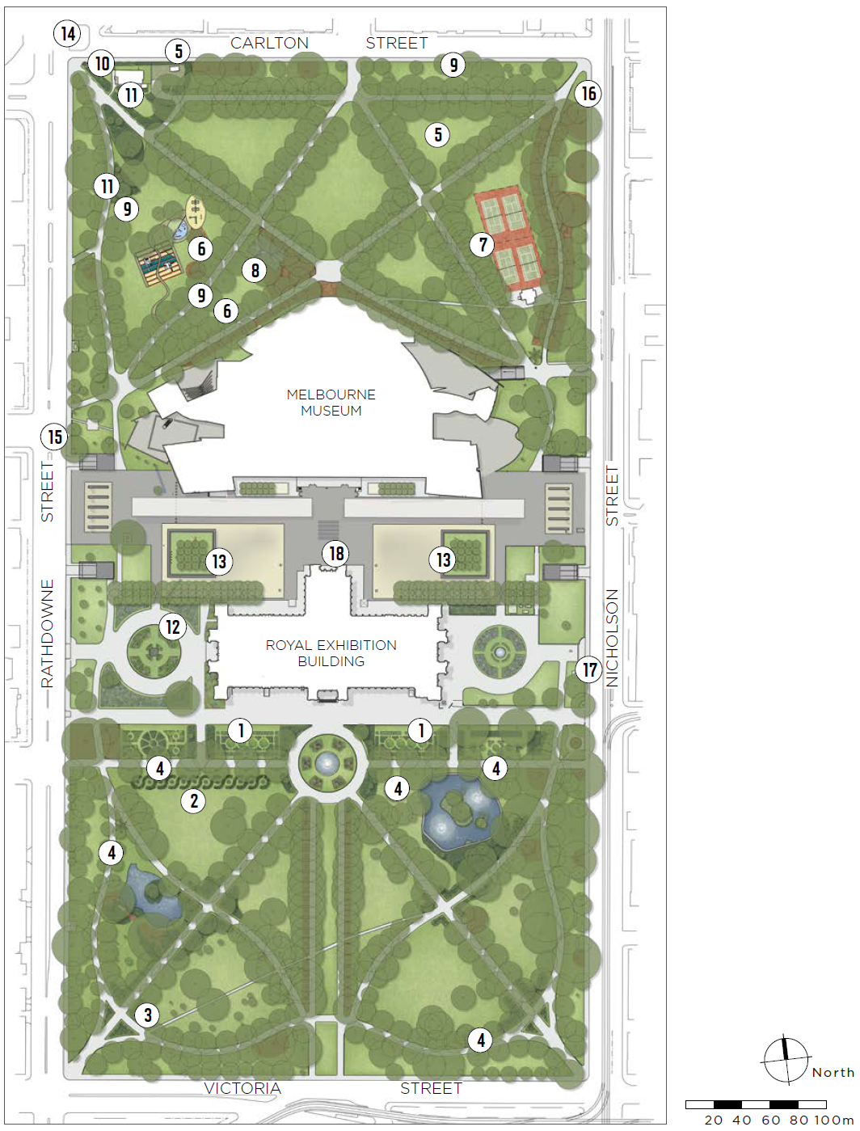

Key

Carlton Gardens South
- Parterre Garden – Reconstruction of formal parterre gardens south of the Royal Exhibition Building.
- Scroll Garden – Reconstruction of the scroll garden (original decorative bed shape) south of the western section of the Melia walk.
- Pathways and entry garden beds – Reconstruction of the curved pathway and entry garden beds near corner of Rathdowne and Victoria streets.
- Avenues renewal and rare tree replacement – Renewal and replacement of the Oak Avenue, Melia Avenue and rare tree replacement (Harpephyllum caffrum).

Carlton Gardens North
- Garden maintenance facility – Removal of the former depot north of the tennis court and re-establishment of lawn area, creation of a new maintenance facility to the rear of the curator’s cottage.
- Toddlers’ playground and new picnic area – Installation of a toddler play area adjacent to the existing playground; installation of picnic area in the former toddler play area.
- Tennis courts – Repairs and upgrades to lighting, fencing and internal pavilion facilities.
- Basketball court – Addition of a second basketball hoop for the basketball area.
- Avenues and rare tree replacement, infill planting – Tree renewal and replacement – northern edge at Carlton Street, row adjacent to the picnic area, rare tree replacement (Acmena ingens).
- Curator’s cottage – Restoration of the bluestone plinth, cast iron fence and gate facing Carlton Street. Replacement of the Bhutan hedge with a new species.
- Garden bed fencing – Restoration of the original garden bed fencing around shrub beds near north west entry and curator’s cottage fence.

Exhibition Reserve (with Museums Victoria)
- New stormwater collection tank – City of Melbourne made a financial contribution to the stormwater collection tank installed by Museums Victoria. In return, use of the collected water is shared for re-use on site.
- Tree replacement in Museum forecourt – Advice and assistance provided by City of Melbourne on a tree replacement project for the two square planter areas.

Connections and linkages
- Barkly-Carlton-Rathdowne streets – Redesigned the intersection to improve safety for pedestrians and cyclists.
- Rathdowne Street cycle lane – Implemented a dedicated cycle lane along Rathdowne Street. (now a protected cycling lane).
- Minor improvements to Nicholson Street shared path as opportunities arose.

Onsite interpretation and signage (with Museums Victoria)
- Onsite signage – Installation of signage at key locations on site consistent with World Heritage place guidelines.
- Interpretive information – Creation of a self-guided walk around the site and contributions to a dedicated webpage on the Museums Victoria site.

Appendix C – Summary of recommendations Carlton Gardens Master Plan 2022

4.1 Heritage and conservation
Recommendation | Action type
1. To conserve the landscape and structures remaining from the 19th century period of key heritage significance to form and character through preservation of existing elements or restoration, where practicable. | Garden management policy
2. To conserve areas of importance to Traditional Owner and First Peoples as identified in the Traditional Owner and First Peoples Cultural Values Report. | Garden management policy
3. To investigate the feasibility of reintroducing horticultural features of the key historic period of significance, where this assists the understanding or interpretation of the site. | Project-new
4. To maintain and enhance identified historic significant views and vistas both to the Royal Exhibition Building and within the Carlton Gardens South. | Garden management policy
5. To ensure that no new permanent structures (including monuments or memorials) are permitted in Carlton Gardens unless contemplated in this Master Plan or are replacements of existing structures. | Garden management policy

4.2 Fabric and features: Garden beds
Recommendation | Action type
1. Investigate the creation of new garden beds where current conditions allow and where a reintroduction of a garden bed is supported by historic evidence. Key areas of interest include the ornamental lakes surrounds and the internal pathway intersections in Carlton Gardens South (refer to Figure 4 for priority investigation areas). | Project-new
2. Continue to conserve and renovate the surviving and reconstructed elements of the historical 19th century garden bed planting schemes, maintaining overall form, character, edge and structure for beds consistent with historic evidence. | Project-renewal
3. Prepare maintenance and renewal plans for all garden beds including an assessment of their importance in the interpretation of the overall site. The plan should include a planting schedule, future plant selection options which will serve the form and character of the bed, preferred maintenance techniques and the requirements for a high standard of horticultural excellence. | Project-renewal

4.2 Fabric and features: Garden bed iron fencing
Recommendation | Action type
1. Retain and conserve all existing portions of fence around garden beds and the curator’s cottage. | Garden management policy
2. Re-use stored fencing, as required, in other areas of Carlton Gardens and in other City of Melbourne historic gardens which used the same style of fencing. It can be used for repairs, reconstruction of fencing sections or where it assists in the interpretation of the place. | Project-renewal

4.2 Fabric and features: Lawns
Recommendation | Action type
1. Open lawns should be kept to a high standard of visual presentation and be irrigated where required. Locations of specimen tree plantings should allow the open lawns to present as a feature in their own right, in keeping with the historic Gardenesque style. | Garden management policy

4.2 Fabric and features: Water features
Recommendation | Action type
1. Maintain both the fountain and lakes in good order, retaining the current landscape envelopes for these features. In a circumstance where the extent of the current eastern lake needed to change, consultation with key heritage and cultural heritage stakeholders is recommended. Heritage Management Plan guidance on options to restore the original alignment of the eastern lake and the values of the adjacent registered Aboriginal historic place (identified in the TO and FPCV) should be used to inform any future alignment changes. | Project-renewal
2. Continue to maintain natural clay lake bases to support both local birds, insects and amphibians, and current water permeability function. | Garden management policy
3. Implement new planting and landscape plans for both of the lake surrounds including planting of replacement trees and introducing a variety of low planting. | Project-new
4. For the western pond, progress replanting of the entire pond edge with lower-level planting and garden beds. | Project-new
5. For the eastern pond investigate additional riparian and aquatic native species at the pond margins. | Project-new
6. Undertake repairs and refurbishment, based on conservation advice, to the historic fabric of the fountain, lake walls and islands, as required. | Project-renewal

4.2 Fabric and features: Pathways
Recommendation | Action type
1. Preserve the surviving 19th century layout of the path system and restore or reconstruct missing parts of the 19th century path system if needed. | Garden management policy
2. Retain asphalt surfacing and the simple edge treatment of the historic pathways as this treatment is associated with the Exhibition period. | Garden management policy
3. Minor access pathways to, or for particular features in the Carlton Gardens, can be created as required for community access but should be modest in presentation and width and be constructed of granitic gravel. | Garden management policy

4.2 Fabric and features: Exhibition Gardens Meeting Place
Recommendation | Action type
1. Progress work on improving fig tree health and longevity and recognising and interpreting the significance of the Exhibition Gardens Meeting Place. | Project-new

4.2 Fabric and features: Garden entrances
Recommendation | Action type
1. Maintain all current entrance locations. | Garden management policy
2. Undertake any works at entrances as required for disability access. | Garden management policy
3. Keep the area around the former south entrance to the Grand Allée clear of planting to allow interpretation or reconstruction of this entry at a future date. | Garden management policy
4. Reintroduce triangular planted beds in South Carlton Gardens at the south-east entrance to match the reconstructed beds at the south-west entrance. | Project-new

4.3 Facilities
Recommendation | Action type
1. Replace the existing public toilet facilities with new facilities. Key considerations for replacement are that the public toilets are safe to use, secure, accessible to contemporary standards and are unobtrusive in design and siting. The current street frontage location of the existing facilities is consistent with the City of Melbourne’s policy for public toilet provision and it is recommended these same general locations are used for the new facilities. A new design should respond to the policy guidance at 3.5.10 in the Heritage Management Plan. | Project-renewal
2. Retain all other existing community facilities in Carlton Gardens and ensure these assets are well maintained to acceptable asset condition ratings and renew if required. | Project-renewal
3. For the curator’s cottage, conduct a program of regular inspection and undertake maintenance and heritage preservation works as required, particularly for its exterior historic fabric, front garden and fencing. | Project-renewal

4.3 Facilities: General garden furniture
Recommendation | Action type
1. Use community engagement input to guide installation of new garden furniture or to replace existing furniture. | Project-renewal
2. New or replacement furniture should be in keeping with the overall Gardens presentation and be pre-approved by the City of Melbourne if not part of the current furniture suite. | Garden management policy
3. Audit existing signage and replace or update to current standards where required. | Garden management policy
4. Further investigate installation of barbecues and, if supported, install in the picnic area in North Carlton Gardens. | Project-new

4.4 Tree management and replacement

1. Strategic Recommendations
Recommendation | Action type
1.1 Continue to monitor and nurture the existing historic trees and maintain the garden character of a densely treed edge, axial avenues, mixed layer plantings in garden beds and internal open lawn areas supporting specimen trees. | Garden management policy
1.2. Continue to plant a range of tree species in the Gardens, with selection being consistent in character with the trees planted in the 1880-1901 period of significance. | Garden management policy
1.3. Develop a Tree Management and Replacement Plan specific to Carlton Gardens. This plan will be based on the policies of the Heritage Management Plan (2022), the City of Melbourne’s Urban Forest Strategy and Tree Policy and the tree audit completed in 2021. A particular focus for the Plan will be to prepare detailed replacement strategies for trees audited as most likely to need replacing over the next 10 years, and to develop planting plans for key areas that currently require tree planting. (Listed in the Recommendations below).  The revised Tree Management and Replacement Plan should:  - Include a short list of options for ‘climate resilient’ species, which can be used where assessed as being required, and allow for the advanced growing of these new replacement trees to proceed if necessary.  - For major tree avenue replanting, investigate the feasibility of reinstating shrub beds as part of the revised planting, if this was part of the earlier 19th century historic presentation. (see 4.2 Garden beds).  - Use historic planting presentations where evidence supports this action (examples include irregular / reg-ular avenue set outs, bosquets groups of specimen trees, denser planting on perimeter garden edges).  - Consider relevant Recommendations in the Traditional Owner and First People’s Cultural Values Report on tree management species selection and cultural values.  - Provide new tree plantings, particularly in key activity areas in Carlton Gardens North, in response to community requests to increase shade in these areas.  - Prior to finalisation of the revised plan invite comment from Heritage Victoria and the Historic Heritage Branch of the federal Department of Agriculture, Water and Environment (or equivalent), the World Herit-age Management Plan Steering Committee and the public. | Garden management policy
1.4 If tree replacement is required prior to this revised plan being completed, continue to use the Heritage Management Plan policies and Urban Forest Strategy to guide decision making. | Garden management policy
1.5 Continue to monitor the health of identified individual rare tree species in Carlton Gardens. If replacement is required, prioritise propagation of replacement specimens for replanting. | Garden management policy

2. Recommendations for tree renewal – Carlton Gardens South

Avenues
Recommendation | Action type
2.1. White Poplar Avenue replacement – This avenue, while senescent, is not part of the original 19th century plantings. The opportunity to select a new species and design a replacement avenue that includes former shrub beds should be explored. | Project-renewal
2.2. Investigate enhancement planting to reinstate the form of the west axial Elm Avenue. | Project-renewal
2.3. Continue the replanting program to renew individual trees in the formal Oak Avenue on the curved pathway extent, as growing conditions allow. | Project-renewal

General tree planting
Recommendation | Action type
2.4. Eastern pond surrounds – Develop a design to replant around the lake edge and replace trees that have died or been removed in the last decade, or are senescent. Recreate a lower-level planting layer beneath the trees, in line with the 19th century presentation (also refer to section 4.2 Water features). | Project-new
2.5. Western pond and west garden perimeter edge – Replant a new tree layer to replace trees that have died or been removed. Recreate the informal, dense pattern on the western edge of the gardens typical of the 19th century character. | Project-new
2.6. Undertake works to improve the growing conditions of the Moreton Bay fig closest to Gertrude Street, in line with recognising the importance of the Exhibition Gardens Meeting Place. | Project-renewal
2.7. Replace individual specimen trees, as required, informed by the revised Tree Management and Replacement Plan and Heritage Management Plan policies. | Project-renewal

4.4 Tree management and replacement

3. Recommendations for tree renewal - Carlton Gardens North

Avenue replacement
Recommendation | Action type
3.1. White Poplar Avenue replacement, including both the senescent 19th century avenue section and the failed 2005 replacement planting section. The opportunity to select a new climate resilient species should be investigated, informed by the revised Tree Management and Replacement Plan and Heritage Management Plan policies. | Project-renewal

General tree planting
Recommendation | Action type
3.2. Undertake new tree planting in the playground (the former lake) and picnic area lawns to provide additional shade, improve user amenity and comfort and respond to current user needs. | Project-new
3.3. Replace individual specimen trees as required, informed by the revised Tree Management and Replacement Plan or Heritage Management Plan. | Project-renewal

4.5 Uses and activities

1. Whole of Carlton Gardens
Recommendation | Action type
1.1. Continue to manage Carlton Gardens primarily as a passive recreation space with Carlton Gardens North also available for local informal active recreation activities. The tennis courts are recognised as providing a different activity, and can continue to be used for that purpose. | Garden management policy
1.2. Continue to promote Carlton Gardens as an environment where a range of passive recreation activities can be provided. These include relaxation, quiet contemplation, informal play, personal exercise and socialising and connecting. | Garden management policy
1.3. Formal, organised active recreation activities or sports, outside the existing tennis courts, are not supported. | Garden management policy

2. Carlton Gardens South
Recommendation | Action type
2.1. Continue to manage Carlton Gardens South as a passive recreation space, with primary use by city workers, students, day visitors and residents. | Garden management policy
2.2. Enable capital city activities such as appropriate tourism visits and tours, interpretation, education and events, in keeping with the capital city designation and the clear relationship of Carlton Gardens South to the Royal Exhibition Building. | Garden management policy
2.3. Continue a high level of maintenance and presentation in horticulture, water features, trees and lawns to ensure the aesthetic experience and historical presentation of Carlton Gardens South is maintained. | Garden management policy
2.4. Maintain amenity assets to a good standard and provide new toilets, seats, drinking fountains, signage and public lighting as required. (also refer to section 4.3 Facilities for detailed Recommendations). | Garden management policy

4.5 Uses and activities

3. Carlton Gardens North
Recommendation | Action type
3.1. Continue to manage Carlton Gardens North for both passive recreation and informal recreation activities in line with the current arrangements and facilities. | Garden management policy
3.2. Prioritise regional and local general recreation uses in Carlton Gardens North for residents, workers and day visitors. This includes visitors to Melbourne Museum, including school and other education- based groups. | Garden management policy
3.3. As ongoing use is clearly demonstrated, maintain the current range of community facilities and renew, as required, taking into account the current demographic profile of the local community in any asset renewal works. | Garden management policy
3.4. Improve facility amenity by following Council’s asset maintenance standards and providing renewed assets such as playground equipment, toilets, seats, picnic tables and drinking fountains when required. | Garden management policy
3.5. To further meet current community requests, investigate the addition of:  - Barbecue facilities in the picnic area  - A modest adult informal exercise area to allow for this kind of activity to occur in a suitable location. | Project-new
3.6. To ameliorate potential increases in urban heat and the consequent negative impact on recreational uses, provide more shade in key public gathering areas, such as the playground and picnic area, by planting additional specimen trees. (also refer to section 4.4 Tree Management and Replacement). | Project-new
3.7. Undertake a lighting audit of Carlton Gardens North to assess current lighting levels and inform the planned improvement in lighting levels. | Project-new
3.8. Specific lighting improvement actions include:  - Installing new park lights along the north-east path from the tennis club to the corner of Carlton and Nicholson streets  - Providing additional general lawn lighting to improve recreational amenity in the playground, ball court and picnic area precincts, so that these areas can be used for longer periods, particularly in winter months. | Project-new
3.9. Maintain amenity assets to a good standard and provide new toilets, seats, drinking fountains, signage and public lighting as required. (also refer to section 4.3 Facilities for detailed Recommendations) | Garden management policy
3.10. Minor upgrades, additions or adjustments to the current recreational and open space facilities may be considered if community need or demand is demonstrated and the changes do not impact on the heritage values or presentation of Carlton Gardens. | Garden management policy

4.6 Events

1. All events
Recommendation | Action type
Events are part of a range of activities that occur in Carlton Gardens, however the number, size and impact of these events needs to be balanced against both the impact on the cultural and historic values of the site and general public access to the Gardens. | Garden management policy

2. Major events
Recommendation | Action type
Major events in Carlton Gardens South will be supported if they are provided for under the Crown Land (Reserves) Act 1978 and / or any Victorian Government Regulations. Major events must meet the following criteria: | Garden management policy

Heritage considerations
Recommendation | Action type
2.1. The event must use the Royal Exhibition Building (or its historic forecourts) and Carlton Gardens South in an integrated way (i.e. no major events in the Gardens only). | World Heritage management and co-operation
2.2. The nature and purpose of the event should relate to the cultural values of the place, such as exhibition or civic / ceremonial events. | World Heritage management and co-operation
2.3. The event recognises the First Peoples’ cultural association with the site, which should be included in event programming. | World Heritage management and co-operation
2.4. The event is conducted in accordance with strict management processes to avoid impact on the heritage and cultural values of the place and be consistent with heritage permits. | World Heritage management and co-operation
2.5. The event must have an approved Heritage Victoria permit and a heritage impact assessment (note: if there is any inconsistency between a City of Melbourne policy or procedure and a heritage permit,  the heritage permit requirement takes precedence). | World Heritage management and co-operation
2.6. A program of onsite monitoring before, during and after the major event and a reinstatement plan are required. | Garden management policy

Access / use considerations
Recommendation | Action type
2.7. The combined Carlton Gardens South and North site is not available at one time for major events for public access reasons. | Garden management policy
2.8. If an event is held annually, the conduct and layout of the event must adjust to any permanent changes in the layout of Carlton Gardens that have taken place between events. | Garden management policy
2.9. The total period of time allowed for major events per year is capped at 13 weeks or 25 per cent of the calendar year. This includes event set-up and delivery and any required post-event reinstatement works. Any variation to this provision must be specifically considered and approved by Council. | Garden management policy
2.10. When considering applications for major events in the Carlton Gardens, Council should consider relevant seasonally specific conditions, for example, if there is a reduced risk of soil compaction and the irrigation requirements of historic trees at different times of year. | Garden management policy

3. General event bookings
Recommendation | Action type
3.1. Continue to allow small event bookings in both Carlton Gardens South and Carlton Gardens North. As Carlton Gardens North plays a significant open space role on a regional level and contains a range of recreational facilities that must be available at all times (i.e. playground, tennis courts and the half basketball courts), events bookings should not impact on these regular uses. | Garden management policy
3.2. For both Carlton Gardens South and North, develop agreed standard heritage permit exemptions for small events and request inclusion in the Victorian Heritage Register site registration. | World Heritage management and co-operation
3.3. As recommended in the Heritage Management Plan, work cooperatively with Museums Victoria and the Steering Committee on a Temporary Events Management Plan for the entire Carlton Gardens site. | World Heritage management and co-operation

4.7 Connections and linkages

1. External to the site
Recommendation | Action type
1.1. In conjunction with Museums Victoria, improve access to Exhibition Reserve and Carlton Gardens from footpaths on Rathdowne Street and Nicholson Street. A key focus should be on providing a contemporary standard of disability access, repairing and modifying bluestone crossovers, asphalt maintenance and minimising installation of unnecessary street furniture on these paths. | Council transport objective
1.2. Improve pedestrian access, develop and install wayfinding signage from key transport hubs such as Parliament Station, and adjacent tram stops, to Carlton Gardens and Melbourne Museum. | Council transport objective
1.3. Continue to advocate to VicRoads for improved, safer pedestrian crossing points on Victoria Street. | Council transport objective

2. Within the site
Recommendation | Action type
2.1. Continue to manage Carlton Gardens as a pedestrian precinct, with pedestrians having priority use and other vehicle movements kept to a minimum. | Garden management policy
2.2. In conjunction with Museums Victoria, maintain visual connection and public access between Carlton Gardens South and North, particularly along the eastern and western ends of Exhibition Reserve. | World Heritage management and co-operation
2.3. In conjunction with Museums Victoria, maintain a suitable presentation along the south face of the Royal Exhibition Building to provide a positive visual connection between the Building and the Carlton Gardens South setting. | World Heritage management and co-operation
2.4. Maintain major pathways to a satisfactory standard, consistent with the historic layout. | Garden management policy
2.5. The addition of new pathways to this historic network would not be supported without a high level of justification. | Garden management policy
2.6. Minor access pathways as required (such as around the lake) are supported to access facilities or features and / or provide for DDA access. Minor paths should present in a different material to the main network such as granitic sand. | Garden management policy

4.8 Climate resilience
Recommendation | Action type
1. Continuing to monitor and investigate opportunities to increase the amount of non-potable water use in Carlton Gardens. | Garden management policy
2. Continue to improve the efficiency of irrigation systems and complete the upgrade of the Carlton Gardens North irrigation system. | Project-renewal
3. Increase the amount of natural shade through additional tree planting in key activity areas in Carlton Gardens North to improve user comfort (refer also to section 4.5 Recreational uses in Carlton Gardens). | Project-new
4. Monitor heat and shade levels across Carlton Gardens and identify areas where improvement may be required. | Garden Management Policy

4.9 Interpretation
Recommendation | Action type
1. Revise and refresh the current interpretive offer, in conjunction with other key agencies, in particular Museums Victoria. | World Heritage management and co-operation
2. Develop and expand the range of stories about the site, including interpretation that is inclusive of what children value about the site. | Garden management policy
3. Ensure presentation of the whole site is consistent with agreed interpretive messages and consistent with information in both the Heritage Management Plan and Traditional Owners and First Peoples Cultural Values Report. | World Heritage management and co-operation
4. Continue to cooperate and work with both the Steering Committee and Museums Victoria on interpretation projects of mutual interest. | World Heritage management and co-operation
5. Develop a plan in conjunction with Museums Victoria for interpretative actions and products. Priority actions are to:  - update the current self-guided walk (with Museums Victoria) – including making it available on digital formats and platforms used by the City of Melbourne to promote visitor experiences in Melbourne  - investigate the extension of the visitor experience of the dome promenade by enhancing onsite interpretation, with a focus on the Melia Avenue precinct in Carlton Gardens South. Actions could include new, discreet identification signage for selected historic trees and shrubs and a convenient starting point for the self-guided walk. | World Heritage management and co-operation
6. Enhance recognition of the Aboriginal cultural values of the site, including:  - completing the agreed installation at the Exhibition Gardens Meeting Place as part of the fig tree protection works  - investigating opportunities for the use of Aboriginal language in signage and place naming. | Garden management policy
7. Monitor visitor demand and tourist profile, and explore the introduction of additional interpretative activities if opportunities arise. | World Heritage management and co-operation
8. New permanent monuments, artworks, memorials or plaques in Carlton Gardens will generally not be contemplated unless there is a specific connection to the site and the proposed topic is of a significance appropriate to its heritage values. The assessment of any request should be consistent with the World Heritage Management Plan, the Heritage Management Plan policies and the City of Melbourne’s Plaques and Memorials Policy. | Garden management policy

6. Management and cooperation
Recommendation | Action type
1. Museums Victoria and the City of Melbourne continue to work cooperatively on projects of mutual interest at the site and share relevant information, plans and interpretation approaches particularly in relation to the World and National Heritage values. This can occur both directly and through the World Heritage Management Plan Steering Committee structure. Key priorities include refreshing the current interpretation offer and self-guided walk and development of a temporary events management plan. | World Heritage management and co-operation
2. Museums Victoria and the City of Melbourne continue to share the use of recycled water from a storage tank underneath Exhibition Reserve, with the current agreement due to be renewed in 2024. | World Heritage management and co-operation
3. Using City of Melbourne contract specifications, ensure the highest standards of work by all open space, tree management and other maintenance contractors to achieve good presentation of the site at all times. Encourage the development of similar, consistent service standards across the entire site. | Garden management policy
4. All contractors responsible for the care and management of Carlton Gardens must be familiar with the heritage significance of the site and its component elements. | Garden management policy
5. The City of Melbourne continues to be actively involved as a member of the World Heritage Management Plan Steering Committee for the site and the surrounding World Heritage Environs Area. | World Heritage management and co-operation

ADDITIONAL REFERENCE
Carlton Gardens Master Plan, City of Melbourne, 2005
Carlton Gardens Shrub and Floral Plantings, 1880 Melbourne International Exhibition Draft Report, Meredith Gould Architects Pty Ltd, June 2004
City of Melbourne City of Possibility, Council Plan 2021-2025
Climate Change Adaptation Strategy Refresh, City of Melbourne, 2017
Implications of climate change for Australia’s World Heritage properties: Assessment of impacts and vulnerabilities, prepared by CSIRO with contributions from DAWE, WHA Property Managers and Traditional Owners, 2020
Melbourne’s Historic Public Gardens: A Management and Conservation Guide, Rex Swanson, 1984
Nomination of Royal Exhibition Building and Carlton Gardens by the Government of Australia for Inscription on the World Heritage List, Environment Australia, 2002.
Open Space Strategy, City of Melbourne, 2012
The Burra Charter: The Australia ICOMOS Charter for Places of Cultural Significance, 2013.
The City of Melbourne’s Future Urban Forest – Identifying vulnerability to future temperatures, Dave Kendal and Jess Baumann, University of Melbourne, 2016
Transport Strategy, City of Melbourne, 2019
Urban Forest Strategy, City of Melbourne, 2012

https://www.melbourne.vic.gov.au/about-council/vision-goals/pages/council-plan.aspx
A summary of works and actions completed by the City of Melbourne as a result of the 2005 Carlton Gardens Master Plan is included at Appendix B – Master Plan implementation 2005 to 2021
Useful life expectancy is an estimate of how long a tree is likely to remain in the landscape, based on its health, amenity, environmental contribution and risk to the community. It also assumes that the growing environment will remain relatively stable over the same period.
Vulnerability ratings taken from The City of Melbourne’s Future Urban Forest, 2016, Kendal, Dave and Baumann, Jess; City of Melbourne.

