
Macaulay Refresh Discussion Paper
CONSULTATION ANALYSIS

SUMMARY REPORT

2 March 2020

Prepared by Global Research Ltd

For


We’re Planning For The Future Of Macaulay

The City of Melbourne is developing a refreshed structure plan for Macaulay.  We published a discussion paper in November 2019 to share current information about the Macaulay urban renewal precinct, as well as invite a public conversation about how best to plan for the future of the neighbourhood.  Outcomes for Macaulay: A Discussion Paper to inform a Refreshed Structure Plan suggested a consolidated vision statement for the area, as well as a series of proposals under six themes:  Theme 1. Activities & Land Use (Zoning & Affordable Housing)  Theme 2. Urban Structure & Built Form  Theme 3. Transport & Access  Theme 4. Public Realm  Theme 5. Community Infrastructure  Theme 6. Flooding  This summary report provides an overview of the consultation analysis and findings.  On the following pages, the percentage response refers to results from the 31 online surveys. | 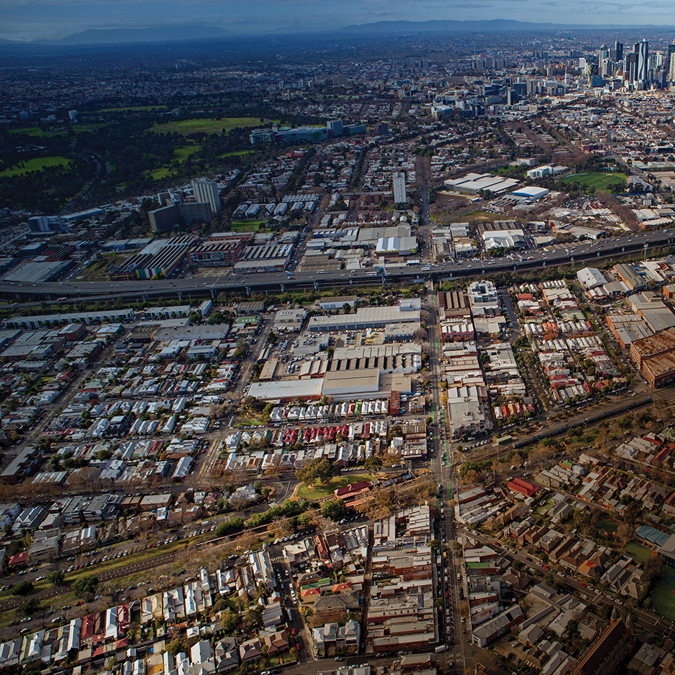

How We Engaged With The Community
In total, six local events were hosted, six digital platforms were utilised, over one hundred thousand people were reached, and 269 ideas recorded.
The Discussion Paper was distributed widely. We spoke with residents, workers, neighbourhood associations, Aboriginal Custodians, landowners, property and planning groups, state agencies, local and state government.
We informed and encouraged people to participate in the conversation through the project page on Participate Melbourne, targeted social media promotion, emails to local organisations and state agencies, letters posted to large landowners, e-newsletters and public information sessions in community settings. An iPad station was also installed at North Melbourne Library.
ENGAGEMENT PROMOTION | 8    SOCIAL MEDIA POSTS | 197    EMAILS SENT | 400    POSTCARDS SHARED
ENGAGEMENT REACH | 103,963    SOCIAL MEDIA VIEWS | 2,509    WEBSITE VISITORS | 168    FACE-TO-FACE CONTACTS
FEEDBACK | 31    ONLINE SURVEYS | 7    WRITTEN SUBMISSIONS | 128    IN-PERSON COMMENTS

What You Told Us About The Vision
“Macaulay will transition into a mixed use, midrise neighbourhood with a distinct inner urban character. New development will be high quality and deliver amenity for residents, workers and visitors. Improvements to public transport services, walking and cycling will be prioritised to support sustainable modes of travel. Greening of streets, enhancing the Moonee Ponds Creek and the delivery of new open spaces will provide connections and a network of local places. Public and private investment will deliver community infrastructure to meet the needs of a growing and diverse neighbourhood. Macaulay will adopt innovative solutions to climate change adaptation and mitigation.”
- Macaulay Structure Plan Refresh (Discussion Paper)

You said:  We heard:  “The vision highlights the need for Macaulay to become more people orientated rather than its current industrial focus.”  - Online Survey Respondent  - Ninety-five percent of respondents either fully or partially supported the consolidated vision for Macaulay.  - Height restrictions on new developments should be enforced to maintain a mid-rise character.  - Green, open spaces, as well as sky views and natural light should be prioritised.  - The outcome must result in a nice place to live that is sensitive to the needs of those using the Macaulay area. | 95%  of respondents supported or somewhat supported the vision.  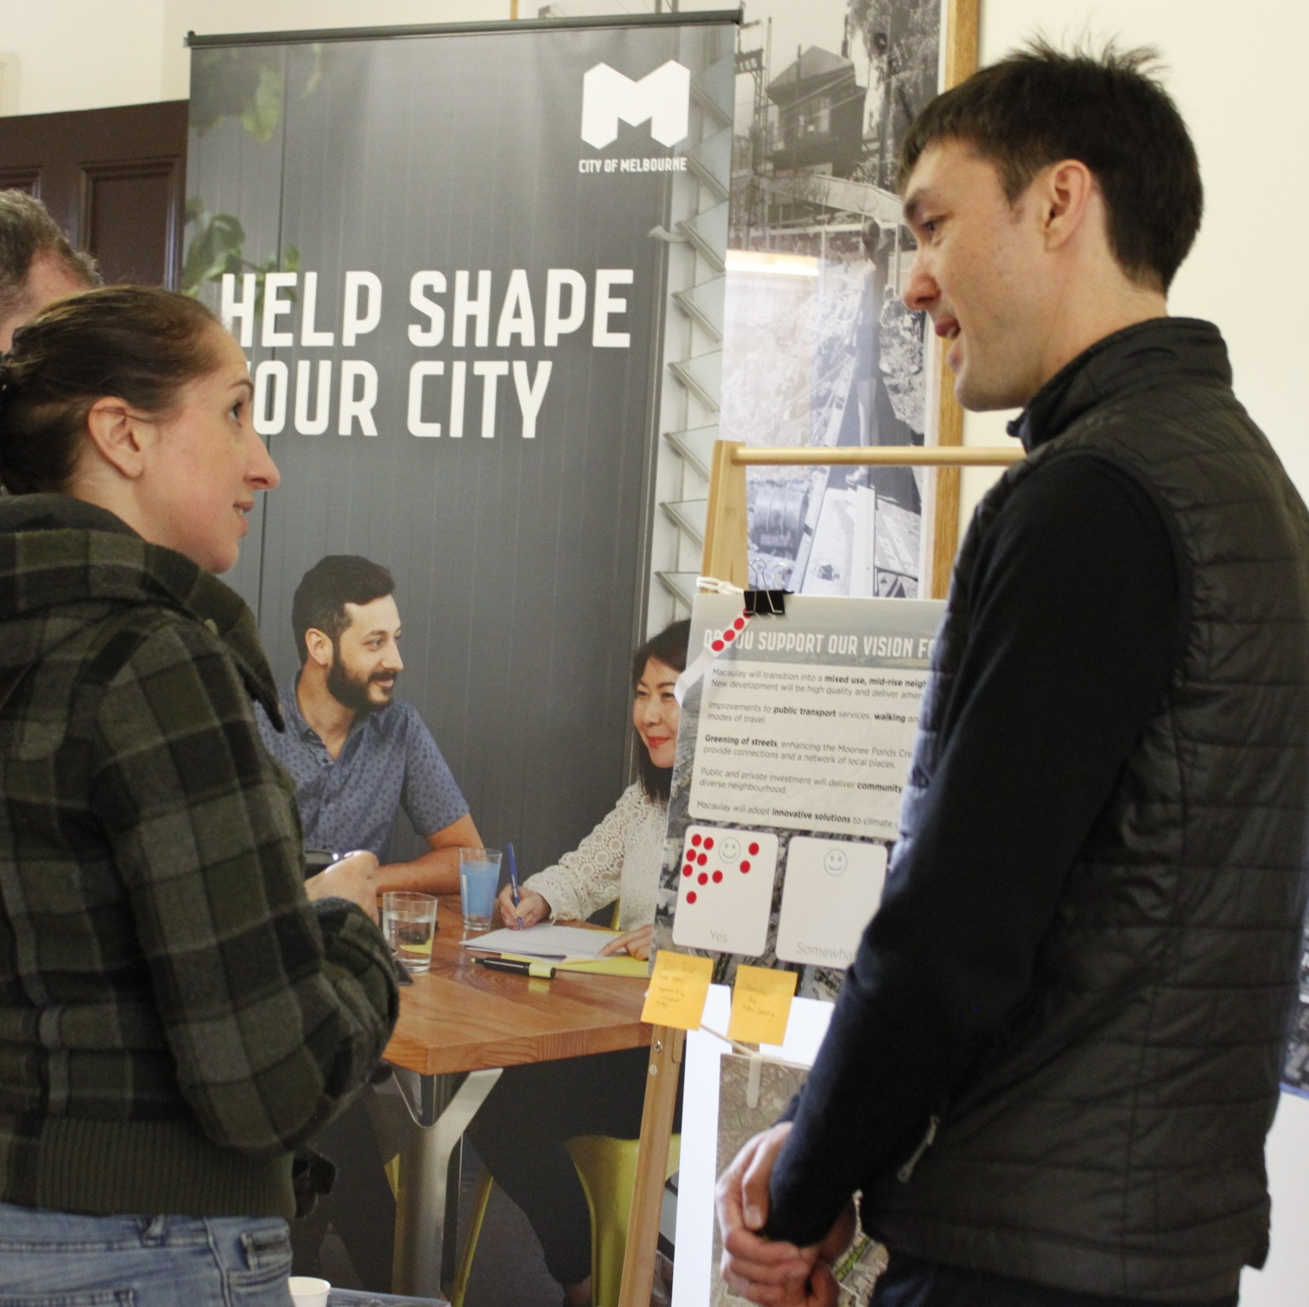

Theme 1. Activities & Land Use: Zoning

The future vision for Macaulay is a neighbourhood with a mix of different activities - homes, workplaces, shops and services. This helps make a place livelier and more interesting at different times of the day and days of the week.  You said:  “The more a community can shop and work locally the less stress on the various travel modes. Staying local means more people walking, more community connectiveness and more social inclusion.”  - Online Survey Respondent  We heard:  - It is important for the area to have a mix of residential and local employment opportunities.  - Forming and maintaining community connections is crucial and can be facilitated by living and working in the neighbourhood.  - Retaining a residential feel and reducing the carbon footprint associated with commuting should be considered.  - It is important to acknowledge, promote and accept community diversity.  - While we should try and minimise the industrial ‘feel’, there should be sufficient commercial activity in the area, so locals don’t have to go elsewhere to access basic needs and services. | 87%  of respondents thought it important that there is a mix of homes and local employment opportunities in a neighbourhood.  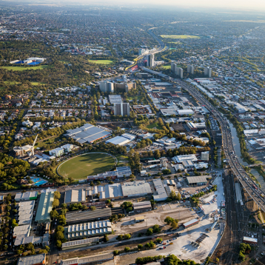

Theme 1. Activities & Land Use: Affordable Housing

Future development in Macaulay should help provide more accessible, affordable and diverse homes. This would make the level of amenity and access to services available to a greater range of people.  You said:  “The area is close to employment centres with great connectivity. Affordable housing in this area will give more vulnerable groups opportunities for upward social mobility.”  - Online Survey Respondent  We heard:  - There must be opportunities for lower-income people to live in the Macaulay area.  - It is important that there be a minimum proportion of housing dedicated for low-income use.  - It is important to have a mix of income groups in the area, including lower and higher income.  - Housing stock must remain high-quality. It is not OK to encourage cheap housing with a short lifespan. | 68%  of respondents thought it important that new residential developments contribute to increasing the amount of affordable housing.  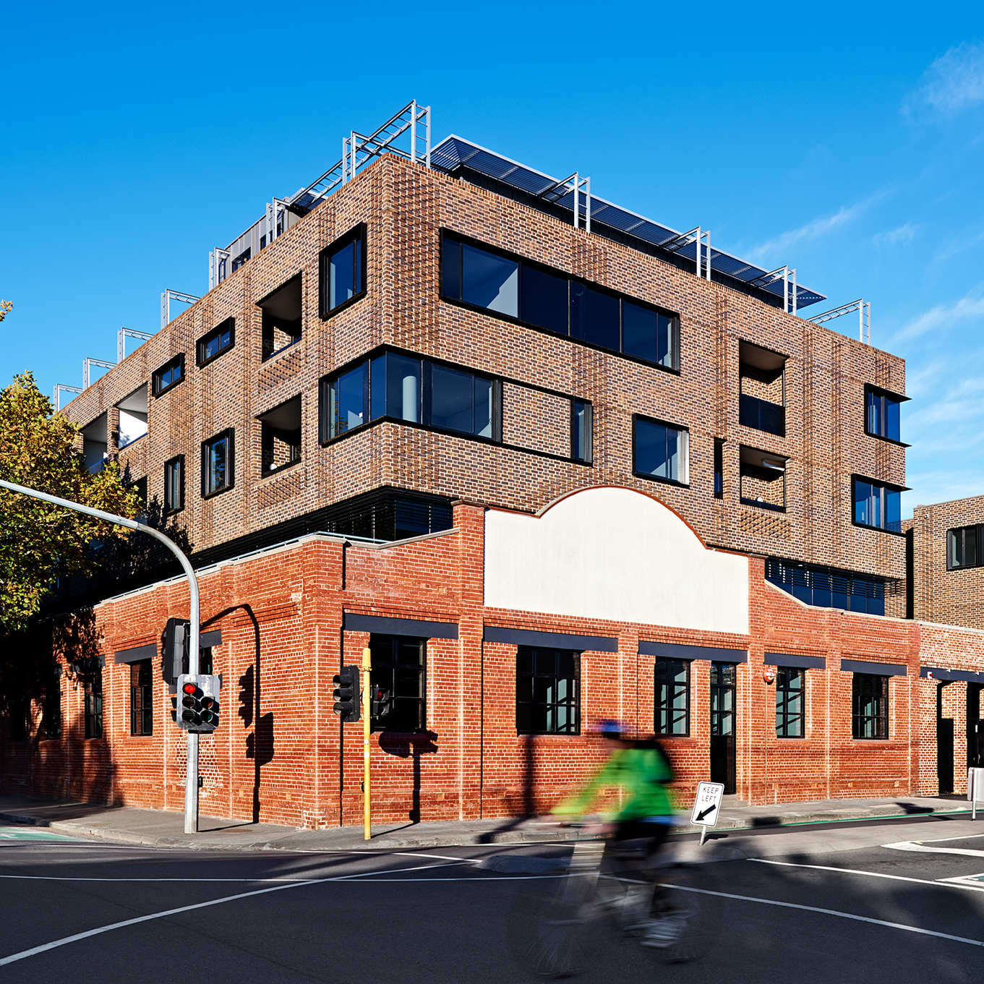

Theme 2. Urban Structure & Built Form

New development should provide high quality urban design outcomes for Macaulay. We want to ensure that there is:  - greater certainty about how much development occurs in Macaulay  - there is design flexibility to deliver high quality buildings  - ensuring new buildings are sustainable.  You said:  “we have to put boundaries around the growth of medium density development; not in wind tunnels when you walk in the street, sunshine is important”  - Online Survey Respondent  We heard:  - We do not support unfettered high-rise development.  - It is important that height restrictions are in place to ensure human-scale living is retained.  - It is important to us that planning controls allow variation in the height and shape of buildings.  - We value the aesthetics of our neighborhood. | 87%  of respondents thought it important that planning controls allow variation in the height and shape of buildings.  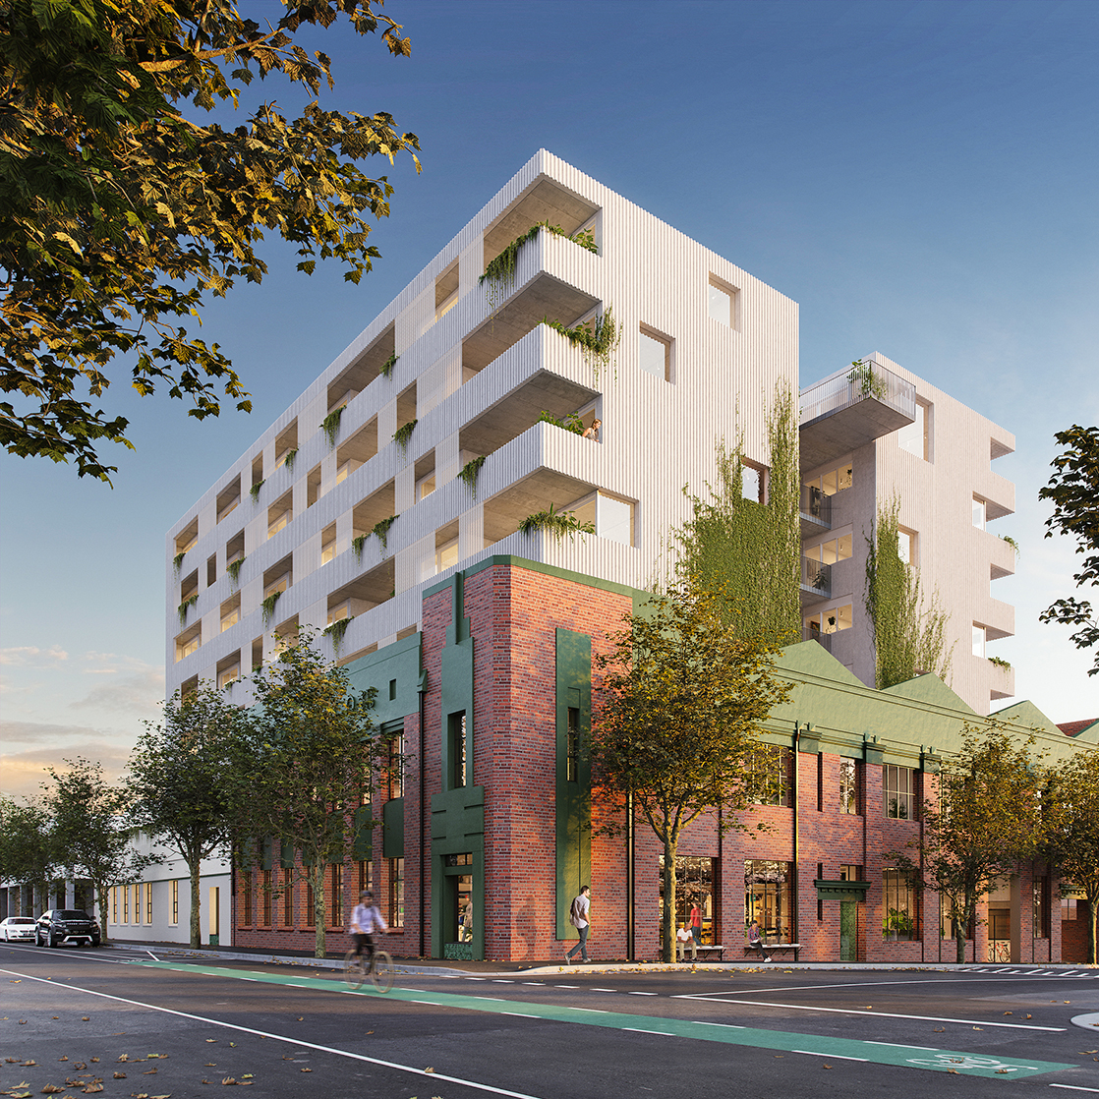

Theme 3. Transport & Access

We want to improve the safety, comfort, attractiveness and convenience of walking, cycling and taking public transport. We’ll do this by:  - supporting increased use of active transport (walking and cycling)  - improving public transport  - reducing use of private vehicles.  You said:  “Streets prioritised for people; better walkability, separated bike lanes, no or reduced on-street parking, more trees & gardens.”  - Face-To-Face Respondent  We heard:  - We all agree, to at least some degree, that walking routes should be improved.  - Walking route improvement will assist people’s ability to move around within the area.  - It is important that bike paths are improved.  - Cyclists should be able to use this mode safely, and separate bike paths are the best way to achieve this.  - Public transport is, or should be, an integral part of any city.  - It is important that public transport is regular, reliable and user-friendly.  - Car parking is a contentious topic. We want the freedom to own and park a car, but we also recognise that too many cars in the area will be problematic.  - Congestion is an issue, and one that will require a system-wide solution. | 100%  of respondents thought it important to improve public transport in the Macaulay area.  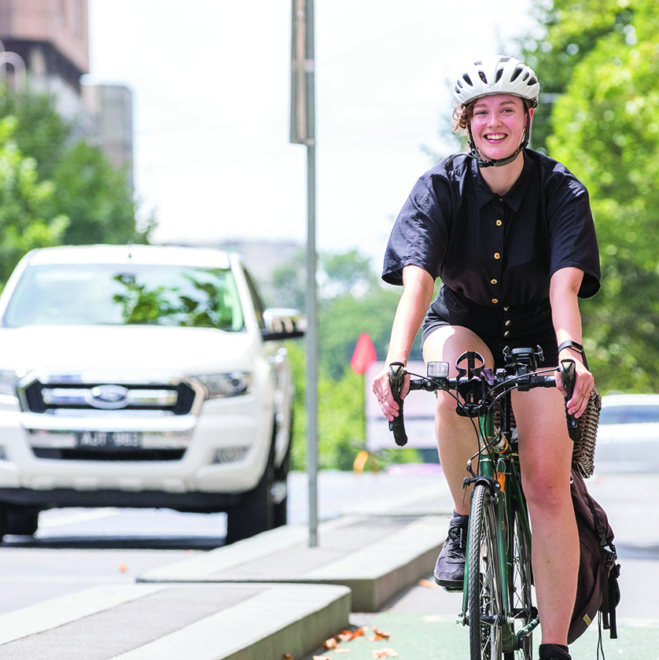

Theme 4. Public Realm

Macaulay’s streets and open spaces will be great places for people, celebrating water in the landscape and helping to improve the environment. We’ll work towards delivering:  - better streets  - a revitalised Moonee Ponds Creek  - new open spaces.  You said:  “Where will the children play, where will people engage in recreational activities, where will the community veggie gardens be located? Kensington residents have for years asked for these amenities. A population increase will also require new schools and kinders. We do not want a repeat of Docklands, which has had to retrofit community facilities and open spaces.”  - Written Submission Respondent  We heard:  - It is important that there are open, green spaces for the community to use.  - These spaces must be welcoming and easy to access, e.g. sheltered from the effects of wind, rain and sun.  - It is important for the community to have places to play sport and stay fit.  - If the area is to be a mix of residential and commercial, it must include more public spaces that cater to the residential population. | 29%  of respondents selected sustainability as one of their top three activities that outdoor public space should cater for.  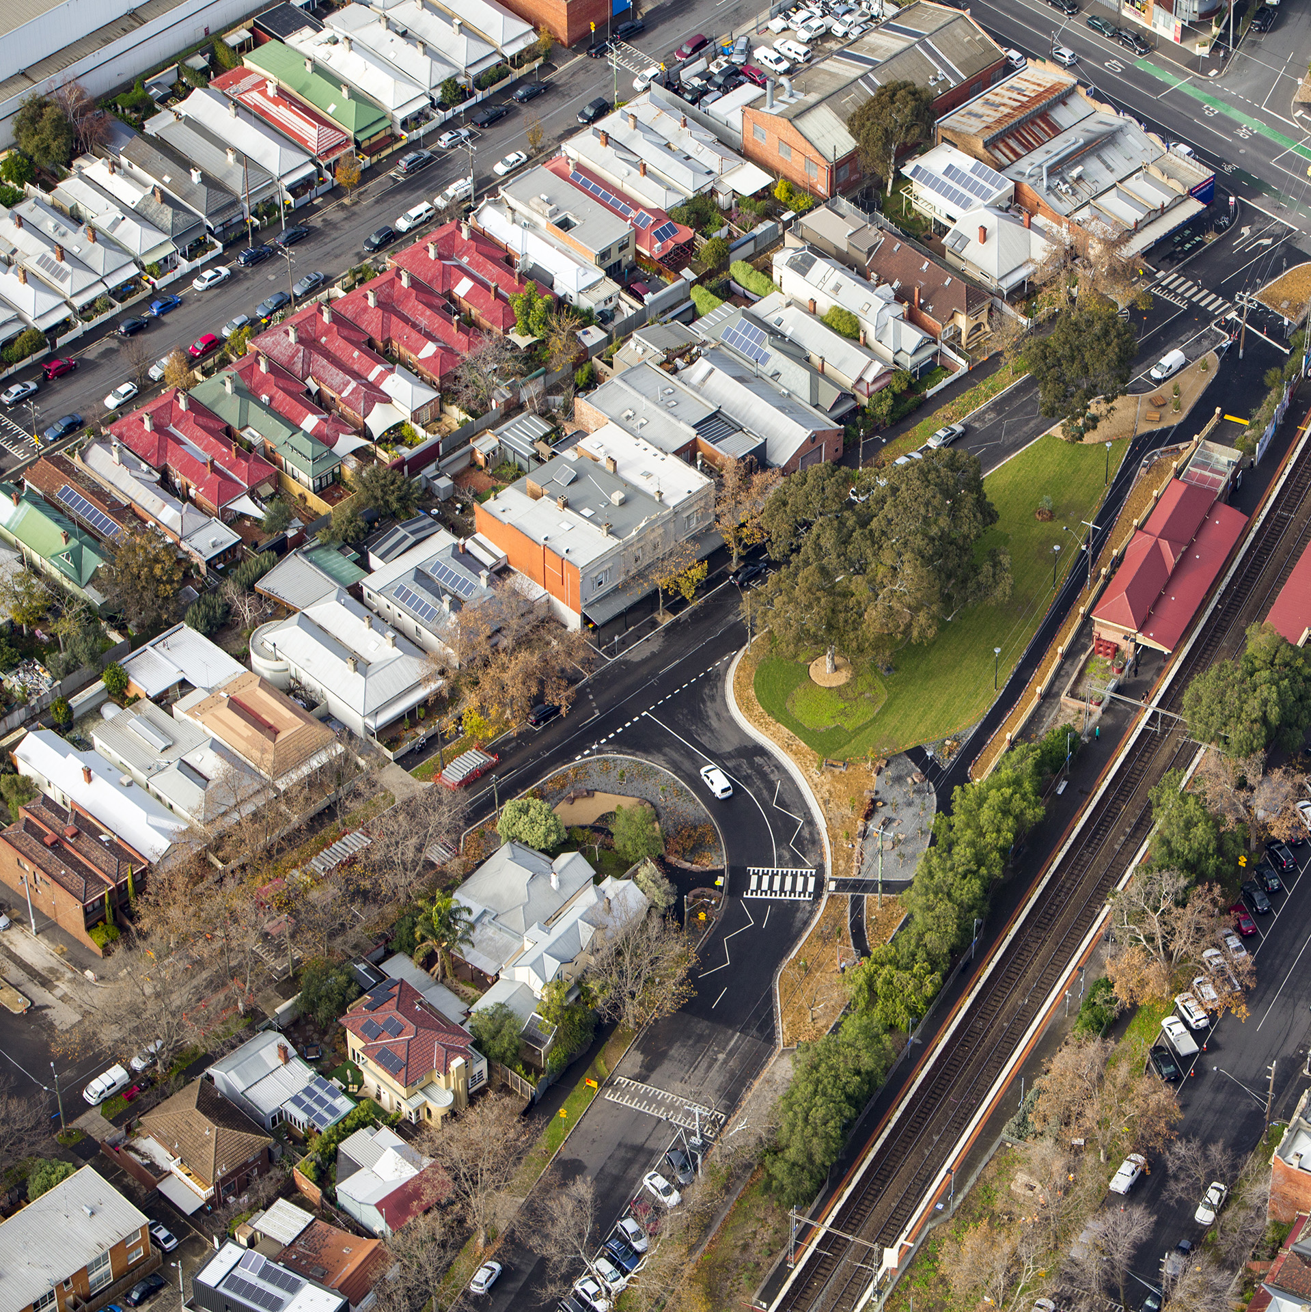

Theme 5. Community Infrastructure

We will work with the Victorian Government and other agencies to plan for Macaulay’s future community infrastructure needs.  You said:  “Community facilities; somewhere to keep fit, connect with people, invigorate.”  - Face-To-Face Respondent  We heard:  - Access to multi-purpose community spaces should be easy and cheap.  - Space should be made available for sport/fitness, community, social and creative endeavors.  - The main activities that we want to see community spaces being used for are arts and culture, and programs for children.  - Easy to book, cheap spaces will encourage community cohesion.  - Community facilities should be culturally appropriate and inclusive, so that all members of the community feel welcome to use them. | 23%  of respondents wanted indoor community facilities to cater for arts and culture, and childhood programs and services.  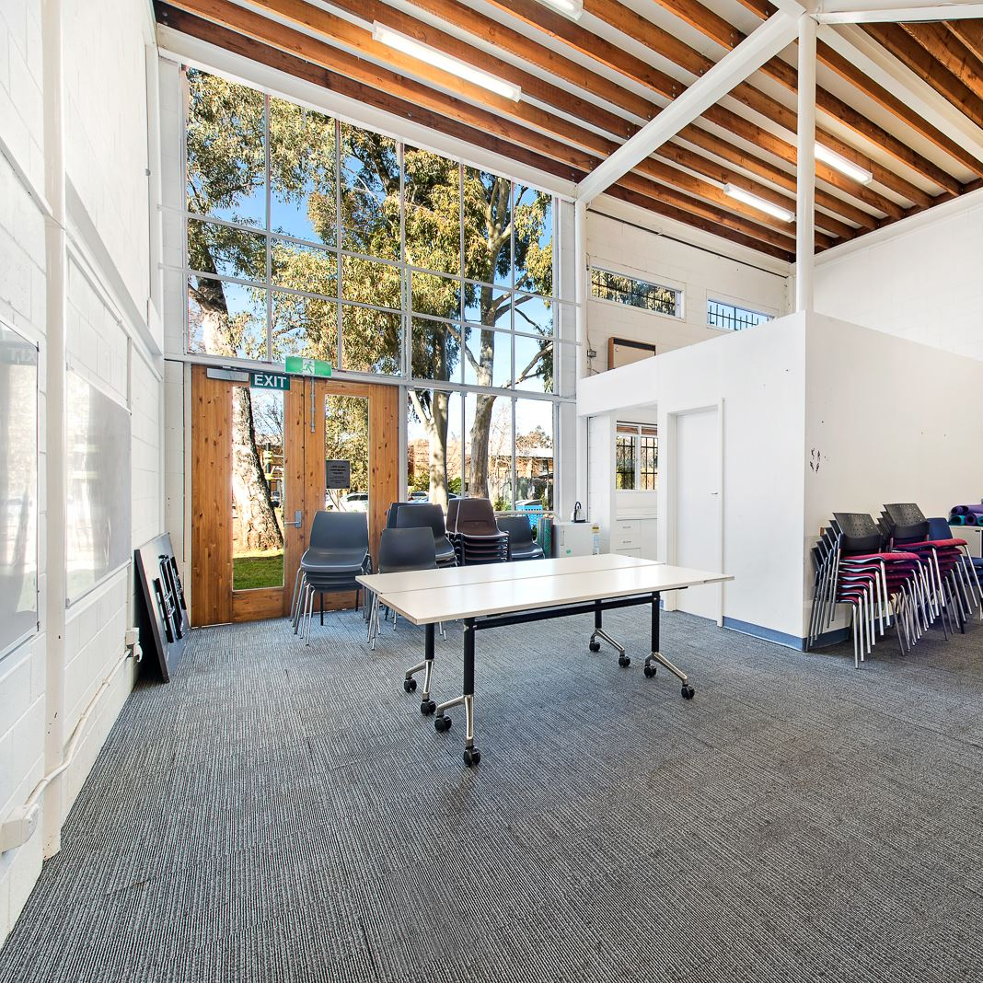

Theme 6: Flooding

Water can be celebrated as a feature of Macaulay. This can be achieved by incorporating stormwater treatment and reuse into buildings, streets and open space.  You said:  “The area is already susceptible to flooding, as evidenced by the existing levees. The combination of a growing population density & climate change will only exacerbate into the future.”  - Online Survey Respondent  We heard:  - The Macaulay area is susceptible to flooding.  - Environmental factors and climate change may see an increased risk of flooding in the area in the future.  - We are concerned about potential social, environmental and economic consequences of flooding.  - It is important to address flood mitigation in planning, to protect people and property. | 90%  of respondents thought it important to allocate space in streets and parks to manage flooding.  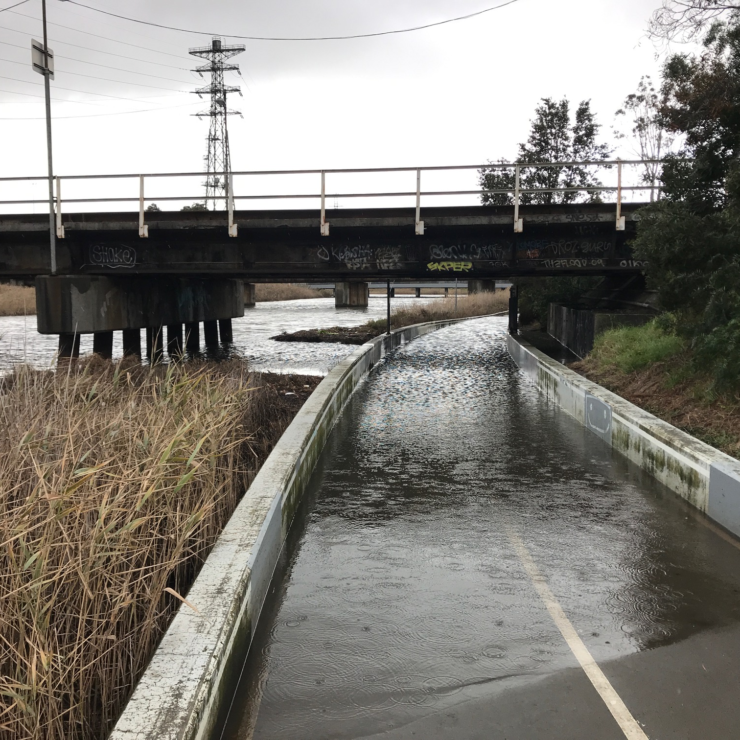

Key Themes Emerging From Community Feedback

We want Macaulay to be:
A place prepared for the future
  - Making provisions to ensure that our housing, transport systems and employment opportunities can support a growing population.
  - Looking ahead to a changing climate, focusing on flood management, increased green spaces, and improving the precinct’s pedestrian, cycling and public transport networks.
A nice place to live
  - Making sure that the Macaulay precinct is a nice place to live, work, play and relax.
  - Ensuring that employment opportunities, housing, and transport options allow for a good quality of life.
A place for the community
  - A desire for community spaces where all can be welcome and inclusive, including green spaces, sports facilities and community buildings.
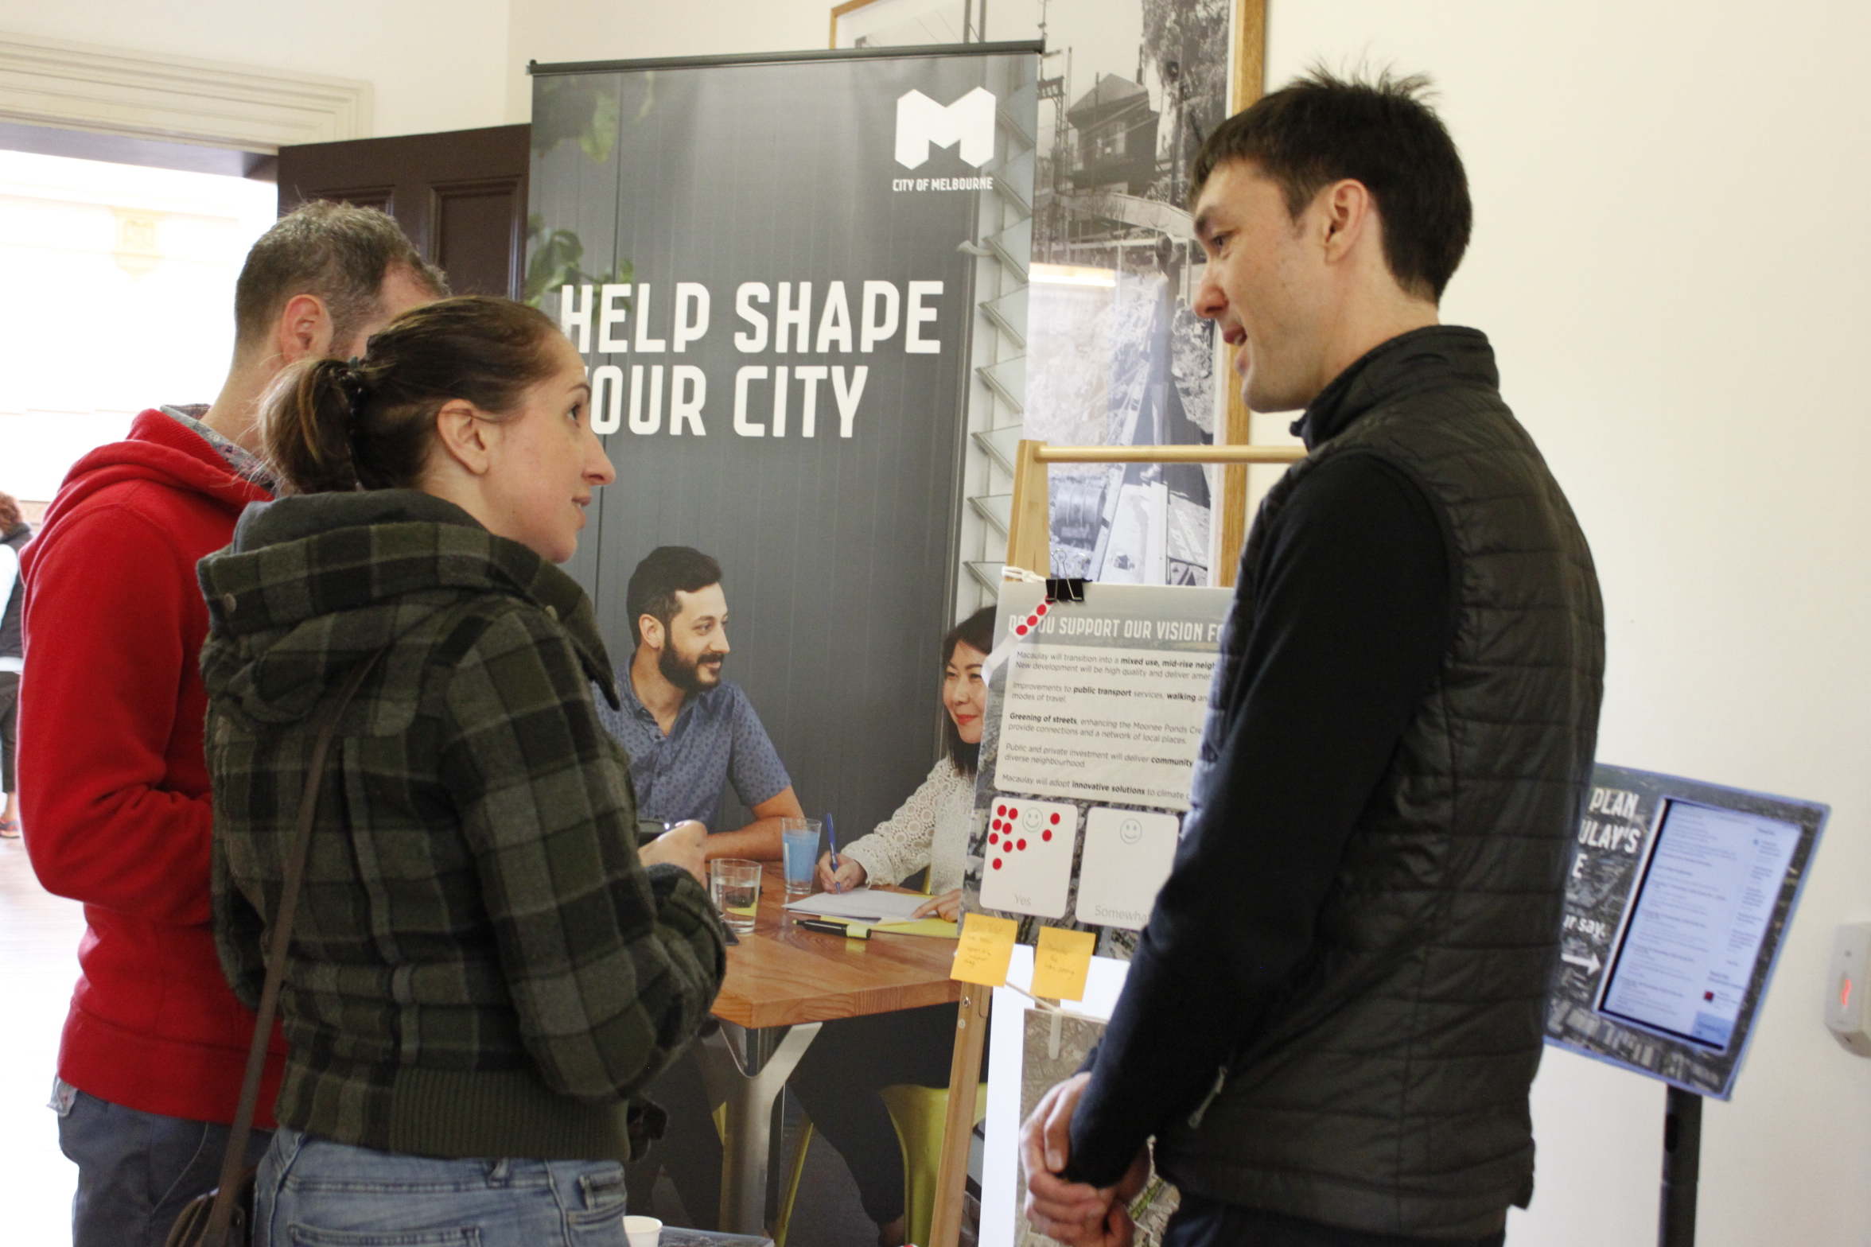
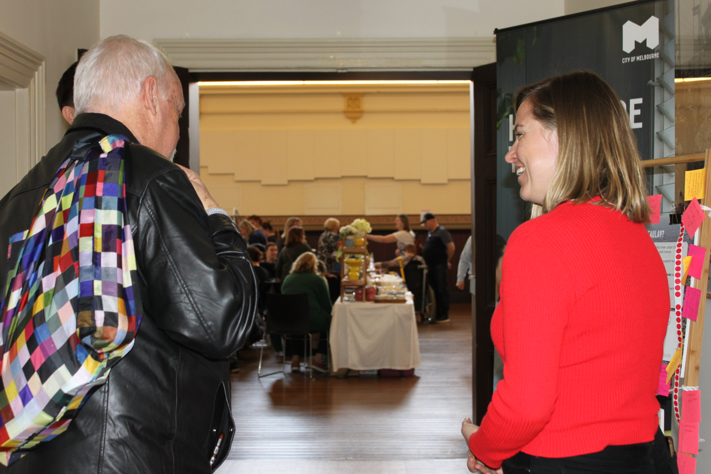
  - Having accessible community spaces will facilitate and encourage social connection within the community.

How Your Feedback Will Be Used

The ideas and reflections gathered through this discussion phase and analysed within this summary will help the City of Melbourne to refresh the structure plan for Macaulay and identify further work required.

This summary, and a full report will be published online and provided to Council.

In early-mid 2020, a draft Macaulay Structure Plan Refresh will be shared with the community and other stakeholders. The draft plan will provide greater detail and direction for the future of the neighbourhood.

At this time, further feedback will be welcomed.

It's anticipated that in the later part of 2020 the structure plan document will be finalised and recommended to the Future Melbourne Committee for formal endorsement.

This report has been prepared by:
Global Research
150 Office Rd
Merivale
Christchurch 8014
New Zealand
+64 3 355 4562
www.globalresearch.nz

