Planning and Environment Act 1987

Melbourne Planning Scheme

Amendment C463melb

Explanatory Report

Overview
The amendment implements the West Gate Service Stations 1 & 2 West Gate Freeway, Port Melbourne Heritage Review (GJM Heritage, April 2024) (the Review) which seeks to apply heritage controls to the properties identified in Figure 1. The amendment applies one Heritage Overlay (HO1380) to the two sites, updates the Heritage Places Inventory March 2022 (City of Melbourne, August 2024) and incorporates a Statement of Significance and Incorporated Plan to reflect the recommendations of the Review and makes consequential changes to the Melbourne Planning Scheme.

Where you may inspect this amendment
The amendment can be inspected free of charge at the Melbourne City Council website at: https://participate.melbourne.vic.gov.au/amendment-c463
And/or
The amendment is available for public inspection, free of charge, during office hours at the following places:
City of Melbourne
Customer Service Counter
Ground Floor Melbourne Town Hall Administration Building
120 Swanston Street
MELBOURNE VIC 3000
The amendment can also be inspected free of charge at the Department of Transport and Planning website at http://www.planning.vic.gov.au/public-inspection or by contacting the office on 1800 789 386 to arrange a time to view the amendment documentation.

Submissions
Any person may make a submission about the amendment to the planning authority. Submissions about the amendment must be received by 7 February 2025.
A submission must be written and either lodged via:
- an online form available at: participate.melbourne.vic.gov.au
- emailed to: heritage@melbourne.vic.gov.au
- or posted to Manager Strategic Planning (Heritage) City of Melbourne GPO Box 1603 MELBOURNE VIC 3001

Panel hearing dates
In accordance with clause 4(2) of Ministerial Direction No.15 the following panel hearing dates have been set for this amendment:
- Directions hearing: week beginning 21 July 2025 (TBC).
- Panel hearing: week beginning 25 August 2025 (TBC).

Details of the amendment

Who is the planning authority?
This amendment has been prepared by the City of Melbourne which is the planning authority for this amendment.

Land affected by the amendment
The amendment affects properties within the area shown below.
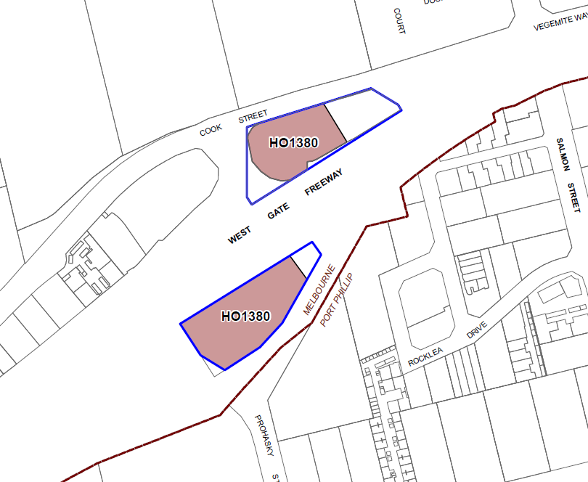
Figure 1: Map of north and south service stations (1 & 2 West Gate Freeway, Port Melbourne) with the proposed HO1380 extent shown in brown and the property boundaries shown in blue.
The amendment applies to the land outlined in brown which is the extent of the Heritage Overlay as shown in Figure 1. The blue line shows the property boundary.
A mapping reference table providing further information about the land affected by the amendment is at Attachment 1 to this explanatory report.

What the amendment does
The amendment proposes to amend the Melbourne Planning Scheme to implement the recommendations of the Review on a permanent basis by:
Overlay map
- Inserting a new Planning Scheme Map No. 10HO to apply the Heritage Overlay to part of the sites at 1 and 2 West Gate Freeway, Port Melbourne (HO1380).
Planning scheme ordinance
- Amending Clause 15.03-1L-02 (Heritage) to insert the West Gate Service Stations 1 & 2 West Gate Freeway, Port Melbourne Heritage Review (GJM Heritage, April 2024) as a policy document.
- Amending the Schedule to Clause 43.01 (Heritage Overlay) to:
  - Insert one new individual heritage place on a permanent basis: HO1380 West Gate Service Stations, 1 & 2 West Gate Freeway, Port Melbourne and introduce a Statement of Significance and Incorporated Plan:
    - West Gate Service Stations Statement of Significance 1 & 2 West Gate Freeway, Port Melbourne (GJM Heritage, April 2024)
    - West Gate Service Stations Incorporated Plan 1 and 2 West Gate Freeway, Port Melbourne (City of Melbourne, March 2024)
- Amending the Schedule to Clause 72.03 (What does this Planning Scheme consist of?) to:
  - Insert one new Heritage Overlay Map No. 10HO.
- Amending the Schedule to Clause 72.04 (Incorporated Documents) to:
  - insert the following incorporated documents:
    - West Gate Service Stations Statement of Significance 1 & 2 West Gate Freeway, Port Melbourne (GJM Heritage, April 2024)
    - West Gate Service Stations Incorporated Plan 1 and 2 West Gate Freeway, Port Melbourne (City of Melbourne, March 2024)
  - Amend the title of the existing incorporated document Heritage Places Inventory March 2022 (City of Melbourne, August 2024) to change the date to (December 2024).
- Amending the incorporated document titled Heritage Places Inventory March 2022 (City of Melbourne, August 2024) to:
  - Change the date from August to December 2024.
  - Insert 1 West Gate Freeway with a significant building category.
  - Insert 2 West Gate Freeway with a significant building category.
- Amending the Schedule to Clause 72.08 (Background Documents) by inserting the West Gate Service Stations 1 & 2 West Gate Freeway, Port Melbourne Heritage Review (GJM Heritage, April 2024) as a background document.

Strategic assessment of the amendment

Why is the amendment required?
The amendment is required to provide permanent heritage protection for the place identified in the Review. The introduction of heritage controls will ensure that the impact of new development on the heritage value of the place is assessed as part of development applications.

How does the amendment implement the objectives of planning in Victoria?
The amendment implements the objectives of planning in Victoria as outlined in section 4(1) of the Planning and Environment Act 1987 (PE Act) as follows:
- Provide for the fair, orderly, economic and sustainable use, and development of land
The amendment will result in the fair, orderly, economic and sustainable use and development of land by implementing a well-planned, holistic strategy that considers the heritage value of the service stations while recognising the operational requirements of the facility.
- Conserve and enhance those buildings, areas or other places which are of scientific, aesthetic, architectural or historical interest, or otherwise of special cultural value;
The West Gate Freeway Service Stations Heritage Review identifies the local heritage significance of the service stations and proposes to protect them while with the application of a Heritage Overlay as well as recognising the operational requirements of the facility through the permit exemptions of the Incorporated Plan.
- Balance the present and future interests of all Victorians.
The proposed provisions in the Heritage Overlay schedule have been drafted to ensure development occurs in a logical manner consistent with the objectives set out in paragraphs a), d) and g).

How does the amendment address any environmental, social and economic effects?
Environmental effects
It is widely understood that the conservation of heritage buildings has environmental sustainability benefits. Reduction in energy usage associated with demolition, and minimising waste disposal from demolition and new construction to landfill is achieved through the conservation of heritage buildings. Retaining and adapting heritage buildings promotes sustainable development by conserving the embodied energy in the existing buildings.
Social and Economic effects
Heritage assets contribute to an area's liveability and sense of cultural identity and can have a positive influence on many aspects of the way a community develops.
Heritage buildings and places engender a sense of place and connection in communities. The recognition of the iconic service station canopies contributes to an understanding of the western gateway into and out of Melbourne.
It is noted that there is an economic impact regarding maintenance of the stations’ canopies. The PVC membrane fabric has a lifespan of approximately 12-15 years and will therefore require periodic replacement or repair with a similar fabric. While all infrastructure requires periodic maintenance, it is acknowledged that the general upkeep of the canopies may place an economic encumbrance on the property owner.

Does the amendment address relevant bushfire risk?
The amendment applies to an urban area that is not subject to a bushfire risk.

Does the amendment comply with the requirements of any other Minister’s Direction applicable to the amendment?
The amendment complies with the requirements of the Ministerial Direction – The Form and Content of Planning Schemes (section 7(5) of the PE Act).
Ministerial Direction No. 11: Strategic Assessment of Amendments
The amendment complies with Ministerial Direction No. 11: Strategic Assessment of Amendments under section 12 of the PE Act. The amendment is consistent with this direction which ensures a comprehensive strategic evaluation of a planning scheme amendment and the outcomes it produces. This explanatory report provides a comprehensive strategic evaluation of the amendment and the outcomes it produces.

How does the amendment support or implement the Planning Policy Framework and any adopted State policy?
The amendment is consistent with the following clauses of the Planning Policy Framework and will assist in achieving objectives of the clauses:
Clause 15.01-1R - Urban design
To create a distinctive and liveable city with quality design and amenity.
Clause 15.03-1S - Heritage conservation
To ensure the conservation of places of heritage significance.
Clause 15.03-1L-02 - Heritage
To encourage high quality contextual design, to encourage the retention of the three-dimensional fabric and form of a building, to enhance the presentation and appearance of heritage places, and to protect significant views and vistas.
By including the identified places within the Heritage Overlay, the amendment will ensure that the significance of these heritage places is protected, conserved and enhanced. The Heritage Overlay will require consideration to be given to the significance of the identified heritage place as a decision guideline and will encourage development that is designed and sited to respect the identified significance of heritage places.
Clause 18.01-1S (Land use and transport integration)
To facilitate access to social, cultural and economic opportunities by effectively integrating land use and transport. A strategy to achieve this objective is to plan land use and development to allow for the ongoing improvement and development of the State Transport System in the short and long term.
The amendment affects land located in a declared freeway which is part of the state transport system. The subject land is located within the Transport Zone (TRZ2 Principal road network). The amendment supports the objective and strategies of Clause 18 in that it will not impede the improvement or development of the state transport system. A development proposal for this site will be assessed against all relevant sections of the planning scheme including Clause 18. The introduction of a Heritage Overlay ensures that the heritage significance of the stations’ canopies will be considered as part of an overall assessment against the relevant controls. It is also noted that the Incorporated Plan identifies permit exemptions to recognise the operational requirements of the service stations.

How does the amendment support or implement the Municipal Planning Strategy?
The Municipal Planning Strategy (MPS) contains objectives and strategies that are relevant to the proposed amendment. In particular, the amendment supports the strategic directions of Clause 02.03-4 (Built environment and heritage) of the Municipal Planning Strategy which seeks to: conserve and enhance places and precincts of identified cultural heritage significance.

Does the amendment make proper use of the Victoria Planning Provisions?
The amendment makes proper use of the Victoria Planning Provisions. The application of the Heritage Overlay, Schedule, statement of significance and incorporated plan is the appropriate Victorian Planning Provision tool for the protection of heritage places of local significance.
The amendment makes proper use of incorporated documents to clearly outline the heritage significance and to establish planning permit exemptions of the places affected by the amendment. The application of the Heritage Overlay and statements of significance have been prepared in accordance with Planning Practice Note 1: Applying the Heritage Overlay.

How does the amendment address the views of any relevant agency?
The views of relevant agencies, affected property owners and relevant community groups will be sought during the public exhibition phase for the amendment.

Does the amendment address relevant requirements of the Transport Integration Act 2010?
As the service stations are located in a declared freeway and the Transport Zone, consideration has been given to all of the components of the “transport system”, as defined in section 3 of the Transport Integration Act 2010 (TIA) and it has been determined that the amendment will not have a significant impact on the transport system. In particular consideration has been given to:
- The physical components: which includes the service station building, where the introduction of a Heritage Overlay in conjunction with an Incorporated Plan which provides some specific permit exemptions, will not impede the operation of the facility.
- The management components: which includes strategic and operations planning, it is noted that a Heritage Overlay does not prohibit the redevelopment of a site but requires consideration to be given to the heritage significance of the place balanced with the other relevant provisions of the planning scheme. An Incorporated Plan is proposed to include some permit exemptions to ensure the facility can continue to function safely, efficiently and appropriately.
The amendment is consistent with the objectives and decision-making principles in the TIA. Specifically:
- It does not impact on social and economic inclusion or prosperity of the transport network as it is not altering the accessibility of the existing network.
- It does not impact on the environmental sustainability of the transport system as it is not relevant to the lowering of transport related emissions.
- It does not impact on the effective integration of transport and land use, as it does not limit general transport efficiencies or impact on land use planning.
- It will not impact on the safety of the service stations as the tensile membrane fabric is unlikely to cause a safety issue. It is acknowledged that the fabric will require periodic maintenance and the Statement of Significance facilitates this by noting that the fabric can be replaced with similar fabric and will not adversely affect the significance of the place.
The amendment does not have an impact on the transport system as defined by Section 3 of the TIA.

Resource and administrative costs

What impact will the new planning provisions have on the resource and administrative costs of the responsible authority?
The inclusion of one new place in the Schedule to the Heritage Overlay may contribute to a minor increase in the number of planning permit applications.
This increase can be accommodated within existing resources. These resource and administration costs will be off-set by a reduction in the need for individual responses to the possible demolition of significant heritage places which are not currently included within the Schedule to the Heritage Overlay.
Attachment 1 – Mapping reference table
Land Affected | Mapping Reference | Address | Proposed Zone changes | Proposed Overlay changes | Proposed deletion changes
Part 1 West Gate Freeway, Port Melbourne  The Heritage Overlay extent generally follows the property boundary with the exception that the eastern boundary aligns with the western kerb of the internal north-south road. | Melbourne C463melb  001hoMap10 Exhibition | 1 West Gate Freeway, Port Melbourne | N/A | Apply HO1380 | N/A
2 West Gate Freeway, Port Melbourne  The Heritage Overlay extent generally aligns with the property boundary with the exception that the eastern boundary springs from the intersection of; the northern edge of the driveway kerb and the southern property boundary. | Melbourne C463melb  001ho Map10 Exhibition | 2 West Gate Freeway, Port Melbourne | N/A | Apply HO1380 | N/A

