
Queensberry Street Riding lanes
Peel Street to Rathdowne Street
Contents
Queensberry Street riding lanes 3
Peel Street to Rathdowne Street 3
Details of treatments for this project 3
Road cross-sections 5
Queensberry Street Riding Lanes (1/4) 6
Queensberry Street Riding Lanes (2/4) 7
Queensberry Street Riding Lanes (3/4) 8
Queensberry Street Riding Lanes (4/4) 9

Queensberry Street riding lanes

Peel Street to Rathdowne Street
Prior to Metro Tunnel works starting, Queensberry Street had one traffic lane in each direction.
With Grattan Street now open and Metro Tunnel’s new Parkville Station almost complete, we’re proposing to reinstate Queensberry Street to one traffic lane in each direction, and deliver safer and better-connected riding lanes from Peel Street to Rathdowne Street.
In line with City of Melbourne’s Urban Forest Strategy, we’re also proposing to plant up to 57 trees. This mix of small to large evergreen and deciduous trees will help to create a cooler environment in the warmer months, reduce air pollution, encourage outdoor activity and support biodiversity.

Details of treatments for this project
Protection at intersections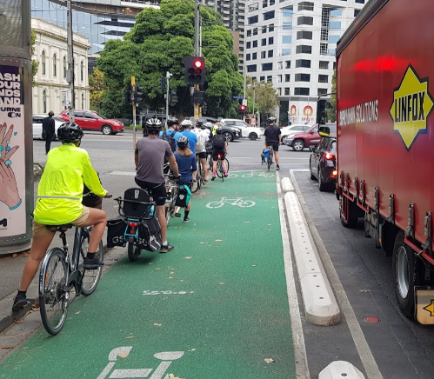
Flexible bollard 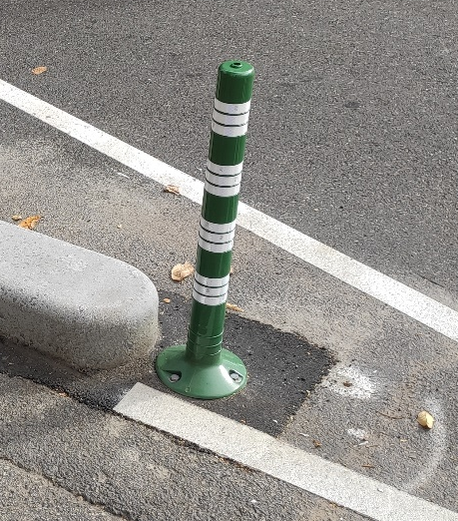
Concrete separator kerbs 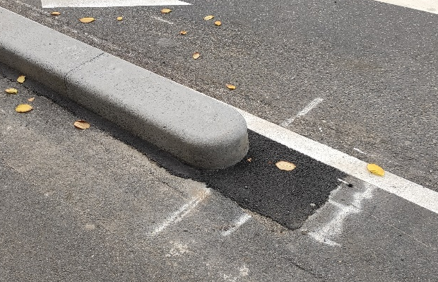
Concrete separator islands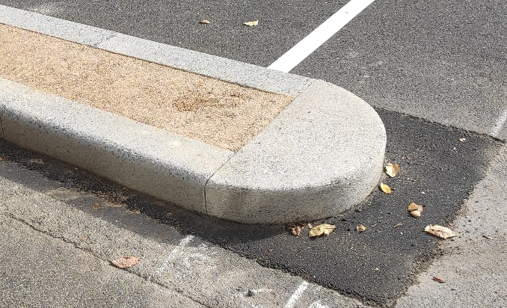
Footpath extensions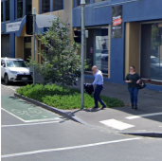
Island with tree planting 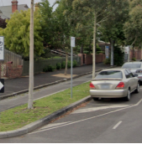
Vehicle hook turn boxes 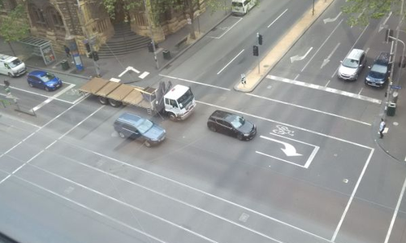
Green surface treatment at selected locations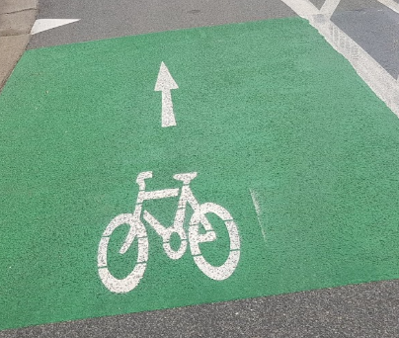

Road cross-sections
Previous conditions on Queensberry Street 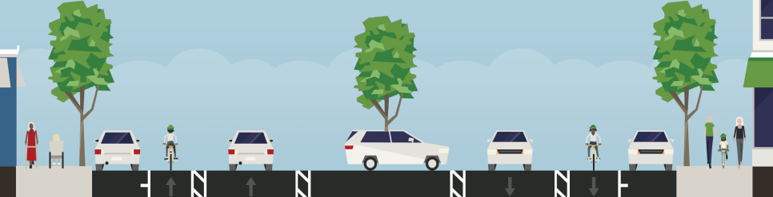

Existing conditions on Queensberry Street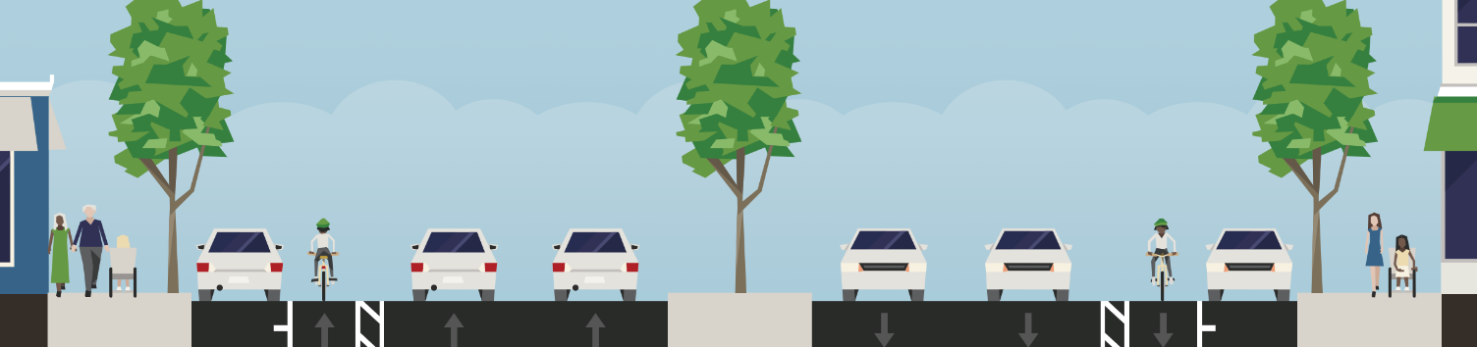
Proposed new conditions on Queensberry Street 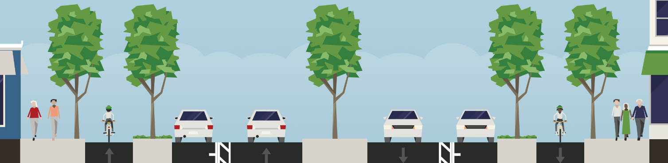

Map of the surrounding riding lane network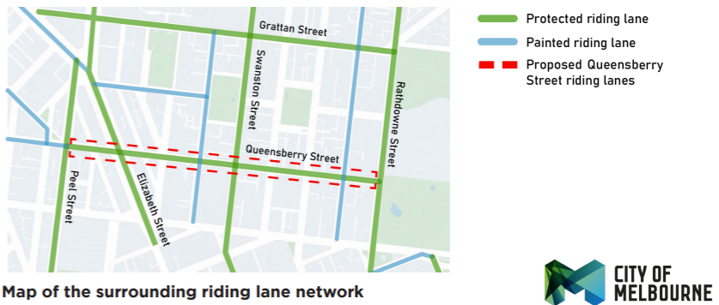

Queensberry Street Riding Lanes (1/4)

Section: Peel Street to Leicester Street
Key changes:
- Reduced traffic lanes in both directions.
- Protected riding lanes on both sides of the street, and on Leicester and Bouverie Streets approaching Queensberry Street.
- Green surface treatment at selected locations.
- Up to 4 new trees.
- New zebra crossings on O’Connell and Berkeley Streets.
- Wider footpaths on the corners of O’Connell, Berkeley and Leicester Streets with new trees.
- Right turn traffic bans at O’Connell and Berkeley Streets.
- Hook turn boxes at Elizabeth Street (eastbound) and Leicester Street.
- 14 parking bays retained (12 removed).
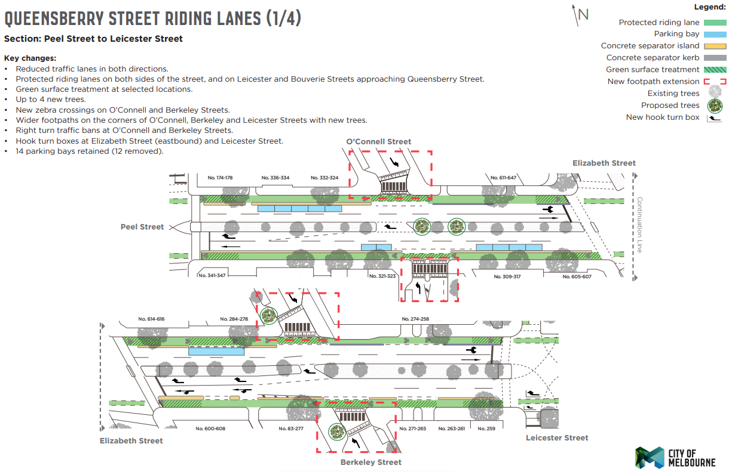

Queensberry Street Riding Lanes (2/4)

Section: Swanston Street to Lygon Street
Key changes:
- Reduced traffic lanes in both directions.
- Protected riding lanes on both sides of the street.
- Green surface treatment at selected locations.
- Up to 20 new trees.
- Gaps closed in median islands to improve safety.
- Hook turn boxes at signalised intersections.
- 31 parking bays retained (14 removed).
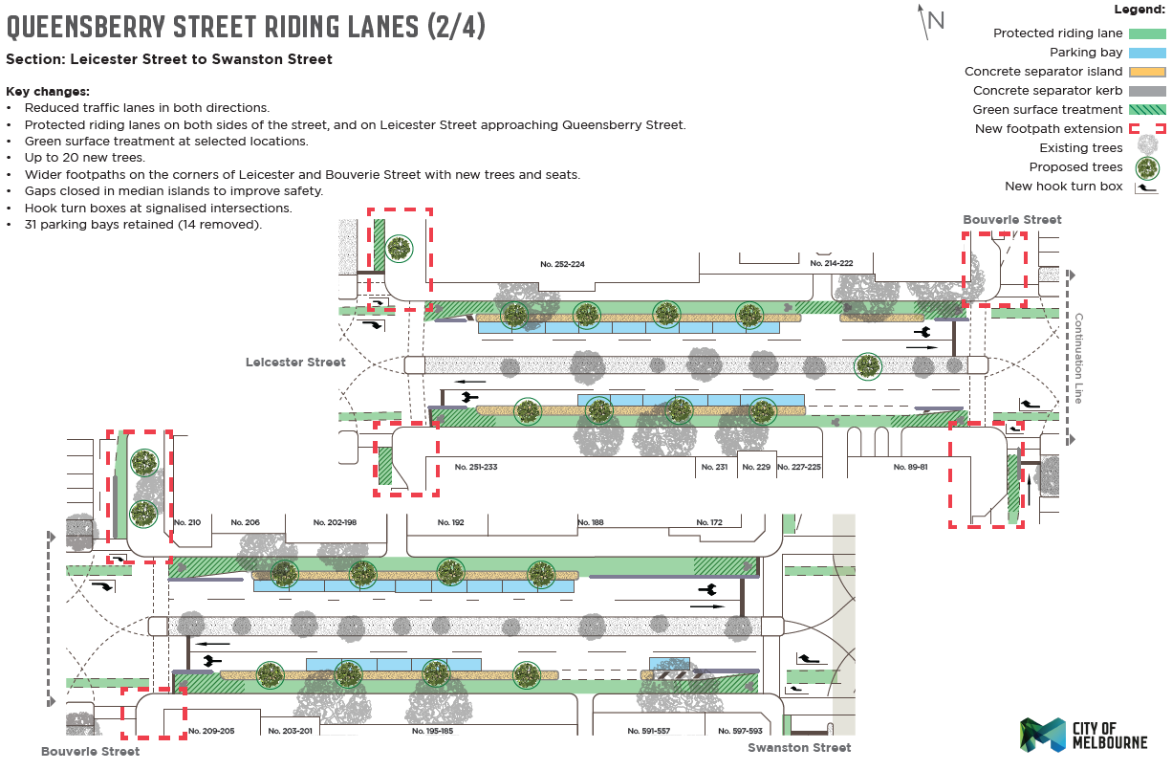

Queensberry Street Riding Lanes (3/4)

Section: Swanston Street to Lygon Street
Key changes:
- Reduced traffic lanes in both directions.
- Protected riding lanes on both sides of the street.
- Green surface treatment at selected locations.
- Up to 20 new trees.
- Gaps closed in median islands to improve safety.
- Hook turn boxes at signalised intersections.
- 31 parking bays retained (14 removed).

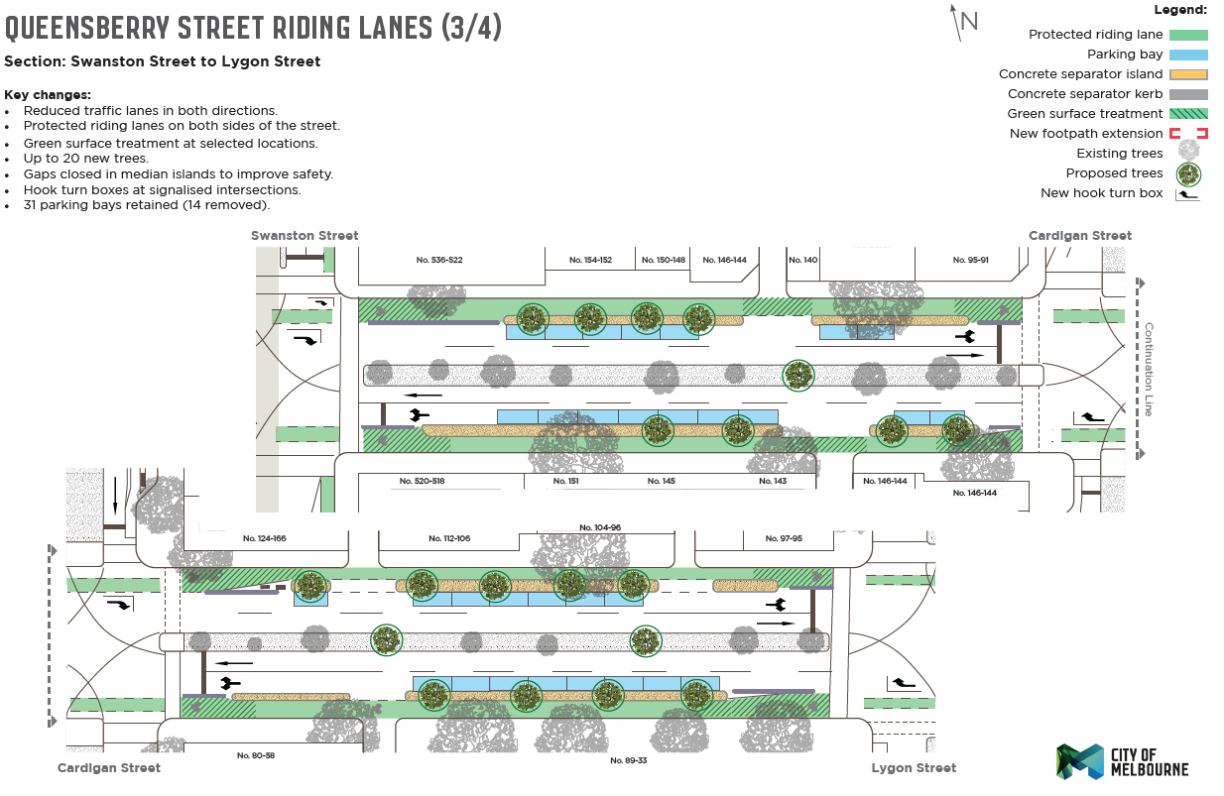

Queensberry Street Riding Lanes (4/4)

Section: Lygon Street to Rathdowne Street
Key changes:
- Reduced traffic lanes in both directions.
- Protected riding lanes on both sides of the street.
- Green surface treatment at selected locations.
- Up to 13 new trees.
- Gaps closed in median islands to improve safety.
- Hook turn boxes at signalised intersections.

