
Planning Scheme Amendment C466melb
Supporting Document
August 2025

Acknowledgement of Traditional Owners
The City of Melbourne respectfully acknowledges the Traditional Owners of the land we govern, the Wurundjeri Woi-wurrung and Bunurong / Boon Wurrung peoples of the Kulin and pays respect to their Elders past and present. We acknowledge and honour the unbroken spiritual, cultural and political connection they have maintained to this unique place for more than 2000 generations.
We accept the invitation in the Uluru Statement from the Heart and are committed to walking together to build a better future.

Contents
Introduction 5
Purpose of Amendment C466melb 5
Purpose of this document 5
Summary of Proposed Changes 5
Background and Rationale for Proposed Changes 9
1. Town Planning Satisfaction 9
2. Map 1 in DDO1 10
3. Zoning of 70-90 Chelmsford Street, Kensington 12
4. Window display permit exemption 13
5. Minor sports and recreation facility 14
6. ESO2 Exceptional Tree - Chinese Honey Locust Tree 17
7. Heritage Overlay and Heritage Places Inventory changes 19
a. HO63 Former Factory & Residence 119-125 Leicester St, Carlton 19
b. HO633 266-272 Exhibition Street, Melbourne 20
c. HO711 64-78 Lonsdale Street, Melbourne 22
d. HO719 472-474 Lonsdale Street, Melbourne 23
e. HO759 25-29 Wills Street, Melbourne 25
f. HO788 502 Spencer Street, West Melbourne 26
g. HO608 401-417 Collins Street, Melbourne 27
h. HO668 11-13 Heffernan Lane, Melbourne 28
i. HO234 27-37 Gower Street, Kensington 30
j. HO333 Cricket Pavilion & Scoreboard, University of Melbourne 31
k. HO512 Chinese Honey Locust Tree, King Street, Melbourne 33

Introduction

Purpose of Amendment C466melb
Amendment C466melb proposes to make changes and improvements to the Melbourne Planning Scheme (the Scheme) that are minor in nature and do not warrant stand-alone planning scheme amendments.
Amendment C466 proposes to make changes that aim to:
- improve the functioning of the Melbourne Planning Scheme
- streamline planning processes
- reduce the regulatory burden and cost to users of applying the Scheme
- ensure that planning controls are appropriately applied to relevant sites

Purpose of this document
This document provides the background to and rationale for the changes proposed in Amendment C466melb. It explains the reasons for the proposed changes and, where applicable, it provides relevant history and context.
This document should be read in conjunction with the C466melb Explanatory Report and the proposed planning scheme provisions, when they are formally exhibited.

Summary of Proposed Changes
Identified Issue | Relevant Planning Scheme Clauses | Proposed change
Town Planning Satisfaction is triggered for minor works. | Schedule 2 to the Comprehensive Development Zone  Schedule 1, 2, 3, 6 & 7 to the Capital City Zone  Schedule 1, 2,3, 4, 5 & 6 to the Docklands Zone | Amend the following text under No Permit Required in each schedule:  - The construction, or modification, of a waste pipe, flue, vent, duct, exhaust fan, air conditioning plant, lift motor room, skylight, security camera, street heater or similar minor works provided they are to the satisfaction of the responsible authority.  - A modification to the shop front window or entranceway of a building to the satisfaction of the responsible authority having regard to the architectural character of the building.  - An addition or modification to a verandah, awning, sunblind or canopy of a building to the satisfaction of the responsible authority.
Map 1 in Schedule 1 of the Design and Development Overlay does not align with the DDO1 map in the planning scheme | Schedule 1 to the Design and Development Overlay, Clause 6.0, Map 1 | Amend Map 1 in Clause 6.0 of DDO1 to include the land at 135-149 Kings Way.
Zoning of 70-90 Chelmsford Street, Kensington does not reflect intended use as public open space. | Map Zone 4 | Amend Zone Map 4 to apply the Public Park and Recreation Zone to 70-90 Chelmsford Street, Kensington.
The sign clauses in schedules to the Capital City Zone includes a permit exemption for a ‘window display’. | Schedules 1, 2, 3, 5, 6 and 7 to the Capital City Zone, Clause 5.0, (Clause 6.0 in CCZ5)  Schedules 1, 2, 3, 4, 5 & 6 to the Docklands Zone, Clause 6.0  Schedule 7 to the Docklands Zone, Clause 5.0  Schedule 2 to the Comprehensive Development Zone, Clause 7.0 | Delete “A window display” from “Advertising Sign” clauses in relevant zone schedules.
The drafting of Schedule 5 to the Capital City Zone is unclear regarding the land use ‘Minor sports and recreation facility’. | Schedule 5 to the Capital City Zone, Clause 1.0 | Amend the following text in Section 2 of the land use table in Schedule 5 to the Capital City Zone:  • Leisure and Recreation (other than Minor sports and recreation facility and informal outdoor recreation).
ESO2 Exceptional Trees mapping does not include the Chinese Honey Locust Tree at 607-619 Bourke Street, Melbourne and the tree address in the overlay schedule does not reflect the listing in the Exceptional Tree Register 2019 | Map 8ESO  Schedule 2 to the Environmental Significance Overlay | Amend Map 8ESO so that ESO2 is shown as applying to the tree.  Amend the tree description to reflect the address of the tree in the City of Melbourne’s Exceptional Tree Register 2019 - 607-619 Bourke Street, Melbourne.
7. Heritage anomalies: anomaly in Heritage Overlay mapping, Schedule to the Heritage Overlay and/or Heritage Places Inventory (incorporated document)
7a HO63 Former Factory & Residence 119-125 Leicester St, Carlton is incorrectly mapped as applying to 127-133 Leicester Street | Map 5HO | Amend Map 5HO to apply HO63 to 119-125 Leicester Street, and delete HO63 from 127-133 Leicester Street, to reflect the property address in the HO schedule.
7b HO633 266-272 Exhibition Street, Melbourne is mapped on the wrong buildings | Map 8HO2 | Amend Map 8HO2 to apply HO633 to 266-272 Exhibition Street to reflect the description in the HO schedule.
7c HO711 64-78 Lonsdale Street, Melbourne is not mapped on all the buildings in this street range | Map 8HO2 | Amend Map 8HO2 to apply HO711 to all of 64-78 Lonsdale Street to reflect the property address in the HO schedule.
7d HO719 472-474 Lonsdale Street, Melbourne is not mapped on 472-474 Lonsdale Street | Map 8HO2 | Amend Map 8HO2 to apply HO719 to 472-474 Lonsdale Street to reflect the property address in the HO schedule.
7e HO759 25-29 Wills Street, Melbourne is not mapped on the correct building within this property | Map 8HO2 | Amend Map 8HO2 to apply HO759 to 25-29 Wills Street to reflect the heritage place description in the HO schedule.
7f HO788 502 Spencer Street, West Melbourne is incorrectly mapped as applying to 504 Spencer Street instead of 502 Spencer Street | Map 8HO | Amend Map 8HO to apply HO788 to 502 Spencer Street and delete HO788 from 504 Spencer Street to reflect the heritage place description in the HO schedule.
7g HO608 401-417 Collins Street, Melbourne mapping does not cover 415-417 Colins Street | Map 8HO2  Schedule to the Heritage Overlay | Amend Map 8HO2 to extend HO608 to include 415-417 Collins Street to reflect the description in the HO schedule.  Change the property description in the HO schedule from “HO608 401-417 Collins Street, Melbourne” to “HO608 401-403, 405-407 and 415-417 Collins Street, Melbourne” to reflect it does not include 409-413 Collins Street.
7h HO668 11-13 Heffernan Lane, Melbourne mapped to 15-21 Heffernan Lane instead of 11 Heffernan Lane | Map 8HO2 | Schedule to the Heritage Overlay Amend Map 8HO2 to apply HO668 to 11 Heffernan Lane to reflect the property address in the HO schedule.  Change the property description in the HO schedule from “11-13 Heffernan Lane” to “11 Heffernan Lane”.
7i HO234 27-37 Gower Street, Kensington mapping does not cover full extent of the fence at the Holy Rosary Catholic Primary School | Map 4HO  Schedule to the Heritage Overlay  Heritage Places Inventory (Incorporated Document) | Amend Map 4HO to apply HO234 to the whole extent of the fence along 37-43 Gower Street.  Change the property description in the HO schedule from “HO234 27-37 Gower Street, Kensington” to “HO234 27, 29, 31, 33, 35, Part 37-43 Gower Street, Kensington”.  Change the property description in the Heritage Places Inventory from “37-43 Gower Street, includes 37 Gower Street (Fence and Gateway)” to “37-43 Gower Street (Part, Fence and Gateway)”.
7j HO333 Cricket Pavilion & Scoreboard, Uni of Melbourne Schedule refers to the Pavilion and scoreboard but is mapped on the Grandstand | Map 5HO  Schedule to the Heritage Overlay  Heritage Places Inventory (Incorporated Document) | Amend Map 5HO to apply HO333 to the pavilion as well as the grandstand.  Change the property description in the HO schedule from “HO333 Cricket Pavilion & Scoreboard, Uni of Melbourne” to “HO333 Cricket Pavilion and Grandstand, Uni of Melbourne”.  Change the property description in the Heritage Places Inventory from “Cricket Pavilion & Scoreboard” to “Cricket Pavilion and Grandstand”
7k HO512 Chinese Honey Locusts Tree, King Street, Melbourne mapping does not reflect location of tree and the tree description on the schedule to the HO and the Heritage Places Inventory does not reflect the listing in the Exceptional Tree Register 2019.  (see also reference to ESO2 above) | Map 8HO2  Schedule to the Heritage Overlay  Heritage Places Inventory (Incorporated Document) | Amend Map 8HO2 so that HO512 is on the location of the tree.  Change the description in the HO schedule from “HO512 Chinese Honey Locusts Tree, King Street, Melbourne” to “HO512 Chinese Honey Locust Tree, Part 607-619 Bourke Street, Melbourne”  Change the description in the Heritage Places Inventory from “Chinese Honey Locusts Tree, King Street” to “607-619 (Part, Chinese Honey Locust Tree), Bourke Street”

Background and Rationale for Proposed Changes

1. Town Planning Satisfaction

Background
The Town Planning Satisfaction (TPS) application process is a minor consent process which is triggered where a planning scheme specifies that a matter must be done to the satisfaction of a responsible authority, Minister, public authority or municipal council.
The City of Melbourne processes approximately 30-50 TPS applications per year , due to provisions in the Capital City Zone (CCZ), Comprehensive Development Zone (CDZ) and Docklands Zone (DZ) that require a variety of works to be done to the satisfaction of the responsible authority, including shop front alterations, verandah and awning alterations, building services (i.e. pipes, flues, ducts) and other minor façade alterations.
While a planning permit is not required, the TPS provision requires the submission of plans, associated documentation and an application fee ($359.30 at 2025). An assessment is undertaken to determine that the proposed works are to Council’s satisfaction, however the Decision Guidelines that apply to planning permit applications do not apply to this determination.
Planning Scheme Amendment VC142 made changes to all Victoria planning schemes and was gazetted in 2018. Amendment VC142 sought to streamline planning processes and reduce regulatory burden and cost to users of the system by removing low impact and low risk matters from the planning system, allowing for resources to be directed to more significant applications. The retention of Town Planning Satisfaction for minor works in the Melbourne Planning Scheme is not consistent with this statewide reform.

Proposed change
It is proposed to amend the relevant clauses so that minor works will no longer trigger the need for Town Planning Satisfaction assessment. This is achieved by amending the following text under ‘No Permit Required’ in each schedule:
- The construction, or modification, of a waste pipe, flue, vent, duct, exhaust fan, air conditioning plant, lift motor room, skylight, security camera, street heater or similar minor works provided they are to the satisfaction of the responsible authority.
- A modification to the shop front window or entranceway of a building to the satisfaction of the responsible authority having regard to the architectural character of the building.
- An addition or modification to a verandah, awning, sunblind or canopy of a building to the satisfaction of the responsible authority.

Reason for proposed change
The changes to the TPS requirements are limited to the above three requirements. There are other TPS requirements in the zone schedules that require Council’s satisfaction for matters such as footpath vehicle crossovers, bus and tram shelters, and external works to provide disabled access. These requirements will be retained as it is considered to beneficial for Council to have some input into these matters. The proposed changes focus on buildings and works for minor works where the TPS in the zone schedule adds little value, but in cases where a planning permit is triggered by another planning control a full assessment can be undertaken (such as a heritage overlay or design and development overlay).
In the case of the first dot point above (relating to waste pipes, flues etc), removal of this requirement reflects the intent of the following exemption in Clause 52.02-2 of all planning schemes, introduced through Amendment VC142:
Any requirement in this scheme relating to the construction of a building or the construction or carrying out of works, other than a requirement in the Public Conservation and Resource Zone, does not apply to:
- Services normal to a building other than a dwelling or small second dwelling, including chimneys, flues, skylights, heating and cooling systems, hot water systems, security systems and cameras, downpipes, window shading devices, or similar.
The exemption in Clause 52.02-2 means that neither a planning permit nor town planning satisfaction would be required for these types of works, following approval of amendment C466melb.
The works described in the second two points would continue to be assessed through planning permit processes where the planning scheme requires a permit. Namely, the Heritage Overlay and the Design and Development Overlay Schedule 1 (DDO1).
The TPS assessment and approval process currently triggered by the CCZ and DZ is confusing for applicants and does not typically result in meaningful consideration of planning matters. Importantly, the decision guidelines used for assessing permit applications do not apply.
When adequate information has been supplied to confirm a planning permit is not otherwise triggered, a brief report is prepared by a planner and the plans stamped as satisfactory. It is considered that this process adds little value to built form outcomes for the City of Melbourne, unless the proposal is assessed under separate permit trigger such as the Heritage Overlay or Design and Development Overlay.
As a standalone assessment, it is confusing for users of the planning scheme, and the cost and time associated with the preparation of plans and the processing of the application places an unnecessary administrative burden on landowners and business owners. The administrative burden for applicants is particularly evident in cases where the substantive merits of a proposal have been considered under different provisions such as a Heritage Victoria permit and a subsequent TPS is also required. Removal of TPS requirements will support Council’s commitment to streamlining processes and alleviating costs for business.
It is not considered that the proposed change would result in poor built form outcomes. The nature of the works are minor, and the number of applications considered annually is relatively small in the context of development activity across the city. Importantly, these minor works require a planning permit under the Heritage Overlay. Therefore, sites that are affected by the Heritage Overlay will not be detrimentally affected by the proposed change.
Furthermore, land within the CCZ1 is also covered by Design and Development Overlay Schedule 1 (DDO1) Urban Design in Central Melbourne. Important elements relating to ground floor interface and streetscape appearance, for the central city and Southbank, are assessed against the requirements of Design and Development Overlay Schedule 1, ensuring positive urban design outcomes.

Affected planning scheme clauses
- Schedule 2 to the Comprehensive Development Zone, Clause 4.1
- Schedules 1, 2 & 3 to the Capital City Zone, Clause 3.0
- Schedules 6 & 7 to the Capital City Zone, Clause 4.0
- Schedules 1, 2, 3, 4, 5 & 6 to the Docklands Zone, Clause 4.0

Affected land
- All land within the affected zones schedules

2. Map 1 in DDO1

Background
Schedule 1 to the Design and Development Overlay (DDO1) applies to land in the central city, Southbank and North Wharf and aims to ensure that development achieves high quality urban design, architecture and landscape architecture. The spatial application of DDO1 is established in planning scheme maps 8DDO1 and 11DDO1.
Map 1 in Clause 6.0 of DDO1 identifies the ‘areas’ referred to in the schedule that specify design and development requirements (see Figure 1). The map guides the application of the built form requirements relating to matters such as urban structure, site layout and building mass.
According to map 8DDO1, DDO1 applies to the land at 135-149 Kings Way, Southbank. However, Map 1 at Clause 6.0 in DDO1 does not include the site.
Map 1 was created through C308, after the exhibition period (August 2018) and was approved as part of the amendment (gazetted 30/9/21). At the time that the map was created, 135-149 Kings Way was zoned Road Zone. It is understood that this zoning resulted in the site being excluded from Map 1. Since 2019, the site has been zoned Capital City Zone Schedule 3 (CCZ3), which is in line with the surrounding land.

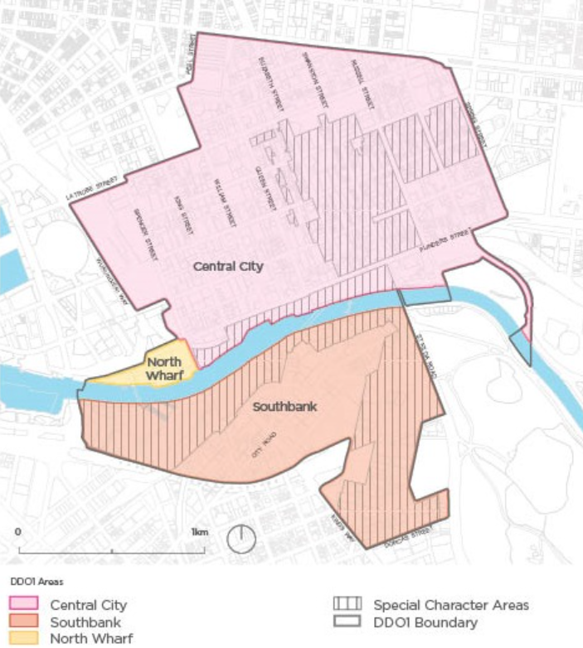
Figure 1 - Map 1 to schedule 1 to the Design and Development Overlay (Source: https://planning-schemes.app.planning.vic.gov.au/Melbourne/ordinance/43.02-s1)

Proposed change
It is proposed to amend Map 1 in Clause 6.0 of DDO1 to include the land at 135-149 Kings Way, Southbank.

Reason for proposed change
Map 1 in the schedule needs to be amended to include this site, so that the relevant requirements of DDO1 will apply to the site and to provide clarity for the assessment of any future permit application for the site.
The proposed change will not change the planning status of the site, which is already affected by DDO1. It will however minimise any confusion in the assessment of future planning permit applications.

Affected planning scheme clauses
- Schedule 1 to the Design and Development Overlay, Clause 6.0, Map 1

Affected land
- 135-149 Kings Way, Southbank

3. Zoning of 70-90 Chelmsford Street, Kensington

Background
In 2021, Council purchased 70-90 Chelmsford Street in Kensington for the purpose of public open space.
The Chelmsford Street Open Space project is a deliverable of Council Plan Major Initiative 16, which seeks to increase the amount of public open space in areas of greatest need, such as Southbank and emerging urban renewal areas. Funding for the Chelmsford Street Open Space is sourced from the Public Open Space Reserve.
The site currently includes a warehouse, concrete yard and an easement providing vehicle access to an adjacent property. Part of the warehouse is currently leased with the lease term ending in July 2025.
Once completed, the Chelmsford Street Open Space will provide approximately 3,600 square metres of new public open space for the Kensington community in an area experiencing significant growth due to the Macaulay urban renewal area.
Two phases of community engagement were completed for the project. The final concept plan was also informed by engagement with the Wurundjeri Woi-wurrung Cultural Heritage Aboriginal Corporation, the Disability Advisory Committee, the Melbourne Design Review Panel and service authorities.
The Chelmsford Street Open Space final concept plan was endorsed by the Future Melbourne Committee on 20 August 2024. Construction is anticipated to commence in the 2026-2027 financial year. The draft City of Melbourne budget includes funding for project planning in 2025–2026 and delivery in 2026–2027.

Proposed change
It is proposed to amend Zone Map 4 to apply the Public Park and Recreation Zone to 70-90 Chelmsford Street, Kensington.

Reason for proposed change
The proposed change will rezone the land from Mixed Use Zone to Public Park and Recreation Zone. The key purpose of the Public Park and Recreation Zone is to recognise areas for public recreation and open space.
The proposed change is consistent with the Practitioners Guide to the Victorian Planning Scheme (June 2024) (the Practitioners Guide) in that it ensures that there are appropriate statutory requirements that apply to the use and development of public land (in addition to other land management legislation). Section 5.1.1 of the Practitioners Guide states the following:
“A public land manager or transport manager should be able to use and develop public land for any purpose under the relevant land management or transport legislation without the need for a permit. This is achieved by allowing many uses to be Section 1 within a public land zone, subject to the use being conducted by or on behalf of the public land manager, transport manager or a specified public authority.”
The proposed zone will support the development and on-going use of the site for public open space.
The timing of the proposed rezoning—following the adoption of the concept plan and prior to the development of the open space—is consistent with previously approved amendments to the Melbourne Planning Scheme and other schemes in Victoria. Amendment C245 to the Melbourne Planning Scheme (gazetted 31 August 2017) applied the PPRZ to land identified for future open space in the Queen Victoria Market Precinct Master Plan 2015.
The proposed rezoning of 70-90 Chelmsford Street is consistent with the Macaulay Structure Plan. A separate planning scheme amendment (C417melb) is currently underway to implement the Structure Plan.

Affected planning scheme map
- Zoning map 4

Affected land
- 70-90 Chelmsford Street, Kensington

4. Window display permit exemption

Background
The Advertising Signs clauses of Schedules 1, 2,3, 5, 6 & 7 of the Capital City Zone, Schedules 1-7 of the Docklands Zone and Schedule 2 to the Comprehensive Development Zone contain the following permit exemption (among others):
A permit is required to erect an advertising sign, except for:
- A window display
‘Window display’ is not a defined term in contemporary planning schemes in Victoria. It is understood that the presence of the term in the Melbourne Planning Scheme derives from when it was included in the City of Melbourne (Central City) Interim Development Order 1982 (IDO), a document that preceded the new format Planning Schemes introduced in 1999.
Clause 73.02 of the Scheme defines terms which may be used in planning scheme in relation to signs. Clause 52.05 and various zone schedules specify the permit triggers and requirements for categories of signs.

Proposed change
It is proposed to delete “A window display” from the relevant zone schedules.

Reason for proposed change
Clause 73.02 of the Scheme defines terms which may be used in a planning scheme in relation to signs, including but not limited to:
- Animated sign
- Business identification sign
- Electronic sign
- Promotion sign
Window display is not included in this list of defined signage terms.
The concept and meaning of “window display” in the Melbourne Planning Scheme has twice been considered by VCAT. In one case, VCAT found that LED screens in a window were both a “window display” and an “electronic sign”, but the effect of Clause 52.05-2 was that the most restrictive of those definitions had to be applied, with the effect that a permit was required under the CCZ2. The second case found that “the scheme contains the general provision that if a sign can be interpreted in more than one way, the most restrictive requirement must be met. In this proceeding the sign can be interpreted as an electronic sign. If it could also be interpreted as a window display, its interpretation as an electronic sign is more restrictive because the former is exempt, and the latter requires a permit”.
Clause 52.05-2 of the Melbourne Planning Scheme states that “If a sign can be interpreted in more than one way, the most restrictive requirement must be met.” Given that ‘window display’ is not defined in the Scheme, a proposed sign should also be considered against the relevant, defined sign category. The need for a permit would be based on the more restrictive of the sign categories. The presence of the ‘window display’ exemption is confusing to more casual users of the Scheme, who may not be aware of the interpretation required by Clause 52.05-2 (represented in the VCAT decisions noted above).
The term ‘window display’ is outdated and inconsistent with the operation and interpretation of signage provisions in a contemporary Planning Scheme.

Affected planning scheme clauses
- Schedules 1, 2, 3, 6 & 7 to the Capital City Zone, Clause 5.0
- Schedule 5 to the Capital City Zone, Clause 6.0
- Schedules 1, 2, 3, 4, 5 & 6 to the Docklands Zone, Clause 6.0
- Schedule 7 to the Docklands Zone, Clause 5.0
- Schedule 2 to the Comprehensive Development Zone, Clause 7.0

Affected land
- All land within the relevant CCZ, CDZ and DZ schedule areas.

5. Minor sports and recreation facility

Background
Schedule 5 to the Capital City Zone (CCZ5) applies to the area known as City North, generally bound by Grattan Street to the north, Victoria Street to the south, Royal Parade and Peel Street to the west and Swanston Street to the east (see Figure 2).
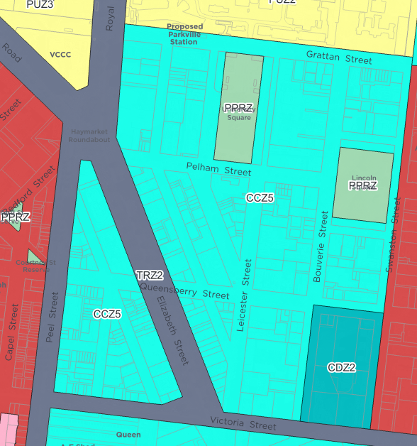
Figure 2 Area affected by Schedule 5 to the Capital City Zone CCZ5 (Source: excerpt from Planning Schemes Online)
One element of the drafting of the Land Use Table at Clause 1.0 of the CCZ5 has been identified as causing some confusion for permit applicants and other users of the scheme. Specifically, there is a potential lack of clarity regarding the land use ‘Minor sports and recreation facility’ (MSRF). It is open to interpretation as to whether the land use is prohibited or whether it is permissible with a planning permit.
‘Minor sports and recreation facility’ is defined in the Melbourne Planning Scheme as:
- Land used for leisure, recreation, or sport, without substantial provision for spectators, and which is usually open to non-paying spectators.
The land use table at Clause 73.03 specifies that ‘minor sports and recreation facility’ includes the following type of land uses:
- Indoor recreation facility such as a dance studio
- Open sports ground which may include lights, change rooms, pavilions and shelters.
- Outdoor recreation such as a golf course
- Restricted recreation facility such as a bowling or tennis club, gymnasium and fitness centre.

Proposed change
It is proposed to amend the land use table in CCZ5 to clearly specify that a planning permit is required for a ‘Minor sports and recreation facility’. This is achieved by deleting the words ‘Minor sports and recreation facility and’ from the land use table as follows:
- Leisure and Recreation (other than Minor sports and recreation facility and informal outdoor recreation).

Reason for proposed change
City of Melbourne’s planning department has consistently determined that MSRF is a ‘Section 2 – permit required’ land use. The proposed change to the drafting of the land use table will remove any doubt that may arise for other users of the scheme.
Land use tables in zones and schedules are divided into:
- Section 1 – Permit not required;
- Section 2 – Permit required; and
- Section 3 – Prohibited.
They may specify specific conditions to be met.
MSRF is listed in CCZ5 as follows:
Section 2 – Permit required
Use | Condition
Leisure and Recreation (other than Minor sports and recreation facility and informal outdoor recreation). | [None specified]

Clause 73.04-6 of the Scheme includes a range of land uses listed under the umbrella term ‘Leisure and recreation’, including MSRF and informal outdoor recreation shown in the table above. When another specific land use is included in brackets next to an umbrella land use term, this typically indicates that the more specific land use term will be listed somewhere else in the table of uses (either Section 1, Section 1 with a condition, Section 2 with a condition, or Section 3). In the case of ‘informal outdoor recreation’ in the CCZ5, it is listed in Section 1 – no permit required. However, MSRF is not listed anywhere else in the table (including not being included in Section 3 – prohibited). The absence of MSRF elsewhere in the land use table is open to interpretation and has led to some confusion for users of the scheme.
Council officers have determined that MSRF is a ‘Section 2 – Permit required’ use on the technical basis that:
- Clause 71.03-1 of the Melbourne Planning Scheme (Scheme) states [a] use in Section 1 does not require a permit.
- Clause 71.03-2 of the Scheme states [a] use in Section 2 requires a permit. Any condition opposite the use must be met. If the condition is not met, the use is prohibited.
- Clause 71.03-3 of the Scheme states [a] use in Section 3 is prohibited.
- Every table of use for each zone within the Scheme includes the following phrase at Section 2 – permit required:
  - [a]ny other use not in Section 1 or 3, meaning that if land use is not specifically listed in Section 1 or Section 3, it defaults to ‘Section 2 – permit required’.
Applying the above clause 71.03 provisions and the phrase “[a]ny other use not in Section 1 or 3”, the land use term MSRF is considered to be Section 2 – permit required, as it is nested under ‘Leisure and recreation’. However, it is confusing that MSRF is listed within brackets but not listed elsewhere in the table. The proposed change would mean that MSRF will automatically be treated as a Section 2 use because it is nested under ‘Leisure and recreation’.
MSRF is a Section 2 use in the majority of Capital City Zone schedules and the Mixed Use Zone (the adjacent zone to the CCZ5). The requirement for a planning permit ensures that the potential amenity impacts of a proposed facility can be assessed in the context of surrounding land uses. Applications for most land uses within the CCZ5 are exempt from the notice requirements of the Act, meaning that adjoining landowners would not be notified of the proposal.
The drafting change proposed for CCZ5 will resolve any confusion regarding the interpretation of the land use table, which will benefit users of the scheme and proponents of the types of activities and business operations included in this land use term.

Affected planning scheme clauses
- Schedule 5 to the Capital City Zone, Clause 1.0

Affected land
- All land zoned CCZ5

6. ESO2 Exceptional Tree - Chinese Honey Locust Tree

Background
The City of Melbourne’s Exceptional Tree Register 2019 identifies trees that are of exceptional significance, including a Chinese Honey Locust Tree at 607-619 Bourke Street, Melbourne. The trees have been identified for a variety of reasons, including their horticultural, aesthetic or historical value, because they are rare, old, or in a particular location or context; because they are an outstanding size or are a curious growth form, because they have outstanding habitat value or micro-climate services or because of their Aboriginal association or social, cultural or spiritual value. Many of these trees are also included in the National Trust of Australia (Victoria) Register of Significant Trees.
Schedule 2 to the Environmental Significance Overlay (ESO2) lists identified trees with the following descriptors:
- Property Address of Exceptional Tree
- Tree Name (Botanical & Common)
- Identified Value(s)
- Tree Protection Zone Radius (m)
- Exceptional Tree Register Tree Report Number:
- Planning Scheme Map No.
- Statement of Significance
Amendment C212 implemented the Round 1 recommendations from the Exceptional Tree Register (2012) by applying ESO2 to identified trees in the municipality, including the Chinese Honey Locust Tree. Amendment C212 gazetted in the Melbourne Planning Scheme on 30 April 2015.
Amendment C379melb implemented the second round of nominations for the Exceptional Tree Register, applying the ESO2 to an additional 119 trees. Amendment C379 was gazetted on 22 February 2024.

Proposed changes
It is proposed to:
- amend Map 8ESO so that ESO2 is shown as applying to the tree. The extent of the overlay should be the extent of the Tree Protection Zone used in the Exceptional Tree Register (see Figure 3).
- amend Schedule 2 to the Environmental Significance Overlay (ESO2), so that the address of the tree aligns with the description in the City of Melbourne’s Exceptional Tree Register 2019 — 607-619 Bourke Street, Melbourne.

Reason for proposed change
The Chinese Honey Locust Tree at 607-619 Bourke Street, Melbourne is identified in the Exceptional Tree Register and is listed in Schedule 2 to the Environmental Significance Overlay. However, it is not included in the relevant planning scheme maps for ESO2. This mapping error occurred during the process of introducing Amendment C379melb. Due to a clerical error, ESO2 was removed from this tree when ESO2 was correctly removed from an adjacent property.
The listing in Schedule 2 to the Environmental Significance Overlay specifies the address of the tree as 607 Bourke Street, Melbourne. For completeness, it is proposed to amend the schedule, so that the address of the tree aligns with the description in the City of Melbourne’s Exceptional Tree Register 2019 — 607-619 Bourke Street, Melbourne.
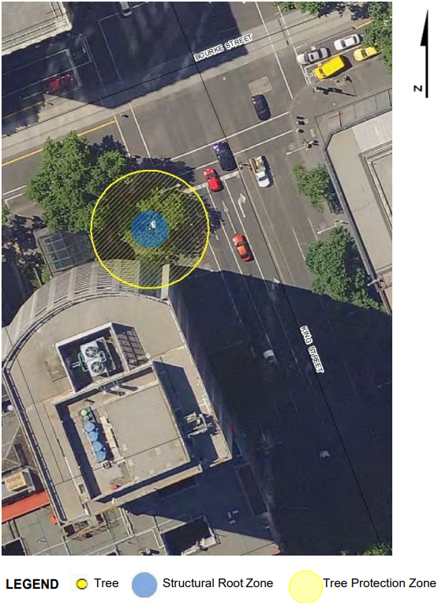
Figure 3 – Location of Chinese Honey Locust Tree (Source: City of Melbourne’s Exceptional Tree Register 2019)

Affected planning scheme clauses
- Map 8ESO
- Schedule 2 to the Environmental Significance Overlay
[See also related changes to the Heritage Overlay in Section 8k below.]

Affected land
- 607-619 Bourke Street, Melbourne

7. Heritage Overlay and Heritage Places Inventory changes

Background
The Heritage Overlay is the planning provision which provides heritage protection through Victorian planning schemes. When a site within the City of Melbourne is included in a Heritage Overlay it is:
- Listed in the Schedule to the Heritage Overlay
- Included in the Melbourne Planning Scheme maps that show the extent of the overlay
- Listed in the City of Melbourne’s Heritage Places Inventory, which is an incorporated document in the Melbourne Planning Scheme.
In order to avoid confusion, it is important that the description of the heritage place and the extent of the overlay are consistent across these three locations.
The description of the heritage place and the extent of the overlay should reflect the heritage values of the site identified in the relevant statement of significance, which forms the strategic justification for application of the Heritage Overlay. Building Identification Forms (BIF) were used to identify heritage fabric as part of heritage conservation studies from the 1980s to the early 2000s. BIFs are publicly available through the City of Melbourne Libraries Heritage Collection website. For several of the proposed changes below, BIFs have been used to verify the heritage site/fabric that should be reflected in maps or text.
Planning scheme amendments that introduce or amend heritage protections of sites and precincts often include large numbers of sites and a large amount of information. The changes to the Melbourne Planning Scheme outlined below result either from clerical errors that have occurred during the planning scheme amendment process or that have been identified as long-standing errors that have not previously been resolved through a tidy-up amendment.

a. HO63 Former Factory & Residence 119-125 Leicester St, Carlton

Proposed change
The following two changes are proposed:
- amend the Heritage Overlay mapping to ensure that HO63 covers 119-125 Leicester St, Carlton.
- amend the Heritage Overlay mapping to delete HO63 from 127-133 Leicester Street, Carlton

Reason for proposed change
The schedule to the Heritage Overlay states that HO63 applies to the Former Factory & Residence at 119-125 Leicester St, Carlton (see Figure 4).
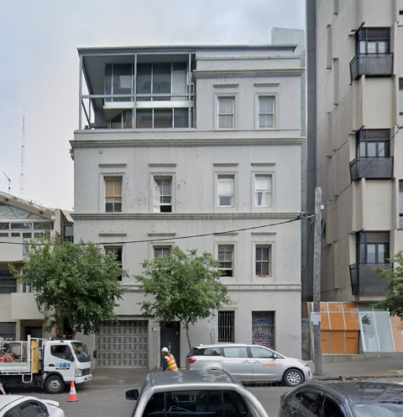
Figure 4 119-125 Leicester Street, Carlton (Source: Google Streetview via ComPASS accessed 11 June 2025)
HO63 is incorrectly mapped in the planning scheme maps as applying to 127-133 Leicester Street, Carlton. This is a historical mapping error that has been in place since the introduction of the new format planning scheme.
The relevant Statement of Significance shows that the former factory and residence at 119-125 Leicester Street is the identified heritage building.

Affected planning scheme clauses
- Map 5HO

Affected land
- 119-125 Leicester Street, Carlton
- 127-133 Leicester Street, Carlton

b. HO633 266-272 Exhibition Street, Melbourne

Proposed change
It is proposed to amend the Heritage Overlay Mapping to ensure that HO633 covers 266-272 Exhibition Street, Melbourne.

Reason for proposed change
The Schedule to the Heritage Overlay states that HO633 applies to 266-272 Exhibition Street, Melbourne (see Figure 5). 266-272 Exhibition Street forms part of a larger site known as 242-284 Exhibition Street (Telstra Centre).
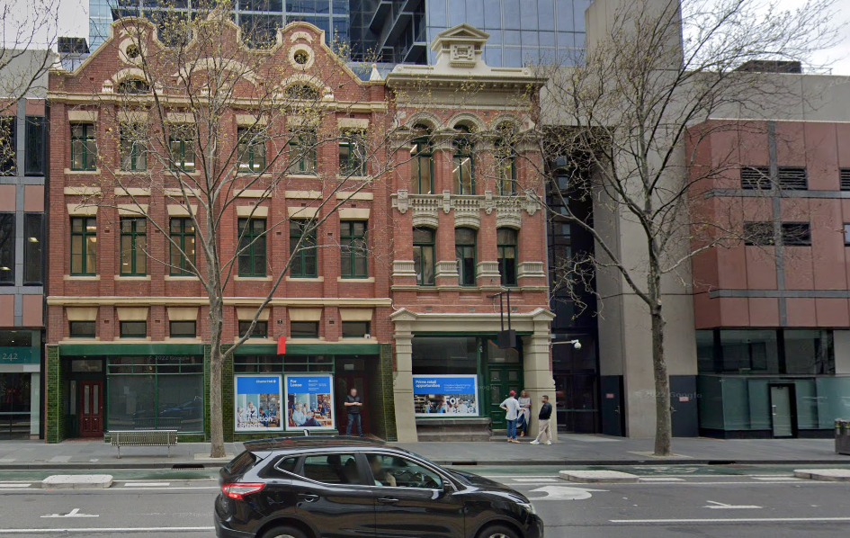
Figure 5 Heritage fabric at 266-272 Exhibition Street, Melbourne (Source: Streetview via CoMPASS accessed 11 June 2025)
The relevant BIFs (1, 2) for the site demonstrate the c1910 and c1891 heritage buildings that are of heritage significance. There is a contemporary building adjacent to these heritage buildings. The planning scheme maps show HO633 as partially applying to the contemporary building.
It is proposed to amend the Heritage Overlay mapping to apply HO633 to 266-272 Exhibition Street to reflect the place description in the HO schedule and BIFs (see HO633 shaded in purple in Figure 6).
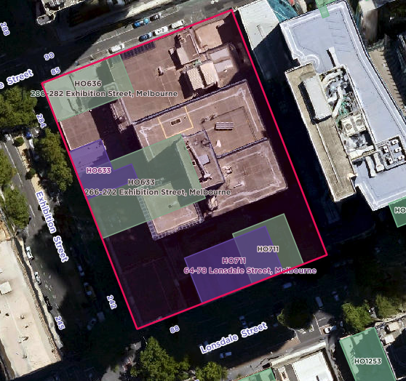
Figure 6 Extent of heritage fabric 266-272 Exhibition Street shown in purple, current planning scheme mapping shown in green (Source: CoMPASS, accessed 19/6/25)

Affected planning scheme clauses
- Map 8HO2

Affected land
- 266-272 Exhibition Street, Melbourne

c. HO711 64-78 Lonsdale Street, Melbourne

Proposed change
It is proposed to amend the Heritage Overlay mapping to ensure that HO711 covers 64-78 Lonsdale Street, Melbourne.

Reason for proposed change
The schedule to the Heritage Overlay states that HO711 applies to 64-78 Lonsdale Street, Melbourne (see Figure 7). 64-78 Lonsdale Street, Melbourne forms part of a larger site known as 242-284 Exhibition Street (Telstra Centre).
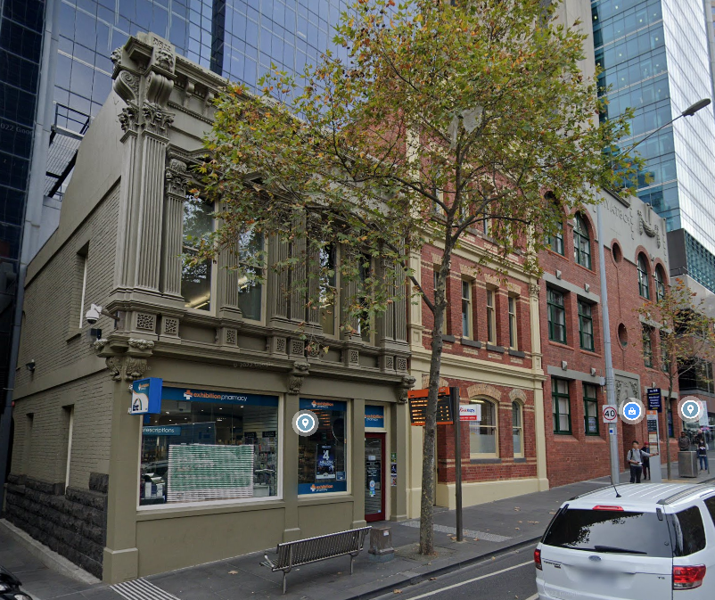
Figure 7 64-78 Lonsdale Street, Melbourne (Source: Google Streetview accessed 11 June 2025)
HO711 is mapped incorrectly as only applying to part of the Khyat Building at 64-70 Lonsdale Street and part of a laneway to the east. This is a historical mapping error that has been in place since the new format planning scheme.
The relevant BIFs (1, 2, 3, 4, 5, 6, 7, 8, 9) show the heritage buildings at 64-78 Lonsdale Street which should be subject to HO711 (see HO711 shown in purple in Figure 8 below.
Figure 8 Extent of heritage fabric at 64-78 Lonsdale Street shown in purple, current heritage mapping shown in green (Source: CoMPASS accessed 19/6/25)

Affected planning scheme clauses
- Map 8HO2

Affected land
- 64-78 Lonsdale Street, Melbourne

d. HO719 472-474 Lonsdale Street, Melbourne

Proposed change
It is proposed to amend the Heritage Overlay mapping to ensure that HO719 covers 472-474 Lonsdale Street, Melbourne.

Reason for proposed change
The schedule to the Heritage Overlay states that HO719 applies to 472-474 Lonsdale Street, Melbourne (see Figure 9 below). 472-474 Lonsdale Street is part of a larger parcel of land at 240-278 William Street, Melbourne (Victorian County Court).
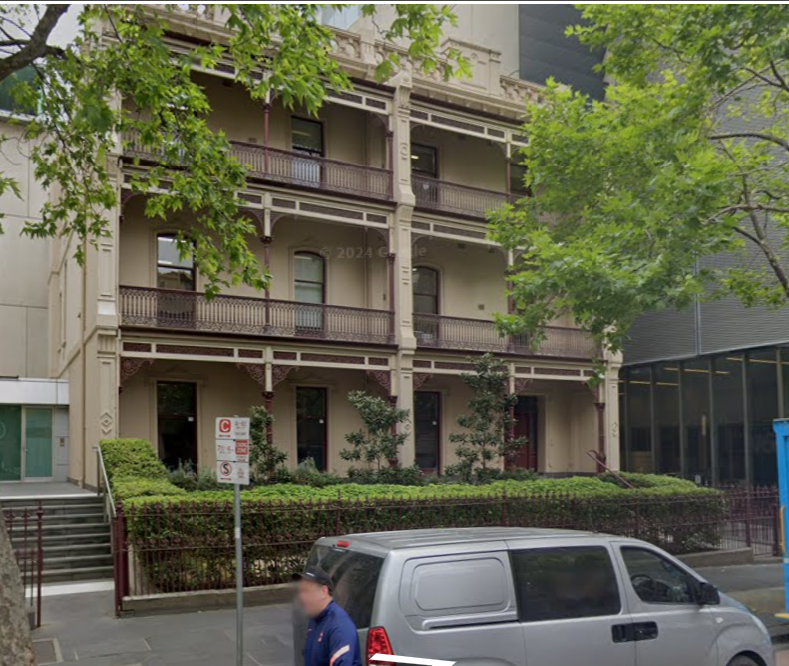
Figure 9 Streetview image of 472-474 Lonsdale Street, Melbourne (Source: Google Streetview via CoMPASS accessed 2/6/25)
HO719 is incorrectly applied in the planning scheme maps to 452-456 Lonsdale Street, Melbourne. This is a historical mapping error that has been in place since the new format planning scheme.
The Building Identification Form for the original heritage listing shows the relevant buildings are the terraces shown in Figure 9, shown in purple in Figure 10.
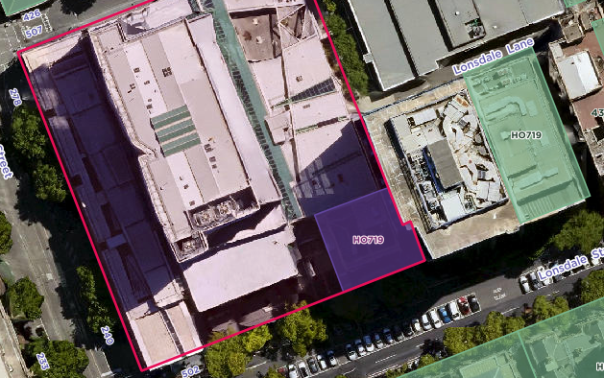
Figure 10 Extent of heritage fabric at 472-474 Lonsdale Street shown in purple, current heritage mapping shown in green

Affected planning scheme clauses
- Map 8HO2

Affected land
- 472-474 Lonsdale Street, Melbourne
- 452-456 Lonsdale Street, Melbourne

e. HO759 25-29 Wills Street, Melbourne

Proposed Change
It is proposed to amend the Heritage Overlay mapping to ensure that HO759 covers 25-29 Wills Street, Melbourne.

Reason for proposed change
The schedule to the Heritage Overlay states that HO759 applies to 25-29 Wills Street, Melbourne (see Figure 11).
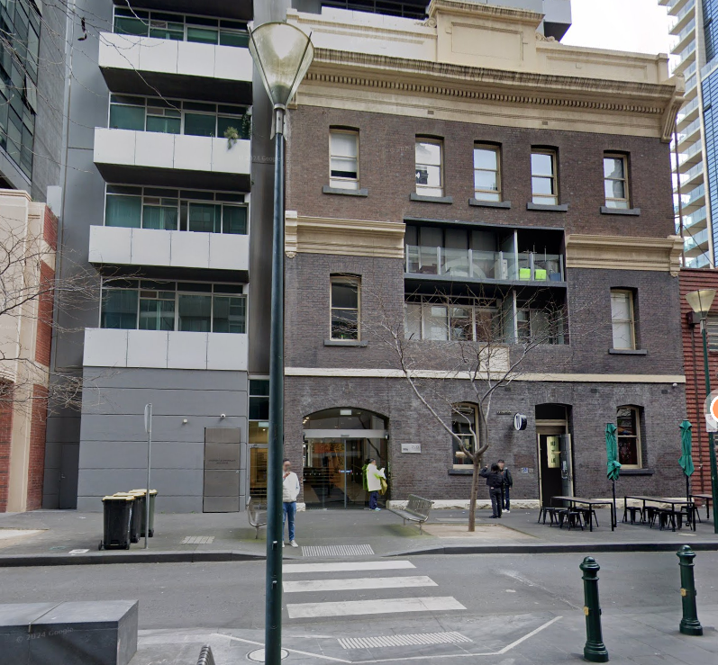
Figure 11 25-29 Wills Street, Melbourne (Source: Google Maps accessed 4/6/25)
The heritage building on the site is the former Melbourne Telephone Exchange at the northern part of 25-29 Wills Street, as shown in the relevant BIFs for the site (1 and 2).
A contemporary building has been constructed on the site, to south and west (rear) of the heritage building. HO759 is incorrectly applied to the contemporary building on the site, rather than the heritage building.
This is a historical mapping error that has been in place since Amendment C19 Part1 was gazetted on 31 December 2001. HO759 was not part of Amendment C19. However, due to a clerical error, HO759 mapping was moved from the former Melbourne Telephone Exchange building at the northern part of 25-29 Wills Street to the southern part of 25-29 Wills Street through Amendment C19 Part1.

Affected planning scheme clauses
- • Map 8HO2

Affected land
- 25-29 Wills Street, Melbourne

f. HO788 502 Spencer Street, West Melbourne

Proposed change
It is proposed to amend the Heritage Overlay mapping to ensure that HO788 covers 502 Spencer Street, West Melbourne.

Reason for proposed change
The schedule to the Heritage Overlay states that HO788 applies to 502 Spencer Street, West Melbourne (see Figure 12).
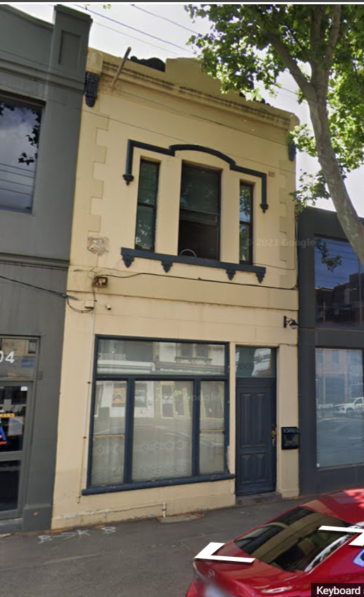
Figure 12 502 Spencer Street, Melbourne (Source: Google Streetview via CoMPASS, accessed 2/6/25)
HO788 is shown in the planning scheme maps as applying to 504 Spencer Street, West Melbourne. This is a historical mapping error that has been in place since Amendment C19 Part1 was gazetted on 31 December 2001.
Prior to Amendment C19 Part1, HO788 applied to both 502 and 504 Spencer Street.
Amendment C19 Part1 implemented the City of Melbourne Planning Scheme Heritage Review, 2000. This review assessed that 504 Spencer Street is not a heritage building. It assessed that 502 Spencer Street is a heritage building as shown on the BIF.
Due to a clerical error during the Amendment C19 Part1 process, HO788 mapping was removed from 502 Spencer Street rather than 504 Spencer Street.

Affected planning scheme clauses
- Map 8HO

Affected land
- 502 Spencer Street, Melbourne
- 504 Spencer Street, Melbourne

g. HO608 401-417 Collins Street, Melbourne

Proposed change
It is proposed to make the following two changes:
- Amend the planning scheme maps to ensure that HO608 covers the sites at 415-417 Collins Street
- Amend the HO schedule listing to show that HO608 does not apply to the site at 409-413 Collins Street as this has a separate listing (HO1009)

Reason for proposed change
The schedule to the Heritage Overlay states that HO608 applies to 401-417 Collins Street, Melbourne. There are four sites within this address range:
- 401-403 Collins Street, Melbourne
- 405-407 Collins Street, Melbourne
- 409-413 Collins Street, Melbourne
- 415-417 Collins Street, Melbourne
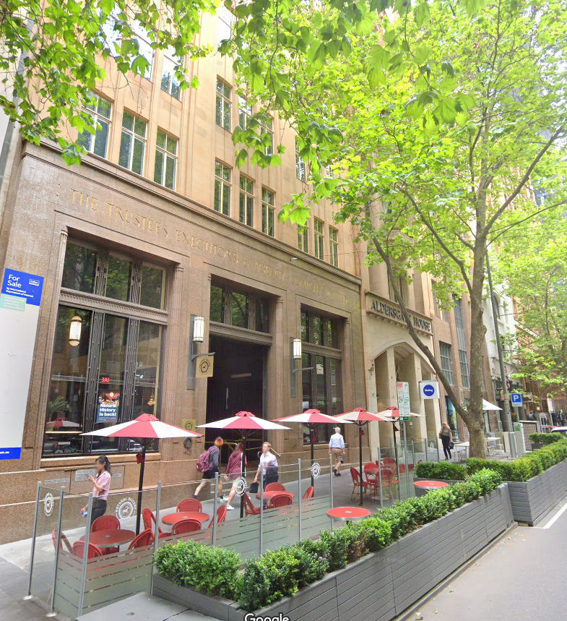
Figure 13 Partial view of 401-417 Collins Street (Source: Google Maps, accessed 2/6/25)
Although within the address range specified for HO608, the site at 409-413 Collins Street has a separate HO listing (HO1009).
The mapping in the planning scheme maps shows HO608 as applying to 401-403 Collins Street and 405-407 Collins Street only. It omits the site at 415-417 Collins Street. The BIF shows the heritage building at 415-417 Collins Street. This is a historical mapping error that has been in place since the new format planning scheme.
The planning scheme maps correctly shows 409-413 Collins Street as being with HO1009.
For clarity, it is recommended that the HO schedule listing for HO608 be amended from “HO608 401-417 Collins Street, Melbourne” to “HO608 401-403, 405-407 and 415-417 Collins Street, Melbourne” to reflect that it does not include 409-413 Collins Street.

Affected planning scheme clauses
- Map 8HO2
- Schedule to the Heritage Overlay

Affected land
- 409-413 Collins Street, Melbourne
- 415-417 Collins Street, Melbourne

h. HO668 11-13 Heffernan Lane, Melbourne

Proposed change
The following two changes are proposed:
- Amend the property description in the HO schedule from “11-13 Heffernan Lane” to “11 Heffernan Lane”.
- Amend Map 8HO2 to apply HO668 to 11 Heffernan Lane to correctly reflect the property address in the HO schedule.

Reason for proposed change
The schedule to the Heritage Overlay states that HO668 applies to 11-13 Heffernan Lane, Melbourne.
However, the BIFs relevant to this site (1, 2, 3, 4) identify the building that is at 11 Heffernan Lane as being of significance (see Figure 14) and do not reference the brick wall or other elements at 13 Heffernan Lane. It is therefore proposed to amend the HO schedule listing “11 Heffernan Lane, Melbourne”.
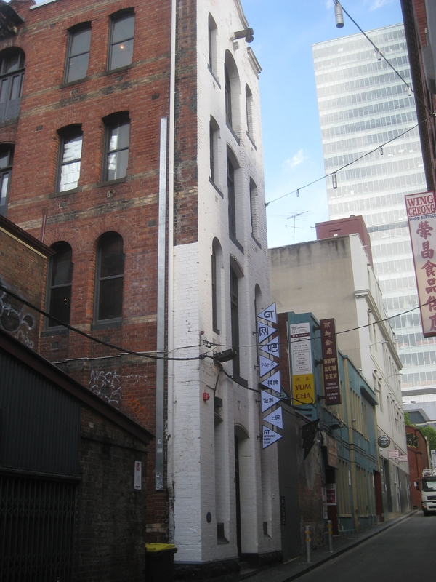
Figure 14 11 Heffernan Lane, Melbourne (Source: CoMPASS, accessed 11/6/25)
The planning scheme maps show HO668 applying to 15-21 Heffernan Lane instead of 11 Heffernan Lane. This is a historical mapping error that has been in place since the new format planning scheme.

Affected planning scheme clauses
- Map 8HO2
- Schedule to the Heritage Overlay

Affected land
- 11 Heffernan Lane, Melbourne
- 13 Heffernan Lane, Melbourne
- 15-21 Heffernan Lane, Melbourne

i. HO234 27-37 Gower Street, Kensington

Proposed change
The following three changes are proposed:
- Amend Map 4HO to apply HO234 to the whole extent of the front fence at 37-43 Gower Street.
- Change the property description in the HO schedule from “HO234 27-37 Gower Street, Kensington” to “HO234 27, 29, 31, 33, 35, Part 37-43 Gower Street, Kensington”.
- Change the property description in the Heritage Places Inventory from “37-43 Gower Street, includes 37 Gower Street (Fence and Gateway)” to “37-43 Gower Street (Part, Fence and Gateway)”.

Reason for proposed change
The schedule to the Heritage Overlay states that HO234 applies to 27-37 Gower Street, Kensington. This comprises the following sites:
- 27 Gower Street, Kensington (dwelling)
- 29 Gower Street, Kensington (dwelling)
- 31 Gower Street, Kensington (dwelling)
- 33 Gower Street, Kensington (dwelling)
- 35 Gower Street, Kensington (dwelling)
- 37-43 Gower Street, Kensington (Holy Rosary School)
The BIF for the site at 37-43 Gower Street (Holy Rosary School) shows that the fence at this site is of significance (see Figure 15). However, the planning scheme maps include only part of this fence as being within HO234. This is a historical mapping error that has been in place since the new format planning scheme.
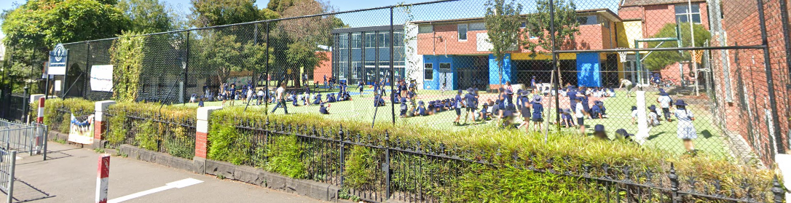
Figure 15 Fence at 37-43 Gower Street, Kensington (Source: Google Maps accessed 11/6/25)
It is noted that a recent planning permit application from the Holy Rosary School (TP-2023-790) accepts that there is an anomaly and that the Heritage Overlay applies to the full fence length.
For clarity, it is recommended that the place description in the schedule to the HO be amended from “HO234 27-37 Gower Street, Kensington” to “HO234 27, 29, 31, 33, 35, Part 37-43 Gower Street, Kensington”.
It is also considered prudent to amend how the heritage fabric at 37-43 Gower Street is described in the Heritage Places Inventory description from “37-43 Gower Street, includes 37 Gower Street (Fence and Gateway)” to “37-43 Gower Street (Part, Fence and Gateway)”.

Affected planning scheme clauses
- Map 4HO
- Schedule to the Heritage Overlay
- Heritage Places Inventory (Incorporated Document)

Affected land
- 37-43 Gower Street, Kensington

j. HO333 Cricket Pavilion & Scoreboard, University of Melbourne

Proposed change
It is proposed to the make three changes:
- Amend the Heritage Overlay Mapping to apply HO333 to the Pavilion in addition to the Grandstand.
- Amend the place description in the Heritage Overlay schedule from “HO333 Cricket Pavilion & Scoreboard, Uni of Melbourne” to “HO333 Cricket Pavilion and Grandstand, Uni of Melbourne”.
- Amend the place description in the Heritage Places Inventory from “Cricket Pavilion & Scoreboard” to “Cricket Pavilion and Grandstand”

Reason for proposed change
The schedule to the Heritage Overlay states that HO333 applies to “Cricket Pavilion & Scoreboard, Uni of Melbourne”. This relates to a building to the north of University Oval (see “Ernie Cropley Sports Pavilion in Figure 16 below).
The Heritage Overlay map in the planning scheme shows HO333 as applying to the Grandstand (a separate building at the western edge of University Oval – see Figure 16).
This is a historical mapping and schedule error that has been in place since the new format planning scheme.
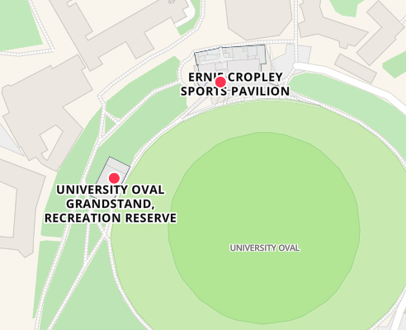
Figure 16 Grandstand and Pavilion, University of Melbourne (Source: https://maps.unimelb.edu.au/parkville/building accessed 11/6/25)
Separate BIFs were prepared as part of the Carlton, North Carlton and Princes Hill Conservation Study, 1985 for the two separate heritage buildings:
- Cricket Pavilion & Scoreboard (BIF)
- Grandstand (BIF)
It is therefore considered appropriate that both sites be covered by a Heritage Overlay. Given the relationship of the buildings, it is considered appropriate that they be under the same HO number (HO333).
The pavilion was redeveloped in 2014. The scoreboard had been removed prior to this development and part of the original pavilion remains intact (see Figure 17). It is proposed to amend the Heritage Overlay mapping to add HO333 to the remaining heritage fabric at the pavilion site (see highlighted area in Figure 18).
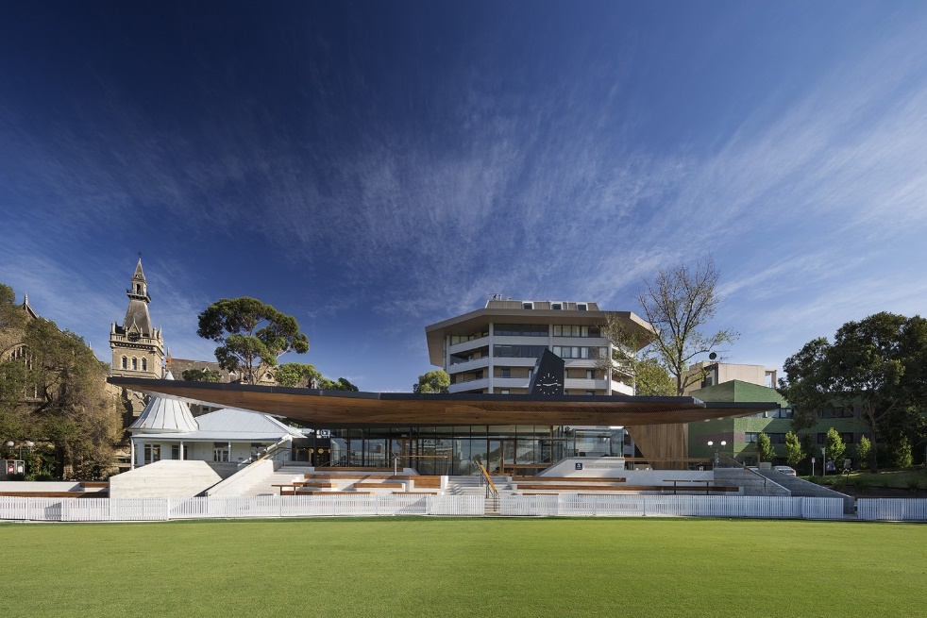
Figure 17 Ernie Cropley Pavilion contemporary addition (Source: https://www.coxarchitecture.com.au/project/ernie-cropley-pavilion/ accessed 11/6/25)
It is noted that the Statement of Heritage Impact submitted in support of the planning permit to develop the pavilion (TP-2012-743) accepted that there is an anomaly, in that the Pavilion is listed in the Schedule under HO333 but not mapped, and the Grandstand is mapped under HO333 but not listed in the schedule:
“Notwithstanding these anomalies, the assumption is that the Heritage Overlay applies to both structures. Both were graded C in the Carlton Conservation Study prepared for the City of Melbourne by Nigel Lewis and Richard Aitken in 1984, and both were ascribed a Level 1 streetscape ranking.” (Statement of Heritage Impact, Main Oval Pavilion, the University of Melbourne, Prepared for the University of Melbourne, Lovell Chen, September 2012)
As the scoreboard has been removed, it is proposed to remove reference to it from the HO schedule and inventory. It is therefore proposed to amend the description in both the schedule to the Heritage Overlay and the Heritage Places Inventory to add the Grandstand and delete reference to the Scoreboard.
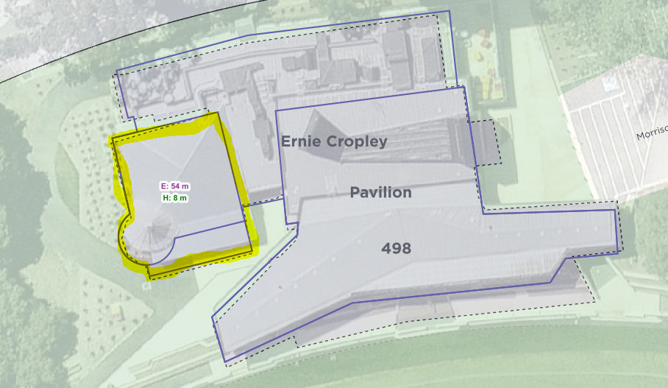
Figure 18 Heritage fabric at the Pavilion shown highlighted (CoMPASS, and Roof Plan submitted with planning application, Cox Architects, September 2012)

Affected planning scheme clauses
- Map 5HO
- Schedule to the Heritage Overlay
- Heritage Places Inventory (Incorporated Document)

Affected land
- University of Melbourne

k. HO512 Chinese Honey Locust Tree, King Street, Melbourne

Proposed change
It is proposed to make three changes:
- HO mapping: amend Map 8HO2 so that HO512 is on the location of the tree. The HO extent should be the extent used in the Exceptional Tree Register.
- HO schedule: amend the name and location of the tree from “HO512 Chinese Honey Locusts Tree, King Street, Melbourne” to “HO512 Chinese Honey Locust Tree, Part 607-619 Bourke Street, Melbourne” (note the correct terminology is ‘locust’ in the singular)
- Inventory: amend the name and location of the tree from “Chinese Honey Locusts Tree, King Street” to “607-619 (Part, Chinese Honey Locust Tree), Bourke Street”” (note the correct terminology is ‘locust’ in the singular)

Reason for proposed change
The schedule to the Heritage Overlay states that HO512 applies to Chinese Honey Locusts Tree, King Street, Melbourne. While the tree is on the King Street frontage, the correct address of the site is 607-619 Bourke Street, Melbourne. It is listed at this address in the Significant Tree Register (see item 6 above regarding the application of the ESO2 to this tree). The correct common name for this species of tree is Chinese Honey Locust, as noted in the Exceptional Tree Register (with ‘locust’ in the singular).
The Heritage Overlay mapping does not cover the location of the tree and should be amended to resolve this error. As per the ESO mapping, the HO extent should be the extent used in the Exceptional Tree Register (see Figure 3 above). This is a historical mapping error that has been in place since the new format planning scheme.
For completeness, it is proposed to update the description in the Heritage Places Inventory to reflect the correct address of the site and correct common name of the tree.

Affected planning scheme clauses
- Map 8HO2
- Schedule to the Heritage Overlay
- Heritage Places Inventory (Incorporated Document)

Affected land
- 607-619 Bourke Street, Melbourne

2022 = 32 applications; 2023 = 50 applications; 2024 = 39 applications; Jan to June 2025 = 13 applications
See also Mornington Peninsula Amendment C188morn (part 1) - gazetted on 25 June 2015, applied the PPRZ to an existing skate park and additional land to be developed for community use in accordance with a Council decision of 27 October 2014; and Nillumbik Amendment C117nill (part 2) - gazetted on 22 October 2020, applied the PPRZ to a site that was identified for future use as open space, as set out in the Open Space Precinct Plan, Graysharps Road Hurstbridge adopted by Council on 11 December 2018.
See Checkpoint Buildings Surveyors v Melbourne CC VCAT reference no 2240/2013
See Melbourne City Council v Filippou Management Pty Ltd VCAT reference no P93/2015
A planning permit is not required for MSRF in Schedule 1 (Central City outside the retail core) provided that it is located on or near the Yarra River and is licensed by Parks Victoria. A planning permit is not required in Schedule 4 (Fishermans Bend Urban Renewal Area).

