STATEMENT OF SIGNIFICANCE
Heritage Place: Swanston Street North Precinct | PS ref no: HO1288  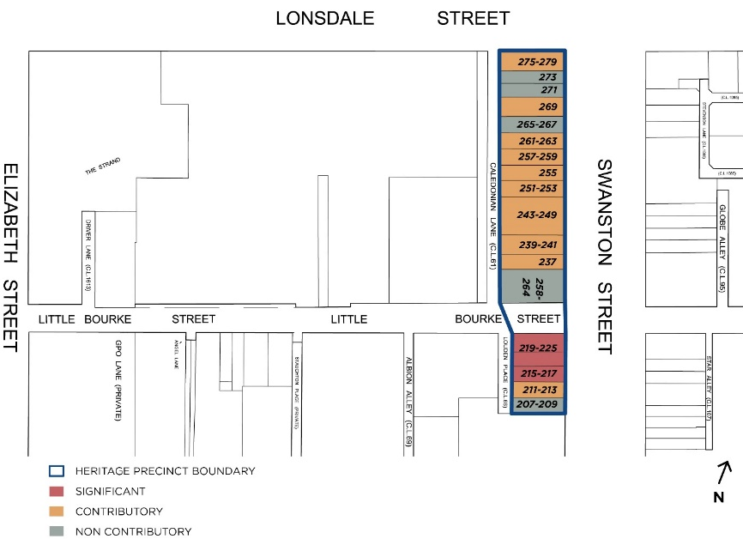
What is significant?
The Swanston Street North Precinct comprising small scale commercial buildings between 207-279 Swanston Street and 258-264 Little Bourke Street.
Elements that contribute to the significance of the precinct include (but are not limited to):
- The small scale commercial buildings constructed from c1856 to c1926, as shown on the precinct map.
- The pattern of development in the precinct which comprises a mixed streetscape of Victorian, Federation and interwar commercial buildings, and the key features and original detailing characteristic of their respective styles.
- The overall consistency of built form (two- to three-storey wall heights), materials and detailing (masonry construction, stucco detailing), and siting (consistent low-rise, narrow allotments).
- The laneway rear aspects of the buildings, particularly those on Caledonian Lane.
The buildings at 211-213, 237, 239-241, 243-249, 251-253, 255, 257-259, 261-263, 269 and 275-279 Swanston Street are contributory.
The buildings at 215-217 and 219-225 Swanston Street are significant.
Non-original alterations and additions to the Contributory buildings, including all ground floor shop fronts and the glazed balcony at 243-249 Swanston Street, are not significant.
The buildings at 207-209, 258-264, 265-267, 271 and 273 Swanston Street are non-contributory to the precinct.
How it is significant?
The Swanston Street North Precinct is of local historic, representative and aesthetic significance.
Why it is significant?
The Swanston Street North Precinct is within the retail area of the central city. The Swanston Street North Precinct demonstrates the predominant land use of retailing that was established quite early in the development of the central city between Swanston and Elizabeth Streets. (Criterion A)
Historically the Swanston Street North Precinct is significant for its demonstration of retailing from pre-1860 to c1930, including drapers, clothing outfitters, tailors, furniture dealers, booksellers, (including Coles Book Arcade), canvas manufacturers, homecrafts and a ‘motorcycle exchange’. These uses are evident in the individual buildings, the streetscape, laneways and documentary evidence in plans and photographs. Historically the Swanston Street North Precinct demonstrates the small allotment size that was created by the small subdivision patterns of the 1870s and 1880s and that established the urban density of the Hoddle Grid until the 1950s. (Criterion A)
No 275-279 Swanston Street is historically significant as the former Coreglia House, developed by the Catholic Church as office accommodation and clubrooms as well as ground floor retailing. No.215-217 Swanston Street is significant for its early date of construction of 1856, a relatively rare pre-1860 place to survive within the Hoddle Grid study area. (Criterion A)
The Swanston Street North Precinct demonstrates a commercial building morphology of two to three storeys. This built form was evident from the 1850s through to the 1920s, despite changes in building construction and technology that allowed building heights of up to 40 metres from 1912. The particular characteristics of this low scale building form include masonry street walls generally faced with stucco at the front, a regular pattern of small windows, parapets that disguise the roof form and a variety of classically derived façade details. The Swanston Street North Precinct comprises buildings from 1856 to c1930 with characteristics of the periods that are most strongly evident to the upper floors. The Swanston Street North Precinct demonstrates retail development between 1856 to 1930 and has representative elements from each of the Victorian (1850-1900), Edwardian (1900-1919) and interwar (1919-1935) periods. Together these elements comprise a small but distinctive low scaled and fine-grained survivor within the retail heart of the city. (Criterion D)
The Swanston Street North Precinct is aesthetically significant for the upper floors of the buildings that demonstrate the different periods and styles in which they were built. Whilst the street level has generally been modified, the upper floors have retained architectural characteristics of the period including parapets, original window openings, moulded stucco decoration to the masonry walls and stylistic detail and elements common to each period. The Swanston Street North Precinct is aesthetically significant for its human scale in the central city. The views of the rear of buildings along Caledonian Lane north to Drewery Lane and south to Louden Place are also aesthetically significant. The rear elevations of the buildings abutting the laneways including 209-225 Swanston Street facing Louden Place, and 237- 273 Swanston Street facing Caledonian Lane are aesthetically significant for their scale, form and brick and stucco walls with a pattern of window and loading bay openings. (Criterion E)
Key attributes of the precinct include:
- Victorian-era buildings:
- No.215-217, a two-storey shop at built in 1856 as part of a row, and now the only survivor
- No.239-241, a three-storey furniture business at built by 1880
- No.243-249 a large three storey store built in 1876-77
Edwardian era buildings:
- No.237, a three-storey shop built in 1919
- No.251-253, a two-storey shop with austere classical detail
- No.255, a two-storey shop alteration designed by A A Fritsch built in 1918
- No.257-263, a two-storey pair of shops built in 1912 and designed by R G Webb
- No.269, a two-storey shop with stuccoed quoins
Interwar era buildings:
- No.207-209, a highly altered three-storey shop
- No.211-213, a two-storey shop with classical detail and steel-framed windows
- No.219-225, the Greek Revival former ES&A bank by Henry Hare built in 1928
- No.275-279, Coreglia House, a highly modified two storey retail and office corner building by A A Fritsch
The laneway rear aspects of the buildings, particularly those on Caledonian Lane.
Primary source
Hoddle Grid Heritage Review (Context & GJM Heritage, 2020)

