Planning and Environment Act 1987

Melbourne Planning Scheme

Amendment C447melb

Explanatory Report

Overview

The amendment proposes to rezone land at 192-200 Arden Street North Melbourne to a Mixed Use Zone and insert a new Design and Development Overlay (DDO84) schedule to guide any future redevelopment of the site. The proposed DDO proposes staggered building heights across the site ranging from 3.4 metres up to 20 metres.

Where you may inspect this amendment

The Amendment can be inspected free of charge at Participate Melbourne, the City of Melbourne’s online engagement hub at https://participate.melbourne.vic.gov.au/amendment-c447 and during office hours at the City of Melbourne Customer Service Counter, Ground Floor Melbourne Town Hall, 120 Swanston Street Melbourne.

The amendment can be inspected free of charge at the Department of Transport and Planning website at http://www.planning.vic.gov.au/public-inspection or by contacting the office on 1800 789 386 to arrange a time to view the amendment documentation.

Submissions
Any person may make a submission to the planning authority about the amendment. Submissions about the amendment must be received by Thursday 25 July 2024.
A submission must be lodged by one of the following:
- Online at https://participate.melbourne.vic.gov.au/amendment-c447
- By email to planningpolicy@melbourne.vic.gov.au

Panel hearing dates
In accordance with clause 4(2) of Ministerial Direction No.15 the following panel hearing dates have been set for this amendment:
- Directions hearing: the week commencing 23 February 2025
- Panel hearing: the week commencing 23 March 2025

Details of the amendment
Who is the planning authority?

This amendment has been prepared by the City of Melbourne who is the planning authority for this amendment.
The amendment has been made at the request of Ethos Urban on behalf of the Electrical Trades Union (ETU).

Land affected by the amendment

The amendment applies to the land at 192-200 Arden Street, North Melbourne and formally referred to as Lot 1 on TP002368D and Lot 1 on TP002403E as shown hashed in red in Figure 1.

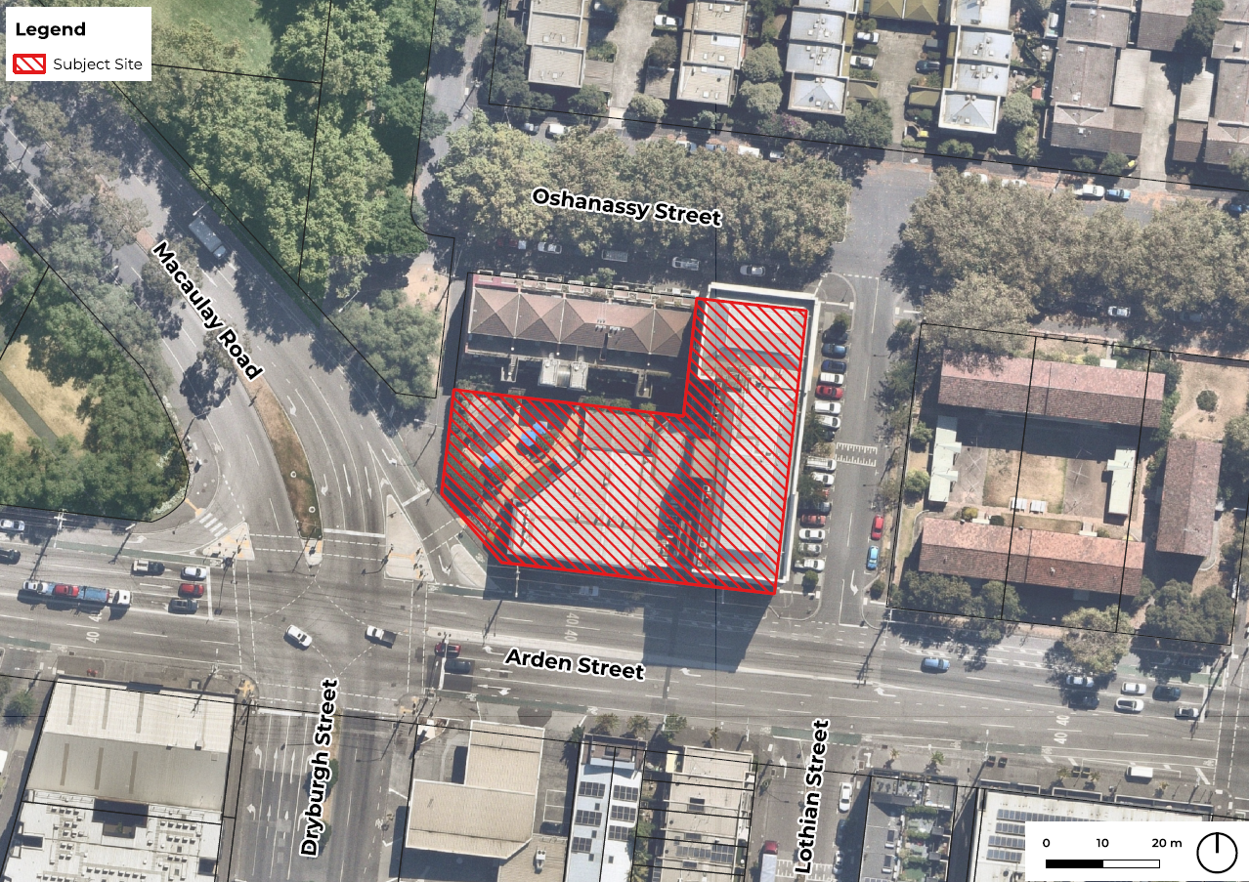

Figure 1: Land affected by the amendment

What the amendment does

The amendment proposes to rezone the land from General Residential Zone – Schedule 1 (GRZ1) to Mixed Use Zone (MUZ) and insert a new Schedule 84 to the Design and Development Overlay to guide any future redevelopment of the site.
The amendment:
- Rezones the site from General Residential Zone – Schedule 1 (GRZ1) to Mixed Use Zone (Clause 32.04) to provide for the continued use of the site for offices and support future redevelopment.
- Inserts a new Schedule 84 to the Design and Development Overlay (Clause 43.02) to guide appropriate built form through discretionary building heights and setbacks, street wall heights and upper-level setbacks.
- Amends Planning Scheme Map 4 and inserts Map 4DDO to rezone the land to the Mixed Use Zone and apply the new Schedule 84 to the Design and Development Overlay.
- Amends the Schedule to Clause 72.03-What the planning scheme consists of.
Strategic assessment of the amendment

Why is the amendment required?

The ETU has owned and occupied the site at 192-200 Arden Street, North Melbourne for in excess of 10 years and currently utilises the site predominantly as its administrative head office and for some training and health services. They intend to continue this use of the site and in the future increase the building floor area to accommodate expanded office and training facilities.
The current use and established built form of the site do not align with the planning controls applying to the land. Office use is prohibited under the GRZ1 unless associated with a significant residential development with affordable housing and training facilities, (defined as Education Centres) is a section 2 permit required use. As the predominate office use continues to operate under Existing Use Rights in accordance with Clause 63.01, the ETU considers that this does not provide a suitable level of certainly regarding the ongoing use of the site or plan for the future expansion of the existing office and training facilities. Furthermore the GRZ1 includes a mandatory maximum building height limit of 11 metres for a dwelling or a residential building which is below the 20 metre height of the existing Mills heritage building.
How does the amendment implement the objectives of planning in Victoria?

The amendment implements the following objectives of planning in Victoria by as set out in Section 4 (1) and 12(1)(a) of the Planning and Environment Act 1987 specifically:
- to provide for the fair, orderly, economic and sustainable use, and development of land;
- to secure a pleasant, efficient and safe working, living and recreational environment for all Victorians and visitors to Victoria;
- to conserve and enhance those buildings, areas or other places which are of scientific, aesthetic, architectural or historical interest, or otherwise of special cultural value;
- to facilitate development in accordance with the objectives set out in paragraphs (a), (b), (c), (d);
- to balance the present and future interests of all Victorians.

The amendment implements these objectives by:
- Enabling the land to be appropriately re-developed with a building of a scale that supports an economically viable expanded administrative offices and training facilities.
- Supporting new business and economic growth through contributing to diverse employment opportunities in a highly accessible location walking, cycling and public transport.
- Providing a development outcome that is responsive to the heritage values of the existing Mills building and preferred character of the area.
- Retaining high value heritage fabric at the site and proposing development that is respectful of the heritage values of the heritage Mills building and the broader heritage precinct.
How does the amendment address any environmental, social and economic effects?
The amendment will not result in any adverse environmental, social or economic effects. The amendment is likely to have positive environmental, social and economic benefits by:
- Providing greater opportunities for employment generating land uses on the site in a well-serviced location including the ongoing use and potential expansion of the ETU offices and training facilities that service the wider community.
- Introducing built form controls that will ensure that future development on the site positively contributes to the surrounding context and is responsive to the heritage values of the existing Mills building.
Does the amendment address relevant bushfire risk?
The amendment affects land within inner metropolitan Melbourne which is not a bushfire prone area.
Does the amendment comply with the requirements of any Minister’s Direction applicable to the amendment?
The amendment complies with the requirements of the following Ministerial Directions:
Ministerial Direction on the Form and Content of Planning Schemes
The amendment is consistent with the Ministerial Direction on the Form and Content of Planning Schemes under section 7(5) of the Planning and Environment Act 1987.
Ministerial Direction No. 9 Metropolitan Strategy
Plan Melbourne 2017- 2050 sets out a long-term framework for the future growth and development of Melbourne. The amendment complies with Ministerial Direction 9 as it facilitates the development of the site generally in accordance with the directions contained within Plan Melbourne 2017- 2050. The proposed massing, setbacks and detailed design outcomes sought by DDO84 will ensure any future development is sensitive to on-site and surrounding heritage fabric and the low rise adjoining built form.
Ministerial Direction No. 11 Strategic Assessment of Amendments
The amendment has been prepared in accordance with Ministerial Direction No. 11 Strategic Assessment of Amendments as outlined in this Explanatory Report.

How does the amendment support or implement the Planning Policy Framework and any adopted State policy?
The amendment is consistent with the specific objectives of the PPF at Clause 11.03-6L-10 (North Melbourne) to support small to medium enterprises and businesses that provide professional and business support services in the Mixed Use Zone and to ensure that development is sympathetic to the architecture, scale and heritage character in the precinct.
The amendment also supports the following objectives of Clause 11 (Settlement), Clause 15 (Built Environment and Heritage), Clause 17 (Economic Development) and Clause 18 (Transport) in the Planning Policy Framework:
- Clause 11.01-1S (Settlement) seeks to promote the sustainable growth and development of Victoria and deliver choice and opportunity for all Victorians through a network of settlements by enabling appropriate growth at the site, in line with the aspirations for the wider Arden Precinct.
- Clause 11.02-1S (Supply of urban land) ensures a sufficient supply of land is available for residential, commercial, retail, industrial, recreational, institutional and other community uses. This amendment will ensure that the site can continue to be operated and used by the ETU and will give certainty for future development outcomes which will bring significant community benefit.
- Clause 15.01-1S (Urban design) aims to create urban environments that are safe, healthy, functional and enjoyable and that contribute to a sense of place and cultural identity, by ensuring built form outcomes appropriately respond to the urban design context, and key features of the wider site area.
- Clause 15.01-2S (Building design) recognises the need to achieve building design outcomes that contribute positively to the local context and enhance the public realm. This amendment ensures that future building design and outcomes are appropriate and will positively contribute, through the controls incorporated within the DDO.
- Clause 15.01-2S (Heritage) seeks to ensure the conservation of places of heritage significance. The policy acknowledges the need to encourage appropriate development that respects places identified as having heritage value.
- Clause 17.01-1S (Diversified economy) aims to strengthen and diversify the economy. The amendment will enable ETU to continue to provide its services, which include activities relating to employment and job support. This amendment will allow ETU to expand their support offer, which in turn will bring significant benefits to the local and wider economy.
- Clause 17.02-1S (Business) – to encourage development that meets the community’s needs for retail, entertainment, office and other commercial services.
- Clause 18.02-2S (Public transport) – to facilitate greater use of public transport and promote increased development close to high-quality public transport routes. The amendment will encourage the use of public transport given its proximity to existing and emerging strategic transport linkages.

How does the amendment support or implement the Municipal Planning Strategy?

The amendment does not seek to change the strategic directions in the MPS, It supports the existing MPS directions as follows:

Clause 02.02 Vision sets out six strategic goals for the City of Melbourne, which are to be: a city for people, a creative city and a prosperous city, a city of knowledge, an eco-city and a connected city.

Through the rezoning of the land to the Mixed Use Zone Schedule (MUZ) and the inclusion of Design and Development Overlay Schedule 84 (DDO84), the amendment supports the Strategic Directions in the following ways:

Clause 02.03-3 (Environment risks and amenity) acknowledges the importance of ensuring development gives due regard to climate change matters. It also recognises the importance of managing interfaces between sensitive land uses, to ensure that safeguard against amenity impacts. MUZ and DDO84 provide specific guidance relating to amenity and will ensure that such matters are considered through any planning decisions relating to the site. The framework for decision-making ensures that amenity considerations are appropriately assessed.

Clause 02.03-4 (Built Environment and Heritage) recognises the importance of retaining Melbourne’s distinctive urban structure, and significant heritage buildings. It goes on to outline that where built form character of an area is valued, new development must respect such character and add to the overall quality of the environment. This amendment provides detailed built-form guidelines through the application of the MUZ, DDO84 and the ongoing application of HO3. This provides a robust framework for decision making which will ensure that built-form outcomes enhance the character and heritage features of the site and surrounding area.

Clause 02.03-7 (Transport) identifies that a priority for the City is to maximise the use of sustainable modes of travel, in particular public transport. The location of the site ensures that public transport is accessible, and multiple modes of travel to and from the site are within a walkable catchment. This amendment will ensure the aspiration of increasing public transport accessibility, and encouraging sustainable travel is achieved.

The application of the MUZ and DDO84 is consistent with the direction provided by the PPF for the established areas of Arden Street.
Does the amendment make proper use of the Victoria Planning Provisions?

The amendment makes proper use of the Victoria Planning Provisions (VPP) to the proposal by applying the Mixed Use Zone and introducing a new Design and Development Overlay Schedule.

Mixed Use Zone
A Mixed Use Zone (MUZ) is the most appropriate zoning for the site as it provides a greater suite of land uses that are still considered suitable in a residential context. The MUZ is the most appropriate zone given that it:
- Aligns with much of the surrounding context south of Arden Street, noting land is largely within the MUZ.
- Only allows up to 250sqm of office-floorspace without a planning permit. Anything above 250sqm would trigger the requirement for a permit. This safeguards residential amenities and ensures that the building cannot be occupied by a more intensive office use unless an appropriate assessment has been made.
- While the MUZ has a greater suite of land uses identified within Category 2 when compared with the GRZ, this is acceptable as Category 2 uses require a permit. Council would be able to ensure that any potential conflict with existing residential uses could be appropriately assessed including any potential amenity impacts from future uses.
In comparison, the Commercial Zone 1 or 2 would be not be the preferred option as:
- The suite of land uses considered acceptable in a Commercial Zone, when compared to the MUZ, are of more potential detriment to residential land uses. Commercial Zones 1 and 2 have lesser restrictions in relation to maximum floor space restrictions, and a wider range of potential use classes that could occupy the site, without the need for a permit.
- Office uses are allowed within Commercial Zone 1 and 2, without any restrictions or conditions relating to their occupation. This could allow land uses that could use the site far more intensely by a future owner/occupier (without the requirement for a permit) which could be of potential detriment.
- The Commercial Zone 2 allows a number of land uses a Section 1 use, which do not require a permit subject to compliance with the conditions and could be of detriment to the adjoining residential land uses.

Design and Development Overlay – Schedule 84
The Design and Development Overlay (DDO) is proposed to introduce specific requirements relating to the design and built form of future development on the site. DDO84 will provide site-specific controls that will ensure that future development including additional built form on the site is responsive to the surrounding context, site slope and heritage fabric. The DDO is the most appropriate control to achieve these outcomes.

How does the Amendment address the views of any relevant agencies?

All relevant stakeholders and agencies will be notified and their views will be sought as part of amendment exhibition process.

Does the amendment address relevant requirements of the Transport Integration Act 2010?
The amendment has no significant impact on the transport system.
Resource and administrative costs

What impact will the new planning provisions have on the resource and administrative costs of the responsible authority?
The amendment is not expected to have an impact on the resource and administrative costs of the responsible authority.

