

Faraday Street Public Toilet Placement
Community Engagement Analysis
18 August 2020

Prepared by Global Research Ltd
for

Contents
Executive Summary 3
Introduction 5
Methodology 8
Engagement reach and range 9
Location preference 11
Discussion 13
How the feedback will be used 22

Executive summary

Background and process
- In 2019, the City of Melbourne proposed the installation of a new public toilet in the centre of Faraday Street, west of the intersection with Lygon Street. A public consultation was carried out to determine which of four potential locations was preferred by the community. The four options were:
  - Location 1: Faraday Street at the Cardigan Street intersection (east side)
  - Location 2: Faraday Street at the Lygon Street intersection (west side).
  - Location 3: Faraday Street between Lygon and Drummond streets (midblock adjacent to decommissioned toilet)
  - Location 4: Faraday Street at Drummond Street intersection (west side).
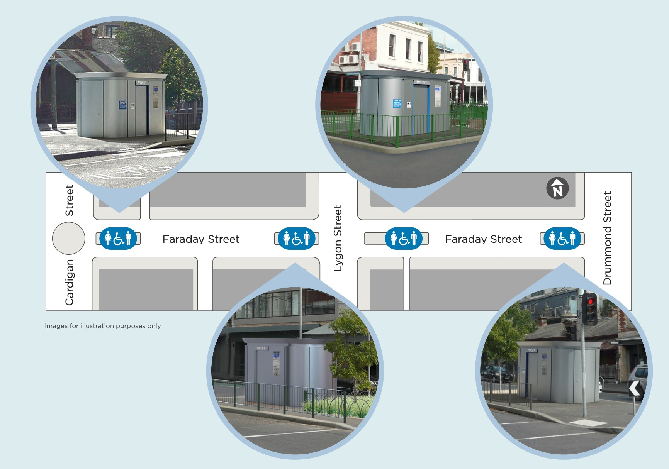
- In total, CoM received responses from 96 individuals.
  - 73 respondents contributed to the consultation via the Participate Melbourne online engagement portal. The survey followed a simple structure, asking five questions in addition to the request for the participant’s email address.
  - Email submissions were received from 7 respondents.
  - 18 respondents completed a face-to-face survey at the Church of all Nations.

Results
- Survey respondents were asked to select their preferred location for a new public toilet on Faraday Street.
- Location 3 was the most popular choice.
- Locations 4 and 2 were the second and third most popular choices respectively, with only one percentage point of difference between the two.
- Location 1 received the least support from respondents.
- Respondents were then asked to share the reason for their selection and to provide any additional comments about the consultation. The factors that respondents most often considered were:
  - Proximity to shops, public transport and other amenities that drew foot traffic and crowds. Some respondents felt that a location close to these services would be most practical, while others worried it could negatively impact local businesses, in particular, restaurants and cafes.
  - Proximity to residential properties – most respondents objected to having the new public toilet close to where people live.
  - How the new public toilet will impact the surrounding area, visually as well as socially. Respondents were concerned that it may attract the ‘wrong crowd’, be vandalized, or clash with the heritage aesthetic of the area.
- The level of disruption that will be caused by the installation of a new toilet. Respondents were concerned at how parking, access and the general look and feel of the area may be impacted.

Introduction

Purpose
The purpose of the engagement is to ascertain from the community their preferred location for the installation of a new public toilet to replace the decommissioned underground toilet in Faraday Street, Carlton.

Background
In 2019, the City of Melbourne proposed the installation of a new public toilet in the centre of Faraday Street, west of the intersection with Lygon Street.
This proposal came following the 2016 decommissioning of the heritage underground toilet located east of the same intersection due to safety and accessibility concerns, and in response to requests from nearby residents and businesses to provide a public toilet to service the area.
The City of Melbourne received feedback on the proposed location from residents and businesses at the time, with some in favour and some opposing the location. Council then reviewed the project and identified additional locations suitable for a public toilet in the area, returning to community consultation with four proposed locations along Faraday Street.

Engagement approach
2016: Original underground heritage toilet on Faraday Street decommissioned.
2017/18: Requests from the community to install a replacement public toilet in the area.
2019: Community consultation on the proposal to install a public toilet on the median strip of Faraday Street, west of the intersection with Lygon Street. Consultation involved letters to local residents and businesses advising of the process.
29 May to 13 July 2020: Community consultation was undertaken on four proposed locations. Consultation involved letters to local residents and businesses, communication and poster distribution to local stakeholders and via City of Melbourne channels, pop-up displays in two areas in Carlton and an online survey on Participate Melbourne. The survey asked about location preferences, reasons for preference, and for demographic information of the respondents (age and connection to the area).
Impact of COVID-19: Due to COVID-19 restrictions, the engagement focused on approaches that took into consideration the health and safety of the community and government measures. A survey was made available via the Participate Melbourne website, letters were sent to local residents and businesses, and two pop-up displays were set up during the engagement period (see image below). Opportunities for information sessions or staffed pop-up kiosks were not possible during this period. These limitations on face-to-face engagement affected the engagement reach and because of this, the response rate for this project was relatively small.
One facilitated face-to-face session was held with residents as part of a community market day at the Church of all Nations. The data collected by community staff included age, gender, postcode and location preference only, although an overall summary of sentiment was collected and has been included in the analysis. Thirteen of these 18 respondents selected Location 4 as the preferred toilet location.
It is important to note that because of this, and the lack of opportunity for other groups to contribute via similar sessions, the data collected in this session has been included as a separate data set in our graphs.
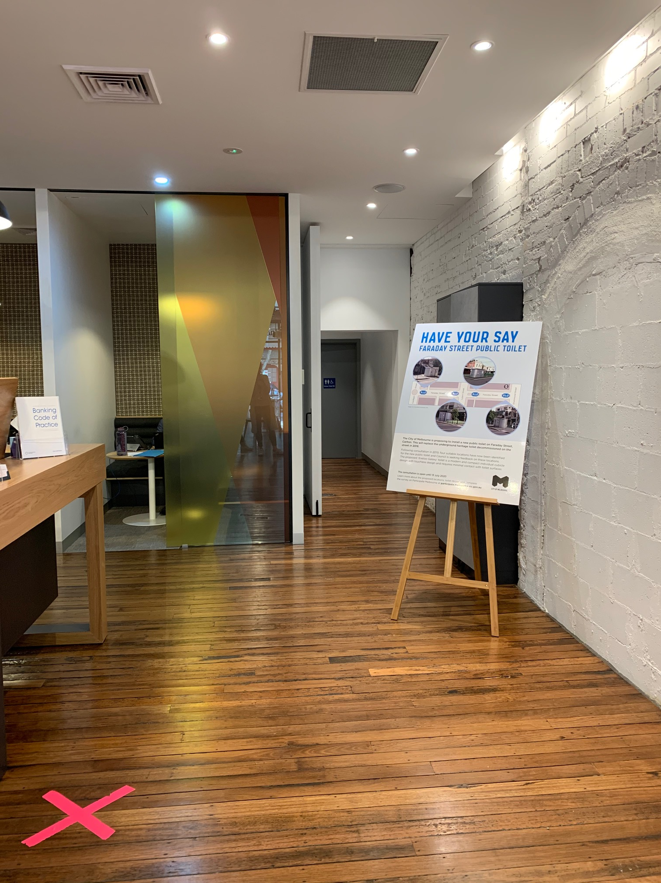
Image: Pop-up display sharing information about the Participate Melbourne consultation.
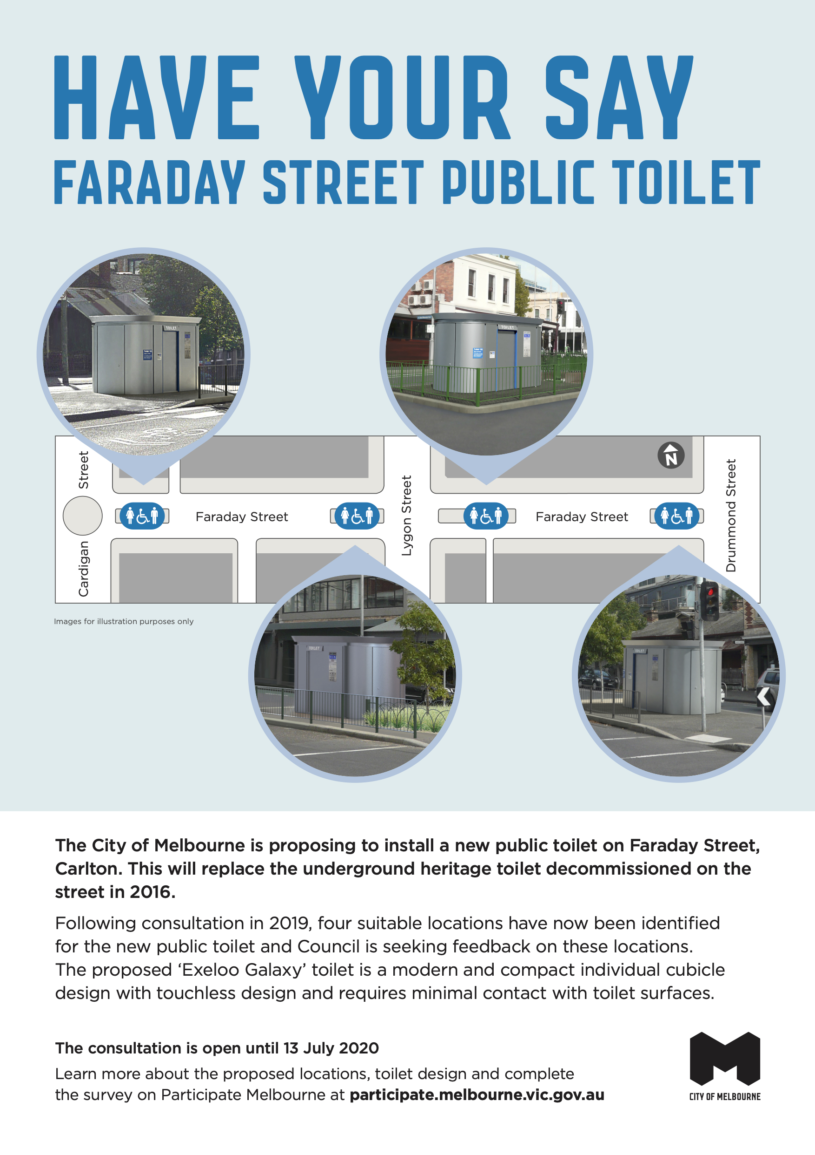
Image: Promotional poster used to inform the community about the Participate Melbourne consultation.

Methodology
During this consultation, community responses were collected primarily through an online survey hosted on the Participate Melbourne website. In addition, City of Melbourne received seven email submissions, and one facilitated face-to-face session was held, in which 18 participants selected their preferred location.
In total 73 respondents contributed to the consultation via Participate Melbourne. The survey followed a simple structure, asking five questions in addition to the request for the participant’s email address.
This report analyses the responses to the following five survey questions:
- Rank the four locations in order of preference.
- Tell us why you prefer your first choice.
- Do you have any other comments?
- What is your connection to the Carlton area? (select all that apply)

- I am a resident
- I am a business owner
- I am a worker
- I am a visitor
- I am a student
- Other (please specify)

- Which age group do you belong to?

- 18-24
- 25-34
- 35-44
- 45-54
- 55-64
- 65+

The data collected from the three quantitative questions (Rank the four locations in order of preference, What is your connection to the Carlton area? and Which age group do you belong to?) has been analysed and presented in charts within this report.
Comments offered in response to the two qualitative questions (Tell us why you prefer your first choice, and Do you have any other comments?) were grouped by theme (coded). These are presented in the section of the report titled Discussion of comments.
To give a clear and consistent indication of the number of comments received on each topic, the following key was used to describe the relative number of comments on each topic:
Key for comment numbers
3 comments | A few
4−7 comments | A small number
8−14 comments | Several
15−24 comments | A moderate number
25−49 comments | A considerable number
50−74 comments | A substantial number
Note that participant quotes from the Participate Melbourne survey are included verbatim; spelling and grammar errors have not been corrected.

Engagement reach and range
In total 96 respondents contributed to this engagement, via the following channels:
- Participate Melbourne survey: 73
- Face-to-face surveys: 18
- Email submitters: 7
The charts below present the characteristics of the 73 respondents who contributed via Participate Melbourne and the 18 respondents who took part in the facilitated face-to-face session at the Church of all Nations in Carlton as part of the local community market day. The email respondents did not provide information that could be included in this dataset.

Respondent age groups

(Note that percentage total does not add to 100 due to rounding.)

Findings:
Percentages of 73 Participate Melbourne and 18 face-to-face respondents who were within particular age groups:
- There was a relatively even split of respondents across all age groups: 47% were aged under 45 years of age and 52% were aged over 45 years of age.
- The largest individual respondent age groups were respondents who were 35-44 years (23%), 65+ years (22%) and 25-34 years (20%).

Respondent connection to Carlton area

(Note the total is greater than 100% because respondents could have more than one connection to Carlton.)

Findings:
The chart shows the percentages of 73 Participate Melbourne and 18 face-to-face survey respondents who had particular connections to Carlton. Note that respondents could register more than one connection:
- The largest individual respondent group was residents (43%)
- The second largest individual respondent group was business owners (23%)
- Face-to-face session participants made up 20% of respondents; all were residents.

Location preference

Analysis of selected preferences

Question description
Respondents were asked to rank four options for the location of the toilet in order of preference, from most preferred to least preferred.
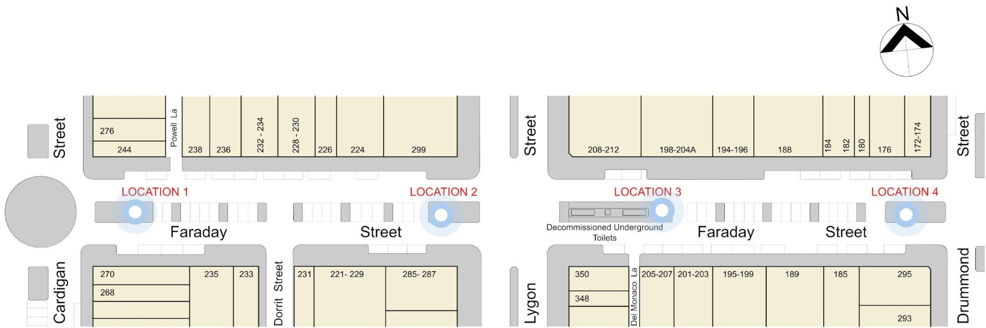
Location options for Faraday Street toilet (source: Participate Melbourne)
In order to assist respondents to select the most suitable location for the toilets, the four proposed locations shown on the Participate Melbourne website in an interactive map (shown above), and were provided with an artist’s impression and a list of features and impacts for each site.
  - Location 1: Faraday Street at the Cardigan Street intersection (east side)
  - Location 2: Faraday Street at the Lygon Street intersection (west side).
  - Location 3: Faraday Street between Lygon and Drummond streets (midblock adjacent to decommissioned toilet)
  - Location 4: Faraday Street at Drummond Street intersection (west side).

Data collection and cleaning
The data which comprised the location preferences came from two sources.
- 73 responses were collected via the Participate Melbourne online survey.
- 18 responses were collected via a facilitated face-to-face session with local residents held at the Church of all Nations, Carlton which is located close to the public housing estates.
Also note that four Participate Melbourne survey responses contained comments which clearly contradicted their selected location preference. This discrepancy was attributed to respondents selecting the 4 options in the order they were presented simply to enable them to move past the question; each respondents location preferences were listed in numerical order, 1-4, but were changed by analysts to reflect what the comments indicated as their true preferences.

Location preference for respondents

First preference

Findings:
- The most popular location preference was Location 3, which was selected by 37% of respondents.
- Location 4 was the second most popular choice for the preferred location (24%) with only one percentage point of difference to Location 2 (23%).
- The least popular location was Location 1, which was only selected by 15% of respondents.

Discussion

Toilet location preferences

Key findings
- Location 3 was the most popular choice and received the most comments.
- Respondents who selected Location 3 as their preferred location generally felt that this location would cause the least disruption to the area; it seemed to make more sense as a public toilet had been there previously.
- Location 2 received the second most comments. Respondents who selected Location 2 as their preferred option did so for its proximity to amenities such as shops, where high concentrations of people gather and move.
- Comments about Location 1 generally expressed the opinion that the main benefit of this location was its proximity to shops and restaurants, without being directly in front of them. Additionally, respondents felt it was well located for public transport users, and that it would cause less aesthetic intrusion than other locations.
- The least number of comments were made about why respondents selected Location 4 as their preferred option, offering varied reasons that did not fit a particular theme. Thirteen out of 21 respondents who selected Location 4 were face-to-face respondents surveyed during a local market event at the Church of all Nations and their feedback was limited due to the format of the session as well as COVID-19 restrictions.
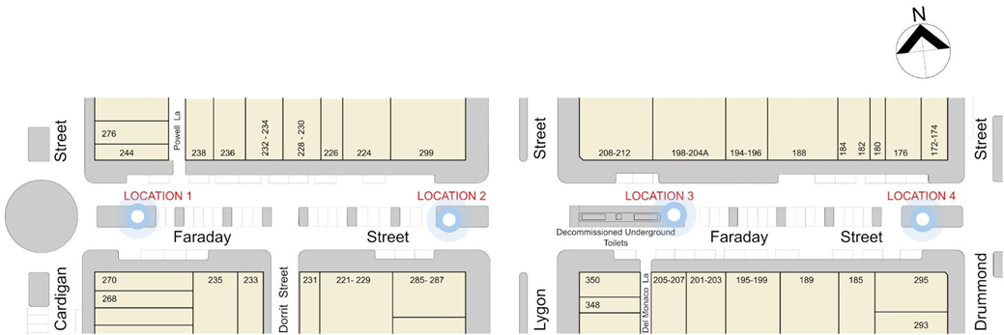
Location options for Faraday Street toilet (source: Participate Melbourne)

Location 1 11 Comments
Faraday Street at the Cardigan Street intersection (east side)
The most common reference made in connection to Location 1 was the proximity to restaurants and cafes. A small number of these comments appeared to come from respondents who objected to any Faraday Street public toilet installation, detailing that there is already an abundance of bathroom options that patrons may use at restaurants and cafes nearby and hence Location 1 - which is slightly further from restaurants - is more suitable. A few respondents added that Location 1 will pose the least aesthetic intrusion for the operating businesses.
I have chosen this location, because it is a busy area as well as it will not interfere with the ascetics of a more busier location such as next to restaurants and other business.
A small number of respondents additionally felt that having the toilet at Location 1 was the most appropriate as it is closer to transport hubs, the library, and the university and away from the heavily occupied hospitality areas.

Location 2 26 comments
Faraday Street at the Lygon Street intersection (west side)
Over a third of those who preferred Location 2 did so for its proximity to amenities such as shops, where high concentrations of people gather and move. Respondents stated that Location 2 was ideal due to the number of pedestrians using this area, citing that the Lygon Street entertainment area results in shops in the Faraday Street area around Location 2 receiving frequent requests for toilet use. The following comments are indicative.
I am a business operator on Lygon Street and we need a public toilet in this area as there are none right now.
Closest to Lygon, heavy foot traffic.
Closer to most of the visitor amenities, including proximity to Lygon street.
One fifth of respondents in favour of Location 2 stated that the centrality of that location was ideal. Comments such as that it is the “most convenient for the most people” characterise the theme of these. In addition, one respondent stated that an “obvious” location was necessary to counter the negative effects of “on-going laneway foulings”. Another respondent stated:
Ample space, flat ground, closest to public areas of Lygon street and easily visible to avoid being misused.
A few respondents preferred Location 2 on the basis that it is not located near residential dwellings, conveying the sentiment that the toilet is perceived as an impingement on residents.
Location 2 is close enough to service both end of Faraday St as well as the Lygon St precinct without being too close to residential homes.
Similarly a few respondents raised the issue of parking, and that Location 2 has the least impact on the availability of parking.
No further loss of car-parking.
One person each noted the following idea in support of Location 2: a safer location for use at night, particularly for those with disabilities; that it “feels better”; and, that it will “create the least eyesore”.

Location 3 52 comments
Faraday Street between Lygon and Drummond Streets (adjacent to decommissioned toilet)
Overwhelmingly, the most common reason that respondents chose Location 3 was because it was the site of the existing public toilet. Respondents felt that it made most sense to retain the location that people knew; that it may be easier to use existing plumbing; and that it will cause less disruption to the area as there has previously been a toilet there. Almost one third of respondents who selected Location 3 did so on the basis that it was the location of an existing public toilet.
Location 3 is the best of these options as it is discrete and accessible and provides the least visual impact on this heritage location. It aligns with prior use of this location and has the least negative impact.
People still head to the old toilet block and check if they can use it. There also seems to be the most amount of room there, and the impact on parking seems like it would be the least here.
The accessibility of the site was also mentioned by a small number of people, who felt that Location 3 offered safer and easier access.
This makes the most sense as it would already have access to plumbing from the original site, there is already a more substantial space for wheelchair access. It also seems the safest as people are always speeding around the roundabout at cardigan street.

Two respondents commented on the need for public toilets to be easily visible and accessible in order for people to use them instead of relieving themselves in nearby lanes and doorways as is reportedly common in the area at present.
A small number of respondents noted that Location 3 was an appropriate choice due to its proximity to Lygon Street, where most of the foot traffic is, and close to retail and commercial activity, and away from residential properties.
Public toilets should be visually present, does not make sense to put a public toilet in front of residences down the street rather than amongst the shops on Lygon Street where the original toilet was.

The visual impact of a public toilet was also considered by a small number of respondents who discussed Location 3 as having the least impact on the visual appearance of Lygon Street; this was due to it being slightly set back from the corner. This was viewed as more in keeping with the heritage status of the area. One respondent noted that they did not feel a public toilet in the area was suitable as it will be an ‘eyesore’ and may attract ‘the wrong crowd’.
Respondents also liked the fact that Location 3 is not too close to residential properties, and therefore will have less disruption for local residents.
Closer to Lygon St where most foot traffic is, less impact on available parking which is already an issue, particularly for residents of Cardigan Street.

Another positive feature of Location 3 was that it was perceived to have the least impact on current parking availability. One respondent added that no trees would need to be removed if Location 3 was used.
A few respondents also offered generically supportive comments as to why they chose Location 3, including:
Most convenient
It meets the needs for appropriate amenity

Location 4 6 comments
Faraday Street at Drummond Street intersection (west side)
Only a small number of comments were made regarding reasons for preferring Location 4. These reasons included:
It is the furthest point from the residential area.
I think it would be an eyesore from a Lygon Street prospective
Location 4 is best positioned away from the main shopping strip, although within easy access and within a high pedestrian area.
Further away from a busy intersection feels safer for traffic and more private and not on the main strip.

Although only a small number of comments were made by survey respondents in support of Location 4, it is worth noting that this location was commonly selected as top preference by respondents in the face-to-face session. The Community Development worker who presented the proposal also reported that Drummond Street is a well utilised route to enter Lygon Court. He also stated that many people do not know about the toilet in Lygon Court as it is upstairs in the centre and difficult to find.

Other comments
This section discusses comments about the provision of a toilet generally, rather than being focused on a particular location.

Toilet is unsightly 16 comments
Several respondents described the designs as unsightly. There was concern that the visual impact of the installation would not add to the streetscape, rather that it would detract from it. Several comments were made about the design of the proposed public toilets, suggesting that there would possibly be less opposition if a more attractive design were chosen.
Are there alternatives to the modern public toilet as situated at Argyle Square? Has consideration been given to a more attractive design?

Toilet is needed 9 comments
Several comments expressed support for the proposed public toilet installation, stating that there is a need for one in the area. Below are some examples of comments:
It will be great to get some toilets here as often people are searching, and as a business owner, we often have people requesting the use of our toilet.
These toilets would benefit from being installed as soon as possible due to the absence of public toilets nearby despite the considerable foot traffic and visitation to the area by locals and tourists.

Toilet will negatively impact adjacent businesses 8 comments
Some business owners in the Carlton area expressed concerns about the installation of a public toilet in the area negatively impacting their businesses. Concerns generally related to how the unappealing design might deter customers, as might the anti-social behaviour that is thought to occur around public toilets. These comments were generally made via email submissions, and were accompanied by photographs of vandalised, dirty and neglected public toilets in the area. A few of these comments referred to the difficult business conditions that have arisen due to COVID-19. One response offered suggestions as to how money could be better spent on helping struggling businesses in the area, including installing bike repair and pump stations to attract more cycling enthusiasts from other areas of Melbourne, or a stronger police presence in the area to deter crime and vandalism, and help visitors feel safer.
There is zero doubt by any of the traders that these new proposed toilets would seriously harm the ambiance and environment of the area, which relies heavily on curb side seating and which has already been crippled by high rents, increased labour costs, and now the Covid-19.
One respondent did however take the opposite view, strongly supporting the installation of a new public toilet in the area of their business.

General opposition 8 comments
Several respondents expressed general opposition to the installation of a new public toilet on Faraday Street. Some comments were very general in nature, and made statements such as: “Don’t put it in at all” or “Ridiculous would prefer none”. Meanwhile, others elaborated on the reasons for their opposition, which included: “a new toilet is not necessary”; “money would be better spent elsewhere”; “it may draw the wrong crowd”; “it will destroy the visual amenity of the heritage area”; and:
the negative impacts on businesses and the look of the area will be damaging.

Safety 7 comments
Concerns about safety were raised by a small number of respondents who worried that a new public toilet would increase the risk to people using the area, particularly at night. There were concerns about the type of people that similar, existing toilet blocks attract, often involving drug use and vandalism.
I'm not sure why we need a public toilet in this area. They are constantly graffitied and full of drug paraphernalia and they are generally unsafe and unhygienic.
One respondent suggested that the area would need to be well lit at night to reduce the risk for members of the public.

Alternative location suggestion 7 comments
A small number of comments recommended alternative locations not included in this proposal. These included restoring the decommissioned underground toilets, or choosing a location further away from businesses and properties. Other specific location suggestions were:
If toilets are needed, they should be placed near the tram stop in Swanston Street close to the kitchen feeding the homeless
There should be an additional toilet setup further down Lygon st near the parks
It would be better to put the toilet out the back of Lygon Court near Woolworths/courthouse, in the Lamama forecourt, or near the tramstop in Elgin St where people need it.

Issues with the process 7 comments
Seven respondents noted considerable contempt over the toilet planning process, detailing how they were provided with little to no information and that the attempted consultation with the residents and business owners was a case of ‘too little, too late’. Such respondents appear upset with the toilet proposal entirely and would have appreciated an opportunity to object earlier.
It is seriously unfair if people whose properties and livelihoods will be adversely affected by this proposal do not have the principal say about the existence or location of the toilet. We should have been properly involved in and informed of this proposal ahead of less impacted stakeholders.
We are yet to hear any explanation as to why these toilets are required on our street, and have yet to hear the CoM’s response to emails we have sent which had attached multiple signed petitions and letters of objection by the traders and landowners who will be most affected by this development.

Toilets are already provided nearby 5 comments
Respondents accepted that the current toilets are inaccessible to disabled peoples but rejected the idea that new toilets of a wheelchair friendly nature are necessary. These respondents emphasised the proximity of other toilets with disability access, specifically, at the library, Lygon Court and in King and Godfree.

Accessibility 4 comments
Respondents here offered suggestions on how to maximise the toilet’s accessibility for all users. One respondent simply noted the need for a public toilet in the area, particularly for people with medical conditions that mean they need frequent and ready access to toilet facilities. Another specifically noted lighting and using it to guide the path to the toilet, as well as signage to aid the visually impaired:
I think the new public toilet should have good lighting surrounding it. Concrete Tactile Ground Surface Indicators (TGSIs) should lead up to the facility from the street without impacting on wheelchair users. Signage should be of sufficient text size and with good colour contrast for people with low vision to see from a reasonable distance.
Lastly, one respondent suggested that Location 1 was in effect ‘hiding’ the toilet from users as it is the furthest away from the shopping precinct and thus harder to access for most users.

Questions 2 comments
Two respondents raised questions concerning specific characteristics of the new toilets.
How frequently will this be cleaned and what hours will this be accessible.
Has consideration been given to the type of loo to be installed? Exeloos are not user friendly for women (wet toilet seats due to the washing system) and in my experience they rarely have all features working.

Parking 1 comment
One respondent raised a concern over how the new toilet will further limit parking in the area which businesses rely on for their customers.

Other 9 comments
The bulk of the other comments were limited simply to respondents saying “no”. Though two comments provided more detailed suggestions. One respondent suggested utilising space by building the new toilets above the current unused toilets, as seen below:
Some thought should be given to the decommissioned toilets; if they are too dangerous to use, perhaps there could be a slab of concrete placed over that opening as a foundation for the new toilets.
One comment made reference to the disappointing standard to which existing public toilets are maintained, stressing the importance of having useable, safe public toilets.
The final comment requested that council drop the toilet proposal entirely and cease imposing burdens on small businesses, displaying a lack of faith in the Council’s intentions and consideration for the community.

Responses by group
Written responses to questions 2 and 3 (Tell us why you prefer your first choice, and; Do you have any other comments?) were coded to themes and topics, along with email submissions received by Council. Below, these comments have been divided into respondent types (resident; business owner; worker; visitor; and student), to uncover whether and/or how opinions from specific groups may differ to overall sentiment. (Refer to p.9 for chart showing Respondent connection to Carlton.)
Topics with four or more comments from a particular respondent group have included in discussion; topics are in order of most common to least common.

Residents

Keep existing location 15 comments
The most frequent comments made by residents were in support of keeping the existing (decommissioned) location (Location 3), with 15 residents discussing this topic. Some comments were very general in nature, such as “Next to existing toilet” or “Best location is at the prior toilet location”. Other comments were more specific, stating reasons such as: people were familiar with the existing public toilet so it would be convenient for the public; the council may be able to utilise existing plumbing and electricity at Location 3; the location is visible, easy to access and safe; and that there has previously been a toilet there so complaints about it would be limited.
People are used to having a public toilet in that position. It is central to most activities and is a well lit safe location.

Proximity to public transport, shops and other amenities 13 comments
Locations closer to Lygon Street were favoured by a few residents, as they are closest to shops and the main pedestrian area. Another resident suggested that having a public toilet on Lygon Street would be unnecessary, and possibly damaging for cafes and restaurants, especially those with outdoor seating. A couple of respondents suggested that Location 4 might be more suitable as it is slightly further away from the main shopping area, but still within easy access.
Location 4 is best positioned away from the main shopping strip, although within easy access and within
a high pedestrian area.
Residents felt that the most accessible site was Location 3, here it is visually available for restaurant patrons and there is adequate space for wheelchair access.
This makes the most sense as it would already have access to plumbing from the original site, there is already a more substantial space for wheelchair access. It also seems the safest as people are always speeding around the roundabout at cardigan street.

Visual impact 12 comments
Residents were conscious of the visual impact that the new toilets would have on the street and felt that this impact would be minimised by having the toilets adjacent to the old decommissioned toilets that cannot be moved. These comments were accompanied by criticism of the visual appeal of the new toilets but there was hope that this would best be disguised if within the boundaries of the heritage toilet block.
Its closest to the decommissioned facility and better respects the visual amenity of Lygon Street.
A small number of residents objected to the aesthetic appeal of the new toilets and requested a new design, calling the current proposal “ugly” and an “eyesore”. One resident requested that the toilet design be adjusted to be more sympathetic to its surroundings and the neighbouring businesses. The resident further noted how local businesses such as King & Godfree have been welcomed by the community, uplifting the feel of the street and that they would hate to see this atmosphere changed by a toilet if businesses don’t have adequate input into the design.

Proximity to residential locations 8 comments
Several comments were made by residents regarding the proximity of potential locations to residential properties. Two respondents felt that Location 1 was inappropriate as it was too close to residential properties, while one respondent felt that Location 4 was too close to peoples’ homes. One comment suggested that Location 2 might be a good compromise, stating:
Location 2 is close enough to service both end of Faraday St as well as the Lygon St precinct without being too close to residential homes.

Safety 6 comments
Safety was mentioned by a small number of residents, who were mostly concerned that a public toilet may draw the wrong crowd to the area, and may be increase the risk to members of the public.
This is a safety issue. We have a young & vulnerable community with many uni students living, working, & socialising in the area. This shouldn't be close to the areas in which people frequent at night or when the streets are quiet where they could be put in harms way.

Toilet sorely needed 6 comments
Six residents also expressly stated that a new public toilet in the area is needed. In particular, these respondents believed that it would reduce the amount of ‘laneway fouling’ occurring in nearby alleys and doorways, and, be convenient for visitors to the area.

Other specific suggestions 4 comments
A few residents provided specific suggestions such as having the toilets further down Lygon Street near the parks or near the tram stop on Elgin Street. One resident wanted the underground toilets to be utilised if possible.

Business owners

General support 4 comments
Four business owners showed support for the new toilets, stating that the sooner they were there the better and that there is dire need given how busy the area is.

Other comments
Other business owners offered varied responses to the toilet proposal, including a request for council to prioritise fixing the footpath surface on the street; another owner requested the new toilets be clearly visible to prevent their misuse.

Workers

Proximity to public transport, shops and other amenities 6 comments
A small number of workers stated that having the new toilet close to Lygon Street would be the most suitable option given the heavy foot traffic in that area and the lack of a nearby toilet to accommodate the current demand.
Proximity to Lygon Street, where the highest demand from tourists and non locals exists. Also replaces the previous facility.

Generic support 4 comments
Four workers offer support for the new toilet feeling it would be a suitable and convenient option for users.

Visitors

Proximity to public transport, shops and other amenities 5 comments
Visitors typically felt that on or close to Lygon Street was the most suitable location for the new toilet where it is visually present, safer to use at night, and amidst the busiest part of the area.
Appreciate that Faraday Street has a lot of commercial and education services along it but Lygon Street is the main shopping and dining strip and is a more appropriate location for a public toilet.

Students
There were no topics with more than 4 comments made by students.

Other - Property owners
Four additional comments were made by ‘other’ respondent types. This included 2 property owners and 2 individuals acting on behalf of a traders association for the Carlton business district. All four comments generally opposed the installation of a new public toilet on Faraday Street, due to negative impacts perceived to have on businesses in the area.

How the feedback will be used

The feedback gathered through community consultation will be reviewed and used by the City of Melbourne to
- understand the needs of visitors, residents, traders and other stakeholder groups
- identify the preferred location where a toilet should be installed in Faraday Street
- identify any issues with the proposed location(s).

A recommendation will then be made by management for Council to consider and approve.

This report has been prepared by:
Global Research
150 Office Rd
Merivale
Christchurch 8014
New Zealand
+64 3 355 4562
www.globalresearch.nz

This report has been prepared by:
Global Research
150 Office Rd
Merivale
Christchurch 8014
New Zealand
+64 3 355 4562
www.globalresearch.nz

