
Self–Guided Bike Ride
Parkville Heritage Review
Parkville
Tour distance: 7.5 km
Tour time: Approximately 1.5–2.0 hours
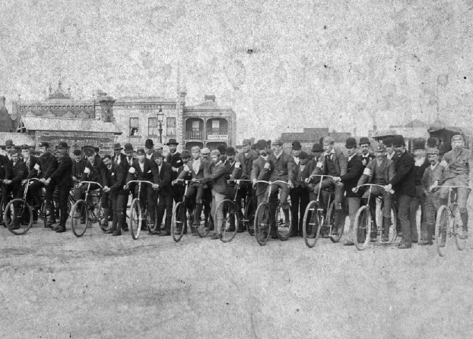
Contents
Acknowledgement of Traditional Owners 3
This Page is for the Grown–Ups! 4
START 5
Corner of Bayles and Fitzgibbon Streets 5
Stop 1 6
Old Parkville Post Office (now a house), 69 Fitzgibbon Street, corner Bayles Street 6
Stop 2 8
Old Royal Park motor garage (now a house), 26 Wimble Street 8
Stop 3 10
Butler Lane, Rear of 46 Morrah Street (second House from Wimble Street) 10
Stop 4 12
Old Shop (Now a cafe), 52 Morrah Street 12
Stop 5 14
House, 44 Morrah Street 14
Stop 6 16
Old Horse Market (now University High Oval), 77 Story Street 16
Stop 7 18
Old Cattle Market (now Bio21), Story Street 18
Stop 8 20
Old Stable (now a house), Behind 34 Gatehouse Street 20
Stop 9 22
Ievers Reserve, 42 Flemington Road 22
Images 24
Front Cover 24
Stop 1 24
Stop 2 24
Stop 3 24
Stop 4 24
Stop 5 24
Stop 6 25
Stop 7 25
Stop 8 25
Stop 9 25
Back Cover 25

Acknowledgement of Traditional Owners
City of Melbourne respectfully acknowledges the Traditional Owners of the land we govern, the Wurundjeri Woi–wurrung and Bunurong / Boon Wurrung peoples of the Kulin and pays respect to their Elders past and present. We acknowledge and honour the unbroken spiritual, cultural and political connection they have maintained to this unique place for more than 2000 generations.
We accept the invitation in the Uluru Statement from the Heart and are committed to walking together to build a better future.

The Review
The Parkville Heritage Review is the most comprehensive review of heritage places in the local area since 1979. Reviewing an expansive area centred on Royal Park, City of Melbourne’s independent consultant has identified places of local and state significance.
This cycling tour takes you to some of the places identified in the Review. Included are houses, a former market, and even a stables with a famous former occupant.
The recommendations in the Review are being implemented through Planning Scheme Amendment C444, which has been prepared by City of Melbourne.
Find out more and have your say at participate.melbourne.vic.gov.au/parkville-heritage-review.
Unless otherwise stated, text based on the Parkville Heritage Review by GML Heritage, and images by GML or City of Melbourne. Other images used with permission.
Front cover
Commencement of a race in Elizabeth St, North Melbourne, c1895, opposite Haymarket Hotel (near Haymarket roundabout). Source: Picture Collection, State Library of Victoria, Accession No. H6295

Notes

Places
Each stop nominates the type of protection that is being proposed through the Parkville Heritage Review, as follows:

Local Protection
This place is proposed for local protection through the Melbourne Planning Scheme.

Local and Part State Protection
This place is proposed for local protection through the Melbourne Planning Scheme, and state protection through the Victorian Heritage Register.

Local Context
This place is not proposed to change through the Parkville Heritage Review, but is included due to its importance to Parkville’s local context.

Acronyms
AM Member of the Order of Australia
HO Heritage Overlay
VHR Victorian Heritage Register
WWII World War Two (1939–45)

Start

Ievers Reserve, 42 Flemington Road
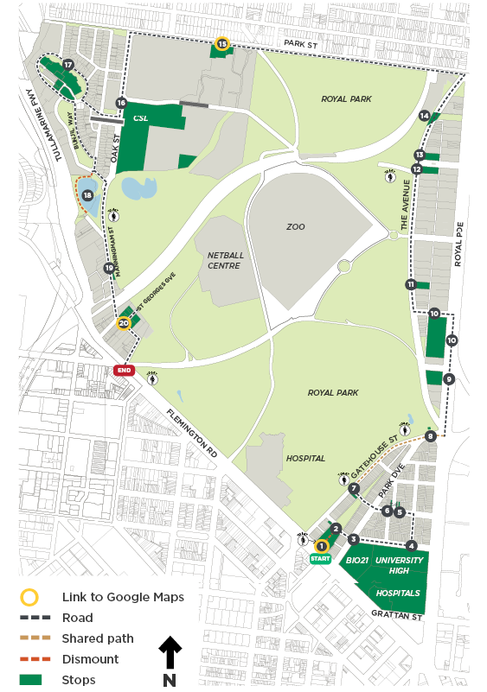

Stop 1

Local Protection

Ievers Reserve

42 Flemington Road
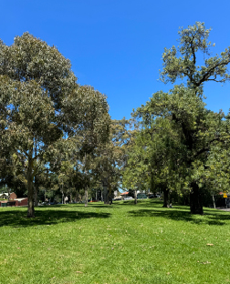
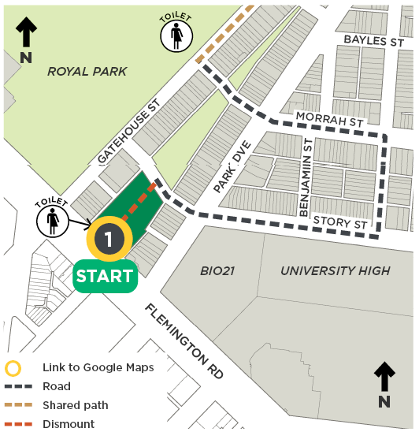

Architect(s): N/A
Constructed: c1870s
Current heritage: In HO4 Parkville Precinct
Proposed heritage: Significant to HO4 South Parkville Precinct
The Wurundjeri Woi–wurrung are the traditional owners of the land that is now called Parkville. For tens of thousands of years, Wurundjeri Woi–wurrung walked this Country. People have been born onto Country and laid to rest on Country. The Wurundjeri Woi–wurrung people continue to be the custodians of the land and its living culture and heritage.
At the time of European colonisation Royal Park was thinly timbered with gum, wattle and she–oak. This was a well–watered and resource rich area, making it an ideal place for living and meeting. Parkville lies only a few kilometres to the north of the Birrarung (Yarra River). Small streams once flowed from the higher ground in Royal Park into the Moonee Ponds Creek, which was defined by a series of lagoons.
The location you are standing on has been heavily modified from the time of European contact. The triangular shaped open space named Ievers Reserve was once the location of a creek, one of a number of creeks that ran through what is now Royal Park. This creek was relocated to an underground drain sometime between the 1860s and 90s, in order to optimise the area of land available for use, and to reduce its susceptibility to flooding.
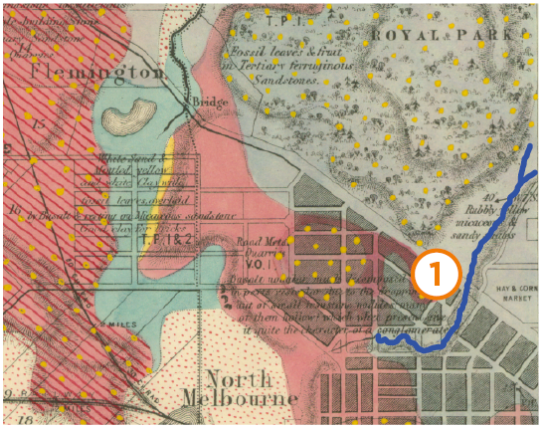
An historic geological map showing the creek that once existed at Stop 1, Ievers Reserve. Melbourne Surveyed, by Department of Public Lands, Victoria, Geological Survey of Victoria, 1860. Source: Maps Collection, State Library of Victoria, Record No. 9918747963607636
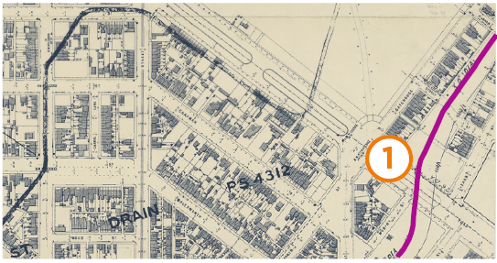
Melbourne and Metropolitan Board of Works Plan No. 31, Melbourne and North Melbourne, 1895. Source: Maps Collection, State Library of Victoria, Record No. 9915969693607636

Stop 2

Local Protection

Stable, 34–36 Gatehouse Street (Rear)
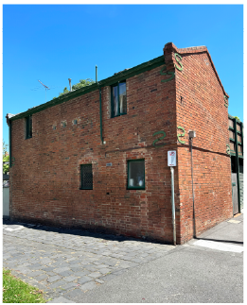
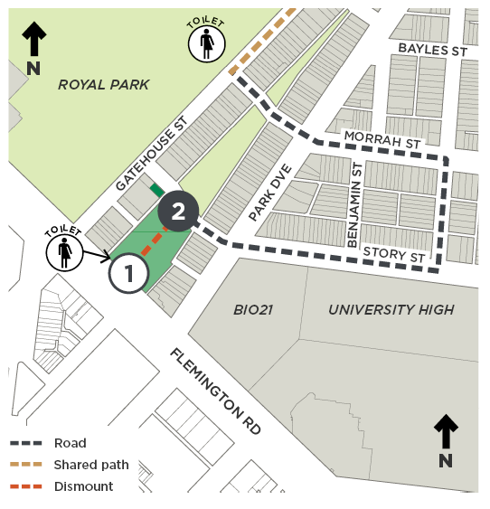

Architect(s): Unknown
Constructed: 1878
Current heritage: Contributory to HO4 Parkville Precinct
Proposed heritage: Significant to HO4 South Parkville Precinct (stable building at rear); no change (34–36 Gatehouse Street)
The former stables at the rear of the property on Redpath Rise, were once occupied by renowned Australian artist Sir Sidney Nolan as his studio. Here he painted View from the Artist’s Studio, Parkville in 1944, and Parkville in c1944–45.
Nolan also painted the first of his Ned Kelly series at his Gatehouse Street studio. It is speculated that the way Nolan represented Ned Kelly’s eyes through his helmet was inspired by Nolan himself peering through the letterbox on the door to look out for and avoid compulsory conscription during WWII.
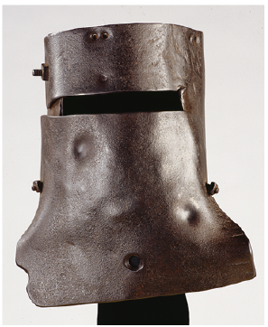
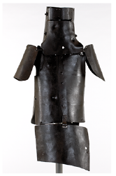
Suit of armour worn by Ned Kelly in 1880. Source: Pictures Collection, State Library of Victoria, Accession No. H20171

Stop 3

Local Protection

Northern Market and Lecture Hall, Story Street
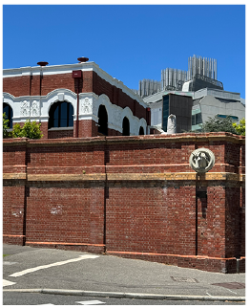
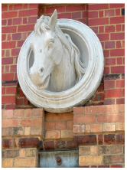

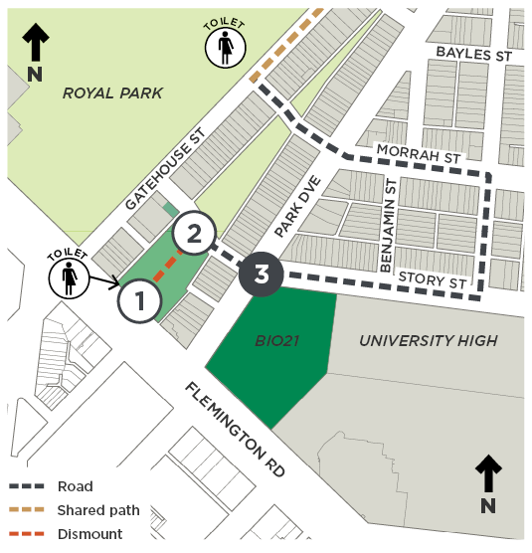
Architect(s): Various
Constructed: Various
Current heritage: Northern Market wall on the VHR
Proposed heritage: Lecture Hall 1908 (Bio21 site) Significant to HO4 South Parkville Precinct
Following a series of subdivisions between 1868 and 79, the street layout of South Parkville was established and included a market area bounded by Sydney Road (now Royal Parade), Story Street, Park Drive, Flemington Road and Grattan Street. From around the 1870s, the Northern Market was operating here as a horse, cow and pig market. It continued until the early twentieth century when the site was progressively redeveloped for a veterinary college (Bio 21 site, Flemington Road), University High (Stop 4) and hospitals (Flemington Road and Royal Parade).
The Northern Market served Melbourne’s early meat industry at a time when the local economy was largely driven by the pastoral industry. In the early 1900s, the occupations of a number of residents of South Parkville, including carters and stablemen, suggest there was a close association with the market.
The market was enclosed with a tall brick wall in 1888, which is still partially present. Constructed to a design by City of Melbourne architect William Salway, the structure features a horse’s bust fixed to the wall in Story Street near the corner of Park Drive.
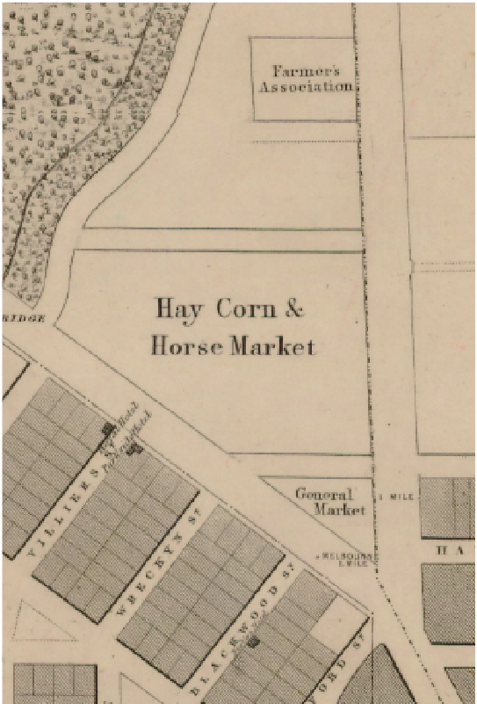
Melbourne and its suburbs compiled by James Kearney, 1855, showing the extent of the Northern Market. Source: Maps Collection, State Library of Victoria, Record No. 997869963607636

Stop 4

Local Protection

University High oval, 77 (part) Story Street
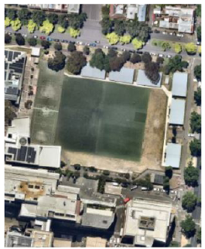
(Nearmap)
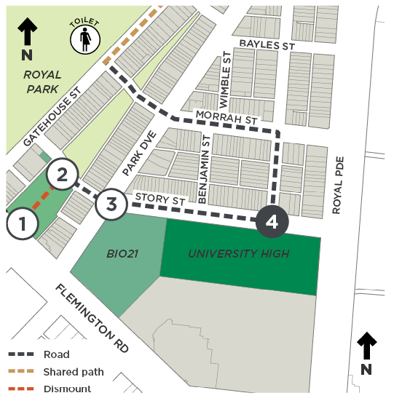

Architect(s): N/A
Constructed: 1860s
Current heritage: University High Northern Building (VHR H2183); oval nil
Proposed heritage: Significant to HO4 South Parkville Precinct
University High School was developed from 1929 on the eastern end of Northern Market, on what was the Victorian–era horse market.
The school oval was formed with the creation of University High in 1929 and was formalised by 1931. It has remained in almost continual recreational use since that time, except during World War II when the United States Army occupied the school oval with barracks for soldiers.
The remainder of the school site comprises a complex of buildings from various periods of development. The Northern Building at 77 Story Street was the initial school building established in 1929 and remains the most publicly visible building on site. This building is heritage protected through the Victorian Heritage Register.
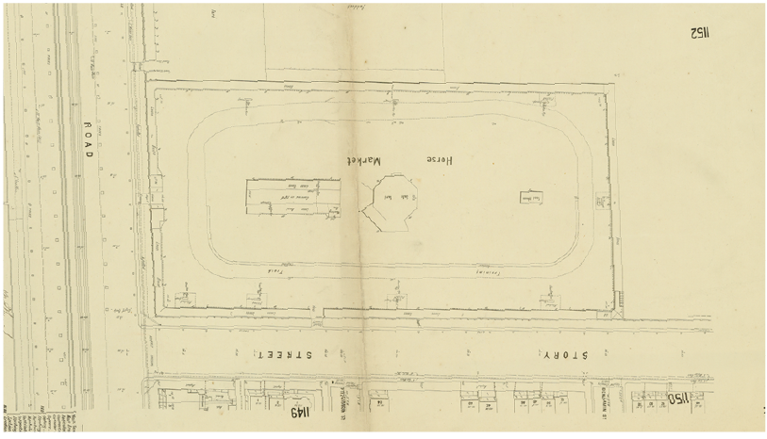
1896 map showing the Horse Market, oriented south to match the aerial photo below. Source: Maps Collection, State Library of Victoria, Record No 9911638363607636
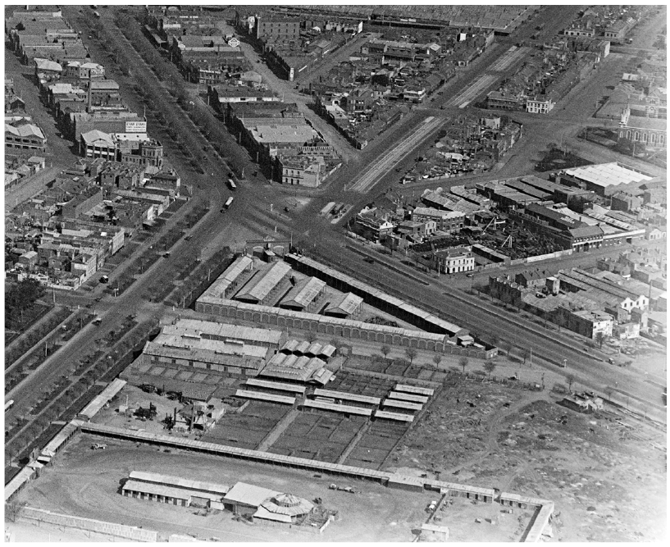
Looking over the city in the c1920s, with the horse market in the foreground. Photo by Charles Pratt. Source: Pictures Collection, State Library of Victoria, Accession No. H91.160/519
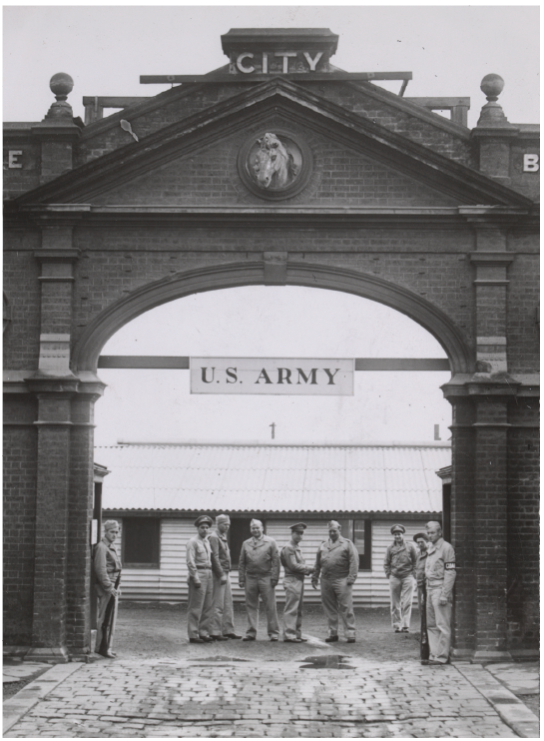
American soldiers standing at the entrance to the United States Army Camp at the old Horse Market (now University High), view from Story Street, c1944. Note the horse bust just under the ‘City’ sign, similar to the bust you saw at Stop 3. It may even be the same bust, which has been moved. Source: Pictures Collection, State Library of Victoria, Accession No. H2000.200/1245

Stop 5

Local Protection

Dwelling, 44 Morrah Street
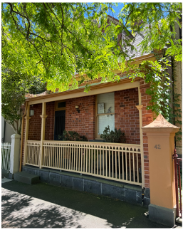
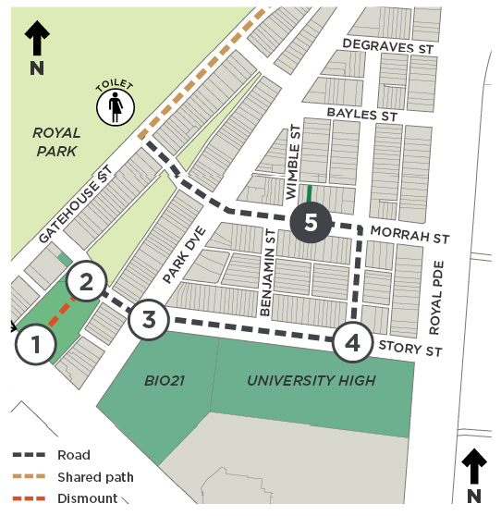

Architect(s): Unknown
Constructed: 1873
Current heritage: Significant to HO4 Parkville Precinct
Proposed heritage: Significant to HO4 South Parkville Precinct
44 Morrah Street is a single storey, single fronted brick terrace dwelling that is one of the first houses built in the precinct, after land was excised from Royal Park in 1872. What is unusual about this workers’ terrace is its particularly steep gable roof form and dormer window with scalloped barge board. Its design simplicity is reminiscent of cottages built in Tasmania that bear links to earlier Georgian architecture. Highly intact, this house is a fine example of early cottage design before Melbourne’s boom years of the 1880s.

Stop 6

Local Protection

Former shops, 48 Morrah Street and 52 Morrah Street
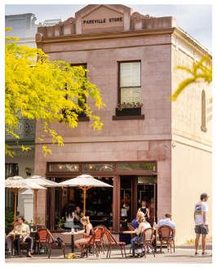
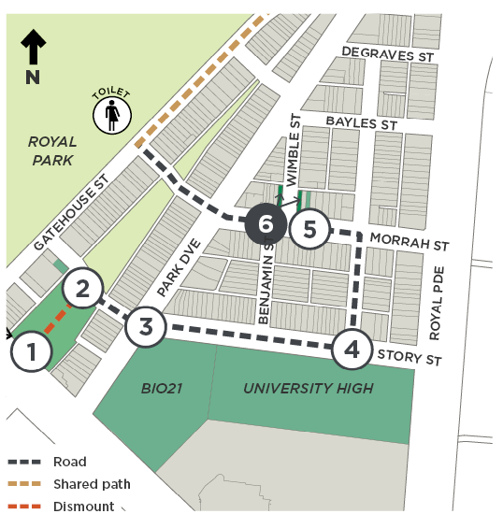

Architect(s): No. 48 – Unknown; No. 52 – Walter Gunn
Constructed: No. 48 – 1890; No. 52 – 1884
Current heritage: No. 48 – Significant to HO4 Parkville Precinct; No. 52 – Contributory to HO4 Parkville Precinct
Proposed heritage: Both Significant to HO4 South Parkville Precinct
48 Morrah Street is a highly intact corner building demonstrating a restrained use of the Victorian Italianate style. The building features what appears to be an original or early shopfront with rounded corners. A second entrance off Wimble Street retains its original door.
52 Morrah Street, Parkville Store, is a Victorian Italianate shop residence, also restrained in design. It was built a little earlier to a design by architect Walter Gunn. Originally occupied by a grocer, the shop features a large ‘ghost sign’ advertising John Bull Oats on its upper wall facing Wimble Street. The date of this sign is unknown. Local shops are often found on corners where they were easy to find and made the most of passing trade from two streets rather than one. Aside from a corner location, former shops can often be identified by remnant advertising, and verandahs (or verandah post holes in the bluestone kerb) that were built to protect window stock from the sun, present advertising and provide weather protection for shoppers.
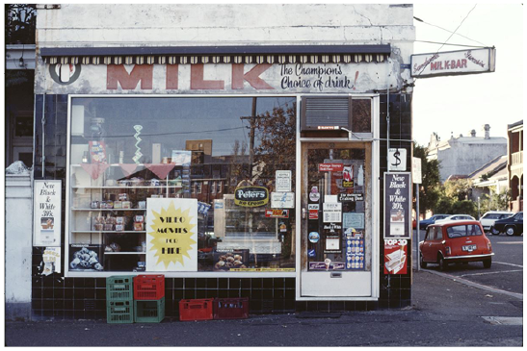
Exterior view of a milkbar in Parkville, c1983–84, as seen from Morrah Street; photo by Christopher van der Craats. Source: Pictures Collection, State Library of Victoria, Accession No. H2019.250/60

Stop 7

Local Protection

Saunders House, 90–92 Gatehouse St
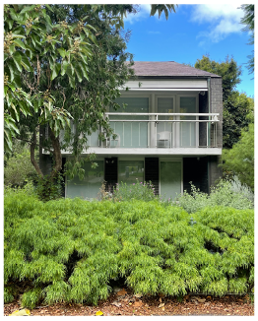
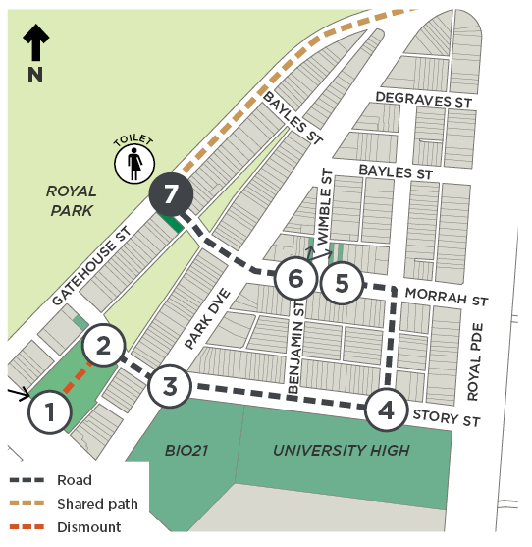

Architect(s): David and Doreen Saunders
Constructed: 1961–62
Current heritage: In HO4 Parkville Precinct
Proposed heritage: Individually Significant Place
The only residential design by David and Doreen Saunders, 90–92 Gatehouse Street was designed as their family home. The house demonstrates careful consideration and manipulation of the terrace typology in built form and setbacks. The skillion roof and stepped–back levels create a sloping frontage that reflects the established Victorian–era terrace house typology in Parkville, in order to conform with the strict planning regulations of the compact urban block at the time. The roof is split in the middle to allow for additional windows, so that natural light flows into the tightly planned interiors.
David Saunders was a well–regarded architectural historian and professor, particularly in the study of nineteenth–century Australian architecture, and was an early advocate of heritage conservation. Saunders House is notably modern but blends into historic Parkville. Its design combines David’s interest in contemporary architecture with the couple’s appreciation of historic buildings.
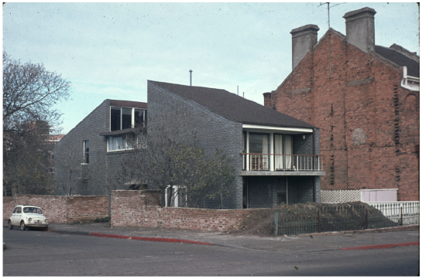
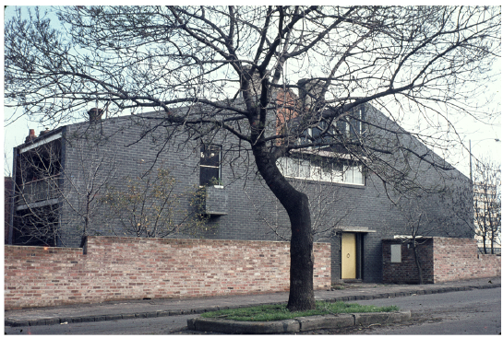
Saunders House, at the corner of Gatehouse and Morrah streets, built in 1962. Photographs by Peter Wille. Source: Pictures Collection, State Library of Victoria, Record No. 9939664460207636

Stop 8

Local Context

Walmsley House, 161 Gatehouse Street
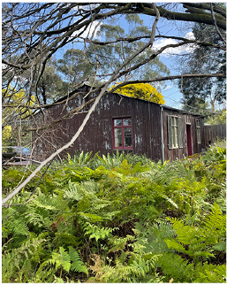
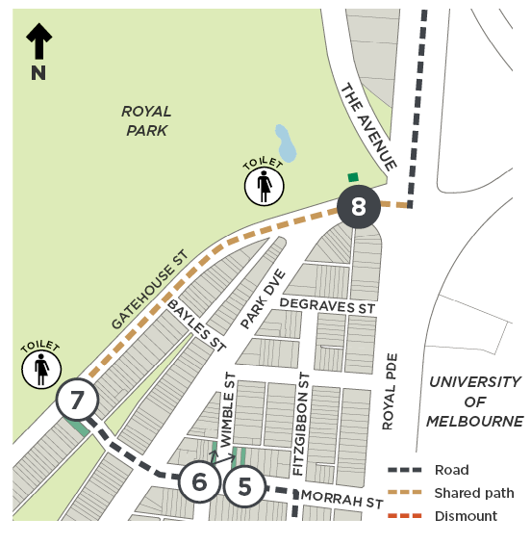

Architect(s): Walmsley of London (manufacturer)
Constructed: 1850s
Current heritage: VHR H1946, HO895
Proposed heritage: No change
Walmsley House is a prefabricated iron house of the mid–nineteenth century. It was manufactured by Walmsley of London, a wholesale ironmonger at 127 London Road, Southwark, London, who supplied prefabricated iron buildings to Australia. It is thought Walmsley may have been subcontracted by John Walker who exported a number of similar houses to Victoria.
Walmsley House was brought to the colony in 1853 or 1854 for use as a public building (such as a military depot or lock–up). In 1862, the building was moved to Royal Park to be used as the first official residence of the park ranger and bailiff, Mr Francis Meaker. In 1905, Frances was succeeded by his son Charles. The Meaker family lived here for 79 years. It would have been an incredibly uncomfortable house, with such buildings referred to as ‘camp ovens’ because they were so hot in summer. Walmsley House is now managed by City of Melbourne and used for local community meetings.
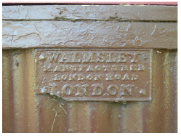
The manufacturer’s plaque. Source: Inset Royal Park Protection Group, retrieved 27/11/23.
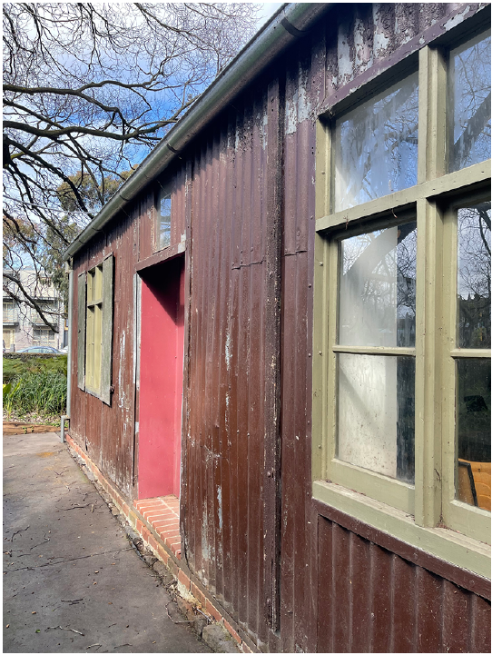
Walmsley House North elevation, looking towards Gatehouse Street

Stop 9

Local Protection

Park and Trinity Terraces, 157–175 Royal Parade
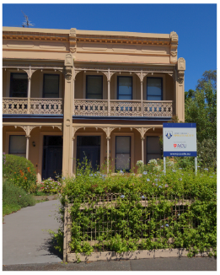
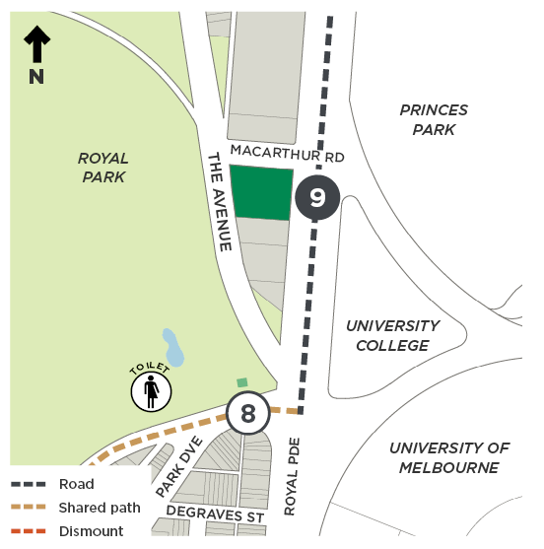

Architect(s): Park Terrace – George Brown; Trinity Terrace – Norman Hitchcock
Constructed: Park Terrace – 1877; Trinity Terrace – 1885 to 86
Current heritage: In HO321 157–175 Royal Parade
Proposed heritage: New Statements of Significance
Park Terrace and Trinity Terrace are fine examples of the Victorian Italianate style that provide evidence of the middle–class suburban development of Parkville in the late nineteenth century. Land between Royal Parade and The Avenue was excised from Royal Park in 1868 as part of wider action by the Victorian Government to raise revenue by selling areas of public parkland in the City of Melbourne. The resulting subdivision provided large blocks that the Government placed under a strict covenant specifying the construction of villas and terrace houses in stone or brick. It shaped the predominantly Boom–style Victorian residential character of Parkville. The terraces are two of a small number of surviving examples fronting Royal Parade.
Park Terrace is noteworthy for its deep garden setback, and its prominent position at the corner of Royal Parade and Macarthur Road, which was not always so. A house once stood to the north of Park Terrace, featuring a fernery, wash house and poultry yard to its rear. It is thought this house was demolished after WWII to make way for construction of Macarthur Road, as the missing east–west link between Royal Parade and Elliot Avenue.
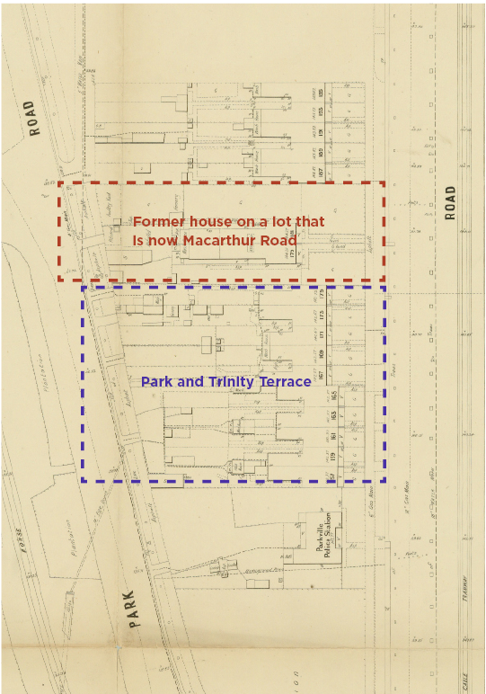
Melbourne and Metropolitan Board of Works detail plan, No. 1148, City of Melbourne, 1899. Source: Maps Collection, State Library of Victoria, Record No. 9911638253607636

Stop 10

Local and Part State Protection

International House, 197–259 Royal Parade
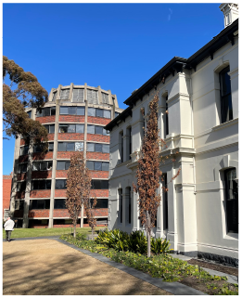
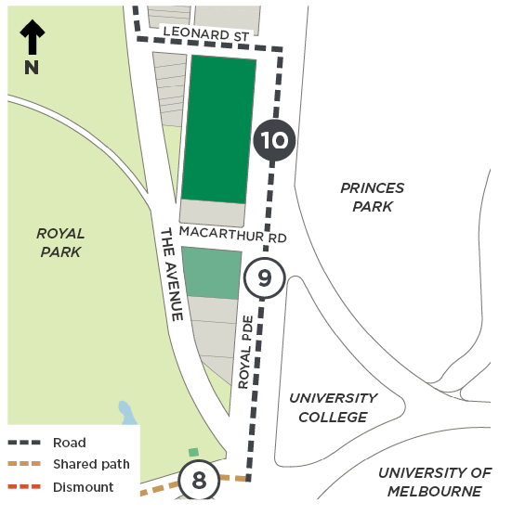

Architect(s): Various
Constructed: Various
Current heritage: In HO4 Parkville Precinct, with 1–31 Leonard Street Significant, 197–203 Royal Parade Contributory and 217 Royal Parade Significant
Proposed heritage: Individually Significant Place and VHR for Ayr Cottage on Leonard Street
International House was established to address an acute housing shortage for domestic and overseas students attending the University of Melbourne after WWII. Between 1953 and 1976, the University incrementally acquired land and buildings to create a consolidated site for International House. The new purpose–built buildings can be read in the landscape as distinct forms – responding sensitively to earlier buildings in terms of alignment and spacing – and largely continuing the rhythm of the 1868 subdivision pattern along Royal Parade. Each building contributes aesthetic variety in the mix of architectural styles: Victorian Italianate, Rustic Gothic, Federation Queen Anne and Modernist styles.
As a university residential complex, International House demonstrates a change in higher education policy after WWII, associated with a surge in domestic and overseas student numbers from the 1950s. At this time, Australia sought to build its relationship with the Asia–Pacific, and so in July 1951 launched the Colombo Plan, resulting in an influx of overseas students to Australia.
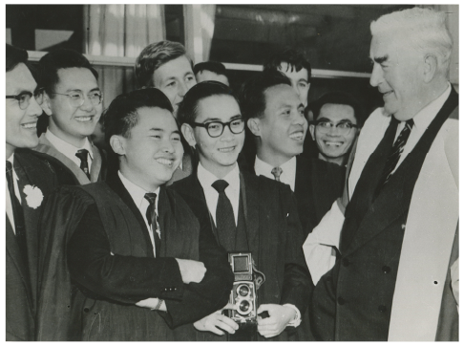
Prime Minister of Australia Robert Menzies chatting to students at the official opening of International House on 24 May 1958. Source: International House Collection, the University of Melbourne, blogs.unimelb.edu.au/international-house-melbourne/2020/05/10/official-opening-of-international-house/, retrieved 23/11/23
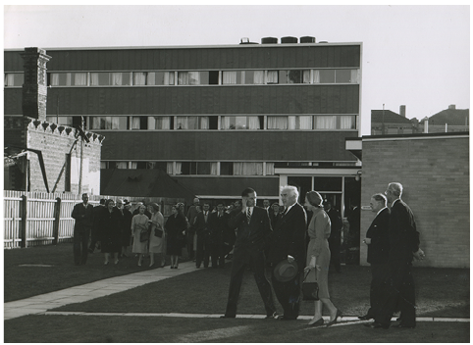
Ian Clunies Ross, Robert Menzies, Pattie Menzies, Arthur Dean and Warden Brian Jones at the official opening of International House, 24 May 1958. Source: International House Collection, the University of Melbourne, blogs.unimelb.edu.au/international-house-melbourne/2020/05/10/official-opening-of-international-house/, retrieved 23/11/23

Stop 11

Local Protection

Townhouses, 68–78 The Avenue
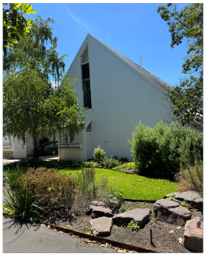
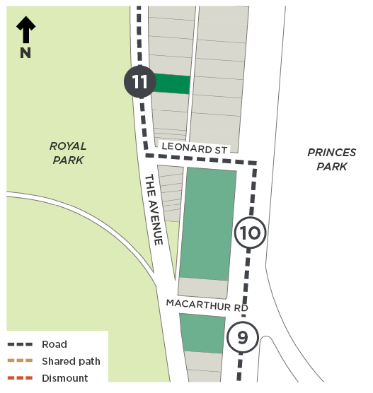

Architect(s): Peter Clarke
Constructed: 1977
Current heritage: In HO4 Parkville Precinct
Proposed heritage: Significant to HO1433 The Avenue Precinct
68–78 The Avenue is a double–storey townhouse complex built to a design by Peter Clarke, a director of the building development company Linkon Projects Pty Ltd. It is a fine example of the low–rise, high–density, multistorey townhouse typology that emerged in the 1960s and 1970s, as a housing alternative to suburban houses and high–rise apartments. It displays characteristics of the Late Modern style through its use of an uncompromising, bold geometric form.
Aerial photography from the 1940s shows that an earlier house must have been demolished to make way for the townhouses. Demolition has been rare in the residential streets of Parkville, particularly in Parkville South where most post–war buildings were constructed on former gardens (for example Saunders House, Stop 7), rather than through demolition.

Stop 12

Local Protection

Park Avenue Towers, 236–246 The Avenue
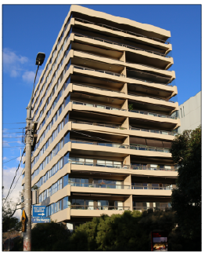
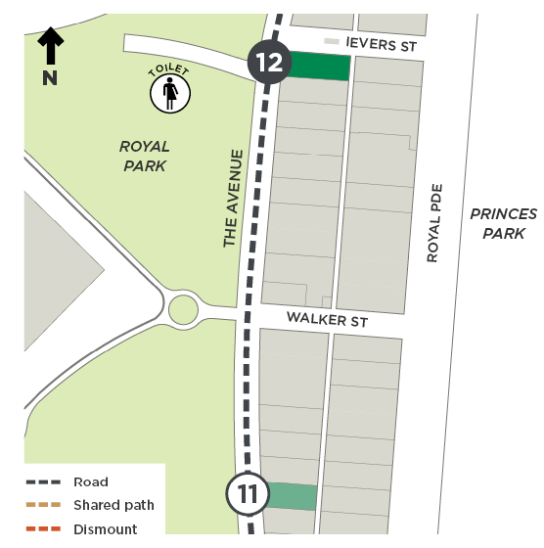

Architect(s): Ermin Smrekar
Constructed: 1976–78
Current heritage: In HO4 Parkville Precinct
Proposed heritage: Significant to HO1433 The Avenue Precinct
Park Avenue Towers is a 13–storey post–war Modernist, high–rise apartment building constructed to a design by architect Ermin Smrekar. It displays distinct characteristics of the Modernist style including simple geometric volumes, lack of ornamentation and extensive use of glass.
Unlike the townhouses at Stop 11, this apartment tower capitalises on views to Royal Park and surrounds. Park Avenue Towers offered a lifestyle novel to Melburnians in the 1970s, when most dwellings came in the form of mid–rise flats or detached houses. The site offered onsite car parking, landscaped grounds and a swimming pool for residents, comparable to apartments being constructed in South Yarra at the time (see our South Yarra Heritage Review at participate.melbourne.vic.gov.au/south-yarra-heritage-review).

Stop 13

Local Protection

Apartments, 248–258 The Avenue
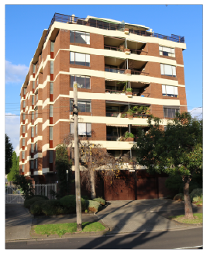
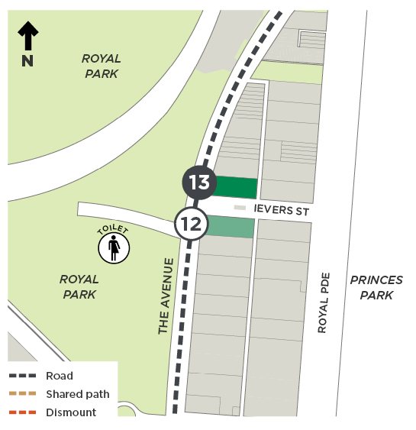

Architect(s): Ermin Smrekar
Constructed: 1969–70
Current heritage: In HO4 Parkville Precinct
Proposed heritage: Significant to HO1433 The Avenue Precinct
248–258 The Avenue is an eight–storey post–war Modernist, high–rise apartment building constructed in 1969 to 1970 to a design by the same architect as the previous stop. The building reflects late 1960s and early 1970s popular style particularly in central Melbourne, featuring contrasting cream–painted horizontal concrete edge beams with brown–brick wall cladding and prominent projecting balconies.

Stop 14

Local Protection

Railway Bridge, The Avenue
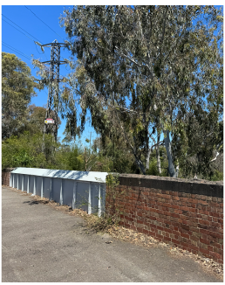
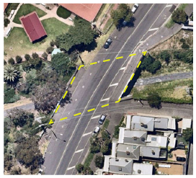
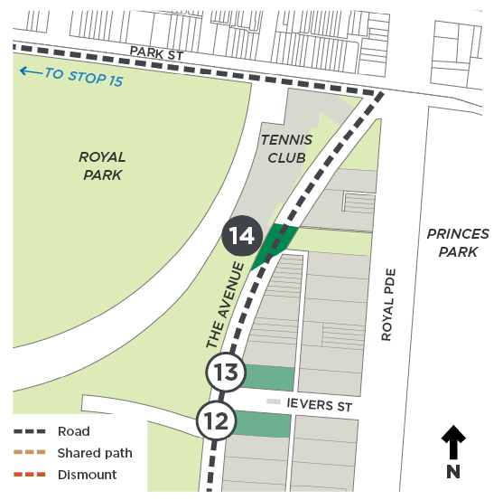
Architect(s): Unknown, possibly Public Works
Constructed: 1879
Current heritage: In HO4 Parkville Precinct
Proposed heritage: Contributory to HO1433 The Avenue Precinct
One of the principal Victorian–era infrastructure projects in Parkville was construction of the railway bridge near the top end of The Avenue (just north of 310 The Avenue). This bridge was constructed as part of the Inner Circle railway line, which opened 8 May 1888.
A section of railway that ran below the bridge was part of the line that connected the Royal Park Railway Station (originally known as Junction Railway Station) and the former North Carlton Railway Station (originally named Langridge Street Station). This railway line travelled to Fitzroy or Clifton Hill and was closed to passengers on 15 November 1948. The line was converted to a recreational path in the 1990s, over 100 years after the railway was opened.
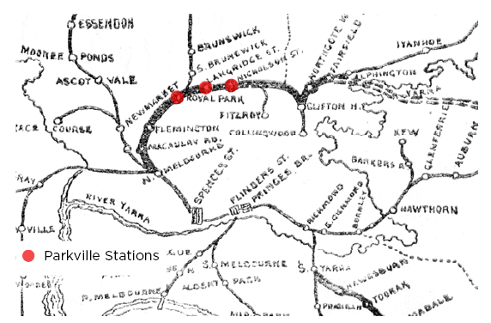
Inner Circle railway route, 1889; David Syme and Co. Source: Pictures Collection, State Library of Victoria, Accession No. IAN01/06/89/18
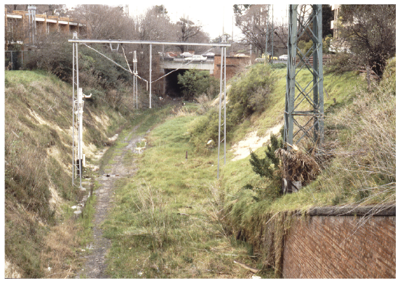
Inner circle line at Royal Parade – looking towards Royal Parade from The Avenue; photographed in 1988 by Weston Langford before the disused rail line was turned into a recreational path. Source: westonlangford.com; retrieved 08/12/23

Stop 15

Local Protection

Former Royal Park Depot buildings, 866–934 (part) Park Street
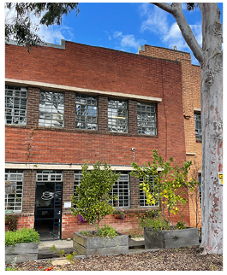
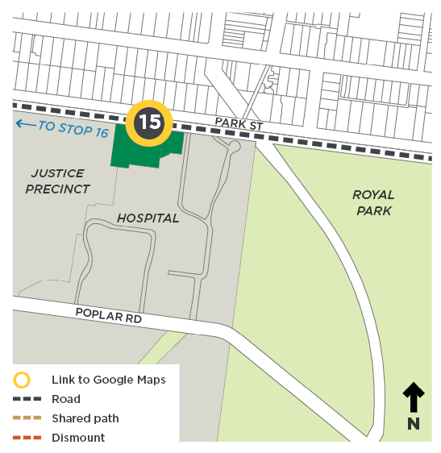

Architect(s): Public Works Department
Constructed: 1925, 1940
Current heritage: Nil
Proposed heritage: Individually Significant

Note: Potentially triggering content
These two former Royal Park Depot buildings include a nurses’ quarters that is a two–storey interwar building, constructed in 1925 as an on–site staff accommodation and training facility for ‘problem girls’ (its secondary wing, built in 1944, was demolished in the 1990s). The neighbouring former junior girls’ and toddlers’ building was constructed in 1940, as part of an effort to improve the conditions of girls’ quarters and to separate children who were wards of the state from those in remand.
These two buildings provide evidence of the changing approaches to the care of children and young offenders, as well as welfare services for children. The care of children became a significant public issue in the 1920s and 1930s, and the Royal Park Depot facilities were particularly prominent in public debate regarding this issue, prompting the expansion and improvement of the site in the 1920s and the late 1930s onwards. These buildings date from this period of expansion and the original fabric and later modifications are representative of the development and evolution of welfare facilities throughout the twentieth century.
Both buildings are associated with a difficult and complicated past, being the site of traumatic experiences such as child abuse and the separation of children from their families. For people from across Victoria, this is a place associated with additional trauma and sadness because of its role in the administration of policies of child removal.
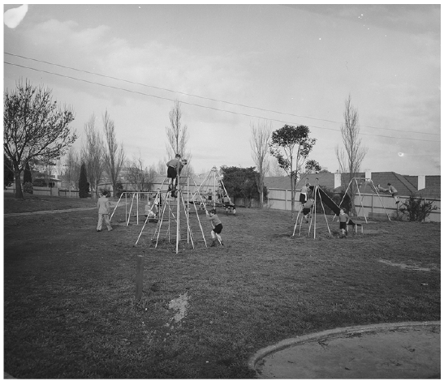
Children play on equipment, Royal Park Children’s Home, c1950s. Source: Public Record Office Victoria, VPRS 14517/P0001/8, E591, Royal Park, Children’s Welfare Department
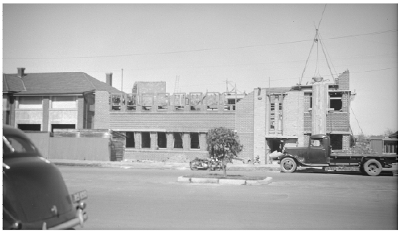
View looking south from Park Street, showing the construction of the new junior girls’ and toddlers’ block in 1939; note the 1925 nurses’ quarters to the east. Source: Public Record Office Victoria, VPRS 10516/P0001, Royal Park, Children’s Welfare Department
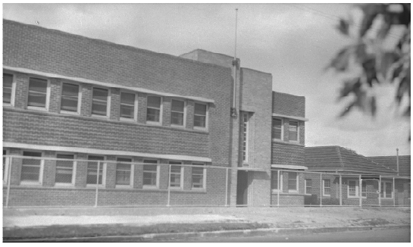
View showing the completed junior girls’ and toddlers’ block, c1940. Source: Public Record Office Victoria, VPRS 10516/P0001, Royal Park, Children’s Welfare Department

Stop 16

Local and Part State Protection

CSL, 39–79 (part) Poplar Road
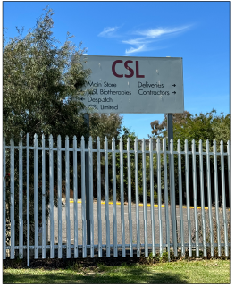
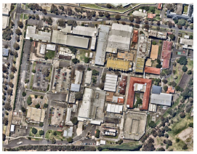
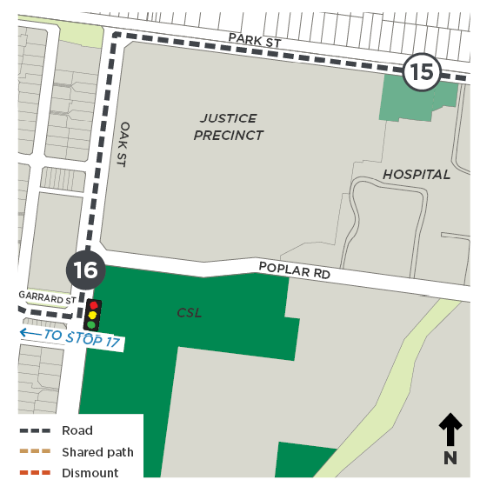
Architect(s): Various
Constructed: 1910s onwards
Current heritage: VHR H1794 for the Jennerian Building at 45 Poplar Road
Proposed heritage: Individually Significant
The Commonwealth Serum Laboratories (CSL), is a purpose–built scientific institution established by the Commonwealth Government for the research and production of vaccines and sera as a means of preventing human and animal disease.
Following the onset of World War I in 1914, and the subsequent global shortage of essential medical supplies, Australia needed to manufacture its own medical products, including vaccinations. CSL was founded in 1916, inheriting the existing 1904 Jennerian Building already onsite. A large complex of offices, laboratories and animal accommodation was completed in 1918–19, with further construction from the mid–1930s.
CSL has been a critical and highly respected scientific institution in Australia, serving the needs of public health and animal health for over 100 years through the production of penicillin and a range of other sera and vaccines. CSL played an important role during WWII, inoculating servicemen and women, and undertaking vital work in blood processing. It has also been critical in the management of epidemics and pandemics including the Spanish flu (1919), poliomyelitis (1955), HIV/AIDS (1980s) and COVID–19 (2019–).
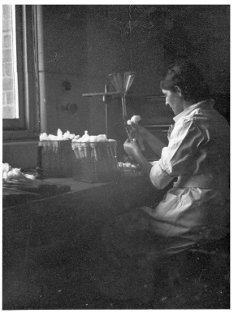
Amy Silver, technician, in the CSL laboratory, Parkville, c1935–39. Source: Pictures Collection, State Library of Victoria, Accession No. H2001.177/6
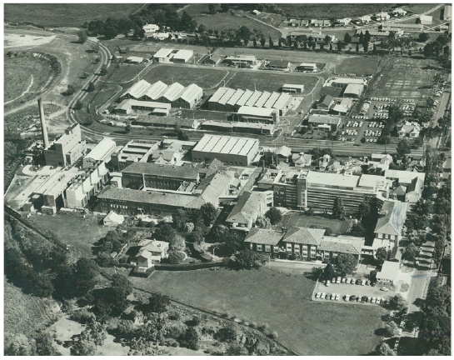
Aerial view of CSL, Royal Park, 1950–60; photo by Charles Pratt. Source: Pictures Collection, State Library of Victoria, Accession No. H2008.32/54

Stop 17

Local Context

Former Psychiatric Hospital, Cade Way
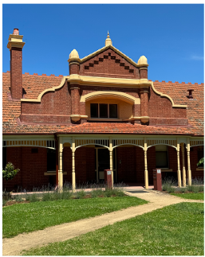
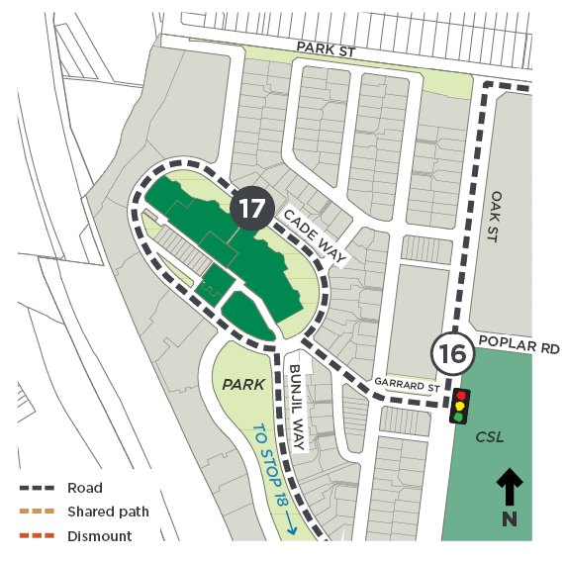

Architect(s): Various
Constructed: 1906 onwards
Current heritage: VHR
Proposed heritage: No change

Note: Potentially triggering content
The former Royal Park Psychiatric Hospital (‘Hospital for the Insane’) was constructed between 1906 and 1913. The architect SE Bindley, of the Victorian Public Works Department, applied the Federation Domestic Queen Anne style to his design.
The facility was part of an integrated system of psychiatric treatment introduced under the first Inspector General of the Insane in Victoria, Dr Ernest Jones, in the early years of the twentieth century. It was the first psychiatric hospital to be established following the introduction of the Lunacy Act 1903 and was intended for the treatment of patients with transient and recoverable disorders.
The Queen Anne style buildings are now encircled by Cade Way – a street named after John Cade, an Australian doctor who in the 1940s discovered lithium to be a highly effective treatment for manic depression (bipolar disorder). Research into the clinical use of lithium took place at Royal Park Psychiatric Hospital.
The site is significant for demonstrating early twentieth century approaches to patient assessment and cure, with an emphasis on early intervention.
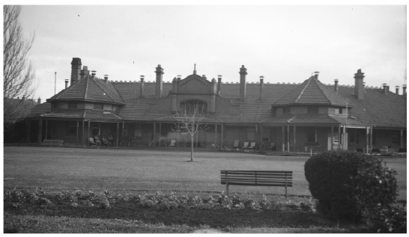
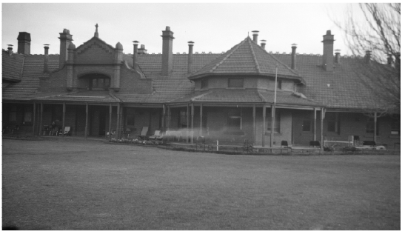
Royal Park Psychiatric Hospital when still operating, with patients sitting on the verandah, c1940s–50s. Source: Public Record Office Victoria, VPRS 10516/P0001, Royal Park Mental Hospital

Stop 18

Local Context

Trin Warren Tam–boore Wetland
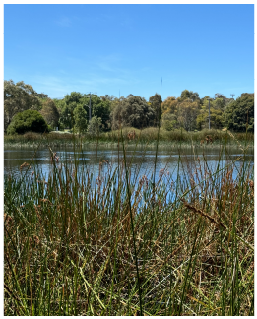
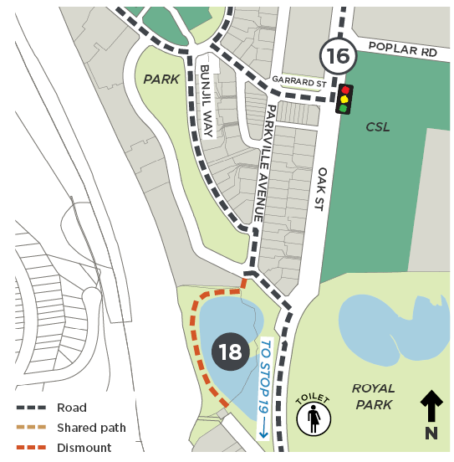

Architect(s): City of Melbourne
Constructed: 2006
Current heritage: VHR (Royal Park)
Proposed heritage: No change
Trin Warren Tam–boore (Bellbird Waterhole) was completed in 2006 as a treatment wetland of two ponds covering about five hectares. The wetland is located in a natural low point where Moonee Ponds Creek once ran.
The wetland has been designed to treat water from the surrounding area through natural biological processes and provides water for irrigation systems in Royal Park, including for the golf course and sports ovals.
Trin Warren Tam–boore has a variety of aquatic plants that provide food and shelter for fauna and birdlife. It is one of the sites where the Friends of Royal Park conduct bird surveys, which have been undertaken since 2007. Birds observed in Royal Park include kookaburras, the white faced heron, great egret, straw–necked ibis, and even the rare swift parrot.
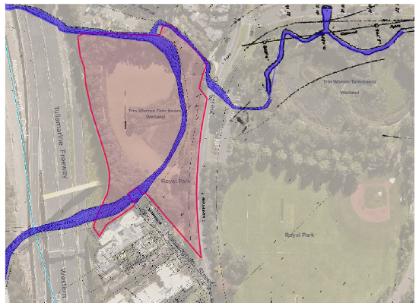
An overlay of the current aerial photo and the Melbourne and Metropolitan Board of Works plan from the 1890s, showing that the Mooney Ponds Creek once ran through the current wetland. Source: imagery.aerialphotography.fsdf.org.au/ngx-device-detector.mjs.map, retrieved 2023
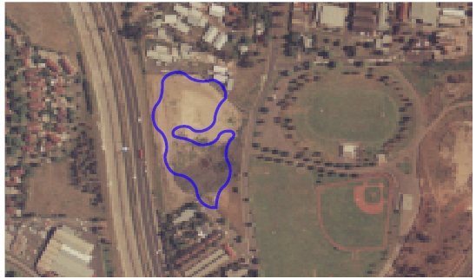
An aerial photo from the 1980s showing the wetland prior to construction. Source: imagery.aerialphotography.fsdf.org.au/ngx-device-detector.mjs.map, retrieved 2023

Stop 19

Local Protection

Dwelling, 72 Manningham Street
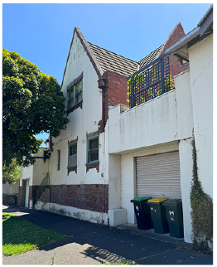
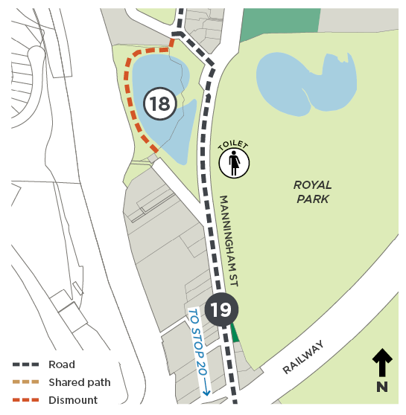

Architect(s): Possibly EF Barnard
Constructed: 1940–41
Current heritage: Contributory to HO4 Parkville Precinct
Proposed heritage: Individually Significant
72–78 Manningham Street is a highly intact example of a modest interwar dwelling designed in the Old English Revival style. Constructed at the end of the interwar period in 1940–41, the building demonstrates the enduring popularity of the style and the ongoing preference for brick construction throughout the period.
The house’s situation on a narrow, irregular lot, replacing an earlier building on the site, is reflective of the interwar period of development in Parkville, where remaining residual lands from Victorian estates and modest Federation dwellings were redeveloped to provide accommodation for professionals. It is an uncommon example of the typology in Parkville of modest, affordable housing with restrained design that was the result of the Depression and austerity in the early war years.

Stop 20

Local Protection

St Georges Grove Precinct
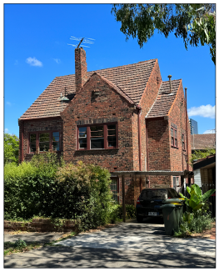
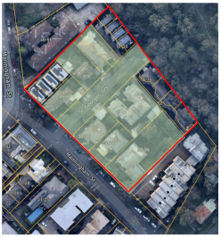
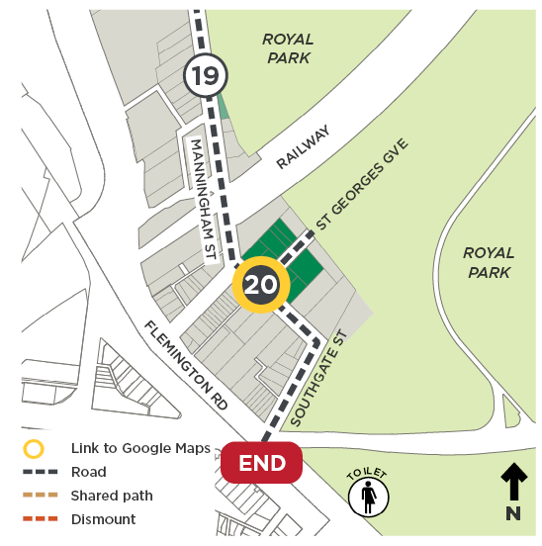
Architect(s): Various
Constructed: 1920s–30s, 1951
Current heritage: Contributory to HO4 Parkville Precinct
Proposed heritage: New Heritage Precinct
This proposed heritage precinct comprises 1–5, 7, 9, and 4–10 St Georges Grove, and 20–24, 26–28, 30–32 and 34–40 Manningham Street. It provides evidence of a period of concentrated interwar and post–war residential development associated with the subdivision of the former St George’s Church site. This church was a wooden building constructed in 1854 and used by the Church of England for services and a Sunday school. According to The Herald, the school was often without a teacher and the church services were irregular. The building eventually fell into disrepair and was sold and removed from the site.
Following subdivision of the church land in 1929, most residences at this stop were built by 1937. The remaining land was developed on following WWII, from 1946 to 1959. The Precinct is distinctive within Parkville as the only example of an interwar residential subdivision. Other interwar and post–war development generally occurred within the established nineteenth–century residential blocks.
The intact group of dwellings represent typical domestic architectural styling popular from the 1930s to the 1950s. While the residences express a lively sense of individuality through their mix of architectural styles (Spanish Mission, Old English, Moderne and post–war vernacular aesthetic) and built form (single–storey houses, maisonettes and double–storey flats). The distinctive character of the Precinct is enhanced by the consistent setback pattern, original car garages and fences.
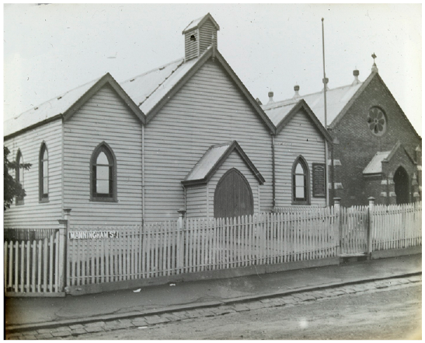
St Georges Church of England and Hall, Manningham Street, between 1906 and 14; photo by Arthur Fox. Source: Pictures Collection, State Library of Victoria, Accession No. H90.137/105

END

Royal Park, Flemington Road
To return to Gatehouse Street, you can ride on the track through Royal Park. Otherwise, downloading the arevo app from this link may be helpful to you: melbourne.vic.gov.au/cycling-lanes-and-routes.
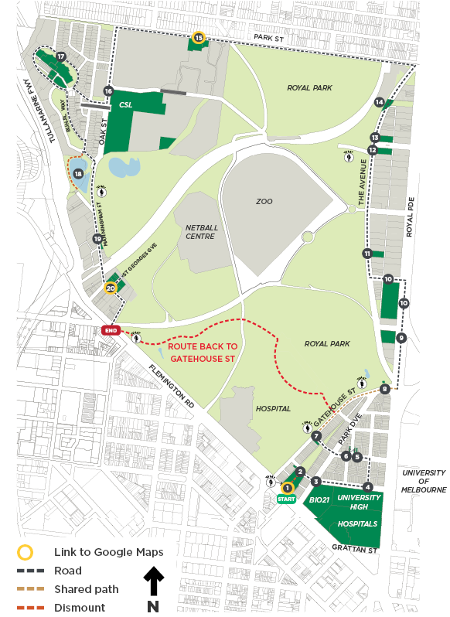

END NOTES
- aboriginal-map.melbourne.vic.gov.au/, retrieved January 2024.
- City of Melbourne, unpublished research.
- Parkville resident, October 2023.
- City of Melbourne, unpublished research.
- Brine, J, 2012, ‘David Arthur Lewis Saunders’, Australian
- Dictionary of Biography website, accessed on 4 January
- 2024, https://adb.anu.edu.au/biography/saunders-david-ar
- thur-lewis-15756.
- Royal Park Protection Group, website, accessed
- 27 November 2023, https://royalparkprotect.com.au/ar
- chives/general/walmsley-house/
- Royal Park Protection Group, website, accessed
- 27 November 2023, https://royalparkprotect.com.au/ar
- chives/general/walmsley-house/.
- City of Melbourne, 1957–67, street card for Macarthur Road.
- Melbourne 1945 website, accessed 1 December 2023,
- https://1945.melbourne.
- City of Melbourne, unpublished research.
- City of Melbourne, unpublished research.
- Atkinson, H, 1991, Suburban Tickets of the Victorian
- Railways, Regal Press, Launceston.
- Atkinson, H, 1991, Suburban Tickets of the Victorian
- Railways, Regal Press, Launceston, p.216.
- Heritage Council of Victoria, Victorian Heritage Database
- website, accessed 1 December 2023, https://vhd.heritage
- council.vic.gov.au/places/2633.
- vhd.heritagecouncil.vic.gov.au/places/2633, retrieved
- 1/12/23.
- vhd.heritagecouncil.vic.gov.au/places/2633, retrieved
- 1/12/23.
- City of Melbourne, CoMPASS map, accessed December
- 2023.
- Friends of Royal Park website, accessed 2 December
- 2023, https://royalpark.org.au.
- Friends of Royal Park website, accessed 2 December 2023
- and 5 January 2024, https://royalpark.org.au.
- The Herald, Melbourne, 18 December 1916, p.3. Quoted by
- GML Heritage in the Parkville Heritage Review.

Back Cover
We hope you enjoyed the Parkville self–guided bike ride, which was prepared as part of the Parkville Heritage Review.
The Parkville Heritage Review recommends heritage protection for a range of places, some of which you have visited today.
Visit participate.melbourne.vic.gov.au/parkville-heritage-review by 31st October 2025 to find out more and have your say.

