
Yarra River - Birrarung Strategy
Future aspirations for Melbourne’s inner city river
December 2019
A city planning for growth

Melbourne will be a leader in planning for growth and technological advancement. We will guide and influence the future development of the city for the benefit of all city users and in a way that values and celebrates its historical and cultural identity.

Acknowledgement of Traditional Owners
The City of Melbourne respectfully acknowledges the Traditional Owners of the land, the Boon Wurrung and Woiwurrung (Wurundjeri) people of the Kulin Nation and pays respect to their Elders, past and present.

Contents
Foreword from the Lord Mayor of Melbourne and Councillor Reece 5
Introduction 6
Vision 13
Strategic directions 16
Ecology 18
Strategic directions 20
1. Riparian greening 20
2. Ecologically connected 22
3. Resilient 24
Culture 27
Strategic directions 28
4. Collaborative 28
5. Visible 30
6. Maritime 32
Place 33
Strategic directions 34
7. Inviting 34
8. Multi-functional 36
9. Public 38
10. Legible 42
Movement 46
Strategic directions 47
11. Slow 47
12. Integrated 49
13. Accessible 51
Implementation 54
Current capital works 54
Policy summary 55
Actions summary 56

Issue for Future Melbourne Committee – 3 DECEMBER 2019
Cover Image: Yarra River, Birrarung, aerial view looking east. Photo Credit: City of Melbourne
Disclaimer
This report is provided for information and it does not purport to be complete. While care has been taken to ensure the content in the report is accurate, we cannot guarantee is without flaw of any kind. There may be errors and omissions or it may not be wholly appropriate for your particular purposes. In addition, the publication is a snapshot in time based on historic information which is liable to change. The City of Melbourne accepts no responsibility and disclaims all liability for any error, loss or other consequence which may arise from you relying on any information contained in this report.
To find out how you can participate in the decision-making process for City of Melbourne’s current and future initiatives, visit melbourne.vic.gov.au/participate

Foreword from the Lord Mayor of Melbourne and Councillor Reece
The Yarra River, Birrarung, has played a pivotal role in the Aboriginal history and modern development of Melbourne. The river continues to be critical to Melbourne’s identity, appeal to tourists and liveability.
The Birrarung Many cities around the world embrace their rivers and in Melbourne we have an exciting opportunity to transform our waterfront.
This strategy focuses on the city’s relationship with the Birrarung, our Yarra River, to reveal the layers of history, particularly the Aboriginal significance, and to guide our approach to improving the river environment.
The Yarra River is one of our most important assets and we are at a pivotal point for its future. We want to turn our focus to our waterfront areas. How do we enhance them and create more inviting spaces for people to gather?
We can begin with pilot projects to transform the hard edges of the river to improve habitat and biodiversity. We’re also investigating how best to reflect the importance of the river in Aboriginal culture. During our recent community consultation, many ideas were posed, from more launching points for kayaking and boating to connecting up some of our city’s most attractive walking routes along the river and creating safe routes for commuter cyclists.
However, our draft strategy identified some challenges that need to be overcome. Habitat for native species has been degraded along sections of the Yarra River and areas have flooding risks. These challenges are shared ones as the City of Melbourne does not own or independently manage the waterway. We need to work closely with other authorities to ensure we coordinate our actions to improve the health of the Yarra River.
The City of Melbourne recognises areas for improvement and this strategy helps guide the long term future of our urban river.
To protect and improve the Yarra River for the future, we have identified opportunities to:
- Improve the natural environment along the river;
- Learn more about the history of the river; and
- Make it easier for people to move around and enjoy the river.
Melbourne people want to know the story of the river and this strategy ensures we value the river’s cultural and ecological significance in all that we do. We look forward to working with all in the community who enjoy our river in the city’s heart.

Sally Capp Cr Nicholas Reece
Lord Mayor Portfolio Chair, Planning
In this strategy, the Yarra River is also called by its traditional name Birrarung meaning ‘river of mists’ in the Boon Wurrung and Woiwurrung languages.

Introduction
Yarra River, Birrarung, is one of the defining features of central Melbourne, providing both a recreational area and destination for many of the activities that contribute to the life of the City. As Melbourne continues to experience significant growth and change, it is increasingly important to preserve and celebrate our city’s greatest natural asset.
The Yarra River, Birrarung, corridor has strong ecological, cultural, economic and social significance to Melbourne. Over recent decades, the inner-city reaches of the river have evolved markedly, however the substantial potential of this asset as a living ecological entity remains to be fully realised.
Areas from Punt Road to Princes Bridge have long recognised the recreational benefits of the Yarra River, Birrarung, however to the west, particularly along the Northbank, surrounding uses have little relationship with the waterways and there is limited expression of cultural heritage. The complex land ownership and governance arrangements also challenge decision making and the delivery of change.
As Australia’s fastest growing city, Melbourne has a great opportunity to broaden the way we use our river and its edges. Increasing worker, residential and visitor populations will also put additional demands on the public space, recreation and movement uses of the river and create challenges to the river health. Sustaining and improving the, Yarra River, Birrarung has never been so important.
There is a need to rehabilitate and improve the natural spaces along the river corridor, not only to benefit the growing population but as a commitment to restoring the ecology of the river. An opportunity to improve reconciliation with the traditional owners is a key ambition of this strategy and also a key challenge for a rapidly growing city. Ultimately, the goal is to significantly raise the health and quality of the Yarra River, Birrarung, environs in the city to be central to Melbourne’s economy, culture and liveability.

Purpose
This strategy defines City of Melbourne’s vision and direction for the inner-city reaches of the Yarra River, Birrarung. It will direct policy decisions and inform all future capital works project planning within the City of Melbourne’s river corridor. The strategy also provides an advocacy tool to guide the City of Melbourne, adjoining landowners and investors, in preserving and evolving the Yarra River Birrarung’s character and liveability and offer a planned response to avoid ad hoc decisions and holistically shape future proposals.
The overall management of the river is highly complex and fragmented. Many of the opportunities for the river corridor are outside of direct City of Melbourne control and within the jurisdiction of other government agencies or the private sector. Many of the issues and inconsistencies along the river, including challenges from activation proposals, come from organisations operating independently and with different remits. This strategy provides an agreed City of Melbourne direction for the Yarra River, Birrarung, and seeks to create alignment and identify mutually beneficial outcomes where possible.so important.
Strategy development
A ‘place based’ approach has been taken for this strategy to provide a multi-layered understanding of the complex urban waterways environment; the physical, cultural, economic and social aspects of place. The approach is informed by an understanding of how natural systems have been adapted by the presence of people, and how the built environment has impacted on natural systems.
The development of this Strategy was based on the following approach:
- A review of relevant plans, strategies and policies that influence the planning and design of the waterways across the City of Melbourne municipality.
- Site visits involving observing user activity and behaviour and the influence of the physical environment on their behaviour.
- Reference to the City of Melbourne’s pedestrian counting data at key locations across the corridor and to previous speed and volume surveys undertaken through recent studies.
- Pre-contact historical research of vegetation and landscape conditions and understanding of the process of change.
- Recognition of post-contact maritime heritage aspects like wharves, vaults and warehouses along the river.
- Multi-layered analysis of: biodiversity and urban forest; topography and flooding; place and urban design; access and movement; and activation and uses.
- A review of international best practice in urban waterfront developments and their relevance in the Melbourne context.
- Key internal and external stakeholder engagement, including discussions with the Traditional Owner groups.

Image 1. A ‘place based’ strategy
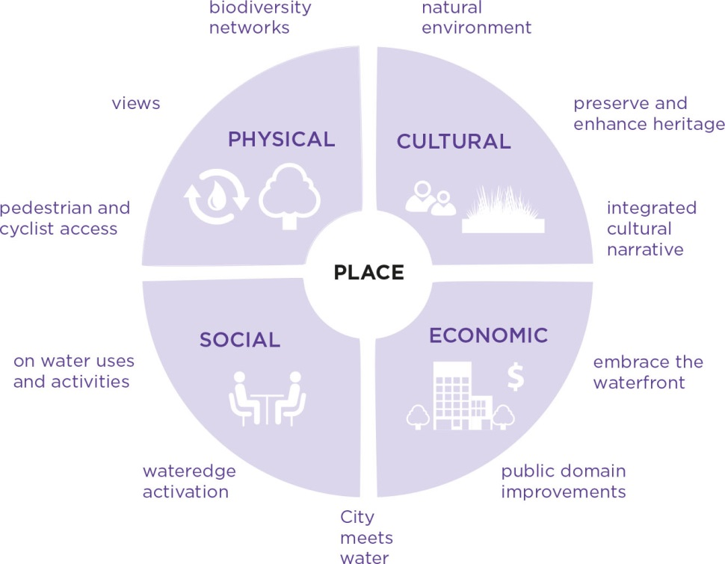

Community feedback
A draft strategy was endorsed by the Future Melbourne Committee on 16 April 2019 for community engagement. The public consultation process on the draft strategy involved online and face-to-face engagement activities including pop-ups along the river, an online survey, stakeholder meetings, displays in community facilities, social media posts and an ideas forum.
There was significant interest in the draft strategy:
42,000 people alerted to the project via social media
5,000 visits to the Strategy web page
79 Participate Melbourne survey responses
128 Participate Melbourne online Ideas Forum posts
100 face-to-face engagement responses
13 formal detailed stakeholder submissions
Overall, respondents supported the draft strategy. Participant feedback indicated that 90% of respondents ‘strongly agreed’ or ‘agreed’ with strategic directions outlined under the four themes.
The ecology directions received the most enthusiastic support from survey respondents with aspirations for the river to be ‘more natural’ and healthy. There was also broad agreement that Aboriginal heritage be acknowledged via a visible presence in any changes to the river or its banks. Other themes included greater recognition of the maritime history of the river.
A Yarra River Big Ideas Forum including Government, business and community stakeholders was held on 15 August 2019 by Yarra River Business Association. Key ideas from this have informed this Strategy.

Strategic context
The Yarra River - Birrarung Strategy has been informed by key policies and legislation:
- Yarra River Protection (Wilip-gin Birrarung murron) Act 2017
- Melbourne Water – Yarra Strategic Plan (Draft in development)
- Yarra River 50 year Community Vision
- Wurundjeri Water policy Nhanbu narrun ba ngargunintwarn Birrarung,( Ancient Spirit and Lore of the Yarra)
- Lower Yarra River Management Advisory Committee Report
- Protecting Victoria’s Environment – Biodiversity 2037
- Water for Victoria (2016)
- Melbourne Water’s Healthy Waterways Strategy 2018
City of Melbourne
- Open Space Strategy 2012
- Transport Strategy 2030
- Bicycle Plan
- Total Watermark – City as a Catchment 2014
- Urban Forest Strategy 2012–2032
- Moonee Ponds Creek Strategic Opportunities Plan
- Elizabeth Street Strategic Opportunities plan
- City Road Masterplan
- Docklands Public Realm Plan
- Domains Parklands Masterplan 2019-2034
- City of Melbourne Design Standards
- Nature in the City Strategy 2017
- Integrated Water Management Plan 2014.
Melbourne Water – Yarra Strategic Plan
“Our Yarra River, Birrarung, is recognised around the world as an iconic example of a nurturing relationship between a river and its community…” 50 year Community Vision, Draft Yarra Strategic Plan. In parallel with development of this Strategy, Melbourne Water has been leading delivery of the Yarra Strategic Plan Melbourne Water’s first step in devising The Plan involved inviting the broader community to contribute to the development of the Yarra River 50 Year Community Vision. Capturing the entire 200km expanse of the river, the Vision is that “Our Yarra River, Birrarung, is recognised around the world as an iconic example of a nurturing relationship between a river and its community.”
The City of Melbourne supports this direction and looks to apply these values of a positive, prosperous and healthy connection with our waterways to focus on the unique characteristics of our municipal area of the Yarra River, Birrarung. This strategy will inform and guide Council’s input to the Yarra Strategic Plan and will be complementary in terms of offering more place specific discussion for the Yarra River, Birrarung. Melbourne Water is working towards a public draft by late 2019 and a final, Ministerial approved plan in late 2020.
Study area and conditions today
The focus of the Strategy is the inner city reaches of the Yarra River, Birrarung, covering the area of river from Punt Road to Bolte Bridge, as indicated in the map below. The Port of Melbourne land is not included, due to the long term lease arrangement to 2066 providing limited scope to influence change in this area.
Image 2. Plan of the study area with key open spaces and bridges and images illustrating some of the key challenges:
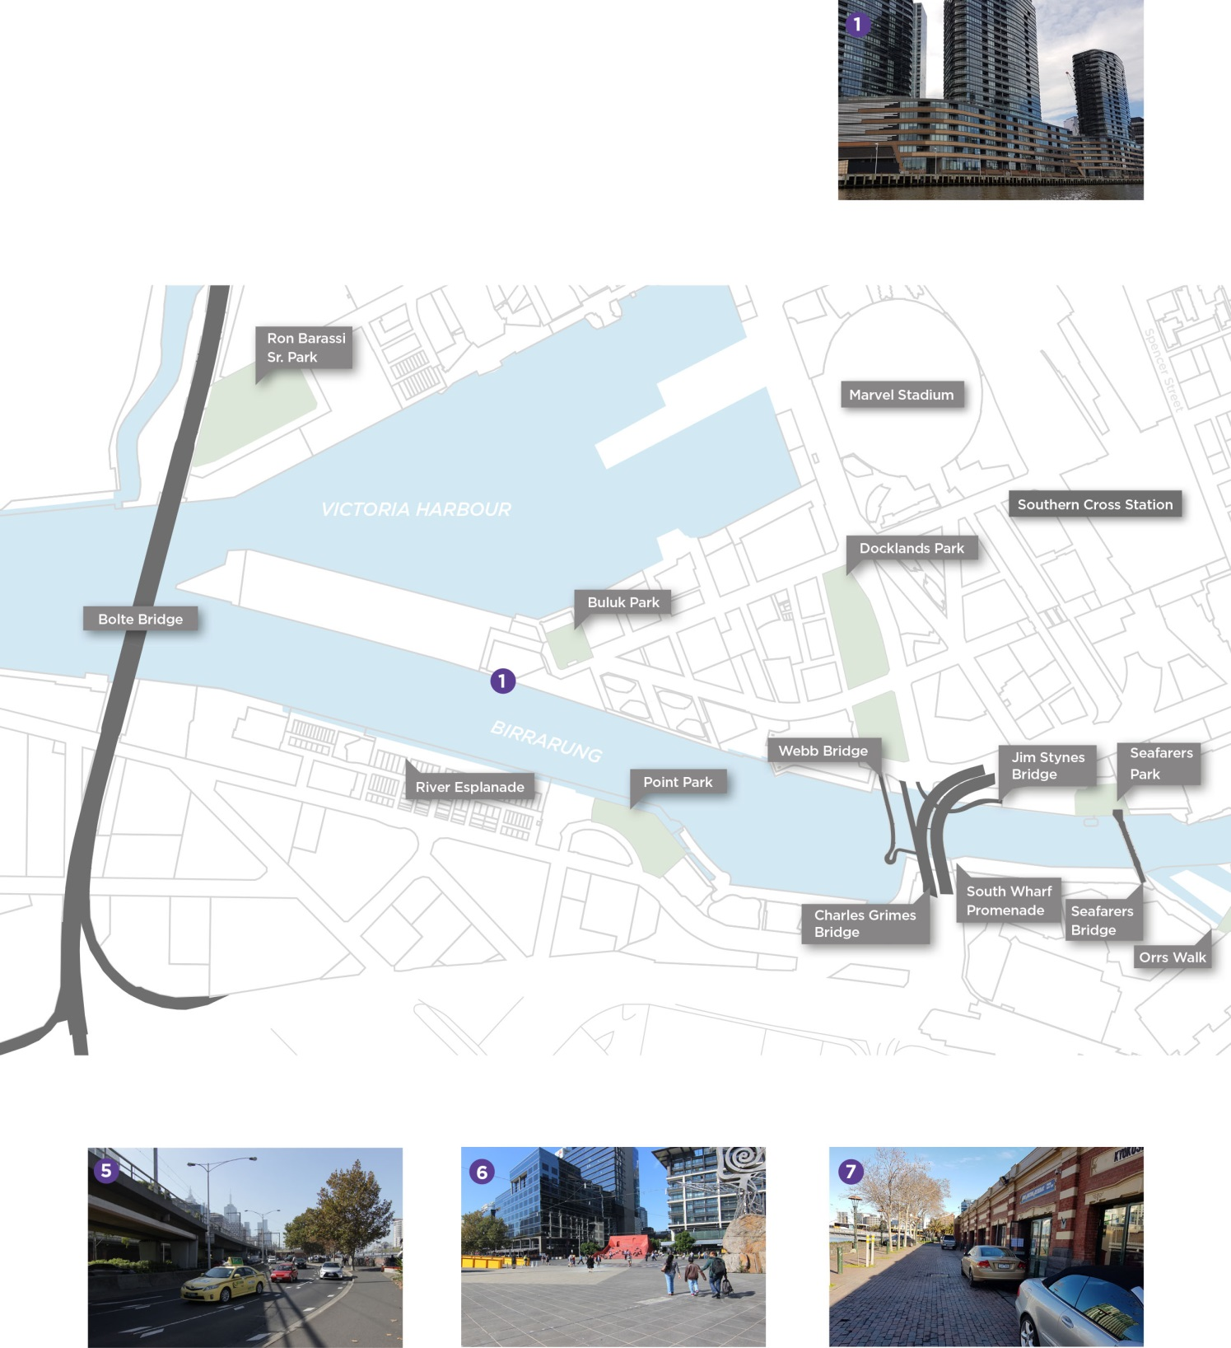
.
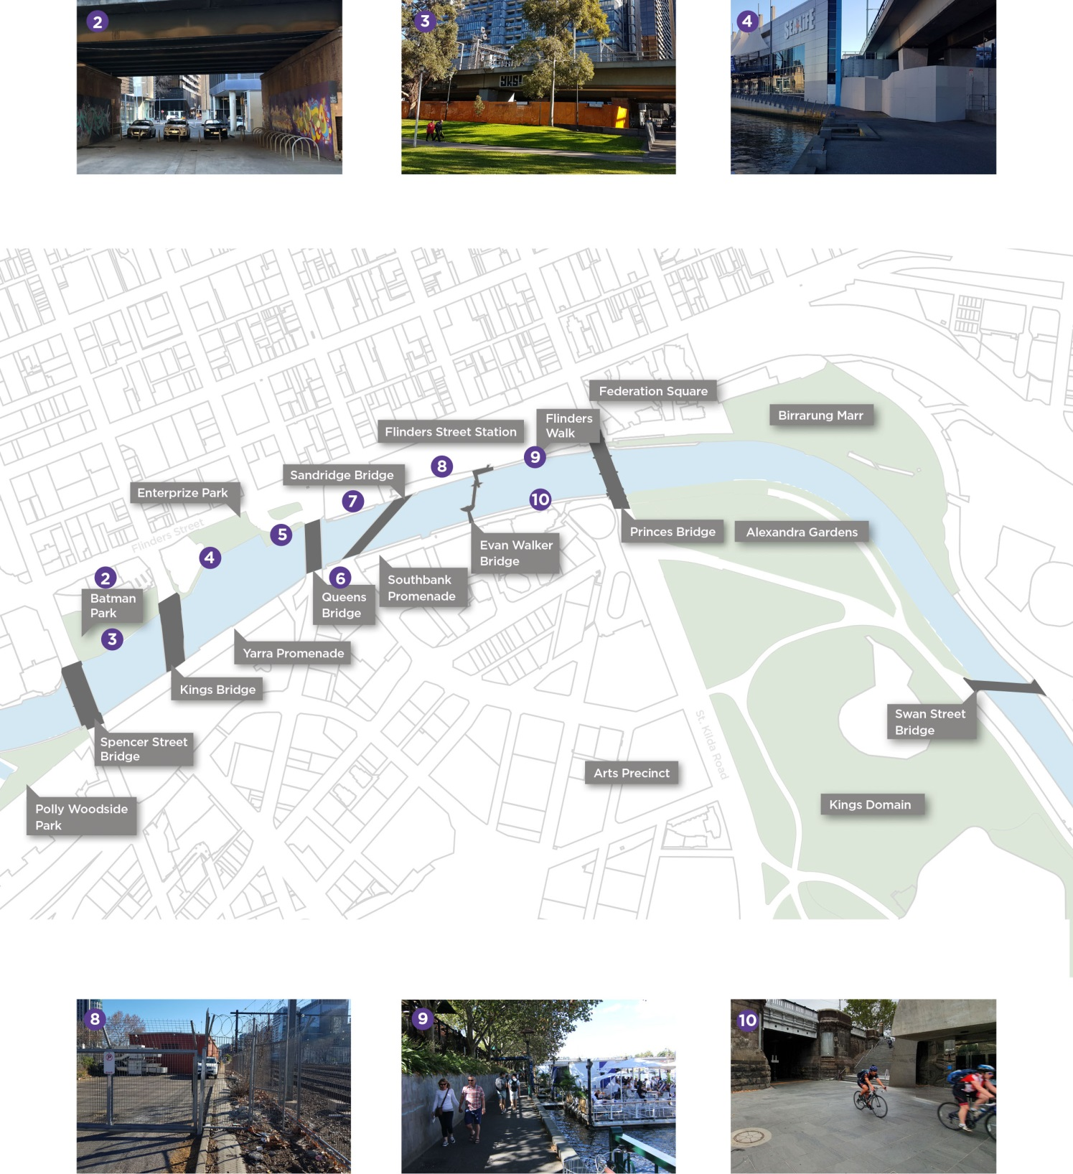

Vision
The Yarra River, Birrarung, will be an inspiring public waterfront that celebrates the rich Aboriginal culture and offers a green sanctuary, loved by Melbournians.
Evoking the richness of the pre-contact landscape and enhancing the ecological values, the River immerses people in nature. The Yarra River, Birrarung, is restored as a healthy water landscape experience.
The significant Aboriginal and maritime history and cultural values of the Yarra River Birrarung are celebrated. The sites, stories and memories offer a place of reflection, education and enrichment.
Melbourne’s river is celebrated as a defining feature of the city’s identity. The Yarra River, Birrarung, and its banks are an attractive complement to the central area, offering important open space amenity, a diversity of uses and new economies and destinations that are welcoming to all.
Spacious public spaces connect the river creating an important destination and place to enjoy the journey away from the intensity and rush of the urban centre. Through improved access to and along the waterfront, the river provides the natural complement to the fast pace of the City and Southbank.
Image 3. Artist’s impression of a possible long term improvements to the Yarra River, Birrarung (Illustrative for discussion purposes only).
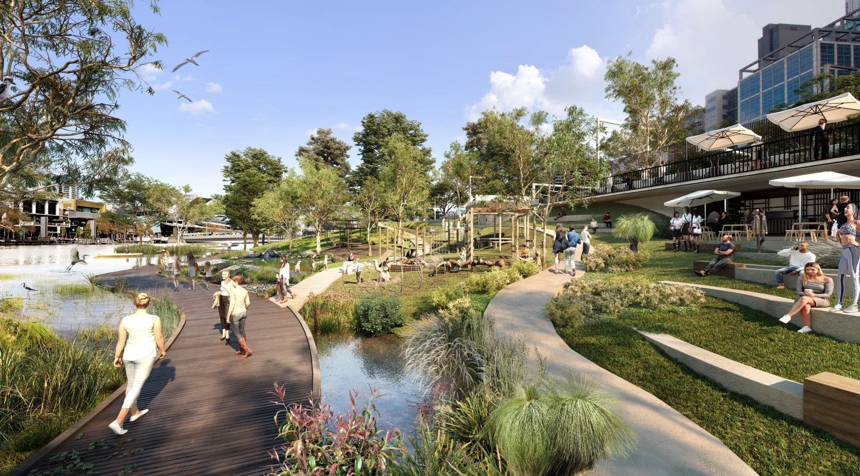
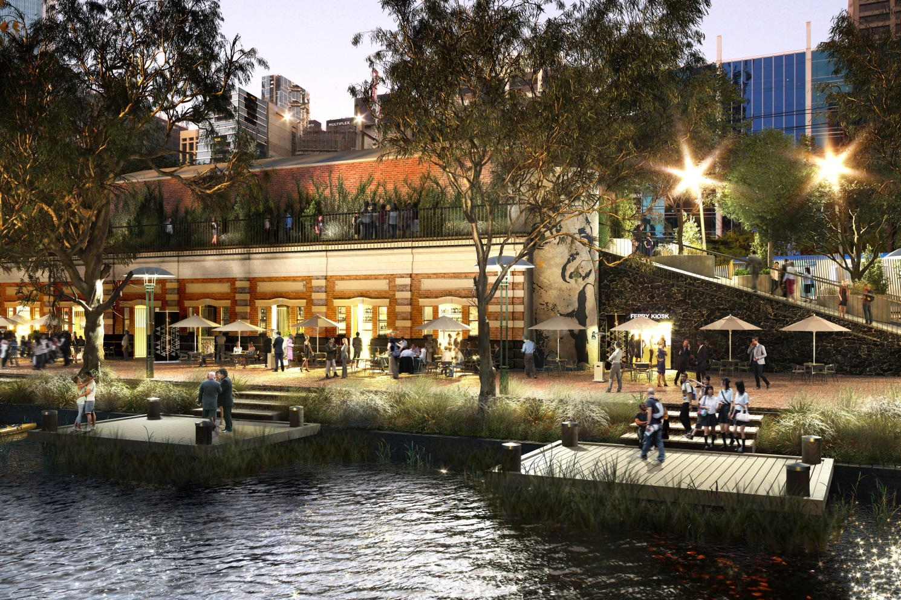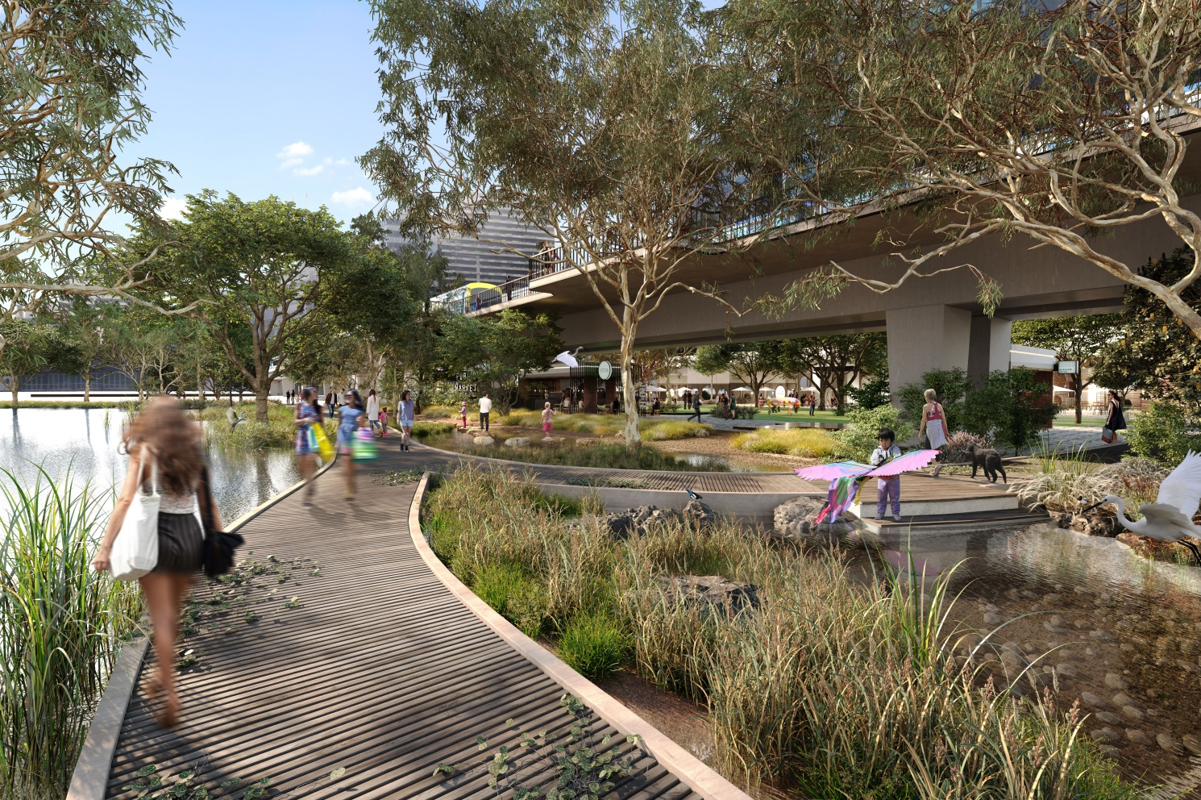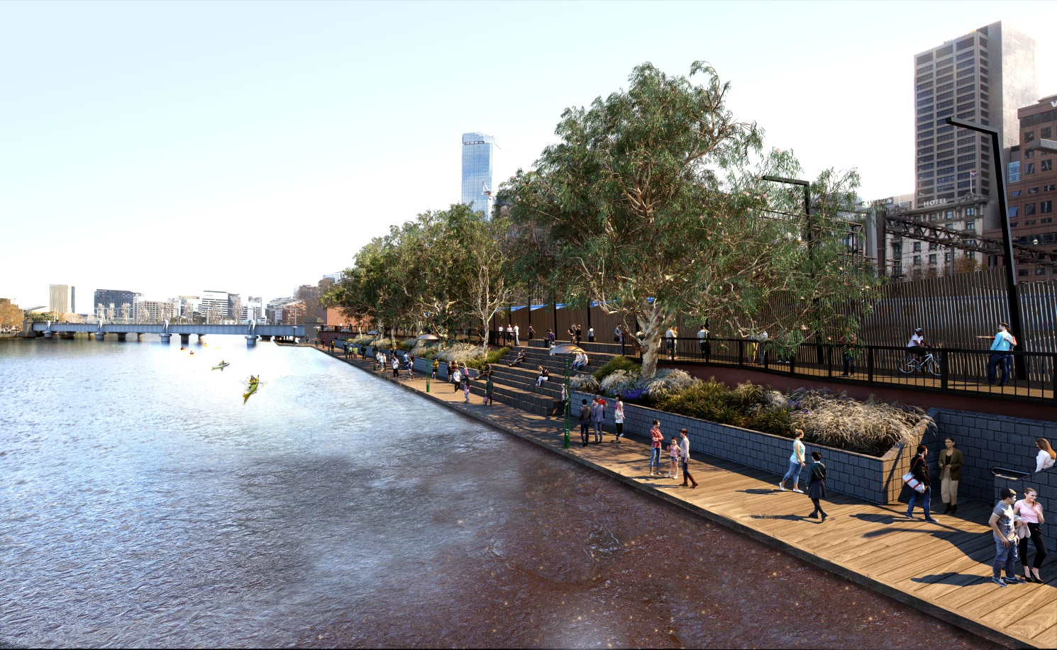

Strategic directions
Organised around four key themes of Ecology, Culture, Place and Movement, the following strategic directions are to guide appropriate actions and future development of the inner Yarra River, Birrarung corridor, bringing the vision to life.

Theme 1. ECOLOGY
- 1. Riparian greening
Transform the hard edges of the river banks with vegetation to promote a healthy river ecosystem.
- 2. Ecologically connected
Prioritise an Indigenous planting palette and increase greening to improve local biodiversity and ecological networks.
- 3. Resilient
Address flood risk and improve water quality.

Theme 2. CULTURE
- 4. Collaborative
Collaborate with Traditional Owner groups to help tell the living cultural story of the Aboriginal connection to the Yarra River, Birrarung.
- 5. Visible
Increase the public visibility of Aboriginal intangible heritage of the Yarra River, Birrarung, through interpretation and information.
- 6. Maritime
Recognise the historical and contemporary importance of the maritime uses of the Yarra River, Birrarung.

Theme 3. PLACE
- 7. Inviting
Prioritise Northbank renewal to create an inviting destination adjacent to the City.
- 8. Multi-functional
Celebrate character areas and encourage new economies: a range of high quality civic, educational, cultural, hospitality and water dependent uses.
- 9. Public
Sustain the civic focus by encouraging activation that supports an inclusion, public waterfront.
- 10. Legible
Rationalise clutter and on-water infrastructure to ensure unobstructed views and vistas.

Theme 4 MOVEMENT
- 11. Slow
Distinguish the river as a slower paced environment by creating safe, alternative north and south bicycle routes.
- 12. Integrated
Better integrate pathways along and leading to the riverfront, particularly to the north-west.
- 13. Accessible
Raise the quality and universal accessibility of riverfront pathways and crossings.

Ecology
Evoking the richness of the pre-contact landscape and enhancing the ecological values, the river immerses people in nature. The Yarra River, Birrarung, is restored as a healthy water landscape experience.
The City of Melbourne is increasingly facing significant challenges: climate change, flooding, urban heating and population growth. These will place pressure on the urban fabric, services and people of the city. We need to respond to these challenges by proactively building healthy resilient landscapes for future generations. The Yarra River, Birrarung, plays a critical environmental role in this context.
The Yarra River, Birrarung, has the potential to be the major biodiversity connector in the Melbourne municipality. It could connect biodiversity hotspots in the city and become a key link for flora and fauna, forming unique urban ecosystems. These ecosystems are also crucial for maintaining health and wellbeing by filtrating air and water and providing shade and places for recreation.
The delta landscape of Melbourne has many low lying and flood prone areas along the waterways. Effects of flooding and impacts on water quality are particularly damaging in the lower reaches of the river being the outlet of the entire Yarra River, Birrarung, catchment.
Key ecology and water challenges are:
- The ecological values and biodiversity of the original landscape in the wider delta region have been removed or significantly modified. High biodiversity values are now limited to ‘hotspots’ (Royal Park, Domain, Westgate Park).
- There is little or no riparian habitat available for fauna in the city reach of the river. River edges are primarily made up of hard materials and surfaces reducing the ability of riparian land to act as a corridor for wildlife.
- There is limited opportunity to be close to the water and be immersed in an experience of urban nature away from the bustling city.
- There is risk of flooding through significant rain events with water levels in the river rising and main storm water drains being affected at Elizabeth Street, King Street, Spencer Street and Clarendon Street.
- Flooding levels will be further exacerbated through expected sea level rise in the coming decades. This will particularly affect the western part of the city.
- The health of the river is poor and unsafe with high levels of pollution. Water quality is an issue along with sewage and stormwater discharges.
- Other threats to river health are litter, pollution, urban development and invasive species.

Image 4. Melbourne’s pre-European landscape types and present day suburbs.
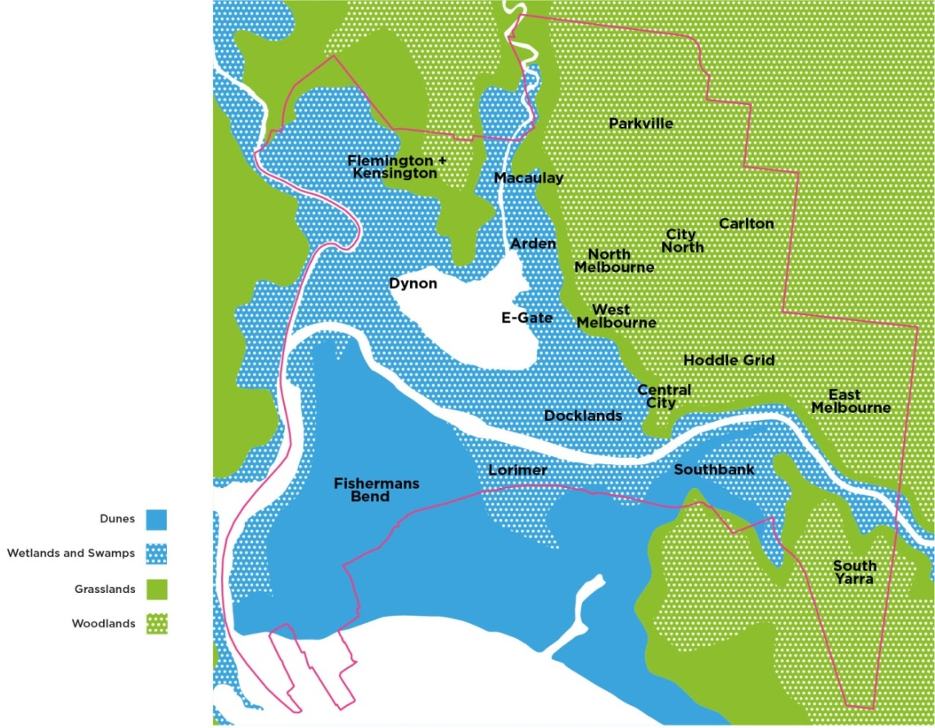

Strategic directions

1. Riparian greening
Transform the hard edges of the river banks with vegetation to create a healthy river ecosystem.
Pre-settlement, the riparian zone along the Yarra River, Birrarung, provided wildlife habitat and movement corridors, enabling river fauna and flora to migrate between habitats along the river system. The vegetation on the rivers edge reduced soil erosion and minimised flood damage.
Today, the river is mostly channelised through stone or concrete application on its banks. Most of the original wetlands have been removed and the smaller streams have been culverted. The landscapes edging the river have been urbanised and habitat values have diminished.
A key strategic direction for the future of the river is for new initiatives and projects in the public and private realm to contribute to a restoration of and return to riparian qualities. Internationally, there are many river cities that have reintroduced and partly revived their river edges through inspiring projects. Examples of this are:
- Chicago River ‘Wild Mile’ river rejuvenation project with new floating habitat
- San Antonio River Improvements Project with urban riparian restoration
- Paris river Seine floating green barges with activation of the river’s edge and creation of ecological habitat
- New York ‘Swale’ project is a mobile food-forest on a barge moving between river edge communities.
Riparian vegetation
Riparian vegetation has a prominent role in supporting a diversity of species and improving water quality. A primary strategic direction for the Yarra River, Birrarung, is to transform the hard edges of the river banks with vegetation with the aim to reintroduce and improve the ecological riparian condition in the city. The river includes many shallow sections that could potentially be transformed to incorporate riparian vegetation.
Four different types of riparian vegetation have been identified as opportunities in the tidal environment of the Yarra River, Birrarung. These are:
- Dry riparian zones.
- Wet riparian zones.
- Floating structures with vegetation.
- Tidal wetlands (inundated at high tide).
Prominent potential locations for riparian greening are the park interfaces with Birrarung Marr, Batman Park and Enterprize Park. The Domain Parklands Masterplan specifically indicates opportunities for native planting at the river edge, particularly with new understory planting adjacent to the river.
The City of Stonnington has been developing the Yarra River Biodiversity Project since 2010 to increase habitat connectivity along the river. There is an opportunity for the river edge along Domain and Birrarung Marr to align with the indigenous riparian revegetation works in the adjoining local government area and optimise connectivity for biodiversity.
Some areas of the river including Southbank and Docklands have an urbanised edge and limited opportunity to incorporate riparian planting within the edge. In these locations there are opportunities to improve biodiversity within the river environs through floating structures with vegetation at the water’s edge. The Chicago Riverwalk is an example of a successful floating landscape on an urban scale that provides riparian regeneration, positive biodiversity outcomes and recreational areas of respite that inform visitors of the local ecological context.
Technical aspects, marine transport, intensive people use and rubbish collection need to be considered with the type of solution and the type of planting. Trials and pilot planting programs are required to test species selection and technical solutions along various sections of the river to test success of planting, wildlife attraction and maintenance.
Policy 1: Encourage riparian greening along the Yarra River, Birrarung, including existing river banks
Action 1: Deliver a trial project of riparian vegetation on the river bank in collaboration with State Government
Action 2: Deliver a trial project for floating vegetation in the river in collaboration with State Government.

2. Ecologically connected
Prioritise an Indigenous planting palette and increase greening to improve local biodiversity and ecological networks.
The pre-contact landscape of Melbourne incorporated a rich variety of vegetation types along the river with reed swamps, brackish wetlands, swamp scrub and mangroves. The landscape character of the original vegetation has completely disappeared and is mostly replaced with exotic vegetation, consisting of lawn and introduced trees.
Today, larger open spaces and reserves like Westgate Park in Fishermans Bend and the Royal Botanic Gardens have re-established biodiversity hotspots in the city. Waterways act as a connector for wildlife and the spread of vegetation through a connected habitat framework for water and land based species particularly birds, reptiles and frogs.
The benefits of a more connected habitat framework with restored and improved biodiversity values for the city are wide ranging. This is articulated in the City of Melbourne Nature in the City Strategy 2017 with ‘The city as an ecosystem’ philosophy.
The City of Melbourne Urban Forest Strategy 2012-2022 and both the Central City and Southbank Urban Forest Precinct Plans indicate that many trees in the river corridor have a limited ‘useful life expectancy’. The Urban Forest Strategy proposes that many European tree types in the city should be replaced by other species, including native and indigenous ones. This will improve tree diversity, tree health and decrease vulnerability to diseases and pests.
A native planting palette
Through tree diversity and the introduction of more understory planting, the river precinct will regain some of its original characteristic vegetation including riparian plant communities, where possible. This will provide a clear river landscape identity and distinction from the city street landscape character. The use of native and indigenous species will provide a greater link to place and the Aboriginal history, establishing a characteristic Yarra River, Birrarung, experience in the heart of Melbourne.
In selecting species, the specific soil conditions, local climatic constraints and future climate change effects must also be considered. More extreme weather events including drought and flooding will require resilient species. The growing conditions along the river corridor are highly modified from presettlement conditions and in some instances quite challenging for native species. Therefore a mix of exotics and natives will continue to be part of the river landscape.
Connecting with nature
Introducing new trees and vegetation along the river, including mid height plants and ground cover, will re-establish a movement corridor for urban wildlife and increase the areas for fauna habitat. It will encourage people to engage with the natural environment in the city and be immersed in a riverine experience.
Masterplanning for both the Royal Botanical Gardens and the Domain are highlighting the opportunities for physical connections with nature for the community. The Yarra River - Birrarung Strategy aligns with this principle and interpretive signage and other forms of education about the river landscape should be provided to encourage more interest and engagement.
Consider additional green infrastructure in parallel streets like Flinders Street, Siddeley Street and Whiteman Street as opportunities to strengthen the movement corridor for biodiversity along the river corridor. Improvement of a river biodiversity corridor is being complemented by individual initiatives like the proposed Melbourne Sky Farm and its offering for learnings across sustainable food production, biodiversity and urban cooling.

Saltmarsh habitat
Recreating riparian habitat conditions will likely attract wading birds like White-faced heron, Nankeen night heron, Great egret and Royal spoonbill. These species are now increasingly found in urban environments (like Royal Botanical Gardens and Carlton Gardens) and are likely to use the Yarra River, Birrarung, if appropriate habitat conditions are being reinstated. Creating the right conditions for wetland birds will increase the likelihood of other fauna establishing itself in the river corridor and in general aid in the connectivity for species.
Policy 2: Encourage a native and resilient planting palette along the Yarra River, Birrarung, promoting nature in the city.
Policy 3: Encourage riparian habitats in urban parks edging the Yarra River, Birrarung.
Action 3: Develop a plan for interpretive signage highlighting the natural river environment in collaboration with Parks Victoria and Royal Botanic Gardens.

3. Resilient
Address flood risk and improve water quality.
Flooding is an increased risk for the city as a result of sea level rise and changes in intensity of rain events. Both Southbank and Northbank will increasingly be affected by flooding from rain events. More intense storm events will also result in poorer water quality, increased sediment and nutrient loads, reduced oxygen, rapid alteration of habitats, and reduced amenity and access for communities.
Historically, the river was part of a dynamic delta landscape where flooding was a regular event where the river would expand over the floodplain. In the urban context, there is no space for the river to expand and water is being channeled through the city in order to clear the urban space from storm water as quickly as possible. As a result, the riparian condition of the waterways has been degraded and minimal amounts of vegetation remain or have been partly replanted more recently. This has significantly reduced the ability of riparian land to act as a natural bio filter, to stabilise the river banks and to dampen flood peaks.
Sponge City
An approach that some cities take to address flooding and water quality is to think of the city as a sponge. In order to minimise the effects of flooding, stormwater is captured, retained, filtered and slowed down as much as possible. The ‘Sponge City’ concept promotes the idea of a managed urban floodplain.
This strategic direction is intended to explore opportunities to physically combine stormwater management measures with new approaches to public realm spaces at the river edge. These could be designed to retain water volumes in a peak rain event and slow down runoff significantly. Measures could include retention tanks, wetlands, raingardens and permeable pavements. Open spaces could also be utilised to partly accommodate excess rain water volumes during storm events.
The Sponge City concept will allow the riverfront to be an attractive and inviting area that isn’t constrained by its relationship to water, but instead is enhanced by it. It will generate opportunities to shape environmental quality and local identity in different sections of the river. It will also make water more visible in places where people interact with it.
River water quality
To enhance the health and biodiversity of our waterways, we need to reduce stormwater pollutants and improve water quality. The City of Melbourne Total Watermark Strategy (updated 2014) and Integrated Water Management Plan (2014) highlight water quality for liveability and for the environment. A water quality target for stormwater is set for 2030 as a 30% reduction in Total Nitrogen contributed to the waterways from the municipality of Melbourne’s catchment (baseline year 2000). Melbourne Water recently finalised the Healthy Waterways Strategy 2018 which sets out targets for water quality, supporting community health and wellbeing.
Internationally there are many river cities that have introduced projects that bring people back to the river by advocating for a swimmable and healthy waterway. The Copenhagen ‘Havnebadet’ is an iconic example of urban river swimming that has promoted a clean harbour and has transformed the harbourfront use. The Yarra River, Birrarung has a proud recreational history pre and post contact, including swimming races. Recent community led ideas like the Yarra Pools focus on the idea of swimming to raise water quality issues and provide new recreational opportunities.
Sunlight on the river
The living quality of the river is being affected negatively by the lack of sunlight due to development overshadowing. Sunlight for people in public spaces on the riverbank is also less available, particularly on the Northbank. The remaining areas that do receive sunlight along the river need better planning protection.
Policy 4: Encourage Sponge City strategies in the public realm and private development adjacent to the river.
Policy 5: Encourage initiatives in the city reach of the river to improve water quality in collaboration with Melbourne Water including filtration of water runoff.
Action 4: Address planning scheme gaps in sunlight protection to the river and adjacent public spaces (outside the Capital City Zone).
Action 5: Develop urban design guidelines for flood prone areas across the municipality in the public and private realm.
Image 5. Habitat Plan
Illustrative plan of the preferred spatial distribution and priorities for future riparian zones along the central city area of the Yarra River, Birrarung.
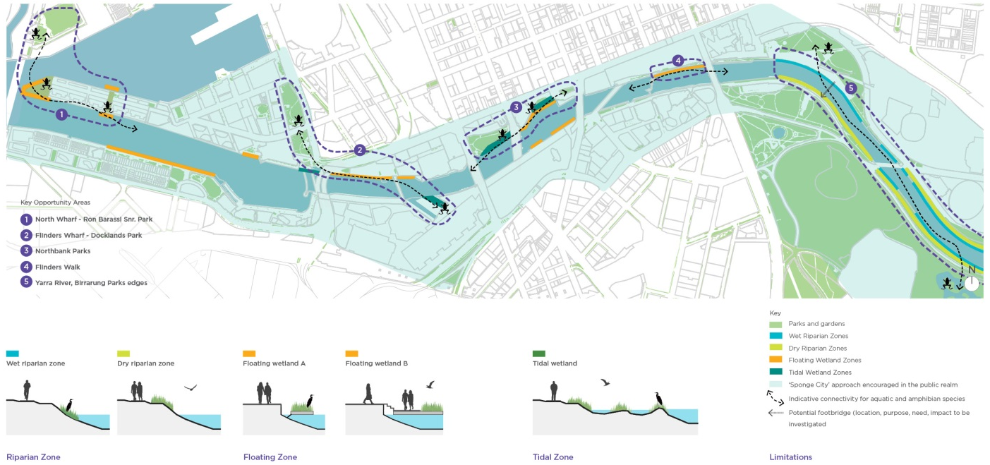
Riparian zone
The section of the Yarra River, Birrarung with basalt rock beaching has the potential to be revegetated, softening the edges of the river and creating habitat in the city. This approach is costructible and cost effective given there are no significant changes to the existing assets.
Floating Zone
The floating zones have been identified at sections of the river with a hard edge that are not already occupied by berthing areas. Two types have been considered that move with the tides, floating wetlands (tethered) and floating garden beds (both with roots in contact with the river below).
Tidal Zone
The aim of a tidal wetland is to attract wading birds that feed in brackish tidal environments and to create opportunities for education and engagement. This wetland type will be in open connection to the river and will require protection from floating debris and bow waves from river traffic. A previous trial at the Jim Stynes Bridge with mangrove planting has partly failed because it was too exposed to the river.
Limitations
Any physical additions to the rivers edge should not create any conflicts with the boating on the river. Boating and berthing require navigable waters in the river with a minimum of 41m for commercial and recreational vessels (2 way traffic) and 50m wide for rowing (4-lane rowing course. For access to the various wharves and landings, dredging is required to occur and maintain the min 50m navigable width. Boat berthing zones are excluded from any additional riparian vegetation.

Culture
The significant Aboriginal and maritime history and cultural values of the Yarra River, Birrarung, are elevated and celebrated. The sites, stories and memories offer a place of reflection, education and enrichment.
There are many cultural values and spatial characters within the Yarra River, Birrarung, urban landscape. The area has evolved over time, people have settled, places have been established, and the river has been a constant presence throughout that history. The river is a place of shared Aboriginal and non-Aboriginal history and cultural heritage values. The existing parks and gardens along the Yarra River, Birrarung, are a physical expression of our European cultural heritage. The challenge is to continue to value this heritage and combine it through reconciliation into something that is new and resilient to climate change.
Before European settlement the river was a rich and fertile landscape. The river followed a different course, with extensive wetlands along much of the lower parts of the area. It provided food supplies and was an important meeting place.
The river landscape is a place of great spiritual importance for Aboriginal people. The Aboriginal cultural narrative for the Yarra River, Birrarung, provides an opportunity to reconnect to heritage, landscape and ecology in the urban context.
The Yarra River, Birrarung, played a central role in the Aboriginal communities who lived in harmony with their environment. This is reflected in the creation stories that provide insight into the importance of water and the river in the delta landscape.
The Yarra River, Birrarung, is also tightly connected to the story of European colonisation and the very location of Melbourne city itself. The Falls in the river at Queensbridge Square was the location where fresh water could be obtained by the settlers and ship access from Port Phillip Bay was possible at this point in the turning basin. The city was founded on the river banks and a strong and vibrant connection between the settlement and the river was established.
The State Government of Victoria introduced the Yarra River Protection (Wilip-gin Birrarung murron) Act 2017. The Act recognises the Yarra River, Birrarung, as part of our first people’s rich story and our celebrated history.
Key aspects of culture, narrative and heritage:
- Many stories from Melbourne’s history are intertwined with the Yarra River, Birrarung, making the river a very rich and layered source of cultural narrative from both pre and post contact eras.
- The Aboriginal cultural heritage is an underrepresented layer in the contemporary river landscape and is lacking visibility in the city.
- Significant elements of the pre contact river landscape have been largely removed. Examples of this are the Falls, the wetlands and Batmans Hill.
- The Aboriginal cultural narrative connected to Yarra River, Birrarung, is often embedded in intangible records such as stories and practices like song, dance and ritual.
- The Yarra River, Birrarung, has a rich and diverse maritime history that reflects the settlement, development, growth and change of Melbourne.
- The Yarra River, Birrarung, is of cultural and historic interest to the people of Victoria as evidenced by various separate listings on the Victorian Heritage Register, National Heritage List and Victorian Aboriginal Heritage Register.

Strategic directions

4. Collaborative
Collaborate with Traditional Owner groups to help tell the living culture story of the Aboriginal connection to the Yarra River, Birrarung.
The Yarra River, Birrarung, is significant to Aboriginal People. It is a place of shared Aboriginal and non-Aboriginal history and cultural heritage values. The river is also a place of living culture, not just one reflecting the past. This strategy acknowledges the Aboriginal history of the Yarra River, Birrarung, while also creating a platform to celebrate Aboriginal culture in Melbourne in the 21st century. People want to know the Aboriginal story of the river.
Traditional Owner groups
Riparian There are three distinct Aboriginal communities associated with the City of Melbourne reach of the Yarra River, Birrarung. At the same time, the river is important for all the Aboriginal Nations in Victoria. In light of future engagement with the Traditional Owner groups a Memorandum of Understanding is proposed to be established with all groups to:
• ensure there is meaningful engagement with Traditional Owner groups.
• be respectful of Traditional Owner knowledge.
• avoid miscommunication and/or misappropriation of Traditional Owner intellectual property.
• ensure that engagement assists Traditional Owner groups in their capacity building.
Meaningful collaboration should ensure that Traditional Owners prior and informed consent is prioritised and that Traditional Owner groups views are sought from the outset and ongoing throughout the project.
Aboriginal cultural narrative
An Aboriginal Cultural Narrative is to highlight tangible and intangible aspects of history and culture while highlighting opportunities to incorporate these in the public realm or spatially in an integrated, contemporary way and in the management of the public domain.
The pre-contact landscape
Cataloguing vegetation that would have historically been present in the pre-contact landscape and of importance for Aboriginal people’s livelihood is an important task. This research conducted with the Traditional Owner groups should include the Aboriginal names of plants, the use of the plants, the landscapes they were in, the management of the landscape and the seasons associated with plant growth, flowering and fruiting.
The pre-contact landscape of the Yarra River, Birrarung, was a sustainably managed landscape by Aboriginal groups. The landscape was considered part of the tribe or the family and was referred to and cared for accordingly. Such knowledge of landscape management is an important part of the Aboriginal cultural narrative, as it highlights the unique Aboriginal approach to living in and with nature.
The research could be shared widely and undertaken with partners such as the University of Melbourne’s research on indigenous plants and learnings from the ‘Living Pavilion’ project. This knowledge would inform plant species selection for any future planting along the riverfront.
Action 6: Establish a Memorandum of Understanding for future engagement with each of the Traditional Owner groups.
Action 7: Develop an Aboriginal Cultural Narrative of the city section of the Yarra River, Birrarung, in collaboration with all Traditional Owner groups.
Action 8: Research the pre-contact landscape character and botanical aspects of the Yarra River, Birrarung, including the landscape management aspects to establish a reference planting guide.

5. Visible
Increase the visibility and understanding of Aboriginal intangible heritage, culture and the history of the Yarra River, Birrarung, through interpretation, design, information and management.
For the Traditional Owners, water bodies such as rivers were and are inextricably connected to life’s meaning and have powerful cultural associations. Many Aboriginal groups told stories about special places, and believed that beings from the Dreaming occupied particular water sites. These beliefs are sometimes recorded in tangible artworks but are more often embedded in intangible records such as stories, dance, song and ritual.
The Falls (Yarro Yarro) were a key factor in the founding of the City of Melbourne. They were a point of crossing in the Yarra River, Birrarung, and the location where fresh water was accessible for settlers. The cultural significance of the Falls is of great importance for the Traditional Owners and also for the history of Melbourne post-contact. The Falls were removed in 1883 in response to significant floods in the preceding years.
Other elements of the river’s ancient landscape are no longer visible in the city, such as the Williams Creek (now under Elizabeth Street), the Botanic Gardens lagoon which was once a part of the river, and the large wetlands that existed within the Docklands area.
The river’s natural heritage significance with its relationship to Melbourne’s lost swamps, billabongs and lagoons can add to the cultural narrative. Furthermore, there is great authentic tourism potential of bringing greater visibility to Melbourne’s Indigenous culture.
Aboriginal history of the Yarra River, Birrarung
Public visibility of Aboriginal history and narrative needs to be increased because of the historic significance and unique local qualities of the river. The way to improve visibility will be through information, but opportunities must also be sought to integrate interpretation and give more inclusive meaning to specific places along the Yarra River, Birrarung. Aboriginal values will be more holistically expressed by means of physical projects, integrated in capital works initiatives and interpretations through street art or creative installations.
However telling the story of the river does not end with the realisation of physical projects. River management and care of landscape are an integral part of Traditional Owner groups’ knowledge. Engagement with Aboriginal management principles can also assist in raising the understanding of Aboriginal culture.
Other aspects of the living river and Aboriginal cultural narrative are the potential return of culturally significant species to the river, including ravens (Waa is the keeper of waterways) in visible and recognizable populations. This opportunity aligns with the ecology strategic directions.
Sites of significance
The river landscape has a number of sites of significance with opportunities to reference the history and cultural importance of the pre contact landscape in the public domain of the river.
The Falls are an example of a site of significance which is currently not recognised. Although full physical reinstatement of the Falls is unachievable due to flood risk, partial reinstatement of the Falls or interpretation through urban design treatments, landscape architecture or art is strongly encouraged.
Action 9: Identify sites of significance and culturally significant species for the Yarra River, Birrarung, in collaboration with Traditional Owner groups and explore opportunities to reintroduce these to the river.

Action 10: Develop an interpretation strategy including storytelling and signage for the Yarra River, Birrarung, on the basis of the Aboriginal cultural narrative, maritime trading heritage and shared post contact history.

Action 11: Explore opportunities for creative installations that position the river as an environmental educator, elevating understanding of aboriginal culture in the past, present and into the future.

6. Maritime
Recognise the historical and contemporary importance of maritime uses of the Yarra River, Birrarung.
In the early European settler days, ships could reach Melbourne from Port Phillip Bay by sailing to dock or anchor at what is now Enterprize Park, just below the Falls. Development of trade and commerce took place along the river from early settlement and has particularly influenced urban planning in the city downstream of Queens Bridge. Many built structures of this early era have been removed over time. Some historic maritime elements from the period, like sheds and wharves, are still in place and have been, more or less, integrated in more recent development.
Many of the European cultural heritage assets related to the Yarra River, Birrarung, are engineering works that assisted in, and improved shipping access to Melbourne. These works, initiated by the Melbourne Harbour Trust, have modified the original course of the river (through the Coode Canal) and have widened the waterway. Many modifications were carried out to relieve congestion and increase accessibility and efficiency for shipping. Another driver for works was to mitigate the recurrent flooding that took place, affecting the city significantly.
The river’s role changed quickly from being the focus of life and source of food, to a trading corridor serving the city. The ecological values and biodiversity of the river declined as a result of shipping and industrial development.
The building of Spencer Street (Batman) Bridge in 1927 cut off the river wharves upstream and subsequent bridges like Charles Grimes Bridge have gradually pushed port activities westward. The city gradually lost the intrinsic maritime trading connection with the river over time and industry replaced the active and vibrant wharves.
Beyond the maritime trading history, the Yarra River, Birrarung, is a place of rich social history. It was a popular place to swim and to gather for public events such as Henley on the Yarra. The rowing continues along the river to this day. More recently there have also been new traditions such as the dragon boating.
Maritime trading history
The Melbourne maritime history is a significant aspect of the Yarra River, Birrarung, sense of place. It gives shape to the iconic qualities of the river. There are opportunities to reference key aspects of Melbourne maritime history, integrated in built form, in the public domain, in art, signage and in urban landscapes. Seafarers Rest Park is an example of a current opportunity for public realm renewal and inclusion of maritime heritage and contemporary uses in a key location along North Wharf.
A maritime network
Recognising the importance of Melbourne’s Maritime history is particularly relevant to the river west of Queens Bridge (from the turning basin) given the heritage components of sheds, restored wharves, and heritage port features like wharf cranes. There is a rich potential for the public realm around these sites to be part of a distributed Maritime Network extending from the inner city out to Bolte Bridge and potentially beyond. Such a maritime network would link sites of significance and provide a cohesive experience to better appreciate history of the Yarra River, Birrarung. The Mission to Seafarers precinct, together with the future Seafarer’s Rest Park could potentially play a central role in this network being a place of historical and contemporary significance.
Policy 6: Advocate for Maritime Heritage to be considered in planning and design for key opportunity areas. Encourage interpretation and a connected network between heritage precincts through a city wide strategy(refer action 10).

Place
Melbourne’s river is a defining feature of the city’s identity. The Yarra River, Birrarung, and its banks are an attractive complement to the central area, offering important open space amenity, a diversity of uses and new economies that are welcoming to all.
The character and use of the Yarra River, Birrarung, has evolved significantly over the last 200 years. Historically, the river west of the now removed falls, near Queens Bridge, was where boats docked. While the east was characterised by soft, landscape edges with access to fresh water. These conditions of maritime docks to the west and parkland edges to the east are still evident today, though the central city waterfront has transformed to be home to a range of major recreational, cultural and hospitality destinations.
The Yarra River, Birrarung, is identifiable by its distinctive features of the parks, bridges, vaults, railway viaduct structures, sweeping city views and numerous historical sites. It is important to respond and celebrate these aspects while ensuring river use remains relevant to today’s lifestyles. It is vital for our economy that the inner city river continues to emerge as a vibrant, creative and well activated destination, unique to Melbourne. A riverfront with a distinctive, locally authentic character that promotes its past and present will build a genuine and memorable city identity.
Key place challenges are defined below:
- Northbank stands out as a broad area of poor definition and inconsistent quality that weakens a strong, attractive identity for the City.
- Limited day to day activation of the central riverfront.
- Balancing public access to the riverfront with private commercial activations.
- Range of treatments, furniture, signage types, contributing to a lack of consistency and clarity.
- Diversity of landowners impacting the management and conditioning of riverfront areas.

Strategic directions

7. Inviting
Prioritise Northbank renewal to create an inviting destination adjacent to the City.
Northbank is located on the doorstep of the City, yet has been long perceived as the unattractive counterpart to the southern bank. Southbank Promenade and Crown Casino river frontage feature sunny, active, highly pedestrianised, public spaces. These contrast markedly with areas along Northbank, where public spaces and pathways are generally of a lower quality, removed from active frontages and more prone to safety and security issues.
In recent decades, Melbourne has sought to re-embrace the Yarra River and the completion of Birrarung Marr and Federation Square, has raised the profile of the northern bank of the river. However Northbank, from Spencer Street to St Kilda Road, covering Banana Alley, Enterprize Park and Batman Park needs significant improvements. The poor and inconsistent quality of the public realm, lack of active frontages and connectivity issues create a highly underwhelming experience, out of step with this location.
The rail viaduct is a defining characteristic of the Northbank, however the studios along Rebecca’s walk and at-grade parking underneath the rail structures, detract from the amenity and activity potential of the surrounding park spaces. The general presentation of the park is also in need of improvement to increase opportunity for use as a safe public space for the surrounding community. The Aquarium and Immigration Museum are the main public attractors to this area, yet these have limited relationship and poor connection to the riverside setting, due to access and orientation issues.
Northbank plays a prominent role in contributing to Melbourne’s identity. As further development occurs and the central city population increases, there is growing demand for quality and high amenity parkland in this area. There are modest improvements currently planned for Enterprize and Batman Parks, however, we recommend making Northbank a priority of major investment, enabling much needed public realm improvements of this highly visible asset to the central city.
Interventions could include widening the pathways so that they are broad, well-lit and have visible destinations; bold changes to surrounding intersections; protecting remaining areas of sunlight in open spaces; and major design modifications to Enterprize and Batman Parks. A concerted focus on this particular area of the Yarra River, Birrarung, would reinforce the central, urban riverfront as an inviting, attractive asset of Melbourne.
Action 12: Work with the Victorian Government and adjacent landowners to develop an agreed design, and deliver improvements to the central city Northbank area.

Image 6. Northbank as a future Greenline
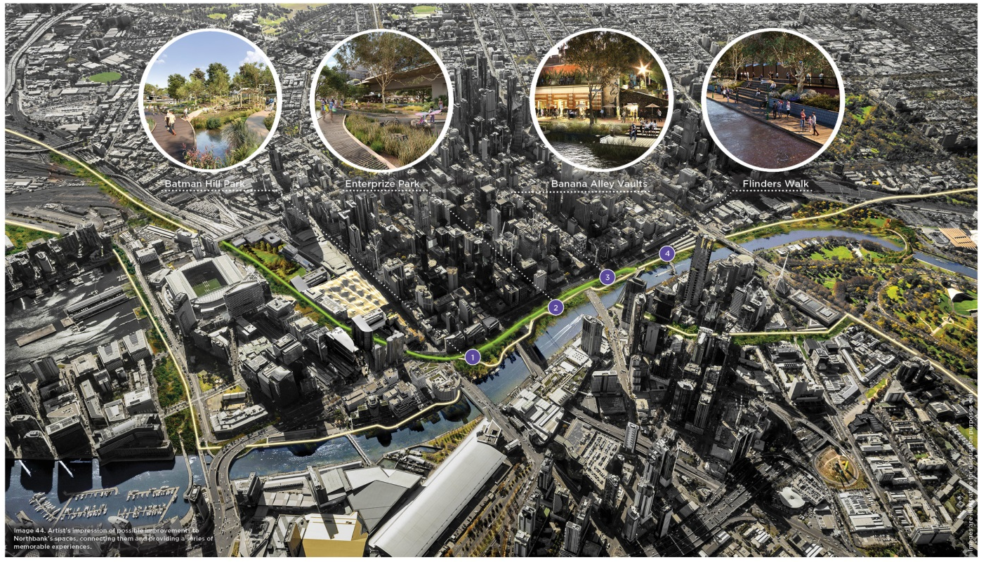

8. Multi-functional
Celebrate character areas and encourage new economies: a range of high quality civic, educational, cultural, hospitality and water dependant uses.
Successful urban environments are defined by well used, high quality, plentiful and diverse spaces and activities. Places and spaces along the inner city river have a distinct identity and offer a mix of sensory experiences, ranging from the openness of the eastern parklands to the more intimate setting along Flinders Walk, where cafes and bars echo the character of the city’s laneways. Downstream of Queens Bridge is dominated by larger-scale uses including the Melbourne Exhibition and Convention Centres, large businesses and residential complexes that transition into the Docklands precinct.
A range of uses.
Looking to the future, the Yarra River, Birrarung, should offer an even greater diversity of uses for extended times of the day and appeal to broad sections of the community, including locals, visitors, old and young. Currently parts of the riverbank are largely focused on drinking and eating venues. There lies the potential for new economies offering broader interest and better use of the river location, such as creative and water dependant industries. The rich history of the Yarra River, Birrarung, could provide place based education opportunities. There is also a need for more play and picnic spaces to attract family groups. These could be complemented by maritime and nature learning opportunities.
Diverse character areas.
As opposed to a homogenous corridor, the Yarra River, Birrarung, should build on the series of unique districts with their own distinct character, spatial definition and function. Currently there are at least ten different areas with their own distinctiveness and character that punctuate the journey along the river, offering many layers of experience. These areas could be improved and identified as distinct areas in order to attract patronage to support the functions therein and could be broadly grouped into three main urban settings of Maritime, City and Parklands. Refer Activation Plan for detailed area descriptions.
Policy 7: Encourage a range of civic, educational, cultural, hospitality and water dependant uses that complement a focus on high quality public spaces.
Policy 8: Build on diverse character districts to create a series of unique, locally authentic experiences.

Image 7. Project exemplar: Chicago Riverwalk, Illinois , U.S.A.
Scale: 2km long, 60-80m wide
Timeline: 1990-2009 (Phase 1), 2010-2015 (Phase 2), 2016-onwards (Phase 3)
The Chicago River was once an under utilised, polluted shipping channel. To enhance the experience of living, working and visiting Downtown Chicago, major redevelopment of the 2km inner city riverfront was undertaken. A new, expanded riverwalk was created that offers four character areas, featuring distinct urban landscapes and activities.
The Chicago riverfront now provides a broad range of attractions: outdoor bars and restaurants, children’s play areas, museums, pier fishing, boating, kayaking, public art and bird-life, amongst a harmonious blend of nature and an urban cityscape.
The Chicago Riverwalk has taken some time to be realised. Decades of planning was undertaken before the physical Riverwalk began to take shape in 2001. Funding for the many improvements came from multiple sources, including federal and state/local budgets.
The final result is that Chicago is no longer embarrassed by the state of its river – they embrace it. The successful transformation of Chicago’s riverfront offers many insights for our city riverfront, highlighting the future possibilities and potential multiple benefits of investment.
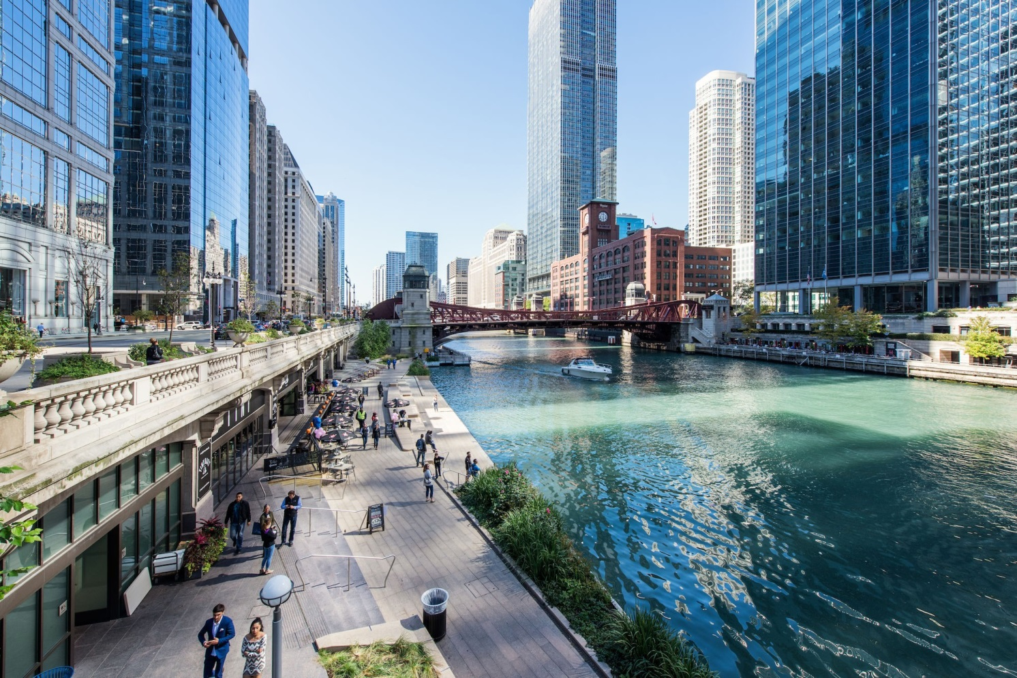

9. Public
Sustain the civic focus of the river by encouraging activation that offers broader inclusion and supports a public waterfront.
The Yarra River, Birrarung, is a public arena for many of the activities that contribute to the life of the City. However, some events or commercial uses limit public access to the riverfront. Given the special inherent qualities of the river, we promote the Yarra River, Birrarung, being first and foremost a public place for people and recommend generous public access and pathways along the banks. This is currently compromised in some locations with pedestrian passage constrained by adjoining commercial activities. Numerous private developments along the city riverfront also turn their back to the river. The Northbank is particularly vulnerable to the incidence of this given the southern aspect.
We advocate for a balanced approach to activation and commercialisation along the banks. We recommend the river’s legibility as a public place be elevated, so that it can be enjoyed by everyone without expense. The significant value of the river must be upheld and every intervention must be of the highest quality to deliver memorable and delightful experiences to tourists and residents.
Activities that support a public waterfront
The commercial function and economy generated by the river is important. However, this should not compromise the public benefit of the river experience and amenity. For instance, in the right locale, privately funded, floating infrastructure such as a bar or swimming pool could be good temporary additions. The inclusion of activities and uses that have the potential to have substantive positive impact and influence, with minimal adverse consequences should be supported.
A balanced approach which distributes commercial operations, allowing room for other activities to diversify the riverfront experience is encouraged. There is much scope to particularly increase activation of Queensbridge Square on the Southbank and the areas beneath the rail viaduct on Northbank. The Activation Plan illustrates priorities, ideas and a preferred spatial distribution for future activation nodes along the central city area of the Yarra River. Specific Guiding principles for activation proposals are discussed in detail below.
Riverfront buildings and landscapes
The relationship of surrounding developments immediate to the river environs has a significant impact on the use of these spaces and the behaviour of users within them. On water and water edge activities, events and uses should be orientated and designed for public use. The Aquarium is an inward oriented development that takes little advantage of its prime location adjacent to the river edge. Future riverfront developments should be required to feature active frontages that welcome the public and embrace the riverside location. All landscapes in riverfront developments should also be publicly accessible.
Carparking and helicopter facilities
Incompatible uses that, on a regular basis are detrimental to the river environment by way of noise, disturbance, erosion, discharge of air pollutants should be discouraged. There remains numerous instances of visible private carparking immediate to the inner city riverfront. The Helipad at Batman Park also incurs adverse impacts on the experience and amenity of this important green space. A general reduction to all carparking, particularly at-grade, visible facilities from this key people zone is critical and safe alternative locations for helipads must be explored as development of the riverfront continues to evolve.
Policy 9: Ensure unrestricted public riverfront access.
Policy 10: Encourage riverfront buildings to address the water with physical openings and active edge uses.
Policy 11: Discourage helicopter facilities and carparking along riverfront areas and work to minimise ambient noise.
Policy 12: Promote activities that support a public, safe and attractive riverfront.
Action 13: Develop a long term program of high quality events and activities that align with The Activation Plan and work towards transforming key locations of the riverfront into vibrant, safe and inclusive destinations.

Guiding principles for built form activation proposals in the river corridor
The City of Melbourne are regularly in receipt of built form proposals to activate the riverfront. To inform the planning, assessment, selection and approval of these proposals we provide the following key guiding principles. These are in addition to any statutory requirements.
1. Authentic to the river context
Consider how proposals can better elevate experience of the unique river context and be consistent with the vision and strategic directions for the river.
2. Public
Sustain the Yarra River, Birrarung, as being first and foremost a public place for people to enjoy, with key pedestrian movement zones, bridge landings, key views and waterfront features kept free of obstructions.
3. Diversity of activities
Contribute to achieving a well-balanced distribution of activation uses across the entire central city riverfront area and avoid excessive repetition or discord between neighbouring activities.
4. Visual accessibility
Maintain openness to the river as much as possible and ensure views to the water from adjoining riverbank areas are not concealed over long distances.
5. Generosity, access and inclusion
Provide universal accessibility to all areas of any activation venue. A minimum public pathway width of 2.5 to 3m (where existing conditions allow) is also to be maintained, along the river edge, and kept clear of obstacles.
6. Integrated
Complement the surrounding built form and public realm, particularly in relation to sensitive planting, cultural works and heritage elements. Activation proposals must not involve tree removals or additional carparking in waterfront areas. Service areas also to be discreetly integrated to ensure public realm areas are not compromised.
7. Comfort and safety
Public interfaces of any proposal must enhance the nominated site’s spatial qualities, contributing to the use, activity, safety and interest of the public realm. Activation proposals must not cause additional shadowing impacts between 11am-2pm or contribute noise/light pollution that disturbs surrounding residential areas.
8. Environmentally responsive
Minimise the environmental impact with sustainable management and maintenance practices. Initiatives to improve the waterfront environment, such as contributing to river cleaning, are also encouraged.
9. Design excellence
Invest in creativity and expert design to ensure every intervention is high quality, sustainable and memorable, elevating the visitor experience.

Image 8. Recommended minimum standards for unfettered public access at all times.
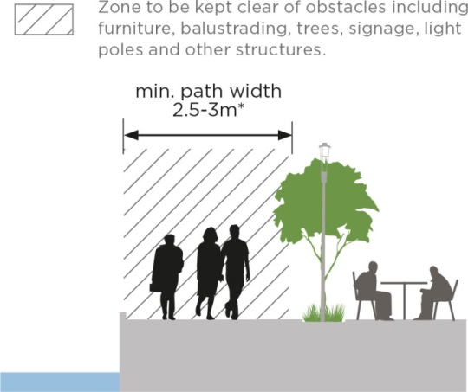

10. Legible
Rationalise clutter and on-water infrastructure to ensure unobstructed views and vistas.
The role of rivers in a city context could be likened to urban parks in terms of providing essential elements of fresh air, trees and green space, openness and relief from the intensity of urban life. Waterfront clutter and on-water infrastructure should not detract from the elemental qualities of this unique, natural setting, nor undermine the peaceful amenity of the area. It is important that we preserve our riverfront, acknowledging its significance and are accordingly discerning about what structures and objects are placed within the confines of this natural asset.
There is a myriad of signage and ad hoc placement of outdoor seating, bins and light poles, adversely impacting pedestrian flow, which collectively weaken the legibility and overall attraction of the waterfront asset. Floating, on-water infrastructure such as bars, boats under repair, pontoons and expansive berthing areas also compete with uses on the banks and most importantly obstruct clear views of the riverfront. There are also numerous at-grade parking areas immediate to waterfront areas, particularly along the Northbank.
Riverbank clutter
The placement of objects (signage, bins, light poles) or structures (floating bars, booking kiosks) should be well integrated with the environs, have a clear, beneficial purpose. Key pedestrian movement zones, key vistas and views of key elements (heritage, public art etc) are to be kept free of obstruction. This concerns selectively rationalising electrical service cabinets and bins, consolidating light poles and introducing better placement of street furniture to de-clutter the riverfront. Private activities must manage storage needs such as tables, chairs, barrels on-site. In addition, the location of floating bars and other on-water infrastructure should be minimised or effectively dispersed so as not to dominate an area or obstruct public access to the water’s edge for long distances, as previously mentioned.
Bridges over the river
The panoramic views provided by bridges is a positive part of the river experience. Bridges are also highly visible elements in the river landscape and therefore the location of bridges, their height and alignment to minimise expanse and maximise the environmental and visual experience of users is key to the riverfront experience.
There are currently nine cross-river links within the central city area. In the future, there is potentially a need for one to two additional bike and pedestrian crossings over the inner city river area to support enhanced connectivity and use. A potential pedestrian and bicycle bridge between Birrarung Marr and Domain Parklands would provide connection between major parkland assets. The proposal for a bridge across to Fisherman’s Bend on the Collins Street axis will also offer critical connectivity between the City, Docklands and this new community. The design and location however must be sensitively resolved to respect the local context and environment, particularly with regards to viewsheds, on water usage and additional overshadowing.
Riverfront signage and treatments
To improve the legibility of the corridor, co-ordinate signage, treatments and evoke an authentic, local character, the development of technical guidance for the riverfront is recommended. This would offer clear and consistent direction on a base palette of preferred materials, signage, landscaping and details that recognise the unique location and are visually cohesive and recessive.

This could include treatments which accord with each character area and may be addressed through additions to the City of Melbourne Design Standards. As a basis, in the interim the selection of materials is to be guided by the Docklands Design and Construction Standards for Public Infrastructure Works, the Docklands Public Realm Plan and the City of Melbourne Design Standards.

Policy 13: Rationalise existing and proposed clutter to ensure unobstructed appreciation to identified views and landmarks.

Policy 14: Consider impact on views in design and location of additional bridges only where cross river connectivity is critical.

Action 14: Incorporate within the City of Melbourne Design Standards relevant technical guidance for riverfront treatments and signage to establish a consistent palette.

Action 15: Work with the Victorian government to deliver general maintenance upgrades - decluttering, graffiti removal, street furniture, lighting etc.

Action 16: Investigate the location, purpose and need for a new bridge to improve pedestrian and bicycle access between Birrarung Marr and Domain Parklands and, if supported, work with the Victorian Government to fund and deliver.

Image 9. Activation Plan
Illustrative plan of the priorities, ideas and preferred spatial distribution for future activation nodes along the central city area of the Yarra River, Birrarung.
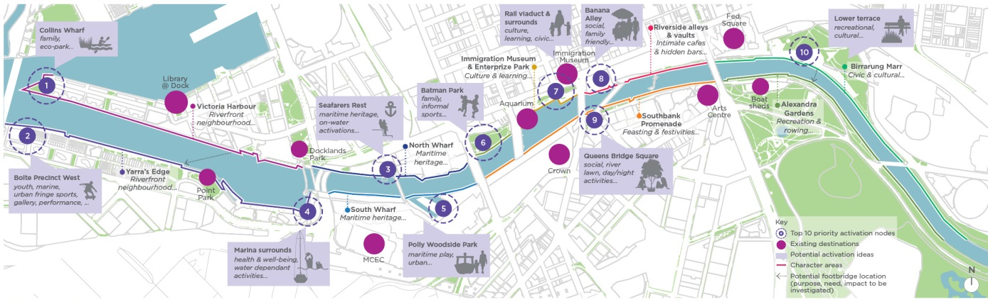
Character area descriptions:
MARITIME...
Yarra’s Edge and Victoria Harbour
Riverfront neighbourhood...
Bathed in sunlight and the site of a future tram bridge, the area holds much potential for additional public, water dependant activities such as an urban beach/swimming pool (privately funded). Community and ecological interventions are encouraged to complement the commercial nature of this area.
North Wharf and South Wharf
Maritime heritage...
This precinct holds great potential as a destination for authentic maritime elements that offer insights to the maritime history. Activities introduced to the precinct should honour and build upon this focus. The Polly Woodside and sunlit grassed area nearby could be reinvigorated with more direct access routes. Adjoining the restored heritage sheds, there also lies the opportunity for complementary on water activities that sit below wharf height.
CITY...
Batman Park
Urban Park…
This area holds great potential as an excellent urban park space with attractions for all ages, supporting the high residential, worker and visitor population immediate to this zone. Create opportunities for families and children to stay and play in the precinct. Phase out helicopters as the noise and wind gusts compromise the park experience. Offer opportunity for informal sporting activity, bbqs and picnics..
Immigration Museum and Enterprize Park
Culture and learning...
An area to reimagine the river’s edge connecting the Immigration Museum to the river, alongside activating both the rail viaduct undercroft and the park with a meaningful cultural education program. Bring the colour, creativity and activity that happens within the Museum outside for all to enjoy and provide greater activation at the Aquarium to make the area a must visit destination.
Riverside alleys and vaults
Intimate cafes and hidden bars...
Characterised by an intimate, urban character, this portion of the river is a key arrival point and needs to provide ample room for people to clearly experience the unique riverside environment. Commercial uses should purposefully catalyse activity in this zone, without compromising public riverfront areas and critical movement zones. The mix of offerings could also be complemented with family friendly food and beverage and boutique retail.
Southbank Promenade
Feasting and festivities...
Southbank Promenade is one of the city’s busiest public spaces featuring a notable concentration of waterfront dining and drinking, arts and cultural venues. The opportunity afforded by the northern aspect and ready population should be further maximized. Pockets of sunlit, lawn space should be retained and new civic areas created in the most populated areas, such as nearby Evan Walker Bridge. Queens Bridge Square also holds much potential for improved amenity and recognition of its important cultural location.
PARKLANDS...
Birrarung Marr
Civic and cultural...
A highly valued cultural precinct and well-designed urban contemporary landscape, this is a place for both peace and quiet, alongside public events. Aboriginal history and connection to place is represented in the native landscaping and public art located throughout Birrarung Marr. The views of the city, Arts Centre, river and Alexandra Gardens must also be protected. Future activations should support the area’s civic and cultural focus, and enable day to day activation to complement the calendar of larger public events.
Alexandra Gardens
Recreation and rowing...
This area is characterised by openness, featuring vast lawn areas, palm trees, ornamental shrubs and the historic rowing boathouses along the river. The gardens also include areas that accommodate some of the city’s events. As a rare landscape oasis so close to the City, this area should continue as a precinct primarily for recreation. Commercial activities in this zone would detract from the amenity of the parkland environment and are readily available in the adjoining Southbank precinct.

Movement
Spacious public spaces connect the river creating an important destination and place to enjoy the journey away from the intensity and rush of the urban centre. Through improved access to and along the waterfront, the river will provide the natural complement to the fast pace of the City and Southbank.
The Yarra River, Birrarung, offers a unique setting and being lineal in nature is a key drawcard for many users wishing to both connect with other destinations and enjoy the river environs. Consequently, the waterfront currently accommodates significant volumes of both pedestrians and cyclists. These two broad categories of users, have very different needs and expectations. The intensity and movement patterns vary greatly across and within these groups. As such, conflict between users sometimes occurs and consequently the overall experience of the waterfront is negatively impacted. The fundamental issue is that the riverfront is currently pressured to accommodate both ‘place’ and high speed, commuter functions within a constrained environment.
Despite the attraction of the river environs, surrounding rail and road infrastructure hinder easy access to and enjoyable movement along the river. Northbank has a particularly poor level of connectivity due to numerous major traffic barriers. The physical conditioning of pathways, limited extent of universal accessibility and the lack of coherent wayfinding and signage is a further compounding issue. A notably challenged pedestrian setting exists between the Yarra River, Birrarung, and Docklands. The lack of easy and intuitive access means that few Docklands workers and residents venture down to the riverfront.
Key movement challenges are defined below:
- Many cyclists travel at speed, despite signage to slow down, with numerous modal conflict sites, particularly along Southbank Promenade and Crown Casino.
- Poor level of pedestrian connectivity due to major traffic barriers along Northbank.
- Poor physical pathway conditions, numerous pathways with steep gradients and varied light conditions.
- Constrained access to the riverfront from the Central City, especially to Northbank west.

Strategic directions

11. Slow
Distinguish the river as a slower paced environment by creating safe, alternative north and south bicycle routes.
The riverfront is an important recreational asset of natural beauty, a place to wander, rest and observe. It is important that these values are protected by addressing movement issues along the riverfront. The main cause of modal conflict is the mixing of high speed, commuter cyclists with slow speed, recreational users.
The spatial constraints of the riverfront further exacerbate this issue. The location of Flinders Street and surrounding road infrastructure to the west, has created a particularly narrow, Northbank river corridor for movement and access. Current pathways, as narrow as 2m along Flinders Walk, are too restrictive for the passage of multiple modes. Also, unlike other cities that feature expansive waterfront areas, Melbourne’s typical river corridor width doesn’t allow for separate cycle pathways, away from key pedestrian areas.
The river is a key destination that primarily functions as a ‘place’ rather than a movement corridor. We recommend promoting travelling along the river and its edges at a slower pace, enabling time to appreciate the key views and diverse spaces. This would be consistent with the 5 knot zone (fast walking speed) already defined for the waterways.
However, it is important to acknowledge that the Yarra River, Birrarung, corridor has long been seen as a commuter cycling route, identified in strategic documents and with significant improvements made to riverfront cycle paths leading to the city. To achieve a slower paced, river environment, safe, alternative commuter cycle routes would need to be provided. The future design of river promenade spaces should also look to support this idea of a meandering journey through considered landscaping arrangements that set visual cues to slow cyclists.
An alternative Northbank bicycle route.
We propose interrogation into a safe, comfortable, and connected alternative bicycle route on the northern, central city side of the river to provide a viable, preferable alternative to the river promenade for fast cyclists. The alternate route must offer: connectivity (easy access to other routes); efficiency (offers a quick journey with minimal delays); and safety (separation between vehicles and pedestrians).
A potential future route for cyclists, particularly commuter cyclists, could be Flinders Street via Batman Avenue. This would address the poor level of connectivity from Northbank West through to Banana Alley. Flinders Street holds great potential to be an optimal alternate route because it is not a local route; there is a current lack of east-west connections in the southern portion of the central city; it features a flatter, topographical alignment; and Flinders Street holds the opportunity for complete separation from vehicles, alongside better connectivity with key cycling routes in the south-west such as Harbour Esplanade.
While requiring significant changes to the existing streetscape, Flinders Street holds the potential for a long term solution of the issue, rather than ongoing management of conflict between modes.
An alternative Southbank bicycle route.
The investigation into an alternative Southbank Promenade route diverting from along the waterfront to alternately follow Alexandra Avenue, City Road to Clarendon Street has been proposed by numerous policy documents. These include the Southbank Structure Plan 2010 and the Bicycle Plan 2016-2020 which introduces the action of a long term preferred alternative bike route, including the provision of separated bicycle lanes running the length of City Road and Clarendon Street. Major upgrade works to Southbank Boulevard and Linlithgow Avenue are currently underway, however, to complete the route requires delivery of the Alexandra Avenue, City Road and Clarendon Street segments.
Action 17: Further investigate the feasibility and deliver Flinders Street bicycle lanes.
Action 18: Continue delivery of the alternative Southbank commuter cycle route, including Alexandra Avenue, City Road, Kavanagh Street and Clarendon Street segments.

12. Integrated
Better integrate pathways along and leading to the riverfront, particularly to the north-west.
Easy and direct access from the central city to the river and continuous movement along the riverfront is impeded by the traffic focus of key surrounding routes. The positioning of major road connections, substantial developments, and car parks has compromised access along and to the riverfront area.
The riverfront location is a key asset of Docklands, however major road infrastructure and poor wayfinding creates a sense of disconnection between Docklands and the Yarra River, Birrarung. Wurundjeri Way is a major hindrance to access with the complex road arrangement and speed of traffic also detracting from the amenity of the area. Pedestrian crossings are far apart and the alignments provide extended crossing times and distances. Siddeley Street is currently not a safe alternative due to the vehicular traffic and bluestone paving making this a hazardous option.
Batman and Enterprize Park are particularly disconnected with notable gaps to continuous east west movement along the riverfront. Bound on all sides by the barriers of two major arterial roads and two overhead rail viaducts, this physical and visual disconnect from the city discourages park use. Particularly at Williams Street, a quality walking environment is impeded by “dog-leg” crossings, multiple crossing stages and vehicle dominance, creating an inhospitable pedestrian environment.
Barriers to integrated access
Flinders, Williams, King and Spencer Streets, Wurundjeri Way and the railway corridor currently act as visual and physical barriers to integrated access to and along the riverfront. Converting, where possible, the conditions of these mini motorways into more pedestrian friendly environments that feature improved visual and physical qualities would vastly improve access to and along the riverfront. This aligns with City of Melbourne’s current work to transform Southbank Boulevard and Dodds Street into a pedestrian friendly place and improve connectivity between the Domain Parklands and the Yarra River, Birrarung.
Some minor interventions, offering immediate resolution, could be made at Queensbridge Street, Kings Way, Spencer and Russell Streets. This could include planting trees, widening kerbs and realigning paths to create more direct crossings. More long-term, major transformations could include changing the free flow arrangement at Queen’s Bridge and Williams Street to remove the multiple western lanes. This would enable extension of Enterprize Park and Customs Square creating better connectivity to and along the riverfront. Closing the northbound vehicle lane of Market Street adjacent to the Immigration Museum to better integrate the museum and riverfront should also be explored.
The possibility of lowering Wurundjeri Way to create a safer, higher amenity and more direct pedestrian link across to Docklands is also worth encouraging. Noting Wurundjeri Way is an important heavy vehicle route and popular alternative to the CityLink Tunnel and Bolte Bridge. Also any proposed changes would need to be assessed and approved by VicRoads.
The decking of the Jolimont railyards and extension of Russell Street as a means of providing a stronger connection between the central city and the river is a further long held idea that we continue to advocate for, requiring substantial public and private investment.
Policy 15: Better integrate pathways along and leading to the riverfront by creating direct pedestrian crossing arrangements and amenity improvements.
Policy 16: Advocate to the Victorian Government to investigate the potential to lower Wurundjeri Way and create a seamless waterfront link.
Action 19: Work with the Victorian Government to deliver amenity improvements and better pedestrian crossing arrangements along key waterfront desire lines of Queensbridge Street, Kings Way, Spencer Street and Russell Street/Hosier Lane.
Action 20: Work with the Victorian Government to investigate future reconfiguration of and deliver improvements to the Williams and Flinders Street intersection.

13. Accessible
Raise the quality and universal accessibility of riverfront pathways.
The maintenance, conditioning and safety of pathways vary considerably along the Yarra River, Birrarung, corridor. The materials and detailed design of the pedestrian environment in some areas is of a high quality, however the linking areas adjoining these spaces is generally poor. There are also some materials not fit for purpose. For instance the precast pavers are not sufficient for events loading and others offer limited environmental benefit.
Numerous pathways and bridges along the river feature challenging level changes, both limiting access for all and creating safety hazards. Examples include disappearing edges, excessive cross falls which do not meet accessibility standards and vertical access issues. Access between the western footpath of St Kilda Road and the river’s edge is currently limited to a series of staircases. Along Flinders Walk there are also several areas within the steep gradient category, that are steeper than 1:14. The journey down to Banana Alley from the eastern approach involves a particularly steep grade on an uneven surface.
Universal accessibility
Universal accessibility to and along the water’s edge, including access for people with physical limitations, needs to be provided. All walkways must meet accessibility standards. A series of access improvements, including universally accessible ramps, walkways and elevators are needed in numerous areas to ensure easy access for everyone, and to improve the function and commercial viability of the riverfront. Key riverfront access points that should be prioritised for better accessibility include addressing the steep transition from Banana Alley to Les Erdi Plaza and access from the north-western side of Princes Bridge down to Flinders Walk.
Pathway widths, physical conditioning and maintenance
After decades of wear and tear there are numerous pathways along the riverfront due for renewal. Existing tree placement, bins, bollards, light poles, stairs, bridge landings often reduce useable circulation space and visibility in key areas and the worn condition negatively impacts the riverfront experience. Areas where pathway capacity is critical include where pedestrian flows are intense in peak periods. Buskers, particularly along Southbank Promenade generate large crowds that impact pedestrian movement and flow.
A detailed audit of existing conditioning and capacity issues is recommended and then staged renewal of paving, lighting and street furniture with material selection and furniture placement coordinated by a technical guide for waterfront treatment.
Policy 17: Advocate for universal accessibility to ensure the river environment safely caters for everyone.
Action 21: Undertake a detailed audit of existing conditions and work with the Victorian Government to develop a coordinated maintenance and physical upgrade program.

Image 10. Movement Plan
Illustrative plan of improvements to city routes leading and immediate to the riverfront.
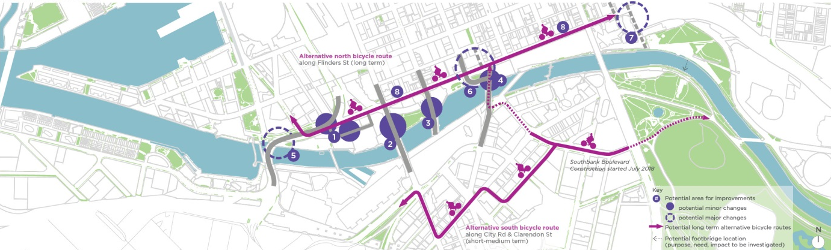
Plan also illustrates the following:
Potential minor changes (investigate and deliver streetscape improvements) include:
Wurundjeri Way and Siddeley Street
Advocate for shorter signal waiting times and more direct pedestrian crossing arrangements at Flinders Street and improve pedestrian and bicycle conditions on Siddeley Street.
Spencer Street
Improve crossing alignment between Northbank west and Batman Park. Provide kerb outstands and additional street trees.
King Street
New signalised crossing aligned directly between Batman Park and Enterprise Park, using an existing alignment with pathways through the park.
Williams Street
New signalised crossing aligned directly between Enterprise Park and Banana Alley, eliminating the three stage crossing.
Potential major changes (investigate options, feasibility and deliver) include:
Wurundjeri Way
Investigate the potential to lower Wurundjeri Way and create a seamless waterfront link.
William Street
Currently slow, staged and indirect crossing journey. Investigate changing the free flow arrangement to extend Enterprize Park and create better relationship between the riverfront and Immigration Museum.
Russell Street
As a longer term aspiration advocate for decking of exposed rail infrastructure adjoining the river to achieve a long-term continuous public ground plane.
Flinders Street
An initial desktop investigation has been completed, which deemed Flinders Street as the most optimal alternative route.

Implementation
The successful delivery of a renewed central city riverfront will require coordination and funding across a number of different stakeholders.
The Yarra River - Birrarung Strategy ambitiously imagines the future river. It sets out a range of exciting opportunities that will take time, through staged implementation, and collective input to achieve.
This document will be the basis for working with key stakeholders, including the Victorian Government, and key landowners on initiatives identified.
The City of Melbourne will commit operational and capital funds to deliver the actions. However, some of these projects will require collaboration, approval and co-funding from the Victorian Government or other partners.
This chapter provides a summary of the strategy:
- in 17 policies and
- in 21 actions, including research, engagement, design and delivery.

Current capital works
Projects underway
Budget approved and works underway or set to commence in next 1-2 years.
- Seafarers Rest Park - a new open space
A $1 million project adding 3500 sqm of open space to the riverfront in Docklands
- Enterprize Park - public space improvements
Green space in the park is proposed to increase from 1650 sqm to 2690 sqm. A budget of $2 million is available for design and costruction of this phase of works.
- Southbank Promenade Stage One - promenade revitalization
Revitalising a 300 metre section of Southbank Promenade from Princess Bridge to Evan Walker Bridge. 2019/20 budget: $5.1 million.
- Southbank Boulevard and Dodds Street - Revitalising public space.
The transformation of Southbank Boulevard will add 2.5 hectares of new public open space and neighbourhood parklands to Melbourne’s most densely populated suburb. Due for completion in 2020. 2019/20 budget: $11.9 million to finalise Stage 1 of the $47 million project.
- City Road - streetscape upgrades
City Road: $2 million in Capital Works in the next two years for streetscape transformation works. This is a longer term project with a cost of $35 million identified.

Policy summary
Ecology
1.Encourage riparian greening along the Yarra River, Birrarung, including existing river banks.
2.Encourage a native and resilient planting palette along the Yarra River, Birrarung, promoting nature in the City.
3.Encourage riparian habitats in urban parks edging the Yarra River, Birrarung.
4.Encourage Sponge City strategies in the public realm and private development adjacent to the river.
5.Encourage initiatives in the city reach of the river to improve water quality in collaboration with Melbourne Water including filtration of water runoff.
Culture
6.Advocate for Maritime Heritage to be considered in planning and design for key opportunity areas. Encourage interpretation and a connected network between heritage precincts through a city wide strategy (refer action 10).
Place
7.Encourage a range of high quality civic, educational, cultural, hospitality and water dependant uses that complement a focus on high quality public spaces.
8.Build on diverse character districts to create a series of unique, locally authentic experiences.
9.Ensure unrestricted public waterfront access.
10.Encourage waterfront buildings to address the water with physical openings and active edge uses.
11.Discourage helicopter facilities and carparking along riverfront area and work to minimise ambient noise.
12.Promote activities that support a public, safe and attractive riverfront.
13.Rationalise existing and proposed clutter to ensure unobstructed appreciation to identified views and landmarks.
14.Consider impact on views in design and location of additional bridges only where cross river connectivity is critical.
Movement
15.Better integrate pathways along and leading to the riverfront by creating direct pedestrian crossing arrangements and amenity improvements.
16.Advocate to the Victorian Government to investigate the potential to lower Wurundjeri Way and create a seamless waterfront link.
17.Advocate for universal accessibility to ensure the river environment safely caters for everyone.

Actions summary
Timeframe assessment:
- Short term 2020 - 2025
- Mid term 2025 - 2035
- Long term 2035 +
Cost assessment:
- Low up to $300,000
- Medium $300,000 to $3 million
- High $3 million +

Actions | Timeframe | Cost | Potential collaborations
Ecology
1. Deliver a trial project of riparian vegetation on the river bank in collaboration with State Government. | Short | Medium | Parks Victoria; Royal Botanical Gardens
2. Deliver a trial project for floating vegetation in the Yarra River, Birrarung, in collaboration with State Government. | Short | Medium | Parks Victoria; Melbourne Water
3. Develop a plan for interpretive signage highlighting  the natural river environment in collaboration with Parks  Victoria and Royal Botanic Gardens. | Mid | Low | Parks Victoria; Royal Botanical Gardens
4. Address planning scheme gaps regarding sunlight protection to the Yarra River, Birrarung, and adjacent public spaces. (outside Capital City Zone). | Mid | Medium | Department of Environment, Land, Water and Planning
5. Develop urban design guidelines for flood prone areas across the municipality in the public and private realm. | Short | Low | Melbourne Water; Department of Environment, Land, Water and Planning
Culture
6. Establish a Memorandum of Understanding for future engagement with each of the Traditional Owner groups. | Short | Low | Traditional Owner Groups
7.Develop an Aboriginal Cultural Narrative of the city section of the Yarra River, Birrarung, in collaboration with Traditional Owner groups. | Short | Low | Traditional Owner Groups; Aboriginal Victoria; Birrarung Council
8.Research the pre-contact landscape character and botanical aspects of the Yarra River Birrarung, including the landscape management aspects to establish a reference planting guide. | Short | Low | Traditional Owner Groups; Aboriginal Victoria; Birrarung Council
9.Identify underrepresented sites of significance and culturally significant species for the Yarra River, Birrarung, in collaboration with the Traditional Owner groups and explore opportunities to reintroduce these to the river. | Short | Low | Traditional Owner Groups; Aboriginal Victoria; Birrarung Council
10. Develop an interpretation strategy including storytelling and signage for the Yarra River, Birrarung, on the basis of the Aboriginal cultural narrative, maritime trading heritage and shared post contact history. | Short | Low | Traditional Owner Groups; Aboriginal Victoria; Birrarung Council
11. Explore opportunities for creative installations that position the river as an environmental educator, elevating understanding of aboriginal culture in the past, present and into the future. | Short | Low | Traditional Owner Groups; Aboriginal Victoria; Birrarung Council
Place
12. Work with the Victorian Government and adjacent landowners to develop an agreed design, and deliver improvements to the central city Northbank area. | Mid | High | Parks Victoria; Department of Environment, Land, Water and Planning
13. Develop a long term program of high quality events and activities that align with The Activation Plan and work towards transforming key locations of the riverfront into vibrant, safe and inclusive destinations. | Short | Low | Parks Victoria; Yarra River Business Association
14. Incorporate within the City of Melbourne Design Standards relevant technical guidance for waterfront treatments and signage to establish a consistent palette. | Short | Low | Parks Victoria
15. Work with the Victorian government to deliver  general maintenance upgrades - decluttering, graffiti  removal, street furniture, lighting etc. | Mid | High | Parks Victoria, Victrack
16.Investigate the location, purpose and need for a new bridge to improve pedestrian and bicycle access between Birrarung Marr and Domain Parklands and, if supported, work with the Victorian Government to fund and deliver. | Mid | High | Parks Victoria; Department of Environment, Land, Water and Planning
Movement
17. Further investigate the feasibility and deliver Flinders Street bicycle lanes. | Mid | Medium | Department of Transport
18. Continue delivery of the alternative Southbank commuter cycle route, including Alexandra Avenue, City Road, Kavanagh Street and Clarendon Street segments. | Mid | High | Department of Transport
19. Work with the Victorian Government to deliver amenity improvements and better pedestrian crossing arrangements along key riverfront desire lines of Queensbridge Street, Kings Way, Spencer Street and Russell Street/Hosier Lane. | Mid | High | Department of Transport
20. Work with the Victorian Government to investigate future reconfiguration of and deliver improvements to the Williams and Flinders Street intersection. | Mid | High | Department of Transport
21. Undertake a detailed audit of existing access conditions and work with the Victorian Government to develop a coordinated maintenance and physical upgrade program. | Short | Medium | Department of Transport

