Queensberry Street Protected Riding Lanes
Engagement Summary Report

The conversation
In line with City of Melbourne’s Transport Strategy 2030, we’re delivering new bike lanes across the municipality – giving people the confidence to start riding and ride more often.
With Grattan Street now reopened to traffic and Metro Tunnel’s new Parkville Station almost complete, we’re proposing to reinstate Queensberry Street to one traffic lane in each direction and deliver greener and better-connected riding lanes.
We shared the draft design plan with the community which shows the proposed changes on Queensberry Street from Peel Street to Rathdowne Street. We asked if it meets the objectives of the project and how they felt about the design.
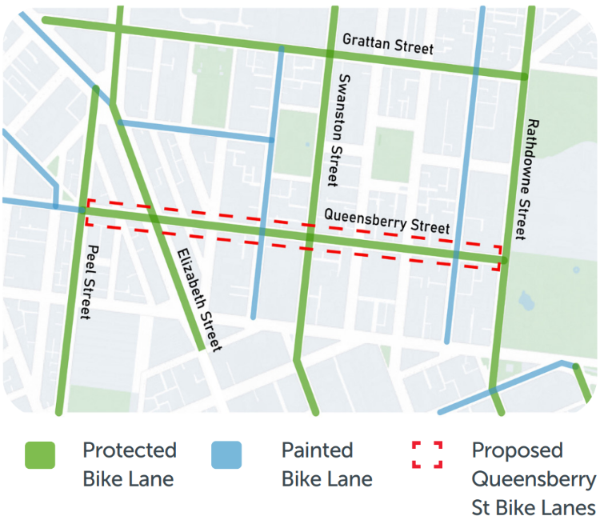

Gathering insight
The Queensberry Street protected riding lanes engagement ran from Thursday 27 June to Thursday 8 August 2024. The engagement and reach included:
- 742 survey responses
- 102 conversations conducted during pop-up sessions
- 10 business door knocking discussions
- 3,500 visits to the project page
- 24,544 views on social media
- Letter delivery to 1,800 properties
- 1 written submission from a residents association

What the community had to say throughout the engagement

Overall level of support for the draft design plan
- 76% support*
- 23% don’t support*
- 1% neutral

*’Strongly Agree’ and ‘Agree’ in the survey option became ‘Support’, and ‘Strongly Disagree’ and ‘Disagree’ became ‘Don’t support’.

Level of support by group
94% supported by riders*
60% supported by non-riders*
*Riders: people who ride bikes or e-scooters.
*Non-riders: people who walk, drive and use public transport when travelling in the area.

Who we heard from through the survey
Gender
- 30% women
- 62% men
- 2% non-binary
- 5% prefer not to say
- 1% use another term
Age
- 2% Below 20 years
- 38% 20-34 years
- 37% 35-54 years
- 23% Over 55 years
Connection to the Project
- 23% workers
- 54% residents (74% of residents lived in Carlton, North Melbourne or the CBD)
- 11% visitors
- 6% students
- 2% business owner
- 4% other or prefer not to say
Mode of Transport
- 18% car
- 23% walk
- 49% bike or e-scooter
- 8% public transport
- 2% other (including motorbikes)

How well would the draft design plan achieve its objectives?
Create a calmer and quieter street with reduced traffic: 73% support
Improve the safety and access for all users: 75% support
Encourage people to travel more sustainably in the area: 73% support
Create a greener street: 81% support
Accommodate parking needs for locals and visitors: 54% support
Facilitate smoother traffic in the local area: 63% support
What we heard:
The draft design plan would achieve its objectives because it would…
- reduce vehicle traffic in the local area
- improve safety for cyclists, drivers, and pedestrians
- improve liveability and the ‘neighbourhood feel’ of Queensberry Street
- more urban greening.
Additional ideas
- Install clear traffic signals and signage
- Native and evergreen trees for street greening
The draft design plan would not achieve its objectives because it would…
- reduce parking space for residents and local businesses
- potential cause traffic congestion with the reduced vehicle lanes
- create safety concerns for road users with the new proposed arrangement
- not encourage more active transport.

What’s next?
The community engagement findings will be reviewed and used to inform whether the project proceeds to the next design stage.
Project updates will be posted via the Participate Melbourne page: participate.melbourne.vic.gov.au/queensberry-street-riding-lanes

