Planning and Environment Act 1987

MELBOURNE PLANNING SCHEME

Notice of the preparation of an amendment to a planning scheme

Amendment C463melb

Overview

The amendment implements the West Gate Service Stations 1 & 2 West Gate Freeway, Port Melbourne Heritage Review (GJM Heritage, April 2024) (the Review) which seeks to apply heritage controls to the properties identified in Figure 1. The assessed heritage significance only applies to the stations’ canopies.

The amendment applies an individual Heritage Overlay (HO1380) to part of the two sites, updates the Heritage Places Inventory March 2022 (Amended August 2023) and incorporates a Statement of Significance and Incorporated Plan to reflect the recommendations of the Review and makes consequential changes to the Melbourne Planning Scheme.

For further details, refer to the explanatory report about the amendment.

Details of the amendment

The City of Melbourne planning authority has prepared Amendment C463melb to the Melbourne Planning Scheme.

The land affected by the amendment is shown in Figure 1 below:
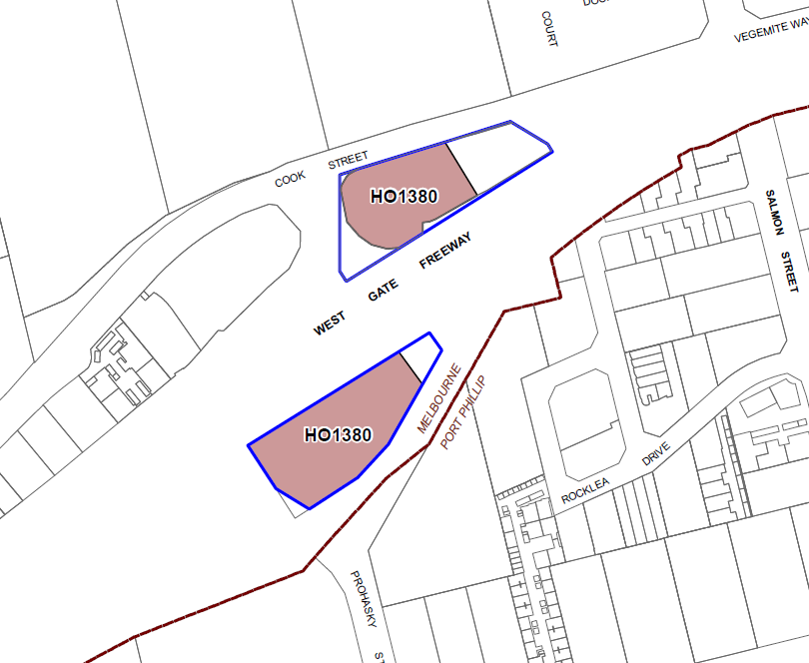
Figure 1: Map showing No. 1 West Gate Freeway (north) and No. 2 West Gate Freeway (south) with the proposed Heritage Overlay extent shaded and the property boundaries shown in blue.
In brief, the amendment proposes to:
- include the Review as policy document at Clause 15.03-1L-02 (Heritage).
- include the new heritage place HO1380 in the Schedule to Clause 43.01 (Heritage Overlay).
- insert a new Planning Scheme Map No. 10HO to apply the Heritage Overlay to part of the properties.
- include a Statement of Significance for the heritage place which identifies that the heritage significance of the place is limited to the stations’ canopies in the Schedules to Clause 43.01 (Heritage Overlay) and Clause 72.04 (Incorporated Documents).
- include an incorporated plan to apply permit exemptions to the heritage place in the Schedules to Clause 43.01 (Heritage Overlay) and Clause 72.04 (Incorporated Documents).
- apply a significant building category to 1 and 2 West Gate Freeway, Port Melbourne in the incorporated document titled Heritage Places Inventory March 2022.
- make consequential changes to the schedules to Clauses 72.03, 72.04, 72.08.
You may inspect the amendment, any documents that support the amendment and the explanatory report about the amendment, free of charge, at:

- the Department of Transport and Planning website planning.vic.gov.au/public-inspection or by contacting 1800 789 386 to arrange a time to view the amendment documentation.

- during office hours, at the office of the planning authority, City of Melbourne, customer service counter, Melbourne Town Hall, 120 Swanston Street, Melbourne, Victoria 3000

- the City of Melbourne website at participate.melbourne.vic.gov.au/amendment-c463

Any person may make a submission to the planning authority about the amendment. Submissions must be made in writing giving the submitter’s name and contact address, clearly stating the grounds on which the amendment is supported or opposed and indicating what changes (if any) the submitter wishes to make.

Name and contact details of submitters are required for the planning authority to consider submissions and to notify such persons of the opportunity to attend planning authority meetings and any public hearing held to consider submissions.

The closing date for submissions is Friday 7 February 2025. A submission must be written and lodged via:
- online at: participate.melbourne.vic.gov.au/amendment-c463
- email to: heritage@melbourne.vic.gov.au, or
- posted to Manager Strategic Planning (Heritage) City of Melbourne GPO Box 1603 MELBOURNE VIC 3001
The planning authority must make a copy of every submission available at its office and/or on its website for any person to inspect free of charge until the end of the two months after the amendment comes into operation or lapses.

Jo Cannington
Director City Strategy
City of Melbourne

