
Transport Strategy Discussion Paper
Motor Vehicles

This discussion paper is to inform a new City of Melbourne Transport Strategy to 2050. A draft strategy will be released for consultation in 2018. We are seeking your views on these issues and ideas.
Most streets in the municipality have been designed and optimised for motor vehicles. Yet the majority of trips within the city are on foot and by public transport. Since 2001, the share of car trips to work has decreased by 28 per cent while jobs have increased by 43 per cent. The use of cars in the municipality is declining. The number of people in the municipality is expected to grow from 914,000 per day to 1.4 million per day by 2036.
The central city will not be able to cater for this growth without major changes to the priority given to cars. The question is not whether this should change, but how much, when and where.
Reducing traffic volumes will improve conditions for emergency vehicles, servicing, freight, construction, bikes, public transport and accessibility. Traffic reduction policies will also improve health, road safety and air quality. These policies will reduce emissions and noise, create more space for other uses such as walking, dining, trees and bike lanes, improving the liveability of our city.
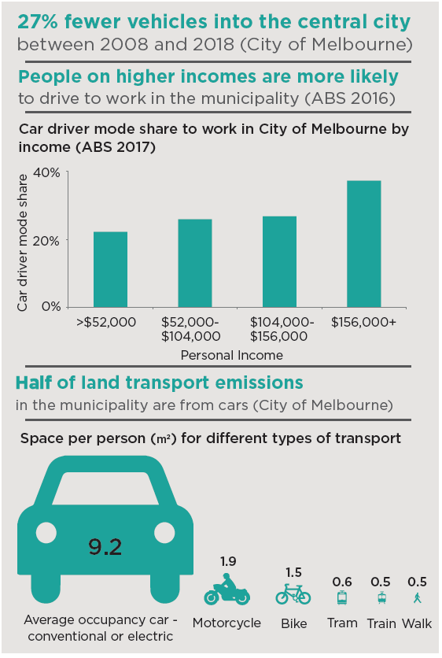

What are the current issues?

Vehicle congestion, delays and through traffic
Congestion undermines economic growth and productivity. Traffic that passes through the municipality exacerbates this issue, with about one in three vehicles on streets such as Flinders, King and Spring using the central city as a through route. Private vehicles cause significant delay for people walking and riding bikes. Buses and trams stuck in traffic or blocked at intersections undermine the efficiency and reliability of public transport. Traffic lights in Melbourne are configured to favour motor vehicles, despite cars being significantly outnumbered by people using other modes. As a result of these delays, unsafe crowding of people at intersections presents a major road safety risk.

Emissions and air quality

Current transport emissions in the City of Melbourne exceed the levels required to meet Australia’s obligations under the Paris Climate Agreement. Private cars account for around 52 per cent of land transport emissions in the municipality. Electric cars have the potential to reduce emissions if they are powered by renewables. Victoria’s coal fired power means that the CO₂ emissions of today’s electric cars are no cleaner than conventional cars.

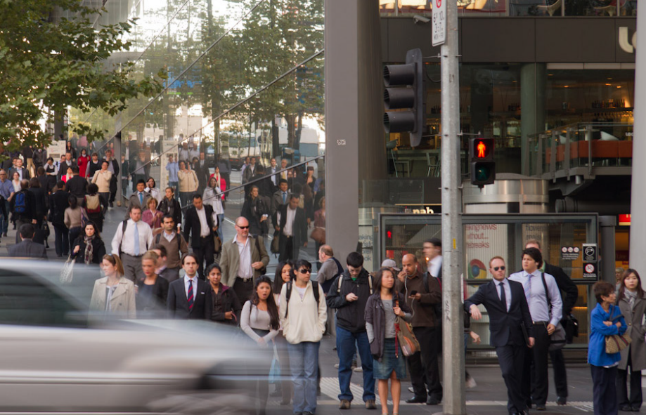
Vehicle priority increases wait times and pedestrian overcrowding.

Motor vehicle emissions also affect air quality. In particular, diesel engines create dangerous particulate matter which includes carcinogens. Six of the top 10 most popular cars in Australia run on diesel fuel, as does Melbourne’s current bus fleet. Many countries are moving to ban diesel vehicles due to the impacts on human health.

Inequality
People on incomes above $156,000 are more likely to drive to the city for work (ABS 2016). People on higher incomes tend to live in areas well served by public transport. Driving to the central city, especially in peak periods, can have a significant negative impact on other city users.

Safety and security

The City of Melbourne has the highest rate of pedestrian road trauma in Victoria. Vehicle attacks on people walking also highlight the threat cars can pose. Security measures such as bollards are being installed. More car free places and less vehicles in the city will further reduce risk.

What are other cities doing?
Cities around the world are facing challenges similar to Melbourne. These global best practice ideas can help to inform the right approach for Melbourne.

Convert road space into people space
Many cities around the world are converting inefficient vehicle space into other, more productive uses. For example, both London and New York have removed road space to create iconic people spaces as well as movement corridors for other modes. In London, a section of road was removed to create a seamless connection for pedestrians between the National Gallery and Trafalgar Square. Also in London, significant numbers of motor vehicle lanes have converted to cycle superhighways. Cyclists are now the single largest mode of transport on central London streets in the morning peak hours. Road lanes converted to cycle use now carry many more people than they did in cars.
In New York, sections of Broadway have been closed to traffic creating popular new public spaces at Times Square and also improving traffic flow on nearby streets. The Ninth Avenue protected bicycle lane in New York, built on space previously used by traffic, resulted in significant pedestrian and road safety improvements, more cycling and an increase in retail sales.
In Sydney’s George Street, sections have been closed to cars to improve the public realm and walking environment, with more space for people and trees. A new light rail line has replaced a large number of diesel buses with a smaller number of trams.
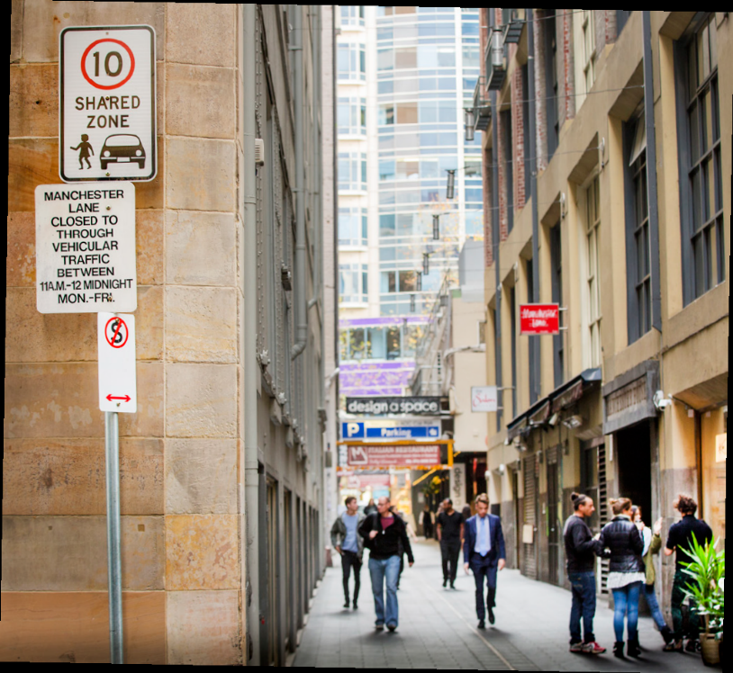
Shared spaces such as Manchester Lane serve people and vehicles.

What should be done to address these issues?

Provide high quality alternatives
Melbourne needs to significantly increase its transport capacity to serve a 65 per cent increase of people in the city. The expansion needs to be based on space efficient modes better suited to city movement: public transport, cycling and walking. First steps include commencing detailed planning of Melbourne Metro 2, supercharging tram and bus performance and improving the network of high-quality separated bicycle lanes which will attract everyday riders. This will make it easier for those who need to use private vehicles.

More space for non-car uses
Unsafe pedestrian crowding occurs at several places around the city including at train station entries and tram stops. Continued population growth will make crowding worse. There is an urgent need to relieve pressure by expanding the space available for people and allow pedestrians to disperse more comfortably by reducing delays at traffic signals. In the long term, continued intensification will mean parts of the central city will need to be largely free of private cars to operate effectively.

Prevent through-traffic
Motor vehicle traffic which travels through the central city imposes costs including delays to others, pollution, noise, physical separation and road trauma. Through-traffic benefits individuals but places an economic burden on the city. More can be done to reduce through-traffic by reconfiguring traffic signals, redesigning streets and making better use of other more appropriate routes around the central city.

More efficient driving
There may be opportunities to make driving more efficient by providing incentives for vehicles with higher occupancy or supporting other ways of sharing vehicles such as car share and car pooling. Shared mobility businesses need to integrate and support public transport and not compete with it.

City Freight and Delivery
Goods delivery to shops, cafes, restaurants, offices and homes is at the heart of how our city works. Efficient freight movement improves liveability, prosperity and sustainability. ‘Last kilometre freight’ should take priority over private vehicle traffic. As in Bourke Street Mall and Swanston Street, time managed access for deliveries can work well in pedestrianised areas. The freight sector needs to be more efficient and innovative. Footpath delivery drones are currently being tested in other cities.

Car share
Car share has the potential to significantly reduce car ownership and use. Car share should be supported to deliver greater benefits to the city. This means that more on-street space needs to be provided for car share vehicles in the future

Key areas of strategic opportunity

Motorcycles
Motorcycling provides a number of benefits to the rider. These include door-to-door convenience, the ability to cut through congestion by filtering between slow moving or stopped cars, and being cheaper to buy and operate than a car.
Motorcycles account for 0.7 per cent of journeys to work in the municipality - around 2700 people each day (ABS 2016).

Opportunities
- People who ride motorcycles can benefit the city by taking up less road space than cars and reducing demand on our public transport system.
- The distance motorcycles can travel has traditionally been an advantage over bicycles. Electric pedal-assist bicycles can also support journeys of greater distance.
- Opportunities for more off-street parking for motorcycles should be explored.
- Trials of a motorcycle waiting box in front of the intersection stop line will soon commence to understand possible road safety benefits

Challenges
- Motorcycles produce more noise than bicycles, emit pollution and can undermine the amenity of the street.
- The combination of higher speeds and limited physical protection means that motorcycles and scooters have on average a greater road safety risk compared to bicycles and all other modes.
- Motorcycles occupy more space than a bike, and when parked on a footpath, have a much greater impact. Motorcycle parking guidelines are not enforceable and often breached.
- Footpath parking encourages riding on footpaths which creates a growing safety risk for pedestrians as the city gets busier.
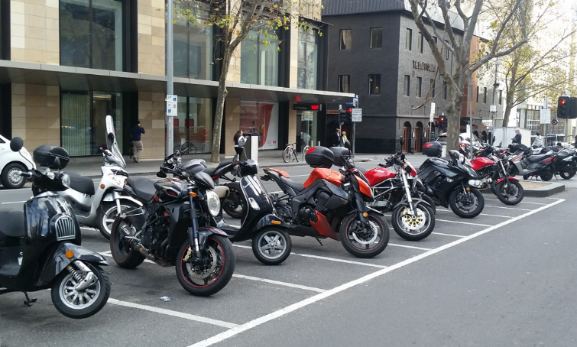
Motorbikes are allocated on-street parking on Russell Street.

What should be done to address these issues?
Dedicated on-street motorcycle parking is limited. The majority of motorcycle parking occurs on the footpath, where conflicts with people walking and deliveries occur. As demand for footpath space grows there will be more and more places where motorcycle parking on the footpath is not appropriate. More dedicated motorcycle parking will be needed. While the amount of on-street car parking will reduce, a greater proportion of what remains will need to be allocated to motorcycles.
What if more on-street motorbike parking was provided to improve ease of movement and accessibility on our footpaths?

Car share
Car share reduces vehicle ownership. Car share users walk, ride bikes and use public transport for the bulk of their trips and maintain access to a shared car for less frequent and irregular trips. The City of Melbourne allocates parking spaces on street for car share vehicles. However, providing more spaces will require careful management.
Each car share vehicle replaces nine privately-owned vehicles. Compared to car owners, car share users drive half as many kilometres each year.

Opportunities
- There are around 450 car share vehicles in the municipality. Car share providers indicate that there is uncatered demand from residents and businesses.
- Policies to enable operators to access more space, particularly access to existing unused off-street car parking could be revised.
- New technologies such as Mobility-as-a-Service could let people choose from multiple providers on one app.
- Electric car share vehicles could improve air quality and provide battery storage capacity for the city.

Challenges
- Providing on-street car share spaces reduces parking revenue used to deliver essential city services.
- Storing car share vehicles on the street takes up valuable space. Demand for kerb space is increasing with the need for more accessible parking, loading zones and pick up/drop off spaces.
- More share cars will need to be stored off-street, which can be difficult and more costly for providers.
- The optimal number on-street car share vehicles and locations in the municipality needs to be determined.
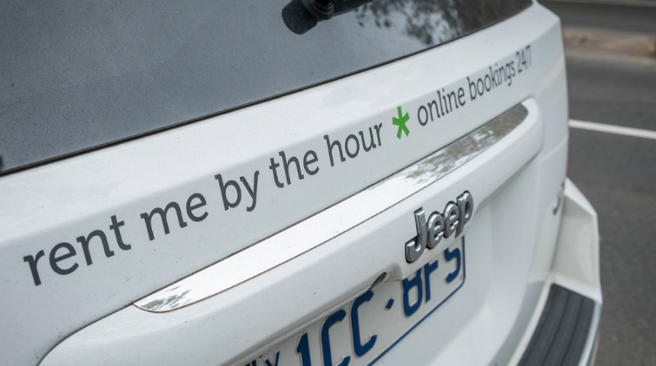
On-street car share spaces are allocated by the City of Melbourne.

What should be done to address these issues?
Changes to the approach towards car share are needed to increase the benefits for Melbourne. The growth of the fleet has not been enough to prevent the number of privately owned vehicles increasing. More people and businesses would use the service if it was easier to access.
Increasing car share will require more spaces to be provided in the municipality. There is an excess of off-street parking which could store car share vehicles and help to manage the demand for kerb space. Equally, revenue from on-street parking is not sustainable long term and car share policy may provide opportunities to transition to new era of mobility technology, secure new revenue sources and support more efficient management of street space.
What if more car share vehicles were available and private vehicle ownership in the city was reduced?

Electric cars
Many electric vehicles operate in Melbourne already - our trains and trams. Trams are soon to be powered by renewable energy, and transitioning trains to renewables should be prioritised. While electric cars reduce noise and tail-pipe emissions, they do not address the main issues caused by cars in cities. Cars occupy a disproportionate amount of space relative to the number of people they move about.
Based on current ownership, if all cars were electric, the average household would consume 84% more electricity.

Opportunities
- Electric cars do not produce tail-pipe emissions so substituting combustion engine cars with electric would result in cleaner air in the city.
- Prices of electric cars are forecast to be equivalent to conventional cars by 2025.
- The municipality has an estimated 13,000 unused residential parking spaces. Opportunities for conversion to electric vehicle charging stations may arise if there is market demand. Charging is already provided in some multilevel car park buildings.

Challenges
- Victoria currently has a growing proportion of clean electricity (around 30%). Rapid take up of electric cars would place enormous additional demand on the grid.
- Electric cars require the same space for storage as a normal car plus infrastructure for charging. Many buildings lack the infrastructure to handle the additional power load.
- The average age of a motor vehicle in Australia is 10years. A transition of the entire current fleet to electric cars would take more than 15 years and generate a lot of waste.
- The high demand for kerbside space in the city will make it difficult to provide on-street vehicle charging.
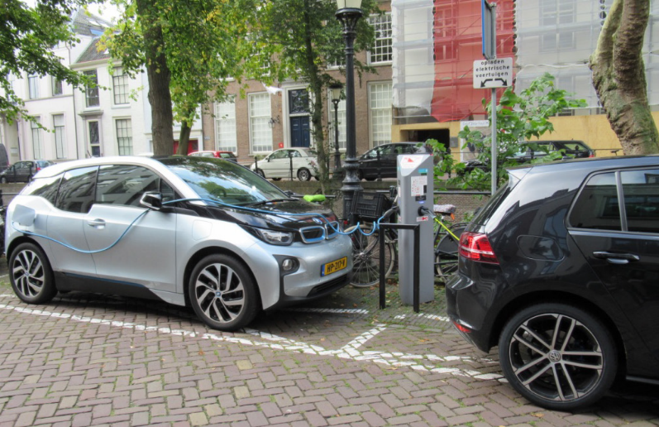
A car is stored on the street in Amsterdam while charging (Institute for Sensible Transport)

What should be done to address these issues?
Some cities provide on-street electric vehicle charging. Generally this happens in older cities where limited off-street parking is available. In Melbourne, an excess off-street parking already exists. Local government has not in the past played a role in providing for the fuelling of private vehicles.
What if policy and action delivered the target of 2000 car share vehicles in the city? If electric, this would provide an electricity storage facility comparable to South Australia’s Tesla battery.

Urban freight
The efficient movement of goods is critical to the function of the city and powers economic growth and productivity. As the city gets busier, delivering goods and services becomes more challenging. The City of Melbourne must facilitate change and innovation in freight to maintain the liveability, sustainability and economic prosperity of the city.
More than 10,000 delivery vehicles access the central city on an average weekday.

Opportunities
- Larger trucks could unload onto smaller vehicles or bikes at freight consolidation centres near the central city. New technology and data can support this.
- Deliveries could be re-timed to off-peak periods and streets designed to perform different functions at different times of day, if business can adapt to this.
- Innovative low-impact delivery vehicles are becoming commercially available, such as electric cargo bikes and battery assisted foot trolleys.

Challenges
- A substantial increase in freight demand is forecast over the next 30 years, including at the Port of Melbourne.
- Last kilometre freight - getting goods to their final destination - is a growing challenge in Melbourne.
- New business models continue to emerge, such as food delivery services direct to the customer. Any impacts on urban amenity must be managed and minimised.
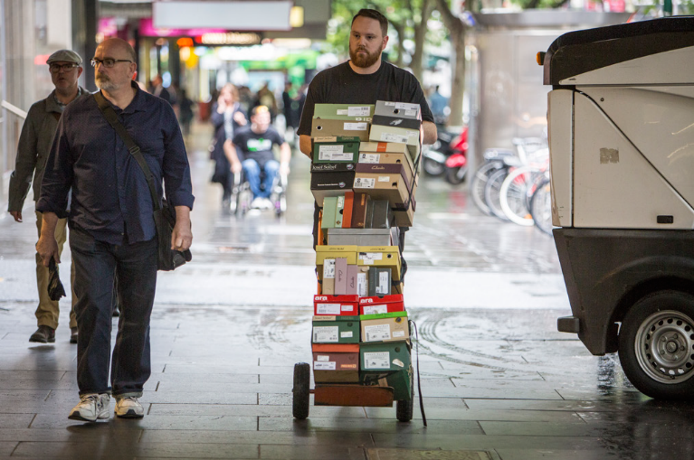
Hand trolleys are used to complete a delivery

What should be done to address these issues?
Dynamic management of loading zones will be required. This may include use of time restrictions and charges to manage demand for delivery access. New regulations may be needed to ensure that on-demand delivery services do not impact on urban amenity. More efficient, low-impact delivery models should be promoted.
What if delivery trucks were removed from the central city through the use of freight consolidation centres and smaller vehicles?

We want your thoughts!
participate.melbourne.vic.gov.au/transportstrategy PH: 9658 9658
transport@melbourne.vic.gov.au

