
Transport Strategy Discussion Paper
Public Transport Network

This discussion paper is to inform a new City of Melbourne Transport Strategy to 2050. A draft strategy will be released for consultation in 2018. We are seeking views on these issues and ideas.
A world-class public transport system is critical to a liveable, prosperous and sustainable city. Mass public transport is the most space-efficient means of moving high volumes of people across medium to long distances. The City of Melbourne manages much of the interface with the public transport network; our streets. The experience of people on the streets in our city, including at interchanges and transfer points, impacts on the reputation of the city.
Our public transport network is under strain. The number of people living, working and visiting the municipality is growing faster than can be accommodated by current services and committed public transport projects. The crucial Melbourne Metro Rail Tunnel will be at capacity soon after completion.

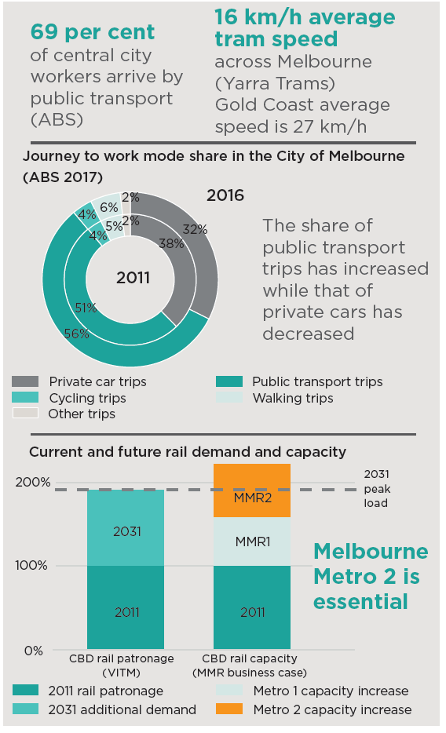

What are the current issues?

Underperforming transport system
Our world class global city must be supported by an excellent public transport system. However, overcrowding is increasing, reliability is poor and many services are infrequent. Demand for access to the central city continues to grow rapidly. Poorly designed tram platforms are often cramped, uncomfortable and inaccessible.

Radial network limitations
Melbourne has a radial public transport network with most tram and train lines passing through the inner city. A disruption where lines overlap means one service can impact many others. Without high-quality links between suburbs, driving in a car is often the only option for trips across and around the metropolitan area.
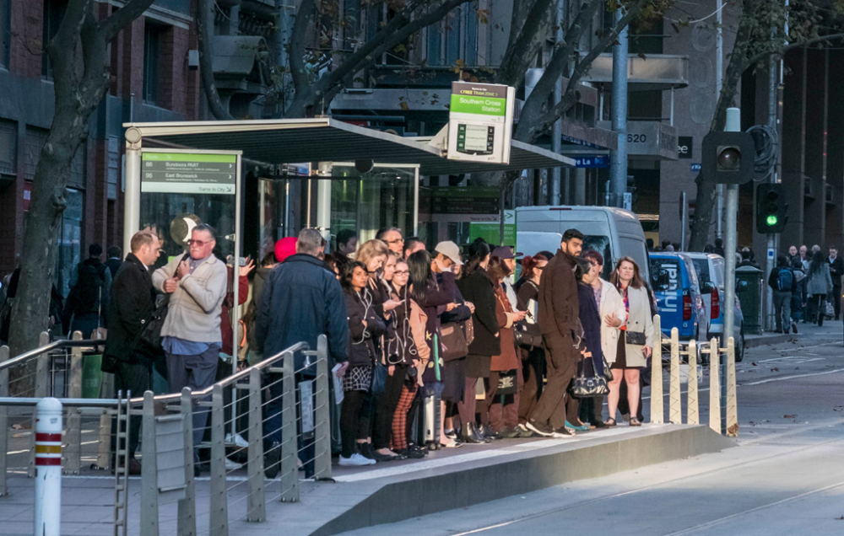
Passengers squeeze onto the tram platform at Southern Cross.

Trams and buses stuck in traffic
Eighty per cent of Melbourne’s tram routes run in mixed traffic while dedicated bus lanes are very limited. This means traffic congestion undermines the reliability, efficiency and frequency of trams and buses. Reducing these delays would allow more services to run without the need to buy more trams and buses, giving such improvements a high benefit-cost ratio.
For peak period trips to the central city, trams carry at least twice as many people than cars on roads including Nicholson Street, Brunswick Street, Smith Street, Victoria Street and Bridge Road. On St Kilda Road the ratio of tram passengers to car occupants is more than five to one. The only way to get more people into the city along these roads is to improve the tram service - increased speeds mean better frequency, carrying more people with our existing trams.

Public transport drives economic growth
The high value jobs in the central city rely on face-to-face interactions and drive productivity and innovation for Victoria and Australia. While our public transport network could be improved, it is effective in connecting many people to employment opportunities in the central city. As Melbourne grows, investment in efficient transport is the most effective way to provide access to the growing job opportunities of the central city.

Opportunities for public transport

Airport rail can serve multiple functions
Access from the airport to the city for tourism and business is important. There is also a need to connect people in the north-west suburbs to jobs at the airport and in the central city. Rail coverage in this part of Melbourne is very limited and roads will continue to become increasingly congested.

Using technology to increase efficiency
Trials are under way to increase priority for trams at traffic lights with tram to signal communications. In the future, tram to vehicle communications could ensure that congestion does not impede trams, letting drivers know to clear tracks for trams as they approach. Technology could also assist with the enforcement of this priority.

Tram stop design improvements
Upgrades to tram stops across the network to meet accessibility requirement offer an opportunity to better integrate tram stops with the street and other modes, such as bikes. With lower speeds and less vehicles in the central city, tram waiting areas can be designed in different ways, such as the Macarthur Street stops.

Improved bus priority and electrification
Bus reliability and travel speeds could be improved by reprioritisation and reconfiguration of intersections. Electric buses with charging capabilities either at stops, along the route or both have the potential to offer improved air quality and potentially unlimited range (like a tram).
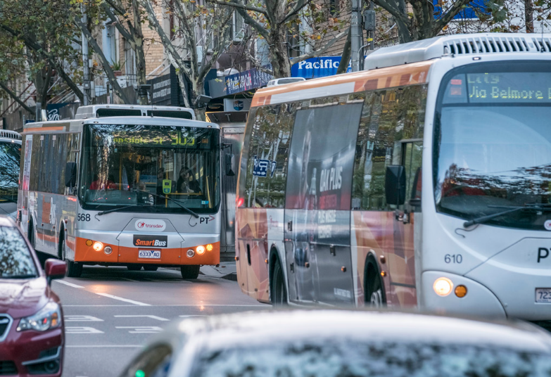

Melbourne’s future rail network?
Melbourne Metro 2 has been identified as an important infrastructure project but has not yet been committed by government. At the core of the project is a new rail tunnel proposed to link Newport to Clifton Hill via Fishermans Bend. High capacity trains would run on dedicated tracks from Wyndham Vale to Mernda.
The benefits of this project could include high capacity access from the west to major destinations, freeing up additional capacity in the city loop, reducing pressure on city loop stations and greatly improving east-west connectivity across the city. This city-shaping project would provide residents the choice to reduce car dependency, particularly in the western suburbs.
A Melbourne Metro 3 concept has been identified by independent researchers to help meet Melbourne’s growth challenge – a new generation driverless, high frequency, rail system - to support intensification of the inner city and reduce car dependence. An alignment through Southern Cross via E-gate, Arden Macaulay, Highpoint and Maribyrnong to the airport would support increased densities, unlock development potential, offers value capture opportunities and could complement a regional airport rail alignment via Sunshine.
The eastern end of the line could extend to north-east Richmond and beyond, filling a gap in the heavy rail network, providing better walking catchments than an Eastern Freeway Doncaster rail, further improve Airport access and ease congestion in surrounding areas.
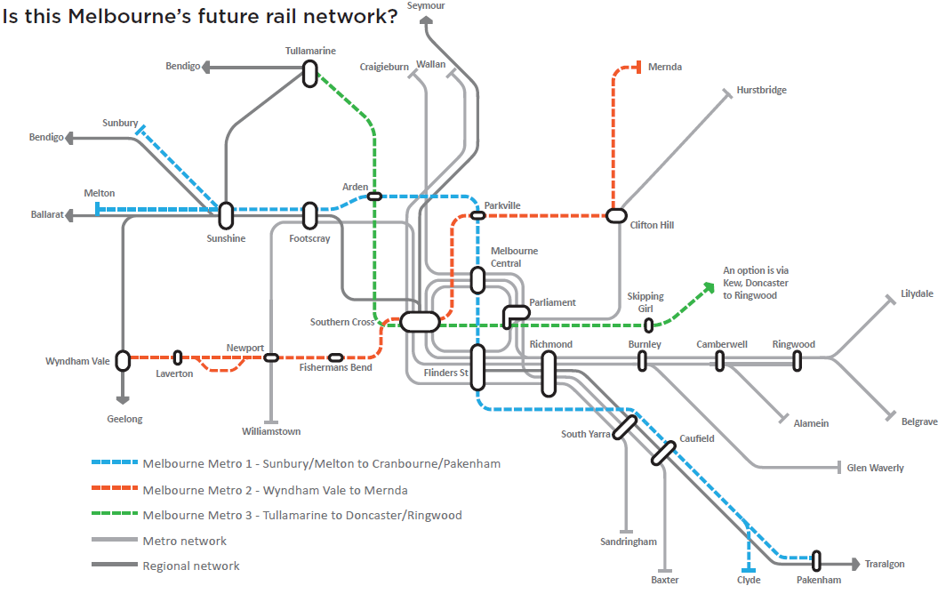

What are other cities doing?
Cities around the world are facing challenges similar to Melbourne. These global best practice ideas can help to inform the right approach for Melbourne.

Heathrow Airport rail connections, London
- By approximately 2028, the number of trips to and from Tullarmarine Airport will be comparable with Heathrow Airport today.
- Three rail lines service Heathrow providing options for different passengers and markets: the ‘Tube’ stopping all stations, an express line to central London and a limited express, soon to be extended through central London.

Melbourne with 8 million people will need several public transport connections to the airport including regional rail, metropolitan rail, tram and bus
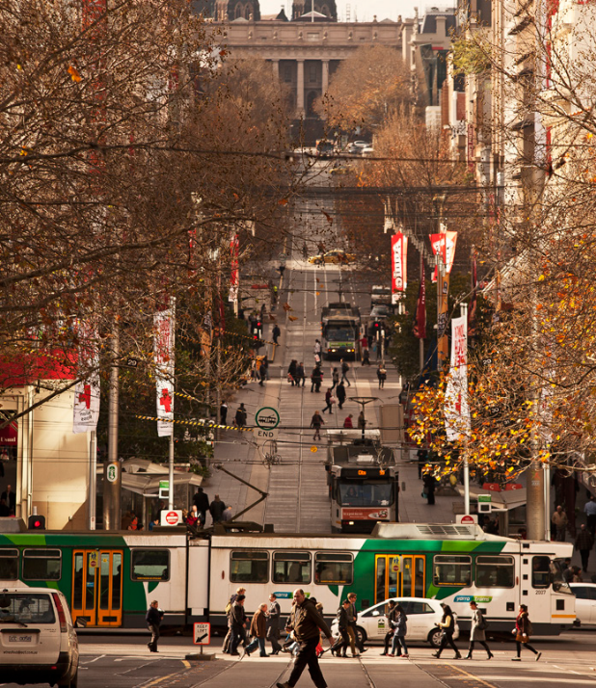

Improving tram performance, Zurich
- Zurich has had tram prioritisation measures in place since the 1980s which have caused a dramatic increase in tram patronage.
- Zurich trams spend only 6% of their time at traffic lights, compared to Melbourne trams which spend 17% of their time at traffic lights. Zurich gives absolute priority at traffic lights and allocates dedicated road space to trams, with the ideal situation being one where trams need only stop to set down or pick up passengers.

What should be done to address these issues in Melbourne?

Build Melbourne Metro 2
This should be the highest priority major transport project for Victoria. The project was identified as a priority by Infrastructure Victoria and the Rail Network Development Plan. The Melbourne Metro Rail Authority is in place with the skills and knowledge to deliver this project. If planning commenced in 2018, Melbourne Metro 2 construction could begin prior to finishing Metro 1. The vision for Fishermans Bend will not be realised without Melbourne Metro 2 to enable the transition to a world class urban renewal area.

Planning for Melbourne Metro 3
The next major transport project for further investigation. Melbourne Metro 3 would supplement a regional airport rail connection and open up urban renewal opportunities in the north-west. It will further increase capacity of the rail network and provide for convenient car-free cross city journeys.

Supercharge the tram network
Providing trams with priority through intersections and dedicated road space will improve the reliability, efficiency and capacity of the tram network. Faster trams can complete their run sooner and provide more services with the current fleet. Enforcement of road rules is critical to prevent private vehicles blocking trams, improve safety and increase reliability. Trams freed from traffic are extremely efficient - Swanston Street carries more people each day than the West Gate Bridge.

New orbital services
The Victorian Government needs to invest to develop high capacity, efficient bus and light rail orbital routes. By connecting train lines this will provide greater choice for trips around the metropolitan area. This would make public transport more useful for more trips - including to the central city. The importance of orbital services was also identified by Infrastructure Victoria’s 30 Year Strategy and supported in principle by the Victorian Government.

What if?
- Melbourne Metro 2 was completed by 2030, connecting the western suburbs into the central city and unlocking the potential of Fishermans Bend.
- Melbourne Metro 3 was completed by 2035, providing a second airport rail link and north-west connectivity through the central city to North Richmond and beyond.
- Trams were ‘supercharged’ with more tram-only right of way and cars removed from tram tracks across the network to improve travel times and reliability.
- New and existing road rules to protect the priority of efficient transport modes were enforced.

We want your thoughts!
participate.melbourne.vic.gov.au/transportstrategy
9658 9658
transport@melbourne.vic.gov.au

