vi
Economic development strategy 2025-29
Consultation draft

Acknowledgement of Traditional Owners
The City of Melbourne respectfully acknowledges the Traditional Owners of the land we govern, the Wurundjeri Woi-wurrung and Bunurong / Boon Wurrung peoples of the Kulin and pays respect to their Elders past and present. We acknowledge and honour the unbroken spiritual, cultural and political connection they have maintained to this unique place for more than 2000 generations.
We accept the invitation in the Uluru Statement from the Heart and are committed to walking together to build a better future.

Council Plan 2021-25
The Council Plan 2021-25 sets out our strategic direction and commitment to the community. Based on six strategic objectives, this detailed plan considers the needs of all people who access and experience the City of Melbourne municipality. For more information visit melbourne.vic.gov.au/council-plan
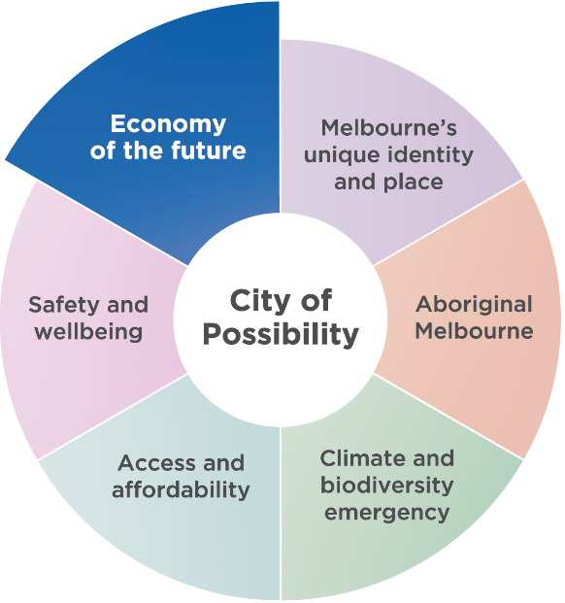

Economy of the future
Driving economic recovery is one of our chief objectives, to ensure the central city maintains a strong reputation as a destination to do business, visit, study and live. We will support a diverse mix of industries and jobs by creating conditions for a sustainable and thriving future economy.

Contents
Acknowledgement of Traditional Owners 2
Council Plan 2021-25 2
Executive Summary 5
Melbourne’s economic strengths 5
Key opportunities for growth 5
Opportunity 1: A global powerhouse of innovation 5
Opportunity 2: A magnet for the world’s brightest minds 6
Opportunity 3: Alive with energy 6
Getting the fundamentals right: Ensuring Melbourne’s continued liveability 6
Introduction 7
Vision for Melbourne 7
Prosperous Melbourne 7
Economic Development: More Than Economics 8
Building prosperity for all 8
Community ownership of the local economy 8
United Nations Sustainable Development Goals 8
Melbourne’s Economy 10
Key industries 10
Melbourne’s highly skilled workforce 12
Precincts 13
Metro Tunnel (2025) 13
The Fox: NGV Contemporary (proposed for 2028) 13
Airport Rail Link (proposed for 2033) 13
Areas for improvement 14
Strategic opportunities to drive success 15
Opportunity 1: A global powerhouse of innovation 16
Opportunity 2: A magnet for the world’s brightest minds 18
Opportunity 3: Alive with energy 20
Getting the fundamentals right: Ensuring Melbourne’s continued liveability 22
Implementation plan 24
Related plans 24
Conclusion 25
Appendix: facts and figures 26

18 March 2025

Disclaimer
This report is provided for information and it does not purport to be complete. While care has been taken to ensure the content in the report is accurate, we cannot guarantee it is without flaw of any kind. There may be errors and omissions or it may not be wholly appropriate for your particular purposes. In addition, the publication is a snapshot in time based on historic information which is liable to change. The City of Melbourne accepts no responsibility and disclaims all liability for any error, loss or other consequence which may arise from you relying on any information contained in this report.
To find out how you can participate in the decision-making process for City of Melbourne’s current and future initiatives, visit melbourne.vic.gov.au/participate

Executive Summary
The City of Melbourne is an economic powerhouse.
On just 38 km² of land, it generates $116 billion in annual economic activity, which is nearly 22 per cent of Victoria’s total output. With a reputation for innovation, diversity and resilience, the city is a magnet for investment, talent and visitors.
Over the past two decades, the City of Melbourne has maintained an average annual growth rate of about 5 per cent, more than twice as fast as the rest of the Victorian economy. This has been driven by the city’s knowledge-based economy, world-class retail and hospitality sectors, globally leading universities and a thriving cultural scene of events and activations.
This draft Economic Development Strategy 2025–29 proposes a bold ambition: to make Melbourne the Asia- Pacific’s city of choice for innovation, talent and liveability. At the same time, it identifies that economic growth must be inclusive and community-driven, ensuring that prosperity is shared by all.

Melbourne’s economic strengths
The City of Melbourne’s strong economy is underpinned by four key elements: a broad range of industries; a strong knowledge economy, a diverse, young and talented population, and a central geographic location. Our city is home to leading financial institutions, cutting-edge innovation hubs, and vibrant retail and hospitality precincts. The city is competitive and resilient, built on the interdependence between the knowledge industries in high-rise office buildings and the economic activity taking place in the shops, restaurants and other premises at street level.
Melbourne must adapt to global competition, shifts in working habits and affordability challenges. This strategy sets out a plan to capitalise on opportunities and overcome challenges to secure Melbourne’s future as a global leader in business, culture and innovation.

Key opportunities for growth
This strategy focuses on three key opportunities to strengthen Melbourne’s economy.

Opportunity 1: A global powerhouse of innovation
We will position the city as a premier location for doing business, and we will further enhance the city’s strengths in innovation.
To realise this opportunity, we will:
- Support start-ups and scale-ups in Melbourne’s key innovation sectors: health technologies, climate tech, digital games, sports tech and education tech.
- Strengthen social impact innovation by enabling investment, capability building, procurement and promotion.
- Build Melbourne’s global reputation as a premier destination for investment, entrepreneurship and innovation.
- Lead in climate solutions by capitalising on the shift to a zero-carbon economy and expanding the circular economy.
- Connect industry, government research and entrepreneurs to drive commercial activity and boost Melbourne’s competitive edge.
- Foster emerging businesses through targeted investment, red-tape reduction and innovation pilots.
- Accelerate innovation districts in Arden, Fishermans Bend and City North in partnership with the Victorian Government.
By fostering high-growth industries – particularly in the innovation economy – Melbourne will be an even more attractive destination for investment and jobs, further enhancing its economic resilience and global competitiveness.

Opportunity 2: A magnet for the world’s brightest minds
Melbourne’s diverse workforce is a strength. By creating pathways for underutilised talent and enhancing its appeal to global talent, Melbourne can secure its position as a magnet for skilled individuals and ensure that all city residents and workers can maximise their potential and access the benefits of the city’s economy.
To realise this opportunity, we will:
- Support entrepreneurial initiatives within migrant and diverse communities that boost economic participation and strengthen the city’s reputation as a place where everyone can thrive.
- Strengthen the work to realise Melbourne’s ambition to be the world’s best city for the student experience.
- Develop targeted programs to transition international students into the workforce.
- Attract and embed global talent by advocating for more favourable migration outcomes.
- Lead on initiatives that maximise participation for all, including a renewed focus on Aboriginal economic development.
By working towards an inclusive workforce, Melbourne’s economy will provide more opportunities for more people.

Opportunity 3: Alive with energy
Invigorating the city’s vibrancy and economic performance will cement the city’s reputation as the preferred
Asian-Pacific city in which to work, study, live and play. To realise this opportunity, we will:
- Strengthen Melbourne’s 24-hour economy by helping traders and businesses adapt to new city rhythms, engaging with industry and government to reduce regulatory burden on traders and businesses, and aligning Council operations with changing demand.
- Maximise the benefits of new infrastructure, including five new Metro stations in 2025 and the future airport rail link, to boost city access, activity and productivity.
- Revitalise underused properties by encouraging creative reuse, converting vacant office spaces and supporting the transition to net zero buildings.
- Tailor support for city precincts through targeted initiatives like Business Improvement Districts to enhance local economic development.
- Sustain a vibrant experience economy by supporting retail, hospitality and live music to keep Melbourne’s high streets active and appealing.
A thriving city secures Melbourne’s reputation as a top global destination for business, culture and tourism.

Getting the fundamentals right: Ensuring Melbourne’s continued liveability
Beyond major economic initiatives, Melbourne must maintain its reputation as one of the world’s most liveable cities. Success depends on vibrant streetscapes, green spaces, cultural activation, safety, accessibility and high- quality transport.
To achieve this, we will:
- Support affordable housing and public transport to benefit key workers and improve city accessibility.
- Deliver a world-class events program that activates precincts year-round and showcases Melbourne’s diversity.
- Strengthen the creative sector by facilitating collaborations, supporting public art, and improving access to affordable workspaces.
- Enhance city amenity with dedicated programs to keep Melbourne clean, beautiful and safe for all.
- Support business success through clear communication, targeted information, and a proactive Business Concierge service.
- Align city programs with community values, including Melbourne’s global connections, sustainability goals and net zero commitments.
By getting the fundamentals right, Melbourne enhances its economic competitiveness and liveability.
By leveraging its strengths — the knowledge economy, business innovation, cultural vibrancy and the city’s reputation — Melbourne can secure its future as a global leader.
This strategy ensures that Melbourne’s economic growth is bold, inclusive and shared by all.

Introduction
The City of Melbourne is one of Australia’s most important economic centres. Its $116 billion economy accounts for 22 per cent of Victoria’s output and almost 5 per cent of the national economy. The City of Melbourne economy has experienced compound average annual growth of nearly 5 per cent, about twice the rate of the national economy.
Melbourne’s economy has rebounded strongly since the COVID pandemic. In 2023, the City of Melbourne economy was 9 per cent larger than it was in 2019.
The city’s economy is driven by knowledge-related activity, which makes up about two-thirds of output and jobs. This is underpinned by vibrant and globally renowned festivals, events, activations, and retail and hospitality offerings that continue to attract visitors and new residents. The City of Melbourne’s location at the geographical centre of Victoria further creates economic benefits for residents, workers and visitors.
As a city whose influence and impact extends well beyond its borders, our engagement with the world in general and Asia in particular remains a priority. The region contains 12 of Australia’s largest 15 trading partners, accounting for two-thirds of total trade. The connection between Australia’s fastest growing city and the world’s fastest growing region presents uncapped opportunities for Melbourne.
This strategy outlines how Melbourne can leverage its strengths, tackle its challenges, and seize emerging opportunities to secure its place as one of the world’s most dynamic and liveable cities.

Vision for Melbourne

Melbourne
Asia-Pacific’s city of choice for talent, investment and opportunity.

Prosperous Melbourne
Melbourne has always been an economic powerhouse. Long before European settlement, First Nations Elders recognised the banks of the Birrarung (Yarra River) as an important meeting place, shaping a tradition of gathering, exchange and prosperity that continues today.
Successive waves of migration have enriched the city, bringing fresh ideas, skills and perspectives. The mid–19th century gold rush and the Eureka rebellion embedded a legacy of both economic opportunity and a strong commitment to fairness. Post-war migration transformed Melbourne into a diverse and globally connected city, strengthening its economic resilience.
Today, Melbourne’s economy is vibrant and multifaceted, anchored by a world-class education sector and a thriving innovation ecosystem. As Australia’s largest and fastest- growing city, it has demonstrated remarkable adaptability, reflected in strong consumer spending and the lowest shopfront vacancy rate in the country. Its renowned events, culture and live music scenes continue to attract residents and visitors, reinforcing its status as a dynamic global destination.
As Victoria’s capital and economic engine, the central city is a hub for employment, innovation and investment. While the City of Melbourne spans almost 38 km², its economic impact extends far beyond its borders. Workers earn their income here but spend across the metropolitan region, and businesses generate revenue both locally and globally.
Melbourne’s connectivity fuels its success. With all major transport networks leading into the city, businesses benefit from a deep talent pool, and traders access the largest customer base in the country. The city’s compact design fosters collaboration, with key networks and decision- makers just a short walk or tram ride away.
The lower cost of doing business further strengthens Melbourne’s competitive edge. A recent CBRE report found that commercial rents in Melbourne are around 40 per cent lower than in Sydney, and broader business costs in Victoria remain highly competitive (Table 1, Appendix).
With world-class universities, a thriving innovation ecosystem, and an entrepreneurial, diverse population, Melbourne is uniquely positioned to thrive. By building on its strengths, addressing its challenges, and embracing bold, transformative strategies, the city can secure its future as a global leader in innovation, talent and culture.

Economic Development: More Than Economics

Building prosperity for all
Done well, economic development fosters both prosperity and resilience – qualities that became especially important as the city emerged from the pandemic. By diversifying industries, supporting innovation and unlocking the potential of people and places, economic development can help the city to better navigate change and uncertainty.
Economic development isn’t just about numbers and statistics. It’s also about creating opportunities and improving quality of life for individuals and the whole community. A strong, dynamic economy provides access to better jobs, higher incomes and greater opportunities for personal and professional growth. When businesses thrive, they generate employment, invest in local infrastructure and support community services that benefit everyone.

Community ownership of the local economy
Economic development is about building a Melbourne where everyone can thrive.
Communities should have the opportunity to identify outcomes that will most benefit their lives and help shape economic strategies that align with those ambitions.
When communities take ownership of the tools and policies, a shared vision comes to life. This is critical to the city’s long-term success and resilience.
Effective economic development ensures that growth benefits the entire community while addressing broader challenges, such as climate change. It also ensures that the economy continues to allocate resources effectively to meet demand.
When the community, business and Council work together, we can shape an economy that supports a vibrant culture, secure employment and a high quality of life for all.
Economic development is about building a Melbourne where everyone, including our multicultural communities, can thrive.

United Nations Sustainable Development Goals
The United Nations Sustainable Development Goals are 17 globally recognised ambitions to progress sustainable development and track performance.
A central pillar of the Sustainable Development Goals is to ‘leave no one behind’. Global support can help to end poverty, protect the planet and ensure all people enjoy peace and prosperity by 2030.
The City of Melbourne has taken the lead and is the first council in Australia to conduct a Voluntary Local Review of the city’s progress towards the Goals. The Sustainable Development Goals are a guiding framework for the City of Melbourne, ensuring our initiatives achieve holistic sustainable development.
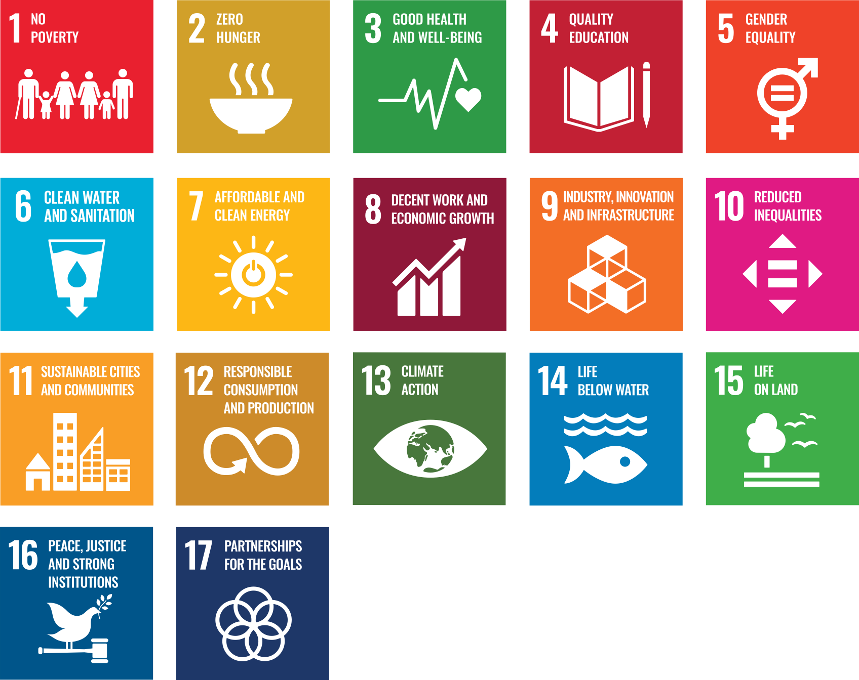
This Economic Development Strategy aligns to the aspirations of the following Goals:

Table 1: Sustainable Development Goals considered in the Economic Development Strategy

Primary Goals
The following Goals are most strongly aligned to the strategic objectives set out in this strategy
- Goal 8 Decent work and economic growth: Creating decent jobs and economic opportunities for everyone
- Goal 9 Industry, innovation and infrastructure: Making sure everyone has the infrastructure they need to connect to the rest of the world
- Goal 10 Reduced inequalities: Reducing the gap between the richest and the poorest
- Goal 11 Sustainable cities and communities: Putting cities at the heart of sustainable development in an urbanising world

Secondary Goals
The following Goals also align to the intent of this strategy
- Goal 1 No poverty: To end poverty in all its forms everywhere
- Goal 3 Good health and wellbeing: Helping people to live long and healthy lives
- Goal 4 Quality education: Enabling everyone to study, learn and fulfil their full potential
- Goal 5 Gender equality: Ending violence and discrimination against women and girls and making sure they have equal opportunities in all areas of life
- Goal 7 Affordable and clean energy: Making sure everyone has affordable access to green energy
- Goal 12 Responsible consumption and production: Reducing our impact on the planet by only producing and consuming what we need
- Goal 13 Climate action: Making positive action to reduce the effects of global warming
- Goal 16 Peace, justice and strong institutions: Keeping people safe and making sure that government works effectively and fairly
- Goal 17 Partnerships for the Goals: Strengthening and maximising collaboration with other councils, government agencies, businesses and our local community

Melbourne’s Economy

Key industries
Melbourne’s strong economy is driven by its knowledge sector, which accounts for about two-thirds of the city’s total economic activity (see Figure 1, Figure 2). A key factor in this strength is the attractiveness of the central city, which is home to the headquarters of two of Australia’s major banks, along with a diverse range of firms in financial services, professional and scientific services, and the rapidly growing innovation economy. This includes Melbourne’s globally competitive life sciences sector – centred around Parkville – and features one of Australia’s largest companies, CSL.
While the knowledge sector dominates, its interdependence with the ‘street-level and laneway’ economy is crucial. A vibrant streetscape, engaging activations, world-class restaurants and retail establishments help create an environment where professionals actively choose to work in the central city. In turn, the hundreds of thousands of office workers who commute to the city daily sustain local traders.
This symbiotic relationship between the knowledge economy and the street-level economy is the foundation of Melbourne’s economic strength, and the focus of this strategy.
Over the past decade, the industries that have contributed most to economic growth in the City of Melbourne are mostly knowledge-related services (Figure 1, and Table 4 in the Appendix). Just three industries – finance, professional services and computer systems – contributed almost half of the city’s economic growth.

Figure 1. Contribution to the growth of City of Melbourne’s economy over the past decade
(Increase in value-add 2013–14 to 2022–23)
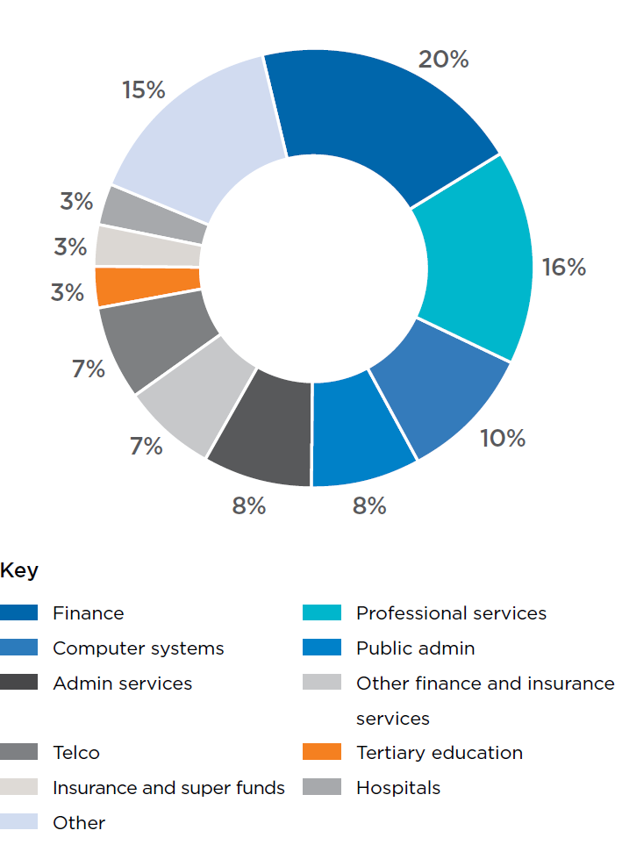
Source: economy.id

Some sectors have enjoyed astonishing growth rates. The fastest-growing sectors are mostly associated with the growth of the internet and information technologies. These sectors have experienced a two-, three- or even five-fold increase in size (Figure 2).

Figure 2. City of Melbourne’s 10 fastest-growing industries
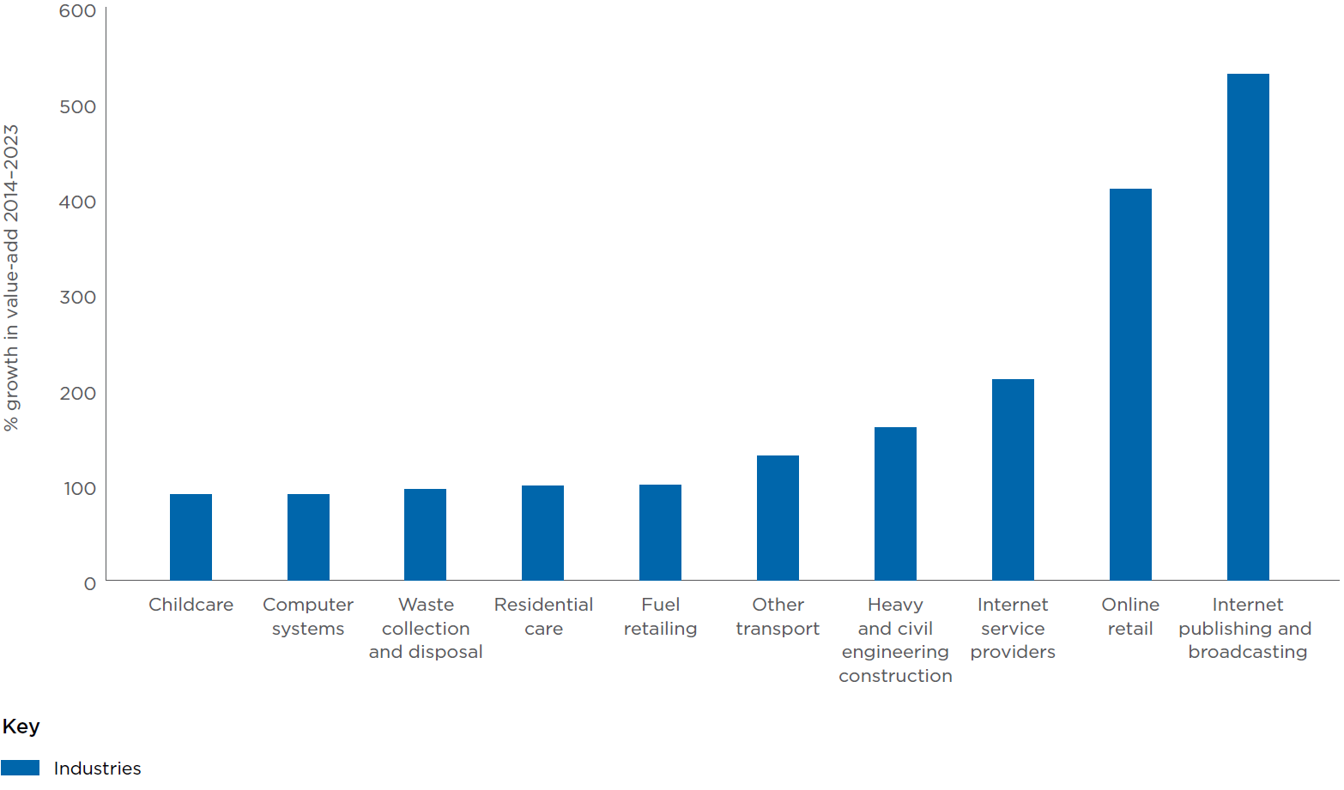
Source: economy.id

Melbourne’s highly skilled workforce
There are more than 600,000 jobs in the City of Melbourne. Given the important role played by the knowledge economy, workers in the City of Melbourne tend to be more highly qualified than workers in the rest of the state. About two-thirds of workers have a bachelor degree or higher (Figure 3). Due both to the skill level of employees and the productivity of Melbourne’s knowledge intensive industries, labour productivity in the City of Melbourne is much higher than elsewhere in Victoria ($176,000 in value-add per worker, compared to $126,000 for Victoria as a whole).
Almost 90 per cent of the city’s workforce lives in other municipalities. The City of Melbourne’s biggest sources of workers are: Merri-bek (29,985 – 6 per cent), Wyndham (28,928 – 6 per cent), Boroondara (23,267 – 5 per cent), Yarra (21,467 – 4 per cent) and Port Phillip (20,818 – 4 per cent).vii
By ensuring the city is alive with energy, Melbourne will continue to attract the many knowledge workers who live outside the municipality. This will help to sustain the city’s high economic output, and ensure Melbourne stays at the epicentre of Victoria’s knowledge economy.

Figure 3. Qualifications of workers in Melbourne
(2021)
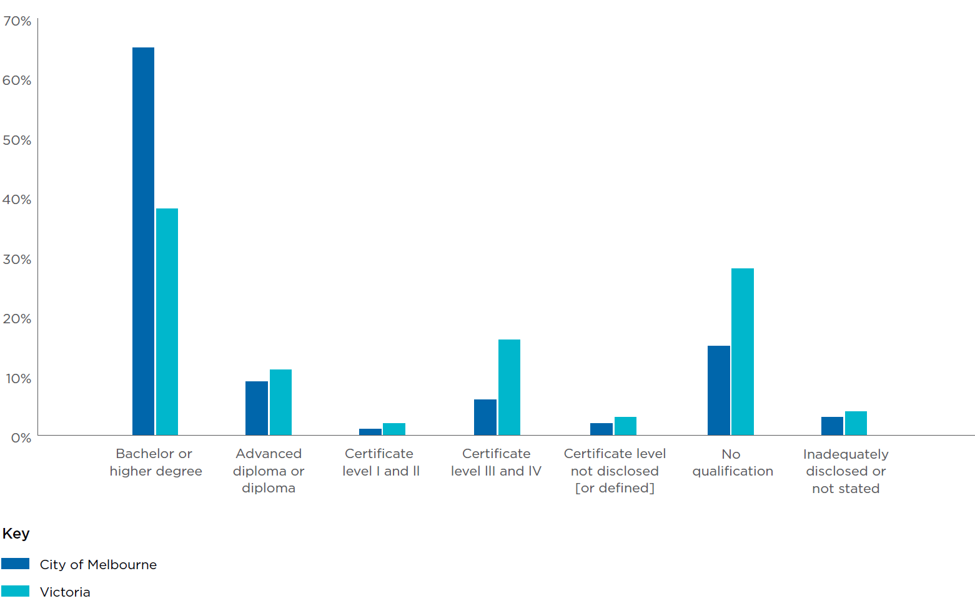
Source: economy.id

Precincts
One of Melbourne’s greatest strengths is its geography. The city’s physical layout and the concentration of different sectors and activity zones across the municipality play a crucial role in its economic success.
Melbourne can also be understood through its many precincts, each defined by its unique street-level activity. The Collins Street East precinct is home to much of the city’s luxury retail, while City North is rapidly evolving to meet the growing demand driven by increasing numbers of international students.
Different industry sectors are also prevalent across the city (Figure 4). Docklands, for example, is dominated by the financial and insurance services sector, while Parkville’s economy is led by healthcare and social services.
Looking ahead, major infrastructure investments will create new opportunities to attract visitors and expand economic activity:

Metro Tunnel (2025)
The five new metro stations set to open in 2025 will significantly alter activity levels around each location. Maximising these benefits will be key to ensuring their full economic impact.

The Fox: NGV Contemporary (proposed for 2028)
This $1.7 billion addition to the Melbourne Arts Precinct will enhance and reshape the cultural and tourism landscape.

Airport Rail Link (proposed for 2033)
The introduction of a direct rail connection to Melbourne Airport will provide a major boost for tourism, business, and broader economic activity. Planning now will help the city fully capitalise on this opportunity.

Figure 4. Largest sector in City of Melbourne neighbourhoods
(by jobs)
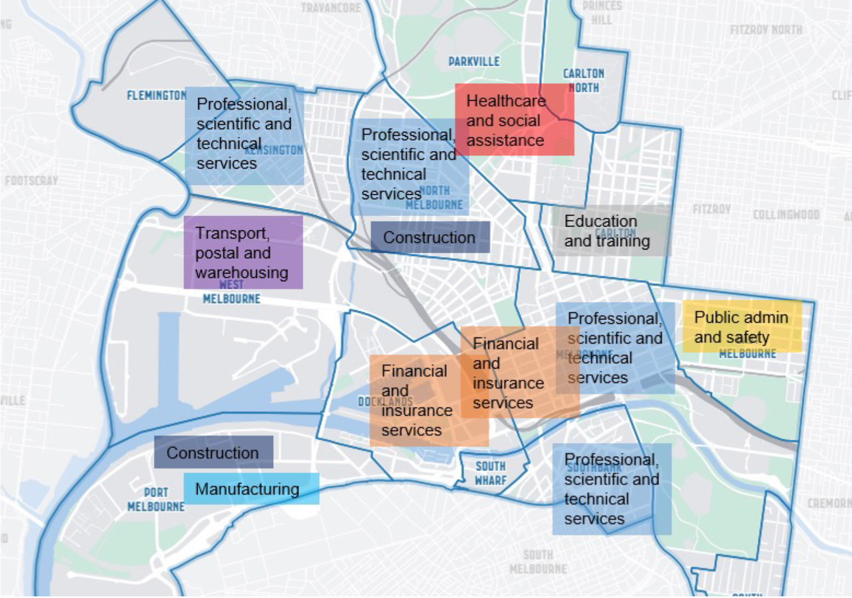
Source: economy.id

Areas for improvement
Melbourne’s core strengths have played a significant role in its resilience and success. However, certain challenges must be addressed to create new opportunities for growth:
- Strengthening Melbourne’s reputation as a global business city. While Melbourne is well positioned as a global city, competition among peer cities is intensifying. Melbourne’s brand as an events and cultural hub is strong, but its recognition as a leading destination for global business does not yet match its capacity. To remain competitive, the city has an opportunity to reinforce and promote its business brand on the global stage.
- Maximising the benefits of a diverse and youthful population. Stronger pathways can be developed between education and professional engagement for international students and emerging talent. This can enhance workforce integration and strengthen Melbourne’s diverse economy. Improving these linkages will deliver better outcomes for students and maximise the city’s available labour force. Efforts to integrate students more effectively will further strengthen Melbourne’s reputation as the world’s best city for the student experience.
- Supporting the continued growth of Melbourne’s innovation economy. The city takes a proactive role in fostering innovation, particularly in five sectors where it has clear competitive advantages: life sciences, climate technology, sports technology, digital games and education technology. The establishment of the Melbourne Climate Network in 2023 demonstrated how city leadership can help seed innovation. Each innovation ecosystem faces distinct challenges, from improving capital flow to streamlining procurement processes so that emerging technologies and enterprises can compete on a level playing field. Addressing these challenges will help unlock Melbourne’s full innovation potential.
- Enhancing access to affordable housing, particularly for key workers. Like the rest of Australia, Melbourne faces ongoing challenges in housing affordability. Expanding access to housing is essential for supporting the city’s workforce and maintaining its attractiveness. A particular focus is needed on housing for the low-income key workers who are essential to the city’s daily operations, such as hospital staff and employees in service industries. Addressing this gap will strengthen both the city’s productivity and liveability.
- Restoring balance in office accommodation. Office attendance continues to recover post-pandemic, but a mismatch remains between supply and demand, particularly in certain office stock categories. The ‘flight to quality’ trend has seen tenants favouring higher-standard office spaces, particularly those with strong sustainability credentials. More can be done to enhance the appeal of underused office stock, including repurposing assets that no longer meet market expectations, and leveraging the planning and building requirements to optimise expectations.
- Improving access to the city to boost economic activity. Efficient access to the city is vital for economic development. However, Melbourne’s centrality contributes to congestion. About 43 per cent of vehicle traffic travels through the Hoddle Grid without stopping. Council’s goal is to improve accessibility, encourage greater patronage, and support the city’s long-term liveability and economic vibrancy.

Strategic opportunities to drive success
To maintain Melbourne’s position as a global leader in innovation, talent, and culture, bold and transformative action is required. The focus must be on leveraging
the city’s unique strengths, addressing key challenges, and unlocking new opportunities. By acting decisively, Melbourne can ensure its economy remains resilient, its community inclusive, and its future bright.
This strategy identifies three key strategic opportunities:
- Melbourne is a global powerhouse of innovation.
- Melbourne is a magnet for the world’s brightest minds.
- Melbourne is alive with energy.
While these ambitions are presented separately, they are deeply interconnected. For example, Melbourne’s attractiveness as a tourism destination aligns closely with its appeal to businesses, which in turn influences investment, trade, and broader economic outcomes. This interconnectedness is illustrated in Figure 5.

Figure 5. Interconnectedness of a city economy
(London & Partners)
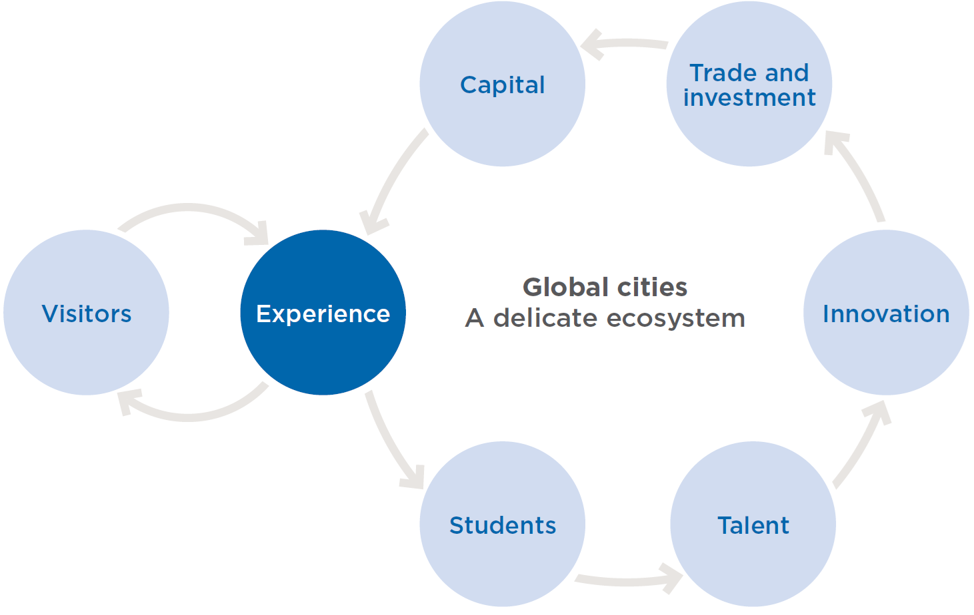
The City of Melbourne will use its levers, networks and voice to bring about change.
As a local government, the City of Melbourne has some capacity to shape, implement and influence change in the economy. But economic development relies on contributions from a wide range of organisations and levels of government. Accordingly, some of the actions that flow from the strategic priorities will be delivered directly by the city, some will be delivered in partnership with others, while other priorities will require Council to take on an advocacy role.

Opportunity 1: A global powerhouse of innovation

What it involves
Melbourne is a city of ideas and enterprise, where world- class research institutions, high-growth startups and industry leaders come together to drive innovation. Our strengths in priority sectors – such as health technologies, climate tech, digital games, sports tech and education tech – give us a competitive edge in the global economy. By strengthening these sectors, fostering collaboration and attracting top talent and investment, Melbourne can generate high-value jobs, improve productivity and develop solutions that address major global challenges.

Why it will make a difference
Innovation is key to economic growth, resilience and prosperity. Melbourne is already a centre for innovation, and over the past four years, the number of startups in Melbourne has grown by nearly 70 per cent. Realising this opportunity will mean:
- More high-value jobs in emerging and fast-growing industries.
- A stronger pipeline between research, commercialisation and industry.
- Increased global investment and trade opportunities.
- A more resilient economy, better equipped to adapt to global shocks.
- Breakthrough innovations that improve quality of life – whether in healthcare, sustainability or technology.
A city that fosters innovation is a city that prospers. By leading in key sectors and embracing new technologies, Melbourne can secure long-term economic success while improving the lives of its residents, workers and businesses.

Our priorities
Our priorities | City of Melbourne role
Support startups and scaleups in Melbourne’s key innovation sectors: health technologies, climate tech, digital games, sports tech and education tech. | Deliver
Strengthen social impact innovation by enabling investment, capability building, procurement and promotion. | Partner Advocate
Build Melbourne’s global reputation as a premier destination for investment, entrepreneurship and innovation. | Deliver Partner Advocate
Lead in climate solutions by capitalising on the shift to a zero-carbon economy and expanding the circular economy. | Deliver Partner Advocate
Connect industry, government research and entrepreneurs to drive commercial activity and boost Melbourne’s competitive edge. | Deliver Partner Advocate
Foster emerging businesses through targeted investment, red-tape reduction and innovation pilots. | Partner Advocate
Accelerate innovation districts in Arden, Fishermans Bend and City North in partnership with the Victorian Government. | Deliver Partner Advocate

How we’ll know we’ve succeeded
- The number of startups in our five priority areas increases
- Melbourne’s reputation is strengthened as a global city in which to do business
- More global companies make Melbourne their regional home
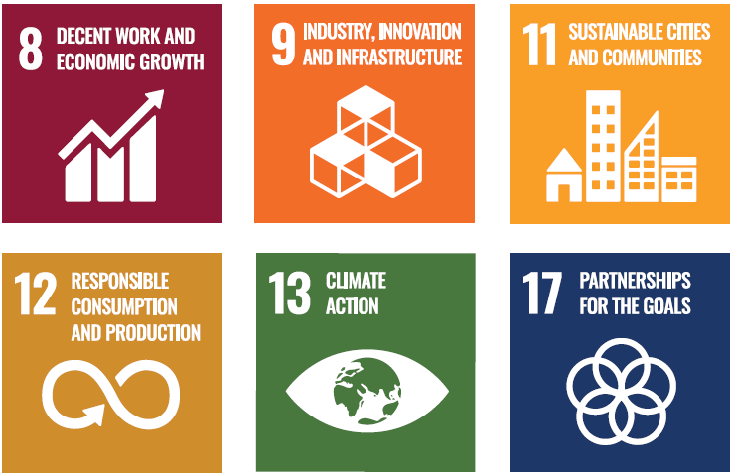

Opportunity 2: A magnet for the world’s brightest minds

What it involves
Melbourne will be a city where the world’s most talented people choose to live, work and build their futures. A place where ambition is matched by opportunity, where local and international students seamlessly transition into the workforce, and where the entrepreneurial spirit of our diverse communities drives new industries and economic growth.
It will be a city that fully harnesses the strengths of its people – where Aboriginal businesses and entrepreneurs thrive, where migrant and women-led enterprises flourish, and where all workers can reach their potential. Melbourne’s global reputation will be built not just on its liveability but also on its economic dynamism, offering a compelling mix of career pathways, investment opportunities and cultural vibrancy that makes talent want to stay.
By fostering an environment where skills, ideas and businesses can grow, Melbourne will secure its place as a top destination for talent – one that is globally connected, economically inclusive and future-focused.

Why it will make a difference
A city that attracts and retains the best talent – while unlocking the full potential of all its people – will be more dynamic, innovative and globally competitive. By removing barriers to participation, fostering entrepreneurship and strengthening international ties, Melbourne can become the go-to destination for people with the ideas and skills to shape the future.

Our priorities
Our priorities | City of Melbourne role
Support entrepreneurial initiatives within migrant and diverse communities that boost economic participation and strengthen the city’s reputation as a place where everyone can thrive. | Deliver
Strengthen the work to realise Melbourne’s ambition to be the world’s best city for the student experience. | Deliver Partner
Develop targeted programs to transition international students into the workforce. | Deliver Partner Advocate
Attract and embed global talent by advocating for more favourable migration outcomes. | Advocate
Lead on initiatives that maximise participation for all, including a renewed focus on Aboriginal economic development, women and under-represented groups. | Deliver Partner

How we’ll know we’ve succeeded
- Melbourne is ranked number 1 globally for student experience
- Participation rates increase for women, First Nations people and under-represented groups
- The number of international students who gain work after competing their studies increases
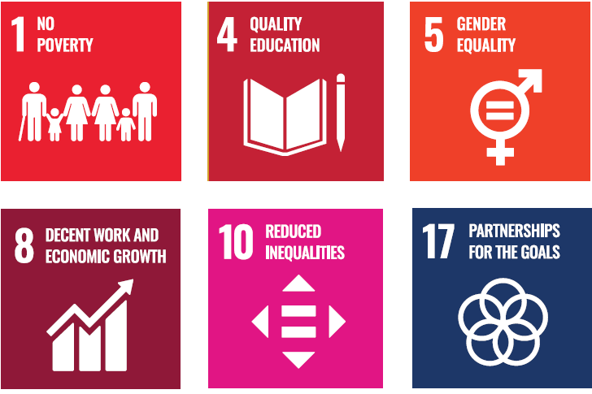

Opportunity 3: Alive with energy

What it involves
Melbourne will be a city that never stands still – where streets are alive with activity, businesses thrive and people are attracted by an unmatched sense of vibrancy. From bustling cafes in the morning to a thriving economy at night, the city will offer something for everyone, 24 hours a day.
The city’s commercial heart will be powered by a dynamic mix of retail, hospitality, arts and entertainment, seamlessly connected to a growing customer base of workers, residents, students and visitors. Underused spaces will be reimagined as vibrant hubs of culture and commerce, while major events and festivals will draw people in year-round, reinforcing Melbourne’s status as a global destination.
With new infrastructure unlocking fresh opportunities, the city will maximise the benefits of transformational investments, ensuring that Melbourne remains a magnet for talent, business and tourism.

Why it will make a difference
A city alive with energy attracts people – knowledge workers, international students, new residents, customers and visitors – fuelling economic growth and reinforcing Melbourne’s position as Australia’s most dynamic urban centre. A thriving central city will drive demand across all sectors, stimulate business investment, and sustain the cultural and commercial vitality that defines Melbourne’s global appeal.

Our priorities
Our priorities | City of Melbourne role
Strengthen Melbourne’s 24-hour economy by helping traders and businesses  adapt to new city rhythms, engaging with industry and government to reduce regulatory burden on traders and businesses, and aligning Council operations with changing demand. | Deliver Partner Advocate
Maximise the benefits of new infrastructure, including five new Metro stations in 2025 and the future airport rail link, to boost city access and activity. | Deliver Partner
Revitalise underused properties by encouraging creative reuse, converting vacant office spaces, and supporting the transition to net zero buildings. | Partner
Tailor support for city precincts through targeted initiatives like Business Improvement Districts to enhance local development. | Deliver Advocate
Sustain a vibrant experience economy by supporting retail, hospitality and live music to keep Melbourne’s high streets active and appealing. | Deliver Partner

How we’ll know we’ve succeeded
- The percentage share of trading hours after 5pm increases
- Activity levels around five Metro stations are equal to other city precincts
- Vacant office space in the central city decreases.
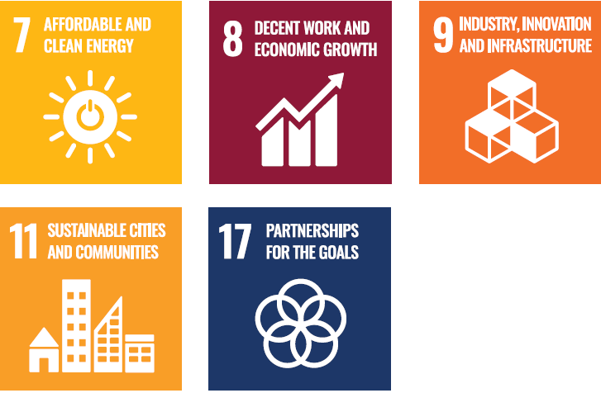

Getting the fundamentals right: Ensuring Melbourne’s continued liveability
Melbourne’s global reputation as one of the world’s most liveable cities is built on strong foundations. A clean, safe and vibrant city isn’t just a backdrop for economic growth – it’s essential to attracting residents, workers and visitors. To stay competitive, Melbourne must offer an exceptional urban experience, with lively streetscapes, accessible amenities and a dynamic cultural scene that excites and inspires.

What it involves
Maintaining a well-maintained, welcoming city is central to Council’s role. World-class events and activations will bring energy to the streets, while investment in public spaces and infrastructure will ensure Melbourne remains beautiful, functional and accessible. Workers should have opportunities close to home and key workers should be
able to live near their jobs. Small businesses will continue to be supported as critical parts of the city’s appeal. Whether for business, study or leisure, Melbourne will remain the destination of choice for all.

How we will make this happen
Our priorities | City of Melbourne role
Support affordable housing and public transport to benefit key workers and improve city accessibility. | Advocate
Deliver a world-class events program that activates precincts year-round and showcases Melbourne’s diversity. | Deliver Partner
Strengthen the creative sector by facilitating collaborations, supporting public art and improving access to affordable workspaces. | Deliver Partner
Enhance city amenity with dedicated programs to keep Melbourne clean, beautiful and safe for all. | Deliver
Support business success through clear communication, targeted information and a proactive Business Concierge service. | Deliver
Align city programs with community values, including Melbourne’s global connections, sustainability goals and net-zero commitments. | Deliver

How we’ll know we’ve succeeded
- More key workers live closer to their places of employment
- More visitors come to Melbourne to participate in the city’s events
- Our Business Concierge service supports an increased number of businesses to open and grow
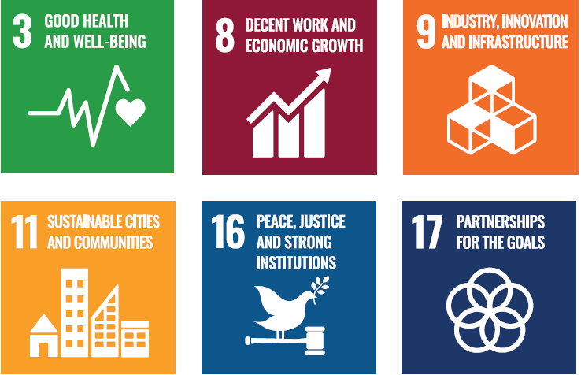

Implementation plan
This strategy leverages Melbourne’s strengths and sets a clear direction for the Council’s economic development efforts over its current term. While the City of Melbourne has the tools and resources to drive progress, success will also depend on strong partnerships with other levels of government, key policy stakeholders and the businesses, institutions and communities that power the city’s economy.
Implementation will be guided by the consultative process informing the Council Plan 2025–29. This plan outlines clear measures of success, specifying:
- initiatives delivered directly by the City of Melbourne
- areas where we collaborate with partners for funding and delivery
- priorities for advocacy to align policy and funding at other levels of government.
A cross-sector advisory group – including industry, academia and community representatives – will oversee implementation, provide guidance and track progress to ensure Melbourne remains on course to achieve its economic ambitions.

Related plans
This Economic Development Strategy is one of several plans that will guide the City of Melbourne until 2028–29 (see Figure 6), when the current Council term ends.
In addition to the broader relationship with these key strategic outputs, other City of Melbourne strategic and operational frameworks also complement and align with this strategy.
These include:
- Annual Budget process
- Stretch Reconciliation Action Plan 2024–27
- Inclusive Melbourne Strategy 2022–2032
- Experience Melbourne
- International Engagement Framework
- Affordable Housing Strategy 2020–30
- Climate Change Mitigation Strategy to 2050
- Transport Strategy 2030.

Figure 6. City of Melbourne plans and strategies

2050 Community Vision
Sets out a long-term vision for the city

Economic Development Strategy
Sets out a high-level strategic direction for economic development

Council Plan
Outlines Council priorities for the four-year term, including specific initiatives

Annual Plan
Includes specific activities and milestones

Conclusion
This strategy outlines a bold and decisive plan to strengthen Melbourne’s economy, while ensuring that growth creates opportunities for all – residents, workers, students and visitors alike. By building on the city’s strengths and tackling its challenges, we will foster an economy that is both dynamic and inclusive, generating prosperity and sharing it widely.
At its core, this strategy is driven by three priorities: innovation, inclusion and liveability. These themes are the key drivers of economic success through population growth, workforce participation and productivity.
The strategic ambitions outlined here reinforce these priorities, ensuring Melbourne remains a global leader in economic opportunity and quality of life.
Melbourne’s continued growth and evolution are inevitable. This strategy ensures that growth is purposeful and leads to outcomes that deliver the greatest benefits for the greatest number of people.

Appendix: facts and figures

Table 2: Comparative cost of doing business in Victoria and other states
 | Victoria | New South Wales | Queensland
Payroll Tax 1 | 4.85% | 5.45% | 4.75% for <$6.5 million in wages 4.95% for > $6.5 million in wages
Prime industrial lease costs ($ / sqm, NF 2) | $140 | $245 | $158
Prime office costs ($ / sqm, NF 3) | $717 | $1,320 | $769
Gas price 4 (DWGM) | $12.25 | $13.66 | $14.71
HF = Net Face Rent
DWGM = Declared Wholesale Gas Market

Sources:
- Victorian State Revenue Office, Revenue NSW, Queensland Revenue Office
- Knight Frank Research, Market Report, 2024
- Knight Frank Research, Market Report, 2024
- Australian Energy Market Operator, Quarterly Energy Dynamics, Q4, 2024

Figure 7: Jobs in the City of Melbourne by sector

(FTE, as at 30 June 2023, source: economy.id)

Knowledge services
Professional services: 133,372
Financial: 92,855
Public admin: 56,687
ICT and telco: 24,775
Admin services: 18,055
Real estate services: 9803

Population services
Accommodation and food: 21,748
Construction: 20,355
Retail: 19,015
Arts and recreation: 14,374
Other services: 9323

Health and education
Healthcare: 42,662
Education: 29,834

Traditional Industries
Transport: 22,269
Manufacturing: 12,801
Utilities: 12,601
Wholesale: 7103

Figure 8: Value-add by sector in City of Melbourne
($ million, as at 30 June 2023)

Knowledge services
Financial: 31,077
Professional services: 19,692
Public admin: 9560
ICT and telco: 7816
Admin services: 6520
Real estate services: 2823

Traditional Industries
Transport: 4145
Manufacturing: 2130
Utilities: 3679
Wholesale: 1903

Population services
Construction: 3853
Arts and recreation: 1979
Retail: 1889
Accommodation: 1813

Health and Education
Healthcare: 4925
Education: 4548

Table 3: Industries that have contributed most to the City of Melbourne’s economic growth over the decade to 2022–23
 | Industry | Increase in value-add 2013-14 to 2022-23 ($m) | Contribution to growth  (%, rounded)
1 | Finance | 5752 | 20
2 | Professional, scientific, and technical services (except computer system design and related services) | 4638 | 16
3 | Computer system design and related services | 2954 | 10
4 | Public administration | 2282 | 8
5 | Administrative services | 2237 | 8
6 | Auxiliary finance and insurance services | 2198 | 7
7 | Telecommunications services | 2055 | 7
8 | Tertiary education | 991 | 3
9 | Insurance and superannuation funds | 919 | 3
10 | Hospitals | 790 | 3

https://participate.melbourne.vic.gov.au/
https://participate.melbourne.vic.gov.au/united-nations-sustainable-development-goals/project-overview
https://hdp-au-prod-app-com-participate-files.s3.ap-southeast-2.amazonaws.com/4816/5595/7875/SDGs-FINAL_21_06_2022_4195_Voluntary_Local_Review_ONLINE-compressed.pdf
Comprising of 77.2% of Victoria’s exports in City of Melbourne Economy.ID (https://economy.id.com.au/melbourne/industry-sector-analysis?BMID=40&IndkeyNieir=24502)
City of Melbourne combined Accommodation and Food + Retail Trade increased 18% between 2022/23 and 2018/19 financial years (inflation adjusted) Economy.ID (https://economy.id.com.au/melbourne/industry-sector-analysis?IndkeyNieir=23600&sEndYear=2019)
CBRE August 2024 (https://www.cbre.com/insights/reports/h1-2024-australian-cbd-retail-vacancy)
City of Melbourne is 24.1% of Victoria’s value add, and 34.4% of exports, Economy.ID (https://economy.id.com.au/melbourne/industry-sector-analysis?BMID=40&IndkeyNieir=22000)
CBRE, October 2024 (https://www.cbre.com/insights/reports/h1-2024-australian-cbd-retail-vacancy)
Economy.ID (https://economy.id.com.au/melbourne/industry-sector-analysis?IndkeyNieir=23600&sEndYear=2019)
Australian Bureau of Statistics, Census of Population and Housing 2021. (https://www.abs.gov.au/statistics/people/housing/housing-census/latest-release) Compiled and presented in Economy.ID (https://economy.id.com.au/melbourne/industry-sector-analysis?BMID=40&IndkeyNieir=22000).
In the 5yrs ending June 2024, median unit rents have increased by an average of 3.4% in Melbourne City compared to an increase of 6.3% in Greater Melbourne, Housing Monitor (https://housingmonitor.org.au/)
CBRE Research, (https://www.cbre.com.au/press-releases/cbd-occupancy-rates-spike-as-more-australians-return-to-the-office) November 2023
City of Melbourne, Transport Strategy 2030,
For a more detailed discussion, view this clip online
City of Melbourne Annual Report 2023-24, (https://mvga-prod-files.s3.ap-southeast-4.amazonaws.com/public/2024-10/annual-report-2023-24_0.pdf)
Economist Intelligence Unit (https://www.eiu.com/n/campaigns/global-liveability-index-2023/?utm_source=eiu-website&utm_medium=blog&utm_campaign=liveability23)

