

Defining Key worker housing
Consultation pack
October 2023

What is the problem we are trying to solve?
Why?
- Key worker housing is not defined in local or state government policy.
- CoM has more key workers than any local government area in Victoria. Key workers are critical to the functioning of our city, but with rental prices increasing faster than wages, lower income key workers face housing stress and long commutes.
- Without an endorsed position the state government and development sector are using varying terms or approaches, creating inconsistency in the market.
- The research helps us identify where efforts should be focused for key
worker housing.

Outcomes
- Support achievement of Council’s objectives, including to inform development on CoM land, advocacy opportunities and planning permit approvals.
- Address a range of planning and housing policy aspirations.
- Facilitating affordable housing for key workers enables more productive, diverse, inclusive and resilient communities.
- Reduce commute times for key workers with resulting environmental and health benefits.
- Provide more housing options for local workers who earn very low to moderate incomes.

What is the problem we are trying to solve?
Wage growth is not keeping up with rental price increases. This is leading to significant rental stress, particularly for very low to moderate income households.
- Growth in the Wage Price Index to June 2023 = 3.6% (ABS, 2023)
- 12-month change in Melbourne rents to June 2023 = 15.7% (Homes Vic, 2023)

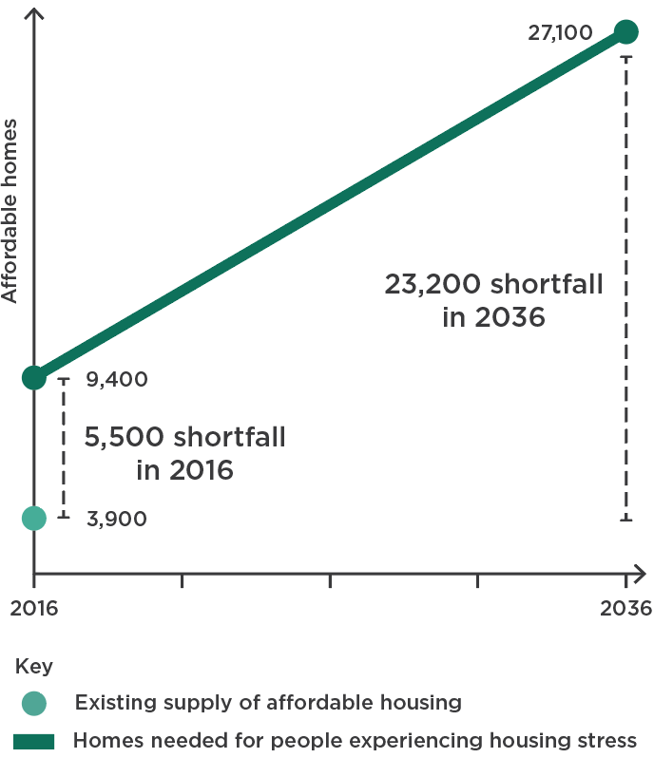
Existing and forecast demand for affordable housing in the City of Melbourne, 2016 - 2036

What research did we undertake to inform this?
Date | Input
07 February 2023 | Scoping phase
12 February 2023 | Internal workshop with relevant Council officers
June/July 2023 | Detailed ABS data analysis undertaken to test initial thinking and  understand demand
June/July 2023 | Community engagement process completed to source insights from local workers
June/July 2023 | Testing of findings with various internal and external stakeholders.
08 August 2023 | Draft key worker definition was presented at Councillor Forum
05 September 2023 | Draft Key worker definition presented at Future Melbourne Committee meeting

What is our conclusion?

The research showed us:
- CoM has more key workers than any other Victorian LGA (approx. 142,000).
- 48% of CoM key worker households earn very low to moderate incomes.
- 20% of CoM key worker households earning very low to moderate incomes are in ‘housing stress’.
- ‘Traditional’ key workers such as paramedics, firefighters and teachers are less likely to be in housing stress.
- 22% of key workers are travelling more than 30km to CoM.
- 64% of surveyed key workers are interested in moving to CoM.

This indicates:
- There is a need for more Affordable Housing in CoM for key worker households.
- Lower income key worker households would benefit most from subsidised
rental housing.
- A definition of key worker housing that incorporates income limits is required.
- Application of the existing Affordable Housing income ranges (very low to moderate) is appropriate.

The proposed definition of key worker housing
Affordable rental housing that is appropriate for people who work within the City of Melbourne, who require a physical presence to perform their work, and whose household earns very low, low or moderate incomes. The housing must be allocated and monitored by a Registered Housing Agency.

Unpacking the definition
‘Affordable rental’ | Focusing on rental housing is consistent with the Affordable Housing Strategy.  ‘Affordable’ means that rents are set at less than 30% of household income.
‘Appropriate’ | This term is defined in the Ministerial Notice in the P&E Act.  Includes allocation, affordability, longevity, tenure, location, integration and need.
‘Who work within’ | Only people who work with CoM are eligible. Community benefit is retained locally and commuting distances are reduced.
‘Physical presence’ | Key workers are typically unable to work from home to perform their work activity.
‘Household’ | Only one member of the household needs to be a key worker, but rental stress is tested through income eligibility being based on the household income.
‘Incomes’ | Defined in the Governor in Council Order in the P&E Act.  This utilises an existing regulatory tool that is updated annually.
‘Allocated and monitored’ | A housing provider must allocate tenants and monitor their eligibility. This utilises an existing regulated sector to ensure outcomes are achieved. Daily ‘management’ by a housing provider is generally not compatible with a build-to-rent model.

Eligibility for affordable housing
Affordable housing eligibility income ranges, June 2023
Household type | Very low income | Low income | Moderate income
Single | Up to $29,770 | $29,771 to $47,630 | $47,631 to $71,450
Couple | Up to $44,650 | $44,651 to $71,450 | $71,451 to $107,170
Family | Up to $62,510 | $62,511 to $100,030 | $100,031 to $150,030

Maximum affordable weekly rents for eligible households, June 2023
Household type | Very low income | Low income | Moderate income
Single | $172 | $275 | $412
Couple | $258 | $412 | $618
Family | $361 | $577 | $866

How does this align with affordable housing?
Planning process:
- Voluntary contribution agreed to
- Planning permit is granted
- Section 173 Agreement secured
- Key worker housing is delivered
Policy alignment:
- Key worker housing is a type of affordable housing.
- It would be facilitated in the same way as affordable housing, using existing planning processes and regulatory tools.
- All key worker housing contributions would be voluntary agreements.
- To assist with alignment, the key worker housing definition is modelled on the affordable housing definition:
“housing, including social housing, that is appropriate for the housing needs of very low, low, and moderate-income households” (Planning & Environment Act 1987)
How will we use the definition?
Research
- Reinforces and builds on research outlined in the Affordable Housing Strategy.
- Establishes a clear demand for Affordable Housing from key workers, as
required by the Ministerial Notice in the P&E Act.
Advocacy
- Provides a strong advocacy platform for local, state and federal government policy to ensure community benefit is realised.
- Establishes a policy position that could be refined through implementation, testing and iteration with industry and government partners.
- Ensures affordable housing is being delivered for our most vulnerable residents, including those who are key workers.
- Maximises our ability to optimise opportunities on state (and others land) within the municipality e.g. Arden.
Delivery
- Informs affordable housing projects being delivered on CoM land.
- Assists with assessment of planning permit applications that are seeking to include key worker housing.

Background information
The housing spectrum
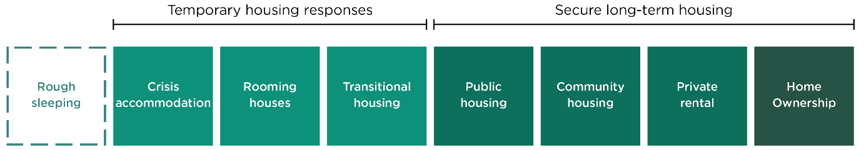
Key worker housing could be provided through community housing, or in the private market with oversight from a Registered Housing Agency.

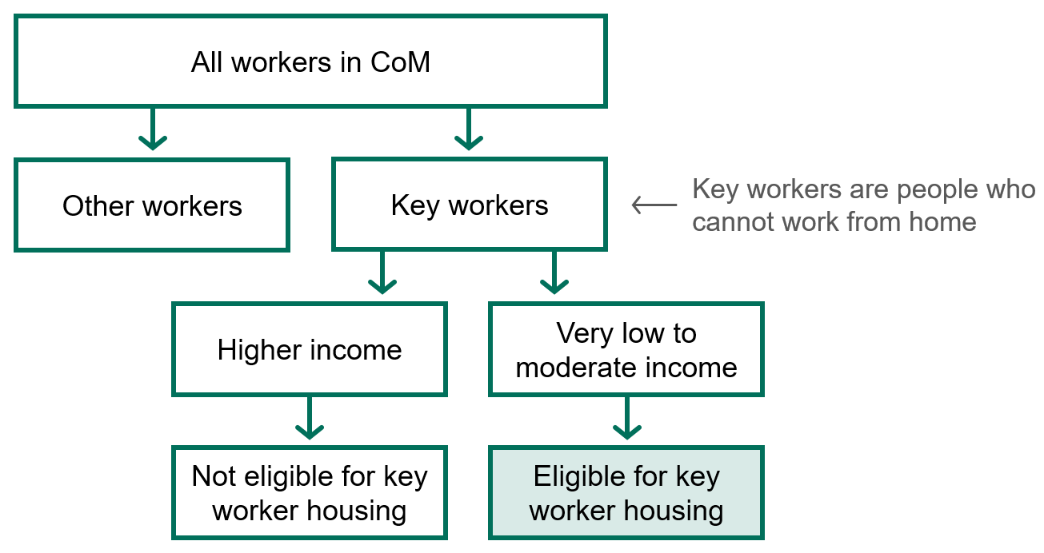
Who would be eligible for key worker housing?

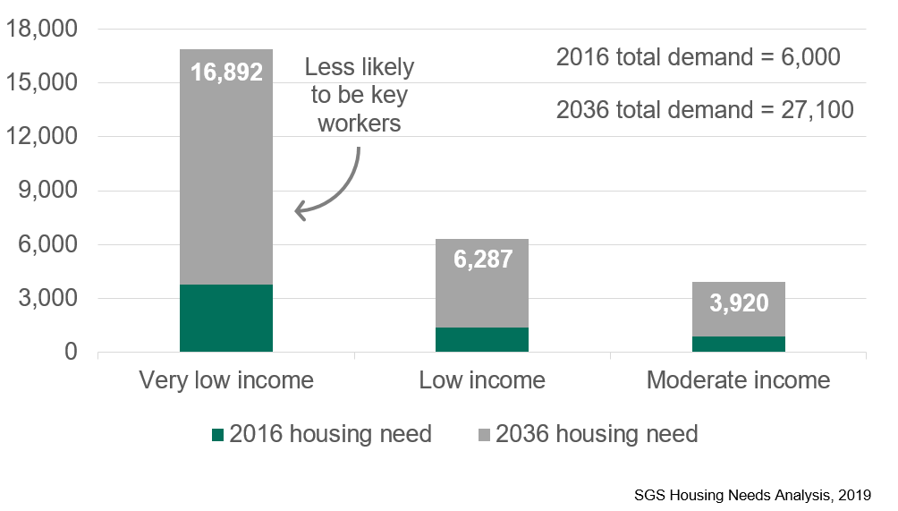
Forecast demand for affordable housing in CoM by income range to 2036

Community engagement results
All data sourced from the key worker housing survey

Engagement process:
- Survey distributed
- 304 responses from local workers
- Key worker filter
- 94 key worker responses
Engagement results:
- Community engagement was undertaken with all workers in the City of Melbourne.
- 304 online survey and intercept surveys were undertaken.
- Responses were consistent with the ABS data analysis.
- Key worker respondents were more likely to have lower incomes.
- Key worker respondents were more likely to drive to work.
- The most common response for moving to CoM was for ‘more employment opportunities’.
- The most common response for not moving to CoM was the ‘higher cost of housing’.
- 64% of key workers were ‘interested’ or ‘very interested’ in moving to CoM.

Key worker respondents were more likely to live alone or without children than other workers
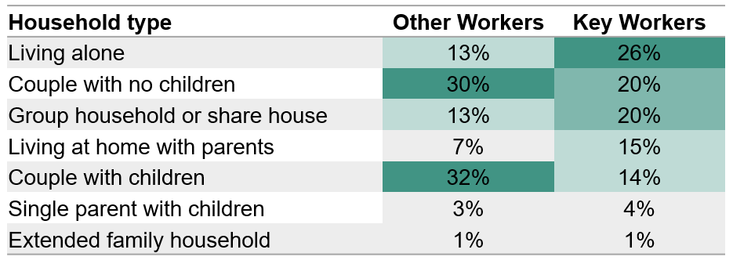

Key worker respondents were more likely to have lower household incomes
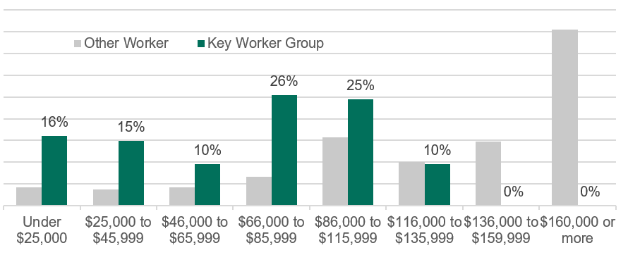

Key worker respondents were more likely to rent than other workers
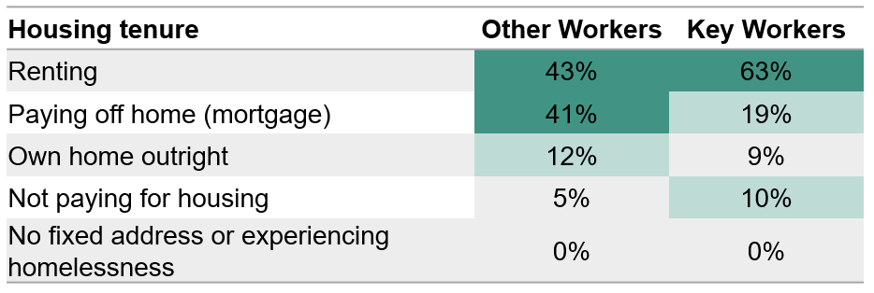

Key worker respondents spent less on housing costs than other workers
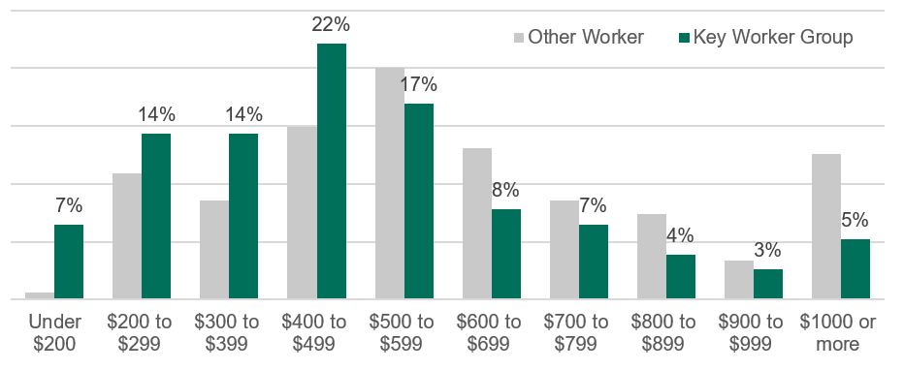

Key worker respondents were more likely to drive to work than other workers
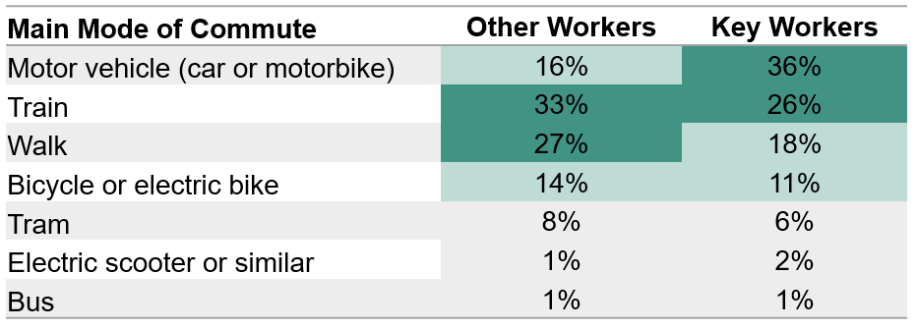

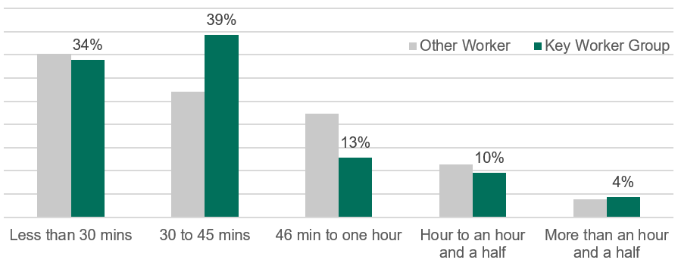
Key worker respondents were more likely to commute 30-45 minutes than other workers

The most common response for moving to the City of Melbourne was for more employment opportunities
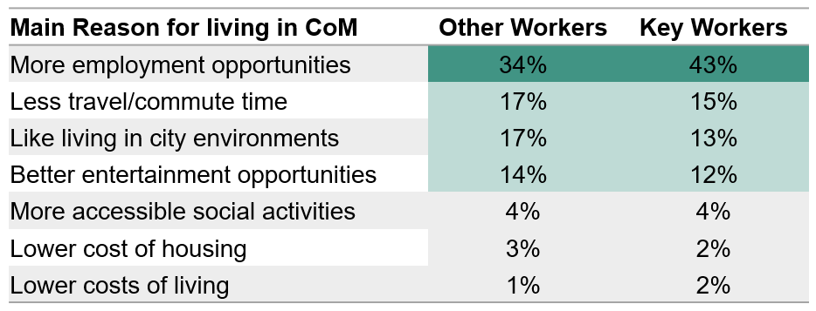

64% of key workers were interested or very interested in moving to the City of Melbourne, which was more than other workers (54%).
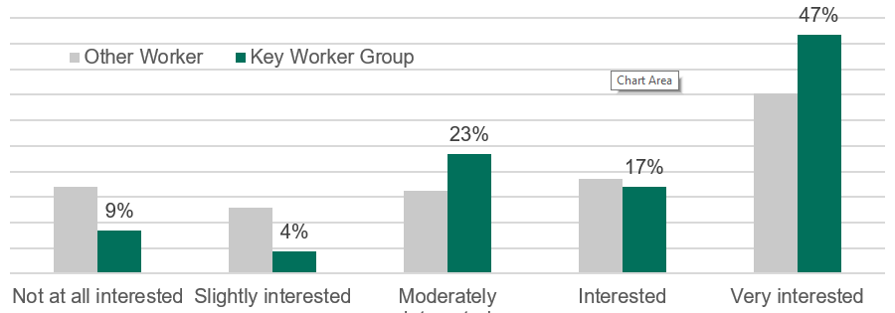

Demographic Data Results
All data sourced from the ABS census of population and housing, 2021

Data analysis process:
- All workers within City of Melbourne
- Key worker filter
- 208 occupations
- 142,000 workers
Data analysis results:
- CoM has more key workers than any other Victorian LGA
- Key workers make up 28% of the total CoM workforce
- 48% of key workers are born overseas
- 42% of CoM key workers commute more than 20km to CoM
- 48% of CoM key worker households earn very low to moderate incomes
- 20% of CoM key worker households are in ‘housing stress’ (vs 11% in Greater Melbourne)

Very-low to moderate income earners by industry, CoM 2021
Industry | Very low income | Low income | Moderate income | Total  employment | # very low to mod. earners | % very low to mod. earners
Accommodation and Food | 27% | 20% | 27% | 21,842 | 16,163 | 74%
Professional, Scientific, Technical | 4% | 4% | 8% | 96,061 | 15,183 | 16%
Retail Trade | 13% | 16% | 24% | 16,496 | 8,746 | 53%
Health Care and Social Assistance | 4% | 5% | 10% | 41,418 | 7,743 | 19%
Financial and Insurance | 2% | 2% | 6% | 75,089 | 7,470 | 10%
Education and Training | 9% | 6% | 10% | 28,744 | 7,262 | 25%
Administrative  and Support | 9% | 12% | 21% | 16,432 | 6,790 | 41%
Arts and Rec. | 6% | 8% | 21% | 13,910 | 4,873 | 35%
Public Admin.  and Safety | 1% | 2% | 5% | 53,876 | 4,586 | 9%
Construction | 4% | 3% | 8% | 17,642 | 2,713 | 15%

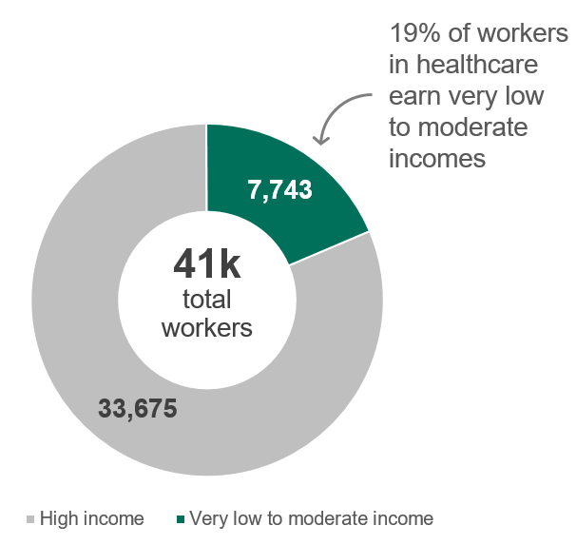
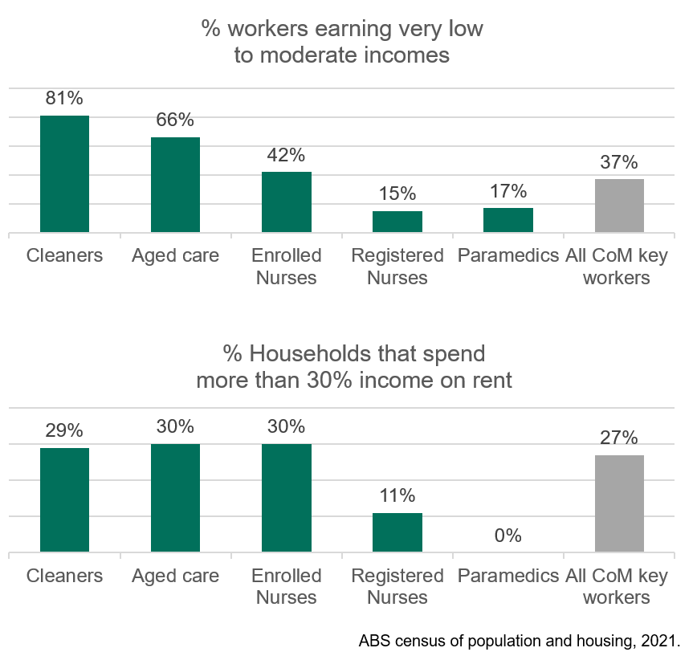
Insights from the healthcare industry
