
Carlton Gardens Master Plan
Draft 2021

Contents
1. Master Plan vision 4
2. Introduction 4
2.1 Purpose of this Master Plan 4
2.2 Preparing this draft Master Plan 5
3. The place 9
3.1 The current gardens 9
3.2 Heritage significance – world, national, state and local 10
3.3 Planning and management responsibility 11
4. Master Plan guiding principles 12
5. Recommendations 12
5.1 Heritage and conservation 12
5.2 Fabric and features 13
5.3 Facilities 17
5.4 Tree management and replacement 18
5.5 Uses and activities 26
5.6 Events 28
5.7 Connections and linkages 33
5.8 Climate resilience 34
5.9 Interpretation 37
6. Garden precincts 39
6.1 Carlton Gardens South 39
6.2 Carlton Gardens North 40
7. Management and cooperation 41
8. Implementation of the Master Plan 41
9. Review of the Master Plan 41
10. Appendices 42
10.1 Appendix A – Carlton Gardens selected plans. 42
10.2 Appendix B – Engage Victoria Survey Results (2020) 44
11. Additional References 55

The City of Melbourne respectfully acknowledges the Traditional Owners of the land, the Wurundjeri Woi Wurrung and Bunurong Boon Wurrung peoples of the Eastern Kulin and pays respect to their Elders past, present and emerging.
We are committed to our reconciliation journey, because at its heart, reconciliation is about strengthening relationships between Aboriginal and non-Aboriginal peoples, for the benefit of all Victorians

Master Plan vision
Carlton Gardens is a living setting for the world-renowned Royal Exhibition Building and reflects the historical, cultural and social fabric of late 19th century ‘Marvellous Melbourne’. The Gardens will continue to be a treasured recreational space, contributing significantly to Melbourne’s public open space network.

Introduction
The Carlton Gardens form the essential and unique setting for the majestic Royal Exhibition Building, which together create Australia’s first built environment included on the World Heritage List in 2004. It is one of only two World Heritage Listed sites in Victoria, the other being the Budj Bim Cultural Landscape, included in 2019.
With its stunning tree avenues, formal garden beds, central fountain, ponds, pathways and sweeping lawns the site is linked to the historic International Exhibition movement of the late 19th and early 20th centuries. Established in the 1850s on the traditional country of the Eastern Kulin, the early Gardens were redesigned for the 1880 Melbourne International Exhibition and the 1888 Centennial International Exhibition. They are one of Australia’s most significant heritage gardens. The site played a key part in the story of Australian federation, with the opening of the first national Parliament held at the Royal Exhibition Building in 1901. The site is also on the National Heritage List.
Now comprised of two distinct garden areas, with the Melbourne Museum and the Royal Exhibition Building situated at its centre, Carlton Gardens South and Carlton Gardens North are much loved by Melburnians and form a key component of Melbourne’s capital city and inner-urban regional open space network. They provide a valuable recreational space for Melbourne residents, workers and visitors.

Purpose of this Master Plan
Carlton Gardens Master Plan was first adopted by the City of Melbourne in 2005. In 2013, a comprehensive World Heritage Management Plan was developed for both the World Heritage Listed site and the surrounding buffer zone. Carlton Gardens Master Plan is one of a suite of five documents that together make up the Royal Exhibition Building and Carlton Gardens World Heritage Management Plan (2013) (World Heritage Management Plan), as shown in Figure 1.
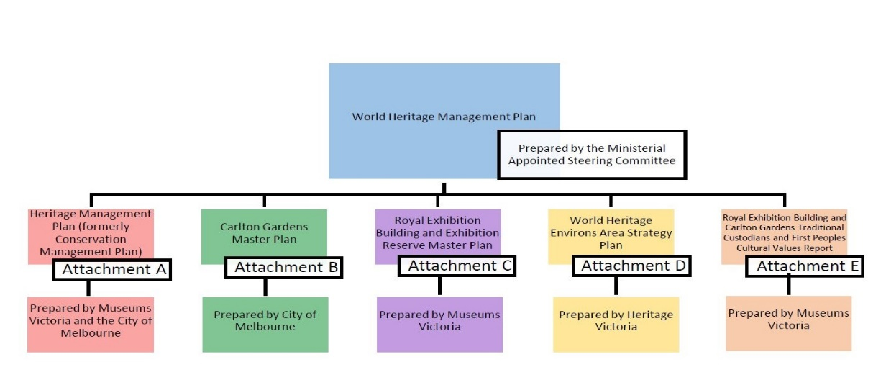
Figure 1: Documents forming the World Heritage Management Plan
Diagram created by Heritage Victoria for informative purposes during the World Heritage Management Plan Review
In 2020 Heritage Victoria commenced a review of the World Heritage Management Plan thereby enabling a simultaneous review of the Carlton Gardens Master Plan. Within the overarching planning framework for the World Heritage listed site, Carlton Gardens Master Plan includes a set of guiding principles, recommended actions and key works for the City of Melbourne to ensure the Gardens are appropriately managed and responsive to current and future needs.
The City of Melbourne’s Council Plan 2021-25 has ‘identity and place’ as a key priority:
- Melbourne's unique identity and place: celebrate and protect the places, people and cultures that make Melbourne a unique, vibrant and creative city with world-leading liveability.
Revision of Carlton Gardens Master Plan clearly fits this objective, with Carlton Gardens South and Carlton Gardens North managed by the City of Melbourne. The central Exhibition Reserve around the Royal Exhibition Building and Melbourne Museum is the addressed in a separate, yet complimentary master plan developed by Museums Victoria. This differs from the 2005 Carlton Gardens Master Plan, which included recommendations for some elements of Exhibition Reserve.

Preparing this draft Master Plan
A key objective of Carlton Gardens Master Plan is to ensure the Gardens are managed in accordance with their recognised cultural and heritage significance. Underpinning this revised Carlton Gardens Master Plan are two key reports. One is a new report: the Traditional Custodians and First Peoples Cultural Values Report, which outlines the cultural heritage significance of the combined site and surrounding area from the perspective of its Traditional Owners and the broader Aboriginal and Torres Strait Islanders people. This report was prepared by Context Pty Ltd in 2020-21 (Attachment E in Figure 1). Recommendations in this Master Plan continue to be informed by the policy direction set out in the Royal Exhibition Building and Carlton Gardens Heritage Management Plan, prepared by Lovell Chen in 2020. This document updates and replaces the previous Conservation Management Plan for the site (Attachment A in Figure 1). The Heritage Management Plan outlines the overall heritage significance of Carlton Gardens and the Royal Exhibition Building and sets out a series of objectives for protecting and enhancing their historic features.
This draft Carlton Gardens Master Plan 2021 also takes into account works completed and new community issues or needs identified since 2005. This includes new recommendations consistent with the contemporary understanding of climate change and the need to plan to mitigate for or adapt landscapes in response to these environmental challenges.
Other key reports used to prepare the revised Master Plan include:
- relevant recommendations from the World Heritage Management Plan (2013)
- recommendations for open space provision and management set out in the City of Melbourne Open Space Strategy (2012)
- garden user surveys undertaken in 2017 and recent demographic information
- Responses from Engage Victoria stakeholder and community consultation for the World Heritage Management Plan Review conducted in June/July 2020. This recent engagement process was an open-ended conversation allowing individuals, groups and agencies to provide input to the Review. It included some questions regarding Carlton Gardens (refer to Appendix B)
Further comment on this draft Carlton Gardens Master Plan will be used to finalise the Master Plan, which will then be submitted to Council for consideration and adoption.

PLAN 1 Area covered by the Master Plan
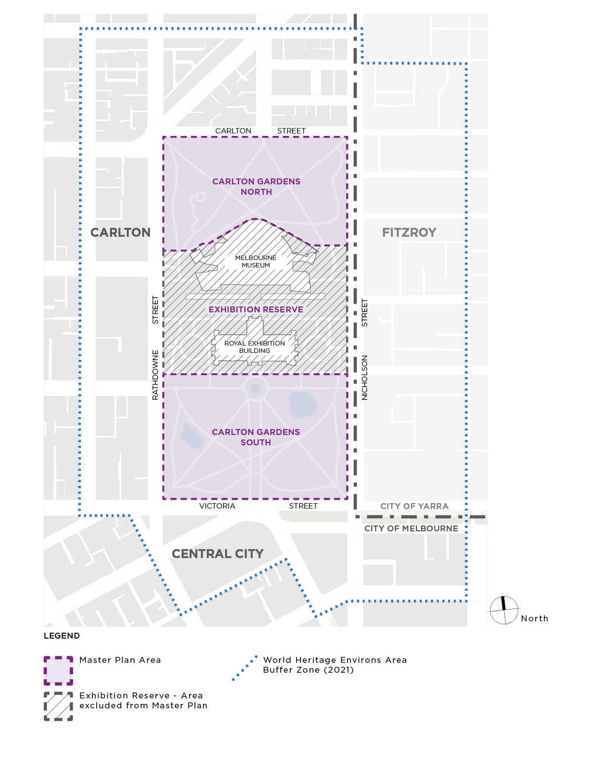

Plan 2 Master Plan Works completed 2005 - 2021

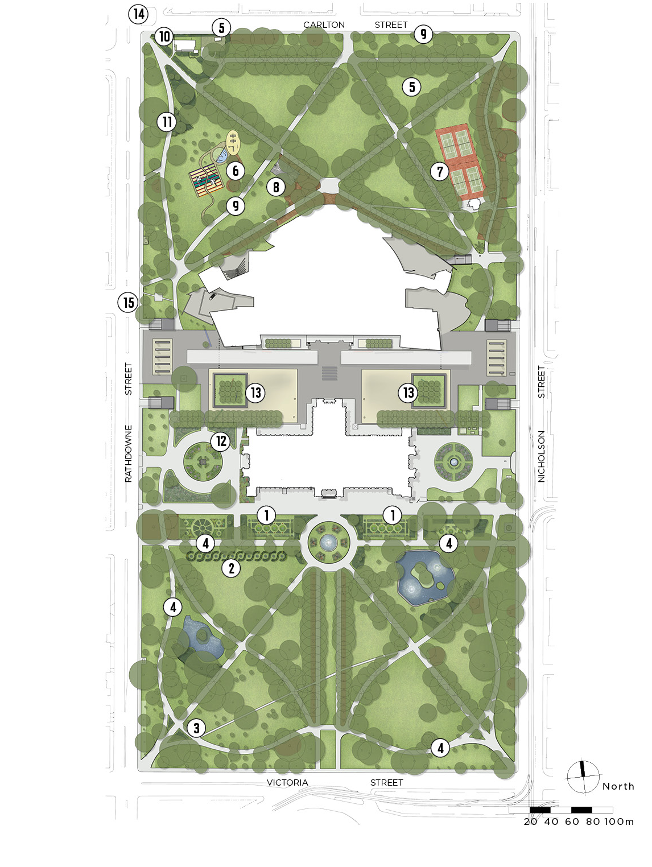
Listed works on Plan 2
Carlton Gardens South
1. Parterre Garden
Reconstruction of formal parterre gardens south of the Royal Exhibition Building.
2. Scroll Garden
Reconstruction of the scroll garden (original decorative bed shape) south of the western section of the Melia walk.
3. Pathways and entry garden beds
Reconstruction of the curved pathway and entry garden beds near corner of Rathdowne and Victoria streets.
4. Avenues and specimen trees
Renewal and replacement of the Oak Avenues, Melia Avenue and individual specimen trees.
Carlton Gardens North
5. Garden maintenance facility
Removal of former depot north of the tennis court and re-establishment of lawn area, creation of a new maintenance facility to the rear of the curator’s cottage.
6. Toddlers playground and new picnic tables
Installation of a toddler play area adjacent to the existing playground; installation of picnic area in the former toddler play area.
7. Tennis courts
Repairs and upgrade of lighting, fencing and internal pavilion facilities.
8. Basketball court
Addition of a second basketball hoop for the basketball area.
9. Avenues and specimen trees
Tree renewal and replacement – northern edge at Carlton Street, avenue adjacent to the picnic area and individual specimen trees.
10. Curator’s Cottage
Restoration of the bluestone plinth, cast iron fence and gate facing Carlton Street. Replacement of the Bhutan hedge.
11. Garden bed fencing
Restoration of the original garden bed fencing around shrub beds near north west entry and the Curator’s Cottage.
Exhibition Reserve (with Museums Victoria)
12. Stormwater collection tank
City of Melbourne made a financial contribution to the stormwater collection tank installed by Museums Victoria as part of the Western forecourt reconstruction project. Use of the water is shared.
13. Tree replacement - Museum forecourt
Advice and assistance on tree replacement for the square planter areas - Museum forecourt.
Connections and Linkages
14. Barkly-Carlton-Rathdowne streets
Redesigned intersection to improve safety for pedestrians and cyclists.
15. Rathdowne Street cycle lane
Implemented dedicated cycle lane along Rathdowne Street.

The place
The Wurundjeri Woiwurrung people of the Eastern Kulin have lived in the area for thousands of years and have an enduring connection to the land that is now central Melbourne. Carlton Gardens is situated on land that gently slopes towards the central city, land that was part of the plains grassy woodlands. The creation of Melbourne in 1835 led to a complete reorganisation of the land, the people and the vegetation in the area.
The present Carlton Gardens were set aside for public purposes and recreation by the Victorian colonial administration of Superintendent Charles J. La Trobe when the Carlton area was released for land sale in the 1850s and permanently reserved for public gardens in 1873. In 1878, the land was re-acquired for use as the site of the Melbourne International Exhibitions which were held in 1880 and 1888. As part of this arrangement, Carlton Gardens South were redesigned to form the setting for the Royal Exhibition Building – a layout that remains substantially intact today.
The main Exhibition Hall was built in the centre of the Gardens (now renamed Exhibition Reserve) with the Carlton Gardens North largely used for temporary annexes during both the 1880 International Exhibition and again during the 1888 Centennial Exhibition. After both Exhibitions, the temporary annexes were demolished and the North Gardens reinstated. The North Gardens retain much of the original layout from the c1890 reinstatement but also include subsequent 20th century developments such as the tennis courts and playgrounds. Between Carlton Gardens South and North lies the Exhibition Reserve site, where the Royal Exhibition Building and Melbourne Museum are located. (Refer to Historic Plans in Appendix A)

The current gardens
The Carlton Gardens are bound by Rathdowne Street to the west, Carlton Street to the north, Nicholson Street to the east, and Victoria Street to the south. While the Gardens and Exhibition Reserve read as one contiguous site, for master planning purposes, the site is divided into three distinct land parcels:
- the southern section – Carlton Gardens South
- the central third, where Melbourne Museum and the Royal Exhibition Building are located – Exhibition Reserve, and
- the northern section – Carlton Gardens North.
The City of Melbourne, as both joint Trustee and Committee of Management, is responsible for the Land Reserve Rs 9990 (Carlton Gardens) – that is the northern and southern sections of the site.
Carlton Gardens are formal in design and execution, providing tree-lined pathways, fountains and lakes, as an integral part of the overall site design and setting for the Royal Exhibition Building. The original gardens were developed as a public garden for passive recreation, with the later more classical garden modifications, including ‘Gardenesque’ elements, made in 1879 to form an appropriate setting for Royal Exhibition Building.
The main garden elements in the Carlton Gardens South include:
- the main north-south, tree-lined avenue (Grand Allée)
- the central Hochgurtel Fountain with surrounding garden beds
- the radial pattern of tree-lined linear pathways converging at the fountain and the serpentine path around the interior edge
- formal garden beds (parterres) and several informal garden beds
- ornamental lakes
- the planting of trees in groups or clumps (bosquets) on lawns, and
- the incorporation of axial views and vistas.
Carlton Gardens North feature diagonal, tree-lined paths and mature specimen trees, primarily from c1890 when these Gardens were reinstated following the removal of various structures erected for the 1888 Centennial Exhibition. Recreational facilities, such tennis courts (c1924) and various playgrounds (c1910), are longstanding features of Carlton Gardens North.
Throughout both Carlton Gardens North and South, plantings include pines, cedar, araucaria, cypress, gums, figs, pepper trees, elms, plane trees, oaks, poplars, Canary Island date palms and Washington palms – most are mature and many are of a significant size.
Carlton Gardens and its specimen trees are maintained by specialist contractors, with clear oversight by the City of Melbourne. Contracts stipulate the highest possible maintenance standards and frequent assessments are carried out by the City of Melbourne to ensure these standards are met. Exhibition Reserve is maintained by contractors on behalf of Museums Victoria.

Heritage significance – world, national, state and local
The heritage significance of the Royal Exhibition Building and Carlton Gardens is best understood as a hierarchy, ranging from world heritage significance, followed by national, state and local levels. Each level of significance is assessed against different yet complementary sets of criteria.
The World Heritage Management Plan outlines each of these levels of significance in detail. In summary, the formal levels of significance are:

World heritage
The Royal Exhibition Building and Carlton Garden were inscribed on 1 July 2004 on the World Heritage List by the World Heritage Committee under criteria (ii) of the World Heritage Convention adopted by UNESCO in 1972. The description of Criterion (ii) is exhibit an important interchange of human values, over a span of time or within a cultural area of the world, on developments in architecture or technology, monumental arts, town-planning or landscape design. With the designation for this place reading:
The Royal Exhibition Building and the surrounding Carlton Gardens, as the main extant survivors of a Palace of Industry and its setting, together reflect the global influence of the international exhibition movement of the 19th and early 20th centuries. The movement showcased technological innovation and change, which helped promote a rapid increase in industrialisation and international trade through the exchange of knowledge and ideas.

National heritage
The Royal Exhibition Building and Carlton Gardens were listed on the National Heritage Register in 2004 as a place of National Heritage significance (Place ID 105708, and Place File 2/11/033/0235). This listing is based on the role the Royal Exhibition Building and Carlton Gardens played in the exhibition movement and the Federation of Australia. It is the place where the first national Parliament was held in 1901 and where the first Australian flag was flown. It was also the location of the Victorian Parliament while the national Parliament sat in Parliament House, Spring Street prior to (Old) Parliament House in Canberra being constructed.

State heritage
The Royal Exhibition Building and Carlton Gardens are also listed on the Victorian Heritage Register (no. H1501). While referencing the complete World Heritage values, the Victorian Heritage Register Statement of Significance concludes the Carlton Gardens are of historical, architectural, aesthetic, social and scientific (botanical) significance to the State of Victoria in their own right : ‘The Carlton Gardens, the setting for the Royal Exhibition Building, are aesthetically significant for their 19th century ‘Gardenesque’ style, featuring specimen trees and parterre garden beds in a symmetrical design with the use of axial views and foci. The Hochgurtel Fountain and the ‘Grand Allée’ lined with Plane trees are integral to the setting of the Royal Exhibition Building.’
The Exhibition Gardens Meeting Place, within Carlton Gardens, is included on the Victorian Aboriginal Heritage Register as an Aboriginal historical place. Its cultural importance stems from it being an important gathering and connection place for the Victorian Aboriginal community since at least World War One and meeting place since the 1930s. Two large Moreton Bay fig trees (Ficus macrophylla) at the edge of Carlton Gardens, near the junction of Nicholson and Gertrude streets, mark the significance of this Meeting Place.

Local heritage
Carlton Gardens is included under heritage overlay (HO69) in the City of Melbourne planning scheme.

Planning and management responsibility
As a World Heritage listed site, planning and management responsibilities are specified under Commonwealth and State legislation as follows:

International obligations
The Australian Government has signed and ratified the UNESCO Convention concerning the Protection of the World Cultural and Natural Heritage (the World Heritage Convention). Under the World Heritage Convention all countries that have ratified the convention are expected to protect the World Heritage values of the properties inscribed and are encouraged to report periodically on their condition. The Australian Government protects and manages the World Heritage values of World Heritage listed sites through the Environment Protection and Biodiversity Conservation Act 1999 (Cth) (EPBC Act).

Commonwealth legislation
The EPBC Act requires that no actions are taken that would have a significant impact on the world or national heritage values of the site, and also requires the development of comprehensive management arrangements for the site. In 2004 the Victorian Heritage Act 2017 was amended to require the preparation of a World Heritage Management Plan for the site and a Strategy Plan for the precinct surrounding the site to assist in meeting the obligations required in the EPBC Act for a planning and management framework.
The current Royal Exhibition Building and Carlton Gardens World Heritage Management Plan was approved in 2013 and is being reviewed and updated in 2020-21.

State legislation
As a Victorian Heritage Register (VHR) listed site, the Victorian Heritage Act requires the approval of the Executive Director, Heritage Victoria, for any works in Carlton Gardens that have not been granted a permit exemption. The Heritage Council of Victoria is the appeals body for VHR heritage permits and refusals.
The Crown Land Reserves Act 1978 provides the underpinning reservation of the Carlton Gardens as permanently reserved as Public Gardens and enables the Melbourne City Council to manage the Carlton Gardens as both Joint Trustee and Committee of Management. This means Melbourne City Council is responsible for the care and management of Carlton Gardens.
The Victorian Aboriginal Heritage Act 2006 includes provision to protect registered places from harm and approval is required for works within the area registered as the Exhibition Gardens Meeting Place. The Registered Aboriginal Party for the land where Carlton Gardens is located is the Wurundjeri Woi Wurrung Cultural Heritage Aboriginal Corporation.

Master Plan guiding principles
Four overarching guiding principles underpin the revised Carlton Gardens Master Plan and the detailed recommendations. These principles help guide decisions around the need to simultaneously consider and acknowledge the past while meeting current requirements and identifying likely changes that may occur over the next decade.
The four guiding principles are:
- Culture and heritage: The recognised heritage and cultural values of Carlton Gardens are understood and reflected in the presentation, management approach and promotion of the Gardens.
- Use: Carlton Gardens continue to be managed primarily as a passive recreation space, with uses, activities and supporting facilities provided which will meet contemporary public open space needs.
- Resilience: The impact of climate change is actively planned for in renewal works in Carlton Gardens so that it remains a healthy, accessible and resilient landscape in the future.
- Partnership: The City of Melbourne continues to work in close cooperation with our World Heritage site partners to protect and promote the values of the site and provide a positive visitor experience.

Recommendations
When formulating the recommendations contained in this revised Master Plan, the overarching consideration was to protect Carlton Gardens’ cultural values and heritage assets while ensuring the site was available for continuing community use. Discussed below, the recommendations also take into account other relevant issues such as community safety, equitable access for all abilities, recreational opportunities and environmental management.

Heritage and conservation
Recommendations relating to cultural and heritage values, and the features and fabric of Carlton Gardens, are based on the policies of the Heritage Management Plan (2020) and the World Heritage Listing determination. In the World Heritage Listing, the key period of historic significance for the overall site is from 1880 to 1901. While all cultural and heritage values are important, elements of Carlton Gardens relating to this era are of particular importance.

Recommendations: Heritage and conservation
- To conserve the landscape and structures remaining from the 19th century period of major heritage significance to form and character through preservation or restoration, where practicable.
- To continue to investigate the feasibility of reintroducing horticultural features of the historic period of significance, where this assists the understanding or interpretation of the site.
- To ensure that no new permanent structures (including monuments or memorials) are permitted in Carlton Gardens unless contemplated in this Master Plan, or are replacements of existing structures.
- To maintain and enhance identified significant views and vistas both to the Royal Exhibition Building and within the Carlton Gardens themselves.

Plan 3 Views and Vistas Carlton Gardens South

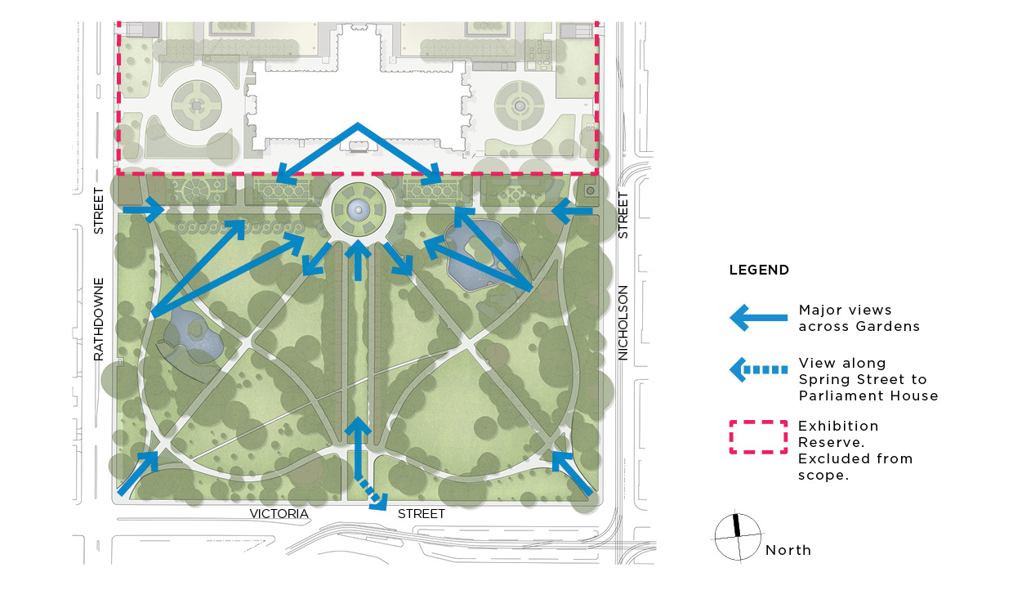

Fabric and features
The essential components of historic gardens are living and growing plants, which require a different management approach to historic buildings. While buildings can be preserved, restored and managed without significant change, gardens continually change and need ongoing management and renewal. Key historic features of Carlton Gardens that need to managed and maintained are garden beds and garden bed iron fencing, lawns, water features, pathways, garden entrances, Exhibition Gardens Meeting Place and the Curator’s Cottage. Other parts of the Carlton Gardens fabric, while not historic in themselves, contribute to the overall presentation of the Gardens and are also included in these recommendations.

Garden beds
Garden beds were used prolifically in 19th century planting schemes and are particularly evident in Carlton Gardens South. The number, layout and planting stock of garden beds has changed over time, with many earlier beds being removed. This is most likely due to changes in maintenance costs and regimes, an increase in tree canopy, changes in growing conditions, or as a result of public safety considerations. However, detailed investigations show that some of the earlier 19th century shrub layers could be reinstated.

Recommendations: Garden beds
Opportunities exist to increase the number of shrub beds and lower-level plantings, particularly in Carlton Gardens South. These opportunities could occur at the same time as other horticultural renewal works such as tree avenue renewal.
- Investigate the creation of new garden beds where the conditions allow and where a reintroduction of a garden bed is supported by historic evidence.(refer Plan 4)
- Continue to conserve and renovate the surviving elements of the historical 19th century garden bed planting schemes, maintaining overall form, edge and structure for beds consistent with historic evidence.
- Maintain new garden beds, reconstructed since the 2005 Master Plan, such as the parterre garden beds across the south forecourt of the Royal Exhibition Building and the south-west corner entry beds to a high standard of horticultural excellence.
- Develop a maintenance plan for all garden beds including an assessment of their importance in the interpretation of the site, with suitable plant selection options and preferred maintenance techniques.
- For all garden beds, while form and structure is important, plant selection should be guided by availability, maintenance, weed potential, ecological contribution and sustainability. If suitable historic plant species are not available or are inappropriate, then other plant species should be used.

Plan 4 Garden Beds – Historic locations

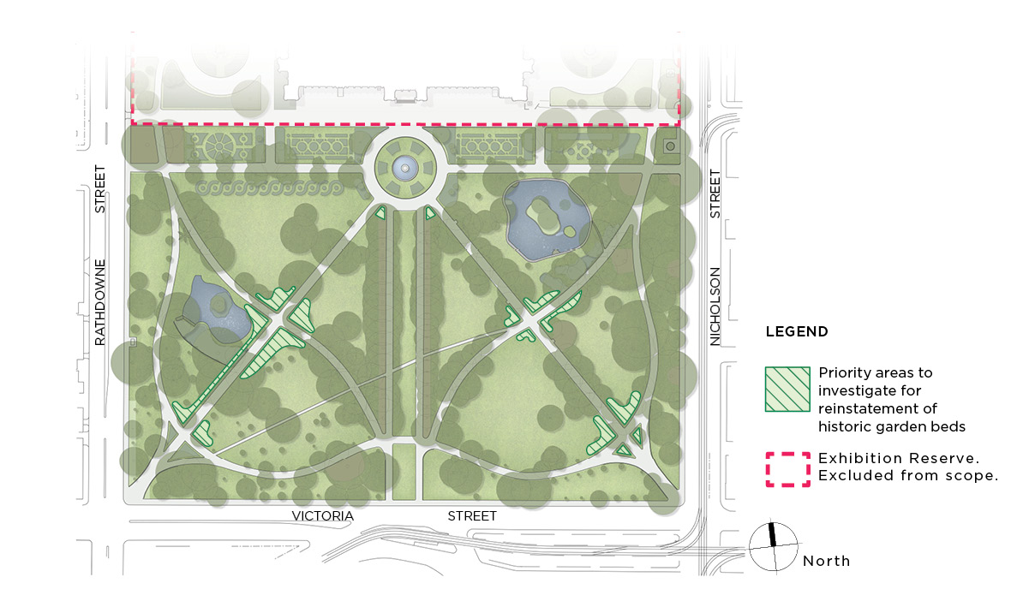

Garden bed iron fencing
Iron hurdle fencing, used since the 19th century as movable fencing to control access to garden sections, is still present in Carlton Gardens North around a shrub bed and as the fence for the curator’s cottage. Similar fencing was removed and repaired when the Carlton Gardens North depot was demolished and is in storage.

Recommendations: Garden bed iron fencing
- Retain and conserve all existing portions of fence around garden beds and the curator’s cottage.
- Re-use stored fencing, as required, in other areas of Carlton Gardens and in other City of Melbourne historic gardens which used the same style of fencing for repairs or reconstruction of fencing sections or where it assists in the interpretation of the place.

Historic Garden Bed Typology

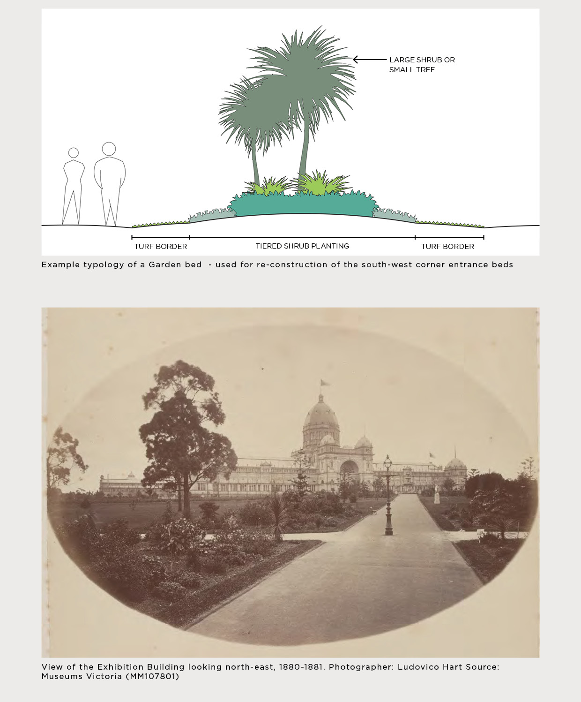

View of the Exhibition Building looking north-east, 1880-1881. Photographer: Ludovico Hart.
Source: Museums Victoria (MM107801)

Lawns
Lawn areas are an important landscape feature in both Carlton Gardens North and South and are associated with the 19th century character of the site. The current open lawns are both an important visual element of the Gardens as well as providing for multiple passive recreation uses.

Recommendations: Lawns
- Open Lawns should be kept to a high standard of visual presentation and be irrigated where required. Locations of specimen tree plantings should be controlled to allow the open lawns to present as a feature in their own right, in keeping with the historic Gardenesque style.

Water features such as lakes and fountains
The two lakes and the Hochgurtel Fountain at the northern end of the Grand Allée are key features of Carlton Gardens South. Historic plans show the original lake extent may have differed to the current presentation. The Heritage Management Plan contemplates reinstatement of the original form and extent of both of the lakes. However, conditions around the lakes, such as the presence of mature, significant trees within the former extent, precludes such an action currently. Therefore, the City of Melbourne recommends not pursuing such an action as part of this Master Plan. However, replanting around the immediate surrounds of both lakes in their current presentation is required to renew current trees and shrubs.

Recommendations: Water features
- Maintain both the fountain and lakes in good order and for the life of this Master Plan retain the current landscape envelopes for these features.
- Continue to maintain natural clay lake bases to support both local birds, insects and amphibians, and current water permeability function.
- Implement new planting and landscape plans for both of the lake surrounds including planting of replacement trees and introducing a variety of low shrub and riparian plantings.
- Undertake repairs and refurbishment, based on conservation advice, to the historic fabric of the fountain, lake walls and islands, as required.

Pathways
Much of the 19th century pathway layout, dating from the Exhibition period, remains intact today, meaning all surviving elements of this layout should be conserved.

Recommendations: Pathways
- Preserve the surviving 19th century layout of the path system and restore or reconstruct missing parts of the 19th century path system if needed.
- Retain asphalt surfacing of the historic pathways as this material is associated with the Exhibition period.
- Minor access pathways to, or for particular features in the Carlton Gardens, can be created as required, but should be modest in presentation and width and be constructed of granitic gravel.

Exhibition Gardens Meeting Place
The connection to, and importance of, the Meeting Place in Carlton Gardens South for Aboriginal people is clear. The Meeting Place is centred around two fig trees on the south-east side of the Gardens and the land around these trees. A plaque acknowledging the significance of the Meeting Place is positioned in the surround of the tree closest to Gertrude Street and is part of a City of Yarra self-guided cultural heritage walk. This tree is need of additional interventions to keep it in good health. The existing stone surround and associated paving are restricting the tree’s growth and deteriorating under root pressure.
A plan has been developed to create a larger growing area for the tree and provide opportunity for greater connection and acknowledgment of the site in consultation with Registered Aboriginal Parties, and other Aboriginal stakeholders with a strong connection to the site. The project has received both cultural and heritage permits to proceed. Although recent pandemic restrictions have delayed the implementation phase of the project, Council is committed to completing the works. The City of Melbourne will continue to progress these plans, in consultation with Registered Aboriginal Parties and other stakeholders with a clear connection to this place.

Recommendation: Exhibition Gardens Meeting Place
- Progress work on improving fig tree health and longevity and recognising and interpreting the significance of the Exhibition Gardens Meeting Place.

Garden entrances
Garden entrance points are associated with the former fence and gates which were installed around the Carlton Gardens to control entry to the International Exhibition. Mostly the current Carlton Gardens entrances reflect this arrangement, with the notable exception being the entrance to the Grand Allée from the south. The original entrance here was smaller and oriented to the alignment of Spring Street.

Recommendations: Garden entrances
- Maintain all current entrance locations.
- Undertake any works at entrances as required for disability access.
- Keep the area around the former south entrance to the Grand Allée clear of planting to allow interpretation or reconstruction of this entry at a future date.
- Reintroduce planted beds at the south-east entrance to match the reconstructed beds at the south-west entrance.

Facilities
Community facilities in Carlton Gardens North include a tennis club pavilion and courts, a playground, a casual ball court and general garden furniture. Maintenance facilities are based at a curator’s cottage. Public toilet facilities are situated in both Carlton Gardens North and South. These facilities have been established at different times, ranging from the historic curator’s cottage in the late19th century, the tennis courts in the 1920s and the maintenance facility in 2009. All facilities are in daily use, which will continue for the foreseeable future.
Valued and well-used, the tennis pavilion and courts are leased to the Carlton Gardens Tennis Club, a community-based club, which has a large, active membership.
The upkeep and maintenance of community facilities is managed by the City of Melbourne. A 2017 garden user survey shows the playground and tennis court rated well as facilities, whereas the current toilet facilities were identified as in need of improvement. The public toilets are necessary facilities that present in an older style but were installed in the 1990s. While visually discreet, they do not meet current user needs or access standards.

Recommendations: Facilities
- Replace the existing public toilet facilities. Key considerations for replacement are to make them safe to use, secure, accessible to contemporary standards and visually unobtrusive. It is not necessary to retain the 19th century cast iron style if other requirements cannot be met. The current street frontage location of both facilities is consistent with the City of Melbourne’s requirements for public toilet facilities.
- Retain all other existing facilities in Carlton Gardens and ensure these assets are well maintained.
- Conduct a program of regular inspection and undertake maintenance as required, for the curator’s cottage, particularly its exterior historic fabric, front garden and fencing.

General garden furniture
Carlton Gardens contains a range of public furniture such as seats, picnic tables, rubbish bins, lighting, bollards, drinking fountains and signage. The current suite of furniture is part of the City of Melbourne’s standard parks and gardens furniture set and is not part of the historic fabric of the Gardens. The standard furniture set designs meet standards for disability access, durability and maintenance requirements.

Recommendation: General garden furniture
- Audit existing signage and replace or update to current standards where required.
- Replace existing furniture as required, retaining consistency in style throughout the Gardens.
- New or replacement furniture should be in keeping with the overall Gardens presentation and be pre-approved by the City of Melbourne.

Tree management and replacement
Trees are a major landscape feature in Carlton Gardens, providing character, visual appeal, amenity, environmental and ecological benefits and a sense of history for visitors. As living things, trees must be individually and collectively cared for, with a clear framework to guide management, replacement and renewal decisions.
As a heritage listed place, approval from Heritage Victoria is required if significant changes or replacement of trees is proposed for Carlton Gardens. The City of Melbourne has clear policies for tree management which guides the protection and management of all trees managed by the municipality. The current policy includes additional matters to those which informed the 2005 Master Plan, and therefore this area of the Master Plan needs to be revised.
The 2005 Master Plan provided broad recommendations to guide tree replacement as well as several identified locations where significant replacement would be required in the foreseeable future. Table 1 outlines the key recommendations on tree replacement in the 2005 Master Plan. All recommendations have either been completed or are ongoing.
Table 1: Key recommendations and progress on tree replacement in the 2005 Master Plan
Recommendation | Implementation progress
- To plant…. a range of tree species, primarily exotic, with the selection being consistent in character with those planted in the 1880-1901 period of significance. | - One major infill planting project was completed (2005) across the entire Gardens, focusing on adding new tree elements in locations where a new tree could be successfully planted in locations consistent with the previous historic layout.  - Ongoing individual replacement of original specimen trees that have died, as required
- To progressively implement a planting program for the tree avenues. Replacement priority is where most of the trees exhibit advanced decline, to be removed and replaced in sections, replace with the same species and similar configurations.  Graded priority avenues likely to require replacement were identified in:  - Carlton Gardens South – the east/west Melia Avenue; the Oak avenue ring; and the west axial Elm avenue.  - Carlton Gardens North – a new avenue planting between the playground and picnic area. | Completed tree avenue projects:  - Melia Avenue (Carlton Gardens South) – re-organised and complete.  - New tree avenue between playground and picnic area (Carlton Gardens North) – modified proposal approved and replanted with poplars. Further subsequent replacement plantings required. Assessed in 2021 as a failed planting.  - Oak avenue ring (Carlton Gardens South) – significant infill and replacement planting across the four sectors as required.
- Further detailed investigation of replacement species for lawn and perimeter areas to develop a replanting program. | Further advice commissioned to identify all historic trees and planting era (2006) and possible species replacement.
- Propagate and replant individual rare tree species, as required. | Two individual rare species have been replanted (original trees both died). These included Acmena ingens (red apple) and Harpephyllum caffrum (South African native plum). Other individual rare species remain in Carlton Gardens.

World Heritage guidance
The World Heritage Management Plan provides further high-level guidance on tree avenue replacement:
Where avenues wholly, partially, senescent or have lost such a number of trees that they no longer retain a sense of visual continuity, the avenue should be replaced in its entirety. Subject to availability and environmental considerations every effort should be made to replant the same species.

Historic Photos Carlton Gardens South from the Exhibition Building dome c:1880-1888

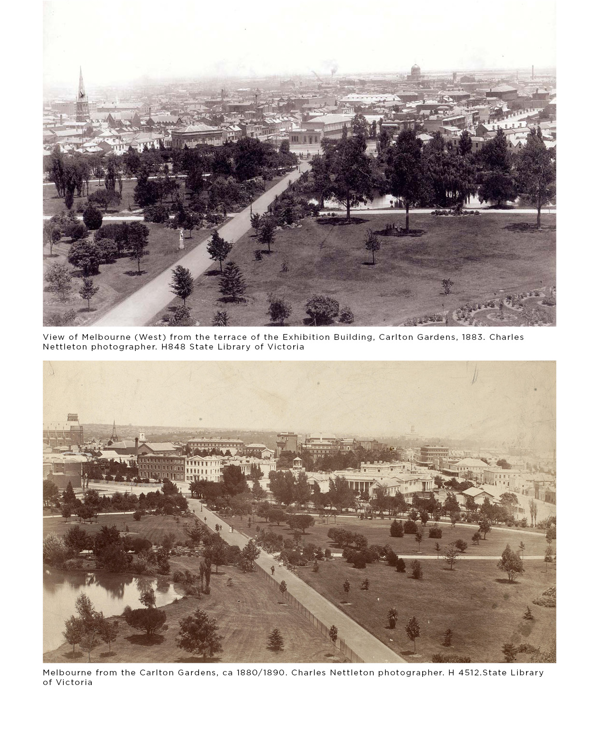

Tree replacement in a changing climate
A key driver of the City of Melbourne’s current approach to tree replacement is to ensure all new trees planted are able to respond to a changing climate. In a changing climate scenario (refer to section 6 Climate Resilience), some tree species perform better than others.
Given that many trees planted today will still be there in decades to come, it is important to incorporate anticipated climate change impacts when making tree species replacement decisions. This consideration is required for all open spaces in the City of Melbourne, including heritage-listed places such as Carlton Gardens.
All current tree species planted in the City of Melbourne have been assessed for vulnerability against predicted mean temperature increases expected to occur over the next 25 years. (The City of Melbourne’s Future Urban Forest, 2016). Across Melbourne 35% of all trees were assessed as either moderately or extremely vulnerable. The current tree population in Carlton Gardens contains a number of ‘category one’ tree species from colder climates, such as northern Europe and the north-eastern United States, which are particularly vulnerable to climate change.
While this group of trees make important contributions to the City of Melbourne’s cultural identity, liveability and biodiversity, they may become less reliable with increasing temperatures. Over time, there will also likely be a need for increased tree removal, pruning and planting in response to accelerated tree decline and mortality.
Within this broad category of vulnerability, replanting of existing species may still be suitable in some places where there are reliable supporting management actions, such as guaranteed irrigation and improved soil conditions. However, this needs to be assessed on a ‘location by location’ basis and the best course of action may be to use another species.

Assessing climate risks when deciding on tree replacement approaches
The City of Melbourne will need to adapt future planting decisions and consider the impact of climate change by assessing the risks associated with a previously accepted heritage approach – that is replanting with like-for-like species – in every replanting situation. For current high temperature vulnerability in either a moderate or extreme climate change scenario (referred to as rated amber or red), ‘climate ready’ species choices should be prioritised over a ‘like-for-like’ approach.
When considering substitute species for Carlton Gardens, in addition to climate readiness, consideration needs to be given to finding trees that achieve as many of the similar characteristics of the tree(s) to be replaced as possible. These include:
- similar size (height and spread)
- climate ready alternative species within the same genus
- consistency for deciduous or evergreen habit
- similar leaf colour and characteristics
- similar prominent aesthetic characteristics, such as flowers, autumn colour
- listed as available in Plants Listed in Nursery Catalogues in Victoria, 1855 to 1889
- suitability to plant in a specific location in Carlton Gardens.
Figure 2 is an example of how the decision-making process for tree replacement in Carlton Gardens could be implemented.

Community perception of tree management in Carlton Gardens
As part of the consultation process for updating the World Heritage Management Plan in 2020, Engage Victoria asked survey participants to comment on the following statement:
The gardens need to adapt for changing climate conditions, whilst retaining their historic layout and features.
Of the 187 participants who commented on this statement:
- 32.09% strongly agreed
- 45.45% agreed
- 11.23% were neutral
- 6.95% disagreed
- 4.28% strongly disagreed.
Overall, 77% of survey participants agreed or strongly agreed the management of Carlton Gardens needed to adapt to changing climate conditions.
In preparation for the 2021 Master Plan, an independent audit of all trees in Carlton Gardens was completed for standard indicators of tree health, useful life expectancy and overall condition. The audit found that of the 643 trees in the Carlton Gardens, while 30% were ‘over mature,’ approximately 90% of trees had a useful life expectancy greater than 10 years.
Therefore, approximately 10% of the total tree population are likely to need replacing within the next 10 years. These include:
- 20 trees located in Carlton Gardens North
- 23 trees located in Carlton Gardens South
Within this group, two older avenues and one more recently planted avenue were identified as in need of replacement. In all cases the avenues are planted with Populus alba (White Poplar) which has been assessed as having an amber rating for vulnerability in a moderate climate change scenario, and a red rating for vulnerability in a more extreme climate change scenario. An alternative replacement tree should be considered. In addition to these avenues, individual tree specimens scattered throughout Carlton Gardens will need replacement as and when required.

Recommendations: Tree management and replacement

Strategic recommendations
- Develop replacement plans for the 10% of the trees likely to need replacing over the next 10 years, including determining alternative species selection where required and planning for the advanced growing of new replacement trees.
- Continue to monitor and nurture the existing historic trees and maintain the garden character of a densely treed edge, axial avenues and internal open lawn areas with specimen trees.
- For major tree avenue and group replanting, investigate the feasibility of re-instatement of shrub beds as part of the revised planting, if this was part of the earlier 19th century historic presentation. Reproduce historic planting presentations where evidence supports this action (such as irregular/regular avenue set outs, bosquets groups of specimen trees).
- Develop a tree plan for Carlton Gardens which shows all trees likely to need replacing with ‘climate ready’ species and develop a shortlist of substitute trees suitable for future use in Carlton Gardens, including preferred locations.

Specific tree renewal recommendations – Carlton Gardens South
- White Poplar Avenue replacement – select new species and design a replacement avenue that includes former shrub beds where possible.
- Investigate enhancement planting of the west axial Elm Avenue.
- Continue to replant formal Oak Avenue on the curved pathway extent, as required.
- Eastern pond surrounds – develop a design to replant around the lake edge to replace removed or senescent trees and recreate a lower-level planting layer.
- Western pond and west garden edge – progress replanting of the entire pond edge with lower-level planting and garden beds. Replant trees in an informal, dense pattern on western edge of gardens.
- Undertake works to improve the growing conditions of the Moreton Bay fig closest to Gertrude Street in line with enhancing the recognition of the Exhibition Gardens Meeting Place.
- Replace individual specimen trees as required, informed by the tree plan.

Specific tree renewal recommendations – Carlton Gardens North
- White Poplar Avenue replacement, including both the original avenue and the 2005 replacement planting. Select new species and redesign replacement avenue.
- Undertake new tree planting in the playground and picnic area lawn to provide additional shade and improve user amenity and comfort. This planting should respond to current user needs over any previous historic layout plan. (refer to section 5.5)
- Replace individual specimen trees as required, informed by the tree plan.

Plan 5 Replanting Priorities
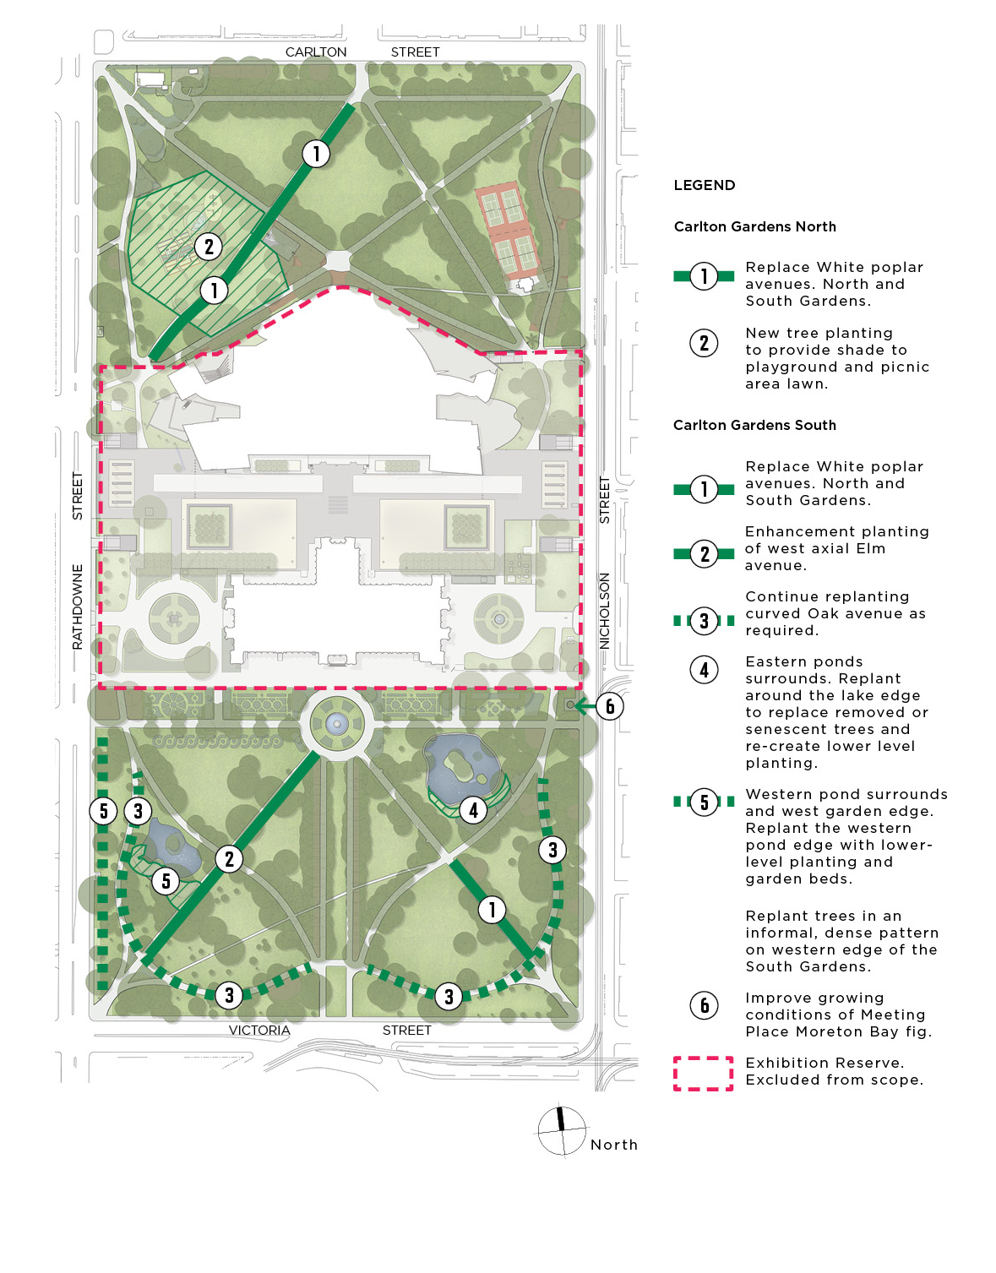
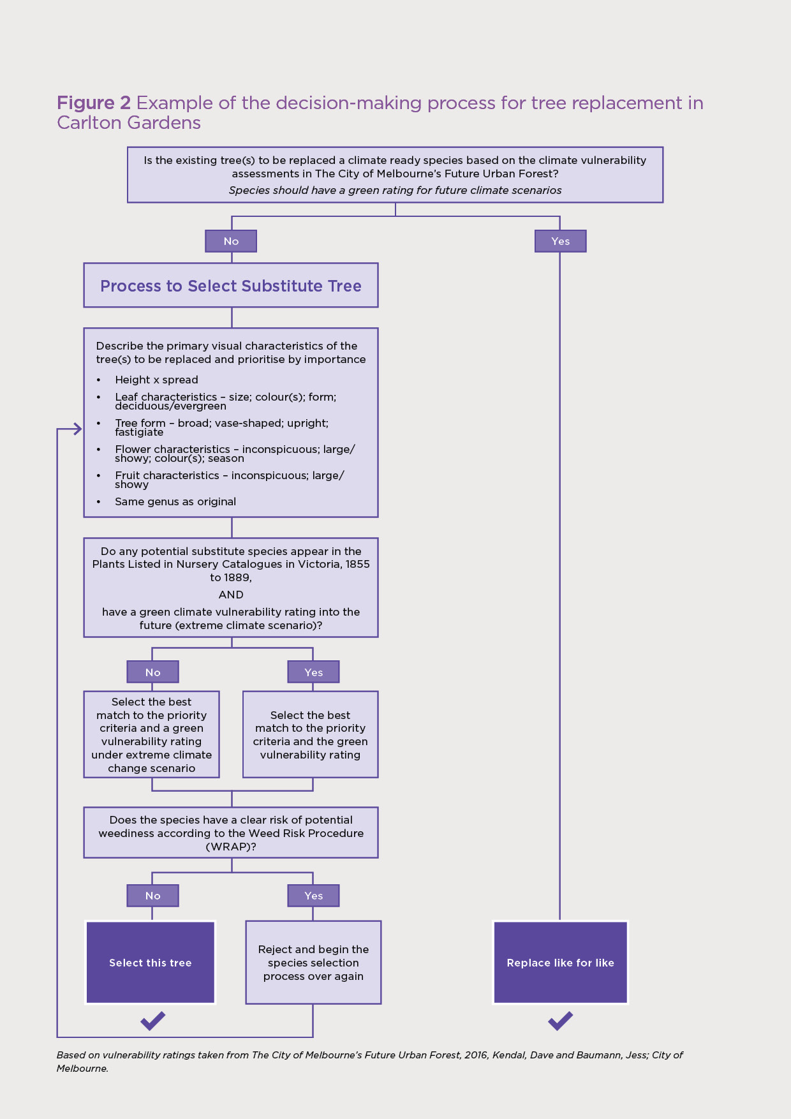

Figure 2 above: Flow chart for replacement tree selection

Uses and activities

Recreational uses in Carlton Gardens
Carlton Gardens has long provided an ideal place for informal recreation for people who live in the nearby area and for those who visit the gardens from further away. There are many reasons why people visit the Gardens ranging from taking a daily walk or run to attending a specific event or activity. With close to three million visitors per annum, Carlton Gardens is one of Melbourne’s most popular green spaces.
The City of Melbourne’s Open Space Strategy 2012 provides policy guidance to help manage uses in public spaces such as Carlton Gardens and outlines what appropriate facilities and activity types for each open space type in the City of Melbourne. Under this strategy, Carlton Gardens South and Carlton Gardens North have differing roles and emphasis:
Carlton Gardens South is classified a ‘capital city open space’ defined as Iconic open space that is primarily established and managed to stage activities and events of international, national, state and metropolitan importance, catering to a broader public need. These spaces are synonymous with the character of the City of Melbourne and provide facilities that are known by and primarily for international and interstate visitors to Victoria and the City of Melbourne.
Carlton Gardens North is classified as a ‘regional open space’ which should cater to a broader Melbourne-wide catchment of visitors, as well the local community. Generally regional open spaces are easily accessible to people from adjoining municipalities and may be of regional recreational importance and use and/or regional environmental value.
Carlton Gardens Master Plan must consider the specific roles each section of the Gardens (North and South) plays as part of meeting the open space and recreational needs of people who live, study and work within the City of Melbourne. In addition to residential and commercial uses, the presence of nearby University of Melbourne and RMIT campuses has resulted in the surrounding area of Carlton accommodating a large student population, with people aged between 20 and 24 being the largest age group in this suburb.
In general, recommendations on uses and activities in Carlton Gardens must be consistent with requirements contained in relevant legislation and local laws. These include the Joint Trustee Regulations under the Crown Land (Reserves Act) 1978, the Activities Local Law 2019 and the Domestic Animals Act 1994.

Recreational improvements since the 2005 Master Plan
The 2005 Master Plan provides the following direction on recreation uses and facilities: That the whole of the Carlton Gardens continue to be managed primarily as a passive recreation space with Carlton Gardens North also available for local informal active recreation activities and the tennis courts continuing to be used for that purpose. Formally organised active recreation activities or sport outside of the tennis courts, is not supported.
A number of changes were made in Carlton Gardens North to provide for these recreational uses, including the consolidation of depot facilities to the north-west corner, creation of a new lawn on the west side, installation of a picnic tables adjacent to the basketball court, renewal and repair of the playground and basketball court, new tennis court lighting, fencing and internal pavilion facilities improvements.
User surveys show these improvements, made since 2005, have been generally positively received. A 2017 survey found most people who visited Carlton Gardens (64%) were regular users, with the total annual visitation estimated to be 2.8 million visits per year.
This same survey found the most popular activities in Carlton Gardens were walking (commuting or exercise) jogging, socialising, playground use, reading/relaxing, social games, picnicking, sightseeing, school excursions and dog walking.
Key improvements people wanted to see were:
- more and improved toilets including baby change facilities
- more lighting on pathways and around the basketball court
- more play equipment and/or a second playground
- more general park furniture such as drinking fountains and water bottle fillers, seats, tables, a coffee point, BBQs and dog waste bag dispensers.

Community perception of recreational uses in Carlton Gardens
As part of the consultation process for updating the World Heritage Management Plan in 2020, Engage Victoria asked participants what uses people valued at the site. Participants could answer a range of questions or a drop a pin on a map of the site.
While noting the questions covered both the Exhibition Reserve and Carlton Gardens, the overall findings confirm those of the earlier 2017 user survey. The 2020 Engage Victoria survey found there is a strong attachment to Carlton Gardens, with 90% of respondents agreeing or strongly agreeing the site is well-maintained and accessible to the public while 80% agreed or strongly agreed the site allowed for an appropriate balance of passive and active activities.
Most survey respondents (63%) visited Carlton Gardens to undertake leisure activities (i.e. reading, relaxing, social gathering, basketball, playground use etc.). This was confirmed in the frequency of visits to Carlton Gardens (daily, weekly, fortnightly) which indicated most visits (63%) were for recreational purposes from local users who could walk to the site.
In the pin drop survey, a significant number of comments were lodged about the value of the tennis courts and the Carlton Tennis Club program. Lighting in Carlton Gardens North was identified as needing attention around the basketball court and the path north of the tennis courts. For more information about the Engagement Victoria consultation process, refer to Appendix B.
What people liked about Carlton Gardens:
• Mature avenues of trees for shade and visual appeal
• The varied wildlife and biodiversity found around the lakes and gardens
• The beautiful green space so close to the Melbourne CBD
• Feeling connected to the Melbourne community when using the space for recreation, walking and relaxing
The following individual responses reflect common responses to the question, ‘What is your favourite thing about the Royal Exhibition Building and Carlton Gardens?’
“EVERYTHING! I love the gardens, the museum, the fountain, the trees, the slope of the hills, seeing people sitting in the gardens.”
“The ponds and different paths. And the DUCKs!”
It is a stunning garden space in the middle of the city. I love going through it for my dose of beauty and green on the way to work.”
“The basketball court and the community that gathers there.”
Based on the responses to both the Engage Victoria survey and the earlier 2017 survey, existing activities and facilities in Carlton Gardens suit many people’s recreation needs.

Recommendations: Uses and activities

Whole of Carlton Gardens
- Continue with the current framework for uses and activities as set out in the 2005 Master Plan.

Carlton Gardens South
- Continue to manage Carlton Gardens South with passive recreation as the primary use for city workers, students, day visitors and residents.
- Prioritise capital city activities such as tourism visits and tours, interpretation, education and events, in keeping with the capital city designation and the clear relationship of Carlton Gardens South to the Royal Exhibition Building.
- Continue a high level of maintenance and presentation in horticulture, water features, trees and lawns to ensure the aesthetic experience and historical presentation is maintained.
- Maintain amenity assets to a good standard and provide seats, drinking fountains, signage and public lighting as required.

Carlton Gardens North
- Continue to manage Carlton Gardens North for both passive recreation and informal recreation activities in line with the current arrangements and facilities.
- Prioritise regional and local general recreation uses in this space for residents, workers and day visitors. This includes visitors to Melbourne Museum, including school and other education-based groups.
- Improve basic amenity through maintenance or provision of new toilets, seats, picnic tables and drinking fountains.
- Maintain the current range of facilities and renew, as required, taking into account the current demographic profile of the local community.
- Minor upgrades, additions or adjustments to the current recreational and open space facilities can be considered if community need is demonstrated and the changes do not impact on the heritage values or presentation of Carlton Gardens.
- Provide more shade in key public gathering areas such as the playground and picnic area by planting additional specimen trees to ameliorate the potential increase in heat levels impacting on recreational use.
- Improve overall lighting levels by installing new pathway lighting along the north-west path to the corner of Carlton and Nicholson streets. Assess light levels in the key activity areas and, if required, provide additional lawn lighting to improve recreational amenity, particularly in winter months.

Events

Events in Carlton Gardens
Melbourne is Victoria's capital city and the business, administrative, cultural and recreational hub of the state. Carlton Gardens, Melbourne Museum and the Royal Exhibition Building all contribute to the cultural and recreational experience of Melbourne.
In conjunction with the Royal Exhibition Building, Carlton Gardens has a long history of hosting largescale exhibitions and events. The Gardens are also popular for wedding ceremonies, film and television locations, photography and smaller-scale community events.
While the Royal Exhibition Building is an event venue in itself, large events involving Carlton Gardens require additional consideration and guidance, given the potential for negative heritage impacts on the Gardens site. At the time of developing the 2005 Master Plan, only one annual major event involved both the Royal Exhibition Building and Carlton Gardens South – the Melbourne International Flower and Garden Show.
While many events are held in the Royal Exhibition Building each year, major events involving both the Building and the Gardens are confined to the Melbourne International Flower and Garden Show and in more recent years, the White Night Festival.
A designated State major event, the five-day Melbourne International Flower and Garden Show has taken place in the Royal Exhibition Building and Carlton Gardens South since the late 1990s. A major highlight of Melbourne’s events program, it is a gated, ticketed event that attracts up to 270 exhibitors and vendors and 100,000 visitors. Given the nature of the displays, the event requires an exclusive two-week installation phase, followed by post show restoration works, primarily turf replacement, after which the Gardens are re-opened for public use. It takes around six weeks for Carlton Gardens South to revert to its usual presentation levels.
The White Night Festival was a 12-hour, lower impact event, with the focus of the activity being the projection of images on the external walls of the Royal Exhibition Building, with some ancillary art installations throughout Carlton Gardens South. While visitor numbers were large, very little post event restoration was required as the experience involved only modest additional infrastructure.
The distinguishing features of both events has been the continued use of the ‘exhibition’ concept (through horticulture and art), for which the Royal Exhibition Building and Carlton Gardens South were first established, to attract visitors from across Melbourne, Victoria and interstate.

World Heritage guidance
The World Heritage Management Plan 2013 provides further guidance for major events at the site:
- Where consistent with the Conservation (now Heritage) Management Plan and this Management Plan, major events should continue to be held at the Place (Place means the sum total of Royal Exhibition Building/Exhibition Reserve and the Gardens).
- Events involving the wider Gardens outside Exhibition Reserve should involve either Carlton Gardens North or South, but not both.
- Remove specific reference to Melbourne International Flower and Garden Show in the next review of the Carlton Gardens Master Plan.
- Heritage Victoria permits and a heritage impact assessment statement are required for major events effecting Carlton Gardens and a decision to issue a permit and any conditions should be based on the Conservation (now Heritage) Management Plan policies.
- Monitoring before, during and after the event is always required.

Master Plan 2005 guidance
In relation to events in Carlton Gardens, the 2005 Master Plan recommended that:
- Small Scale Events are permitted (both North and South Gardens).
- No commercial event requiring exclusive occupation of the Gardens (other than Melbourne International Flower and Garden Show) is permitted. The one exclusion would be if the event specifically related to the World Heritage status of the site.
- That the existing installation requirements for Melbourne International Flower and Garden Show be further developed to ensure protection of the historic values of the Gardens and recommended that investigations be made into using the hard stand areas around the Royal Exhibition Building for higher impact structures.
An exhibitors’ handbook, setting out installation and operational requirements for the Melbourne International Flower and Garden Show, has been in place for many years and is progressively updated. Regular soil testing is undertaken to measure soil compaction and an onsite monitor is present during the installation and removal of all show exhibits. (Refer to Breakout Box for further details).
A Heritage Permit for the event and a pre- and post-occupancy event report are required by Heritage Victoria. Although an event of the size of the Melbourne International Flower and Garden Show has the potential to have a high impact on Carlton Gardens South, a review of test results and reports since 2005 shows that clear guidance, strict management and consistent onsite monitoring has served the site and exhibitors well, with no apparent cumulative impact on the heritage values of Carlton Gardens. Other factors contributing to this positive outcome are:
- the time of year the event is held (autumn, where soils are not as likely to be impacted)
- the same event with returning exhibitors, who understand the process and the expectations and are from the landscape management profession.

Community perception of events in Carlton Gardens
As part of the consultation process for updating the World Heritage Management Plan in 2020, Engage Victoria asked survey respondents to comment on the following statement:
The events and exhibitions held on the Royal Exhibition Building and Carlton Gardens site are appropriate to the setting and the community.
In total, around 72% of respondents agreed or strongly agreed with this statement. For this reason, it can be argued the public are generally comfortable with the current program of events on the site, with strict management processes and clear limits on the use of the site likely to be key contributors to this perception. For more information about the Engagement Victoria consultation process, refer to Appendix B.
If future events are in line with current permit conditions, and monitoring systems and the level of impact on heritage values remains negligible or low, it is likely the public will generally continue to support the use of the Carlton Gardens for these types of larger events.

Recommendations: Events
- Events are part of a range of activities that occur in Carlton Gardens, however the number and impact of these events needs to be balanced against both the impact on the cultural and historic values of the site and the other agreed uses at the site.

Carlton Gardens South
Remove the specific reference to the Melbourne International Flower and Garden Show (as recommended in the World Heritage Management Plan 2013) and change to the following guidance.
- Major events in Carlton Gardens South will be supported if they are provided for under the Crown Land (Reserves) Act 1978 and/or any Victorian Government Regulations, or meet all of the following criteria:
  - Use both the Royal Exhibition Building or its historic forecourts and Carlton Gardens South in an integrated way (i.e. no major events in the Gardens only).
  - The combined Carlton Gardens South and North site is not available at one time for major events for public access reasons.
  - The nature and purpose of the events should relate to the cultural values of the place, such as exhibition or civic/ceremonial events. A recognition of the First Peoples cultural association with the site should be included in event programming.
  - Are conducted in accordance with strict management processes to avoid heritage impact on the cultural values of the place and are consistent with Heritage permits.
  - Have an approved Heritage Victoria permit and a heritage impact assessment (Note: if there is any inconsistency with a City of Melbourne policy or procedures, this permit requirement takes precedent).
  - On site monitoring before, during and after a major event is required.
  - If an event is held annually, the conduct and layout of the event must adjust to any permanent changes in the layout of Carlton Gardens that have taken place between events.
  - The total period of time allowed for major events per year is capped at 13 weeks or 25% of the calendar year. This includes event set up and delivery and any required post event reinstatement works.
  - When considering any applications for major events in the Carlton Gardens, Council should consider any seasonally specific impacts on the space. For example, the reduced risk of soil compaction and the irrigation requirements of historic trees during the drier months of the year.

Carlton Gardens North
- Continue small event bookings. Carlton Gardens North plays a significant open space role on a regional level. It contains a range of recreational facilities that must be available to the public at all times such as the playground, tennis courts and the half basketball courts. Small events can be part of this mix but not a dominant use.
Small event bookings will continue in line with standard City of Melbourne management and booking procedures.

Monitoring and Assessment of heritage impacts from Events
The Melbourne International Flower and Garden Show is held annually in both the Royal Exhibition Building and Carlton Gardens South. The City of Melbourne must issue a licence for the event, and Heritage Victoria must issue a permit. A range of monitoring and reporting requirements are required as part of these approvals.

Soil compaction testing
Regular soil compaction testing has been undertaken since 2003 with tests taken both before and after the show since 2007. Over that time there has been no overall detectable change in the bulk density of the soils in Carlton Gardens. A key reason for this is that the soil exhibits an increased strength at drier times of the year, which is when the event is held.

Tree protection plan
A tree protection plan is prepared as part of the planning process. This plan identifies tree protection zones and is used to inform the location and layout of exhibitor spaces and other activities. Limited activity occurs within these zones. To date there has been no major impacts on trees as a result of the show, indicating early planning is effective.

Monitoring exhibitor set up and removal
All exhibitors receive an Exhibitor Manual and attend an information session where installation requirements are explained. An onsite monitor attends during the show set up and removal to ensure exhibitor compliance with garden and tree protection requirements.
The onsite monitor is able to direct adjustments on site to ensure compliance and provides a report at the conclusion of the event on any incidents which have occurred and recommendations for future shows. A review of these reports from 2005 and 2019 shows that a small number of minor incidents (under five per show) is typical.
Over the years the Exhibitor Manual has been updated in response to monitor reports, which have included recommendations such as the use of pro-floor in stands to reduce turf impact and the use of the Western Forecourt for vehicle entry, rather than Nicholson Street.

City of Melbourne annual works
Trees are inspected annually prior to the Melbourne International Flower and Garden Show to ensure they are within tree maintenance guidelines. Lawn reinstatement after the show is now undertaken with pre-grown turf, reducing the time required for lawns to return to a suitable level of presentation. This approach is in contrast to earlier years where a mix of turf and direct seeding was used for lawn reinstatement.

Connections and linkages
How people access Carlton Gardens, and how they move through the Gardens, is as important today as it was in the 2005 Master Plan. The Gardens, Royal Exhibition Building and Melbourne Museum are popular visitor destinations and must be well supported by clear information, appropriate wayfinding signage and safe, direct links to nearby public transport. This includes providing a high standard of adjacent footpaths and roads.
As most people think of Carlton Gardens as one place, it is important to enhance the perception of a single site and maintain clear connections between Carlton Gardens South and North, the Royal Exhibition Building and Melbourne Museum.
As a location adjacent to the central city, Carlton Gardens also serves a secondary role as a movement corridor, particularly for pedestrians. The 2005 Master Plan recommended the entire site be managed as a pedestrian precinct, with pedestrians having priority and vehicle movements kept to a minimum.
It was also recommended that bicycle routes around the Gardens, rather than through the Gardens, be upgraded to provide for cyclists who commute to the city. This has largely occurred, with the installation of a dedicated bicycle lane on Rathdowne Street in 2010. In 2021 this route was upgraded to a protected bike lane, further establishing Rathdowne Street as a key cycling route into the central city.
A new cycling route on Barkly Street, from Canning to Rathdowne streets, was also developed as recommended by the 2005 Master Plan. The current east-west cycling link, from Gertrude to Queensberry streets, runs through Exhibition Reserve. Changes or amendments to this link will be addressed in the Exhibition Reserve Master Plan.
Overall, these improvements in the wider cycling network are working well, with a 2017 user survey and the recent Engage Victoria consultation process confirming this.

Safe access to Carlton Gardens
Despite these recent access improvements, feedback from the Engage Victoria consultation process confirmed pedestrian access to Carlton Gardens is still a key challenge.
While all crossing points and garden entrances are important, the most commonly used entry points for Carlton Gardens and Melbourne Museum are at Nicholson Street and Victoria Street for Carlton Gardens South and Rathdowne Street and Carlton Street for Carlton Gardens North.
Identified in the 2005 Master Plan as a key issue is the connection to Carlton Gardens via Victoria Street, a primary linkage that still needs improvement. In order to access both the Gardens and the Museum from the CBD, Parliament Station and its adjacent tram stops, pedestrians need to cross Victoria Street. As a VicRoads managed road, any improvements to the Victoria Street crossing will only occur by advocating for safety improvements to these pedestrian crossings.
Vehicle crossovers and footpaths abutting Carlton Gardens and Melbourne Museum, particularly on Rathdowne Street and the shared path on Nicholson Street, vary in condition from adequate to below standard. These footpaths cannot be widened which means improvements must focus on asset maintenance and general management.

Recommendations: Connections and linkages

External to the site
- In conjunction with Museums Victoria, improve access to Exhibition Reserve and Carlton Gardens from footpaths on Rathdowne Street and Nicholson Street. A key focus should be on providing a contemporary standard of disability access, repairing and modifying bluestone crossovers, asphalt maintenance and minimising installation of unnecessary street furniture on these paths.
- Improve pedestrian access, develop and install wayfinding signage from key transport hubs such as Parliament Station and adjacent tram stops to Carlton Gardens and Melbourne Museum.
- Continue to advocate to VicRoads for improved, safer pedestrian crossing points on Victoria Street.

Within the site
- Continue to manage Carlton Gardens as a pedestrian precinct, with pedestrians having priority use and other vehicle movements kept to a minimum.
- In conjunction with Museums Victoria, maintain visual connection and public access between Carlton Gardens South and North, particularly along the eastern and western ends of Exhibition Reserve.
- In conjunction with Museums Victoria, maintain a suitable presentation along the south face of the Royal Exhibition Building to allow a positive visual connection between the Building and the Carlton Gardens South setting.
- Maintain major pathways to a satisfactory standard, consistent with the historic layout.
- The addition of new pathways to this historic network would not be supported without a high level of justification.
- Minor access pathways as required (such as around the lake) to access facilities or features and/or provide for DDA access are supported. Minor paths should present in a different material to the main network such as granitic sand.

Climate resilience
In developing this revised Master Plan it is important to consider new and emerging factors that may impact Carlton Gardens and consider how to reduce the impact of future climate shocks and stresses, manage disruptions should they occur and allow the Gardens to continue to contribute positively to the social and economic life of Melbourne.
Commissioned by the Australian Government in 2020/21, the CSIRO report entitled Climate Change Vulnerability and Risk for Australia's World Heritage Properties, points to some of these key considerations. New actions to build resilience are considered within the context of a valuable heritage landscape.
Carlton Gardens is an ageing garden and continued stress on its vegetation could lead to an accelerated decline in some species. The renewal of the living layer of the Gardens needs to occur in an environment that is predicted to change due to a drier climate, higher average temperatures and increased evaporation.
In addition, the residential population around Carlton Gardens has increased since 2005, with the residential population of neighbouring Carlton increasing from 14,000 people in 2011 to 19,000 people in 2016, an increase of around 25% over that period. Flats and apartments are now the most common dwelling type and the area has a younger age profile reflective of its large student population.
Over the same period the number of daily visitors to the City of Melbourne has also increased. Notwithstanding the current drop in city workers, students and visitors due to the COVID-19 pandemic, it is still estimated that overall worker, visitor and resident numbers will continue to rise in the City of Melbourne for the foreseeable future. Between 2005 and 2017, the number of visitors to Carlton Gardens rose by a third, creating more demand on local open space, both in terms of facilities use and maintenance requirements.
Based on current climate change projections, actions will be required to ensure Carlton Gardens retains a good level of amenity and comfort for visitors, particularly on hotter days. The 2005 Master Plan canvassed a range of opportunities for continuing to maintain an irrigated garden, while decreasing overall potable water use, through more efficient irrigation methods and increased access to non-potable water sources.
Museums Victoria installed an underground rainwater tank under the Western Forecourt in 2014 and Melbourne Museum and the City of Melbourne share this resource. The efficiency of the City of Melbourne’s overall open space irrigation system is continually improving through a combination of better management and upgraded irrigation systems.

Recommendations: Climate resilience
- Continuing to monitor and investigate opportunities to increase the amount of non-potable water use in Carlton Gardens.
- Continue to improve the efficiency of irrigation systems, and specifically complete the upgrade of the Carlton Gardens North irrigation system.
- Increase the amount of shade through additional tree planting in key activity areas in Carlton Gardens North.
- Monitor heat and shade levels across Carlton Gardens and identify areas for improvement.

The impacts of a changing climate on Carlton Gardens
In 2020/21 the Australian Government commissioned the CSIRO to undertake a report entitled Climate Change Vulnerability and Risk for Australia's World Heritage Properties. This report builds on a 2009 report – Implications of Climate Change for Australia’s World Heritage properties.
While not a site listed for natural values, the Report showed the Royal Exhibition Building and Carlton Gardens was not immune to the vulnerabilities and risks associated with climate change.
Potential climate change risks* for Carlton Gardens include:
- Temperature rise and more extreme temperatures
- Drought
- More extreme rainfall
- Potential impacts on the property
- Reduced water available for irrigation of Carlton Gardens; damage to vegetation
- High temperatures can affect presentation of Outstanding Universal Value and visitation
- Flooding and extreme storm events prevent access and hosting of large events.

Impacts on Outstanding Universal Value
One of the most important threats to the Outstanding Universal Value of the Royal Exhibition Building and Carlton Gardens is the impact higher temperatures and extreme daily rainfall will have on the iconic trees and plants of Carlton Gardens. This may be especially true for iconic trees (e.g. plane trees) that run along the park boulevards, as well as trees within the park that are culturally important for Traditional Owners.
Replacement of existing plants with more heat- and dry-tolerant species may be necessary, which will change the iconic look and authenticity of the current horticultural fabric of Carlton Gardens. However, tree species that can survive in future climate conditions and can provide shade and green space allows for recreational use to continue for a majority of the year.
If trees with similar characteristics to the current offer are used, the recognised garden layout and look and feel of the gardens can be maintained. (In fact, this was the process used for plant selection for the reconstructed scroll and parterre garden beds). The Moreton Bay fig trees, which are of historic importance to the Aboriginal community, if lost, would be irreplaceable.
More extreme rainfall, flooding, winds and storms will damage plants and building structures. A redesign of the landscape and an upgrade to the building’s roof may be necessary to prevent water ingress during storms. However, these changes would need to occur in a sustainable way to protect the authenticity of the property.
Alterations to stormwater infrastructure may help redirect water flows away from the building and gardens. A large underground water tank has been installed in the Western Forecourt to help capture water for irrigation of Exhibition Reserve and Carlton Gardens.
*Key climate change risks in the report have been edited to list impacts to Carlton Gardens only

Interpretation

Interpretation of the World Heritage Site
Raising community awareness and developing interpretation programs for the Royal Exhibition Building and Carlton Gardens is an ongoing consideration for any place on the World Heritage List.
Interpretation can be delivered by all parties with a responsibility for the site, including the Australian Government, Heritage Victoria, Museums Victoria and the City of Melbourne with each organisation having different roles to play and audiences to communicate with. The Heritage Management Plan and Traditional Owners and First Peoples Cultural Values Report are resources from which key elements can be drawn for interpretation purposes.

What has happened since the 2005 Master Plan
The 2005 Master Plan recommended interpretation of Carlton Gardens should be part of an overall interpretation plan for the entire site. It recommended that interpretation cover both the historical and botanical features of the Gardens. Museums Victoria and City of Melbourne both recognise the benefits of planning and working together on interpretation projects.
Joint interpretation actions and products delivered since 2005 include:
- use of a consistent style of onsite interpretive signage
- development of a self-guided walk which includes Exhibition Reserve, Carlton Gardens and the immediate urban area surrounding the Gardens
- a dedicated Royal Exhibition Building webpage, which includes information about Carlton Gardens, developed and curated by Museums Victoria. This content was developed on behalf of all organisations as part of the World Heritage Management Plan 2013 recommendations.
- promotion of Carlton Gardens on City of Melbourne websites and social media channels.

Community perception of interpretative practices
As part of the consultation process for updating the World Heritage Management Plan in 2020, Engage Victoria asked survey respondents to comment on the following statement:
The information available about the history, significance and features of the Royal Exhibition Building and Carlton Gardens site is sufficient.
In response to this statement, only 50% of those surveyed rated current interpretative practices as delivering well or very well. While signs on site, exhibitions, displays and walking tours are still the preferred delivery methods nominated by those surveyed, new digital platforms and methods should be considered.
The scheduled opening of the Royal Exhibition Building dome promenade walk by Museums Victoria in 2022 provides an opportunity to revise and refresh the current interpretation offer.
In addition to information-based tools and resources, place interpretation is also supported by people’s experiences of that place. Careful management of Carlton Gardens, particularly the protection of key views and aesthetic elements in Carlton Gardens South, is an important factor in this form of interpretation.
For example, the dome promenade at the Royal Exhibition Building will give visitors a similar experience to the 19th century viewing platform around the dome. Therefore, to be a successful experience, Carlton Gardens South must present from the dome as an appropriate visual spectacle and enable key historic elements of the 1880 layer to be identified appropriately.
Similarly, protecting an uninterrupted view line to the historic building entrance from both the southern and northern end of Grand Allée is an important management device that will aid historic interpretation.

Recommendations: Interpretation
- Revise and refresh the current interpretive offer, in conjunction with other key agencies, in particular Museums Victoria.
- Ensure presentation of the whole site is consistent with agreed interpretive messages and consistent with information in the Heritage Management Plan and Traditional Owners and First Peoples Cultural Values Report.
- Continue to cooperate and work with Museums Victoria on interpretation projects of mutual interest.
- Review feedback relating to preferred ways of receiving heritage information as per the Engage Victoria survey and refresh the interpretation approach to align with the top four preferences for interpretation techniques (refer to Appendix B).
- Develop a plan in conjunction with Museums Victoria for interpretative actions and products with an emphasis on delivering the preferred engagement methods. This should include:
  - Update of the current self-guided walk (with Museums Victoria) – including making it available on digital formats and platforms used by the City of Melbourne to promote visitor experiences in Melbourne.
  - Extension of the visitor experience of the dome promenade by enhancing onsite interpretation, with a focus on the Melia Avenue precinct in Carlton Gardens South. Actions could include new, discreet identification signage for selected historic trees and shrubs and a convenient starting point for the self-guided walk.
- Provide recognition of the Aboriginal cultural values of the site, including:
  - Completing the agreed installation at the Exhibition Gardens Meeting Place as part of the fig tree protection works.
  - Investigating opportunities for use of Aboriginal language in signage and place naming.
- Monitor visitor demand and tourist profile, and explore the introduction of additional interpretation activities if opportunities arise.
- New permanent monuments, artworks, memorials or plaques in Carlton Gardens will generally not be contemplated unless there is a specific connection to the site and the proposed topic is of a significance appropriate to its heritage values. The assessment of any request should be consistent with the World Heritage Management Plan, the Heritage Management Plan policies and the City of Melbourne’s Plaques and Memorials Policy.

Garden precincts

Carlton Gardens South
Plan 6 – Carlton Gardens South Master Plan
Proposed works
1. Views and vistas
Maintain clear view at the southern entry from Spring st to the Grand Allee.
2. Lake surrounds
New planting and landscape plans for both lake surrounds. Retain important view lines to the Royal Exhibition Building.
3. Meeting Place
Progress works to protect health of the Moreton Bay fig tree at Exhibitions Gardens Meeting Place. Work with Traditional Owners and the wider Aboriginal community on recognition and interpretive elements in the place.
4. Toilet facilities
Replace existing toilet with new in same location.
5. Trees and avenues - South Gardens
Progressively restore avenue and specimen planting, as per Plan 4 - Replanting Priorities.
6. Historic shrub beds
Investigate potential to re-instate shrub beds, consistent with the 1880 design, at key pathway intersections.
7. North - South connection
Work with Museums Victoria to maintain and enhance connection between the North and South Gardens through Exhibition Reserve.
8. Pedestrian access
Repair crossovers and footpaths on Rathdowne and Nicholson Streets.
9. Wayfinding
Develop and install new pedestrian wayfinding signage from the central city to the Gardens.
10. Pedestrian crossings
Advocate for safer pedestrian crossing points to the Gardens from Victoria Street.
11. Interpretation zone
Investigate additional on-site interpretation to complement the Dome Promenade walk.

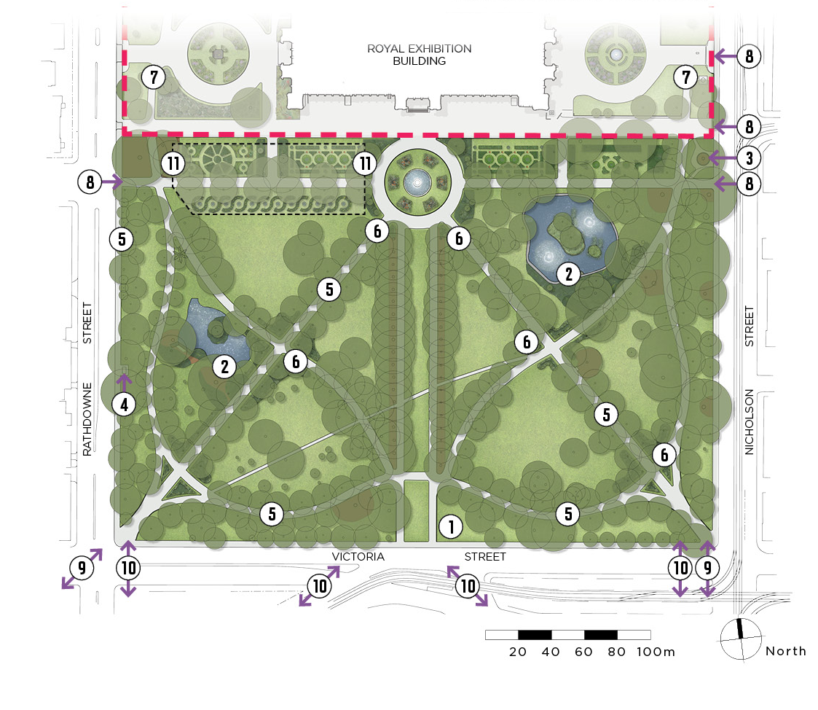

Carlton Gardens North
Plan 7 – Carlton Gardens North Master Plan
Proposed works
1. Toilet facilities
Replace existing toilet with new in same location.
2. Trees and avenues - North Gardens
Replace White poplar avenue.
3. Shade trees
New tree planting for shade in playground and picnic areas.
4. Pathway lighting
Additional lighting along eastern pathway – from Tennis courts to corner of Carlton and Nicholson streets.
5. Activity lighting
Investigate upgrade to activity lighting in playground, picnic area and basketball areas.
6. North - South connection
Work with Museums Victoria to maintain and enhance connection between the North and South Gardens through Exhibition Reserve.
7. Pedestrian access
Ongoing maintenance of footpath on Rathdowne Street and shared path on Nicholson Street.

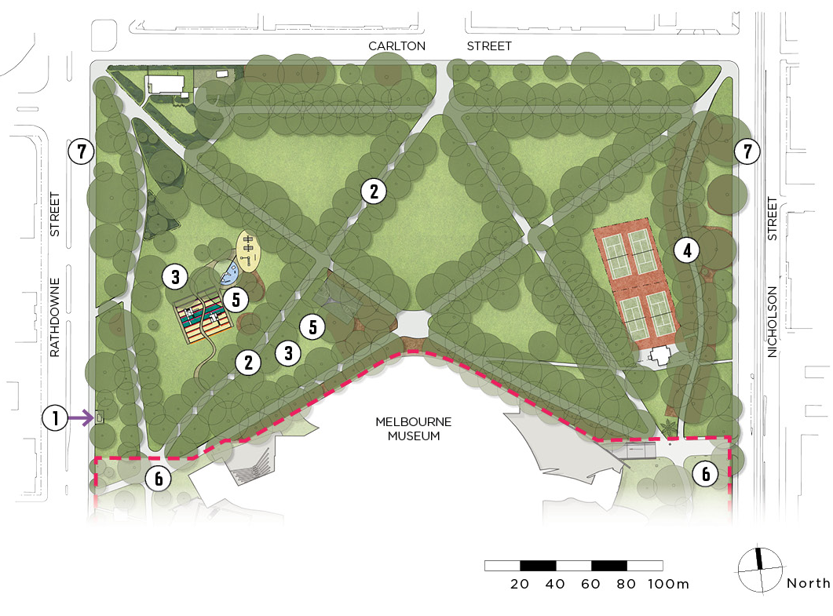

Management and cooperation
Although Carlton Gardens is managed by the City of Melbourne, and Exhibition Reserve is managed by Museums Victoria, a coordinated approach to managing the whole site is essential to ensure the shared objectives of the Master Plan and the World Heritage Management Plan are realised.
A high standard of maintenance of Carlton Gardens and Royal Exhibition Building forecourts is required to meet community expectations of a World Heritage listed site.

Recommendations: Management
- Museums Victoria and the City of Melbourne continue to work cooperatively on projects of mutual interest at the site and share relevant information, plans and interpretation approaches particularly in relation to the World and National Heritage values. This can occur both directly and through the World Heritage Management Plan Steering Committee structure.
- Museums Victoria and the City of Melbourne continue to share the use of recycled water from the storage tank, with the current agreement due to be renewed in 2024.
- Through City of Melbourne contract specifications, ensure the highest standards of work continues to be required by all open space, tree management and other maintenance contractors for the purpose of achieving good presentation of the site at all times. Encourage the development of similar, consistent service standards across the entire site.
- All contractors responsible for the care and management of Carlton Gardens must be familiar with the heritage significance of the site and its component elements.
The City of Melbourne continues to be actively involved as a member of the World Heritage Management Plan Steering Committee for the site and the surrounding World Heritage Environs Area (WHEA).

Implementation of the Master Plan
An implementation plan for future capital and renewal works over next five years will be developed once the revised Master Plan is approved by Melbourne City Council. The directions of the Master Plan remain in place until the next review. If new issues or needs arise, which are not contemplated in the Master Plan, the vision and guiding principles set out in the Master Plan should be used to direct assessment and decision-making.

Review of the Master Plan
Currently the Heritage Act requires that the World Heritage Management Plan be reviewed every seven years. The next review of the Carlton Gardens Master Plan should occur as part of the wider review of the World Heritage Management Plan.

Appendices

Appendix A – Carlton Gardens selected plans. Two pages
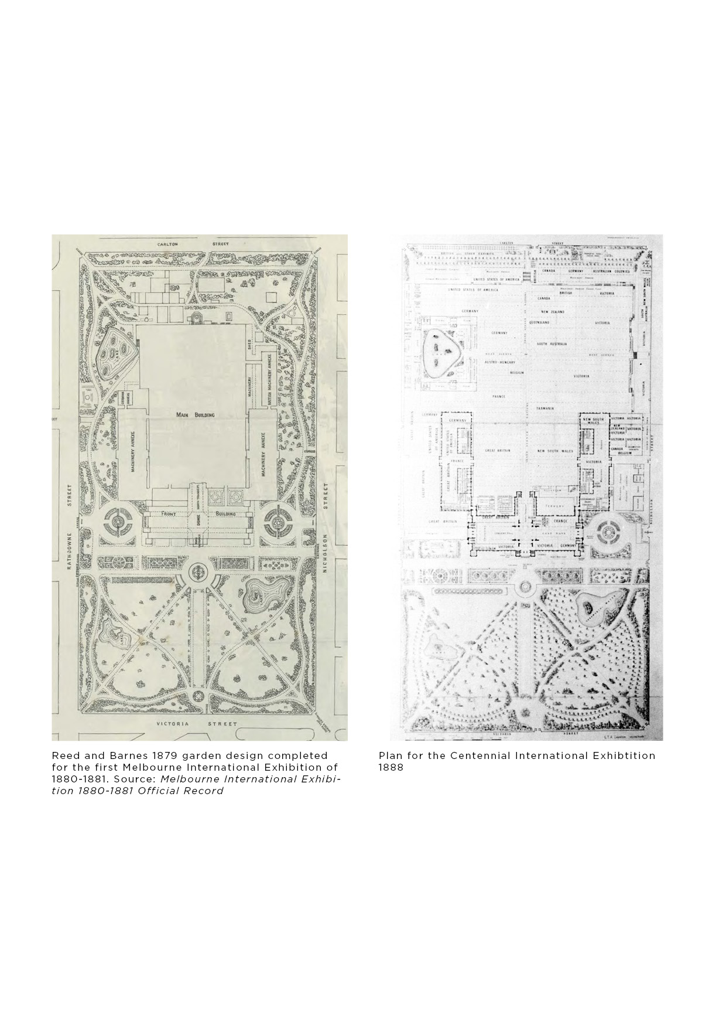
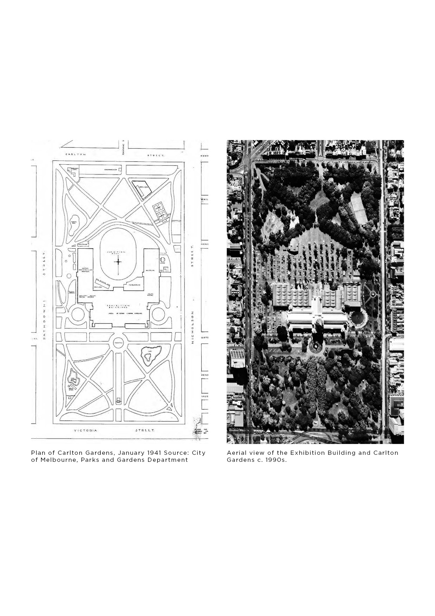

Appendix B – Engage Victoria Survey Results (2020)

All Survey questions relevant to Carlton Gardens. Eleven pages.
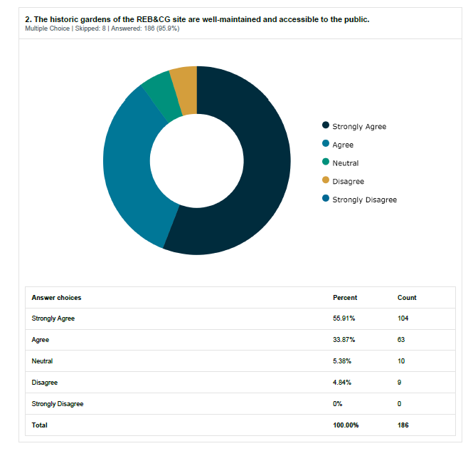
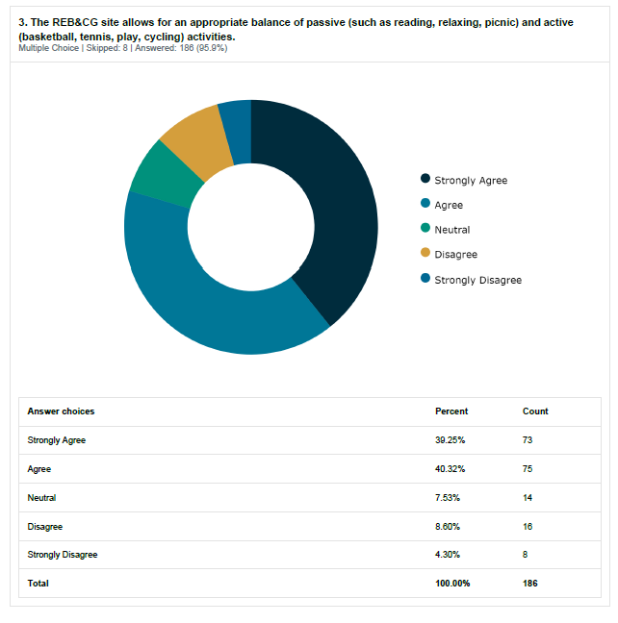
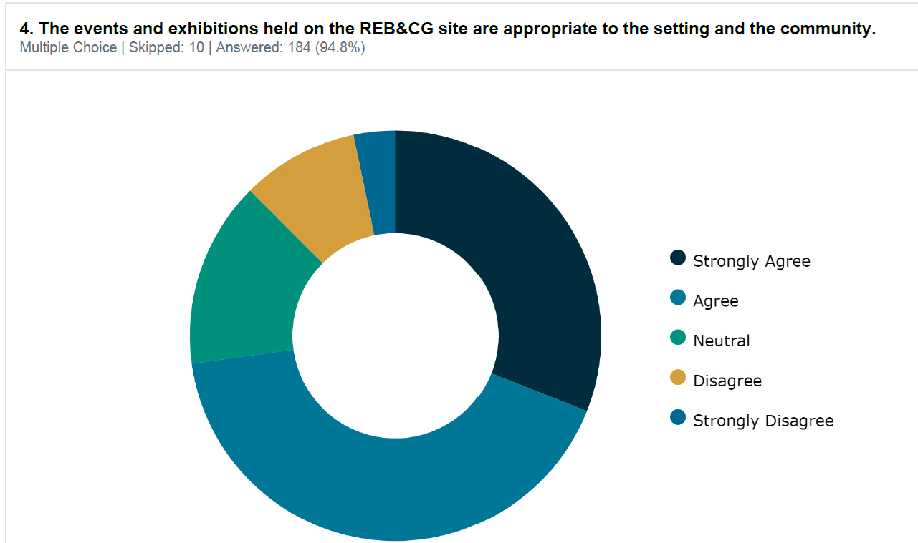
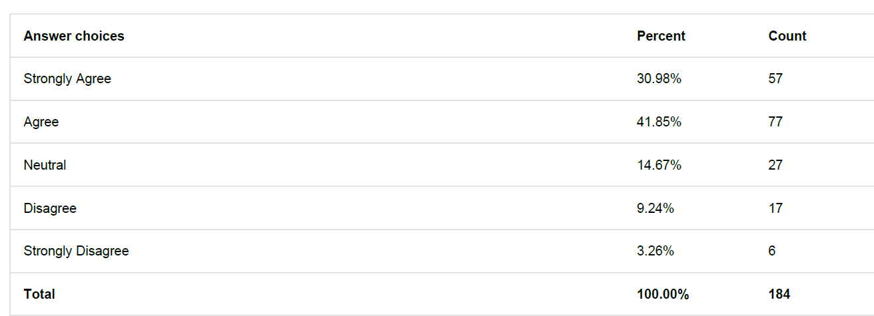

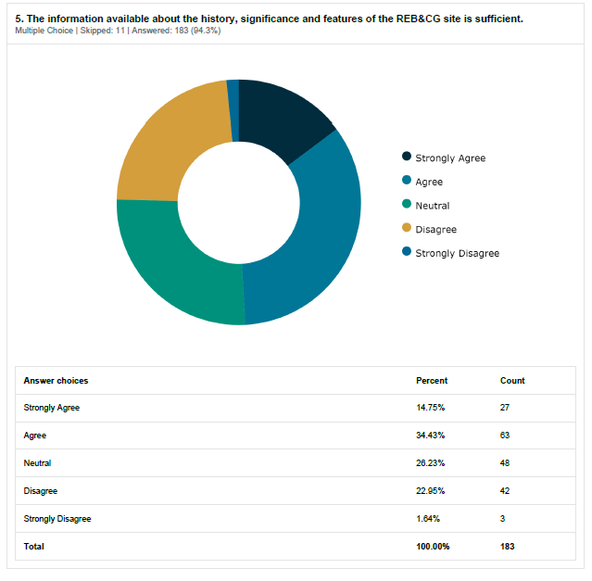
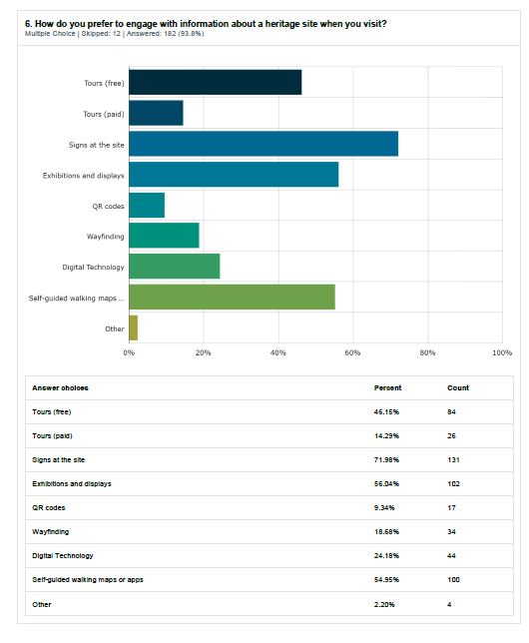
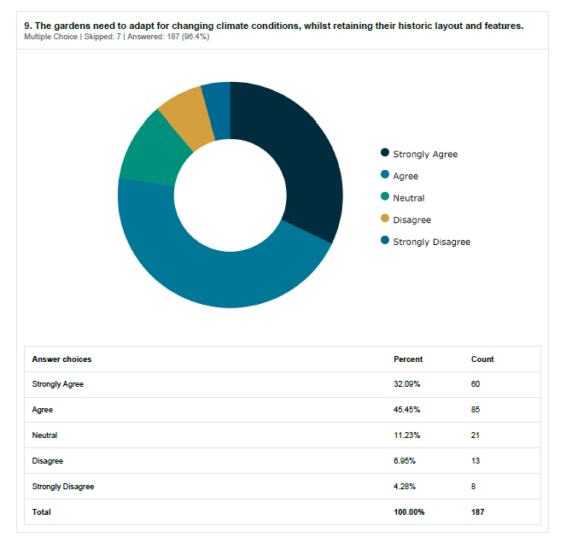
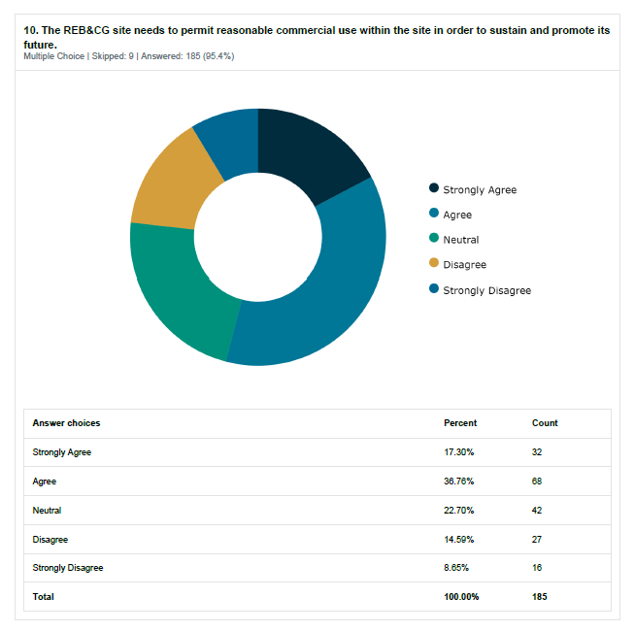
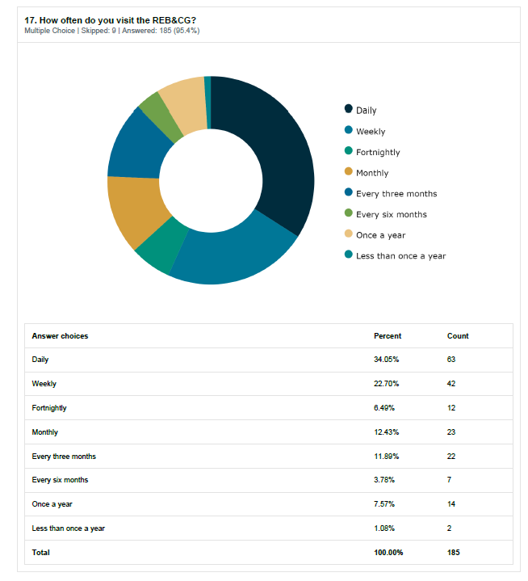
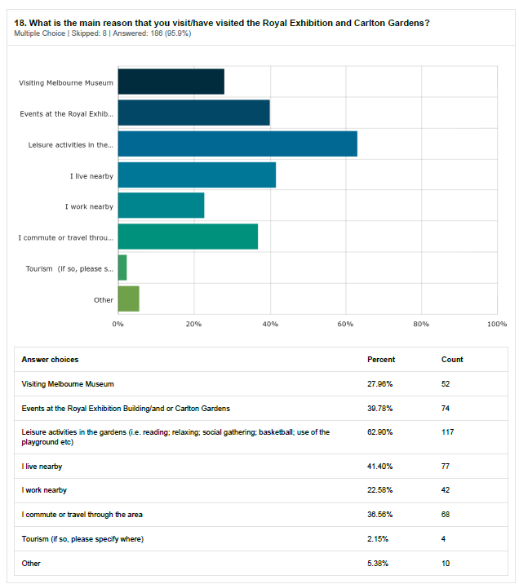

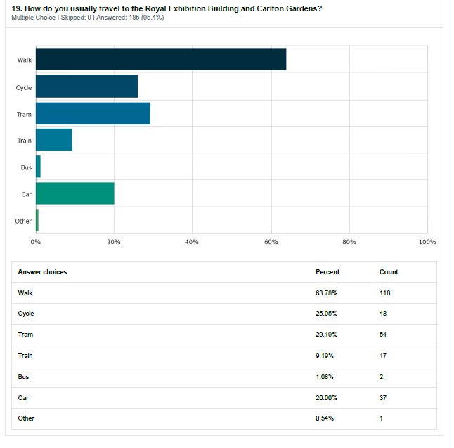

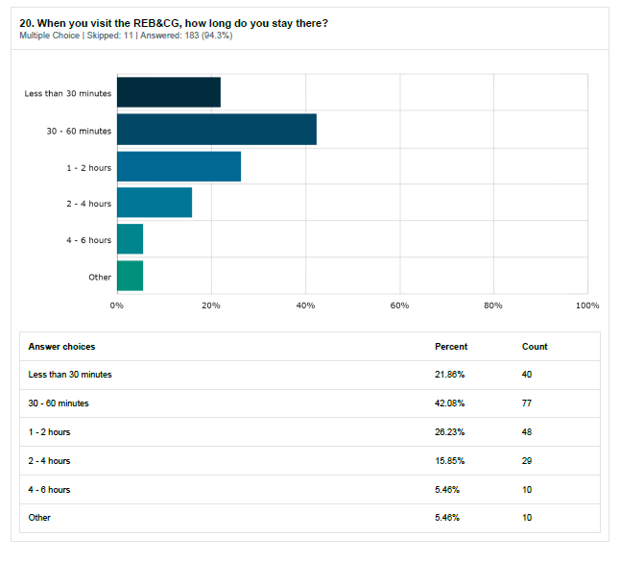

Additional References
Carlton Gardens Master Plan, City of Melbourne, 2005
Carlton Gardens Shrub and Floral Plantings, 1880 Melbourne International Exhibition Draft Report, Meredith Gould Architects Pty Ltd, June 2004
City of Melbourne City of Possibility, Council Plan 2021-2025
Climate Change Adaptation Strategy Refresh - City of Melbourne 2017
Implications of climate change for Australia’s World Heritage properties: Assessment of impacts and vulnerabilities Prepared by CSIRO with contributions from DAWE, WHA Property Managers and Traditional Owners 2020
Melbourne’s Historic Public Gardens: A Management and Conservation Guide, Rex Swanson, 1984
Nomination of Royal Exhibition Building and Carlton Gardens by the Government of Australia for Inscription on the World Heritage List, Environment Australia, 2002.
Open Space Strategy, City of Melbourne 2012
The Burra Charter: The Australia ICOMOS Charter for Places of Cultural Significance, 2013.
The City of Melbourne’s Future Urban Forest- Identifying vulnerability to future temperatures, Dave Kendal and Jess Baumann, University of Melbourne 2016
Transport Strategy - City of Melbourne 2019
Urban Forest Strategy - City of Melbourne 2012

Useful life expectancy is an estimate of how long a tree is likely to remain in the landscape, based on its health, amenity, environmental contribution and risk to the community. It also assumes that the growing environment will remain relatively stable over the same period.
2 Vulnerability ratings taken from The City of Melbourne’s Future Urban Forest, 2016, Kendal, Dave and Baumann, Jess; City of Melbourne.

