Planning Scheme
Amendment Request
200 Arden Street, North Melbourne


‘Dagura Buumarri’
Liz Belanjee Cameron
‘Dagura Buumarri’ – translates to Cold Brown Country. Representing Victoria.
The river system illustrated in this visual image is bound in greens and golds to acknowledge the warmth often felt in a colder climate. The rich earth hues of green, reds and browns reflect the local landscapes of this state while the extensive use of rhythmical patterning captures the unique landscapes of flat and mountainous areas. The use of earth colours imparts a sense of strength and serenity while contrasting greens throughout the image reminds us of the lushness of the natural world, where animals and humans once lived in harmony – it reminds us of the importance to protect the lands, waterways and skies and care for our localised environment. Scattered throughout the image are bold colours of oranges – a source of energy that continues to be felt as a life-giving source. The orange hues also portray the varying sunsets in which many Victorians enjoy seeing.

Ethos Urban acknowledges the Traditional Custodians of Country throughout Australia and recognises their continuing connection to land, waters, and culture.
We acknowledge the Wurundjeri Woi Wurrung people, of the Kulin Nation, the Traditional Custodians of the land where this document was prepared, and all peoples and nations from lands affected.
We pay our respects to their Elders past, present and emerging.
Contact |  | Henry Wallis  Associate Director | HWallis@ethosurban.com  0409 524 842
This document has been prepared by: Hasnain Ikram |  |  | This document has been reviewed by: Henry Wallis
Hasnain Ikram |  | 02/11/2023 | Henry Wallis | 02/11/2023
Version No. |  | Date of issue | Prepared By | Approved by
 |  | 11/01/2023 | HIk | HW
2.0  3.0  4.0 |  | 04/04/2023  29/11/2023  26/03/2024 | HIk  HIK  HIk | HW  HW  HW
5.0 |  | 03/06/2024 | HIK | HW
Reproduction of this document or any part thereof is not permitted without written permission of Ethos Urban Pty Ltd. Ethos Urban operates under a Quality Management System. This report has been prepared and reviewed in accordance with that system. If the report is not signed, it is a preliminary draft.
 | Ethos Urban Pty Ltd | ABN 13 615 087 931 | Level 8, 30 Collins Street, Melbourne VIC 3000 (Wurundjeri Woi Wurrung Land) Melbourne | +61 3 9419 7226 | ethosurban.com

Contents
Executive Summary 6
1.0 Introduction 8
1.1 Purpose of this Report 8
1.2 Planning Summary 8
1.3 Consultation 9
1.4 Background to the Electrical Trade Union 10
2.0 Site Location and Context 11
2.1 The Subject Site 11
2.2 Surrounding Area 12
2.3 Strategic Context 15
3.0 Existing Planning Controls 16
3.1 Municipal Planning Strategy (MPS) 16
3.2 Planning Policy Framework (PPF) 16
3.3 Zones, Overlays and Particular Provisions 18
4.0 The Proposal 22
4.1 Proposed Planning Scheme Amendment 22
5.0 Planning Assessment 23
5.1 Rezoning the site from the General Residential Zone (GRZ) to the Mixed-Use Zone (MUZ) 23
5.2 Application of the Design and Development Overlay (DDO) 25
5.3 Building Height Testing 26
5.4 Response to the PPF 27
5.5 Response to Heritage Overlay 3 27
5.6 Response to the Zone Provisions 28
6.0 Urban Design Assessment 29
6.1 Building Height 29
6.2 Built Form 31
6.3 Assessment of Stepped Building Form 33
6.4 Overshadowing 33
6.5 Further Considerations 34
7.0 Strategic Planning Considerations 35
7.1 Why is an Amendment Required? 35
7.2 Does the Amendment Implement the Objectives of Planning and Address Any Environmental, Social and Economic Effects? 35
7.3 Does the Amendment Address Relevant Bushfire Risk? 35
7.4 Does the Amendment Comply with All Relevant Minister’s Directions? 35
7.5 Support or Implement the Planning Policy Framework? 35
7.6 How Does the Amendment Support or Implement the Local Planning Policy Framework and Specifically the Municipal Strategic Statement? 36
7.7 Does the Amendment Address the Requirements of the Transport Integration Act 2010? 37
7.8 What Impact Will the New Planning Provisions have on the Administrative Costs of the Responsible Authority? 37
8.0 Ministerial Directions 37
8.1 Ministerial Direction No. 1 37
8.2 Response to Ministerial Direction No. 1 37
8.3 Ministerial Direction No. 9 37
8.4 Response to Ministerial Direction No. 9 38
8.5 Ministerial Direction No. 11 38
8.6 Response to Ministerial Direction No. 11 38
8.7 Ministerial Direction No. 12 38
8.8 Response to Ministerial Direction No. 12 38
8.9 Ministerial Direction No. 19 38
8.10 Response to Ministerial Direction No. 19 38
9.0 Conclusion 39

Appendices
Appendix A Illustrative Built Form Outcomes 40
Appendix B Draft Design and Development Overlay (DDO) Schedule 84 41
Appendix C 200 Arden Street – Built Form Testing Map 42
Appendix D Letter of Support prepared by Trethowan Architecture 43
Appendix E DDO84 Site Map 44

Table of Figures
Figure 1 Context Map 11
Figure 2 Building Height Context 12
Figure 3 Locational Context Map 13
Figure 4 Zone Map 18
Figure 5 HO3 Map 20
Figure 6 DDO66 Map 21
Figure 7 Illustrative Building Height Outcomes 30
Figure 8 Illustrative Built Form Outcome - Arden Street & Macaulay Road 32
Figure 9 Overshadowing Study 34

Table of Tables
Table 1 Key planning summary 8
Table 2 GRZ1 Table of uses 18
Table 3 MUZ Table of uses 19
Table 4 Helicopter Landing Sites 21

Executive Summary
Background
  - Ethos Urban has been engaged by the Electrical Trades Union (ETU) to prepare a Planning Scheme Amendment (PSA) request for the subject site at 200 Arden Street, North Melbourne.
  - The site is currently included within the General Residential Zone (GRZ), however the site has been used as an office, and has been in such use, for in excess of 10 years.
  - The zoning of the site does not reflect its historical and on-going industrial and commercial use, as recognised by CoM and DELWP.
  - Significant engagement has been undertaken with the City of Melbourne (CoM) Council and various stakeholders including the Victorian Planning Authority (VPA) and the Department of Families, Fairness and Housing (DFFH) since 2019.
  - Ethos Urban have recently engaged with the City of Melbourne’s internal teams, including Statutory Planning, Heritage, and Urban Design. These teams have confirmed in-principle support the amendment. Updates to the DDO have been completed in response to the commentary received.
The Planning Scheme Amendment
A review of relevant policy documents makes clear:
  - The existing zoning as GRZ is not appropriate for the existing use.
  - The MUZ is the most appropriate zone for the site.
  - All alternative zones (both residential and commercial) do not provide a mechanism to control site-specific design matters, and so a site-specific DDO (DDO82) has been prepared alongside the PSA.
  - Other potential zones would be inappropriate given the potential to have adverse impacts on the surrounding land uses in proximity to the site.
Why is the Amendment Sought?
  - The existing zone is inappropriate, and the MUZ is the most suitable given the site’s use and surrounding context.
  - The existing planning controls relating to the GRZ do not include a fixed height limit for non-residential buildings, and so there is uncertainty in respect of the site’s capacity for development or change.
  - The appropriate zoning of the site will give the proponent more certainty in respect of their occupation, and any future works that are undertaken relating to the site.
Conclusion
  - The amendment addresses the requirements of all relevant Ministerial Directions including Ministerial Directions 1, 9, 11, 12 and 19. The proposed amendment to the Planning Scheme is appropriate and will ensure that the zoning reflects the existing land use.
  - The amendment retains the existing Heritage Overlay (HO3) to ensure the heritage significance of the Melbourne Mills building is appropriately protected.
  - Any future development scheme will be required to address all requirements of the HO and Clause 15.03-1L-02.
  - The maximum building height and minimum setback requirements of the proposed DDO82 will ensure future built form does detract from the heritage significance is protected.
  - The proposed re-zoning will ensure that residential amenity in the area is protected and ensure that land uses that could have a potential negative impact would require an assessment through the permitting process.
  - The proposed re-zoning of the land will not lead to any built-form outcomes that would impact adjoining land uses in respect of overshadowing or sunlight provisions.
  - Utilises the MUZ as the most appropriate zone, when compared with other residential and commercial zones.
  - Protects residential amenity and ensures that other land uses that could have a potential negative impact would require an assessment through the permitting process.
  - It will encourage the use of sustainable modes of travel, particularly once Arden Station is fully operational.
  - The amendment will create far greater certainty for the ETU, which will ensure its operation can continue and grow at the site. This will bring significant benefits to local communities and employers.
  - Built-form controls set out within the DDO will ensure that any future development at the site will be an appropriate response to the surrounding context, and adjacent sensitive land uses in proximity.
  - The rezoning can ensure future outcomes will appropriately respond to the Heritage Overlay (HO3) which relates to the site.

Introduction

Purpose of this Report
Ethos Urban have been engaged by the Electrical Trades Union (ETU) to prepare a Planning Scheme Amendment (PSA) request for the subject site at 200 Arden Street, North Melbourne.

The ETU have owned the site and utilised the existing commercial building for the purpose of administrative offices for more than ten years. A significant portion of the building is used by the ETU to deliver a variety of training and support programmes to ETU members, their families, and the local community. The ETU also currently leases part of the property to Holmesglen Institute for use as commercial offices and training facilities, and there have previously been similar lease arrangements in relation to other parts of the property.

The ETU intend to continue using the site as its administrative offices and training facilities, however, will require an increased building floor area to accommodate the increased need for training facilities at the subject site. The proposed amendments would correct the planning controls at the subject site to better reflect the existing uses and character of this area of North Melbourne.

The proposed PSA is required to facilitate the continued use of site by the ETU and support its capacity to provide various services and facilities which achieve a net-community benefit for the wider area.

In support of this PSA, an Urban Design Assessment has been included in this report. This Assessment reviews the urban design context and identifies key implications for the site. It does not cover heritage, traffic or other specialist matters that are the domain of other relevant experts. The scope includes review of local area’s physical context and urban design assessment of the proposed development at 200 Arden Street, North Melbourne.

Planning Summary
The following table provides an overview of the relevant information regarding the PSA request, including the existing planning scheme policies and controls that apply to the site.
Table 1 Key planning summary
Item | Site
Address | 200 Arden Street, North Melbourne 3051
Title | 2\LP218927
Existing use and development | Commercial office building
Proposed planning scheme amendment | Rezone the subject site from the GRZ to the MUZ  Apply DDO84 to the subject site
Existing Zone | General Residential Zone – Schedule 1
Overlay | Heritage Overlay (HO3)  Design and Development Overlay – Schedule 66 (DDO66)
Other controls | Nil
Planning Policy Framework | Clause 11 – Settlement  Clause 13 – Environmental Risks and Amenity  Clause 15 – Built Environment and Heritage  Clause 17 – Economic Development  Clause 19 – Infrastructure
Restrictive covenants & easements | Caveat - AH566090F  S173 - AE133430A

Consultation
On behalf of the ETU, Ethos Urban have been engaging with the City of Melbourne (CoM) Council and various stakeholders including Victorian Planning Authority (VPA) and Department of Families, Fairness and Housing (DFFH) since 2019 in relation to the future redevelopment opportunities, and the anomalous zoning that applies to the site.

The first engagement with CoM was via a meeting held on 11 November 2019. The primary focus of the meeting and discussions related to the emerging Arden Urban Renewal Precinct, which was part of the Arden Structure Plan process that was being undertaken. ETU requested the Council consider including 200 Arden Street site into the Renewal Precinct as part of a formal submission made on 9 August 2020.

VPA provided written correspondence on 22 February 2021 in which it confirmed it would not extend the Renewal Precinct to include 200 Arden Street as it had identified additional work would be required to consider the site within any future PSA for Arden. VPA expected this would have included changes to the detailed modelling and technical assessments prepared for drainage, transport, and the built form.

Ethos Urban then met with CoM for a second time in February 2021 in which we undertook discussions with Robyn Hellman. The key matter discussed was the principle of the re-zoning, along with the ETU’s long-term intentions/aspirations for the site.

Following the meeting, CoM provided a written response covering the key matters discussed. We have summarised the feedback as follows:
  - Principle of re-zoning was acceptable.
  - Would like to ensure height is controlled (although there are currently no controls in respect of height)
  - Suggested that DDO32 is extended, to include the site, rather than creating a new DDO which was site-specific.
CoM also liaised with the DELWP who provided comments on the proposed re-zoning. The comments received from DELWP highlighted some additional matters to consider, however, there were no significant concerns raised in respect of the re-zoning of the site. The anomalous zoning of the site as GRZ despite its historical and on-going industrial and commercial use was recognised by CoM and DELWP. The key points raised by the DELWP were as follows:
  - Any future amendment must be based on the strategic justification and merit of the proposal, rather than the development potential of the site.
  - Primary purpose of rezoning the land is to reflect the existing/long-established use, (which is logical) but the Council should provide some justification around why the MUZ is the most appropriate land use option.
  - Extending DDO32 doesn’t seem to be the most logical option, given that the site appears to have different built-form outcomes to the remainder of the DDO32 area. Certain matters are discussed in DDO32 which would not necessarily apply or be relevant to 200 Arden Street.
A third meeting was held with the CoM on 4 November 2022 in which we discussed DELWP’s comments. Discussion included how these should be interpreted, and what their implications would be for us in terms of any future submissions.
Based on the feedback from DELWP and further discussions with City of Melbourne, it was suggested that the PSA should also include a site-specific DDO (along with the re-zoning) to ensure that design matters can be adequately controlled. It was considered inappropriate to extend the boundary of DDO32 to include our site, so a separate DDO (DDO84) has been prepared in support of this submission.

The most recent engagement completed with City of Melbourne, including Statutory Planning, Strategic Planning, Heritage, and Urban Design has confirmed Council’s in-principal support for the amendment. Amendments to the design objectives within the DDO have been prepared In line with the comments received.

Background to the Electrical Trade Union
The ETU has owned and occupied the site for in excess of 10 years. The ETU represents approximately 18,000 members in Victoria. The branch currently utilises the site as its administrative head office, and for the provision of training and health services to its members and their families, as well as the local community and the broader union movement.

The ETU also leases commercial office space within the building to the ‘Centre For U’ (CFU), Protect (Electrical Industry Insurer), and the Holmesglen Institute. The CFU is a separate entity through which the ETU provides training, personal and professional services to members and their families at the site. These services include:
  - Accredited short courses delivered by registered training organisations;
  - Health and skin checks;
  - Counselling services;
  - Financial and legal services; and
  - WorkCover advice.

The courses offered by the CFU include training in the design and installation of grid-connected solar photovoltaic systems. It is envisaged that further courses in sustainable and renewable technology will be offered in the future, including battery storage installation. The CFU has plans to establish strategic partnerships with ‘like-minded’ community organisations and has so far secured two working relationships with social organisations AMAZE and PANDA to provide autism education and post-natal depression seminars to members and the community.

The CFU also offers its premises to community organisations to use as a venue. This includes evening and weekend events to support full access and utilisation. The City of Melbourne is one of the organisations that has used the CFU’s premises for this purpose. With approximately 40 services, including 18 training courses, provided at the premises each year, the ETU and CFU envisage growth in the training and community support services provided on the site. These include possible community outreach programmes and a soup kitchen.

Additional industry-related training is provided via ‘Futuretech’ as a collaborative training venture between the ETU and Homesglen Institute. Futuretech was the recipient of the State and Federal Industry Collaboration Award in 2017. Training delivered at Futuretech includes:
  - Electrical Pre-apprenticeships.
  - Electrical Apprenticeships; and
  - Electrical industry accredited courses.
  - Like the CFU, Futuretech also offers several courses in the design and installation of solar and other renewable energy systems.

Additionally, the ETU provides Future Energy Skills (an Energy Safe Victoria-approved assessment centre) with free training facilities, enabling them to make the Licenced Electrical Assessment more accessible for apprentices.

Site Location and Context

The Subject Site
The subject site is located at 200 Arden Street, North Melbourne. The site has been owned and occupied by the ETU for over ten years for the purposes of administrative offices and the delivery of training and support programmes.

The building that occupies the site was originally constructed for industrial use by Melbourne Mills at the turn of the 20th century and was repurposed as an office complex in 1990-1991. Prior to its purchase by the ETU, the building was used as offices for tenants including Nickless Ltd and P&O Services Pty Ltd.

The site is located on the north side of Arden Street, directly east of its intersection with Macaulay Road, as shown in Figure 1. The ETU site directly adjoins the property at 139-153 O’Shanassy Street which is held by the Department of Health and Human Services (DHHS) and is occupied by social housing. These properties form a block bound by Arden Street to the south, Macaulay Road and Dryburgh Street to the west, O’Shanassy Street to the north and Lothian Street to the east.

Key features of the site include:
  - The site is a single irregularly shaped allotment of approximately 2,109m2 in size.
  - The land slopes gently from the south-eastern corner towards the north-west.
  - The site benefits from a street frontage of approximately 48.5m to Arden Street, a combined interface of 35m to Macaulay Road and Dryburgh Street, a side interface of 50.5m to Lothian Street, and a rear interface of 19.5m to O’Shanassy Street.
  - There are multiple access points to the site via all its interfaces. The main vehicle access point is on Macaulay Road and the main pedestrian access is from Arden Street.
  - Development on the land consists of a four-storey commercial and community uses building built to boundaries. The development also comprises an elevated outdoor area overlooking Macaulay Road. This terrace is accessed via stairs on the western edge of the site.

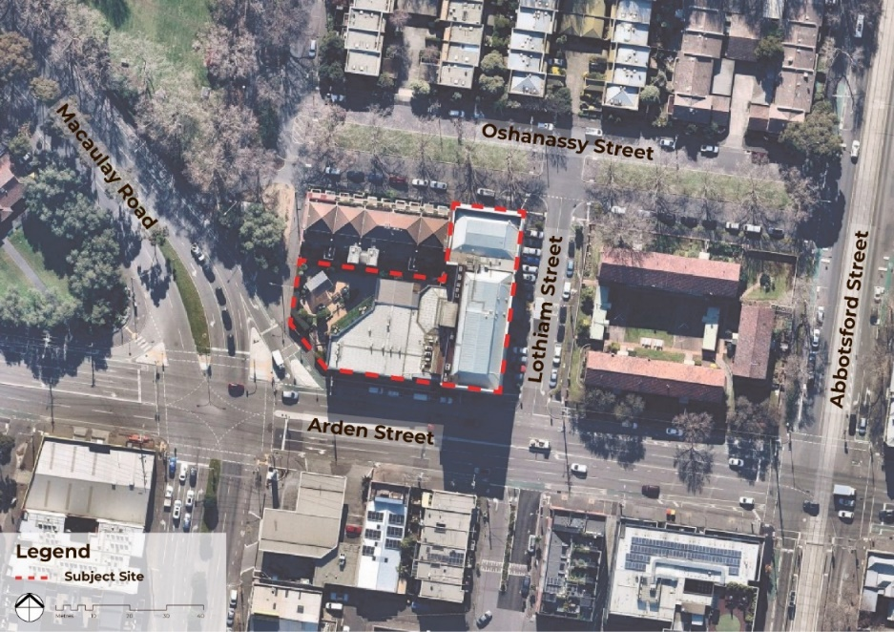
Figure 1 Context Map
Source/Notes: Ethos Urban & NearMap

Surrounding Area
The subject site is located approximately 1.6km north of Melbourne’s Central Business District (CBD) in the suburb of North Melbourne. The site is located within the City of Melbourne local government area (LGA). The North Melbourne Railway Station is located approximately 835m south of the site.

The surrounding area comprises a diversity of land uses including residential, commercial, industrial, community and recreation uses. The subject site is located between the mixed-use area to the south of Arden Street and the residential area to the north of Arden Street. The site is located within the General Residential Zone – Schedule 1, which applies to the residential area bound by Arden Street to the south, Dryburgh Street to the west, Haines Street to the north and Curzon Street to the east.

The context of the subject site is characterised by:
  - The existing height of the existing ‘Mills Building’ of 20.98m.
  - The existing height of the ‘DHHS Building’ to the north of 14.78m.
  - The wide road reserves of Arden Street and Macaulay Road of 30m and 43m respectively.
  - The less sensitive interfaces to Arden Street and Macaulay Road created by these high traffic volume streets.
  - The interface to the Arden Precinct to southwest where building heights will be 6 - 18 storeys.

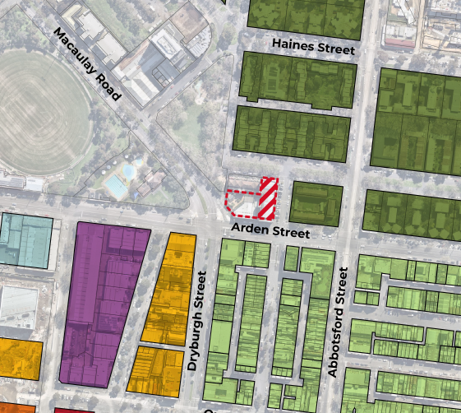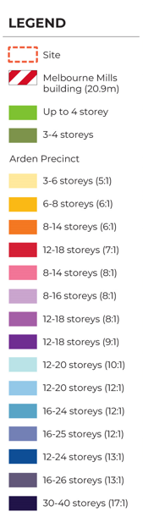
Figure 2 Building Height Context
Source: Ethos Urban – Excerpt from Appendix C

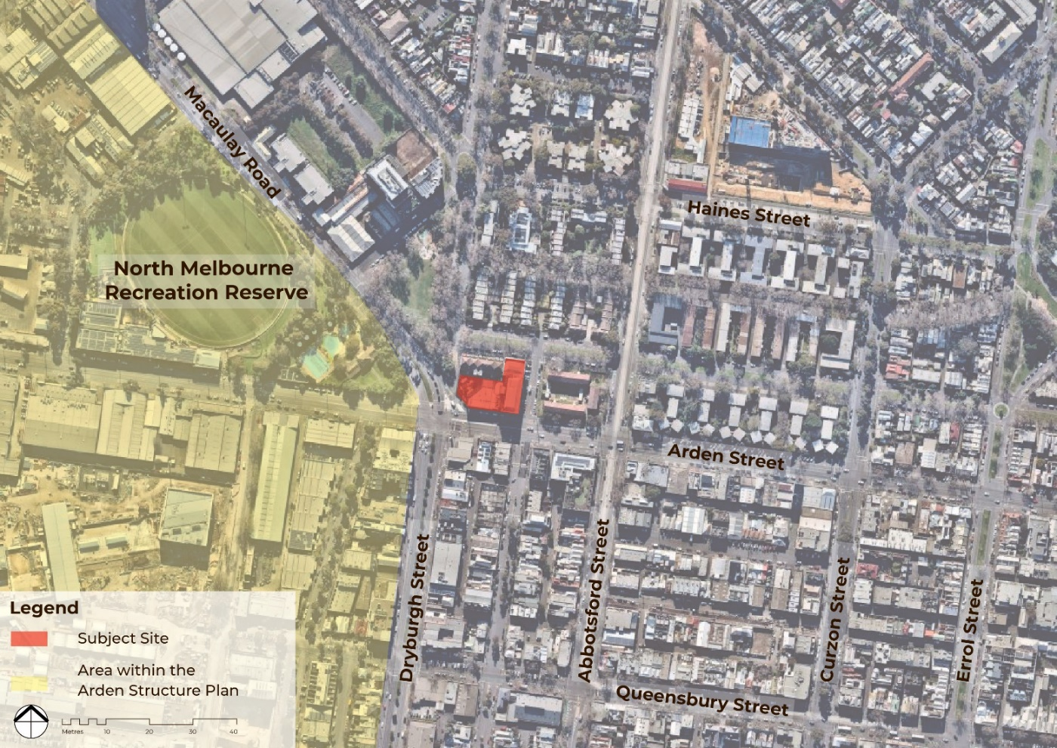
Figure 3 Locational Context Map
Source: Ethos Urban & NearMap
West
The North Melbourne Recreation Reserve and the Gardiner Reserve are both located west of the subject site, immediately west of Macaulay Road and Dryburgh Street respectively. Both reserves are within the Public Park and Recreation Zone. The precinct boundary of the Arden Structure Plan is also located immediately west of the subject site, as shown in Figure 3.

Macaulay Road is a boulevard type road of approximately 30m width. The road consists of two vehicle lanes and an unprotected bicycle lane on each side. Vegetation on Macaulay Road consists of medium to large trees along the road reserve and edge planting on the south-western edge of Gardiner Reserve.

Arden Street is approximately 22m wide and incorporates four traffic lanes (two in each direction), a right-turn lane, on-street parking, and unprotected bike lanes on both sides. Arden Street contains minimal landscaping on the south side. Most vegetation is within or adjacent to the North Melbourne Recreation Reserve, featuring medium to large leafy trees and edge planting. A small number of kerbside small to medium trees are sparsely planted on other parts of Arden Street.

Development south of Arden Street consists of up to three-storey commercial and retail development, typically built to all site boundaries, featuring painted concrete or cement sheet external walls with a varied colour palette that includes bright yellow, black, green, and different tones of grey. All development along Arden Street is viewed as featuring flat roofs from the street.

The new Arden Train Station will be located approximately 380m south-west of the subject site. Buildings of significant heights are expected along Arden Street, in line with the aspirations of the Arden Structure Plan.

South
Arden Street is located immediately to the south of the site. This portion of Arden Street has four traffic lanes (two in each direction) and one lane for turning right, as well as on-street parking on the north side and unprotected bike lanes on both sides. Landscaping consists of scattered small trees along both footpaths.

Land south of the subject site is affected by a heritage overlay.

A service station, a single-storey commercial building and a two-storey townhouse style development are located opposite the subject site on the southern side of Arden Street. The commercial property features exposed dark grey and ruby brickwork.

The residential properties have an earthy colour painted concrete. All dwellings front Lothian Street: only one of the properties has an interface to Arden Street, which features a two-storey high external wall with two small windows on the top floor. Accordingly, the subject site’s southern interface is not considered sensitive.

A large part of the area located to the south of Arden Street is covered by DDO32. The area covered by DDO32 is a historic residential area, with an established character of 2 to 3-storey heights. In contrast to the subject site, this residential area is characterised by:

  - A fine grain subdivision pattern
  - A generally consistent building height
  - A street layout characterised by the 19.m wide Lothian Street
  - A network or narrower 10m and 3.7m wide laneways

East
The adjacent eastern portion of the subject site is occupied by the heritage-significant Melbourne Mills building. There are no vehicle crossovers on the eastern interface of the subject site.

Lothian Street is located immediately east of the site. The road reserve is 20 metres wide. It includes car parking on the western and eastern sides of the street.

There are two, three-storey residential buildings located on the east side of Lothian Street. These buildings have frontages to Arden Street and O’Shanassy Street, where the main access points are.

The western side boundary features a 1.2m high wooden fence which has two secondary pedestrian entry points. A single-storey service building is also adjacent to the western site boundary. All development on this site features exposed brickwork and pitched roofs.

North
The site is partially bounded by the property at 139-153 O’Shanassy Street north-west of the site and O’Shanassy Street to the north-east.

Development at 139-153 O’Shanassy Street consists of a four-storey multi-dwelling residential development slightly set back from the front boundary along O’Shanassy Street and built to both side boundaries. The built form consists of a mix of exposed brickwork and cream painted concrete. The front boundary features a 1.2m high painted wooden fence and some landscaping.

The primary outlook and SPOS of these dwellings are to the north. Building services and accessways are located along the building’s southern façade. This site is occupied by the Melbourne Mills building and will not be subject to future external redevelopment. The site is held by DHHS. This represents the subject site’s only sensitive interface.

The O’Shanassy Street Road reserve is a 22m wide boulevard type street. There is a single traffic lane on each direction and on-street parking, as well as a 7.5m wide landscaped strip running through along the central median.

O’Shanassy Street has a strong landscape character associated with the proximity to Gardiner Reserve. Mature canopy trees are positioned along the boulevard’s median. The residential properties on the northern interface feature exposed earth colour brickwork and landscaped front setbacks. These properties consist of two-storey medium-density units laid out in a U shape and accessed via courts off O’Shanassy Street.

Strategic Context
Plan Melbourne
Plan Melbourne is the metropolitan planning strategy that defines the future shape of Melbourne over the next 35 years. The plan sets out a hierarchy of Principles, Outcomes, Directions and Policies to ensure Melbourne grows more sustainable, productive, and liveable as its population approaches 8 million.

Plan Melbourne 2017-2050 outlines the long-term plan to manage growth in the city and suburbs to the year 2050. It seeks to integrate long-term land use, infrastructure and transport planning, and in doing so meet the city’s future environmental, population, housing and employment needs. Plan Melbourne provides a major focus on enhancing and unlocking the development potential of the metropolitan area and highlights transport integration throughout the city, accommodation of at least one million jobs and nearly one million people in the central subregion, stimulation of the economy through job creation and facilitation of employment land as key strategic directions of the plan.

Plan Melbourne identifies Arden as one of the major urban renewal precincts, which are considered places that can accommodate a significant amount of residential and jobs growth over the next 35 years. Their availability is considered to give Melbourne greater flexibility, particularly around timing and land use, with different areas having the potential to cater for different uses. The plan identifies that such precincts will:
“Take advantage of underutilised land close to jobs, services and public transport infrastructure, to provide new housing, jobs and services. Major urban renewal precincts will play an important role in accommodating future housing and employment growth and making better use of existing infrastructure.”
Arden Structure Plan
The Arden Structure Plan was formally adopted in July 2022 and sets out the aspirations for the Precinct’s renewal while making considerations and recommendations for future development.

While the site is not part of the Arden Structure Plan, it lies immediately adjacent to its defined boundary. The Structure Plan sets out the long-term vision for the Arden Precinct and recognises that there is a significant need to capitalise on the existing and emerging infrastructure delivery in the immediate area, including the new Arden Train Station.

The Arden Structure Plan sets out the strategic context for much of the area that surrounds the site and identifies Arden as an area that can substantially benefit from increased densities, particularly in Arden Central where it is proposed that new buildings will generally be low to mid-rise in scale.

The Arden Structure Plan identifies the wider area to be suitable for a range of uses, densities and development typologies.

Existing Planning Controls

Municipal Planning Strategy (MPS)
The MPS is a succinct expression of the overarching strategic policy directions of a municipality. Explaining the planning scheme’s policy foundation, based on the municipality’s location and regional context, history, assets, strengths, key attributes, and influences, and is set out within Clause 02 of the Planning Scheme.

The MPS supports but does not form part of the PPF. Given the nature of the proposed PSA, the MPS is considered to have limited relevance.

Planning Policy Framework (PPF)
Key clauses of the PPF considered applicable to this proposal include:

Clause 11 – Settlement

Clause 11 (Settlement) advocates for planning to anticipate and respond to the needs of existing and future communities through the provision of zoned and serviced land for housing, employment, recreation and open space, commercial and community facilities and infrastructure, recognise the need for a contribute towards health, wellbeing and safety, diversity of choice, adaptation in response to changing technology, economic viability, a high standard of urban design and amenity, energy efficiency, prevention of pollution to land, water and air, protection of environmentally sensitive areas and natural resources, accessibility and land use and transport integration.

Clause 11 also advocates for planning to prevent environmental problems created by siting incompatible land uses close together and facilitate sustainable development that takes full advantage of existing settlement patterns, and investment in transport and communication, water and sewerage and social facilities.

Clause 11.01-1S (Settlement) seeks to “promote the sustainable growth and development of Victoria and deliver choice and opportunity for all Victorians through a network of settlements.” The policy goes on to identify several points relevant to the proposal, including that development should “promote and capitalise on opportunities for urban renewal and infill development”.

Clause 11.02-1S (Supply of urban land) seeks to “ensure a sufficient supply of land is available for residential, commercial, retail, industrial, recreational, institutional and other community uses.”

Clause 11.03-1R (Activity centres – Metropolitan Melbourne) seeks to support the development and growth of activity centres.

Clause 15 – Built Environment and Heritage

Clause 15 addresses the design of the built environment and includes the principle objectives of ensuring land use and development responds to its landscape, character, valued built form and cultural context, and delivering functional, accessible, safe and diverse physical and social environments through the appropriate location of use and development and through high-quality buildings and urban design.

Clause 15.01-11 (Urban design) seeks to “create urban environments that are safe, healthy, functional and enjoyable and that contribute to a sense of place and cultural identity.”

A number of sub-clauses of Clause 15 are also considered relevant, which address urban design, building and subdivision design, neighbourhood character and sustainable development.

Clause 15.01-2S (Building design) seeks to “achieve building design outcomes that contribute positively to the local context and enhance the public realm.”

Clause 15.03-1L-02 (Heritage) applies to places located within the Heritage Overlay, and to properties that are considered ‘significant’, ‘contributory’, and ‘non-contributory’. The policy encourages the retention and enhancement of heritage assets and places with heritage qualities.

Clause 17 – Economic Development

Clause 17 addresses the importance of planning in providing for a diversity of land uses and industries which can facilitate the economic development of an area.

Clause 17.01-1S (Diversified economy) seeks to “strengthen and diversify the economy.”

Strategies relevant to the subject site to achieve this objective include:
  - Facilitate growth in a range of employment sectors, including health, education, retail, tourism, knowledge industries and professional and technical services based on the emerging and existing strengths of each region.
  - Improve access to jobs closer to where people live.
Clause 17.02-1S (Business) seeks to “encourage development that meets the community’s needs for retail, entertainment, office and other commercial services.”

Clause 18 – Transport

Clause 18 addresses the integration of sustainable transport systems to provide access to social and economic opportunities and to ensure it provides reliable movements of people and goods.

Clause 18.02-2S (Public transport) seeks to “facilitate greater use of public transport and promote increased development close to high quality public transport routes.”

Clause 18.02-4S (Car parking) seeks to “ensure an adequate supply of car parking that is appropriately designed and located.”

Zones, Overlays and Particular Provisions

Existing Zone (General Residential Zone – Schedule 1)
The subject site is located within the General Residential Zone – Schedule 1 (GRZ1), as shown in Figure 4.

The Purpose of the GRZ1 is:
  - To implement the Municipal Planning Strategy and the Planning Policy Framework.
  - To encourage development that respects the neighbourhood character of the area.
  - To encourage a diversity of housing types and housing growth particularly in locations offering good access to services and transport.
  - To allow educational, recreational, religious, community and a limited range of other non-residential uses to serve local community needs in appropriate locations.

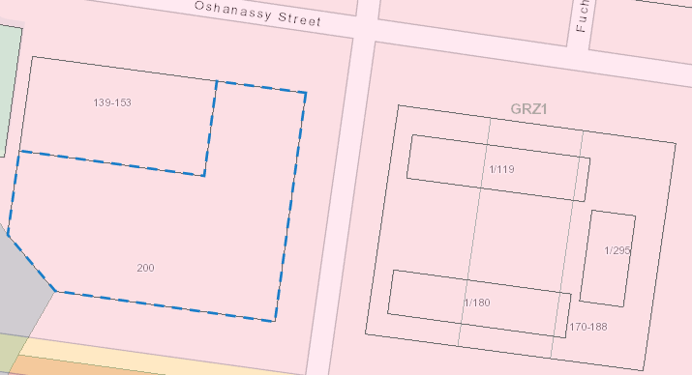
Figure 4 Zone Map
Source: Ethos Urban & VicPlan

Clause 32.08-2 includes the Table of uses which identifies uses as Section 1 (permit not required), Section 2 (permit required) and Section 3 (prohibited).

Section 1 Uses (Permit not required)
  - Bed and breakfast (accommodation for no more than 10 people)
  - Dependent person’s unit (must be the only dependent person’s unit)
  - Community care accommodation
  - Dwelling
  - Home based business
  - Informal outdoor recreation
  - Medical Centre (The gross floor area of all buildings must not exceed 250m2)
  - Place of worship (The gross floor area of all buildings must not exceed 250m2)
  - Racing dog husbandry
  - Residential aged care facility
  - Rooming house
  - Tramway

Section 2 uses (Permit required)
  - Accommodation
  - Agriculture
  - Car park
  - Car wash
  - Convenience restaurant
  - Convenience shop
  - Food and drink premises
  - Leisure and recreation (other than informal outdoor recreation and Motor racing track)
  - Market
  - Place of assembly
  - Service station
  - Store
  - Take away food premises

Section 3 uses (Prohibited)
  - Amusement parlour
  - Animal production
  - Animal training
  - Brothel
  - Cinema based entertainment facility
  - Domestic animal boarding
  - Extractive industry
  - Horse husbandry
  - Industry (other than Car wash)
  - Motor racing track
  - Nightclub
  - Office (other than Medical centre)
  - Retail premises (other than Convenience shop, Food and drink premises, Market, and Plant nursery)
  - Saleyard
  - Transport terminal
  - Warehouse (other than Store)

Proposed Zone (Mixed Use Zone – Schedule 1)
Clause 33.04 sets out the Table of Uses for the MUZ, which identifies uses as Section 1 (permit not required), Section 2 (permit required) and Section 3 (prohibited).

Section 1 uses (Permit not required)
  - Informal outdoor recreation
  - Medical centre - The gross floor area must not exceed 250 square metres
  - Museum
  - Office (other than Medical centre) - The leasable floor area must not exceed 250 square metres.
  - Place of worship - The gross floor area of all buildings must not exceed 250 square metres.
  - Racing dog husbandry - Must be no more than 2 animals.
  - Railway
  - Residential aged care facility
  - Rooming house - Must meet the requirements of Clause 52.23-2.
  - Shop (other than Adult sex product shop) - The leasable floor area must not exceed 150 square metres.
  - Tramway
  - Any use listed in Clause 62.01 - Must meet the requirements of Clause 62.01.

Section 2 uses (Permit required)
  - Accommodation (other than Community care accommodation, Dependent person's unit, Dwelling, Residential aged care facility and Rooming house)
  - Agriculture (other than Animal production, Apiculture, Domestic animal husbandry and Racing dog husbandry)
  - Domestic animal boarding
  - Domestic animal husbandry (other than Domestic animal boarding) – if the Section 1 condition is not met
  - Grazing animal production
  - Industry (other than Materials recycling and Transfer station)
  - Leisure and recreation (other than Informal outdoor recreation)
  - Place of assembly (other than Art gallery, Carnival, Circus, Museum and Place of worship)
  - Retail premises (other than Food and drink premises and Shop)
  - Utility installation (other than Minor utility installation and Telecommunications facility)
  - Warehouse

Section 3 uses (Prohibited)
  - Adult sex product shop
  - Animal production (other than Grazing animal production)
  - Brothel
  - Extractive industry
  - Materials recycling
  - Transfer station (other than Automated collection point)

As per Clause 32.04-4 a permit is required to subdivide land.

Clause 32.04-11-10 sets out that the maximum building height requirement should follow the requirements set out in the schedule to the clause. The schedule does not set out a maximum building height.
Overlays

Heritage Overlay
The subject site is impacted by the Heritage Overlay (HO). The Purpose of the HO is to
  - To implement the Municipal Planning Strategy and the Planning Policy Framework.
  - To conserve and enhance heritage places of natural or cultural significance.
  - To conserve and enhance those elements which contribute to the significance of heritage places.
  - To ensure that development does not adversely affect the significance of heritage places.
  - To conserve specified heritage places by allowing a use that would otherwise be prohibited if this will demonstrably assist with the conservation of the significance of the heritage place.
The subject site is located within the Heritage Overlay – Schedule 3 (HO3) which impacts the North and West Melbourne Precinct, as shown in Figure 5. The subject site is included in Heritage Precinct Statements of Significance February 2020, which was added as an incorporated document to the Melbourne Planning Scheme through Amendment C258.

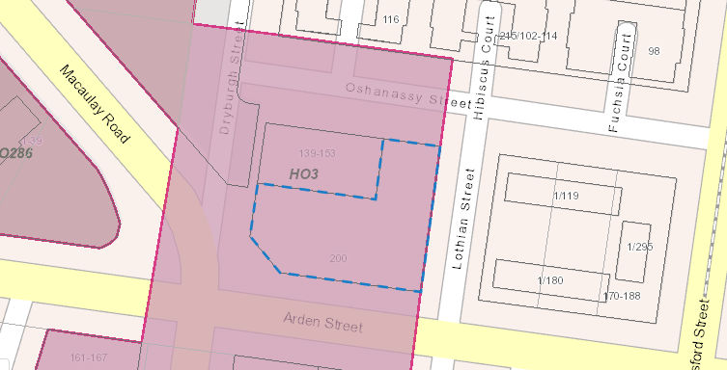
Figure 5 HO3 Map
Source: Ethos Urban & VicPlan
As per Clause 43.01-1, a permit is required to subdivide land, demolish, or remove a building, construct a building or carry out works within the HO.

Design and Development Overlay
The subject site is impacted by the Design and Development Overlay (DDO), as shown in Figure 6.

The Purpose of the DDO is:
  - To implement the Municipal Planning Strategy and the Planning Policy Framework.
  - To identify areas which are affected by specific requirements relating to the design and built form of new development.
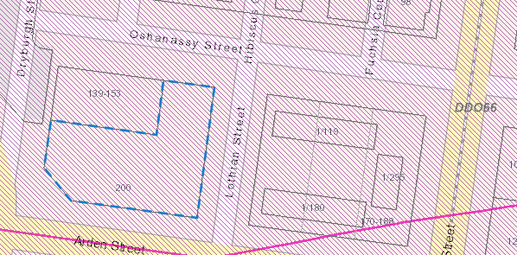
Figure 6 DDO66 Map
Source: Ethos Urban & VicPlan
The entirety of the subject site is covered by the Design and Development Overlay – Schedule 66 (DDO66) which relates to the hospital emergency services helicopter flight paths for the Alfred Hospital, Royal Children’s Hospital, and the Royal Melbourne Hospital.

The design objectives for the DDO66 are:
  - To ensure that the height of buildings and works do not encroach on the flight path areas associated with hospital helicopter landing sites.
  - To ensure that the height of development avoids creating a hazard to aircraft using hospital helicopter landing sites.
A permit is required to construct a building or carry out works which would result in height which exceeds the referral height detailed in Table 4 below.
Table 4 Helicopter Landing Sites
Helicopter Landing Site | Helipad Height (AHD) | Referral Height (AHD)
Alfred Hospital | 15.7m | 25.7m
Royal Melbourne Children’s Hospital | 62.4m | 72.4m
Royal Melbourne Hospital | 67.3m | 77.3m
Source: Melbourne Planning Scheme

The Proposal

Proposed Planning Scheme Amendment

The Electrical Trades Union (ETU) propose various amendments to the existing controls impacting the subject site at 200 Arden Street, North Melbourne. The ETU have owned and occupied the subject site for more than 10 years, using the site as its administrative head office in Victoria, and requires minor amendments to enable the continued use of the site by the ETU.

The ETU utilise the existing commercial building for the purposes of administrative offices, meeting rooms, and the delivery of training and support programmes to ETU members, their families, and the local community. The ETU also currently leases part of the property to separate entities, Protect and Holmesglen Institute, for use as commercial offices and training facilities, respectively, and there have previously been similar lease arrangements in relation to other parts of the property.

The ETU wants to maintain its existing use of the building, however, amendments to the existing controls would be required to ensure the continued use of the subject site by the ETU. The subject site is currently within the General Residential Zone (GRZ) which prohibits the existing Office use of the subject site. This restricts the potential future uses that can occur at the site resulting in an unreasonable burden on the developmental potential of the subject site.

The ETU will require additional floor space to respond to a demand for further training facilities at the subject site. Amending the zone to reflect the existing and historical use of the site would provide an improved level of certainty regarding the ongoing use of the site and enable the ETU to effectively plan for the future expansion of existing office and training facilities. Furthermore, the GRZ does not provide a height limit for non-residential buildings and therefore does not provide a clear guide for the preferred height of new buildings in this area of North Melbourne.

As discussed above, amendments are required to ensure the planning controls impacting the subject site reflect the existing uses and can be effectively used to guide the preferred character of this area of North Melbourne. Specifically, the amendments will:
  - Rezone the site from the General Residential Zone (GRZ) to the Mixed-Use Zone (MUZ)
  - Apply the Design and Development Overlay (DDO) to 200 Arden Street. Schedule 84 of the DDO will cover the entire site.
An assessment of the proposed amendment is provided in Section 5.

Planning Assessment

Rezoning the site from the General Residential Zone (GRZ) to the Mixed-Use Zone (MUZ)
The subject site is currently within the General Residential Zone (GRZ) – Schedule 1. The GRZ is also applied to the residential area north of Arden Street and south of Haines Street. The site’s existing use as Office is prohibited under the GRZ, however, continues to operate under Existing Use Rights in accordance with Clause 63.01. The current GRZ controls place significant limitations on the land uses that can occur at the site and contradict the existing use of the site.

The site has not been used for residential purposes at any time. The past and current uses conflict with the GRZ which is currently applied to the site. The GRZ appears to have been applied in a manner than simply incorporated the site into the residential area to the north and east. The application of the GRZ was inaccurate having regard to the site’s historic and ongoing commercial use.

The ETU wishes to remain at the site in the long term and continue to provide training and support services at the site. These services are provided to ETU members and their families in addition to local community outreach. Although permitted within the GRZ, the use of an Education centre or Place of assembly are limited by the Purpose of the GRZ and local policy to those that ‘serve the local community needs.’ The application of the GRZ unnecessarily limits the ongoing use of the site for the current purpose and places an inappropriate burden on the ETU in relation to any future planning permit applications for use and development.
Assessment of the Residential Zones and their suitability
The Council and DELWP have both recognised that the General Residential Zone (GRZ) is inappropriate for the site, and that it clearly does not align with the current, and future land use. As it is widely acknowledged that the GRZ is not appropriate, we have looked to other residential zones to identify which are considered appropriate.
The Residential Growth Zone (RGZ) is also not an appropriate zone for the site given that it is used for the purposes of identifying significant, future growth for residential land (with other uses being considered ancillary to such land use).
Assessment of the Commercial Zones and their suitability
As the building is occupied in its entirety for office floor space, an assessment of the commercial zones that could potentially be relevant to the site has been undertaken.

We do not consider Commercial Zone 1 or 2 would be appropriate zones when considered in the immediate and wider context because:
  - The suite of land uses considered acceptable in a Commercial Zone, when compared to the MUZ, are of more potential detriment to residential land uses. Commercial Zones 1 and 2 have lesser restrictions in relation to maximum floor space restrictions, and a wider range of potential use classes that could occupy the site, without the need for a permit.
  - Office (as defined in the nesting diagram) uses are allowed within Commercial Zone 1 and 2, without any restrictions or conditions relating to their occupation. This could allow land uses that could use the site far more intensely by a future owner/occupier (without the requirement for a permit) which could be of potential detriment.
  - Commercial Zone 2 considers the following land uses a Section 1 use, which do not require a permit subject to compliance with the conditions and could be of detriment to the adjoining residential land uses:
- Industry (other than Materials recycling and Transfer station)
- Office
- Supermarket
- Warehouse (other than Mail Centre)
  - A Commercial Zone would be entirely outside of the Residential Zoning suite of zones. This would be a more drastic change and would allow a land use that is considered to conflict with much of the surrounding residential context.
  - While ETU operate an office space, they are not a standard ‘commercial use’. The type of use is not akin to the typical land uses that are recognised within the Commercial Zone and would not be an accurate representation of the land use.
Assessment of the Special Use Zones and their suitability
A Special Use Zone (SUZ) should only be applied where the strategic intent of a site is not known, or the combinations of statutory planning controls (i.e., zones, overlays, and policies) are unable to ensure the desired outcomes. Special Use Zones should only be used where there is clearly no suitable alternative.

Given the relevancy of the MUZ and its suitability for the site and surrounding context, a SUZ is not considered an appropriate zone for the site.
Assessment of the Mixed Use Zones and their suitability
A Mixed Use Zone (MUZ) is the most appropriate zoning for the site as it is it provides a greater suite of land uses that are still considered suitable in a residential context.
The MUZ is the most appropriate zone given that it:
  - Aligns with much of the surrounding context, noting that the adjacent site is largely within the MUZ.
  - Is a transitionary Zone that allows for alternative uses which do not fall within the GRZ, but are considered compatible with residential land uses, and the GRZ more generally.
  - Only allows up to 250sqm of office-floorspace without a permit. Anything above 250sqm would trigger the requirement for a permit. This safeguards residential amenities and ensures that the building cannot be occupied by a more intensive occupier until an appropriate assessment has been made.
  - Ensures flexibility for the site, while also ensuring that the flexibilities are appropriate and will lead to a sound planning outcome, in that all the potential land uses are considered compatible with the GRZ and the MUZ which surround the site.
  - Is a more accurate reflection of the ETU’s land use, given that much of their operations are community outreach, engagement, and support.
  - We note that there are several uses (e.g., industry, retail, and place of assembly) which are Category 2 uses within the MUZ, and so will require a permit should such uses be proposed. Council will be able to ensure that the potential uses are assessed, to understand their potential impact on residential amenity if there are concerns.
  - While the MUZ has a greater suite of land uses identified within Category 2 when compared with the GRZ, this is acceptable as Category 2 uses require a permit. Council would be able to ensure that any potential conflict with existing residential uses could be appropriately assessed. This suitably manages the planning risk associated with potential amenity impacts from future uses.

Given that existing land use rights apply, the MUZ is the most appropriate zone as this will give the Council certainty that the future use of the site can remain in a use that is consistent with the wider area, particularly if land ownership changes in the future. While the MUZ does not specify building height controls or any site-specific measures of relevance to our proposal, these are to be controlled via the DDO that has been prepared and submitted in support of the amendment.

Application of the Design and Development Overlay (DDO)
As recommended by DELWP in earlier discussions, a separate DDO has now been prepared relating to the site, ensuring that design matters can be controlled in relation to any future redevelopment of the site. There is currently no maximum budling height for commercial buildings at the subject site.

While a DDO currently applies to the adjacent land, the site context and design considerations that relate to the existing DDO are not considered relevant to 200 Arden Street, so the DDO shouldn’t be extended to include the site. As such, a site-specific DDO is proposed as part of this submission.

The DDO provides Council and the community with confidence that particular built-form outcomes will be achieved, and the development will give consideration to the surrounding context, and any sensitivities that may affect the site.

Specific consideration needs to be given to the northern and eastern interface of the site by the DDO to ensure that any future development will not impact the adjacent residential dwellings. The heritage significance, sensitivities of the surrounding interfaces, and the relationship with the streetscape mean that any future development will need to be focused to the west of the site. This part of the site is considered to have low-sensitivity interfaces to the south and west, given its positioning/outlook on both Macaulay Road and Arden Street.

Subject to an appropriately designed scheme, the proposed design and development controls would ensure that the built-form outcomes are appropriate and add to the qualities of the Melbourne Mills Building. Likewise, it would ensure that there would be no detrimental impact on the adjacent premises and sensitive interfaces. Refer to Section 6 of this report for a detailed Urban Design Assessment.
Preferred Maximum Building Height
In a similar vein to DDO32 which applies to the south of Arden Street, the proposed DDO will set a clear expectation for the maximum building height at the site. This will outline a maximum building height of 20m to ensure that any future development is compatible with the adjoining Melbourne Mills building, as well as the wider context and streetscape.

In early discussions with Council, it was suggested that the height limitations that are applied to the DDO32 area should be extended to our site. DELWP provided commentary, which suggested that extending DDO32 was not acceptable, as the context for both areas is substantially different.

In contrast to the subject site, the area covered in DDO32 is a historic residential area, with an established character of 2 to 3-storey heights. Due to the historic residential context, this area includes a fine grain built-form pattern, with smaller lot sizes and a narrower lot layout, as well as laneways that service the dwellings. The maximum building height in DDO32 is 14m.

The land at 200 Arden Street forms part of a different historic subdivision pattern, where lot sizes do not follow a fine grain pattern as seen in the site area located within DDO32. The area in which 200 Arden Street is located is characterised by large lots and substantial building footprints including that of the historic industrial building at the site.

There are clear and substantial built form and character differences between the subject site and the area located to the south of Arden Street within DDO32. Accordingly, the application of a 14m height limit is not suitable at the subject site. The application of a 20m height limit is a more suitable limitation on height when the existing and emerging built-form character of the site and its interfaces are considered.
Interfaces and Setbacks
The subject site has a residential interface to the north, comprised of a four-storey residential building held by the DFFH at 139-153 O’Shanassy Street. To ensure any future development does not unreasonably impact the amenity of the residential building to the north, any future redevelopment of the site must maintain the existing 9m setback from the boundary of the adjacent residential building.

To maintain this setback, and to ensure any potential development at the site has no impact on overshadowing the secluded private open space (SPOS) of the dwellings at 139-153 O’Shanassy Street, any future redevelopment should not exceed 20m in overall height. This will also ensure that the overall residential amenity to the northern interface of the subject site is unaffected.

The existing planning controls do not identify a preferred maximum building height for a non-residential building at the subject site. The application of the Mixed-Use Zone will be accompanied by the application of a DDO to guide the built form of development that can occur at the subject site.

The maximum building envelope under DDO84 would prevent new development from obscuring the Melbourne Mills building’s street-facing north, east, or south façades. It allows new development to partially conceal its west façade, which is located in an internal-facing, secondary part of the subject site.

The west façade has undergone significant alterations over the years, where some original openings are obscured or infilled. Clause 15.03-1L-02 states that new buildings should not obscure views from the street of the front or principal part of adjoining significant or contributory places or buildings. The addition of new mass to this elevation, therefore, would not visually disrupt the appreciation for the Melbourne Mills building’s principal south and east facades from Arden and Lothian streets.

The addition of an adjoining mass that conceals part of the west façade is acceptable, as it would not detract from the significance and character of the Melbourne Mills building. Likewise, the 20m height limitation for the proposed new mass responds to the 20.98m height of the adjoining Melbourne Mills building and does not dominate its prominence. This building height will not detract from the heritage significance of the existing Melbourne Mills building as is set out in detail in the supporting letter prepared by Trethowan Architecture (see Appendix D).
Built Form Outcomes
As set out in the DDO Built Form Outcomes requirement, any new development will be required to respect the scale and siting of the existing Melbourne Mills heritage building. Guidelines are also set out in the DDO in respect of the maximum building height, as well as the preferred building setback to the northern site boundary to 139-153 O’Shanessy Street at 9m. This ensures that residential amenity for the DHHS site to the north is unaffected by the development.

Future development proposals are also required to be consistent with the existing character of buildings along Arden Street and provide a suitable response to the intersection to the south-west. The inclusion of this within the DDO Built Form Outcomes ensures that development will have to appropriately respond to the surrounding character, and the Heritage Overlay.

Figure 6 demonstrates an indicative building envelope based on the height limitations and setback requirements of the draft DDO. While this is only indicative at this stage, the massing and overall scale are an appropriate response to the site and its context. A future building design will be required to respond to the heritage character of the Mills building and will naturally include articulation and fenestration that will reduce the perceived building scale and mass.

Subject to an appropriately designed scheme, the proposed design and development controls would ensure that the built-form outcomes are appropriate and add to the qualities of the Melbourne Mills Building. Likewise, it would ensure that there would be no detrimental impact on the adjacent premises and sensitive interfaces.

Building Height Testing
Alongside the illustrative maximum building envelope illustrated above, an assessment of the existing and emerging building height patterns in the context of the site has also been completed (see Figure 2 below). This includes the future building heights set out by the Arden Structure Plan, which outlines that the area will undergo significant change.

The pattern of maximum building heights in proximity to the site is characterised by predominantly 3-4 storeys. The allowable height of buildings within the Arden Precinct will see a significant intensification of tall buildings in the immediate area. To the south-west of the site, heights are expected to vary between 6 to 18 storeys.
  - Melbourne Mills Building at 20.98m
  - Land to the south-west within the Arden Precinct, where building heights will be 6-18 storeys.
  - The existing maximum height of the ‘DHHS Building’ to the north of 14.78m
  - The existing height limits to the north and south of up to 4 storeys.
The indicative building height outcomes in Figure 7, are an appropriate response and would ensure an appropriate built form outcome at the subject site.

Figure 2 Building Height Context

Response to the PPF
The PPF provides a high-level strategic framework for land use and development. The policies outlined above enable planning at a municipal level and guide the formulation of local policies to implement good planning outcomes.

The planning scheme amendment proposes to rezone land to form part of the MUZ will ensure that the zone will reflect the correct land use and will also ensure that, the site remains in an appropriate zone when considered in the wider context.

Response to Heritage Overlay 3
In response to the Heritage Overlay that applies to the site, a Letter of Support has been prepared by Trethowan Architecture. The letter can be found in Appendix D of the report.

The letter concludes that:
  - The proposed PSA and DDO84 request at the subject site are generally supportable from a heritage perspective.
  - The proposed DDO constraints are limited to the later west portion of the subject site, while the historic Melbourne Mills building remains unaffected. Although future development allowed under DDO84 could potentially block views of its west façade, this is an acceptable heritage outcome because the façade has undergone extensive alterations and does not contribute to the heritage significance of the building.
  - The proposed staggered height limit, with a maximum of 20m under DDO84 appropriately responds to the scale of the Melbourne Mills building and does not detract from its significance and character. Similarly, the 9.1m set-back at the north ensures that future development would not have adverse effects on the adjoining land uses.
  - While DDO84 enables additional height to the western portion of the subject site, it should only be considered as a general guideline for the maximum allowable building envelope at the subject site.
  - Other factors not outlined in the PSA request, i.e., design, form, materials, and openings, are also fundamental contributing factors that may affect how the heritage significance of the subject site is perceived. These aspects of any future development would need to comply with other Planning Scheme controls, including the HO, which provides confidence that new work would not detract from the heritage significance of the Melbourne Mills building.

Response to the Zone Provisions
As identified in the above, the existing use and ownership of the site is inconsistent with the purpose of the GRZ1. This Amendment seeks to undertake a site-specific zoning change to apply the MUZ, which will better reflect the existing use on the site and will also ensure that alternative uses are not precluded in the future.

We consider that the amendment will ensure the zones are appropriately applied as:
  - Most zones that are considered a ‘residential’ land use (including the RGZ and GRZ) are not considered compatible with the historic and ongoing use of the site.
  - In a sequential sense, the next most appropriate zone would be the MUZ. Most surrounding zones are either within the GRZ or MUZ, making this the most compatible with the site.
  - Commercial Zones have also been considered; however, these would be inappropriate for the site and the surrounding context as they could allow for more intensive land uses that could be detrimental to residential amenity without the need for a permit.
  - Both Commercial Zone 1 and 2 allow for a far greater suite of uses, some of which would be considered to conflict with the predominantly residential context in the immediate area.
The Amendment will ensure the zones are applied correctly and will ensure that an appropriate zone will apply to the site, providing an improved certainty of the potential development outcomes that can occur at the subject site.

Urban Design Assessment
This PSA seeks to rezone the site and incorporate a DDO into the planning scheme. As this is not a permit application, details of architectural expression and building design cannot be assessed. Such details will be assessed against the planning scheme, as well as the DDO Decision Guidelines at permit stage.

To complete this Urban Design Assessment, we have made assumptions on the potential outcomes at the site. The assessment uses the maximum footprint/scale that is supported via the DDO. Actual built form outcomes on the site could be of a lesser scale than what has been assessed.

Building Height

To easier understand potential built form outcomes, we have identified sub-areas within a Site Map. This is attached at Appendix E. The Site Map is referred to in the preferred Building Setbacks and Building heights in DDO84.

If the maximum heights allowed via the DDO were the building heights at the site would include:
Table 5 Preferred Building Heights
Interface Area | Preferred Maximum Street Wall Height | Preferred Maximum Building Height
A | n/a | 3.4 metres
B | 7 metres | 7 metres
C | 16.5 metres | 16.5 metres
D | 20 metres | 20 metres

Assessment
  - The pattern of building heights in proximity to the site is predominantly 3-4 storeys, however there are several buildings of significant scale in proximity. The adjoining Melbourne Mills Building is 20.98m in height. The ‘DHHS Building’ to the north is 14.8m in height.
  - There will be a significant intensification of taller buildings in the immediate area, as supported by the Arden Precinct Structure Plan. To the south-west of the site, heights are expected to range between 6 to 18 storeys.
  - The maximum building height of 3.4 metres in Interface Area A is an acceptable outcome. This reflects the existing street wall height. A single storey-built form outcome at this part of the site will have limited visibility from sensitive receptors and is compatible with the preferred maximum heights in the adjoining interface areas.
  - The proposal comprises a new development with varying heights, responding to the topography, and falling slopes along Arden Street. The stepped building form will reach a maximum of 20m along Arden Street. The lowest point is at Macaulay Road, at 7m.
  - The building steps down from the interface with the existing Mills Building to the western boundary, this enables a decrease in building height that responds to the slope of the land, the height of built form in the west and the north and provides an appropriate interface to the western boundary of Macaulay Street.
  - The maximum height of 20m is less than the existing height of the Melbourne Mills building. Ensuring future built form is less than existing built form reduces any would not visually disrupt the appreciation for the southern and eastern facades of the Melbourne Mills building. The addition of an adjoining mass that conceals part of the west façade does not detract from the significance and character of the Melbourne Mills building.
  - The existing and emerging built form context of the site supports an increase in building heights where it is demonstrated they will respond to the existing building heights, the slope of the land, protect sensitive interfaces and protect the public realm. The site and controls deliver this and are an appropriate response to the existing and emerging built form context.
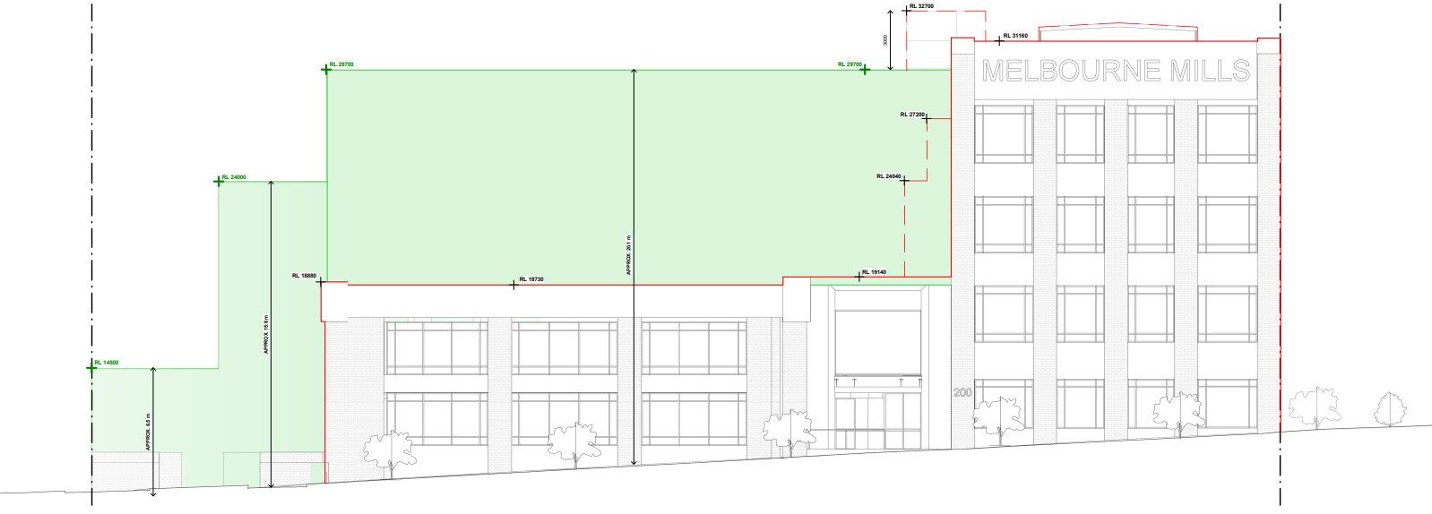
Proposed Envelope – Arden Street Elevation
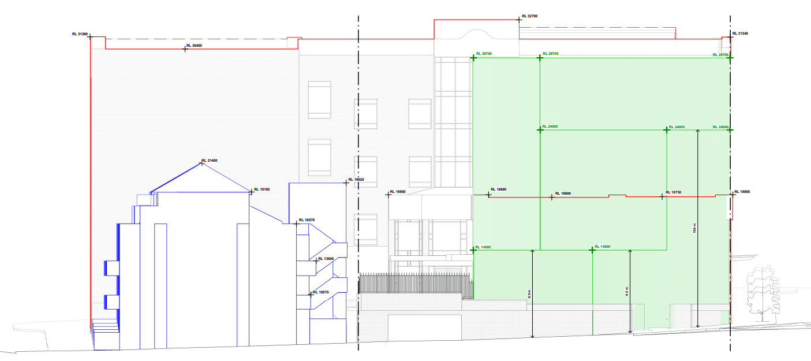
Proposed Envelope – Dryburgh Street & Macaulay Road Elevation
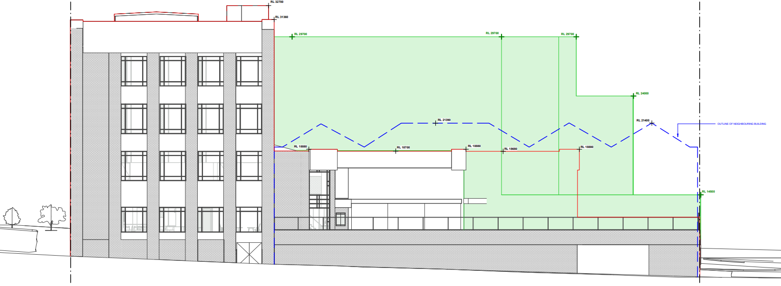
Proposed Envelope – Dryburgh Street & Macaulay Road Elevation
Figure 7 Illustrative Building Height Outcomes
Source: Airstream Architects

Built Form

The Site Map in Appendix E identifies the interface areas and includes dimensions for setbacks from the western and northern boundaries. This is summarised in Table 6 below.
Table 6 Preferred Building Setbacks and Building Heights
Interface Area | Preferred Setback from Western Boundary | Preferred Setback from Northern Boundary | Preferred Maximum Street Wall Height | Preferred Maximum Building Height
A | 0 metres | 0 metres | n/a | 3.4 metres
B | 0 metres | 9 metres | 7 metres | 7 metres
C | 6.5 metres | 9 metres | 16.5 metres | 16.5 metres
D | 12 metres | 9 metres | 20 metres | 20 metres

Built Form Outcome
Future-built form that adopts the heights and setbacks set out in the DDO; it would include:
  - A single storey built form outcome to the north of the site, with a maximum height of 3.4m.
  - Staggered building height ranging from 7m along the western boundary, increasing up to 20m to the eastern boundary adjacent to the Melbourne Mills building.
  - Development of part of a 7m tall portion of building, with no setback to the western boundary.
  - Development of part of a 16.5m tall portion of building setback 6.5m from the western boundary.
  - Development of part of a building with a 20m height setback 12m from the western boundary, immediately adjoining the Melbourne Mills building.
  - Retaining the 9m setback from the rear boundary of the site.

Assessment
  - A single storey-built form outcome to the rear of the site is an acceptable outcome. A maximum building height of 3.4m will have limited visibility from sensitive receptors, given the existing street wall height and the topography of the site. This will have no impact on streetscape given its location within the site.
  - The retention of the 9m setback to the northern boundary ensures that built form outcomes will not impact the amenity of the residential building to the north.
  - Limiting building height to 7m adjacent to the western boundary reduces perceptions of building scale and assists in creating visual interest in the new built form.
  - No setbacks are proposed to the southern elevation. There is existing built form which adjoins the southern elevation of the Melbourne Mills building, and so it would be unreasonable to incorporate a setback in this location.
  - Ensuring future built form remains below the height of the existing built form, preventing any visual disruption to the primary southern and eastern facades of the Melbourne Mills building. The addition of an adjoining mass that conceals part of the west façade does not detract from the significance and character of the Melbourne Mills building.
  - The most important interface of the existing Melbourne Mills building is the southern interface along Arden Street. The development would have no impact on the southern interface given its positioning to the west.
  - The built form outcome is an appropriate response to the site and its context. Any future building design will need to respond to the slope requirements of the DDO and will naturally include articulation and fenestration that will reduce the perceived building scale and mass.

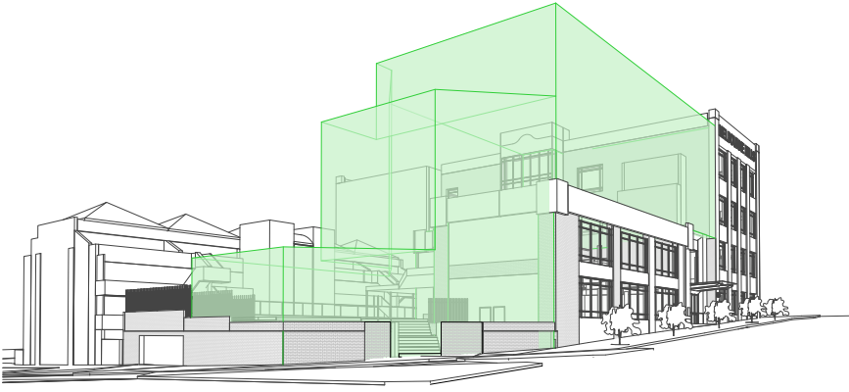
Figure 8 Illustrative Built Form Outcome - Arden Street & Macaulay Road
Source: Airstream Architects

Assessment of Stepped Building Form

The DDO prepared in relation to the site requires that the built form outcome be stepped, progressively reducing overall height from east to west. The built form outcomes required by the DDO are set out in Table 5.

The number of height transitions is limited to three, to reflect the rhythm of the streetscape along Arden Street and Macaulay Road. As earlier described, the building heights in the surrounding area are generally 3-4 stories, though there are regularly significant variations in building height. Likewise, the emerging built form context as recognised through the Arden PSP will enable a significant increase in building heights proximate to the site.

The resulting stepped built form will ensure that there is a gradual decrease in the building form, which will provide an appropriate transition to the western interface of the site, that occupies a more prominent corner position. The DDO requirements will produce future built form that reduces from the east, which is characterised by the 20m Melbourne Mills building, in a graduated manner to the west characterised by the dual street interfaces at the intersection of Arden Street and Macaulay Road.

The portion of the site with a 20m height limit is immediately adjoining the Melbourne Mills Building. The 20m component applied to a 31m portion of the frontage. This relates the extent of the existing commercial constructed to Arden Street and enables its retention/adaptation as part of any future development outcome. Future built form in in its location will not impact the western interface or views to the west as the positioning of the Melbourne Mills building, which is of a greater overall height, blocks view. The presentation to Arden Street is an acceptable outcome and will reflect the existing built-form character and interface associated with the Melbourne Mills building.

Further to the west, the DDO sets out a reduced maximum building height of 16.5m. The 16.5m building height applies to a width of 5.5m. This gradual reduction in height ensures that the built form continues to provide a pedestrian scale street interface while responding to the slope of the land, the character of building heights and widths to Arden Street and the greater sensitivity of views to the west.

At the site’s western boundary, the DDO requires a further reduction in maximum building height. The maximum height in this location is 7m as depicted in Figure 8 and will occupy a frontage width of 6.5m. This reduction will ensure an appropriate scale of built form and minimise visual prominence when viewed from the reserve to the west, and from greater distances from Macaulay Road.

These reductions in built form also ensure that there is an appropriate interface with the DHHS buildings to the northern boundary of the site. Ensuring that any future building avoids unreasonable visual bulk and allows for longer range outlook to the south and south west.

The widths of the three distinct graduations in maximum building height within the DDO reflect the pattern of variation in building width and height along Arden Street while also ensuring that the future building footprints are sufficient to provide functional internal areas.

This assessment of the stepped nature of the built form has been completed as the basis of the maximum provisions made through the DDO and is an acceptable response in respect of the site’s context.

Overshadowing

Built Form Outcome
Future built-form outcomes directed by the DDO will avoid unreasonable shadow impacts. Figure 9 sets out the expected shadow that results from the maximum built form envelope. This demonstrates that shadows will:
  - Extend over land to the south-west during morning hours. Shadow over Macaulay Road and Arden Street but does not extend to the Public Open Space further to the south-west. It does not extend to the southern footpath along Arden Street.
  - Be partially cast over Arden Street during mid-day, the northern footpath remains affected, but the southern footpath remains unaffected.
  - Not affect the buildings to DHHS buildings to the north. This is the most sensitive receptor in proximity to the site.

Assessment
  - The building height as described by DDO84 will not result in any overshadowing impacts to sensitive receptors, this includes the DHSS building to the north.
  - Shadow will only be cast over the footpaths and roads serving Macaulay Road, Lothian Street, and the northern footpath of Arden Street. The shadow cast to Macaulay Street and Lothian Street is an existing condition that is cast by the Melbourne Mills building.
  - There will be no impact on any Public Open Space north-west along Macaulay Road. The shadows cast by the building will not affect the southern footpath to Arden Street, ensuring the amenity of the public realm is protected.
  - While it has been demonstrated that the proposal will have no significant overshadowing impacts, the Responsible Authority has the discretion to request a technical, hour-by-hour Shadow Impact Assessment at permit stage.
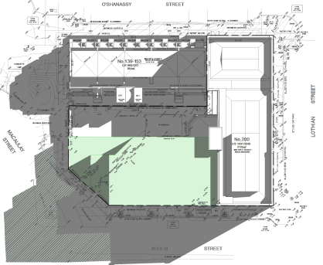 | 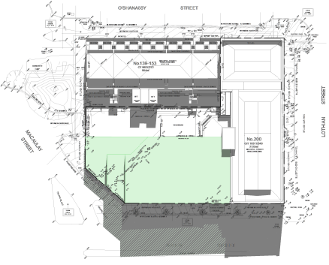
Shadow Diagram of Illustrative Massing: 9:00am | Shadow Diagram of Illustrative Massing: 12:00pm
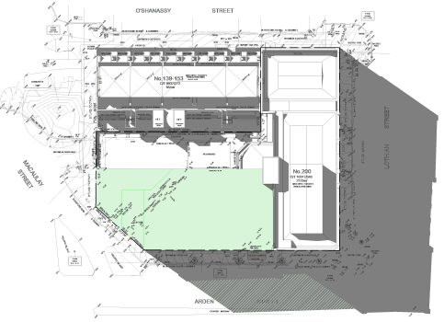

Shadow Diagram of Illustrative Massing: 3:00pm
Figure 9 Overshadowing Study

Further Considerations

Architectural Expression
  - At this stage, assumptions on the architectural expression of future proposals at the site cannot be made. Notwithstanding, the DDO provides appropriate controls to ensure that future proposals demonstrate that they appropriately respond to the site and surrounding context.
  - The DDO requires that an Urban Design Assessment is undertaken at permit stage for any future proposals, which will demonstrate how each of the Design Objectives and Built Form Outcomes of the DDO Schedule are achieved.

Strategic Planning Considerations

Why is an Amendment Required?
The amendment proposes to change the zoning controls identified in the City of Melbourne Planning Scheme. The current zoning for the site, the General Residential Zone – Schedule 1 (GRZ1), does not reflect the long-established and current use of the site for offices that are owned and occupied by the ETU.

The ETU intend to continue using the site as its administrative offices and training facilities, however, will require an increased building floor area to accommodate the increased need for training facilities at the subject site. The proposed amendments would amend the planning controls at the subject site to better reflect the existing uses and character of this area of North Melbourne.

This amendment is required to facilitate the continued use of the site by the ETU and support its capacity to provide various services and facilities that achieve a net-community benefit for the wider area.

This will also ensure zone controls reflect the existing use and provide the landowner with an improved certainty of the potential development outcomes that can occur at the subject site.

Does the Amendment Implement the Objectives of Planning and Address Any Environmental, Social and Economic Effects?
The proposed amendment ensures that zone controls are correctly applied to land so that it can be used and developed in accordance with the City of Melbourne Planning Scheme. The proposed amendment is administrative in nature and seeks to ensure the zoning accurately reflects the land use. The amendment will not result in any adverse environmental, social, or economic effects.

Does the Amendment Address Relevant Bushfire Risk?
The subject site is not located within a designated bushfire prone area pursuant to Department of Transport and Planning (DTP) mapping. The proposal will not increase bushfire risk or place people or property in danger.

Does the Amendment Comply with All Relevant Minister’s Directions?
The proposal complies with all of the relevant Minister’s Directions, please see Section 6.0 below.

Support or Implement the Planning Policy Framework?
The amendment proposes to rezone the site and apply built form controls seeks to amend and does not make any changes to the existing MSS or PPF and is consistent with the objectives of the PPF.

The PPF provides the strategic framework for land use and development. The policies outlined below enable planning at a state and regional level and guide the formulation of local policies to implement good planning outcomes.

The amendment supports the following objectives of Clause 11 (Settlement), Clause 15 (Built Environment and Heritage), Clause 17 (Economic Development) and Clause 18 (Transport) in the Planning Policy Framework:
  - Clause 11.01-1S (Settlement) seeks to promote the sustainable growth and development of Victoria and deliver choice and opportunity for all Victorians through a network of settlements by enabling appropriate growth at the site, in line with the aspirations for the wider Arden Precinct.
  - Clause 11.02-1S (Supply of urban land) ensures a sufficient supply of land is available for residential, commercial, retail, industrial, recreational, institutional, and other community uses. This amendment will ensure that the site can continue to be operated and used by the ETU and will give certainty for future development outcomes which will bring significant community benefit.
  - Clause 11.03-1R (Activity centres – Metropolitan Melbourne) supports the development and growth of activity centres. The amendment will not have any adverse on Activity Centres in Metropolitan Melbourne and will not seek to compete with such land use.
  - Clause 15.01-1S (Urban design) aims to create urban environments that are safe, healthy, functional, and enjoyable and that contribute to a sense of place and cultural identity, by ensuring built form outcomes appropriately respond to the urban design context, and key features of the wider site area.
  - Clause 15.01-2S (Building design) recognises the need to achieve building design outcomes that contribute positively to the local context and enhance the public realm. This amendment ensures that future building design and outcomes are appropriate and will positively contribute, through the controls incorporated within the DDO.
  - Clause 15.01-2S (Heritage) seeks to ensure the conservation of places of heritage significance. The policy acknowledges the need to encourage appropriate development that respects places identified as having heritage value. This amendment has demonstrated that the principle of development in this location can be supported. HO3 and DDO84 ensure that future built outcomes will respond appropriately to the heritage context.
  - Clause 17.01-1S (Diversified economy) aims to strengthen and diversify the economy. The amendment will enable ETU to continue to provide its services, which include activities relating to employment and job support. This amendment will allow ETU to expand their support offer, which in turn will bring significant benefits to the local and wider economy.
  - Clause 17.02-1S (Business) – to encourage development that meets the community’s needs for retail, entertainment, office, and other commercial services.
  - Clause 18.02-2S (Public transport) – to facilitate greater use of public transport and promote increased development close to high-quality public transport routes. The amendment will encourage the use of public transport given its proximity to existing and emerging strategic transport linkages.
  - Clause 18.02-4S (Car parking) – to ensure an adequate supply of car parking that is appropriately designed and located. The amendment incorporates sufficient car parking for the existing land use. This amendment proposes to rezone land to form part of the MUZ will ensure that the zone will reflect the correct land use and will also ensure that, the site remains in an appropriate zone when considered in the wider context.
  - Clause 11 seeks to promote the sustainable growth and development of Victoria and goes on to recognise the importance of urban renewal and infill development. This amendment will enable the development of an under-utilised, sustainably located building, and as such, the proposal complies with Clause 11.
The potential built-form outcomes will be an appropriate response to the site and surrounding heritage context. The proposal aligns with the aspirations of Clause 15. These built-form outcomes will be further controlled by the DDO that will apply to the site.

The amendment will provide greater certainty for the ETU and will provide greater confidence in their substantial investment at the site. This brings economic and social benefits, both directly from any future employment at the site, but also through the Union work and broader, community support services offered by the ETU.

The amendment aligns with the aspirations of Clause 17. Applying the MUZ is consistent with the direction provided by the PPF. It will ensure that the site is appropriately zoned and will also ensure that built-form outcomes are appropriately controlled via the DDO.

How Does the Amendment Support or Implement the Local Planning Policy Framework and Specifically the Municipal Strategic Statement?

Clause 02.02 Vision sets out six strategic goals for the City of Melbourne, which are to be: a city for people, a creative city and a prosperous city, a city of knowledge, an eco-city, and a connected city.

Through the rezoning of the land to the Mixed Use Zone Schedule (MUZ) and the inclusion of Design and Development Overlay Schedule 84 (DDO84), the amendment supports the Strategic Directions in the following ways:

Clause 02.03-1 Settlement provides guidance on the existing and future urban renewal areas. The proposed amendment will assist in accommodating future growth of an appropriate land use, in Arden which is an identified, existing urban renewal area.

Clause 02.03-2 Environment and Landscape Values seeks to ensure that habitats in strategically important areas are protected and enhanced. It also goes on to encourage the retention of vegetation and consider the environment through the decision process. The application of the MUZ and DDO84 will ensure that the framework guiding planning decisions is appropriate and will continue to ensure that any potential environmental and ecological impacts of future development will be addressed.

Clause 02.03-3 Environment risks and amenity acknowledges the importance of ensuring development gives due regard to climate change matters. It also recognises the importance of managing interfaces between sensitive land uses, to ensure that safeguard against amenity impacts. MUZ and DDO84 provide specific guidance relating to amenity and will ensure that such matters are considered through any planning decisions relating to the site. The framework for decision-making ensures that amenity considerations are appropriately assessed.

Clause 02.03-4 Built Environment and Heritage recognises the importance of retaining Melbourne’s distinctive urban structure, and significant heritage buildings. It goes on to outline that where built form character of an area is valued, new development must respect such character and add to the overall quality of the environment. This amendment provides detailed built-form guidelines through the application of the MUZ, DDO84. and HO3. This provides a robust framework for decision making which will ensure that built-form outcomes enhance the character and heritage features of the site and surrounding area.

Clause 02.03-7 Transport identifies that a priority for the City is to maximise the use of sustainable modes of travel, in particular public transport. The location of the site ensures that public transport is accessible, and multiple modes of travel to and from the site are within a walkable catchment. This amendment will ensure the aspiration of increasing public transport accessibility, and encouraging sustainable travel is achieved.

This amendment seeks to revise the zoning maps associated with the Planning Scheme. It does not seek to make any changes to the existing MSS or PPF and is consistent with the objectives of the PPF.

The application of the MUZ and DDO84 is consistent with the direction provided by the PPF for the established areas of Arden Street.

Does the Amendment Address the Requirements of the Transport Integration Act 2010?
This Amendment does not have any significant impacts on the objectives and decision-making principles set out in the Transport Integration Act 2010.

What Impact Will the New Planning Provisions have on the Administrative Costs of the Responsible Authority?
The Amendment will not have a significant impact on the resource and administrative costs of the responsible authority. The proponent will be liable for any costs with the amendment process.

Ministerial Directions

Ministerial Direction No. 1
Ministerial Direction no. 1 requires a Planning Authority to:
  - satisfy itself whether or not the land, or parts of the land, are potentially contaminated.
  - where it has determined that the land is not potentially contaminated, state the determination in the amendment Explanatory Report; and
  - where it has determined the land, or parts of the land, are potentially contaminated, must state the determination in the amendment Explanatory Report and satisfy itself that the environmental conditions of that land are or will be suitable for that use.

Response to Ministerial Direction No. 1
The site is not known to have a history of land contamination and is not located in proximity to any environmental designations that would suggest that there are such risks present. Any matters relating to land contamination could be adequately assessed/managed through the permitting process.

Ministerial Direction No. 9
Ministerial Direction no. 9 requires the following to be met:
  - Have regard to the Metropolitan Planning Strategy.
  - Include in the explanatory report discussion of how the amendment addresses the following matters:
- What aspects, if any, of the Metropolitan Planning Strategy are relevant?
- How does the Metropolitan Planning Strategy affect the amendment?
- Is the amendment consistent with the directions and policies in the Metropolitan Planning Strategy?
- Does the amendment support, give effect to or assist the implementation of the Metropolitan Planning Strategy or can it be reasonably modified to do so?
- Will the amendment compromise the implementation of the Metropolitan Planning Strategy?

Response to Ministerial Direction No. 9
The proposed amendment is consistent with the directions and policies of the Metropolitan Planning Strategy (MPS). The amendment aligns with the policy aspirations for Arden which is identified as a Major Urban Renewal Precinct. The PSA will facilitate the future redevelopment of the site, so that it can be used in a more effective manner, allowing for the growth of land use that supports both local employment and the local community.

Ministerial Direction No. 11
DELWP outlines a set of Strategic Assessment Guidelines for preparing and evaluating planning scheme amendments, pursuant to Ministerial Direction No. 11. The purpose of the guidelines is to provide a consistent framework for preparing and evaluating proposed planning scheme amendments.

Response to Ministerial Direction No. 11
A response to each of the Strategic Assessment Guidelines is provided in Section 7.0 below.

Ministerial Direction No. 12
Ministerial Direction No. 12 requires the following to be met:
  - In preparing an amendment a planning authority must evaluate and include in the explanatory report a discussion about how the amendment implements any Growth Area Framework Plan applying to the land.
  - In preparing an amendment to incorporate a precinct structure plan in the scheme, or change an incorporated precinct structure plan, a planning authority must demonstrate and show in the explanatory report that the precinct structure plan or any changes to it are in accordance with any applicable Precinct Structure Plan Guidelines approved by the Minister for Planning.
  - In preparing an amendment to introduce or change provisions in a schedule to the Urban Growth Zone, a planning authority must evaluate and include in the explanatory report a discussion about:
- How the provisions give effect to the intended outcomes of the precinct structure plan.
- How a translation of the provisions can be achieved, once development anticipated by the precinct structure plan is substantially complete.

Response to Ministerial Direction No. 12
The matters set out in The Ministerial Direction No.12 are not of relevance to the proposed, planning scheme amendment.

Ministerial Direction No. 19
Ministerial Direction 19 requires that:
Planning authorities to seek the views of the Environment Protection Authority (EPA) in the preparation of planning scheme reviews and amendments that could result in use or development of land that may result in significant impacts on the environment, amenity, and human health due to pollution and waste.

Response to Ministerial Direction No. 19
The proposed amendment will not give rise to any impacts relating to human health or pollution. The rezoning will simply ensure that the appropriate land use applies to the site.

Conclusion
This PSA proposed by the Electrical Trades Union (ETU) for the re-zoning of 200 Arden Street, and the proposed introduction of a specific Design and Development Plan Overlay (DDO), will better reflect the existing uses of the area, which currently consists of commercial uses at the site.
The proposed amendments will ensure the zoning accurately reflects the land use, ensuring that the site is contained within a more appropriate zone, which reflects the current operations while also safeguarding future residential amenity if the site is subject to redevelopment by an alternative tenant or owner in the future.
The PSA also provides an improved certainty of the potential development outcomes of the site to assist the ETU to effectively plan for the future of the site. This would facilitate the continued use of the site by the ETU to provide various services and facilities that gain net community benefit for the wider area.
The amendment should be supported as it:
  - Addresses the requirements of all relevant Ministerial Directions including Ministerial Directions 1, 9, 11, 12 and 19.
  - Is consistent with the policy aspirations of the Melbourne Planning Scheme.
  - Ensures that the Planning Scheme accurately reflects the land uses undertaken at the site.
  - Utilises the MUZ as the most appropriate zone, when compared with other residential and commercial zones.
  - Protects residential amenity and ensures that other land uses that could have a potential negative impact would require an assessment through the permitting process.
  - Has no adverse impact on any surrounding land uses and does not preclude the delivery of adjoining land for alternative uses.
  - Will be in an accessible area, which will benefit from enhanced connectivity to public transport once Arden Station is fully operational.
  - Can ensure that the built-form and design outcomes are controlled via the DDO, ensuring an appropriate response to the site and surrounding area.
  - Is supported from a heritage perspective and is an appropriate response to the Heritage Overlay (HO3).
  - Will create far greater certainty for the ETU, which will ensure their expansion plans can be undertaken, which will bring significant benefits to local communities and employers.
  - Will ensure that the built-form outcomes are consistent with the Arden Street Precinct context and add to the qualities of the Melbourne Mills Building.
  - Will ensure that there would be no detrimental impact on the adjacent premises and sensitive interfaces. Accordingly, the PSA is strategically justified, is consistent with State and local planning policy and warrants support.

- Illustrative Built Form Outcomes

- Draft Design and Development Overlay (DDO) Schedule 84

- 200 Arden Street – Built Form Testing Map

- Letter of Support prepared by Trethowan Architecture

- DDO84 Site Map

